: REPORT

Health, Wellbeing and Sustainable Development
Name: Neneh Bangura
Student no :2130272
Module code: 6030
Lecturer: DR Itse Olaoye

Table of Contents
Introduction 3
Sustainable Development Goal 3 3
Overview of SDG 3 3
Impact on Global Health and Well-being 3
Sustainable Development Goal 10 4
Overview of SDG 10 4
Impact on Health and Well-being 5
Critical Analysis 6
National wellbeing initiatives 6
NHS Long Term Plan 6
NHS Core20PLUS5 7
Local wellbeing initiatives 8
Social Prescribing 8
Local Authority Public Health Programmes 8
Recommendations 8
Conclusion 9
References 10

Health, Wellbeing and Sustainable Development

Introduction
The concepts of health, well-being, and sustainable development are also interrelated and have an impact on population health outcomes and health service provision. The concept of health encompasses physical, mental, and social well-being, and sustainable development is about satisfying the needs of the present without harming the needs of future generations. The increased attention on social, economic and environmental determinants of health and health inequalities is growing in evidence, highlighting how these contribute to health gaps and outcomes (Marmot, 2020; UKHSA, 2023). This report reviews the importance of SDG 3 and SDG 10 as it relates to health and well-being, reviews and critiques some initiatives and gives recommendations for how things can be improved.

Sustainable Development Goal 3

Overview of SDG 3
Sustainable Development Goal 3 (SDG 3) targets to ensure healthy lives and promote wellbeing at all stages of life, which was confirmed when set, which includes maternal and child mortality, mental health and prevention of diseases as well as universal health coverage. But progress globally remains inadequate, and many targets remain unmet by 2030 (United Nations, 2024).

Impact on Global Health and Well-being
The contribution from SDG 3 to global health and wellbeing has been tremendous in terms of access to health, prevention of disease and health systems. Positive health system outcomes such as reduced maternal and child mortality, better healthy life expectancy and increased access to essential health services are linked to effective health systems, especially for vulnerable groups (European Parliament, 2024). To further reduce barriers to care and better health outcomes, the introduction of universal health coverage has further promoted more equitable health outcomes. It is also observed that mental health has come into the spotlight under SDG 3.
The Covid-19 pandemic brought the importance of mental well-being to the fore in the world, as people were living socially isolated, anxious and economically uncertain lives, and the healthcare systems were put under unprecedented pressure (European Parliament, 2024). It is therefore recognised that integrated strategies that link different policies (namely health and social, educational and environmental policies) are important for the long-term well-being and resilience.
Another important aspect of sustainability in the environment has been highlighted as a priority to reach SDG 3. The impacts of climate change on health are direct, through the effects of heatwaves, flooding, droughts and wildfire, and indirect through the spread of climate-sensitive infectious diseases. Excess mortality and increased demand on clinical and social services have already been reported for heatwaves occurring in England, and some social determinants of health, such as food security, are being disproportionately affected by climate effects on those already vulnerable (UKHSA, 2023). These issues show that there is a need for strategies to improve health, which can incorporate environmental sustainability as a part of health services and care.
Significant barriers must be overcome for progress to be made. In a way, targets in Figure 3 show that even with international commitments, much remains to be done for these SDG targets. Additionally, the pandemic COVID-19 caused disruptions in health care services around the globe, leading to a chain of delayed diagnosis, lower availability of treatment and a decrease in healthy life expectancy in certain regions, such as Europe (European Parliament, 2024). The long-term impact of climate change is a threat too, as it is expected that as global temperatures rise, so will the number of individuals that die from heat-related illnesses, putting further strain on the NHS and society in general and highlighting the need for long-term investments and policy efforts (UKHSA, 2023).
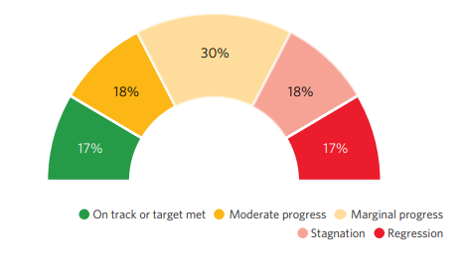
Figure 1: Overall progress across targets based on 2015–2024 global aggregate data (United Nations, 2024)

Sustainable Development Goal 10

Overview of SDG 10
SDG 10 is about tackling inequalities by fostering social, economic and political inclusion for all. It acknowledges there are worse conditions of living, less money and less access to health services amongst disadvantaged populations. Conversely, millions of individuals around the globe continue to suffer from poverty and social exclusion, which plays a role in reducing progress and well-being for sustainable development. (United Nations, 2024).

Impact on Health and Well-being
Addressing health inequalities has a considerable impact on physical and mental health. There is a strong link between the burden of deprivation and health outcomes, as the population living in the less deprived areas tend to have greater life expectancy and healthier life expectancy than the population living in the more deprived areas (Marmot, 2020). This trend is found throughout the social gradient and becomes even more pronounced at the worst levels of deprivation. Poor nutrition, lack of safe homes, education and health care make it more likely that someone living in poverty will suffer from chronic diseases and poor health and restrict them from eating food of high nutritional quality, from having access to a safe home, to getting education and health care services, or to accessing the internet, which is where they get recipes for healthy food from (United Nations, 2024).
Beyond that, there are differences in terms of access to services, quality of services and health outcomes found between population groups (The King's Fund, 2025). Ethnic inequalities are also a particular concern. For example, infectious disease admissions are higher amongst certain ethnic minority groups than for the White British population, which demonstrates the need for SDG 10 'reduced inequalities' to support the goal of 'good health and wellbeing' (UKHSA, 2025).
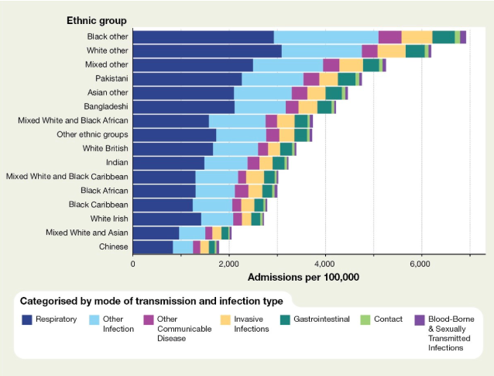
Figure 2: Emergency admission rates for infectious diseases by ethnic group in England (UKHSA, 2025)
The key facts for England in Figure 2 show very high ethnic disparities in health outcomes. There is also evidence of lower levels of admission for infectious diseases amongst several ethnic minority groups compared with the White British population, which is further evidence of social and structural inequalities which persist in society (UKHSA, 2025). There are also inequities in mental health: left disadvantaged and socially cut off, such as homeless people, refugees and asylum seekers are at a greater risk of experiencing mental illness and suicide attempts (The King's Fund, 2025). These new results are a clear indication that tackling inequalities is essential to improving health outcomes for men's and women's physical and mental health.

Critical Analysis
The welcome recognition by SDG 10 of a much broader set of social determinants that have an impact on health and not just access to health services itself is a key strength of SDG 10. These factors are all interrelated and are being addressed in the goal, which supports a broad, people-centred, and equitable strategy to achieve the goal of good health and well-being for people. But there have been varied levels of implementation. There are still vast health inequalities between regions and communities, with inequalities in life expectancy increasing the most amongst deprived communities and in regions outside the South East and London (Marmot, 2020). The health inequalities are further evidence of structural inequalities in accessing health services and health protection (UKHSA, 2025).

National wellbeing initiatives

NHS Long Term Plan
The NHS Long Term Plan is about changing the way the NHS operates by preventing someone from getting ill in the first place; changing how access to health services is provided; digital innovation; and the increasing use of community services. Prevention, digitalisation and augmenting community health services remain key focuses of the Government agenda. There are several strengths to be recognised in the initiative. First, the aspect of prevention is in synchrony with SDG 3, as said, prevention can help in increasing the population's health and lower the demand for health services. Second, there is potential to increase investments in digital healthcare that will lead to improved access and efficiency. Third, the plan includes efforts to transition to community-based care, which can lead to better patient outcomes and offload hospitals (Smout, 2024).
However, there are still several challenges in the way. Service delivery is continuing to be hampered by staffing deficiencies. The United Kingdom has been found to have fewer doctors, nurses and healthcare resources compared to many other countries with similar populations (Anandaciva, 2023). Even more, waiting times have significantly worsened as a result of the COVID-19 pandemic, which keeps people away from timely access to treatment. Such obstacles argue for the need to provide more capacity for the policy to be delivered.

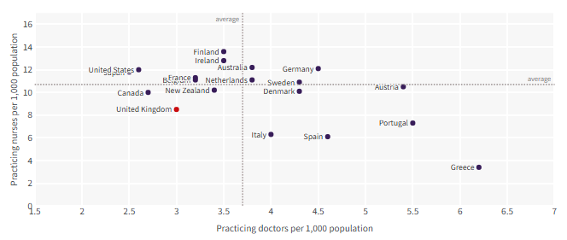
Figure 3: Number of doctors and nurses per 1,000 population in the UK compared with selected OECD countries (Anandaciva, 2023)

One can clearly see in figure 3 one of the biggest issues the NHS are facing. There are insufficient registered doctors and nurses per capita in countries, including the UK, compared to many other countries with high GDP, which is related to workforce shortages in the UK and increased waiting times (Anandaciva, 2023). Increased investment in a workforce of recruits and sustaining employees is needed to improve effectiveness. There is the potential to sustain this increase in training and provision of better working conditions and infrastructure for community healthcare to alleviate pressure on acute services.

NHS Core20PLUS5
Core20PLUS5 is an NHS strategy that aims to tackle the health inequalities within society with an emphasis on the worst off 20% of the population, plus other vulnerable groups such as ethnic minorities, those at risk of homelessness and socially excluded communities (NHS England, n.d.). The theme of health equity is an important strength of the programme, as is its attention to the wider determinants of health. It seeks to boost the benefits available in priority areas, including asthma, diabetes, epilepsy, oral health, and mental health and promote working together between national and local health care providers.
However, there are implementation challenges as uneven outcomes can occur across regions due to differences in local resources and/or capacity to deliver services. Further, integrated approaches have to be taken amongst the different sectors (healthcare, housing, education and social care) to address the complex needs of disadvantaged groups. Monitoring systems could be strengthened, multi-agency working improved, and investments to deprived communities increased to boost the effectiveness of the programme (NHS England, 2025).

Local wellbeing initiatives

Social Prescribing
Social prescribing is 'a service developed in communities that helps people find activities that meet their needs and support their health and wellbeing' (NHS England, 2020), which is when health professionals have the opportunity to signpost individuals to services that are outside of the healthcare system. The strategy seeks to tackle broader social determinants of health such as loneliness, social isolation, housing, employment and participating in the community. One of the key benefits of social prescribing is helping to support people's mental health and wellbeing by helping them to access the local support networks and voluntary organisations.
The Rotherham Social Prescribing Pilot has shown that it was able to bring benefits for service users, such as improving their wellbeing and decreasing the reliance on healthcare services in both social and economic ways (Dayson et al., 2014). However, there is an uneven availability of social prescribing as its impact is often reliant on resources and capacity within the local community and voluntary sector. There is scope to improve referral pathways with increased investment in community organisations, increases in partnership working and improving the awareness of NHS professionals on the support available (NHS England, 2020).

Local Authority Public Health Programmes
Social prescribing is complemented by local public health strategies that develop and encourage prevention and improvements to lifestyle habits within communities. These can support tackling broader determinants of health and decrease the pressure on the NHS by working with community organisations and services. However, there is a need for continued investment in community-based support networks and in the partnership building between health, concerned local authorities and voluntary organisations (Dayson et al., 2014).

Recommendations
A greater focus on investment into preventative health, in building workers and in providing community services, for the benefit of promoting health, wellbeing and SDOs. Funding, monitoring systems and collaborations across sectors must be increased across national initiatives, including the NHS Long Term Plan and Core20PLUS5, to tackle the broader determinants of health (NHS England, n.d). Internationally, further social prescribing and public health programmes need to be extended through stable funding and increased collaboration with the voluntary sector to increase access and help to reduce inequalities (Dayson et al., 2014). In addition, climate resilience and health equity need to be at the centre of plans in favour of greater progress towards SDG3 and SDG10.

Conclusion
The Sustainable Development Goals 3 and 10 are very important to support the global promotion of health, well-being, and equity. However, evidence suggests that significant challenges remain, including persistent inequalities, poverty and the long-term effects of the COVID-19 pandemic. The NHS Long Term Plan and Core20PLUS5 prioritise prevention and the reduction of inequalities. Social prescribing and public health programmes aim to promote the well-being of people in their communities. Greater coordination between global frameworks, national policies and local interventions is required to address health inequalities and achieve sustainable health outcomes for future generations.

References
Anandaciva. S. 2023. How does the NHS compare to the health care systems of other countries? The King’s Fund. Available at: https://www.kingsfund.org.uk/insight-and-analysis/reports/nhs-compare-health-care-systems-other-countries
Dayson, C. and Bashir, N., 2014. The social and economic impact of the Rotherham Social Prescribing Pilot: main evaluation report. Sheffield Hallam University.
European Parliament. 2024. Achieving Sustainable Development Goal 3 (SDG 3). Available at: https://www.europarl.europa.eu/RegData/etudes/BRIE/2024/762380/EPRS_BRI(2024)762380_EN.pdf
Marmot, M., 2020. Health equity in England: the Marmot review 10 years on. Bmj, 368.
NHS England. 2020. Social prescribing and community-based support. Available at: https://www.england.nhs.uk/wp-content/uploads/2020/06/social-prescribing-summary-guide-updated-june-20.pdf
NHS England. 2025. Progress report – delivering a greener NHS: five years on. Available at: https://www.england.nhs.uk/long-read/progress-report-delivering-a-greener-nhs-five-years-on/
NHS England. Core20PLUS5 – An approach to reducing health inequalities for children and young people. Available at: https://www.england.nhs.uk/about/equality/equality-hub/national-healthcare-inequalities-improvement-programme/core20plus5/core20plus5-cyp/
Smout. A. 2024. Reform or die: UK PM Starmer promises 10-year plan to fix health service. Reuters. Available at: https://www.reuters.com/world/uk/uk-pm-starmer-promises-10-year-plan-fix-health-service-crisis-2024-09-11/
The King’s Fund. 2025. What are health inequalities? Available at: https://www.kingsfund.org.uk/insight-and-analysis/long-reads/what-are-health-inequalities
UKHSA. 2023. Health Effects of Climate Change (HECC) in the UK. UK Health Security Agency. Available at: https://assets.publishing.service.gov.uk/media/659ff6a93308d200131fbe78/HECC-report-2023-overview.pdf
UKHSA. 2025. Health inequalities in health protection report 2025. UK Health Security Agency. Available at: https://www.gov.uk/government/publications/health-inequalities-in-health-protection-report/health-inequalities-in-health-protection-report-2025
United Nations. 2024. The Sustainable Development Goals Report 2024. Available at: https://unstats.un.org/sdgs/report/2024/The-Sustainable-Development-Goals-Report-2024.pdf

