

Title: Combustion chemistry calculations
M3X8824
Module tutor: Malcom McDonald
BEng Motorcycle Engineering
Compiled by Alex Brannovic-Jones
P142455

Contents
Introduction 3
Mass percentage 3
Ethanol 3
Iso-octane 3
percentage by Mass 3
Air/Fuel mass ratio for stochometric combustion 4
Enthalpy of formations 5
Higher and lower heating values explained 5
Lower heating value 6
Mass of CO2 produced per kg fuel 7
The ‘ideal’ fuel… 8
Conclusion 8
Bibliography 9
Appendixes 9

Introduction

For this assignment a blend fuel will be analysed. The blend will be made up of an even molar mix of ethanol and iso-octane.
Element | Weight
Carbon | 12
Hydrogen | 1
Oxygen | 16
Nitrogen | 14
The mixing of fuels, in particular ethanol and iso-octane, is a widespread practice, often implemented for government level regulations to varying degrees . This blend fuel has been taken up as a cleaner option then pure iso-octane, and this will be looked at during the course of the assignment.
Throughout this assignment the atomic weight of elements will be referenced. Using the periodic table (Appendix 1) these weights have been put in into a table (table 1). The lower number on each element is the atomic weight, which for this assignment have been rounded up.
Table 1

Mass percentage
Using appendix 2, the formula for the ethanol and iso-octane can be found, ethanol being $C_{2}H_{5}OH$, and iso-octane $C_{8}H_{18}$. From this formula the mass can be found when the atomic weights are taken into account (table 1).

Ethanol
Equation 1 $C_{2}H_{5}OH=\left(2*12\right)+\left(6*1\right)+\left(1*16\right)=46 kg$

Iso-octane
Equation 2 $C_{8}H_{18}=\left(8*12\right)+\left(18*1\right)=114 kg$

percentage by Mass

If the mass of ethanol and iso-octane are worked out as a percentage of the blend then;
Combining Equations 1 and 2,
Equation 3 $46 + 114=160kg (total wt)$
$For Ethanol \frac{46}{160}= 28.75\%$
$For Iso-octane\frac{114}{160}=71.25\%$
From this it can be seen that although the fuel blend is an equal mix by molar composition, by mass percentage it is by far iso-octane heavy.

Air/Fuel mass ratio for stochometric combustion

To achieve stoichiometric combustion the mass of reactants (fuel and air) will be equal to the mass of the products (exhaust gases).
To calculate the air/fuel ratio the amount of carbons, hydrogens, oxygen and nitrogen in equation 5 need to be balanced.
Equation 4 $Fuel 1+Fuel 2 + x(O_{2}+3.76N_{2})=A\left(CO_{2}\right)+B\left(H_{2}O\right)+C(N_{2})$
Equation 5 $C_{8}H_{18}+ C_{2}H_{5}OH+x(O_{2}+3.76N_{2})=A\left({CO}_{2}\right)+B\left(H_{2}O\right)+C(N_{2})$
If the total carbon of both fuels combined is;
$C=2+8=10$
Then
$A\left(CO_{2}\right)=A\left(10\right)$ A=10
Equally hydrogen in the combined fuel would be
$H_{2}=6+18=24$
$H=\frac{24}{2}=12$ B=12
Inputting to calculate O gives the reactants as ;
$O=\left(10*2\right)+12=32$
With O calculated, x can be solved for;
$2x=32-1$ ( -1 for the O in the ethanol)
$x=\frac{31}{2}$ = 16 x= 15.5
$C=x*3.76$
$C=15.5*3.76=58.28$
Gives the final equation 6 (from equation 5)
$C_{8}H_{18}+ C_{2}H_{5}OH+x\left(O_{2}+3.76N_{2}\right)=A\left({CO}_{2}\right)+B\left(H_{2}O\right)+C\left(N_{2}\right)$
Equation 6 $C_{8}H_{18}+ C_{2}H_{5}OH+15.5(O_{2}+3.76N_{2})=10\left({CO}_{2}\right)+12\left(H_{2}O\right)+58.28(N_{2})$
Air/fuel by mass would be;
$\frac{A}{F}=\frac{x\left(O_{2}+\left(3.76*N_{2}\right)\right)}{fuel 1+fuel 2}$
$\frac{A}{F}=\frac{x\left(O_{2}+\left(3.76*N_{2}\right)\right)}{C_{2}H_{5}OH+ C_{8}H_{18}}$
$\frac{A}{F}=\frac{15.5*(2*16+\left(3.76*2*14\right))}{\left(2*12\right)+\left(6*1\right)+\left(1*16\right)+\left(8*12\right)+\left(18*1\right)} =13.299$

Enthalpy of formations

The enthalpy of formation, referred to as $∆h_{f}^{°}$, relates to the energy within the molecules of the initial (in this case the ethanol/iso-ocane blend) and final states. This energy is needed or created to form one molecule into another. In this case the fuel blend (reactants) gives energy when it forms the products. This change in enthalpy shows the formation of one mole of a compound from the elements composing of that compound.
Equation 7 $∆h_{f}^{°}= ΣnH_{f}^{°}\left(Products\right)-ΣmH_{f}^{°}(Reactants)$
In this assignment the standard of 298.15°k is used.

Higher and lower heating values explained

The Higher Heating Value (HHV) and the Lower Heating Value (LHV) differ depending on the state of the water in the equation. The LHV calculations are taken when the water is in a gas, or vapour, state, whereas HHV would include it in a liquid state. Water in either state has a different enthalpy of formation, meaning it takes more or less energy depending on the state. The water as a gas holds more energy, thus requires less energy added, giving the LHV figure.

Lower heating value

From equation 6 $C_{8}H_{18}+ C_{2}H_{5}OH+15.5(O_{2}+3.76N_{2})=10\left({CO}_{2}\right)+12\left(H_{2}O\right)+58.28(N_{2})$
Enthalpy required for the fuels (reactants) to reach zero;
Iso-octane ($C_{8}H_{18})$= 224.1
Ethanol ($C_{2}H_{5}OH)$ = 234.6
Oxygen = 0
Nitrogen = 0
Total required = 458.7 MJ/kmol
Enthalpy produced by the Products;
Carbon dioxide = $10 * 393.5=3935$
Water (gas) = $12*241.8=2901.6$
Nitrogen = 0
Total produced = 6836.6 MJ/kmol
Resulting in;
$enthalpy produced-enthaply required=net enthaply realesed$
$6836.6-458.7=6377.9MJ/kmol$
Given the calculated mass of the fuel is 160kg, then;
$\frac{6377.9}{160}=39.862MJ/kg$
Compared to pure Iso-octane and Ethanol;
Ethanol
Equation 7 $C_{2}H_{5}OH+7(O_{2}+3.76N_{2})=2\left({CO}_{2}\right)+3\left(H_{2}O\right)$
$1512.4-234.6=1277.8MJ/kmol$
$\frac{1277.8}{46}=27.78MJ/kg$
Iso-Octane
Equation 8 $C_{8}H_{18}+12.5\left(O_{2}+3.76N_{2}\right)=8\left({CO}_{2}\right)+9\left(H_{2}O\right)+47\left(N_{2}\right)$
$5324.2-224.1=5100.1MJ/kmol$
$\frac{5324.2}{114}=44.65MJ/kg$

Mass of CO2 produced per kg fuel

From equation 6 $C_{8}H_{18}+ C_{2}H_{5}OH+15.5(O_{2}+3.76N_{2})=10\left({CO}_{2}\right)+12\left(H_{2}O\right)+58.28(N_{2})$
Given
$C_{8}H_{18}+ C_{2}H_{5}OH$ = Total mass of fuel
$$\left((8*12\right)+\left(18*1)\right)+ \left((2*12\right)+\left(6*1\right)+\left(1*16)\right)=160kg$$
10 CO2 therefor;
$10*\left(\left(1*12\right)+\left(2*16\right)\right)=440kg of CO_{2}$
Resulting in;
$\frac{Total mass of CO_{2}}{Total mass of fuel}$ = $\frac{CO_{2}}{kg}fuel$
$\frac{440}{160}=2.75kg of CO_{2} per kg of fuel$
If we then compare this figure to both pure Ethanol and Iso-octane;
Equation 9 $C_{2}H_{5}OH=2\left(CO_{2}\right)$
$\frac{2*\left(\left(1*12\right)+\left(2*16\right)\right)}{\left(2*12\right)+\left(6*1\right)+16}= 1.91kg CO_{2} per kg of fuel$
Equation 10 $C_{8}H_{18}=8\left(CO_{2}\right)$
$$\frac{8*\left(\left(1*12\right)+\left(2*16\right)\right)}{\left(8*12\right)+\left(18*1\right)}= 3.09kg CO_{2} per kg of fuel$$
From this it can be seen how the CO2 from Iso-octane is much higher then the CO2 produced by the Ethanol, with the blend fuel expectedly in the middle.
However, then the lower calorific values are taken into account;
Blend fuel;
Equation 11 $\frac{CO_{2}}{LHV}=\frac{2.75}{39.86}=0.069 CO_{2} per MJ$
Ethanol;
Equation 12 $\frac{CO_{2}}{LHV}=\frac{1.91}{27.78}=0.0688 CO_{2} per MJ$
Iso-octane;
Equation 13 $\frac{CO_{2}}{LHV}=\frac{3.09}{44.65}=0.0692 CO_{2} per MJ$
It can clearly be seen that the CO2 emissions are very similar when it comes to power created.

The ‘ideal’ fuel…
The modern engine needs a range of qualities in the fuel that it uses. An ideal fuel would have a high calorific value, with a high octane rating. This will decrease the auto-ignition of the fuel under higher pressures, reducing the chances of knock, while also providing adequate power.
Due to the higher octane rating, higher compression ratios could be used, resulting in higher pressures and increased temperatures. Therefor the fuel while need the correct ignition temperature. If this is too low the flame efficiency, or flame travel speed, may be effected. However, if this is too high early detonation may occur.
A key factor that may not be an aid to the engine, but is a requirement, would be to consider the emissions created. Emissions control is one of the major restraints for the manufacturers, with a number of restrictions on what is sold in key markets. If the fuel could be altered to reduce these emissions then that would be ideal for major manufacturers.
The health of the engine and associated components will also be a factor. Carbon deposits within the engine can create heat points, leading to early fuel combustion. This build-up can be treated with cleaning additives in the fuel, however this may effect burn rate. Low moisture content will also be required, both for burn rate and to increase the life of the exhaust. Ethanol is hydroscopic, so moisture content can sometimes to an issue with older fuel.
With these factors in mind, the ideal for one won’t always be the ideal for another. Different fuels will need to meet different requirements. A racing fuel will need different qualities to a mass production, everyday fuel. This will be because of many factors. The maintenance level of the engines (regular strip-down for a race engine, requires less cleaning additives in the fuel), the self life required (production cars may be sat for a length of time, with fuel left in the tank, which would need to be considered), the extreme conditions of some climates (cold start or high running temperatures), will all be contributors.

Conclusion
The blending of fuels has, and will continue to, increase. This is both due to the constant search to improve the internal combustion engine, and the real need to reduce our emissions.
While emissions, in particular CO2, out of the exhaust will be similar in quantity for both iso-octane and ethanol, the carbon footprint overall can be different. When the life cycle of the fuel is looked at (‘when the sum of emissions resulting from all stages of the life cycle of a product’), then it is widely claimed the net CO2 of Ethanol is less than regular fuel. This figure can be between 19-48%, depending on a number of factors. The offset of the CO2 captured by the crop grown for Ethanol is the main factor for this net CO2 reduction.
Ethanol, in particular an E85 blend, is also used in some of the top tier motorsport racing. Both the Indycar (appendix 4) series and the Supercar Championship (Aussie V8 supercar, soon to be V6) use E85 as the official fuel. Supercar Championship teams have reported due to lower running temperatures the life expectancy of the engines has increased, with less maintenance required. Both the USA and Australia have E85 available at the pump, due to the advanced production of the fuel, an area Europe as a whole is lacking (E10 is however regulation pump fuel across the EU). Brazil however is leading the way in ethanol production. Current generation ethanol production facilities are net providers to their respective national grids, due to energy harvested in the fermentation process.
Ethanol can often cause issues with competition to other crop growth, and this a concern in a number of key markets. Australia have tried to address this concern by only producing Ethanol as a by-product of food crops.
Another factor that may affect the ‘ideal’ fuel, and yet has no bearing in either the engine/engineering needs or government regulations, is the social stance, or ‘green’ image that the consumer requires. The pursuit of a reduction in the carbon footprint by the following generation may a be factor that is considered when marketing a fuel.
The future ‘ideal’ fuel may also be changing. With the advance of hybrid systems, the range extender type engine may take a larger focus for manufactures. This engine could be run at a more consistent set of conditions, meaning the fuel could be tailored to a narrower set of parameters, potentially increasing efficiency.

Bibliography
Richard Stone, 1989, Motor vehicle fuel economy, macmillan education
Goodger, 2000, Transport Fuels Technology, Landfall Press.
Joshua dowling, 2010, The pros and cons of ethanol, www.motoring.com.au
British Standards Institution, 2011, Specification for the assessment of the life cycle greenhouse gas emissions of goods and services, BSI
US department of energy, 2017, Alternative Fuels Data Center, www.afdc.energy.gov
Heywood, 1998, Internal combustion Engine Fundamentals, McGraw Hill

Appendixes
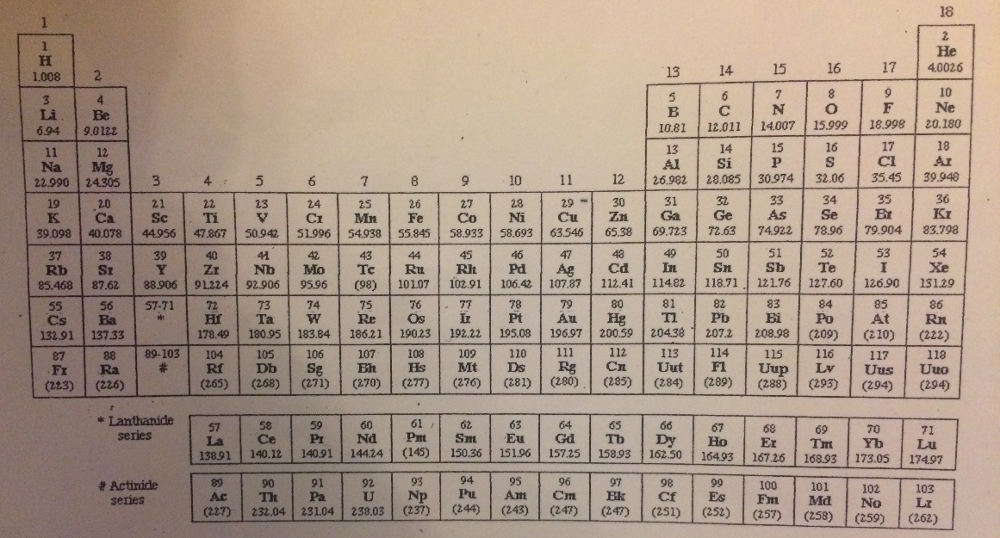
Appendix 1

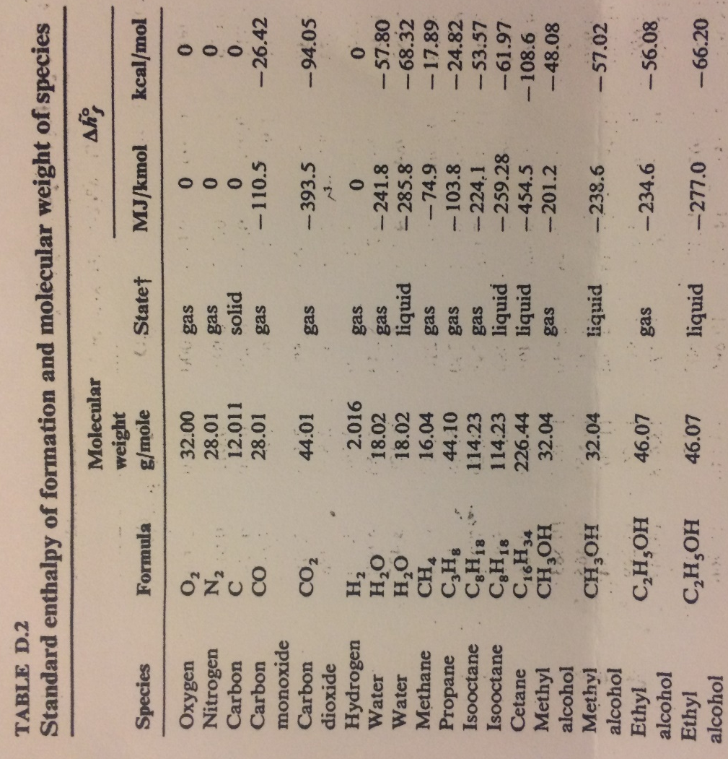
Appendix 2
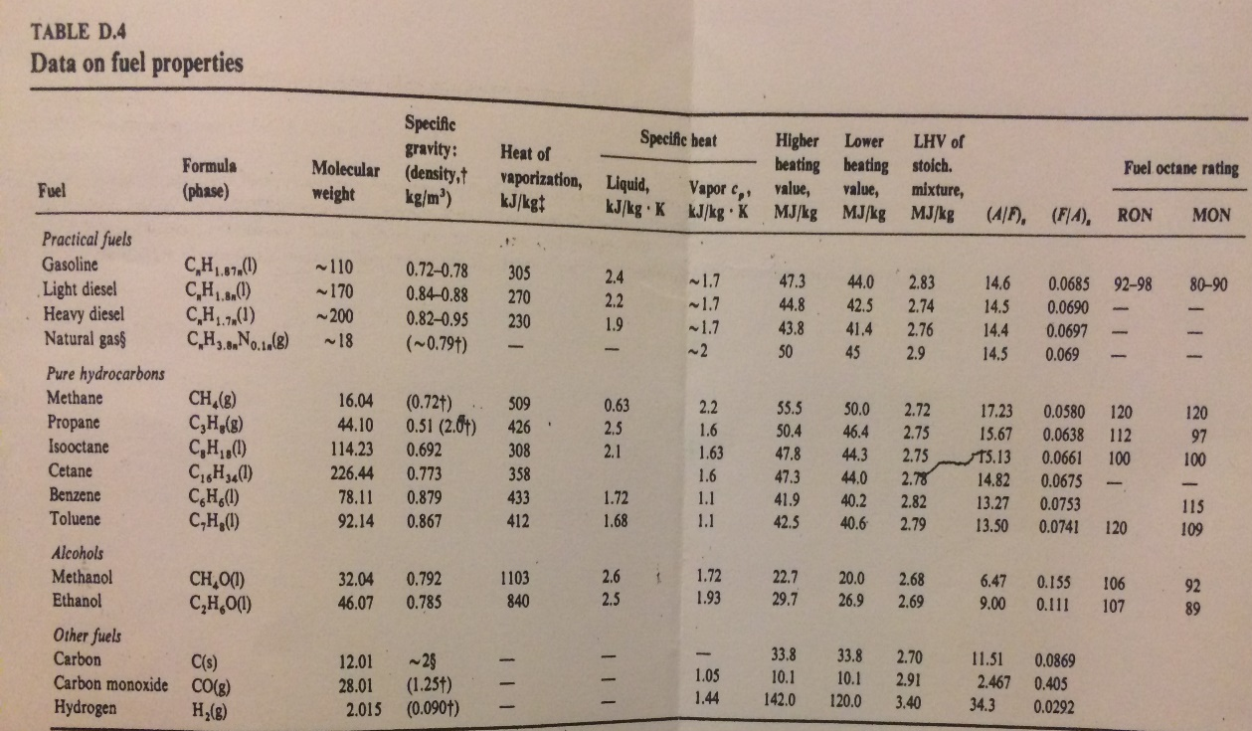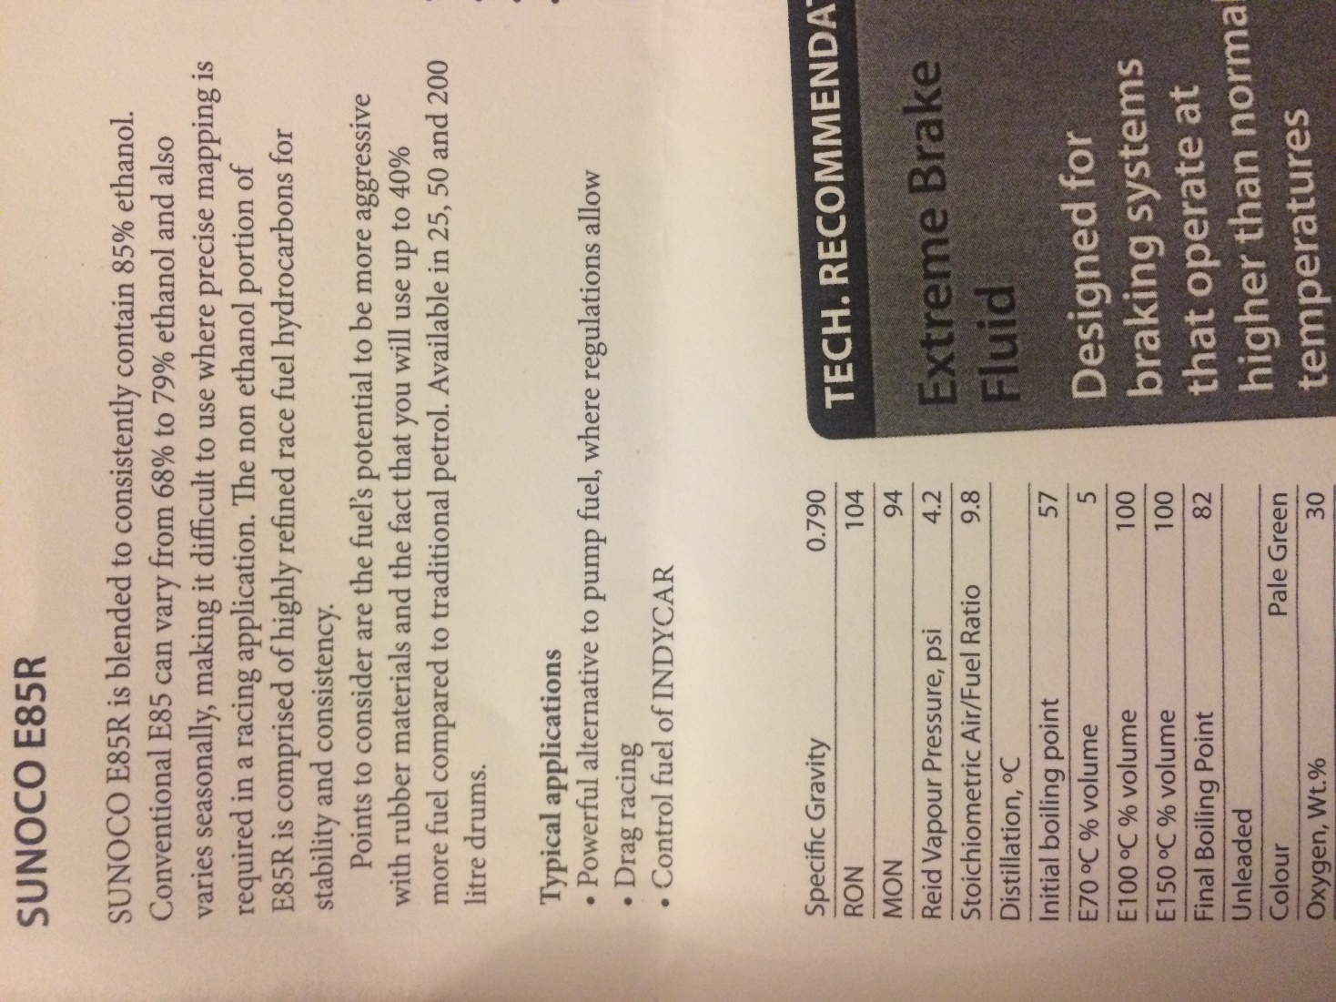
Appendix 3
Appendix 4

