DS 1 My Digital Life - Mohammed Abab Miah

My Screenshots/Photos
Screenshot/Photo 1
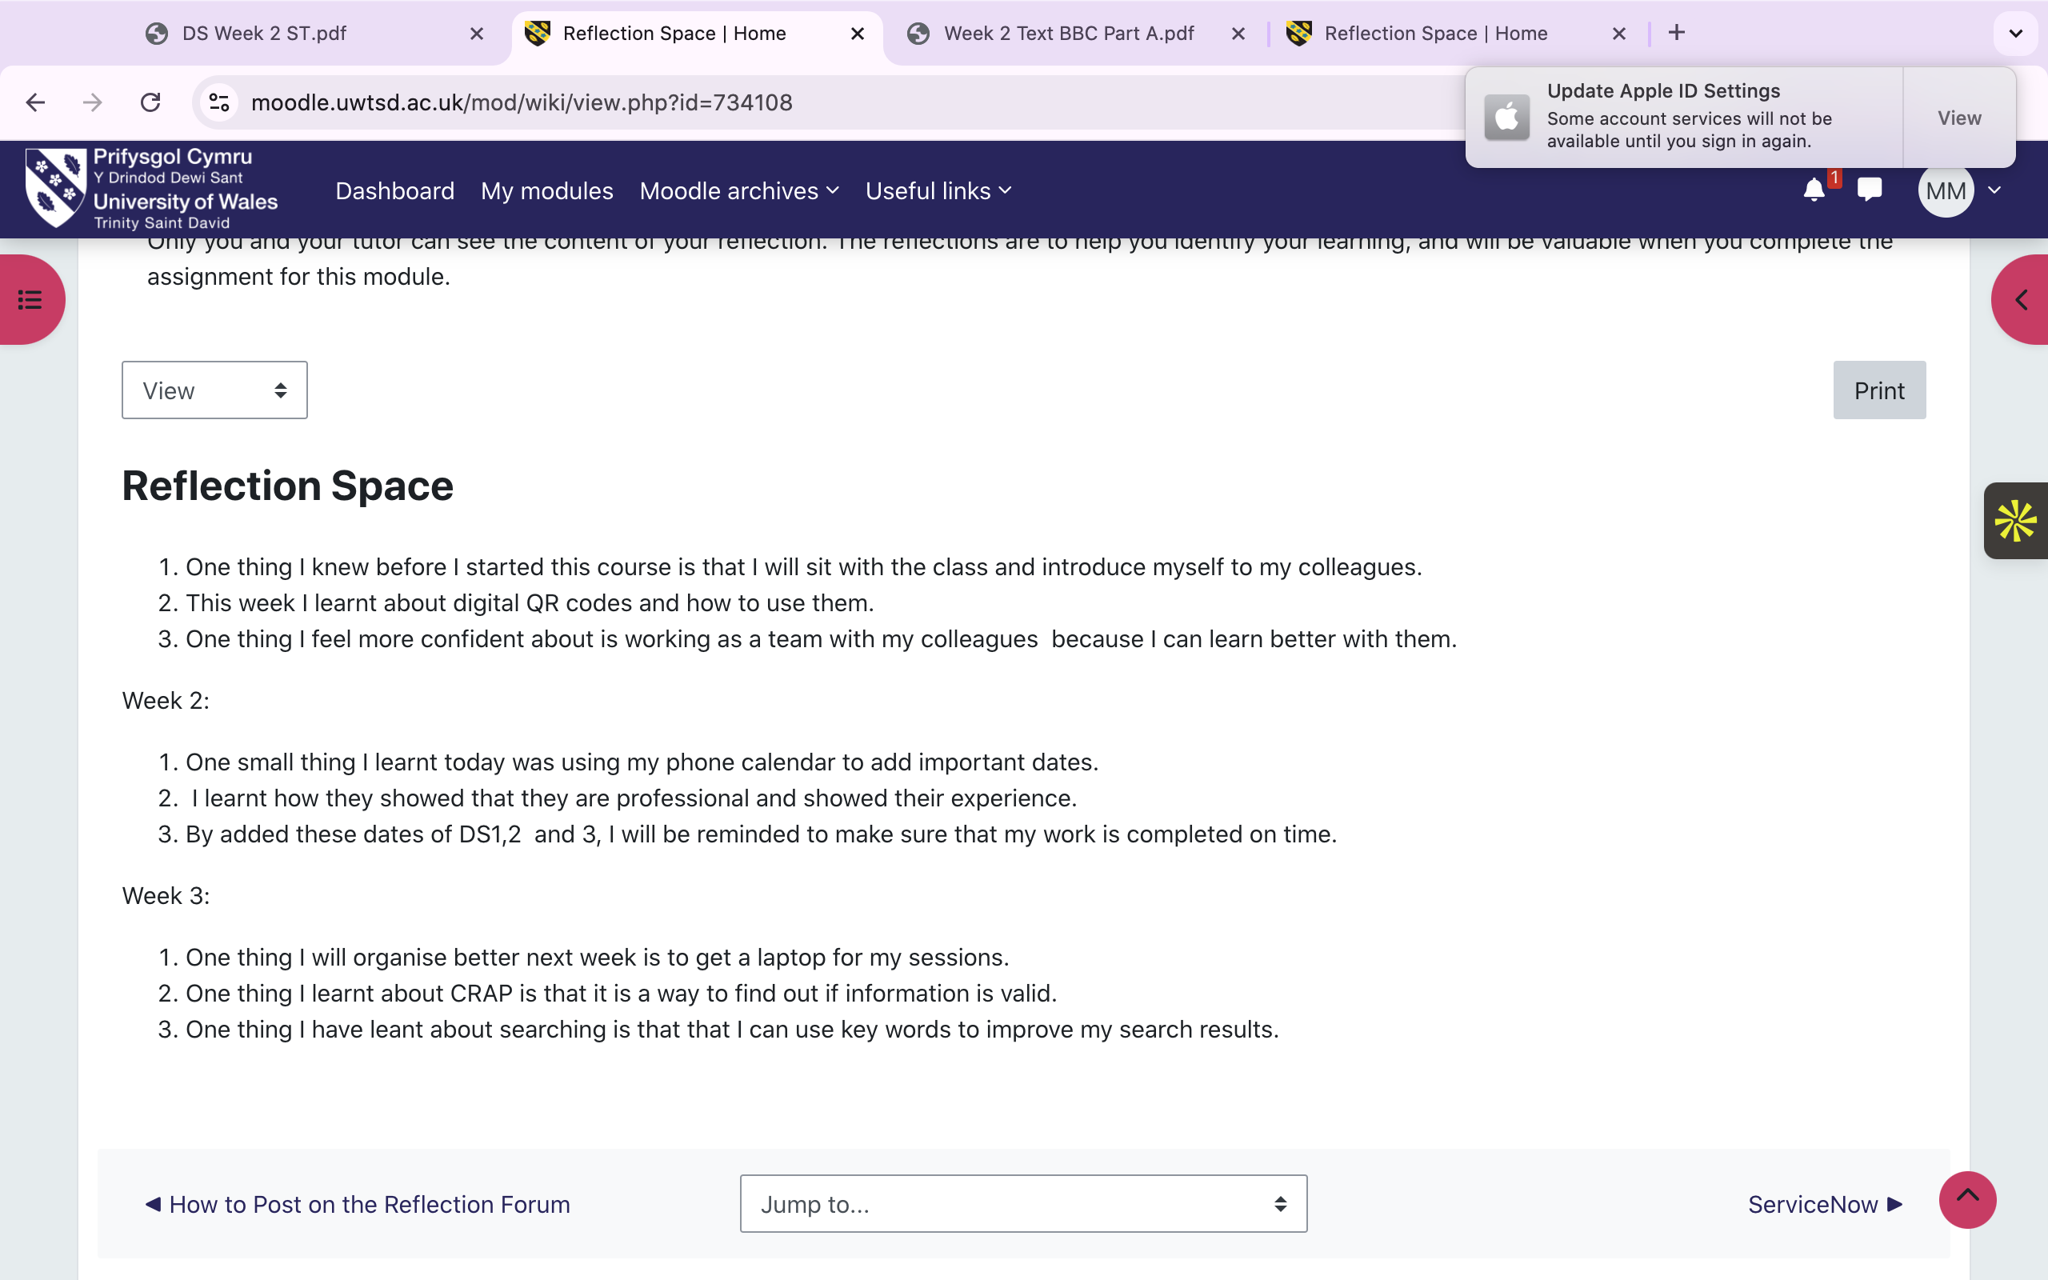
Here is a screenshot of my reflections that I post weekly. The purpose of the reflection is to show how my digital skills are improving. I can find the individual reflection link on Moodle on the tile Assessment information and submissions.

Screenshot/Photo 2
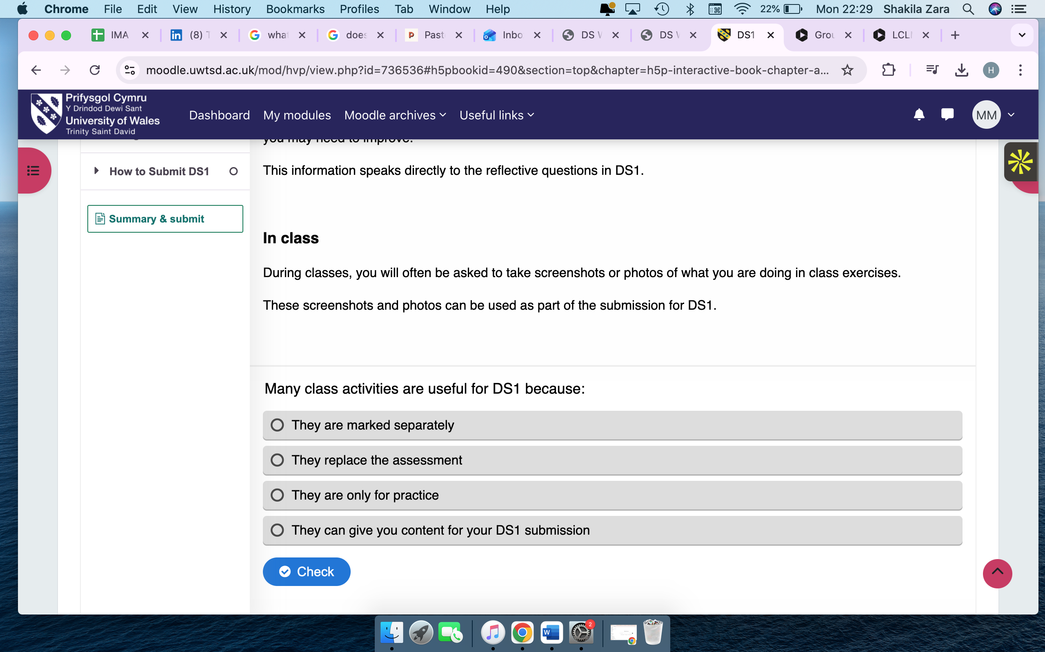

This is a screenshot of my homework from week 2. It was a task that was on an interactive book. I had to complete it to help me get more understanding on the assessment.

Screenshot/Photo 3
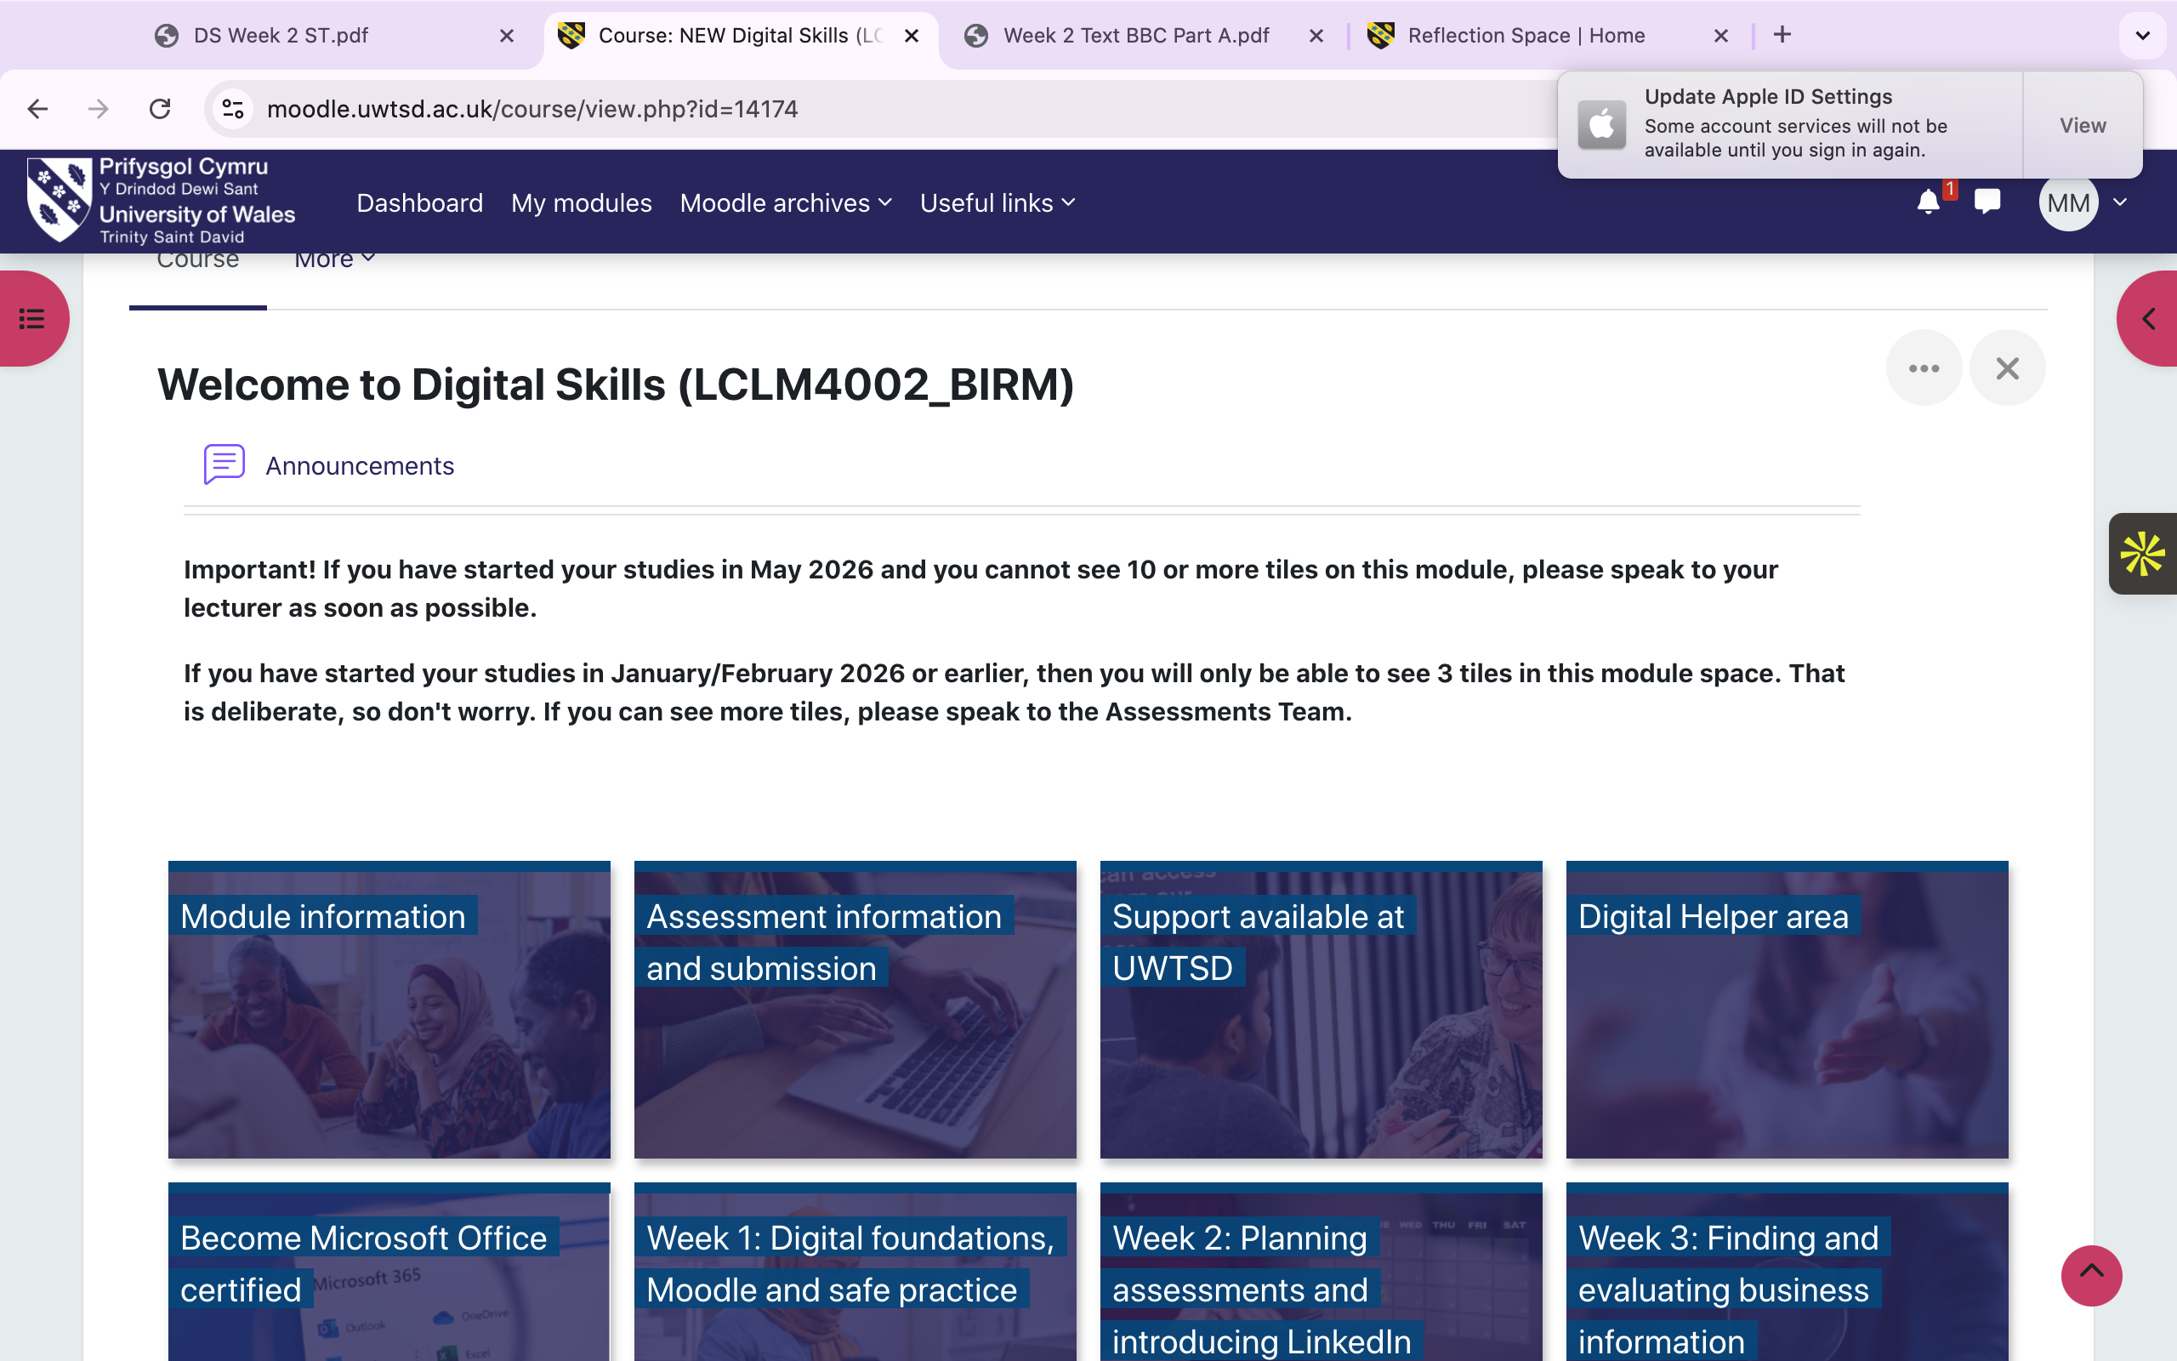
This a screenshot of Moodle where I find information about both my modules. This module is Digital skills. I use the tiles to help me keep track of each week.

Screenshot/Photo 4
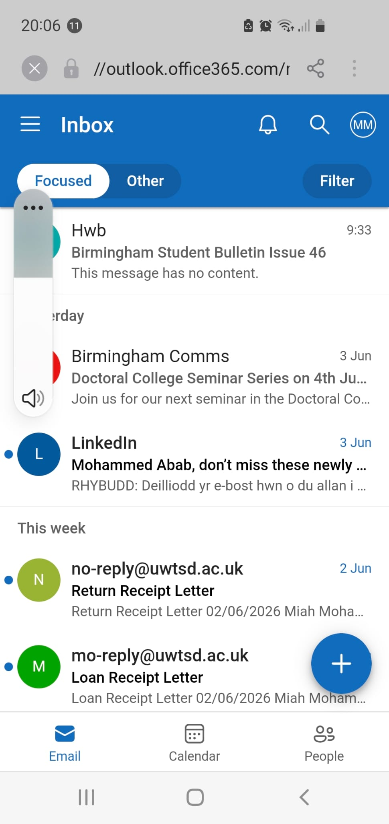
This is a screenshot of my Outlook on my phone. It helps me keep up to date with my emails every day.

Screenshot/Photo 5
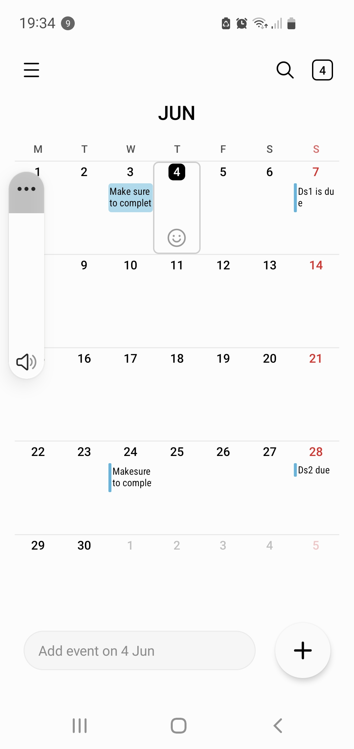
This is a screenshot of my Calander on my phone. I used this to help me keep organised so that I do not forget my assignments and submission dates.

My Short Reflection

I use digital tools to help me in my course.
I feel confident when I work as a group.
I want to improve on learning how to use a laptop.
I often use these tools to help get through the different information and resources.
I sometimes feel nervous about not knowing how to do tasks.
I hope this module will help me get better at using a laptop.
Digital skills are important for me because it is needed for every day tasks.

