The Role of Gen AI in Preventing Financial Crime: Balancing Effectiveness, Ethics and Sustainability

Abstract:
Financial crime remains an enduring and evolving threat to global economic stability and social welfare, with increasingly sophisticated criminal enterprises exploiting systemic vulnerabilities enabled by rapid technological advancements. The digitization and globalization of financial transactions have not only accelerated the flow of money across borders but also complicated the detecting and preventing of unlawful activities such as laundering money, financing to terrorist, tax evasion, and financial fraud. Traditional frameworks such as anti-money laundering (AML) and counter financing to terrorism (CFT) efforts, though foundational, have struggled to keep up the pace with the intricacy, speed, and scale of modern financial crimes. This critical literature review assesses the emergent role of generative artificial intelligence (Gen AI) as the transformative tools in the detection and prevention of financial crime, offering novel insights into their effectiveness, ethical implications, impact on sustainable financial innovation, and regulatory governance.

The study is motivated by the urgent need to address the limitations of conventional financial crime risk management techniques amid an era marked by increasingly sophisticated threat actors and digital financial ecosystems. Despite promising advances in AI-driven detection systems, there remain significant knowledge gaps related to the operational effectiveness of Gen AI models in practical, real-world settings; the nuanced ethical challenges raised by their deployment; the influence of AI integration on sustainable and innovation-driven financial ecosystems; and the adequacy of existing regulatory frameworks to govern these emerging technologies in a manner consistent with broader societal values.

Guided by four principal research questions, this review systematically synthesizes extant academic and industry literature to evaluate:
- The effectiveness of Gen AI technologies in identifying and mitigating key modalities of financial crime, including money laundering, terrorist financing, tax evasion, and financial fraud.
- The ethical considerations and challenges inherent in deploying generative AI within financial crime prevention, encompassing issues including equity, openness, confidentiality, human rights, potential biases, and environmental sustainability.
- The broader impacts of AI-driven innovation on the financial sector’s sustainability, including considerations tied to energy consumption, particularly in the context of renewable energy use, and the balancing act between innovation and responsible technology adoption.
- The extent to which current regulatory regimes effectively govern AI applications in financial crime risk management, and how foundational ethical principles can be operationalized within policy frameworks that guide the prudent and responsible introduction of generative AI.
The evidence reviewed indicates that generative AI holds considerable promise in advancing the identification of complex illicit financial patterns that often elude traditional rule-based systems. Through enhanced data synthesis, anomaly detection, and predictive analytics, Gen AI models can bolster operational efficiency and accuracy in transaction monitoring and suspicious activity reporting. Such capabilities suggest a paradigm shift in financial crime risk management, potentially reducing false positives and enabling more adaptive, real-time responses to emerging threats.

However, the deployment of Gen AI is not without significant ethical challenges. Critical issues include potential algorithmic biases that may inadvertently perpetuate systemic inequalities, transparency barriers given the often “black-box” nature of complex AI models, and risks related to privacy infringements and disproportionate surveillance impacts. Moreover, the environmental sustainability of AI systems emerges as a salient concern, given the substantial energy requirements for training and operating advanced generative models. The literature underscores the need to align AI development with sustainability goals, emphasizing the utilization of green energy sources and designing energy-efficient AI architectures to mitigate ecological footprints.

Regulatory oversight remains fragmented and frequently lags behind rapid technological innovation, resulting in potential governance gaps that could undermine accountability and public trust. Existing financial regulations often lack clear guidelines tailored to AI’s unique capabilities and risks, creating legal ambiguities and inconsistent enforcement across jurisdictions. The operationalization of ethical principles such as fairness, transparency, human rights protection, and sustainability requires robust, adaptive frameworks that integrate cross-disciplinary inputs from legal, technical, and social domains. This would facilitate responsible innovation while safeguarding individual rights and societal well-being.

Future research should prioritize several critical avenues. First, empirical studies assessing the effectiveness and real-world impacts of Gen AI deployments in diverse financial contexts are essential for validating theoretical promises. Second, interdisciplinary work requires to build explainable AI methodologies which will improve openness and interpretability, thereby fostering informed human oversight. Third, research must focus on optimizing the ecofriendly footprint of AI ecosystems—through energy-efficient algorithms, hardware innovations, and integration with green energy solutions—to align AI advancement with global sustainability imperatives. Fourth, the development of comprehensive, harmonized regulatory standards that embed ethical AI principles in financial crime risk management will be crucial. Collaborative efforts among policymakers, technologists, financial institutions, and civil society stakeholders can help close governance gaps while promoting innovation that respects human and environmental rights.

In conclusion, generative AI represents a powerful yet complex tool for combating financial crime. Its effective incorporation into risk management frameworks necessitates careful balancing of technological promise with ethical responsibility and sustainability considerations. By addressing current knowledge gaps and enhancing governance mechanisms, the financial sector can leverage Gen AI to foster a safer, more resilient, and equitable financial ecosystem attuned to the challenges of the digital age.

Key words: Financial Crime Risk; Money Laundering; Ethics; Artificial Intelligence; Sustainability; Net-Zero; Green energy; Digital Banking; Cyber-currency; Data Center

The Role of Gen AI in Preventing Financial Crime: Balancing Effectiveness, Ethics and Sustainability: A Critical Literature Review

- Introduction:

Financial crime continues to pose a major risk to global economic stability and societal well-being. The increasing sophistication of criminal enterprises, coupled with rapid technological advancements, has transformed the landscape of financial crime, introducing new complexities and vulnerabilities. The emergence of technological innovations has accelerated the speed and complexity of financial transactions, enabling criminals to exploit systemic weaknesses with unprecedented efficiency. Conventional anti money laundering (AML) and counter financing of terrorism (CFT) systems, despite being essential, often lag behind the changing landscape of these threats.

Existing regulatory frameworks are insufficient to address the scale and sophistication of contemporary threats, particularly in today’s digital age. The emergence of generative artificial intelligence (AI) offers transformative potential to enhance detection and prevention mechanisms through advanced data analytics, adaptability, and automation. However, integrating AI into financial crime prevention raises critical ethical and privacy concerns. Balancing the imperative to effectively combat crime with safeguarding individual rights, maintaining ethical standards, and ensuring sustainability is essential but challenging.

This literature review aims to present a detailed and critical assessment about significance of generative AI to preventing financial crime, with an emphasis on balancing between effectiveness, ethics, and sustainability. It examines the nature and significance of financial crime, evaluates existing regulatory frameworks and their limitations, explores the rise of digital financial crimes, and analyzes the benefits and obstacles associated with AI integration. It further looks to add to the ongoing conversation for developing trustworthy AI by offering insights and recommendations for legislators, technology experts, and scholars involved in shaping the future of AI in financial crime prevention.
In organizing this review and ensure a focused analysis, the investigation will be directed by the research questions outlined below:

RQ1: What is the efficacy of generative AI in identifying and mitigating financial crimes such as money laundering, terrorist financing, financial fraud and tax evasion?
RQ2: What ethical issues and concerns arise from employing generative AI in the financial crime risk management?
RQ3: In what ways does generative AI integration affects financial innovation and sustainability?
RQ4: To what extent do existing regulatory frameworks - govern the deployment of AI in managing financial crime, and how can foundational ethical principles (including human rights, fairness, transparency, and sustainability, with particular attention to renewable energy use) be operationalized to guide the responsible creation and launching of generative AI systems, ensuring inclusive results and mitigating probable harms to people and the environment?

Addressing the above guiding enquiries, this research underlines the imperative of embedding principled AI for financial crime prevention and detection, thereby ensuring that technological progress upholds ethical standards, mitigates inequalities, and supports sustainability objectives.

2. Understanding Financial Crime and Money Laundering
2.1 Defining Financial Crime and Money Laundering
There is a widespread practice of using 'Financial Crime' and 'Money Laundering' as synonyms around the world. Financial crime encompasses a broad range of illicit activities involving the unlawful acquisition, transfer, or use of financial assets - for example, bribery, tax evasion, fraud, money laundering and insider trading specifically refers to the act of disguising illegally gained funds to legitimize.

According to FinCEN (2019), money laundering conceals the illicit origins of funds, giving them the appearance of legitimacy. This process enables criminals to utilize unlawfully obtained proceeds undetected, thereby facilitating activities such as drug trafficking, arms smuggling and terrorism which cause considerable damage to humanity.
The United Nations Office on Drugs and Crime (2024) promotes the development of policies aimed at countering money laundering and terrorist funding. In addition to policy advocacy, the organization monitors and analyzes related activities, raises global awareness, and facilitates cooperation between the UN and other international entities. According to the 1988 Vienna Convention, the definition of money laundering is:

“The conversion or transfer of property, knowing that such property is derived from any offense(s), for the purpose of concealing or disguising the illicit origin of the property or of assisting any person who is involved in such offense(s) to evade the legal consequences of his actions.”

It typically takes places in three steps:
- First, introducing illicit cash into the financial system known as “Placement”.
- Second, process to obscure the source of funds through a number of intricate transactions known as “Layering”.
- Third, the reintegration of the laundered money back into the legitimate economy, known as “Integration”.

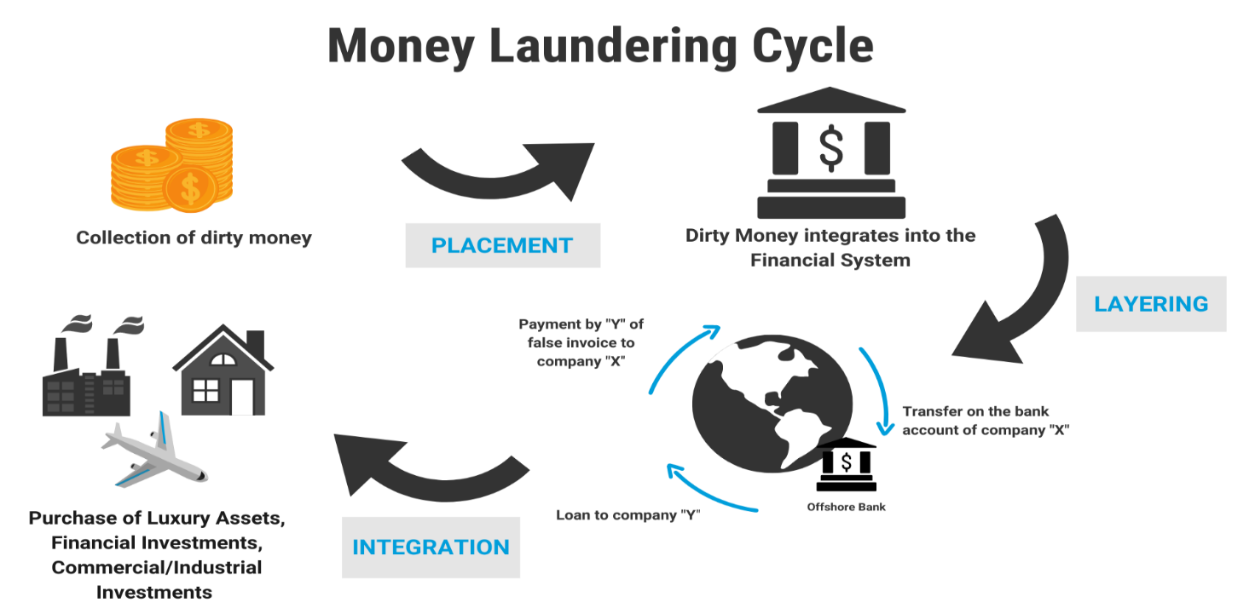
2.2 Historical Context and Evolution of Money Laundering/Financial Crime
Money laundering likely dates back as far as crime itself. Sterling Seagrave-an American historian notes that around 2,000 years ago, affluent merchants in China engaged in money laundering to evade trade restrictions imposed by regional authorities and government suspicion, as their income often came from black market activities, extortion, and bribery. To protect their wealth from bureaucratic extortion, they converted money into movable assets and transferred funds out of jurisdiction—methods still common in money laundering today. The modern money laundering history is often associated with the Prohibition era in the US during the 1930s. Between 1920 and 1933, the United States enforced Prohibition, which banned the production, importation, transportation, and sale of alcohol nationwide. During this time, organized crime syndicates dominated the lucrative illegal alcohol market and sought methods to legitimize their illicit proceeds by combining them with earnings from lawful businesses. A common strategy involved acquiring legitimate companies and integrating illegal profits with the businesses’ legal revenues. Laundromats were especially attractive to criminals because of their cash-heavy operations, offering a convenient front for figures such as Al Capone. Despite his involvement in numerous criminal activities, Capone was ultimately convicted in October 1931 for tax evasion that played a crucial role in shaping the modern understanding of money laundering (Financial Crime Academy, 2024).
Recognizing the growing danger associated with money laundering to economic and political stability worldwide, major international institutions have since taken active roles in combating it. The International Monetary Fund (IMF) and The World Bank (WB) have been main contributors to this global endeavour. While the WB focuses on alleviation of poverty and developing community, the IMF strives to safeguard the stability of the world economic system. Subsequent to the 9/11 attacks, both organizations intensified their commitment to tackling money laundering and terrorist financing by endorsing the Financial Action Task Force’s (FATF) suggested forty Money Laundering and the eight (now nine) Terrorist Financing related recommendations as guidelines serving as international standards for AML/CTF. The involvement of these leading international organizations greatly strengthened initiatives to fight money laundering (IMF, 2004).
2.3 The Scale and Significance of Financial Crime
Considering the extensive scope and serious impact of illicit finance globally, enhancing anti-money laundering (AML) capabilities remains essential. According to the United Nations Office on Drugs and Crime (UNODC), global money laundering amounts to an estimated between two to five percent of world’s gross domestic product (GDP), equating between $800 billion to $2 trillion each year (UNODC, 2021). Additionally, Nasdaq’s 2024 Global Financial Crime Report reveals that approximately USD 3.1 trillion in illicit funds circulated within the global financial system in 2023 (Friedman, 2024). This alarming statistic demonstrates the far-reaching and entrenched presence of money laundering worldwide, emphasizing the critical importance of implementing robust and adaptable AML frameworks (Atta and Atalor, 2024).

- Regulatory Frameworks for Financial Crime Prevention
3.1 Overview of Global Anti-Money Laundering (AML)/ Countering the Financing of Terrorism (CFT) Regulations
At the core of these efforts are AML /CFT regulations, which serve like the backbone for detecting and preventing financial crime. Although these frameworks differ across jurisdictions, they share common goals: to identify, monitor, and report suspicious financial activities. Nesbitt (2024) outlines the principal regulations that govern financial crime on a global scale are:
United States: In the United States, the foundational AML/CFT laws are the Bank Secrecy Act of 1970 and the USA Patriot Act of 2001. The Financial Crimes Enforcement Network (FinCEN) and the Office of Foreign Assets Control (OFAC) are the primary authorities to enforce these guidelines and overseeing compliance (IMF, 2004).
United Kingdom: In UK, the Financial Conduct Authority (FCA) serves as the main authority for the AML/CFT framework, which is grounded in the Proceeds of Crime Act 2002 (POCA), the Terrorism Act 2000, and the Money Laundering, Terrorist Financing and Transfer of Funds (Information on the Payer) Regulations 2017 (MLRs).

European Union: The EU’s AML/CFT structure is going to be enhanced through the Sixth Anti-Money Laundering Directive (6AMLD) of 2020 and the creation of the Anti-Money Laundering Authority (AMLA), a new EU-wide regulatory body scheduled to become operational in 2025.

Hong Kong: Hong Kong’s anti-money laundering and counter-terrorist financing activities are primarily overseen by the Hong Kong Monetary Authority (HKMA). The core pieces of regulation in Hong Kong that are concerned with ML, TF, PF and financial sanctions are the Anti Money Laundering Ordinance (AMLO), the Drug Trafficking (Recovery of Proceeds) Ordinance (Cap. 405) (DTROP), the Organized and Serious Crimes Ordinance (Cap. 455) (OSCO), the United Nations (Anti-Terrorism Measures) Ordinance (Cap. 575) (UNATMO), the United Nations Sanctions Ordinance (Cap. 537) (UNSO) and the Weapons of Mass Destruction (Control of Provision of Services) Ordinance (Cap. 526) (WMD(CPS)O). (Cr.gov.hk, 2025)

3.2 Effectiveness and Challenges of Legacy Systems
Despite comprehensive frameworks, Anti- Money Laundering (AML) effectiveness remains limited. The research team from Basel Institute on Governance (2021) indicates that only about 0.1% of laundered money is intercepted globally, highlighting a significant enforcement gap. Moreover, AML fines reached a record $8 billion in 2022, signaling regulatory pressure but not necessarily improved outcomes (Nesbitt, 2024). Compliance failures can erode consumer confidence and damage reputations, underscoring the high stakes for financial institutions.
The limitations of legacy AML systems stem from several factors:
- Reliance on static, rule-based approaches that struggle to detect novel or sophisticated laundering schemes
- High false positive rates leading to inefficient investigations and resource drain
- Fragmented data systems impeding comprehensive risk assessment
- Reactive enforcement focused on penalties rather than proactive prevention

These challenges highlight the urgent need for innovative, technology-driven solutions that can adapt to evolving criminal tactics.

4. The Digital Transformation of Financial Crime
4.1 Impact of Digital Banking Growth
Cele and Kwenda (2024) report that the size of global online banking market was projected at $803 billion globally in 2019 that is further evaluated to thrive to $1,610 billion by 2027. Retail banking holds the largest portion, accounting for over 71% of the market share. However, by 2027, digital payments are anticipated to take the lead in market share. While this growth enhances convenience and accessibility, it also expands the attack surface for financial criminals. Digital platforms’ complexity and speed complicate transaction monitoring, requiring advanced tools to detect illicit activities. Cybersecurity vulnerabilities further exacerbate risks, necessitating integrated defenses combining technology, regulation, and user education.

4.2 Emergence of New Financial Crime Modalities

The digitization of financial services has revolutionized how money moves globally, enabling 24/7 electronic transactions and expanding financial inclusion. However, this transformation has also introduced new vulnerabilities exploited by criminals. Emerging financial crime trends projected for 2025 include (Taylor, 2024):
- Crypto-Related Crimes: Ransomware attacks, crypto-money laundering, and illicit use of decentralized finance platforms.
- AI-Powered Fraud: Synthetic identity fraud, AI-driven scams, and automated social engineering.
- Deepfake and Voice Cloning Fraud: Manipulation of audio and video to deceive victims in financial transactions.
- Biometric Data Theft: Breaches and manipulation of biometric authentication systems.
- Environmental, Social, and Governance (ESG) Fraud: Greenwashing and falsified ESG reporting.
- Cyber-Fraud in Supply Chains: Exploiting digital supply chain vulnerabilities for financial gain.
These trends illustrate criminals’ agility in exploiting technological advances, challenging traditional law enforcement and regulatory approaches.

5. Evidence of Increasing Financial Crime Impact
The rapid expansion of digital banking has introduced new vulnerabilities, enabling financial criminals to exploit emerging technologies and platforms in unprecedented ways. The FBI’s Internet Crime Complaint Center (IC3) 2023 report highlights this trend, documenting a 22% increase in reported cybercrime losses, reaching a staggering $12.5 billion (Paganini, 2024). Complaints rose nearly 10% to 880,418, though actual incidents are likely higher due to underreporting.

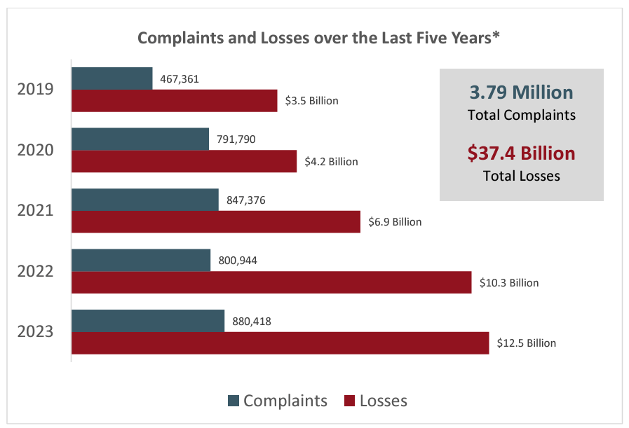
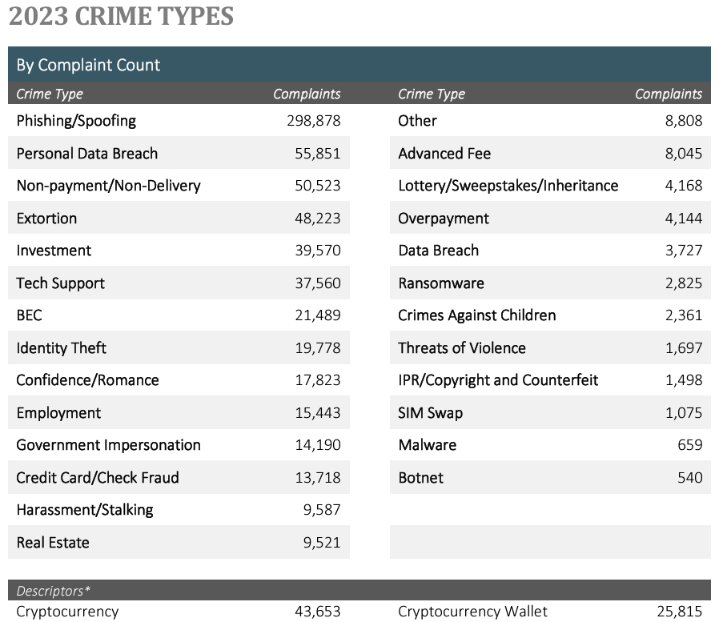
This surge in financial crime reflects how traditional AML and fraud prevention methods struggle to keep pace with evolving digital threats. The report identifies a significant rise in sophisticated scams tied to digital platforms, including:
- A 38% surge in investment scams, resulting in $4.57 billion in losses
- $2.9 billion losses due to Business email compromise (BEC) attacks
- Increased incidents of tech support scams and extortion crimes
- Ransomware complaints leading to $59.6 million in financial damages
These figures demonstrate that criminals are leveraging digital banking’s convenience and speed to perpetrate complex fraud schemes that legacy, rule-based detection systems often fail to identify or prevent effectively. Vulnerable demographics such as individuals aged 30-49 are most targeted by investment fraud, while the elderly face disproportionate risks from tech support scams, underscoring the need for more adaptive and technology-driven defences.
In summary, the growth of digital banking has not only expanded financial services but also amplified the scale and sophistication of financial crime, exposing the limitations of existing AML frameworks and highlighting the urgent need for innovative, real-time solutions.

6. The urgency of AI Incorporation to Financial Crime
Addressing the increasing challenges of detecting and preventing money laundering, cutting-edge technologies—particularly Artificial Intelligence (AI) and Cloud Computing—have added significant momentum in enhancing AML abilities. AI’s capability to process enormous volumes of data, recognize intricate patterns, and continually update from new information offers a transformative potential for cultivating accuracy and efficiency of money laundering detection. As opposed to traditional rule driven frameworks that depend on static, preset conditions, AI-driven AML solutions adapt dynamically to evolving laundering tactics, thereby strengthening detection processes.
Supporting this, Garcia-Segura (2024) highlights how AI’s rapid data processing and analytical power are revolutionizing compliance and monitoring across industries, enabling organizations to uphold regulatory standards more effectively. Arner, Barberis, and Buckley (2015) emphasize that AI technologies such as machine learning, natural language processing (NLP) and predictive analytics, provide adaptive and perceptive method for detecting anomalous events. These AI-driven systems are replacing or significantly enhancing conventional manual compliance methods by identifying latent risks early and enabling proactive interventions.
Moreover, Bughin et al. (2017) note that AI improves monitoring efficiency by automating repetitive tasks, reducing human error, and swiftly flagging irregularities within extensive datasets. Rai (2019) further explains that AI’s sophisticated analytical capabilities extend beyond basic rule enforcement, uncovering hidden unethical or unfair market practices embedded in large volumes of data.
To conclude, incorporating AI into AML frameworks marks a pivotal advancement, offering adaptive, proactive, and highly efficient solutions that overcome the limitations of legacy systems. By leveraging AI’s predictive and analytical strengths, banks and other finance institutions can notably improve their capability to prevent and detect financial crime, safeguarding the veracity of the international financial eco system.
7. Ethics in AI Development to manage Financial Crime Risk
Introducing Artificial Intelligence (AI) in managing financial crime risk offers transformative potential to detect and prevent illicit activities more effectively. Nevertheless, advancement of technology introduces significant ethical challenges which requires careful attention to guarantee responsible and equitable use. Discussing ethics in AI development is essential because financial crime detection involves sensitive personal data, high-stakes decision-making, and significant implications for individuals’ rights and societal trust. Key ethical considerations are:
Data Privacy and Protection
AI models need extensive access to private personal and financial information to detect unusual trends. As Martin (2019) highlights, this raises profound privacy concerns, as the analysis and processing of such data risk unauthorized use or breaches of individuals’ privacy rights. For example, AI-driven surveillance of employee communications or financial transactions, while aimed at crime prevention, can conflict with fundamental privacy protections (Garcia-Segura, 2024). Balancing effective crime detection with safeguarding privacy is therefore a critical ethical challenge.
Fairness and Biasness
The neutrality of AI algorithms is shaped by the quality and fairness of their training data. Flawed or incomplete training datasets can embed systemic biases, leading to inaccurate risk assessments or unfair targeting of certain groups (Martin, 2019). Barocas and Selbst (2016) warn that such biases can perpetuate discrimination, resulting in false accusations or unjust profiling. In financial crime risk management, this could mean disproportionately scrutinizing specific demographics or individuals without sufficient cause, undermining fairness and social justice.
Transparency and Accountability
Transparency is a foundational ethical principle, emphasized by the Organization of Economic Cooperation and Development (OECD)’s AI Values framework (OECD, 2024). Affected individuals must understand how AI systems make decisions that impact them, especially when those decisions lead to adverse outcomes such as investigations or employment consequences. Accountability requires organizations to manage risks throughout the AI lifecycle, ensuring that systems are regularly audited, biases mitigated, and errors addressed. Storbeck (2022) stresses that responsible AI deployment, particularly in sensitive areas like predictive policing, must uphold these principles to maintain human rights and public trust.
Human Rights and Legal Frameworks
Global AI applications in crime prevention must not aggravate current biases or discriminatory practices within the criminal justice system (Cath, 2018). This calls for the advancement of legal systems to manage the unique issues brought about by AI, including cross-border regulatory cooperation. Taddeo and Floridi (2018) argue that international consensus is vital to standardize AI governance, especially as technology-facilitated crimes transcend national boundaries, requiring harmonized ethical and legal responses.
Introduction of AI in financial crime detection is not merely a technical upgrade but a profound shift in how decisions are made and enforced. Without a rigorous ethical framework, AI systems risk causing harm through privacy violations, biased outcomes, and opaque decision-making processes. These risks can erode consumer confidence, damage institutional reputations, and potentially violate human rights.
By proactively addressing the concerns for ethics— including safeguarding confidentiality, promoting transparency, reducing algorithmic bias and enforcing accountability, financial institutions can build AI systems that are effective as well as just and trustworthy. This ethical foundation is critical to balancing the dual goals of robust crime prevention and respect for individual rights.
In conclusion, there is a pressing need to comprehensively review legal frameworks to pledge that AI-driven crime prevention approaches are consistent with core legal norms and the values upheld by society. The progression of AI in crime prevention shall ultimately be determined by the ability to harmonize technological advancements with evolving ethical and legal norms.

8. Sustainability Consideration for AI Integration in Financial Crime Prevention
Building on these ethical considerations, sustainability emerges as another critical dimension in the integration of AI for financial crime risk management. Sustainability, meaning the fulfilment of current necessities without impeding the rights of future generations to meet theirs, involves responsible resource management, minimizing environmental impact, and fostering social and economic well-being over the long term. The environmental footprint of AI technologies presents substantial challenges. The rapid acceleration of technological consumption driven by AI contributes to “planned obsolescence” which means to design products that wear out “prematurely” (i.e., have useful lives that were well below customer expectations), resulting in massive electronic waste and depletion of critical natural resources like rare earth elements (Guiltinan, 2008; Nations and International Science Council, 2024).

Beyond electronic waste, AI's infrastructure demands substantial energy and water resources. Li et al (2023) claims that the increasing carbon footprint of artificial intelligence (AI) has attracted significant public attention; however, the equally critical issue of AI’s water footprint—both in terms of withdrawal and consumption—has largely gone unnoticed. For instance, the process of training the GPT-3 model at Microsoft’s cutting-edge U.S. data facilities may use up to seven hundred thousand (700,000) litres of clean freshwater, yet this information has not been widely disclosed. More importantly, water withdrawals globally related to AI are expected to reach between 4.2 billion to 6.6 billion cubic meters by 2027, surpassing the total annual water use of four to six Denmarks or nearly half that of the United Kingdom. This trend is alarming given the growing scarcity of freshwater resources worldwide. To address these pressing water challenges, AI must embrace social responsibility and lead efforts to reduce its own water consumption.

Furthermore, Shehabi et al. (2024) reported in 2024 United States Data Center Energy Usage Report, that server energy use has more than tripled in recent years, with GPU-accelerated AI servers consuming over 40 TWh in 2023 alone. Projections estimate that by 2028, server energy use could range between 240 and 380 TWh, depending on operational practices (as shown in Figure 4). Additionally, U.S. data centers have an indirect water footprint of nearly 800 billion liters, which results from water usage tied to electricity consumption, calculated according to the regional electricity grid mix at data center sites. At the same time, the total greenhouse gas emissions associated with this electricity grid mix amount to 61 billion kilograms of CO2 equivalent
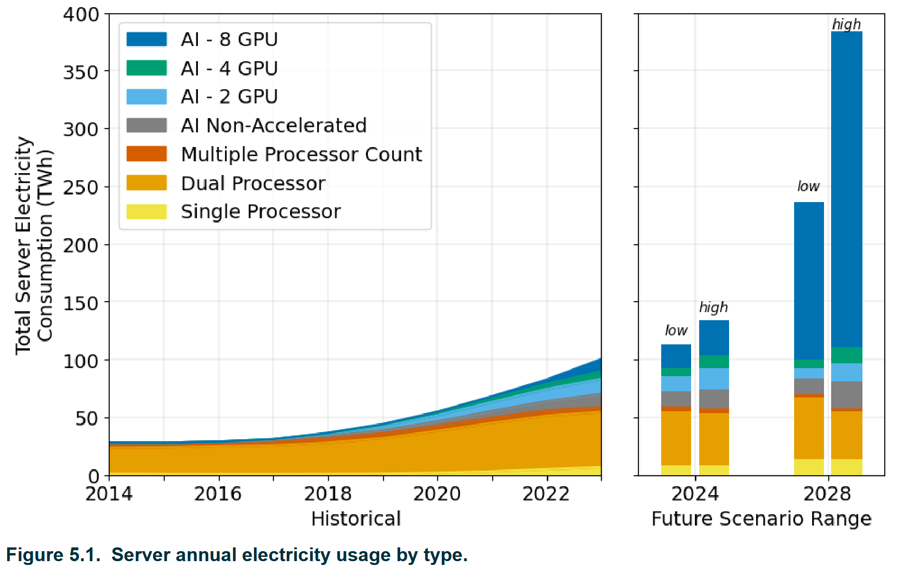

Concurrently, Galaz et al. (2023) highlight that AI’s rapid expansion is not only straining physical resources but also reshaping the digital information landscape, creating a “perfect storm” to mislead climate information. The proliferation of generative AI tools, such as OpenAI’s ChatGPT released in 2022, has lowered barriers to producing realistic but potentially misleading content. This transformation accelerates the spread of misinformation related to climate change and sustainability, fundamentally altering how such information circulates globally.
When combined with AI’s capacity to generate synthetic content, these dynamics foster widespread misinformation propagation, which has tangible consequences on public perception. For instance, Sparkman et al. (2022) found that biased and inaccurate media coverage leads many U.S. citizens to underrate community support for striving environmental policies. Similarly, a transnational survey led by the Climate Action Against Disinformation and Conscious Advertising Network (2022) revealed pervasive misconceptions about climate change across several countries. In US and Australia, 33% of respondents believe that change of climate is a natural phenomenon unrelated to human activity. In Brazil, 30% reject the anthropogenic causes of climate change, and 24% consider temperature records undependable or manipulated. In the UK, 29% trust there is substantial scientific disagreement regarding the causes of climate change.
Moreover, misinformation and conspiracy theories (according to Douglas et al. (2019) conspiracy theories describe explanations of past, current, or future events or situations that attribute the main cause to a secretive small group of powerful individuals, the conspirators, acting for their own gain or against the public interest) surrounding renewable energy projects, such as wind farms, are already impeding the expansion of clean energy infrastructure, thereby undermining efforts to conversion to net-zero energy systems (Winter et al., 2022). These trends underscore the urgent need to address the complex interplay between AI, digital media, and public understanding to safeguard effective climate action.

Given these realities, embedding sustainability into AI deployment for financial crime prevention is essential. As Tkachenko (2025) claims that financial institutions and regulators are increasingly recognizing AI’s environmental impact and integrating sustainability into risk management frameworks. This includes adopting energy-efficient AI models, leveraging green cloud computing, and managing AI resource lifecycles to align with net-zero goals
Kandemir (2025) suggests several strategies can mitigate AI’s environmental costs without sacrificing its performance: optimizing domain-specific AI models to reduce computational demands employing advanced energy-saving hardware like neuromorphic chips, transitioning data centers to renewable energy sources, and scheduling computations to coincide with peak renewable energy availability.

Conclusion
This literature review demonstrates that the landscape of financial crime is rapidly evolving, driven by digital transformation and the increasing sophistication of criminal tactics. Traditional AML/CFT frameworks, while foundational, are no longer sufficient to address the scale, speed, and complexity of threats in the digital era. Introducing generative AI to prevent financial crime offers significant promise, enabling advanced data analysis, pattern recognition, and real-time anomaly detection that can outpace legacy systems.
Nevertheless, embracing AI comes with its own set of challenge. Key ethical challenges—such as privacy, bias, and transparency—need to be addressed to guarantee fairness, accountability, and respect for individual rights in AI-driven solutions. Moreover, the environmental sustainability of AI systems is becoming increasingly important, as their energy and resource demands grow alongside their adoption.
To build resilient and trustworthy financial crime prevention frameworks, it is vital balancing the effectiveness of AI with robust ethical governance and sustainable practices. Embedding these guidelines within the development, execution, and control of AI systems will support ensure that technological progress does not come at the expense of societal values or environmental health
Future research should focus on empirically evaluating the effectiveness of generative AI to distinguish and counteract financial crimes like money laundering and counter terrorist funding, scam and tax evasion across varied regulatory and operational contexts. Alongside technical performance, there is a need for deeper investigation into the moral and societal consequences of AI integration, principally regarding privacy, bias, transparency, and impacts on vulnerable groups. Studies should also address sustainability by exploring ways to reduce AI’s environmental footprint, including energy-efficient algorithms and sustainable data centre practices. Comparative analyses of regulatory frameworks are warranted to identify best practices and develop new governance models that embed fairness, transparency, human rights, and sustainability. Interdisciplinary collaboration—bringing together technology, law, finance, ethics, and environmental science—will be vital to address these complex challenges. Finally, future work should examine AI’s dual role in both combating and amplifying financial and climate-related misinformation, and develop strategies to strengthen public resilience and awareness.
By advancing these research directions, the academic and professional community can support the progress of robust, ethical, and sustainable AI solutions that strengthen financial crime prevention while upholding societal values and contributing to global sustainability objectives.
*Limitations: The research was limited to using only secondary data. Primary data will be collected through planned interviews and surveys.
Reference:

Arner, D.W., Barberis, J.N. and Buckley, R.P. (2015). The Evolution of Fintech: a New Post-Crisis Paradigm? SSRN Electronic Journal, 47(4). doi:https://doi.org/10.2139/ssrn.2676553 [Accessed 30 January 2025].

Atta, C.A. and Atalor, I. (2024).Enhancing anti-money laundering capabilities: The strategic use of AI and cloud technologies in financial crime prevention. World Journal of Advanced Research and Reviews, 23(2), pp.2035–2047. doi :https://doi.org/10.30574/wjarr.2024.23.2.2508 [Accessed 25 January 2025].

Basel Institute on Governance. (2021). How effective are jurisdictions at preventing money laundering? Insights from the 10th Basel AML Index. [online] Available at: https://baselgovernance.org/blog/how-effective-are-jurisdictions-preventing-money-laundering-insights-10th-basel-aml-index [Accessed 25 January 2025].

Barocas, S. and Selbst, A.D. (2016). Big Data’s Disparate Impact. California Law Review, 104(3), pp.671–732. doi:https://doi.org/10.2139/ssrn.2477899 [Accessed 26 January 2025].

Bughin, J., Hazan, E., Ramaswamy, S., Chui, M., Allas, T., Dahlström, P. and Henke, N. (2017). Artificial Intelligence the next Digital Frontier? [online] Available at: http://dln.jaipuria.ac.in:8080/jspui/bitstream/123456789/14268/1/MGI-artificial-intelligence-discussion-paper.pdf [Accessed 29 January 2025].

Cele, N.N. and Kwenda, S. (2024). Do Cybersecurity Threats and Risks Have an Impact on the Adoption of Digital banking? a Systematic Literature Review. Journal of financial crime, 32(1). doi:https://doi.org/10.1108/jfc-10-2023-0263 [Accessed 25 June 2025]

‌Climate Action Against Disinformation and Conscious Advertising Network (2022). The Impacts of Climate Disinformation on Public Perception. Report. Online: https://caad.info/wp-content/ uploads/2022/11/The-Impacts-of-Climate-Disinformation-onPublic-Perception.pdf [Accessed 25 June 2025]

Cr.gov.hk. (2025). Companies Registry - Anti-Money Laundering and Counter-Terrorist Financing - Guidelines. [online] Available at: https://www.cr.gov.hk/en/Guidelines.htm [Accessed 5 Jul. 2025].
‌
Cath, C. (2018). Governing artificial intelligence: Ethical, legal and technical opportunities and challenges. Philosophical Transactions of the Royal Society A: Mathematical, Physical and Engineering Sciences, [online] 376(2133). doi:https://doi.org/10.1098/rsta.2018.0080 [Accessed 29 January 2025].

Douglas, K.M., Uscinski, J.E., Sutton, R.M., Cichocka, A., Nefes, T., Ang, C.S. and Deravi, F. (2019). Understanding Conspiracy Theories. Political Psychology, [online] 40(S1), pp.3–35. doi:https://doi.org/10.1111/pops.12568.[Accessed on 05 July 2025]
‌
FinCEN (2019). What is money laundering? [online] Financial Crimes Enforcement Network. Available at: https://www.fincen.gov/what-money-laundering [Accessed 20 January 2025].

Financial Crime Academy. (2024). The History Of Money Laundering. [online] Available at: https://financialcrimeacademy.org/the-history-of-money-laundering [Accessed 18 January 2025].

Friedman, A.T. ed., (2024). Global Financial Crime Report. [online] Available at: https://elements.visualcapitalist.com/wp-content/uploads/2024/04/1711973384569.pdf [Accessed 20 Jul. 2025].
‌
Garcia-Segura, L.A. (2024). The Role of Artificial Intelligence in Preventing Corporate Crime. Journal of Economic Criminology, 5, pp.100091–100091. doi:https://doi.org/10.1016/j.jeconc.2024.100091 [Accessed 25 January 2025].

Galaz, V., Metzler, H., Daume, S., Olsson, A., Björn Lindström and Arvid Marklund (2023). AI could create a perfect storm of climate misinformation. arXiv (Cornell University). doi:https://doi.org/10.48550/arxiv.2306.12807 [Accessed 10 June 2025].

‌Guiltinan, J. (2008). Creative Destruction and Destructive Creations: Environmental Ethics and Planned Obsolescence. Journal of Business Ethics, [online] 89(S1), pp.19–28. doi:https://doi.org/10.1007/s10551-008-9907-9 [Accessed 15 June 2025]

‌Hasham, S., Joshi, S. and Mikkelsen, D. (2019). Financial crime and fraud in the age of cybersecurity. [online] Available at: https://www.mckinsey.com/~/media/McKinsey/Business%20Functions/Risk/Our%20Insights/Financial%20crime%20and%20fraud%20in%20the%20age%20of%20cybersecurity/Financial-crime-and-fraud-in-the-age-of-cybersecurity.pdf [Accessed 29 January 2025].

IMF. (2004). Press Release: IMF, World Bank Enhance Efforts at Combating Money Laundering, Terrorist Financing. [online] Available at: https://www.imf.org/en/News/Articles/2015/09/14/01/49/pr0470. [Accessed 29 January 2025].

Kandemir, M. (2025). Why AI uses so much energy—and what we can do about it. [online] Institute of Energy and the Environment. Available at: https://iee.psu.edu/news/blog/why-ai-uses-so-much-energy-and-what-we-can-do-about-it [Accessed 16 June 2025]

Li, P., Yang, J., Islam, M.A. and Ren, S. (2023). Making AI Less ‘Thirsty’: Uncovering and Addressing the Secret Water Footprint of AI Models. [online] arXiv.org. Available at: http://arxiv.org/abs/2304.03271 [Accessed 29 June 2025].

‌Martin, K. (2019). Ethical Implications and Accountability of Algorithms. Journal of Business Ethics, 160(835-850). doi:https://doi.org/10.1007/s10551-018-3921-3 [Accessed 30 January 2025].

United Nations and International Science Council (2024). Navigating New Horizons: A global foresight report on planetary health and human wellbeing. Unep.org. [online] doi: https://doi.org/978-92-807-4166-7 [Accessed 01 July 2025]
‌
Nesbitt, M. (2024). AML essentials: 11 crucial insights into compliance for businesses. [online] ComplyAdvantage. Available at: https://complyadvantage.com/insights/aml-essentials-crucial-insights-into-compliance/ [Accessed 31 January 2025].

OECD (2024). AI principles. [online] OECD. Available at: https://www.oecd.org/en/topics/ai-principles.html [Accessed 31 January 2025].

Paganini, P. (2024). 2023 FBI Internet Crime Report reported cybercrime losses reached $12.5 billion in 2023. [online] Security Affairs. Available at: https://securityaffairs.com/160142/cyber-crime/2023-fbi-internet-crime-report.html [Accessed 30 January 2025].

‌Rai, A. (2019). Explainable AI: from Black Box to Glass Box. Journal of the Academy of Marketing Science, [online] 48(1), pp.137–141. doi:https://doi.org/10.1007/s11747-019-00710-5 [Accessed 26 January 2025].
Shehabi, A., Smith, sarah, Hubbard, A., Newkirk, A., Lei, N., Abu, M., Holecek, B., Koomey, J., Masanet, E. and Sartor, D. (2024). 2024 United States Data Center Energy Usage Report. [online] Escholarship.org. Available at: https://escholarship.org/uc/item/32d6m0d1[ Accessed 01July 2025]

‌Sparkman, G., Geiger, N. and Weber, E.U. (2022). Americans experience a false social reality by underestimating popular climate policy support by nearly half. Nature Communications, [online] 13(1), p.4779. doi:https://doi.org/10.1038/s41467-022-32412-y [ Accessed 01 July 2025]

‌Storbeck, M. (2022). Artificial intelligence and predictive policing: risks and challenges Recommendation paper 2. [online] EUCPN. Available at: https://eucpn.org/sites/default/files/document/files/PP%20%282%29.pdf [Accessed 26 January 2025].

Tkachenko, N. (2025). Sustainable integration of frontier AI in banking: A framework for emissions accounting and regulatory alignment. [online] Journal of Financial Compliance. Available at: https://hstalks.com/article/9414/sustainable-integration-of-frontier-ai-in-banking-/[ Accessed on 01 July 2025]

‌Taddeo, M. and Floridi, L. (2018). Regulate Artificial Intelligence to Avert Cyber Arms Race. SSRN Electronic Journal. doi:https://doi.org/10.2139/ssrn.3198556 [Accessed 27 January 2025].

Taylor, E (2024). New Threats in Financial Crime in 2025 - Evolution Recruitment Solutions. [online] Evolution Recruitment Solutions. Available at: https://evolutionjobs.com/exchange/new-threats-in-financial-crime-in-2025/ [Accessed 27 January 2025].

United Nations Office on Drugs and Crime (2024). Money laundering. [online] United Nations : UNODC ROMENA. Available at: https://www.unodc.org/romena/en/money-laundering.html [Accessed 11 January 2025].

U.S. Department of the Treasury. (2024). Treasury Announces Enhanced Fraud Detection Processes, Including Machine Learning AI, Prevented and Recovered Over $4 Billion in Fiscal Year 2024. [online] Available at: https://home.treasury.gov/news/press-releases/jy2650. [Accessed 01 July 2025]
‌Winter, K., Hornsey, M.J., Pummerer, L. and Sassenberg, K. (2022). Anticipating and defusing the role of conspiracy beliefs in shaping opposition to wind farms. Nature Energy, 7(12), pp.1200–1207. doi:https://doi.org/10.1038/s41560-022-01164-w [ Accessed 01 Jul1 2025]
‌

‌

‌

Annotated Bibliography

Annotated Bibliography
- Arner, D.W., Barberis, J.N. and Buckley, R.P. (2015). The Evolution of Fintech: a New Post-Crisis Paradigm? SSRN Electronic Journal, 47(4). doi:https://doi.org/10.2139/ssrn.2676553 [Accessed 30 January 2025].
Summary & Relevance: Arner et al. (2015) analyze fintech’s evolution post-2008 crisis, highlighting digital innovation’s impact on financial crime risks and regulatory challenges.
- Atta, C.A. and Atalor, I. (2024).Enhancing anti-money laundering capabilities: The strategic use of AI and cloud technologies in financial crime prevention. World Journal of Advanced Research and Reviews, 23(2), pp.2035–2047. doi :https://doi.org/10.30574/wjarr.2024.23.2.2508 [Accessed 25 January 2025].
Summary & Relevance: Atta and Atalor (2024) provide evidence on how AI and cloud technologies strategically enhance AML capabilities, directly supporting my study
- Basel Institute on Governance. (2021). How effective are jurisdictions at preventing money laundering? Insights from the 10th Basel AML Index. [online] Available at: https://baselgovernance.org/blog/how-effective-are-jurisdictions-preventing-money-laundering-insights-10th-basel-aml-index [Accessed 25 January 2025].
Summary & Relevance: The Basel Institute (2021) shows global AML systems are largely ineffective, highlighting enforcement gaps and the urgent need for innovative approaches
- Barocas, S. and Selbst, A.D. (2016). Big Data’s Disparate Impact. California Law Review, 104(3), pp.671–732. doi:https://doi.org/10.2139/ssrn.2477899 [Accessed 26 January 2025]
Summary & Relevance: Barocas and Selbst (2016) emphasize algorithmic bias risks in big data, supporting this review’s focus on ethical challenges and fairness concerns.

- Bughin, J., Hazan, E., Ramaswamy, S., Chui, M., Allas, T., Dahlström, P. and Henke, N. (2017). Artificial Intelligence the next Digital Frontier? [online] Available at: http://dln.jaipuria.ac.in:8080/jspui/bitstream/123456789/14268/1/MGI-artificial-intelligence-discussion-paper.pdf [Accessed 29 January 2025].
Summary & Relevance: Bughin et al. (2017) highlight AI’s role in automating tasks and reducing errors, supporting this review’s argument for advanced AI over legacy systems.
- Cele, N.N. and Kwenda, S. (2024). Do Cybersecurity Threats and Risks Have an Impact on the Adoption of Digital banking? a Systematic Literature Review. Journal of financial crime, 32(1). doi:https://doi.org/10.1108/jfc-10-2023-0263 [Accessed 25 June 2025]
Summary & Relevance: Cele and Kwenda (2024) systematically show cybersecurity threats hinder digital banking adoption, supporting the need for AI-driven AML solutions to enhance security.
- THE IMPACTS OF CLIMATE DISINFORMATION ON PUBLIC PERCEPTION Executive Summary. (2022). Available at: https://caad.info/wp-content/uploads/2022/11/Executive-Summary_The-Impacts-of-Climate-Disinformation-on-Public-Perception.pdf. [Accessed 25 June 2025]
Summary & Relevance: This report shows disinformation’s impact on public perception, reinforcing this review’s concerns about ethical risks of AI-generated misinformation
- Cr.gov.hk. (2025). Companies Registry - Anti-Money Laundering and Counter-Terrorist Financing - Guidelines. [online] Available at: https://www.cr.gov.hk/en/Guidelines.htm [Accessed 5 Jul. 2025].
‌Summary & Relevance: Cr.gov.hk (2025) details Hong Kong’s updated AML/CTF guidelines, reinforcing this review’s focus on robust, adaptive global regulatory frameworks for effective compliance.

- Cath, C. (2018). Governing artificial intelligence: Ethical, legal and technical opportunities and challenges. Philosophical Transactions of the Royal Society A: Mathematical, Physical and Engineering Sciences, [online] 376(2133). doi:https://doi.org/10.1098/rsta.2018.0080 [Accessed 29 January 2025].
‌Summary & Relevance: Cath (2018) examines AI governance’s ethical, legal, and technical challenges, supporting this review’s emphasis on balancing ethics, effectiveness, and sustainability in AI frameworks
- Douglas, K.M., Uscinski, J.E., Sutton, R.M., Cichocka, A., Nefes, T., Ang, C.S. and Deravi, F. (2019). Understanding Conspiracy Theories. Political Psychology, [online] 40(S1), pp.3–35. doi:https://doi.org/10.1111/pops.12568.[Accessed on 05 July 2025]
‌ Summary & Relevance: Douglas et al. (2019) examine conspiracy theories’ spread and impact, supporting this review’s analysis of AI-amplified misinformation undermining public trust
- FinCEN (2019). What is money laundering? [online] Financial Crimes Enforcement Network. Available at: https://www.fincen.gov/what-money-laundering [Accessed 20 January 2025]
‌Summary & Relevance: FinCEN (2019) defines money laundering and its societal harms, underpinning this review’s emphasis on the need for robust, technology-driven AML frameworks
- Financial Crime Academy. (2024). The History Of Money Laundering. [online] Available at: https://financialcrimeacademy.org/the-history-of-money-laundering [Accessed 18 January 2025].
‌ Summary & Relevance: Financial Crime Academy (2024) offers a historical overview of money laundering, enriching this review’s context on the evolution of financial crime

- Garcia-Segura, L.A. (2024). The Role of Artificial Intelligence in Preventing Corporate Crime. Journal of Economic Criminology, 5, pp.100091–100091. doi:https://doi.org/10.1016/j.jeconc.2024.100091 [Accessed 25 January 2025].
‌Summary & Relevance: Garcia-Segura (2024) analyzes AI’s effectiveness in preventing corporate crimes like fraud and insider trading, supporting this review’s focus on generative AI’s potential and ethics.
- Galaz, V., Metzler, H., Daume, S., Olsson, A., Björn Lindström and Arvid Marklund (2023). AI could create a perfect storm of climate misinformation. arXiv (Cornell University). doi:https://doi.org/10.48550/arxiv.2306.12807 [Accessed 10 June 2025].
‌Summary & Relevance: Galaz et al. (2023) warn AI amplifies climate misinformation, reinforcing this review’s concerns about generative AI spreading financial disinformation and ethical governance.
- ‌Guiltinan, J. (2008). Creative Destruction and Destructive Creations: Environmental Ethics and Planned Obsolescence. Journal of Business Ethics, [online] 89(S1), pp.19–28. doi:https://doi.org/10.1007/s10551-008-9907-9 [Accessed 15 June 2025]
‌Summary & Relevance: Guiltinan (2008) explores ethical and sustainability issues of planned obsolescence, enriching this review’s emphasis on responsible and sustainable AI development.
- Hasham, S., Joshi, S. and Mikkelsen, D. (2019). Financial crime and fraud in the age of cybersecurity. [online] Available at: https://www.mckinsey.com/~/media/McKinsey/Business%20Functions/Risk/Our%20Insights/Financial%20crime%20and%20fraud%20in%20the%20age%20of%20cybersecurity/Financial-crime-and-fraud-in-the-age-of-cybersecurity.pdf [Accessed 29 January 2025].
Summary & Relevance: Hasham et al. (2019) analyze digital transformation and cybersecurity threats fueling new financial crimes, supporting this review’s call for advanced AI and cybersecurity integration.

- IMF. (2004). Press Release: IMF, World Bank Enhance Efforts at Combating Money Laundering, Terrorist Financing. [online] Available at: https://www.imf.org/en/News/Articles/2015/09/14/01/49/pr0470. [Accessed 29 January 2025].
Summary & Relevance: IMF (2004) highlights the pivotal role of international organizations in strengthening global AML/CTF efforts, supporting this study.
- Kandemir, M. (2025). Why AI uses so much energy—and what we can do about it. [online] Institute of Energy and the Environment. Available at: https://iee.psu.edu/news/blog/why-ai-uses-so-much-energy-and-what-we-can-do-about-it [Accessed 16 June 2025]
Summary & Relevance: Kandemir (2025) examines AI’s high energy use, informing this review’s focus on generative AI’s sustainability challenges and balancing technology with environmental responsibility.
- Li, P., Yang, J., Islam, M.A. and Ren, S. (2023). Making AI Less ‘Thirsty’: Uncovering and Addressing the Secret Water Footprint of AI Models. [online] arXiv.org. Available at: http://arxiv.org/abs/2304.03271 [Accessed 29 June 2025].
Summary & Relevance: Li et al. (2023) reveal AI’s hidden water footprint, supporting this review’s focus on generative AI’s environmental challenges and responsible resource management.
- ‌Martin, K. (2019). Ethical Implications and Accountability of Algorithms. Journal of Business Ethics, 160(835-850). doi:https://doi.org/10.1007/s10551-018-3921-3 [Accessed 30 January 2025].
Summary & Relevance: Martin (2019) explores the ethical implications and accountability of algorithms, directly supporting the argument of need for transparent, fair, and responsible AI

- United Nations and International Science Council (2024). Navigating New Horizons: A global foresight report on planetary health and human wellbeing. Unep.org. [online] doi: https://doi.org/978-92-807-4166-7 [Accessed 01 July 2025]
Summary & Relevance: United Nations and International Science Council (2024) emphasizes the interconnectedness of planetary health, human well-being, and technology, supporting my study directly
- Nesbitt, M. (2024). AML essentials: 11 crucial insights into compliance for businesses. [online] ComplyAdvantage. Available at: https://complyadvantage.com/insights/aml-essentials-crucial-insights-into-compliance/ [Accessed 31 January 2025].
Summary & Relevance: Nesbitt (2024) outlines essential AML compliance insights, supporting this review analysis of evolving regulatory frameworks for financial crime prevention.
- OECD (2024). AI principles. [online] OECD. Available at: https://www.oecd.org/en/topics/ai-principles.html [Accessed 31 January 2025].
Summary & Relevance: OECD (2024) outlines ethical AI principles, directly supporting this review emphasizes on responsible, transparent, and sustainable AI integration
- Paganini, P. (2024). 2023 FBI Internet Crime Report reported cybercrime losses reached $12.5 billion in 2023. [online] Security Affairs. Available at: https://securityaffairs.com/160142/cyber-crime/2023-fbi-internet-crime-report.html [Accessed 30 January 2025].
‌‌ Summary & Relevance: Paganini (2024) highlights record cybercrime losses, reinforcing my review’s argument for urgent, AI-driven innovation in digital financial crime prevention.

- ‌Rai, A. (2019). Explainable AI: from Black Box to Glass Box. Journal of the Academy of Marketing Science, [online] 48(1), pp.137–141. doi:https://doi.org/10.1007/s11747-019-00710-5 [Accessed 26 January 2025].
‌‌ Summary & Relevance: Rai (2019) highlights the importance of explainable AI, supporting your review’s emphasis on transparency and trust
- Shehabi, A., Smith, sarah, Hubbard, A., Newkirk, A., Lei, N., Abu, M., Holecek, B., Koomey, J., Masanet, E. and Sartor, D. (2024). 2024 United States Data Center Energy Usage Report. [online] Escholarship.org. Available at: https://escholarship.org/uc/item/32d6m0d1[ Accessed 01July 2025]
‌‌ Summary & Relevance: Shehabi et al. (2024) provide comprehensive data showing U.S. data center energy use tripled since 2014, highlighting AI-driven growth and sustainability challenges
- Sparkman, G., Geiger, N. and Weber, E.U. (2022). Americans experience a false social reality by underestimating popular climate policy support by nearly half. Nature Communications, [online] 13(1), p.4779. doi:https://doi.org/10.1038/s41467-022-32412-y [ Accessed 01 July 2025]
‌‌ Summary & Relevance: Sparkman et al. (2022) highlight misperceptions in public support for climate policy, supporting this review’s discussion on societal awareness and ethical AI
- ‌Storbeck, M. (2022). Artificial intelligence and predictive policing: risks and challenges Recommendation paper 2. [online] EUCPN. Available at: https://eucpn.org/sites/default/files/document/files/PP%20%282%29.pdf [Accessed 26 January 2025].
‌‌ Summary & Relevance: Storbeck (2022) discusses predictive policing’s risks, supporting the ethical challenges and accountability in AI-driven technology

- Tkachenko, N. (2025). Sustainable integration of frontier AI in banking: A framework for emissions accounting and regulatory alignment. [online] Journal of Financial Compliance. Available at: https://hstalks.com/article/9414/sustainable-integration-of-frontier-ai-in-banking-/[ Accessed on 01 July 2025]
‌‌Summary & Relevance: Tkachenko (2025) presents a sustainable AI integration framework for banking, supporting this review’s focus on emissions accounting, regulation, and balanced innovation
- ‌Taddeo, M. and Floridi, L. (2018). Regulate Artificial Intelligence to Avert Cyber Arms Race. SSRN Electronic Journal. doi:https://doi.org/10.2139/ssrn.3198556 [Accessed 27 January 2025].
‌‌Summary & Relevance: Taddeo and Floridi (2018) highlight the necessity of regulating AI to prevent a cyber arms race, reinforcing for ethical governance in AI
- Taylor, E (2024). New Threats in Financial Crime in 2025 - Evolution Recruitment Solutions. [online] Evolution Recruitment Solutions. Available at: https://evolutionjobs.com/exchange/new-threats-in-financial-crime-in-2025/ [Accessed 27 January 2025].
‌‌Summary & Relevance: Taylor (2024) identifies emerging financial crime threats for 2025, directly supporting analysis of evolving digital risks and the necessity for AI
- United Nations Office on Drugs and Crime (2024). Money laundering. [online] United Nations : UNODC ROMENA. Available at: https://www.unodc.org/romena/en/money-laundering.html [Accessed 11 January 2025].
‌‌Summary & Relevance: UNODC (2024) provides authoritative definitions and highlights global AML/CTF efforts, supporting foundational discussion on money laundering

- U.S. Department of the Treasury. (2024). Treasury Announces Enhanced Fraud Detection Processes, Including Machine Learning AI, Prevented and Recovered Over $4 Billion in Fiscal Year 2024. [online] Available at: https://home.treasury.gov/news/press-releases/jy2650. [Accessed 01 July 2025]
‌‌Summary & Relevance: The U.S. Treasury (2024) demonstrates AI-driven fraud detection’s real-world effectiveness, supporting argument for integrating advanced technologies
- ‌Winter, K., Hornsey, M.J., Pummerer, L. and Sassenberg, K. (2022). Anticipating and defusing the role of conspiracy beliefs in shaping opposition to wind farms. Nature Energy, 7(12), pp.1200–1207. doi:https://doi.org/10.1038/s41560-022-01164-w [ Accessed 01 Jul1 2025]
‌‌Summary & Relevance: Winter et al. (2022) examine how conspiracy beliefs shape opposition to sustainable initiatives, supporting discussion on public perception challenges in ethical AI adoption.
- Anderson, T. (2015). Anti-Money Laundering: History and Current Developments. [online] 30(10), pp.521–531. Available at: https://www.researchgate.net/publication/316526702 [Accessed 19 January 2025].
‌‌‌Summary & Relevance: Anderson (2015) outlines anti-money laundering's historical evolution, key legal frameworks, and emerging challenges
‌
- Al-kfairy, M., Mustafa, D., Kshetri, N., Insiew, M. and Alfandi, O. (2024). Ethical Challenges and Solutions of Generative AI: An Interdisciplinary Perspective. Informatics, [online] 11(3), pp.58–58. doi:https://doi.org/10.3390/informatics11030058 [Accessed 25 January 2025].
Summary & Relevance: Al-kfairy et al. (2024) systematically review generative AI’s ethical challenges—privacy, misinformation, bias, copyright—and advocate interdisciplinary, fair, transparent AI governance

- Dimitrios Kafteranis, Athina Sachoulidou and Umut Turksen (2023). Artificial Intelligence in Law Enforcement Settings : AI Solutions for Disrupting Illicit Money Flows. doi:https://doi.org/10.30709/eucrim-2023-006 [Accessed 29 January 2025].
Summary & Relevance: Al Kafteranis, Sachoulidou, and Turksen (2023) present the TRACE project developing AI tools to detect, track, and prosecute illicit money flows, emphasizing ethical, legal, and regulatory challenges in law enforcement AI adoption.
- EU Artificial Intelligence Act (2024). High-level Summary of the AI Act. [online] EU Artificial Intelligence Act. Available at: https://artificialintelligenceact.eu/high-level-summary/ [Accessed 30 January 2025].
Summary & Relevance: The EU AI Act (2024) categorizes AI into unacceptable, high, limited, and minimal risk, banning harmful AI and imposing strict transparency, oversight, and data governance on high-risk systems
- Gorny, T. (2022). Anti-Money Laundering Guide for Digital Banks. [online] Available at: https://www.sanctions.io/blog/anti-money-laundering-guide-for-digital-banks [Accessed 25 January 2025].
Summary & Relevance: Gorny (2022) details AML risks in digital banks—fast onboarding, anonymity, fraud schemes—and stresses regulatory compliance with AI-driven customer due diligence
- Min, B. and Ferris, G. (2022). Regulating Artificial Intelligence for Use in Criminal Justice Systems in the EU Policy Paper. [online] Available at: https://www.fairtrials.org/app/uploads/2022/01/Regulating-Artificial-Intelligence-for-Use-in-Criminal-Justice-Systems-Fair-Trials.pdf [Accessed 31 January 2025].
Summary & Relevance: Min and Ferris (2022) stress urgent EU AI regulation in criminal justice to prevent discrimination, ensure transparency, protect human rights, and ensure accountability

- O Temitope, Awodiji, Ayoola, F., D Aderonke and Owoyemi, J. (2023). Stop Cyber Attacks Before They Happen: Harnessing The Power Of Predictive Analytics In Cybersecurity. [online] 10(4), pp.2458–9403. Available at: https://www.researchgate.net/publication/370414664_Stop_Cyber_Attacks_Before_They_Happen_Harnessing_The_Power_Of_Predictive_Analytics_In_Cybersecurity [Accessed 25 January 2025].
Summary & Relevance: Temitope et al. (2023) explore predictive analytics in cybersecurity, highlighting early threat detection, behavioral anomaly identification, and automated responses to prevent cyberattacks effectively.
- Tropina, T. (2016). Do Digital Technologies Facilitate Illicit Financial Flows? openknowledge.worldbank.org. [online] doi:https://doi.org/10.1596/23803 [Accessed 22 January 2025].
Summary & Relevance: Tropina (2016) analyzes how digital technologies facilitate illicit financial flows at all stages—earning, transferring, and using illegal funds
- Artificial Intelligence in Banking The changing landscape in compliance and supervision Foreword 2 Acknowledgements 3. (2020). Available at: https://www.aof.org.hk/docs/default-source/hkimr/applied-research-report/airep.pdf [Accessed 01 April 2025].
Summary & Relevance: The 2020 HKIMR report highlights AI’s role in enhancing financial crime detection, ethical governance, and sustainable compliance in Hong Kong banking system
- Naheem, M.A. (2015). Money laundering: A primer for banking staff. International Journal of Disclosure and Governance, 13(2), pp.135–156. doi:https://doi.org/10.1057/jdg.2015.10.
Summary & Relevance: Naheem (2015) highlights money laundering risks and urges robust, risk-based AML systems—directly supports my study.

- Australian Institute of Criminology (2024). Money laundering and the harm from organised crime: Results from a data linkage study Money laundering and the harm from organised crime. [online] Australian Institute of Criminology. Available at: https://www.aic.gov.au/publications/special/special-18.
Summary & Relevance: The Australian Institute of Criminology (2024) study links money laundering to organised crime harm, informing AI-driven strategies for ethical, effective financial crime control.
- Pavlidis, G. (2023). Deploying artificial intelligence for anti-money laundering and asset recovery: the dawn of a new era. Journal of Money Laundering Control, 26(7), pp.155–166. doi:https://doi.org/10.1108/jmlc-03-2023-0050.
Summary & Relevance: Pavlidis (2023) examines AI’s transformative role in AML and asset recovery, emphasizing balancing enhanced efficiency with ethical, rights-based regulatory safeguards—key for my research.
- Anselem Chinweike Ozioko (2024). The Use of Artificial Intelligence in Detecting Financial Fraud: Legal and Ethical Considerations. Multi-Disciplinary Research and Development Journals Int’l, [online] 5(1), pp.66–85. Available at: https://mdrdji.org/index.php/mdj/article/view/86 [Accessed 9 Jul. 2025].
Summary & Relevance: Ozioko (2024) explores AI in financial fraud detection, focusing on legal and ethical challenges
- Kal Bukovski, Cooper, J. and Basu, D. (2024). Enhancing Financial Crime Detection by Implementing End to End AI Frameworks. [online] University of Strathclyde. Available at: https://pureportal.strath.ac.uk/en/publications/enhancing-financial-crime-detection-by-implementing-end-to-end-ai.
Summary & Relevance: Bukovski, Cooper, and Basu’s 2024 paper outlines financial crimes introduction, AI-driven crime rise, criminals’ AI techniques, and AI methods to counteract threats comprehensively.

- Abraham Okandeji Omokanye, Akintayo Micheal Ajayi, Olawale Olowu, Ademilola Olowofela Adeleye, Ernest C Chianumba and Olayinka Mary Omole (2024). AI-powered financial crime prevention with cybersecurity, IT, and data science in modern banking. International Journal of Science and Research Archive, [online] 13(2), pp.570–579. doi:https://doi.org/10.30574/ijsra.2024.13.2.2143.
Summary & Relevance: The article reviews AI, cybersecurity, and data science integration in banking, emphasizing AI’s role in real-time crime detection, false positive reduction, and regulatory compliance.

- Singh, C. (2025). Is generative AI (artificial intelligence) the next advent in the evolution of finance and navigating financial crime and regulation? Journal of Financial Crime. doi:https://doi.org/10.1108/jfc-07-2024-0232.
Summary & Relevance: Singh (2025) explores how generative AI can revolutionize finance by enhancing financial crime detection, regulatory compliance, and cyber threat management in institutions.
*Limitations: Due to the word limit constraint for this assignment, certain descriptions and discussions related to key points and usability have been summarized to maintain focus and clarity.

