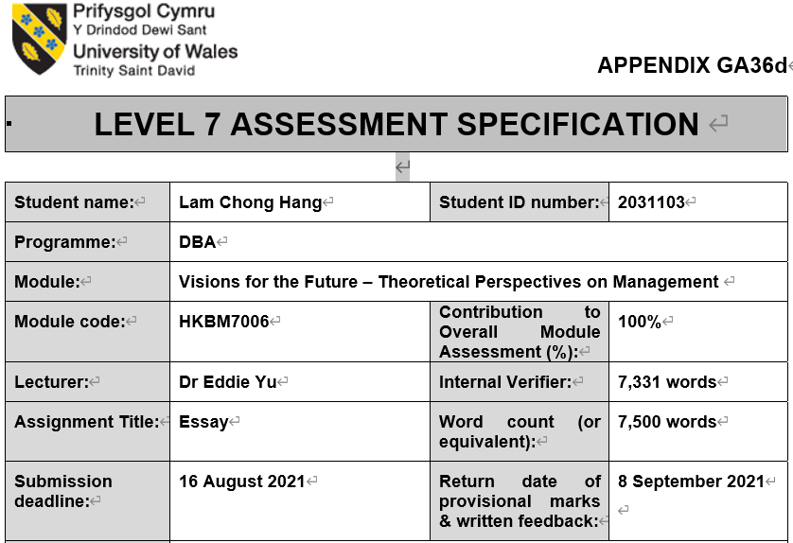
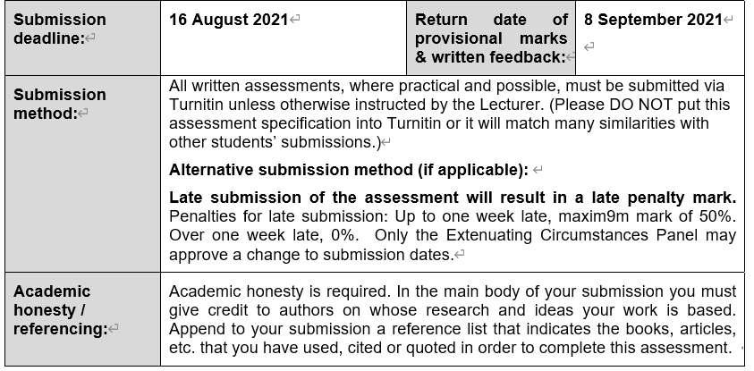
Research Paper Individual Assessment

Module name and code:
Visions for the Future: Theoretical Perspectives on Management (Code: HKBM7006)

Student Name:
Lam Chong Hang Alvin (Student No.: 2031103)

Title of the paper:
Effects of Workplace Retirement Planning Program with 3H framework on psychological wellbeing of middle-aged employees in Hong Kong

Area of interest
This study will focus on understanding the effects of a new workplace retirement planning education course to Hong Kong employees. Middle-aged employees will be the focused group of employees in this study since they concern more on retirement when compared with younger working adults. The study will explore the changes in the levels of anxiety, stress, as well as attitudes in future retirement of this group of employees after completing the retirement planning education course.
Offering retirement planning education courses to employees is a common benefit in workplace financial wellness programs of different organizations, the study will also examine the effectiveness of these programs in other places in order to gain more insights when these programs are implemented in Hong Kong.
Finally, the study will investigate the effects of integrating 3H framework in the retirement planning education course.

Research aim
Chung and Marmot (2020) reveals that Hong Kong population has the longest life expectancy globally. Investor and Financial Education Council (IFEC, 2015) finds that 65% of working people felt stressful about their finance with major worries on increasing living cost, unexpected expenses, job insecurity and poor economy. In addition, their financial stress had impacted their work performance negatively. Financial stress increases with age due to the worries of shortening working years and retirement without income. Employees cannot perform well in their works due to stress will affect organizational performance, subsequently they will be made redundant when organizations are forced to close or downsize with the reason of poor organization performance.
The research aim of this study is to reduce levels of anxiety and stress of middle-aged employees and improve their planning behaviours and attitude toward retirement through comprehensive retirement planning education course, consequently organizational performance is also improved. In addition, it aims to encourage organizations to include the retirement planning education course in their workplace financial wellness programs.

Research Objectives
There are different key research objectives of this study.
- To understand the current status of retirement preparation of middle-aged employees in Hong Kong.
- To examine employers’ policies relating to employees’ retirement planning.
- To evaluate the progress of workplace financial wellness programs in Hong Kong.
- To explore the challenges of current financial and social situations for employees planning for retirement.
- To identify needs, in additional to financial need, that would impact middle-aged employees’ retirement satisfaction.
- To explore the challenges in the process of developing retirement planning programs for employees at different levels or age groups.
- To describe the quantifiable objectives or goals of the programs to the providers, employers and the participating employees.
- To understand the marketing and communication strategies that can encourage employers and employees to participate in the workplace retirement planning programs.

Research questions
The following research questions will guide the study.
- What is the current status of retirement preparation of middle-aged employees in Hong Kong?
- What are the employers doing to help middle-aged employees plan for retirement?
- What is the progress of workplace financial wellness programs in Hong Kong?
- What are the challenges to employees in current market situations in achieving their retirement goals?
- In addition to financial need, what are the other needs that would impact middle-aged employees in their retirement planning?
- Why is a holistic approach important in developing a workplace retirement planning education program?
- If 3H framework is used in the process of developing the workplace retirement planning program, what should be covered in the program?
- What will be the challenges if 3H framework is used in the development of the retirement planning staff program?
- What will be the challenges in developing workplace retirement planning programs for employees at different levels or age groups?
- How to measure quantifiable objectives or goals of the programs to the course developer, employers and the participating employees?
- How to encourage employers and employees to participate in the workplace retirement planning programs?
- How to design an effective marketing and communication plan to encourage targeted employers and employees to participate in the program?

Significance of the issues to be explored in the paper
Mandatory Provident Fund Schemes (MPF) were started 21 years ago in 2000. Mandatory Provident Fund Schemes Authority (MPFA, 2020) discloses that at the end of 2019, average accrued benefits held in each employee’s MPF account is HK$159,000 only, this amount is just enough for a short term of retirement living. Besides, aging population is a continuing trend in Hong Kong. In 2020, the median ages of the population reached 44.9 for male and 45.2 for female. The life expectancy at birth for male and female are 82.7 years and 88.1 years respectively in 2020 (Census and Statistics Department, [CSD], 2021), the figures are higher than many countries or regions in the world. As employees’ retirement protection from government and employers are insufficient, they are required to prepare more by themselves if they want to achieve their expected retirement living standard.
If employers can provide suitable retirement planning education program to employees so that they can understand more the reality, then they may decide to start their retirement planning earlier and have more actions to tackle the coming challenges on retirement.
One of the possible contributions of this study is to improve the retirement planning behaviours and attitudes of employees especially those in middle-aged group. It will assist employees of different levels to plan well for their financial health. The employers include the workplace retirement planning programs as one of the employees’ wellness benefits will also be benefited. It is because employees with positive attitudes and lower levels of stress and anxiety will have better contributions to their works, it ends up will improve organization performance. Finally, the findings will assist HR to decide the criteria to assess the workplace financial wellness programs for their employees.

Literature Review
History and developments Workplace financial wellness programs. Workplace financial wellness programs started to become popular in the past few years, however in the past two decades, the programs have been developed in a less structural format (Davidson, 2018). Figure 1 shows the development of financial wellness programs in organizations.
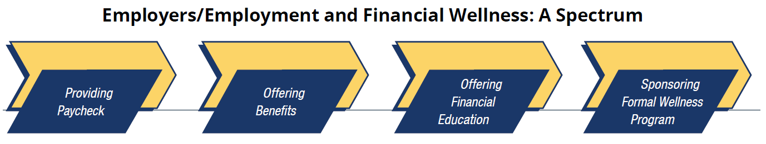
Figure 1: Development of formal financial wellness programs (Dupont, 2020, p.32)
The fundamental objective of employees to provide their skills, knowledge and efforts to organizations is to earn income as return. In addition to monetary compensations, employees are expected to get more from employers. Offering financial education is one of the employees’ benefits and a structured approach to enhance employees’ financial situations is formal financial wellness programs in organizations.
Formal workplace financial wellness programs can have different types and content. Wernette (2019) suggests that there are five most common types of workplace financial wellness programs, namely Tool-based programs, Product-based services, Education and literacy programs, Coaching and behavioral programs, and Customized employee education programs. Tool-based programs are often related to technical supports to help employees manage their own finance, online calculators are commonly included in the programs. Product-based services are similar to Tool-based programs, but more specific financial solutions will be provided, like life insurance needs and retirement income plans. Education and literacy programs are mainly in online format. The purposes are to educate employees to manage their savings and spending practices properly. Employers often provide online resources related to different personal financial topics for employees to learn, assessment tools are also included so that employees can assess their financial situations by themselves. Coaching and behavioural programs emphasize participations. Through the discussions with professionals, employees will be encouraged to focus on behaviours which can help improve their short-term to long-term financial status. Customized employee education programs are tailor-made financial wellness programs for selected employees.
Indeed, workplace financial wellness programs can offer many advantages to employers. Davidson (2018) suggests that there are several improvements in the organization performance through the implementation of the financial wellness programs. Areas with improvement include reduction in employees’ absence rates, reduction of withholding employees’ salaries for specific purposes like debt repayment and child support, reduction of staff turnover and reduction of employees’ financial stress. In addition, the programs can help increase employees’ productivity, increase their monetary savings for future spending in health and retirement. Dupont (2020) has similar findings and suggests that there are additional benefits of offering financial wellness programs by employers. The additional benefits for employees are having greater work satisfactions; better preparation for retirement, lower stresses in different areas. Employers’ additional benefits are higher employee engagement in the companies, reduction in expenses for company medical plans and meeting or exceeding employees’ expectations on company benefits. These research findings encourage employers to provide workplace financial wellness programs to their employees.
Although there are many benefits to the employers, Dupont (2020) finds that there are currently only 29% of employers are offering these programs and 43% interviewed employers do not offer or have no plan to do so. Dupont (2020) argues that common reasons for employers not to arrange these programs are “employees have no interest to know” and “employers are unsure the benefits to them”. Siciliano, Rizek and Veld (2019) suggests the biggest challenge for successful implementation of financial wellness programs in organization is to engage employees in the programs. Davidson (2018) summarizes the reasons of failure of workplace financial wellness programs into nine areas which are 1) changes of financial behaviours of employees; 2) scale of the programs; 3) availability to employees; 4) utilization with other employee benefits; 5) use of technology; 6) suitability of programs to employees; 7) communications with employees; 8) programs with focus on retirement planning; and 9) program fees by employers or other sources.
Davidson (2018) further elaborates the failure of nine areas.
Changes of financial behaviours of employees. The programs are not tailor-made for employees’ specific situations and they are just told to do without suitable coaching to follow up on behavioural changes. In addition, financial products are offered in the process before employees gain sufficient explanations and trusts.
Scale of the programs. Employers use large scale approach in the programs implementation. However, learning and communication skills of people are different, employees are unable to understand the required knowledge and skills properly. When large number of employees are focused, individualized communications is difficult, monitoring of behavioural changes is therefore difficult.
Availability to employees. Financial wellness programs should be offered to employees at all levels as all of them needs advice on financial planning. However, some employers only provide benefits to selected groups of employees, such as middle to senior managers. Besides, delay in launching such programs to employees also affect employees’ development of healthy financial behaviours.
Utilization with other employee benefits. Employees may see workplace financial wellness program as a standalone program, but through the program employees can understand how to manage other employee benefits so as to provide the most suitable benefit package to themselves. If employers do not explain clearly the purposes of financial wellness programs to the employees who may not be able to participate in other benefits.
Use of technology. Technology can help improve the organization performance if it can be used correctly. However, in workplace financial wellness programs, technology alone is insufficient to change employees financial behaviours significantly. Often technology can help provide information faster and easier, but more human interactions and coaching supports are more important for employees’ behavioural changes. Finally, data security issue may make some employees hesitate to use the technological supports in financial wellness programs.
Suitability of programs to employees. No one single financial wellness program can fulfill the needs of employees in different levels due to their diversified backgrounds. Some employees may need more guidance to manage their finance, but emphasizing too much on what “should” do is not easy to be accepted especially employees may expect advice on fixing immediate financial issue instead of long term planning. Therefore, ideally different financial wellness programs should be launched for different levels of employees.
Communications with employees. Employees can understand clearly the benefits of the financial wellness programs only when they join the programs. Therefore employers should put more efforts to promote the so as to attract employees to join especially during some important periods, such as when the employees just join the company.
Programs with focus on retirement planning. For companies with financial wellness programs, retirement planning is the most common content (Dupont, 2020). However, background of speakers for the programs will affect the effectiveness. If financial salespeople are the speakers for the programs, employees may have the concerns that the speakers are focusing on selling instead of giving most suitable advice to them. Besides, the programs may not relate directly to employees’ existing retirement plans so that they have no idea how to apply the knowledge and skills to manage their current plans. Finally, for young or middle-aged employees, retirement is a medium to long term goal, but currently some employees may be struggling with the present debt or cash flow problems such that they have no additional resources to plan for retirement.
Program fees by employers or other sources. If financial wellness program is a benefit to employees, they would expect employers to pay for whole fee. But in some programs, employers need them to pay, this makes employees uncomfortable which affect adversely their trusts on the employers and the programs. In some cases, the programs are free with the condition that the benefits providers can sell their services to the employees, this also affect the employees’ acceptance on the programs.
The discussions indicate that workplace financial wellness programs are beneficial to both the employees and the employers. Employees can learn appropriate knowledge and skills to improve their financial behaviours and also financial health, employers can enhance their organization performance through different improvement in workplace, such as better productivity and employees’ satisfaction. However, the effectiveness of the programs is affected during the implementation process which includes the stages of development of programs, acceptance by employers and employees and the delivery etc.
This research will investigate the approaches to make the implementation of workplace financial wellness programs in Hong Kong successful. Then what is the status of development of workplace financial wellness programs in Hong Kong?
Development of financial wellness programs in Hong Kong. Keeping good employees is very important to ensure the company has sustainable growth. Randstad Hong Kong Limited (RHKL, 2021a) reveals that attractive salary and benefits are the most important considerations for employees in Hong Kong, but it is not enough to retain competent employees especially when competitors increase the salary to attract high quality people. Therefore, employers need to put more efforts to help the employees to stay and perform in the organizations. Randstad Hong Kong Limited (RHKL, 2021b) suggests that employees are more likely to stay loyal to their employers if they can participate in financial support programs which help improve the level of financial literacy of the employees.
Hong Kong is a busy and stressful city, A survey discovers that 29.6% of respondents experienced high pressure from work, where education, construction and transportation sectors have 30% of their workers are very stressful (Siu, 2020). Occupational stress will lead to absenteeism, family problems or sickness (Siu, 2020), therefore easing workplace stress will likely reduce the costs of employers and improve the organization performance.
There are different sources of stress, Siu, Cooper, Roll & Lo (2020) identifies 5 major types of stress that Hong Kong employees are facing, which are Insecurity in job, Workloads, Constraints in organization, Interpersonal conflicts and Problems in work-family balance.
Stress from job security may appear when employees face uncertainty, for example uncertainty may happen when there is restructure in organization or department, or when the economic environment is weakened. Employees may face stress from workloads when the deadlines to finish assigned tasks are changed to earlier time or more tasks are assigned. Constraints in organization are mainly related to the work setting which is difficult to change. For example, lack of manpower, equipment or supplies due to budget cut may lead to stressful environment to employees. Conflicts between employees may happen in any organization no matter the scale is large or small as people has unique background. When arguments happen, stress will follow. Work-life balance is commonly heard, but not everyone can do so. When an employee wants to have better performance in work, he or she may need to spend more time and efforts at work and therefore may sacrifice the time on family members. The struggle between work and family can create stress.
As the workplace stress is high and Hong Kong employees are not required to work to a particular age so as to get the most benefits from social security, Hong Kong employees often choose to retire early if conditions allow. Lee & Choi (2019) reveals that Hong Kong people at age 30 to 40 on average estimated to retire at 61 with HK$3.6 million of savings and assets, but their estimations for retirement needs may be inadequate with existing wealth management approach. Yiu (2021) opines that majority of working people in Hong Kong would not have enough pension savings to retire at their expected living standard and increase in health care costs may further worsen the situations.
Under current legislation, employers and employees joining MPF schemes are required to contribute 5% of monthly relevant income as mandatory contributions to the schemes. The employees may only withdraw their accumulated benefits, called accrued benefits, from their mandatory contributions upon reaching age 65, except for certain specific circumstances (Mandatory Provident Fund Schemes Authority [MPFA], 2021a). In addition to mandatory contributions, employers and employees can also make voluntary contributions to the MPF schemes.
Mandatory Provident Fund Schemes Authority [MPFA], 2021b) reported 2.61 million employees are making contributions to Mandatory Provident Fund schemes (MPF Schemes), which is more than 76% of the total number of employees in Hong Kong. Therefore, the amount of retirement savings under MPF schemes is very critical to most of the employees in Hong Kong. If their accrued benefits under MPF schemes are sufficient, their retirement protection will be better. Then how much is accumulated in the MPF system?
As at the end of December 2019, average accrued benefits held in each employee’s MPF account is HK$159,000 (Mandatory Provident Fund Schemes Authority [MPFA], 2020). Each employee may have more than one MPF account, so the total accrued benefits per each employee may be more than this amount. Institute of Financial Planners of Hong Kong (IFPHK, 2021) reported their findings that retirees interviewed on average spent HK$11,500 per month. The amount has reflected the situation that travelling and dining-out expenses of retirees were significantly dropped due to COVID-19. It implies retirees in general will spend more than this amount. Even with the amount, HK$159,000 can last for 13.8 months only, less than 2 years. This gives a warning signal that retirement savings in general is seriously inadequate for retirement living.
Figure 2 shows the distribution of MPF accounts by range of accrued benefits (MPFA, 2020), it can be noted that only 14% of total number of accounts have more than HK$200,000 accrued benefits. Therefore, if employees cannot save more for retirement during their working periods, they may not be able to accumulate sufficient amount for retirement spending.
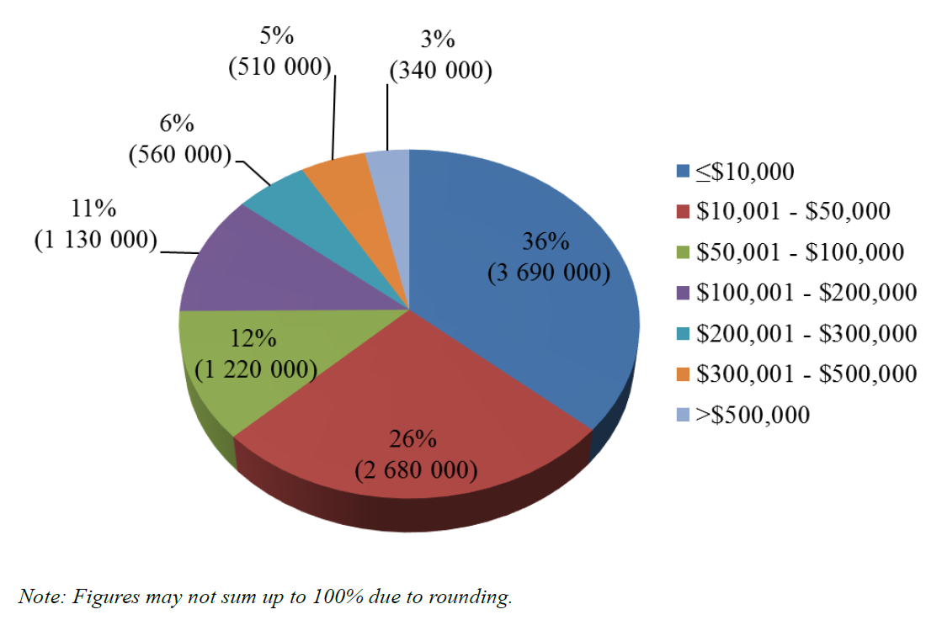
Figure 2: Distribution of Accounts by Range of Accrued Benefits (MPFA, 2020)
In addition to the challenge of insufficient savings for retirement spending, Hong Kong employees also face the longevity risk. Yiu (2021) explains that Hong Kong people has the highest life expectancy in the world with average more than 85 years. Census and Statistics Department, Hong Kong Special Administrative Region (CSD, 2021a) reports that the life expectancies at birth are 82.7 for male and 88.1 for female. For employees at adult ages, the life expectancies will be higher. Figure 3 shows the projected life expectancies of males and females in Hong Kong at selected ages. For example, the life expectancies for male and female at age 40 are 83.6 and 88.8 respectively.
In 1991, the life expectancies at birth for females and males were 80.7 years and 75.2 years respectively. Comparing 1991 and 2020, it can be observed the life expectancy of Hong Kong people is in increasing trend. “Living too long” is one of the most common worries of employees in Hong Kong，if employers can offer more assistance to help employees to prepare better for their retirement, it must be able to reduce the stress levels of employees.
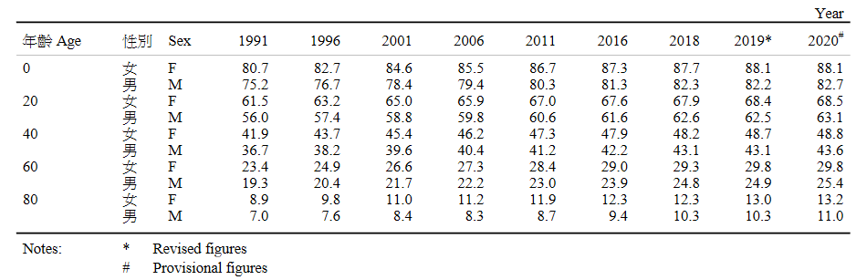
Figure 3: Expectation of life by selected age and sex (CSD, 2021a, p43)
Investor and Financial Education Council (IFEC, 2015) finds that 65% of interviewed working adults felt that they are stressful about their personal financial situations where 26% of them claimed that their work performance were negatively affected. They reported that the financial stress made them difficult to focus at work and some even could not go to work. The same research also reveals that employees are interested to learn financial knowledge at workplace. They have diversified interests in different financial topics, younger working adults wanted to know more on investment products, retirement planning is more welcomed by employees with age over 40 (IFEC, 2015).

Theoretical framework for the program development. There are evidences that workplace financial wellness programs are useful to enhance organization performance in different various aspects (Davidson, 2018, Dupont, 2020). On the other hand, there are also many challenges that workplace financial wellness programs are difficult to implement in organizations (Davidson, 2018, Siciliano, Rizek and Veld, 2019). According to these findings, the strategies to implement workplace financial wellness programs will be impacts on the performance of the programs.
Yu, E. (2021) suggests that 3H framework is developed for holistic management of people, organizations and even nations with framework’s key domains represented by the metaphorical expressions of Heart, Head and Hand.
Necessary and sufficient conditions are required to be fulfilled in holistic management approach (Yu, 2021). Cheung and Yu (2020) explains Heart, Head and Hand separately are the necessary factors for effective organizational performance, however, their integrations and synergies are the sufficient conditions for organizations achieving long term performance. By using 3H framework in program development and implementation, a systematic process can be followed to ensure holistic coverage. 3H is a framework such that different theories and concepts can be used in different H’s.
The 3H framework helps individual and organization to perform effectively and efficiently. Yu (2020, p.10) explains that “effectiveness” is measured by the extent to which the organizational goals or objectives can be achieved, and the identified problems are solved. On the other hand, “efficiency” is about the utilization of resources in getting the required results, such as time, money and number of employees.
First H, Heart Domain. The first H is “Heart”, it aims to encourage employees to commit in achieving organizational goals through the caring of their emotional and motivational issues (Yu, 2020, p.14). As it involves the knowledge and skills to change the attitudes and behaviours of employees, so it is also the most challenging “H” among 3H (Yu, 2020, p.14). If “Heart” strategies cannot be properly implemented, it is expected the final results will not be good (Yu, 2020, p.14). There are many theories related to “Heart”, topics include but not restricted to organizational behaviour, leadership, change management, and communication etc. (Yu, 2020, p.14). In this research, theories of the first H, “Heart”, will be focused on employees’ motivation and communications. No matter how good the workplace financial wellness programs are, it cannot provide any contribution to the organization if employees do not know the benefits to them and participate in the programs. Therefore, understanding suitable strategies to communicate with and motivate employees to participate in the programs are critical in the study.
Maslow’s Hierarchical Theory of Human Needs. Maslow Abraham proposed the human motivational concept “Hierarchy of needs” in 1943 in his article “A Theory of Human Motivation” and now is one of the most influential motivational theories. Conley (2013) describes that there are five levels in the pyramid of hierarchy of needs. The bottom level is physiological needs, then need for safety, in the middle is the social or belonging needs, then self-esteem needs, and at the apex is the self-actualization needs. Lussier, K. (2019) suggests the pyramid of hierarchy of needs is a practical toolkit for explaining human motivations in business and management training, the simple and easy-to-remember pyramid allows managers to follow and identify the different levels of needs that the employees are looking for. Hicks (2018) explains that when employees reach their goals, their needs for esteem are satisfied as they experienced the sense of accomplishment, this will make them more confident in their abilities. If social needs are fulfilled, such as good relationships with working partners, friends and families, employees will have better bonding and trusts with people, it can also enhance the positive outcomes in workplace. Good managers should be good at motivating staff. In addition to money, Stein (2013) opines that employees are also motivated by many different factors, such as recognition, security of employment and personal growth. Stein (2013) suggests some principles for managers to follow so as to boost the motivations of the team, namely offering appropriate incentives and rewards; consistent and clear communications; and be a role model leading by example.
This pyramid of hierarchy of needs can be used to explain human motivations, organizational behaviours and also personal financial needs. Spafford (2015) argues that earning income for spending is the physiological needs of people, getting financial security is about the need for safety, interdependence of people is equivalent to the needs for love and belonging, people at affluent level can achieve the need of esteem, legacy succession is about the need of self-actualization.
Lee and Hanna (2015) associates saving goals and behaviours with the levels in Maslow’s Hierarchy. The lowest level of physiological needs consists of the budgets for basic quality of living and savings are for daily spending, like paying bills, taxes and food. When people are still struggling for the money to pay for the basic daily expenses, they are hard to plan for the future. Working people in this level may concern more on job security and salary increments. In the level of needs for safety, the saving objectives are mainly for financial and physical safety, such as savings for expenses due to unexpected events like accident, illness or unemployment. Buying shelter for family is also in this level. Saving goals in this level include saving for emergency and instalment for buying flat for living. People in this level may want to know more on knowledge and skills in budgeting and cashflow management. Saving for retirement and security is in the third level of needs. In this level, people save for their future goals, like retirement living and additional income for future use. The next level of financial needs is saving for loved ones and the society. Saving goals are for family members, like saving for university education fund for children. Saving for esteem or luxuries is related to the needs for self-esteem. Some individuals believe that certain kind of behaviours may help get recognitions from others. Financially, they may buy some luxury items like expensive cars, jewellery and watches, or live with luxury lifestyles. These behaviours may convey the messages to others that they are more superior in status and others may then respect them. The highest level is saving for self-actualization. This goal level consists of strong desire to achieve one’s personalized values in life. Money may be saved for others, such as making charitable or religious contributions. If for own use, money may be saved for buying businesses or living at a totally different lifestyle.
If Maslow’s “Hierarchy of needs” is used in developing workplace financial wellness programs, it can firstly help categorise employees in accordance with their level of needs, and then appropriate financial concepts and skills can be taught to employees in different level of needs.
“Heart” factor is important but not the only one factor affecting the performance of the workplace financial wellness programs and also the organization performance, another two Hs should also be considered at the same time.
The second H, Head Domain. The second “H” is Head. Yu (2020, p.30) explains it is about HR strategy and corporate planning to achieve set tasks. Company strategies should react to the environmental changes. After more than a year of pandemic, what should the employers do to help their employees reduce their stresses? PwC (2021) suggests four strategies in workplace financial wellness programs. Firstly, as the financial situations of employees in general are worsened, employers should commit to employees that workplace financial wellness programs will be a core element in company wellness programs so that they can get suitable financial advice. Secondly, as the backgrounds of employees vary, they are looking for different financial solutions to meet their personalized needs. Employers can consider offering range of benefits and different compensation packages to meet employees’ needs. At the same time, workplace financial wellness programs should be provided to assist employees to make appropriate financial solutions. Thirdly, personal financial situation is a sensitive issue that employees may not want to disclose to their employers, proper HR process, rules and procedures are required to protect employees’ privacy and dignity. Content and classes of workplace financial wellness programs should also be carefully developed to avoid touching on sensitive issues of employees and more resources may be allocated to support the vulnerable groups. Lastly, more uncertainties have been evolved in current environment, financial wellness programs should have more flexibilities so as to continuously engage the employees. Employers can utilize online tools to educate employees general financial concepts and help them track their spending and savings habits. In the meantime, one-on-one financial coaching benefits may be offered to selected group of employees.
“Head” also involves resources allocation (Yu, 2021, p.10). Nielsen et al. (2017) indicates that there are four levels of workplace resources which can have impacts on employee well-being and organizational performance, namely individual, group, leader and organizational levels. Individual level resources help employees perform in workplace, which are related to personal characteristics or behaviours, resilience and self-efficacy and problem-solving skills are examples of individual level resources. It can be expected that a team with good interactions and mutual supports will have better performance, these qualities are examples of Group level resources. Employers welcome good teamwork because employees can interact positively and contribute their knowledge and talents to make the organization success. Leader level workplace resources are related to leadership style and leaders’ quality, good leaders know the importance of workplace motivation and strategies to support the team to perform. Ability to build trust with people is also important for leaders. Finally, organizational level resources are about how the tasks are decided, implemented and managed. Performance review system, compensation packages and autonomy are examples of organizational level resources.
Nielsen et al. (2017) suggests that all four levels of resources have positive impacts on organization performance and employees’ well-being and multiple levels are recommended.
The third H, Hand Domain. The third “H” is Hand. Yu (2020, p.50) reveals great strategy or plan still needs frontline workforce to implement, so HR managers are in charge of recruiting competent employees or developing employees to be capable to perform in their positions. For the implementation of workplace financial wellness programs, duties of HR managers may be different, they are required to appoint qualified and suitable professionals to conduct the programs.
Verheyen, Kohn, and Diersch (2018) explains that workplace financial wellness programs can be conducted by internal or external business partners. Internal business partners can be colleagues from different departments, but they need to be the experts in the relevant topics. If colleagues from different departments are involved as instructors or program providers, participation rates of the programs may be higher because they are organized by their peers. However, the program content must be carefully designed to avoid any sensitive topics. On the other hand, external business partners should be used to fill the gaps that internal business partners cannot cover and also bring inspiring ideas to employees. No matter by internal staff or external consultants, clear schedule for the programs must be provided.
Integration of the 3H in business management can bring a holistic solution to organizations with the chance of leading to the best organizational performance (Yu, 2020, p.9).
Cheung, H.Y. and Yu, E. (2020) reveals that creating a 3H conducive culture is vital for effective implementation of strategic plans. If employers include 3H framework in their planning in promoting financial wellness to employees, the effects should be much better.

Hypotheses
Building on the 3H framework and Maslow’s Hierarchy of Needs, this study aims to examine the effects of workplace retirement planning program with psychological content on retirement preparation of middle-aged employees. Accordingly, 4 hypothese are formulated.

Hypothesis 1: Higher financial stress of employees is associated with lower organizational performance.

Hypothesis 2: Positive attitudes toward retirement and lower retirement anxiety and stress are associated with more planning behaviours for retirement.

Hypothesis 3: Psychological preparations for retirement can reduce the stress level of middle-aged employees in Hong Kong.

Hypothesis 4: Workplace retirement planning programs developed with 3H framework can encourage the planning behaviours for retirement of middle-aged employees in Hong Kong.

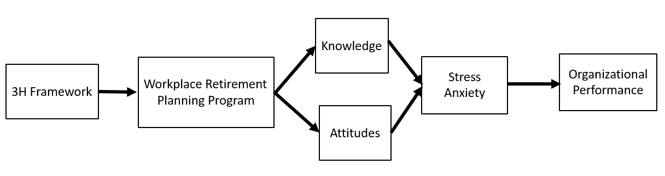
Hypothesized model of the relationships between the variables
Methodology
Sampling and Participants
The study will utilize convenience sampling. Employees aged 40 or above will be invited to participate in the study through different means of recruitment. Some possible ways of recruitment may include but not restricted to posting invitation through social platforms, such as facebook and Moment in Wechat, advertising in online media, and sending invitation letters to different organizations to invite their staff to join.
Workplace retirement planning program with psychological content will be developed for middle-aged employees in this study. The objective of the program is to increase the participants’ retirement preparation and investigate their effects on psychological wellbeing. Through the program, participants will learn both financial and psychological knowledge and skills aiming to develop their positive attitudes and reduce their anxiety level for retirement. Classroom learning, homework assignments and diversified group activities are included in the program to enhance its effectiveness.
Before doing the actual program, a pilot program will first be conducted to ensure the teaching materials would successfully influence the participants’ planning behaviors for retirement. In the program, participants will be randomly assigned to two groups, Intervention Group and Control Group. Participants of Intervention Group will participate in the workplace retirement planning program and the Control Group will participate in financial planning for retirement program which has the same class time as the workplace retirement planning program but concentration on financial planning knowledge only.

Measurements
Pre- and post-tests will be performed to examine whether the program can successfully improve middle-aged employees’ retirement attitudes and planning behaviours, and reduce their anxiety. This study adopts the longitudinal design to measure individual changes in resources, attitudes and anxiety level after the program.
Three waves of assessments will be used in order to capture the changes. Time 1 assessment will be conducted at the beginning of the first module, Time 2 assessment will be conducted immediate after the last module. Time 3 assessment will be conducted three months after Time 2 assessment.
The questionnaire to be used for the pre- and post-test measurements consist of 4 parts which are changes in retirement planning knowledge, behaviours, stress and anxiety, and attitude toward retirement. Basic demographics will be collected, including gender, marital status, education level, age range and monthly average income range. Tables 1 to 3 are the proposed groupings in the demographics to be measured. Age Range in Table 1 follows the categorisation in IFEC (2015). Although this study will focus on middle-aged employees, employees at different age ranges will also invited to participate in the study to get more insights on the effects of the education program to employees at different ages. Categorisation of Education Level include the most common educational backgrounds in Hong Kong.
Census and Statistics Department, Hong Kong Special Administrative Region (CSD, 2017, 2019, 2021b) provide the monthly wage distributions of all employees in Hong Kong in the years 2015 to 2020. Table 3.1 summarizes the monthly wage distributions of all employees in Hong Kong in the years 2015 to 2020 in accordance with the 10th, 25th, 50th, 75th and 90th percentile. The Monthly Average Income Range use approximate values to the wages of the given percentile.

Category | Age Range
1  2  3  4 | 18-29  30-39  40-49  50-64
Table 1 Proposed Age Range in the questionnaires

Category | Highest Education Level Attained
1  2  3  4  5 | Below Secondary School  Secondary School  Associate Degree / Higher Diploma  Bachelor Degree  Master Degree or above
Table 2 Proposed Education Level in the questionnaire

Category | Monthly Average Income Range
1  2  3  4  5 | Less than $10,000  $10,001 to $15,000  $15,001 to $30,000  $30,001 to $50,000  More than $50,000
Table 3 Proposed Income Range in the questionnaire

Monthly wage distribution (HK$): all employees | May - June 2020 | May - June 2019 | May - June 2018 | May - June 2017 | May - June 2016 | May - June 2015
10th percentile | 9,600 | 10,000 | 9,900 | 9,500 | 9,000 | 8,500
25th percentile | 13,200 | 13,100 | 12,600 | 12,100 | 11,600 | 11,000
50th percentile | 18,400 | 18,200 | 17,500 | 16,800 | 16,200 | 15,500
75th percentile | 28,800 | 28,200 | 27,300 | 26,300 | 25,400 | 24,400
90th percentile | 45,300 | 44,600 | 43,300 | 42,400 | 40,900 | 39,400
Table 3.1 Monthly wage distribution of all employees in Hong Kong in 2015 to 2020 (CSD, 2017, 2019, 2021b).

The questionnaire will be a combination of four scales. Table 4 indicates the scales proposed to be used.
Variables to be measured | Measures / Instruments
Changes in financial knowledge for retirement | Scale for retirement planning knowledge
Changes in retirement planning behaviours | Retirement Planning Activity Scale
Changes in stress and anxiety levels | Scales for anxiety and stress of Depression, Anxiety and Stress Scale - 21 Items (DASS-21)
Changes in attitude toward Retirement | Attitudes toward retirement Scale
Table 4: Proposed scales for different variables measurement

Scale for retirement planning knowledge
Jacobs-Lawson and Hershey (2005) uses the scale to measures 3 areas on retirement planning knowledge, namely financial planning for retirement, financial risk tolerance and investing for retirement, and retirement savings. All items use a seven-point response format (1 _ strongly disagree, 7_ strongly agree).
Part 1: Knowledge of financial planning for retirement
1. I am very knowledgeable about financial planning for retirement.
2. I know more than most people about retirement planning.
3. I am very confident in my ability to do retirement planning.
4. When I have a need for financial services, I know exactly where to obtain information on what to do.
5. I am knowledgeable about how Social Security works.
6. I am knowledgeable about how private investment plans work.
Part 2: Financial risk tolerance and investing for retirement
1. I am willing to risk financial losses.
2. I prefer investments that have higher returns even though they are riskier.
3. The overall growth potential of a retirement investment is more important than the
level of risk of the investment.
4. I am very willing to make risky investments to ensure financial stability in retirement.
5. As a rule, I would never choose the safest investment when planning for retirement.
Part 3: Retirement saving
1. Made meaningful contributions to a voluntary retirement savings plan.
2. Relative to my peers, I have saved a great deal for retirement.
3. Accumulated substantial savings for retirement.
4. Made a conscious effort to save for retirement.
5. Based on how I plan to live my life in retirement, I have saved accordingly.

Retirement Planning Activity Scale
This 10-item scale is designed to tap the frequency of both information seeking and instrumental planning activities that have occurred during the preceding 12 months.
​Hershey et al. (2007) designs this 10-item scale to measure the retirement planning activities during the preceding 12 months. It uses the seven Likert-type response format (1 = strongly disagree; 7 = strongly agree), participants are asked to indicate the extent to which they agree or disagree with each of the following statements.​
1. Frequently read articles/brochures on investing or financial planning.
2. Read one or more books on investing or financial planning.
3. Frequently visited financial planning sites on the World Wide Web.
4. Gathered or organized your financial records.
5. Regularly tuned into television/radio shows on investing or financial planning.
6. Conducted a thorough assessment of your net worth.
7. Identified specific spending plans for the future.
8. Discussed financial planning goals with a professional(s) in the field.
9. Discussed financial retirement plans with an employer’s benefits specialist.
10. Discussed retirement plans with a knowledgeable friend or acquaintance.

Scale for Anxiety and Stress
Part of the questions in the Depression, Anxiety and Stress Scale - 21 Items (DASS-21) are used as the scale to measure the levels of anxiety and stress of participants. DASS-21 has three self-report scales to measure the emotional states of depression, anxiety and stress, each scale contains 7 items, only scales measuring anxiety and stress are used in the study. Chan et al. (2021) uses the scale to assess any symptoms of anxiety.
Please read each statement and circle a number 0, 1, 2 or 3 which indicates how much the statement applied to you over the past week. There are no right or wrong answers. Do not spend too much time on any statement.
The rating scale is as follows:
- Did not apply to me at all
- Applied to me to some degree, or some of the time
- Applied to me to a considerable degree or a good part of time
- Applied to me very much or most of the time
(I) Questions measuring anxiety level
- I was aware of dryness of my mouth
- I experienced breathing difficulty (e.g. excessively rapid breathing, breathlessness in the absence of physical exertion)
- I experienced trembling (e.g. in the hands)
- I was worried about situations in which I might panic and make a fool of myself
- I felt I was close to panic
- I was aware of the action of my heart in the absence of physical exertion (e.g. sense of heart rate increase, heart missing a beat)
- I felt scared without any good reason
(II) Questions measuring stress level
- I found it hard to wind down
- I tended to over-react to situations
- I felt that I was using a lot of nervous energy
- I found myself getting agitated
- I found it difficult to relax
- I was intolerant of anything that kept me from getting on with what I was doing
- I felt that I was rather touchy

Attitudes toward retirement Scale
Attitudes toward retirement will be measured by the scale developed by Glamser (1976). It is a five-item Likert with five possible responses each (1=strongly disagree to 5=strongly agree). The final score of participants will be calculated, which is ranged from 5 to 25, with higher scores indicating more positive attitudes toward retirement.
Items in the scale:
- Retirement is mostly good for a person;
- I think that things will go well for me in retirement;
- It is not fair to make a person retire because of his age;
- I am looking forward to the time off that retirement will bring;
- If it were up to me alone, I would keep on working as long as possible.

Other features relevant to the study
Due to time constraint, the workplace retirement planning program with 3H framework has not yet completed, however the scales proposed indicates the content will be focused on three key areas which are psychological perspective, from both the angles of employers and employees; planning perspective, structure and procedure to achieve retirement satisfaction; and individual perspective, competence of individual in managing retirement assets.

References

Census and Statistics Department, Hong Kong Special Administrative Region, 2021a. Women and Men in Hong Kong – Key Statistics, 2021 Edition [pdf] Available at: <https://www.censtatd.gov.hk/en/data/stat_report/product/B1130303/att/B11303032021AN21B0100.pdf> [Accessed 11 August 2021].
Census and Statistics Department, Hong Kong Special Administrative Region, 2021b. 2020 Report on Annual Earnings and Hours Survey [pdf] Available at: <https://www.censtatd.gov.hk/en/data/stat_report/product/B1050014/att/B10500142020AN20B0100.pdf > [Accessed 16 August 2021].
Census and Statistics Department, Hong Kong Special Administrative Region, 2019. 2018 Report on Annual Earnings and Hours Survey [pdf] Available at: <https://www.censtatd.gov.hk/en/data/stat_report/product/B1050014/att/B10500142018AN18B0100.pdf> [Accessed 16 August 2021].
Census and Statistics Department, Hong Kong Special Administrative Region, 2017. 2016 Report on Annual Earnings and Hours Survey [pdf] Available at: <https://www.censtatd.gov.hk/en/data/stat_report/product/B1050014/att/B10500142016AN16B0100.pdf> [Accessed 16 August 2021].
Chan, S., Au-Yeung, T., Wong, H. et al. (2021). Long Working Hours, Precarious Employment and Anxiety Symptoms Among Working Chinese Population in Hong Kong. Psychiatr Q (2021). doi: 10.1007/s11126-021-09938-3
Cheung, H.Y. and Yu, E. (2020). A review of the strategic planning process in the Hong Kong Police Force. Public Administration and Policy: An Asia-Pacific Journal, 23(3), pp. 245–258. doi: 10.1108/PAP-06-2020-0027.
Chung, R. Y., and Sir M. Marmot. (2020). People in Hong Kong have the longest life expectancy in the world: Some possible explanations. NAM Perspectives. Commentary, National Academy of Medicine, Washington, DC. https://doi.org/10.31478/202001.
Conley, C. (2013) ‘LEADERSHIP’, Leader to Leader, 2013(67), pp. 30–35. doi: 10.1002/ltl.20059.
Davidson, L. (2018) ‘What’s Working (and What’s Not Working) in Financial Wellness Programs’, Benefits Magazine, 55(9), pp. 22–28.
Dupont, D. (2020) ‘FINANCIAL wellness IN THE WORKPLACE’, LIMRA’s MarketFacts Quarterly, (3), pp. 31–35.
Glamser, F. D. (1976). Determinants of a positive attitude toward retirement. Journal of Gerontology, 31, 104-107.
Hershey, D. A., Jacobs-Lawson, J. M., McArdle, J. J., & Hamagami, A. (2007). Psychological foundations of financial planning for retirement. Journal of Adult Development, 14, 26-36. doi: 10.1007/s10804-007-9028-1
Hicks, R. (2018) ‘Coach’s Corner: Modern Thinking, in Tune with the Basics’, Physician Leadership Journal, 5(3), pp. 62–64. Available at: http://search.ebscohost.com/login.aspx?direct=true&db=bth&AN=129151397&site=ehost-live (Accessed: 12 August 2021).
Siciliano, V., Rizek, B. and Veld, D. (2019) ‘Financial Wellness in the Workplace: Getting Back to the Basics’, Plans & Trusts, 37(6), pp. 16–21.
Wernette, G. J. (2019) ‘Developing Workplace Financial Wellness Programs’, Benefits Magazine, 56(2), pp. 42–46.
Investor and Financial Education Council, 2015. IFEC Segment Research – Working Adults[pdf] Available at: <https://www.ifec.org.hk/common/pdf/about_iec/iec-segment-research-working-adults-2015.pdf> [Accessed 11 August 2021].
Institute of Financial Planners of Hong Kong, 2021. Press release of “Hong Kong Retirees’ Actual Expenses Survey” [pdf] Available at: <http://www.ifphk.org/pdf/press_release/PR20210413_en.pdf> [Accessed 11 August 2021].

Jacobs-Lawson, J. M. and Hershey, D. A. (2005) ‘Influence of future time perspective, financial knowledge, and financial risk tolerance no retirement saving behaviors’, Financial Services Review, 14(4), pp. 331–344. Available at: http://search.ebscohost.com/login.aspx?direct=true&db=bth&AN=19521128&site=ehost-live (Accessed: 16 August 2021).
Lee, G., & Choi, M., (2019). Hong Kong millennials want to retire earlier on lower savings, but their maths may fail, JPMorgan survey shows. South China Morning Post, [online] 17 December. Available at: https://www.scmp.com/business/money/wealth/article/3042336/hong-kong-millennials-want-retire-earlier-lower-savings-their [Accessed 11 August 2021].
Lee, J. M. & Hanna, S. D. (2015). Savings Goals and Saving Behavior From a Perspective of Maslow’s Hierarchy of Needs. Journal of Financial Counseling and Planning, 26(2), 129–147.
Lussier, K. (2019) ‘Of Maslow, motives, and managers: The hierarchy of needs in American business, 1960–1985’, Journal of the History of the Behavioral Sciences, 55(4), pp. 319–341. doi: 10.1002/jhbs.21992.
Nielsen, K., Nielsen, M.B., Ogbonnaya, C., Känsälä, M., Saari, E., and Isaksson, K., (2017). Workplace resources to improve both employee well-being and performance: A systematic review and meta-analysis, Work & Stress, 31:2, 101-120, DOI:10.1080/02678373.2017.1304463.

PwC, 2021. 2021 PwC Employee Financial Wellness Survey, [online]. Available at: <https://www.pwc.com/us/en/services/consulting/workforce-of-the-future/library/employee-financial-wellness-survey.html> [Accessed 12 August 2021].
Mandatory Provident Fund Schemes Authority, 2020. Statistical Analysis of Accrued Benefits Held by Scheme Members of Mandatory Provident Fund Schemes. [pdf] Available at: <https://www.mpfa.org.hk/en/-/media/mpfa/files/research-report-eng/statistical_analysis_of_accrued_benefits_held_by_scheme_members_2020.pdf> [Accessed 11 August 2021].
Mandatory Provident Fund Schemes Authority, 2021a. MPF System Withdrawal of MPF. Available at: < https://www.mpfa.org.hk/en/mpf-system/withdrawal-of-mpf/withdrawal-of-mpf-upon-retirement > [Accessed 11 August 2021].
Mandatory Provident Fund Schemes Authority, 2021b. Mandatory Provident Fund Schemes Statistical Digest, March 2021. [pdf] Available at: < https://www.mpfa.org.hk/en/-/media/mpfa/files/pdf/tab-8/march_2021_issue.pdf> [Accessed 11 August 2021].

Randstad Hong Kong Limited, 2021a. hongkongers want attractive salary and benefits. Available at:<https://www.randstad.com.hk/hr-trends/employer-brand/hongkongers-want-attractive-salary-benefits/>[Accessed 10 August 2021].

Randstad Hong Kong Limited, 2021b. why employee financial wellness is important to your talent strategy. Available at:＜https://www.randstad.com.hk/hr-trends/employer-brand/why-employee-financial-wellness-is-important/＞[Accessed 11 August 2021].

Siu, O., 2020. LU study finds work stress costs Hong Kong HK$14.9 billion a year. Lingnan Touch, [online] January. Available at:＜https://www.ln.edu.hk/lingnan-touch/99/lu-study-finds-work-stress-costs-hong-kong-hkusd14-9-billion-a-year＞[Accessed 11 August 2021].
Siu, O. L., Cooper, C. L., Roll, L. C., & Lo, C. (2020). Occupational Stress and Its Economic Cost in Hong Kong: The Role of Positive Emotions. International journal of environmental research and public health, 17(22), 8601. https://doi.org/10.3390/ijerph17228601.
Spafford, K. (2015) ‘Succession starts with your personal financial security’, Southeast Farm Press, 42(24), p. 12. Available at:<http://search.ebscohost.com/login.aspx?direct=true&db=bth&AN=110563108&site=ehost-live> (Accessed: 12 August 2021).
Stein, N. (2013) ‘Motivation matters’, Horticulture Week, p. 23. Available at: <http://search.ebscohost.com/login.aspx?direct=true&db=bth&AN=90308366&site=ehost-live> (Accessed: 12 August 2021).
Verheyen, T., Kohn, T. and Diersch, B. (2018) ‘A Practical Guide to Workplace Financial Wellness Considerations, Assessment, and Implementation’, Journal of Pension Planning & Compliance, 44(1), pp. 78–90. Available at: <http://search.ebscohost.com/login.aspx?direct=true&db=bth&AN=127768364&site=ehost-live> (Accessed: 12 August 2021).
Yiu, E (2021). Pension Shortfalls Keep 9 Out Of 10 Middle-income Hong Kong Residents Toiling. South China Morning Post, [online] 05 July. Available at:＜ https://www.scmp.com/business/banking-finance/article/3139893/nine-out-10-middle-income-hongkongers-aged-over-50-have-no?＞[Accessed 11 August 2021].
Yu, E. (2020), “Seminar Day 1: Visions for the Future: Theoretical Perspectives on Management”, Lecture notes, BM7006, University of Wales – Trinity Saint David, delivered 19th and 20th June.
Yu, E. (2021). An analysis of China’s strategy in combating the coronavirus pandemic with the 3H framework. Public Administration and Policy: An Asia-Pacific Journal, 24(1), pp. 76–91. doi: 10.1108/PAP-12-2020-0055.

