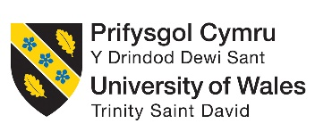
The Savoy Hotel: Greener Practices and Sustainability Gaps

Assignment 2: Written Report

Module: Sustainable Hospitality & Tourism Management
Module Code: BMIH5006
Lecturer: Lisa-Marie Bassler

Student Name: Alexandra Viorela Gjoka
Student ID: 2224325

AI Acknowledgement Statement

I declare that I have not incorporated any AI tools in executing and writing this assignment. I did not submit any materials that have been generated by artificial intelligence as my own work. I acknowledge that I have copies of my drafts, notes, other referenced resources used by me.

Table of Content
Executive Summary: 3
Introduction: 4
Current Sustainability Initiatives at The Savoy: 5
Energy Efficiency: 5
Waste Management: 5
Water Conservation: 6
Identifying the Sustainability Gap: Single-Use Plastics 6
Proposed Solution: Introduction of Biodegradable and Reusable Alternatives 7
What the Initiative Entails: 7
Benefits for Sustainability: 8
Challenges and Considerations: 8
Benefits for The Savoy and the Environment: 8
Environmental Impact: 8
Operational Efficiency: 9
Brand Reputation: 9
Conclusion and Recommendations: 9
Reference List: 11

Executive Summary:

This report is a case study about The Savoy Hotel's sustainability campaigns in London, one of the UK's reputable luxury hotels. The hotel works on this through energy efficiency, waste management and water conservation, among other areas of sustainability. On the other hand, it still leaves a big cave in its application of disposable plastic goods that are not biodegradable; hence, scorching plastics remain. In response, the report recommends making biodegradable and various Toiletries available and replacing them with reuse alternatives like Bamboo toiletries & refillable soap dispensers to mitigate the environmental impacts. This initiative could also drastically reduce plastic waste, create better sustainability credentials and enhance its reputation as a leader in environmental performance. The potential difficulties for such changeover, like the immediate investments demanded to develop biodegradable products and how one must adapt to its supply chain, are also discussed in the report. With its combination of environmentally friendly benefits and guest perception, the initiative presents an appealing option to help The Savoy meet their sustainability goals positively.

Introduction:

In strengthening the hospitality industry, greener practices are important to save on cost and have a long-term approach. It is characterised by practices and techniques such as energy conservation, waste reduction or the employment of sustainable materials, which are intended to ensure a hotel operation with a limited carbon footprint and minimum consumption of resources. The Savoy Hotel is an established luxury hotel in the UK which has already put considerable effort into embedding sustainability throughout its operations (The Savoy, 2024). Adopting state-of-the-art technology, implementing comprehensive waste management schemes, and water-saving techniques, among many others, sustainability (Sloan, Legrand and Chen 2017).
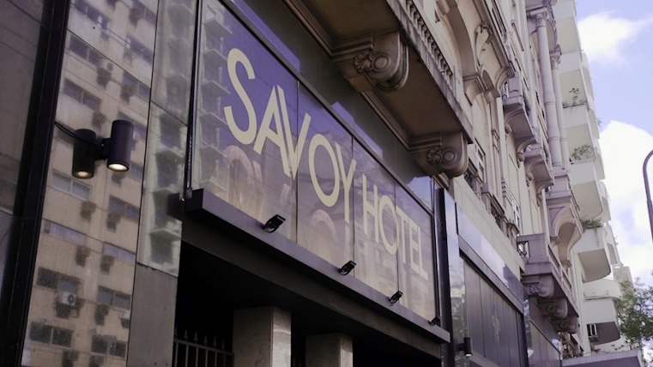
Figure 1: The Savoy Hotel (The Savoy, 2024).
But, while this is a great outcome, there are further opportunities for improvement, especially in single-use plastics, which remain an issue for many hotels worldwide. But, that goal is intended to reduce the plastic waste problem created by single-use items like toiletries and water bottles. In this report, I will be looking at introducing biodegradable alternatives, as well as reusable for example, eco-friendly toiletries and installed water refill stations to aid The Savoy in closing that sustainability gap (The Savoy, 2024). Consequently, The Savoy will be able to improve its eco-credentials and reflect the current sustainability zeitgeist on an international scale whilst maintaining a position as an innovative luxury hospitality leader committed to sustainable operations.

Current Sustainability Initiatives at The Savoy:

One of London's most venerable luxury hotels, The Savoy Hotel is a clear leader in sustainability for other high-end properties; larger environmental players have also noted.

Energy Efficiency:

The Savoy has slashed its carbon emissions by installing cutting-edge energy management systems. These have ideal applications in energy-efficient LED lighting and HVAC (heating, ventilation & air conditioning) systems for higher productivity (The Savoy, 2018). Intelligent controls are integrated to use energy only when necessary to optimise the energy obligations through optimizedotel usage. Integrating all these systems has made The Savoy reduce its energy consumption by a wide margin in terms of sustainable best practices within the industry (Sloan, Legrand & Chen 2017). This helps not only to lower the operational costs but also leads towards declining carbon footprints, which are pivotal when it comes to climate change.

Waste Management:

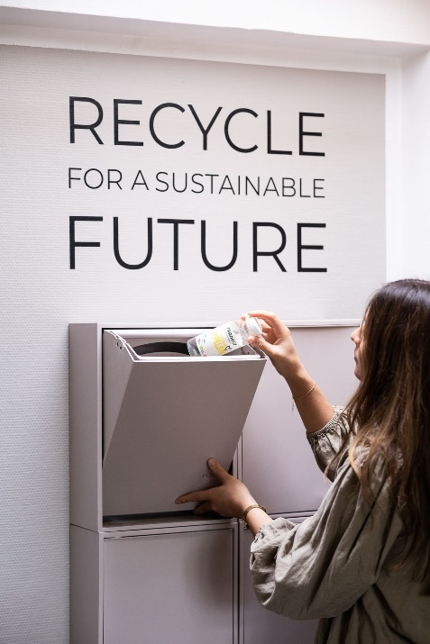
Figure: SUSTAINABILITY in Savoy (savoyhotel, 2023)
They have also sought to be responsible community members by maintaining a zero-waste-to-landfill status in operations, even before the new rule. The hotel is engaged in a wide recycling campaign concerning the sorting and recovering of waste materials such as glass, aluminium or paper. Beyond traditional recycling, The Savoy is organising and donating all organic waste, meaning food scraps and other biodegradable materials are being treated responsibly (DitchCarbon, 2024). This is only part of the initiative; it also leads to less waste going into landfills and helps produce compost, which farmers can utilise.

Water Conservation:

Another major focus for The Savoy's sustainability strategy is water conservation. The hotel also has low-flow showerheads and faucets, saving on water (Paquette, 2020). Moreover, it enables information on advanced water management systems. Hence, there is potential to monitor how much water is consumed in nearly all areas of a hotel's operation and where and when efficient usage can be achieved (Cooper, 2021). These initiatives go a long way to decrease the water footprint of the hotel in general, which is critical for urban sites as water supplies are dwindling.
The Savoy monitors its environmental preservation in these three areas and upholds the luxury hospitality industry. It is a prime example to other businesses of how waste can be minimised following minimised time.

Identifying the Sustainability Gap: Single-Use Plastics

Notably, in amenity items for guests, which include toiletries, bottled water and packaging The Savoy Hotel continues to create a big environmental problem with the discretion of single-use plastic. This creates significant plastic waste from single-use plastics that go against the hotel's promise to lower its carbon footprint. Establishing an international agreement to address plastic pollution directly reflects the actions taken by countries such as Europe and Australia that have partially implemented bans or restrictions on disposables (Tudor and Williams, 2021). Eco-friendly hotels have mainly moved toward biodegradable or reusable options, and the shift has a trickle-down effect on the industry. More widely, this is a fundamental step towards honouring guests increasing environmental expectations and bolstering the hotel's position as one of London's most sustainable luxury properties. Ceasing all use of single-use plastics could help The Savoy cut its contributions to plastic waste and increase resource conservation, hopefully also setting an example in the hospitality industry for more sustainable practices (Haski-Leventhal 2018).

Proposed Solution: Introduction of Biodegradable and Reusable Alternatives

Swap plastic toiletries with biodegradable or long-life products at The Savoy Hotel. Through this service, the hotel strives to lessen plastic waste production by offering a sustainable way for customers to consume their products.

What the Initiative Entails:

The Savoy could become eco-friendly by swapping a single-use plastic product like toiletries for biodegradable versions (Moshood et al., 2022). For example, instead of plastic toothbrushes, the hotel can offer guests to use bamboo, which is 100% compostable. This also can involve the provision of refillable soap dispensers, which would entirely replace single-use plastic soap containers, resulting in an enormous reduction in plastic waste from guest amenities. Moreover, suppose it is convenient for The Savoy to replace plastic bottles with reusable glass water bottles (Moshood et al., 2022). In that case, it improves the hotel's wasteful relationship towards plastics and aims to have a strong, sustainable position. Not only would this be a boon to the environment, but it would also align itself as one of the leaders in luxury sustainability.
Some other luxury hotels have already engaged in similar initiatives quite successfully. In addition, The Langham and Claridge's two hotels famous for their high-end service level—have swapped out the single-use plastic mini-toiletries with biodegradable options and glass water bottles. These hotels exemplify a few of the many ways to make changes that will not detract from the guest experience and are feasible. By utilising these exams, Savoy will be ready to ensure that efficient alternatives are biodegradable and reusable (Inkson & Minnaert, 2018).

Benefits for Sustainability:

This move is not only better for the environment; it will also have a big impact. The conversion over to biodegradable toiletries and ending single-use plastic bottles will dramatically tackle The Savoy's waste problem, helping them and compatibility promote a greener hotel operation. Biodegradable materials decompose naturally and do not leave harmful residues, making them a more sustainable option than plastic. In addition, this builds on the increasing demand from environmentally friendly customers that luxury properties should become more sustainable (Wickham et al., 2021). This will solidify their image as a progressive hotel regarding sustainability efforts.

Challenges and Considerations:

Though there is a benefit to doing so, this move costs too. One of the main barriers is the more expensive front buy-in for disposable and compostable options (Hughes, 2020). Biodegradable toiletries can be pricey compared to their plastic counterparts, whilst switching over from reusable glass bottles involves other changes around logistics flows (like renovating supplier contracts and amenities). In addition, these products will require training for hospital staff. Yet, compared to the costs and work of setting up, overall financials and environmental perks are anticipated to mirror the drawbacks (Costa & Costa, 2022).

Benefits for The Savoy and the Environment:

Environmental Impact:

The use of biodegradable products and reusable alternatives at The Savoy will translate to a major reduction in plastic waste produced by the hotel, which is directly aligned with global efforts underway to address concerns over single-use plastics' impact on our environment (Mazhandu et al., 2020). For years, single-use plastics have significantly contributed to environmental degradation, especially in the world's oceans, where they wreak havoc on marine life and ecosystems. The Savoy can then demonstrate what could be translated to another luxury hotel by reducing its use of those materials (Pekdemir, 2021). In addition, embracing sustainable materials such as bamboo and refillable dispensers will complement Savoy's environmental ethos, making it one of the sector leaders in hospitality when considering eco-issues. Today's guests are more aware of environmental issues, and promoting their eco-friendly products can attract this fast-growing environmentally attentive segment of travellers (Batabyal, 2018).

Operational Efficiency:

Biodegradable and recyclable items use fewer resources and reduce waste, which, besides having environmental benefits, can translate into long-term operational efficiencies (Moshood et al., 2022). While upfront costs may be significant, there is potential to have positive returns on the cost associated with tipping and operational efficiencies over time. This would ultimately save The Savoy money, as its bulk buying per sustainable alternative is unnecessary to replenish single-use plastics widely. In addition, less plastic decreases waste to be managed, which can help hotels in their operations and lower the hotel's environmental footprint (Sustainable Tourism: Breakthroughs in Research and Practice, 2019).

Brand Reputation:

It will also help with The Savoy's brand reputation to commit to being a sustainable leader (Moshood et al., 2022). By implementing greener practices, the hotel can improve its standing as a responsible luxury brand and attract a growing pool of eco-conscious consumers. Not only will this appeal to guests concerned with the environment, but it can also be an easy way to keep customers coming back and choosing you as their host in the future (Edgell 2020); a crucial part of hospitality is retention after acquisition.

Conclusion and Recommendations:

The Savoy Hotel has had paramount success in creating an ethos that applies to all forms of sustainability, particularly those concerning energy usage, waste management, and water efficiency. The success of these initiatives has established the hotel as the best for luxury sustainable tourism. Yet another critical gap is the usage of single-use plastics, which makes it problematic to meet the hotel's holistic environmental goals. The Savoy can reduce plastic usage using biodegradable and reusable replacements, like eco-friendly toiletries or glass water bottles.
It is a global sustainability trend that aligns with the eco-conscious hospitality consumers, and perhaps it was coming because of the increasing demand from both guests to stay green. While these changes can be enormous, they will provide little expense compared to environmental and operational returns. Making the transition would lower the cost of maintaining and operating waste management and help increase certain ecological facts from the hotel by attracting socially-minded visitors. The above should be implemented in phases. The Savoy will want to start with pilot programs by geographical sections, scaling up only if feedback from guests is positive and supportable, given revised operational guidance. This graduated approach enables the hotel to monitor and assess how well this initiative is performing so any needed refinements can occur.

Reference List:

Batabyal, A. (2018) Managing Sustainable Tourism Resources. IGI Global.
Cooper, C. (2021) Essentials of tourism. 3rd edn. London: SAGE.
Costa, C. and Costa, C. (2022) Sustainability and competitiveness in the hospitality industry. Business Science Reference.
DitchCarbon. (2024) Savoy Trust Sustainability Report Insights. [online] Available at: https://ditchcarbon.com/r/savoy-trust-sustainability-report-insights/ [Accessed 15 Oct. 2024].
Edgell, D. L. (2020) Managing sustainable tourism: a legacy for the future. 3rd edn. London: Routledge.
Haski-Leventhal, D. (2018) Strategic corporate social responsibility: tools & theories for responsible management. London: SAGE.
Hughes, A. (2020) Plastic-free UCC: exploring societal and marketing levers. [online] cora.ucc.ie. Available at: https://cora.ucc.ie/handle/10468/11852 [Accessed 15 Oct. 2024].
Inkson, C. and Minnaert, L. (2018) Tourism management: an introduction. 2nd edn. London: SAGE.
Korstanje, M. E., George, B. and Nedelea, A. (2020) Strategies for promoting sustainable hospitality and tourism services. IGI Global.
Management Association (2018) Sustainable tourism. IGI Global.
Mazhandu, Z.S., Muzenda, E., Mamvura, T.A., Belaid, M. and Nhubu, T. (2020) ‘Integrated and Consolidated Review of Plastic Waste Management and Bio-Based Biodegradable Plastics: Challenges and Opportunities’, Sustainability, 12(20), p.8360. doi: https://doi.org/10.3390/su12208360.
Moshood, T.D., Nawanir, G., Mahmud, F., Mohamad, F., Ahmad, M.H. and AbdulGhani, A. (2022) ‘Sustainability of biodegradable plastics: New problem or solution to solve the global plastic pollution?’, Current Research in Green and Sustainable Chemistry, 5(100273), p.100273. doi: https://doi.org/10.1016/j.crgsc.2022.100273.
Paquette, J. (2020) ‘France and the restitution of cultural goods: the Sarr-Savoy report and its reception’, Cultural Trends, 29(4), pp.302–316. doi: https://doi.org/10.1080/09548963.2020.1819773.
Pekdemir, S. (2021) Development of sustainable cities by using circular economy: Circular cities. [online] webthesis.biblio.polito.it. Available at: https://webthesis.biblio.polito.it/21048/ [Accessed 15 Oct. 2024].
savoyhotel. (2023) Savoy hotel / sustainableinfo. [online] Available at: https://savoyhotel.dk/sustainability/ [Accessed 15 Oct. 2024].
Sloan, P., Legrand, W. and Chen, J. S. (2017) Sustainability in the hospitality industry: principles of sustainable operations. 3rd edn. London: Butterworth-Heinemann.
Sustainable Tourism: Breakthroughs in Research and Practice (2019) IGI Global.
The Savoy (2018) Iniciativas sostenibles del hotel | The Savoy. [online] The Savoy London. Available at: https://www.thesavoylondon.com/about-us/sustainability-initiatives/ [Accessed 15 Oct. 2024].
The Savoy (2024) The Savoy London. [online] The Savoy London. Available at: https://www.thesavoylondon.com/ [Accessed 15 Oct. 2024].
Tudor, D.T. and Williams, A.T. (2021) ‘The effectiveness of legislative and voluntary strategies to prevent ocean plastic pollution: Lessons from the UK and South Pacific’, Marine Pollution Bulletin, 172, p.112778. doi: https://doi.org/10.1016/j.marpolbul.2021.112778.
Wickham, T., Donnelly, T. and French, L. (2021) ‘Strategic sustainability management in the event sector’, Event Management, 25(3), pp. 279–296.

