

STUDENT NAME: MARIAN LEBA
STUDENT ID:2313869
MODULE CODE:LCBB5013
NAME LECTURER:FOUZIYA FARHEEN
TASK 1- BUSINESS PLAN DEVELOPMENT (ELEMENTS 1-4)

Table of Contents
Element 1: Business Idea, Products/Services, Objectives, and Unique Selling Point (USP) 3
Element 2: Business Environment and Competitor Analysis 5
Element 3: Marketing Mix (4Ps), Market Segmentation, and Marketing Strategies 8
The Marketing Mix: Application of the 4Ps 9
Element 4: Legal, Management, and Financial Planning 11
Legal Structure of the Proposed Business 12
Organisational Structure and Management 13
Start-Up Funding Requirements and Sources of Funding 14
Conclusion 14
References (Harvard Style) 15

BUSINESS IDEA – HOME-BASED ORGANIC FOOD PRODUCTS
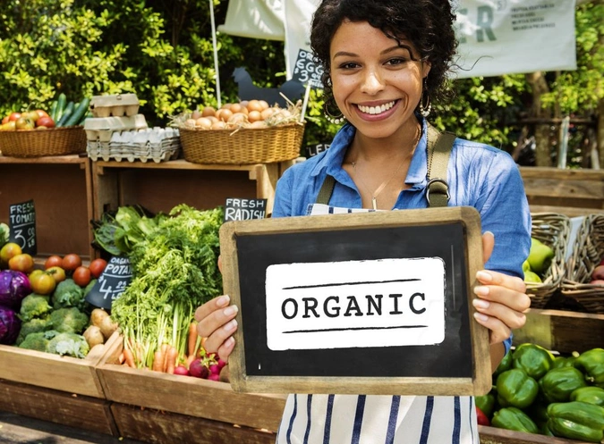

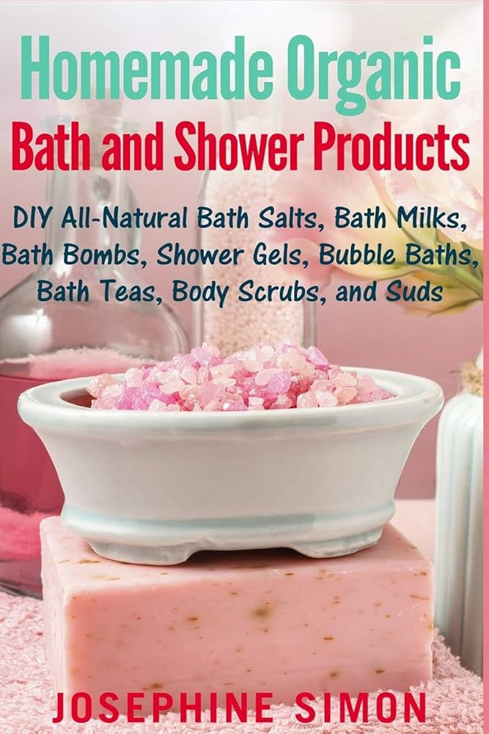

Element 1: Business Idea, Products/Services, Objectives, and Unique Selling Point (USP)

Business Idea Overview
The business proposal is for a home-based, organic food products business that produces natural, preservative-free food. The company supports the growing market for healthier, safer, clean, and more sustainable food. Over time, consumers have become increasingly sensitive to adverse health effects caused by highly processed foods, artificial additives, and chemical preservatives, and consequently there is a rapid demand to purchase organic and homemade foods (Kotler & Keller, 2016). In its first stage, the company will function as a smaller operation and will run on a home-based production model that will facilitate flexibility, cost efficiency, and direct control over product quality. Using traditional cooking styles with contemporary aspects of food safety and hygiene standards, the business aims to produce authentic and reliable food. It’s going to be for the health-conscious consumer, the family, the single person who needs clean-label food for a healthy living. The business will be distributed direct-to-consumer using social media channels, local markets, and local community contacts. It reduces intermediaries’ dependence and costs, fosters better relationships with customers, and is key to the growth of a small business and builds brand trust (Scarborough, 2018).


Products and Services

The business is going to only sell a limited selection of organic, homemade foods not a large product range. Core product categories are organic spice blends, traditional pickles, sauces, chutneys as well as some dry food items. All products will be produced from top-quality, organically sourced ingredients and continue using traditional recipes to keep it fresh, nutritious, and full of flavour. Production will take place in small batches with proper freshness and consistency as well as strict quality control. Small-batch production also allows the business to know and adjust quickly to feedback from customers regarding recipes or quantities as needed. Remarkably, no artificial preservatives, colours, or flavor enhancers will be used, which is in line with the consumer's demand for natural products (Magnusson et al., 2017). Alongside physical production, the business will provide value-added options of the customer in the form of tailored orders determined by dietary preferences that may include low-sodium or spice-adjusted options. Clear product labelling and an honest description as to where they got their ingredients and methods from can only increase trust. These include products that help to differentiate, as well as enhance customer loyalty in a competitive food market.
Business Objectives
Business aims are developed in both the short and long term, and both operational stability and sustainable growth are guaranteed. In terms of short-term targets (0–2 years), the goals are to make the business a legitimate home-based food enterprise by complying with local food safety and hygiene regulations. Another big goal is to establish a recognised brand identity of organic, authentic, and trustworthy. In this phase, the business will strive for steady monthly sales via direct-to-consumer channels and gain consistent customer relationships through proven product quality and exceptional customer service. Customer feedback will also take place as this will be of utmost importance to informing product improvements and any further development. This objective resonates with early-stage business strategies focused on market entry, customer acquisition, and operational learning (Burns, 2016). Long-term goals in terms of 3–5 years are business expansion and market positioning. These include growing manufacturing scale and production capacity whilst still maintaining organic standards, entering new product development/new product lines based on consumer demand, and extending its business network through partnerships with local retailers or online marketplaces. The key focus is for the organization to position itself as a trusted brand within the organic food sector, known for quality, transparency, and customer-centric practices.
Unique Selling Point (USP)
The USP of the business in this niche is authentic homemade production combined with a strong health and transparency focus. Whereas mass-produced food brands prioritize scale and cost efficiency, this industry value is all about quality, freshness, and traditional preparation. When considering food safety and long-term health risks, the use of organic ingredients together with the absence of artificial preservatives directly responds to the changing consumer concerns (World Health Organization, 2020). The other key feature of the USP is transparency. Consumers also care more about where they order their food from and how it’s prepared. The business builds trust and credibility through transparent ingredient sourcing, preparation processes, and nutritional information. Its degree of transparency goes a long way in building a sense of perceived value, while also distinguishing the business from the larger competitors that often lack direct interaction with customers. Moreover, the direct-to-consumer model enables personalized interactions and customized product offerings that large-scale producers are unable to duplicate and can be implemented with varying degrees of flexibility and responsiveness. This strategy enables differentiation, allowing the operation to compete based on quality, authenticity, and consumer ties rather than price alone (Porter, 2008).

Element 2: Business Environment and Competitor Analysis
Understanding the business environment is essential for evaluating the feasibility and sustainability of a business idea. This section applies the PESTEL and SWOT analytical frameworks to assess the external and internal factors influencing a home-based organic food products business. These models are widely used in strategic management to analyse macro-environmental conditions, competitive forces, and organizational capabilities (Johnson, Scholes, & Whittington, 2020).

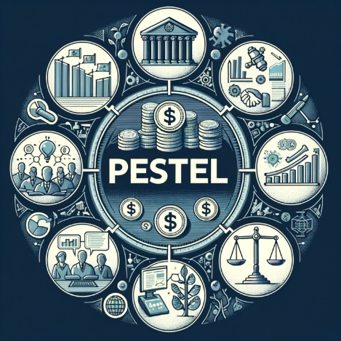
PESTEL Analysis
The PESTEL framework examines Political, Economic, Social, Technological, Environmental, and Legal factors which have an impact on the organic food industry.
Political factors
Public health, sustainability, and small businesses are directly affected by government policies. Most governments support small and home-based businesses with grants, training programs, and easier registration procedures. But changes in food safety laws or agricultural policy will add to compliance costs for small producers (OECD, 2021). Economic factors
Consumer purchasing power is significantly impacted by economic conditions. Organic food products are often priced higher than conventional alternatives due to production costs, making demand sensitive to economic fluctuations. Inflation, rising raw material prices, and supply chain disruptions might make it more expensive to operate. Nevertheless, the organic food market is increasingly growing, due to long-term health awareness and increasing disposable income among middle-class consumers (Statista, 2023).
Social factors
The business idea for the first step is likely to draw strongly from social trends. Food is an issue that concerns more consumers today, health, nutrition, and food safety as well as health concerns of lifestyle. Food products are receiving increasing interest from urban consumers and families with a taste for organic, natural production, locally sourced products. The cultural preference for traditional and homemade food also enhances market demand (Magnusson et al., 2017).
Technological Factors.
Digital technology is used to help small food businesses growing. Social media, e-commerce, and digital payment systems allow easy direct-to-consumer sales for low capital expenses. And technologies also assist improved food packaging, labelling and inventory management. But small businesses might be at risk of not being able to tap into cutting-edge production technologies if their financial resources are limited (Chaffey, 2022).
Environmental factors
Environmental sustainability is one key element that contributes greatly to the organic food economy. Growing numbers of consumers are choosing to support businesses that use environmentally friendly practices, such as organic farming, less chemical use, and recyclable packaging. Such demands are matched very precisely by the business proposed where natural ingredients are used with as little environmental impact (FAO, 2020).
Legal factors
Legal compliance in the food industry is key. Home-based food businesses need to adhere to food safety standards, hygiene rules, labelling regulations and licensing laws. Any breach of legal standards could open the risk of fines or harm to reputation. But clear regulatory frameworks also safeguard consumers and help to build trust in certified food producers (World Health Organization, 2020).
SWOT Analysis
The SWOT analysis assesses internal strengths and weaknesses of the business, as well as external opportunities and threats within the industry.
Strengths
One of the notable virtues of the newly proposed business is its emphasis on homemade, preservative-free organic goods. Small-batch production is a more manageable way to ensure better quality control, freshness, and authenticity than mass-produced choices. Direct customer interaction enables close personal service and quick feedback, fostering better customer relations and increased brand loyalty (Porter, 2008).
Weaknesses
During its first phase, a small business could operate with limited production ability, budget, and brand recognition. Manual processes can limit scalability and workload-dependent operation of the manufacturing. It would also be difficult for a small business to consistently source certified organic ingredients.
Opportunities
The rise in the demand for organic and health-oriented food offerings is generating huge growth prospects. Digital marketplaces and new social media marketing are burgeoning marketplaces for effective brand marketing and increased customer interaction. And there is the opportunity for a diversification of product lines and partnerships with local retailers, organic chain stores, or online platforms as the business develops (Kotler & Keller, 2016).
Threats
The business competes against tried-and-true organic food brands and established local purveyors. Big competitors might enjoy the benefit of economies of scale, distribution networks, and marketing budgets that are larger-market advantages. Regulatory risks, growing input costs, and economic recession can also pose a great danger. Achieving sustained high quality and compliance to standard is a prerequisite for controlling reputational damage (Johnson et al., 2020).
Competitor Analysis
Organic food market includes both commercial and small local producers. Big brands have massive retail presence, strong brand recognition, and an extensive distribution network. But they usually come without the warmth and personalized touch that homemade goods have. Small local producers are direct competitors, especially in the local and online markets. Despite the rise in competition for the segment, offering an effective product with differentiated value proposition, such as quality, transparency, and customer engagement, sets a competitive edge. In this fragmented marketplace, market players based on niche goods or direct-to-consumer relationships is a valid product (Porter, 2008).

Element 3: Marketing Mix (4Ps), Market Segmentation, and Marketing Strategies
n today's fiercely competitive market environment, where businesses are more often faced with marketing and branding challenges, effective marketing strategies are essential to the development of any firm. By concentrating primarily on this topic, the article seeks to critically analyse the market segmentation and target consumers in which the planned business for home-based organic food products is situated. This paper further applies the four marketing factors of marketing product, price, place, and promotion to the business idea and then analyses online marketing strategies for attracting and nurturing customers. These frameworks serve as a systematic framework by which to assess customer needs and align marketing actions with value creation activities creating competitive advantage (Kotler & Keller, 2016).
Market Segmentation and Target Customers.
Market segmentation is a method of splitting up a large market into smaller and identifiable groups of consumers who share similar characteristics, needs, or behaviours. Strong segmentation helps businesses to segment their customers and products and refine marketing strategies better, hence improving customer satisfaction and loyalty rates (Armstrong et al., 2020). The specific business proposed in the application will follow a multi-dimensional segmentation strategy that will place more emphasis on demographic, psychographic, and behavioural factors. The target market, from a demographic perspective, is targeted at the adult consumer between 25-55 years old, especially on the middle-income families and working professionals. They are more likely to have disposable income and be prepared to pay more for organic and health-conscious food products. Families with children are also a significant audience as many parents worry much more about the nutrition of the food, food safety, and long-term health outcomes. Psychographic segmentation plays a key role in this style of business. The intended customers are health-conscious consumers who care about natural products, eco-friendly practices, and ethical consumption. These are a lifestyle-oriented rather than price-sensitive group of consumers that actively seek products consistent with their values (e.g., preservative-free and homemade foods) (Magnusson et al., 2017). Behaviourally, you aim for consumers who tend to buy organic or local food regularly, shop for clean-label products, and exhibit brand loyalty when trust is established. These users respond better to honesty, narrative, and direct relationships with makers. In general, the target market is a niche but expanding market: people who value quality, authenticity, and health benefits above mass-marketing convenience items.

The Marketing Mix: Application of the 4Ps
Product
This means our product strategy is to make good quality organic homemade food that we prepare in small batches. Key categories are organic spice blends, pickles, sauces, and chutneys. No artificial preservatives, colours, or additives, freshness, no processed food, and the main idea is traditional preparation. With authenticity, transparency and perceived health benefits, a product becomes competitive and differentiated. Clear labelling, standard quality and personalized options (reduced salt or spice, for example) increase customer value. As the research team of Kotler and Keller (2016) states, product differentiation is vital for competitiveness in those markets where only functional reasons would not be enough (Kotler and Keller 2016).
Price
Pricing is key in locating the enterprise in the organic foods industry. The business as envisioned would utilize value-based pricing as it would be based on the quality of ingredients, small-batch manufacture and health benefits. Price is going to be up but within organic and homemade food industry they will be competitive with mass produced alternatives. Consumer expectations are well represented by this strategy, as organic food consumers will typically pay a premium for products that appear healthier and more reliable (Statista, 2023). Introductory pricing, promotional bundles, and loyalty discounts must be deployed to help promote trial purchases and repeat purchases without destroying the perceived value.
Place.
There is also a focus on place (distribution) tactics direct-to-consumer channels. Products will be mainly sold via social media platforms, messaging apps and community-centric networks. It minimizes dependence on intermediaries, decreases distribution costs, and offers more control over customer interactions. As the business scales, distribution may widen to include local organic stores, farmers’ markets, or online marketplaces. Rosenbloom (2018) states that direct distribution channels are particularly effective for small businesses seeking flexibility, customer feedback, and brand differentiation.
Promotion
Promotion is about generating awareness, trust and repeat purchase. The business will heavily rely on digital and relationship-based promotion strategies due to the limited marketing allocations. That consists of things like posts, customer testimonials, referrals, and storytelling that demonstrate the homemade, organic attributes of the products. Health messaging will highlight benefits of ingredient transparency, and tradition in preparation. This is consistent with modern consumer preferences for authentic brand communication versus aggressive advertising (Chaffey, 2022).

Online Marketing Strategies
In the proposed model of a business, online marketing plays an important role in acquiring and retaining customers. Digital platforms offer cost-effective means of engagement, brand building, and long-term customer relationships that few traditional channels can offer. The primary online strategy will be based in social media marketing. Social media is a significant channel for distribution of services. Instagram and Facebook provide business with an outlet for the business to put across their items in visual form, allow them to show their products behind the scenes and communicate direct to consumers. Regular content that is posted, interactive stories, and customer feedback bring the audience in touch and awareness of the brand (Tuten & Solomon, 2020). Content marketing will be critical as well. Education about organic food benefits, ingredient sourcing, how to shop for healthy food, the role of posts in promoting healthy food and a reputation for knowledge are created by educating people to position the business as a brand that they can feel confident about and trust. This approach adds authority and contributes to more successful long-term customer retention. Customers will receive personal touch communication, follow-up messages, and loyalty rewards as part of customer relationship management (CRM) models. Engagement allows the business to respond to feedback and adjust offerings based on what works best. Customer retention is cheaper than customer acquisition, especially for small businesses (Kotler & Keller, 2016). Moreover, eWOM (electronic word-of-mouth), reviews and customer recommendations will also be encouraged. Positive reviews have been proven to impact purchasing decisions in the food sector particularly small and up and coming brands (Hennig-Thurau et al., 2015). The framework used in the marketing plan revolves around the market segmentation, the audience, the customer demand and the value added. Through catering to health-conscious, quality-driven consumers and effectively integrating the 4Ps, the company can grow market recognition despite limited resources. Use of online marketing tools is used strategically to improve brand visibility, increase customer engagement, and drive retention. These strategies together contribute to achieving sustainable growth and competitive positioning in the organic food industry.

Element 4: Legal, Management, and Financial Planning
In the UK, a Sole Trader is the simplest type of business ownership in which a person owns and manages the business. In this system, all debts and liabilities are legally the owner’s and no separation of the owner and the business exists (Gov.uk, 2023).
A Limited Company is a legal entity apart from its owners (shareholders). It has limited liability protection in that the extent to which the shareholder is responsible for the debts goes only up to the value of their investment. Limited companies are subject to corporation tax and stricter reporting requirements (McLaney & Atrill, 2020).
A Partnership is when two or more people share ownership, responsibilities, and profits. Unless the partnership is structured as a limited liability partnership (LLP) (Burns, 2016), partners are jointly liable for business debts.
A Franchise is the method in which a person (the franchisee) operates under the brand, systems, and support of another known as the franchisor in exchange for fees or royalties. Franchising minimises risk, but it constrains operational independence (Scarborough, 2018).
An Online Enterprise is an organization that sells products or services using the internet. These businesses have lower overheads and broader exposure to markets; however, they rely heavily on technology and digital marketing (Chaffey, 2022).
A Social Enterprise is a business which reinvests profits to benefit social or environmental goals instead of increasing shareholder returns. Although still commercially oriented, social enterprises value social outcomes alongside financial sustainability (Social Enterprise UK, 2021).

Legal Structure of the Proposed Business
For initial stages the proposed home-based organic food products business will be a Sole Trader. This legal structure is suitable because it is straightforward, low in capital required to set up and comes with minimal paperwork. As a small and home-based enterprise limited by the initial capital available to it when starting out, sole trader status is ideal for maintaining the ownership, decision-making & operations of the company. Additionally, the act of registering as a sole trader is easy in the UK and helps the company to respond promptly to market demand without the complexities of intricate governance. The sole trader is entirely liable, but, at this early stage, as a small venture, the risk is thought to be manageable. As the company matures then as soon as the business expands, a limited company can be established to limit the exposure and facilitate future growth in case of personal liability (Burns, 2016).

Organisational Structure and Management
The business will share a simple centralized organisational structure, mirroring its narrow scale and early-stage development. The business will start with owner-managed, multi-role employee structure which minimizes operation costs for its owner as well as operational efficiency.
Key roles include:
- Owner/Manager: Responsible for strategic planning, decision-making, supplier relationships, and compliance with food safety and legal requirements.
- Production and Quality Control: Overseeing food preparation, hygiene standards, quality assurance, and inventory management.
- Marketing and Sales: Managing social media platforms, customer communication, order processing, and promotional activities.
- Finance and Administration: Handling bookkeeping, budgeting, pricing, and tax-related responsibilities.
As the business grows, additional support may be obtained through part-time staff or outsourced services, such as accounting or digital marketing. This flexible structure supports scalability while maintaining cost control (Johnson, Scholes, & Whittington, 2020).
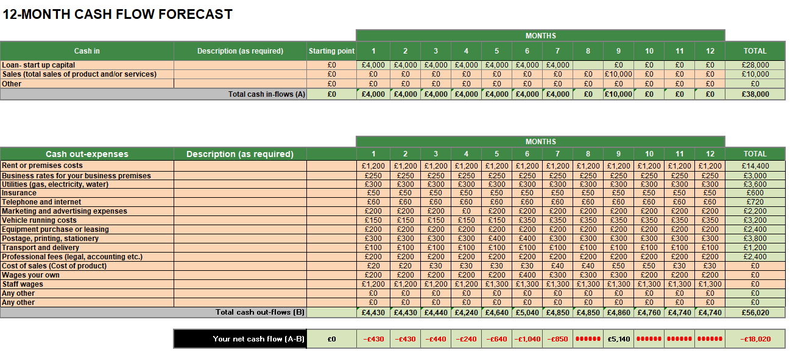

Start-Up Funding Requirements and Sources of Funding
Good financial planning is critical for a start-up enterprise, especially in food where operating costs and regulatory compliance can be high. Using the 12-month cash flow projection, the home-based organic food products business would require start-up funding of about £28,000, primarily invested to cover the operating fees over the initial seven months of trading. These early months produce negative net cash flows, as is typical for a start-up where costs outstrip revenues before a market stabilizes. This cash flow forecast shows significant spending areas are rent or premises, utilities, marketing/advertising, transport, staffing, and cost of sales. This is crucial for production continuity and regulatory compliance and penetrating new market segments. Sales revenue also comes later in the year. It shows a cash deficit at £18,020 as an indication that enough start-up capital remains for operations to move forward and for liquidity. McLaney and Attrill (2020) contend that inadequate working capital is one of the top reasons for a small enterprise's failure. I would consider the fundamental funding source for a new business as owner's capital, whether through personal savings or a start-up loan. Owner financing is particularly suitable for a sole trader, as it avoids paying any interest fees and lets them retain full managerial control (Burns, 2016). Moreover, personal investment sends a strong signal of intention and minimises money risk early in operation. Additional funding sources could come from government-backed start-up loans/grants commonly available in the UK for small businesses and self-employment (Gov.uk, 2023). A fund source gives access to investment but at very low interest rates and consultative assistance. The business is small and owner-managed, thus external equity financing is not deemed adequate at this stage.

Conclusion
Lastly, the proposed home-based organic food products business will become a profitable and sustainable entrepreneurial venture in the larger, growing organic food market. This business model is consistent with increasing consumer demand for healthier, preservative-free, and environmentally responsible food alternatives. This small-scale model also has the advantages of minimizing costs while being flexible as well as closely engaging with customers that is directly available through direct-to-consumer channels. Using strategic frameworks like, but not limited to PESTEL, SWOT and the 4Ps of marketing shows that the business stands by favourable social and technological trends while managing potential competitive and regulatory challenges. In addition to that, the established short- and long-term goals offer a structured manner through which to grow incrementally and establish a name for themselves. So long as it has adequate financial planning in place and distinguishes itself in an authentic manner and remains transparent, the company can grow consistently with a fighting chance in the organic food marketplace.

References (Harvard Style)
Armstrong, G., Adam, S., Denize, S. and Kotler, P. (2020) Principles of Marketing. 8th edn. Harlow: Pearson Education.
Burns, P. (2016) Entrepreneurship and Small Business. 4th edn. London: Palgrave Macmillan.
Chaffey, D. (2022) Digital Marketing: Strategy, Implementation and Practice. 8th edn. Harlow: Pearson Education.
Food and Agriculture Organization of the United Nations (FAO) (2020) Sustainable food systems and organic agriculture. Rome: FAO.
Gov.uk (2023) Set up a business. Available at: https://www.gov.uk/set-up-business
Hennig-Thurau, T., Hofacker, C.F. and Bloching, B. (2015) ‘Marketing the pinball way: Understanding how social media change the generation of value for consumers and companies’, Journal of Interactive Marketing, 13(1), pp. 38–47.
Johnson, G., Scholes, K. and Whittington, R. (2020) Exploring Strategy. 12th edn. Harlow: Pearson Education.
Kotler, P. and Keller, K.L. (2016) Marketing Management. 15th edn. Harlow: Pearson Education.
Magnusson, M.K., Arvola, A., Hursti, U.K., Åberg, L. and Sjödén, P.O. (2017) ‘Consumer attitudes towards organic foods’, Appetite, 38(1), pp. 1–9.
McLaney, E. and Atrill, P. (2020) Accounting and Finance for Non-Specialists. 11th edn. Harlow: Pearson Education.
OECD (2021) Policies for small and medium-sized enterprises. Paris: OECD Publishing.
Porter, M.E. (2008) Competitive Strategy: Techniques for Analyzing Industries and Competitors. New York: Free Press.
Rosenbloom, B. (2018) Marketing Channels. 9th edn. Boston: Cengage Learning.
Scarborough, N.M. (2018) Essentials of Entrepreneurship and Small Business Management. 9th edn. Harlow: Pearson Education.
Social Enterprise UK (2021) What is a social enterprise? Available at: https://www.socialenterprise.org.uk
Statista (2023) Consumer demand for organic food products. Available at: https://www.statista.com
Tuten, T.L. and Solomon, M.R. (2020) Social Media Marketing. 4th edn. London: Sage Publications.
World Health Organization (2020) Food safety and healthy diets. Geneva: WHO.

