INTRODUCTION TO CASE STUDY

ABDUL KHAN 1917185
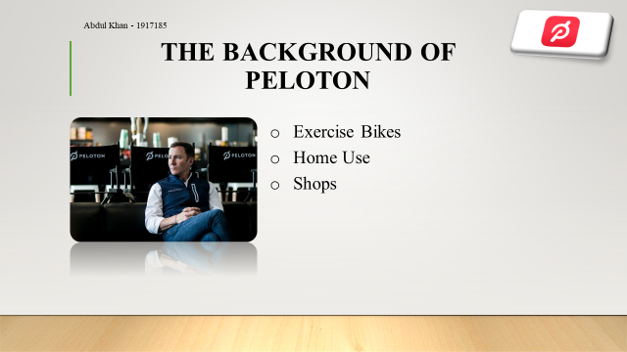
In this first slide I will talk about the company we choose and how they started off before technology come into play. Peloton was formed in 2012 in USA, New York. It was founded by Graham Foley, Tom Cortese and Young Feng. Peloton started off as an exercise equipment provider. Peloton had shops where they sold exercise bikes, exercise equipment for home base use. This was normal standard exercise equipment they would supply for home base use. Peloton at this stage where not providing any online facilities where you can go online and purchase your exercise bike, or exercise equipment. ​

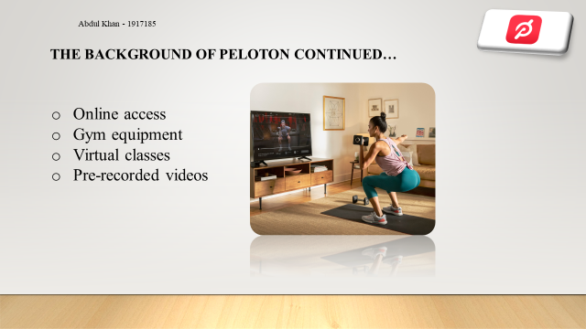
In slide 2 I will talk about how Peloton moved on from selling basic exercise equipment to moving the company into technology side. After few years Peloton started off by making customers access their online shopping. This meant customers could go online and order gym equipment and other exercise equipment. The prices where reasonable which customers could afford. By the time online accessibility took off, Peloton quickly moved to offering virtual classes to customers. This was pre-recorded videos where customers can log online and follow the exercise provided on the video. This was convenient for people who didn’t have the time to go to a gym. Customers would need to subscribe to this service which cost $39 per month. ​

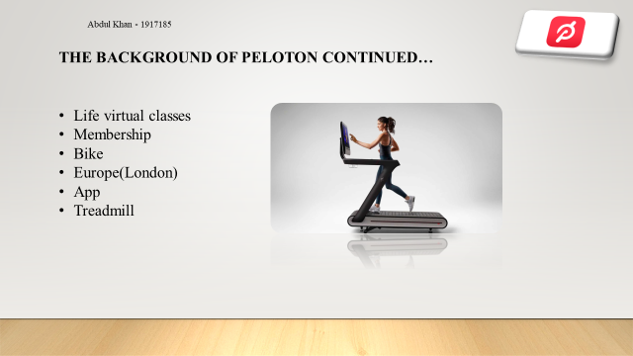
Peloton then took technology to another level. Peloton started to offer its customers live on-demand workouts from their homes. Peloton's key product was there exercise bike. The bike which comes with a basic package can be purchased in UK for £1995, and in USA for $2245. Peloton where the first company to offer this kind of service to consumers who can access live exercise from anywhere in the world. Customer's would have to sign up for membership subscription which would cost them £39.50 per month in UK and $39

in USA - for unlimited live and on demand classes. The bike would come with a 24-inch monitor have so many different functions and with a touch of a button customers can view live classes taking by a fitness instructor. The bike was such a success Peloton in 2018 also bought out treadmill. The treadmill would cost for basic package $4295, monthly subscription $39 per month. Peloton has a studio in London, Chelsea and

New York, Manhattan. Peloton broadcast 10 to 14 live cycling classes a day from its studio in Manhattan. Peloton also have an app for its customers to download from smart phones this comes free with membership. ​

TELETHA DUBERRY 1917189
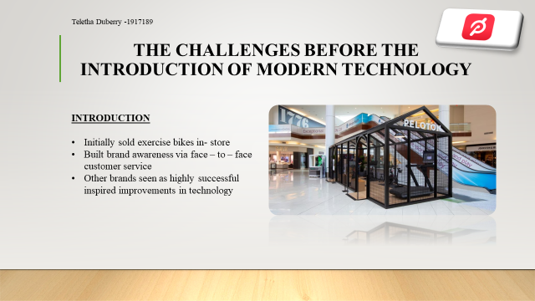
Peloton initially operated by sporting good shops, including setting up a pop-up shop in 2013 at a Mall in New Jersey with their prototype bike, aiming to attract suburban clients who didn’t have as much access to other brands. They built their buzz by providing great customer service, getting their message across to client’s face – to – face, whilst selling exercise bikes in stores. More investors took notice and invested in the brand helping them to fund opening of new stores, delivery services and modern technology, creating exceptional user experience.
Although they were founded in 2012 where modern technology was standard for most organisations, Peloton still faced a few challenges when building their brand. This inspired them to evolve by introducing and improving on their technology, paying careful attention to the industry they were operating in, making them determined to fit in and be one the leading brands for fitness.


Foley had to face a fair amount of apprehension from investors, when persuading them to fund the manufacturing of the Peloton bicycle as well as the production of a fitness studio and social software to bring it all into one.
The closest competition to Peloton in fitness hardware are gadgets like GoPro and FitBit, who had a difficult time growing and soon or later branched out as a public brand. Foley admitted that the main challenges of Peloton when it came to growing the brand, was lack of capital but never lack of vision.
Given the fact that Peloton was known for their expensive fitness equipment, they still maintained a large clientele. Seeing as technology was evolving they couldn’t just stop at selling and delivering technology based exercise equipment, Peloton had to explore further modern technology to make sure the brand was in alignment with the latest features plus more. This grew their brand awareness even more, however they still offer classes to local New York residents who couldn’t afford the expense of at home exercise equipment.

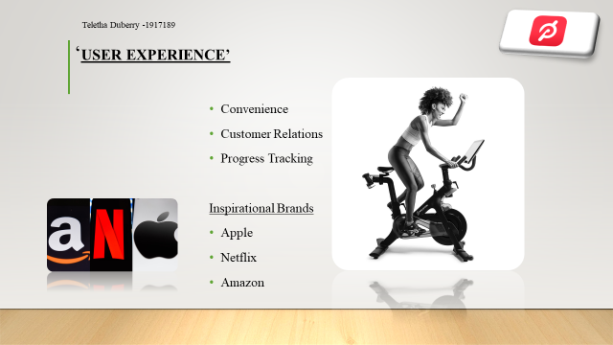

Peloton’s CEO and Co – Founder John Foley said he noticed that people were drawn to expensive cycling classes due to having a favourite instructor or music playlist more than the actual brand, and ventured to make the overall experience more convenient for potential clients.
According to an article I read on ‘How Peloton exercise bikes became a $4 billion business start- up with a cult following, ‘Peloton’s founders classed the brand as a ‘media - technology – retail – logistics company,’ which has also been nicknamed the ‘Apple of fitness.’ They realised that focusing on various areas of their brand was important when introducing and improving ‘user experience,’ especially sitting in the same industry as highly successful brands such as Apple, Netflix and Amazon, who focused on this also and inspired Peloton’s modern technology services that they later introduced.

FIONA TESFAZGH 1914615
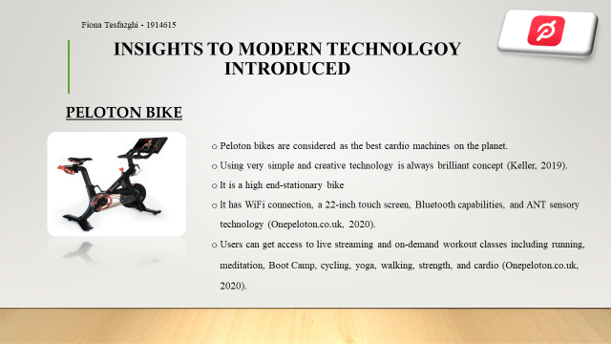
Peloton bikes are considered as the best cardio machines on the planet. Using very simple and creative technology is always brilliant concept (Keller, 2019). It is a high end-stationary bike.
It has Wi-Fi connection, a 22-inch touch screen, Bluetooth capabilities, and ANT sensory technology (Onepeloton.co.uk, 2020).
It offers numerous benefits to the users while staying at home. Users can get access to live streaming and on-demand workout classes including running, meditation, Boot Camp, cycling, yoga, walking, strength, and cardio. It saves time as users can eliminate getting stuck in traffic or parking problems. Users can walk out at any time. Users can also get relevant information regarding their power output and calorie burn (Onepeloton.co.uk, 2020).
It offers numerous benefits. Firstly, it never rides alone. Peloton bike users can connect with other peloton members live and on-demand. It offers the benefits to send high fives as well as provides benefits of filtering by age, gender, and followers (Onepeloton.co.uk, 2020).
It provides real-time metrics on daily progression including heart rate, cadence, resistance, and output (Onepeloton.co.uk, 2020).

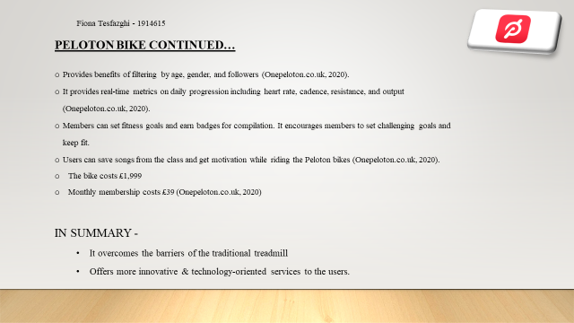
It also offers training programs and challenges. Members can set fitness goals and earn badges for compilation. It encourages members to set challenging goals and keep fit.

It also provides motivation through music. Users can save songs from the class and get motivation while riding the Peloton bikes. Users can connect Bluetooth headphones and hear songs without disturbing anyone (Onepeloton.co.uk, 2020).
In summary, it overcomes the barriers of the traditional treadmill and offers more innovative & technology-oriented services to the users.
The bike costs £1,999
Monthly membership costs £39 (Onepeloton.co.uk, 2020)

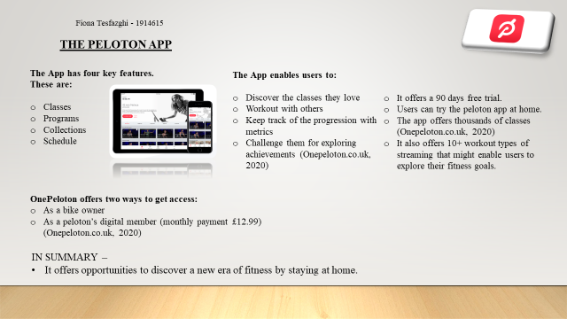
According to Peloton Project by smith (2019), Peloton App has 4.9 ratings out of 5.
It offers a 90 days free trial. Users can try the peloton app at home.
The app offers thousands of classes (Onepeloton.co.uk, 2020)
It also offers 10+ workout types of streaming that might enable users to explore their fitness goals.
It enables the user to get access to Onepeloton’s full library of workout stream life from the studio (Onepeloton.co.uk, 2020).

The app has four key features. These are:
Classes
Programs
Collections
Schedule

The App enables users to:
Discover the classes they love
Workout with others
Keep track of the progression with metrics
Challenge them for exploring achievements (Onepeloton.co.uk, 2020)

Peloton offers two ways to get access in the peloton app
As a bike owner
As a peloton’s digital member (monthly payment £12.99) (Onepeloton.co.uk, 2020)
In summary, it offers opportunities to discover a new era of fitness by staying at home.

MARIO ROBINSON 1917203
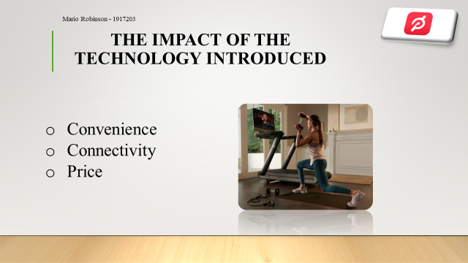
Peloton similar to the likes of Uber and AirBnB has been instrumental in finding ways to create platforms through the use of technology that expand venues with fixed capacity. These technological advancements have their advantages and disadvantages as it regards to the impact it has created.


-In terms of convenience, Peloton’s bike as well as the treadmill is equipped with a 22-inch HD sweat proof touch screen which lets you tune in and experience all the activity and adrenaline of 14 daily live and over 8000 on-demand classes, without having to leave the comfort of your home (Street,2019).

-Also a progress report is generated from each ride/activity which will give the user data that will better enable them to analyse and improve on areas of fitness that need attending to without a physical instructor. There are options available that allows a user to select your preferred virtual instructor and enjoy live sessions with the instructor.

-There is a Peloton app available that operates on both IOS and Android operating systems which are most popular and convenient for Apple, Samsung, Huawei users and users of smaller companies who utilise these operating systems. The App gives the option to have a Peloton studio on your Television with a full library

of workouts that is also streamed live to any device with airplay or Chromecast support, available also on Amazon Fire Tv and Android Tv.

-In terms of Connectivity with the technology introduced by Peloton through the use of referral programs and various social media platforms for example Facebook, Instagram and Snapchat. Persons who are friends on these social media platforms and have become members on Peloton, can see notifications on their Peloton accounts as to which one of their friends is active whether it be virtual cycling, studio workouts or other activities and have an option to join them and workout together.

-Users can also share their membership with unlimited friends through most social media platforms.

-Not much as it regards to space is required, a small living room space about 12feet by 12 is sufficient. The bike and treadmill are no longer than 6feet in length and are foldable to half the size once finished being used and can be neatly tucked away.

- Peloton’s technology also allows for a good Work Life Balance as it enables you to set specific time frames for workouts, schedules and dates that are best suitable for your daily routines.


As it relates to Price, this may be off putting for some potential customers as it will cost about £2000 for the Peloton bike due to the level of sophisticated technology implemented in it. However, there is an option provided that will enable a customer to have a 30-day trial with the bike if they wish to finance it and an option to opt out before the 30-day period has ended.

TAMARA HARDY 1917202

After analysing the need for fitness and technology being the most used source for convenience and communication, John Foley decided to build a future for ‘at – home fitness.’
These days, it is much easier for entrepreneurs and start-up businesses to purse their ideas where modern technology is concerned. With apps, social media and built in media equipment being produced, it is now easier to build customer relations and brand awareness. Having a business mind - set, product knowledge and market research is important when starting a business, and it seems like the CEO of Peloton had most of his required knowledge from paying attention to the needs of other fitness fanatics as well as himself.
Foley never stops seeking ways to build the Peloton brand, making sure that the company’s profits are spent wisely and all the right things are being put into place for the long – term results. When building a brand, you need to focus on the customers you aim to attract, what is your product/service going to do for them? Can your product/service produce results? This will most likely lead you into having a successful business.
Where modern technology is concerned, there is so much competition amongst businesses in all different sectors. Therefore, it is important that when starting a business or looking at ways for the company to grow, you figure out how you can be in line with/ better than the other leading companies with a similar branding, and never stop developing new ideas as technology evolves.



Although Peloton is known for selling expensive fitness equipment, they have stood by their prices, whilst ensuring that they offer other services to assist customers with their purchased equipment, making it a full package that they can benefit from as a whole, this also includes potential customers.
With modern day technology you will find that there are thousands of online services on their own as a brand or as a feature of a brand. Due to the competition, a lot of companies are building their brand awareness by online promotion, including Free Trial periods allowing potential customers to try their services and choose to stay or leave when this time is up.
It is important when providing services via modern day technology, that you focus on your audience first as this can sooner determine the success of your business in a matter of a few years, as proven with Peloton.

Bibliography

Arora, N., 2019. Amazon, Netflix And Apple Shares Are No Longer Beloved By The Average Investor. [online] MarketWatch. Available at: <https://www.marketwatch.com/story/amazon-netflix-and-apple-shares-are-no-longer-beloved-by-the-average-investor-2019-09-23> [Accessed 4 May 2020].
Betters-Picaro, É., 2020. Peloton Appoints Blacklist Creative As London Production Studio Consultants – Marketing Communication News. [online] Marcommnews.com. Available at: <https://marcommnews.com/peloton-appoints-blacklist-creative-as-london-production-studio-consultants/> [Accessed 29 April 2020].
George, L., 2020. A Buyer’S Guide To The New Peloton Treadmill | 20 Fit. [online] 20 Fit. Available at: <https://shapescale.com/blog/fit-tech/everything-about-the-peloton-treadmill/> [Accessed 4 May 2020].
Hancock, A. and Platt, E., 2019. Peloton Wants IPO Investors To Believe It Can Kill The Gym. [online] Ft.com. Available at: <https://www.ft.com/content/f9d70890-c9b3-11e9-a1f4-3669401ba76f> [Accessed 4 May 2020].
Jr., T., 2020. How Peloton Exercise Bikes Became A $4 Billion Fitness Start-Up With A Cult Following. [online] CNBC. Available at: <https://www.cnbc.com/2019/02/12/how-peloton-exercise-bikes-and-streaming-gained-a-cult-following.html> [Accessed 29 April 2020].
Keller, E., (2019). Generating Bodies And Gendered Selves. Seattle: University of Washington Press.
Love, A., 2018. Ally Love - Peloton. [online] Facebook.com. Available at: <https://www.facebook.com/pg/allylovepeloton/photos/?ref=page_internal> [Accessed 4 May 2020].
Moon, J., 2019. Peloton’S Cringe-Y Ad Got Everyone Talking. Its C.E.O. Is Silent.. [online] Nytimes.com. Available at: <https://www.nytimes.com/2019/12/09/business/media/peloton-ad-ryan-reynolds.html> [Accessed 4 May 2020].
Olmsted, L., 2016. The Best Home Workout & Fitness Machine: Peloton Review. [online] Forbes. Available at: <https://www.forbes.com/sites/larryolmsted/2016/11/02/the-best-home-workout-fitness-machine-peloton-review/#67c1c2585a0d> [Accessed 4 May 2020].
Onepeloton.co.uk, (2020). Peloton® | Exercise Bike With Indoor Cycling Classes Streamed Live & On-Demand. [online] Onepeloton.co.uk. Available at: <https://www.onepeloton.co.uk/app> [Accessed 1 May 2020].
Onepeloton.co.uk, (2020). Peloton® | Exercise Bike With Indoor Cycling Classes Streamed Live & On-Demand. [online] Onepeloton.co.uk. Available at: <https://www.onepeloton.co.uk/bike> [Accessed 1 May 2020].
Onepeloton.co.uk. 2020. Peloton® | Exercise Bike With Indoor Cycling Classes Streamed Live & On-Demand. [online] Available at: <https://www.onepeloton.co.uk/> [Accessed 4 May 2020].
Press.onepeloton.com. 2020. Peloton | Media Press Kit. [online] Available at: <https://press.onepeloton.com/#logos> [Accessed 4 May 2020].
Seller, S., 2020. Advantages And Disadvantages Of Selling Quality Products - Australian Seller. [online] Australian Seller. Available at: <https://australianseller.com.au/advantages-and-disadvantages-of-selling-quality-products/> [Accessed 4 May 2020].
sheerluxe.com. 2020. 8 Of The Best At-Home Subscription Workouts. [online] Available at: <https://sheerluxe.com/2020/01/29/8-best-home-subscription-workouts> [Accessed 4 May 2020]

SmartBrief. 2019. What’S Shaping The Next Generation Retail Experience. [online] Available at: <https://www.smartbrief.com/original/2019/05/what%E2%80%99s-shaping-next-generation-retail-experience> [Accessed 4 May 2020].
Street, C., 2019. Peloton Bike Review: Is The £2000 Exercise Bike Really Worth It?. [online] Evening Standard. Available at:
<https://www.standard.co.uk/lifestyle/health/peloton-review-uk-spinning-at-home-a3898016.html> [Accessed 16 April 2020]
Webbyawards.com. 2020. [online] Available at: <https://www.webbyawards.com/winners/2018/mobile-sites-apps/general/health-fitness/peloton-app/?/> [Accessed 4 May 2020]

