

MODULE CODE: ECPT6006

ASSESSMENT COMPONENT: A Critical Evaluation of the Role of Digital Innovation in Professional Practice

STUDENT NAME: Sophie Bailey

STUDENT NUMBER: 1810168

Use of Generative AI in Assessment

(Lecturer to indicate Yes or No against each element)

RESEARCH | For this assessment, you can use Generative AI to support you in research, including searching for bibliography, using tools to summarise, compare and interrogate materials. | Yes ☒  No ☐
STRUCTURE | For this assessment, you can use Generative AI to support you in structuring your submission, including creating a draft argument structure, identifying parts and headings, etc. | Yes ☒  No ☐
PROOFREADING | For this assessment, you can use Generative AI to check your own text/creation for grammatical and syntactical mistakes, including rephrasing of your own work within specific standards. | Yes ☒  No ☐
WRITING | For this assessment, you can use Generative AI to create text for submission. | Yes ☐  No ☒
CREATIVE | For this assessment, you can use Generative AI to create creative materials, such as images. | Yes ☒  No ☐
PROGRAMING | For this assessment, you can use Generative AI to create and check code. | Yes ☐  No ☒
NONE | For this assessment, you are not allowed to use any type of Generative AI support. This includes research support, structure support, writing/proofreading support and creative support. | Yes ☐  No ☒

AI Acknowledgement
I confirm that I have not used any AI tools in the research and creation of this assignment.
I confirm that I have not presented any AI generated materials as my own work.
I confirm that I have copies of my drafts, notes, and other resources I used, which I may be asked to provide in evidence.

Introduction (271 words)
Digital innovation has become an increasingly significant aspect of post sixteen education in Wales, influencing how learners engage with content, how educators design learning experiences and how assessment is carried out across further education settings in Wales. As practitioners working within education, it is essential to understand not only the potential of digital tools but also the theoretical and professional frameworks that guide their effective use.
This portfolio aims to explore the role that creativity and digital innovation play in teaching with a particular focus on how interactive assessment tools, such as Kahoot can enhance learning and participation and formative evaluation within the higher and further education sectors. Recent education research places a growing emphasis on creativity and digital innovation, acknowledging the significant influence of rapid technological change on the ways knowledge is created, communicated and experienced. Emerging and developing tools such as artificial intelligence, learning analytics and virtual reality are reshaping pedagogical practice. This is now both an influential and worry with practicing professionals often not only considering the full potential of digital innovation but the ethical, pedagogical and theoretical implications of their use.
Research frequently emphasises the close connection between creativity and digital innovation while also recognising that the link between creativity and digital innovation can foster inclusivity, collaboration and learner autonomy while concurrently raising concerns around equity of access, data privacy and the sustainability of technological integration. By engaging critically with these perspectives, this review seeks to highlight the ways in which creativity and digital tools intersect within the post sixteen sector, offering insights into how educators can harness innovation responsibly while navigating its underlying difficulties and obstacles.

Literature Review (1507 words)
Recent education research places a growing emphasis on creativity and digital innovation, acknowledging the significant influence of rapid technological change on the ways knowledge is created, communicated and experienced. Emerging tools such as artificial intelligence, advanced learning analytics and extended reality are reshaping pedagogical practice, promoting educators to consider not only their full potential but the ethical, theoretical and pedagogical implications of their use. Research frequently emphasizes the close connection between creativity and digital innovation, while also recognizing that the link is shaped by the design decisions and professional judgement of educators. Situating these debates within the literature provides a critical lens through which this review will examine both the opportunities and challenges that technology introduces to current teaching and learning environments. This literature review highlights how digital innovation can foster inclusivity, collaboration and learner autonomy while simultaneously raising concerns around equity of access, data privacy and the sustainability of technological integration. By engaging critically with these perspectives, this review seeks to highlight the ways in which creativity and digital tools intersect within the post- sixteen education sector, offering insights into how educators can harness innovation responsibly while navigating its inherent complexities.
Creativity is commonly conceptualized as the ability to generate new and valuable ideas and in educational contexts is associated with exploration, problem solving and learner autonomy (Runco and Jaeger, 2012). Digital tools can enhance these creative capacities by offering new learners’ new ways of representing ideas, collaborating with piers and engaging with complex concepts. However, creativity does not emerge automatically from the presence of technology, rather it arises from the purposeful integration of digital tools with sound pedagogy. Mishra and Koeheler’s (2006) Technological Pedagogical Content (TPACK) framework, although the framework was developed in 2006 it remains influential for explaining how creativity emerges at the intersection of technological, pedagogical and content knowledge. This is reaffirmed with Redecker (2023) stating that creative digital teaching requires sensitivity to the capabilities and limitations of technology as well as the learning needs of students. This implies that digital innovation must be ground in thoughtful pedagogical design rather than implemented solely for its novelty.
The relationship between digital innovation and creativity also aligns with socio-constructivist perspectives, in which learning is seen as a collaborative and socially mediated process. Vygotsky (1978) emphasis on interaction and scaffolding provides a theoretical foundation for understanding how digital tools can extend opportunities for creative learning by connecting learner and supporting joint knowledge building. Modern platforms such as collaborative writing spaces such as word clouds and virtual discussion platforms such as Microsoft teams enable learners to share ideas, negotiate meaning and build collective insights. Recent studies indicate that digital collaboration can help to stimulate creativity by exposing students to diverse perspectives and by encouraging them to develop new ways of integrating knowledge (Benmayor and McCarty, 2022). In this way, digital innovation can transform not only what learners produce, but also how they think and interact.
Digital technologies and competencies also enhance pedagogy by enabling personalised learning environments and experience, engagement and adaptive feedback. Ai systems provide real time feedback. This can be seen with supportive creative learning allowing students to experiment, reflect and revise without waiting for teacher intervention (Holmes et al., 2022). Similarly, immersive technologies such as virtual reality create spaces where learners can explore complex environments, simulate scenarios and engage with abstract ideas more concretely. Hamilton et al.’s (2023) research suggest that virtual reality increases engagement and encourages creative problem-solving by enabling learners to manipulate variables and observe outcomes in ways in which would be impossible in traditional settings. Such immersive experiences can develop skills associated which creativity, including curiosity, exploration and innovative thinking.
Another significant digital practice supporting creative learning is digital storytelling. Allowing students to combine images, audio, video and text, digital storytelling fosters multimodal communication and narrative creativity. Qian et al. (2022) note that digital story telling not only enhances learner motivation but also helps them construct meaning through creative synthesis of different media forms. These opportunities to generate original artefacts highlight how digital innovation can empower learners as creators rather than passive consumers of information.
As digital innovation becomes embedded in education research, the ethics of how such research is designed and conducted is increasingly scrutinised. Research involving digital tools often entails the collection of sensitive learner data including behavioural patterns and academic performance, location data and interaction logs which raises ethical considerations. Ensuring informed consent, transparency of data use and the protection of participants privacy is essential. Williamson and Kizilcec (2023) stress that research must avoid reinforcing bias and exposing participants to surveillance like conditions. Additionally, ethical research practice demands that findings are used to enhance learning rather than to categorise or penalise students. Researchers must also ensure equity by avoiding methodologies that exclude learners with limited digital access, thereby preventing digitally marginalised groups from being overlooked in evidence-based decision making. In line with institutional ethical review standards, all researching involving digital innovation must ensure beneficence, non-maleficence and respect for autonomy, especially as technologies evolve more rapidly than regulatory frameworks.
While digital innovation supports creativity, it also requires shifts how educators design and facilitate learning. Scholars argue that teachers must adopt design- orientated mindsets becoming architects of learning experiences rather than deliverers of content as stated by Selwyn (2022). This perspective emphasises that creative digital pedagogy involves intentional planning, experimentation and reflection. Teachers must consider how digital tools enable learners to engage deeply with content and how tasks can be structured to promote creative thinking and how assessments can capture process orientated learning rather than solely outcomes. When educators embrace these roles, digital tools can amplify creativity rather than constrain it.
However, the increasing use of learning analytics, artificial intelligence and digital platforms has raised concerns around privacy, fairness and surveillance. Student data is now generated continuously, and ethical digital practice requires transparency, equity and safeguards to protect learners’ rights. Ofcom (2023) highlights growing worries about distraction, online fatigue, and the social pressures associated with constant digital engagement. Creative digital pedagogy must therefore involve critical digital literacy enabling students to understand how technologies influence their behaviour, choices and wellbeing (Livingstone et al., 2022).
Equity is a central theme with contemporary debates, particularly as the digital divide remains persistent. Learners without access to devices, stable internet or digital skills face structural barriers that inhibit creativity and limit participation in innovative learning. The United Nations Educational, Scientific and Cultural Organization (2023) emphasises that without reasonable access, digital technologies risk amplifying rather than reducing educational disparities. For digital innovation to support creativity meaningfully, inclusive design and equitable distribution of digital resources are essential.
As emerging technologies continue to develop and evolve, their potential to reshape creative learning appears considerable. Artificial intelligence is becoming increasingly sophisticated, enabling adaptive learning systems, that personalise tasks and resources in real time. Luckin (2023) suggests that future artificial intelligence may support intelligent tutoring systems capable of deeply personalised interactions. Generative artificial inelegance also presents new opportunities for ideation, creative experimentation, through concerns around originality and academic integrity persist. (Kalio and Koivisto, 2024). Extended reality technologies similarly offer opportunities for experiential learning that fosters creativity and early explorations of metaverse based learning environments hint at transformative possibilities for collaborative creative work (Davies et al, 2023).
Learning analytics and data driven pedagogical approaches play an increasingly influential role in shaping creative learning. When applied thoughtfully, such tools enable educators to instruct adaptive environments that respond to learners evolving needs (Ifenthaler and Gobson, 2022). This aligns with the principles of constructivist learning theory, which emphasises learner-centred environments where knowledge is actively built rather than passively received. Similarly, socio-cultural theory highlights the importance of context and interaction, reminding us that analytics should support collaborative meaning making rather than reduce learning to isolated data points.
Although literature highlights substantial benefits of digital innovation, it also offers important critiques. Selwyn (2022) argues that many educational technologies fail to deliver meaningful change because they are implemented without a clear pedagogical rationale. Some digital platforms constrain creativity by imposing rigid structures, mirroring administrative rather than pedagogical priorities (Bayne et al., 2022). The rapid pace of innovation can also overwhelm educators many of whom report feeling underprepared to integrate digital tolls effectively. Professional development often remains inadequate or misaligned with teacher’s needs, resulting in superficial implementation (Jones and Attard, 2023). Creative digital Pedagogy therefore requires not only technological infrastructure but sustained investment in teacher learning, collaboration and reflective practice.
Taken together, the literature suggest that creativity and digital innovation are mutually reinforcing when approached thoughtfully. Digital tools provide possibilities for learner expression, collaboration and exploration, while creativity guides the pedagogical decisions that determine how these tools are used. Yet ethical; considerations including responsible research practices, data privacy, algorithmic fairness, equitable access and digital wellbeing must remain central to discussions about digital innovation. Ultimately creativity is not only an outcome of effective digital pedagogy but also a guiding principle shaping how innovation is conceptualised, implemented and sustained. Through critical, ethical and intentional design, digital innovation can create learning environments where learners engage creatively, think independently and collaborate meaningfully.

Selection and Justification. (1090 words)
Selecting the correct digital tool for teaching in the post sixteen sector requires clear alignment between technology, pedagogy and professional responsibility. The Technological, Pedagogical and content knowledge framework also known as TPACK is valuable when guiding in this process because it emphasises the meaningfully integration of technology with pedagogical approaches and subject content. (Koehler et al., 2022). In addition to this, the Welsh professional standards (Welsh Government, 2023) for teaching and leadership highlight the importance of pedagogy, collaboration, innovation and reflective, evidence-informed practice, requiring educators to demonstrate purposeful and creative use of digital tool capable of supporting creativity, collaboration and inclusion within the post sixteen education sector.
Research conducted by Ruiz-Palmero, Gomez-Garcia and Sanchez-Riaz (2022) identifies Padlet as an online collaborative noticeboard that allows learners to post text, images, audio, drawings and links. It’s multi model student centred design aligns strongly with creative digital pedagogy, encouraging learners to express ideas in diverse formats. Studies indicate that tools like Padlet enhance engagement and stimulate creativity by enabling flexible contribution and active participation (Abdullah and Sharan, 2023). Such qualities reflect the Welsh Standards emphasis on designing inclusive and engaging learning experiences that offer equal opportunities for all learners.
Padlet provides an accessible interface that supports real time collaboration, creative representation and the integration of multimedia elements, all of which contribute to learners digital capability. It aligns well with pedagogical models such as inquiry based learning, active learning and collaborative learning. Chew and Blewitt (2023) argue that digital boards facilitate deeper thinking by allowing learners to share, question and build upon one another’s ideas. Because Padlet is adaptable across multiple subject areas, it enables learners to explore concepts, curate resources and construct shared understanding all of which are key indicators of alignment with TPACK which requires digital tools to enhance rather than replace pedagogical intent as stated by Koehler et al., 2022). This also reflects the Wesh Professional Standards expectation that teachers design purposeful, digitally enhanced learning experiences.
As highlighted in the literature review, creativity in education involves generating meaningful ideas and apply neurodivergent thinking (Runco and Jaeger, 2012). Benmayor and Mccarty (2022) discuss that Padlet’s multimodal design supports creative expression by allowing learners to upload images, videos, links and comments that represent their thinking. Adding to this recent research undertaken by Lim and Har (2023) suggests that Padlet fosters creativity by enabling students to produce original content and remix ideas in shared digital spaces. These practices align with the Welsh Standard of Innovation, which encourages teachers to adopt creative, research informed approaches to improve learner outcomes (Welsh Government, 2023) By supporting collaboration, idea generation and exploration from multiple perspectives, Padlet contributes to a culture of innovation within classroom practice.
Inclusivity is a central component of professional standards in Wales (Welsh Government, 2023) and Padlet supports this by allowing learners to contribute through text, audio or video which also aligns with Universal Design for learning Principles. The option for anonymous contributions can reduce anxiety for both quieter and neurodivergent students, encouraging engagement as Livingstone et al. (2022) discusses. Research by Qian et al (2022) reinforces that boards such as Padlet that are collaborative increase participation and provide inclusive opportunities for shared meaning making and understanding. This aligns with the Welsh standard of collaboration, which emphasis valuing learner voice and fostering inclusive learning communities.
Padlet offers several pedagogical benefits relevant to post sixteen teaching sectors and contexts. A key application is capacity to supported collaborative idea generation. By enabling students to brainstorm in real time, to create concept maps and contribution to shared digital spaces allows students to evaluate credibility and compare sources both are which skills increasingly essential to employability and higher level study (Waghid and Waghid, 2022) .
Another significant function of Padlet lies in facilitating peer feedback and formative assessment. Learners can comment directly on one another’s posts, enabling structed peer review that promotes reflective practice and enhances feedback literacy as stated by Nicol and McCallum (2023). Padlet also enables digital story telling and multimodal project work, allowing learners to combine image, audio and video within written text. Qian et al (2022) highlight that such multimodal expression enhances motivation =, creativity and comprehension, particularly for learners who benefit from varied forms of representation. These applications align closely with the professional standards (Welsh Government, 2023) which advocate for high-quality pedagogy that empowers learners and promotes active engagement.
However, the use of Padlet must also be situates within ethical and responsible digital practice. As Padlet collects user data including device information, activity logs and uploaded content, educators must ensure compliance with general data protection regulation, safeguarding requirement and institutional digital policies. Chen and Chung (2021) emphasise the need for educators to understand how learner data is stored and accessed, while also remaining vigilant about risks of profiling or data misuse in third-party platforms. Williamson and Kizilcec (2023) further highlight the Opaque nature of data processing in many educational technologies, reinforcing the need for transparency when integrating such tools into teaching. Ethical implementation therefore requires teachers to clearly communicate how data will be used, anonymise contributions where appropriate, avoid sharing sensitive information and provide alternative means of participation for learners who prefer not to use the platform. Thes practices reflect the Welsh professional standards of learning which require educators to fully engage critically with digital tools and apply them responsibly.
The integration of Padlet in the lesson plan and delivery demonstrates alignment with several Welsh professional standards. It supports high quality pedagogy by enabling interactive engaging and digitally enhanced learning experiences. It collaborative nature, promotion of inclusive practice and amplification of student voice all correspond with the Welsh professional standards (Welsh government, 2023). Padlet’s multimodal and flexible design aligns with the standard of innovation, enabling creative research approaches to teaching. Finally, using Padlet through a TPACK framework models the standard of professional learning and teaching by demonstrating effective reflective theory-driven engagement with digital pedagogy.
Overall, Padlet represents a well justified tool for supporting creativity, collaboration and deeper learning in post sixteen education. When understood within the TPACK framework and aligned with the Welsh Professional standard it provides a flexible digital environment that enables socio-constructivist learning, multimodal creative expression and inclusive pedagogical practice. Among available digital tools, Padlet offers strong alignment with pedagogical aims by supporting collaborative knowledge building, creative expression and accessible participation in ways that directly benefit learners within the post sixteen settings. Although its use requires careful attention to data privacy and ethical considerations, when implemented thoughtfully. Padlet enhances digital innovation while maintaining the pedagogical integrity expected within contemporary Welsh post sixteen education.

Application of the chosen learning tool (Equiveillance of 1000 words around 700 words)
The use of Padlet within this session proved valuable in supporting inclusive collaborative learning, aligning closely with the intended lesson outcomes and the Welsh Professional standards. As evidenced in the screenshots, Padlet enabled students to research legislation independently and then present their findings though multimodal posts, which supported creativity. Engagement during the activity was notably high, with many learners commenting that the Padlet Board felt “safe” and “easy to use” and several remarked that the sharded digital space helped them understand complex legislation more clearly. The board also served as a continued learning resource3 after the session, with students returning to it to support their assignment preparation. The tool therefore exceeded its function as a momentary activity, becoming a sustained reference point that reinforced key concepts introduced in the lesson. While some learners required initial guidance with navigation, they gained confidence quickly, suggesting the importance of including a brief demonstration in future lessons. Overall, Padlet enhanced interaction, supported knowledge organisation and provided a clear visual record of learning that complemented the lesson plan’s aims of developing understanding of inclusion, ALN and legislation. This experience reinforces the value of integrating accessible digital tools to promote learner agency and deepen engagement in complex topics.
Below is some annotated screenshots of the tool being used and how it was presented to the class. The lesson plan shows where the Padlet was used and some reflective feedback that was given upon the delivery of the Padlet.

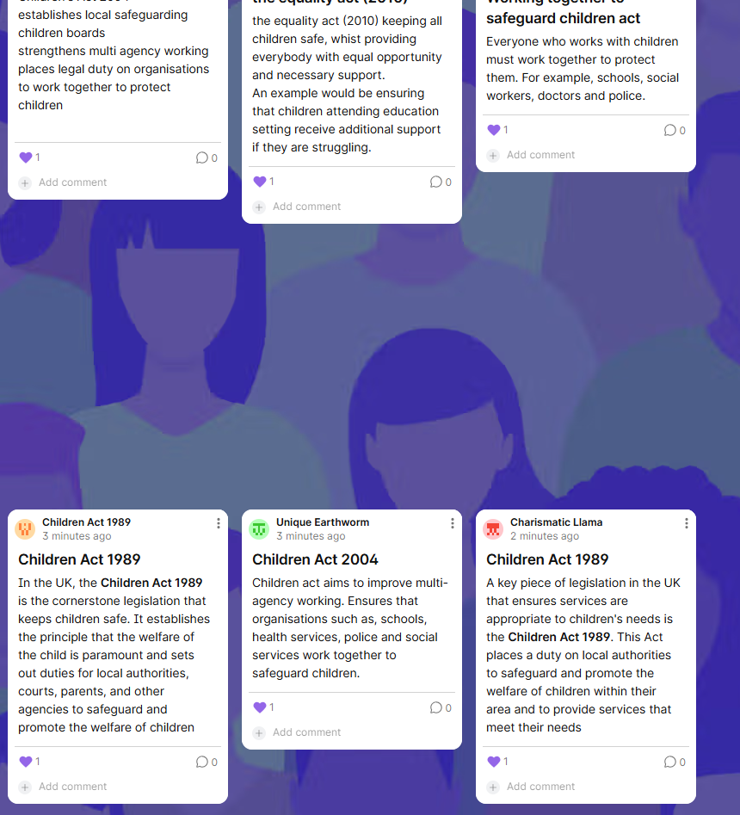

This screenshot shows learners posts on the Padlet board created during the legislative research task. Each student contributed independently by summarising a different Act and providing an example of its application to inclusive practice. The variety or responses, text explanations and bullet points demonstrates how Padlet supported differentiation creativity and learner autonomy. It also evidences real time collaboration as a collection of shared knowledge is built that they can later use during group discussions and assignment preparation.

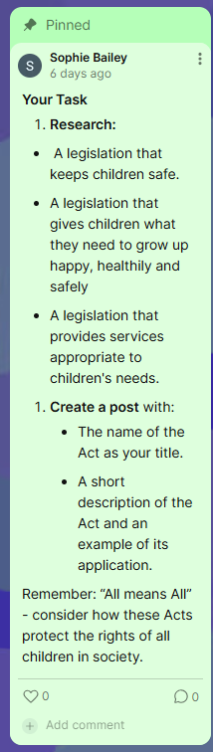
This screenshot shows the task instructions pinned to the top of the Padlet board, providing students with a clear, accessible reference point throughout the activity. The instructions outline the research task. Pinning these instructions ensured that learners could work independently and at their own pace, reducing reliance on repeated verbal clarification. This design choice supported inclusive practice by enabling all students to engage confidently with the tasks.
The reminder to consider the principle and name of the module being All means All reinforces the sessions focus on inclusion and ensured learners made explicit links between legalisation and inclusive practice, as outlined in the lesson plan. Overall, this screenshot is evidence of intentional scaffolding, clarity of expectations and effective integration of the digital tool to support learner autonomy and understanding.

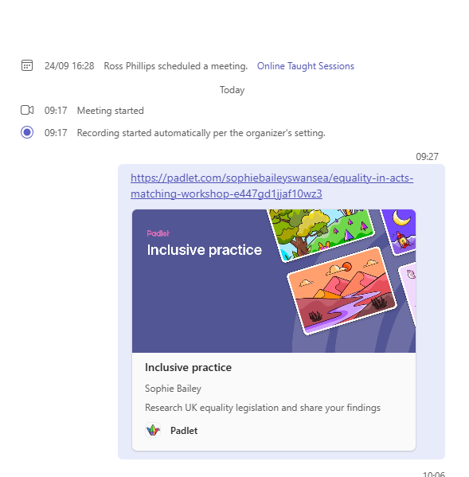
This screenshot is evidence in how the Padlet link was shared with learners in the live online session. Sharing the collaborative board through teams ensured accessibility for all learners and reflects good digital practice by embedding the tool within familiar platforms. It also supports the principle of universal design for learning by providing multiple access points to the resource.

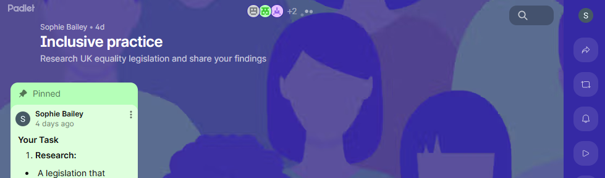
This screenshot captures learners actively engaging with the task in real time. The visible posts and timestamps demonstrate participation and progress showing that students understood the task and could independently navigate the digital tool. This evidence supports the lessons plan’s focus on developing autonomy, critical engagement with legislation and the ability to present information using technology.

Within the appendices of this portfolio, you will find a lesson plan with the integration of this Padlet activity. The lesson plan clearly demonstrates where the Padlet was used and integrated to support learners research into United Kingdom equality and safeguarding legislation. The Padlet activity is purposefully placed after the introduction of key concepts allowing learners to apply their understanding by creating their own posts. This aligns with the session’s learning outcomes by promoting independent research, collaboration and the use of digital tools to organise information. The plan shows that Padlet was not used as an add on, but as a structured part of the learning sequence designed to enhance engagement, support inclusive practice and provide a shared space for learners to present and compare their findings.

Evaluation and Reflection (812 words)
Evaluating the use of Padlet within a post sixteen sector requires a critical examination of its implementation, impact on learner engagement and alignment with the intended learning outcomes. The digital tool was introduced to promote collaboration, creativity and inclusive participation during a session within the “all means all” module. These aims aligned with the TPACK framework and the Welsh Professional standards, which empathises purposeful digital pedagogy, learner centred design and reflective professional practice. The following evaluation considers evidence from learner feedback, observation and self-reflection to assess the effectiveness of Padlet and its implications for future practice.
The intended outcomes of the session were to enhance learners understanding of inclusive educational principles while fostering collaboration and enabling creative expression through multimodal contributions. Padlet was chosen for its capacity to support these aims by providing an accessible digital space in which students could contribute text, links and audio reflections. Initial observation indicated that the tool effectively facilitated real time collaboration with students building upon each other’s posts. This aligns with Davies et al (2023) who found that collaborative digital; tools support deeper understanding and reasoning by enabling learners to refine ideas collectively.
Student feedback suggested that Padlet added value to the session. Several students reported that the anonymous option reduced pressure allowing them to contribute and quieter students where able to contribute without fear of judgement. This reflects Livingstone et al. (2022) who discussed that anonymous or low risk digital spaces can reduce participation anxiety.
However, the evaluation also revealed areas in which the implementation was less effective than intended. A small number of students reported difficulty in navigating Padlet, which led to some delays in contribution. Although Padlet is generally self explanatory, it’s multimodal design and features can overwhelm some students who are not familiar with its layout or with digital platforms as a whole. This observation echoes findings by Jones and Attard (2023), who argue that insufficient digital confidence among learners is a persistent challenge in further education settings. To address this isn future practice, providing a short demonstration to students or a scaffolded task at the start of the lesson may help build student confidence and reduce cognitive load.
Another challenge related to the depth of contributions. While many learners posted meaningful research information, others added less meaningful findings and merely just posted a comment or two suggesting varying levels of engagement. This highlights a broader challenge with collaborative digital tools that although they can facilitate participation, they do not guarantee quality of contribution. As Nicole and McCallum (2023) emphasise, effective peer interaction requires clear guidance and modelling. In future sessions, incorporating expectations and peer feedback expectations may encourage deeper engagement and thinking.
Reflecting on the link between intended and actual outcomes highlights areas where Padlet had a strong impact on learning. The tool supported socio-constructivist learning by enabling a collaborative meaning making, consistent with Vygotsky’s (1978) emphasis on social interaction. It also demonstrated alignment with the Welsh Professional standards, particularly collaboration and Pedagogy by amplifying student voices and promoting interactivity. Many students felt more involved in the activity stating that the digital tool Padlet made it easier to understand and see the range of perspectives in the room. This suggested that the tool was used successfully an in line with the Welsh Professional Standards.
In terms of professional development, the experience reinforced the importance of modelling digital competence and adopting a reflective approach to digital innovation. The addition of the digital tool Padlet demonstrated is potential to improve pedagogy but also highlighted that technology is most effective when guided by clear pedagogical intent rather than novelty. This is consistent with Selwyns (2022) discussion that digital tools only add value when thoughtfully embedded within learning design. In future practice, greater emphasis will be placed on aligning each digital activity with explicit learning objectives and success criteria.
The evaluation also underscores the need for ongoing digital professional learning, particularly regarding accessibility and ethical digital practice. Engaging with emerging and historical research can income decision making when selecting digital tools, ensuring that choice remain inclusive and evidence based, Future practice will include trialling Padlet in additional lessons and gathering further learner and tutor feedback and experimenting with peer review and collaborative tasks to deepen engagement.
Overall, the implementation of Padlwet had a positive impact on learner engagement, inclusion and creative expression. Although minor challenge relating to digital confidence and clarity of expectations arose during the lesson the teacher was able to identify and is now looking to further predict this is in planned lesson when using Padlet. These reflections have informed a clearer understanding of how digital tools can be utilised more effectively in post sixteen teaching. By continuing to apply the principles of TPACK framework, the Welsh professional standards and evidence informed pedagogy, future practice will be strengthened through more intentional, ethical and learner focused integration of digital technologies.

Reference list
- Bayne, S., Evans, P., Ewins, R., Knox, J., Lamb, J. and Macleod, H. (2022) The Manifesto for Teaching Online. 2nd edn. London: MIT Press.
- Benmayor, R. and McCarty, C. (2022) ‘Digital Storytelling and Creative Collaboration in Higher Education’, Journal of Digital Learning in Teacher Education, 38(3), pp. 261–273.
- Bruner, J. (1966) Toward a Theory of Instruction. Cambridge, MA: Harvard University Press.
- CAST (2018) Universal Design for Learning Guidelines Version 2.2. Wakefield, MA: CAST.
- Chen, R. and Chugh, R. (2021) ‘Student Privacy and Data Protection in Online Learning: A Review of Ethical Concerns’, Education and Information Technologies, 26, pp. 7601–7623.
- Chew, E. and Blewitt, J. (2023) ‘Digital Platforms for Collaborative Learning: Exploring the Impact of Padlet in Higher Education’, Interactive Learning Environments, 31(2), pp. 284–299.
- Çebi, A. and Dinçer, S. (2023) ‘Digital Literacy Development Through Collaborative Online Tools’, Journal of Computer Assisted Learning, 39(1), pp. 123–139.
- Davies, M., Grainger, P. and Diepeveen, L. (2023) ‘Digital Concept Mapping as a Tool for Deep Learning in Post-Compulsory Education’, British Journal of Educational Technology, 54(4), pp. 1250–1265.
- Education Workforce Council (2017) Professional Standards for Teaching and Leadership. Cardiff: Welsh Government.
- Hamilton, D., McKechnie, J. and Edgerton, E. (2023) ‘Exploring Virtual Reality as a Tool for Creative Learning in Further Education’, Computers & Education, 194, 104676.
- Holmes, W., Bialik, M. and Fadel, C. (2022) Artificial Intelligence in Education: Promises and Implications. Boston, MA: Center for Curriculum Redesign.
- Ifenthaler, D. and Gibson, D. (2022) ‘Data-Driven Decision-Making in Education: Current Trends and Future Directions’, Journal of Learning Analytics, 9(1), pp. 1–14.
- Jones, A. and Attard, A. (2023) ‘Teachers’ Experiences of Implementing Digital Tools: Professional Development Challenges and Opportunities’, Teaching and Teacher Education, 121, 103926.
- Kalio, T. and Koivisto, J. (2024) ‘Generative AI in Education: Creative Opportunities and Integrity Challenges’, British Journal of Educational Technology, 55(1), pp. 100–116.
- Koehler, M.J., Mishra, P. and Cain, W. (2022) ‘TPACK: Twenty Years of Research and Trends’, Educational Technology Research and Development, 70(4), pp. 1429–1454.
- Lim, C. and Har, C. (2023) ‘Collaborative Digital Creativity: Exploring Students’ Creative Processes in Online Learning Environments’, Computers in Human Behaviour, 139, 107563.
- Livingstone, S., Stoilova, M. and Nandagiri, R. (2022) Children’s Data and Privacy Online: Growing Up in a Digital Age. London: LSE.
- Luckin, R. (2023) AI for School Teachers. London: Routledge.
- McGrew, S. (2023) ‘Teaching Online Source Evaluation: A Review of Research and Practice’, Review of Educational Research, 93(1), pp. 3–33.
- Mishra, P. (2020) ‘Considering Contextual Knowledge: The Fourth Pillar of TPACK’, Teachers College Record, 122(1), pp. 1–24.
- Nicol, D. and McCallum, N. (2023) ‘Peer Review and Feedback Literacy: A Dialogic Approach’, Assessment & Evaluation in Higher Education, 48(3), pp. 334–348.
- Ofcom (2023) Online Nation 2023 Report. London: Ofcom.
- Qian, Y., Ahmad, Z. and Kim, J. (2022) ‘Digital Storytelling for Creative Learning: A Systematic Review’, Computers & Education, 182, 104467.
- Redecker, C. (2023) European Digital Competence Framework for Educators: Updated Guidelines. Luxembourg: Publications Office of the European Union.
- Ruiz-Palmero, J., Gómez-García, M. and Sánchez-Rivas, E. (2022) ‘Perceptions of University Students Towards Padlet for Collaborative Learning’, Education and Information Technologies, 27, pp. 4373–4392.
- Runco, M. and Jaeger, G. (2012) ‘The Standard Definition of Creativity’, Creativity Research Journal, 24(1), pp. 92–96.
- Selwyn, N. (2022) Education and Technology: Key Issues and Debates. 3rd edn. London: Bloomsbury.
- UNESCO (2023) Global Education Monitoring Report: Technology in Education. Paris: UNESCO.
- Vygotsky, L. (1978) Mind in Society: The Development of Higher Psychological Processes. Cambridge, MA: Harvard University Press.
- Waghid, Z. and Waghid, F. (2022) ‘Examining the Use of Padlet to Promote Critical Digital Literacy in Higher Education’, Education and Information Technologies, 27, pp. 13517–13533.
- Welsh Government (2017) Professional Standards for Further Education and Work-Based Learning Practitioners. Cardiff: Welsh Government.
- Williamson, B. and Kizilcec, R. (2023) ‘Algorithmic Education: Student Data, Surveillance and Ethics’, Learning, Media and Technology, 48(1), pp. 1–15.

Appendices

Lesson Plan Template



Lesson Plan

Topic: Introduction to All Means All |  | Class: Level 5
Date: Monday 1st December | Length of lesson: 2 Hours |  | Number of students: 8
Resources required:
Power-point presentation
Padlet resource
Microsoft teams

Aim of Lesson

- To understand the concept of inclusion and the nature of additional learning needs.​
​
- To develop an understanding of the implications of additional learning needs (ALN) for society as a whole.​

Learning Outcomes – The Learners Should Be Able To:

- Analyse issues relating to good practice for inclusion.​
​
- Recognise and show appreciation of the range of values attitudes and skills needed to live in a diverse society.​
- Critically engage with issues of diversity from a legislative, historical and contemporary perspective.
- ​Organise their knowledge and learning through the use of a range of information sources, including ICT and present their work at the appropriate level.

Previous student knowledge required for the session:

  - Basic understanding of inclusion
  - Familiarity with the idea of Diversity and Equality
  - Awareness of previous Child or Education Legislation
  - Basic English or Welsh writing skills
  - Ability to partake in

Anticipated difficulties (if applicable):

Technical issues for both Lecturer and students.
Students not understanding complex legislation.

Professional Standards (where are these being met within the session)

1: Demonstrate commitment to learners, their learning, safety and well-being:
  - Creating a safe place for discussion on inclusion, ALN, diversity and rights
  - Stepping out activity with sensitivity to power dynamics and wellbeing
  - Clear instructions, structured tasks, scaffolded discussion
  - Ensuring learners have examples, context and assignment links to support success

2: Value and promote diversity, equality of opportunity and inclusion:
  - Topic “All means All” is entirely based on inclusion
  - Activities challenge stereotypes (Stepping out activity)
  - Children’s Rights Wales task explicitly connects inclusion and equality
  - Exploring legalisation that protects all children (Padlet task)

3: Understanding the importance of Welsh culture and language as a bilingual nation
  - Children’s rights Wales is a Wales- specific framework
  - ALN and Tribunal Act 208 is Welsh legislation
  - Discussion relates to how inclusion operates within Welsh law and systems.

4: Demonstrate dignity, courtesy and respect towards others:
  - Discussion on stereotyping builds respect and empathy
  - Group discussions and breakout rooms require respectful interaction
  - Lecturer reminders to thank students and value contributions

5: Maintain and update knowledge of my subjects and how best to teach and assess them:
  - ALN legislation (ALNET 2018)
  - Children’s rights Wales
  - Curriculum for Wales
  - Inclusion theory
  - Effective formative questioning and scaffolding.

6: Know how to use evidence and research to improve my practice:
  - Students are instructed to research legislation
  - Discussion of theory, historical context and contemporary perspectives
  - Linking theory directly to their assessment task
  - Use of digital tools (padlet, teams) to capture evidence of learning.

7: Plan and deliver effective learning, teaching and assessment:
  - A clear, scaffolded progression from intro- theory – legalisation and application
  - Pair and group activities and breakout tasks
  - Whiteboard and Padlet Formative assessment opportunities
  - Use of a video to support varied learning styles
  - Clear learning outcomes linked to activities.

8: Build positive and collaborative relationships
  - Breakout rooms for collaborative discussion
  - Electing a spokesperson in groups
  - Students working collectively on Padlet
  - Lecturer modelling respectful behaviour and thanking contributions

9: Enable learners to share responsibility for their own learning and assessment:
  - Student choses Acts to research
  - Students create their own Padlet posts
  - Birth month character activity encourages reflection on their own values
  - Whiteboard task asks them to generate definitions and justify them
  - Students can relate content to their own assignment choices.

10: Critically reflect on own values, knowledge and skills to improve learning:
  - Activities explicitly challenge bias, stereotypes, judgments and assumptions
  - Discussions on inequality, inclusivity, rights and ALN
  - End of lesson reflection questions (“How does this help inclusive practice”)

11: Demonstrate a commitment to sustainability
  - Highlighting sustainability within the curriculum or Wales
  - Discussing sustainable systems in education
  - Broadening “inclusive practice” to include sustainable societal wellbeing

Lesson Detail:

Stage | Focus | Strategy | Time
Introduction  This is where the Padlet was used within my lesson  Ongoing slides | What is meant by the Term ALN?  Rules and Law  Inclusive Practice and the law.  Stepping out activity/ Children’s Rights Wales.  Children’s Rights Wales.  Additional Learning Needs and Education Tribunal (Wales) Act 2018.  Additional Learning Needs (short video).  Aims of the Bill  ALN Tribunal (Wales) Act  Common Types of ALN  What might this look like?  The curriculum for Wales.  Conclude | Using a teams whiteboard ask students to write down any words associated with the term Additional Learning Needs.  - Remember to ask students how they can define what they’ve stated? Remember to thank them for what they have done.  Padlet link: https://padlet.com/sophiebaileyswansea/equality-in-acts-matching-workshop-e447gd1jjaf10wz3/wish/lDK1ZRjbyovMZJ9z.  - Ask students to complete individually research on: A legislation that keeps children safe.  - A legislation that gives children what they need to grow up happy, healthy and safely  - A legislation that provides services to appropriate to children’s needs.  They need to create a post with: The name of the Act as their title and a short description of the act and an example of it’s application. (Remember All means All- consider how these Acts protect the rights of all children in society).  Recap discussing how Children’s Rights Wales help with inclusive practice what does it do etc? In breakout rooms choose 2 of the acts on the slide and as small groups discuss and elect one person to feedback on how they can help in achieving inclusive practice.  Break 10 minutes (If Ross hasn’t given them a break yet)  Introduce the activity. Ask students to select their birth month character. Remind students to make stereotypical judgments about their character profile. When asking the questions in the activity ask students to raise a finger to if they can do the statements as this character. After the activity remember to discuss:  - What are the main differences between the characters (Age is the Answer).  - Explain that adults often make decisions about children and young people’s lives and hold more power. This is why we have children’s rights and a children’s commissioner to help and support children and young people.  Present an overview of Children’s Rights Wales. Ask students to discuss how this would affect children with Additional Learning Needs. Link to the assignment (the background section of the guide) Any theories or research students have found as-well as any I’ve given them.  Remind students that this Act is a key document for this assignment. Talk about experiences with it and a few examples if can.  Before the video ask students to note down:  - Why was a new additional learning needs act required?  - What are some of the changes?  Talk through the aims of the Bill and expand on the programme. Rember to see if anyone has any questions?  Consider what “special education” implies. Is it outdated? etc  Make the link to an assignment  Do not have to use examples on the board use some other examples while talking to so they are encouraged to not just use what is situated on the slide.  Carry on discussing what It would look like including instability in many aspects of like including jobs, education friends, impulsive behaviours memory etc.  Talk about the new curriculum and how this helps with experiences in education systems. With the last slide then, can these be used to plan for an individual with ALN?  What can be the issues with this?  Any questions about today’s topics?  Anyone have a good idea on their assignments and what they are picking? See you all Thursday. | 10 mintues  10 -15mintues  15- and 5-minute recap after break minutes  10 minutes  With video 15 minutes  20 minutes  5 minutes  10 minutes  5 mintues

Assessment Strategies: when and how are they included within the lesson?

Assessment strategies here embedded throughout the session using a range of formative approaches to monitor learning and support progress. The lesson began with diagnostic questioning and early discussion to assess learner’s prior understanding of ALN and inclusion. Formative questioning was used to continuously to check for comprehension and thinking to a critically degree. The Padlet activity allowed for individual assessment of learner’s ability to research legislation, summarise acts and apply them to inclusive practice. Collaborative assessment took place during the breakout room task, where learners discussed selected Acts, and applied them to real world scenario, followed by whole-class feedback that enabled the lecturer to assess group reasoning and correct misconceptions. The stereotype activity provided an opportunity to asses learners reflective thinking and understanding pf bias and power in relation to children’s rights. The ALN video, accompanied by purposeful note-taking prompts, allowed assessment of learner’s comprehension of key legislative changes. With a reflective activity at the end learners will be able to demonstrate their understanding of ALN concepts at the end of the session. Throughout, the lecturer provided ongoing verbal feedback and concluded by assessing learners’ readiness for their assignment through a brief discussion of their ideas.

Informal reflection (to be completed after the session)

The level 5 group can be challenging due to their quiet and reserved nature and don’t often feel happy enough to contribute towards whole class discussions. However, the introduction of Padlet in this session helped many of them come out of their shells. The anonymous posting option enabled students to participate without fear of judgement and the multimodal format allowed learners who usually remain silent to express their understanding confidently through short summaries, visuals and examples. Engagement was noticeably strong then in previous sessions, with learners commenting that the sharded Padlet space felt less intimidating. A technical issue occurred when the team’s whiteboard failed to load but this required me to adapt quickly by asking students to contribute their definitions in the group chat instead. This unplanned change modelled digital flexibility and maintained the flow of learning without disrupting the lesson. Reflecting on the experience, this session reinforced the value of using accessible digital tools to reduce learner anxiety. Going forward I will continue integrating Padlet and similar platforms to support learner confidence and I will prepare simple alternatives for any planned digital activity to ensure continuity of learning regardless of technical challenges.

