

INDIVIDUAL BLOG
(REPORT)

1)BA Business Managements
Marketing Fundamentals
Lecturer. Dr Piyumika Kithulgoda Gamage
2) Ivan Sendrev (2235334)

Introduction
Marketing is an activity or a process for creating, communicating, and delivering values to the consumers according to their needs and wants. Marketing includes all aspects of business such as product development, sales, distribution method and advertising. To understand the fundamental concept of marketing TESCO PLC has been taken & exampled into consideration in this blog. Company is a well-known multinational retailer brand in the UK. Tesco, founded by Jack Cohen in 1919, since then Company expands geographical into retail industries like books, fashion (clothes), electronics, and kid’s toys, as well as range of financial services, telecommunications (phones, laptops, tv’s), and internet service divisions. Tesco remodeled & reinvented itself from a low-cost shop to one that appealed to a wide range of socioeconomic groups in the 1990s by presenting a selection of own-label products ranging from 'Tesco Value' goods to its 'Tesco Finest' line. It operates in a variety of store sizes, from Tesco Extra to larger supermarkets that provide all of Tesco's product lines as well as a full selection of non-food goods, to 'One Stop' (Tesco local) stores, which are small customers stores. The following blog is going to cover the detail STP and marketing mix analysis of the chosen company (Kotler, 2019).

STP ANALYSIS (SEGMENTATION, TARGETING AND POSITIONING)

Segmentation, targeting and positioning commonly known as STP analysis, is a strategic approach of marketing which helps the businesses to analyze their target market and audience hence it contributes to deciding the location where the brand can be positioned (Tyagi, 2023). Tesco is the chosen company for this blog. It is a British multinational retailer which deals in grocery and general merchandise. The blog is about the STP analysis of the company to analyze the company’s segmentation, targeting and positioning of its goods. This model will be helpful for the business in segmenting their audience based on demographic, psychographic, geographic, and behavioral. The business will be able to target appropriate customers and put its products and services among the customers appropriately.
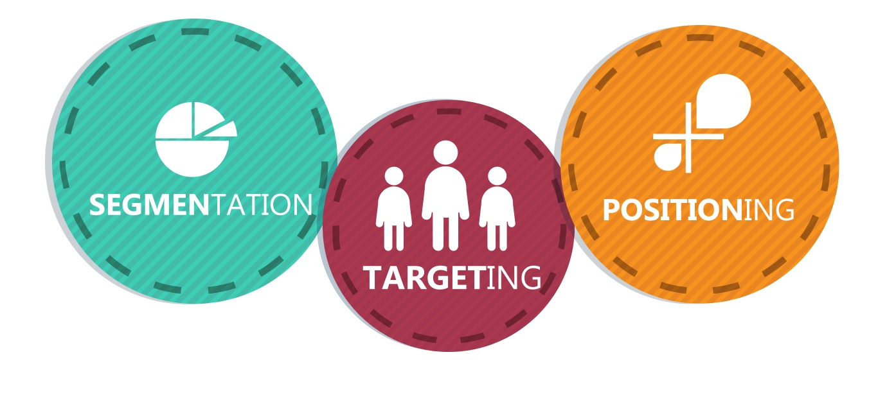
Figure 1, A Beginner’s Guide to STP Marketing, Hamzah Shaikh, 2020

Segmentation:
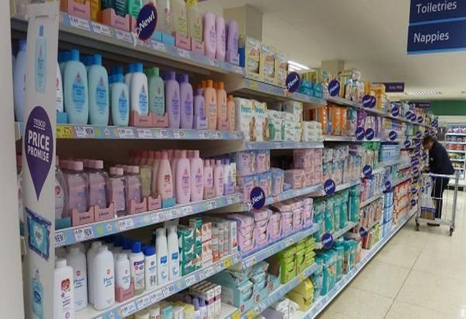
It is the process of dividing the large markets into smaller ones to analyze the customer groups more effectively (Wang and Chang, 2021). The segments are since four groups including - demographics, psychographics, geographic and behavioral. Tesco is one of the biggest retailers in the world that uses a variety of segmentation techniques to connect with diverse client demographics (Cao and et. al., 2022). The company has its branches in different countries where it segments its consumer based on the interests and demands of each market. For example, it may provide a variety of goods or services based on regional tastes and preferences.
Demographics: Tesco offers services to a variety of demographics, including those based on age, income, and occupation (Dibb, 2019). It provides goods and services geared towards various age groups, including retirement planning services, health and beauty products and infant products. For example, Tesco offers various discounts to the students and has separate sections for baby products (Tesco, 2023).
Psychographic: Tesco considers its consumers' beliefs, attitudes and way of life while creating psychographic segments. For example, it provides luxury goods for those looking for excellent quality as well as organic and nutritious food selections for people who are health conscious (Tesco, 2023).
Geographic: It is the segmentation of the customers according to the location based on the different geographic region. As per this segmentation, Tesco segments the customers as per different geographic locations they are operating at, and they customize their stores according to the specific requirement of the location and customer.
Behavioral: Tesco analyses consumer behavior, including frequency and history of purchases, to segment its client base and personalize its products (Romppanen, 2021). Through its Clubcard reward program, it offers personalized discounts and promotions based on individual purchasing patterns (Tesco, 2023). Tesco Express focuses on the low- and middle-income category which are working class, skilled workers meanwhile Tesco superstore focuses on the middle- and high-income category which have high income.
Targeting

It is the process of choosing a specific group of people as target market because of product they are offering, demands for the products, customer needs and others. Targeting is crucial as it allows the businesses to find relevant customers and maintain the base accordingly. In the case of Tesco, the company divides the market into different target categories after which it decides whom to consider the target market.
Tesco has a varied targeting approach in which it concentrates on several market segments with various products (ZXhang, Haxo and Mat, 2023). Tesco hopes to draw clients from a variety of market groups by providing a wide range of goods and services. To meet the demands of diverse target groups, it offers various store styles including Tesco Extra, Tesco Metro and Tesco Express.
Income: The customers are also targeted based on their incomes. High-income people are the main target audience for luxury and branded products while Tesco also caters to different income brackets by providing both low-cost and expensive solutions (Taqatqa, 2021). Tesco Finest and Tesco Value are two of its private label brands that target certain client demographics.
Positioning
Positioning entails forging an individual and appealing picture of a brand in the eyes of consumers in comparison to rivals. Tesco has positioned itself as a retailer that prioritizes convenience, quality, and value for its customers (Moura, 2021). There are various strategies which are being used by other businesses to position its brand among the customers so that the sales can be enhanced, and the business can also gain per year revenue.

Convenience: Tesco's extensive network of locations, which includes huge hypermarkets, compact supermarkets, and convenience stores, has helped the company build a strong presence (Thomas and George, 2021). Customers may easily access its products and services since it provides a variety of shopping options, including physical storefronts, online marketplaces, and mobile apps.
Tesco wants to provide its consumers with items of the highest caliber. Tesco Finest and Tesco Organic are examples of its own private label products that have been established and are marketed as premium choices (McDougal and et. al., 2021). To strengthen its status as a premium retailer, Tesco also emphasizes food safety and sustainable sourcing.

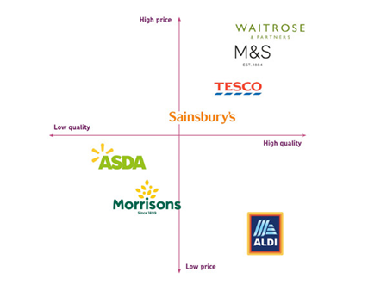
Value: Tesco is renowned for its value promise, which includes low pricing and frequent sales to draw in customers who are sensitive to price. Price match guarantees and the Clubcard loyalty program, which provides consumers with extra benefits, help to further improve the value offering (Kampamba, 2020). Tesco’s corporate social responsibility programs, which include efforts to cut down on food waste, aid local communities, and promote environmental sustainability, have an impact on the company's position as well. These programs help Tesco maintain its standing as a trustworthy and moral store.
MARKETING MIX (7Ps)

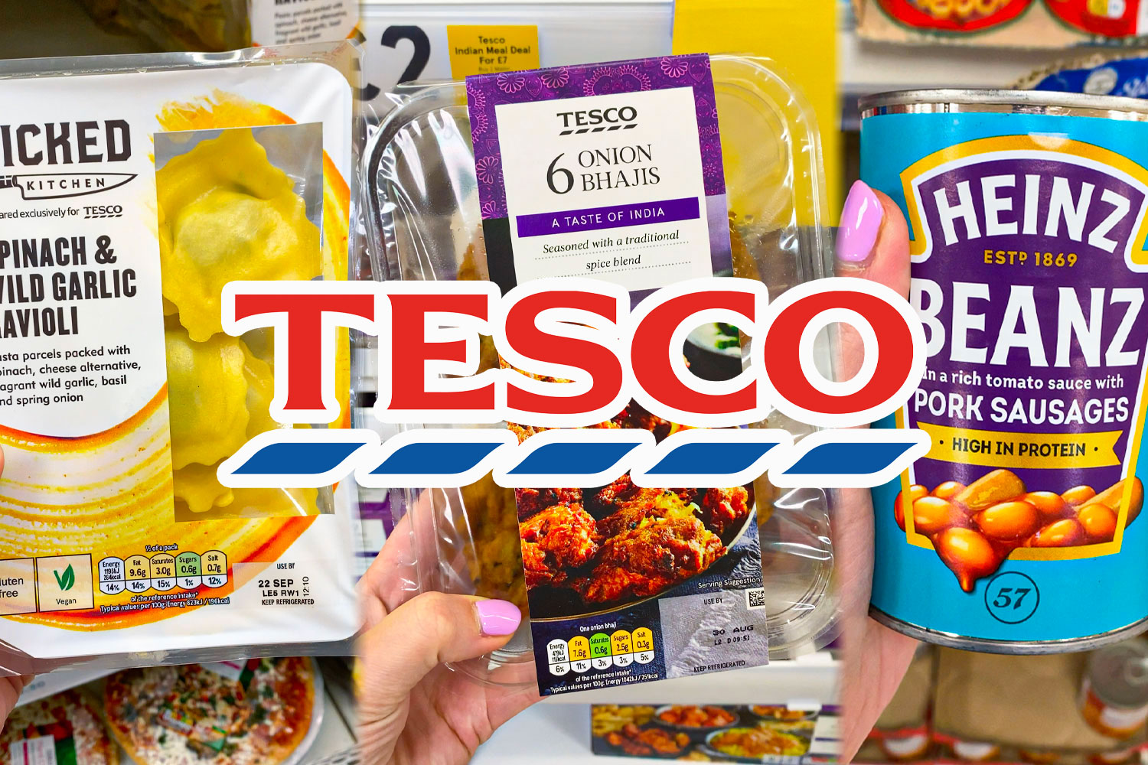
The marketing mix, commonly referred to as 7Ps, is a framework which allows the business to create and implement different strategies to attain competitive advantage (Darmawan and Grenier, 2021). According to the Kotler & Armstrong 15/16th edition, there are 7 marketing principle which is known as the 7Ps of marketing Mix. The 7Ps are - Product, Price, Place, Promotion, People, Process and Physical Evidence, respectively. It is also known as principles of marketing which allows a business to identify their products and promote them to the people, they are targeting to enhance sales and revenue (Kotler and Armstrong, 2023).
Tesco is the chosen organization for this blog. It deals in groceries and general merchandise and has its headquarters in England, the UK. This blog is regarding the marketing mix analysis of Tesco.
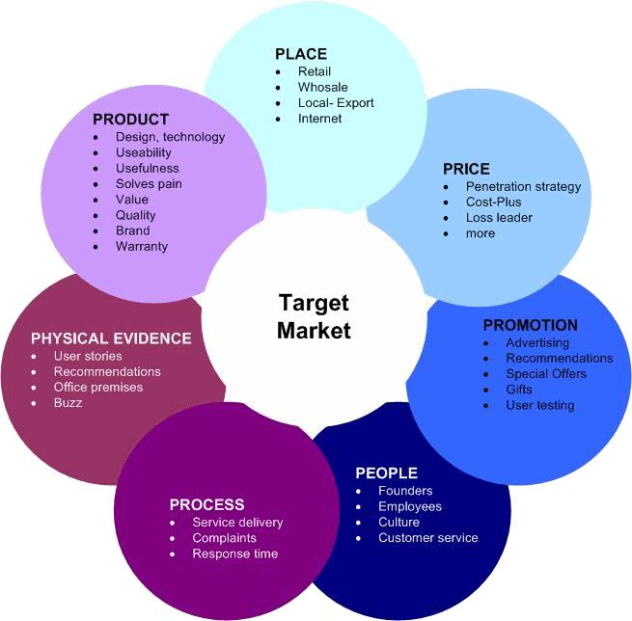
Product: These are the finished things that a company sells to its clients (Lahtinen, Dietrich, and Rundle-Thiele, 2020). Tesco provides its clients with alternatives based on their budget and desired degree of quality through its own private label brands such as Tesco Finest and Tesco Value, Tesco Loves Baby, Tesco Lotus, Tesco Bank and much more (Tesco, 2023). For example, the management of Tesco redesigned its finest coffee brand packaging with an innovative design and packaging strategy (Tesco, 2023). The new and detail packaging make the finest coffee different and uniquely delicious.

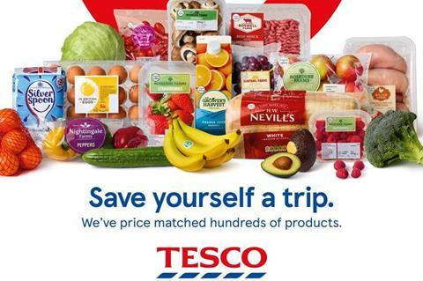
Price: A company might provide different pricing techniques to establish the cost for their items. The price at which a product or service is formed and sold to a consumer (Hanaysha, Al Shaikh and Alzoubi, 2021). Tesco applies come-own pricing techniques to acquire more customers while remaining competitive. Value pricing on everyday products ensures that companies like Tesco are perceived as a cost-effective option by shoppers. Tesco also provides price discounts, loyalty programs, and price match warranties to consumers to deliver the best value possible.
Perceptual map
With an effective value proposition to clients, the external environment is the most crucial success component. Similarly, the Microenvironment indicated that the danger from suppliers was strong, but the likelihood of a new market competitor joining the market was seen as less effective. More study is being done to understand market segmentation approaches, including demographic, behavioral, and geographical segmentation. Furthermore, this report includes the firm's intended client base with market positioning. However, by maintaining strong market positions, the corporation has provided value to society, stakeholders, and customers.

The company's management has implemented a competitive pricing plan for its products to attract price-conscious customers. They actively monitor their competitor’s products’ prices and compare them to make sure that they remain competitive in the market and provide excellent quality products. For example, TESCO has prioritized its everyday low-price approach. This strategy includes setting competitive prices on a variety of products to ensure that consumers see Tesco as an affordable option for their shopping needs (Tesco, 2023). For example- discounts, colleague cards pricing and loyalty card pricing etc.
Place: It is the location where the businesses make their products or services available to their customers (Syapsan, 2019). Tesco has a multichannel distribution strategy and has a significant footprint. They use direct or indirect distribution or both, for example they deliver online as well as have physical stores. Hypermarkets, supermarkets, and convenience stores are examples of the physical modes for retailing the goods. The company also makes its goods and services available over internet with the online delivery. Customers may easily shop at Tesco from anywhere due to its mobile applications and web platform Tesco.com. The Omni-channel strategy improves accessibility and convenience for customers. It is helpful for the business to approach a greater number of customer base because of the thoughtful positioning of its outlets in various places (Jocevski, M., and et. al., 2019).
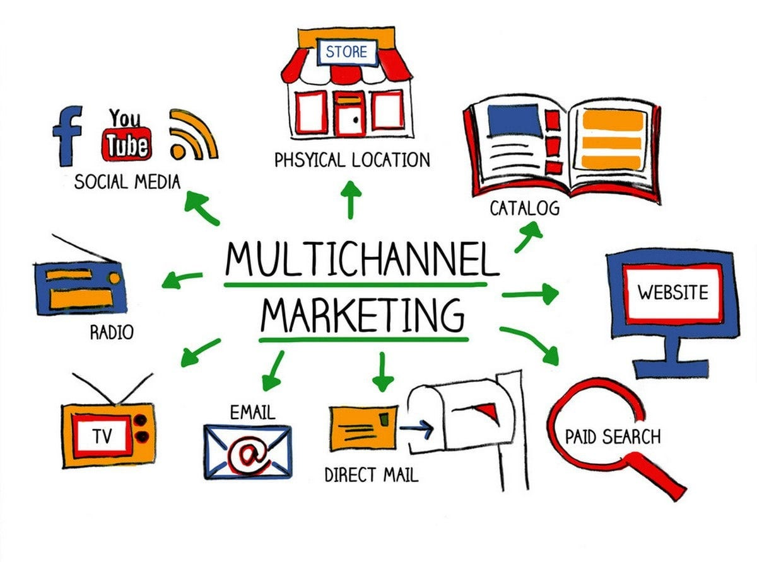
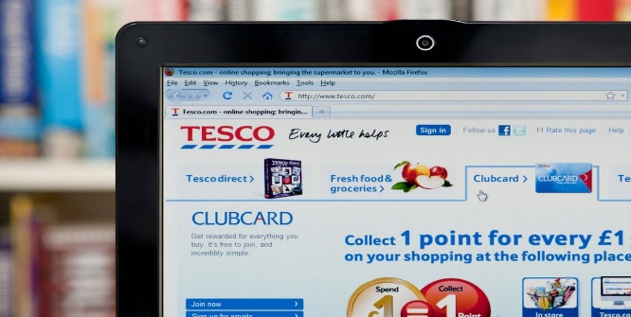
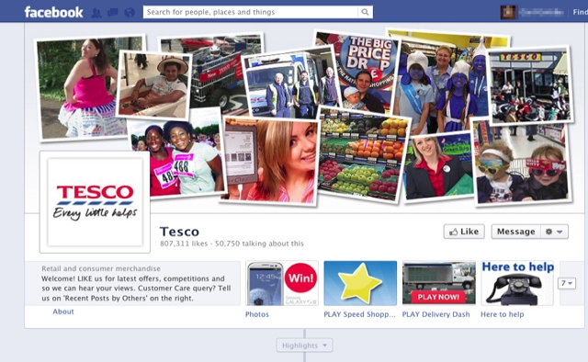
Promotion: These are the ways which a business uses to make their customers aware of the presence of their goods and services with the help of different modes of advertising and promotional strategies (Chautard and Collin-Lachaud, 2019). Tesco uses a variety of promotional methods to enhance brand awareness and boost sales. To reach a large audience, it uses mass media advertising on TV, radio, print and internet platforms. Through its Clubcard program, Tesco also performs targeted advertising campaigns with discounts, loyalty schemes and unique incentives. It regularly engages with clients on social media channels and disseminates pertinent information.

People: These are the individuals or the people who are associated with the business including its customers, employees, or other stakeholders. People are essential for businesses to provide excellent customer experiences (Sudari and et. al., 2019). To maintain a strong customer base, Tesco places a strong emphasis on educating and developing its employees to deliver improved customer service. It places a strong emphasis on appointing qualified, experienced workers who can efficiently manage the customer base. Tesco's staff members are qualified to interact with customers, respond to questions and help, all of which help to make shopping enjoyable. There are approximately 354000 worldwide number of people working for Tesco in 4859 stores who are playing a very crucial role in enhancing the reputation of the company (Tesco, 2023).
Process: It is the stage at which it is determined how the product or service will be supplied to the customers. There is a different process involved in manufacturing and distributing items to clients. (Jobber and Ellis-Chadwick, 2019). Tesco constantly strives to make improvements to its procedures to increase productivity and customer happiness. It makes investments in technology and systems to automate inventory control, supply chain management, and checkout procedures. To make paying easier for consumers, Tesco also provides a variety of payment methods, including cash, credit cards and mobile payments. A flawless shopping experience is ensured by the emphasis on efficient and smooth operations (Tesco, 2023).
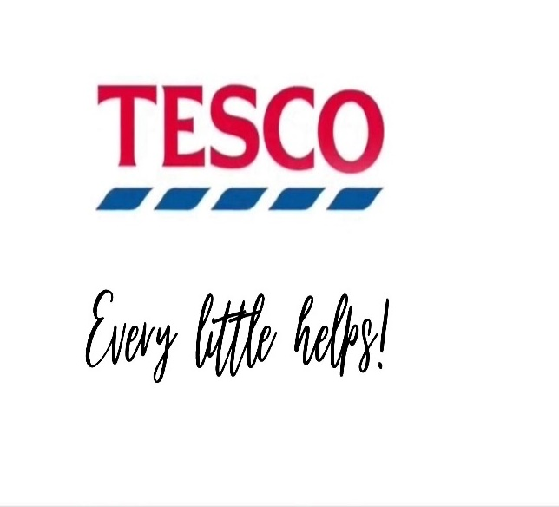
Physical evidence: The tangible objects that customers interact with while shopping are referred to as physical evidence (Kumar, Shankar and Aljohani, 2020). This is any physical proof or anything which the customers can touch, feel, and observe. Tesco takes care to keep its stores tidy, clean, and well-maintained so that customers may enjoy their time there. It includes the tangible illustrations of a company such as furniture, aprons, menus, brochures, letterhead, business cards, reports, signage, and equipment to direct consumers and improve their experience. The tangible proof makes a good first impression and enhances Tesco's brand reputation.
Conclusion
From the above blog it has been concluded that STP model allows businesses to analyze the target market and different segments of the customers along with positioning strategies which further helps the businesses to put their products among their customers. It will be helpful for the businesses in enhancing the sales and profits by making the products available in the right place for the right customers. With the help of this model, the business becomes able to segment its customers and target relevant markets accordingly. The company will be able to position the product among the customers on different platforms. Also, this blog concludes that marketing mix is a strategic framework which allows the businesses to identify their goods and services which they are offering to their customers as per their desires. This model also allows in implementing strategies for promoting and fixing the price for various products. They can also become able to decide the location where they must sell their products or make them available to their customers. The business has become able to represent their products among the customers with different promotional strategies. Additionally, they will be able to analyze suitable locations to place its product as per the targeted people, which will be further helpful in enhancing sales and revenue for better success in the prospective long term.

References

Cao, S., and et. al., 2022, January. Marketing Strategy of Distribution Network of Power Supply Company. In Innovative Computing: Proceedings of the 4th International Conference on Innovative Computing (IC 2021) (pp. 109-116). Singapore: Springer Nature Singapore.

Chautard, T. and Collin-Lachaud, I., 2019. Introducing the storytelling analysis methodology in marketing: Principles, contributions and implementation. Recherche et Applications en Marketing (English Edition), 34(3), pp.27-46.

Darmawan, D. and Grenier, E., 2021. Competitive Advantage and Service Marketing Mix. Journal of Social Science Studies (JOS3), 1(2), pp.75-80.

Dibb, S., 2019. Market segmentation: strategies for success. Marketing Intelligence & Planning, 16(7), pp.394-406.

Hanaysha, J.R., Al Shaikh, M.E. and Alzoubi, H.M., 2021. Importance of marketing mix elements in determining consumer purchase decision in the retail market. International Journal of Service Science, Management, Engineering, and Technology (IJSSMET), 12(6), pp.56-72.

Jobber, D. and Ellis-Chadwick, F., 2019. EBOOK: Principles and Practice of Marketing, 9e. McGraw Hill.

Jocevski, M., Arvidsson, N., Miragliotta, G., Ghezzi, A. and Mangiaracina, R., 2019. Transitions towards omni-channel retailing strategies: a business model perspective. International Journal of Retail & Distribution Management, 47(2), pp.78-93.

Kampamba, J., 2020. An analysis of the potential target market through the application of the STP principle/model. Mediterranean Journal of Social Sciences, 6(4), p.324.

Kumar, A., Shankar, R. and Aljohani, N.R., 2020. A big data driven framework for demand-driven forecasting with effects of marketing-mix variables. Industrial marketing management, 90, pp.493-507.

Lahtinen, V., Dietrich, T. and Rundle-Thiele, S., 2020. Long live the marketing mix. Testing the effectiveness of the commercial marketing mix in a social marketing context. Journal of Social Marketing, 10(3), pp.357-375.

McDougal, E.R., and et. al., 2021. Telling the tale: Applying a strategic brand storytelling process for STP planning. Journal of Strategic Marketing, pp.1-21.

Moura, M.B.L.D., 2021. Equity Research in Food & Retail Industry-TESCO PLC (Doctoral dissertation, Instituto Superior de Economia e Gestão).
Romppanen, J., 2021. Segmentation, Targeting & Positioning (STP). MKTM028 Strategic Marketing at HELBUS.

Sudari, S and et. al., 2019. Measuring the critical effect of marketing mix on customer loyalty through customer satisfaction in food and beverage products. Management Science Letters, 9(9), pp.1385-1396.

Syapsan, S., 2019. The effect of service quality, innovation towards competitive advantages and sustainable economic growth: Marketing mix strategy as mediating variable. Benchmarking: An International Journal, 26(4), pp.1336-1356.

Taqatqa, A., 2021. 5 Tesco. Business Management Case Studies: Pran-RFL, Netflix, Mc Donalds, Google, Tesco, Apple, COCA COLA, PSA Group, Mercedes, Tesla, Toyota, Beximco, KFC, LBC Lao Brewery Company, p.97.

Thomas, M.R. and George, G., 2021. Segmenting, targeting, and positioning (stp) ofgenerational cohorts Y, Z and Alpha. IIMS Journal of Management Science, 12(2), pp.115-129.
Tyagi, K., 2023. Tesco's Marketing Strategy. An Analysis. GRIN Verlag.

Wang, Y. and Chang, J., 2021, April. Future development trend of “new retail” and e-commerce based on big data. In Journal of Physics: Conference Series (Vol. 1852, No. 3, p. 032029). IOP Publishing.

ZXhang, Y.X., Haxo, Y.M. and Mat, Y.X., 2023. Tesco Market Analysis: Unveiling Success in the Retail Landscape. AC Investment Research Journal, 220(44).

https://www.tescoplc.com/investors/reports-results-and-presentations/annual-report-2023

https://www.tescoplc.com/about/

That's dinner sorted - Easy dinnertime meals | Tesco Groceries - Tesco Groceries
A Beginner’s Guide to STP Marketing, Hamzah Shaikh, 2020 [online available] <https://martechlive.com/stp-marketing/>

Kotler, P., and Armstrong, G., 2023. Kotler Principles of Marketing 15th Global Edition c2014. [Online].Available through https://www.academia.edu/43149974/Kotler_Principles_of_Marketing_15th_Global_Edition_c2014
Kotler, P., 2019. A formal definition of marketing management. [Online]. Available throughhttps://digitalschoolofmarketing.co.za/digital-marketing-blog/what-is-marketing-management-exactly-read-this-article-to-find-out/#:~:text=A%20formal%20definition%20of%20marketing,and%20communicating%20superior%20customer%20value%E2%80%9D.

