UWTSD
WISA
Technical Report Writing Academic Skills Evolution of KERS from 2009 and 2023
ACHA4005

YASH PATANI
2306509
19/11/23

Contents
1 Introduction 1
1.1 Justification 1
1.2 Aims 1
1.3 Objectives 1
2 Background 2
3 Discussion 3
4 Conclusion 6
5 References 7

Figures:
Figure 3-1 Time gain from KERS in 2009 on 14 tracks 4
Figure 3-2 Time gain from ERS in 2023 around 14 tracks. 5

Introduction
Becoming a net-zero carbon sport is something the FIA has pledged to achieve by 2030. This commitment is not just the teams themselves, but the entire operation of the sport, including logistics, travel, and events. This initiative aims to address the environmental impact of Formula 1 and help promote sustainability for the future.

Justification
Why was the Kinetic Energy Recovery System (KERS) introduced in 2009? According to Max Mosley, the president of the FIA at the time was that KERS would revolutionize F1 and make the sport environmentally friendly, road relevant and at the cutting edge of future automotive technology. Becoming a net-zero carbon sport is something the FIA has pledged to achieve by 2030.

Aims
Since 2009, a newer technology that is gaining interest is hybridization. The use of motors and generators paired with a battery that can recover, store, and deploy the usually wasted energy during propulsion like braking energy to improve the efficiency of the car. We see Kinetic Energy Recovery Systems (KERS) everywhere nowadays, for many different applications, for example in road cars, where the focus of KERS is not to improve top speed, but to reduce the amount of energy required to reaccelerate a car following a deceleration as it recovers a portion of the braking energy. This in turn improves efficiency and allows for significant fuel savings.

Objectives
Compare and contrast the evolution of the KERS to ERS system from 2009 to 2023, and to show how improvements have been made to overall efficiency, performance boosts, and impacts the evolutions have made.

Background
Since the Inception of F1 in 1950, the Internal Combustion Engine (ICE) had always been the sole source of propulsion of a Formula 1 car, till the 2009 season. From the 1950’s the Federation Internationale de l’Automobile (FIA) the main governing body for Formula 1 had put strong emphasis on maintaining as efficient an engine as possible by implementing regulations for technological advances. (Bopiah & Samuel, 2021)
In 2009, the FIA introduced KERS to Formula 1 for the first time. These systems gave drivers small amounts of extra acceleration but were horrifically inefficient, while giving little fuel saving benefits, therefore it was used mostly as a limited strategic option with little upsides and many limitations. The KERS system was eventually dropped in 2010, before making a comeback in 2011. (EQ Power in F1: A Decade of Hybrid Success, 2021)
In 2014, the FIA introduced ERS, a more comprehensive energy recovery system which also includes the MGU-H to recover thermal energy from the cars’ exhaust and the MGU-K which converts the cars kinetic energy during breaking into electrical energy. The energy converted is then stored in the energy store to be used later. The ERS works synergistically with the ICE to provide drivers with long or short bursts of additional power and with increased efficiency.

Discussion
The KERS takes the laws of energy conservation and applies them to the energy retained through braking. The law of conservation of energy states that energy cannot be destroyed or created but can be converted from one form of energy to another. What that means is that when an F1 car is travelling at 300kph the energy transferred must go somewhere. Usually, this energy would be transferred to heat and sound energy, which for all intents and purposes is lost. The main function of KERS is to harvest a portion of this energy and redeploy it into the car as extra horsepower, to give the driver a performance advantage. The KERS provided an additional 400kJ of energy (80bhp) of extra power for around 6.6 seconds a lap. Compared to today’s F1 cars these numbers are small in comparison. (Bopiah & Samuel, 2021)
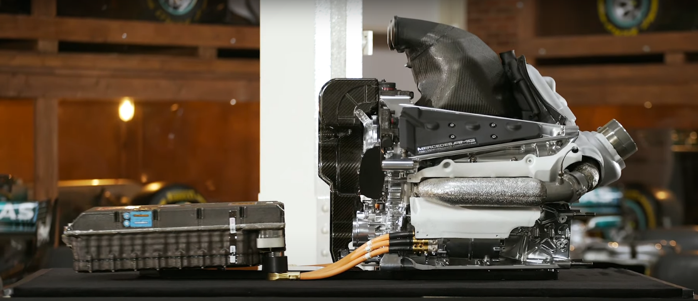
In 2009 the KERS system the energy store was rated to achieve 70% efficiency, which although was much better than the initial 2007 tests, which were rated at 39% efficiency was not deemed enough to be used as a viable strategic option. (EQ Power in F1: A Decade of Hybrid Success, 2021)
'09 KERS and '14 ERS systems 1

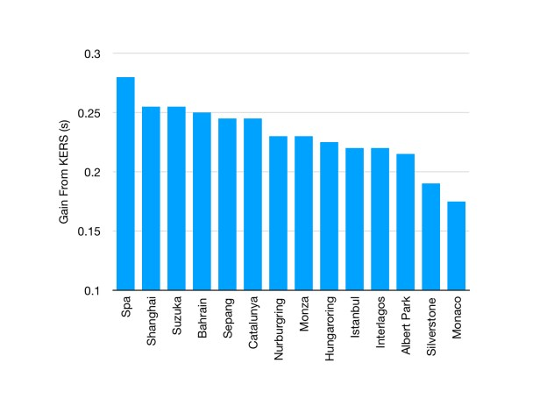
In 2014 with the introduction of turbocharged 1.6L V6 engines with highly capable hybrid systems. In addition to recovering kinetic energy through the MGU-K teams were allowed to harvest energy through the MGU-H. This allowed these advanced Energy Recovery Systems to achieve 96% efficiency. The updated 2014 ERS could provide an extra 160 bhp that dramatically increases the PU’s overall efficiency. While being more advanced and powerful than its 2009 predecessor, their basic principles are similar. The energy recovered by the MGU-K can be used to propel the car. The second electric machine is the MGU-H, which is nestled in-between the compressor and the turbine of the turbocharger. The turbo itself is powered by the exhaust gases of the engine.
Figure 3-1 Time gain from KERS in 2009 on 14 tracks

The average gain in 2009 was marginal. From 0.18s in Monaco to 0.28s in Spa-Francorchamps the KERS was not a particularly useful tool in aiding the drivers. The small boost in power helped with lap times as Figure 3-1 shows and was perceived to be an aid for overtakes. The KERS regulations in 2009 were flexible about how energy could be stored, with capacitors, batteries, and flywheels all legal. But the KERS had significant downsides. Firstly, they were heavy, weighing around 30kg, which considering the 2009 F1 cars weighed 605kg, is a 5% addition of weight, which would negatively affect the cars weight distribution. In addition to this, concerns about reliability and tyre wear meant that there were even more downsides to this system.

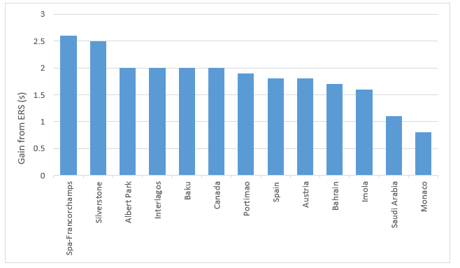
Figure 3-2 Time gain from ERS in 2023 around 14 tracks.
However, since 2014 ERS technology has had a significant impact on the performance of F1 cars. Since 2014 the continued advancements in ERS have enabled more efficient energy harvesting and utilization. From Figure 3-2, you can see that compared to Figure 3-1, with the deployment of ERS you are gaining 8.4x more time compared to 2009. This shows the radical improvements the teams and Formula One have made to ensure that the ERS system is as efficient and powerful as possible.

Conclusion
The evolution of KERS and ERS has been nothing short of impressive. From 2009 to 2023 the gains drivers and teams have been able to make due to the technological advancements made in the development of energy recovery has been astound. From gaining on average 0.2s a lap with KERS in 2009 to almost 2s with ERS in 2023. The benefits of implementing ERS in 2014 show how improvements have been made to overall efficiency, performance boosts, and impacts the evolutions have made in terms of speed and time gained around tracks.

References
(Bopiah & Samuel, 2021)
EQ Power in F1: A Decade of Hybrid Success (2019). https://www.mercedesamgf1.com/news/eq-power-in-f1-a-decade-of-hybrid-success. (Accessed Nov 15th 2023)
F1-Analysis (2023a) Was KERS worth it in 2009? - F1 Analysis. https://f1-analysis.com/2023/04/12/was-kers-worth-it-in-2009/. (Accessed Nov 14th 2023)
(Fédération Internationale de l’Automobile, 2022)
Richmond, S. (2023) 'What Is ERS In F1? An In-Depth Guide to Energy Recovery Systems | F1 Explained,' F1 Chronicle, 31 July. https://f1chronicle.com/what-is-ers-in-f1-guide-to-energy-recovery-systems/#What-is-the-relationship-between-KERS-and-ERS. (Accessed Nov 14th 2023)

