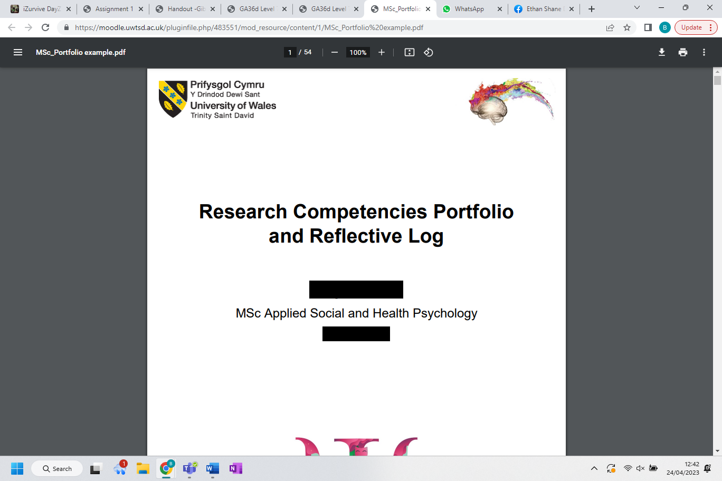

Research Competencies Portfolio
and Reflective Log

Bethan Smith
MSc Applied Social and Health Psychology
ECAS7002

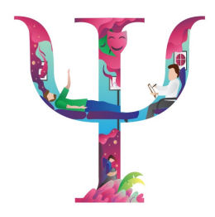
Contents Page

Evidence A:
Expression of Interest Form …………………………………………………………………………………… Pages 3-9
Application for Ethical Approval ………………………………………………………………………….. Pages 9-28

Evidence B:
Consent Form ……………………………………………………………………………………………………. Pages 29-30
Debrief Form …………………………………………………………………………………………….………. Pages 31-32

Evidence C:
Psychometric Scales and Development ………………………………………..……………………. Pages 33-34
Qualtrics Survey Set-Up ………………………………………………………………………………….…. Pages 35-37

Evidence D:
Codebook ………………………………………………………………………………….…………………..…. Pages 38-39
Syntax Creation ……………………………………………………………………………………………….………. Page 40

Evidence E:
Preliminary Results ……………………………………………………………………………………………. Pages 41-42
Conference Abstract ……………………………………………………………………………….…………. Pages 43-44
Conference Submission ……………………………………………………………………………………………. Page 45

Reflective Log ……………………………………………………………………………………………………. Pages 46-52

Evidence A: Project Planning and Research Ethics
Expression of Interest Form
Version 1
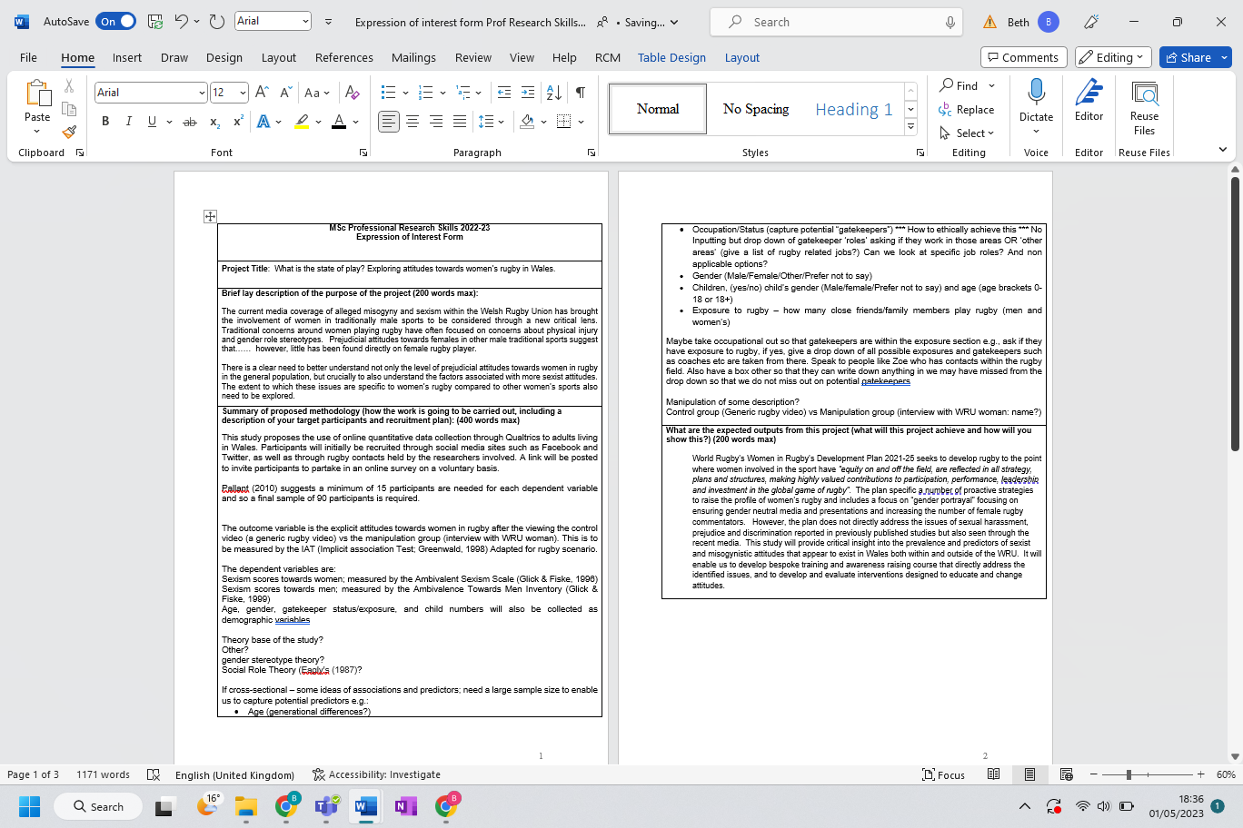
As a group we were very confused on what exactly we wanted to explore, initially deciding on a between-subject design, using a control group and manipulation group so that we could compare the differences.
As a group we were very uncertain on exactly how participants would be recruited, as well as how many we would need due to not having a full finalised idea for the study. I took it upon myself to add information regarding participants at this stage as we had discussed and agreed that they should be from Wales due to the recent allegations within the WRU, and we liked the idea of advertising the study on social media.
We found it difficult to decide on what theory to apply to the research as throughout individual research we each found theories that appeared relevant to our overall topic.
Whilst we had a rough overview on the topic of the research we wished to do, here we struggled to combine our individual research to create a coherent and informative lay description.
We were adamant from the start that we wanted to consider how sexism levels towards both men and women impacted upon a person’s attitudes to women’s rugby and settled on using Glick and Fiske’s methods for measuring these constructs.
Initially we were unsure what would be the best method to measure the difference in attitudes. We were also worried about completing the form in time and so settled on the IAT despite needing to conduct more research on this. In the end we decided it was not appropriate to use.

We wanted to include gatekeepers within the participant population to assess if exposure levels to women’s rugby had an effect. We would need to be careful in how this is conducted however to ensure that there is no bias in out participant selection.

There were multiple demographic variables we were interested in adding to the research to gain more information on what may affect views. However, we were unsure exactly how to capture each of these variables ethically and efficiently.
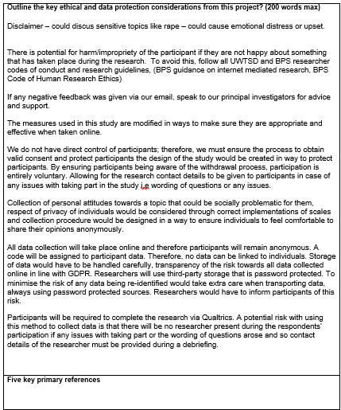
I made the comment that some participants may not like the idea of others viewing them as “sexist” depending on their results. The others agreed with me on this, and we decided that the best way to mitigate this becoming an issue is to ensure participants are advised that the data will be held anonymously.

SH took the lead on this section, typing whilst sharing her screen with other members of the group so that we could all have an input and “spit ball” ideas on what could be considered an ethical complication.

Expression of Interest Form
Final Version
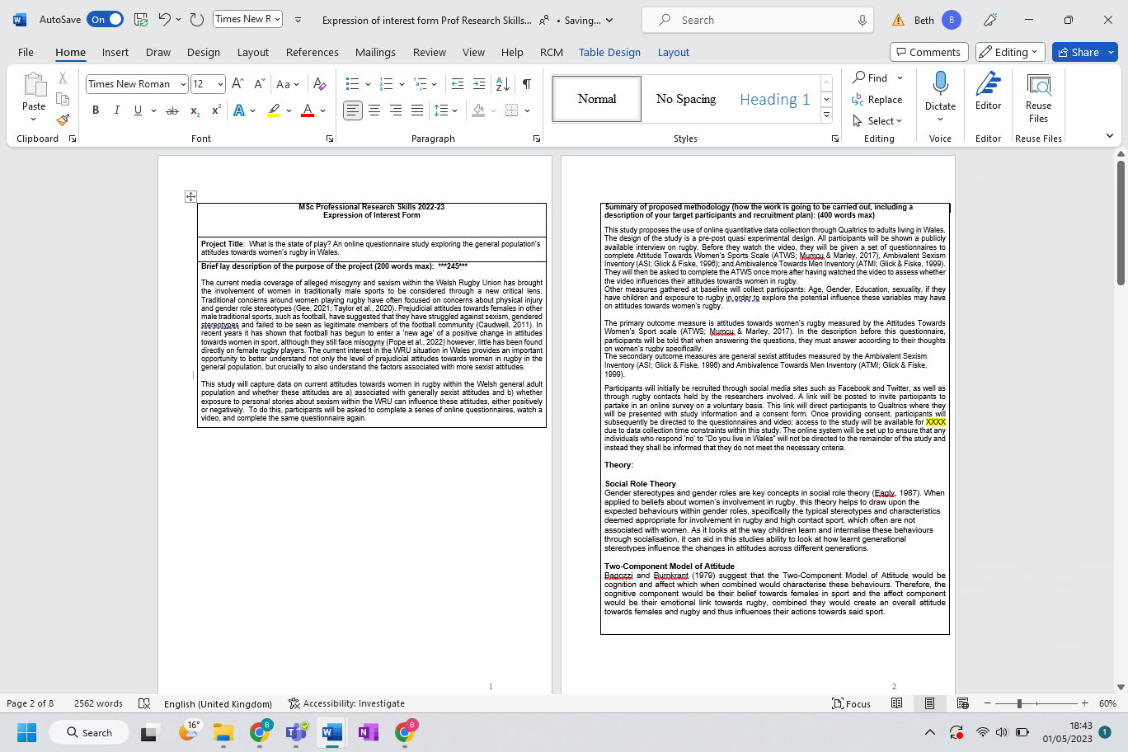
After further individual research, we came together as a group to combine our research and gain a greater insight into why this research needs to be conducted.
The additional research enabled us to narrow down what data we needed to capture. This also enabled us to improve upon our methodology.
After more discussion and research as a team, we decided to alter the project title to sound more professional and add a more specific focus to our research and desired population.
On the advice of CP and PH, we decided to use Qualtrics to both collect and store our data until we were ready to analyse it.
After more deliberation, we also agreed that participants will be recruited via a link posted on social media. We were still unsure how long the study would be available for however due to the modules time constraints and so this was queried with CP right before submission.
After further individual research SH found the ATWS scale which we agreed as a group measured our desired construct more accurately that the IAT.
Due to our more stringent research, we now felt ore confident in which theories best suited our study, acknowledging that social role theory was the most predominantly linked to our topic area.
As a group we decided that a within-subject manipulation design was best suited to our study, removing the need for a control group. Due to this, I termed the design a pre-post quasi experimental design as we would be looking at the change in attitudes before and after exposure to a media clip.
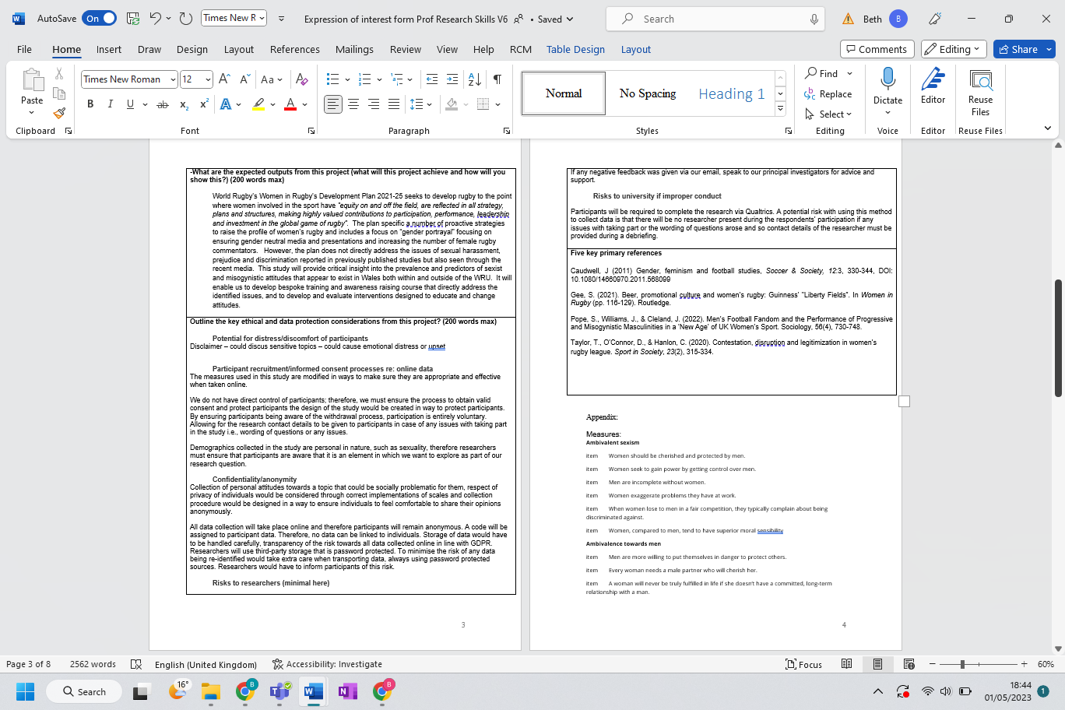
Whilst we previously had the main points of this section, we decided it should be put into sub-sections to avoid confusion over why the point may raise ethical or data concerns, as well as to highlight the risks to participants, researchers or organisations involved.
As we now had a more comprehensive idea regarding our study and what we wished to include/measure, we were able to add in the references we found most informative. We also had more to chose from due to having undertaken more rigorous and extensive research on this topic.

Application for Ethical Approval
Version 1
The title was agreed as a group and followed feedback from CP to keep it relatively short but informative.
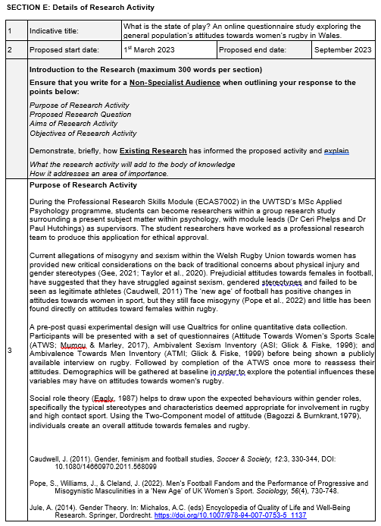
Despite initial confusion regarding exactly what we wished to research, the discussions we had surrounding this during the writing of the expression of interest form enabled us to solidify our ideas and gave us the broad outline for this section. For this reason, we were then able to utilise some of the same wording within our Ethical Approval form.
It was decided to have a lengthy end date to allow for full analysis of results and write up of a report to present at conferences.
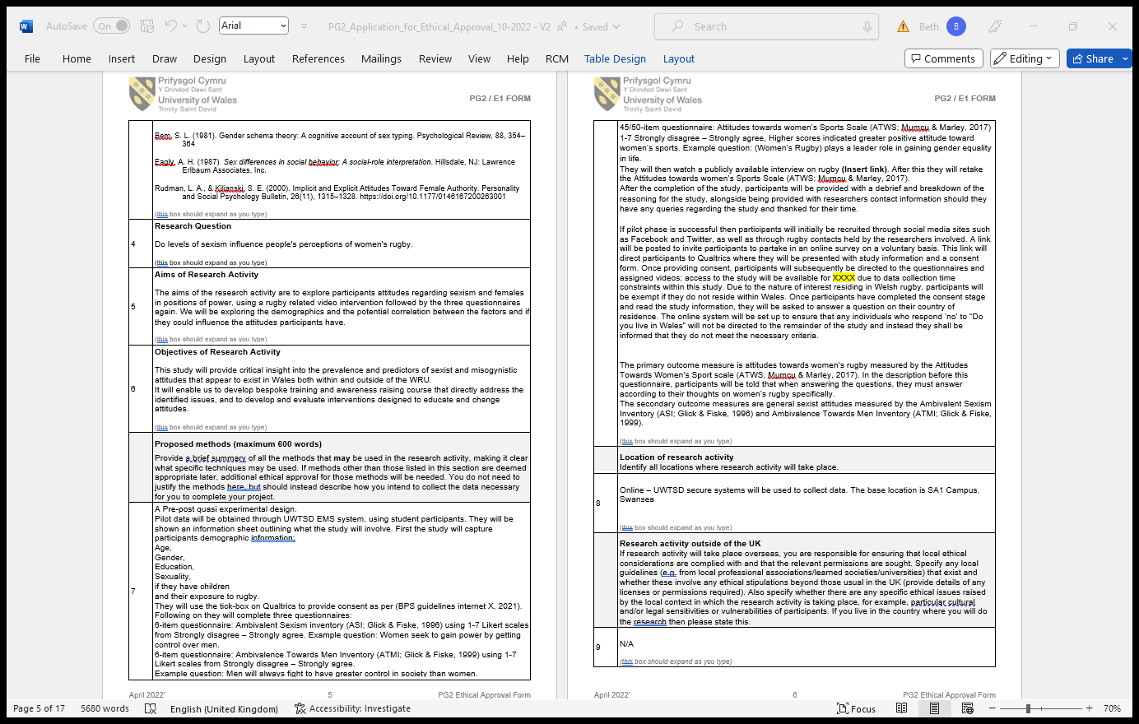
Whilst we had an outline of our proposed methodology at this point, it still needed to be finalised. We did however utilise our psychometric scale materials at this stage to give information on how they capture their desired constructs.
We decided at this point that it would be beneficial to conduct a pilot study to assess the effectiveness of each of our materials in measuring their desired constructs.
As a team, we all had previously had an input in deciding what our outcome measures should be. After SH had found this scale, we decided that it also captured the construct we were most interested in and so this became our primary outcome.
Due to work commitments, I did not contribute greatly to this section. As we had previously discussed it in detail, I was confident in SH and SB’s abilities to complete this. I read over it afterwards and with their permission ensured that any grammatically errors I noticed were rectified.
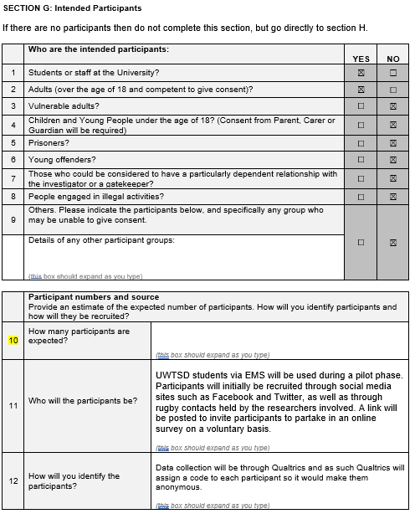
As a group we decided to follow CP and PH’s advice in using Qualtrics to obtain participant data as this software also allows us to assign a ode to each participant to ensure anonymity.
We were still uncertain at this stage how to work out the expected and required number of participants and so we left this blank until we could have further discussions with CP and PH.
We realised at this point that we would be distributing the study amongst university students during the pilot stage of the study.
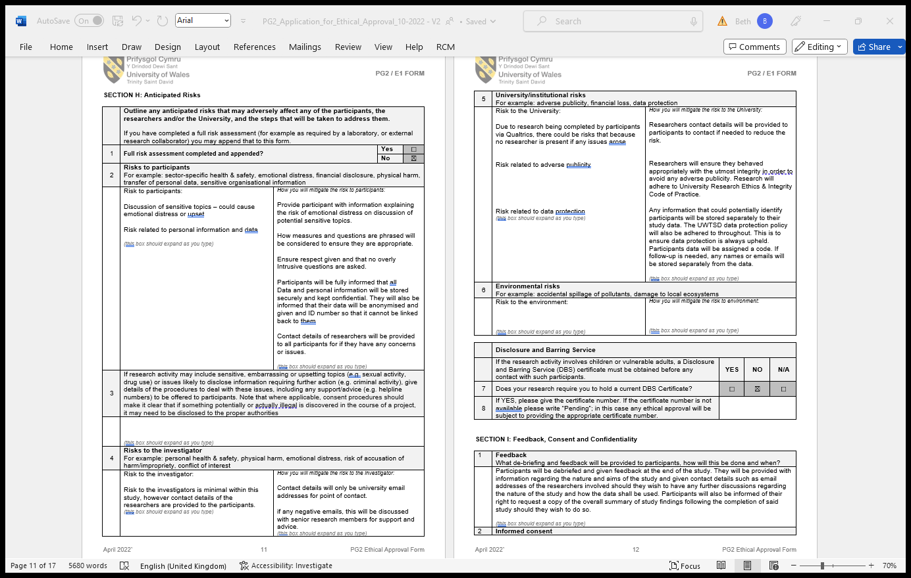
It was considered by the group that as we were providing our email addresses, it was possible that we may receive negative emails from people participating in the study.
However, as we were a small cohort and had many opportunities to discus situations with our supervisors, we believed that this would not cause us much distress as we would be prepared in how to handle this situation.
Whilst we considered including something in this section, nether myself or others in the group could think of any possible environmental factors and so this was left blank.
We decided to make ourselves contactable by participants to lessen the possibility of a negative experience for those who take part. We were also proud to be associated with the research and felt that should we receive any emails regarding the study we would be able to respond appropriately.
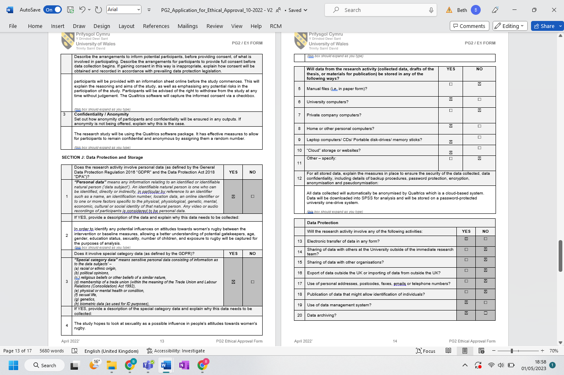
Within the many demographic variables we were considering, we were also interested at this point if sexuality played a role in attitudes and so this box needed to be selected.
Much of the information in these sections had been previously discussed and agreed upon as a group. When completing these sections, we also thought about what would be included within the study itself.
Again, the information regarding data collection and storage via the use of Qualtrics was explored by us as a team prior to completion of this form.
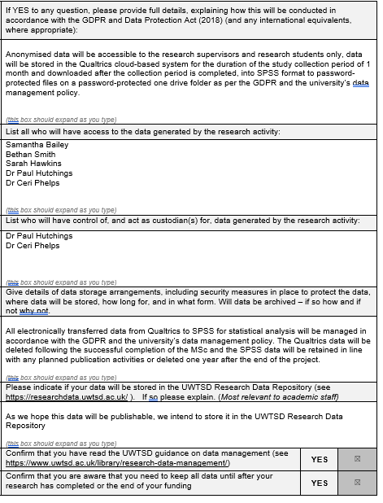
As we had already discussed the possibility of submitting this research to conference with CP, we were aware that this may be a possibility.

Application for Ethical Approval
Final Version
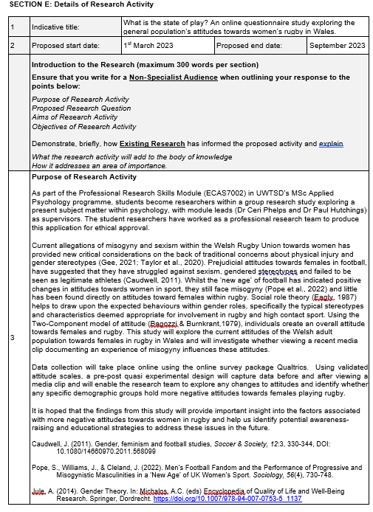
As a team, we agreed early on in the design process that we wanted our research to be able to capture data which could be used to facilitate real-world change strategies to create a fairer and less sexist society towards women.
Here is a more concise and informative paragraph on the data collection process of the study.
Here we were able to better present and improve upon our layout and explanation of the research purpose after spending a lengthy period of time discussing the finalised proposal and discussing any aspects we were not individually happy with.
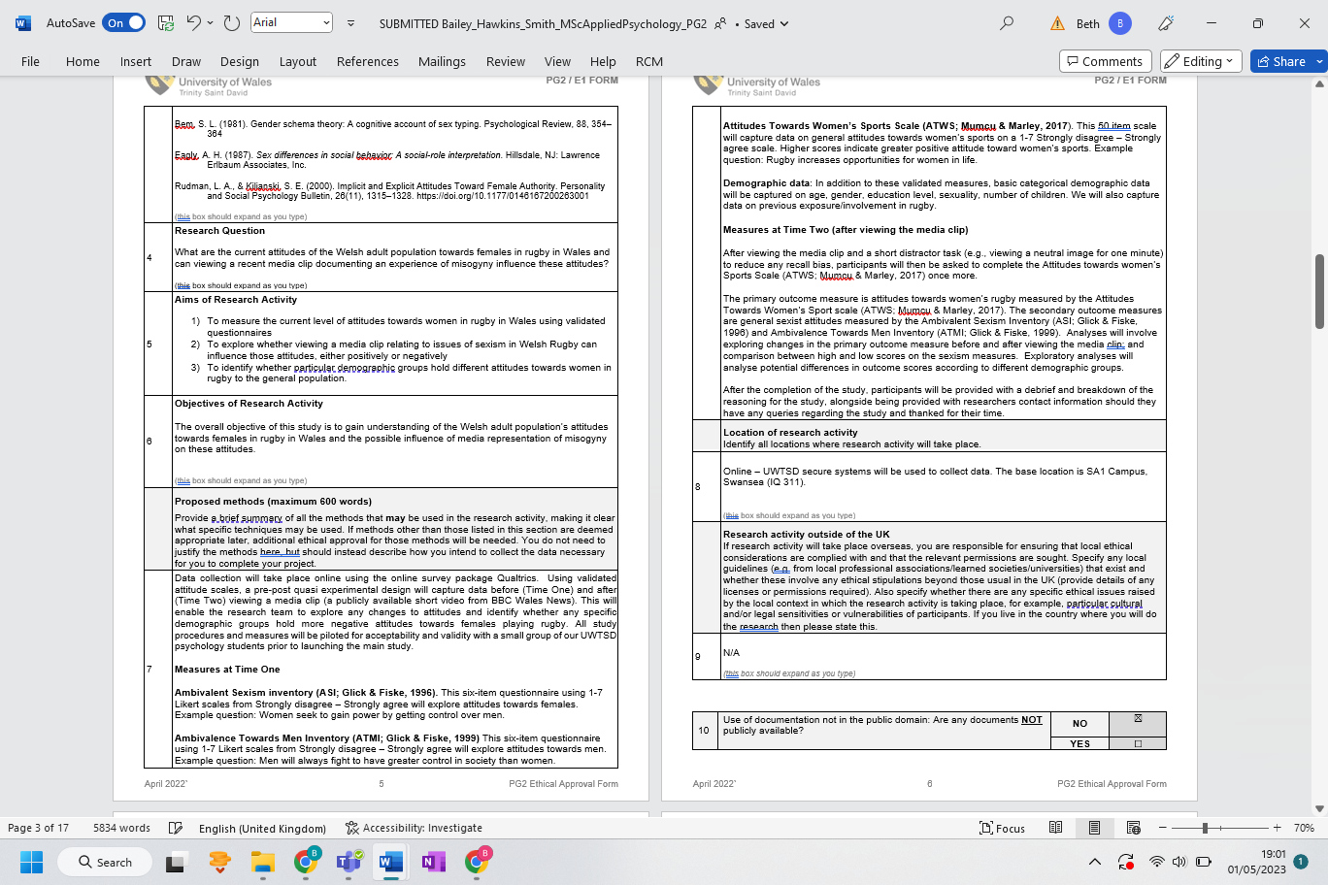
As we had finalised our prosed methodology at this stage, we were more accurately able to explain which measures would be used at time one and time to. We each used the psychometric scale materials we created to explain each of our chosen questionnaire.
Here we had a greater idea of the exact media clip we wished to use within the study after conducting research to find the most appropriate one available.
Here we updated our aims to more concisely portray what we would be assessing. The aims were written in accordance with what the research on the psychometric scales stated they would be able to measure. We also wanted to assess if the addition of exposure to a media clip affected attitudes either positively or negatively.
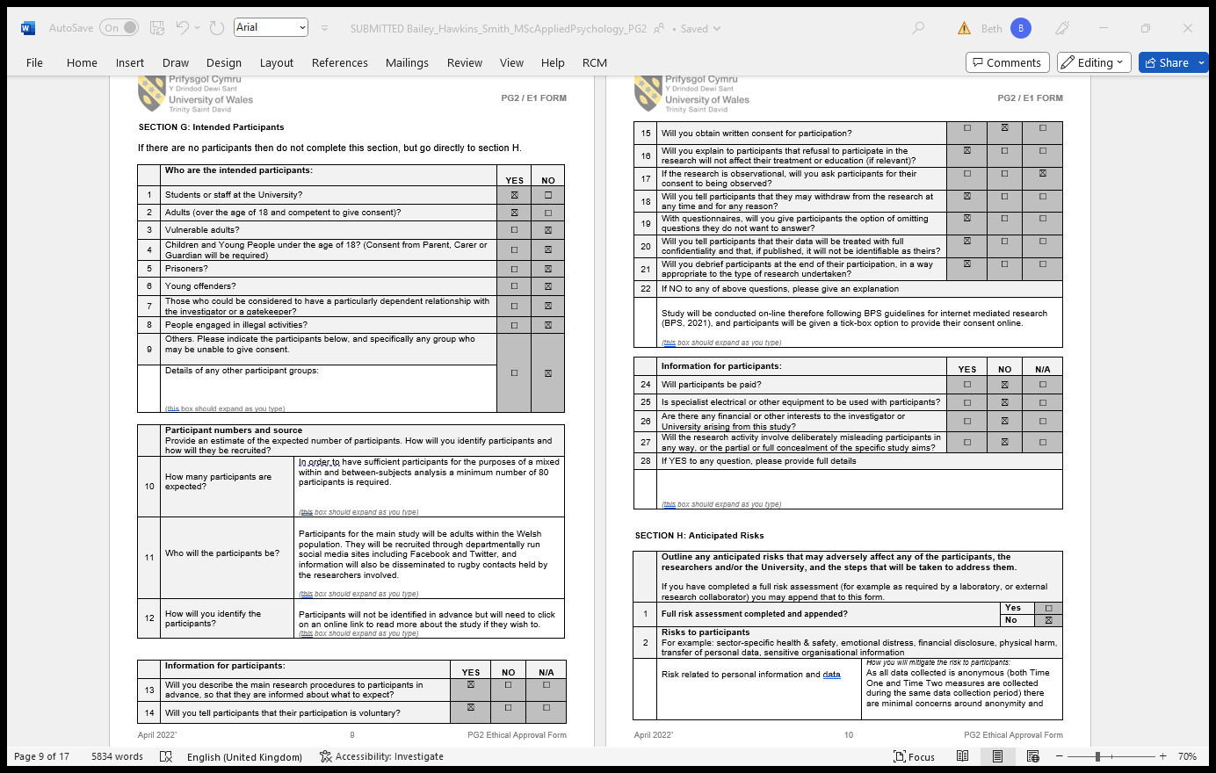
As a group we still struggled to agree how to estimate an expected response rate, however after further discussions with the supervisors it was agreed that we consider the expected number in line with the number of variables contained within the study.
As a group we decided that participants should be provided with the option to omit from answering a question. This is because participants may be uncomfortable answering certain questions and so this allows them the option to omit, instead of closing the study and not completing it instead.
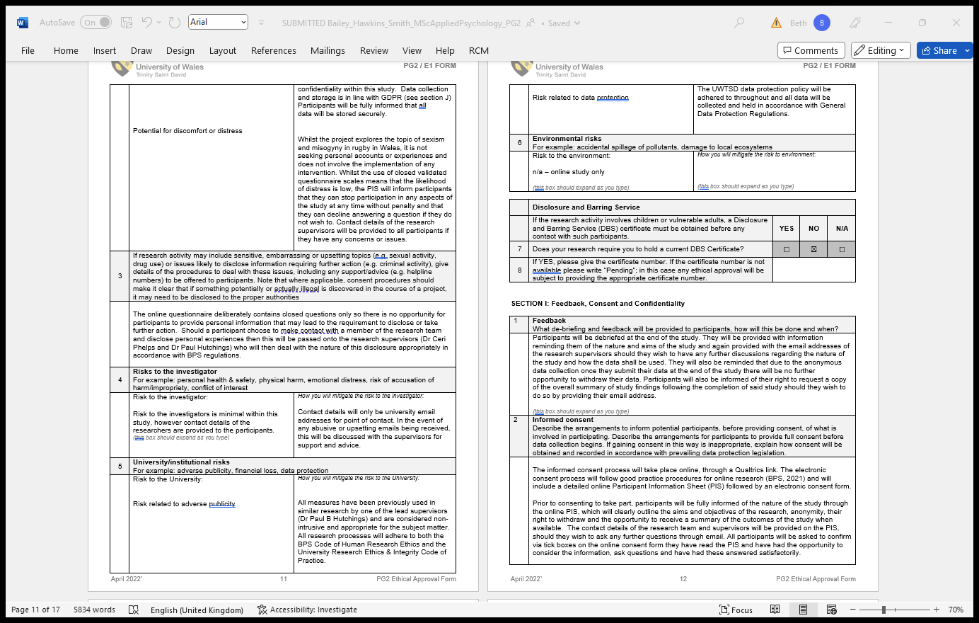
On the advice of PH, as he had previously used each of the measures we were proposing, none of the measures were considered intrusive and so it was deemed the use of them posed minimal risk to the institution.
We decided here that although potential risk to participants is low, we still had a duty to inform participants that they can withdraw participation at any point without penalty and can avoid answering a question they are uncomfortable with.
These three sections were the last area we completed on the form. As there were three boxes, we each took a section to complete. Following an extensive group discussion and the knowledge we had all gained through this discussion, we were able to describe in much more detail, and more effectively, what measures would be taken to ensure these fundamental aspects of ethical research were met. I filled out the consent section as I had conducted further research in this area to ensure we would be able to gain valid informed consent from each participant and what materials would be necessary to ensure this.
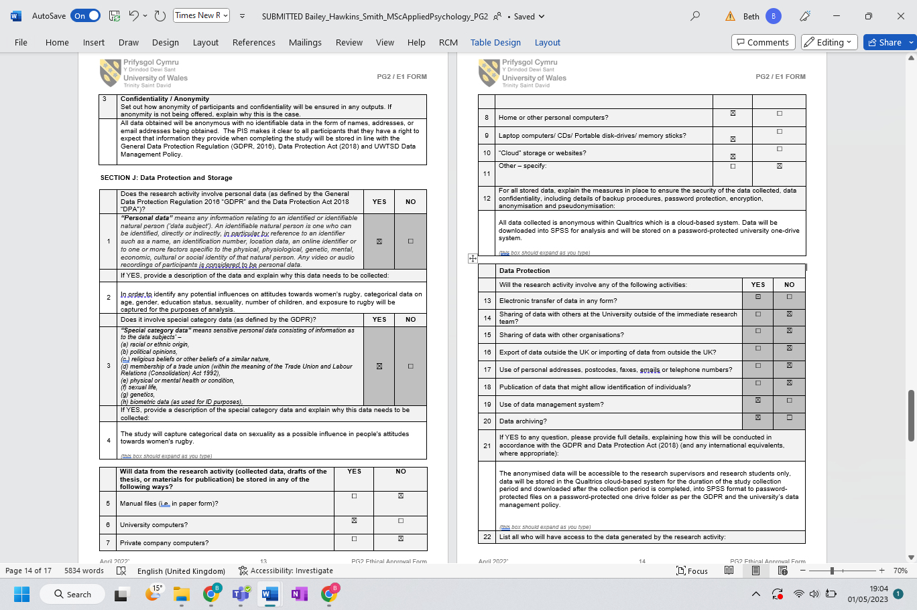
Here we added in how along with Qualtrics, SPSS also would be used in the data process, and how this too is encrypted and held in a secure way.
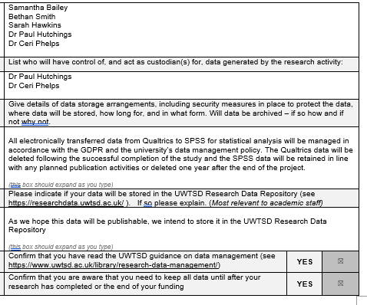
With guidance from the supervisors, as a group we agreed that Qualtrics data would be held until the completion of the study, however data transferred into SPSS would need to be retained for publication reasons, or deleted after one year should we decide not to continue with publication.

Evidence B: Preparation of Recruitment Materials
Consent Form
Version 1
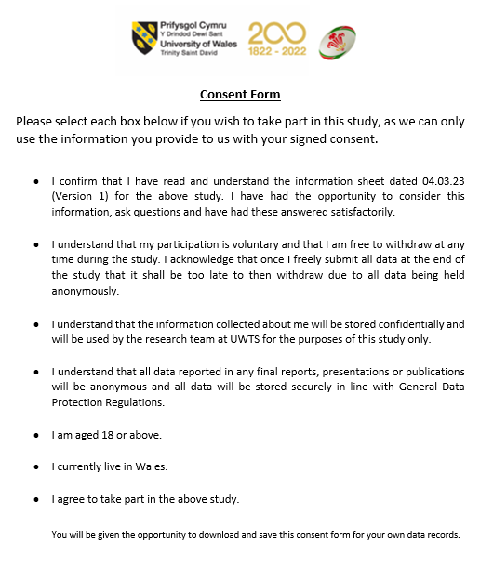
The creation of certain recruitment materials such as the consent form was a personal competency of mine. Here I endeavoured to ensure that all ethical considerations were made by including all necessary information regarding the participants data, including how data was captured and stored.
As we were studying the attitudes of the Welsh population, I thought this would be a good point to include in the participant criteria section. This is because the study was being shared online through sites such as Facebook and Twitter, meaning that it would be easily accessible to people outside our desired population.
As we would not be seeking parental permission, participants were also required to be over the age of 18 to ensure they could provide valid consent.

Consent Form
Final Version
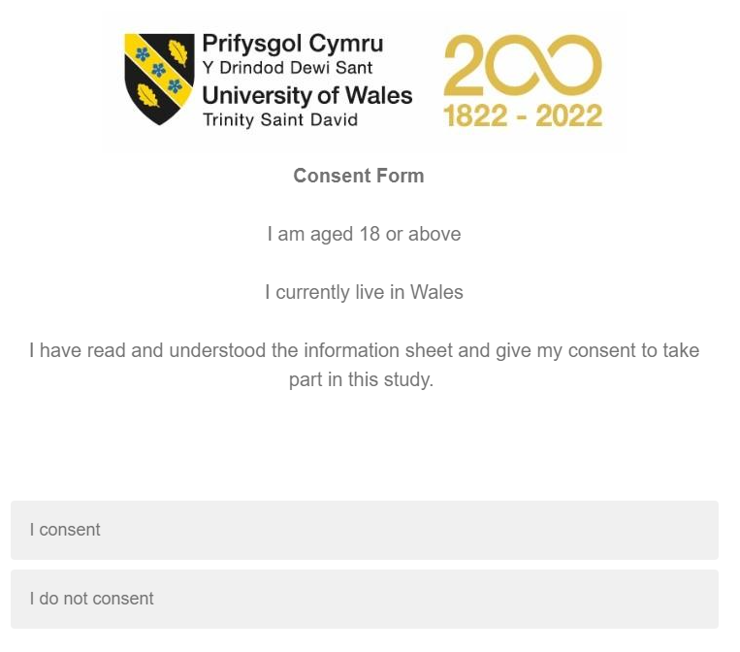
I then produced this final version after discussing with my team members the content contained within the original version. We felt that a lot of the original information was repeated from the information sheet which is provided to participants first, and after a discussion with CP and PH it was decided that to reduce loss of participants due to repetitive information and the reduced threat of risk and harm to participants, alongside limited ethical concerns surrounding the study, that this information could be removed at this stage so that only essential participant criteria needed to be included.
As can be seen from the finalised version of this document, the rugby ball which was initially present had to be removed due to the possibility of participants believing the study was affiliated directly with the WRU which is not the case.

Debrief Form
Version 1
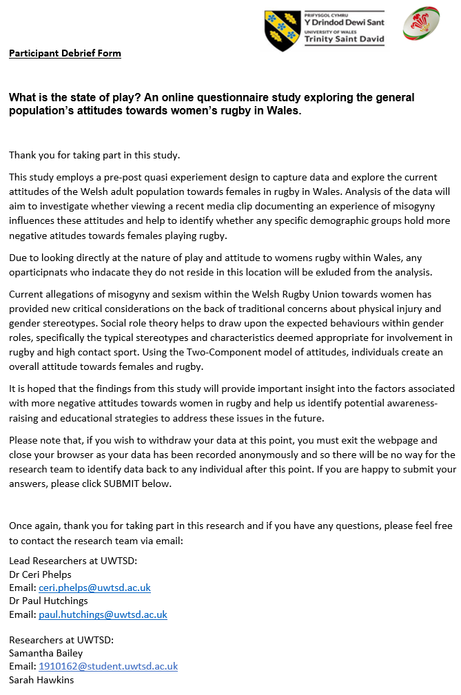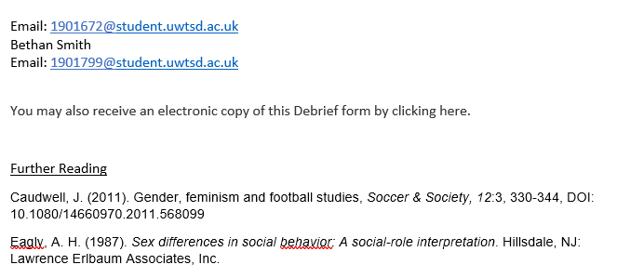
From past teachings, previous debrief forms I had created had included further readings for participants which is why I initially added this section to the debrief form.
As this was the final stage of the study, I also felt it was necessary to remind participants that this was the final point in which they could withdraw from the study as their data would not be traceable after submission.
I made sure to clearly state the purpose of the study and why we felt it was important that this research was carried out within this chosen population.
As with the consent form, it was originally decided that it would look aesthetically pleasing to include a rugby ball on this form as the study was about the sport. However, this had to be removed as we realised it gave the impression it was an affiliated study which is not the case.
I was also tasked with the creation of the debrief form which gave me an opportunity to develop my skills in this area, allowing me to learn which information became relevant to provide to participants at this stage, ensuring any information they were originally unaware of became available to them.

Debrief Form
Final Version
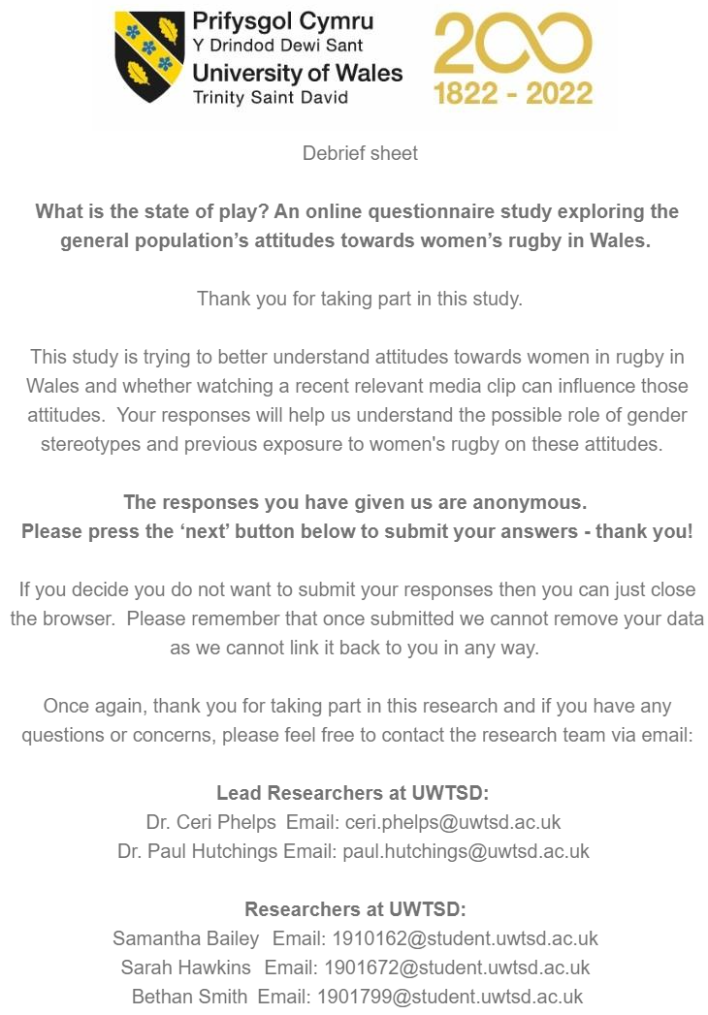
After discussion with SB, SH and CP, it was agreed that the original debrief form contained unnecessary information that our intended participant pool would not be interested in. For this reason, the document was reduced and made more concise but still contained our contact information so that should any wish to have a more detailed summary, this could then be provided to them on request. We also decided that the document looked neater and more professional centred in the page when it appeared on a mobile or computer and so I altered the presentation style to reflect this.
Evidence C: Scale Development and Online Data Collection Tools
Psychometric Scales and Development
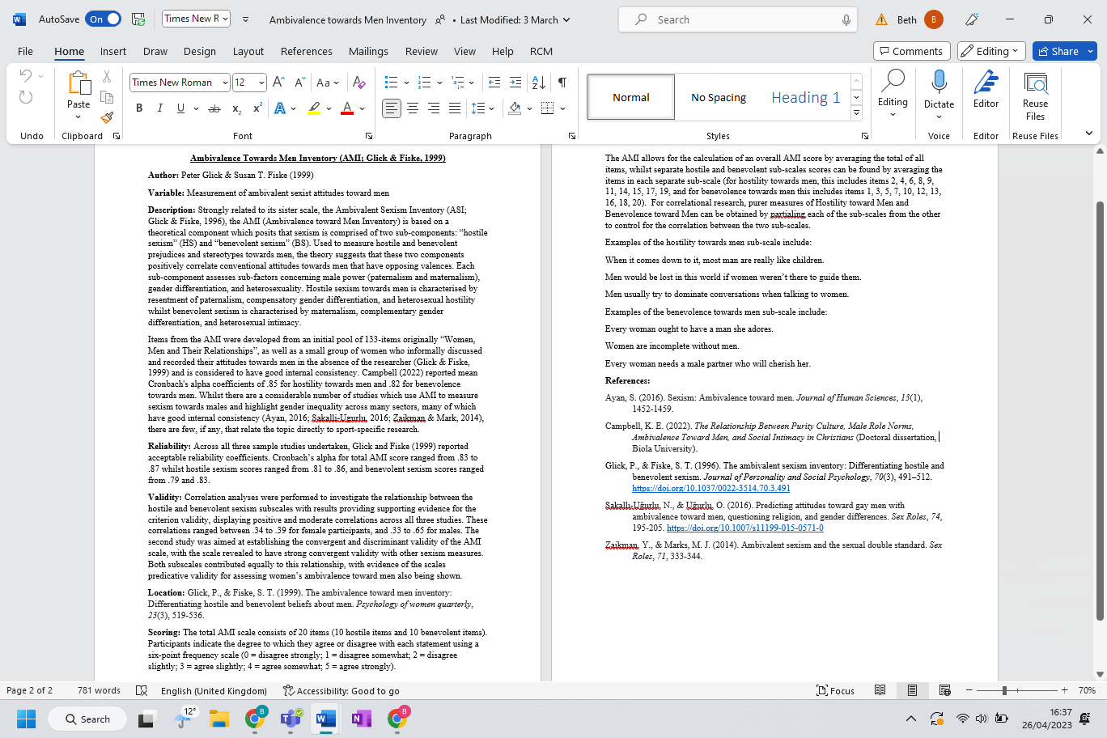
I included the location of the original creation of this scale so that should someone which to compare it to an altered version they find, or to use this exact scale for further research, they will now know where to find. It.
I felt it was important to include that this scale was initially developed from a larger pool of questions, as well as from a focus group as it shows the development stages of the scale and factors associated with the final decision on which questions were included. The inclusion of the studies which have previously utilised this scale also demonstrates the usefulness and reliability of this questionnaire as a proven scale.
The addition of the explanation of what each subscale assess allows others which may use this document to understand if this scale is ideal for what they wish to measure.
As there were three scale questionnaires being utilised within the study, we each took a psychometric scale each to research and document important information on. I was tasked with recording information of the Attitudes Towards Men Inventory.
As the scale is measured on a Likert scale ranging from 0 to 5, I included what each of the numbers translate into (disagree strongly to agree strongly.
The scale also allows for scoring of the scale as a whole or for individual sub-scales should you wish to only measure one form. For this reason, I also included scoring criteria for each possible section and what questions were included within these sections.
I thought it would be beneficial t show examples of the questions included within the scale, some of which belong to the hostile subscale and some which belong to the benevolent subscale.
Here I included a selection of references relevant to this scale, including references to articles which aided in its creation and those which tested its reliability and validity.
When all three write-ups were completed, I was tasked with inputting them all into one single psychometric scale properties document and ensured each section was then completed to a high professional standard by altering any grammatical errors or misused words.

Qualtrics Survey Set-Up
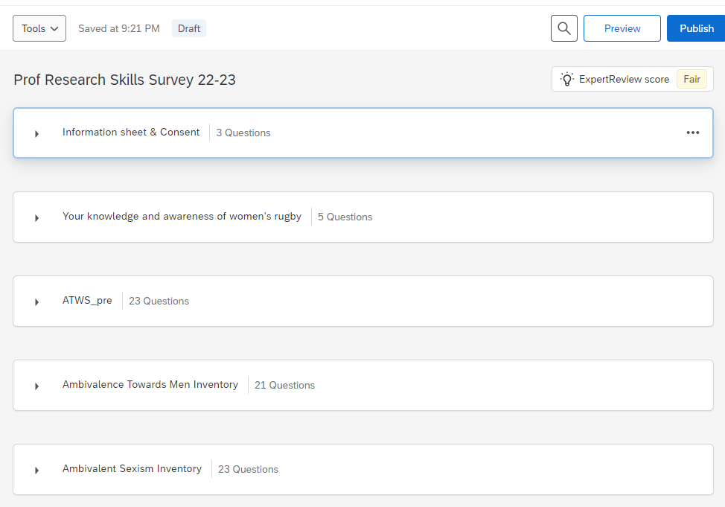
As a group we designed and created these sections together, each taking a primary role in one of the separate questionnaire sections. We discussed as a group the length of the overall study and decided it was best to keep each questionnaire separate.
SH created a survey on Qualtrics and added me, SB, CP and PH as collaborators.
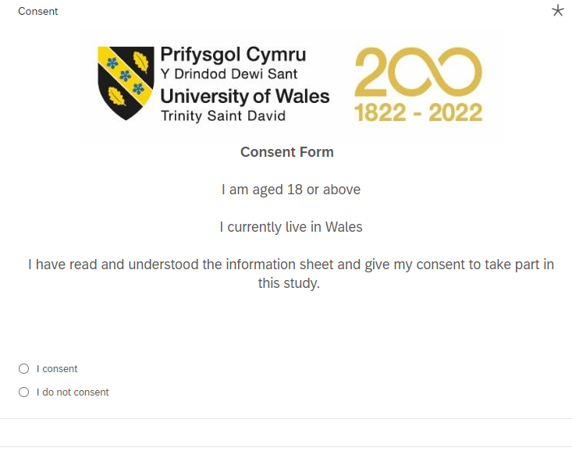
I took lead on this section due to having previously created the consent form. It was at this stage we realised as a group a lot of information from the information sheet had been repeated and so the consent form was reduced to the most important criteria.
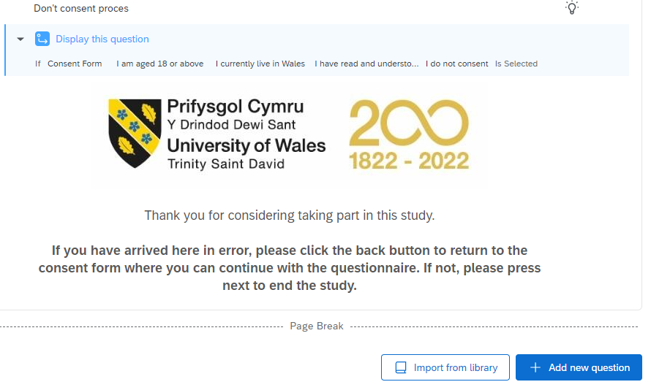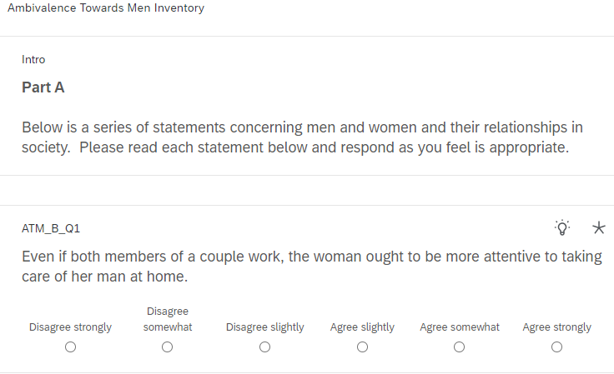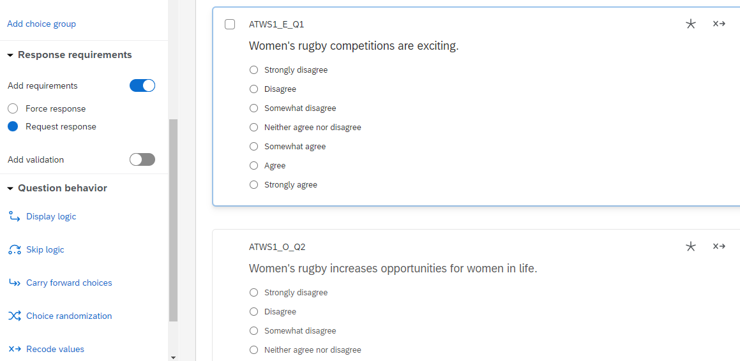
It was also my responsibility to ensure the question ID of each question and section matched with what was shown in the codebook. This ensured an easier transition as variable names were became more readable and identifiable when data was transferred into SPSS.
My main input in the creation of the study on Qualtrics was to adapt the articulation of the information. This was because the others in the group felt that I was able to “word” the information in a more professional manner which expresses the psychological foundation of the study, whilst also making it understandable to a lay audience.
SH entered the chosen ATWS questions here. As the initial original questionnaire included several questions and sections which were irrelevant to our study, before the creation of this section, as a group we discussed which questions/sections were appropriate for us to use. We ran a reliability and validity check on a pilot group to ensure that an altered version of this questionnaire would be acceptable to use.

It was discussed that in the post-media clip version of this tiles that the question order of each questionnaire be altered to avoid repetitiveness affecting participants responses. However, on discussion with CP we all agreed that the length of the study, with the media clip in the middle would mitigate this.

Due to not wanting to force a response from participants if they fund a question uncomfortable, SH suggested we set response requirements to “Request response”. We all thought this was a good idea and as I had not done this before, SH guided me through screen-sharing to show me how then then also apply this to my sections.
I had also never used a video or timer in Qualtrics previously. As SH was more experienced with this software, she also created these sections, showing me and SB how to create both aspects. This means that I will now be able to be more productive and helpful in the creation of future studies as SH has helped me to learn new skills on this software.

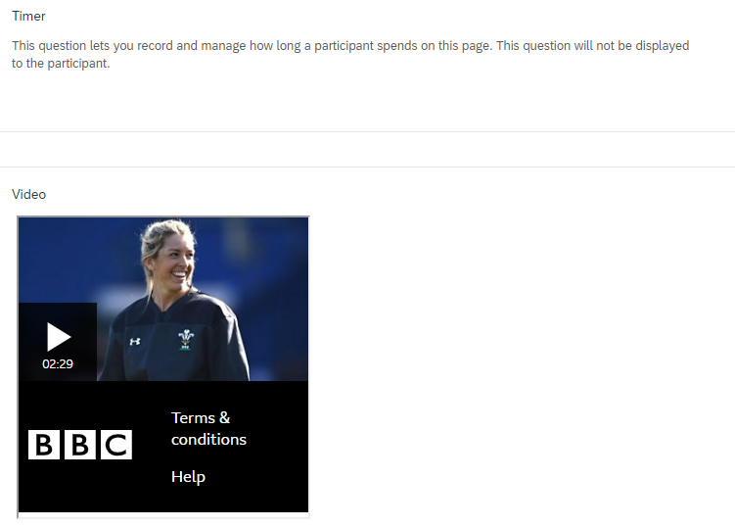

Evidence D: Data Protocols
Codebook
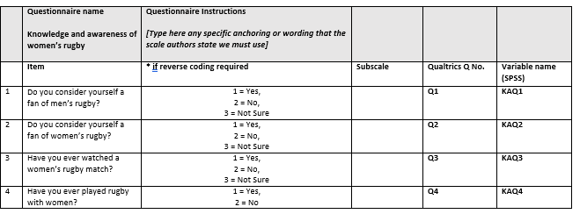
Due to the fiddly nature of the codebook, and the necessity for it to be updated constantly due to changes on Qualtrics and adaptations of the variable codes, I offered to take point on the initial creation as I felt it would be a beneficial skill for me to learn and allowed the others in my team to focus on areas, they wished to further develop in.
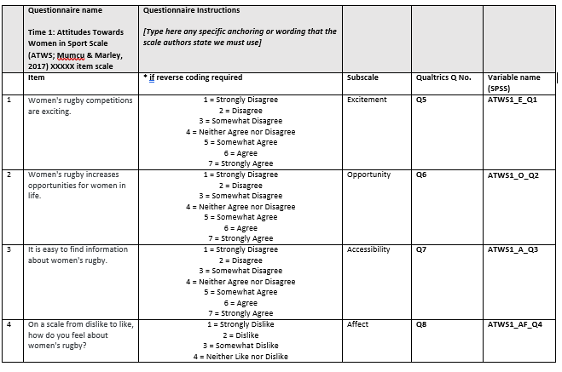
I became frustrated at points due to the constant alterations of the question orders, however I persisted with keeping this codebook up to date as its completion aided in the creation of the final Codebook which included the SPSS reverse coded variables. This final creation was produced by SH.
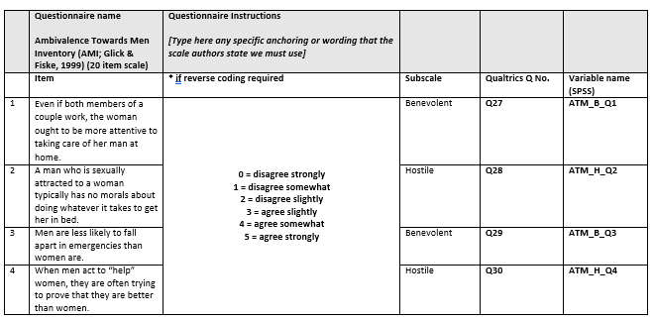
I decided to open the pilot dataset and work from the beginning of the data to ensure the questions were in the correct order. I decided to include coding instructions for each of the questions and label each variable and what they meant so that our dataset could be utilised outside of our group if necessary.
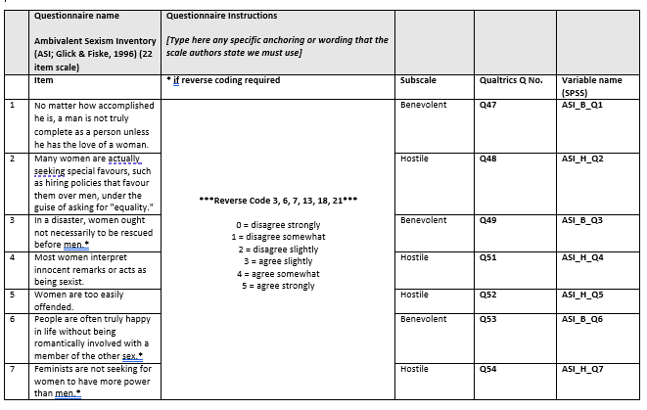
I also chose to change the scale variable names to accurately demonstrate what they were called within the SPSS dataset.
I also chose to include the number each question was in its original questionnaire, as well as the overall question number each question appeared as on within the study on Qualtrics. This allowed us to pin-point immediately how far into each section a specific question would be.
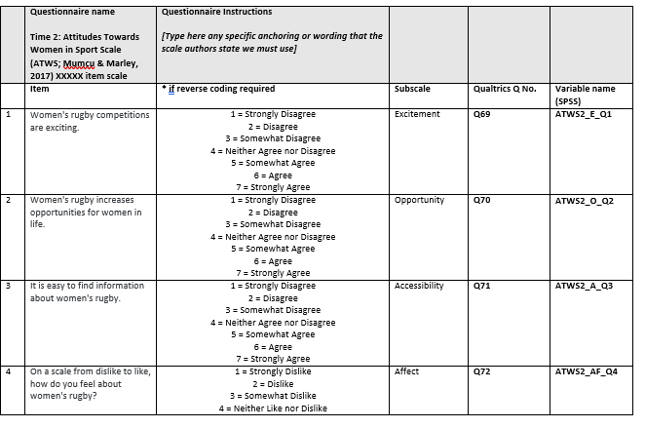
These asterisks show which questions are negatively scored and need to be reverse scored on the dataset. These questions can give us an idea of if participants are reading the questions correctly, or blindly clicking to finish the study.
I also added the which subscale each individual question was associated with for each questionnaire. This section became helpful when needing to know which questions are needed to create total and subscale total scores.
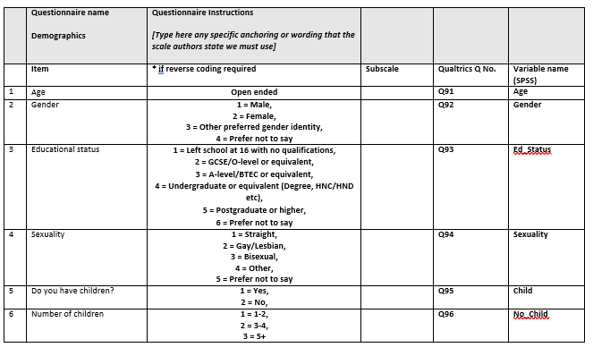
Early in the planning process, we decided we wanted to know if participants had children as we wished to extrapolate more specific data on how this affects attitudes. to see if this affected their view on women’s sports.

Syntax Creation
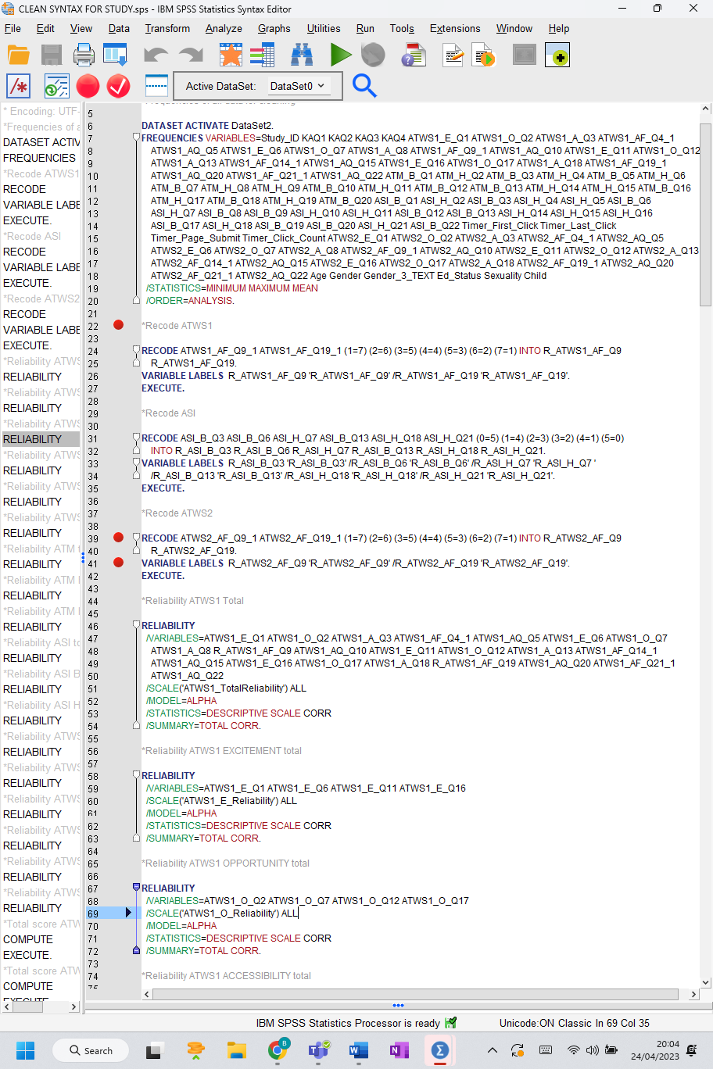
It was decided that the syntax file would be created as it is a beneficial tool to use when running analyses on SPSS as each of these checks would need to be performed during the pilot stage, preliminary results stage, and final analysis stage.

As I was more confident using SPSS and running reliability, validity and total scoring checks compared to SB and SH, as SH shared her computer screen, I walked my team members through each step, allowing them to complete the process with guidance from me until they were comfortable to attempt the process by themselves.
This was completed as a team and during completion we utilised the psychometric scales to ensure we found the total of each scale correctly. The codebook I had previously created was also utilised to ensure the correct questions were used at each stage.

Evidence E: Conference Preparation
Preliminary Results
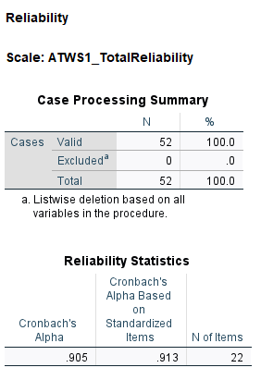
Initially there was more than 52 participants at this point. However, as it is the preliminary stage, it was discussed with PH that participants who did not complete all aspects of the data would be temporarily removed from the data set to allow for simple analyses to take place.
It was decided that it was important to submit data along within the abstract for the conference and so although the study had only been released for a short period of time at this point, I used those participants data to analyse and produce preliminary results.
As I had the mot experience with SPSS, it was decided by the group that I would run the preliminary analyses to ensure accuracy when submitting the data for conference.
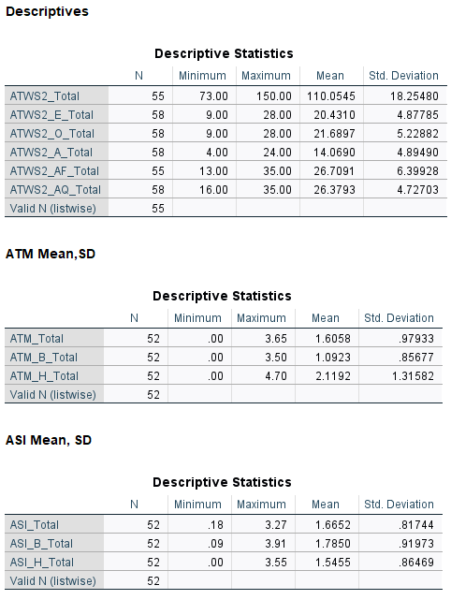
I decided to run the mean and SD for each of the questionnaires total and sub-total scores to identify whether the sample as a whole had high, low or neutral attitudes on various measures.
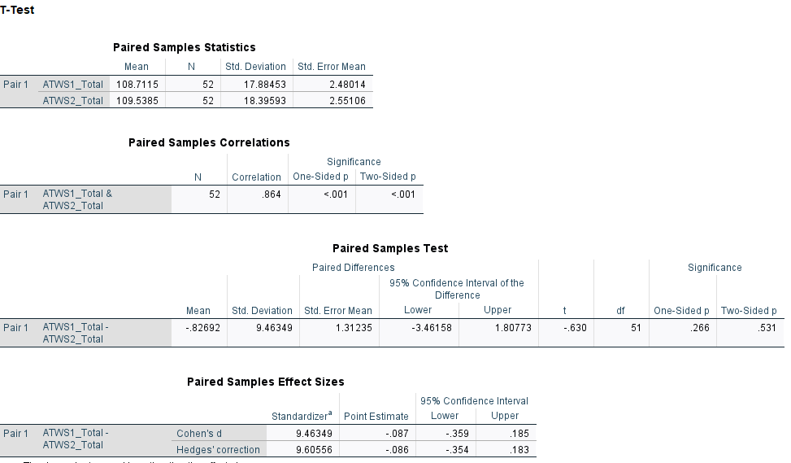

After initial descriptives were completed, it was decided that a paired samples t-test should be conducted to find any initial changes in attitudes towards women’s rugby following the viewing of a recent media clip.

Conference Abstract
Version 1
As I had not submitted to a conference before and felt I needed to improve on writing concisely, I volunteered to create this abstract to improve upon my skills.
Here I struggled to narrow down the information to include in this section due to feeling that a large proportion of the study information was important to include to highlight the relevance and necessity of this research.
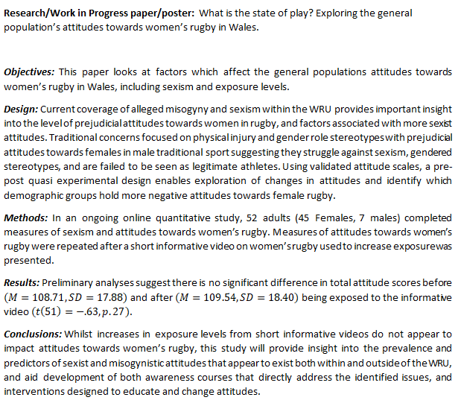
When looking at the abstract submission criteria, it became apparent that there were different submitting formats depending on the style of research being submitted. Here I chose to write the abstract and submit it using the Research/Work in progress as this seemed the most relevant.
In these sections I used the data gathered and analysed from the pool of participants obtained at the beginning of the study release.
Conference
Abstract
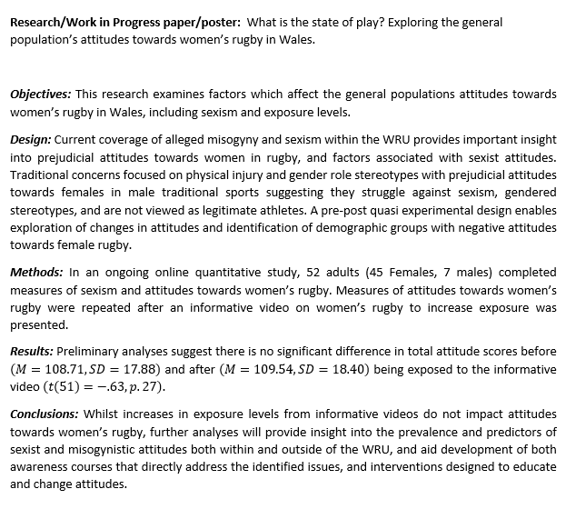
Final Version

The finalised version was then shared with the group via Microsoft Teams to ensure everyone was happy with the finalised version before I submitted it to the conference committee.
Using the feedback from PH’s annotations, I corrected and produced this final version. As the changes made by the connotations meant that the abstract would be over the word limit, I carefully altered each section to ensure it was a concise as possible, without losing any important information.

Conference Submission
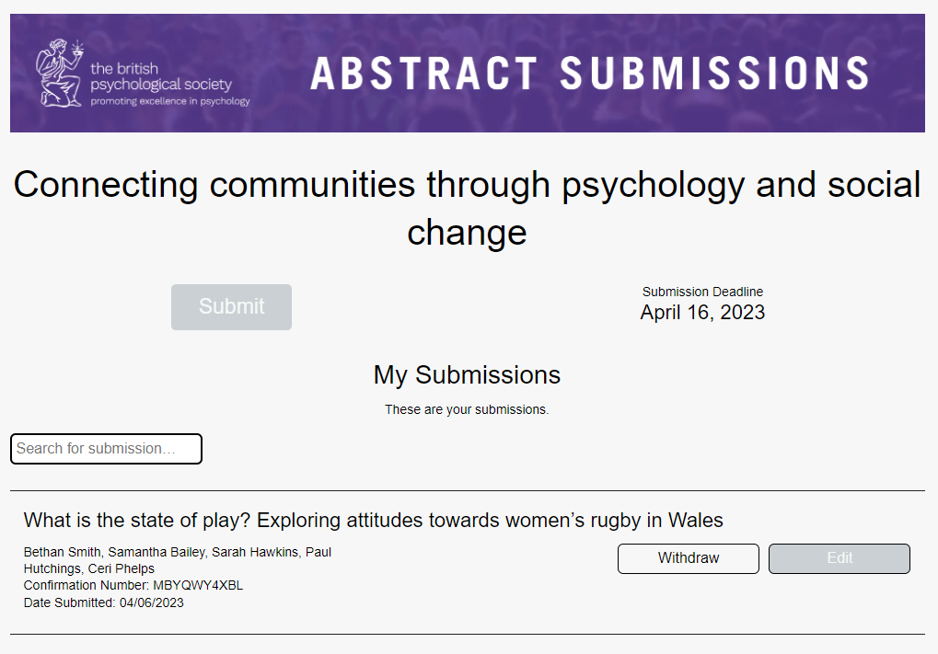

Here I also added CP and PH, alongside my team members, as they are the lead supervisors in the research.
Here I learnt how to successfully submit research for conference. I was surprised by the extent of information that was requested at this stage of the process and needed to contact my team members to ensure I added their full names and emails correctly.

Reflective Log

With reference to psychological theory and professional frameworks, this critical reflection will employ the use of Gibbs’ Reflective Cycle Framework (1988) to provide an honest and clear reflection and evaluation upon my involvement in the MSc Applied Psychology module: Professional Research Skills. Designed to improve and enhance the skills of students in acting as professional physiological researchers, the module required this year’s cohort to collaborate on a research project based on current psychological literature that highlights ongoing difficulties faced by women who participate in predominately male sports.
After being provided with the broad topic, as a group we contributed to the decision on what specifically would be investigated, and after researching current literature, settled on how sexism levels and demographic variables are associated with the general population of Wales’s attitude towards women playing rugby. Initially, I had concerns regarding the layout of this module, and expected to struggle with working closely with others on this piece of work due to not previously experiencing sharing responsibility for a research project. Previously, I had enjoyed completing assignments alone and was apprehensive working with a group that were unknown to me, and anxious about what new issues may arise due to us having different approaches to the work.
The research team consisted of three students; me, SB, and SH, and two lecturers who were the research supervisors; CP and PH. Initially, I had concerns regarding my ability to fit in and feel heard as part of the group. It is common during initial stages of group development for “leaders” to become identified, with these often being the more outspoken and assertive members of the group (Donald and Carter, 2020). I felt that both SB and SH expressed these qualities more often, whereas I struggle with communication in group settings, which results in me appearing quiet and reserved (Medaille and Usinger, 2020).
Despite the small size of the group also raising concerns of increased likelihood of tensions and disagreements between members, I realised we would each have a larger proportion of responsibility for elements of the research process and was relieved as it meant there would be greater opportunities to gain competencies in areas we were less familiar with, which would greatly enhance our researcher skills. Concerns over an inability to “fit in” were soon alleviated after creating a WhatsApp group for us to discuss topics more easily. This aided in communication (Jailobaev et al., 2021) and by also discussing personal lives on app, I came to appreciate my group as individuals and understand how our differences could add value to our work. It also enabled me to understand that in the future I should always endeavour to build positive relationships from the start as it will benefit our communication and work outcomes (Dutton and Ragins, 2017).
During first session I was sent home due to being unwell. This made me feel frustrated as I did not understand what was going on during the next session as I had missed vital parts of the planning stage. Whilst I felt guilty not being able to contribute as greatly as the others during this stage, I was initially more frustrated as when asking what I had missed out on and what had been decided so far, they did not explain this clearly to me, instead appearing annoyed that I did not understand. However, looking at the initial difficulties and stresses we were facing with the Expression of Interest form (EOI) and theory section of the Ethics form, in hindsight this may be because they too were uncertain at this stage of the exact area this study was progressing in.
As mentioned, at this stage the group was unsure which theory we wanted to centre the research around due to all agreeing that multiple theories coincided with the ideas we had. With the deadlines for the EOI and Ethics application looming I became very stressed about the submission deadline as we could still not agree on what exactly we were researching. After a meeting with CP and PH, we realised we had been overthinking the topic and realised that Social Role Theory (Eagly and Wood, 2011) was the most suited to researching attitudes on women in predominately male sporting roles. I had initially felt out of my depth when researching multiple theories, and it became overwhelming. However, once settling on Social Role Theory I become more confident in my knowledge due to previously researching this area for my BSc dissertation, and so I was able to draw upon this when discussing how to approach it within the current study with my group members.
As we were a small group, all three of us contributed during each stage of the project. We shared an online space where we could share and collaborate on documents. This was utilised in the creation of our online Qualtrics survey, and when collaborating on the psychometric scales (Evidence C). My personal contributions to the project varied, with SB and SH asking me to ensure documents such as the Ethics form (Evidence A) were finalised correctly as they thought my academic writing was at a greater standard than their own. This shocked me as I believed we were all equal in our writing abilities, however I appreciated that they believed I had a seemingly valuable trait to offer the group. Also, during the creation of the syntax output (Evidence D), as I was more confident in SPSS data analysis due to more experience, I walked my team members through each stage until they were comfortable attempting it alone. I felt proud that I was able to help them in this area and watch them gain a better understanding of the dataset.
Whilst I found finalising documents rewarding, by checking for grammatical errors and re-wording areas to sound more professional, I was also worried that I may not have interpreted other group members focuses accurately. Although this helped to expand upon my knowledge of the study, as well as improve upon my overall communication with the group, I feel I had more to offer in this area. Unfortunately, due to work commitments, other members of the group completed larger sections of the forms which frustrated me as I wished to have a greater role in this area. On another occasion where the group met without informing me and completed the remaining sections of the pilot study, I became frustrated, and although I was nervous mentioning it, upon discussing it I realised they had assumed I would be working and apologised. Ultimately, this improved our communication and our considerations of each other, ensuring we all made sure everyone had equal opportunities to contribute to documents.
Two tasks I completed in an individual capacity were the initial creation for the SPSS Codebook (Evidence D) and the conference abstract (Evidence E). I utilised class materials and my previous knowledge of SPSS when creating the codebook but felt apprehensive when I realised how much work went into creating this document as this was a new piece of work for me. Using the codebook and pilot data I was then able to run preliminary results to provide empirical evidence in the conference abstract. During these tasks I was concerned I would miss something important or have inaccurate results, however, I welcomed the opportunity to enhance my pre-existing SPSS skills and gain new experience creating professional research materials. To ensure their accuracy, I also asked SH and SB to proofread the documents when completed. I enjoyed the process of creating these documents as it helped me gain confidence in my abilities and helped me to realise how much I had learned from my BSc and MSc degrees, creating a sense of accomplishment and excitement towards the final study results. I look forward to continuing to improve upon my existing knowledge, utilising these new skills within future applied research projects.
In conclusion, I feel this module has provided me with valuable professional and personal research skills that will aid me in both a professional career and my dissertation. Bing able to participate in a real-world study has allowed me to understand the necessity for good communication between team members, which was one of my biggest concerns initially. During this module I learned that whilst I am quiet in group settings due to being concerned about “fitting in”, those who are more vocal also share these concerns and by creating an effective communication outlet we are able to mitigate these worries and use our personal differences to add value and greater insights to different aspects of the research.
In addition to enhancing my interpersonal skills, this module has widened my knowledge on the stringent ethical process required for real-world studies. Previously I considered an ethics form to be a basic document that required multiple tick boxes to fit university standards, however, this project made me focus more deeply on the requirement of the BPS Code of Ethics and Conduct (2018) and BPS Code of Human Research Ethics (2021). This could largely be contributed to the need for acting professionally in the role and the required organisational commitment that accompanies this necessity (Mahjoub et al., 2018). I have also had the opportunity to further enhance my practical skills necessary for research roles by being involved at each stage of the study. This has helped to further my understanding of large datasets, the creation of recruitment documents to a professional standard and enabled a sense of accomplishment in learning how to ensure a project is ready for conference. The completion of this module has improved my confidence as a keen researcher and provided me with greater ambition to further develop my skillset within the field of applied psychology, adding to my commitment to find a professional role within this field.

References
British Psychological Society. (2018). Code of Ethics and Conduct. https://www.bps.org.uk/guideline/code-ethics-and-conduct
British Psychological Society. (2021). BPS Code of Human Research Ethics. https://www.bps.org.uk/guideline/bps-code-human-research-ethics-0
Donald, E. J., & Carter, A. (2020). Overview of common group theories. In W. Killam, A. Carter & S. Degges-White (Eds.) Group Development and Group Leadership in Student Affairs, 17.
Dutton, J. E., & Ragins, B. R. (2017). Exploring positive relationships at work: Building a theoretical and research foundation. Psychology Press.
Eagly, A. H., & Wood, W. (2012). Social role theory. In P. A. M. Van-Lange, E. T. Higgins & A. W. Kruglankski (Eds.) Handbook of theories of social psychology, 2.
Gibbs, G. (1988). Learning by Doing: A guide to teaching and learning methods. Oxford Polytechnic.
Jailobaev, T., Jailobaeva, K., Baialieva, M., Baialieva, G., & Asilbekova, G. (2021). WhatsApp groups in social research: new opportunities for fieldwork communication and management. Bulletin of Sociological Methodology/Bulletin de Méthodologie Sociologique, 149(1), 60-82.
Mahjoub, M., Atashsokhan, S., Khalilzadeh, M., Aghajanloo, A., & Zohrehvandi, S. (2018). Linking “Project Success” and “Strategic Talent Management”: satisfaction/motivation and organizational commitment as mediators. Procedia computer science, 138, 764-774.
Medaille, A., & Usinger, J. (2020). “That’s going to be the hardest thing for me”: tensions experienced by quiet students during collaborative learning situations. Educational studies, 46(2), 240-257.

