IWD
Assignment 2: Website design and development
19/12/2025
.

UNIVERSITY OF WALES TRINITY SAINT DAVIDLONDON CAMPUS
london campus
Module Name: Introduction to Web and Database Concepts

Module Code: ACCA4023

Student Name: Danuzia Aparecida Soares.
Student ID: 2435233
Group: 3

Lecturer’s Name: Suneth Fernando

Table of Contents
Introduction to your case study which you choose 2
User Requirements 3
Website Implementation 5
Home page: 5
Service page: 6
About us page (screenshots) 10
Testimonies page (screenshots) 11
Contact us page (screenshots) 13
Validating my website 14
Self-evaluation of my website 17
Usefulness (usability and utility): 17
Search Engine Optimisation (SEO): 17
Website Accessibility: 17
References 19

Introduction to your case study which you choose
Please explain what type of business which you have chosen and what type of business function which you are going to consider when you design and develop required website.

For my case study, I chose the DS Aesthetic website. DS Aesthetic is a small aesthetics business that offers treatments such as facials, skin care, and non-surgical aesthetic services. The business focuses on helping clients feel better about their appearance and providing professional beauty treatments.
The main aim of the website is to promote the business online and make it easier for customers to find information about the services. The website will be used to show the treatments offered, give details about the treatments, the business, and help customers get in contact easily.
When designing and developing the website, I will focus on important business functions like marketing and customer communication. Pages such as Home, Services, About Us, and Contact will be included to support these functions. The website will also be designed to be simple to use.
After understanding the importance of Website Accessibility, at the end I made some updates to make the site responsive for mobile devices and compatible with different browsers.

User Requirements
List down user requirements. In other words, please identify what user is expecting from your website. This should include, type pages required, each page, what type of content which you need to include.
User requirements: For this Assignment, I am creating the website for the DS Aesthetic Clinic from scratch.
When visiting this website, users expect to find information about the services offered by the clinic, a clean, easy and quick-to-navigate site, how to contact the clinic, how to make bookings or just send questions, they expect to easily find the clinic's address and contact details, and, most importantly, discover why they should trust the DS Aesthetic Clinic.

First Page: HOME PAGE
Users expect a simple and organized page where they can easily find the types of services offered by the clinic. The page was designed to avoid information overload, and therefore, slideshow presentations with images were chosen to attract the user's attention.
Users will find a menu bar to navigate easily and fast between pages and, on the right, icons to find us on social media networks.
Images related to the treatments offered by DS Aesthetic will be displayed in the slideshow, and if the visitor wishes to obtain information about a specific treatment, they simply click on the button corresponding to the desired treatment, which will automatically direct them to the services page where they will find information about the chosen treatment.
Second Page: SERVICES
In this page the users will find all information related to the treatment that the DS Aesthetics offers, to make it even easier, the services have been separated by categories.
Ex. Fillers & Anti-Wrinkle Treatments: Botox and Lip Filler.
Laser treatment: Laser Facial Rejuvenation and Hair removal.
Skin Rejuvenation Treatments: Microneedling, Skin Booster and Chemical Peel.
Hair & Scalp Rejuvenation: Hair Booster Treatment.
At the end of the page there’s a button “Book a consultation” to guide the users on how to get in touch with us.
Third Page: ABOUT US
On the About Us page, users expect to understand why they should trust DS Aesthetic Clinic. This page is important because it helps users feel safe, confident, and comfortable before booking any treatment.
Users want to know who we are, our mission, or values.
Users will see a photo of our reception area, which will help convey the high standards of the clinic.
They want to find out reasons to trust us as professionals such qualifications, experiences and certifications.
Fourth Page: TESTIMONIES
This page provides real feedback from clients that had made treatments with us.
Users will see comments on their experience, results and satisfaction with the treatments.
They will see a list of client testimonials, with their name (or initials) and a short review.
This page is very important because it supports the user’s decision by showing that other people had a positive experience.
Fifth Page: CONTACT US
On this page users will find our address, phone number, email and also our opening days and times.
This page allows users to easily contact the clinic, whether to schedule appointments or simply request more information about any of the treatments offered by DS Aesthetic.
The users will see a contact form to fill in such as: Name, email, phone and a space to type a message so we will be able to get back in contact with them through their phone or email.

Website Implementation
Please explain what type of text editor (Visual studio code) used and what type of scripting languages use used to develop your website. Then provide screenshots of each page.

To build my website I decided to use Visual Studio Code as my text editor.
I mainly chose it because it is free, it is not too difficult to use, and it keeps all my files organised in one place. Visual studio code also shows different colours for HTML and CSS which helped me to notice mistakes easier.
The website was created using HTML, CSS, and a small amount of JavaScript.
HTML was used to build the structure of each page, like the navigation menu, the text, the images and the layout. CSS was used mainly for styling. I used it to set the colours, spacing, fonts, background and to make everything look cleaner and more professional. I also included simple JavaScript from W3Schools examples, for things like the slideshow.
I also used W3.CSS, which is a simple layout framework from the W3Schools website. It helped me make the pages responsive, especially when the website is opened on a phone screen. For the icons (Instagram, Facebook and WhatsApp), I used Font Awesome, which allowed me to add small graphics without using images.
At the end the HTML file was updated to improve mobile friendliness by adding the viewport meta tag, correcting image paths, and improving accessibility elements. This helped the website display correctly across different browsers and mobile devices.

Home page:

Header with the logo and navigation menu so the users can move around the website and the social medias buttons on the right side.
Slideshow to introduce the DS Aesthetic treatments available.
Footer at the bottom with simple information.

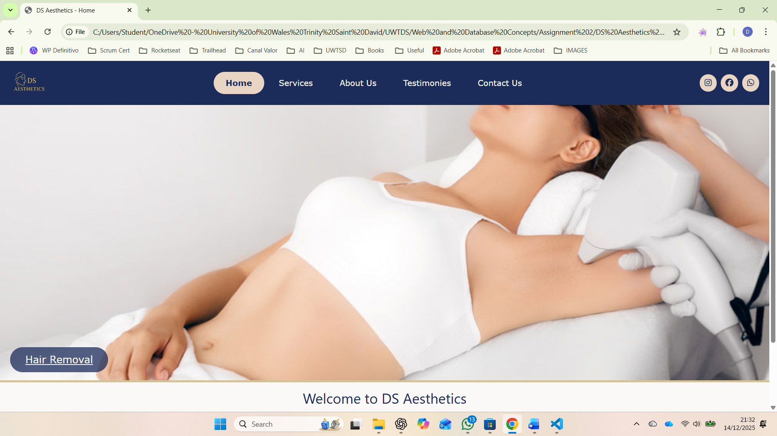

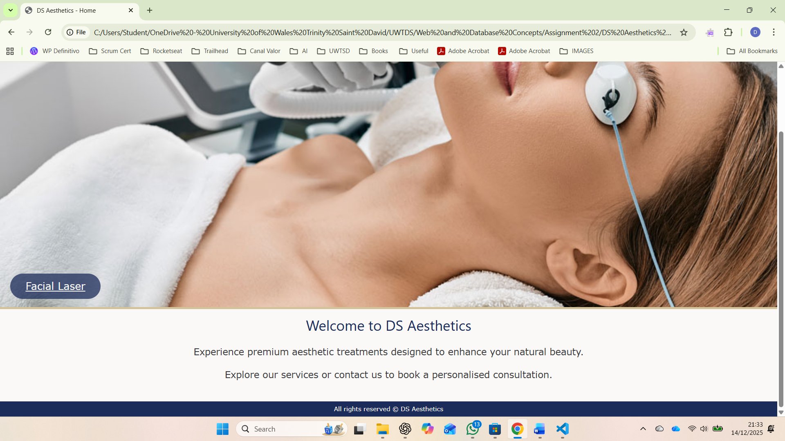

Service page:
Page title showing the user they’re on the services page.
List of all the treatments with correspondent image and information about each service.
At the end of the page, there is a call button for book a consultation.
The pages end with the footer with simple information.

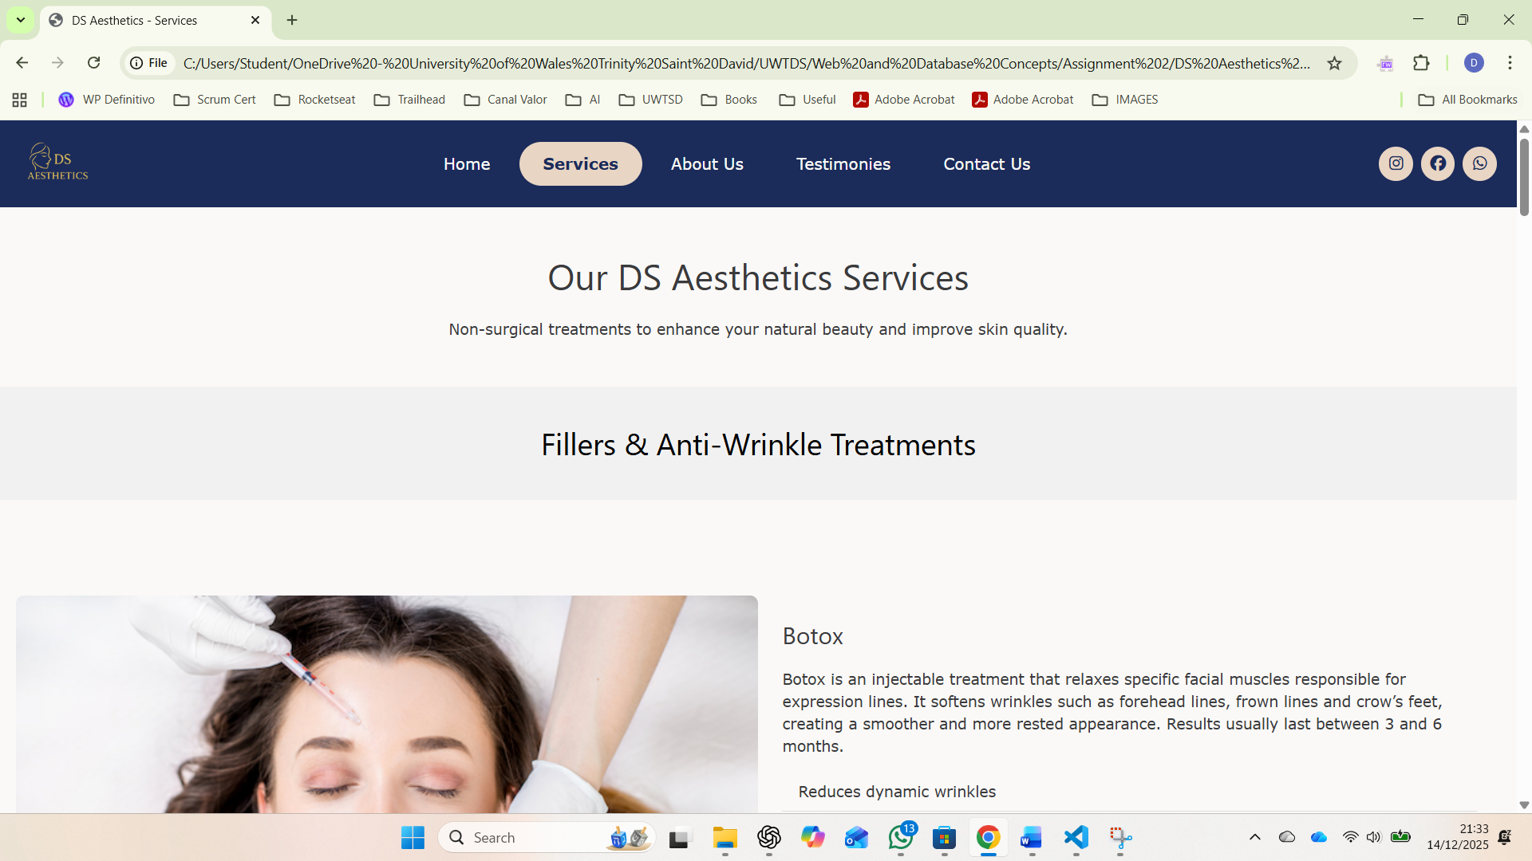

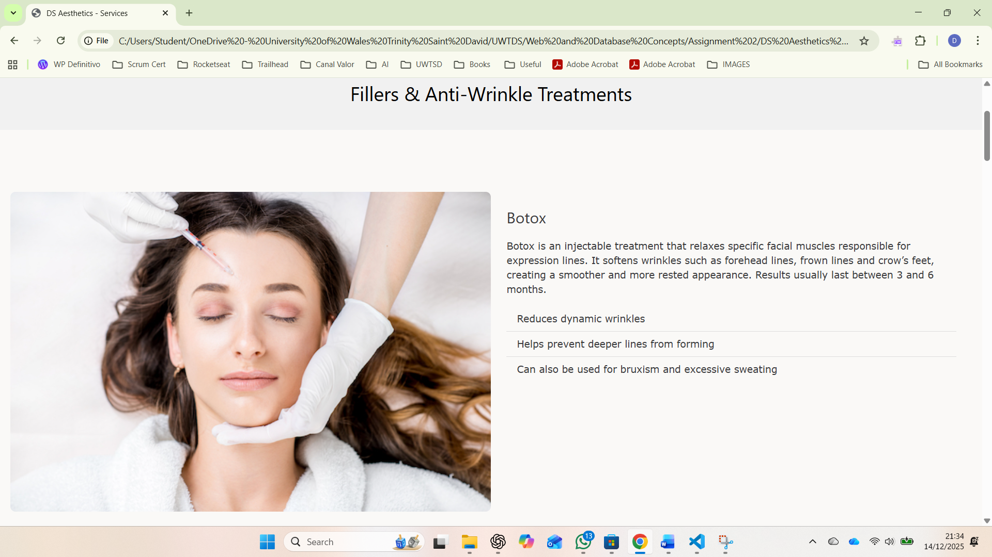

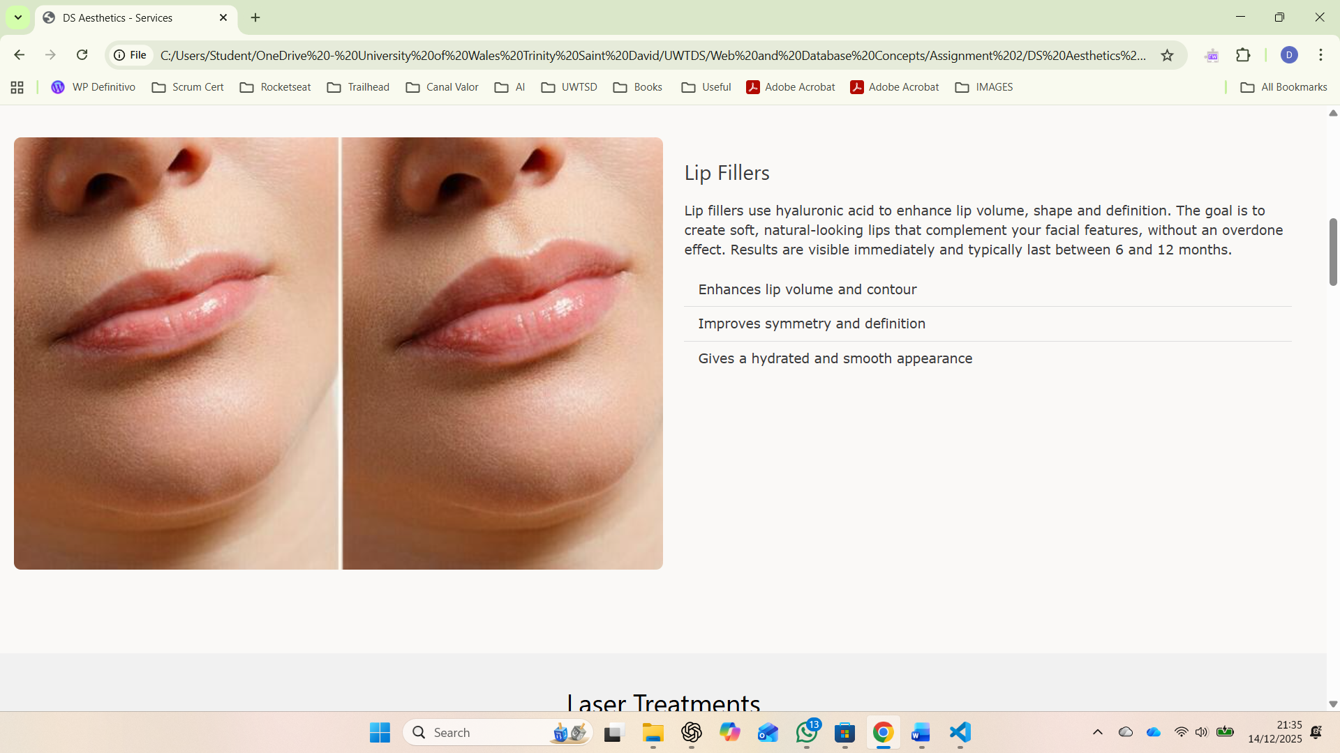

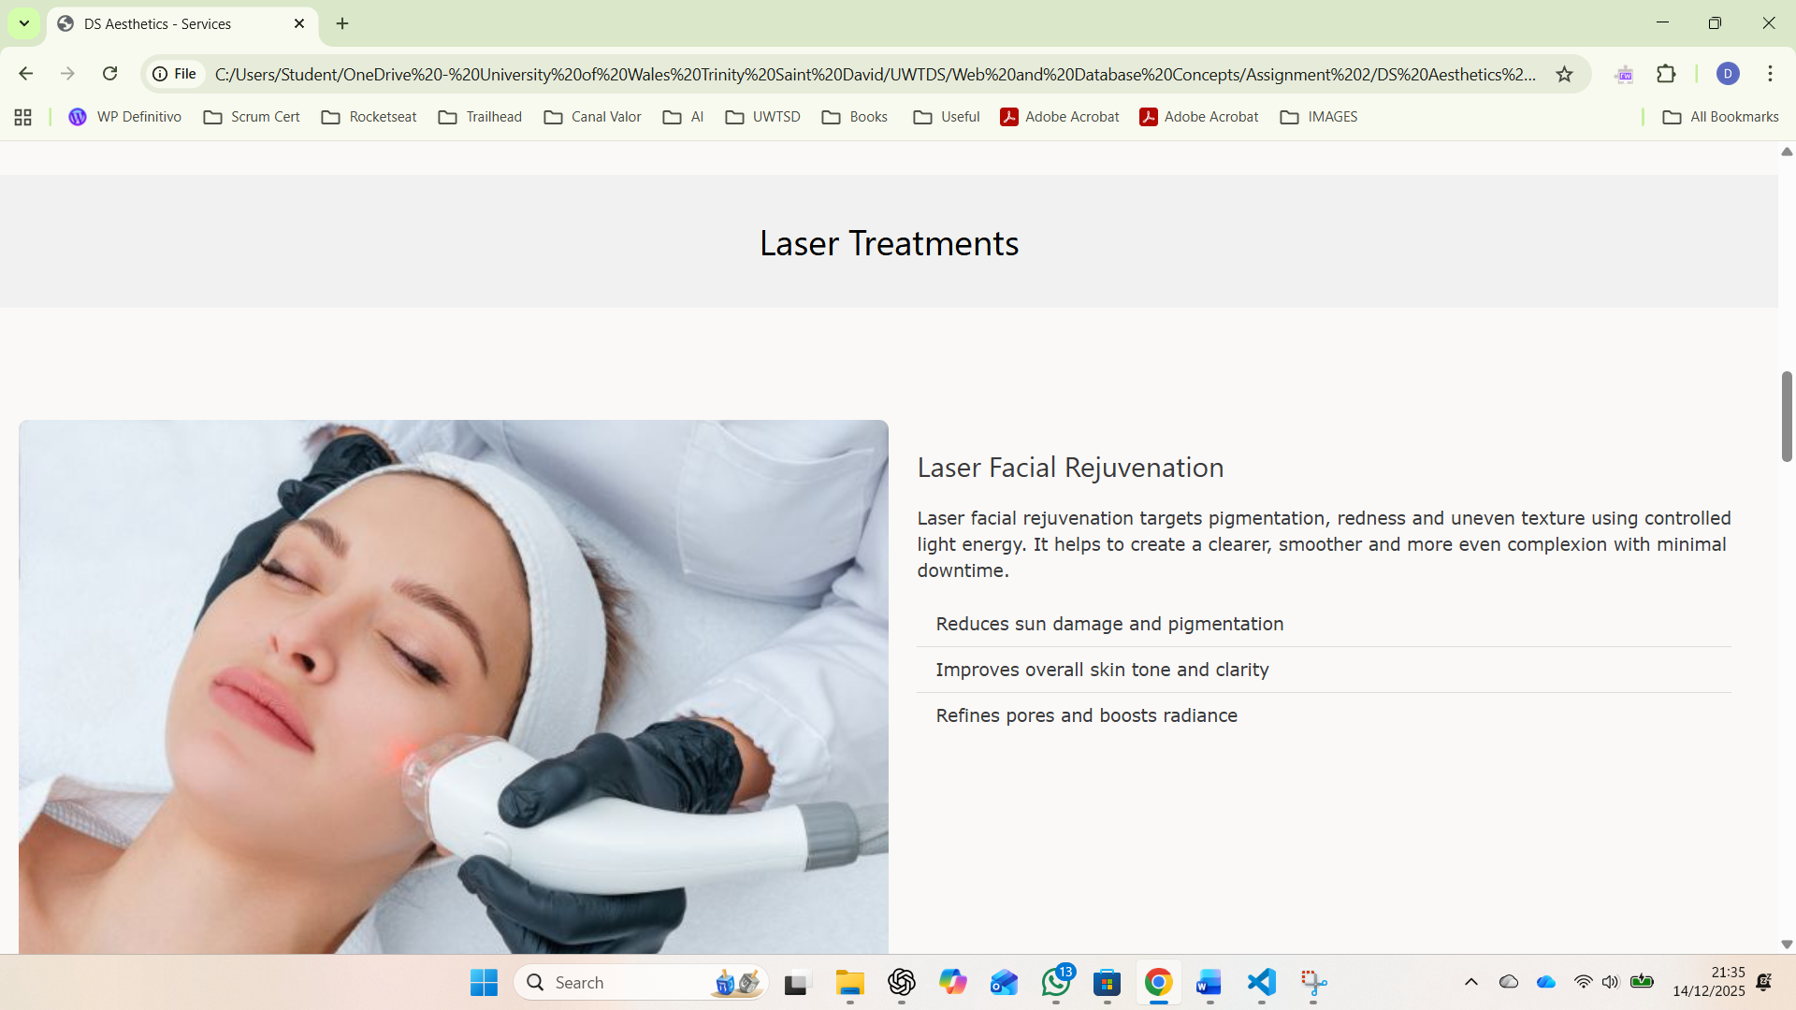

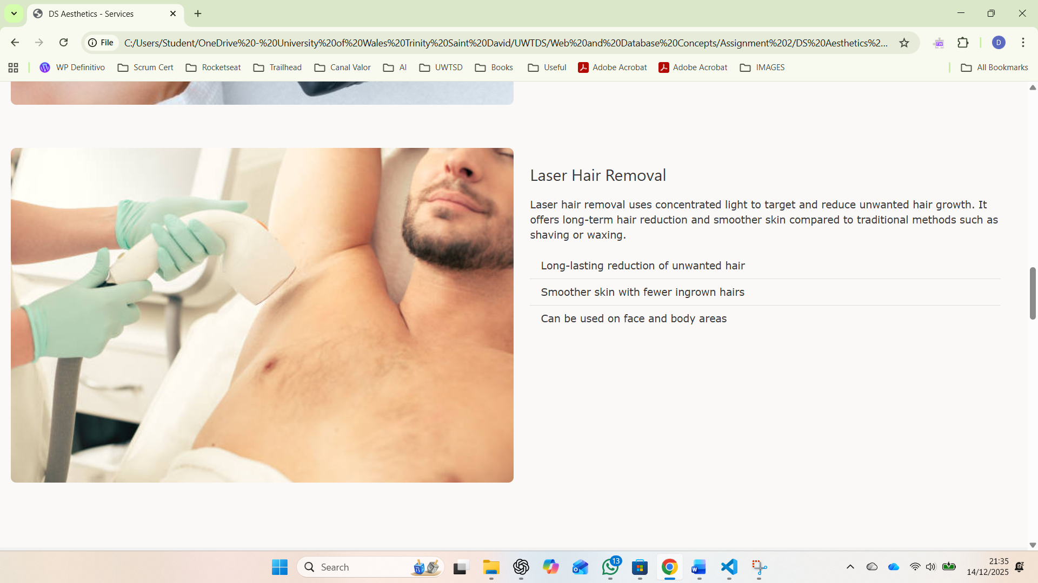

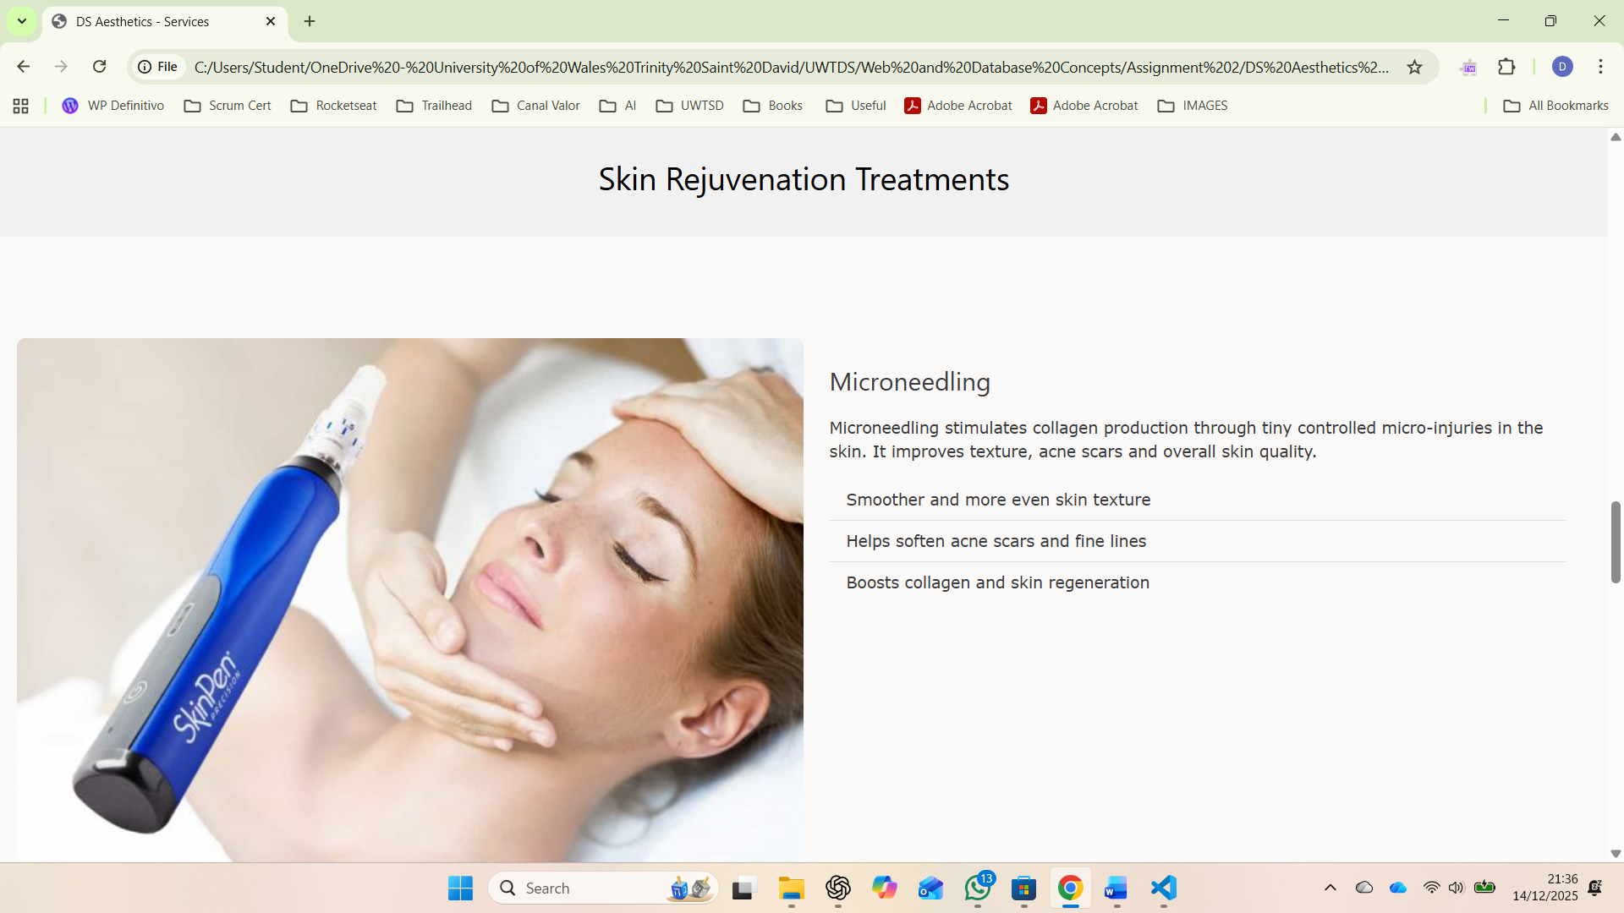

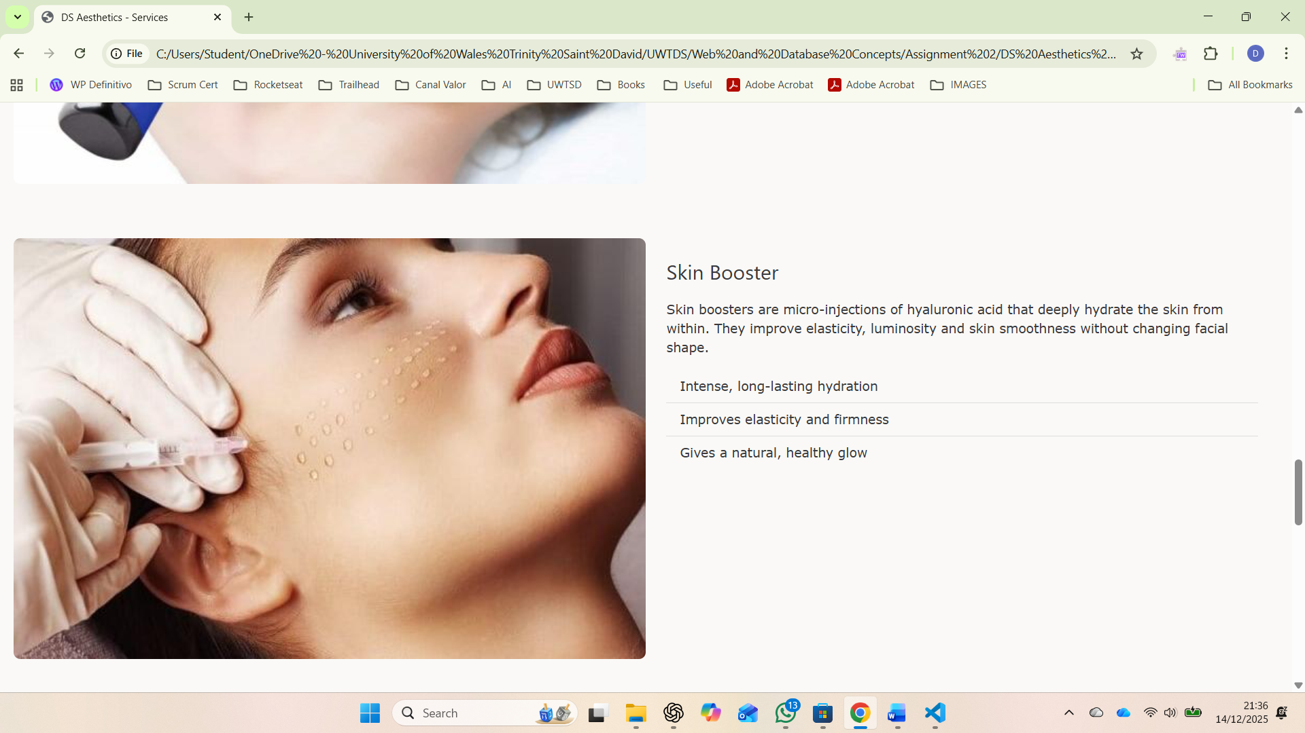

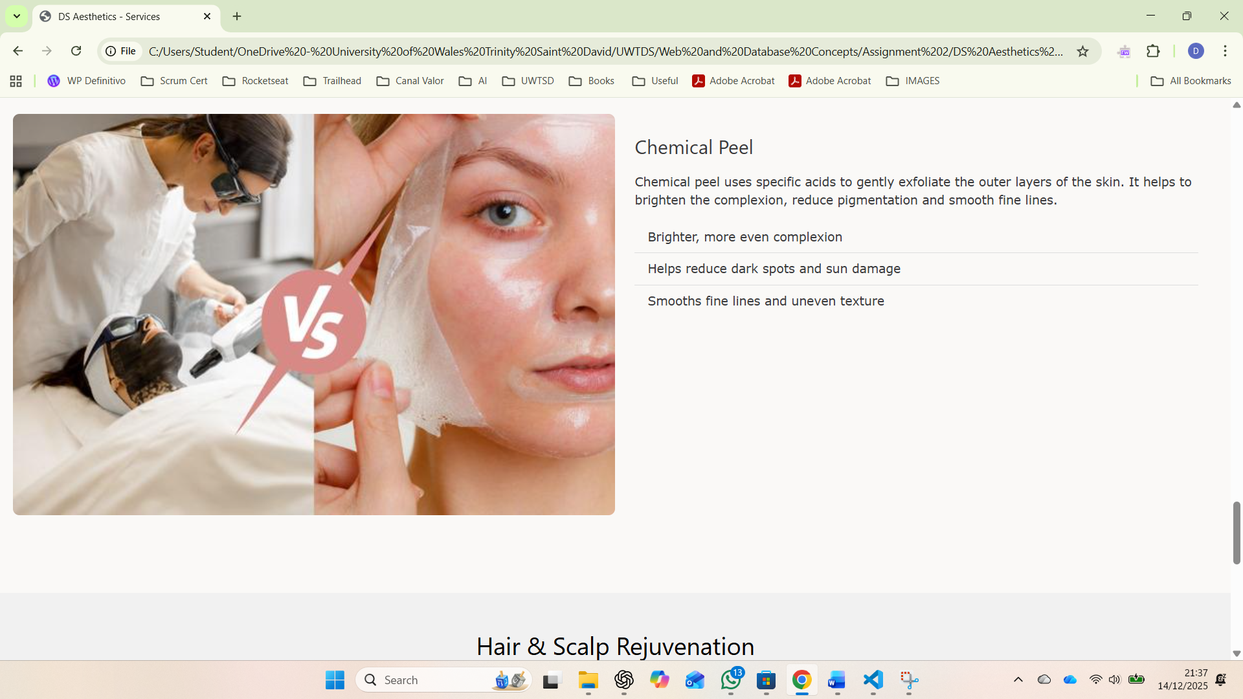

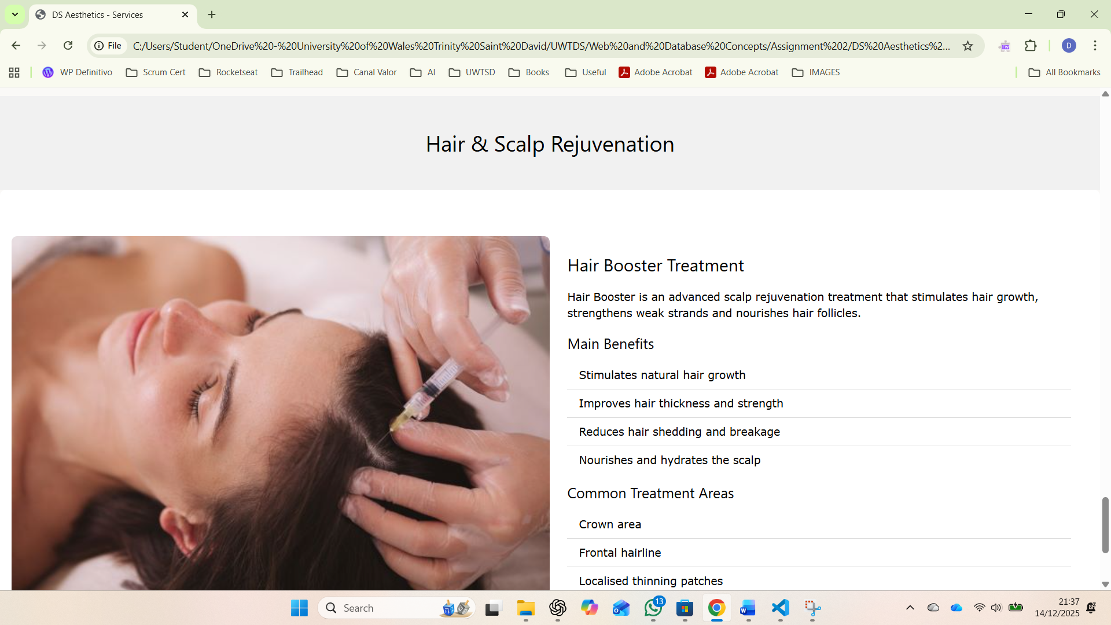

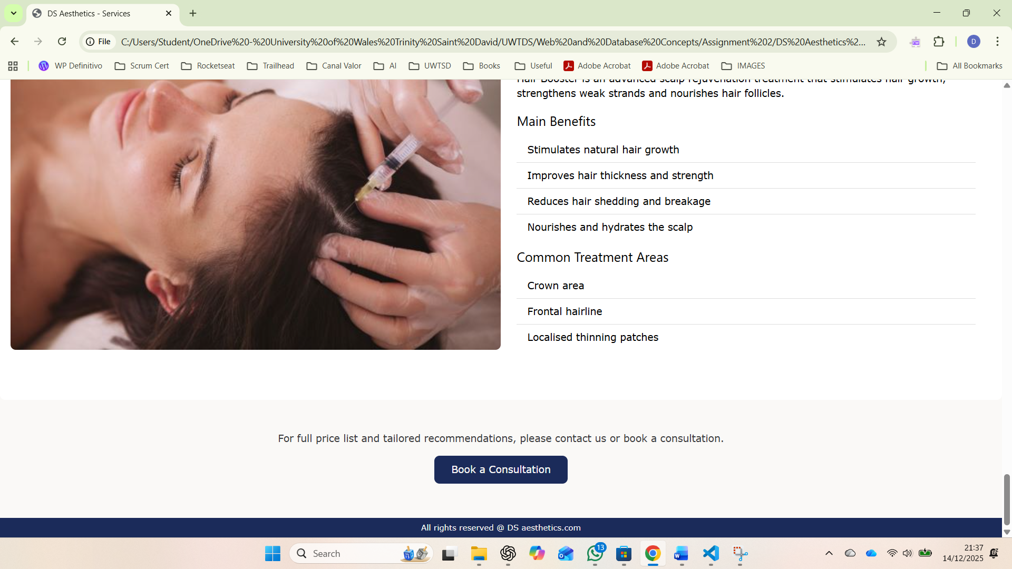

About us page (screenshots)
Main heading “Who we are”
Text describing the clinic’s mission, values, qualifications and experience.
Image on the right showing the clinic environment.

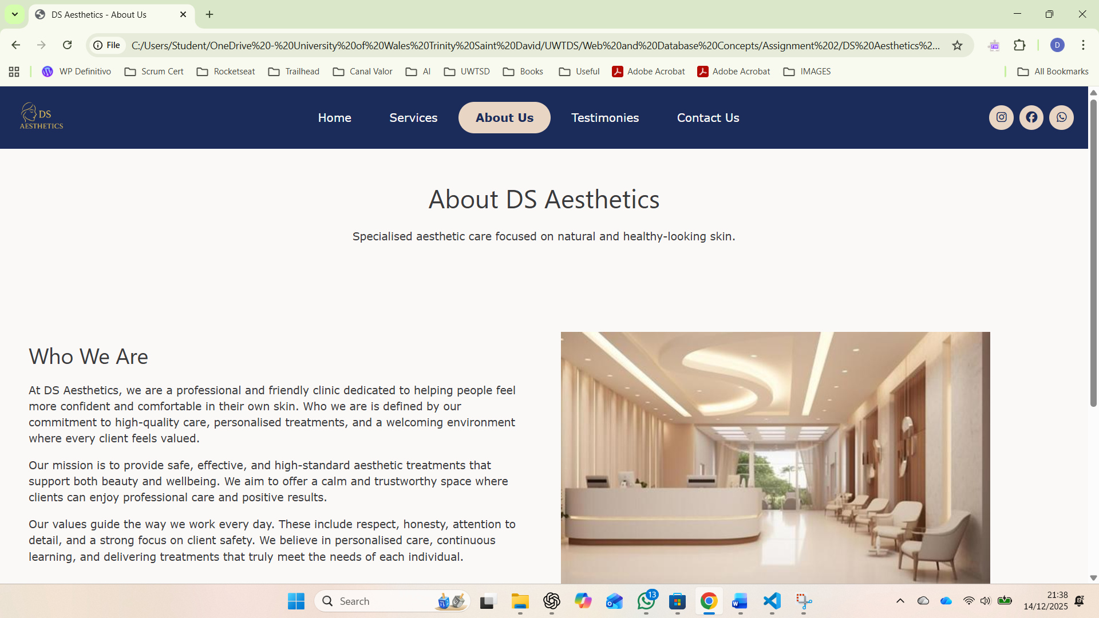

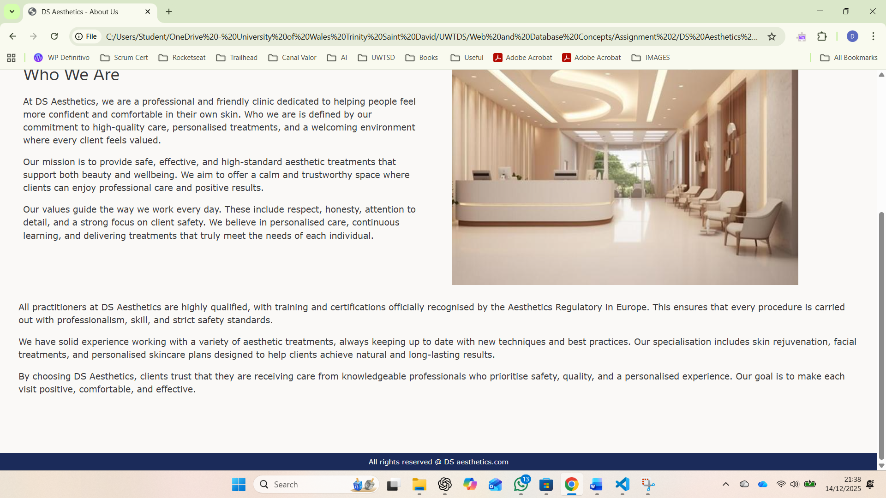

Testimonies page (screenshots)
Title showing this page contains client real feedback.
Boxes reviews from clients telling their experience.
Simple and clear layout that makes the comments easy to read.

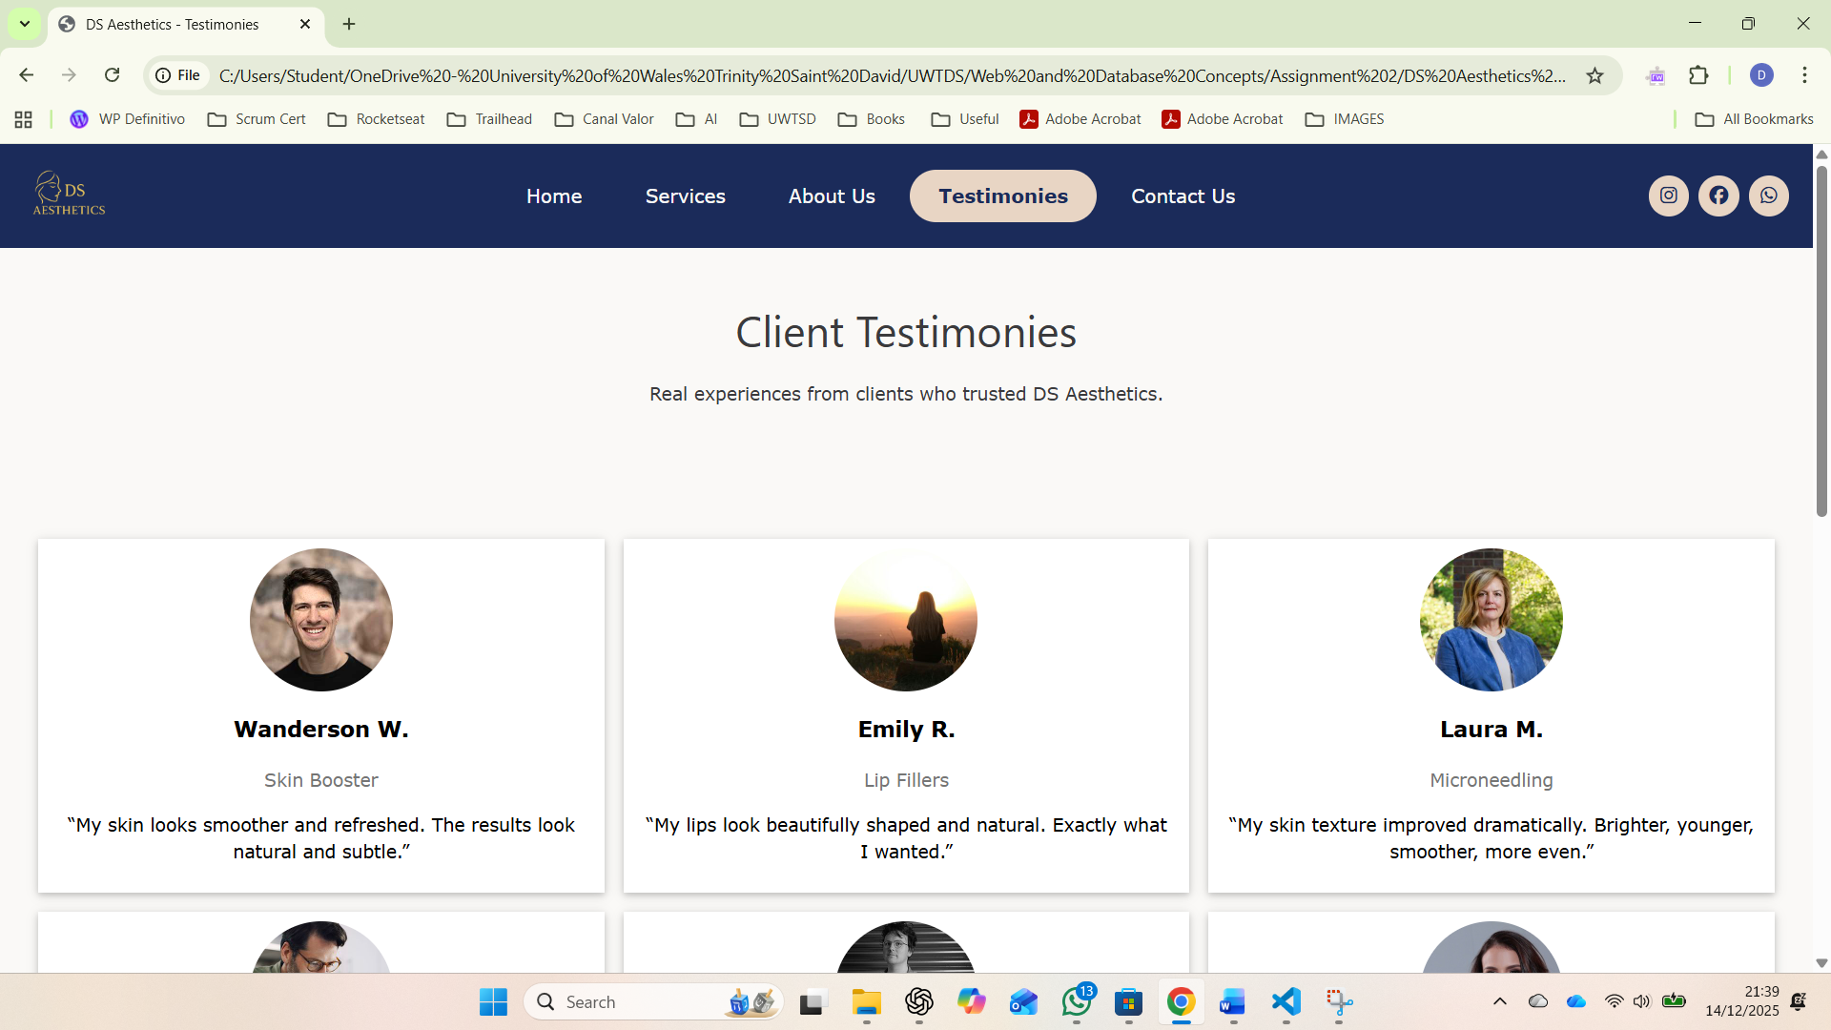

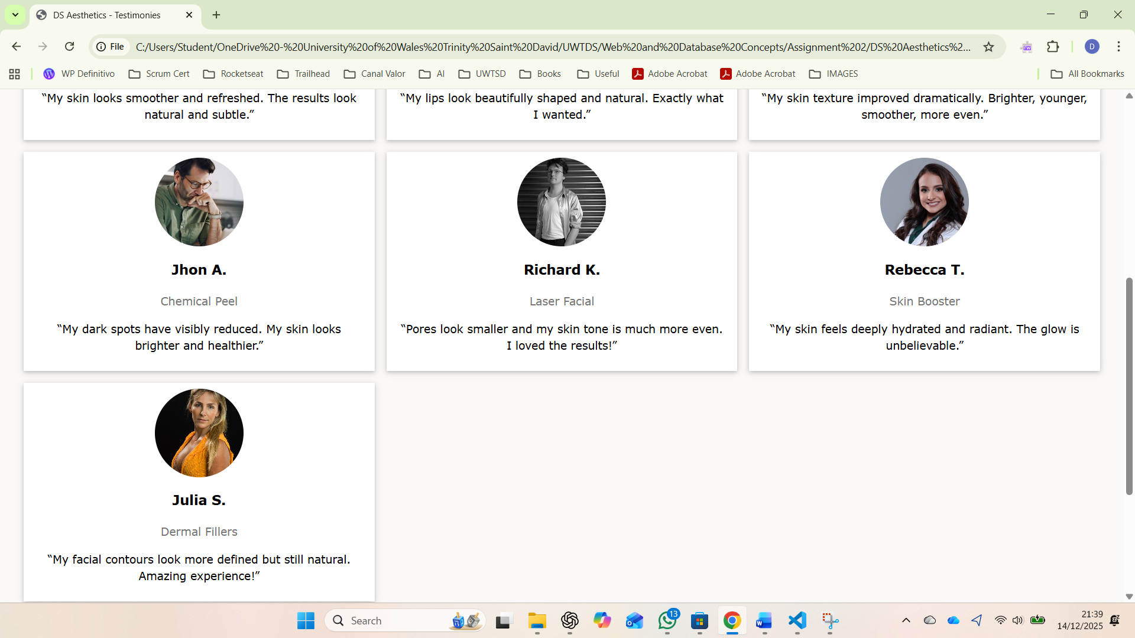

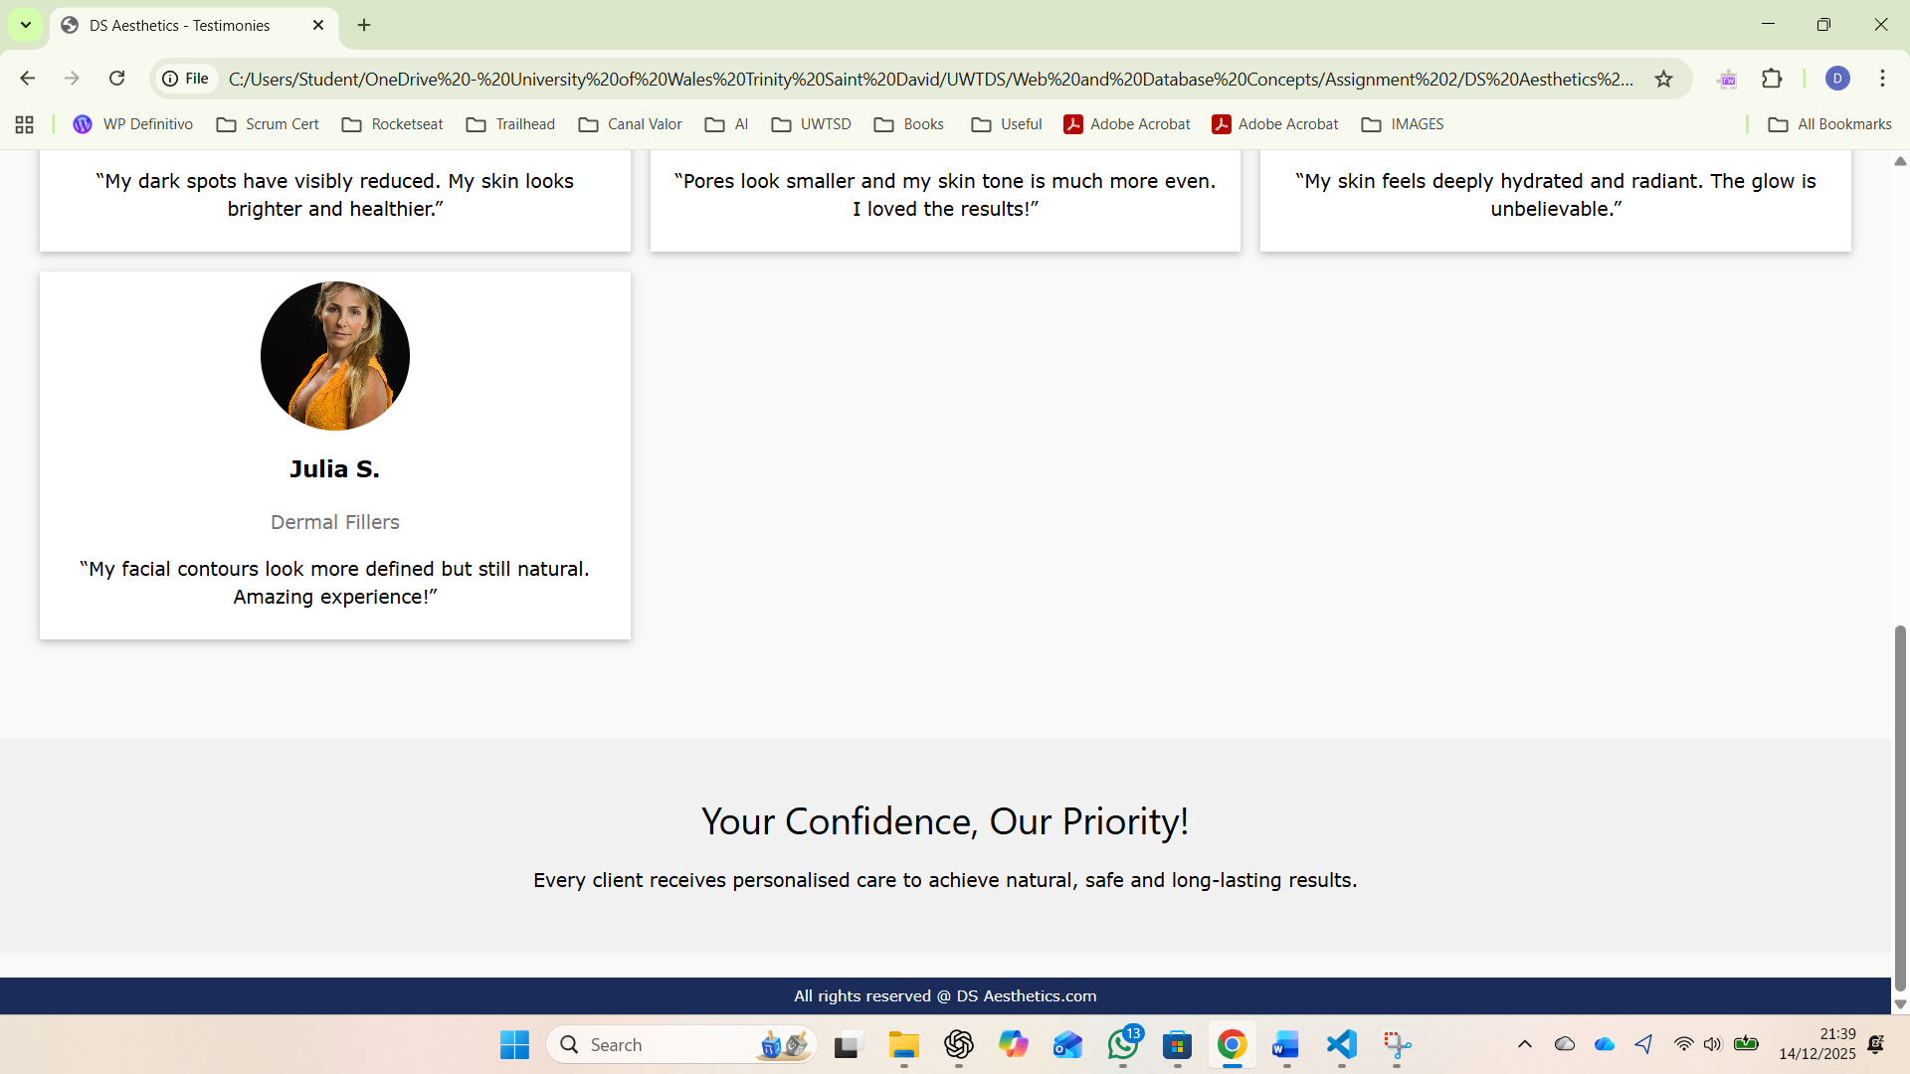

Contact us page (screenshots)
Contact form where the user can type their name, email, phone and message and button to submit the message.
Contact details of the clinic such as address, phone and email.
Information about the opening days and time.

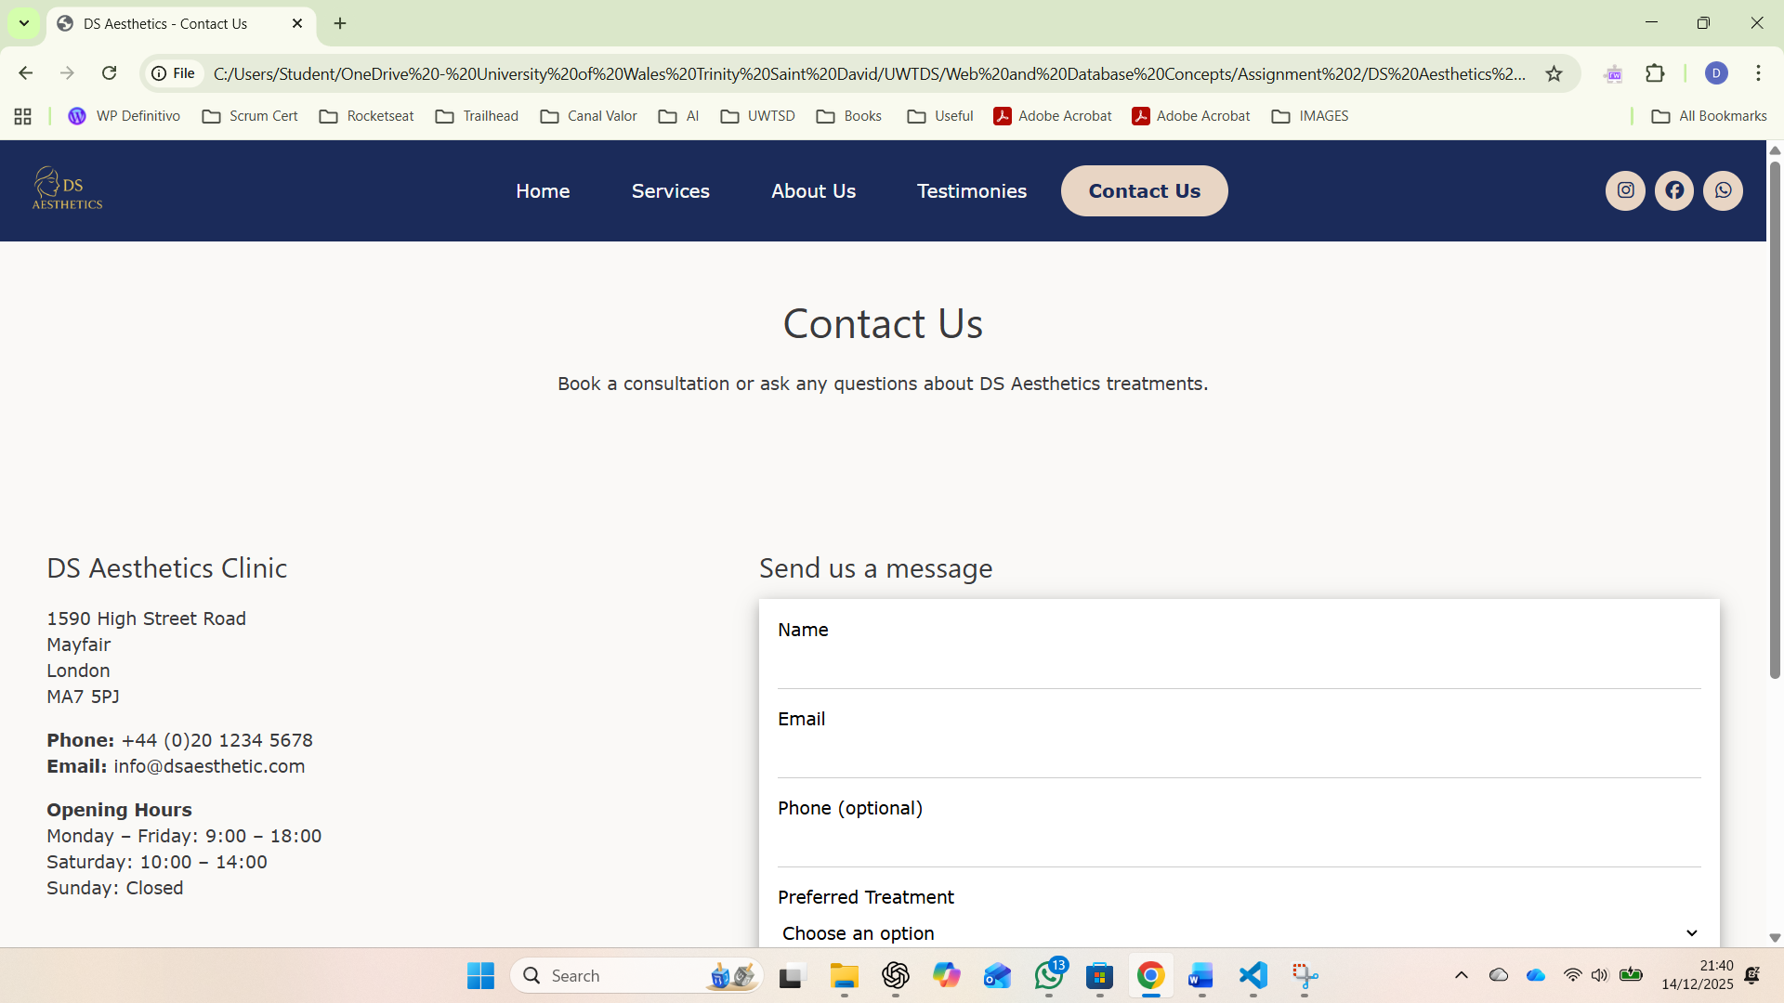
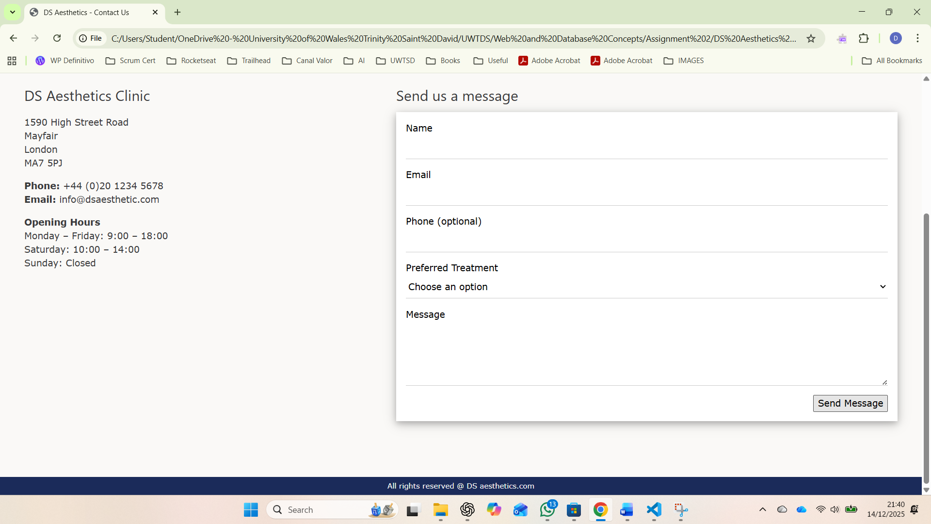

Validating my website

Please use the links provided in assignment brief to validate ONE HTML PAGE AND ONE CSS PAGE
Please find the links below
HTML VALIDATION LINK: https://validator.w3.org/
CSS VALIDATION LINK: https://jigsaw.w3.org/css-validator/
Please load the page and upload one of your HTML pages and generate the report. Take screenshot of each error message and explain what type of coding standard missing in your code.
Do the same to the CSS file as well.

HTML Validation Screenshot:

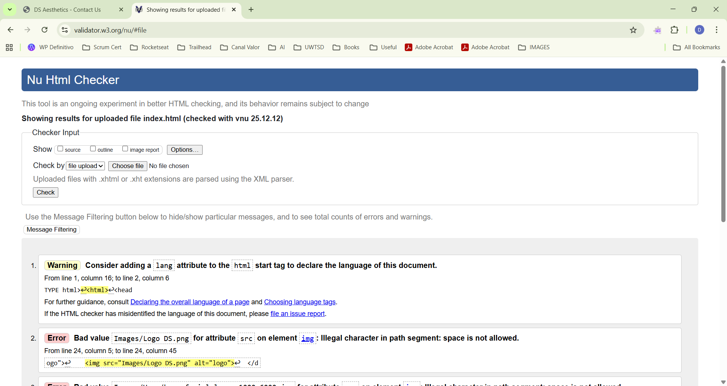

Warning 1: This warning occurs because the HTML file does not specify the page's language. To correct this is necessary to inform the language in the code.
Add a lang attribute to the <html> tag, for example if the language is English: <html lang="en">.

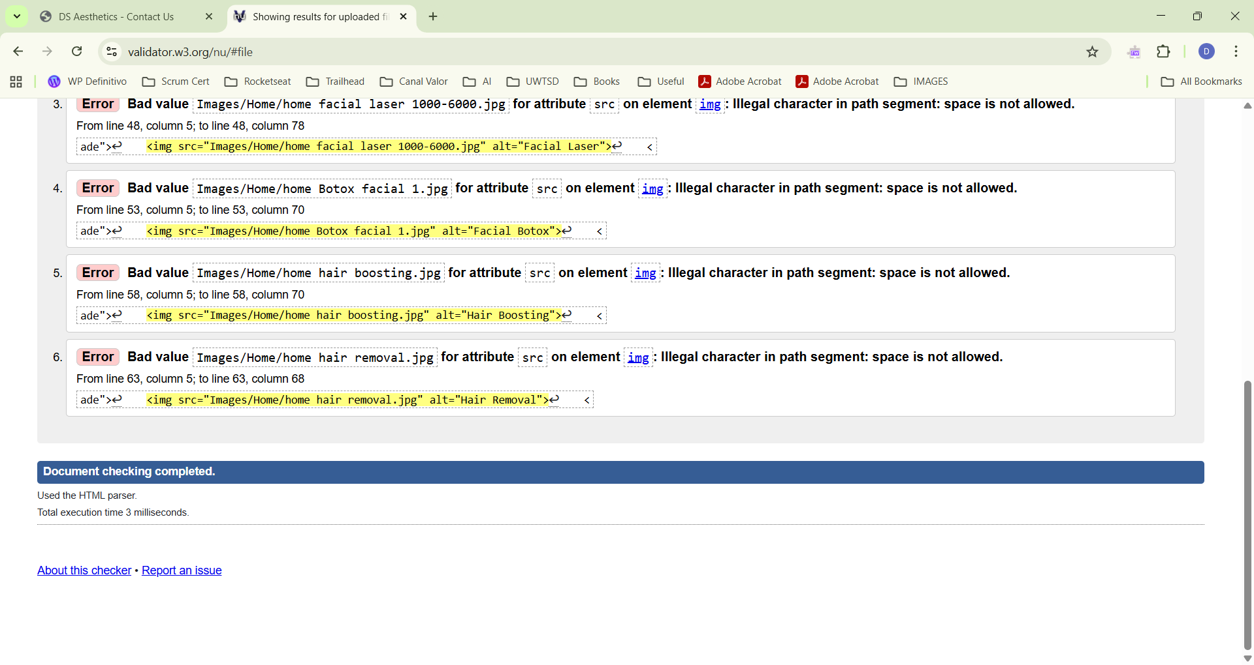
Errors 2 through 6 occurred for the same reason. This error refers to file naming conventions, which should not contain spaces, as URLs do not handle spaces correctly.
Here is the reason for the error: The space between logo and DS
<img src="Images/Logo DS.png" alt="logo">
To correct this error is very simple:
Rename the file using lowercase letters and no spaces, for example:
- logo-ds.png
- logo_ds.png
Then update the HTML:
<img src="Images/logo-ds.png" alt="logo">

After correcting the errors mentioned above and updating the site to be mobile-friendly and responsive to various browser options, I ended up encountering this error.

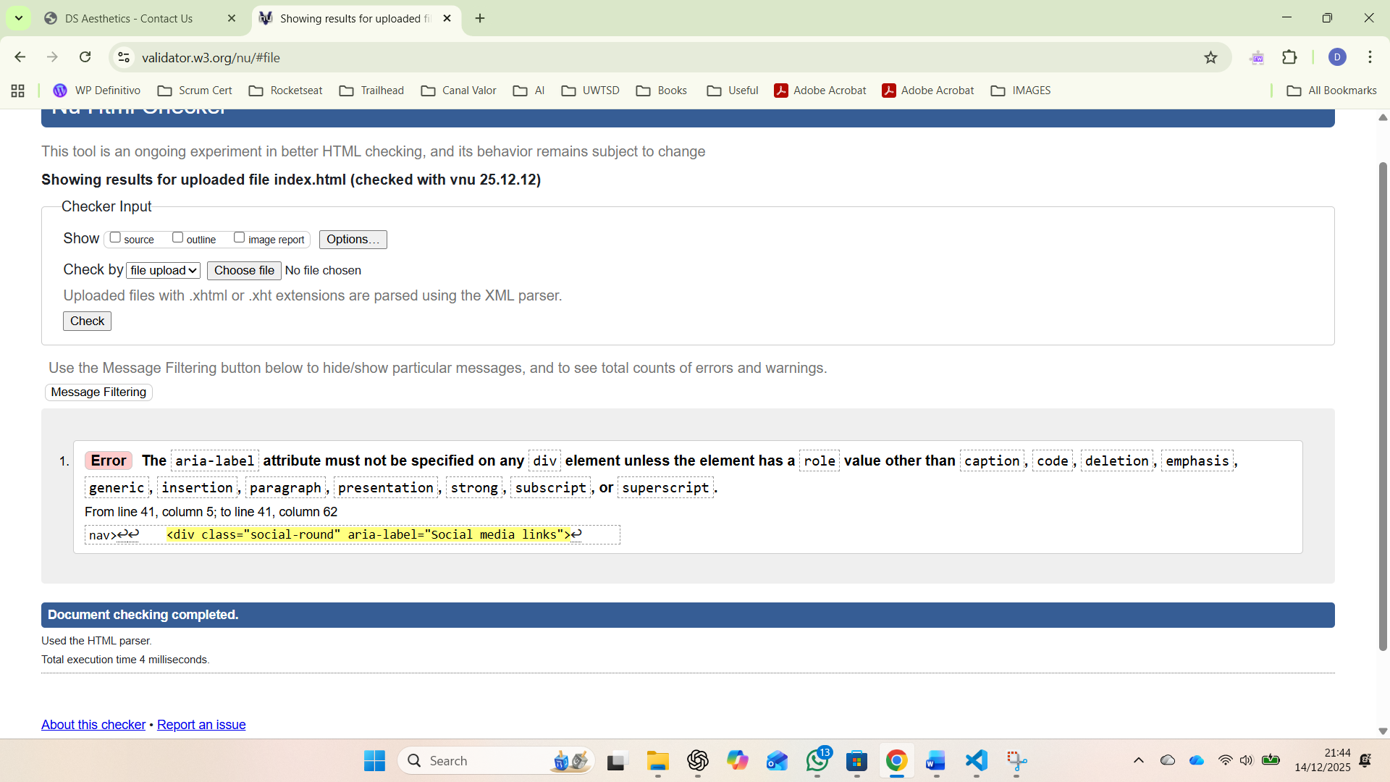

After fixing the errors mentioned earlier, I finally got a report without errors.
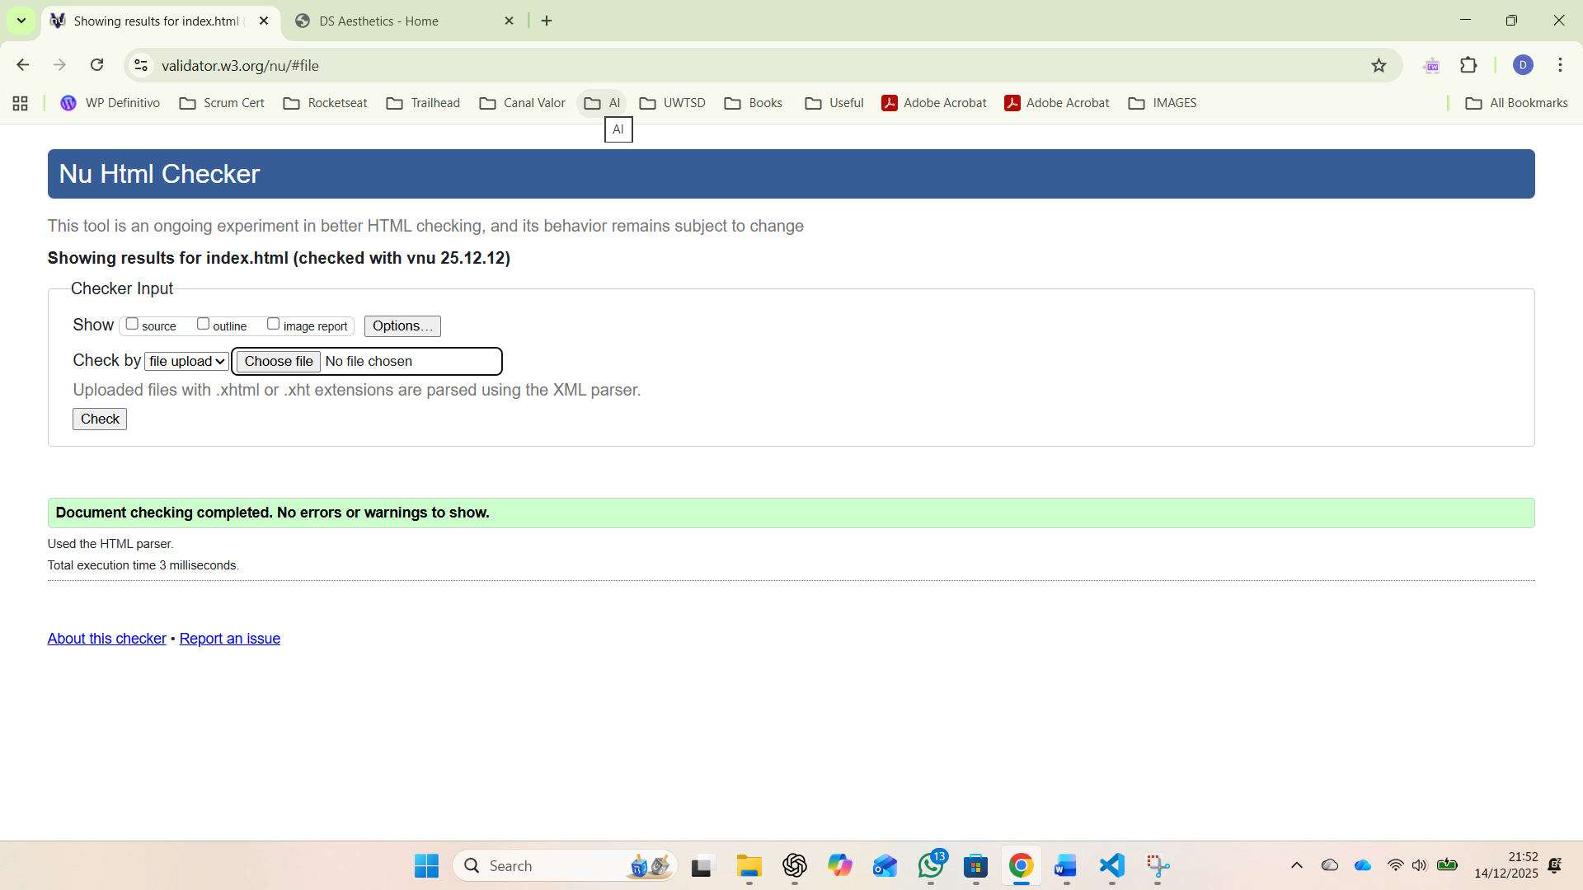

CSS Validation Screenshot:

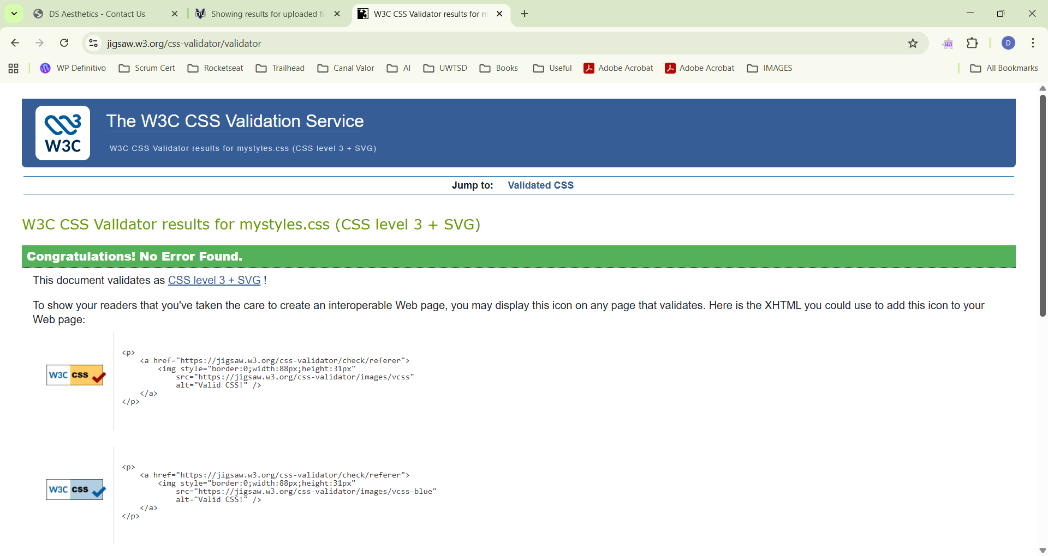
The CSS file was checked using the W3C CSS Validation Service. The validator found no errors, meaning the stylesheet follows CSS standards.

Self-evaluation of my website

Usefulness (usability and utility):
Use academic sources to identify what website usability means and compare your website with this criterion, whether you have met this criterion or not.
Website usability is basically how easy and comfortable a website is for people to use. It looks at things like if the pages are simple to navigate, if the text is clear to read and if users can find what they need without getting confused or stressed. A usable website should load fast and should work on different screen sizes and have buttons or links that are easy to use [1].
Usability means that the user doesn’t have to think too much when they visit the site. It must be easy to know where to click and what each page is about. If the website is difficult to navigate, users will leave so usability is very important to keep users and give them a positive and pleasant experience [2].

Search Engine Optimisation (SEO):
Is the process of improving a website so it appears in search engines like Google. When a website has good SEO it is easier for people to find it when they search for certain words related to the business and is for this reason SEO is very important to be in consideration when designing a website [3].
SEO include things like using the right keywords in text, having clear page titles, adding alt text to images, making the website load fast and making sure the pages work on mobile. All these things help search engines understand what the website is about. The main goal of SEO is to bring more visitors to the website without paying for ads. If the website appears on the first page more people will access it [4].

Website Accessibility:

When designing a website, there are many things that designers need to think about. One of the most important issues is website accessibility - browser compatibility. Today, people use different browsers to access websites, such as Chrome, Edge, or Safari.
Because there are many browsers available, it is important that a website works in the same way on all of them. If a website is not compatible, some parts may not display correctly or may not work as expected.

There are several organisations that are responsible for creating and recommending website design standards. To check if a website follows these standards and works well across different browsers, many automated tools are available online.
These tools usually test websites using their own rules and provide results based on that. One example is an automated tool designed to check browser compatibility according to W3C standards. This type of tool takes a website URL as input, requests the HTML code from the server, and then compares it with W3C guidelines to check if the website is compliant.
The process involves sending a request to the server, receiving the website’s HTML code, and analysing it against existing standards to identify any issues.
There are also other factors that can affect website compatibility between commonly used browsers. These include using different browsers and browser versions, different types of computers, and different screen and font sizes. In addition, issues such as HTML errors, browser bugs, installed add-ons, and third-party components can also cause websites to behave differently [5].
Users are not only using desktop computers anymore, as smartphones have become one of the main ways people access the Internet. Because of this, websites need to work properly on mobile browsers as well as on desktop devices.
Using websites on mobile can be harder than on desktop, because many pages were made for large screens and don’t fit well on smaller devices.
Small screens and narrow layouts make it harder to find content, so users often need to scroll a lot if the website is not made for mobile.
To improve mobile browsing, designers should adapt the layout and content for small screens to reduce scrolling and make things clearer.
Mobile compatibility is not just about loading, it also affects how easy a site is to use when switching from desktop to mobile [6].

References

[1] | N. S. N. H. W. Z. N. a. Y. A. Aziz, “A review of website measurement for website usability evaluation,” In Journal of Physics: Conference Series, vol. 1874, 2021.
[2] | A. A. Ganiyu, A. Mishra, J. Elijah and U. M. Gana, “The importance of usability of a website,” IUP Journal of Information Technology., pp. 27-35, 2017 Sep.
[3] | Yalçın, Nursel and U. Köse, “What is search engine optimization: SEO?,” Procedia-Social and Behavioral Sciences , vol. 9, p. 488, 2010.
[4] | V. M. a. P. A. V. Patil, “SEO: On-Page + Off-Page Analysis,” 2018 International Conference on Information , Communication, Engineering and Technology , 2018.
[5] | J. Manhas, “Comparative Study of cross browser compatibility as design issue in various websites,” BVICA M's International Journal of Information Technology, 2015.
[6] | S. Shrestha, “Mobile web browsing: usability study,” In Proceedings of the 4th international conference on mobile technology, applications, and systems and the 1st international symposium on Computer human interaction in mobile technology, pp. 187-194, 2007.

