

Module Name: Independent Project
Module Code: BMTP6015
Element: Element 2
Student Name: Nia Moores
Student Number: 2200282
Lecturer: Scott James
Deadline: Sunday 29th March 23:59PM

Applied Events
Portfolio of Evidence
Table of Contents
Section 1: Introduction 2
Section 2: Planning and Preparation 3
Section 3: Applied Planning for Your Event Element 6
Section 4: Pre-Event Readiness & Implementation Plan 8
Set-Up Day – Monday 9th March 8
Event Day – Tuesday 10th March 9
Section 5: Reflection and Next Steps 11
Section 6: Portfolio Appendix 13
Reference List 20

Section 1: Introduction
This portfolio outlines the development and implementation of my chosen event element following the submission of Component One, the event bid. The original bid proposed the creation of a cohesive theme and branding strategy, delivered through a series of immersive and interactive zones designed to enhance the visitor experience. This element aims to inspire and educate students about the diverse career pathways within the tourism sector while reflecting the creativity, innovation, and professionalism of the industry. To support this aim, three objectives were established: the first aim is to create three interactive zones to encourage active participation, then to implement a consistent theme and branding across the physical venue and digital content, targeting 90% attendee recognition in the post-event survey, and finally to achieve at least 85% positive feedback regarding the visual presentation of the event.
The live event, ITT Future You Travel and Tourism Conference and Exhibition, is a United Kingdom careers initiative delivered by the Institute of Travel and Tourism (ITT) in collaboration with students across the UK. The event aims to inspire students and graduates to explore opportunities within travel, tourism, and hospitality. This year, the event has expanded its unique selling point by welcoming organisations from the business, education, and public sectors, broadening the scope of career pathways presented and strengthening the long-term legacy of ITT Future You. (Reeves, 1991)
My primary responsibility within the event team is overseeing theme and branding, ensuring a consistent visual identity across the venue, and supporting digital platforms. Branding plays a critical role in establishing recognition, credibility, and long-term engagement among delegates (Ianenko et al., 2020). In addition, my role includes contributing to the design of immersive learning zones and developing the annual event treasure hunt, which encourages structured interaction between attendees and exhibitors. These initiatives directly support the wider event objectives by forcing engagement, enhancing networking opportunities, and creating a memorable learning environment.
This portfolio demonstrates how theoretical frameworks from event management and marketing have informed the planning and delivery of this element. It critically evaluates research, decision-making processes, and practical implementation, showing how theory has been translated into a strategically aligned branding strategy.

Section 2: Planning and Preparation
The planning of the branding and theming element followed a structured event management process model, progressing through stages of research, concept development, planning, coordination, and evaluation (Kim, 2010). While the event management process model provided a useful structured framework, it did not fully reflect the evolving live event planning. For example, exhibitor uncertainty required revisiting earlier stages, suggesting that a more flexible model may have been more appropriate. Event planning emphasises that adopting systematic planning models allows event teams to manage complex tasks while maintaining alignment with overall event objectives.
To support this approach, a project timeline was developed to ensure that the event progressed through clearly defined planning stages. The timeline, see Appendix A: Event Planning Timeline, outlines key milestones including initial concept approval, exhibitor outreach, venue consultation, marketing launch, and final event preparation. Establishing these milestones early in the planning process helped maintain accountability within the team while also ensuring that each element of the event remained aligned with the overall strategic objectives.
Structured planning timelines are widely recognised as an essential tool in event project management, as they allow teams to coordinate multiple tasks while maintaining progress towards key milestones. Within event environments where numerous stakeholders are involved, timelines support accountability and reduce the likelihood of delays. The Project Management Institute’s project management life cycle emphasises the importance of structured planning during the planning phase, where schedules and timelines are created to coordinate tasks and monitor progress towards project milestones (Rose, 2001). In this case, the timeline functioned not only as a scheduling tool but also as a communication mechanism, ensuring that all team members understood when critical tasks such as exhibitor confirmation, venue preparation, and marketing activities needed to be completed.
Seventeen weeks before the event, the team clarified the overall aims, objectives, and direction of the event to ensure collective understanding among all members. Establishing early clarity was essential in preventing role confusion and ensuring that each event element contributed effectively to the wider event goals. Approximately ten weeks before the event, the team collectively initiated outreach to exhibitors, schools, colleges, and guest speakers. A collaborative outreach approach was adopted, allowing team members to utilise their individual networks to maximise participation and strengthen stakeholder engagement.
Nine weeks before the event, planning activity shifted towards marketing and audience engagement. During this stage, social media content was developed to generate early awareness and stimulate interest among the target audience. Proactive communication at this stage contributed to building anticipation for the event and supported attendee recruitment. Four weeks before the event, a venue meeting was conducted with the arena management team. This consultation clarified logistical constraints, venue regulations, and health and safety requirements, ensuring that decorative installations and branding elements could be implemented in compliance with venue policies.
Two weeks prior to the event represented the final coordination phase, focusing on exhibitor confirmations, zoning allocations, and final layout adjustments. This stage required adaptive decision-making due to uncertainty regarding the final number of exhibitors attending the event. Initial concerns led to discussions about potentially reducing the physical size of the exhibition space. However, rather than scaling down the venue, the strategic decision was made to utilise the main auditorium space by incorporating workshop sessions within the Level 0 area. This decision demonstrates adaptive planning, where the team responded to operational uncertainty by enhancing the event programme rather than reducing the scale of the event. Management decisions should always be able to adapt to situations rather than one fixed strategy. (Fiedler, 2015)
Financial planning also formed a significant component of the preparation process. The event operated under considerable budget constraints due to limited university funding, which required members of the team to self-finance certain decorative materials. To manage expenditure transparently, a shared budgeting list was created to prioritise essential items and monitor spending. (Coates and Horngren, 1966) Cost-efficient decisions were implemented where possible, such as substituting stamps with stickers for the treasure hunt activity. See Appendix B: Budget Breakdown. Available funding was therefore strategically directed towards high-impact engagement materials, including printed passports, marketing resources, and mascot characters, which were identified as key contributors to attendee interaction and atmosphere.
Risk management formed a critical component of the event planning process. Live events operate within dynamic environments where operational disruptions may occur, making proactive risk identification essential. A structured risk assessment was therefore developed to identify potential threats to event delivery and establish appropriate strategies; see Appendix C: Risk Management. Key risks considered included technical failures, crowd flow issues, delays during event setup, and potential low engagement with the treasure hunt activity. By identifying these risks in advance, preventative measures could be implemented, ensuring that the event team was prepared to respond effectively if challenges arose. This proactive approach reflects best practice in event management, where anticipating operational risks helps minimise disruption and maintain a positive attendee experience. (Rose, 2001)
To support accountability and reflective planning, a decision log was also maintained throughout the preparation process. Recording key decisions alongside their rationale enabled the team to review alternative options, track changes in planning direction, and justify strategic choices made during the planning phase. This documentation process supported transparency within the team and provided a structured record of how planning decisions evolved; see Appendix D: Decision Log.
Communication with stakeholders was informed by Stakeholder Theory, which recognises that successful event delivery depends on effective relationships between multiple interconnected areas. (Freeman et al. 2010) Effective stakeholder communication is widely recognised as a key determinant of successful event delivery. Maintaining regular communication with stakeholders ensures that expectations remain aligned and that emerging issues can be addressed promptly. In this case, weekly planning meetings provided structured opportunities for discussion and decision-making, while digital communication platforms allowed rapid coordination between team members. See Appendix E: Stakeholder communication. This combination of formal and informal communication channels ensured both accountability and flexibility throughout the planning process.
Key stakeholders included the arena management team, university representatives, exhibitors, suppliers, and the student event team. Weekly planning meetings ensured alignment and accountability across the team. External stakeholders were primarily engaged through professional email communication to maintain clarity and ensure that key information was formally documented.
Overall, the integration of structured timelines, financial planning, risk assessment, stakeholder communication, and adaptive decision-making reflects a professional and systematic approach to event planning. By applying established event management frameworks, the planning process ensured that the branding and theming elements remained strategically aligned with the broader objectives of the ITT Future You event.

Section 3: Applied Planning for Your Event Element
This section presents the detailed applied planning specific to the theme and branding element for the ITT Future You Travel and Tourism Conference and Exhibition. It critically outlines the creative development process, strategic rationale, documentation, and cross-functional coordination that informed the implementation of a cohesive visual and experiential identity across the live event. Rather than operating as a purely aesthetic function, branding was embedded strategically within planning, stakeholder engagement, delegate interaction, and operational delivery. The element, therefore, demonstrates how theoretical principles from event management and marketing were translated into measurable and practical outcomes.
The central theme was developed to reflect innovation, exploration, and professional opportunity within the travel and tourism sector. As the event’s primary audience consists of students and graduates exploring career pathways, it was essential that the visual identity projected professionalism. The branding needed to balance corporate credibility with creativity to hit a younger demographic while maintaining industry stakeholders. This decision was informed by brand identity theory, which emphasises consistency and clarity as key drivers of recognition and trust (Ianenko et al., 2020). Therefore, the theme was not designed solely for visual appeal but to communicate a narrative: that the tourism industry offers diverse and aspirational career pathways.
To operationalise this concept, the exhibition space was divided into immersive zones: Business and Corporate Travel, Education and Professional Development, and Public Sector and Destinations. These categories were selected strategically to reflect the industry while simplifying navigation for attendees. Segmenting the space in this way also aligns with experiential design principles, which suggest that structured environments enhance cognitive processing and reduce decision fatigue. (Leahy and Sweller, 2011) This means that the layout will be easy to understand and not overwhelming. Each zone was visually differentiated through distinct colours and decorative elements.
While servicescape theory supports the idea that physical environments influence behaviour, its effectiveness in this context depends on attendee engagement levels. For instance, if attendees prioritise specific exhibitors rather than exploring workshops, the intended influence of spatial design may be reduced. Therefore, the success of this approach relies not only on layout but also on engagement strategies such as the treasure hunt. (Bitner & Booms, 1981) The layout, colour coding, and spatial organisation were therefore designed to guide movement, encourage stroll time, and enhance engagement. Consistent branding across banners, passports, and digital materials reinforced recognition. The layout map, see Appendix F: Floor Plan, illustrates how branding was embedded within spatial planning rather than added after.
A core component of the applied branding strategy was the development of the annual treasure hunt. The objective of this activity was to transform passive exhibition browsing into structured interaction. Research in experiential marketing highlights that active participation strengthens memory retention and emotional connection (Goldsmith & Tsiotsou, 2012). Therefore, the treasure hunt was designed as a gamified networking tool that aligned delegate experience with exhibitor objectives.
Students are provided with branded “passports” upon arrival. These passports require them to visit designated exhibitors to collect stickers, which could later be exchanged for a prize incentive. The passport design visually reinforced brand consistency. See Appendix G: Passport Design. The decision to use stickers rather than stamps was driven by cost-efficiency, practicality, and speed of interaction. Stickers reduced queuing time at stands and simplified logistical distribution while remaining visually appealing.
Importantly, this initiative also created measurable engagement opportunities. Completion rates of the passports can later be analysed to evaluate interaction levels. The activity was not only experiential but also provided informal evaluative insight. It also increases footfall across all exhibitors' stands, preventing clustering around certain organisations. Although stakeholder theory creates value for all parties, in practice, there were trade-offs. For example, prioritising equal footfall across exhibitors through the treasure hunt may have limited attendees’ ability to spend more time with preferred organisations, suggesting a tension between structured engagement and individual choices. (Harrison and Wicks, 2013)
Branding integration within the exhibition hall required close collaboration with logistical planning processes. With over 60 exhibitors anticipated, planning became increasingly complex. Early drafts of the floor plan were revised multiple times due to confirmation numbers. Concerns emerged regarding whether the main auditorium should remain unused if exhibitor numbers were lower than expected. However, scaling down the physical footprint risked event credibility. Rather than reducing venue usage, a strategic decision was made to incorporate workshop sessions within the space.
This decision demonstrates adaptive strategic planning rather than reactive planning. Adding workshops to the space created relevant tasks and strengthened the educational positioning of the event. The annotated floor plans in Appendix H: Original Floor Plan show how branding and decisions change in response to operational risks. This reflects live event planning, where flexibility is essential but strategic intent must remain the same.
The applied branding element also required cross-team coordination. Collaboration with the team ensured that decorative installations complied with health and safety regulations. Events cannot take place without risk assessments and reasonable steps to prevent harm. (Bruner, 2013)
In parallel, coordination with the marketing team made sure there was consistency between the digital and the physical event environment. Social media posts incorporated the same colour palettes and messaging used within the venue to create an integrated brand experience. This reflects integrated marketing communications theory, which emphasises consistency across touchpoints to enhance recognition and trust. (Varey, 1998) Without alignment between digital and physical branding, attendee expectations may not have matched the live experience.
Engagement with the exhibitor manager also influenced branding decisions. Stand requirements and power access shaped decorative placement. Weekly team meetings helped foster transparency and collective problem-solving, while shared documentation ensured accountability. WhatsApp allowed rapid responses to issues.
Financial constraints shaped decision-making. Limited funding required priority items. Decorative purchases were carefully picked against strategic value. Marketing materials, treasure hunt passports, and mascot characters were prioritised due to their visible influence on engagement and atmosphere in previous years. This reflects principles of event budgeting and cost control, where value maximisation is prioritised over excessive expenditure.
Risk management was also embedded within applied planning. Planning considered crowd flow and accessibility to minimise traffic. Student volunteers reduced confusion, and workshop scheduling staged movement across the venue. These show how branding decisions were made with operational safety and risk to minimise risk.
Overall, the applied planning of the branding element demonstrates the integration of both theoretical frameworks and practical event management strategies. Branding shapes navigation, engagement strategies, stakeholder value, and delegate experience. Through structured documentation, floor plan development, and gamified interaction design. Branding became operational delivery rather than existing as a design layer. The element shows how frameworks, including servicescape theory, experiential marketing, brand identity theory, and stakeholder theory, can become practical. This approach is an immersive and strategic approach to the live event environment that supports both educational and professional objectives.

Section 4: Pre-Event Readiness & Implementation Plan
This section outlines how the theme and branding element of ITT Future You will be delivered successfully across the two-day event on the 9th and 10th of March 2026. Effective pre-event readiness is critical in live event management, as operational targets, role clarity, and contingency planning directly influence overall event quality. The following plan details the event-day schedule, defined team responsibilities, risk strategies, and cross-team coordination measures to ensure smooth delivery.
Set-Up Day – Monday 9th March
The arena will open at 12:00 pm on Monday, 9th March, to allow the team to focus on venue transformation, technical rehearsal, and final branding implementation.
Student volunteers will arrive at 12:30 pm and will be allocated to designated sub-teams. Early role allocation supports efficiency and minimises task duplication. At 1:00 pm, teams will divide into their assigned areas, where I will brief the branding sub-team on expectations, deadlines, and priorities. Clear instructions at this stage ensure consistency in visual delivery and reinforce accountability.
From 1:30 pm, active decoration will begin across multiple zones. On Level 2 (the main entrance area), the check-in desk will be put together, balloon arches assembled, and branded bags packed. This area is prioritised as it forms the first point of contact for attendees and shapes first impressions. Studies have found that first impressions are formed within 7 seconds of entering a situation; this means that the entrance space being of a top standard is essential. (Weekly et al. 2023)
The Treasure Hunt Team will work alongside the Exhibitor Team to communicate expectations for the treasure hunt activity. Exhibitors will be briefed on their role in passport stamping and engagement with attendees. Signposts and reward posters will be positioned strategically to maximise visibility and encourage interaction. This collaboration ensures that the interactive branding is fully in the exhibition experience rather than an isolated activity.
At the same time, the Decoration Team will assist in implementing snow branding, bunting installation, and stage decoration. Maintaining consistency across entrance areas, conference spaces, and exhibition zones enhances immersion and brand identity.
Between 2:30 pm and 4:30 pm, a full technical rehearsal of the conference sessions will take place. This includes testing microphones, presentation slides, lighting, and audiovisual transitions. Conducting a rehearsal reduces the risk of technical disruption and allows time for troubleshooting in a controlled area before the public sees it. This expresses the importance of creating a seamless experience. (Silver Creek Audio, 2024)
At 5:30 pm, final adjustments will be completed. These include repositioning signage if required and ensuring the registration area is fully prepared. Completing these checks the evening before the event reduces pressure on the event morning.
Event Day – Tuesday 10th March
The event team will arrive at 8:00 am to conduct final inspections and any last-minute adjustments. This includes reviewing the check-in desk presentation, checking materials, and verifying signage placement.
Exhibitors will arrive at 8:00 am for stand preparation. During this time, the Treasure Hunt Team will remind exhibitors of their participation responsibilities to ensure consistent engagement.
Doors will open to attendees at 10:00 am. Visitors will check in at Level 2, collect their branded bags and treasure hunt passports, and be encouraged to move into the exhibition hall to maintain smooth visitor flow. Visitor flow management needs to be maintained to minimise any negative impacts. (Enseñat-Soberanis et al., 2018) At 10:45 am, announcements will prompt attendees to take seats for the first conference session, which will run from 11:00 am to 12:00 pm.
Following the morning session, attendees will go back to the exhibition hall and workshop areas at 12:00 pm. At 12:45 pm, seating will begin for the second conference session, 1:00 pm–2:00 pm, during which completed passports will be collected, and awards will be announced. This reinforces engagement and provides an incentive for participation, as it encourages attendees to develop core skills. A lot of people taking part will be young, so they might not have the networking skills. Encouraging them to talk to stallholders will help them work on their skills. (Exley, 2013)
At 2:00 pm, schools and colleges will begin departing; however, the exhibition hall will reopen to allow continued networking for other attendees. The event finishes at 3:00 pm, followed by a set-down from 4:00 pm to 6:00 pm. This process will involve dismantling decorations, deflating balloon installations, and removing signage.
Clear role allocation is fundamental to effective event delivery. My primary responsibility is the implementation of the theme and branding across all event spaces. This includes supervising where they will go, coordinating volunteers, ensuring visual consistency, and approving the final presentation before public entry. See Appendix I: ITT day checklist.
To improve operational efficiency, the branding team is divided into functional sub-teams:
Team A – Registration and Bags
Responsible for assembling branded gift bags and passports, managing the visual presentation of the check-in desk, and overseeing attendee registration. On event day, they will manage visitor flow and promote the treasure hunt activity.
Team B – Treasure Hunt
Responsible for making sure all exhibitors know what is expected of them for the treasure hunt. Make sure signposts and reward posters are in ideal areas. Answer the overall questions for the treasure hunt. They will work directly with exhibitors to maintain consistent communication and engagement standards. This collaborative structure ensures that branding is integrated across departments rather than within one team.
Team C – Decoration Styling
Responsible for stage decor, constructing balloon arches, and other visuals such as snow branding. They will ensure all decorations are secure, aligned with health and safety standards, and positioned to maximise visibility.
Regular briefings and real-time communication will maintain accountability and allow rapid response to issues. As overall branding lead, I retain final decision-making authority regarding visual adjustments to preserve consistency with the event’s vision.
Live events require proactive risk identification to minimise disruption; this is to avoid unwanted outcomes. (Anandarajan, 2003) The following risks have been identified alongside mitigation strategies:
Logo Branding Errors
Incorrect logo placement could damage stakeholder relationships. All materials will be reviewed before use, and digital slides will remain editable during the technical rehearsal to allow immediate correction.
Low Treasure Hunt Participation
To limit low engagement, the registration team will verbally promote the activity, and stage announcements will reinforce reasons to participate. High-traffic signposting will increase visibility.
Technical Failure
The scheduled technical rehearsal reduces the likelihood of malfunction. Technical staff will remain on-site during conferences to respond immediately to issues.
Set-Up Delays
Tasks are prioritised to ensure high-impact areas such as the entrance and signage are completed first. Additional volunteers provide flexibility to adapt if time constraints arise.
Coordination has been maintained through planning meetings, shared floor plans, and collaborative decision-making regarding signage placement and exhibitor help. This integrated communication approach reduces solo working and ensures that branding, exhibition management, and conference operations function together. See Appendix J: Group Spreadsheet.

Section 5: Reflection and Next Steps
The planning and preparation have provided significant personal and professional development, mainly in the areas of strategic thinking, stakeholder coordination, and decision-making. Reflective practice is widely recognised as an important component of professional development within event management, as it enables practitioners to critically evaluate planning processes and improve future event delivery. Previous university work has focused on theoretical application; this live project required the translation of frameworks into realities. This shift from theoretical understanding to execution has strengthened my ability to align creative vision with logistical feasibility, financial limitations, and stakeholder expectations. (Kinsella, 2010)
One of the most notable areas of development has been leadership and accountability. As branding lead, I have been responsible not only for creative choices but also for supervising volunteers, coordinating communication, and making final decisions. This responsibility required a change from contributor to strategic decision-maker. Initially, I struggled to find my leadership within team discussions, often prioritising agreement over efficiency. This occasionally slowed decision-making, particularly when rapid responses were required. In hindsight, a more directive leadership approach in time-sensitive situations would have improved planning efficiency while still allowing for group input at earlier stages. Through weekly meetings, I developed greater confidence in judgment while remaining positive to feedback. This reflects the importance of leadership within live event environments, where uncertainty and time pressure require clarity.
A key strength of the planning phase has been the early integration of theory into decision-making. Applying servicescape theory ensured that branding had a reason rather than being treated as another layer. (Bitner & Booms, 1981). Similarly, stakeholder theory informed communication strategies with exhibitors, sponsors, and venue management, reducing the risk of miscommunication. (Freeman et al. 2010) The structured timeline adopted from event management process models provided a clear framework for progression, minimising last-minute decision-making. Financial transparency through shared budgeting documentation also enhanced team trust and accountability.
The development of the treasure hunt represents another successful element of planning. By aligning marketing principles with measurable engagement outcomes, the activity supports both attendee interaction and exhibitor value. (Goldsmith and Tsiotsou, 2012) The decision to use cost-effective materials while preserving visual impact demonstrates responsible financial management without compromising delegate experience. The decision to maintain the use of the main auditorium by incorporating workshops reflects strategic adaptability.
However, there remain areas that could be strengthened before event day. While communication channels have generally functioned effectively, informal messaging platforms risk misinformation as minutes aren’t being recorded. To mitigate this, I will ensure that final layout versions, branding guidelines, and treasure hunt instructions are all within a shared document before event day. Additionally, although contingency measures have been identified, their effectiveness will depend on live operations. A final pre-event briefing will therefore be critical to reinforce responsibilities.
The current evaluation strategy relies heavily on post-event surveys and passport completion rates; however, limited planning has been undertaken to ensure high response rates. This represents a weakness in the evaluation design, as insufficient data could undermine the ability to measure if objectives have been achieved. Registration volunteers must be briefed clearly on the survey promotion to maximise response rates. Without structured measurement, evaluating branding recognition and visual satisfaction targets of 90% and 85%, respectively, would be limited. Strengthening this process before delivery will enhance the robustness of post-event analysis.
During the live event, several key success indicators will be actively monitored. Audience engagement will be assessed through participation in the treasure hunt and attendance at workshop sessions. High clustering within specific areas may indicate branding or layout issues, while even distribution would suggest effective design. Logistics will be evaluated through adherence to the event-day schedule, speed of registration processing, and absence of major technical disruption. The technical rehearsal conducted on setup day will play a critical role in the conference.
This reflective stage provides a structured foundation for Component 3: Evaluation and Recommendations. By identifying measurable indicators before delivery, the evaluation phase can move beyond descriptive reflection and instead adopt evidence-based analysis. Establishing clear benchmarks now allows for a more objective assessment of whether strategic aims were achieved. Recognising current limitations, mainly in communication and data capture, creates direction for targeted recommendations. Rather than reacting, this forward-thinking approach ensures that evaluation will be strategic and aligned with professional event management practice. (Rodgers and Hunter, 1991)
Overall, the planning process has reinforced the importance of creativity with structure, adaptability with strategic goals, and leadership with collaboration. The live delivery will provide an opportunity to test the effectiveness of these decisions in practice, generating the insight necessary to inform critical evaluation and future professional development.

Section 6: Portfolio Appendix
Appendix A – Event Planning Timeline
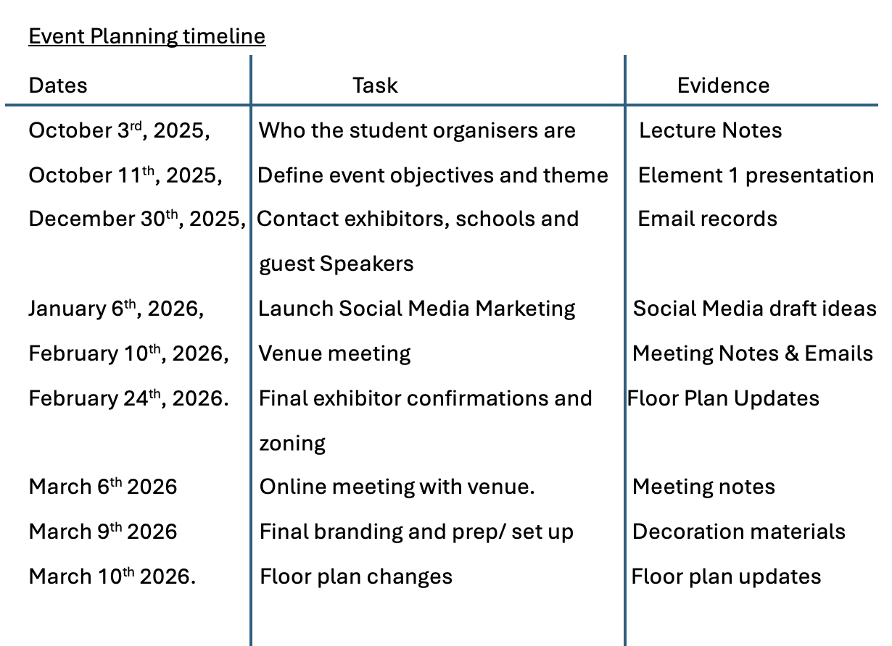

Appendix B – Budget Breakdown
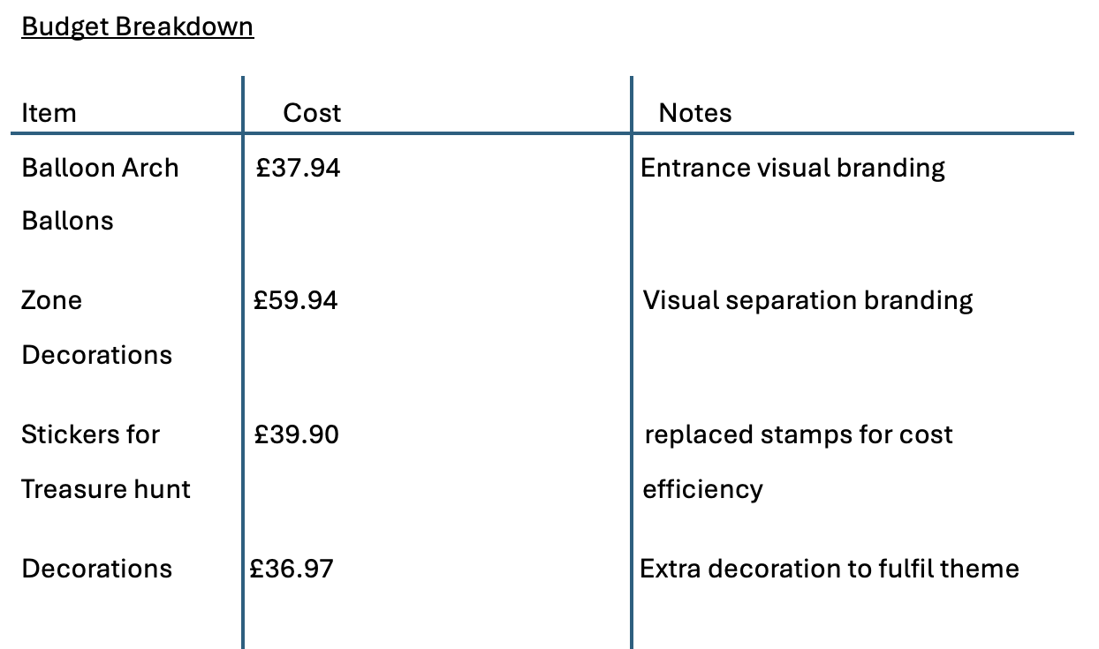

Appendix C – Risk Management Table
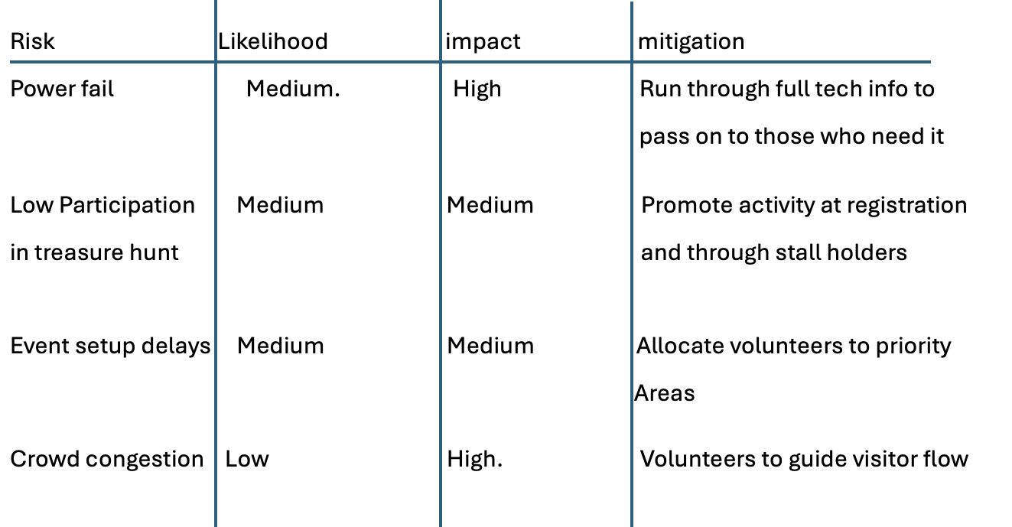

Appendix D – Decision Log 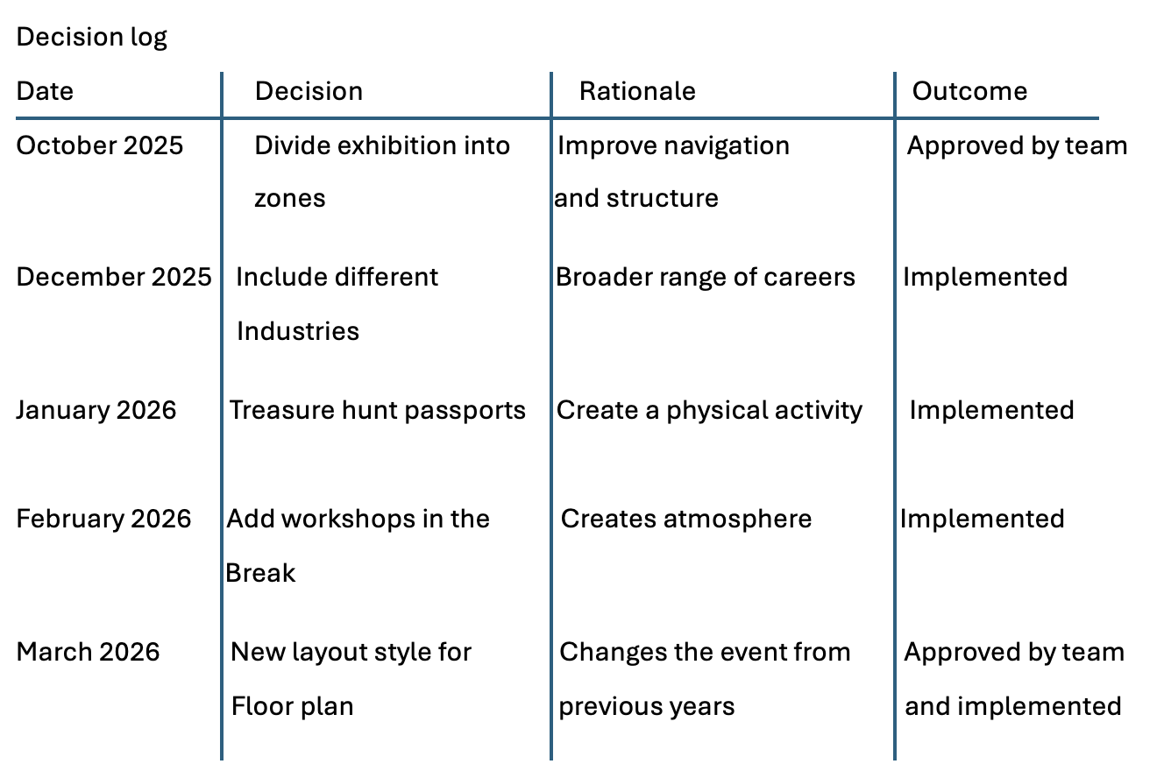
Appendix E – Stakeholder Communication
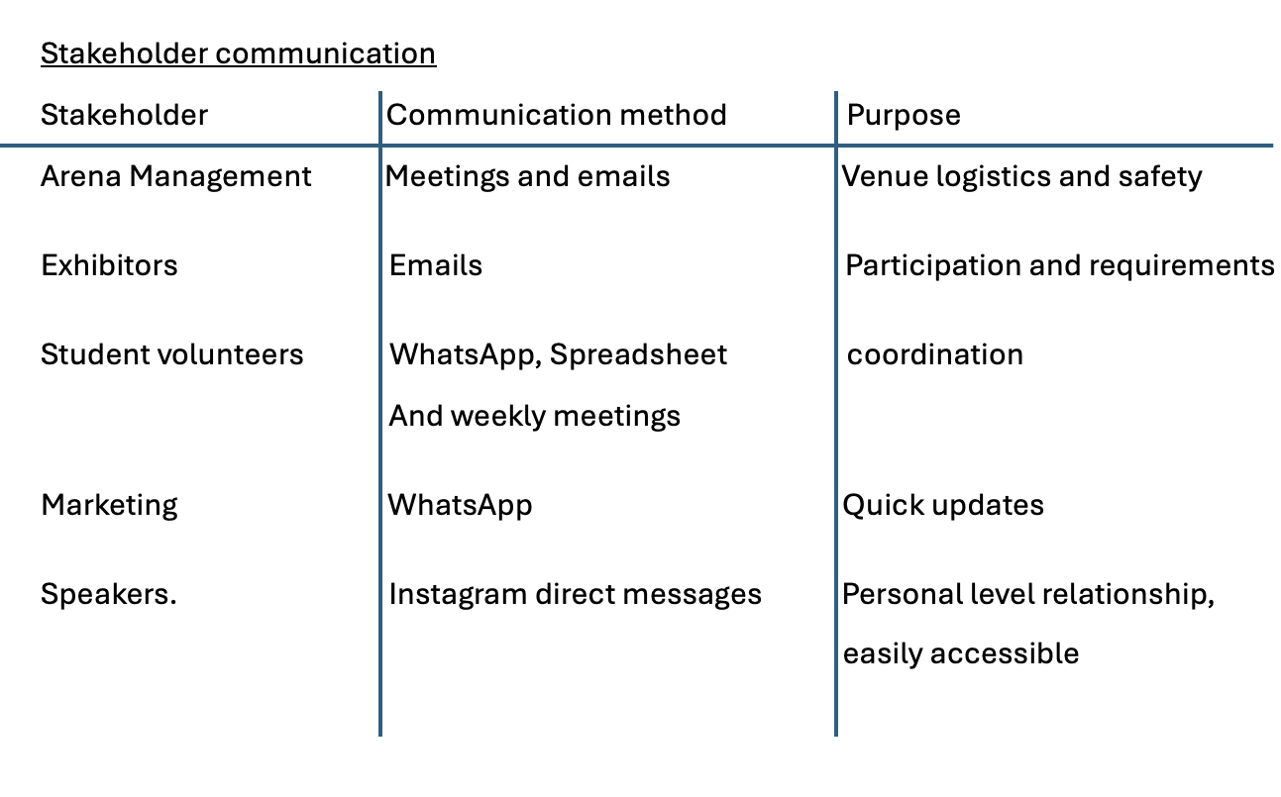

Appendix F - Floor Plans
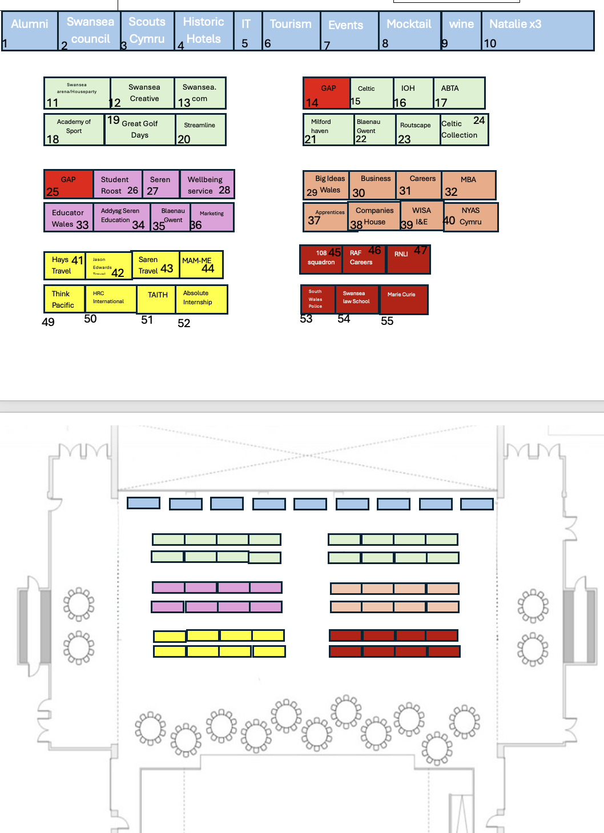

Appendix G –Passport Design

Appendix H – Original Floor Plan
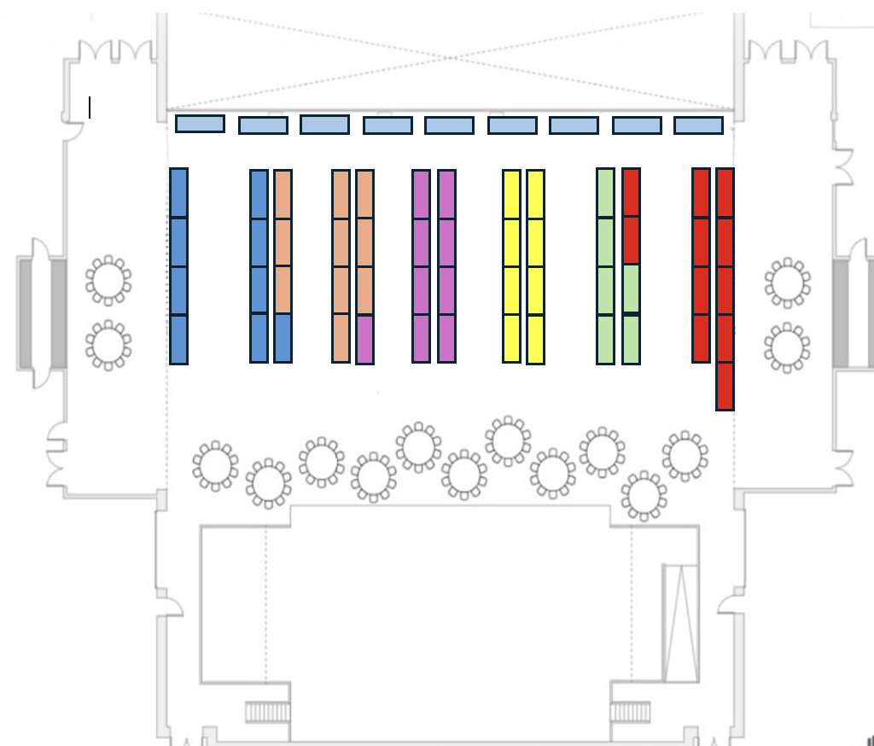
Appendix I – ITT day checklist
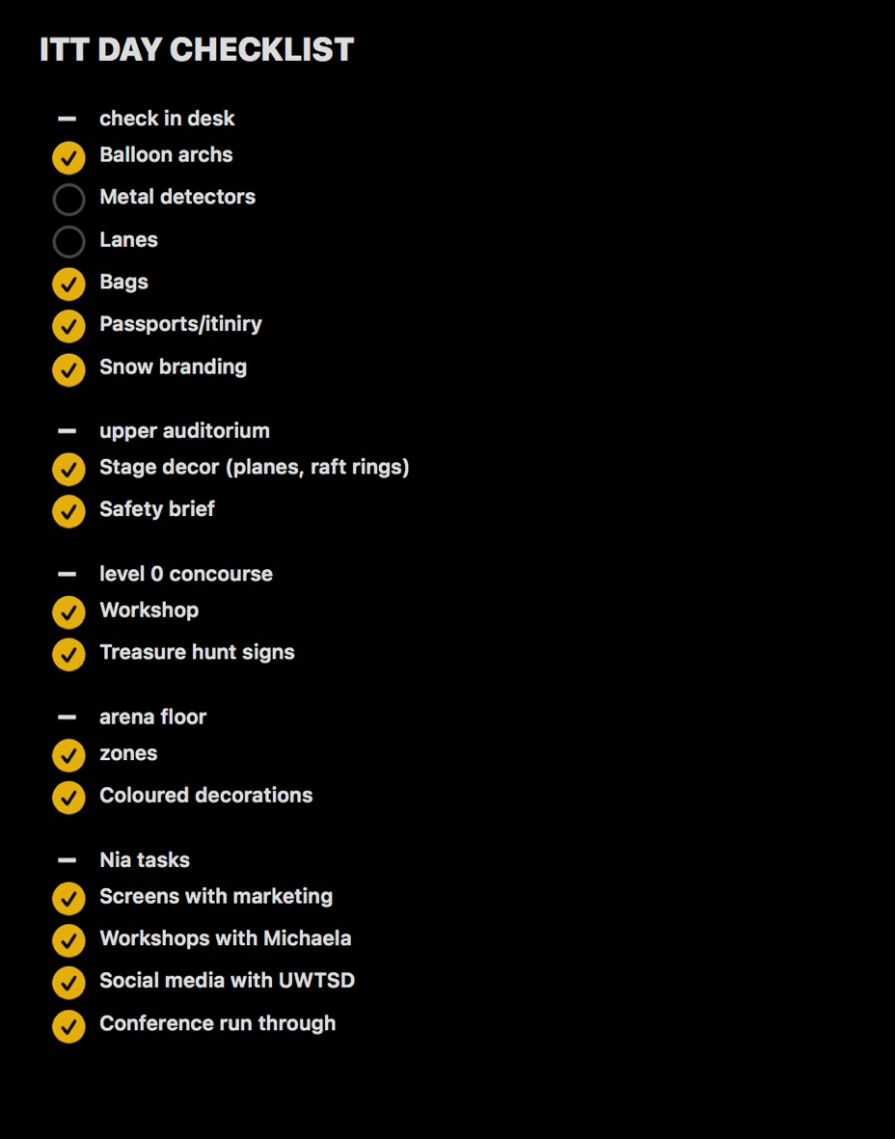

Appendix J: Group Spreadsheet
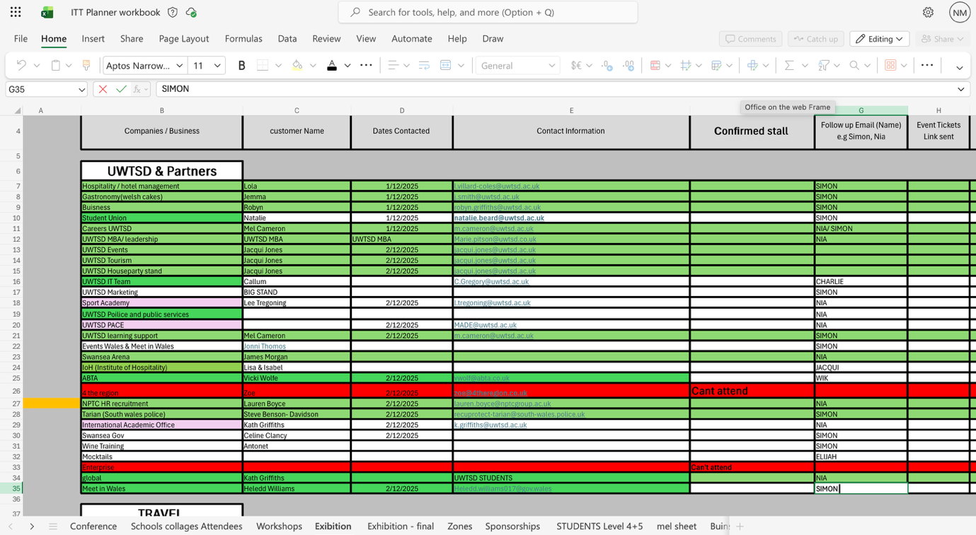

Reference List
Anandarajan, A. “Proactive Risk Management [Book Review].” IEEE Transactions on Engineering Management, vol. 50, no. 4, Nov. 2003, pp. 494–494, https://doi.org/10.1109/tem.2003.820993. Accessed 4 May 2019.
Bitner, Mary J., and Bernard H. Booms. “Deregulation and the Future of the U.S. Travel Agent Industry.” Journal of Travel Research, vol. 20, no. 2, Oct. 1981, pp. 2–7, https://doi.org/10.1177/004728758102000201.
Bratterud, H, et al. “The Sung Diagram: Revitalizing the Eisenhower Matrix.” In International Conference on Theory and Application of Diagram, Aug. 2020, pp. 498–502. Cham: Springer International Publishing.
Bruner, Christopher M. “Is the Corporate Director’s Duty of Care a “Fiduciary” Duty? Does It Matter?” SSRN Electronic Journal, 2013, https://doi.org/10.2139/ssrn.2237400. Accessed 23 Oct. 2019.
Coates, J. B., and Charles T. Horngren. “Accounting for Management Control: An Introduction.” OR, vol. 17, no. 4, Dec. 1966, p. 480, https://doi.org/10.2307/3007453. Accessed 22 Jan. 2020.
Enseñat-Soberanis, Fernando, et al. “A Visitor Flow Management Process for Touristified Archaeological Sites.” Journal of Heritage Tourism, vol. 14, no. 4, 10 Oct. 2018, pp. 340–357, https://doi.org/10.1080/1743873x.2018.1529179.
Exley, Kate. “Encouraging Student Participation and Interaction.” Queen’s University Belfast, 2013, www.qub.ac.uk/directorates/AcademicStudentAffairs/CentreforEducationalDevelopment/FilestoreDONOTDELETE/Filetoupload432480en.pdf.
Fiedler, Fred . “Contingency Theory of Leadership .” Organizational Behavior , vol. 1, 2015, pp. 232–255. Routledge.
Freeman, R. Edward, et al. “Stakeholder Theory: The State of the Art.” Academy of Management Annals, vol. 4, no. 1, Jan. 2010, pp. 403–445, https://doi.org/10.5465/19416520.2010.495581.
Goldsmith, R.E, and R.H Tsiotsou. “Introduction to Experiential Marketing.” Strategic Marketing in Tourism Services, 2012, p. 207.
Harrison, Jeffrey S., and Andrew C. Wicks. “Stakeholder Theory, Value, and Firm Performance.” Business Ethics Quarterly, vol. 23, no. 1, Jan. 2013, pp. 97–124, https://doi.org/10.5840/beq20132314.
Ianenko, Marina, et al. “Brand Identity Development.” E3S Web of Conferences, vol. 164, no. 3, 2020, p. 09015, www.researchgate.net/publication/341154248_Brand_identity_development, https://doi.org/10.1051/e3sconf/202016409015.
Kim, Dong-Jun. “A Study on the Planning Model of Tourism Event.” The Joural of the Korea Entertainment Industry Association, vol. 4, no. 4, 31 Dec. 2010, p. 36, https://doi.org/10.21184/jkeia.2010.12.4.4.36.
Kinsella, Elizabeth Anne. “The Art of Reflective Practice in Health and Social Care: Reflections on the Legacy of Donald Schön.” Reflective Practice, vol. 11, no. 4, Sept. 2010, pp. 565–575, www.tandfonline.com/doi/abs/10.1080/14623943.2010.506260, https://doi.org/10.1080/14623943.2010.506260.
Leahy, Wayne, and John Sweller. “Cognitive Load Theory, Modality of Presentation and the Transient Information Effect.” Applied Cognitive Psychology, vol. 25, no. 6, 15 Feb. 2011, pp. 943–951, https://doi.org/10.1002/acp.1787.
Mahajan, Ritika, et al. “Stakeholder Theory.” Journal of Business Research, vol. 166, no. 1, Nov. 2023, www.sciencedirect.com/science/article/pii/S0148296323004629, https://doi.org/10.1016/j.jbusres.2023.114104.
Plumert, J.M., et al. “The Content and Organization of Communication about Object Locations.” Journal of Memory and Language, vol. 34, no. 4, Aug. 1995, pp. 477–498, https://doi.org/10.1006/jmla.1995.1022. Accessed 2 Apr. 2022.
Reeves, Rosser. “A Unique Selling Point.” The Cornell Hotel and Restaurant Administration Quarterly, vol. 32, no. 4, Dec. 1991, p. 82, https://doi.org/10.1016/0010-8804(91)90105-z.
Rodgers, Robert L, and John E Hunter. “Impact of Management by Objectives on Organizational Productivity.” Journal of Applied Psychology, vol. 76, no. 2, 1 Jan. 1991, pp. 322–336, https://doi.org/10.1037//0021-9010.76.2.322. Accessed 16 Dec. 2023.
Rose, Ken. “Book Review: A Guide to the Project Management Body of Knowledge (PMBOK® Guide) - 2000 Edition.” Project Management Journal, vol. 32, no. 3, Sept. 2001, pp. 58–59, https://doi.org/10.1177/875697280103200310.
Silver Creek Audio. “The Importance of Soundcheck: Setting the Stage for Audio Excellence.” Silver Creek, 17 Apr. 2024, www.silvercreekaudiotx.com/post/the-importance-of-sound-check-setting-the-stage-for-audio-excellence?utm_source=chatgpt.com. Accessed 28 Feb. 2026.
Varey, Richard J. “Locating Marketing within the Corporate Communication Managing System.” Journal of Marketing Communications, vol. 4, no. 3, Jan. 1998, pp. 177–190, https://doi.org/10.1080/135272698345834. Accessed 21 Sept. 2019.
Weekly, B.T, et al. First Impressions: The First Seven Seconds Change Everything. 2023.

