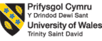

Module: International Business Concepts
Module Code: LCMB7034

Assignment Title: Report

Student Name: Iyappan Balakrishnan
Student ID: 2434791
Lecturer: S Mansoob Murshed
Table of Contents
SECTION 1 3
1. Introduction 3
2. Industry and Country Overview 3
2.1 German Automotive Industry 3
2.2 Major Firms in the Industry 5
2.3 Competitive Positioning 7
3. Porter’s Diamond Model Analysis 8
4. Market Attractiveness Analysis 12
4.1 Overview of Honda in Germany 12
4.2 PESTLE Analysis 13
4.3 Overall Market Attractiveness 19
5. Conclusion 20
SECTION 2 22
Description 22
Feelings 23
Evaluation 23
Analysis 23
Conclusion 24
Action Plan 24
References 26

List of Figures and Table
Figure 1: Logo of Honda Motor Co., Ltd. 3
Figure 2: Electric Vehicle Production in Different Countries 4
Figure 3: Germany's Motor Vehicle Production 5
Figure 4: Revenue of Volkswagen Group 6
Figure 5: Revenue Comparison of 3 Automotive Companies 7
Figure 6: New Car Sales in Germany as of 2024 7
Figure 7: Perceptual Map 8
Figure 8: Porter’s Diamond Model 10
Figure 9: Automotive Market of Germany 11
Figure 10: Global Revenue of Honda 12
Figure 11: GDP Growth of Germany 14
Figure 12: CPI Index of Germany 15
Figure 13: New Electric Car Registrations in Germany 16
Figure 14: CO₂ Emissions of Passenger Cars 18
Figure 15: New Registrations of Passenger Cars in Germany 19
Figure 16: Gibbs Reflective Cycle 22
Table 1: Action Plan 25

SECTION 1

1. Introduction
The automotive business is among the most integrated and competitive spheres worldwide that is considered important in terms of international trade, novelty development, and economic growth. Germany has been traditionally a world leader in the production of automobiles because it is the country with one of the best engineering potentials, a well-developed industrial base, and the ability to compete with foreign companies in the global arena. The German car market is appealing to local and international multinational corporations that are eager to increase their presence in Europe (Micek et al. 2021). The report presents an analysis of the German automotive sector and measures the state of competitive environment in the nation. The focus is made on the functioning of Honda Motor Co., Ltd. as a foreign multinational company in particular. Based on the appropriate international business frameworks, the report focuses on the competitiveness in the industry, the market conditions, and the important factors that determine the success of automotive companies in Germany.
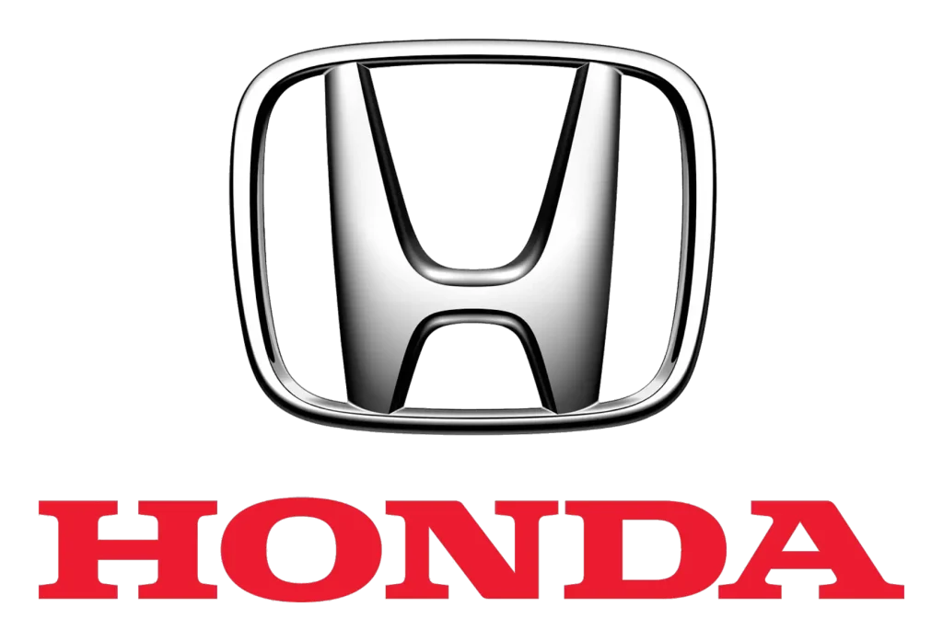

Figure 1: Logo of Honda Motor Co., Ltd.
(Source: Crump, 2024)

2. Industry and Country Overview

2.1 German Automotive Industry
The automobile industry is among the largest economic industries in Germany that contributes significantly to the industrial output, exports, and employment as well as to technological advancement. Germany is also considered to be the automotive manufacturing centre of Europe and one of the cut-throat automotive markets in the world. In 2023, it was estimated that 2.8 million electric vehicles were being produced in Europe, 44% of which were produced in Germany (Di Bitonto, 2025). Besides, it is the biggest vehicle manufacturing location in Europe because the country manufactured about 4.07 million passenger vehicles in 2024. There is also a significant value of the industry on the economy (Di Bitonto, 2025). The revenue of the German automotive industry was approximately in the range of €536 billion in 2024, as it is one of the key aspects of the nation’s economic life and international imports or exports (Di Bitonto, 2025).
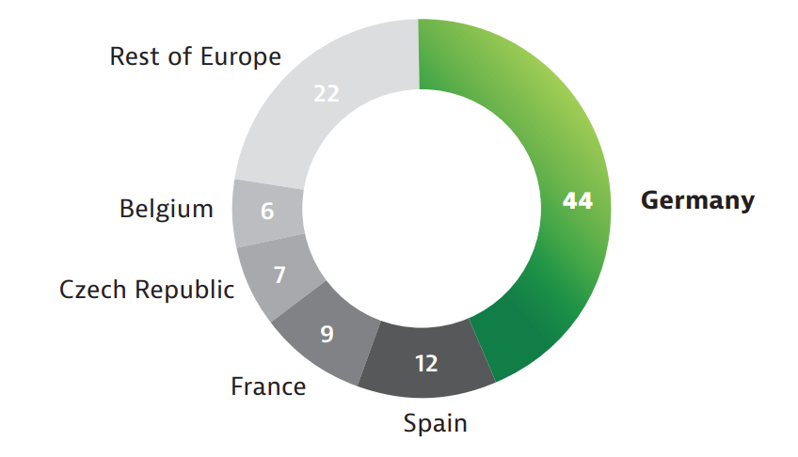

Figure 2: Electric Vehicle Production in Different Countries
(Source: Di Bitonto, 2025)
Exports make approximately 70% of the industry revenue, showing a high level of integration of Germany in the international automotive supply chains and markets. The number of employees in the industry is also high. The automotive sector has about 773,000 people employed in manufacturing, engineering and research work. Employees in research and development make about 158,000 people, which proves the high level of technological innovation and sophisticated production in the industry (Di Bitonto, 2025). The size of the industry can also be determined by trends of vehicle production. In 2023 Germany manufactured around 4.1 million automobiles, and around 3.1 million were exported to other countries, and this confirms the export-driven system of automobile production in the country (CEIC, 2024).
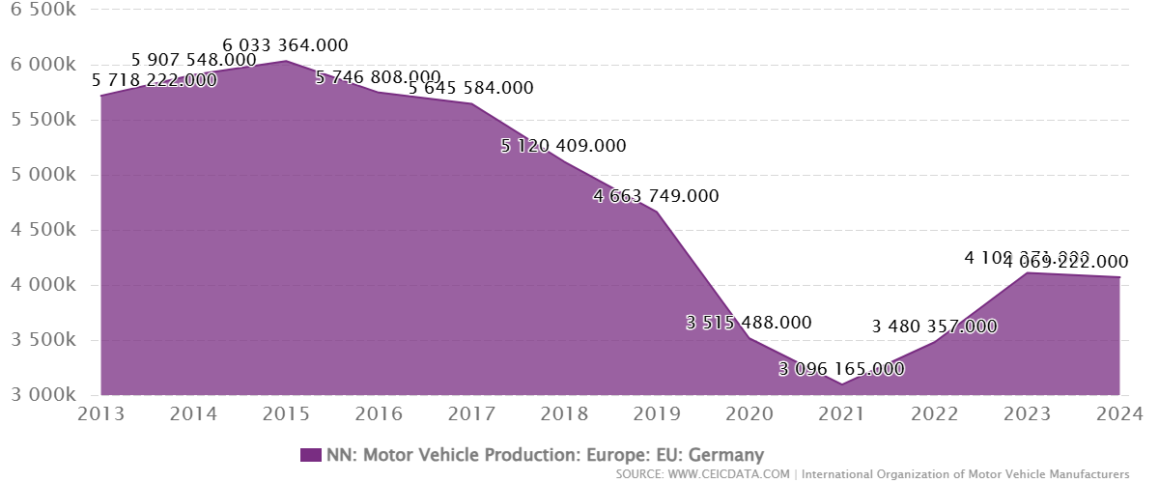

Figure 3: Germany's Motor Vehicle Production
(Source: CEIC, 2024)

2.2 Major Firms in the Industry
The German automotive sector is controlled by a few internationally renowned producers, especially, Volkswagen Group, BMW Group, and Mercedes-Benz Group. These are the main pillars of the automotive competitiveness in Germany and they have a solid portion of the domestic and European markets. One of them is Volkswagen Group which is the largest automotive company in Germany. The company earned about €307 billion in global revenue in 2024 and this makes it the highest-earning German carmaker (Macro Trends, 2025). BMW Group and Mercedes-Benz Group are also heavily represented in the world, also playing a significant role in the total employment in this sector of more than 774,000 workers in Germany (Statista, 2025a).
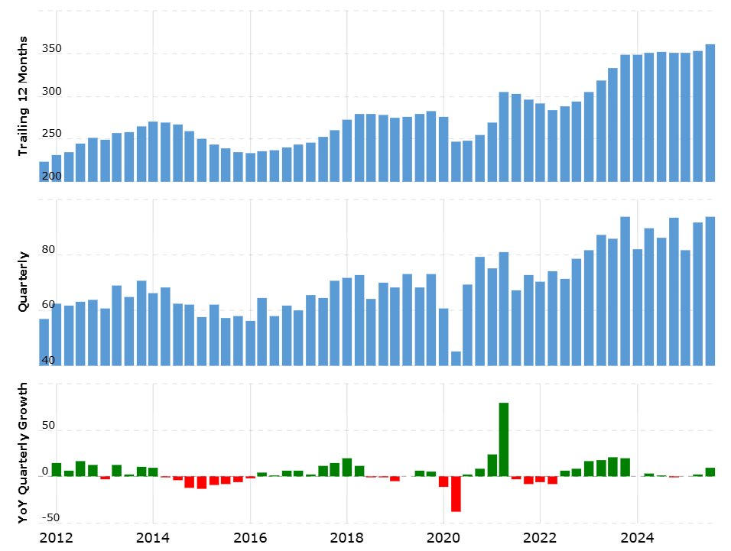

Figure 4: Revenue of Volkswagen Group
(Source: Macro Trends, 2025)
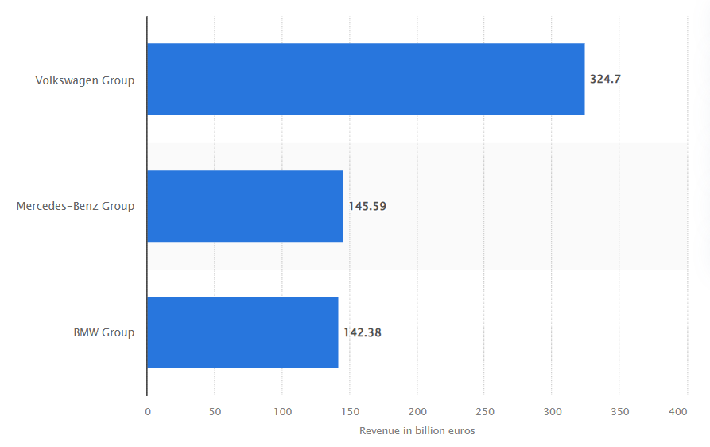

Figure 5: Revenue Comparison of 3 Automotive Companies
(Source: Statista, 2025a)
The domestic sales figures also reveal the supremacy of these companies in the car market of Germany. In 2024, the German client base had approximately 2.82 million passenger cars in the country (MarkLines, 2024). Volkswagen Group registered 536,888 units and then Mercedes-Benz Group registered 257,888 vehicles and finally BMW 232,886 vehicles (MarkLines, 2024). The German market is also adversely affected by foreign multinational manufacturers that lead to increasing competition. The companies that are broadening their operations include Tesla, Inc. and Toyota Motor Corporation mainly in the hybrid and electric vehicle sectors. Existence of international companies shows that Germany is a major automotive market with a strategic entry point to the rest of the European Union.
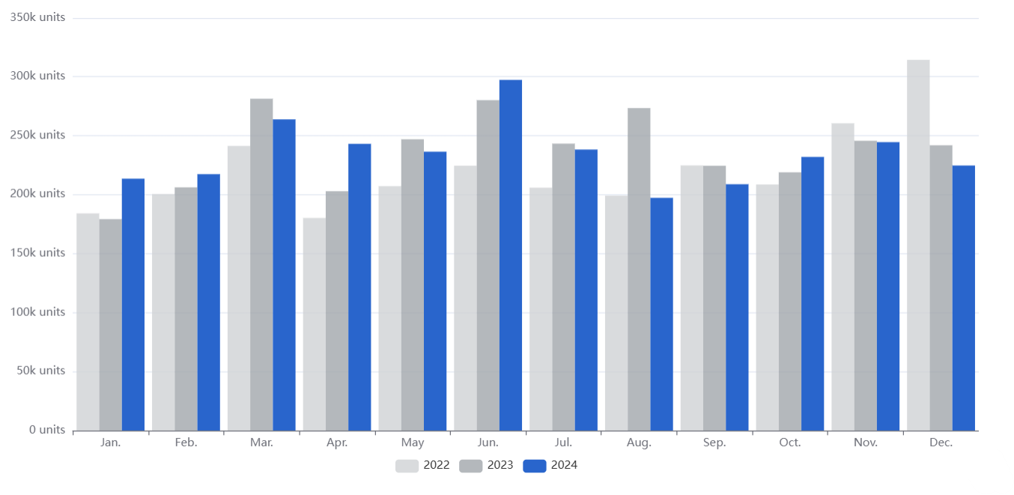

Figure 6: New Car Sales in Germany as of 2024
(Source: MarkLines, 2024)

2.3 Competitive Positioning
The industry in Germany is very competition-based and is highly individual amongst the domestic firms and the international firms. The key German brands that control the market are Volkswagen Group, BMW Group and Mercedes-Benz Group, which address specific strategic segments. In the domestic sales, Volkswagen has a domineering position in mass-market and the market size reaches 19.1% in Germany in the year 2024 (Volkswagen Group, 2025). By comparison, BMW and Mercedes-Benz can be seen as firms in the premium and luxury car market that value technological advancement, speed, and brand status. Electric vehicle technology, hybrid innovation, and other foreign rivals Tesla, Inc. and Toyota Motor Corporation escalate competition (Cheong et al. 2016). Consequently, competitive positioning within the German market has been influenced by variations in price, technological progress and brand name to give rise to a substantially dynamic and innovative automotive business.
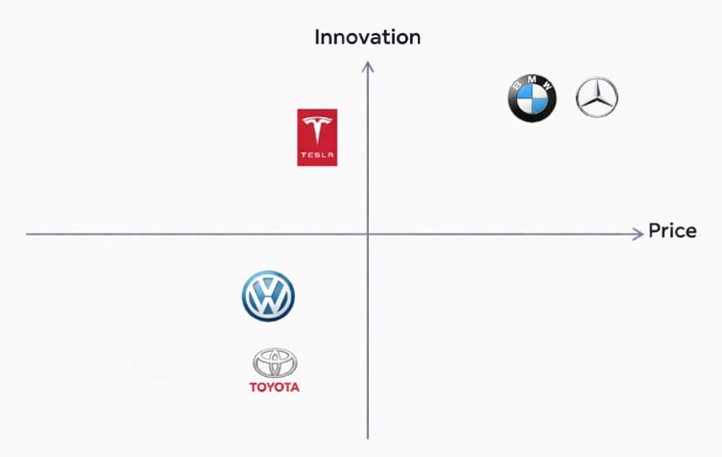

Figure 7: Perceptual Map
(Source: Self-developed)

3. Porter’s Diamond Model Analysis
Porter’s diamond model is a strategic framework for analysing the business environment that helps to evaluate the reasons behind any certain company or industry's success in any specific country where other industrial companies face more struggles. Using this business analysis framework, it helps to elaborate market demand, national drivers, sector networks and organisational behaviour that play an important role as the actual factors to get a sustainable advantage in the market (LPC, 2026). This diamond model was developed by Michael Porter, also known as Porter's diamond model, to illustrate the critical conditions and determinants. It helps to figure out business strengths by analysing their weaknesses and formulating different efficient strategies to manage the cross-border market. In this report, this model helps to understand the national environment of the automotive industry for Honda Motors to expand its business by analysing international competitiveness.
Factor Conditions
Factor conditions indicate the resource availability, like business in first fracture skilled labour for technological capabilities and many others that provide great support to industrial competitiveness. Germany became a world-leading country in engineering and innovation, and became the ideal place for encouraging engineers to grow and learn new things that make a direct contribution to the technology and manufacturing industry in the future (Sharmaa, 2025). This country is home to the world's top universities and technical institutes, which provide advanced courses and also have some of the most iconic and influential automobile companies, making this Nation more competitive by offering high-quality engineering facilities and infrastructure in the world. In this regard, Honda gets full access to utilise a highly skilled workforce along with an advanced technology environment to operate their business.
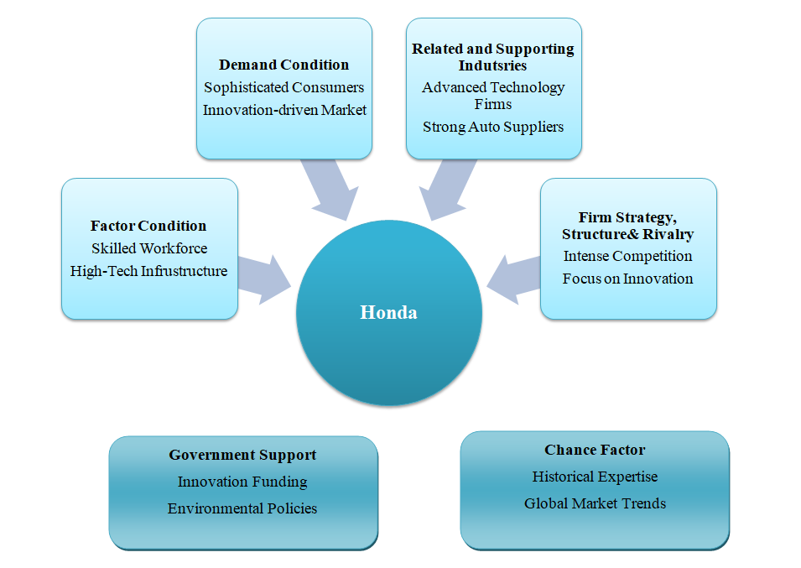

Figure 8: Porter’s Diamond Model
(Source: Self-created)
Demand conditions
Demand conditions mostly indicate the sophistication and nature of consumer demand in the national market. There is a high demand in the automobile market of Germany, where consumers focus on reliability, technological innovation, and safety, along with high-quality automobile products. Germany has the largest automobile market, which indicates its significant growth in revenue generation around EUR 536.1 billion in 2024, reflecting it as an automotive innovative centre (GTAI, 2022). Consumers of this country also give more priority to premium quality, environmental and personal efficiency that increase the number of car registrations for passengers, around 2.8 million that is nearly 22% in 2024. In this regard, Honda gets more facilities to operate their business in such a demanding and continuously innovative market by aligning with the high expectations of German consumers in the automobile sector.
Related and supporting industries
The related and supporting industry is another important factor in Porter’s diamond model that indicates the presence of any other related industry in the business environment. There is a highly developed network of engineering firms, logistic providers, technological companies and automotive suppliers that provide support to the automotive sector in Germany. Germany plays an important role as a leading auto parts manufacturer with different dominating joint companies like Bosch, ZF Friedrichshafen and Continental in the market (Matto Gasket, 2025). Giant manufacturers make a significant transformation in the automotive sector of Germany by implementing advanced technology to align with consumers' demands. Industrial plaster in Germany offers different advantages to Honda; mostly the specialised suppliers' presence helps to access innovative technology and high-quality automotive components locally that reduce its supply chain costs by strengthening its competitive position.
Firm strategy and structure
The final core element of Porter’s diamond model is structure, strategy and rivalry of the national companies. The automotive market in Germany is the most competitive in the European Union and mostly among the entire world because there are many giant automotive manufacturers available like BMW, Volkswagen, Mercedes-Benz, Porsche and Audi (Introspective Market Research, 2025). The automotive industry of Germany plays an important role in shaping the most critical technologies in this industry, like autonomous vehicles, smart manufacturing and electric mobility. This automotive market has an effective combination of the domestic market along with export activity that makes a significant contribution to the GDP rate of Germany. For operating business in the German automotive sector, Honda needs to maintain high technology standards along with a strong appearance of product differentiation that helps to manage the competitive environment in this market.
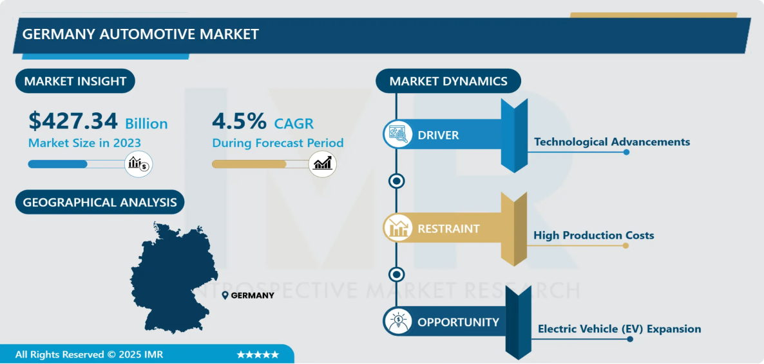

Figure 9: Automotive Market of Germany
(Source: Introspective Market Research, 2025)
Role of government and competitive advantages
The government plays an important role in managing the competitiveness of the automotive industry. The Government of Germany provides more support to the automotive sector, finding in its first structure investment and industrial policies that encourage this industry to make progress in technology innovation, mostly in electric mobility. The German government provides funding programs of up to EUR 900 million to provide efficient support for electric vehicle charging infrastructure (‌GTAI, 2025). Germany has a large production of electric vehicle units in the European Union, around 44% that means 2.8 million in 2023. Effective innovation in engineering and automatic manufacturing's long history also makes a direct contribution to industrial development and encourages global brands to expand their market in Germany. Honda also got a combination scope by expanding their automotive market in this country and a franchising strategy for creating a competitive position in the bleeding automatic market of Germany.

4. Market Attractiveness Analysis

4.1 Overview of Honda in Germany
Honda Motor Co., Ltd. is a major automotive maker in the world with a recognition of being engineered in terms of their innovation of engineering, their fuel efficiency and their powertrain technology. The company was established in the year 1948 in Japan and has grown to have a strong presence in automobiles, motorcycles and power equipment in the world. Honda is currently one of the largest automotive makers worldwide, with an estimated revenue of about $142.2 billion in the world that it earned in the year 2024 alone (Companies Market Cap, 2025). Honda ventured into the European markets in the 1960s and it emerged among the first Japanese producers to enter into the competitive markets like Germany. Other models like the Civic were used early on to build the reputation of the company as a good, reliable company with efficient engineering.
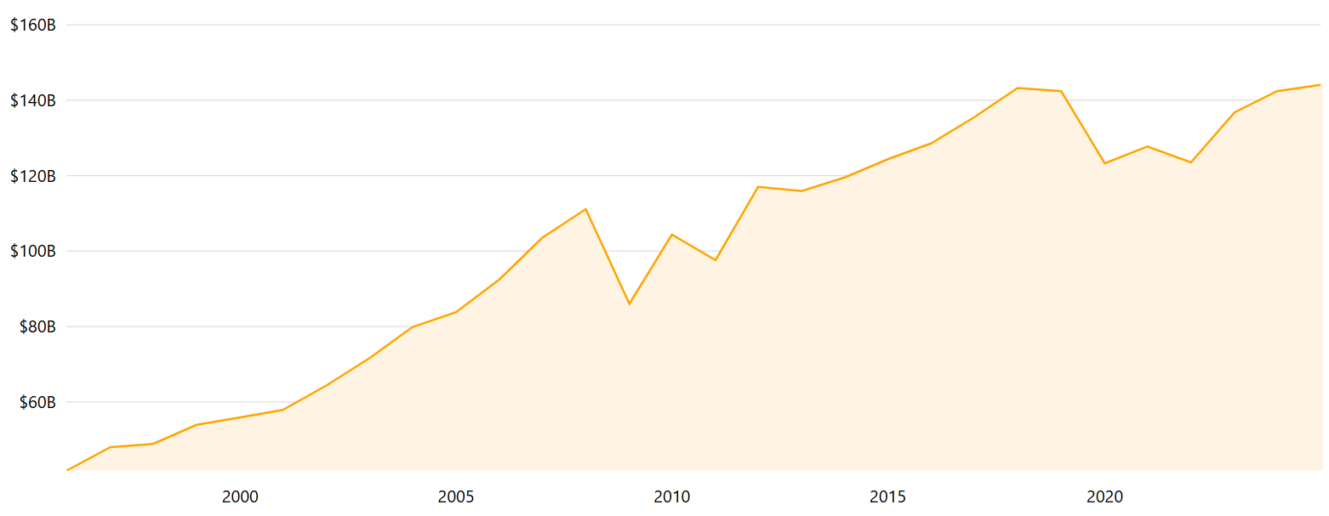

Figure 10: Global Revenue of Honda
(Source: Companies Market Cap, 2025)
In 2024, Honda sold around 3.7 million cars globally and earned around ¥21.7 trillion in sales, which demonstrates its effective presence in other countries (Sasu, 2024). Honda is still operating in Europe today, focusing on hybrid technology and environmentally efficient automobiles. Honda has products of passenger cars, motorcycles, and hybrid or electric ones. It is also the biggest motorcycle factory in the world with more than 20 million units of motorcycles manufactured every year in 37 factories situated in 23 countries (Honda News, 2025). The data demonstrates that in the last few years the world sales demonstrate a gradual decrease that characterises the industry changes to electrification and the heightened competition in the world market. Yet, Honda is a technologically creative brand that is well-developed in terms of hybrid engines and engineering.

4.2 PESTLE Analysis
Political Factor
The political issues have a major effect on the automotive industry of Germany, especially in terms of the governmental regulations and industrial policies as well as the European Union (EU) climate regulations. Germany is among the highest manufacturers of vehicles in Europe and policy attention is given to the industry due to the economic value and the number of people being employed (Gräf and Topuria, 2025). Government programs are also paying more attention to help the shift to electric mobility as opposed to internal combustion engines. One of the key impacts of politics is the government subsidy programme of electric vehicles (EVs). Germany has also implemented financial incentives of between €1,500 and €6,000 per vehicle as a means of achieving the adoption of electric vehicles (Reuters, 2026a).
A national funding scheme of €3 billion is also in favour of the initiative that may support up to 800,000 EV acquisitions between 2026 and 2029 (Reuters, 2026a). These policies are meant to ensure that there is faster uptake of low-emission cars in order to make Germany competitive in the world automobile industry. Market conditions are also influenced by global regulatory systems at the European level. As scheduled by the EU, new car sales of petrol and diesel will be eliminated by 2035 (O’Carroll, 2025). It promotes manufacturers switching to electric vehicles and hybrid vehicles, but the policymakers are evaluating certain flexibilities of hybrid technologies. These laws force manufacturers based in Germany, even foreign companies such as Honda, to make heavy investments in electric mobility technologies.
Economic Factor
The economic environments have a significant impact on the automotive industry performance in Germany since demand for vehicles is directly related to the income level, inflation rate, and economic performance. Germany has a high market, as far as its purchasing power and industrial potential are concerned, with a GDP of about $4.66 trillion in 2024, which is the largest economy in Europe (Clark, 2026). In contrast, it has not been a steady economy in recent years as Germany has been fluctuating. Following the recession of the economy in 2020 as a result of the COVID-19 pandemic, there was an improvement in the economy in 2021 with a growth rate of approximately 3.9% after which there was moderate growth in 2022 (Destatis, 2025). Further, the German economy shrank by 0.2% in 2024 due to poor industrial performance, elevated energy prices and international trade pressure which specifically hit export-driven sectors like automotive manufacturing.
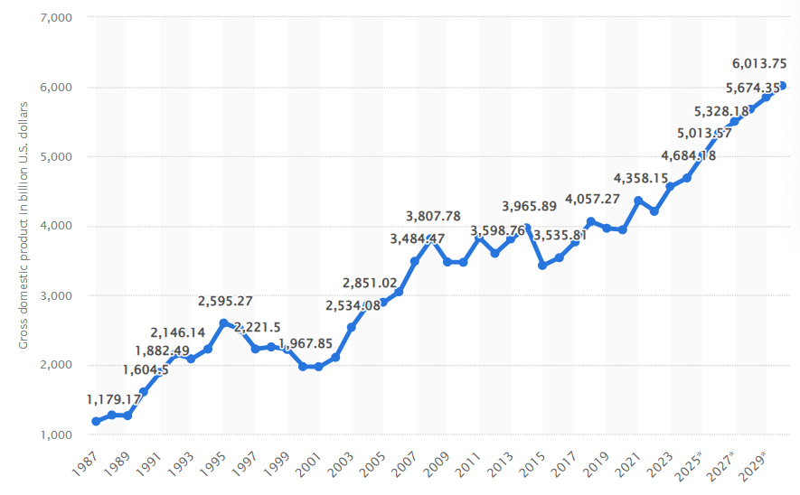

Figure 11: GDP Growth of Germany
(Source: Clark, 2026)
The inflation has been influential as well in determining consumer spending patterns. The post-global energy crisis inflation rates in Germany were quite high, as the consumer price growth reached 6.9% in 2022 and 5.9% in 2023 (Destatis, 2025b). The inflation rate stood at 2.2% in 2024 but inflation is stable as a result of the stabilising energy prices and the monetary conditions are improving. There is a slight recovery as per the economic projections (Destatis, 2025b). The GDP growth in the year 2026 is expected to be about 0.8-1% and the inflation is expected to be about 2-2.5%, which would be in line with the European Central Bank targets (Reuters, 2026b). These economic traits pose opportunities as well as threats to such automotive firms like Honda. High level of income and a high level of industrialisation ensure that Germany has high demand for vehicles including electric and hybrid cars. The growing cost of production, inflationary pressures, and slow economic growth are, however, likely to impact consumer purchasing power and the profitability of the automotive market.
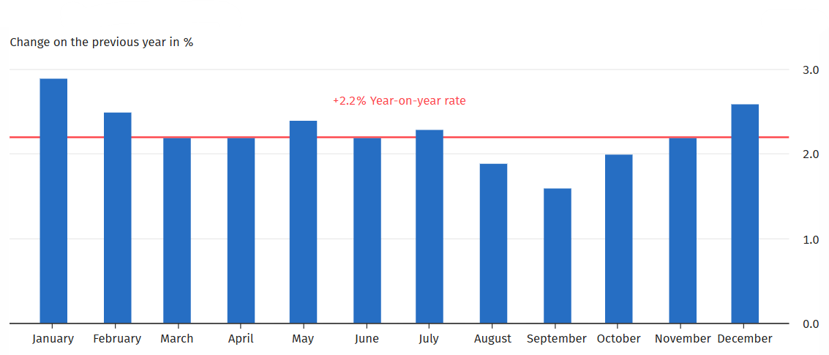

Figure 12: CPI Index of Germany
(Source: Destatis, 2025b)
Social / Cultural Factor
The automotive market in Germany is affected by social and cultural aspects in influencing consumer behaviour. Automobile culture and high vehicle ownership in the country indicate the significance of personal mobility and commuting in daily lives. Germany is projected to have approximately 49.3 million passenger cars per 590 vehicles/1,000 population in 2024, and it is estimated to have one of the highest rates of car ownership in Europe (Business Street Magazine, 2025). Yet, the preferences of consumers are evolving slowly as the level of environmental consciousness and movement within the city is on the rise.
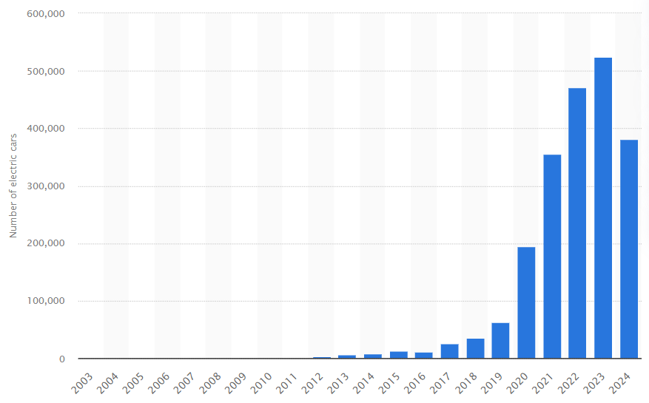

Figure 13: New Electric Car Registrations in Germany
(Source: Statista, 2025b)
Numerous German buyers are increasingly aware of the problem of sustainability and climate change, which promotes the spread of low-emission vehicles, including hybrid and electric cars. Germany registered approximately 380,609 new electric vehicles in 2024, which shows the growth of the population interest in other mobility technologies (Statista, 2025b). Transportation behaviour is also being influenced by urbanisation and changes in lifestyle. In large cities, young customers are increasingly using transit, shared mobility, and car-sharing services instead of owning a personal vehicle (Gopedike et al. 2022). All these tendencies prompt motor-related companies to cut down on ecologically harmful automobiles and new mobility services.
Technological Factor
One of the biggest competitors of the German automotive industry is technological development. Germany is considered one of the pioneers in automotive innovation globally assisted by heavy research and development (R&D) investment and a well-established workforce with engineering skills. In 2024 the German auto industry spent about €30.3 billion in research and development, which is evidence of the enthusiasm with which the industry has embraced technology and development (Di Bitonto, 2025). Also, in 2023, German auto manufacturers spent €58.4 billion on R&D throughout the world (Fritz, 2025). It is an indication of the future-orientated technologies of the sector like electric mobility, autonomous driving, digitalisation, and battery technologies. Such investments help achieve the shift to sustainable mobility and intelligent vehicles. Increasing demand for EVs, AI in vehicles and connected mobility solutions is also a technological change factor. The automotive organisations in Germany are consequently pouring investments into e-motorisation and the digital environments in order to be competitive in the world market (Koelmel et al. 2024). The ecosystem of high technology and high colour levels of innovativeness in Germany opens the door of collaboration, research cooperation, and next-generation hybrid and electric brands to international manufacturers like Honda.
Legal Factor
The automotive industry in Germany is greatly affected by legal regulations since manufacturers need to abide by strict environmental EU and national regulations. The EU CO₂ emission regulation is one of the most significant legal frameworks designed to lower vehicle emissions and speed up the process of low-emission mobility. The European Union has suggested a law to eliminate new internal combustion engine (ICE) motor vehicle sales by 2035 and force manufacturers to concentrate on electric and hybrid technologies (Winton, 2025).
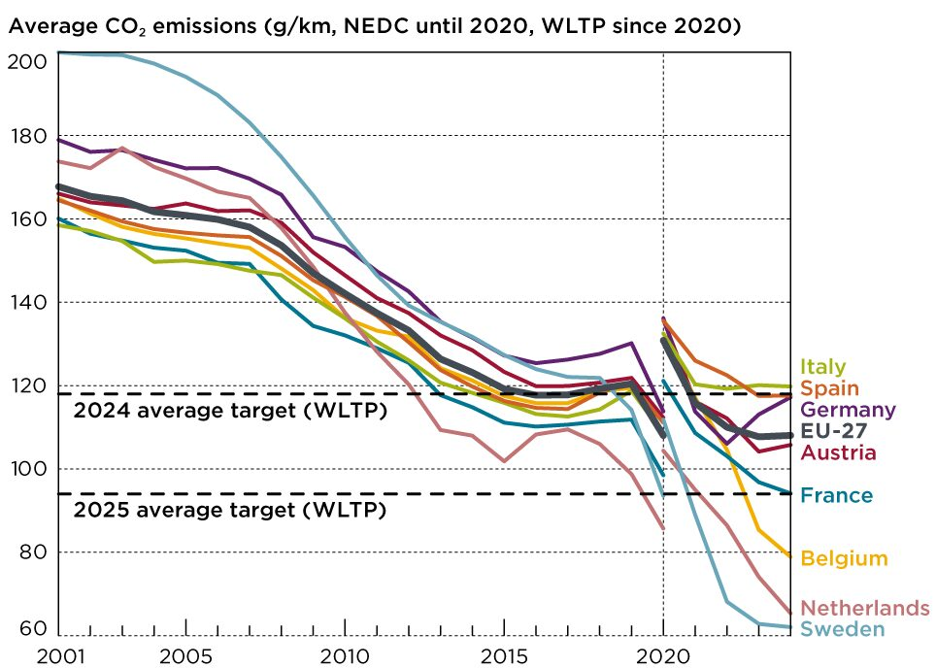

Figure 14: CO₂ Emissions of Passenger Cars
(Source: ICCT, 2026)
Moreover, there are stringent emission policies which have an influence on the design and production policy of vehicles. As an illustration, car emissions of new vehicles in Germany were approximately 117 g/km of CO₂ in 2024 (ICCT, 2026). This underscores the regulatory aspect that manufacturers have to cut on emissions by using cleaner technologies. In the case of local companies like Honda in Germany, the EU emission policy, safety rules, and environmental policies should be followed to ensure market access. It should also be in order to stay competitive in European automotive.
Environmental Factor
The German automotive industry is also experiencing a significant change based on environmental issues especially with climatic policies as well as pressure to decrease the carbon emission. Germany has made the commitment of climate neutrality in 2045, which promotes the shift to the low emission of transportation technologies and renewable energy sources. Electric and hybrid cars have gained wide usage in recent years as a continuation of this transition. Battery-electric vehicles (BEVs) are primarily registered as an approximation of 380,609 vehicles in Germany in 2024 and they took 13.5% of the total new passenger car sales (European Commission, 2025).
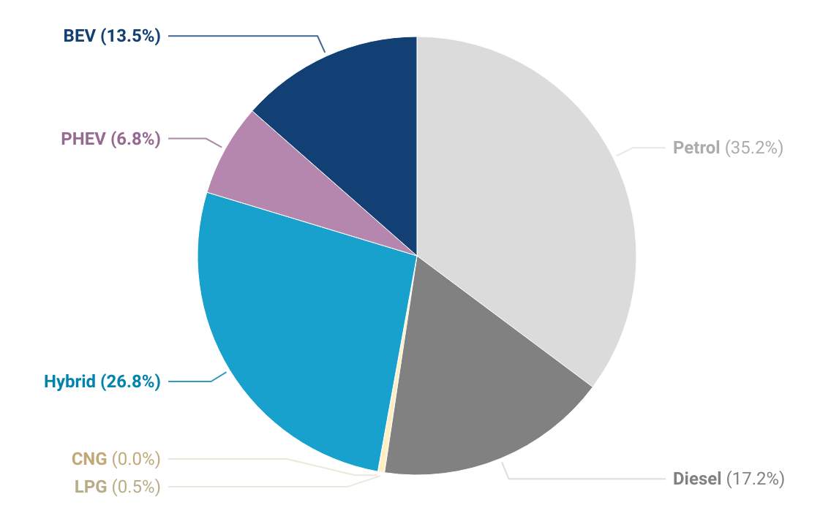

Figure 15: New Registrations of Passenger Cars in Germany
(Source: European Commission, 2025)
Moreover, hybrid cars had a high growth and they constituted 33.6% of new car registrations indicating an increasing demand for environmentally friendly vehicles (Anderson, 2025). The issue of the environment and the general information about climate change keep compelling the manufacturing industries to introduce new clean technologies that involve the use of electric, hybrid, and hydrogen engine vehicles. In the case of Honda, these environmental trends present a pathway to increase the mobility solutions that are sustainable and increase its market share in the German market.

4.3 Overall Market Attractiveness
Advantages
Germany presents a number of strengths that present it as a good market to automotive companies. Initially, the auto infrastructure of the country is among the most developed auto infrastructures in the world with widespread manufacturing capabilities, a good supply chain, and a rich ecosystem of suppliers. In 2024, the automotive industry had a revenue of about €536 billion, and it also produced about 4.07 million passenger vehicles, thus exhibiting the magnitude of the industry (Di Bitonto, 2025). A highly skilled labour force and good research ability are also in favour of Germany. Devoid of that, Germany is the biggest automotive market in the European end, and it has approximately 2.8 million passenger car registrations in 2024, which is approximately 22% of the whole EU vehicle registrations (MarkLines, 2024). All these elements establish a favourable business climate for automotive companies like Honda. This is due to the fact that Germany with its well-developed infrastructure, skilled labour force, and the ability to access the greater European market, is a great strategic position to invest in automotive and further technological advancements.
Challenges
Along with these benefits, the German automobile market is a challenging environment that faces foreign companies as well. Among the problems, the concept of strong rivalry with other established domestic industries, including Volkswagen Group, BMW Group, and Mercedes-Benz Group (MarkLines, 2024), is one of the most important. These are popular in the domestic market and have high brand loyalty of the German consumer. Strict processes and regulations also raise the cost of doing business for the automotive companies. Firms will be required to operate under the tight emission standards by the European Union and make massive investments in electric car technologies. Also, there is uncertainty that is arising due to structural changes in the industry. As an illustration, in the German core of the automotive industry, the number of employees dropped to approximately 721,400 last year, showing a continued reorganisation and switching to an electric economy (Reuters, 2026c). The high cost of production which covers labour and energy costs, is another threat that has the potential of lowering the profit margins of manufacturers currently in operation in Germany.

5. Conclusion
From the above analysis, it can be concluded that Germany has the most competitive automotive market across the world due to its high capability in advanced technology, industrial infrastructure and globally recognised automotive brands. This industry has a direct impact on the national economy by contributing a huge range of revenue with high employment in different sectors of the automotive sector. Through the help of Porter’s Diamond Model, it has also analysed the global competitive market of Germany in the automotive industry. The skilled engineering workforce, strong capability in technology and advanced research institutions also make the automotive sector more demanding, increasing interest among sophisticated domestic consumers who are more interested in automatic quality performance and innovation.
It has also discussed the supporting and related industries, such as different technology firms and specialised automotive suppliers, who also make a direct impact on the industrial ecosystem and encourage this industry to make further development to adopt innovations. The presence of different automotive manufacturers like BMW, Volkswagen, and Mercedes-Benz makes this industry more competitive through their highly innovative and dynamic market. This competitive industrial position also encourages other farms to make further investments in this industry to develop their research and development initiative, and it also provides more scope to Honda to utilise all those opportunities to boost their operation and excellence and make a strong position in this industry of Germany. Germany's advanced technology and strong demand for high-quality automotive vehicles also boost the market for Honda to operate in the international automotive market.

SECTION 2
Gibbs reflective cycle is a reflecting Framework that was developed by Graham Gibbs in 1988 with a systematic structure to analyse the learning based on the past experiences (The University of Edinburgh, 2024). For analysing the overall experience, there are six stages like description, feelings, evaluation, analysis, conclusion and action plan that help to understand the experience by allowing people to learn from the experience for making improvements in future action.
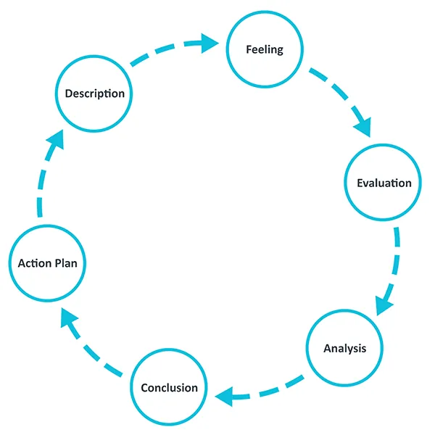

Figure 16: Gibbs Reflective Cycle
(Source: The University of Edinburgh, 2024)

Description
While completing the above assessment, it is most important to make a clear Research and analysis about the automotive industry by using academic investigation and evaluate all the aspects more critically. In the initial stage, I started to review all the different theoretical frameworks regarding the international business environment and industry competitiveness. After a clear understanding of the theoretical frameworks, the automation industry in Germany was selected to evaluate the contribution of the international business environment on Honda to expand its market in this leading automotive sector. I also conducted secondary research through my research and analytical skills by analysing industry report academy journals, and different reliable online sources to get more relevant information about the automotive sector and its leading multinational automotive manufacturer who play a key role in this market.

Feelings
At the beginning of this research, I initially felt more uncertainty and was nervous about how to manage the research procedure by presenting a direct connection between the real-world industry and the theoretical framework to present a clear understanding. For analysing the specific industry according to the model's perspective, a deep Research and analytical skill is most important, and I also realised that a simple description about the industry and the model is not sufficient; it also needs critical analysis to clear all the concepts. Critical thinking skills are most important for analysing all the resources more correctly and assessing all the information to present all the arguments clearly (‌Future Learn, 2024). As the research progressed, I became more confident about the different procedures to interpret the academic sources and developed a direct relation with a practical example that made me more interested in analysing industry complications in the international business environment.

Evaluation
One of the positive things that I found in this research process was the opportunity to apply different academic frameworks and theories within a real industrial context. Using different theoretical models, such as Porter's diamond model, PESTEL analysis, and many others, helps me to analyse the industrial competitiveness of the German automotive sector by understanding different National elements that play an essential role in the domestic environment. I also face more complications in this research process, like figuring out more relevant and reliable sources that help to specifically address the automotive industry competitively by synthesising information through multiple sources.

Analysis
In the process of research, I learned that developing the theoretical frameworks to be applied to real-life business scenarios would need more analytical processing, as opposed to descriptive processing. PESTLE and industry competitiveness frameworks are two examples of the models that I employed when studying the German automotive industry to determine how external environmental factors impact business decisions. This allowed me to comprehend how international businesses act within multicultural global contexts and how the economic, technological, and regulatory aspects influence the market strategies. Reflective learning helps to provide individuals with inclinations to critically evaluate experiences and relate theory to practice to facilitate the creation of better analytical and decision-making skills (Colomer et al. 2020). Another thing I discovered in the course of doing the research was the need to employ valid academic and industry sources. Initially, it could not be easily spotted when considering credible information as it pertains to the German car industry and the global activity of Honda. Yet, reading scholarly articles and reports in the industry assisted me to secure better research and analysis skills. The reflection has also enabled me to understand the importance of critical thinking in the explanation of complex data in the industry and making meaningful conclusions. Reflective practice facilitates more profound learning because it entails people analysing experiences and gauging the results and enhancing future performance (Marshall et al. 2022). Thus, the process of reflection made me more aware of the ways in which theoretical knowledge can be used in practical international business situations.

Conclusion
Altogether, this assessment allowed me to create a better idea of how the world of international business may be deployed to study the actual industry settings. My analytical, research, and critical thinking skills were enhanced as I conducted my research into the competitiveness of the German automotive industry and the Honda company in the market. At first, the process of the research was thought to be hectic due to the necessity to relate theoretical points to the practical cases. Yet, as I advanced, I developed the ability to read academic resources with more confidence and analyse information in the industry. The experience has enhanced my competence in doing systematic research and using theoretical models in real-life business analysis.

Action Plan
Area for Improvement | Action to be Taken | Expected Outcome
Research Skills | To locate more peer-reviewed journal articles, I aim to enhance my academic database searching skills, including a Google Scholar search and using university library resources. | I will get help through this in applying more authoritative academic sources in subsequent tasks.
Time Management | I will draw a plan of research time prior to my commencement of subsequent assignments. | This will enable me to work more resourcefully to do the research and less stress.
Academic Writing | I will utilise scholarly writing advice sources and lecturer feedback. | This will help in revamping lucidity, hierarchy, and standard of my reports.

Table 1: Action Plan
(Source: Self-developed)

References
Anderson, B. (2025). Germany’s EV Sales Crash 28% In First Full Year Without Subsidies. Available at: https://www.carscoops.com/2025/01/ev-sales-in-germany-plunge-over-27-in-2024-after-subsidies-were-scrapped/ (Accessed: 14 March 2026).
Business Street Magazine (2025). Germans own almost 50 million passenger cars. Available at: https://business-street-magazine.com/economy/germans-own-almost-50-million-passenger-cars.html (Accessed: 14 March 2026).
CEIC (2024). Germany Motor Vehicle Production, 1997 – 2024. CEIC Data. Available at: https://www.ceicdata.com/en/indicator/germany/motor-vehicle-production (Accessed: 14 March 2026).
Cheong, T., Song, S.H. and Hu, C. (2016). Strategic alliance with competitors in the electric vehicle market: tesla motor’s case. Mathematical Problems in Engineering, 2016(1), p.7210767. http://dx.doi.org/10.1155/2016/7210767
Clark, D. (2026). Gross domestic product (GDP) in Germany 2030. Statista. Available at: https://www.statista.com/statistics/375206/gross-domestic-product-gdp-in-germany/ (Accessed: 14 March 2026).
Colomer, J., Serra, T., Cañabate, D. and Bubnys, R. (2020). Reflective learning in higher education: Active methodologies for transformative practices. Sustainability, 12(9), p.3827. https://doi.org/10.3390/su12093827
Companies Market Cap (2025). Revenue for Honda (HMC). Available at: https://companiesmarketcap.com/honda/revenue/ (Accessed: 14 March 2026).
Crump, P. (2024). The History and Development of the Honda Logo. Fellow Studio London. Available at: https://fellowstudio.com/services/design/insight/the-history-and-development-of-the-honda-logo (Accessed: 14 March 2026).
Destatis (2025a). Gross domestic product down 0.2% in 2024. Federal Statistical Office. Available at: https://www.destatis.de/EN/Press/2025/01/PE25_019_811.html (Accessed: 14 March 2026).
Destatis (2025b). Inflation rate at +2.2% in 2024. Federal Statistical Office. Available at: https://www.destatis.de/EN/Press/2025/01/PE25_020_611.html (Accessed: 14 March 2026).
Di Bitonto, S. (2025). Germany’s Automotive Industry and Electric Mobility. Available at: https://www.gtai.de/en/invest/industries/mobility/automotive-industry (Accessed: 14 March 2026).
European Commission (2025). Germany: BEV market share at 13,5%. European Alternative Fuels Observatory. Available at: https://alternative-fuels-observatory.ec.europa.eu/general-information/news/germany-bev-market-share-135 (Accessed: 14 March 2026).
Fritz, A. (2025). Research and Development | Automotive industry is the investment leader. Available at: https://www.vda.de/en/news/articles/2023/research-and-development (Accessed: 14 March 2026).
‌Future Learn (2024). Why Is Critical Thinking Important? Available at: https://www.futurelearn.com/info/courses/how-to-develop-critical-thinking-skills/0/steps/335512 (Accessed: 16 March 2026).
Göddeke, D., Krauss, K. and Gnann, T. (2022). What is the role of carsharing toward a more sustainable transport behavior? Analysis of data from 80 major German cities. International Journal of Sustainable Transportation, 16(9), pp.861-873. https://doi.org/10.1080/15568318.2021.1949078
Gräf, H. and Topuria, S. (2025). The impact of the Covid-19 pandemic on industrial policy in Germany and the European Union–the case of the automotive industry. European Journal of Economics and Economic Policies, 22(1), pp.118-134. https://doi.org/10.4337/ejeep.2023.0112
GTAI (2022). Germany’s Automotive Industry and Electric Mobility. Available at: https://www.gtai.de/en/invest/industries/mobility/automotive-industry (Accessed: 16 March 2026).
Honda News (2025). Honda Reaches 500 Million-Unit Milestone in Cumulative Global Motorcycle Production. Available at: https://hondanews.com/en-US/powersports/releases/release-0d29cf91ab5515b985a1c286910fe7fc-honda-reaches-500-million-unit-milestone-in-cumulative-global-motorcycle-production (Accessed: 14 March 2026).
ICCT (2026). European vehicle market statistics 2025/26 - International Council on Clean Transportation. Available at: https://theicct.org/publication/european-vehicle-market-statistics-2025-dec25/ (Accessed: 14 March 2026).
‌Introspective Market Research (2025). Germany Automotive Market Industry Insights, Key Drivers & Forecast to 2032. Available at: https://introspectivemarketresearch.com/reports/germany-automotive-market/ (Accessed: 16 March 2026).
Koelmel, B., Haug, T., Klein, L., Schwab, L., Bulander, R., Hinderer, H., Weyer, M., Brugger, T., Kuehn, A. and Brysch, T. (2024). Are German Automotive Suppliers in the Commodity Trap? Risks and Potentials of the Taiwanese Platform MIH EV Open. Commodities, 3(4), pp.389-420. https://doi.org/10.3390/commodities3040022
LPC (2026). The Diamond Model: Understanding Competitive Advantages and Economic Strategies. Available at: https://lpcentre.com/articles/the-diamond-model-understanding-competitive-advantage-in-business (Accessed: 16 March 2026).
Macro Trends (2025). Volkswagen AG Revenue 2012-2025 | VWAGY. Available at: https://www.macrotrends.net/stocks/charts/VWAGY/volkswagen-ag/revenue (Accessed: 14 March 2026).
MarkLines (2024). Germany - Flash report, Automotive sales volume, 2024. MarkLines Automotive Industry Portal. Available at: https://www.marklines.com/en/statistics/flash_sales/automotive-sales-in-germany-by-month-2024 (Accessed: 14 March 2026).
Marshall, T., Keville, S., Cain, A. and Adler, J.R. (2022). Facilitating reflection: a review and synthesis of the factors enabling effective facilitation of reflective practice. Reflective Practice, 23(4), pp.483-496. https://doi.org/10.1080/14623943.2022.2064444
Matto Gasket (2025). Exploring Germany’s Leading Auto Parts Companies and Innovations. Available at: https://www.engine-gasket.com/exploring-germanys-leading-auto-parts-companies-and-innovations (Accessed: 16 March 2026).
Micek, G., Guzik, R., Gwosdz, K. and Domański, B. (2021). Newcomers from the periphery: The international expansion of Polish automotive companies. Energies, 14(9), p.2617. https://doi.org/10.3390/en14092617
O’Carroll, L. (2025). EU plans to water down ban on new petrol and diesel cars. Available at: https://www.theguardian.com/business/2025/dec/16/eu-water-down-landmark-ban-new-petrol-diesel-cars (Accessed: 14 March 2026).
Reuters (2026a). Germany includes cars with range extender in EV subsidies programme. Reuters. Available at: https://www.reuters.com/business/germany-includes-cars-with-range-extender-ev-subsidies-programme-2026-01-19/ (Accessed: 14 March 2026).
Reuters (2026b). Germany’s IfW institute lowers economic growth forecast on high commodity prices. Reuters. Available at: https://www.reuters.com/business/germanys-ifw-institute-lowers-economic-growth-forecast-high-commodity-prices-2026-03-12/ (Accessed: 14 March 2026).
Reuters (2026c). Employment in German auto sector at lowest level in over a decade. Reuters. Available at: https://www.reuters.com/world/china/employment-german-auto-sector-lowest-level-over-decade-2025-11-20/ (Accessed: 14 March 2026).
Sasu, D.D. (2024). Honda global automobile sales 2019. Statista. Available at: https://www.statista.com/statistics/267276/worldwide-automobile-sales-of-honda/ (Accessed: 14 March 2026).
Sharmaa, A. (2025). Why Germany is a Global Hub for Mechanical Engineering Students. Available at: https://www.tfmeducationconsultants.in/post/why-germany-is-a-global-hub-for-mechanical-engineering-students (Accessed: 16 March 2026).
Statista (2025a). Volkswagen, BMW, Mercedes-Benz: revenue comparison 2024. Statista. Available at: https://www.statista.com/statistics/274013/revenue-comparison-of-volkswagen-bmw-and-daimler/ (Accessed: 14 March 2026).
Statista (2025b). New electric car registrations in Germany 2003-2024. Statista. Available at: https://www.statista.com/statistics/1166572/new-electric-car-registrations-number-germany/ (Accessed: 14 March 2026).
The University of Edinburgh (2024). Gibbs’ Reflective Cycle. Available at: https://reflection.ed.ac.uk/reflectors-toolkit/reflecting-on-experience/gibbs-reflective-cycle (Accessed: 16 March 2026).
Volkswagen Group (2025). Volkswagen delivers around 4.8 million vehicles worldwide in 2024. Available at: https://www.volkswagen-group.com/en/articles/volkswagen-delivers-around-48-million-vehicles-worldwide-in-2024-18951 (Accessed: 14 March 2026).
Winton, N. (2025). Europe Eases CO2 Rules, But Pressure Rises To End 2035 EV Monopoly. Forbes. Available at: https://www.forbes.com/sites/neilwinton/2025/03/06/europe-eases-co2-rules-but-pressure-rises-to-end-2035-ev-monopoly/ (Accessed: 14 March 2026).

