Luke Cripps
motion simulation & fea

Contents
Introduction 2
Research 2
Methodology 2
Results and Analysis 6
Conclusion 9
Evaluation 9
Bibliography 10

Introduction

The aim of this assignment is to model a wishbone and linkage suspension, and through testing using motion analysis and finite element analysis (FEA), using computer aided design software solidworks, modify a component used within the suspension, lower wishbone arm, to improve its characteristics through analysis of the testing. The test will look at the interaction between a wheel, connected to the suspension, and bump in a road, to see how the suspension behaves.

Research

Finite Element Analysis is one of the most used and a powerful feature that computer aided design can have, explained by Bright Hub Engineering, 2019. It is a method to predict how a product will be affected by forces, vibrations, heat and other physical effects in the real world, according to Autodesk, 2019. This method has been used in the automotive industry for a range of reasons, from being used to evaluate components in deisel engines, M. A. Groeneweg, 1987, to aiding in the design of race cars, John Crawford, 1994.
Motion simulation delivers quantitative information about velocity, acceleration, position as well as reactions, inertia forces and power requirements, both the static and dynamic issues, of all components inside a moving mechanism, stated by Solidworks, 2008. An example of the use of motion simulation, investigating the prediction of piston skirt scuffing, carried out by Kobayashi, 2016.

Methodology

Firstly, the suspension used for the modelling needs to be measured accurately, with the dimensions of the different components being written down and recorded. The suspension used was taken from an MCR vehicle. Some of the measuring apparatus used were a tap measure, metal rule amongst others. The dimensions for the components of the suspension can be seen in the figures below:

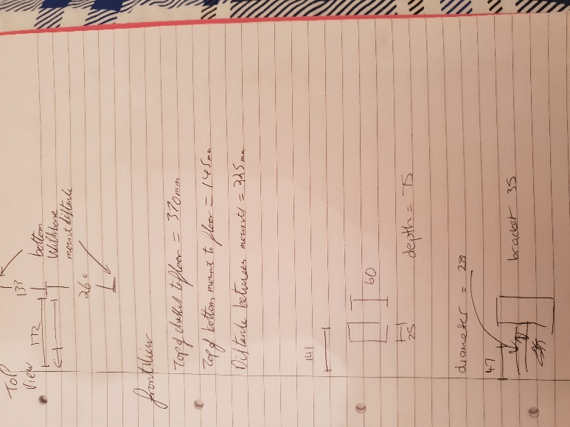
Figure 1 - Dimensions of the wishbone and suspension linkage
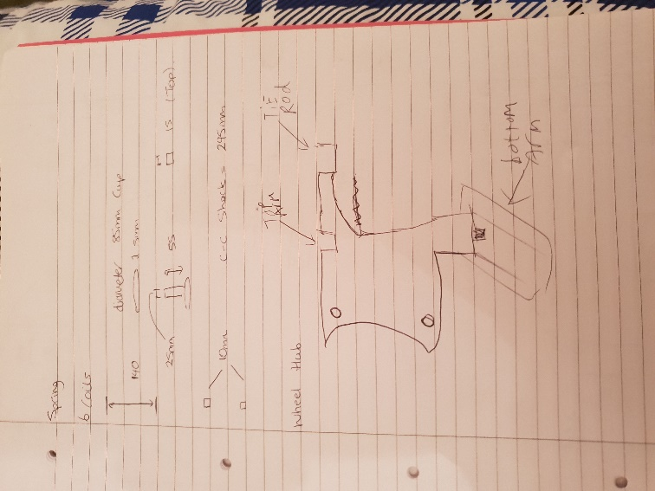
Figure 2 - Dimensions of the wishbone and suspension linkage

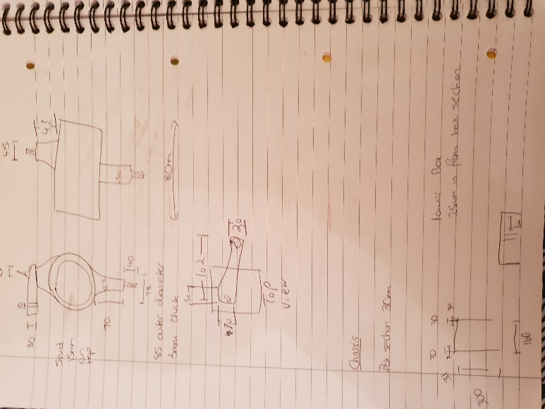
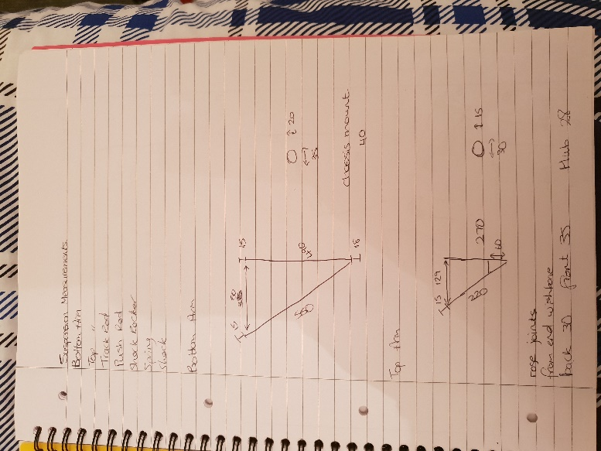
Figure 3 - Dimensions of the wishbone and suspension linkage
Figure 4 - Dimensions of the wishbone and suspension linkage

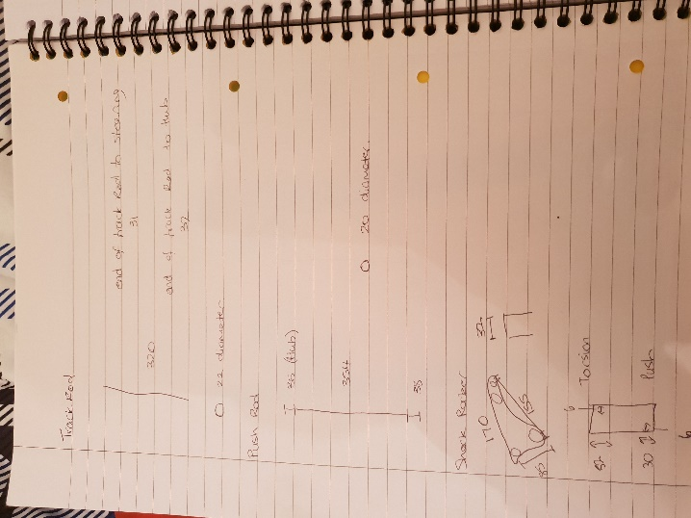
Figure 5 - Dimensions of the wishbone and suspension linkage

Once the necessary dimensions have been recorded, the modelling of the suspension can begin. There are many different components that make up the suspension linkage that need to be modelled:
- Both wishbone arms
- Brackets used to hold components in place
- Chassis plate
- Push and track rod
- Shock rocker
- Shock body and shock top
- Wheel hub
Some of the modelling features used for these components include; extrude revolve; using reference geometry, for example reference planes as well as others. Furthermore, not just the suspension needs to be modelled, as there are other items that need to be created to carry out the tests, including the wheel, the flange for the wheel, and the road.
After all the components have been created for the suspension, the process of assembling takes place. The process used was to fix the chassis plate in place, then mate the components to the chassis one by one, making sure not to move on to the next component until checking that the component just secured in place moves in the manner that it is needed. A variety of mates can be used including concentric, coincident, distance, parallel, width and lock. The assembled suspension with wheel can be seen below.

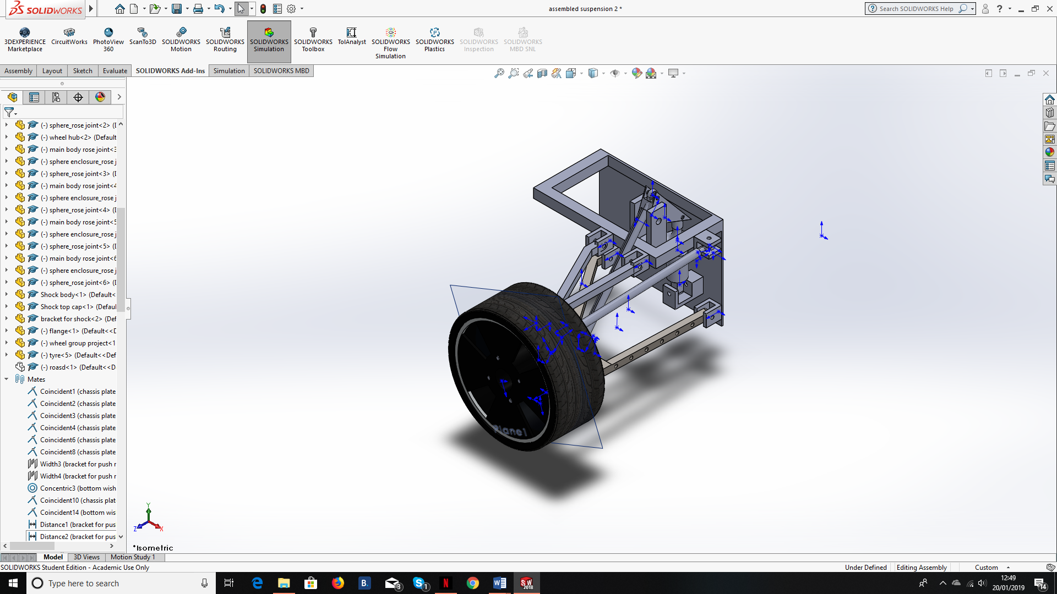
Figure 6 - The fully assembled suspension

The next step after finishing the assembly is to start the motion study. However, when the motion study tab is first opened the correct function will be available to use. To activate this, under the solidworks add-ins section, solidworks motion needs to be turned on. Once this has been done, when in the motion study section, motion analysis will be available to be chosen. When in the motion analysis section, when looking at the mates used in the assembly, there will be a number in brackets, stating the number of redundancies within the mates. It is important to get the number of redundancies down as low as possible, as this will improve the accuracy of the results. This can be done by changing the type of mates used, going from concentric and coincident to hinge, as an example, as well as forming rigid groups.
After completing that step, motors, springs, dampeners and contact points need to be set up in the motion analysis. A linear motor is applied to the road, moving at fifty millimetres per second. A rotary motor is applied to the surface of the tyre, moving at one hundred revs per minute. A linear spring and dampener are applied on the surfaces of the shock, with the spring having a spring constant of twenty-five Newtons per millimetre, and the dampener having a damping constant of eight Newtons per millimetre per second. Lastly, the solid contact point needs to be applied between the tyre and the road.
Once these parameters have been inputted, the study can be calculated, with the wishbone given a material, in this case 1023 carbon sheet steel. Once the calculation has been completed, save the document. Now motion loads can be placed on to the wishbone. In the top left-hand corner, hover over the arrow, some options will appear. Move over to the simulation option, and near the bottom, there will be an import motion loads option. Once selected, a box will appear with various options. The bottom wishbone needs to be selected. As well as this, the multi frame study option needs to be chosen. The start frame needs to be changed to 197 and the end frame being 237, this duration being the time period where the tyre interacts with the bump in the road.
Once complete, open the document containing the wishbone. At the bottom, where the options are for model, 3D view and motion study, there will be two more options, select the option on the right. Under the design tree, there will be a mesh option. Right click and select create mesh. Once the mesh has been created, right click on the mesh option, and select mesh and run, starting the FEA. Once all the scenarios have been calculated, the results can be seen under the results section of the design tree.
After the results have been documented, the design of the wishbone needs to be changed so that comparisons can be made. Once the change has been done, the motion study needs to be run again, and the steps afterwards also, finishing with the FEA. Furthermore, another change needs to be made, which can then be used again for comparison.

Results and Analysis

Below are the FEA results of three different wishbone designs linked with stress:
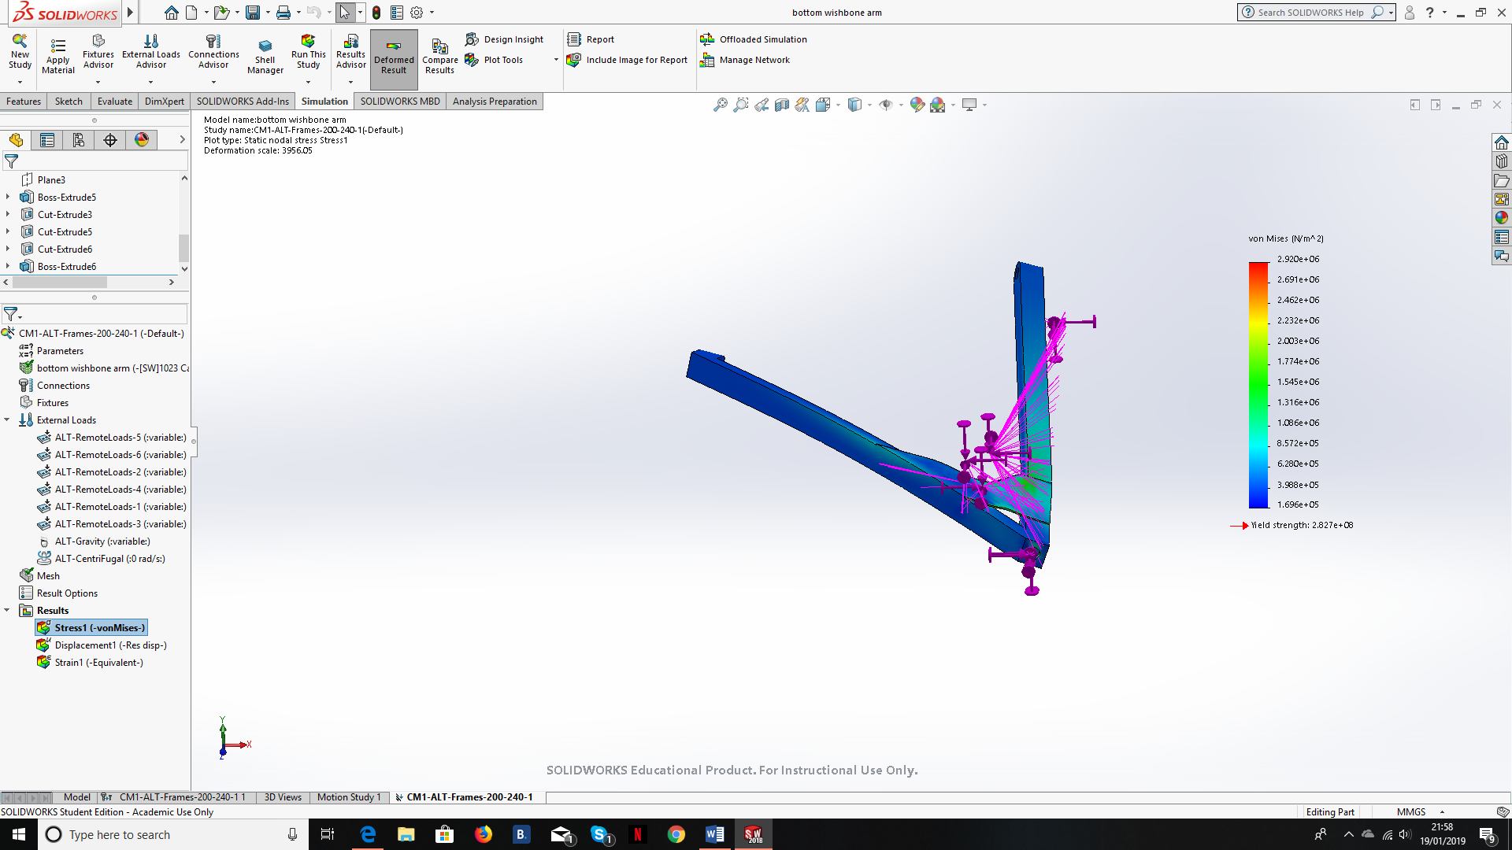
Figure 7 - The FEA results of the first wishbone design linked to stress

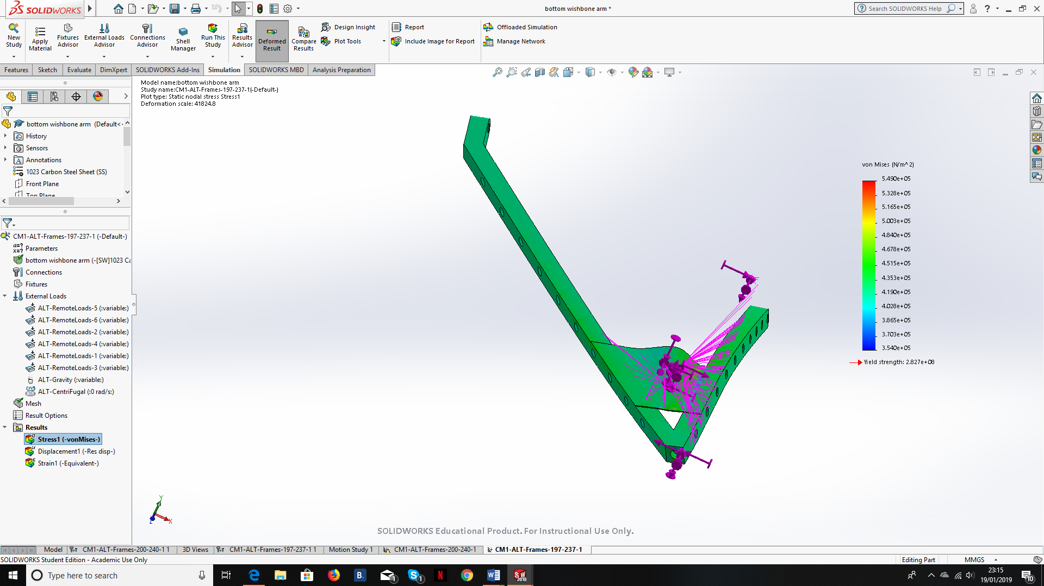
Figure 8 - The FEA results of the second wishbone design linked to stress

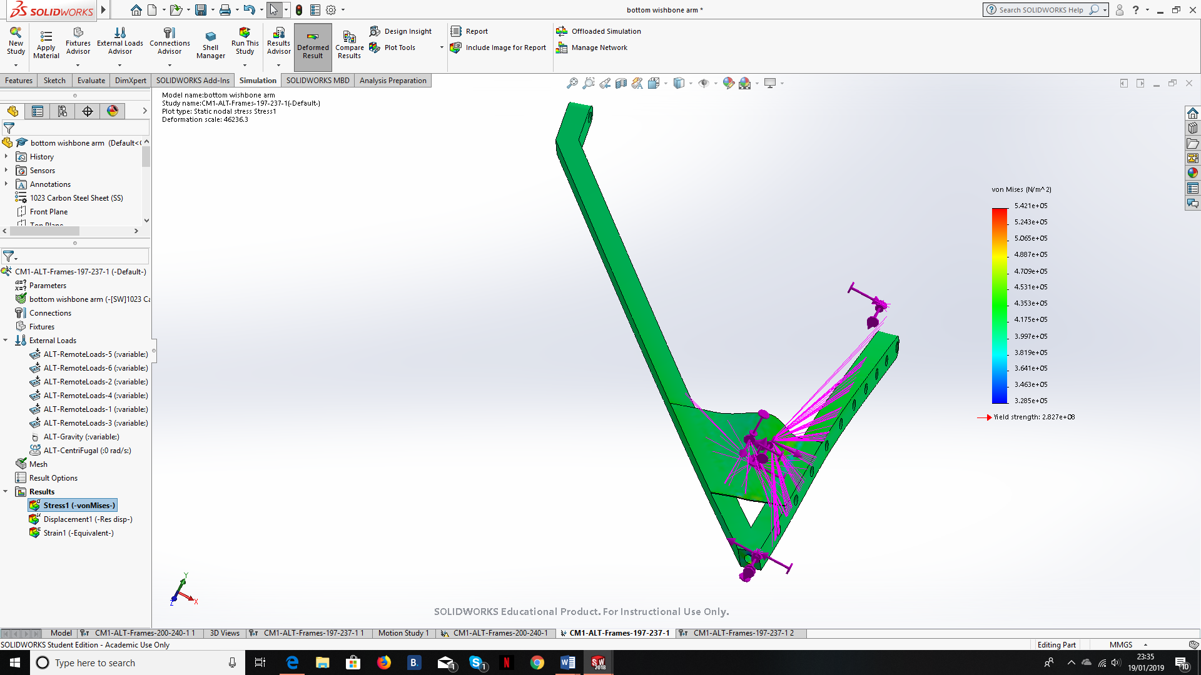
Figure 9 - The FEA results of the third wishbone design linked to stress

From looking at the figures above, it is clear that the first design is not as strong as the second and third, as without much change to the design, only making wishbone lighter, the stresses seen by the wishbone are very similar across all three designs. Looking more closely at the second and third designs, adding a second set of holes in the second arm has not made a huge difference to the stress acting on the wishbone.
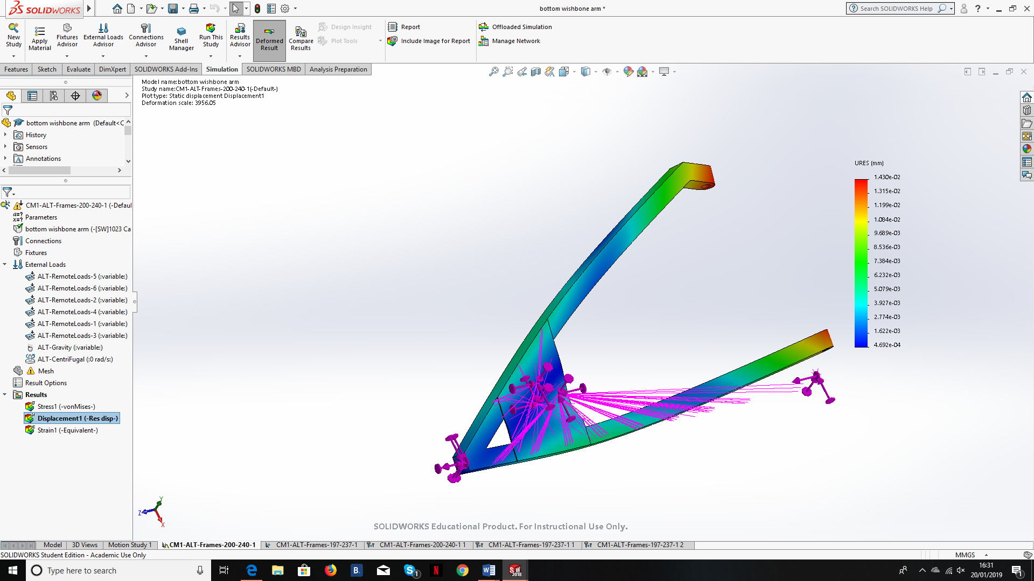
Now looking more closely at the displacement of the wishbone, the figures below illustrate the effects of changing the design:
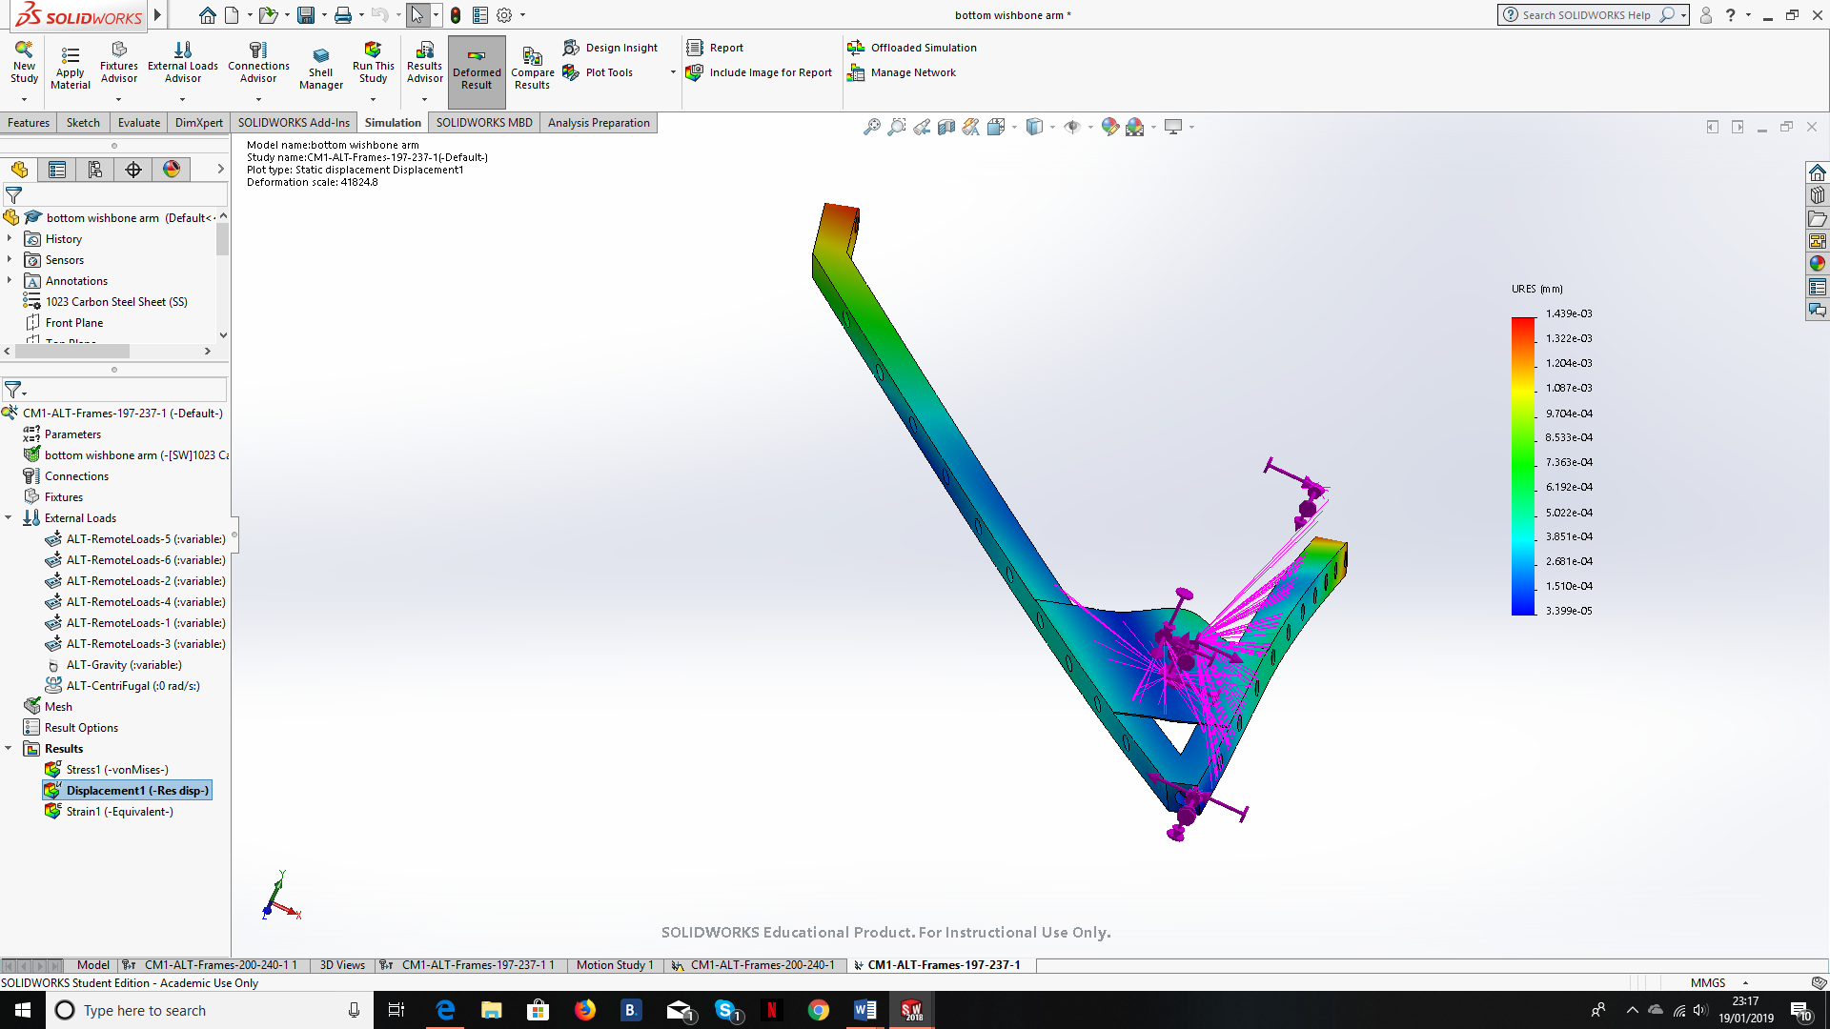
Figure 10 - The FEA results of the first wishbone design linked to displacement
Figure 11 - The FEA results of the second wishbone design linked to displacement
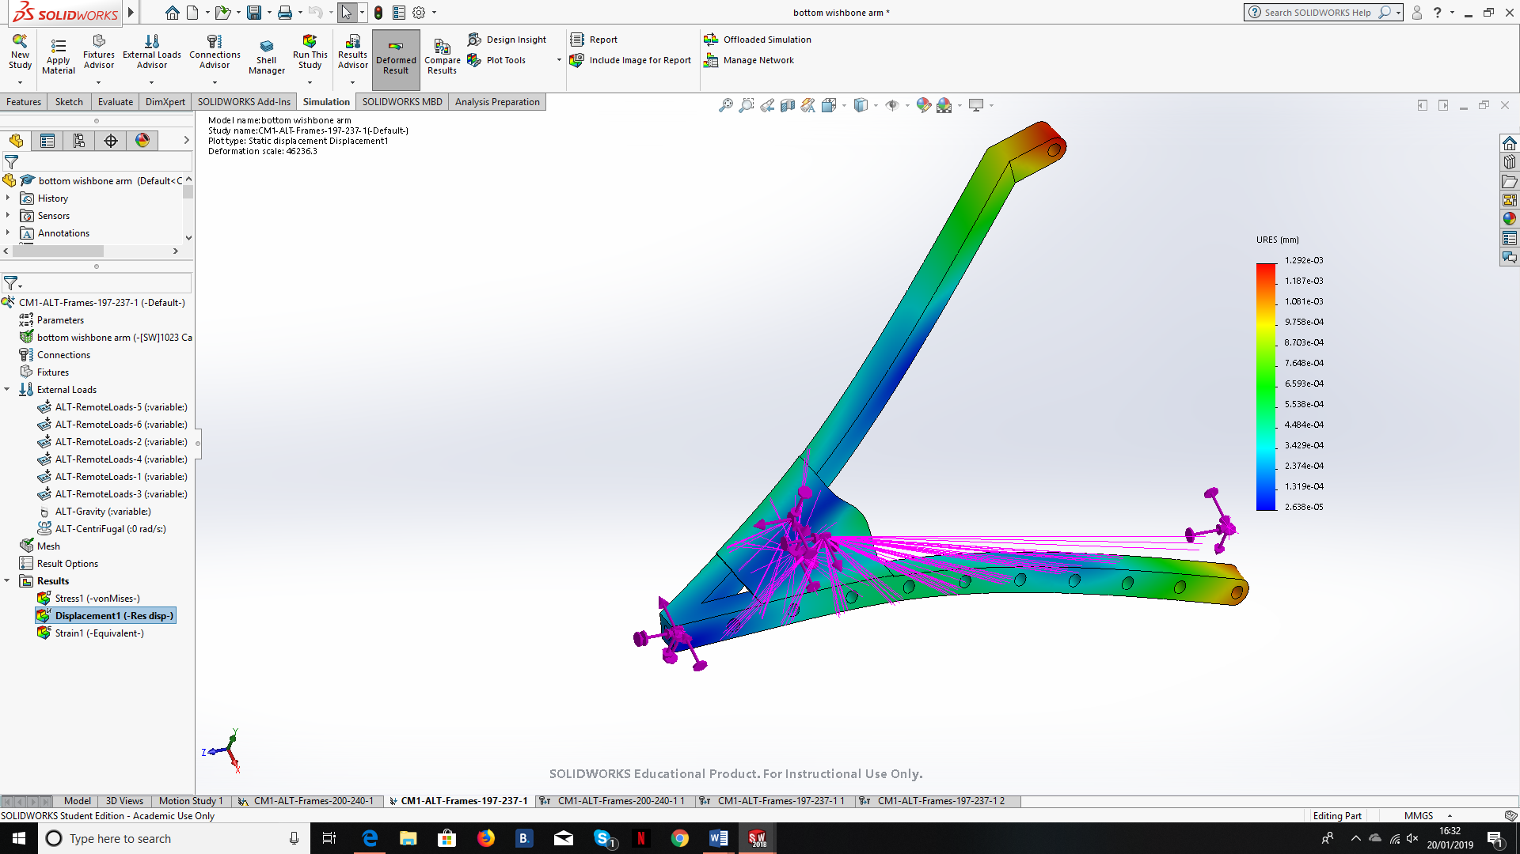
Looking at the figures above, it is clear once again that the first design is not as strong as the second and the third, as the value for its maximum displacement is greater, meaning that it would be at risk of greater deformation compared against the other designs. Looking more closely at the second and third designs, the second design is slightly stronger as it has a smaller maximum displacement.
Figure 12 - The FEA results of the third wishbone design linked to displacement

Conclusion

Looking at the three designs tested, both the second and third design are stronger then the base design. Furthermore, out of the second and third design, the second design was slightly stronger than third, due to its greater resistance to deformation.

Evaluation

Other features of the design of the wishbone could have been tested to find the optimum design. The material of the wishbone could have been changed without the design of the wishbone, to see the impact of the material on the stress and displacement. The shape of the wishbone could also have been changed, circular or oval. Furthermore, the thickness of the wishbone could also have been tested.
As well as features that could have been tested, there were also ways in which the testing could have been made more accurate. Changing the frame rate of the motion study would have made the tests more accurate. Additionally, reducing the mate redundancies would of increase the accuracy of the tests. Furthermore, using a finer mesh when computing the FEA would have also increased the accuracy of the tests.

Bibliography
Autodesk, 2019. Finite element analysis software. [Online]
Available at: https://www.autodesk.co.uk/solutions/finite-element-analysis
[Accessed 12 1 2019].
Bright Hub Engineering, 2019. What is Finite Element Analysis? What is FEA? Engineering Analysis: Applications of CAD Software. [Online]
Available at: https://www.brighthubengineering.com/cad-autocad-reviews-tips/19292-applications-of-cad-software-engineering-analysis-fea/
[Accessed 12 1 2019].
John Crawford, L. D., 1994. Applications of Finite Element Analysis in the Design of the Mazda RX-792P GTP Race Car, s.l.: SAE International.
Kobayashi, T., 2016. Prediction of Piston Skirt Scuffing via 3D Piston Motion Simulation, s.l.: SAE International.
M. A. Groeneweg, R. A. R. F. P. a. T. N. B., 1987. Current Applications of Finite Element Analysis to Diesel Engine conponent design , s.l.: SAE International.
Solidworks, 2008. Understanding Motion Simulation. [Online]
Available at: https://www.solidworks.com/sw/images/content/Training/SIM_Motion_UnderstandingMotion_WP_ENG.pdf
[Accessed 12 1 2019].
Yucheng Liu, G. G., 2013. Effects of Mesh Density on Finite Element Analysis, s.l.: SAE International.

https://uowtsd-my.sharepoint.com/:f:/g/personal/lcripps_149407_student_uwtsd_ac_uk/EgBLuvcwKYRKjtUy1V2_ZO0B225qm25zh1QIlvsWMMrHLQ?e=uKHGsx

