Management and Organizational Behaviour
Module code: M5X01924
Student Name: Anna Petrova
Student Number: 1817455
Lecture: Dr. Janet Green

Table of Contents
Introduction 2
Relationship between structure, culture, people and organisational performance 2
Essential nature of managerial work, role of leadership and variables of effective management and leadership 5
Behavioural approach to management 8
Conclusion and recommendation 9
References 10
Appendix 11
Scenario……………………………………………………………………………………….11

Introduction
In any service sector business, it is very important to satisfy the customer as they deal with the direct business terms with them. A manager is responsible for the business processes of an organization and make them perfect in order to fetch the maximum profit. He is also supposed to take care of the regular incidents along with any sudden and crucial decision making that can affect the business. In hotel sector, a hotel manager is responsible for looking after all the customer and service- related works and make changes where necessary for making the service better in order to make the clients happy and satisfied. In the present work, the refurbishing of UK based The Cranley Hotel will be discussed and focus will be given on how the management and organizational behaviour can make potential effect on it (cranleyhotel, 2020).

Relationship between structure, culture, people and organisational performance
For any organization, the structure, culture and people are the main assets. A well-built organizational structure helps any organization to carry out its mundane procedures with ease and efficiency and thus creates no room for miscommunication or conflict among the employees and provides the customer seamless service. Through a well- structured organizational structure, the relationship strata of all of its employees becomes clear to all and thus maintenance of the system becomes clear. There are generally many types of organizational structure models available to follow with as per the requirement of the business. The commonly seen structures are Hierarchical Structure, Matrix Structure, Horizontal/Flat Structure, Network Structure, Divisional Structure, Line Organizational Structure and Team-based Organizational Structure (Ahmady et al., 2016). In The Cranley Hotel, hierarchical organization structure is maintained so that the manager can get all the required information through which he can take action or make necessary decision. In a hierarchical organization structure, the flow of command is very clear and it flows from the upper level to the lower. In The Cranley Hotel, there are various departments such as front office, restaurant section, logistics, laundry section, housekeeping etc. which are dedicated to serve there best. All of these departments have their own head whom the executives report and the departmental managers then report to the general manager.

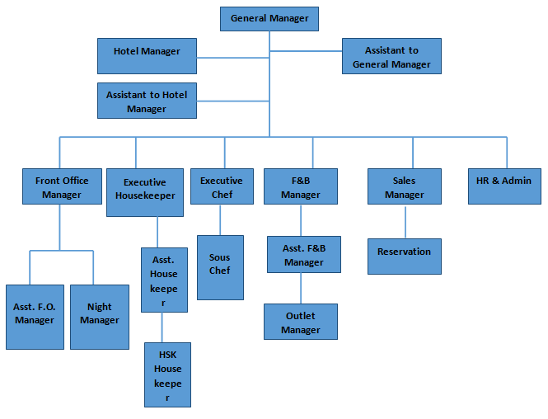
Figure 1: Organisational structure of The Cranley Hotel
(Source: Mathur and Nair, 2016)
When the organizational structure is maintained in a proper way then the works are done in a fast pace along with less chances of error. This ensures the comfort and satisfaction of the guest. If the structure is not maintained or disrupted, then it may cause organizational failure and dissatisfaction of the customers of leading to business loss.
Organizational culture is the representative of the beliefs, values and attitudes of an organisation and depiction of it is considered necessary and should be high in morale. A group of people when works together, forms the culture and the vision of the organization acts as the founding stone of the culture practice. As the hospitality sector encounters the direct interaction with the guests, therefore they are supposed to exhibit the best culture practices before the guests so that a high impression about the hotel could be generated. There are four types of organizational culture namely clan culture, adhocracy culture, hierarchical culture and market culture (Driskill, 2018). The Cranley Hotel maintains a hierarchical culture pattern also so that they can control and coordinate among the different processes that goes through within the system. This helps to make the services more efficient and customer centric and forms a good stability of the structure and culture. The hotel employees believe that the customer is the central point of services and attention and every action of them are dedicated for the customers. They are also responsible for showing the best forms of British cultures through their hospitality services for the foreign clients and they are doing very well in this sector.
When organizational people and the performance is considered then it should be mentioned that The Cranley Hotel is serving their customer with pride since 1869 and it is the efforts of their people and excellent performance that has led them to this position. All the employees are given training on their respective job role so that they can maintain the standard of the hotel so far and can serve the guest with utmost efforts. The employees also maintain a good cordial relationship among them and though they maintain a hierarchical culture and structure, they are cooperative among themselves. The chances of competition within the organization is less and everyone is encouraged to make better efforts in their own respective job role (Al Khajeh, 2018). This working environment has created less job- oriented pressure on the employees and thus they all are motivated to give their best to the organisation. This has provided a scope to all for enhancing their performance and the employees are doing remarkably well following this organizational practice.
Regarding the refurbishing plan of The Cranley Hotel, all the employees have provided the necessity of the changes to make the hotel appealing for the guests as well as make it timely. As the hotel was established centuries ago, therefore, frequent changes need to be done in regular format. For doing this in an easy way, the executives of different departments report the needs of the necessary changes to their departmental managers and they then report them to the general manager of the hotel. The friendly and supportive culture practice helps them all to bring the useful information in a compact way so that the necessary decisions could be taken effectively and within time. The performances are hence enhanced as every employee of the organisation feel valued as the management hears their points. This whole scenario helps The Cranley Hotel to serve the guests with their best efforts and make them a good destination for the tourists.

Essential nature of managerial work, role of leadership and variables of effective management and leadership
A manager is considered as the head of the various actions or departments of an organization and for maintaining the organisational works in a smooth manner the following functions and processes are done by him:
Planning: A manager is the person who makes the final planning behind an action. After gathering the necessary information from various sources, a manager makes a plan for carrying out an action to reach a target. In case of The Cranley Hotel’s refurbishing, the general manager makes the blue print of the possible changes, the schedule and communicate with others for pulling up the resources (Foster et al., 2019).
Organizing: After making the plan, a manager needs to synchronise everything so that the plan becomes effective through certain measure. The hotel manager here decides the date of refurbishing, the actions and hotel sections which needs to be done first etc.
Staffing: For any action, the need of human engagement is required, and the manager decides the number of staff that are required to complete the work. In this present work, the manager decides the number of staff who will be doing the refurbishing action.
Directing: Under the direction of a manger all the actions are performed by the subordinates. In the present case, the manager directs all the employees to take part in the refurbishing programs according to their skills and time schedule. Under his guidance all staff perform to reach the target.
Coordinating: As all the employees report to the manager and he takes decision for all, therefore, he coordinates through the organizational structure pattern to reach his commands top everyone. The hotel manager here takes the help of e mail, notice etc. to convey the important messages to his subordinates.
Reporting: A manager is also responsible to report all the updates to his higher authorities which could be the owner of the hotel in the present case.
Budgeting: It is considered as a great responsibility of a manager to carry out all the budget- based functions. In this case the audit department helps him but seeing the profit and elimination of the extra expenditure is the main responsibility of the manager, he is responsible for making the final decision associated with the budget that helps the organization to make a higher profit (Bouty and Drucker-Godard, 2019). In the present case, the manager asks for tenders for the interested organisations who can do the refurbishing and gives the tender top the party who works the best for the lowest cost.
Controlling: Monitoring all the actions and controlling them to make the desired outcome a reality, the manager of The Cranley Hotel needs to maintain control on the resources and actions taken for the refurbishing programme.
The role of leadership could be best expressed by the six sigma model of leadership according to which there are mainly four types of leaders (Laureani and Antony, 2019).
Champions: Managers of this caliber understand the details and idiosyncrasies of an organization and use them to reach the goal. They eliminate the obstacles by proper planning and actions.
Master black belt: They are resourceful person who believes in trusted methodologies such as proper training. They are true leaders and helps in problem solving, resource management, and project deployment.
Black belt: These managers are leaders by their nature and focuses on the details. They follow models DMAIC (Define, Measure, Analyze, Improve, Control) or DMADV (Define, Measure, Analyze, Design, Verify) to reach their goal.
Green belt: They are trained person and focus in problem-solving techniques. Generally they work with smaller organization and works through gathering data, analyzing information and executing experiments.
The manager of The Cranley Hotel belongs to the champion group as he has to handle so many things that are associated with the reputation of the hotel.
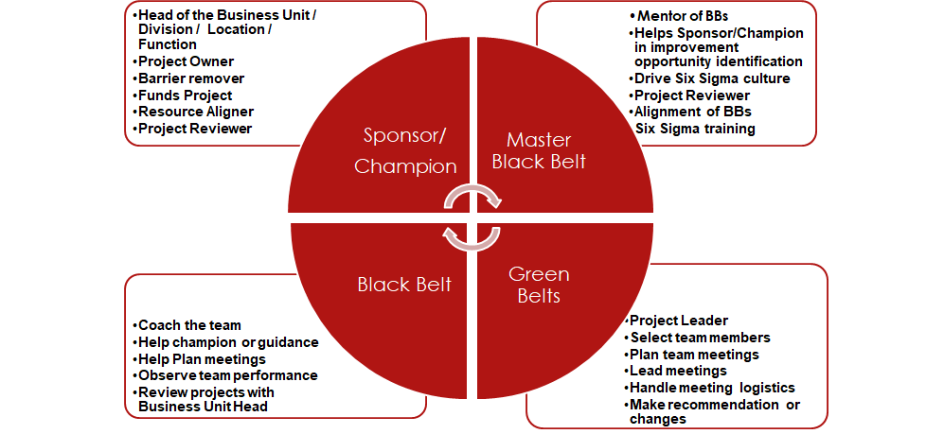
Figure 2: Six -sigma model of leadership
(Source: Laureani and Antony, 2018)
According to the contingency theory, there are various factors which decides the effective leadership or the chances of success of a manager (Otley, 2016). These are:
Leader: The personal values, beliefs, and convictions are the factors which makes the characteristics of a leader. The confidence, challenging nature and mode of action helps him to get the place.
Followers: An effective leader could be established if he has a group of followers who believe in him or his theories. Therefore, personality and speaking power are considered important for making followers.
Organization: The organisational structure, its interdependency among various departments, its culture is another factor for deciding the leadership. A high degree of dependency makes the leadership more important
Environment: supportive environment is highly needed to carry out the best leadership practices. Therefore, the manager needs to work in harmony with all the employees to maintain a good working environment.

Behavioural approach to management
Behavioural management theory could be best understood by the Maslow’s pyramid structure and Herzberg’s model as they best describe the human behaviour at the workplace and focus on motivation, expectation, conflicts etc. According to the Maslow’s hierarchy of needs, there are five stages of human needs. The basic step is physiological needs showing the requirement of food, water, air etc. fulfilment of these creates the next stage of safety needs both physically and financially. Then a person feels the need of love and belongings after which he goes for self- esteem needs and self- actualization needs and wants accomplishment and want to be indulged in creative activities (Oved, 2017).
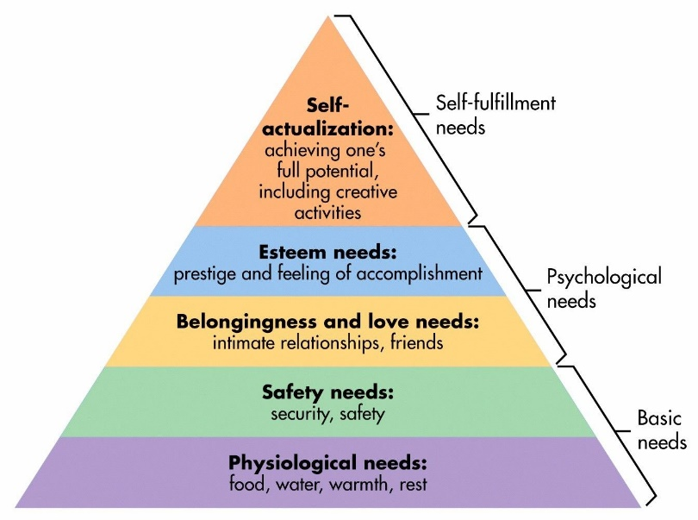
Figure 3: Maslow’s hierarchy of needs
(Source: Oved, 2017)
According to Herzberg’s model there are hygiene and motivating factors which decides the performance of an employee. The motivators are achievements, recognition, satisfying nature of the work and scope of growth that make an employee happy and motivated to put his best for the job. On the other hand, bad company policies, hard supervision, bad relation with the colleagues, workload, poor pay structures are the hygiene factors that reduces the work efficiency of an employee (Kotni and Karumuri, 2018).
A manager therefore needs to identify the needs of an employee to make him comfortable at his job and this can help the organization to make profit and fame through growing a good culture practice
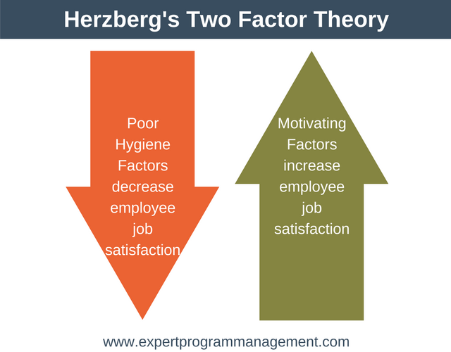
Figure 4: Herzberg’s model
(Source: Kotni and Karumuri, 2018)

Conclusion and recommendation
Therefore, it could be said that being a manager is not an easy task and the manager of The Cranley Hotel needs to check various things before he proceeds with the refurbishing programme. It is suggested that he make a good plan and then arrange the resources, talk with every employees and managers of different departments and then make a schedule that does not hamper the guest’s comfort and could be finished quickly and efficiently making the hotel better than before.

References
Ahmady, G.A., Mehrpour, M. and Nikooravesh, A., 2016. Organizational structure. Procedia-Social and Behavioral Sciences, 230, pp.455-462.
Al Khajeh, E.H., 2018. Impact of leadership styles on organizational performance. Journal of Human Resources Management Research, 2018, pp.1-10.
Bouty, I. and Drucker-Godard, C., 2019. Managerial work and coordination: A practice-based approach onboard a racing sailboat. Human Relations, 72(3), pp.565-587.
Driskill, G.W., 2018. Organizational culture in action: A cultural analysis workbook. Routledge.
Foster, W.M., Hassard, J.S., Morris, J. and Wolfram Cox, J., 2019. The changing nature of managerial work: The effects of corporate restructuring on management jobs and careers. Human Relations, 72(3), pp.473-504.
Kotni, V.D.P. and Karumuri, V., 2018. Application of Herzberg two-factor theory model for motivating retail salesforce. IUP Journal of Organizational Behavior, 17(1), pp.24-42.
Laureani, A. and Antony, J., 2018. Leadership–a critical success factor for the effective implementation of Lean Six Sigma. Total Quality Management & Business Excellence, 29(5-6), pp.502-523.
Laureani, A. and Antony, J., 2019. Leadership and Lean Six Sigma: a systematic literature review. Total Quality Management & Business Excellence, 30(1-2), pp.53-81.
Mathur, P. and Nair, M., 2016. Organization structure a key to driver to competitive advantage. International Journal of Management and Commerce Innovations, 3(2), pp.348-356.
Otley, D., 2016. The contingency theory of management accounting and control: 1980–2014. Management accounting research, 31, pp.45-62.
Oved, O., 2017. Rethinking the place of love needs in Maslow’s hierarchy of needs. Society, 54(6), pp.537-538.
The Cranley Hotel in London - Official Website 2020. Available at: <http://www.cranleyhotel.com/> (Accessed: 17 August 2020).

Appendix
Scenario
The work of The Cranley Hotel regarding its refurbishing shows the needs and effectiveness of the management and organizational behaviour. The role of a manager from an organisation’s point of view is very important and it requires to take care of multitasks. The work shows that a manager needs to be well coordinated, cooperative with visionary power and a good leadership approach. It is considered that under his direction and supervision all the other employees work and the growth of an organisation occurs. Therefore, to maintain the integrity of the organization and making it target oriented the role of a manager is essential. The work has clearly showed that the hotel follows hierarchical organizational structure as this suited the organization the best and helps it to coordinate with all the departments and people in a mannered way. This has helped him to remain connected, the commands are reaching its target in a mannered fashion all employees and management people are getting benefitted from it. The organization has also emphasized on the culture of the hotel and rather than a competitive attitude, it has promoted a supportive environment for all. In this circumstance it has become easier for the employees to perform without any pressure and put their best for the organization. Therefore, they all enjoy working at this hotel and are making the services incomparable. The people over there are helping and forms a family like environment. All services are customer centric thus the reputation of this century old hotel is still intact and rising.
The work has also focused on the essential nature of managerial work including the functions and processes that the manager of The Cranley Hotel performs. This encompasses a great deal of work and responsibility that includes, planning, organizing, directing, controlling and coordinating. Also, light has been shed on the role of leadership based on the six- sigma model of leadership. This has shown that there are mainly four types of leadership approach and each one is unique in it own pattern. While explaining the variables that determine effective management and leadership, it becomes clear through the use of contingency theory that not only the leader but the follower, environment and the organization itself are some crucial points. Dealing with the behavioural approach to management, makes it necessary to discuss about the Maslow’s model of needs and Hertberg’s model which are focused on the human needs that drive a person towards success. The former model talks about five different levels of needs which a person experiences step by step and walks towards the self-actualisation. The later model talks about two types of factor, of which the motivators are the reasons for the need of doing excellence while the hygiene factor pull a person down. Therefore, the work suggests that a manager should take care of these factors and analyse its human resources to get the best display of their skills. Also, he needs to take care of the organizational works in a serious manner so that the it can achieve its goals through continuous improvement.

