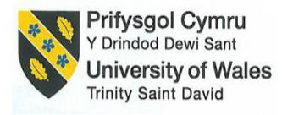

Academic Discipline of Hospitality and Tourism Management
BA(Hons) International Hotel Management
Module code and title: BMIH6007 International Meetings Management for the Hotel Industry
Assignment title: Assignment 2: Planning and Delivering an International Meeting/Event
Assignment type: Report
Student name : Florin Ionut Nitu
Student id : 2240772
Lecturer name : Kathryn Flynn

I confirm that I have not used any AI tools in the research and creation of this assignment. I confirm that I have not presented any AI generated materials as my own work. I confirm I have copies of my drafts, notes, and other resources I used, which I may be asked to provide in evidence.

Table of Contents
Introduction 3
Background 3
Reason behind its selection 3
The Event Cycle 3
Applied to the event 4
Event Concept 4
Aim and Objectives of the Event 6
Aim 6
SMART Objectives 7
6. Event Management – Skills and Resources Required 8
7. Event Budget – Income and Expenditure Analysis 10
8. Industry Trends, Issues, and Impacts 12
Situational and Cultural Considerations 14
Conclusion 16
References 17

Introduction

Background
The Voices of Wales: A Global Storytelling & Folklore Festival is a cultural event celebrating the Welsh and traditions of an oral approach to storytelling. The festival showcases the strength of stories to create connections across various cultures. This is selected to align with Visit Wales’ official theme regarding tourism for 2025 - The Year of Croeso. The event offers a dynamic and immersive experience in a setting that considers an authentic set of buildings in Welsh history. This is held at St Fagans National Museum of History in Cardiff. This site of open-air heritage is considered ideal for storytelling. It has a set of natural stages, traditional settings, and educational aspects. These, as a whole, can enhance the narrative journey.

The reason behind its selection
The festival has been selected to promote the identity of Wales, support cultural tourism, and provide a platform for several underrepresented individuals. These include a range of migrants and communities associated with diaspora. The event fills several traditions at a local level with inclusivity at a global level. This can offer visitors a sense of belonging and a cultural grasp. The strength of storytelling is evident as a potential marketing-related approach to attract a sizeable audience at an event. A few entities witness an increase of around 25% share in the market by utilising storytelling as a tool (Alonso, 2024). Hence, ideating such an event by combining a storytelling-based approach with associating a distinct range of cultures is vital.

The Event Cycle
The event cycle is based on the structured sequence of phases involved in planning, delivering, and evaluating an event. Goldblatt's model for the event management process can be utilised through its interconnected and distinct stages to ensure the event’s development, execution, and improvement. The stages include research, design, planning, coordination, and evaluation.
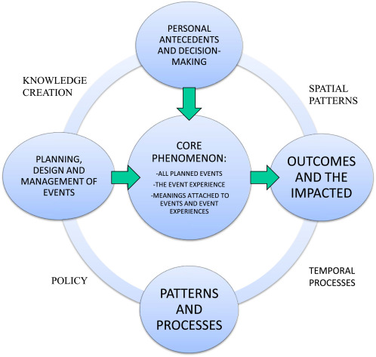
Figure: Event management cycle
(Source: Getz and Page, 2016)

Applied to the event
The cycle commences with research that identifies the audience's interest in cultural tourism and the heritage related to Wales. Demand in the market during a peak tourism period is vital to research. Research on events can be associated with balancing both qualitative and quantitative methods (Fox et al., 2014).
During the design phase, the event's concept is developed based on themes related to welcome, identity, and folklore. These themes can be associated with an immersive range of experiences, such as bilingual storytelling, live theatre, and cuisines.
Planning involves coordinating the logistics of venues at St Fagans National Museum of History. This involves ideating a diverse range of programmes and securing a number of storytellers from Wales and abroad. Strategic planning is considered a vital component related to the success of an entity's project (Cecchi-Dimeglio, 2023).
The phase of coordination will focus on delivery on the premises. This can ensure seamless alignment of performers, volunteers, and technical staff across several zones related to storytelling.
Eventually, evaluation will include surveys of visitors, feedback from stakeholders, and metrics related to engagement in social media. The goal is to assess the festival's influence and inform a number of future modifications.

Event Concept
Day | Activity | Description
1 | CROESO! Opening Ceremonies | Morning - Welcome parade with schoolchildren, choirs, and folk dancers  Afternoon - First session of storytelling named “Branwen, Daughter of Llŷr”  Evening - “The Red Dragon of Wales” as a bilingual tale shared by Welsh and international tellers
2 | Welsh Myths Come Alive | Morning - Story trail through historical buildings  Afternoon - Ghost-related stories in a miner’s cottage and swordplay in a live form  Evening - Mabinogion at Dusk as an immersive theatre under the stars
3 | Global Voices of Croeso | Morning - Story-based sessions from Nigeria, Ireland, Poland, India, and Patagonia  Afternoon - Story and food pairing in the form of dishes from featured cultures  Evening - Discussion in panels such as ‘What Makes a Place Feel Like Home?’
4 | Family Legends and Story Craft | Morning - A camp related to family-based stories, ‘Build-a-Tent’  Afternoon - A parade based on mythical creatures, such as kids in costume  Evening - Poetry slam “Croeso in 5 Words”
5 | Grand Finale: One Story, Many Voices | Morning - A collaborative performance based on a multilingual story  Afternoon - Community-related feast with Welsh and dishes from around the globe  Evening - Fireworks and choir singing for the closing
Table: Complete itineraries
(Source: Self-developed)
Analysis
The festival itinerary is designed to create a balance of immersion in culture, activities in a friendly way for families, and exchanges in cultures. Engagement in a multisensory way through food, workshops, performances, and parades ensures a purposeful experience for guests (Gómez-Suárez and Yagüe, 2021). The emotional and social connections encouraged through a shared approach to storytelling have been proven to enhance the satisfaction and loyalty of visitors. Event attendees can agree to return to a similar set of events due to a memorable experience (Setiawan et al., 2022). The festival celebrates Wales's heritage, enhancing its position as a destination for tourists internationally. This is achieved through combining traditional elements of Wales and a sense of inclusivity.

Aim and Objectives of the Event

Aim
To celebrate the heritage of Welsh storytelling, along with folklore-based traditions around the globe, through an immersive festival by promoting an exchange of cultural knowledge, engagement of communities, and growth of tourism in Wales.

SMART Objectives
Objective | Specific | Measurable | Achievable | Relevant | Time-bound
Attract attendees | To attract at least 3,000 attendees in 4 months through a targeted approach to marketing and outreach-based efforts | Sales of tickets and check-in datasets | Through influencer marketing and campaigns on social media | A high number indicates cultural exposure, along with strengthening Wales’ tourism | Within 4 months
Host international storytellers | To feature storytellers from at least five international communities to promote inclusion and engagement in 4 months | Number of countries represented | Partnerships and diaspora-related networks | Promotes intercultural exchange and participation at a global level | Within 4 months
Achieve post-event satisfaction | To achieve an 85% rate of satisfaction from attendees, based on feedback collected within 1 month after the event | Responses of a survey and feedback-based forms | Follow-up in a professional way, utilising datasets on activities | Measures the quality of experience | Within 1 month post-event
Table: SMART objectives
(Source: Self-developed)

Event Management – Skills and Resources Required
The proper and successful execution of the Voices of Wales festival needs a proper and multidisciplinary approach that ha stem ability to combines operational excellence,, certain making plans, as well as targeted advertising and also the marketing. Given the occasion's scale and cultural ambition, the required abilities span logistical coordination, cultural engagement, fitness and protection compliance, virtual outreach, and stakeholder collaboration.

Operationally, the event requires a skilled team with actual experience in managing open-air as well as multi-location festivals. In the middle, the group ought to mainly include skilled event managers to oversee the general execution and keep timelines, budget management, and disaster control(Vogt et al., 2023). Technical crews can be needed for installation levels, lighting fixtures, structures, audio gadgets, and visual installations—particularly for zones like "Mabinogion at Dusk," which depends heavily on immersive generation and sound layout. A dedicated health and protection officer should be engaged to ensure the venue complies with country-wide safety guidelines, along with the position of fire extinguishers, emergency exits, and crowd management measures. Given the outdoor nature of Portmeirion and St Fagans, climate contingencies, including waterproof tents, temporary walkways, and indoor backup stages, should be taken into consideration as part of the logistical planning.

In terms of human resources, the festival will mainly require a blend of permanent staff and volunteers. The personnel must consist of programmed curators, level managers, technical administrators, accessibility coordinators, and multilingual frontline assist teams. Volunteers—skilled in crowd help, accessibility guide, and guest control—might be critical, specifically given the various target audiences and bilingual nature of the pageant(Hoque et al., 2023). Liaison officials are also required to paint carefully with worldwide performers and migrant communities to ensure respectful and true storytelling reviews.
From a planning perspective, sports need to commence 10 to 365 days in advance. Venue scouting and booking need to be carried out early, mainly in areas like Portmeirion which can be architecturally sensitive and require special permissions. Risk assessments, licensing for public enjoyment, and insurance arrangements need to be finished in the course of the initial stages. Planning have to additionally comprise creative programming, ensuring that issues of Welsh identification, migration, and worldwide folklore are represented meaningfully. Sessions have to be scheduled cautiously to avoid overlapping content and to cater to exceptional age agencies and pursuits, including kids’ storytelling, bilingual workshops, academic panels, and track periods.
Marketing activities play a critical position in ensuring the competition’s visibility and outreach. A robust digital method is required, the usage of social media systems like Instagram, Facebook, TikTok, and YouTube to promote storytellers, teaser performances, and behind-the-scenes pictures(Hayles et al., 2023). A bilingual website need to be created with booking capability, event schedules, performer profiles, and accessibility information. Collaborations with neighborhood influencers, Welsh authors, and cultural tour bloggers will beautify the event’s appeal. Public members of the family efforts have to consist of press kits, interviews with headline storytellers, and insurance in nearby and country wide newspapers and radio. Offline advertising ought to additionally target schools, universities, libraries, and network centers through posters, leaflets, and newsletters. Partnerships with nearby councils, the Welsh Government, and cultural enterprises will no longer simply aid visibility however additionally assist content credibility.
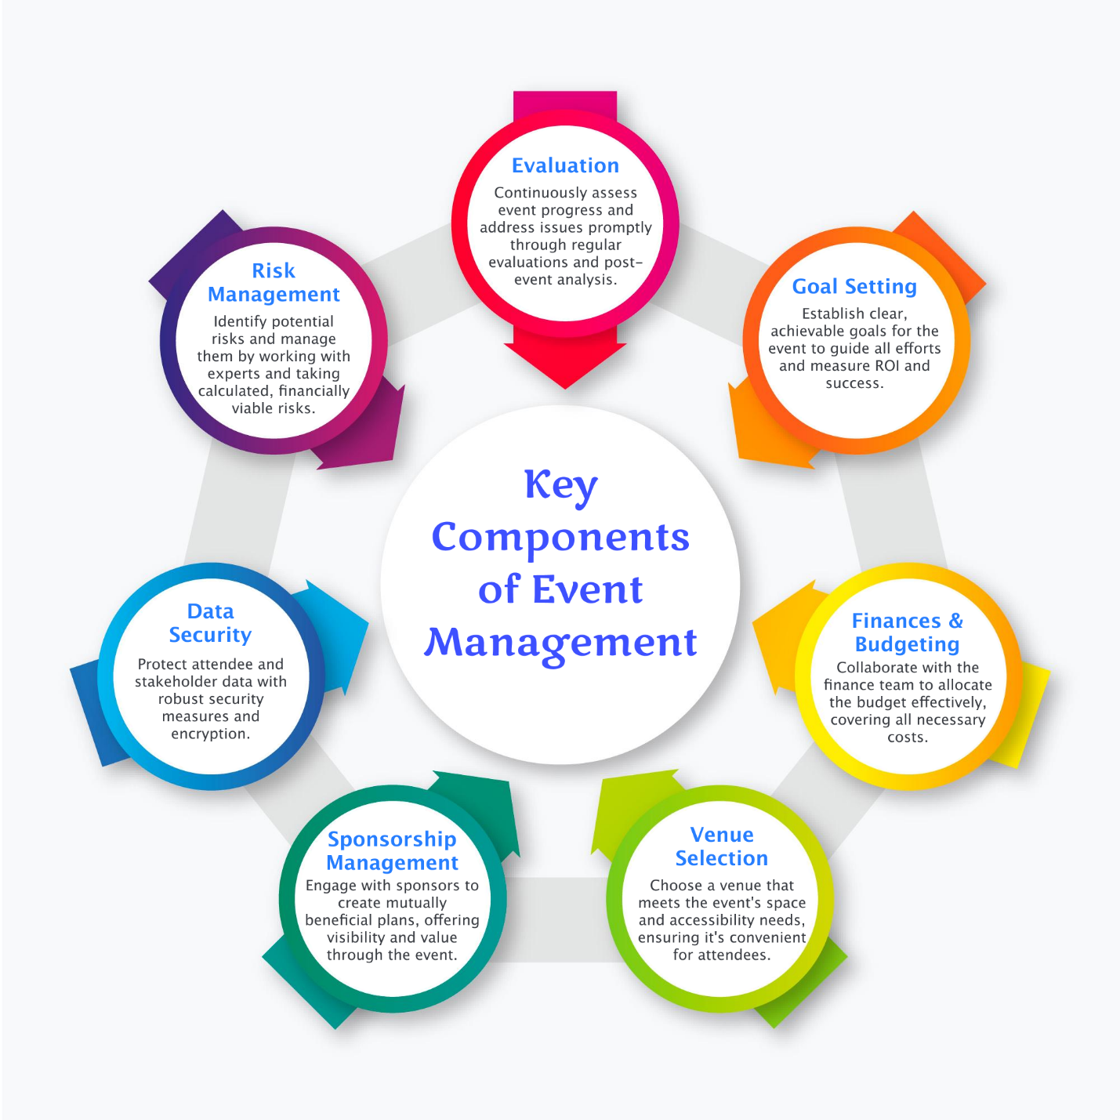
Figure 1: Skills for event management
(Source: eventify, 2021)

Event Budget – Income and Expenditure Analysis
The financial planning for the Voices of Wales festival mainly a follows a community-cultural model that ha stem ability to balances artistic integrity with that of the economic viability.. The projected earnings resources are various, aiming to make the pageant both available and sustainable(Saw et al., 2023). Ticket sales are expected to generate about £75,000 based on slight pricing and anticipated footfall, along with reductions for families, concessions, and early bookings. An extra £30,000 is expected thru corporate sponsorships from Welsh manufacturers or companies aligned with the festival’s values—which includes Penderyn Whisky or the Welsh Books Council.
Significant funding is expected from public grants, especially from organizations like Visit Wales, Arts Council of Wales,, and the Heritage Lottery Fund. These bodies offer financial guide for inclusive cultural events that align with the subject matters of identity, storytelling, and country wide heritage. Such grants may want to make contributions up to £40,000, earmarked for accessibility, network engagement, and programming involving underrepresented voices. Vendor and stallholder fees—charged to food vendors, artisans, and cultural craftspeople—may generate an estimated £10,000. Additional earnings may additionally rise up from merchandise sales inclusive of published folklore books, souvenir tote baggage, or storytelling kits, projected to generate £8,000(Renwick et al., 2023). Finally, income from ticketed workshops and optional donations could carry in every other £7,000, making the overall anticipated income £170,000.
On the expenditure side, venue and infrastructure expenses are projected to be around £25,000, inclusive of permissions, brief structures, and system rental. A further £20,000 is allocated for staging, lighting, and audiovisual necessities. Performers’ expenses, tour reimbursements, and accommodation for nearby and global storytellers make up the most important expenditure class at about £30,000. Staffing charges, along with bills to coordinators, health and protection personnel, and cultural liaisons, would require round £15,000. Marketing, each digital and print, is expected to value £18,000. Catering partnerships and subsidized meal options are budgeted at £7,000, whilst volunteer fees—protecting food, uniforms, and schooling—are expected at £five,000.

Industry Trends, Issues, and Impacts
The festival industry is very much currently shaped by a particular series of dynamic trends and evolving challenges that has the ability to significantly influence the planning as well as the delivery of events like Voices of Wales. One of the most distinguished traits is the upward push of immersive and experiential cultural tourism. Post-pandemic audiences are searching for meaningful engagement, now not just passive amusement. Storytelling festivals, specifically those grounded in region, background, and human connection, are increasingly more attractive to visitors seeking out authenticity and cultural depth(Su et al., 2023). The Voices of Wales competition faucets directly into this trend, supplying audiences the danger to discover historical past thru oral traditions and participatory workshops.
Another key trend is the emphasis on variety, inclusion, and intercultural alternate. Today’s audiences anticipate fairs to head past tokenistic illustration and create areas that absolutely platform minority voices and worldwide views. This occasion responds by curating a programmed that includes storytellers from Wiles’ migrant communities, indigenous voices, and international performers. This technique not simplest broadens attraction however also aligns with government objectives around community cohesion and cultural inclusivity(Lean et al., 2023).
The integration of era into live occasions is another sizeable shift. While many activities now offer hybrid models, Voices of Wales plans to depart a virtual legacy via a recorded storytelling archive. This guarantees that the event isn't sure by using geography or time, extending its academic and cultural reach a long way beyond the physical weekend. Additionally, such digital components beautify accessibility for audiences with mobility boundaries or those residing abroad.
Environmental sustainability is now a critical expectation in occasion planning. Audiences are increasingly privier to carbon footprints, waste discount, and ethical sourcing. The competition plans to use reusable substances, promote walkable venue alternatives, source meals from local and migrant-owned businesses, and offer low-waste alternatives inclusive of virtual ticketing and composting zones (Dale et al., 2023). This awareness not best meets target audience expectancies however also positions the pageant as a forward-questioning and responsible initiative.
However, the industry isn't without its demanding situations. Rising fees of equipment hire, insurance, and staffing, pushed by using inflation and post-pandemic restoration, location pressure on budgets. Securing dependable investment and partnerships is therefore vital to keep away from compromising on programmed high-quality or accessibility(Bainey et al., 2023). Additionally, unpredictable climate patterns—especially in the UK—suggest that fairs must be increasingly climate-resilient, with clear plans for severe conditions. Choosing adaptable venues like St Fagans or Portmeirion ensures this pliability.

Situational and Cultural Considerations
A number of circumstances and culture-based factors play a vital role in shaping the planning, success, and reception of the Voices of Wales festival. The PESTEL analysis can prove to be a vast tool for the evaluation of the external environment. This could influence the event in a systematic way (Walsh, 2021).
Political
Political factors include the support of the Welsh Government for tourism and programming related to cultural aspects in the form of WCCSS and an investment of around 1 million pounds (GOV.WALES, 2025). The event aligns with Visit Wales’ strategy for the Year of Croeso in 2025. This promotes cultural tourism and an inclusive form of storytelling. This makes the political climate favourable, considering opportunities regarding funding and partnerships. Apart from these, interest in the identity of Wales and nationalism after Brexit can enhance cultural relevance to an event focused on folklore.
Economic
The domestic market for tourism in the UK is projected to witness growth at a CAGR of 2.6% between 2025 and 2029 (Statista, 2025). However, pressures regarding the cost of living may influence the affordability of tickets. This makes it vital to offer packages for families and a number of free events. Actual GDP grew by 0.6% in the 3 months to February 2025 (ONS, 2025). This indicates individuals’ strong spending power even in leisure-based events, supporting the festival’s probable success.
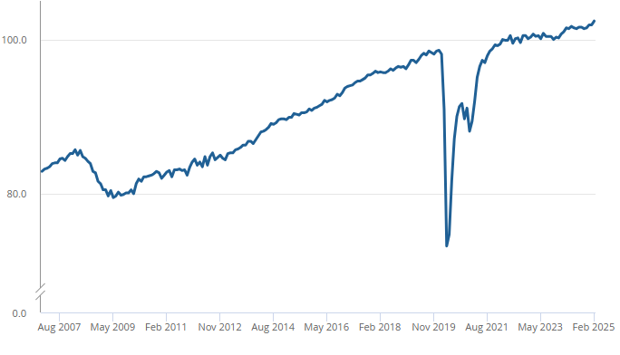
Figure: UK’s GDP growth
(Source: ONS, 2025)
Social
Trends in social terms indicate an enhanced level of interest in cultural inclusivity. Brits are prone to spend around 178 billion pounds on a number of events related to the celebration of heritage and diversity at a local level (Barclays, 2024). The festival responds to this by combining a number of Welsh myths with stories from migrant communities.
Technological
A number of technological advancements in the form of streaming in a live form and augmented reality are helpful for an extremely vast level of reach and accessibility (Lim et al., 2024). The integration of QR codes or apps related to storytelling can enhance the level of engagement. This can specifically be helpful for a younger set of audiences.
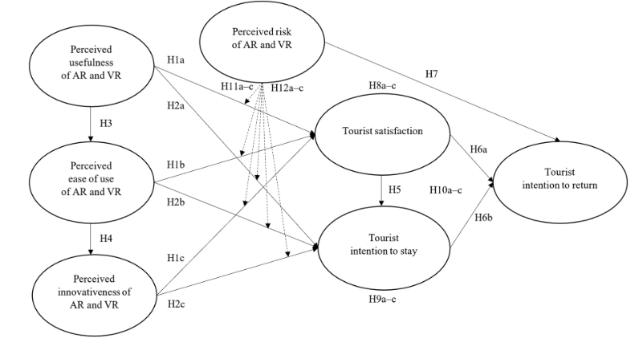
Figure: AR/VR relevance in tourism
(Source: Lim et al., 2024)
Environmental
Environmental considerations are vital due to the event’s placement at St Fagans, a heritage-based site. Around 78% of consumers’ preference for a sustainable lifestyle is evident (Am et al., 2023). This can be aligned considering their satisfaction, along with being a marketing tactic. Hence, a number of sustainable regimes in the form of the reduction of plastics with a single usage can be implemented.
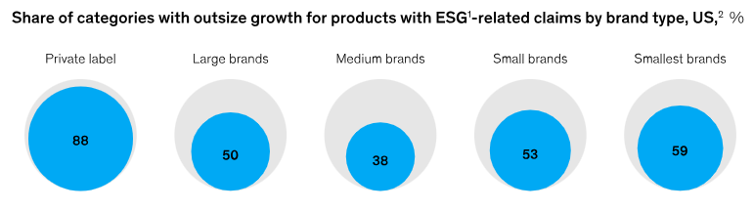
Figure: Products with ESG claims
(Source: Am et al., 2023)
Legal
It is additionally vital for the festival to comply with the Well-being of Future Generations Act of Wales. The compliance can ensure the safeguarding of children, permissions related to copyrights for stories around the globe, and regulations regarding the safety of food for vendors (Future Generations Wales, 2015).

Conclusion
Hence, it can be concluded that the Voices of Wales festival aims to enhance the identity of Wales as a major destination. This can be achieved through a strategic form of planning events, a rich itinerary, and an immersive approach to storytelling. The event is expected to deliver an enriching experience. This is supported by a detailed level of research, collaboration of stakeholders, and a set of sustainable regimes. This can encourage exchanges in cultures, enhance engagement in communities, and eventually contribute to Wales’ growth as a social and economic hub.

References
Alonso, M., 2024. The Power Of Storytelling In Modern Marketing. Available at: https://www.forbes.com/councils/forbescommunicationscouncil/2024/08/05/the-power-of-storytelling-in-modern-marketing/ (Accessed: 9 May 2025).
Getz, D. and Page, S.J., 2016. Progress and prospects for event tourism research. Tourism management, 52, pp.593-631.
Hernández-Rojas, R.D., del Río, J.A.J., Fernández, A.I. and Vergara-Romero, A., 2021. The cultural and heritage tourist, SEM analysis: the case of The Citadel of the Catholic King. Heritage science, 9(1), p.52.
Cecchi-Dimeglio, P., 2023. 3 Ways Leaders Drive Success Through Strategic Planning. Available at: https://www.forbes.com/sites/paolacecchi-dimeglio/2023/12/11/3-ways-leaders-drive-success-through-strategic-planning/ (Accessed: 9 May 2025).
Gómez-Suárez, M. and Yagüe, M.J., 2021. Making Sense from Experience: How a Sustainable Multisensory Event Spurs Word-of-Mouth Recommendation of a Destination Brand. Sustainability 2021, 13, 5873.
Setiawan, R., Wibisono, D. and Purwanegara, M.S., 2022. Defining event marketing as engagement-driven marketing communication. Gadjah Mada International Journal of Business, 24(2), pp.151-177.
Walsh, J., 2021. PEST analysis.
GOV.WALES, 2025. New £1 million fund to boost Welsh tourism come rain or shine. Available at: https://www.gov.wales/new-1-million-fund-boost-welsh-tourism-come-rain-or-shine#:~:text=Welsh%20Government%20support%20for%20the%20sector%20over,a%20%C2%A350%20million%20Wales%20Tourism%20Investment%20Fund (Accessed: 9 May 2025).
Statista, 2025. Travel & Tourism - United Kingdom: Market Forecast. Available at: https://www.statista.com/outlook/mmo/travel-tourism/united-kingdom (Accessed: 9 May 2025).
ONS, 2025. GDP monthly estimate, UK: February 2025, GDP monthly estimate, UK - Office for National Statistics. Office for National Statistics. Available at: https://www.ons.gov.uk/economy/grossdomesticproductgdp/bulletins/gdpmonthlyestimateuk/february2025 (Accessed: 9 May 2025).
Barclays, 2024. Brits to spend £178bn on memorable experiences this summer, with holidays, live entertainment and sports events the stars of the show. Available at: https://home.barclays/news/press-releases/2024/06/brits-to-spend-p178bn-on-memorable-experiences-this-summer--with/ (Accessed: 9 May 2025).
Lim, W.M., Jasim, K.M. and Das, M., 2024. Augmented and virtual reality in hotels: Impact on tourist satisfaction and intention to stay and return. International Journal of Hospitality Management, 116, p.103631.
Am, J. B., Doshi, V., Noble, S. and Malik, A., 2023. Consumers care about sustainability-and back it up with their wallets, McKinsey & Company. McKinsey & Company. Available at: https://www.mckinsey.com/industries/consumer-packaged-goods/our-insights/consumers-care-about-sustainability-and-back-it-up-with-their-wallets#/ (Accessed: 9 May 2025).
Future Generations Wales, 2015. Well-being of Future Generations Act 2015. Available at: https://futuregenerations.wales/discover/about-future-generations-commissioner/future-generations-act-2015/#:~:text=The%20Well%2Dbeing%20of%20Future%20Generations%20Act%20defines%20the%20Sustainable,the%20well%2Dbeing%20goals.%E2%80%9D (Accessed: 9 May 2025).
Fox, D., Gouthro, M.B., Morakabati, Y. and Brackstone, J., 2014. Doing events research: From theory to practice. Routledge.
Bowdin, G.A., Allen, J., Harris, R., Jago, L., O’Toole, W. and McDonnell, I., 2023. Events management. Routledge.
Allen, J., Harris, R. and Jago, L., 2022. Festival & special event management. John Wiley & Sons.
Bladen, C., Kennell, J., Abson, E. and Wilde, N., 2022. Events management: An introduction. Routledge.
Nicholls, S., Organ, K. and Cummings, B., 2021. Planning for sustainable tourism development in Wales: an analysis of destination management plans. Welsh Economic Review, 28, pp.23-32.
Dillette, A. and Ponting, S.S.A., 2021, June. Diffusing innovation in times of disasters: considerations for event management professionals. In Journal of Convention & Event Tourism (Vol. 22, No. 3, pp. 197-220). Routledge.
Radbourne, J., 2023. Arts management: A practical guide. Routledge.
Kerr, S., Joy, M., Torabi, F., Bedston, S., Akbari, A., Agrawal, U., Beggs, J., Bradley, D., Chuter, A., Docherty, A.B. and Ford, D., 2022. First dose ChAdOx1 and BNT162b2 COVID-19 vaccinations and cerebral venous sinus thrombosis: A pooled self-controlled case series study of 11.6 million individuals in England, Scotland, and Wales. PLoS Medicine, 19(2), p.e1003927.
Knight, R., Walker, V., Ip, S., Cooper, J.A., Bolton, T., Keene, S., Denholm, R., Akbari, A., Abbasizanjani, H., Torabi, F. and Omigie, E., 2022. Association of COVID-19 with major arterial and venous thrombotic diseases: a population-wide cohort study of 48 million adults in England and Wales. Circulation, 146(12), pp.892-906.
Vogt, F., Haire, B., Selvey, L., Katelaris, A.L. and Kaldor, J., 2022. Effectiveness evaluation of digital contact tracing for COVID-19 in New South Wales, Australia. The Lancet Public Health, 7(3), pp.e250-e258.
Hoque, M.A.A., Pradhan, B., Ahmed, N. and Sohel, M.S.I., 2021. Agricultural drought risk assessment of Northern New South Wales, Australia using geospatial techniques. Science of the Total Environment, 756, p.143600.
Hayles, C., Huddleston, M., Chinowsky, P. and Helman, J., 2022. Quantifying the effects of projected climate change on the durability and service life of housing in Wales, UK. Buildings, 12(2), p.184.
Saw, J., Starovoytov, A., Aymong, E., Inohara, T., Alfadhel, M., McAlister, C., Samuel, R., Grewal, T., Parolis, J.A., Sheth, T. and So, D., 2022. Canadian spontaneous coronary artery dissection cohort study: 3-year outcomes. Journal of the American College of Cardiology, 80(17), pp.1585-1597.
Renwick, S., Hookes, S., Draycott, T., Dey, M., Hodge, F., Storey, J., Winter, C., Sengupta, N. and Benjamin, F., 2021. PROMPT Wales project: national scaling of an evidence-based intervention to improve safety and training in maternity. BMJ Open Quality, 10(4), p.e001280.
Su, J.R., McNeil, M.M., Welsh, K.J., Marquez, P.L., Ng, C., Yan, M. and Cano, M.V., 2021. Myopericarditis after vaccination, vaccine adverse event reporting system (VAERS), 1990–2018. Vaccine, 39(5), pp.839-845.
Lean, M.E., Leslie, W.S., Barnes, A.C., Brosnahan, N., Thom, G., McCombie, L., Kelly, T., Irvine, K., Peters, C., Zhyzhneuskaya, S. and Hollingsworth, K.G., 2024. 5-year follow-up of the randomised Diabetes Remission Clinical Trial (DiRECT) of continued support for weight loss maintenance in the UK: an extension study. The Lancet Diabetes & Endocrinology, 12(4), pp.233-246.
Bainey, K.R., Marquis-Gravel, G., Belley-Côté, E., Turgeon, R.D., Ackman, M.L., Babadagli, H.E., Bewick, D., Boivin-Proulx, L.A., Cantor, W.J., Fremes, S.E. and Graham, M.M., 2024. Canadian Cardiovascular Society/Canadian Association of Interventional Cardiology 2023 focused update of the guidelines for the use of antiplatelet therapy. Canadian Journal of Cardiology, 40(2), pp.160-181.
Dale, C.E., Takhar, R., Carragher, R., Katsoulis, M., Torabi, F., Duffield, S., Kent, S., Mueller, T., Kurdi, A., Le Anh, T.N. and McTaggart, S., 2023. The impact of the COVID-19 pandemic on cardiovascular disease prevention and management. Nature medicine, 29(1), pp.219-225.
Lee‐Lane, E., Torabi, F., Lacey, A., Fonferko‐Shadrach, B., Harris, D., Akbari, A., Lyons, R.A., Rees, M.I., Sawhney, I., Halcox, J. and Powell, R., 2021. Epilepsy, antiepileptic drugs, and the risk of major cardiovascular events. Epilepsia, 62(7), pp.1604-1616.
Smith, T., 2021. Plane Sailing: The archaeology of aircraft losses over water in New South Wales, Australia.
Ponsford, M.J., Jefferies, R., Davies, C., Farewell, D., Humphreys, I.R., Jolles, S., Fairbairn, S., Lewis, K., Menzies, D., Benjamin, A. and Thaivalappil, F., 2021. Burden of nosocomial COVID-19 in Wales: results from a multicentre retrospective observational study of 2508 hospitalised adults. Thorax, 76(12), pp.1246-1249.
eventify (2021) https://eventify.io/blog/what-is-event-management

