An Examination of Early Help Signposting and Multi-Agency Systems in UK Local Authorities

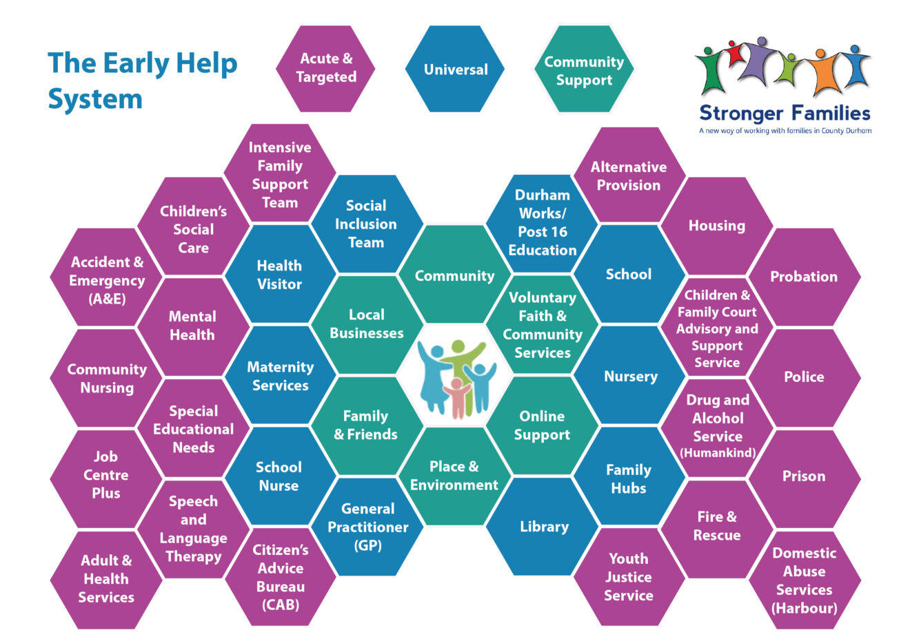

BMHP5021_BIRM

Robert Nartowsk

Student name:

Nashwa Elbouhy Student number:2408300

Introduction
Early Help has become one of the most significant pillars in England’s safeguarding landscape, recognised nationally as a vital approach for supporting children, young people, and families before problems escalate into crises. The central purpose of Early Help is to identify emerging needs swiftly, intervene proportionately, and offer coordinated support that strengthens family resilience. When implemented effectively, Early Help reduces the likelihood of neglect, prevents family breakdown, and minimises escalation to statutory social care—outcomes that align closely with the preventative ambitions set out in Working Together to Safeguard Children (2023) and the Early Help System Guide.
Because Early Help is often a family’s first point of contact with support services,
This report evaluates how three local authorities—Leicester City Council, Leicestershire County Council, and Tower Hamlets Council—present their Early Help offer online. The analysis explores the clarity of signposting, the explanation of eligibility and thresholds, the visibility of multi-agency working, and the availability of clear access routes. Each website is assessed for family-friendliness, transparency, and alignment with national safeguarding expectations.
By comparing different approaches, this report highlights both effective practice and areas for improvement. A well-designed Early Help webpage does more than describe services—it reassures families, reduces fear and stigma, and shows that support is available without judgement. Understanding how local authorities communicate these messages is therefore crucial for ensuring that Early Help systems remain accessible, equitable, and aligned with the needs of diverse communities. The findings in this report offer insights that may help local areas strengthen the visibility and usability of Early Help information, ultimately contributing to better outcomes for children and families.

Explanation of the Early Help system in national context
National guidance positions Early Help not as a standalone service but as a system of coordinated intervention delivered across the partnership of education, health, youth services, housing, policing, voluntary organisations, and community-based support. The purpose is to intervene early enough to prevent escalation into statutory thresholds—especially child protection or Child in Need services.
Working Together to Safeguard Children (2023) describes Early Help as support for children and families of any age who would benefit from extra help to improve outcomes or address emerging problems. It emphasises:
strengthening family resilience
preventing difficulties from worsening
supporting children’s development and wellbeing
reducing the need for statutory children’s social care
Crucially, Early Help incorporates two layers:
Universal services (open to all):
Health visitors
Schools and early years settings
Primary healthcare
Family hubs and community services
Targeted Early Help (more structured, co‑ordinated support):
Parenting programmes
Youth support
Domestic abuse intervention
Housing, employment and financial support
Mental health and wellbeing support
Consent and Escalation
Early Help is generally voluntary, requiring parental consent and collaboration. National expectations emphasise clarity about when Early Help is suitable and when safeguarding concerns must escalate to statutory thresholds. The Early Help System Guide stresses the need for clear access routes, transparent thresholds, and a consistent multi-agency approach.
Local authorities must therefore communicate:
what Early Help is? who can receive it? how to access it? how agencies work together? How are decisions made when concerns indicate possible harm?
The quality of online guidance directly influences family confidence and engagement
. This national context provides the foundation for evaluating how local authorities communicate Early Help.

Multi‑Agency Working in the Early Help System
Multi-agency working is fundamental to safeguarding and early intervention. Local partnerships must share responsibility, information, and ownership of decisions to ensure children receive timely, appropriate support.
Working Together 2023 describes multi-agency safeguarding arrangements as systems designed so that agencies:

- share a common vision
- have clear roles, responsibilities and accountability
- use data, analysis and shared learning
- coordinate assessments and interventions
- identify early signs of neglect, abuse, or family stress
Early Help assessments and plans often follow a lead practitioner model, enabling families to work with a single professional who coordinates support across services.
Local websites should therefore help families understand that:
- Early Help is multi-agency
- professionals collaborate to assess and support
- concerns can escalate where risk of harm increases
- information-sharing supports timely, safe decision-making
Clarity on these points builds trust and transparency.
Understanding multi-agency expectations enables clearer comparison of how councils reflect these principles on their websites.

Evaluation of each local authority website

Criteria | Leicester City Council | Leicestershire County Council | Tower Hamlets Council
Overall Accessibility | Very accessible; simple language; reassuring tone. | Mixed accessibility; family content is clear, but site structure is fragmented. | Highly accessible with detailed explanations and structured Early Help pathway.
Signposting & Navigation | Good signposting, but links often take users to external pages, reducing ease of navigation. | Navigation is complex due to separation between family-facing pages and professional portal. | Clear Early Help section with coherent, centralised navigation and consistent layout.
Clarity of “What Early Help Is” | Strong, family-friendly explanation of Early Help as voluntary support. | Clear definition but scattered across multiple pages; may overwhelm families. | Very clear explanation including age range, universal vs targeted support, and when safeguarding thresholds apply.
Visibility of Contact Routes | Provides 24/7 Duty & Advice line; contact options are visible. | Includes phone numbers, online forms, and professional referral routes. | Strong contact visibility with “What do you want to do now?” options and multiple access routes (email, phone, form).
Thresholds & Escalation | Minimal detail about thresholds; limited information on assessment process. | Provides threshold documents on professional portal; risk of families landing on professional pages. | Detailed explanation of how MAST screens referrals and what happens next.
Multi‑Agency Working Explanation | Implied rather than explicit; focuses on family experience. | References partnership work but not clearly explained on family pages. | Excellent clarity: explicitly lists partner agencies within MAST (health, education, police, CAMHS, etc.).
Self‑Referral Options | Encourages families to speak to trusted professionals; some self-request routes exist. | Clear self-referral form available, though forms sit on external platforms. | Clear self-referral through MAST; well-signposted.
Professional Guidance | Limited on family pages but available elsewhere; family-facing focus. | Strong professional content (MARF, consent, thresholds), though not always clearly separated. | Clear professional guidance, but still kept distinct from family-facing materials.
Ease for Families in Crisis | Good reassurance but limited step-by-step process. | Information can feel overwhelming due to multiple links/pages. | Best for families in crisis: very clear explanation of process and next steps.
Strengths | Simple, warm language; strong reassurance; 24/7 contact route. | Clear routing for families and professionals; wide service menu. | Best overall clarity; strongest depiction of multi-agency working; transparent “front door.”
Weaknesses | Lack of detail on thresholds; external links reduce usability. | Fragmented journey; risk of confusion between family and professional areas. | Amount of information may feel heavy; some contact options less prominent than ideal for crisis support.
Alignment with Working Together 2023 | Good emphasis on voluntary nature; limited detail on system processes. | Strong on thresholds and professional expectations; weaker on family clarity. | Closest alignment: clear multi-agency approach, escalation process, and single access route.

- Comparative Analysis: Communicating Early Help Across Authorities

1. Signposting and Navigation
- Tower Hamlets provides the strongest, most coherent structure. Early Help is easy to find, with a clear “front door” concept.
- Leicester City offers accessible language but spreads key actions across multiple domains.
- Leicestershire County has a robust directory, but navigation is fragmented, especially where professional content appears in search results.

2. Clarity of Early Help Definition
- All three align with national guidance, but:
- Leicester City excels in family-friendly explanation.
- Tower Hamlets is the most thorough, linking definition to access routes and multi-agency practice.
- Leicestershire County is informative but divided across multiple pages.

3. Inclusion of Multi-Agency Working
- Tower Hamlets is strongest, explicitly describing MAST membership.
- Leicestershire County references multi-agency partnerships but less visibly on family-facing pages.
- Leicester City implies partnership working without detailing participant agencies.

4. Actionability
- Tower Hamlets provides a clear, linear pathway from request to assessment.
- Leicestershire County offers rich but complex routes, which may challenge accessibility.
- Leicester City reassures families but provides less detail about what happens once a request is made
Taken together, these evaluations reveal important insights into how Early Help information is communicated and where inconsistencies may impact accessibility for families

Conclusion and Recommendations

Overall, this comparative review demonstrates that while all three local authorities—Leicester City, Leicestershire County, and Tower Hamlets—are committed to delivering Early Help in line with national expectations, their digital communication strategies differ significantly in clarity, accessibility, and practical usefulness for families. Using Working Together to Safeguard Children (2023) and the Early Help System Guide as benchmarks, it becomes clear that the effectiveness of Early Help is influenced not only by the services available but also by how well those services are communicated to the families who need them.
Among the three councils, Tower Hamlets offers the strongest model, presenting Early Help as a coherent system with a clearly defined “front door,” transparent multi-agency processes, and step-by-step guidance that helps families understand what to expect. Its explicit reference to partners such as health, education, youth offending services, CAMHS, and voluntary sector agencies provides reassurance that Early Help is collaborative and robust. This level of clarity is highly aligned with multi-agency safeguarding expectations in Working Together 2023, particularly regarding shared accountability and timely decision-making.
Leicester City excels in accessibility and reassurance, using simple language that reduces the fear often associated with asking for help. However, the reliance on external links and the lack of explicit detail about thresholds and pathways may hinder deeper understanding. Leicestershire County provides extensive information, but fragmentation across multiple platforms and the mixing of family-facing and professional content can make navigation challenging.
To strengthen public trust and engagement, all three authorities would benefit from developing a more unified Early Help landing page, simplifying navigation, and ensuring a clear divide between family content and professional guidance. They should also adopt a more visible approach to explaining multi-agency working, as this supports transparency and aligns with national safeguarding principles.
Ultimately, clear and accessible Early Help communication is not simply an administrative requirement—it is a safeguarding imperative. When families can easily understand what Early Help is, why it matters, and how to access it, they are more likely to seek support early, preventing escalation and promoting better outcomes for children. Strengthening digital signposting is therefore essential to ensuring Early Help systems are inclusive, responsive, and truly effective for diverse communities.

Recommendations Across All Three Authorities

Create a Simple, Unified “Start Here” Early Help Page
This page should include What Early Help is, who it is for, Voluntary nature and consent, Urgent safeguarding instructions, Main contact options, and Pathways to self-referral and professional referral. The Tower Hamlets model should be considered best practice.

Reduce Cross-Site Friction: Where forms or resources sit on external domains, provide:
- clear instructions
- reassurance on data protection
- estimated completion time
- a “return to Early Help” link
This will support user confidence and continuity of navigation.

Separate Family and Professional Content: Ensure families do not unintentionally arrive on MARF or professional guidance pages. Professional material should remain accessible but signposted distinctly from family-facing content.

Increase Visibility of Multi-Agency Working: For example, a short panel such as “Who will support you?” Listing to common Early Help partners. Tower Hamlets provides an effective model.

Align Language with National Guidance: Reinforce that Early Help:
- supports families at the earliest opportunity
- is usually voluntary and based on consent
- includes universal + targeted support
- escalates to statutory services only when appropriate
This consistency supports clarity and public trust.

Overview
Across Leicester City, Leicestershire County, and Tower Hamlets, there is a strong commitment to Early Help. However, the clarity of communication varies significantly. Tower Hamlets stands out for its cohesive, transparent, and multi-agency approach. Leicestershire County offers extensive information but suffers from fragmentation. Leicester City excels in accessibility but could strengthen detail on thresholds and processes.
Implementing the recommendations above would improve family awareness, empower early intervention, and ensure each website fully reflects national frameworks and safeguarding expectations.

References
- Department for Education (2022) Early Help System Guide. London: Department for Education. Available at: https://assets.publishing.service.gov.uk/media/628de13be90e071f5f7e1bd2/Early_Help_System_Guide.pdf
(Accessed: 24 February 2026).

- Department for Education (2023) Working together to safeguard children: statutory guidance. London: Department of Education. Available at:
https://assets.publishing.service.gov.uk/media/6849a7b67cba25f610c7db3f/Working_together_to_safeguard_children_2023_-_statutory_guidance.pdf
(Accessed: 24 February 2026).
- Leicester City Council (2025) Early Help Offer. Available at:
https://families.leicester.gov.uk/i-need-help-right-now/early-help-offer/
(Accessed: 24 February 2026).
- Leicester City Council (2025) Social care and Early Help support. Available at:
https://families.leicester.gov.uk/i-need-help-right-now/social-care-and-early-help-support/
(Accessed: 24 February 2026).
- Leicestershire County Council (2025) Help for children and families. Available at:
https://www.leicestershire.gov.uk/education-and-children/social-care-and-supporting-families/help-for-children-and-families
(Accessed: 24 February 2026).
- Leicestershire County Council (2025) Early Help (Professional Services Portal). Available at:
https://resources.leicestershire.gov.uk/education-and-children/child-protection-and-safeguarding/early-help
(Accessed: 24 February 2026).
- Leicestershire County Council (2025) Multi-Agency Referral Form (MARF). Available at:
https://resources.leicestershire.gov.uk/education-and-children/child-protection-and-safeguarding/multi-agency-referral-form-for-early-help-and-social-care-services-marf
(Accessed: 24 February 2026).
- Leicestershire County Council (2025) Leicestershire Children and Families Partnership. Available at:
https://www.leicestershire.gov.uk/education-and-children/social-care-and-supporting-families/leicestershire-children-and-families-partnership
(Accessed: 24 February 2026).
- Tower Hamlets Council (2025a) Early Help. Available at: https://www.towerhamlets.gov.uk/lgnl/health__social_care/children_and_family_care/Early_Help/About_Early_Help.aspx
(Accessed: 24 February 2026).

- Tower Hamlets Council (2025b) Early Help at the front door (MAST). Available at: https://www.towerhamlets.gov.uk/lgnl/health__social_care/children_and_family_care/Early_Help/Early_Help_Hub.aspx
(Accessed: 24 February 2026).

- Tower Hamlets Council (2025c) Early Help and Children and Family Service. Available at: https://www.towerhamlets.gov.uk/lgnl/health__social_care/children_and_family_care/Early_Help/Early-Help-and-Children-and-Family-Service.aspx
(Accessed: 24 February 2026).

