Principles of Managing Organisations
M4X02103
Essay on Dame Carolyn McCall
Steffan Treharne
1705128

Introduction
The essay will be looking at the different managerial roles that dame Carolyn McCall takes on as the CEO of Easy Jet. According to Mintzberg, H. “the heart of the organization, has been assumed to be like an orchestra leader, controlling the various parts of his organization with the ease and precision”. He describes a manager trying to be organized like an orchestra leader controlling all aspects of the organization with precision. The essay will determine whether Dame McCall can do this, but how efficient and whether she uses any or all the various attributes that is needed to be a good manager. The 10 attributes that make a good manager are as followed:
- Figurehead
- Leader
- Liaison
- Monitor
- Disseminator
- Spokesperson
- Entrepreneurial
- Disturbance handler
- Resource allocator
- Negotiator

This can be compared to Mullins, L, (2016) principles of management

- Division of work.
- Authority and responsibility.
- Discipline.
- Unity of direction.
- Unity of command.
- Subordination of individual interest to general interest.
- Remuneration of personnel.

The essay does not only look at how well she does them but how its effected the company on a whole whilst being CEO of EasyJet. This is the main part on if she’s been successful or not by creating a good working environment also profit for the organization.

Main body

Monitor Role

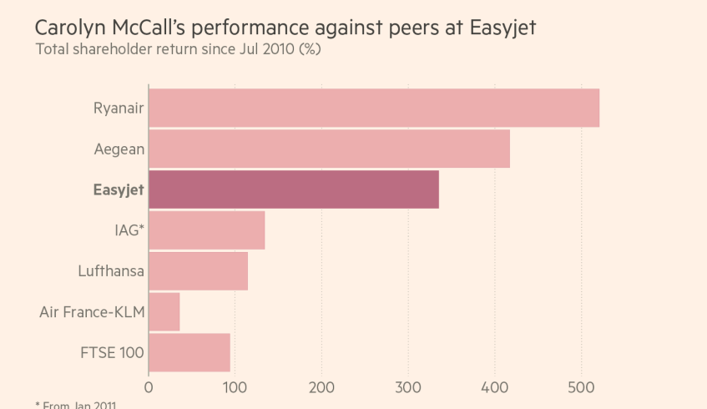
Firstly, looking at one of the 10 roles which is the monitor which is described in Mintzberg, H, “identifies the manager in seeking and receiving information to develop an understanding of the working of the organisation and its environment. Information may be received from internal or external sources, and may be formal or informal”. There is evidence of by what is mentioned in the article by Dina Medland “her six and half years as a CEO have included five years of record profits for the airline”. This shows in the first year and a half she was at the company she took information whether informal or formal to improve the company financially. There is evidence of this in an article online by Hollinger, P (2017) “easyJet’s share price has almost quadrupled from the opening price of 382p on the day she took over and the airline has moved into the FTSE 100.” The next example of this is when Dame McCall does an appearance interview for Forbes (2015) “firstly I did my diligence, I am a researcher by background. Anyone with a research background doesn’t go into anything without researching. I did loads of diligence I talk to loads of people”. This shows even before she agreed to take the job for EasyJet she did research to see how bad the company was doing and whether she could turn it around. Looking at Mullins, L (2016)” responsibility is the corollary of authority. Where authority is exercised responsibilities arises. The application of sanctions is good management, and is needed to encourage useful actions and to discourage their opposite”. This has happened by taking responsibility and creating profit by looking what was wrong and using authority and sanctioning what was needed.

Figurehead role
Figurehead “is the most basic and simple of managerial roles. The manager is a symbol and represents the organisation in matters of formality, participation as a social necessity and being available for people who insist on access to the ‘top’” Mintzberg, H ,Evidence of this is from a article by Dina Medland “ I have always supported and mentored woman and will always give the time to do so”. This shows a figurehead a role model, as to say that she will support women who get discriminated in every day work place.it also shows she is going to support them whilst working for the organisation, this a positive mentality which will help and support the women employees and in turn this will make the women employees work harder. She also goes on to say “ I am always looking for talent and the best person for the job” which is the article by Dina Medland. This also shows she is there for all employees, in turn this will make the employees feel important and in turn will work better and more efficient.

Leader Role
Leader according to Mintzberg, H “ is among the most significant of roles and permeates all activities of a manager. By virtue the authority vested in the manager, there is a responsibility for staffing and for the motivation and guidance of subordinates”. Quoting from Dina Medland’s article “ she took on the role with the task of boosting employee morale and focusing on customers.” This shows that she motivated by boosting the morale of employees to create a better working environment, which in turn means the customer service that was created from this made the company very investible as profits grew and eventually put the company into the FTSE top 100, also making the customer service better than BA. This is also mentioned in the article by Dina Medland “ We are better than BA for service at short haul”. This is a powerful message by Dame McCall to rival BA by providing better customer service than them. Another example of this is in the interview by Forbes (2015) “I spent my first six to eight months doing only two things, being in the operations every day, and getting the right people. Getting the right people in the right jobs, to lead the organisation”. This shows she is a leader as she was spending her first few months in the job its self, being hands on being responsible for staffing and guidance of the operations, in turn this how the company has become one of the best what they do and how efficient they do it.

Entrepreneurial role
According to Mintzberg, H “is a manager’s function to initiate and plan controlled change through exploiting opportunities or solving problems, taking action to improve the existing situation”. An example of this is in the article provided by Dina Medland “the way forward in communicating better with customers involves giving them information that is timely, she adds. A single encounter can make all that walking around worthwhile.” This shows by communicating with customers at the right time, with certain and useful information it changes the way company are viewed by potential customers. Which shows the entrepreneur experience coming out? Another example of this is from Forbes (2015) “so I asked to see the operations director, and the reason for that was I think you cant work for a highly operational company, and not know what’s going on operational. That was part of my diligence”. This shows she exploited a chance to have a meeting with the director of operations and took it to see what was going on a whole with the company. There is also glimpses of unity direction from Mullins, L (2016)” in order to provide for unity of action, co-ordination and focusing of effort, there should be one head and one plan for any group”. She went in to see what was happening and by the information she received from the ops director, she came out knowing she could do it which in turn had a plan and she stuck by it.
Disseminator Role
Disseminator is “involves the manager in transmitting external information through the liaison role into the organisation, and internal information through the leader role between the subordinates”, Mintzberg, H. “The information may be largely factual or main contain value judgements”. You can compare this to Mullins, L (2016) “ in any action an employee should receive from one superior only; if not, authority is undermined and disciplined, order and stability threatened”. This is shown also in the article by providing information such as “the easyJet CEO’s travels include meetings at management level, where the team numbers between 200 and 250 people across Europe. Management conferences are held twice a year”, this moves onto Dame McCall saying “ they could involve anything from customer data to digital innovation. I have lots of one-to-one meetings with the top 50 senior leadership executive team and I see them monthly as a group”. This shows that Dame McCall is always making sure that the company is running and keeping track to things as profit, company satisfaction but also if there are any problems, by having these meetings she is making sure she can resolve the issue for example if numbers of customers are down in France. She would work very close to the executive in France to get it back on track. But also looking at Mullins, L (2016) any action which in this case is meetings where employees receive order as in to show financial numbers, so she can use authority to stabilize what’s being threatened.

Spokesperson role
Spokesperson role “involves the manager as a formal authority in transmitting information to people outside the unit and the general public such as suppliers, customers, government departments and the press”, Mintzberg, H. There is proof of this in the interview with Forbes (2015), “ I had no idea operationally EasyJet was in the state it was in, I knew some of the issues that there were. I knew some of the corporate issues and shareholder”. This shows by doing the research she had done before going in she knew that a lot of things had to change and by speaking to suppliers, shareholders and so on that it was the only way to get the company back to how it was, in future making it better.

Resource Allocator
Mintzberg, H “Involves the manager in using formal authority to decide where effort will be expended, and making choices on the allocation of resources such as money, time, materials and staff”. Evidence of this is in the Forbes (2015), “ I parted company with the ops director and the commercial director within that 6 month period. And promoted two people so I promoted someone within to be the ops director, and I promoted someone within, I changed the commercial job to two people”. This shows that she gave tine to the original directors before deciding to part ways with them, this in turn gave an opportunity within the company its self to promote.

Conclusion
By looking at the essay it is very clear that Dame Carolyn McCall has proven to be a very good manager, there has been significant evidence to prove this in the essay. From looking at certain assets such as the 10 managerial roles and looking at most in detail from monitor to leadership, liaison and entrepreneurial aspects of what is needed from each part. Each one provides a backing evidence that she has gained experienced through years of working hard and climbing the ranks, she has gone on to make easy jet a more viable and profitable company for the future and build relationships to keep the company progressing with other organisations. Not only this but also created a positive effect by making the company one of the best in its category for customer service, this is down with the relationship between her and employees but also being a figurehead to women and she represents all employees and female CEO’s and how good women can be in the work place. Without these attributes she could not be looked at as a success in the managerial field but also a very influential female, also how inspiring she is to the females in the company.

Referencing
Forbes interview (2015) https://youtu.be/wMXXY09p5SA
Hollinger,P (2017) Carolyn McCall wins over critics in 7 years at easyJet, https://www.ft.com/content/985b8a82-6b05-11e7-bfeb-33fe0c5b7eaa
Medland, D, article given on moodle
Mintzberg, H, the managers job folklore and fact
Mullins, L (2016)

