
Stay at Home, Save Lives, Stay Safe?

The Opinions of Professionals Working in the Violence Against Women, Domestic Abuse and Sexual Violence (VAWDASV) Sector on how the Criminal Justice System Dealt with the Covid-19 Pandemic.

Katy Connelly
2114099
MA Criminal Justice and Policing

Contents
3 | Acknowledgements
4 | Abstract
5 | Chapter 1- Introduction
9 | Chapter 2- Literature Review
21 | Chapter 3- Research Methods
28 | Chapter 4- Results Analysis
42 | Chapter 5- Findings and Conclusion
47 | Chapter 6- References
53 | Appendix 1- Copy of Questionnaire
63 | Appendix 2- Copy of Welsh Women’s Aid Newsletter, dated 5th October 2022

Acknowledgements

I would like to take this opportunity to thank all those who completed my survey, as without them this project wouldn’t have been possible.
I would also like to thank my Mum and Dad and my wider family for their support in this process. Without their support or encouragement, I wouldn’t have had the push to begin the master’s qualification or the strength to finish it.
Finally, a huge thank you to my dissertation supervisor, Jane Thomas, who provided valuable advice throughout this process.

Abstract
This dissertation focuses on the opinions of professionals working in the violence against women, domestic abuse and sexual violence (VAWDASV) sector on how the criminal justice system dealt with the Covid-19 pandemic. In the year ending March 2021, Police recorded almost 1.5 million domestic abuse related incidents. Domestic abuse related crimes accounted for 18% of all police recorded crimes in the year ending March 2021 (ONS 2021).
The main research method for this project is online questionnaire using both open and closed questions. The main findings of this research are firstly that domestic abuse is still seen as high priority for the Police forces in England and Wales, however professionals have also recognised issues in relation to virtual court hearings and professionals also see the benefits of virtual multi-agency meetings.
The main conclusions are firstly, the policing response to domestic abuse has improved from prior to the pandemic, secondly, the demand for VAWDASV services in Wales has dramatically increased during the lockdown and finally, while virtual court hearings and multi-agency meetings had their problems at the start, professionals now see the benefits of the process.
This dissertation recommends further research into the effects of the increase of referrals on the well-being of staff working in the VAWDASV sector and to maintain virtual multi-agency meetings but to provide further networking opportunities in person.

Chapter 1- Introduction
This chapter provides the reader with background information on professional opinions of those working within the violence against women, domestic abuse and sexual violence sector on the performance of the criminal justice sector during the Covid-19 lockdown. The aims and focus of the research are discussed. The main research method is outlined, along with timescales for completion. The value of the research is also detailed.
Background
Covid-19 was first discovered in China in late 2019 and on the 11th March 2020, the virus outbreak was declared a Pandemic (WHO, 2022). Research indicates that there was an increase in domestic abuse rates throughout the lockdown (Panovska-Griffiths 2022). On the 23rd March 2020, the UK entered into the first of a series of lockdowns, followed by social distancing regulations which remained in place until July 2021 (IFG 2021).
Domestic abuse accounted for around 18% of all recorded police crimes for the year ending March 2021 (ONS 2021) and research has noted that there was an increase of domestic abuse throughout the year 2020-2021 (ONS 2021).
However, this increase of domestic abuse isn’t reflected in the number of prosecutions, as for the first quarter of 2020-2021, there was a 3% decrease in successful prosecutions (CPS 2022).
Evidence also shows that the demand for accessing VAWDASV services has increased, with different studies reporting anywhere between a 25% and 700% increase in the number of demands for service within a 24-hour period than compared with the same 24-hour period prior to lockdown (Speed et al 2020). As a result, this increase in demand meant that VAWDASV services are “more crucial than ever” (Van Gelder at al 2021), however a number of funding cuts (Speed et al 2020) lead to domestic abuse staff being over-worked and under-resourced (Lyenger and Sabik 2009, cited in Slakoff, Aujla and PenzeyMoog 2020).
Since the first national lockdown, the UK Government introduced a new act, The Domestic Abuse Act (2021) which has brought in extra protections for victims of domestic abuse (Home Office 2022).

Research Focus
There is much debate regarding the levels of domestic abuse during the lockdown between March 2020 and March 2021, which includes the Police arrest and prosecution figures and whether this matches the demand for VAWDASV services, for example there was a slight decrease in the number of prosecutions for the first quarter of 2020-2021 (ONS 2021) but certain VAWDASV services had up to a 700% increase in demand during lockdown (Speed et al 2020).
Research also indicates that the new way of hearing cases in the criminal and family courts, which is virtually, either by telephone or using virtual conferencing software and while these hearings were seen as easier on professionals (Valchev 2020), however research shows that some victims didn’t have the right equipment to join these calls (Speed et al 2020) and research has indicated that victims found some virtual hearings upsetting (Harker and Ryan 2022).
Research over the years has also focussed on the benefits of multi-agency meetings, specifically MARAC for the protection of victims of domestic abuse and since the pandemic, these meetings have been held virtually and as a result meetings had increased attendance; however, some researchers believe that MARAC has now become a tick box exercise rather that a constructive meeting (Davis 2015).
Therefore, this dissertation will focus upon five different areas within the criminal justice system starting with the definitions of domestic abuse, Police and CPS figures, demand for VAWDASV services, virtual court hearings and virtual MARAC meetings.

Overall Research Aim and Individual Research Objectives
The overall aim of this project is to find out the opinions of professionals working in the VAWDASV sector on how the criminal justice system dealt with the covid-19 pandemic.
The main objectives for this project are as follows:
- Explore the different definitions of violence against women, domestic abuse and sexual violence (VAWDASV) and evaluate whether the VAWDASV Act (Wales, 2015) and the Domestic abuse bill (England and Wales, 2020) does enough to protect victims of domestic abuse.
- Compare and contrast police arrests and CPS charging figures for domestic abuse related crimes between March 2020 and March 2021.
- Analyse the demand for VAWDASV services in England and Wales since March 2020.
- Evaluate the effectiveness of video conferencing and remote court hearings for VAWDASV cases in the criminal and family courts since March 2020.
- Evaluate the future benefits of video conferencing for VAWDASV cases, MARAC and other multi-agency partnerships within the criminal justice system.
It is important to understand the definitions of domestic abuse and the protections that the domestic abuse laws in the UK and Wales provides to those who are victims of domestic abuse before discussing police arrest rates and CPS charging figures. It is also important to discuss whether the demand for VAWDASV services matches police arrest figures and to consider the impact that the workload as a result of the pandemic has had on support workers. It is also important to understand that virtual court hearings and virtual multi-agency meetings were brought in as a protective factor during the lockdown and these have remained so evaluating whether staff feel the virtual meetings are beneficial.

Research Methods and Timescales
This research will start with a review of literature in relation to all objectives, but specifically in relation to objectives one and two. The literature will mainly comprise of journal articles, official statistical data and websites.
For objectives, 3, 4 and 5, the research will start with a review of the literature. The main research will be conducted by online questionnaire. Questionnaires are simply a list or series of questions for a respondent to answer (Simply Psychology 2018). This questionnaire will be administered by Google Forms and will contain mainly closed questions where respondents will be asked to give a rating but will be followed by an open question to plug the gaps left by the closed questions (Open University 2021). The respondents will be professionals working in the VAWDASV sector, who will be self-identified.
By using a combination of literature, qualitative and quantitative data for this project a true picture of the level of demand that was placed on the VAWDASV in comparison with police arrests and CPS data will emerge, along with professionals’ true opinions of whether virtual court hearings and virtual multi-agency meetings are beneficial to their service.
The table below shows the full timescale for the completion of the project from the submission of the proposal right to the final submission date.
June- July 2022 | Submit research proposal
July 2022 | Prepare literature review
August 2022 | Prepare methodology chapter, prepare online questionnaire
September 2022 | Distribute questionnaire, 4-week turnaround
October 2022 | Submit analysis of results and findings and conclusion
25th November 2022 | Final Submission deadline

For full details on the research methods used and the sampling techniques, please refer to the research methods chapter.
Value of this research
This research will benefit the academic research community by contributing to the field of domestic abuse during the Covid-19 pandemic. The results of the questionnaire and literature review can be used to influence further work, particularly in relation to the well-being of staff working in the VAWDASV sector. This research also indicates the benefits of virtual multi-agency meetings and court hearings.
The outcome and results cannot be generalised, despite the results being focused within the South Wales Police area, however, the results from the online questionnaire and literature review can act as a focus to inform managers of VAWDASV services about the experiences of staff working in the sector to influence the well-being activities provided to staff.
This research has added benefits to influence further research in regard to the perceived benefits of virtual multi-agency meetings within the criminal justice sector. Also, more research can be conducted related to the benefit of virtual court hearings on victims of domestic abuse.
This work will raise the profile of the VAWDASV sector, The VAWDASV sector during the pandemic was “more crucial than ever” (Bradbury-Jones and Isham 2020, Van Gelder et al 2021). These services have been chronically under resourced (Iyenger and Sabik 2009, cited in Slakoff, Aujla and PenzeyMoog 2020). Speed et al (2020) also note that Idependent Domestic Violence Advisors and Independent Sexual Violence advisors are key partners within the criminal justice system.

Outline Structure
Chapter 1- Introduction
This chapter provides background information on the impact of Covid-19 on domestic abuse. Including a discussion relating to the benefits of the new Domestic Abuse Act (2021) The focus of this research is discussed, along with the research aim and overall objectives. Research methods and timescales are also outlined.
Chapter 2- Literature Review
This chapter firstly defines domestic abuse, then discusses police arrest rates and CPS charging figures. This chapter analyses the demand for VAWDASV services and evaluates the effectiveness and benefits of virtual court hearings and multi-agency meetings. The information provided will justify the need for empirical research in this area.
Chapter 3- Research Methods
This chapter discusses and justifies the chosen research strategy, of online questionnaires. This chapter also discusses the sampling techniques, along with a framework of how the results will be analysed. This chapter also outlines limitations and potential problems.
Chapter 4- Results
This chapter reports on the findings from the questionnaire provided to professionals. The results will be analysed based on themes based on the objectives. Results are also analysed against each other and synthesised with the results from the literature review.
Chapter 5- Conclusion
This chapter revisits the overall aim and objectives of this project. The findings are summarised, and conclusions are drawn from linking the research to the literature. Based upon the conclusions, recommendations for further research are made.
Chapter 6- References
This chapter contains an alphabetical list of sources used in this research. The Havard referencing system is used throughout.

Chapter 2- Literature Review
Introduction
Covid-19 was first discovered in Wuhan, China in December 2019 when several cases of pneumonia and other flu-like illnesses were linked to a local market (WHO, 2021). On the 23rd of March 2020, cases of Covid-19 lead to a series of lockdowns and stay at home orders by the UK government which required everyone to stay at home and only leave for several essential activities such as work, medical appointments and essential shopping only. However, from July 2020, the UK announced local lockdowns, meaning that people were unable to leave their counties, following that, England and Wales entered a short lockdown in late autumn of 4 weeks and 17 days respectively. In Wales, the UK entered another full lockdown on the 19th of December, with England following suit on the 6th of January 2021. Restrictions on personal contact remained in place until July 2021 (IFG 2021).
In the UK, there has been almost 23 million cases of Covid-19 (UKHSA, 2022), Krishnadas and Hayat Taha (2020) estimates that Covid-19 led to over 40,000 deaths in 2020, in 2022, the number of deaths in relation to covid-19 is over 180,000 in the UK (Worldometer, 2022).
Muldoon et al (2021) notes that the World Health Organisation categorised the covid-19 outbreak as a global pandemic on the 11^{th of} March 2020 and referred to a report made by the United Nations which said that as a result of lockdown measures, the levels of domestic abuse may increase. However, despite lockdown restrictions the UK government allowed victims of domestic abuse to travel and leave isolation in order to escape domestic abuse (Home Office, 2020 cited in Krishnadas and Hayat Taha 2020), However, Carillo (2021) disagrees, and found many countries across the world were imposing fines on victims who were caught breaking lockdown laws in order to escape domestic abuse.
Walklate et al (2022 c.) notes that domestic abuse can have a huge impact on the health and well-being of victims of domestic abuse, which “can be exacerbated by poor policing and criminal justice responses” and as a result covid-19 can increase the levels of male violence experienced by women and children. However, it is worth noting that several studies also point out that a similar trend of increased rates of domestic violence happen during a crisis or natural disaster such as during a recession or weather event such as hurricane (Kourti et al, 2021).
Krishnadas and Hayat Taha (2020) cite that the World Health Organization categorised Covid-19 “as a global crisis, demanding a global response activated through public health, legal, economic and social interventions” and mentions that while many women and girls will remain safe from the virus during a lockdown situation, they will not be kept safe from violence and abuse which has led to Walklate et al (2022 b.) mentioning that the United Nations have now named the increase of domestic abuse during covid-19 lockdowns as the ‘shadow pandemic’. The ‘shadow pandemic’ has been seen worldwide in both strong and weaker economies (Kourti et al 2021).
In the UK, for the year ending March 2020, it was estimated that 2.3 million people experienced some form of domestic abuse, with 1.6 million of those being female (Home office 2022). Hopkins and Assami (2021) note that approximately 11% of women and 5% of men are victims of domestic abuse in any given year in Wales.
UN Women (n.d.) estimates that one in three women have experienced violence perpetrated by an intimate partner. Storey and Strand (2017) support this figure by suggesting that 30% of women worldwide have experience some form of IPV. Hopkins and Assami (2021) discredit this figure and suggest that the percentage of women who have experienced some form of domestic abuse and other forms of violence against women is around 35%.
It is also estimated that two women every week are killed by their current or former partner, this number has stayed stagnant for many years (Krishnadas and Hayat Taha 2020) however early indications show that in the UK and worldwide, there has been an increase in the number of domestic homicides (Bradbury-Jones & Isham, 2020). Statistics show that the home is the most dangerous place for women as almost 60% of female homicide victims are killed by their current or former partner (UNODC 2018 cited in Carrillo 2021).
This is supported by the Office for National Statistics data (2020) which says that there were 64 homicides in the first six months of the year, of which 30 occurred between April and June. However, the Home Office (2022) report that between April 2020 and March 2021, there were 114 deaths from domestic abuse, of which 75 were female.
Hopkins and Assami (2021) note that domestic abuse and violence against women is very costly to societies and estimates that the cost is up to 4% of the gross domestic product for many countries and in England and Wales, alone, domestic abuse is said to have cost over £66 billion in costs to the health service, social care and legal services.

Objective 1: ‘Explore the different definitions of violence against women, domestic abuse and sexual violence (VAWDASV) and evaluate whether the VAWDASV Act (Wales, 2015) and the Domestic abuse bill (England and Wales, 2020) does enough to protect victims of domestic abuse’.
Domestic abuse can be defined as “Any incident or pattern of incidents of controlling, coercive or threatening behaviour, violence or abuse between those aged 16 or over who are or have been intimate partners or family members regardless of gender or sexuality” (Home office, 2013) This definition also encompasses five types of abuse which include physical, psychological, sexual, emotional and financial abuse and the definition also included coercive and controlling behaviour. However, this definition has been expanded which now recognises that people 16 or under can now be victims of domestic abuse (Home Office 2022).
However, the Home Office (2013) definition of domestic abuse encompasses all genders and sexualities the World Health Organisation recognises the definition of violence against women which is "any act of gender-based violence that results in, or is likely to result in, physical, sexual, or mental harm or suffering to women, including threats of such acts, coercion or arbitrary deprivation of liberty, whether occurring in public or in private life." (WHO, 2022). This is also known as gender-based violence, and the United Nations High Commissioner for Refugees argues that domestic abuse and all other forms of violence against women is a “serious violation of human rights” (UNHCR, 2021).
Bradbury-Jones and Isham (2020) suggest that domestic abuse is a broad term with the most common type of domestic abuse being intimate partner violence (IPV). Glowacz, Dziewa and Schmits (2022) points out that “one of the most frequent forms of IPV in western societies is psychological”.
Coercive control is a form of domestic abuse and a form of psychological abuse, Slakoff, Aujla and PenzeyMoog (2020) define coercive control by using Stark (2007) which is “coervice control [is] a pattern of behaviour- including violence, intimidation, threats, isolation and controlling tactics that has negative long term impacts on victims”. Coercive control became a criminal offence in the UK in 2015 (Home Office 2022).
The World Health Organisation definition of gender based violence is also used by Speed et al (2020) who note that gender based violence encompasses “domestic abuse, sexual violence, forced marriage, female genital mutilation, stalking, honour based violence and abuse and human trafficking”. Speed et al (2020) also note that this can also be known as violence against women and girls (VAWG) as females are more likely to be victims of abuse and males are more likely to be the perpetrator and more likely to cause a serious injury (Storey and Strand 2017).
In Wales, the first piece of legislation with the idea to protect the public, especially women, from domestic abuse is the Violence against Women, Domestic abuse and Sexual Violence Act (VAWDASV) (2015) It was created with the aim of eradicating all forms of violence against women and domestic abuse in Wales (Welsh Government 2022) and while the VAWDASV (2015) act notes the Home Office (2013) definition of domestic abuse, it notes further components of violence against women, which includes sexual violence, so called ‘honour based violence’, sexual exploitation, forced marriage, female genital mutilation and stalking (Price et al 2020).
While the VAWDASV (2015) Act was ground-breaking and the first of it’s kind in the UK, it only applied to those areas that were devolved as part of the Welsh Government and the criminal justice system isn’t part of devolution (Price et al 2020, Jurasz 2018).
Krishnadas and Hayat Taha (2020) discuss domestic abuse in a historcial context and mentions that while the United Nations recognised discrimination against women in 1979, it took until 1993 for domestic abuse to be recognised as a violation of human rights. The UK adopted the UN Violence against women and children agenda in 1993, however, almost 30 years later, the UK finally adopted legislation in the form of the Domestic abuse Bill (Krishnadas and Hayat Taha, 2020).
The Domestic Abuse Act (2021) was created in order to “improve the effectiveness of the justice system in providing protection for victims of domestic abuse and bringing perpetrators to justice” (Home Office 2021), This act applies to the UK, however some parts of the act are applicable to England only, England and Wales and provides extra provisions in the criminal courts in Scotland and Northern Ireland (Home Office 2021).
The Domestic Abuse Act (2021) also brought in a new defintion of domestic abuse which is “Behaviour of a person (A) towards another person (B) is domestic abuse if A and B are aged 16 or over and are personally connected to each other and the behaviour is abusive” The domestic abuse act (2021) defines abusive behaviour if it includes physical or sexual abuse, coercive or controlling behaviour, psychological or emotional abuse, violent or threatening behaviour and/or economic abuse.
The Domestic Abuse Act (2021) provides extra protections for victims of domestic abuse which includes the introduction of the Domestic Abuse Protection Notices and Orders which replace the current Domestic Violence Protection Notices and Orders and also introduces a new offence of non-fatal strangulation (Home office 2022), however this bill has been criticised for not including extra protections for migrant women or those women who have offended as a direct result of domestic abuse (CWJ 2021).

Objective 2: Compare and contrast police arrests and CPS charging figures for domestic abuse related crimes between March 2020 and March 2021.
Walklate et al (2022 b.) notes that during lockdown, there was an overall decrease in crime and as a result this meant an increase in availability of police resource which allowed for extra efforts in dealing with exisiting levels of domestic abuse and as a result allowed an increase in cases referred to the Crown Prosecution service and and increase in the charging rates for perpetrators of domestic abuse. This increased availability of police resource was largely in part due to the restrictions placed on the night-time economy, which freed up many front line police officers (Walklate et al 2022 b.).
However, Walklate et al (2022 b.)’s study isn’t supported by Crown Prosecution service (2022) data, as data relating to quarter one in the year 2020/2021 suggests that there was almost a 3% decrease in charing perpetrators of domestic abuse, however, when compared to all crimes, which had an almost 4.5% drop in prosecutions, however in Quarter 2 there was over a 75% increase in the number of successful prosecutions for domestic abuse related crimes.
Leslie and Wilson (2020, cited in Walklate et al 2022 c.) cite a study in the USA which states that since the pandemic started, calls to the police for domestic abuse related crimes rose by 10%, however it was noted that these were calls made by families that have a prior history of domestic abuse. This study is supported by the Office for National Statistics (2020) who say that the number of calls relating to domestic abuse increased by around 12% for the London Metropolitan Police Force, however it is noted that during this period, many of the calls came from concerned third parties while the number of calls from victims themselves either remained stable or decreased slightly from the year before.
Walklate et al’s (2022 c.) own research suggests that the number of calls to the police in the UK “declined initially in March [but] returned to normal by May”. The ONS (Office for National Statistics) (2020) state that during lockdown there was an initial increase in domestic abuse related crimes and supports this through the number of arrests which had a 14% increase between 1st April and 30th June 2020 when compared with the same period the year previous. This figure is likely to be higher as the percentage has only been given from 38 forces across the UK who could supply data for both periods.
Walklate et al (2022 c.) mentions that domestic abuse was once “not seen as real police work”, however Krishnadas and Hayat Taha (2020) point out that domestic violence has been dealt with through a criminal justice lens however Walklate et al (2022 c.) mentions while the criminal justice response to domestic abuse has improved throughout the last few years there has been a varying response to how domestic abuse has been dealt with force by force.
Walklate et al (2022 c.) believes that police forces are now using Domestic Violence Protection orders (DVPO’s) instead of powers of arrest. This can be termed as “justice by geography” (MaClenagan 2018, cited in Walklate et al 2022 c.). This has been supported by HMICFRS (2021) who stated that many forces in England and Wales increased the number of applications for DVPO’s which were prioritised through the courts, however noted that initially during lockdown the number of arrests increased.
HMICFRS (2022) noted that South Wales Police are not using the Domestic Violence Disclosure scheme properly, as three quarters of pending applications for the scheme had passed the recommended 42-day completion window.
HMICFRS (2021) noted that one victim they surveyed noted that the police response in 2020 was much more helpful and beneficial to the response that she had received five years previously.
In relation to the Crown Prosecution service, Speed et al (2020) note that all high-risk cases of domestic abuse should receive an immediate charging decision and a form of protective measure such as bail or remand. However, this is not strictly true as the Crown Prosecution service (2022) data from Quarter 4 2020-2021, shows that it takes around 18 days from the first submission of information by the police to the charging decision, however this is around half of the time (36.5 days) when you consider the time taken for all other crimes. Prior to the pandemic the average charging decision took 9 days.
Hopkins and Assami (2021) report that in Wales, police recorded domestic abuse crimes had decreased during the lockdown period compared to the previous year, however police recorded data should be viewed with caution as this is likely only a very small part of reality, many victims are unlikely to come forward through fear of discrimination (Gqola 2015, cited in Kourti et al 2021). Another potential reason for the decrease in police reported crimes during lockdown is that the situation forced both victims and perpetrators together with perpetrators monitoring the victims every action (Piquero et al, van Gelder et al 2020 cited in Kourti et al 2021).
HMICFRS (2021) examined how police were dealing with victims of domestic abuse and found that two forces in England were pro-active in contacting victims of domestic abuse with welfare calls and had positive feedback from those contacted.

Objective 3: Analyse the demand for VAWDASV services in England and Wales since March 2020.
UN Women, (n.d.) mentions that since the outbreak of covid-19 calls to emergency domestic abuse helplines have increased however note that funding for these vital services were diverted to other urgent services such as health in order to assist with the covid-19 response.
Piquero et al (2020 cited in Walklate et al 2022 c.) also reported that calls to a domestic abuse helpline in the USA initially reported an increase in calls.
Bradbury-Jones and Isham (2020) also note that “calls to the UK Domestic abuse helpline increased by 25%”. However the Office for National Statistics also reports on the UK domestic abuse helpline, managed by charity, Refuge reported “a 65% increase in the number of calls compared with the first three months of 2020”, it is worth noting that the ONS (2020) report that in Wales the number of calls to the Wales Domestic abuse helpline (The Live Fear Free Helpline) had an almost 20% decrease between April and June 2020, but reported an increase in communications through alternative means such as email, webchat and text messaging. However these figures vary heavily with one study reporting an increase of demand of between 25% and 700% in one 24 hour period compared with the a similar day before lockdown (Speed, et al., 2020).
Speed et al (2020) also note that the Independent domestic violence and Independent sexual violence advisors are key players in the criminal justice system to support victims of abuse.
van Gelder, et al., (2021) point out that “little is known about the impact of the pandemic on DVA (Domestic violence and abuse) professionals”, however mentions that the local domestic abuse service in the Netherlands did not receive an increased number of reports, despite concerns of a rise in cases. This decrease in cases is supported by Panovska-Griffiths, et al., (2022) who suggested that referrals to the Identification and Referral to Improve Safety Domestic Violence and Abuse programme (IRIS DVA) was down by almost 30% compared to the year previously. IRIS is a programme commissioned by IRISi, a social enterprise that has almost 50 sites across England and Wales that train General Practices, however this decrease can simply be explained by the difficulty in disclosing domestic abuse through a telephone consultation in the presence of a potential perpetrator and children. (Panovska-Griffiths, et al., 2022).
Bradbury-Jones and Isham (2020) alo share the concern of van Gelder et al (2021) by suggesting that voluntary services that support victims of domestic abuse are “more crucial than ever” (Bradbury-Jones and Isham 2020) as these services often support victims who may have had a bad experience with the criminal justice system in the past. Slakoff, Aujla and PenzeyMoog (2020) note that domestic abuse service staff, even before lockdown, were over-worked and under-resourced (Iyenger and Sabik 2009, cited in Slakoff, Aujla and PenzeyMoog 2020). In order to support domestic abuse services, the Home Office announced in May 2020 that it was giving support services for domestic abuse and sexual violence over £27 million, this figure also included support provided to national helplines (Home Office 2022).
The Office for National Statistics (2020) note one study conducted by Women’s Aid England noted that domestic abuse support services in England noted a 58% and an 80% increase in demand for refuge and community services respectively and up to three quarters of services who responded expected a further increase in demand within 6 months to a year post-lockdown.
On the contrary, The Office of National Statistics (2020) reported a study by Welsh Women’s Aid who reported that domestic abuse services in Wales, reported a decrease in demand for refuge accommodation during the first few months of lockdown, however noted that there were difficulties experienced by these services such as sourcing additional personal protective equipment for staff. Speed et al (2020) supported this by suggesting that approximately a quarter of refuges in their study had reduced the number of available beds for victims fleeing abuse and also noted that there had been several cuts to funding throughout the UK and as a result the number of available beds falls below the recommeded number provided by the council for Europe. Hopkins and Assami (2021) note another barrier for women seeking refuge, and suggested that large numbers of women are being turned away from refuges because they are unable to speak English. In order to counteract the lack of referrals, Slakoff, Aujla and PenzeyMoog (2020) note that several domestic abuse services in several countries were using vacant hotels in order to house victims of domestic abuse, this method was favourable for those victims who had to leave home while testing positive for covid-19.
However, the ONS (2020) noted that there was a large demand for community based services during this time as there was “a 41% increase in the numbers of survivors supported, a 59% increase in the number of new referrals and a 143% increase in the number of survivors on the waiting list”.
This is supported by Welsh Women’s Aid data provided to ONS (2022), where the total number of referrals for community based services in Wales, was almost 23,500 between April 2020 and March 2021. There was a significant decrease to just over 16,000 referrals the following year (April 2021 to March 2022).
Speed et al (2020) and Slakoff, Aujla and PenzeyMoog (2020) discuss domestic abuse support services and note that there was an unprecedented demand for services and notes that Refuge saw between a 25% and 700% increase in contacts on any given day during lockdown restrictions.
Kelly (2008 cited in Speed et al 2020) remarks that organisations supporting victims of abuse should be key partners to support statutory agencies such as the criminal justice system.

Objective 4: ‘Evaluate the effectiveness of video conferencing and remote court hearings for VAWDASV cases in the criminal and family courts since March 2020’.
Rossner (2021) discusses that remote hearings in the courts wasn’t just brought in as a response to the covid-19 pandemic as an electronic client management system was introduced for case management and work has been started to enable video conferencing for remand prisoners to access hearings remotely and trials had begun in 2019 for a select number of hearings in the family courts. However, Valchev (2020) notes that in the USA, as far back as the late 1990’s schemes to introduce technology in courts had begun which included facilities for videoconferencing.
From the 23rd of March 2020, all jury trials were suspended in England and Wales which led to the closure of many court buildings (House of Lords, 2021). This meant that either cases were suspended or discussed remotely (Court of Protection 2020).
However, in relation to the Criminal Courts, Godfrey et al (2022) noted that, almost 160 court buildings were kept open and fully operational with social distancing for urgent and essential hearings and another 124 buildings were closed to the public to support video or telephone conferencing.
Speed et al (2020) notes that the emergency legislation passed due to covid-19, allowed the use of telephone and virtual court hearings, however pointed out that this could provide some difficulty for victims who do not have the right equipment to connect to the hearings. However, HMICFRS (2021) note that remote court hearings for DVPO’s were deemed more efficient than in-person hearings. HMCPSI (2021) suggests that the remote court hearings will ease some of the challenges vulnerable witnesses face when attending a court hearing.
However, Harker and Ryan (2022) noted that while remote hearings were more efficient, victims of domestic abuse found some hearings upsetting. Valchev (2020) also supports the efficiency that videoconferencing in the criminal courts brings, by suggesting videoconferencing can “result in reduced travel time, more efficient use of judges’ time, scheduling flexibility and better accommodations for participants who are ill or cannot travel” (Valchev 2020).
Speed et al (2020) noted that many victims of abuse struggled to access and navigate the remote and electronic court system, however as victims of abuse could be seen as vulnerable, their cases in the courts were often prioritised and fast-tracked. Godfrey et al, (2022) note that while domestic abuse related crimes weren’t being prioritised through the criminal courts during the lockdowns, applications for domestic violence protection orders (DVPO’s) were seen as priority one by the HMCTS.
Harker and Ryan (2022) write that throughout England and Wales, there is a variation on the type of technology (either telephone call or video calls) used in family court hearings and is often the preference of the judge.
Speed et al (2020) also discuss cases in the crown courts and suggest that as a result of the suspension of jury trials, the waiting times in the crown court could get to over 6 months. With some cases being listed for hearing in 2023 (HMCPSI 2021). However, House of Lords (2021) note that prior to the pandemic the waiting time for a jury trial in the crown court had reached 32 weeks and the pandemic had only added 17,000 cases to almost 40,000 outstanding cases waiting for trials in the crown court. However, a report by the House of Commons found that a number of the most serious sexual offences were waiting over a year to be heard at Crown Court (House of Commons, 2022).
Prior to the pandemic, victims of domestic abuse who attended court were allowed to apply for ‘special measures’. Special measures include the use of screens, separate waiting areas and video link technology (Citizens Advice bureau, 2022). However, as a result of the new Domestic Abuse Bill, the criminal justice system and the family court system will be made easier for victims and survivors to navigate and access support from trained professionals, make it easier for victims attending court to access special measures and will ensure that victims of domestic abuse cannot be cross examined by their perpetrators in the family courts (Home Office 2022). The House of Commons (2022) report found that one third of people who applied for special measures and other accommodations in the court, had the requests denied.

Objective 5: ‘Evaluate the future benefits of video conferencing for VAWDASV cases, MARAC and other multi-agency partnerships within the criminal justice system’.
Walklate et al (2021 a.) studied the response to multi-agency risk assessment conferences (MARAC’s). the purpose of a MARAC is to share information about high-risk victims of domestic abuse in a multi-agency setting. The agencies in attendance include statutory agencies such as police and probation and non-statutory agencies such as domestic abuse services (Safelives, 2015).
A MARAC only discusses high risk victims of domestic abuse, that have been referred to the MARAC process by several key agencies which include police, health services, probation, domestic abuse support services and housing (SafeLives 2015). In order to establish whether a victim is high risk a DASH-RIC (Domestic Abuse, Stalking and Honour-based violence- Risk Indicator checklist) is completed, there are 24 questions on the form, and once the threshold of 14 yes ticks has been reached, it will be referred into the MARAC process (SafeLives 2014).
There are currently over 270 MARAC’s operating across the UK (Safelives, 2015). Some MARACs in Wales had trialled conference calls prior to the pandemic which focused on the lower-risk victims, however evidence found that these calls weren’t effective, and many had been discontinued. (Price et al 2020)
The ONS (2020) notes that the pattern for the number of cases discussed at MARACs has steadily been increasing year on year, however for the first quarter of 2020, there was a decrease in the numbers discussed which coincided with the first few weeks of lockdown (SafeLives 2020).
HMICFRS (2021) point out that the recommended number of MARAC cases per 10,000 adult females should be 40 per 10,000 female adults with the average for all MARAC’s is around 49 cases per 10,000 adult females (Safelives 2022), however, for the South Wales police force area there are 99 MARAC cases per 10,000 adult females and that there are more than double the number of cases discussed in the South Wales Police force area than was recommended. (Safelives 2022). Nonetheless, SafeLives (2022) also reports that around 10% of cases discussed at MARAC had male victims.
HMICFRS (2022) noted that prior to the pandemic, South Wales police were having daily MARAC meetings, however in late 2021 stopped this practice in order to best manage the demand. HMICFRS (2022) also made the recommendation South Wales Police for South Wales Police to investigate local trends as to why there are a number of high-risk victims in the force area.
While there are benefits to multi-agency working such as improved information sharing, accountability of services involved and the creation or targeted safety and action plans, it could also be noted that many areas now see MARAC as a tick box exercise and a way to reduce liability rather than a constructive intervention (Davis 2015).
The ONS (2020) also notes that while MARACs had moved to online meetings, there was no change in the frequency of meetings. However, Walklate et al (2021 a.) mentions that MARACs throughout England and Wales had to increase the frequency of meetings held in order to cope with the demand, however, discusses that the frequency varies between forces from “quarterly, monthly, fortnightly to daily”, however argues that this has now made MARAC’s more efficient and allows for a more adaptive safety plan for victims.
Walklate et al (2021 a.) noted that since lockdown, police forces moved MARAC meetings to an online video platform and the police forces studied expect that online meetings will remain, which is also supported by Walklate et al (2022 c.) who suggested that “video conferencing would remain the way in which this aspect of their domestic abuse work would be conducted in the future”.
This is supported by Brown and Fleming (2022) who studied police officers, and many respondents wanted virtual meetings to remain and suggested that the use of video conferencing saved time waiting for interpreters. HMICFRS, (2021) noted that virtual MARAC’s that were conducted by video conference “were better attended and more easily arranged, which in turn supported the ability to keep victims safe.”
Driscoll et al (2020) examine innovations in multi-agency working by citing Baginsky and Manthorpe (2020) who suggested that representatives were more likely to attend meetings when it was virtual especially meetings that were arranged at short notice and allowed General Practitioners to attend, when previously, they were unable to take time out of their clinics. (Baginsky and Manthorpe 2020 cited in Driscoll et al 2020).
However, Safelives (2020) reported that around 30% of MARACs that responded to a survey distributed by Safelives during the first three months of lockdown weren’t holding the meetings online, instead had opted for a reduced and socially distanced attendance, some even without an IDVA, who acts as the victim’s voice during the process. Many of the responses highlighted IT issues as one of the reasons why online meetings weren’t going ahead (Safelives 2020).

Chapter 3- Research Methods
Introduction
This chapter discusses and justifies the chosen research strategy of online questionnaires in the collection of data for the purpose of this study. Details of the sample and where they will be sourced is provided within this chapter, together with the framework for the analysis of mainly quantitative data provided by the sample, but also discuss how the small amount of qualitative data will be analysed. The limitations and potential hurdles of this research and the research method is discussed in relation to the reliability and validity of the research but also discusses potential problems of surveying professionals working within the violence against women, domestic abuse and sexual violence sector.
The literature review identified five different objectives for the research which are:
- Explore the different definitions of violence against women, domestic abuse and sexual violence (VAWDASV) and evaluate whether the VAWDASV Act (Wales, 2015) and the Domestic abuse bill (England and Wales, 2020) does enough to protect victims of domestic abuse.
- Compare and contrast police arrests and CPS charging figures for domestic abuse related crimes between March 2020 and March 2021.
- Analyse the demand for VAWDASV services in England and Wales since March 2020.
- Evaluate the effectiveness of video conferencing and remote court hearings for VAWDASV cases in the criminal and family courts since March 2020.
- Evaluate the future benefits of video conferencing for VAWDASV cases, MARAC and other multi-agency partnerships within the criminal justice system.
These objectives then highlighted the need to survey professionals who have previously worked or are currently working in the violence against women, domestic abuse and sexual violence sector. The main focus of the research will involve objective 3, 4 and 5.
This chapter will provide details on the main research strategy used to collect data in this project, including information relating to google forms, which is how the data will be collected. This chapter will also discuss the sample, which includes the intended sample size and where the sample will be derived from. This chapter will also discuss any potential limitations and hurdles and will explain how these can be mitigated.
By surveying professionals working in the violence against women, domestic abuse and sexual violence sector, this will allow for true comparisons between the literature analysed and ‘real life’. This research will allow for a better understanding of the opinions of those supporting vulnerable victims of domestic abuse through the criminal justice system on the effectiveness of criminal justice system before, during and after the Covid-19 pandemic as the criminal justice system implemented changes in order to comply with social distancing and related legislation.
In discussing research methods in a methodical, transparent, and methodical way, means that another researcher can easily repeat the study in another area of the UK and thus test the reliability and validity of the research.

Research Strategy
The chosen method for this research is online questionnaires. Questionnaires can be defined as a list or series of questions for a respondent to answer which can be carried out by telephone, face to face, by post or online (Simply Psychology 2018). The questionnaire will be self-completion and will be administered online using Google Forms.
The questionnaire will contain several closed questions with multi-choice answer and open questions. The advantage of closed questions means that they are easier to analyse but have limited answers, however, open questions can also help to plug any gaps left by the closed questions (Open University 2021).

Questionnaires meets the objectives of this project because they can be administered online, Jones et al (2008) highlight the advantages of using online or web questionnaires which include “the mainly low cost of data collection and processing” as they are designed to reach a large audience very quickly and can also be made user friendly however Jones et al (2008) also note that there are several disadvantages to online questionnaires including a historically lower response rate compared to paper and postal surveys, also Jones et al (2008) also highlights that the survey may come to the attention of those who are outside the target audience and there is no way to determine that the answers are legitimate.
Chapman and McNeill (2005) note another advantage of questionnaires, which include that the influence of the researcher is minimal, and questionnaires are highly reliable, meaning that the study can be repeated and achieve similar results. Chapman and McNeill (2005) also point out the main advantage of questionnaires which is that questionnaires can produce a large amount of statistical information very quickly at relatively low cost. Chapman and McNeill (2005) argue that the statistical information provided by surveys “gives us little insight into how people see and understand their lives”, however this project will mitigate this by using several open questions and text boxes which allows the respondents opportunity to explain their answer.

Semi-Structured interviews were originally considered to achieve the aims and objectives of the project. Semi-structured interviews involve a list of questions which are asked to each respondent, but additional questions can be asked where appropriate (Open University 2021).
Kuter and Yilmaz (2001) suggests that interviews can be a very personal way of gathering information, which means that anonymity or confidentiality cannot be guaranteed, however also note that interviews can also be time consuming as interviews can include a ‘warm-up’ discussing the purpose of the research and conversations that go off-topic.
Bloch, Phellas and Seale (2011) also discuss some disadvantages of interviews, and mention that there is usually a cost involve with interviews, whether this is for room hire or compensating the interviewee for their travel or time. Also, Bloch, Phellas and Seale (2011) note that interviews can introduce researcher bias, which might not be present with questionnaires, researcher bias is the term given to the responses where the interviewee will give a socially desirable answer based upon the behaviour and mannerisms of the interviewer.

Data Collection
The respondents for this project will come from a pool of professionals who are currently working or who have previously worked for Violence Against Women, Domestic abuse and Sexual Violence services (VAWDASV).
In Wales, VAWDASV services are listed under the umbrella service of Welsh Women’s Aid. Welsh Women’s Aid has been in existence since the late 1970’s and is the national charity in Wales, campaigning to end all forms of violence against women and domestic abuse in Wales. Welsh Women’s aid forms a federation of specialist services in Wales and forms part of a network of Women’s Aid federations in England, Scotland and Northern Ireland (Welsh Women’s Aid 2022).
The domestic abuse services that are based in each local authority area in Wales are stand-alone services, meaning that they are charities and not for profit services in their own right and are member services of Welsh Women’s Aid. There are currently nineteen member services in Wales supporting survivors of sexual abuse, domestic abuse and all forms of violence against women and girls, which includes honour-based violence and female genital mutilation (Welsh Women’s Aid 2022).
The respondents will be past and present colleagues working in the VAWDASV sector and will receive the questionnaire in one of three ways, firstly via a google forms link posted on social media websites, secondly, via a google forms link sent through internal email address and lastly, via a google forms link posted in a fortnightly newsletter sent out to Welsh Women’s Aid member groups.
The sample for this group will self-identify as working for a VAWDASV Service and approximately 20 responses are expected.

The questionnaire will remain open for four weeks or until 20 responses have been collected, whichever comes first.
Questions on the questionnaire will include ones relating to the respondent’s employer and local authority area and will then go onto ask the respondent to rate the service of the police, courts (including criminal and civil courts) and MARAC (Multi-Agency Risk Assessment Conference) from their perspective and that of their service users at three key points, firstly prior to lockdown, then during lockdown restrictions and again once lockdown restrictions had lifted.
The questionnaire is mainly targeted at professionals who were in post before, during and after lockdown measures were enacted in March 2020, however as it has been a number of years since the first lockdown, it is likely that respondents may have left the field and replaced by newer members of staff. This questionnaire has been designed to account for respondents who haven’t been in the field for the entire time and has ‘not applicable’ choices throughout.
These questionnaires will collect mainly quantitative data, however at the end of each section, there is an opportunity for the respondent to make a comment about their answer which will give an opportunity for a small amount of qualitative data. In order to maintain confidentiality and anonymity, no personal details will be taken, and respondents can skip questions that they are not happy answering.

The questions will meet the objectives of the research in the following ways:
Objective | Number of questions related to the objective
- How the domestic abuse laws protect victims of domestic abuse | 8
- Police and Crown Prosecution Service | 4
- Demand for VAWDASV Services | 6
- Video conferencing in the courts | 4
- Video conferencing for multi-agency partnerships | 8

Data Analysis
As discussed previously, the data collected in this study will be collected under five different themes, firstly, how the domestic abuse laws protect victims of domestic abuse, then the police and Crown Prosecution service, then the demand for Violence Against Women, Domestic abuse and Sexual Violence services in Wales, then video conferencing in the courts in England and Wales and finally, how video conferencing benefits multi-agency partnerships within the criminal justice system.
These themes will help focus the questions on the questionnaire and will also aid in the analysis of results and the analysis of the results will follow the process in the diagram:

Firstly, the respondent’s data from the questionnaire will be described in numerical form, then results will be themed in relation to the objectives, which includes a number of open questions in the questionnaire. The responses from the open questions will be described using key phrases from patterns that emerge during data collection.
The analysis of results will take several different paths, firstly, as participants state the local authority they work in and the Police force area, the results can be compared with the different local authority areas and police force areas then finally the data will then be compared with the literature already sourced.
Quantitative data produces numerical data which can also be known as categorical data which can then be presented visually through graphs and charts (Singh and Wajgi 2016). The open-ended questions will produce some qualitative data, Cresswell (2013) suggests that qualitative data must be scanned and then ‘coded’ which can match the themes of the research and thus patterns will emerge.
For example, the data from the respondents could be analysed, described and presented by stating 75% of 20 respondents described their current or most recent role as a Domestic Abuse Support Worker. Data from the survey could also be interpreted by stating data such as many respondents did not feel supported by their employer during the pandemic.
The last phase of data analysis is the synthesis of the data, which will be achieved by comparing and contrasting the results to the literature review in order to synthesise what the professionals working in the field have said in comparison with the literature. Synthesising data means the “systematic review process where extracted data … are combined and evaluated” (RMIT University 2022).
The data will be recorded through a series of open and closed questions through google forms, rather than using paper questionnaires which can be costly to print and may not remain anonymous. Google Forms was chosen as a method, as it was free and easy to use and didn’t require a paid membership and could be accessed on any device that had an internet connection.
In order to maintain anonymity, it was felt that online questionnaires rather than interviews would be beneficial also. Due to the Wales wide respondents, it would be too time consuming and costly to travel to do face to face interviews, whereas online questionnaires can be completed in the comfort of the respondent’s home, at a time that suits them.

Limitations and Potential Hurdles
With all research there are potential hurdles and limitations that will have to be overcome. The chosen research method for this project, questionnaires, isn’t without limitations.
One of the limitations of questionnaires is social desirability which means that respondents present a positive image of themselves and lie to look good (Simply Psychology, 2018).
Bartram (2019) also notes that questionnaires historically have a low response rate, and even more so with online questionnaires as many people will simply ignore the requests to complete the questionnaire and used the term ‘questionnaire fatigue’ which happens when respondents are asked to complete surveys very often, in order to overcome ‘questionnaire fatigue’, the questionnaire will be sent to numerous organisations in order to find a large enough sample.
Also, the sample size maybe a limitation, the intention will be to get responses from around twenty professionals who have worked or are working in the violence against women, domestic abuse and sexual violence field. For convenience, the majority of the sample will be working in or have worked in the South West Wales area which means that it won’t be representative of the whole of Wales or the UK. To minimise this, it will be sent to Welsh Women’s Aid for inclusion in the fortnightly newsletter that is sent out to their member groups every fortnight. However, an alternative could mean that the results could be focused on the South West Wales area and thus, generalisations to one area could be made.
The length of time that has passed since the first lockdown (23rd March 2020) is also another limitation, Staff who were working in the sector at the time, may no longer be working in the sector, and therefore may miss an opportunity to complete the questionnaire, also staff, who have only just started working in the sector, to replace those who have left, may answer the questionnaire. In this case, the questionnaire will ask respondents for when they first started working in the sector and will include not-applicable options.
Bartram (2019) also notes that electronic questionnaires, sent out using various different methods such as email, or social media, may come to the attention of respondents who maybe out of the target audience, however structured interviews were initially considered, but potentially there would be a high financial cost involved in travelling Wales wide to meet enough respondents to get enough data, and while interviews could be conducted through electronic means through programmes such as Zoom, Microsoft Teams or Skype, it was felt that questionnaires would provide a level of anonymity or confidentiality that interviews wouldn’t have and interviews would also be very time consuming.
Using Google Forms to gather the data requires an up-to-date modern internet browser such as Google Chrome or Microsoft Edge to work. The benefit of using Google Forms means that respondents can complete anywhere on any device that has an internet connection, however where browser access is an issue, respondents will be asked specifically to open the link using an up-to-date browser.
Another limitation of Google forms is that the software requires the survey writer to have a Google account, however these are free and easy to set up. The respondents do not require a Google account, however they are prompted to add an email address to save progress, however this is entirely optional and won’t be sent with the results.

Chapter 4- Results analysis
This chapter discusses and reports on the findings from the online survey provided to professionals. The results will be discussed under the following themes; firstly, how the domestic abuse laws protect victims, then police and the Crown Prosecution Service, then the demand for violence against women, domestic abuse and sexual violence (VAWDASV) services, then video conferencing in the courts and finally the benefits of video conferencing for multi-agency partnerships within the criminal justice system. It is within this chapter that the analysis and synthesis of results will take place. The results will be analysed against each other and synthesised by comparing and contrasting to the findings of the literature review. Therefore, this chapter describes, discusses, analyses and synthesises the empirical findings with the results from the literature review.
This survey covers specifically three of the objectives of this project;
- Analyse the demand for VAWDASV services in England and Wales since March 2020.
- Evaluate the effectiveness of video conferencing and remote court hearings for VAWDASV cases in the criminal and family courts since March 2020.
- Evaluate the future benefits of video conferencing for VAWDASV cases, MARAC and other multi-agency partnerships within the criminal justice system.
The write up of the results of the questionnaire will take place in a methodical way, by visiting each question in turn, then describing the results, then analysing and synthesising with the literature review.
The respondents of this questionnaire are all working in the violence against women, domestic abuse and sexual violence sector. The organisations these professionals are employed by are charities and not for profit organisations in their own right, but all have memberships to Welsh Women’s Aid. Welsh Women’s Aid currently support nineteen member services across Wales. These member services offer support to anyone who has experienced any time of domestic abuse, sexual abuse or any other form of violence against women, which includes female genital mutilation and so-called honour-based violence. This questionnaire was shared in the Welsh Women’s Aid fortnightly newsletter (See appendix) to ensure a wider Wales approach.

This is the first question and asked the respondents which local authority they are working or have previously worked in. Ten responses were from the local authority area of Swansea. Three were from Neath Port Talbot County Borough Council, two were working or had previously worked in Carmarthenshire. There was also one response from the Cardiff local authority. These results were as expected as the survey was shared by email with workers at Swansea Women’s aid, however it was also shared with other former colleagues of the researcher who had been based in the surrounding local authorities. The survey was also shared by email with Welsh Women’s Aid for inclusion in the fortnightly newsletter, so responses were likely from outside Swansea and the surrounding areas.
One benefit to the locality of responses is that the results can be generalised to the South Wales region.
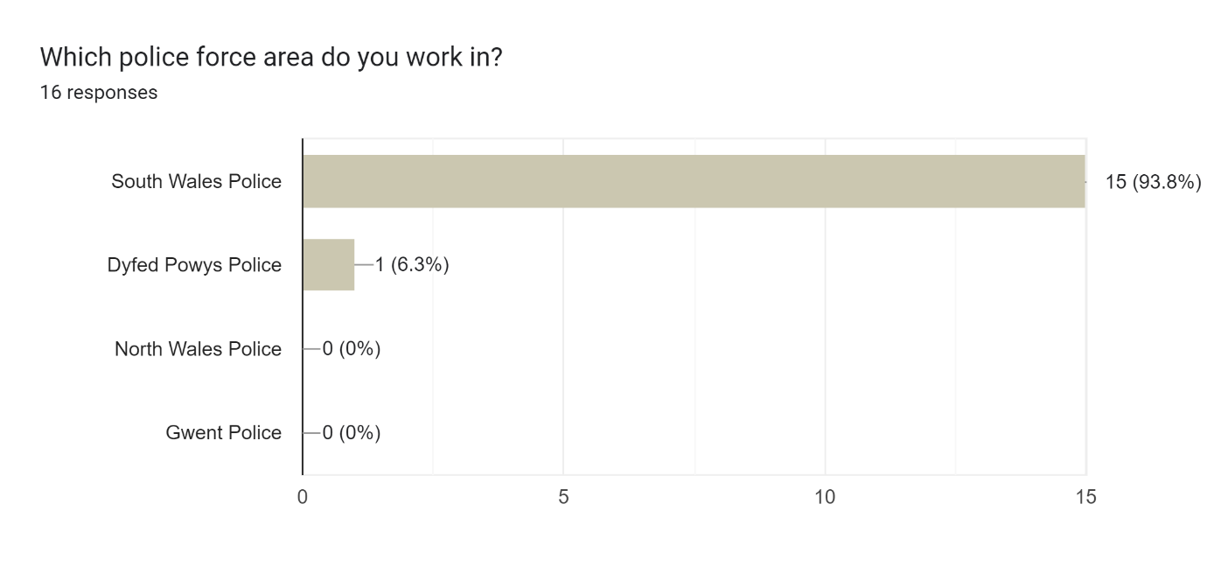
This question asked which police force area that the respondents worked in. 15 respondents had worked or are currently located in the South Wales police force area and one response came from the Dyfed Powys police force.
It is worth mentioning here that these results do not match the previous question. Two responses were received from respondents who were working or had previously worked in the Carmarthenshire area so it would be expected to see it reflected here as Carmarthenshire is within the boundaries of the Dyfed Powys Police force area.

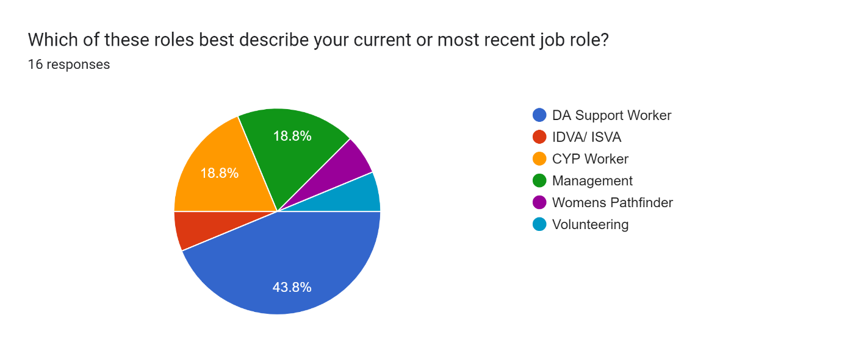
This question asked about the job role that the respondent has undertaken as their current or most recent job role. Seven responses (over 43%) described their role as DA (Domestic abuse) support worker. Three described their role as CYP (Children and young persons) support worker, another three described their role as management within the sector. One respondent also selected the IDVA/ISVA (Independent domestic violence advisor or Independent sexual violence advisor) option. This question also gave an option for ‘other’ and allowed respondents to self-identify their role, therefore one person noted that they worked within the women’s pathfinder service, and another described themselves as being associated with volunteering.
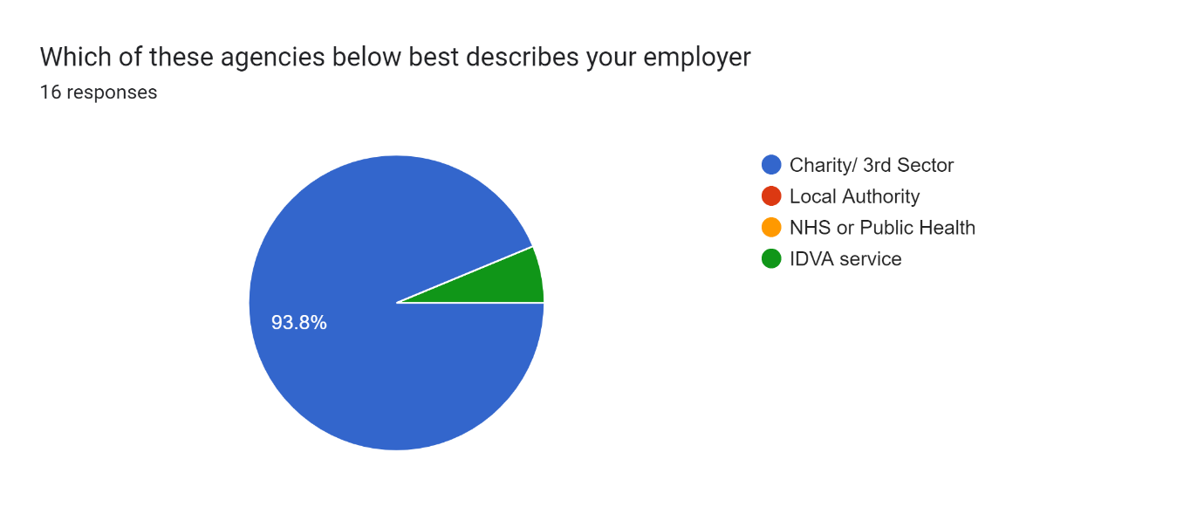

This question asked which option best describes their employer, 15 out of the sixteen responses all said that their employer was classed as a third sector organisation or charity. No responses were selected from the local authority or NHS.
However, one response was selected using the ‘other’ option, and the IDVA service was noted. However, when you compare this to the localities of the workers, in Carmarthenshire, the IDVA service is managed by the third sector organisation, Hafan Cymru (Hafan Cymru 2021). However, it is not clear how the IDVA service is managed within the local authorities of Swansea and Cardiff.
However, these responses were as expected, as all Welsh Women’s Aid member services are charities, third sector organisations or not for profit organisations in their own right (Welsh Women’s Aid 2022).
When did you start working in the sector?
1 | January | 1986
2 | October | 2011
3 | June | 2012
4 | July | 2014
5 | July | 2014
6 | August | 2014
7 | August | 2014
8 | September | 2015
9 | September | 2017
10 | November | 2017
11 | October | 2018
12 | April | 2020
13 | December | 2020
14 | January | 2021
15 | April | 2022
16 | September | 2022
23rd March 2020- UK first national lockdown due to Covid-19
This question asked respondents to note when they started working in the sector. It was important to note this as the following questions asked respondents to rate criminal justice agencies throughout key points before, during and after the first national lockdowns. Eleven of the respondents first started working in the sector prior to the first national lockdown on the 23rd of March 2020 as noted in the table. Five responses were received from respondents starting employment after March 2020. It was felt beneficial to keep these responses within the study as they may have been involved with criminal justice agencies in previous employment in relation to domestic abuse prior to working in the VAWDASV sector.
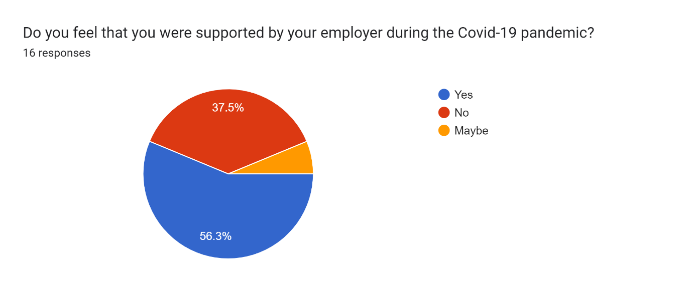
In this survey nine respondents (over 56%) said that they felt supported by their employer during the pandemic. Six respondents said that they didn’t feel supported, and one said maybe. When asked to comment, respondents had a few mixed comments for example “was supported as far as possible in very difficult circumstances for everyone working frontline” but also another commented that “practical support provided but no emotional support, workers [were] isolated and forgotten”. Five of the comments mentioned that their employers allowed them to work from home with one mentioning "I was allowed to work from home as I had no childcare, and had concerns about my health” and another saying “initially working from home was difficult and I felt unsupported as I adjusted to the different way of working as time went on, I was given a desk etc to use at home, I had most of my support from colleagues not management”.
However, this question was also answered by three respondents who had first started in their roles after lockdown measures had eased. However, two made a comment firstly “I was not working for the organisation during the pandemic” and “I was not employed within my current role during the pandemic”. However, it was felt that beneficial to include these responses within the analysis as a whole.
The information from this question, supports the work conducted by van Gelder, et al., (2021) who initially stated that many staff had to start to work from home, with many organisations not being prepared for such a drastic change of working practice. Van Gelder, et al., (2021) also noted many workers experienced a level isolation as they were having less contact with colleagues.
Four respondents in this section also made reference to PPE (personal protective equipment), three out of the four respondents said that they were adequetly supplied with PPE, however one mentioned that they experienced a lack of PPE. Speed et al (2020) does mention that refuge staff “should be provided with PPE in the same way that it is given to care workers”, but does mention that official guidance doesn’t make any mention about staff being provided with sufficient PPE.

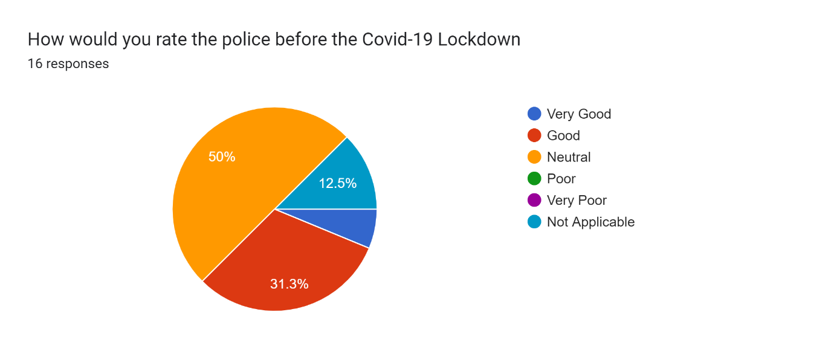
This was the first rating question, which asked respondents to rate the police response to domestic abuse prior to the first lock down in March 2020. Eight responses (50%) had a neutral tone. A further 6 respondents rated the police response as either good or very good and the final two respondents said that this wasn’t applicable to them, however not applicable responses were expected here due the numbers of responses received from those who started their roles after lockdown had begun.
Walklate et al (2022 c.) note that historically policing domestic abuse has had it’s challenges by noting that “domestic violence was most frequently not seen as ‘real’ police work” and does mention that there is a variation in how tools such as the domestic violence protection orders are used, however makes reference to the fact that the use of DVPO’s have increased.
However, when you consider South Wales police prior to the lockdown, HMIC (2014) “found that there are good services for tackling domestic abuse and keeping victims safe in South Wales” and noted that domestic abuse was a high priority for South Wales Police, however noted that some challenges were reflected in the high workloads of police officers and the difficulties posed by officers who are working over seven different local authority areas.
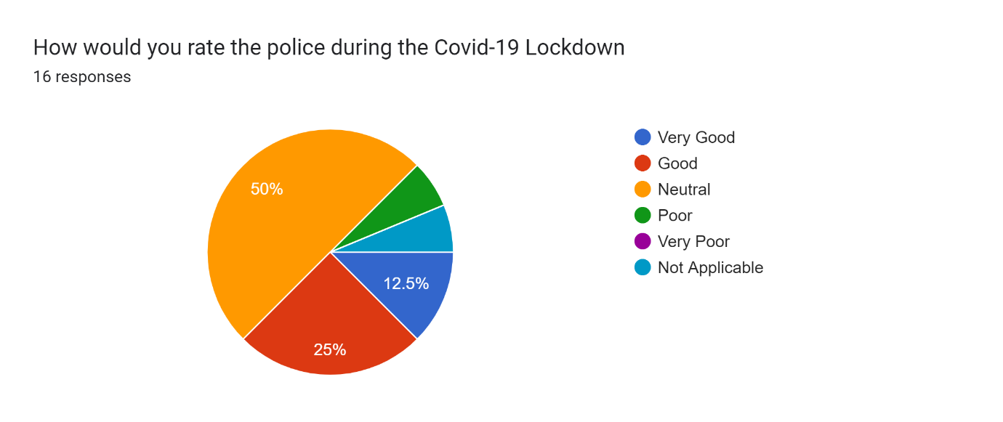
This question provided very similar responses, with eight respondents being neutral about the service from the police during lockdown, a further 6 saying that the response was good or very good. One person noted that this wasn’t applicable to their knowledge, however this was the first time that poor service was noted. These differing opinions were reflected in the comments section, firstly “prompt response to [a] crisis situation, but attitude poor towards the service user (a woman exploited by the sex industry)” but one positive comment suggested “continual support regardless of Covid-19 restrictions. Ongoing police investigations regardless of the low response rate from CPS due to lower staffing. Police were responsive and accurate with all information sharing. High risk victims were still police priority”.
However, Walklate et al (2022 c.) reported that as a result of increased police resources, more police cases were referred to the Crown Prosecution Service and an increase in the number of perpetrators charged with domestic abuse related crimes, However, while CPS (2022) reports an initial decrease in charging decisions, by the 2nd quarter of 2020-2021, there was a 75% increase in charging decisions.
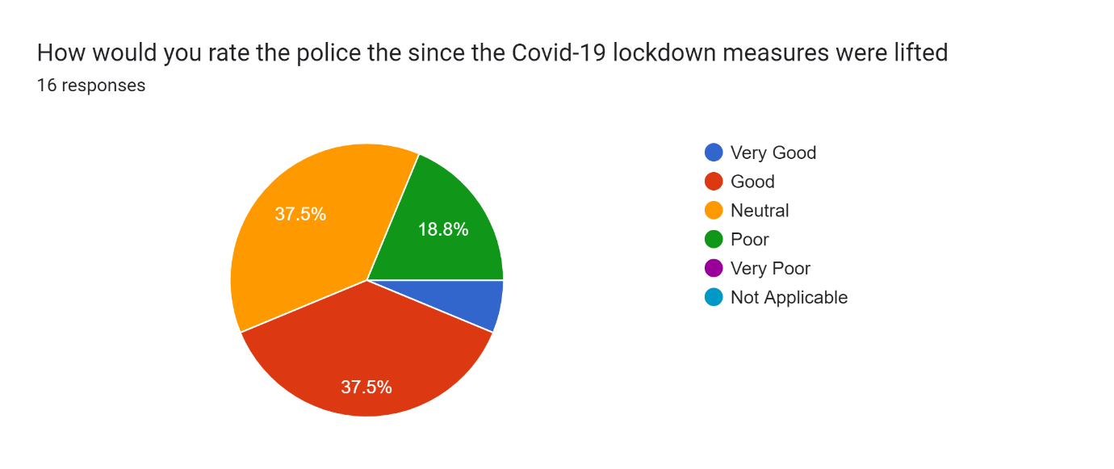
This question asked about police response once lockdown restrictions had lifted. Six respondents still answered their feelings about the police were neutral. However more respondents (7) recognised that the response from the police was good or very good than the previous questions. Three respondents also answered that they thought the service was poor which was two more responses than the previous question. These mixed responses were reflected in the comments again, with one respondent mentioning “Too many [incidents] to recount, frequently liaise/ contact the police in refuge services generally mixed but overall say ‘helpful’”. Another mixed comment said “[a] service user [was] being handled roughly and rude manner with outreach volunteers on one occasion … police had generally been helpful, although wait times on 101 and for police to arrive, have, at times been long.”
HMICFRS (2022) support this mixed response by suggesting that South Wales police are very knowledgeable about domestic abuse, however was slow in implementing disclosures under the Domestic Violence Disclosure Scheme (Claire’s Law) which has potentially put some women in danger, however, HMICFRS (2022) recognises that South Wales Police have a domestic abuse strategy for 2021-2024.
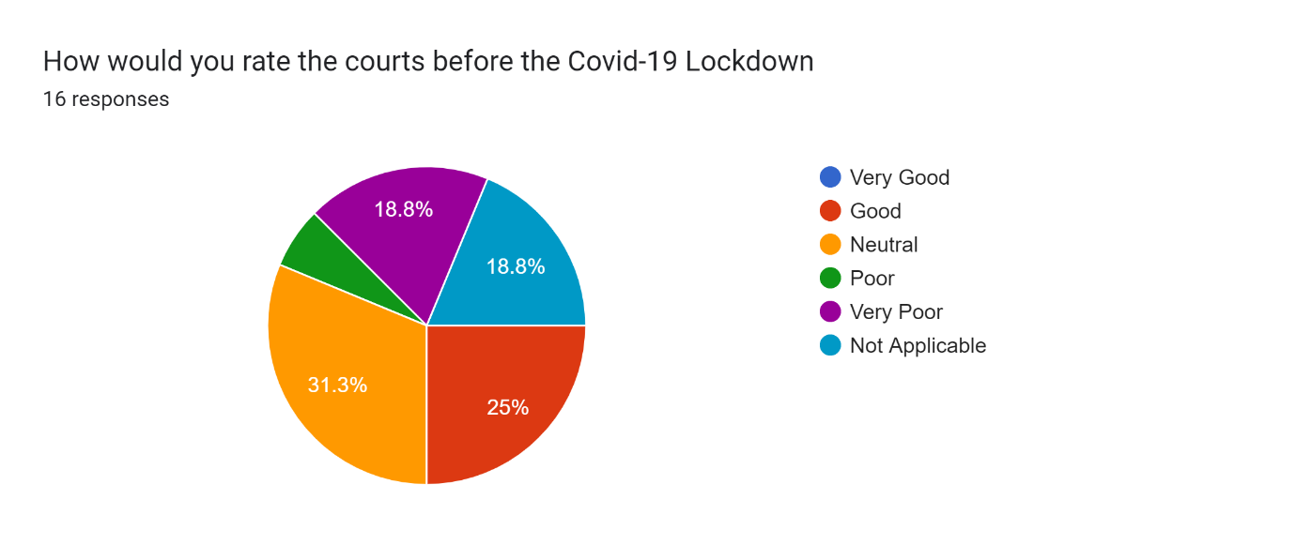
This is the first question that asked respondents to rate the courts. Respondents were asked to consider all courts including the civil and criminal courts. Five respondents were neutral about the court systems. 25% (4 responses) thought that the courts were good. Three answered not applicable, however as with previous answers, it reflects those who started their job roles after the start of the lockdown in March 2020. Four (25%) also note that at this point they rated the courts either poor or very poor.
HMIC (2014) also note that prior to lockdown, the court systems were poor, supporting those respodents who said that the court systems were poor or very poor by reflecting that all victims of abuse should be notified that the perpetrator is being released from prison or custody at the earliest opportunity but “the force [South Wales Police] identified that this was not happening and has improved its internal processes so that more victims are informed, but occasionally victims are not informed in time and their safety is not reviewed” (HMIC 2014).
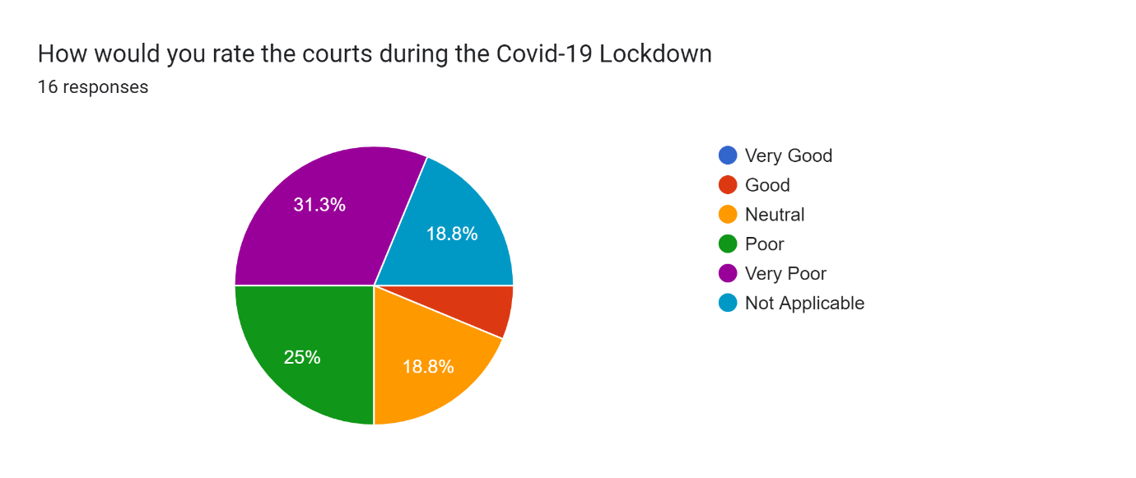
In this question, three respondents selected not applicable, another 3 selected neutral. However only one respondent selected that the service was the courts was good. This is 75% less than prior to lockdown and is now reflected in the increased numbers who felt that the service from the courts was poor (4 or 25%) or very poor (5 or 31.3%). This is well over half of the responses and the poor service from the courts is reflected in the comments for example “poor service in regards to asking victims to join calls at home where the possibility of perpetrators being there causing an obstruction of justice”. And “service users were finding it difficult as things were all done online, some struggled with using the online service.”
Speed et al (2020) support the comments left by the respondents by suggesting that while some court cases were classed as urgent, assumptions were made that victims attending virtual hearings had a safe space to talk, leaving victims in a position “to navigate a telephone hearing, unrepresented, potentially even in the same home as their abuser” while making the recommendation that social services and other businesses offer their office space as a safe place for victims to conduct court business.
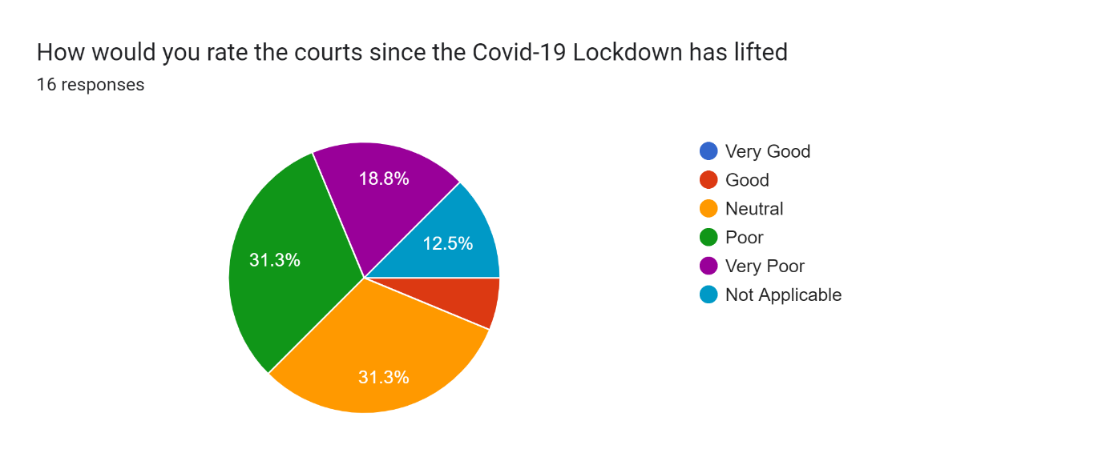
In this question, the number of respondents rating the courts poor or very poor has gone down slightly, down to eight instead of nine. However the number of respondents who rated the service from the courts as neutral has increased in this question from 18.8% (3) to 31.3% (5). Two respondents also answered not applicable and, as the same as the previous question only one respondent rated the courts good. The good service was reflected in one comment by stating that the courts were “enabling the victim to arrive early and leave first and also with the use of screens.”
Four respondents recognised in their that the back-log and long waits for date within the courts was causing stress on victims of domestic abuse, with one commenting “Understandable changes in court dates, but lack of communication to victims which resulted in emotional distress, I had a client prepare of trial only to be told on the day that it had been postponed by at least a month”.
Five respondents also recognised that technology was also proving to be a difficulty for example one comment was that “only positive during C19 is that court attendance was virtual so at least women didn’t have to physically share the same room as their perpetrator. However while the legal machinery seems, to date to always slow, during C19, it was glacially slow”.
Another respondent commented “courts are still using technology for hearings and it has been difficult to support victims in the courts due to social distancing”. This is another view supported by Speed et al (2020) who said “it is also difficult to see how effective support can be given during a hearing to an unrepresented victim by a support service.”
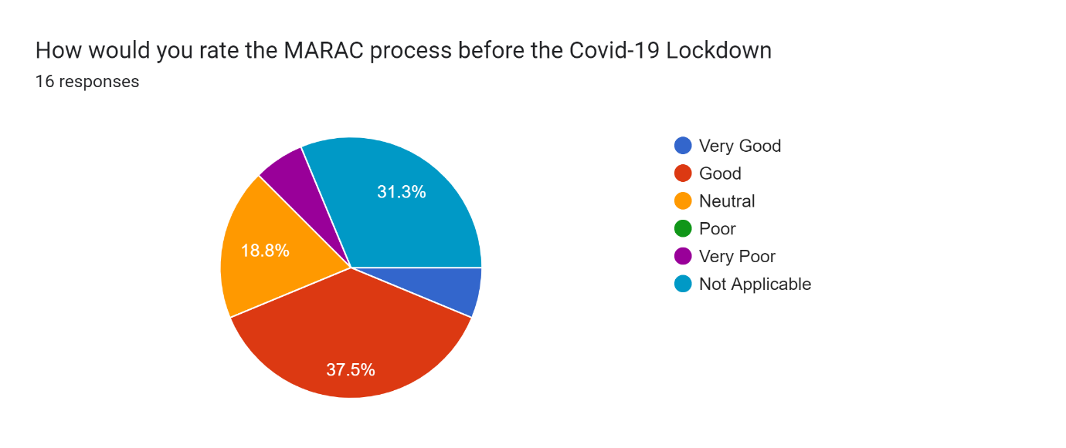
This was the first question asked about the MARAC process. Three respondents rated the process as neutral. One respondent rated the process as very poor. 5 responses selected the not applicable option, however, as with previous questions this is reflected in the numbers of respondents who started their employment after the first lockdown. However, almost half of respondents rated the MARAC process as good (6) or very good (1).
The results of this question, where almost half of the responses say that the MARAC process was good or very good contradict the report produced by HMIC (2014) who say that there are a number of inconsistencies with the MARAC process as they vary between local authorities within the South Wales Police force area and notes that some cases are excluded at the meetings and say “This type of ‘gatekeeping’ is not seen as good practice nationally. It means that some high risk victims are at risk of being denied the level of service” required for their safety.
Walklate, et al., (2021 a.) also make reference to the gate keeping of cases carried out by South Wales Police but on a UK wide basis and mentions that there a number of different approaches to the way MARAC’s are carried out between and within police forces, with each one having a differing outcome for victims of domestic abuse.
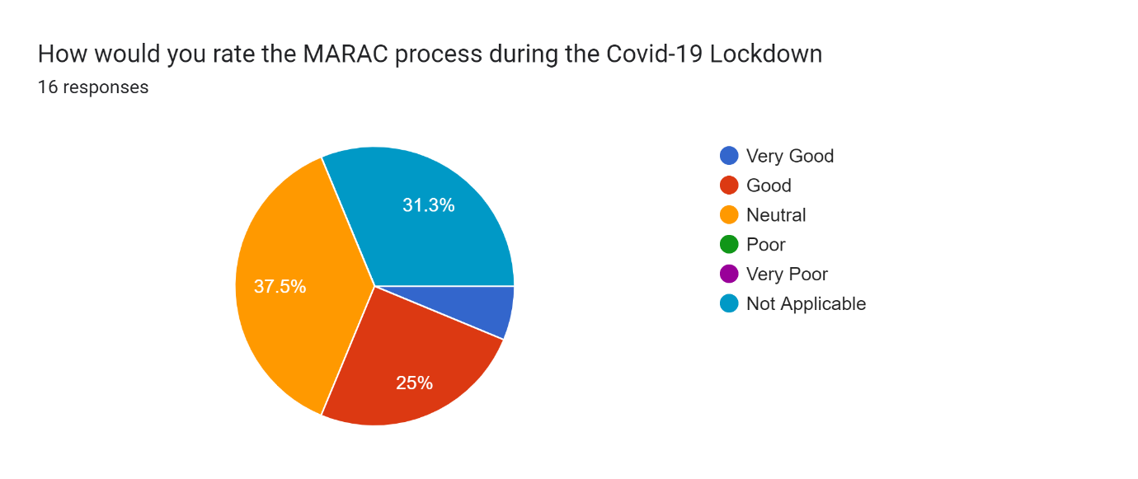
This question asked respondents to rate the MARAC process during the lockdown period. Six respondents rated the process as neutral, another five respondents selected as not applicable, however this matches the number of respondents (five) who started their employment either during or after lockdown started.
The final five respondents rated the MARAC process during lockown as either good or very good. This is reflected in the comments section with one respondent stating “referrals picked up promptly, actions in place and actioned by agencies, positive sharing of information-crucial in lockdowns” and another said “attended one meeting online and appreciated they were doing their best during COVID to still work collaboratively”.
Walklate et al (2021 a.) agrees with the comments regarding the perceived improvements within a MARAC meeting by firstly suggesting that conference calls and virtual meetings will be the way in which domestic abuse work will be carried out in the future and there are “perceived improvements in the quality and efficiency of the meetings”.

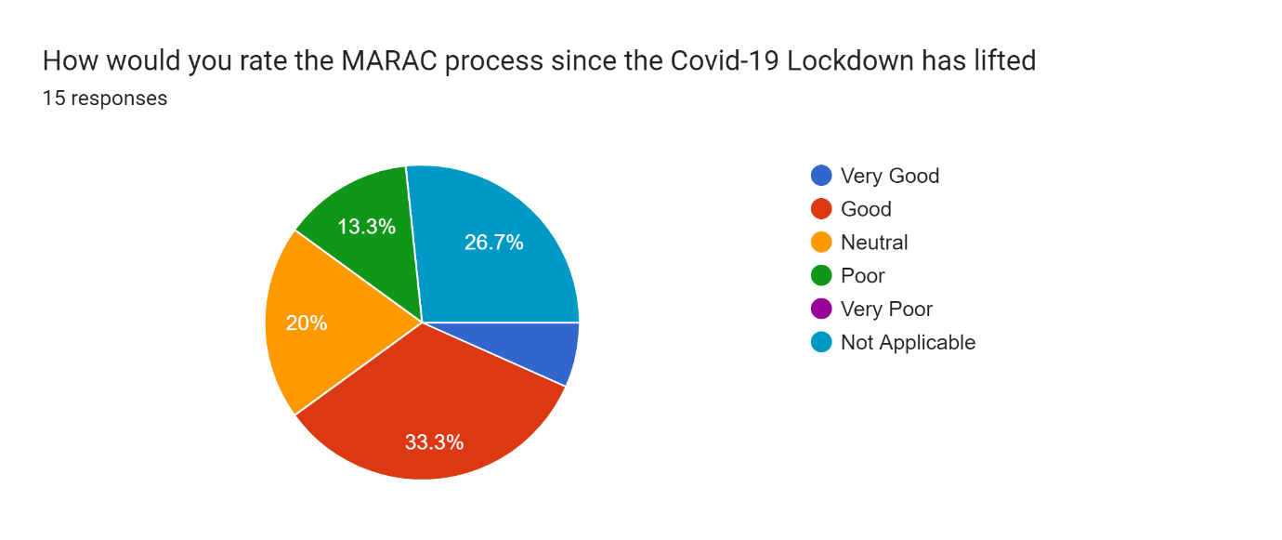
This is the last question which asked respondents to rate the MARAC process once lockdown restrictions had eased. This question only received 15 responses in total, rather than the 16 as expected throughout the rest of the questions. Four respondents selected not applicable for this questions, however this is reflected in the comments with one noting “I have not sat in a MARAC since before covid”.
Three respondents selected neutral, which was 50% less than the previous questions, however this is reflected in the number of polarising opinions, Five respondents selected that the MARAC process was either good or very good which has been reflected in the comments with one respondent mentioning “Good clear and transparents communication with thought out actions for other professionals to ensure all working together for a positive outcome”. However two respondents selected that the MARAC process is poor since lockdown restrictions have lifted.
When the comments are considered, seven respondents mentioned the engagement of professionals during the meetings, Three of which had negative opinions about the engagement for example one comment suggested that “historically, MARAC has been good, it was hard getting everyone in a room together, especially the statutory agencies, however, it was swift moving it online/ conference call, however the meetings were very lengthy leading to some professionals disengaging with the process towards the end of the meeting”. However, one positive comment mentions that “online sharing of information for MARAC produces a higher engagement of public and private sector leads to be available”.

These polarising opinions are reflected in the Peel Assessment carried out by HMICFRS (2022) who mention that while the number of cases discussed at MARAC are double what is expected for the size of the force which has increased the frequency of meetings, South Wales police responds well to victims through the MARAC process and the police staff involved are very knowlegeable about how the police can protect victims.
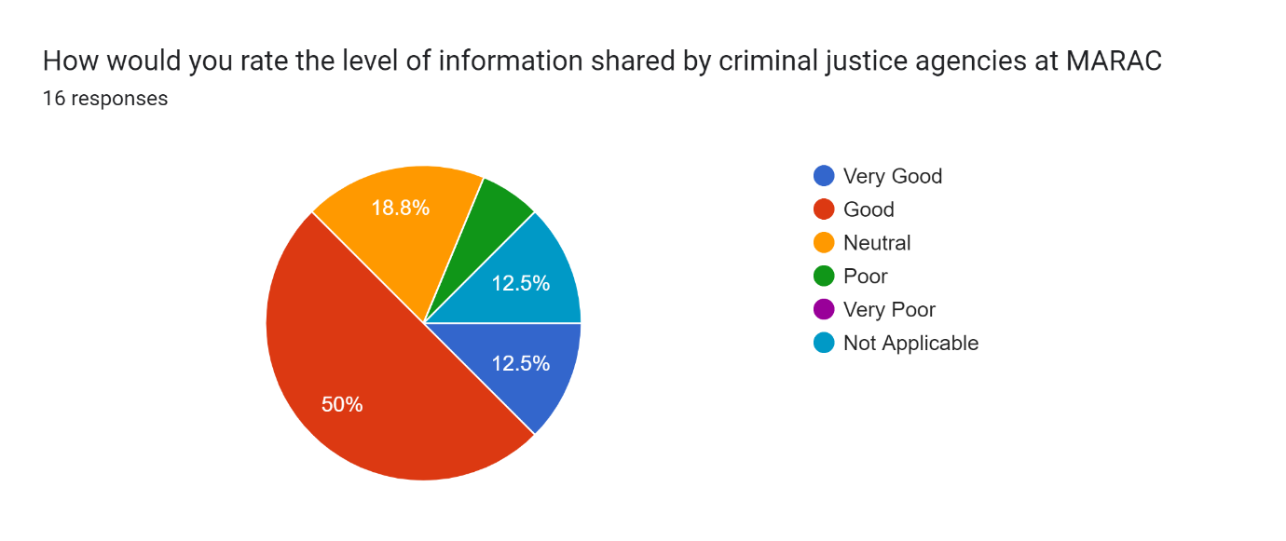
In this question, respondents were asked to rate the level of information provided by criminal justice agencies during MARAC and other multi-agency meetings. 10 respondents answered that they felt that they were getting good or very good levels of information from criminal justice agencies. Three respodents were neutral about the levels of information, and two cited that this information wasn’t applicable to their roles. Only one respondent cited that the information provided in MARAC was poor. A comment that was left was in relation to the poor information was “things move quickly and often out of date by meeting”, however one respondent shared the opposite; “all agenices have been very open in their experiences of working with clients within the window of what is necessary to share and what is relevant”.
The differing opinions of the sharing of information at MARAC is supported by SafeLives (2020) who say that it is difficult to get the information from agencies via email prior to the deadline, however Walklate, et al., (2021 a.) notes that information was now being shared quicker, “findings here cannot comment on the quality and effectiveness of information sharing practices central to MARAC” (Walklate, et al. 2021 a.).
HMICFRS (2022) supported the results of this question by noting that South Wales Police by stating that “Partners told us (HMICFRS) that public protection and local policing teams share information about vulnerable people well, and invite them to training events”.
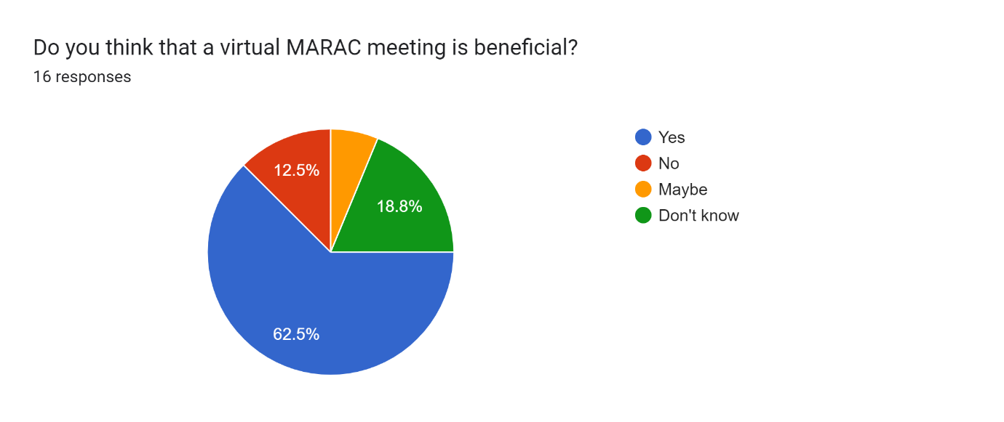
In this question respondents were asked whether they felt that a virtual MARAC meeting was beneficial. Three respondents answered don’t know, however this is reflected in the written comments with one respondent stating that they had “not attended one”. Two respondents said that a virtual MARAC meeting would not be beneficial, with one making a comment suggesting “face to face is better, virtual meetings can be lengthy leading to professionals disengaging with the meeting and getting distracted”. One respondent said that a virtual meeting maybe beneficial.
Ten responses answered that they thought a virtual meeting was beneficial, one comment was “I think a virtual meeting is beneficial as it allows discussion and alternative methods or solutions to be discussed as a team” and another comment stated, “virtual meetings allow more people to attend, enabling more views/voices to be heard”. This view of beneficial virtual MARAC meetings is shared with Walklate, et al., (2021 a.) who said that there were “perceived improvements to the quality and efficiency of the meetings”. Safelives (2020) also shared the view that virtual MARAC meetings were beneficial and shared that “there is no travel time, no vehicle use, no need for payment to hire buildings to hold MARAC”.

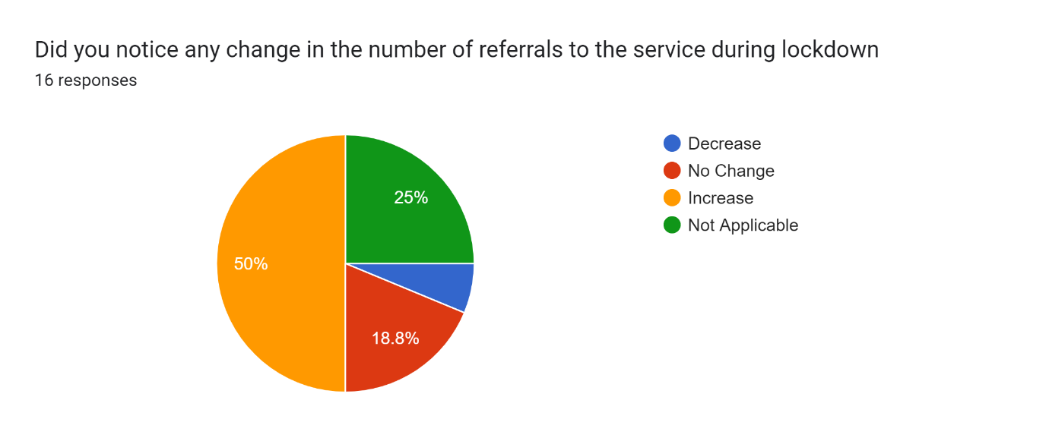
This question asked if they had noticed any change in the number of referrals during the lockdown period. Eight respondents (50%) noticed that there was an increase in referrals. Three noted that there was not a perceived change in the number of referrals. One respondent noted that there was a decrease in the number of referrals. Four respondents also selected not applicable which was expected due to the numbers of respondents who started their employment after the first national lockdown on the 23rd March 2020.
This differing of opinion is shared with Speed et al (2020) who also mention within their study they had a mixed response with some agencies reporting an increase in reports, but over 40% of agencies studied by Speed et al (2020) noted a decrease in reports, however, these agencies reported that this decrease was evident from additional barriers to reporting rather than an actual decrease in reported domestic abuse related crimes.
However, this perceived increase is supported by ONS (2020) data which says that during the pandemic there was an increase in police recorded domestic abuse crimes during the lockdown which has led to an increased demand for victim support services.
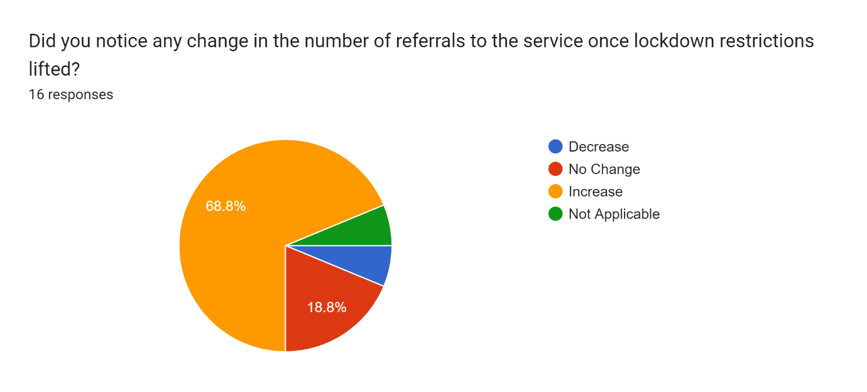
The last question of the survey asked respondents if they had noticed a change in the number of referrals once lockdown restrictions had lifted. Eleven respondents mentioned that they perceived an increase in the number of referrals during this period.
Three respondents answered that they noticed no change in the number of referrals during this time too, one person also noted a decrease in the number of referrals and the last one answered that this wasn’t applicable to them, however, the last not applicable response will be expected as one respondent started in the VAWDASV in September 2022.
However, this perceived change is not supported by ONS (2022) data, as Welsh Women’s aid reports that between April 2021 and March 2022, there were over 16,000 recorded referrals for member services which is down from almost 23,500 recorded between April 2020 and March 2021.

Chapter 5- Conclusion
The overall aim of this project was to explore the views of professionals working in the violence against women, domestic abuse, and sexual violence (VAWDASV) sector on how the criminal justice system dealt with domestic abuse before, during and after the Covid-19 pandemic.
This final chapter will revisit the research objectives, then the chapter will summarise the findings and formulate a conclusion in relation to each objective. The importance of this research and the contribution of this research to those working in the VAWDASV sector will be discussed. This chapter will also make recommendations for further research and will discuss the limitations of this research along with suggestions for the managing the implementation of further research. This chapter will also have a personal reflection on the research journey undertaken.

Research Objectives: Summary of findings and conclusions
- Explore the different definitions of violence against women, domestic abuse and sexual violence (VAWDASV) and evaluate whether the VAWDASV Act (Wales, 2015) and the Domestic abuse bill (England and Wales, 2020) does enough to protect victims of domestic abuse.
This objective didn’t feature within the empirical research, however the literature review identified that there are several accepted definitions of domestic abuse that researchers use. These definitions include domestic abuse, intimate partner violence, gender-based violence and violence against women and girls.
The official definitions of domestic abuse (Home office 2013, 2021) recognise that people aged 16 and over regardless of their sexuality or gender can experience domestic abuse in any relationship. This is the legal definition used by the courts.
However, the definitions of gender-based violence and violence against women and girls recognise that types of violence such as female genital mutilation happen just because the victim is female. However, any type of violence against women and girls is seen as a violation of human rights. (UNHCR, 2021).
The domestic abuse act (2021) recognises that domestic abuse is a violation of human rights and as a result has brought in extra protections to aid victims in navigating the criminal justice system but has criticisms that it doesn’t protect migrant victims of domestic abuse nor those who have offended as a direct result of domestic abuse (CWJ, 2021).
It is therefore, concluded that while the Home Office (2021) definition of domestic abuse is the legal definition in the UK, it doesn’t go far enough to protect all victims of domestic abuse.

- Compare and contrast police arrests and CPS charging figures for domestic abuse related crimes between March 2020 and March 2021.
This was another objective that didn’t feature directly within the empirical research, however, was briefly covered within the research questions which asks respondents to rate the response of the police before, during and after the pandemic.
The literature notes that prior to the first national lockdown, the police response to domestic abuse was poor, Walklate et al (2022 c.) notes that domestic abuse was not seen as real police work and HMICFRS (2021) mentions that one victim of domestic abuse noted that the police response was better in 2020 than five years previously.
However, there were mixed results during the pandemic which are shown in the CPS (2022) data which says that in quarter one of 2020/2021 that there was a drop in successful prosecutions, but an increase in arrests during this period (ONS 2020). The literature also supports the CPS (2022) data which says that there was a 75% increase in successful prosecutions in quarter 2 of 2020/2021 which is supported by Walklate et al (2022 c.) who says that initially the number of calls to the police declined but had returned to normal by May 2020.
The empirical research also notes the mixed messages, with respondents noting that police were still highly responsive to domestic abuse incidents with one noting “continual support regardless of covid-19 restrictions. Ongoing police investigations regardless of the low response rate from CPS due to lower staffing.”
In conclusion, the police response to domestic abuse has improved from prior to the pandemic, and initially during the pandemic the conviction rates dropped, however eventually increased, however the professional response noted that police were highly responsive.
- Analyse the demand for VAWDASV services in England and Wales since March 2020
During this period the demand for VAWDASV services increased, however the actual increase varies between service, for instance, within Wales, The Live Fear Free Helpline reported a decrease in calls, however reported an increase in other services such as email, webchat, and text messaging (ONS 2020).
There was also a huge increase in the demand for community-based services within Wales and UK wide (ONS 2020). In Wales the increase was around 80% within the first few months of lockdown and many VAWDASV services expected an additional increase in demand from 6 months to a year post lockdown.
Refuges, on the other hand, experienced problems during this period, and while the referrals and demand for space was higher than pre-lockdown levels, refuges were not able to cope as some refuges had reduced the number of available beds (Speed et al 2020) and problems sourcing PPE for staff (ONS 2020) and some local authorities were using hotels to accommodate victims of domestic abuse.
This increase in the number of referrals in the literature is supported by the empirical research where half of the respondents noted an increase in referrals during lockdown and since the lockdown restrictions have lifted, 11 out of 16 respondents noted that they perceived an increase in the number of referrals. However, this research doesn’t distinguish whether the referrals are for community-based services or refuge services.
During lockdown, there also wasn’t much research done on the impact of lockdown on professionals working in the VAWDASV sector (van Gelder at al 2021). The empirical research touches on this theme with over half of respondents noting that they felt supported by their employer during the pandemic, however 6 respondents noted that they were not supported by their employer during the pandemic, with three comments mentioning the difficulty of working remotely for example “initially working from home was difficult and I felt unsupported as I adjusted to the different way of working as time went on I was given as desk etc to use at home, I had most of my support from colleagues not management.”
In conclusion, this research concluded that during the pandemic the demand for VAWDASV services in Wales had increased, however, this had come with challenges such as sourcing PPE. It has also been realised that the different way of working has had an impact on professionals, however, there hasn’t been much research in this area.
- Evaluate the effectiveness of video conferencing and remote court hearings for VAWDASV cases in the criminal and family courts since March 2020.
The literature review found that video and virtual hearings within the courts were seen as more efficient (HMICFRS 2021, HMCPSI 2021, Harker and Ryan 2022 and Valchev 2020) and found that virtual hearings would reduce a number of barriers that vulnerable people face when attending hearings (Valchev 2020).
However virtual hearings have also caused problems as some victims didn’t have access to the technology required to attend or did not get the levels of support required (Speed et al 2020).
The closures of the courts and suspension of jury trials has also led to long waiting lists with cases waiting anywhere from 6 months to a year to be heard at a crown court (Speed et al 2020, HMCPSI 2021 and House of Lords 2021).
The research supports the literature review as prior to the lockdown, 4 respondents rated the court system as poor or very poor, during the pandemic, however, 9 respondents rated the court system as poor or very poor during the pandemic and since lockdown restrictions lifted, the number of respondents who rated the courts as poor or very poor decreased to 8.
The comments reflected the literature provided support to Speed et al (2020), HMCPSI (2021) and House of Lords (2021), with one stating “mainly reflecting on family courts. Online courts were used and women not always having access to technology… Sexual abuse cases still very difficult to get to court and decriminalisation of sexual abuse still is in plain sight”.
It is therefore concluded that while professionals appreciate the benefits of virtual court hearings, there are still a number of barriers for vulnerable victims of domestic abuse to attend virtual hearings and the long waiting list after the suspension of jury trials is still traumatic to victims of domestic abuse.

- Evaluate the future benefits of video conferencing for VAWDASV cases, MARAC, and other multi-agency partnerships within the criminal justice system.
Since the introduction of video conferencing within MARAC and other multi-agency meetings, the literature notes several benefits which includes meetings being more efficient and provides adaptive safety plans for victims (Walklate et al 2021 a.), However Price et al (2020) noted that conference calls had been trialled prior to the pandemic and found that these calls weren’t as effective and as a result had been discontinued.
Virtual meetings allowed for more agencies to attend, especially when the meetings were arranged at the last minute (Baginsky and Manthorpe 2020 cited in Driscoll et al 2020), however MARAC was seen as a tick box exercise rather than a meaningful intervention, (Davis 2015).
However, the mixed responses to the MARAC process were reflected within the research with 7 respondents noting that the process was good or very good prior to the pandemic, during the pandemic, the numbers rating the MARAC process either good or very good had dropped to 5, but had increased to 6 when respondents were asked to rate the process after lockdown had lifted. For example, one comment noted “I think it took a while to settle into all agencies working online and found that a lot of agencies were reluctant to engage as much as they would around a table together. It was useful that the MARAC process could be adapted to be completed online and was needed at the time, but I think you miss out in inter-agency cooperation, getting to know colleagues and learning from each other’s knowledge by being online”.
However, when respondents were asked if a virtual MARAC meeting was beneficial, 10 respondents said yes, with two comments noting “[it] can be easier to arrange” and “it makes it easier for attendance”.
The evidence from the literature review and the research has concluded that multi-agency meetings are more efficient when they are virtual and has allowed more agencies to engage with the process.

Recommendations
The conclusion based on objective 1 which concerns the definition of domestic abuse and the protection of victims, mentions that the current legal definition of domestic abuse does not go far enough to protect all victims of domestic abuse which includes migrant women, therefore one recommendation would be for the implementation of additional protections such as the ability to claim benefits so that that migrant women can access refuge. This recommendation would benefit this population by giving them somewhere safe to go when leaving the relationship and would put them on equal footing with UK nationals.
When it comes to conclusion regarding objective 3 which discusses the demand for VAWDASV services. It was noted that the demand for VAWDASV services was overall, higher compared to the same period pre-pandemic, the effect of this increase on staff well-being hasn’t been researched effectively, therefore a recommendation in this area would focus research and evaluate the well-being and support staff received from their employer during the pandemic and since restrictions have lifted. This recommendation will have the benefit of providing managers with an insight on how to best support staff during challenging times.
In relation to objective 4 regarding virtual court hearings, the benefits of a virtual court hearing outweigh the challenges, however, the recommendation for this research would be to minimise any barriers to vulnerable victims of domestic abuse such as allowing vulnerable people to borrow technology from the courts to be able to take part or attending another venue such as the office of their VAWDASV support worker or their solicitor as this would ensure the safety of the victim and their ability to engage in the process.
The conclusion based on objective 5, which discusses virtual multi-agency meetings and MARAC’s, was that a virtual MARAC or multi-agency meeting was beneficial and more efficient, however this wasn’t without problems, so the recommendation here would be to maintain virtual multi-agency meetings, but to also organise additional events such as training days face to face in order to build networks and facilitate multi-agency working. The benefits of this recommendation would be, firstly, that all agencies within a multi-agency team will have received the same training, but secondly, the partnerships and MARAC will maintain attendance levels when the meetings are held virtually.

Final Thoughts
The advice for students going forward would be to select a topic of interest. The researcher’s interests historically have been within the criminal justice system, specifically related to domestic abuse and was employed in the VAWDASV sector during the pandemic. While it is a good idea to have a research objective at the start, the second piece of advice to students is to be open to changing it as the project develops.
Domestic abuse is a topic that has been well-researched historically, however there are still gaps in research around the impact that Covid-19 had on domestic abuse, therefore, finding relevant literature wasn’t an easy task.
However, upon starting to write the literature review chapter, it became clear that there were a number of recent articles available, and these articles helped to provide evidence for the literature review and therefore provided ideas for questions within the survey.
Sampling of this survey did prove difficult. The researcher utilised previous and current professional contacts in order to get enough respondents. The survey was also distributed by Welsh Women’s Aid to all VAWDASV services in Wales through a fortnightly newsletter. These methods only provided 16 responses. In order to provide a more detailed picture of what is going on Wales wide, it would be beneficial to contact each service individually should the survey be repeated.
Should the study be repeated, an online survey would be utilised again as while it helped with the analysis of results, it also provided anonymity and eliminated any potential researcher bias.

Chapter 6- References
Addis, S., Wey, T., Toll, E. & Hopkins, J. C., 2021. What works to prevent adverse childhood experiences (ACES) at the community level? an evidence review and mapping exercise, Cardiff: Public Health Wales.
Anon., 2019. Still We Rise: 5 Year Strategy. [Online]
Available at: https://www.welshwomensaid.org.uk/wp-content/uploads/2019/10/WWA-2019-24-Strat-Landscape-EN-DigiVersion-HighRes.pdf
[Accessed 11 09 2022].
Bartram, B., 2019. Using Questionnaires. In: M. Lambert, ed. Practical Research Methods in Education. London: Routledge, pp. 1-11.
Bates, L., Hoeger, K., Stoneman, M.-J. & Whitaker, A., 2021. Vulnerability Knowledge and Practice Programme- Domestic Homicides and Suspected victim suicides During the Covid-19 Pandemic 2020-2021, London: NPCC.
Biggam, J., 2021. Succeeding with Your Master's Dissertation, A Step by Step Handbook. 5th ed. London: Open University Press .
Bloch, A., Phellas, C. & Seale, C., 2011. Structured Methods: Interviews, Questionnaires and Observation. In: Researching Society and Culture. London: Sage Publications.
Bradbury-Jones, C. & Isham, L., 2020. The Pandemic Paradox: The consequences of Covid-19 on domestic violence. Journal of Clinical Nursing, Volume 29, pp. 2047-20149.
Brown, J., 2021. Policing in the UK. [Online]
Available at: https://researchbriefings.files.parliament.uk/documents/CBP-8582/CBP-8582.pdf
[Accessed 2022 05 08].
Brown, J. & Fleming, J., 2022. Exploration of Individual and work-related impacts on police officers and police staff working in support or front-line roles during the UK's first COVID lockdown. Police Journal: Theory, Practice and Principles, 95(1), pp. 50-72.
Carrillo, D., 2012. Police Culture and Gender: an evaluation of police officer's practices and responses to domestic abuse. Journal of Global Faultlines, 8(1), pp. 69-80.
Centre for Women's Justice, 2021. Domestic Abuse Bill – proposed changes in the law for victims/survivors driven to offend. [Online]
Available at: https://www.centreforwomensjustice.org.uk/dabill
[Accessed 13 08 2022].
Chapman, S. & McNeill, P., 2005. Research Methods. 3rd ed. London: Routledge.
Coliver, S., 1989. United Nations Machineries on Women's rights: How Might They Better Help Women Whose Rights are Being Violated. In: E. L. Lutz, H. Hannum & K. J. Burke, eds. New Directions on Human Rights. Pennsylvania: University of Pennsylvania, pp. 25-50.
College of Policing, 2021. Domestic or Relationship Abuse. [Online]
Available at: https://www.college.police.uk/guidance/violence-against-women-and-girls-toolkit/domestic-or-relationship-abuse#:~:text=Domestic%20abuse%20is%20defined%20in,and%20the%20behaviour%20is%20abusive.
[Accessed 03 11 2022].
Court of Protection, 2020. Remote Access to the Court Of Protection Guidance, London: Judiciary of England and Wales.
Creswell, J. W., 2013. Qualitative Inquiry & Research Design, Choosing Among Five Approaches. 3rd ed. London: Sage Publications.
Crown Prosecution Service, 2022. CPS Quarterly Data Summaries. [Online]
Available at: https://www.cps.gov.uk/publication/cps-quarterly-data-summaries
[Accessed 25 10 2022].
Crown Prosecution Service, 2022. Domestic Abuse. [Online]
Available at: https://www.cps.gov.uk/crime-info/domestic-abuse
[Accessed 29 05 2022].
Davis, R. C. & Mulford, C., 2008. Victim Rights and New Remedies. Journal of Contemporary Criminal Justice, 24(2), pp. 198-208.
Doak, J., 2008. Victim's Rights, Human Rights and Criminal Justice Reconceiving the Role of Third Parties. Portland: Hart Publishing.
Driscoll, J., Lorek, A., Kinnear, E. & Hutchinson, A., 2020. Multi-agency safeguarding arrangements: overcoming the challenges of covid-19 measures. Journal of Children's Services, 15(4), pp. 267-274.
Equality and Human Rights Commission, 2018. The Human Rights Act. [Online]
Available at: https://www.equalityhumanrights.com/en/human-rights/human-rights-act
[Accessed 2022 04 09].
Glowacz, F., Dziewa, A. & Schmits, E., 2022. Intimate Partner Violence and Mental Health during Lockdown of the COVID-19 Pandemic. International Journal or Environmental Research and Public Health, 19(2535), pp. 1-16.
Godfrey, B., Richardson, J. C. & Walklate, S., 2022. The Crisis in The Courts: Before and Beyond Covid. The British Journal of Criminology, Volume 62, pp. 1036-1053.
Grace, J., 2015. Claire's Law or the national Domestic Violence Disclosure Scheme: The contested legalities of criminality information shating. The Journal of Criminal Law, 79(1), pp. 36-45.
Hafan Cymru, 2021. Support. [Online]
Available at: https://hafancymru.co.uk/support/
[Accessed 16 10 2021].
Harker, L. & Ryan, M., 2022. Remote hearings in family courts in England and Wales during Covid-19: Insights and lessons. Nuffield Family Justice Observatory, Volume 60, pp. 207-219.
HM Crown Prosecution Service Inspectorate, 2021. CPS Response to Covid-19: Dealing with the backlogs, London: HMCPSI.
HMIC, 2014. South Wales Police's Approach to Tackling Domestic Abuse. [Online]
Available at: https://www.justiceinspectorates.gov.uk/hmicfrs/wp-content/uploads/2014/03/south-wales-approach-to-tackling-domestic-abuse.pdf
[Accessed 23 10 2022].
HMICFRS, 2021. Review of policing domestic abuse during the pandemic. [Online]
Available at: https://www.justiceinspectorates.gov.uk/hmicfrs/publication-html/review-of-policing-domestic-abuse-during-pandemic/
[Accessed 01 08 2022].
HMICFRS, 2022. South Wales. [Online]
Available at: https://www.justiceinspectorates.gov.uk/hmicfrs/peel-assessments/peel-assessments-2021-22/south-wales/
[Accessed 15 08 2022].
Home Office, 2013. Information for Local Areas on the change to the Definition of Domestic Violence and Abuse, London: Home Office.
Home Office, 2021. Domestic Abuse Act 2021: Overarching Factsheet. [Online]
Available at: https://www.gov.uk/government/publications/domestic-abuse-bill-2020-factsheets/domestic-abuse-bill-2020-overarching-factsheet
[Accessed 13 09 2022].
Home Office, 2022. Tackling Domestic Abuse Plan, London: Home Office.
Hopkins, J. C. & Assami, A., 2021. Uncharted Territory Review, Cardiff: Public Health Wales.
House of Commons, 2022. Reducing the Backlog in Criminal Courts, London: House of Commons.
House of Lords, 2021. Covid-19 and the courts, London: House of lords.
Institute for Government, 2021. Timeline of UK Government Coronavirus Lockdowns and Measures, March 2020 to December 2021. [Online]
Available at: https://www.instituteforgovernment.org.uk/sites/default/files/chart-images/timeline-coronavirus-lockdown-december-2021_0.png
[Accessed 08 08 2022].
Jones, S., Murphy, F., Edwards, M. & James, J., 2008. Doing things Differently: advantages and disadvantages of web questionnaires. Nursing and Allied Health Source, 15(4), pp. 15-26.
Jurasz, O., 2018. Violence Against Women, Domestic Abuse and Sexua Violence (Wales) Act 2015. In: E. Rackley & A. Rosemary, eds. Women's Legal Landmarks: Celebrating the history of women and law in the UK and Ireland. s.l.:Hart.
Kourti, A. et al., 2021. Domestic Violence During the Covid-19 Pandemic: A Systematic Review. Trauma Violence and Abuse, 20(10), pp. 1-27.
Krishnadas, J. & Hayat Taha, S., 2020. Domestic Violence Through the Window of the Covid-19 Lockdown: A Public Crisis Embodied/Exposes in the Private/Domestic Sphere. Journal of Global Faultlines, 7(1), pp. 46-58.
Kuter, U. & Yilmaz, C., 2001. Survey Methods: Questionnaires and Interviews. [Online]
Available at: https://www.researchgate.net/profile/Ugur-Kuter/publication/267366565_Survey_Methods_Questionnaires_and_Interviews/links/5489a6ca0cf225bf669c6e2c/Survey-Methods-Questionnaires-and-Interviews.pdf
[Accessed 10 09 2022].
Muldoon, K. A. et al., 2021. Covid-19 Pandemic and Violence: Rising Risks and decreasing urgent care-seeking for sexual assualt and domestic violence survivors. BMC Medicine, 19(20).
Office for National Statistics, 2020. Domestic abuse during the coronavirus (covid-19) pandemic, England and Wales: November 2020, London: Office for National Statistics.
Office for National Statistics, 2022. Domestic Abuse Support Services Data Set, London: Office for National Statistics.
Open University, 2021. Conducting an Interview. [Online]
Available at: https://help.open.ac.uk/conducting-an-interview
[Accessed 10 09 2022].
Open University, 2021. Using a Questionnaire. [Online]
Available at: https://help.open.ac.uk/using-a-questionnaire
[Accessed 10 09 2022].
Panovska-Griffiths, J. et al., 2022. Impact of the first national COVID-19 lockdown on referral of women experiencing domestic violence and abuse in England and Wales. BMC Public Health, 22(504), pp. 504-514.
Plotnikoff, J. & Woolfson, R., 2019. The Uneasy position of vulnerable defendants. In: J. Plotnikoff & R. Woolfson, eds. Intermediaries in the criminal justice system. Bristol: Bristol University Press, pp. 247-280.
Price, J., Quarmby, S., Johnson, C. & Bristow, D., 2020. Domestic Abuse Intervention in Wales, Cardiff: Wales Centre for Public Policy.
RMIT University, 2022. Systematic Reviews. [Online]
Available at: https://rmit.libguides.com/systematicreviews/synthesise#:~:text=Synthesis%20is%20a%20stage%20in,the%20outcomes%20of%20the%20review.
[Accessed 19 09 2022].
Rossner, M., 2021. Remote Rituals in Virtual Courts. Journal of Law and Society, Volume 48, pp. 334-361.
Safelives, 2015. Frequently asked questions; Multi-agency risk assessment conferences. [Online]
Available at: https://safelives.org.uk/sites/default/files/resources/MARAC%20FAQs%20General%20FINAL.pdf
[Accessed 2022 07 10].
SafeLives, 2020. England, Wales and Northern Ireland Covid-19 Marac Survey. [Online]
Available at: https://safelives.org.uk/sites/default/files/resources/Safe%20at%20Home%20ENWI%20Marac%2020200610.pdf
[Accessed 15 08 2022].
Safelives, 2022. SafeLives MARAC data England and Wales April 2021-March 2022, Bristol: SafeLives.
Simply Psychology, 2018. Questionnaire: Definition, Examples, Design and Types. [Online]
Available at: https://www.simplypsychology.org/questionnaires.html
[Accessed 10 09 2022].
Singh, K. & Wajgi, R., 2016. Data Analysis and Visualization of Sales data. 2016 World Conference on Futuristic Trends in Research and Innovation for Social Welfare, p. 106.
Slakoff, D. C., Aujla, W. & PenzeyMoog, E., 2020. The Role of Service Providers, Technology and Mass Media when home isn't safe for Intimate Partner Violence Victims: Best Practive and Recommendations in the Era of Covid 19 and beyond. Archives of Sexual Behaviour, 49(1), pp. 2779-2788.
Speed, A., Thomson, C. & Richardson, K., 2020. Stay Home, Stay Safe, Save Lives? An Analysis of the impact of COVID-19 on the Ability of Victims of Gender-Based Violence to access justice. The Journal of Criminal Law, 84(6), pp. 539-572.
Storey, J. E. & Strand, S., 2017. The Influence of Victim Vulnerability and Gender on Police Officers' Assessment of Intimate Partner Violence Risk. Journal of Family Violence, Volume 32, pp. 125-134.
UKHSA, 2022. Coronavirus (COVID-19) in the UK. [Online]
Available at: https://coronavirus.data.gov.uk/details/cases
[Accessed 08 08 2022].
UN Women, n.d. The Shadow Pandemic: Violence against women during COVID-19. [Online]
Available at: https://www.unwomen.org/en/news/in-focus/in-focus-gender-equality-in-covid-19-response/violence-against-women-during-covid-19
[Accessed 10 07 2022].
United Nations High Commissioner for Refugees, 2021. Gender Based Violence. [Online]
Available at: https://www.unhcr.org/en-us/gender-based-violence.html
[Accessed 06 07 2022].
United Nations, 2020. Violence against women and girls: the shadow pandemic. [Online]
Available at: https://www.unwomen.org/en/news/stories/2020/4/statement-ed-phumzile-violence-against-women-during-pandemic
[Accessed 21 06 2022].
Valchev, I., 2020. Can you see and hear us, Mrs Smith?: Protecting defendants' right to effective assistance of counsel when using audio and video conferencing in judicial proceedings. The Journal of Criminal Law and Criminology, 110(3), pp. 655-684.
van Gelder, N. E. et al., 2021. Professionals' views on working in the field of domestic violence and abuse during the first wave of COVID-19: a qualitative study in the Netherlands. BMC Health Services Research, 21(624), pp. 1-624.
Walklate, S., Godfrey, B. & Richardson, J., 2021 (a). Innovating During the Pandemic? Policing, Domestic Abuse and Multi-Agency Risk Assessment Conferencing. The Journal of Adult Protection, 23(3), pp. 181-190.
Waklate, S., Godfrey, B. & Richardson, J. C., 2022 (b). Responding to Domestic Abuse- Policing Innovations during the Covid-19 Pandemic. European Law Enforcement Research Bulletin, Volume 5, pp. 177-184.
Walklate, S., Godfrey, B. & Richardson, J., 2022(c). Changes and Continuities in Police Responses to domestic abuse in England and Wales during the covid-19 'lockdown'. Policing and Society, 32(2), pp. 221-233.
Welsh Government, 2022. Violence against women, domestic abuse and sexual violence: Strategy 2022 to 2026, Cardiff: Welsh Government.
Welsh Women's Aid, 2022. Membership. [Online]
Available at: https://www.welshwomensaid.org.uk/what-we-do/our-members/
[Accessed 10 09 2022].
Welsh Women's Aid, 2022. Our Members. [Online]
Available at: https://welshwomensaid.org.uk/what-we-do/our-members/
[Accessed 16 10 2022].
World Health Organisation, 2021. WHO-convened Global Study of Origins of SARS-CoV-2: China Part, Beijing: World Health Organisation.
World Health Organisation, 2022. Timeline: WHO's response. [Online]
Available at: https://www.who.int/emergencies/diseases/novel-coronavirus-2019/interactive-timeline#event-357
[Accessed 05 06 2022].
World Health Organisation, 2022. Violence Against Women. [Online]
Available at: https://www.who.int/health-topics/violence-against-women#tab=tab_1
[Accessed 06 07 2022].
Worldometer, 2022. Covid-19 Coronavirus Pandemic. [Online]
Available at: https://www.worldometers.info/coronavirus/
[Accessed 26 07 2022].

Appendix 1- Questionnaire
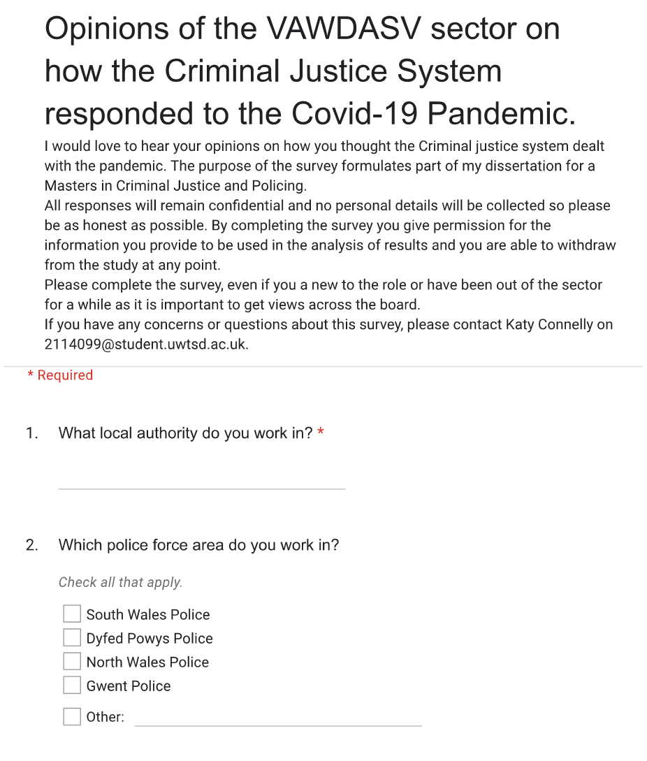

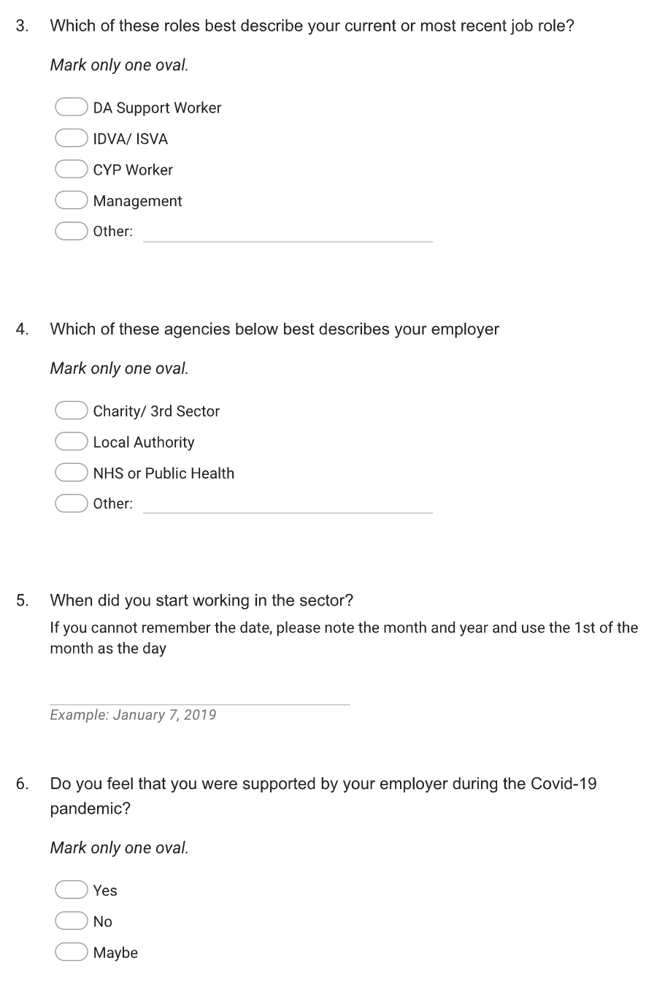
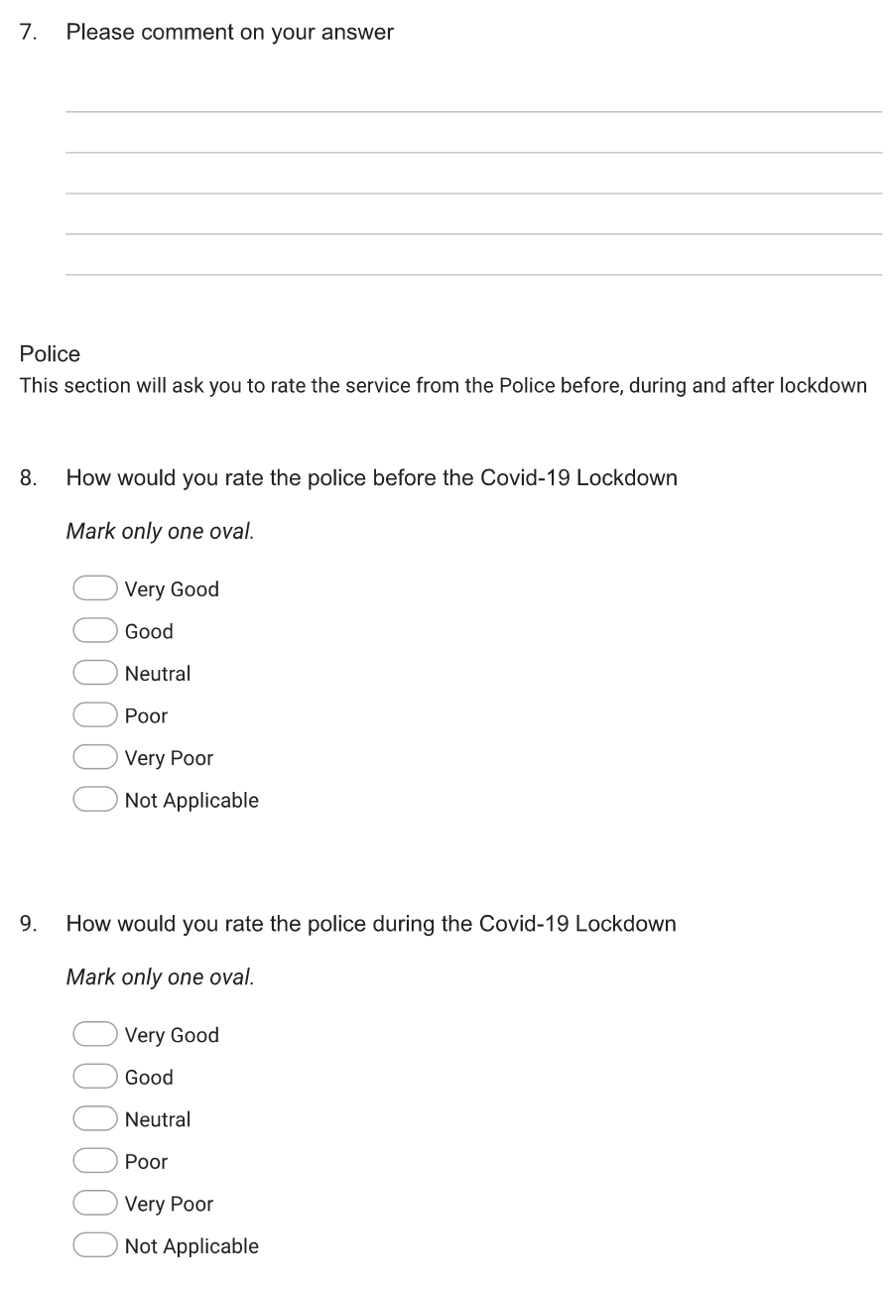

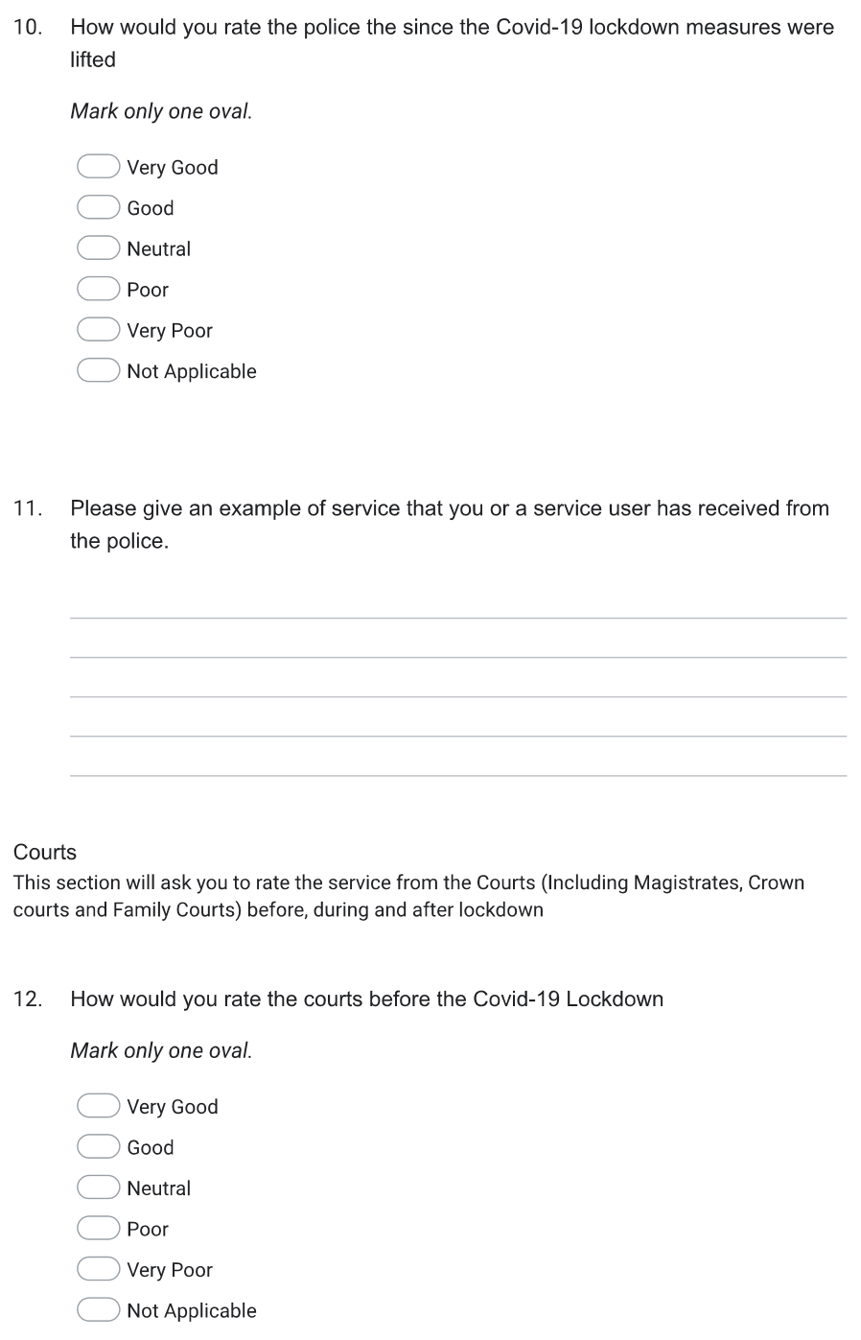
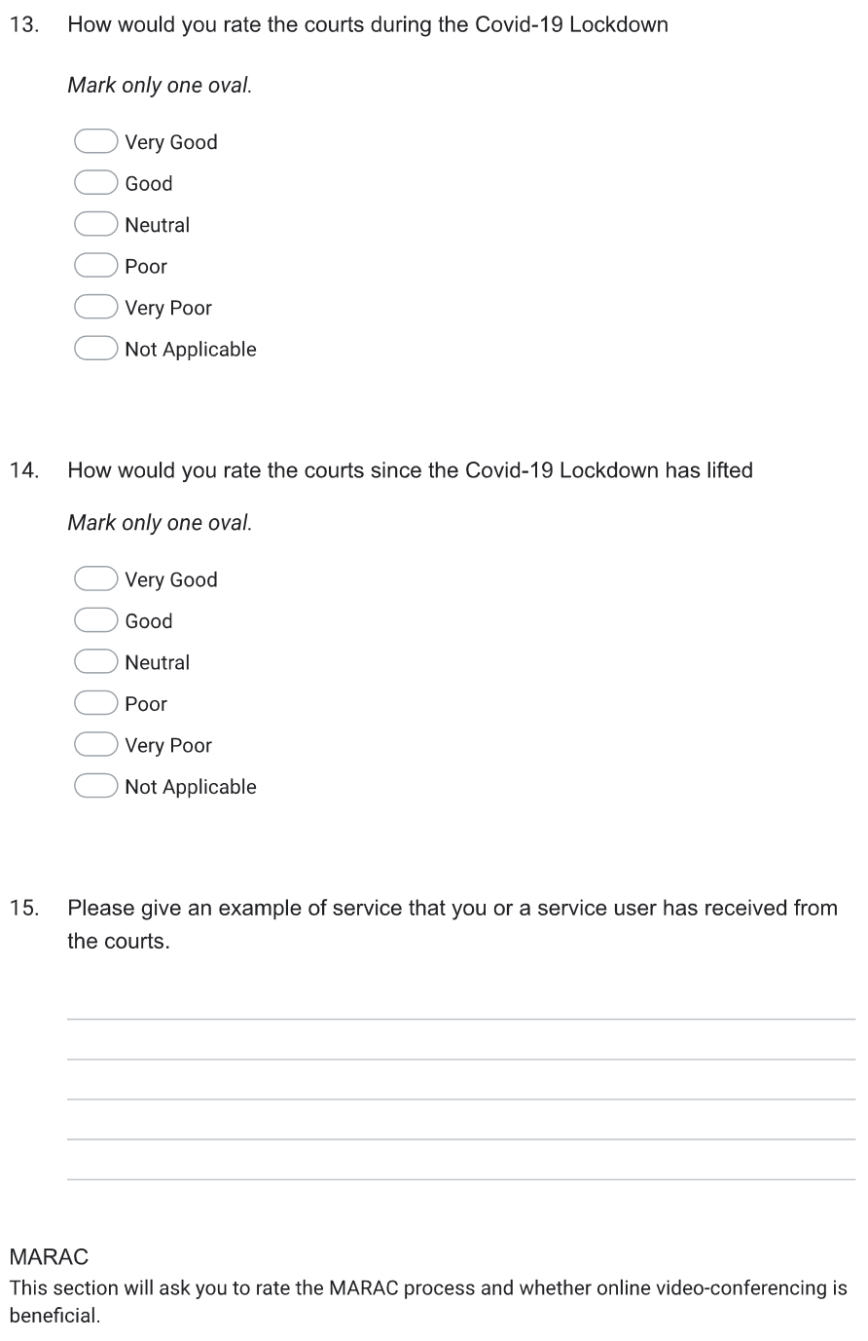
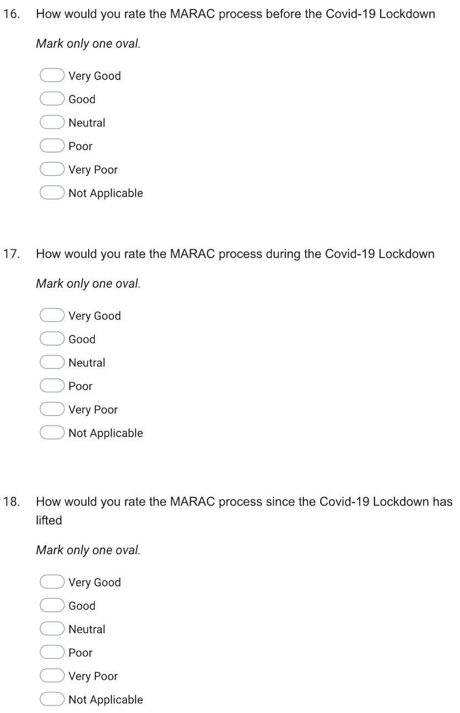
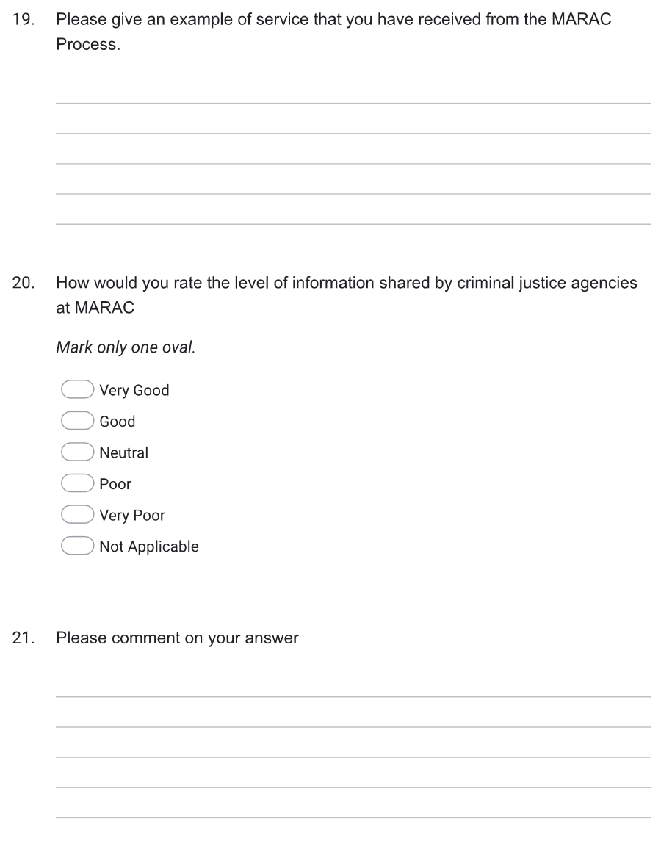

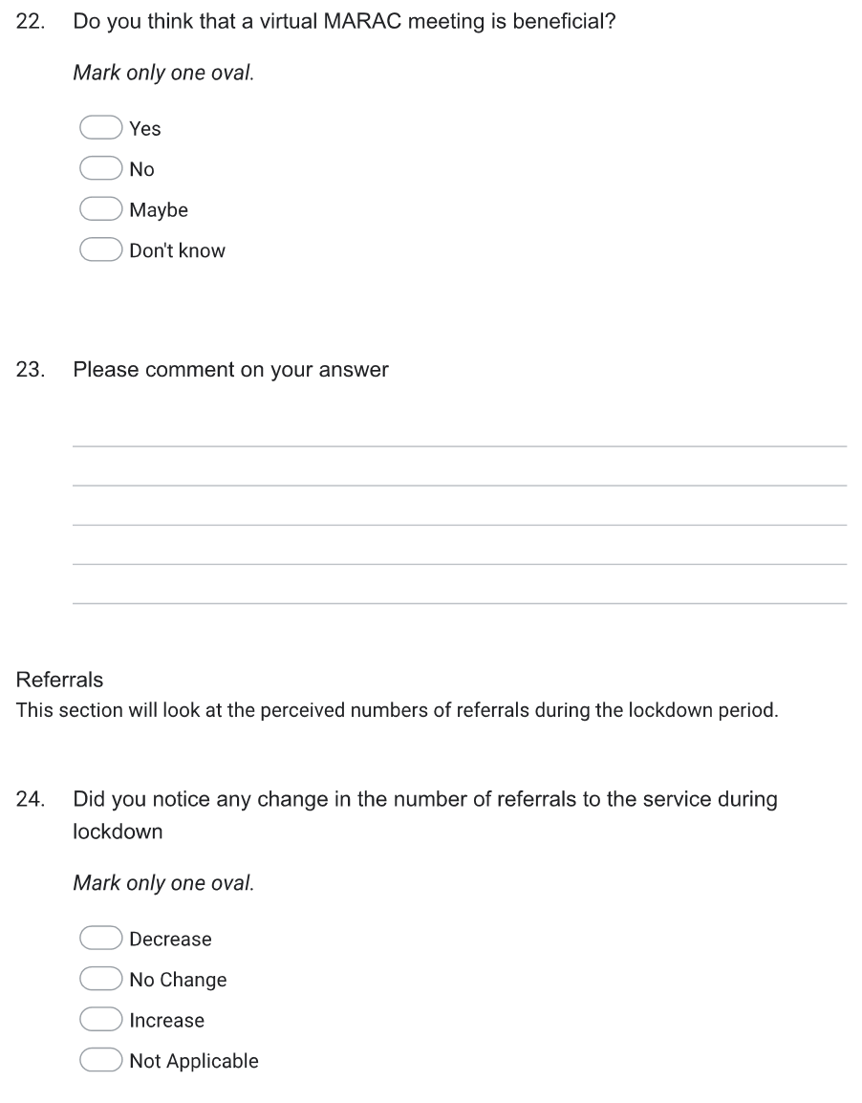

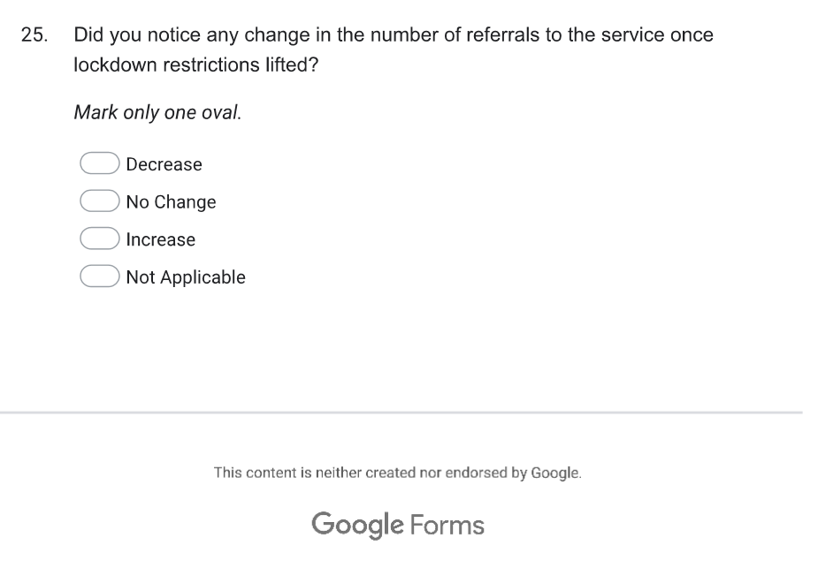

Appendix 2- Welsh Women’s Aid Fortnightly Newsletter, dated 5th October 2022


