

UWTSD MBA HKBM7009
(UWMBA-30013-2022-1-SS)
HKBM7009 Global Business Challenges

An Analytical Study on Exploring Investment Opportunities in a Global Financial Market: The United States

Student Name | ： | Leung, Hon To
Student ID Number | ： | 2133985
Date of Submission | ： | 26 Feb 2023
Lecturer | ： | Dr. Che Cheong Poon

UWTSD MBA (May/Nov 2022 intakes)
HKBM7009 Global Business Challenges

Assignment Title:
An Analytical Study on Exploring Investment Opportunities in a Global Financial Market: The United States

“I, Leung Hon To (Student ID: xxxxxx), certify this work is the result of my own investigations, except where otherwise stated. All references have been duly cited”

Signed: __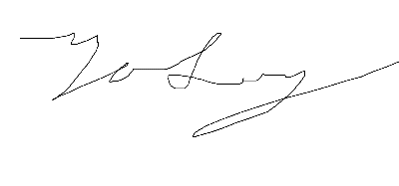___________________
Date: 26 Feb 2023

Synopsis

C Group is a fashion retailer in Hong Kong. It encountered a lot of financial difficulties in the past 5 years due to the outbreak of COVID-19. It had loss in its original retailing business in Hong Kong, Mainland China and Macau. This analytical report helps C Group to explore the opportunity from the US stock market and get a way to earn profits for the company based on a list of favorable factors which seems to be an attractive opportunity to C Group. The report analyzes C Group’s current company situation, the US stock market analysis, the return and risk analysis and finally recommend an investment proposal to C Group.

Table of Contents

 |  |  |  | Page
1 Introduction |  |  |  | 4
1.1 | Research motivation and objectives
1.2 | Research framework
2 Company Background |  |  |  | 7
2.1 | Company profile
2.2 | Current investment portfolio and investment performance
2.3 | The global business challenges and the rationale for exploring investment opportunities in the US financial markets
3 Characteristics of the chosen global stock market |  |  |  | 14
3.1 | A comparison of the stock price index movement between the US stock market and Hong Kong
3.2 | The US stock market profile
3.3 | The economic prospect
4 Analysis and discussion |  |  |  | 19
4.1 | Investment return
 | 4.1.1 |  | Capital return
 | 4.1.2 |  | Income return
 | 4.1.3 |  | Equity premium
4.2 | Investment risk
 | 4.2.1 | Stock price volatility
 | 4.2.2 | Market risk
 | 4.2.3 | Exchange rate risk
4.3 Cost and benefit of investing in the US stock market
5 Conclusion and recommendations |  |  |  | 28
5.1 | Conclusion
5.2 | Recommendations
References |  |  |  | 30

1 Introduction

This analytical report is going to analyze and explore investment opportunities in the global financial market for a Hong Kong fashion company “C Group”. The chosen global stock market is the United States. The report evaluates the challenges and opportunities to provide stock investment decision plan for “C Group” in the US.

1.1 Research motivation and objectives

The research questions regarding to the US stock investment by C Group are: 1) To justify C Group’s profitability in the US stock investment, and 2) to justify the risk diversification in the US stock investment.

The research motivation is the need for C Group to get other potential financial income besides its original business and maintain a good asset management for the company. Under the outbreak of COVID-19 since 2019, the fashion industry has been largely affected due to the lockdowns, less tourism activities and the blockage or delay of international trading. C Group need to find other ways to get more income for the company to maintain a good income statement.

The fashion industry in Hong Kong did not perform well in 2022. Although the resurgence of global economic activity after COVID-19 has been gradually controlled gave a boost for the overall sales in the industry, the logistic bottlenecks and high shipping costs remain as great challenge to C Group (Hong Kong Trade Development Council, 2022). In the fourth quarter of 2022, the Gross Domestic Product (GDP) decreased by 4.2% in real terms from a year earlier, and whole year decreased by 3.5% in real terms from 2021 (Hong Kong Trade Department Council, 2022). The value of retail sales decreased by 4.2% year-on-year in November 2022 over the same month a year earlier. The inflation also rose by 1.9% in 2022 versus 2021. The data has shown that Hong Kong did not recover well from COVID-19 which has occurred nearly 4 years. C Group need to maintain a better finance by US stock investment and seek for external opportunities.

The Dow Jones Industrial Average (DJI), a US stock index, did not perform well in 2022 which the blue chip index fell nearly 8.8% and it was the third-worst decline in the 21st century (The Motley Fool, 2022). However, the index shows an encouraging pattern after the decline experienced in 2022. The average return for DJI in years after a decline of at least 8.8% is 16.7%, which means it is a good timing for C Group to invest in the US stock market in 2023. Therefore, there is an urge for C Group to consider US financial investment.

The research objectives are: 1) To identify the expected return and potential risk of investing in the US stock market; 2) To identify the proportion of capital of C Group to be invested and the timeline of investment in the US stock market.

1.2 Research framework

With the clear research objectives mentioned above, the report is going to explore by analyze the C group’s company background and review its current financial situation and difficulties, then it analyzes the US stock market’s performance and the prospect in the near future, it also conducts a qualitative and quantitative analysis about the return and risk, finally it recommends a detailed investment proposal to C Group.

2 Company background

C Group is a fashion retailer in Hong Kong. It is well-known as “Shirt Expert” in 50’s and 60’s and it was listed on the Hong Kong Stock Exchange in 1971. Its products are diversified, and it involves in menswear, ladies wear, children’s clothing, ties and underwear. The brand spirit is to provide excellent quality clothing. The brand is well known in Hong Kong, Mainland China and Macau (C Group, 2023).

2.1 Company profile

C Group is one of the most famous Hong Kong fashion brand and it was founded in 1952. It positions its brand to be good quality and luxurious clothing products for different age group people. Besides Hong Kong business, it also exports to Japan, Singapore, and other Asian countries. The revenue of the group for the year ended 31 Jul 2022 is HK$103 million and the gross profit declined by 8% to HK$75 million when compared to 2021.

Although Hong Kong’s economy gradually recovered in late 2021 after the strike of COVID-19, it showed a weakening momentum in first quarter of 2022. There are several reasons such as the social distancing policy in Hong Kong and high cautiousness by the public in response to Omicron variants (Disease variants from COVID-19). C Group has its own financial asset management through securities trading, but it also suffered a loss of HK$25 million for the year ended 31 Jul 2022 and the reason behind is the economic uncertainty, the geopolitical tensions and continuous impact of the pandemic in 2022. C Group needs a better financial asset management through overseas stock investment.

The economic recovery seems to be slow, and C Group has taken some business decision in cost adjustment to reduce the negative impact of the COVID-19. It closed some underperforming shops and targeting new shops with cheaper rent. It also reduced the direct selling costs such as staff cost. Even though C Group has tried to manage its income statement better, the trend still reflected a year-on-year drop in revenue and it has dropped by 61% in 2022 (Figure 1) (Post-COVID period) when compared to 2018 (Pre-COVID period).

Figure 1: C Group’s revenue from 2018 to 2022
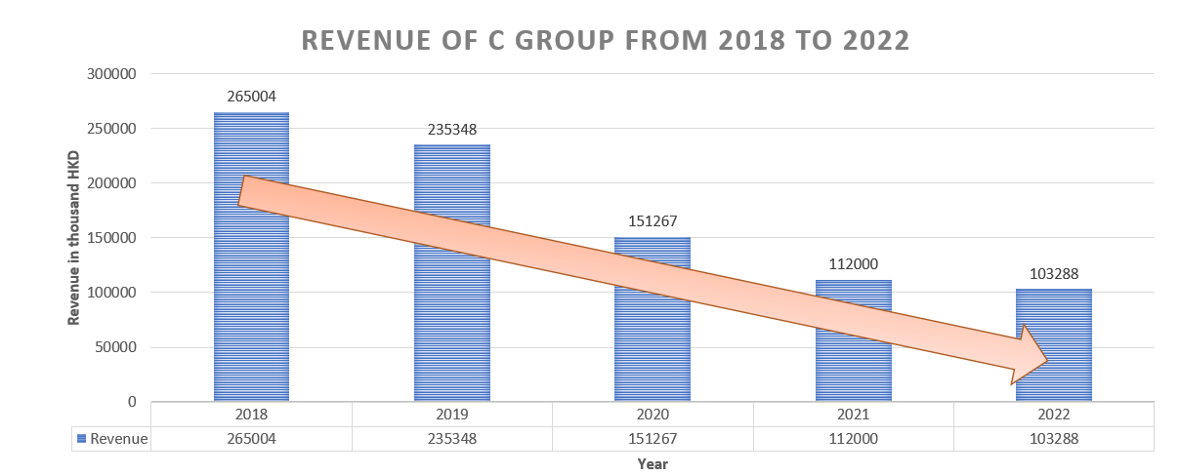
Source: Extracted from the C Group’s annual report, 2018-2022

2.2 Current investment portfolio and investment performance

The investment portfolio of C Group is come from a few areas. One is property investment and letting business in Hong Kong and Mainland China. The group owns its company properties, and it generates a stable rental income. For the year ended 31 July 2022, it earned HK$53 million. The second channel is from securities trading. The group invested in Hong Kong stock market for many years but it does not always generate a good profit for the company. The group suffered a loss of HK$25 million for the year ended 31 July 2022 (Figure 2).

The financial income of C Group comes from gains on financial assets (securities trading) and exchange gains. By looking into figure 2, it shows that C Group did not manage its financial assets properly and generate a good profit. By observing the period of 2018 to 2022, C Group suffered loss in its financial assets so it needs to explore investment opportunities in the global financial market in order to manage a healthy and growth profile.

Figure 2: Financial income of LF from 2018 to 2022
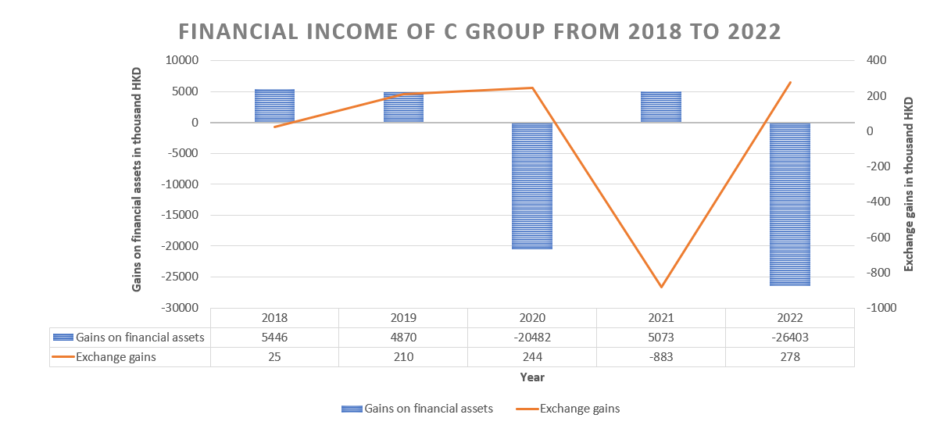
Source: Extracted from C Group’s annual report, 2018-2022

Table 1: Cost Structure of C Group in 2022 financial year
Cost Structure | % | HKD$ (in thousand)
Revenue | 100% | 103,288
Fair value losses on investment properties | 46% | 47,588
Selling and distribution expenses | 43% | 44,633
Administrative expenses | 50% | 51,510
Depreciation | 12% | 12,221
Bank interest income | 0.3% | 269
Government grants | 2.0% | 1,852
COVID-19 related rent concessions | 5.1% | 5,261
Net Loss (Gains) on financial assets at FVTPL | 24% | (24,514)

Source: Extracted from the C Group’s annual report 2022

COVID-19 gave great challenge to C Group and it still reflected in 2022’s income statement. By looking into the cost structure of C Group (Table 1), its selling and distribution expenses and administration expenses have taken up 43% and 50% of the revenue respectively. It shows that the operation cost was a great pressure to C Group and revenue did not cover the cost well. With the support of Hong Kong government in 2022, C Group received government grants of $269,000 so that it can release some operational pressure in short term. For the rental of C Group’s outlet, it got some rent concessions which has negotiated from the landlords so it slightly helped the income statement. However, the security trading has suffered from $24 million loss which has taken up 24% of the revenue. C Group is currently having a weak financial statement. C Group should pursue overseas stock investment and get more profits.

2.3 Global business challenges and the rationale for exploring investment opportunities in the US stock market

To pursue a better financial management for C Group, there are a few business challenges to be tackled in 2023. One is economic uncertainty. The global economy is recovering from the impacts of the pandemic. It is challenging for companies to predict about the financial performance. Secondly, there is a fast-changing consumer demand. Companies need to stay tuned to new trends and adapt to their products or services. If the companies cannot catch the trend well, it will largely affect the full year performance. Thirdly, companies continue to face the challenge of global trade and complex supply chains in 2023. There are different regulations, tariffs and geopolitical conflicts around the world. Companies need to coordinate with suppliers, manufacturers, distributors well in different regions to operate the business well.

There is opportunity in US stock investment. US stock market has suffered from great drop in 2022 but the economic indicators like Gross Domestic Product (GDP) and employment rate are still at a healthy rate and proved to be resilient in 2022. In the fourth quarter of 2022, value stocks in the US stock market has started to outperform in the sectors such as energy, industrials, materials and financials. To generate a better financial income for C Group, the US stock market could be a good choice.

3 Characteristics of the US stock market

The chosen stock market for C Group is the US. The reason of choosing the US stock market is that the US has been the world’s leading economic powerhouse in financial markets since 1871. The Gross Domestic Product (GDP) of the US in 2022 is $25,040 billion USD (IMF, 2023). The real GDP was +1.6% annual change rate in 2022. The US has the biggest and most valuable companies’ trade. Nine of the ten world’s largest companies are from the US, such as Apple, Microsoft, Alphabet (Google), Amazon and Tesla. The huge economy and its great exposure to technology sector have made US stock market attractive to a lot of investors.

3.1 A comparison of the stock price index movement between the UK stock market and Hong Kong

Dow Jones Industrial Average (DJI) represents the US stock market and Hang Seng Index (HIS) represents Hong Kong Stock Market. By looking into the historical price of DJI and HSI (Figure 3), it shows that the stock performance of DJI has steady growth trend from 2010 to 2022. Especially from 2020 to 2022 (Post-COVID period), DJI has continued its rising trend while HSI has a drastic dropping trend. This means that Hong Kong has suffered a great loss in stock market and the companies have not performed well since 2019 while the US stock market was on a good trend in economic recovery in the post-COVID period. It implies that the US stock market is worth to explore.

Figure 3 Comparison of DJI and HSI stock price from 2010 to 2022
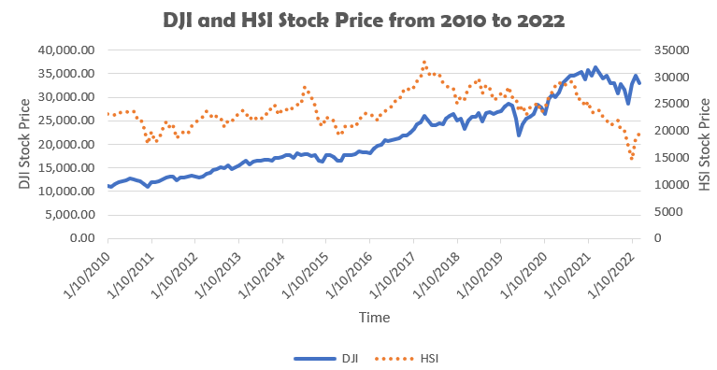
Source: Calculated from DJI and HSI stock price from 2010 to 2022

The correlation matrix of DJI and HSI is 0.399 from 2010 to 2022 and -0.268 from 2019 to 2022 (Post-COVID period) (Table 2). When the correlation value is negative, it means that the two index tend to increase and decrease differently (Higham, 2002). The post-COVID period has a negative value of correlation at -0.268 so the US stock market could diversify the risk from the stock investment in Hong Kong. It is worth the time for C Group to explore the US stock market and it is beneficial to its financial management.

Table 2 Correlation Matrix of DJI and HIS
From 2010 to 2022 | Correlation
DJI vs HSI | 0.399
From 2019 to 2022
DJI vs HSI | -0.268
Source: Calculated from DJI and HSI stock price from various year

3.2 The stock market profile

The Dow Jones Industrial Average is a price weighted measure of 30 US blue-chip companies. The total market capital is $10,061,612 million USD (Dow Jones, 2023). The annualized return of 3 years is 8.68% and 5 years is 7.77%. The annualized risk of 3 years is 21.28% and 5 years is 18.49%. The price per earning (P/E) is 22.32 as of January 31, 2023 which is positive and attractive. The indicated dividend yield is 2.09% which is a stable return. The top three performing blue-chip stocks through January 2023 were Salesforce (CRM), Disney (DIS) and American Express (AXP) (Investors, 2023). In the sector weighting of DJI (Figure 4), the largest components are from Healthcare (20%), Information Technology (19%) and Financial (17%).

Figure 4: Sector breakdown of DJI
Source: Dow Jones, 2023

3.3 The economic prospect

The economic prospect in 2023 can be based on a few data. Firstly, persistently high inflation in both developed and developing economies can affect the income of different countries including the US (United Nations, 2023). High inflation will erode real incomes and the global cost of living will be higher (Ball, 1992). According to the International Monetary Fund (2023), the global inflation rate has raised from 4.7% in 2021 to 8.8% in 2022. It caused aggressive monetary tightening in many developed and developing countries. The stock price of the US stock can be affected and drop if the situation continues.

Secondly, rising interest rate diminished purchasing power and weakened consumer confidence and investor sentiment (Mok, 1993). Rapid interest rate increased by the Federal Reserve of the United States has negative impact to the investment activities. The US stock investment can be reduced and stock price can go down if the interest rate continues to be high.

However, the Real Gross Domestic Product (Real GDP) of the US reflected a good sign for the stock market. The Real GDP of the US in 2022 is +1.6% and it was +5.7% in 2021 (International Monetary Fund, 2023). It shows a recovery trend when it looks back to -3.4% in 2020. Real GDP is an inflation-adjusted measure that reflects the total economic output of a country. In terms of the economic activity, stability, growth of goods and services in an economy, the Real GDP reflected that there are potentials for the US stock market (Reddy, 2012). Therefore, C Group should capture the opportunity in the US stock investment.

4 Analysis and discussion

The US stock market’s profitability and risk can be determined by quantitative and qualitative analysis. The discussion divided into the expected investment return and the potential risks in the investment.

4.1 Investment return

The return on investment is a performance measure used to evaluate the efficiency of an investment. To assess the profitability of the US stock investment decision, the expected return can show the attractiveness of the investment to C Group.

4.1.1 Capital return

The assumption of C Group invests 1% of its equity as of 31 July 2022 which amounted USD$1.9 million in the US stock market (C Group, 2022). The stock price of DJI on 1 Feb 2023 is $34,092.96 (Yahoo Finance, 2023). With the capital of USD$1.9 million, C Group can buy 55 stocks approximately on 1 Feb 2023. According to the historical data of DJI, the annualized return in 3 years is 8.68% (Dow Jones, 2023). The expected capital return for C Group investing in the US stock market is USD$2,407,001.09 (Table 3). This capital return of USD $531,889 during the US stock investment in 3 years generates 22% return on investment which is very attractive to C Group.

Table 3: Capital return and Income return of C Group in the US stock investment
Initial investment | Capital return | Income return
C Group’s Equity  at 31 July 2022:  USD $190 million | DJI stock price on 1 Feb 2023:  34,092.96  (Yahoo Finance, 2023) | Indicated dividend yield:  9.63%  (Stock Analysis, 2023)
Initial investment:  (1% of the equity)  USD$ 1.9 million | Annualized return of 3 years: 8.68%  (Dow Jones, 2023) | Payout frequency:  Monthly  (Stock Analysis, 2023)
The number of DJI stocks C Group can buy:  55 stocks | DJI expected stock price on 1 Feb 2026:  34,092.96*(1+8.68%)^3  = 43,763.66 | Expected dividend gains after 3 years:  $231,794
Capital return:
(43,763.66 – 34,092.96)*55
=$531,889
Source: Constructed by author

4.1.2 Income return

With the investment by C Group of USD$1.9 million and buy 55 stocks at $ $34,092.96 on 1 Feb 2023, the expected income return is $231,794 (Table 3). The dividend is distributed monthly and the dividend yield of DJI is 9.63% (Stock Analysis, 2023). This is a stable income return and the frequency of dividend distribution is attractive.

4.1.3 Equity premium

The equity premium is total return on stock minus the treasury bill rate. It is the excess return a stock pays to the holder over and above the risk-free rate for the risk the holder is taking.

Equity premium can be calculated by the below formular:
Equity Premium = RS - RTB
= [CRS + IRS] – [Inflation + Real interest rate]
= [CRS – Inflation] + [IRS – Real interest rate]
RS is the total return on stocks; CRS is capital return (i.e., capital gain); IRS is income return (i.e., dividends); RTB is the Treasury bill return (i.e., interest rate on zero risk investment) (Jorion and Goetzmann, 1999).

The equity premium for C Group’s US stock investment is $5.5% (Table 4). This shows the expected return of the investment is positive and attractive. The increase in risk associated with an investment accompanied by a rise in potential reward. The figure shows that C Group can consider to invest in the US stock market.

Table 4: Calculation of Equity Premium
Total return on stock (RS) | = capital return (CRS) + income return (IRS)  =$531,889 + $231,794 (Table 3)  =$763,683
Treasury Bill rate (RTB) | Inflation + Real Rate  = 8.1% + (-1.2%)  = 6.9%  (IMF, 2023)  (The World Bank, 2023)
Equity Premium | = RS – RTB  = 12.4% – 6.9%  = 5.5%
Source: Constructed by author

C Group can earn $531,889 of capital return and $231,794 of income return from the transaction of DJI from 1 Feb 2023 to 1 Feb 2026. The return on investment is 12.4% (Table 4). The dividend also has a promising and frequent distribution to the investors and rate of 9.63% is attractive. To conclude, the expected return of the US stock investment is good and C Group should consider to invest.

4.2 Investment risk

Investment risk is the risk that C Group is exposed during the US stock investment and it is important for the company to understand how do the risks affect the investment return.

4.2.1 Stock price volatility

Volatility is the rate at which the price of a stock increases or decreases over a particular period (Brennan and Xia, 2001). High volatility means higher risk and it is an indicator for C Group to estimate the fluctuations that may happen in the future. DJI has a coefficient of variation (CV) of 33.97% which is way higher than HSI 13.62% by looking at all time data (2010-2022) (Table 5). However, the data in post-COVID period (2019-2020), the CV of DJI is 12.92% which is slightly lower than HSI 14.05% (Table 5). As the post-COVID period is more relevant to the current investment decision, DJI shows a lower volatility than that of HSI and this means DJI is relatively lower fluctuations and investment risk is lower so it favors to C Group’s US stock investment decision.

Table 5: Coefficient of variation of DJI and HSI
 | Coefficient of variation (CV) 2010 - 2022
DJI | 33.97%
HSI | 13.62%
 | Coefficient of variation (CV) 2019-2022 (Post-COVID period)
DJI | 12.92%
HSI | 14.05%
Source: Calculated from DJI and HSI’s stock price from 2010-2022

4.2.2 Market risk

The market risks that may affect C Group’s investment are inflation rate and interest rate. The inflation rate of the US is 8.1% (IMF, 2023) and this is 5 years high level in recent years (Table 6). A rising inflation means rising price of goods and services and it creates uncertainty to the US market. The US companies’ profit will be negatively impacted because the profit margin is lower. The investor confidence in the US stock market becomes lower and less willing to hold more stocks. The stock price will hence go down and this is an unfavorable factor to C Group’s investment plan.

Although the inflation rate is high currently, the Federal Reserve has worked on beating down the inflation rate and raised interest rates. The US is in its disinflationary process now. The Fed targets to bring inflation down to 2%. Additionally, the unemployment rate of the US is now at the lowest level in 53 years at 3.4% (Trading economics, 2023). Half a million new jobs were added to the US economy. The stock market in the US has reacted positively and DJI is in its rising trend. Therefore, C Group does not need to be negative about the high inflation rate now.

Table 6: Inflation rate and real interest rate of the US from 2018 to 2022
The US | 2018 | 2019 | 2020 | 2021 | 2022
Inflation rate  (IMF,2023) | 2.4% | 1.8% | 1.2% | 4.7% | 8.1%
Real Interest rate  (The World Bank, 2023) | 2.4% | 3.4% | 2.2% | -1.2% | -
Lending Interest rate  (The World Bank, 2023) | 4.9% | 5.3% | 3.5% | 3.3% | -
Source: IMF, 2023 & The World Bank, 2023

The real interest rate in 2021 is -1.2% (Table 6) and it means that the bank, treasury and money market rates were not keeping up with inflation. According to the recent news (CNBC, 2023), the Fed raises rate a quarter point and expects an ongoing increase on the interest rate. The target range of the Fed is 4.5% - 4.75%, which will be the highest since Oct 2007. Although it do help to lower the inflation, the high interest rates will make stock investors become more reluctant to bid up stock prices because the value of future earnings looks less attractive.

The high interest rate means the cost of borrowing is high and the US companies will borrow less money to invest. The demand for the stock market tends to fall. The US stock price will drop. However, some stocks may perform well during times of rising interest rates. Companies that have strong balance sheets may only feel minimal impacts. Therefore, high interest rate could make the US stock price drop but it is not necessary. C Group could consider this as a risk and carefully observe the market response. C Group can still consider investing in the US stock market.

4.2.3 Exchange rate risk

As the investment involves Hong Kong dollar (HKD) and US dollar (USD), there is exchange rate risk in the transaction. Hong Kong uses a linked exchange rate system (LERS) since 17 Oct 1983 in the range of USD/HKD is 7.75-7.85 (Hong Kong Monetary Authority, 2023). Therefore, the exchange is relatively stable and benefits to stock investment. As of 25 Feb 2023, the current rate of USD/HKD is 7.850 and it is an uptrend for the past year (Gov Capital, 2023). The exchange rate maintains a good portfolio so it is good for future investment.

USD is relatively stable when exchanging from HKD. This is beneficial to C Group in the US stock investment plan. It has less worries about the future value of the currency so the risk of exchange rate is low. C Group should consider to invest in the US.

4.3 Cost and benefit of investing in the US stock market

As analyzed in the previous sessions, the US stock market is attractive and worth to invest. The capital and income return is good with a 12.4% return on investment and a promising monthly dividends will be distributed. The dividend yield is also good. The equity premium is positive with 5.5%. The expected return shows a good sign and good return in the future. By considering the risk of investment, the volatility of the US stock market is slightly lower than that of Hong Kong in the post-COVID period which means less fluctuations in the stock price, the high inflation rate now tends to be lower down by the Federal Reserve soon, and the interest rate will be raised which may raise the concern of stock price drop. However, the situation can be closely monitored and observed. With the cost and benefit evaluation, C Group should invest in the US stock market.

5 Conclusion and recommendations

The analysis about challenges and opportunities about the US stock investment in this report can conclude that C Group should invest in the US stock market because of the good expected return and low risk.

5.1 Conclusion

C Group faced a lot of hardships in recent years because of the outbreak of the COVID-19 and the revenue drop for 5 consecutive years. The research questions of this report are 1) To justify C Group’s profitability in the US stock investment, and 2) to justify the risk diversification in the US stock investment. The analysis shows that C Group generate an attractive profit after 3 years of US stock investment. During the 3 years, C Group can receive dividend monthly so the return is very stable. The risks like inflation rate, interest rate and exchange rates are minimal. C Group just need to carefully monitor the situation during its investment period. For the risk diversification, the US stock investment can help C Group diversify the risk from its original business and its local financial investment because the correlation matrix shows that US and HK stock markets tends to increase or decrease differently. It has the effect of diversifying the risk in Hong Kong market.

5.2 Recommendations

The recommendation to C Group is to invest in the US stock market in Quarter 1 of 2023. The initial investment can be 1% of its equity at around USD$ 1.9 million. C Group can invest in DJI for 3 years. The expected return at the third year is $763,683 (Table 7). The USD$1.9 million will turn into USD$2.6 million in the third year (Table 7).
There may be limitation of the report. The risks of the investment has been assumed to be minimal such as the effect of high inflation rate and interest rate. These depends on the US government’s monetary policy so it is unpredictable, and C Group may need to observe the economic policies and the response of the stock market.

Table 7: C Group’s US stock investment proposal
C Group | USD$
Initial investment | $1,875,112.8
Return on investment | $763,683
Total capital at 3rd year | $2,638,796
Source: Constructed by author

Reference

Ball, L. (1992). Why does high inflation raise inflation uncertainty? Journal of Monetary Economics, 29(3), pp.371-388.

Brennan, M. J., & Xia, Y. (2001). Stock price volatility and equity premium. Journal of monetary Economics, 47(2), pp.249-283.

C Group (2023). Company Official Website. (Accessed: 3 Feb 2023).

Dow Jones (2023). Factsheet of Dow Jones Industrial Average. Available at: https://www.spglobal.com/spdji/en/indices/equity/dow-jones-industrial-average/#overview (Accessed: 3 Feb 2023).

Higham, N. J. (2002). Computing the nearest correlation matrix—a problem from finance. IMA journal of Numerical Analysis, 22(3), pp.329-343.

Gov Capital (2023). USD/HKD Forecast, United States Dollar / Hong Kong Dollar currency rate prediction: Buy or sell USD/HKD pair? Available at: https://gov.capital/forex/usd-hkd/#:~:text=Future%20currency%20rate%20of%20the,on%202024%20February%2025%2C%20Sunday. (Accessed: 25 Feb 2023).

Hong Kong Monetary Authority (2023). Linked Exchange Rate System. Available at: https://www.hkma.gov.hk/eng/key-functions/money/linked-exchange-rate-system/#:~:text=Through%20a%20rigorous%2C%20robust%20and,Kong's%20monetary%20and%20financial%20stability. (Accessed: 25 Feb 2023).

Hong Kong Trade Development Council (2022). Clothing Industry in Hong Kong. Available at: https://research.hktdc.com/en/article/MzEzOTM4MzY2 (Accessed: 3 Feb 2023).

Hong Kong Trade Development Council (2022). Economic and Trade Information on Hong Kong. Available at: https://research.hktdc.com/en/article/MzIwNjkzNTY5 (Accessed: 3 Feb 2023).

Investors (2023). 2023 Top Dow Jones Stocks To Buy And Watch In February: Apple Surges On Earnings. Available at: https://www.investors.com/research/dow-jones-stocks/ (Accessed: 3 Feb 2023).

International Monetary Fund (2023). Inflation rate, average consumer prices. Available at: https://www.imf.org/external/datamapper/PCPIPCH@WEO/OEMDC/WEOWORLD (Accessed: 3 Feb 2023).

Jorion, P., & Goetzmann, W. N. (1999). Global stock markets in the twentieth century. The journal of finance, 54(3), pp. 953-980.

Mok, H. M. (1993). Causality of interest rate, exchange rate and stock prices at stock market open and close in Hong Kong. Asia Pacific Journal of Management, 10, pp.123-143.

Reddy, D. L. (2012). Impact of inflation and GDP on stock market returns in India. International journal of advanced research in management and social sciences, 1(6), pp.120-136.

Stock Analysis (2023). DJIA Dividend Information. Available at: https://stockanalysis.com/etf/djia/dividend/ (Accessed: 24 Feb 2023).

Trading economics (2023). United States Unemployment Rate. Available at: https://tradingeconomics.com/united-states/unemployment-rate (Accessed: 25 Feb 2023).

The Motley Fool (2023). Will the Dow Jones Recover in 2023? Here's What History Shows. Available at: https://www.fool.com/investing/2023/01/14/will-the-dow-jones-recover-in-2023-heres-what-hist/ (Accessed: 6 Feb 2023).

The World Bank (2023). Real Interest rate (%) – United States. Available at: https://data.worldbank.org/indicator/FR.INR.RINR?locations=US (Accessed: 24 Feb 2023).

United Nations (2023). World Economic Situation and Prospects: February 2023 Briefing, No. 169. Available at: https://www.un.org/development/desa/dpad/publication/world-economic-situation-and-prospects-february-2023-briefing-no-169/#:~:text=Average%20GDP%20growth%20is%20projected,weigh%20on%20investment%20and%20exports. (Accessed: 3 Feb 2023).

