2336876 spencer murphy mckirdy

Table of contents

NEW PAGE: e-Portfolio. 1.

A link to the online e-portfolio homepage. 2.A screenshot of the e-portfolio homepage. Task 1 – Written summary. * A screenshot/s of the task answer in the e-portfolio.

Task 2 – Academic poster. 1. A link to view/download the Poster from it’s cloud storage (e.g. OneDrive, google drive). 2.A screenshot/s of the task answer.

Task 3 – Automatic Referencing tool. * A screenshot of the task answer in the e-portfolio.

Task 4 – e-Portfolio creation and review. * Include screenshots of the task answer in the e-portfolio.

essential skills for study and employment

essential skills for study and employment would be turning up to your work on time being punctual having good time keeping skills putting your positive energy into your work or studies not missing work or study for any vague reasons making sure you time manage to get to such and leave time for your priorities such as doing your work online if you work from home or in an office for example doing all your essays or research or filling your forms or paperwork so at your study or workstation then to prioritize your other responsibilities like caring for yourself and family and so on it is also necessary to do the amount of work required of you in a reasonable time to avoid over working which could lead to stress and result in poor work which will not be beneficial to your employer or teacher in college school or university and so on. The stress of over working could perhaps cause illnesses then in the long term you will end up not being employed or at school so leading a balanced approach to your work will help you to achieve results in the correct way. Other things that are essential are the necessary qualifications and minor skills such as fast typing being good at research finding the references or the information that you need to be able to get those qualifications, being able to make use of comprehension and then finding the answers within a text or to be able to provide different views make a surmise of what you think is valid based on the information quoted and give your view of what is contradictory in the source. Using this information to back your viewpoint this also works in the workplace as you may need to find the actual facts rather than make a claim or a reference without bringing the substantiated evidences. These types of things I found useful in both work and my studies and I achieved an A in religious studies at GCSE. However on history I only got a B due to slight procrastination and illness at times and missed some classes this lead to poor memorisation in the exam, didn’t due adequate research unfortunately so I got a lower grade. So I fixed these issues so I can do my level 4 course here at university and then do my own computer manufacturing business.

[www.oxfordlearning.com/10-essential-study-skills-every-student-needs/]

74301_Burns_Essential_Study_Skills.pdf (sagepub.com)

Essential Study Skills (yourknow.com)

26 essential study skills « Essay writing help and study advice (essayzone.co.uk)

Essential Study Skills for Middle School Students - Effective Students

, work together to produce a mind-map that summarises the key considerations of effective teamwork. The mind-map is the artefact for the introductory activity of Unit 2 topic 4 ‘Life is a Team Sport’. • Arrange a day and time for your team to meet and use collaborative technology of your choice such as MS Teams, Zoom or Google Chat/Meet) to discuss ideas and create the map. You can research before and/or during the meeting. • Your mind map should be clear and concise and no more than approx. 400-500 words or approx.150 words per person.

Select one of the topics in Moodle Unit 4 ‘Digital Collaboration’ and summarise some of the main points with several supporting citations and accompanying screenshots/images. Use an automatic referencing tool (such as Refworks) to add relevant citations and a reference list to the summary. (Approx. 350 words)

Collaborative Teamwork and Professional Academic poster (A3 Poster): Create an A3 academic poster highlighting why some of the areas/concepts covered in the Moodle Unit 2 topic 4 ‘Life is a Team Sport’ are important for academic and career success in your chosen discipline. It is important to follow the ‘Academic Poster Guidelines’ on Moodle to complete this task. The guidelines include format and font size instructions that are used instead of a word limit for this task. Citations and a list of references should be included in the poster (Approx. 4/5 sources). The poster should be completed individually. • To receive marks for this task you must ensure your tutor is able to view the Academic Poster online e.g. if using Onedrive/GDrive to store your poster file, make sure the file permissions to the document enable anyone with the link to view the file. After creating your e-portfolio in task 4 below, include your answer to task 2 in the e-portfolio. Team Activity: ‘Life is a Team Sport’ introductory activity.

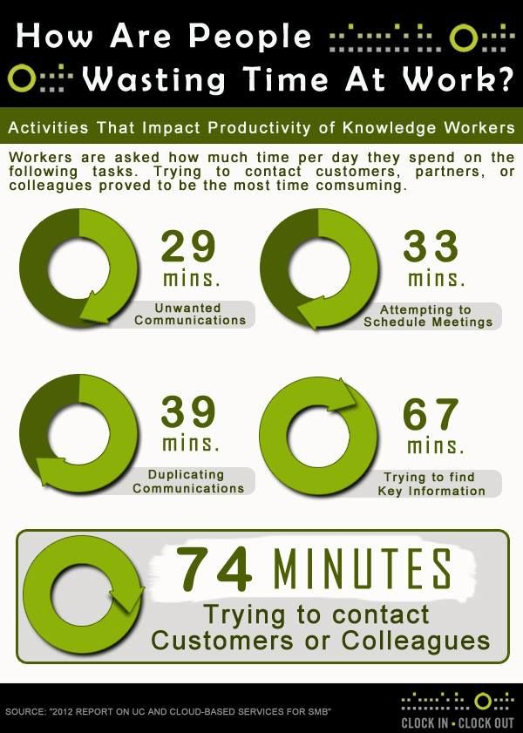

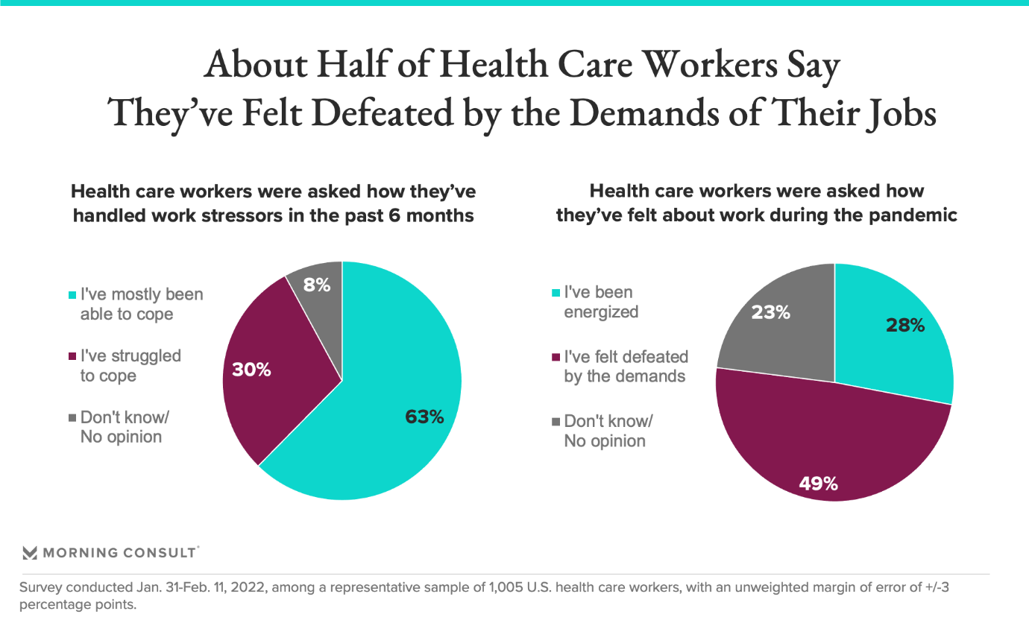

This is my e portfolio

Home | Spencer Murphy 1 (2336876.wixsite.com)
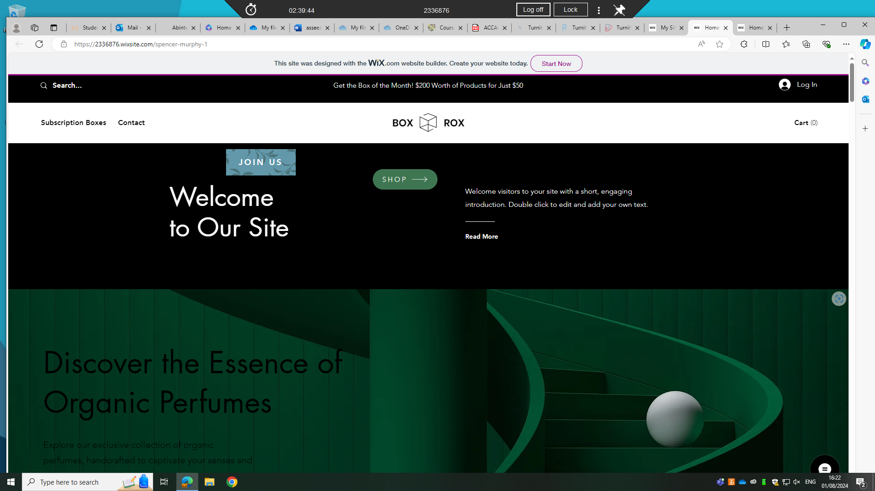

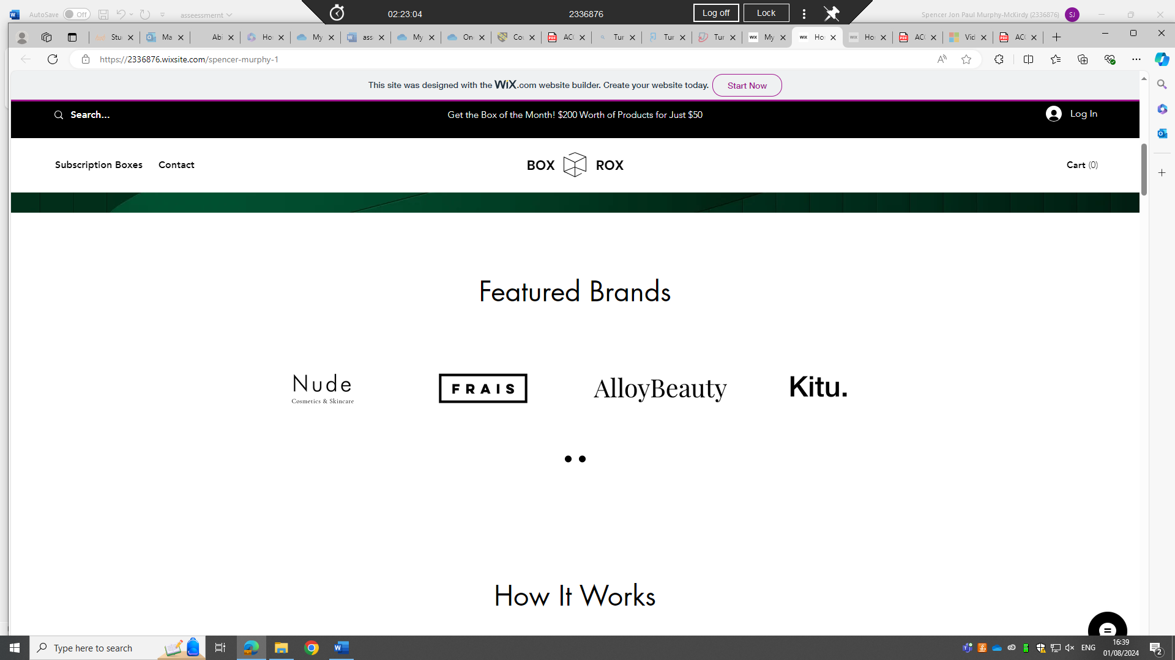
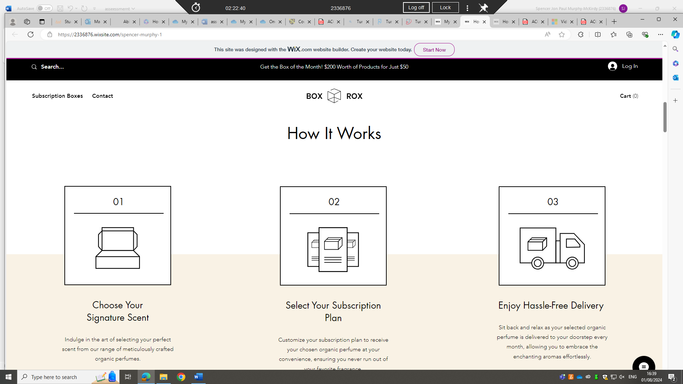
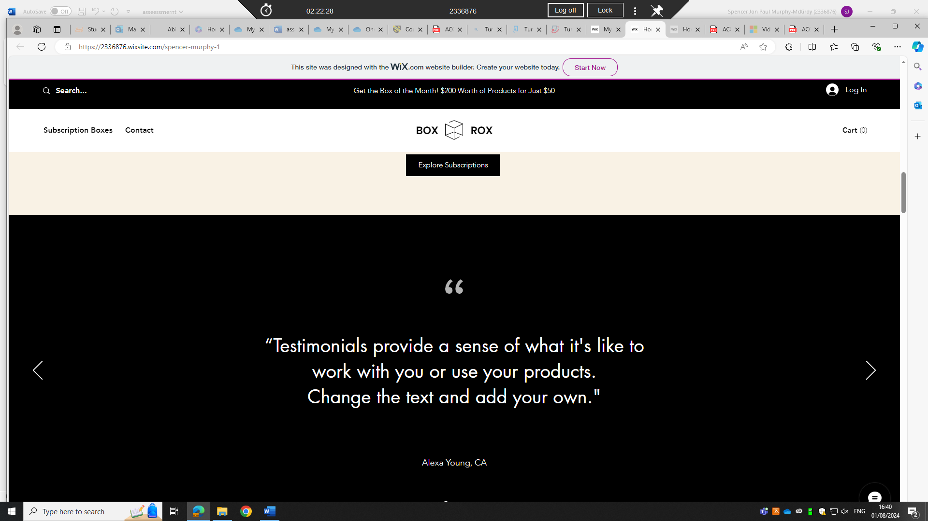
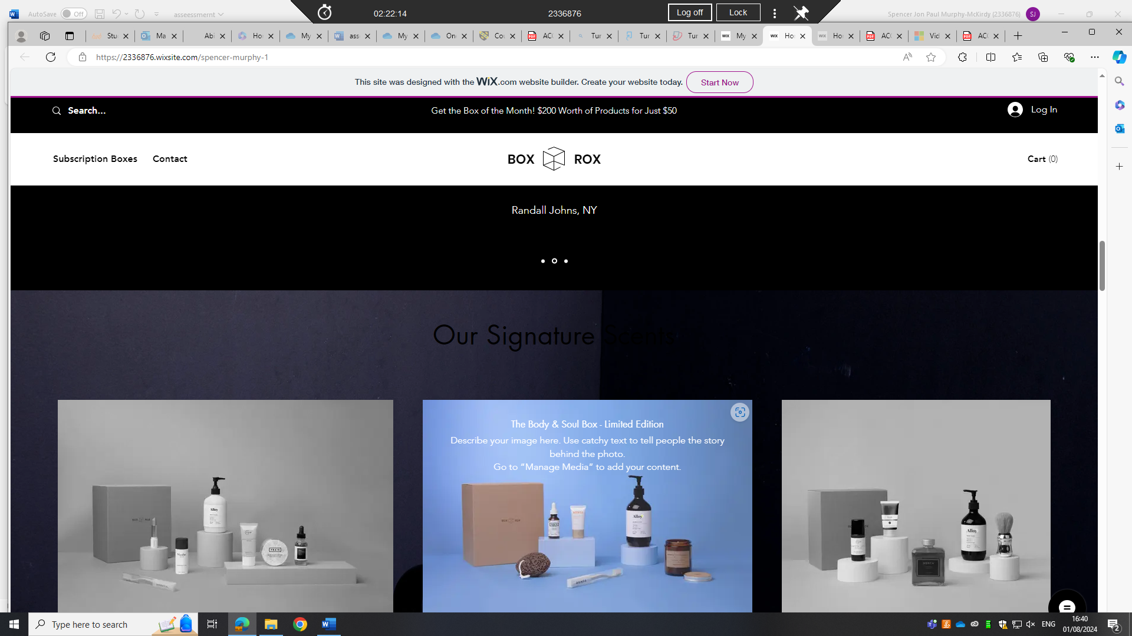
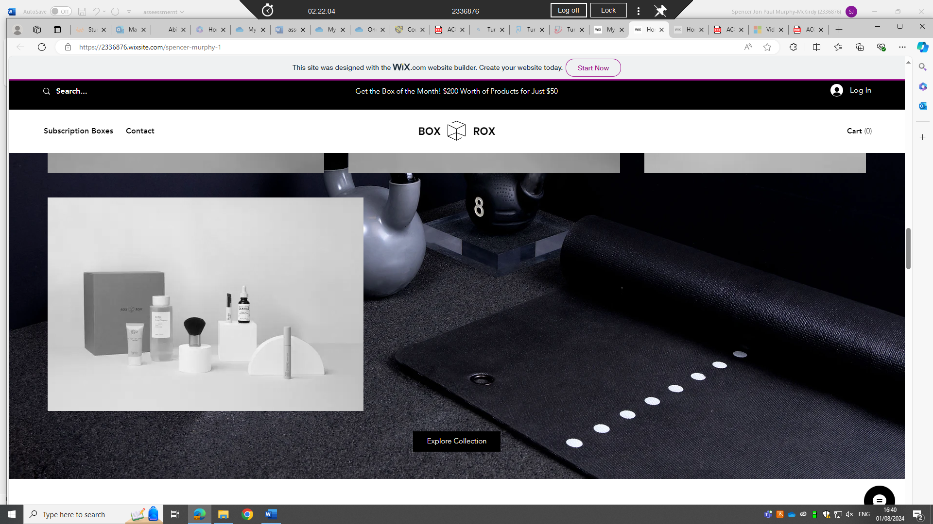
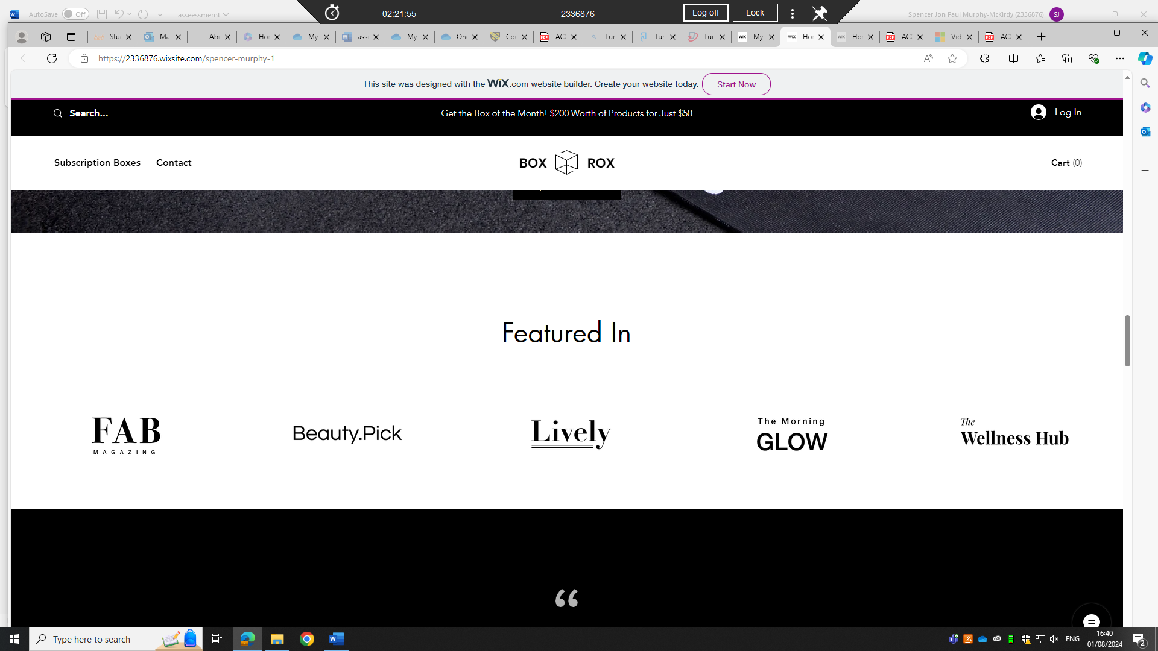

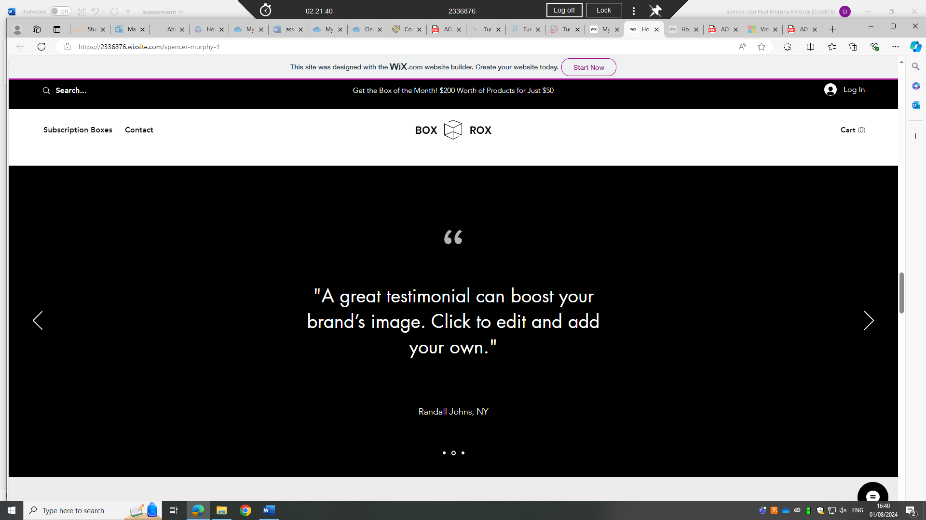
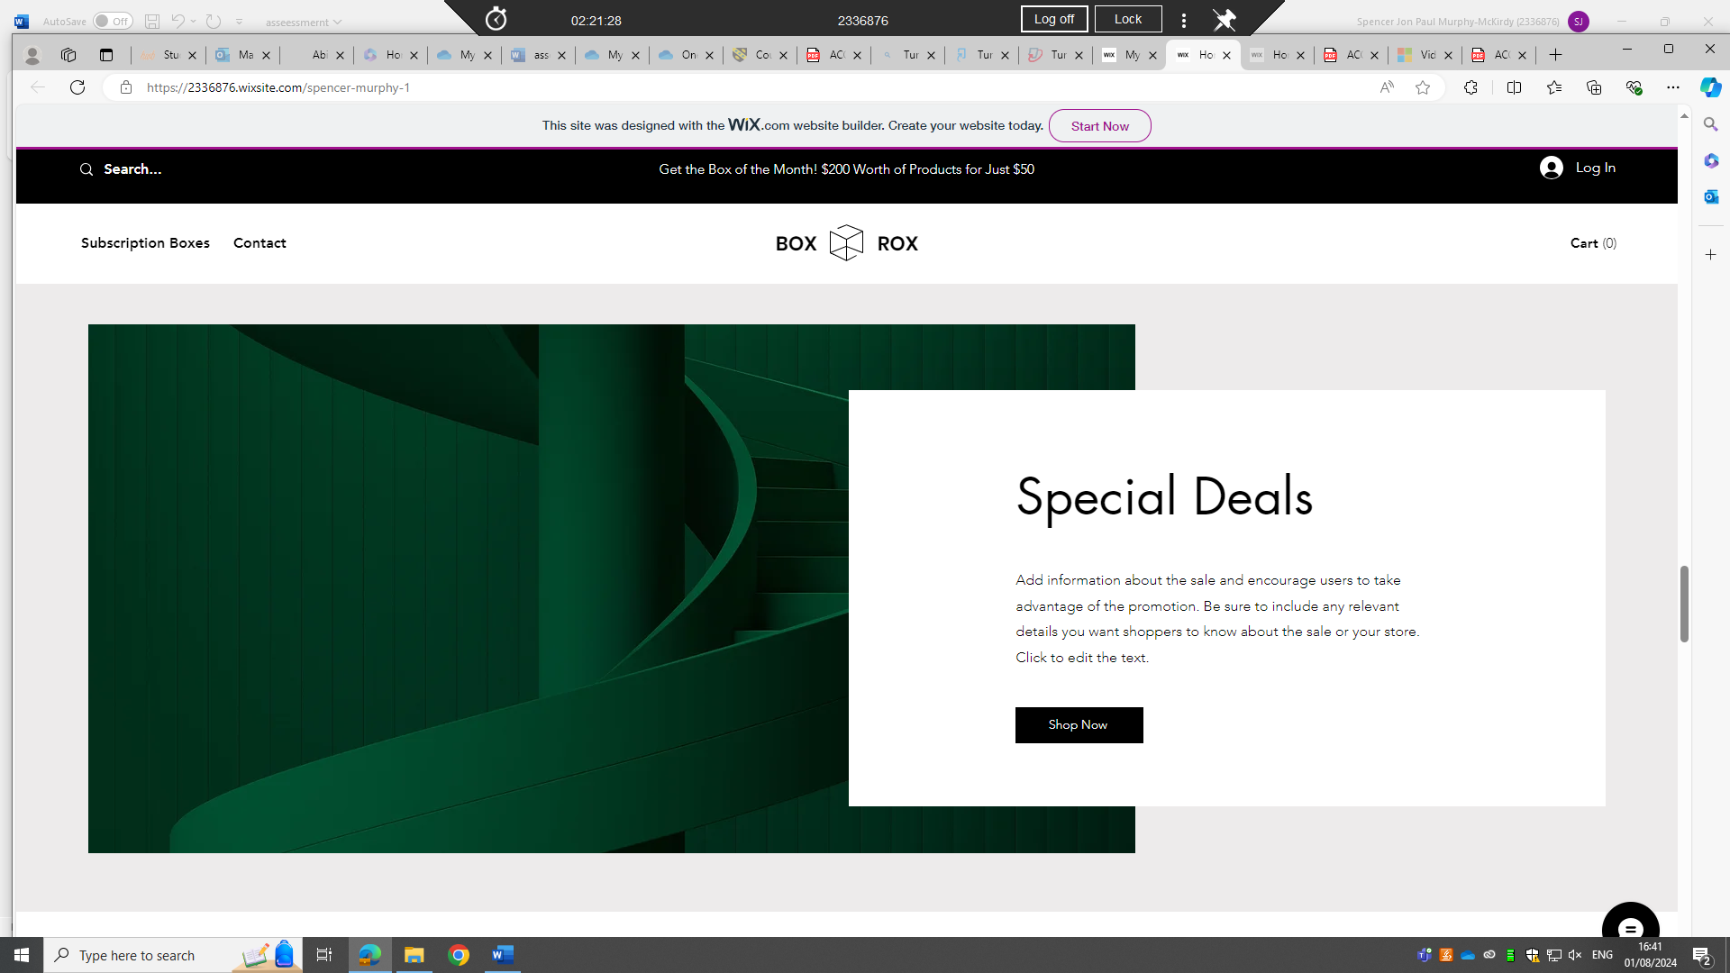
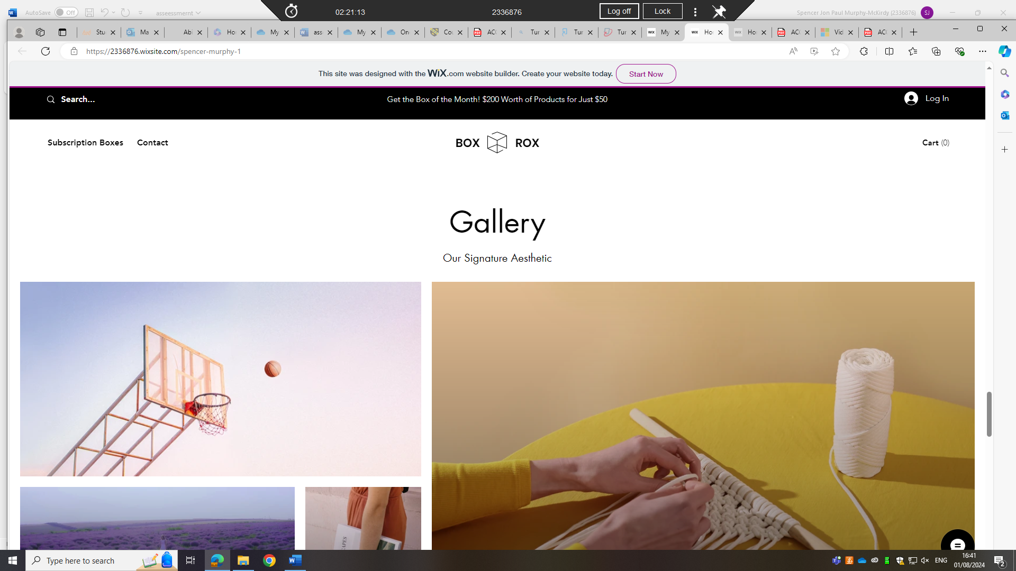
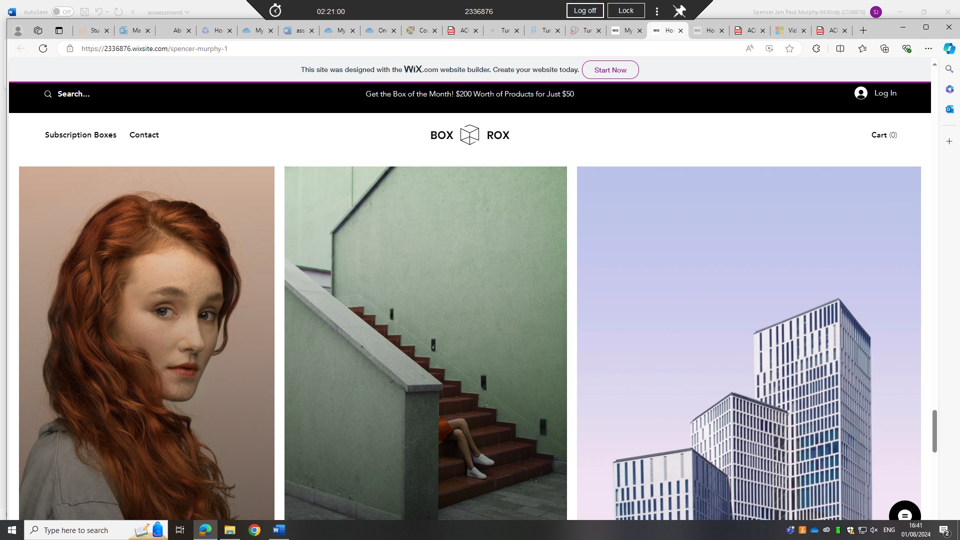
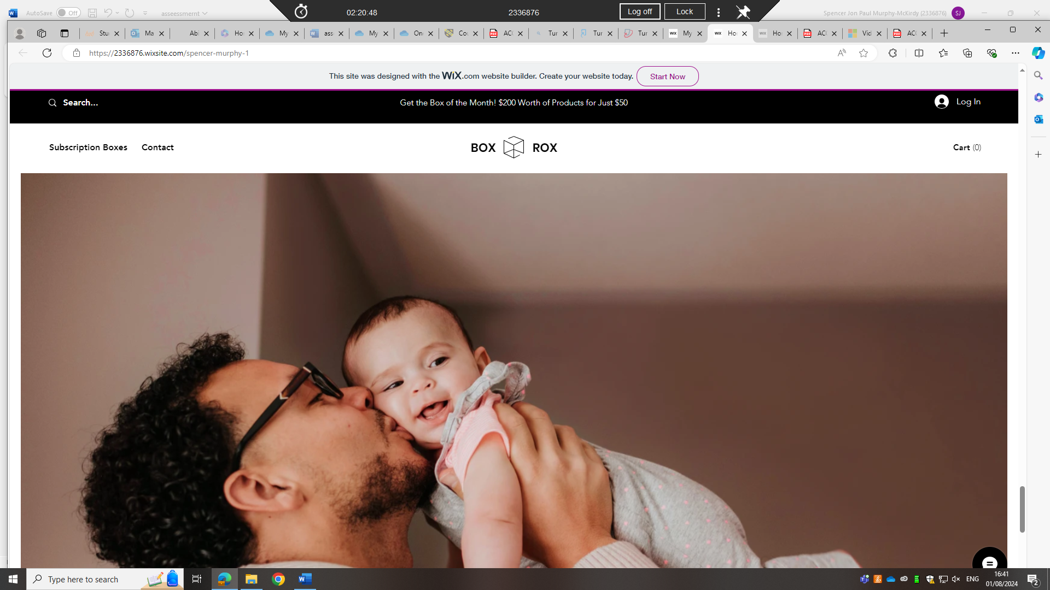
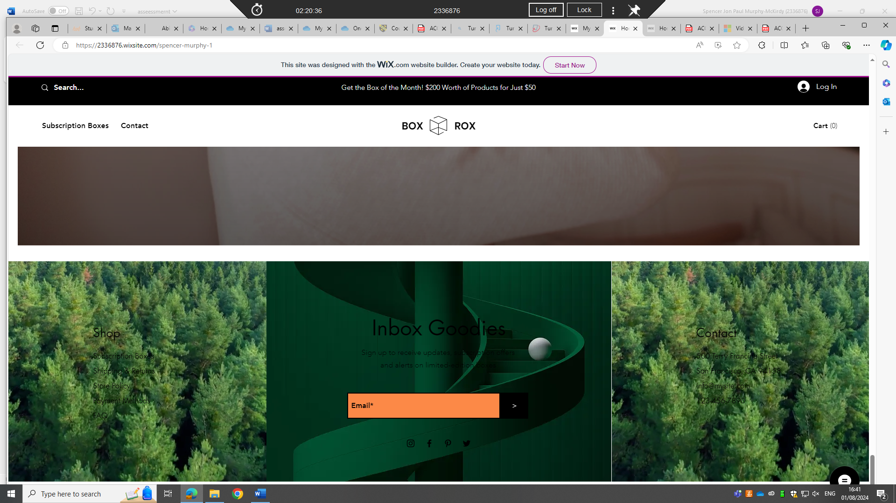
, work together to produce a mind-map that summarises the key considerations of effective teamwork. The mind-map is the artefact for the introductory activity of Unit 2 topic 4 ‘Life is a Team Sport’. • Arrange a day and time for your team to meet and use collaborative technology of your choice such as MS Teams, Zoom or Google Chat/Meet) to discuss ideas and create the map. You can research before and/or during the meeting. • Your mind map should be clear and concise and no more than approx. 400-500 words or approx.150 words per person.

Select one of the topics in Moodle Unit 4 ‘Digital Collaboration’ and summarise some of the main points with several supporting citations and accompanying screenshots/images. Use an automatic referencing tool (such as Refworks) to add relevant citations and a reference list to the summary. (Approx. 350 words)

