

Name: Gloria Armoo
Student ID: 2511523
Module Code: LCHS4003
Module: Introduction to Health and Social Care
Lecturer: Daniel Haruna

Submitted on: 26/03/2026

Table of Contents
Introduction....................................................................................................3
Importance of Effective Communication in Mr Ahmed’s Care.......................3/4
Administrative Skills and Record-Keeping in Professional Practice..............5/6
Collaborative Working in Multidisciplinary Healthcare...................................6/7
Conclusion.....................................................................................................8
References....................................................................................................9/10

Introduction
In health and social care, effective communication, ideal administration, and multidisciplinary interaction are inevitable towards the delivery of patient safety and a quality of care. These factors are necessitated by the weak individuals whose needs such as stroke survivors are resource intensive. This is in line with the case study of a 68-year-old patient, Mr Ahmed who had suffered a stroke in the domiciliary care and who was on the road to recovery meaning that such competencies are essential. The stroke can disrupt the communication, swallowing and cognition that is aggravated by the fact that Mr Ahmed does not speak fluent English. According to (Burton-Hughes, 2017, Carers UK, 2022) a case of a recent missed care visit that resulted in delayed drug administration highlights the necessity to keep records and ensure the provision of this effective communication. It is a critical review of communication, administrative competence and collaborative practice in relation to the case of Mr Ahmed.

Importance of Effective Communication in Mr Ahmed’s Care
Often one of the major components of safe and patient-centred practice in healthcare because communication is an obligatory practice, which is required to make sure that individuals are aware of their care plans, participate in passing judgments, and receive adequate treatment. The case of Mr Ahmed is an especially complex one when it comes to the issue of communication as he had an impairment in communication caused by stroke, as well as the barriers to communication caused by language (Kearns et al., 2025). Insisted that Stroke is commonly followed by the onset of aphasia or some other difficulties related to communication, which is to say that patients may struggle to think, to understand instructions or to be fully engaged in healthcare communication. It is against this basis that the healthcare providers must adopt adaptable and friendly communication patterns when it comes to the stroke survivors.
Equality Act 2010 further imposes limitations on the healthcare givers in that it would allow reasonable accommodations on the healthcare givers to allow equal access to medical services including the use of simplified language, translated documents or interpreters. To enhance the language with a cognitive or speech disability patient, the easy language methods are used in conjunction with the use of short sentences, easy-to-understand words, and graphics because understandable language supports higher perception (Chinn and Buell, 2021). In order to understand how communication operates in the healthcare sector, one may apply the Shannon-Weaver 1948 Communication Model. According to this model, communication is a process that entails the sender, message, communication channel, receiver and potential interference or noise. In the implementation of the case of Mr Ahmed, senders include medical practitioners who pass information on the drug care, rehabilitation and daily routine care. The receiver is Mr Ahmed and his wife who are to react and respond to such information. The barriers such as the language barriers, speech disorders following stroke and the medical terms may however hamper the delivery of the message.

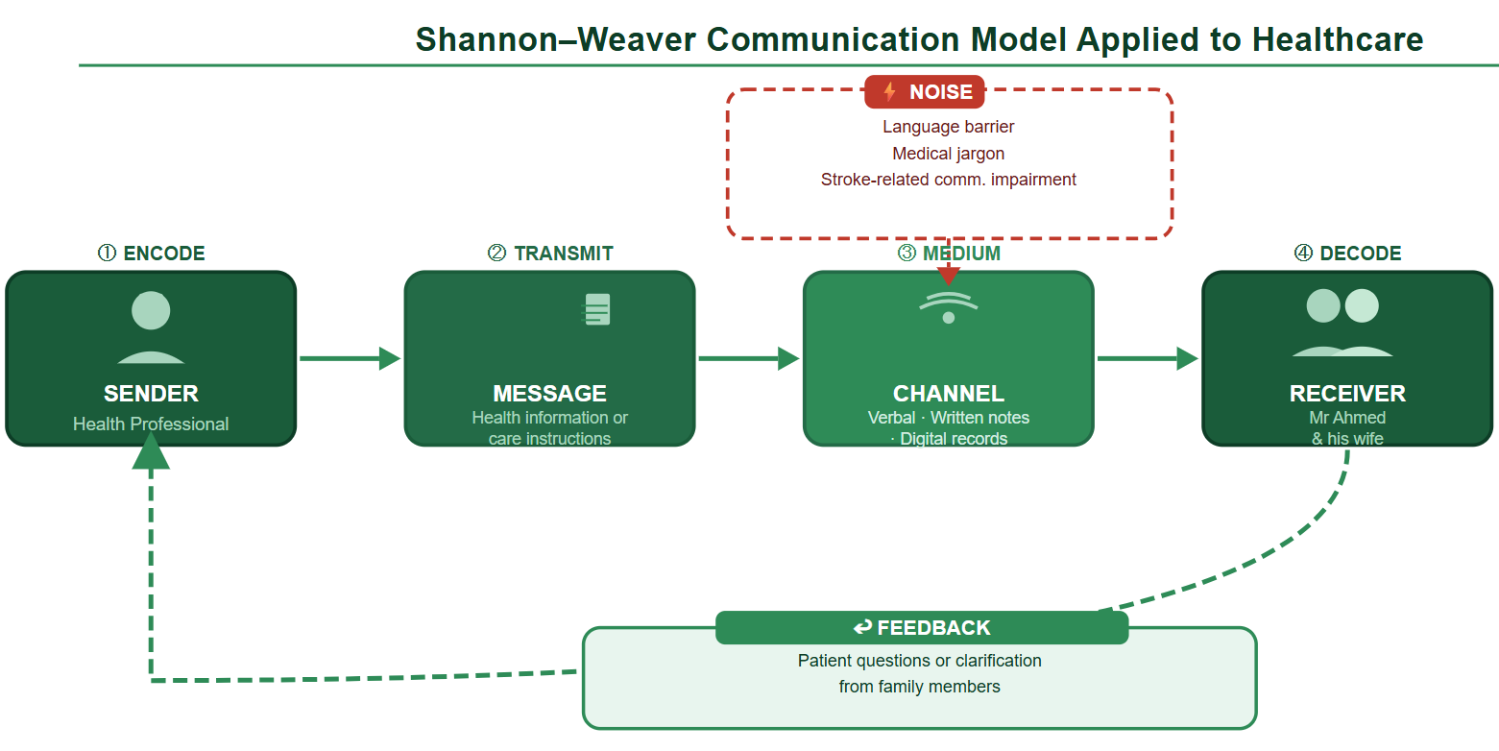
figure 1: Shannon-Weaver Communication Model Applied to Healthcare (self-created)

Through the model, the point that is important to observe is that, effective communication does not only involve the delivery of information but a well-fulfilled meaning of the message. Healthcare professionals therefore should ensure patient understanding and provide them with an opportunity to make comments. The second fact that is disclosed by the research is the statement that there should be access to communication as a necessary condition to enable the inclusion of people with communication disabilities in healthcare fairly (Kearns et al., 2025). As a matter of fact, involving Mr Ahmed in conversations and disrupting the communication therapy through speech therapy courses will be beneficial to his wife and keep him involved in the patient thereby enhancing health results.

Administrative Skills and Record-Keeping in Professional Practice
Some of the aspects in health care that demand administrative skill is accountability, continuity of care and safety of the patients. Effective documentation is used to ensure the staff healthcare professionals are able to retrieve the information required regarding the state of a patient, treatment plan and drug schedule. Mr Ahmed case, in which the shortage of the domiciliary care visit resulting in the delay of the medication serves to illustrate the expression of how weaknesses in the administrative processes can affect the wellbeing of the patient in a negative manner.
Record-keeping is an individual-organized writing of patient data which comprises of patient clinical observation, patient prescription of drugs, and interaction with the practitioners. The records enable the professionals to track down the movement of the patients besides ensuring that the care is offered to the patients in a coordinated way by the different professionals. The development of the healthcare system rests on implementing the electronic medical histories, and this is why the provision of information about patients to many specialists can be given in a safe and efficient manner. According to (Tapuria et al., 2021). the study demonstrates that the efficacy of transparency and better patient involvement in health care procedures can be achieved with help of patient access to electronic health records because patients can make informed choices.
In the United Kingdom, data protection of personal health information is the subject of Data Protection Act 2018 that ensures the legality, security, and transparency of working with personal data. The healthcare organisations must protect patient information by preventing their unlicensed access as well as disclosing the information to the concerned professionals, who will make a clinical decision. The act requires that the personal information should be accurate, it has to be well preserved and should be used with justifiable health intentions. This will not only ensure that the privacy rights of the patients are observed but will ensure that the healthcare teams deliver coordinated care.
The innovations in the technical sphere of healthcare systems have also brought about more problems in the field of the security of data and digital records. For example, healthcare workers are able to discuss online platform via computer-based programmes such as messengers or computer platform. These tools must be carefully used, however, because keeping or transferring a clinical information is easily affected in any case of inappropriate storage/transfer (Morris et al., 2021). Similarly, the current accelerating related healthcare technologies have created new concerns regarding the protection of privacy standards and the management of information (Shahid et al., 2022).

Table 1: Core Principles of Data Protection in Health and Social Care
Core Principles | Application to Mr Ahmed’s Care
Lawfulness | Health information used only for legitimate care provision
Confidentiality | Access restricted to authorised professionals
Accuracy | Records updated after each domiciliary visit
Security | Electronic and physical records protected
Transparency | Patients are informed about how data are used

Collaborative Working in Multidisciplinary Healthcare
The multidisciplinary teamwork works in complicated situations. Mr Ahmed has a GP, a district nurse, domiciliary carers and speech therapist. The partnership helps to exchange information and jointly act in harmony and holistic care (Donaghy et al., 2023; Bailey and Mutale, 2022; Glasby and Dickinson, 2014).
The challenges are encountered in the shape of the organisational culture difference and irresponsibility (Douglas et al., 2022). The structured communication and digital records are used to support teamwork and provide case reviews, shared care plans, and digital records. The family intervention such as the wife of Mr Ahmed adds to the rate of trust and offers culturally sensitive care.

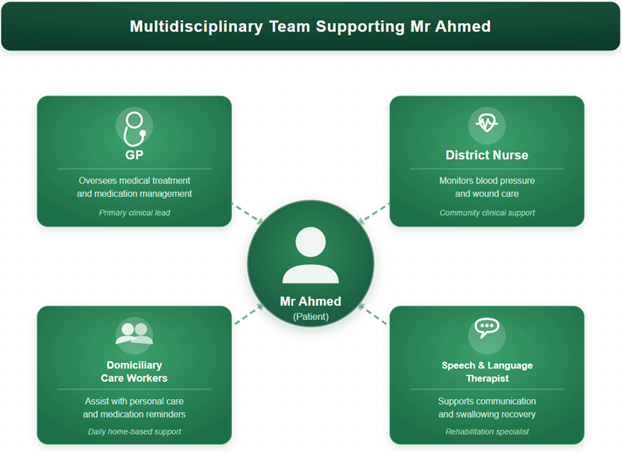
figure 2: Multidisciplinary Team Supporting Mr Ahmed

Although multidisciplinary collaboration can be an issue, the professionals involved are in the different organisations or professional cultures; this could create a barrier in communication and lack of definite responsibilities. According to (Douglas et al., 2022). multidisciplinary team conferences, through observational study it has been found that effective team providing entails implementation of organized communication procedures, effective leadership, and mutual decision-making amid professionals.
To address such challenges, healthcare teams must bring in reforms that foster teamwork and exchange of information. When and how to organize interventions Annual review of the cases: Regulatory case review meetings allow professionals to discuss the progress on patients. The persons on the team are well communicated also with the assistance of digital health records and shared care plans. These joint plans would be applicable in ensuring that the GP, the district nurse, domiciliary carers, and the speech therapist are not left behind to understand his condition and the process of treatment in the case of Mr Ahmed.
The other factor that leads to effective collaborations is that patients and family members need to be considered in the process of making care decisions. This wife of Mr Ahmed plays a major role in communication with the professionals and daily care needs of her husband. The engagement of the family in the conversation improves the communication process and creates trust and helps to ensure that the care plans are accomplished based on the preferences and the cultural context of the patient.

Conclusion
In conclusion, Mr Ahmed’s case can be portrayed in that quality healthcare is based on effective communication, administrative competence and multidisciplinary collaboration. The objectives of patient comprehension and participation are met due to the actions of inclusive communication, which are streamlined by the Equality Act 2010 and theories like Shannon Weaver. The Data Protection Act 2018 ensures safety and accountability of administrative skills. The combination of the professional knowledge and family involvement with the comprehensive care is known as multidisciplinary collaboration. The totality of these practices also ensures that the care of the complex needs of the patient is safe, respectful, and of high quality. The intricate health care needs of patients can be adequately fulfilled by healthcare teams through high levels of communication, shared care plans and close patient engagement. Such professional practices will ensure that patients such as Mr Ahmed will be safely, respectfully and high quality attended in the modern systems of health and social care.

References

Bailey, D. and Mutale, G.J., (2022). Social work's contribution to integrated primary health care teams in the UK for older adults with complex needs. Journal of Integrated Care, 30(3), pp.263-275. https://www.emerald.com/jica/article-abstract/30/3/263/209201

Burton-Hughes, L., (2017). What are the 6 Principles of the Care Act 2014? Principles of the Care Act 2014 | Safeguarding Information for Caregivers. Available at: https://www.highspeedtraining.co.uk (Accessed 2 March 2026).

Carers UK, (2022). Assessments – Your guide to getting help and support in England. Available at: https://www.carersuk.org (Accessed 3 March 2026).

Chambers, D., Cantrell, A. and Booth, A., (2021). Rapid evidence review: challenges to implementing digital and data-driven technologies in health and social care. Sheffield: The University of Sheffield. https://eprints.whiterose.ac.uk/id/eprint/175758/

Chinn, D. and Buell, S., (2021). Easy Language in the UK. Handbook of Easy Languages in Europe, pp.623-657. https://trepo.tuni.fi/bitstream/handle/10024/218529/Handbook_of_Easy_Languages_in_Europe.pdf?sequence=-1#page=624

Donaghy, E., Huang, H., Henderson, D., Wang, H.H., Guthrie, B. and Mercer, S.W., (2023). Primary care transformation in Scotland: a qualitative study of GPs’ and multidisciplinary team members’ views. The British Journal of General Practice, 74(738), p.e1. https://pmc.ncbi.nlm.nih.gov/articles/PMC10756001/

Douglas, N., Mays, N., Al-Haboubi, M., Manacorda, T., Thana, L., Wistow, G. and Durand, M.A., (2022). Observations of community-based multidisciplinary team meetings in health and social care for older people with long term conditions in England. BMC Health Services Research, 22(1), p.758. https://link.springer.com/article/10.1186/s12913-022-07971-x

Kearns, Á., Jagoe, C., Stockdale, R., Clarke, D., Manning, M., Menamin, R.M., Fitzmaurice, Y., Green, J., Duffy, O. and Kelly, H., (2025). Supporting communication access of people with communication disabilities in UNCRPD-ratified countries: an integrative review. International Journal of Language & Communication Disorders, 60(5), p.e70098. https://onlinelibrary.wiley.com/doi/abs/10.1111/1460-6984.70098

Morris, C., Scott, R.E. and Mars, M., (2021). WhatsApp in clinical practice: the challenges of record keeping and storage. International Journal of Environmental Research and Public Health, 18(24), p.13426. https://www.mdpi.com/1660-4601/18/24/13426

Shahid, J., Ahmad, R., Kiani, A.K., Ahmad, T., Saeed, S. and Almuhaideb, A.M., (2022). Data protection and privacy of the internet of healthcare things. Applied Sciences, 12(4), p.1927. https://www.mdpi.com/2076-3417/12/4/1927

Tapuria, A., Porat, T., Kalra, D., Dsouza, G., Xiaohui, S. and Curcin, V., (2021). Impact of patient access to their electronic health record: systematic review. Informatics for Health and Social Care, 46(2), pp.194-206. https://www.tandfonline.com/doi/abs/10.1080/17538157.2021.1879810

