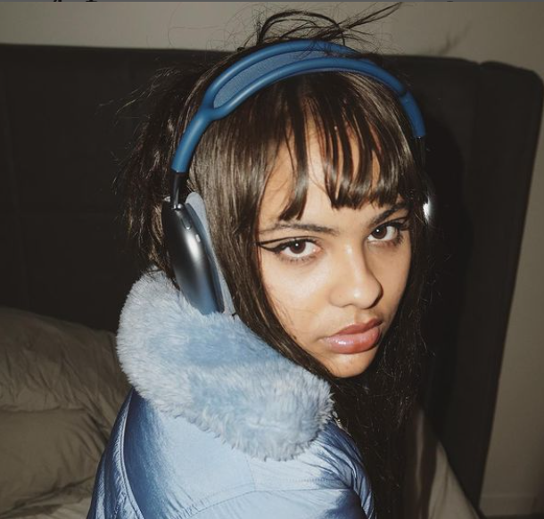
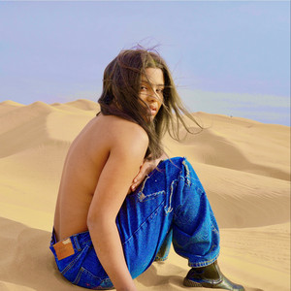
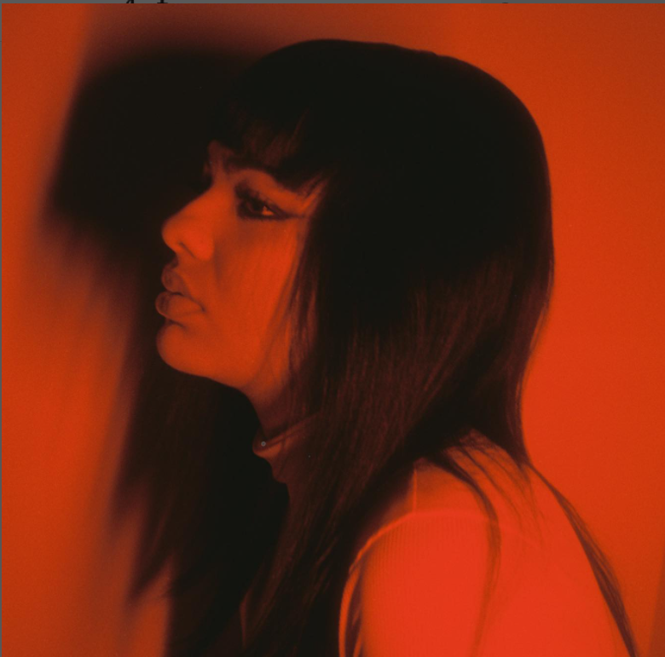
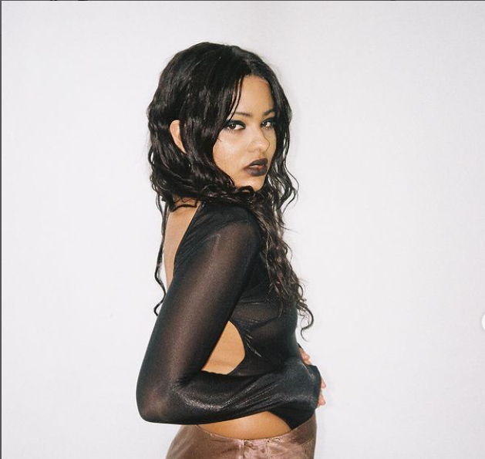
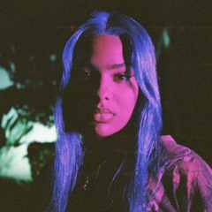
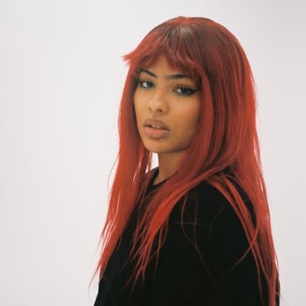

T
A
K
E

V
A
N

*Important note*
When I started this report I did not realise that the artist was releasing an album so close to the assignment date as it was not announced until three weeks ago. Because of this I have made the plan as if I had been appointed as the marketing coordinator on the 20th^{st} of Dec 2021, for example. Many of the marketing activities prior to the hand in date have been completed by the artist and anything after is my suggestion.
Certain things, e.g. PR activity or the creation of an EPK, has been added as the artist has literally not undertaken any of that themselves and it is what I would have done if I were really involved at that point.
Also my computer would not let me reorder the EPK and timeline, so they are not used in the right order in the report

Table of Contents

Executive Summary 4
Key artist information 5
Music release and Tour Plan 6
Media Strategy 10
Timeline and Key Tasks 12
Expected Costs 15
Appendices 16
Bibliography 19

Executive Summary
This report looks at Miami-based artist Take Van and the marketing for the release of a single, album, and remix album. It also looks at an international minitour and the marketing behind that.
It starts off with the key artist information, such as metrics, before going onto the music release and tour plan. The media strategy is stated and is then followed by an explanation of the key tasks and their respective timeframes. The report finishes with the expected costs of the marketing plan. The appendices contain an EPK and project timeline.
The data used has been from verified sources and referenced in the bibliography.

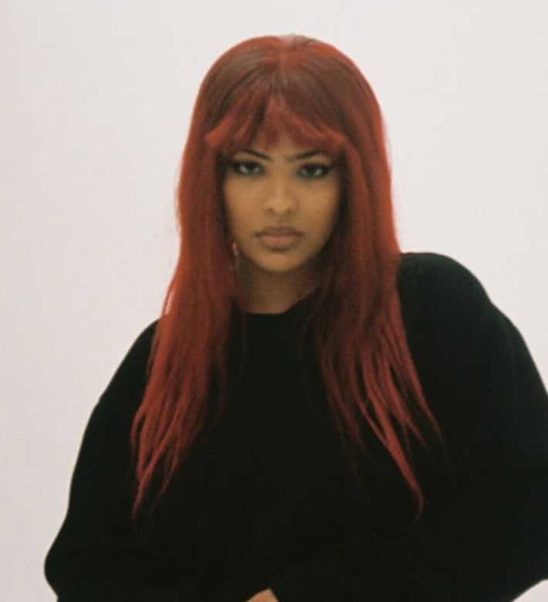
Key artist information
Artist profile:
Name: Take Van
Location: Miami, US

Bio:
Van is Take Van. The non-binary, underground, alternative pop artist of
your dreams. Fresh out of South Florida, Vanessa comes from a below
sea level tropical hell where everyone owns a gun. They began making
their own music on Sound Cloud at the age of 17 after dropping out of
their seemingly racist Miami High School. Almost a year after, Take Van
released their first self-made EP titled Journey in December 2019. (Take Van, 2022)

Key notes:
As mentioned before, Take Van is non-binary and would have access to the LGBTQIA+ community. They are also mixed race and BIP0OC.

Artist Data and Top songs:
Soundcloud:
1,054 followers
- In my head (6 months ago) 979 likes/ 26 reposts/ 36.2k listens/ 30 comments
- Time goes by (4 months ago) 1807 likes/ 52 reposts/ 57.4k listens/ 47 comments
- Pressurized (1 month ago) 332 likes, 16 reposts, 8307 listens, 18 comments
Spotify:
99,905 monthly listeners
- In My Head (1,131,383 listens)
- Time Goes By (491,791 listens)
- Pressurized (367,258 listens)
Top locations:
- Los Angeles, US
- London, UK
- Chicago, US
- New York, US

Music release and Tour Plan
This year Take Van released her final single at the start of the year before releasing her newest album, Far Away, on 31/04/2022. The album featured her most recent tracks as well as unveiling some new material.
The music release plan for the future months is to release a 15-track deluxe version of their album, Far away, on 22/07/2022, approximately 4 months after the album’s initial release. The deluxe version will feature all of the songs on the initial album, two new unreleased tracks, and five remixes by up-and-coming producers. Good remix albums to reference are PinkPantheress’ to hell with it (Remixes) and Aluna’s, Renaissance Remixes.
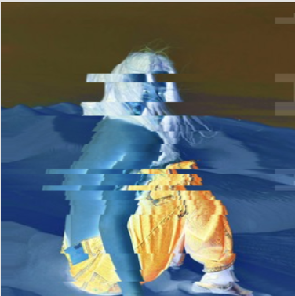

The aim for the remixes is to collaborate with producers to get listeners to associate Take Van with a number of genres, not just Drum and Bass and pop. It should also attract listeners of other genres which will drive traffic to her music.
There will be the release of one single in the months leading up to the deluxe album’s release. This new single will be released on the 24th of June as this is the last Friday of the month and one week before 4th of July weekend. The remix single will be in her popular style of drum and bass inspired pop which is perfect to help people prepare for the party weekend ahead. This is also during the middle of festival season in the UK which is a key time for upbeat/party music.
The UK is the home of Drum and Bass (DnB) music and has a significant fanbase (Jenkins,2020). Take Van’s most popular songs, such as In My Head, are all drum and bass inspired and have potential to succeed in this market than the US one. More specifically, there is a rise in popularity of female (mostly pop) vocals over drum and bass and jungle as seen with artists such as PinkPantheress. This is her most marketable sound.

If you look below, you can see three artists who have a similar style of music to Take Van and are big in the pop/DnB scene. Their monthly listeners and top cities have also been provided to show how popular the scene is.
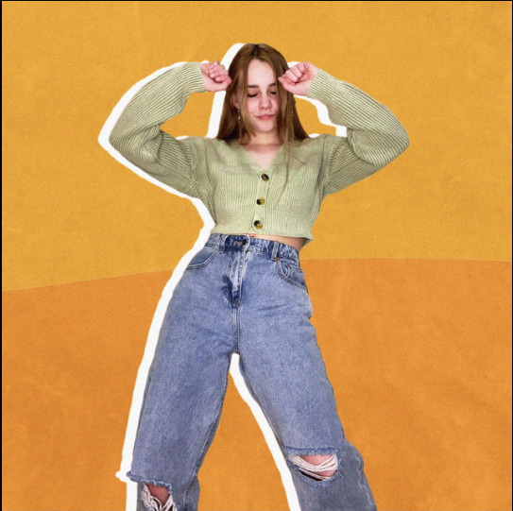

Name: Piri
Monthly Listeners: 547,170
Top Cities:
- London, GB
- Birmingham, GB
- Manchester, GB
- Dublin, IE
- Edinburgh, GB

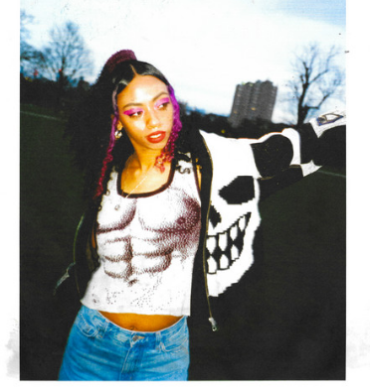
Name: Nia Archives
Monthly Listeners: 735,505
Top Cities:
- London, GB
- Birmingham, GB
- Manchester, GB
- Dublin, IE
- Edinburgh, GB

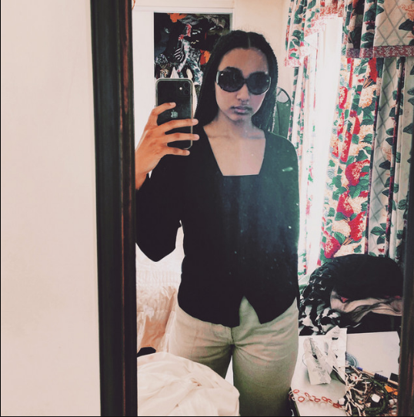
Name: PinkPantheress
Monthly Listeners: 6,701,882
Top Cities:
- London, GB
- Los Angeles, US
- Chicago, US
- New York, US
- Dallas, UK

Coincidentally London appears in all the similar artists’ top cities which shows that this sound is popular there. This means there are potential Another interesting thing is that PinkPantheress, the person Take Van gets mistaken for musically, has a nearly identical list of top cities which indicates that there will be a good number of potential fans in those cities. It also highlights Dallas as a potential place to perform in the future

Tour:
Take Van will go on a mini tour around the US in the lead up to releasing the deluxe album before travelling to London to perform at Lovebox Festival and finishing up with a headline show in London. The US leg of the tour would start on the west coast in La before travelling east and performing in Chicago. The final US show would be in New York. The basis for choosing these cities is Spotify’s top city list in an artist’s bio. It makes sense to perform in the cities with the highest concentrations of listeners as the shows will be more likely to be full. London is also home to many potential fans so is a great place to perform. The other purpose of the Tour is to promote her new material as well as the remixes. There is no point trying to arrange more dates in Europe as London seems to be the only city on the continent that has a sizeable following. Other European cities like Ireland will definitely have a reasonable potential fan base but Take Van needs build her brand and following to access those markets.

The tour schedule is as followed:
- The Echo, Los Angeles: 10/07/2022
- TBC, Chicago: 11/07/2022
- Mercury Lounge, New York: 13/07/2022
- Lovebox, London: 16/07/2022
- Koko, London: 19/07/2022
- Promotion for the tour will include a targeted social media campaign on Instagram as well posters that will be posted around the cities where they are performing. The poster will be in a similar fashion to the PinkPantheress poster as it matches previous album artwork (see bottom right).
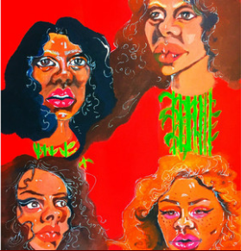
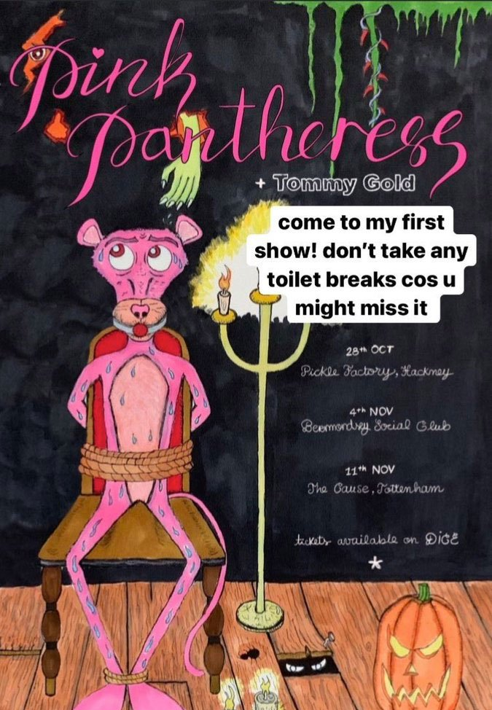

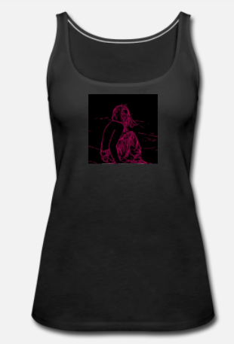
Mock black tank top
There will also be merch to purchase at each show and the aim is to throw 5 items into the crowd for free at the smaller gigs and to generate some buzz and entice those who missed out to purchase. They will also be limited edition. The aim is to start with Tank tops before moving onto lighters and hoodies in the future.

Media Strategy
Dietrich’s paid, earned, shared, and own media model (2018) is a useful model when looking at the various types of media used in an artist’s marketing campaign. The main three channels used for this artist are:
Paid
The paid media used is Instagram ad targeting and getting promoters to post physical posters around key locations in the cities where they are touring.
Earned
I will use vital contacts in the music PR industry to generate editorial content in key magazines such as Wonderland. The main focus are publications that tend to feature the “cool” and “edgy” members of the creative industry. A list has been provided. This artist has had very little exposure in any relevant cultural magazines or blogs. They have done two online interviews, one in 2019 with First Place Magazine and one in January 2022 with Ones to Watch. Magazines like the ones listed below are ideal publications to be featured in as they are highly regarded by the tastemakers/ key figures in the creative industries and have a global reach.
Blog/online publication/ physical pub. | Name
blog | Onestowatch.com
Online/ physical | Wonderland
Online / Physical | Dazed
Online | Dummy mag
Online | AZ Mag
Online | Notion
Online/Physical | I-D
Online/Physical | Attitude

The second method of earned media used would be through radio presenters /DJs on certain UK and US stations. The focus are stations and presenters that have an eclectic music policy and are key figures in the music scene. The benefit of these stations is often global coverage and the fact it immortalizes the song on their websites through saved shows and their respective track lists.
Name | UK or US | Specific shows/presenters
Radio 1Xtra | UK | Jams Supernova, Jeremiah Asiamah
Rinse FM | UK | Jyoty
Foundation FM | UK
Reprezent | UK
Revolution 95.3 | US

Shared
This is simply the social media tools used. Our artist’s social media platforms that have the most engagement are Instagram, TikTok and YouTube. Their social media metrics can be seen below.
- Instagram – 10.4k followers
- TikTok- 19.5m likes/240k+ followers
- YouTube – 1.95k subscribers
Key social media moments for Take Van:
- They were recently featured on Amazons Instagram page for a ones to watch post
- They were featured on Spotify’s TikTok where they spoke about one of their songs from their album.
Spotify is an important platform that helps artists gain exposure and it is important for artists to be featured in their editorial playlists. Below are the current Spotify playlists that Take Van is featured in and a list of playlists we aim to feature their songs.

Current playlist features on Spotify:
- Equal Global (828911 likes)
- Planet rave (133986 likes)
- BAMBII’s track IDs (11786 likes)
- New Music Friday Cratediggers (379952 likes)
Potential Spotify editorial playlists to be featured on:
- Pop Rising (2444273 likes)
- Altar (391309 likes)
- !!! (40956 likes)
- Hug ur friends (2481 likes)
- New Music Friday including regional playlists UK/AUS/CANADA

Timeline and Key Tasks

The key tasks can be seen in the timeline, which can be found in appendix 2, and is split into three main phases. Phase one (Green), two (Yellow) and Three (blue). It includes the start and end date of each task, as well as when key performance indicators (KPIs) had been hit. The main KPIs that were focused on are:
- Instagram followers
- Number of interviews and press coverage
- Number of listeners on Spotify
Phase One
The key aims for this phase:
- Develop an EPK (Completed)
- Release one final single before the initial album release (Completed)
- Release the Far Away album (Completed)
- Reach at least 1 million streams on In My Head by the album release (Completed)
- Increase Instagram following to 10k+ prior to initial album release (Completed)
- Secure at least one interview (Completed)

The first phase is all about establishing the artist image, building up the social media profile, and ensuring that the release of their initial album goes smoothly. Take Van had no EPK or press shots when releasing the singles that have provided the most limelight. They also had very little media exposure e.g., interviews or reviews, which needed to be sorted. Reviews and interviews in good publications are a great way for artists to gain exposure. January’s focus was the development of an electronic press kit which will help journalists get a feel for them and what they are about. This can be seen in appendix 1. The EPK will be developed in the future as it is somewhat small due to Take Van’s limited live performance experience and lack of media coverage.
The other aim for January was to plug her song Pressurized on TikTok, release the live video, and conduct a month-long targeting campaign on Instagram. The targeting parameters we set were used for various ad targeting campaigns. They can be found below. We added extra locations where we think the potential fans are and used a range of interests that we feel relate to Take Van’s music. We also started teasing the new album on the last Friday of the month.
Targeting Parameters on Instagram
Locations | London  Los Angeles  Chicago  New York  Brooklyn  Dublin  Birmingham  Manchester
Interests | Music, Drum and Bass, pop music, dance music, DJ, Radio, emotion, sad, love, self-love, romance, culture, fashion
Gender | All
Age | 16-30

The decided spend was £20 a day for the Pressurized release and £40 a day for the Far Away release. This is always over a period of 30 days (instagram,2022)
The main aim for February was to get in contact with people I know in Music PR in order to get some digital coverage. A physical article is always the aim with this, but it takes up to 6 months of preparation for that to happen. We emailed over the one sheet and gave publications 3 weeks to confirm if they were interested in providing any coverage. We also continued to tease the upcoming album on Instagram and TikTok.
The 10,000-follower target was hit by the beginning of the month and the next target was set for 15,000 by 01/06/2022. Both Amazon and Spotify posted Take Van on their social media accounts, and they also had their first radio interview in their home city, Miami. The release date was announced on the 15th march alongside the cover art and track list. The subsequent two weeks was countdown posts on social media platforms
Phase 2
Key aims for this phase:
- Reach 15,000 followers on Instagram
- Complete tour dates (National and International)
- Complete first festival gig
- Release the deluxe album
- Get two online articles published
The end goal for this phase is the release of a deluxe version of their newest album, which acts as a means to extend the hype around their recent album. It will hopefully feature some exciting names in the industry and show an eclectic mix of talent. The aim is to release one of the five remixes and keep the two unreleased tracks hidden until release day. This means people will need to turn up to their performances to hear the material.
There will be the usual ad targeting campaign for the remix single that will be released, but a lot of the marketing at this phase is self-promotion. It will start with social media posts that properly announce the mini tour alongside the promotional posters.
The second half of this phase focuses on the tour, building a bigger fanbase in London before the shows, and release the deluxe album. The set list on the tour will be their most popular songs and some of the unreleased tracks. Take Van will also mention the album at the end of her shows when everyone is in high spirits. They will associate the album with the memory and will be more likely to stream or purchase it when it releases. Pappas, I.O., Kourouthanassis, P.E., Giannakos, M.N. (2014) states that emotions positively influence shopping behaviour.
A radio plugger will also be recruited to help spread the song around the UK before their appearances. Sticky Toffee PR seems to be the best company to work with to conduct a radio PR campaign. A four-week campaign costs £499 and they have access to specialist radio stations like Rinse Fm and BBC 1XTRA (Sticky Toffee PR, 2022). This will be conducted in the run up to the festival performance and London show to draw up support and gain new fans/potential attendees. We also aim to secure interviews with two “cool” publications and will facilitate this by inviting journalists down to Take Van’s gigs.

Phase 3
The final phase deals with promotion of the final remix album which was an extension of the album released earlier in the year. This is once again through a targeted ad campaign on social media and a promotional video will be created to show fans what life on tour was like. The final aim is to build a base in their hometown, Miami. I think it is important to have a local fanbase as it means they do not have to travel far to perform at shows that are more likely to sell out.
The plan is a throw a free outdoor beach party/concert to promote the release of the deluxe album. This can be spread via social media and word of mouth. There is scope to make it a treasure hunt of sorts e.g., send GPS coordinates that are a simple Google search away, but will make people feel like they have been investigative.
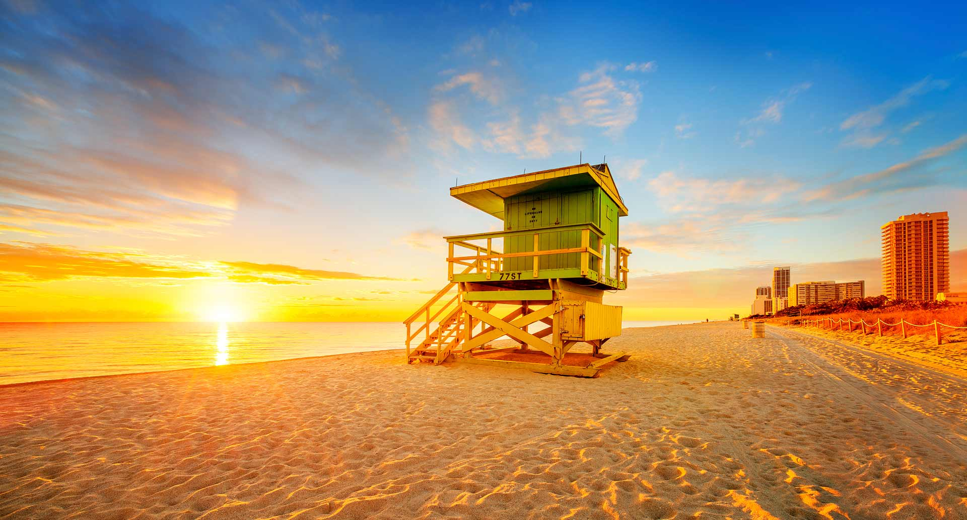
It will start with a live set by Take Van and then a DJ set on portable decks (from a friend) where the remix material will be mixed into a set. This will all be posted on socials and will show the setup, during, and after. The picture below shows the type of setting we would like for the party.

Expected Costs
Phase Three
Phase Two
Phase one
This above is a budget based on all the marketing. It shows the various costs for each phase of promotion and accounts for the marketing consultancy fee. The costliest thing during the campaign will be the Instagram ad targeting. A videographer for each show is also a significant expense.

Activity | Cost (£)
AD Targeting | 600
Photographer | 500
Music PR hire | 500
total | 1600
Radio PR | 499
ad targeting | 1500
Poster printing | 250
Videographer | 1000
Postering | 360
Merch designer | 200
Merchandise | 300
total | 4109
Videographer | 250
Equipment hire | 250
Ad targeting | 1200
total | 1465
Add:
Consultancy fee | 2501
Grand Total | 9925

Appendices
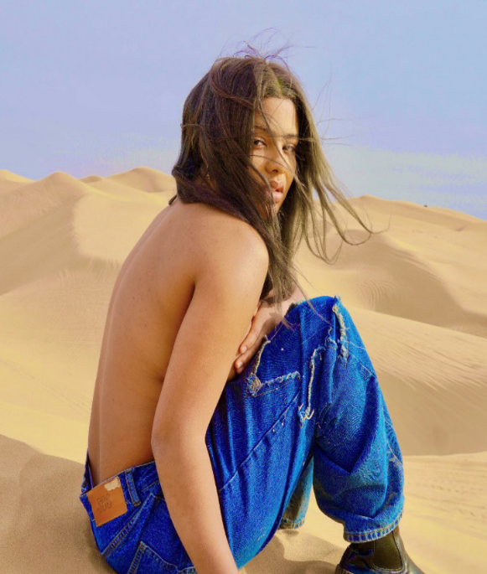
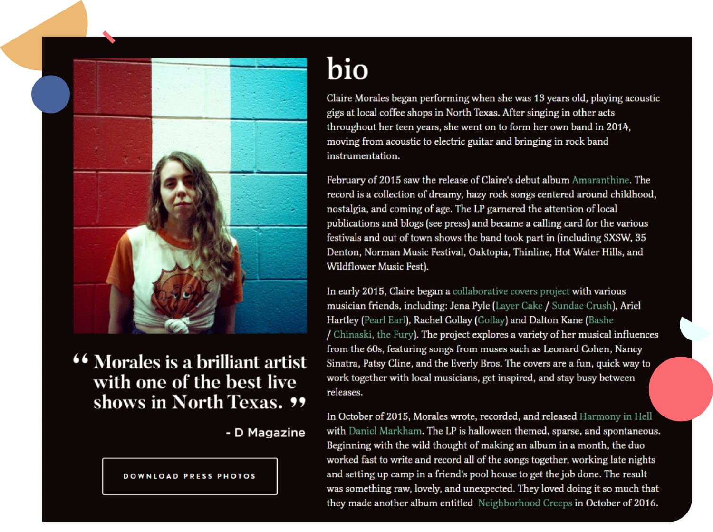
Take Van one sheet
“Take Van is Star Made.”
-Ones to watch
Van is Take Van. The non-binary, underground, alternative pop artist of your dreams. Fresh out of South Florida, Vanessa comes from a below sea level tropical hell where everyone owns a gun. They began making their own music on Sound Cloud at the age of 17 after dropping out of their seemingly racist Miami High School. Almost a year after, Take Van released their first self-made EP titled Journey in December 2019.
Drum & bass and garage beats under pop vocals is a movement we can all get behind. If you want to join in, you better get familiar with South Florida songstress Take Van. The non-binary alternative pop artist captivated us in 2021 with heaters like "In My Head" and "Time Goes By." This year, Take Van starts things off strong with another dreamy tune called "Pressurized."

The track starts off with wavy '80s-inspired synths that paints an eerie mood before the fast-paced drum & bass beat and Take Van's bewitching vocals grab the spotlight. Like other songs in the genre, "Pressurized" is short and sweet, only landing at 2 minutes and 10 seconds. But it's so intoxicating that you won't be able to help but put it on repeat. As one YouTube comment puts it, "This song got drugs in it."

Start date | Key Marketing Tasks, Goals and highlights | When to be completed
09/2021 | Produce and release final single ‘Pressurized’ and music video before album release | 06/01/2022
01/01/2022 | Achieve 10k followers | 01/03/2022
01/01/2022 | Develop an EPK/one sheet | 30/01/2022
01/01/2022 | Photoshoot for press shots and album cover: Various locations | 30/01/22
06/01/2022 | Purchase Ad Targeting on Instagram for 1 month to promote single | 06/02/2022
06/01/2022 | Advertise song on personal TikTok. Start of posting 1 every 2 days for the first week. Decrease in frequency until the end of the month | 06/02/2022
10/01/2022 | Onestowatch.com publishes a good review about Pressurized
14/01/2022 | Release YouTube Video (Live version of Pressurized) | 14/01/2022
28/01/2022 | Start teasing the new album. This could be an Instagram story or posts that shows the photoshoot with a message “Happy Friday! Got something exciting coming soon”. A similar post on TikTok | 28/01/22
01/02/2022 | Email a one sheet to listed publications regarding the album release at the end of march. | 03/02/2022
01/02/2022 | Continue to tease the new album on social media | 15/03/2022
08/02/2022 | Contact producers regarding deluxe edition | 08/02/2022
21/02/2022 | Confirm with publications whether they will post an article or conduct interview | 28/02/2022
01/03/2022 | 10k achieved, hit for 15k | 01/06/2022
03/03/2022 | Email unreleased album to relevant publications | 03/03/2022
03/03/2022 | Radio interview with Miami radio station Revolution 95.3. Talk about experiences in the industry to date and upcoming album | 03/03/2022
15/03/2022 | Fully announce album release date with album artwork | 15/03/2022
18/03/2022 | Every few days post on socials and count down until the album is released | 26/03/2022
31/03/2022 | Album released across all platforms | 31/03/2022
31/03/2022 | Instagram ad targeting for the new album | 31/04/2022
01/04/2022 | Publications release online press regarding new album | 01/04/2022
04/04/2022 | Contact and hire UK radio plugger/ PR agent regarding assistance for two months starting in June | 30/04/2022
04/04/2022 | Start designing merch to sell at future shows | 04/05/2022
29/04/2022 | Announce tour and festival dates on Instagram. Link to tickets in bios of socials | 29/04/2022
05/05/2022 | Post weekly reminders on social media regarding live show dates and ticket purchasing
13/05/2022 | Start teasing deluxe edition album with a short snippet of a remix | 13/05/2022
17/06/2022 | Instagram ad targeting to promote the upcoming deluxe Album and promo single | 24/06/2022
17/06/2022 | Email relevant publications and invite them to headline shows in various cities | 17/06/2022
24/06/2022 | Release remix single on all platforms | 24/06/2022
24/06/2022 | Aim to have had radio plays and at least 2 interviews in the run up to London shows | 15/07/2022
24/06/2022 | Promote new single with ad targeting on Instagram. Consistent posting on TikTok | 15/07/2022
10/07/2022 | Start US leg of mini tour. First Show: LA | 14/07/2022
10/07/2022 | Post on socials showing fans a glimpse into touring | 17/07/2022
11/07/2022 | Second leg: Chicago | 14/07/2022
13/07/2022 | Final US date: Brooklyn, New York | 14/07/2022
16/07/2022 | Lovebox Festival slot | 16/07/2022
19/07/2022 | Headline London show at Koko | 19/07/2022
22/07/2022 | Deluxe album release | 22/07/2022
22/07/2022 | Instagram ad targeting to promote deluxe album | 22/08/2022
25/07/2022 | Create promotional material using tour and show footage | 01/08/2022
05/08/2022 | Do a secret show in Miami, FL to promote the album and post on socials | 05/08/2022

Bibliography

Brilliant Metrics. n.d. What is the PESO Model for Marketing?. [online] Available at: <https://www.brilliantmetrics.com/knowledge/blog/what-is-the-peso-model-for-marketing/> [Accessed 4 April 2022].
Dietrich, G., 2022. Why Communicators Must (Finally) Embrace the PESO Model. [online] Spin Sucks. Available at: <https://spinsucks.com/communication/pr-pros-must-embrace-the-peso-model/> [Accessed 4 April 2022].
FIRSTPLACE. 2019. TAKE VAN Interview - Interviews FIRSTPLACE. [online] Available at: <https://www.firstplacemagazine.com/interviews/2019/10/9/take-van-interview> [Accessed 4 April 2022].
Golden Yacht Charters. 2022. Sunset Cruises | Miami Sunset Cruise | Sunset Yacht Rentals - Golden Yacht Charters (GYC). [online] Available at: <https://goldenyachtcharters.com/destinations/miami/sunset-cruises/> [Accessed 4 April 2022].
Hopkins, S., 2022. [online] Available at: <https://secretldn.com/london-music-festivals/> [Accessed 4 April 2022].
Jenkins, H., 2020. History of drum'n'bass: The genre's evolution & origins. [online] Redbull.com. Available at: <https://www.redbull.com/gb-en/history-of-drum-and-bass-music> [Accessed 4 April 2022].
Koko.co.uk. 2022. KOKO. [online] Available at: <https://www.koko.co.uk/> [Accessed 4 April 2022].
Lovebox Festival. 2022. Lovebox Festival. [online] Available at: <https://loveboxfestival.com/> [Accessed 4 April 2022].
Lovebox Festival. 2022. Lovebox Festival. [online] Available at: <https://loveboxfestival.com/> [Accessed 4 April 2022].
Mercuryeastpresents.com. 2022. Upcoming Events – Mercury East Presents. [online] Available at: <https://mercuryeastpresents.com/venue/mercury-lounge/> [Accessed 4 April 2022].
Ones To Watch. 2022. Take Van Takes Off With “Pressurized” / Ones To Watch. [online] Available at: <https://www.onestowatch.com/blog/take-van-takes-off-with-pressurized> [Accessed 4 April 2022].
Pappas, I., Kourouthanassis, P., Giannakos, M. and Chrissikopoulos, V., 2014. Shiny happy people buying: the role of emotions on personalized e-shopping. Electronic Markets, 24(3), pp.193-206.
Spotify. 2022. Take Van Artist. [online] Available at: <https://open.spotify.com/artist/3BLx7avD36sNpMNA1nZ7Dj> [Accessed 4 April 2022].
Spreadshirt. 2022. Spreadshirt. [online] Available at: <https://www.spreadshirt.co.uk/-C10181?productType=917&appearance=2&affiliateID=1245883&gclid=CjwKCAjwrqqSBhBbEiwAlQeqGnXDYLwLAhYBxOLsjnbLNunwa3AOUaKNRuOvqEwQpDm5l1C5SQvxFRoCYz8QAvD_BwE> [Accessed 4 April 2022].
Stickytoffeepr.co.uk. 2022. Music PR Packages Sticky Toffee PR – Music PR | Radio Plugging | TV Plugging | Media Production. [online] Available at: <http://stickytoffeepr.co.uk/index.php/music-pr/> [Accessed 4 April 2022].
Take Van (@babysoups). 2022. Take Van (Instagram). [online] Available at: <https://www.instagram.com/babysoups/> [Accessed 4 April 2022].
The Echo + Echo Plex. 2022. Home - The Echo + Echo Plex. [online] Available at: <https://theecho.com/> [Accessed 4 April 2022].
Thomas, B., 2019. How much should you pay a marketing consultant. [online] Real Business. Available at: <https://realbusiness.co.uk/how-much-should-you-pay-a-marketing-consultant> [Accessed 4 April 2022].
Van, T., 2022. [online] Available at: <https://www.instagram.com/p/CbwVWdUu5YB/> [Accessed 4 April 2022].
Van, T., 2022. Instagram. [online] Instagram.com. Available at: <https://www.instagram.com/p/CWm7DWCLTfh/> [Accessed 4 April 2022].
VAN, T., 2022. TAKE VAN. [online] SoundCloud. Available at: <https://soundcloud.com/TAKEVAN> [Accessed 4 April 2022].

