The Inter-Cultural Workplace

BMSP5002

Assignment One

Lois Elizabeth Rossiter

1909920

Content Page

Table of Contents
Introduction 2
2.0 – Main Findings 2
2.1- Organisational Context 4
Reference List 14

Introduction

The purpose of this assignment is to document, understand and evaluative the inter-cultural workplace, with reference to an organisation and in this case that will be Marks and Spencer’s. This critical investigation will seek to understand the environment created within said organisation to establish a strategic understanding into its inter-cultural workplace, with reference to the internal and external environments. To establish the ways in which an organisation retains and develops its workers in a sustainable manner that also helps to attract new employees.

2.0 – Main Findings

Operating within the UK and on an international bases Marks and spencer is a British business, to which sells its own branded food, clothing and homeware, from a range of UK stores and within a further 62 (Corporate Marks and Spencer , 2021).

The inter-cultural workplace is in which is “relating to or involving more than one culture” (Cambridge Dictionary, 2021).

Globalisation has positively affected the way modern business is conducted and is in refence with the fourth Industrial Revolution. The Kondratieff cycles also show the stages of innovation and the changes within the workings of the now global economy. Globalisation has created a world where businesses can communicate, distribute and set up international businesses through the world. These cycles that have enabled international growth unlike anything prior. Culture is both a positive and a negative when it comes to globalisation, in today’s business it is normal for individuals from a range of cultures, languages, countries, just to names a few elements. This has now put more emphasis on the human resource management and the organisation policies of individual businesses. Inter-cultural workplaces need to strategies and support their workforce to create a positive and communitive work environment for all employees. There has to be educations that enables co-workers to have strategies in place that enables all to feel happy and secure in a different cultural environment (Malgorzata Rozkwitalska, 2017).

The modern world of work has seen workplace skills changing and therefore puts emphasis on knowledge, including decision making, being able to adjust to changing conditions, the development in the ways of working and the skills needed to work with the continually changing technologies, all of which require training and also workplace learning. The importance of workplace learning goes beyond the community/country in which they are based but has a bigger impact on their international markets (Rozkwitalska, 2019).

The global workplace has put new requirements on the communication networks of the global workplace, therefore meaning that the intercultural workplace now relies on the learning of both skills and support that enables the employees to work effectively within and environment that will include different languages and cultures (Holmes, 2017).

The theory of management surrounds the relationship of organisational and social comprehensive characteristics in all social groups. Interpersonal communication , the social structure, values and the hierarchization, all surround the theory that the cultural differences will call for different interaction approaches (Malgorzata Rozkwitalska, 2017, p. 3).

Marks and Spencer has strategically changed in order to help adapt and equipped their workforce to be effective and confident to work with their inter-cultural colleges, within the international business environment due to preparation into the business changes the organisation wanted to create.

Marks and Spencer employment figures for the UK and its international stores is set at over 80,000 people, these employees are based at the 700 plus UK stores and 400 plus stores that are based in 44 territories. Marks and Spencer created a strategic plan that focused on their business becoming an international retailer, this strategy has worked and they have been able to expand in new territory. Marks and Spencer have taken advantage of globalisation and the positive advantages of trading internationally, but being a UK retailer and then expanding would also see a number of challenges and negativities to work through, remembering that any new part of a business requires a dynamic adaptive approach and the need to interduce the diversification in order for this new strategy to work. Marks and Spencer’s Corporate strategy included the issue and therefore need for the inclusion of a program of intercultural training in order to give staff the skills required for them to be able to work effectivity. With this understanding of this Marks and Spencer outsourced their training to a business called Communicaid (Communicaid, 2021).

Marks and Spencer has put great emphasis on their development of intercultural communication within their business, their strategy development under covered the potential issues regarding this diversification and they found a way in which they could overcome any problems. Their use of cultural training has enabled them to expand their business and still work to support their staff with the human resources needed for them to be able to perform effectively at their jobs.

Communicaid created a strategy by working alongside Marks and Spencer to “gain a thorough understanding of the organisational culture, the strategic international vison and the types of interactions employees would have with their international counterparts” (Communicaid, 2021).

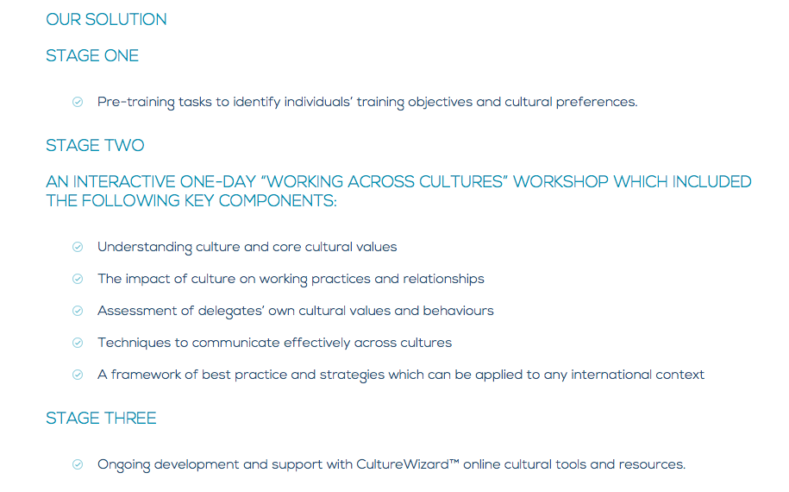
(Communicaid, 2021).

2.1- Organisational Context

Marks and Spencer have re-structured their organisation structure to a flat hierarchy, this means that there are a limited number of management layers and this means that more senior management will have more involvement with employees. Different departments will have limited management so that decisions and any problems can be simply resolved. The flat hierarchy structure can be a difficult structure to manage with a large corporation, such as Marks and Spencer, it puts pressure on the management at the top of the structure because they have to oversee and communicate the divisions, the less people who have involvement in decision making the more room for mistakes. The flat structure allows for less employees, as there is no need to have a middle management section, this allows for more direct involvement between staff workers and management. (Laetitiastuder, 2014).

Marks and Spencer saw need for change within their organisational structure, their market was changing and the competition growing, these external influences resulted in a re-structure. Changing from their traditional structure, of many levels of management to this more traditional one shows that the business is adapting to the modern business environments and keeping themselves competing with their competitors.

This has allowed staff employees to have more self-management & less involvement from a range of tired managers. There are negatives to this structure as it can be difficult to maintain the larger the company grows, there is also a factor of having employees with different skill set and some staff workers may not be able to work independently without the constant level of management supervision and support. An example of a flat organisational structure, is displayed below:

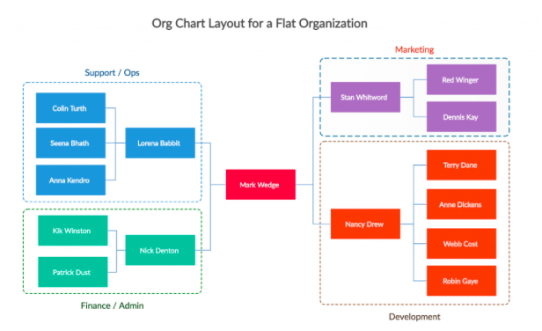
(Creately , 2021).

2.2 - Organisational Culture

“Organisational culture is the collection of traditional values, polices, beliefs and attitudes that constitute a pervasive context for everything we do and think in an organisation” (Laurie J. Mullins, 2019, p. 686).

As documented throughout this assignment organisation culture and culture in general is a very important issue in human resources and the management of both people and the organisation. The question remains is the management of culture is an important with the operations of a business, as most literature suggests. The book “Managing Across Cultures” states that the impact of culture on management is recognised and incorporated with strategies, but rather neglected. Culture is often seen and apparent, but as culture is so diverse any failure to recognise and strategize to be inclusive can result in a negative environment for both the organisation and its workforce (Barsoux, 2003).

The Cultural Spheres of Influence diagram reflects the cultural difference Marks and Spencer will have had to implement strategies into its management plans in order for the cultural differences that needed to resolved in order for the business to operate ethically and efficiently. The UK is one country, even with that said there will be cultural changes, even subtle ones, when they operate stores within different places.

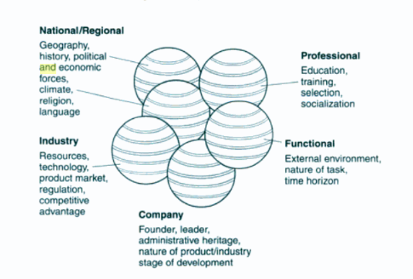
(Barsoux, 2003, p. 52)

The Cultural Iceberg is a representation of the visible and invisible components, it is important that a business identify all that are relevant to aforementioned business, Marks and Spencer. The failure of the business’ management recognising the non-visible components can negatively affect the business operations as a whole.

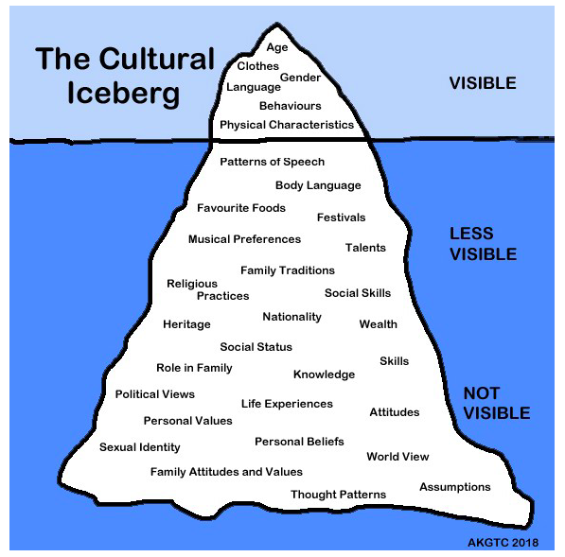
(Downes, 2019).

Marks and Spencer have recognised their company culture and its positive effect on its workforce, by doing this they have established their most important asset and that is their employees moral. The have strategized around four main points, engagement, recognition, support and communication, in doing so they also look to the people who will make up the majority of their workforce in the future and what they collectively perceive as a motivating and engaging working environment. The business put specific emphasis on their relationship with its workforce, they considered the culture their wanted to create within their specific business environment and proceeded to create one. The established a revolutionary model that focuses on recognition, trust and communication, with emphasis on inclusiveness, respect and care. The question remaining is that will this creation of a new business culture impose a positive outcome, Marks and Spencer’s corporate states that happy employees productivity increases by 12%, letting works communicate will help their performance increase by 20%. The most relevant statistic is that if the business has not changed their culture to adapt to current times could have resulted in stress and an increased turnover rate of 50% (Mortimer, 2018).

2.3 – The Management of Human Resources

“Loosely defined, HRM can be considered to be a particular model of employment relations that resolves around the management of people, following a particular ideological position
” (Edwards, 2013, p. 3).

Logical Human Resource Management that focus on a conventional technique through the whole range of their employees, is the most used technique. Nevertheless there are other theories that suggest their method does not work in the modern day work environment
(Edwards, 2013, p. 10).

Marks and spencer follows legislation with the aim of implementing the general global standards that embrace the laws, cultures and social normality that ensures they commit to implementing sustainable business practices, within the global business economy. Their management of human resources strategic policies are based on the fact that the business works within the United Kingdom and the multinational environment. The business’ M&S People Principles outlines their social and environmental responsibility to create a non-discriminatory working environment for their employees. Within this said policy they state to “respect cultural and individual diversity” (Marks and Spencer, 2019).

Therefore the question remains, is there a global policy or standard that can be set for the majority of businesses, or is there argument that human resource policies should be individual to each organisation and implemented differently according to individual levels of a hierarchy. It should be kept in mind that the global economic market and the formation of globalisation has and continues to change, with theories surrounding Human Resource Management differing.

Like many business’ Marks and Spencer adapts a sustainable business approach that incorporates international and national law that support and protects people working within the intercultural workplace. There is some argument against the way in which this traditional approach is used, this theory looks at the hypothesis that different markets within an organisation will adapt to having different policies that are designated to individual categories of employees, in accordance of their hierarchy structure. This theory surrounding the segmentation of employees and therefore differing policies for each segment is seen to create “tension for traditional commitment based models of HRM” (Edwards, 2013, pp. 12,13).

Marks and Spencer’s traditional approach to their Human Recourse Management supports their ethos of being a business focused on ethical and sustainable etiquette.

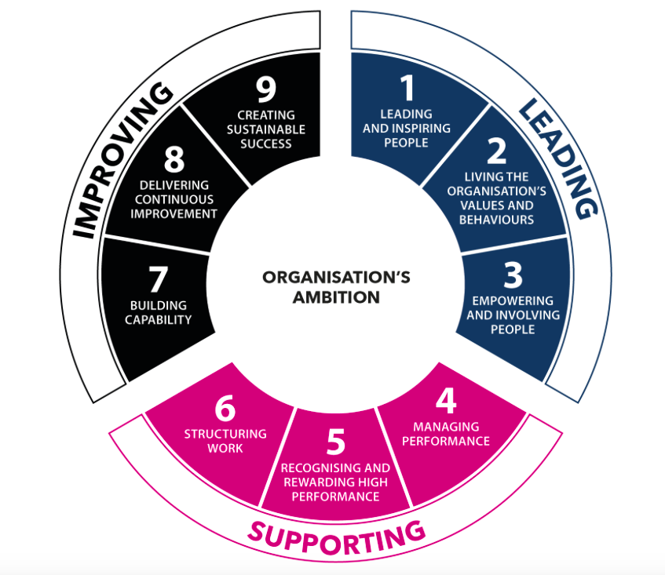

(Investors In People , 2021).

The developmental working environment has meant a subsequent change in how the role is human resources has had to keep changing to adapt. People, technology and the skills have meant that more than a third of human resource managers have had no choice but adapt and change their policies and strategies differently. One of the biggest changes observed recently is the fact that research shows that 95% of human resource units are planning to give the option of employees working flexible working, that is if they are not already (Sage, 2019).

The modern economy of today has many concepts but the most crucial one is that of people, this is acknowledged by academic research and business leaders. It is to be noted that even though this is acknowledged, is this the reality? The answer is no. The human resource departments of business take a lot of financial support and therefore can struggle if business finances are not performing well, depending if the said business feels the investment is worth the outcome. Employment relationships and workplace innovation, is linked to customer retention, financial gain and retention and recruitment of the correct employees (Toulson, 2021).

Intercultural workplace resources and strategies create a positive workplace environment if correctly preformed, however these support and educational strategies have to be correct as to the specific needs of the business. Although there are theories surrounding the way in which human resource management methods are successful, in regards to using traditional vs modern strategies, the positives out way the negatives massively. A successful strategy will create more success than the financial resources needed to create these organisational support performance outcomes.

Marks and Spencer’s brand and business ethics include their strategy to make change within the environmental and social issues, this lead to their creation of their Plan A. This strategic plan looks at how they can help involve issues that affect their consumers and employees. The business’ human resource strategy looks to give their stakeholders a voice, from their supply chain workers to their employees. (Marks and Spencer, 2020)

There has been a lot of research and subsequent publication regarding organisational strategy and resources and the link between them. There is literature surrounding individual strategies and the subsequent competitive advantage gained. The fundamental success can be the businesses advantage with progressive growth and traditional culture, core values can make businesses’ including Marks and Spencer have a bigger social impact which therefore creates business to consumer relationships. The capability of the business is reliant on employees and therefore the effectiveness of the organisation’s human resources (Knudsen, 1996, p. 66).

In order for the business to grow and modernise the need to improve their human resources strategies for areas including, in job learning, training and education all of which allow for new skills and the increase of knowledge. Each business with have specific framework on how their human resources work, ensuring the optimum performance. The success is depended on how the individuals develop via the business’ human resources on offer to them (Pitelis, 2002).

Conclusion

Overall Marks and spencer’s follows largely traditional human resource management strategic approach, although they do focus largely on the ethical approach to their business practices, which is a positive for all stakeholders involved, mainly benefiting their employee network.

Throughout this report it has been show how much emphasis the business puts on the positive impact it can create by the strategies and core values it uses in the day-to-day running of the business, as well as their future goals and objectives.

The Inter-cultural workplace incorporates human resource management and the effect the modern economy has on employees, for example, globalisation. The skills and strategies offered by a business has a huge effect on the happiness and success of their workforce. Working within a global market and communicating with fellow employees from different countries, cultural and languages can be hard for them to adapt too, this is when the human resource departments need to manage the support and training given. Marks and Spencer use a traditional method of human resource management and that alongside their hierarchy is successful within their workforce.

Recommendations

Marks and Spencer’s has impressive plans and strategies surrounding the ethical and sustainable operations within their business, both present and future. These plans included all areas of their business, including stakeholders. The positive human resource strategies show within this report, express an ethical approach, these are all positives however, is the business progressing at the same rate of its competitors? There is argument to say no. Although they are a partnership with food delivery service Ocado, this limits the areas in which the service is available. The argument could be that if Marks and spencer’s created its own food home delivery service, such as, Tesco and Waitrose, their business could expand.

Any expansion with the same policies and principles could help increase their stakeholder numbers, not only making the business more competitive but creating more job opportunities.

Marks and Spencer have a clothing line, this could be developed into a more competitive market. As seen within the report, the business prides itself on being ethical and sustainable, all while protecting its stakeholders. This is something that could help them develop a more sustainable clothing company, looking to attract all age groups. The development of their clothing website and their shipping and returns options would be necessary to enable them to compete within the clothing market.

Although Marks and Spencer have grown into foreign markets, this could further be developed on more of an international scale. Marks and Spencer is a British business but like other supermarkets, they could adapt to other countries cultures, that paired with their strategies surrounding the importance of the inter-cultural workplace and the strategic support they already have in place, there could be success. Many businesses have taken advantage of the modern global markets, that being said Marks and Spencer could do this further, growing their business massively. Although the supermarket industry has a very competitive market, Marks and Spencer is an already established, trusted brand and they need to take advantage of their reputation in order to grow.

Appendices

SWOT Marks and spencer

Strengths

-Brand is well-known.
-Customer experience as a premium supermarket.
-Own food brand.
-Diversification into the clothing, furniture and banking industries.
-Employee treatment.

Weaknesses

-Mainly a British business.
-Food standards can occasionally be an issue.
-The technological disadvantage, the supermarket sector seem to have better websites and online shopping facilities.

Opportunities

-Online shopping and delivery services.
-New innovations, in both food and technology.
-Diversification.
-New international markets.
-Clothing market.

Threats

-Economic factors, low employment levels and income could see their target market opt for their cheaper competitors.
-Supply chain.
-Covid-19 Pandemic.
-Competition from both direct competitors and budget supermarkets.

PESTLE Marks and Spencer

Political

Political factors have a huge influence on any business or organisations, as Governments control legislation, tax and rules. Marks and Spencer will have to adapt their business strategies and practices accordance with any Government changes, for example, the

Economic

Economic influences can create a number of different issues for Marks and spencer’s. Supply and demand, prices, costs, tax are just some of the economic factors that can affect a business, such as, Marks and Spencer’s. Government policies, including, tax levels and legislation can affect the operations of the business, including profitability.

Economic changes can affect the business’ target market, this therefore effects the supply and demand levels and this is dependent on the disposable incomes of their market.

Social

Social factors have an influence on the trend’s market within Mark and Spencer’s, these can include, what are people buying, food trends, the way in which people shop and the demand for goods. Marks and Spencer’s could see the need to change strategies based on the customers dietary needs, for example, introducing vegan or gluten free products.

Technological

Technology is forever developing and therefore needs to be at the forefront of the strategic operations, from their online shopping to their instore technology for both employees and customers. The correct technology investment could help the business with saving costs, for example, self-checkouts for the consumer. The correct investment in technology can help save costs.

Marks and Spencer’s has competition for other supermarkets, from the budget to the premium businesses, that means that their technology has to be effective to help them compete with their market competition.

The business has to have the correct technology to help their strategic progress and their efficiency in the running of the business.

Legal

Legal factors including legislation and government policy will directly and indirectly affect Marks and Spencer’s operations. Business and employment laws are applicable resembling all businesses, there are also legislation that will affect the supermarket and food industry.

Environmental

Environmental factors create importance due to the current demand and both legal and political interest in sustainability and environmental protection. This will have great implications on Marks and Spencer’s strategic planning. The business will have to follow any legislation surrounding their environmental impact, as well as providing a more ethical and sustainable brand and service to their market.

Reference List
Acas. (2016). Managing People. Acas - Help & advice for employers and employees.
Barsoux, S. C.-L. (2003). Managing across cultures . Essex: Pearson Education limited .
Cambridge Dictionary. (2021, February 20). Intercultural . Retrieved from Cambridge Dictionary: https://dictionary.cambridge.org/dictionary/english/intercultural
Communicaid. (2021, February 22). DEVELOPING INTERCULTURAL COMPETENCE. Retrieved from Communicaid, a learnlight company : https://www.communicaid.com/clients/marks-and-spencer-developing-intercultural-competence/
Corporate Marks and Spencer . (2021, February 20). Welcome To M&S. Retrieved from Corporate Marks and Spencer: https://corporate.marksandspencer.com/
Creately . (2021, February 19). Types of Organizational Charts (Organizational Structure Types) for Different Scenarios . Retrieved from Creately: https://creately.com/blog/diagrams/types-of-organizational-charts/
Downes, B. (2019, October 20). To hell with your culture iceberg | Meditations on Intercultural Leadership. Retrieved from Mediun: https://medium.com/@brentdownes/to-hell-with-your-culture-iceberg-meditations-on-intercultural-leadership-ff98867a4fa
Edwards, S. B. (2013). Managing Human Resources Fifth Edition . Chichester, United Kingdom : John Wiley & Sons Ltd.
Holmes, P. (2017). Intercultural Communication in the Global Workplace, Critical Approaches. Durham UK: Durham University UK.
Investors In People . (2021, February 22). We invest in people . Retrieved from Investors in People: https://www.investorsinpeople.com/accreditations/we-invest-in-people/
Knudsen, N. J. (1996). Towards a Competence Theory of the Firm. London: Routledge.
Laetitiastuder. (2014, October 24). Organisational Structure & Corporate Culture . Retrieved from Laetitiastuder.wordpress.com: https://laetitiastuder.wordpress.com/2014/10/24/organisational-structure-corporate-culture/
Laurie J. Mullins, J. M. (2019). Organisational Behaviour in the Workplace, Twelfth Edition . Harlow: Pearson .
Malgorzata Rozkwitalska, L. S. (2017). Intercultural Interactions in the Multicultural Workplace. Traditional and Positive Organizational Scholarship. Poland: Springer.
Marks and Spencer. (2019, February). M&S People Principles. Retrieved from Marks and Spencer Corporate : https://corporate.marksandspencer.com/documents/plan-a-our-approach/mns-people-principles.pdf
Marks and Spencer. (2020). 2020 Plan A Report. Marks and Spencer.
Mortimer, A. (2018, October 1). Change Company Culture and Transform Employee Moral . Retrieved from M&S Corporate Gifts : https://marksandspencerforbusiness.com/change-company-culture-and-transform-employee-morale/
Pitelis, C. (2002). The Growth of the firm, The Legacy of Edith Penrose . Oxford: Oxford University Press.
Rozkwitalska, M. (2019). Learning experiences in mono-and intercultural workplace interactions – the job-demands-resources approach. Journal of Workplace Learning , Vol.31, Iss. 5.
Sage. (2019). The changing face of HR. Sage.
Toulson, D. C. (2021). The Value of Human Resources Measurement in Intellectual Capital and Knowledge sharing. Colombia, Massey University, New Zealand: Delio Castaneda and Paul Toulson Pontificia Universidad Javeriana.

