- Indtroduction
The further research will analyse the economy performance of Republic of Moldova from 2017-2021. Regarding to the availability of data, will be provided as well results from 2022-2023 as much as possible. Will be touched a brief history of RM, type of government, the ethnic and religious compositions.
The study will analyse the performance in manufacturing and is production profile, and through the various data, graphs and tables will be screened the most imports and exports from 2017-2021 and top five country’s major trading partners.
The analyse will bring to attention the macroeconomic indicators of economic growth as The Gross Domestic Product(GDP), Unemployment rate, Inflation rate, The balance of Payments, the budget balance, and the Interest rate.
In Conclusion will be presented the main result of last 5 years economy performance of the Republic of Moldova.

- Main body
2.1 A brief history of the country
Moldova is a country situated in the Est side of the Europe having Romania and Ukraine as neighbours. Its history is coming from IVth century when Moldova was a principality and has a territory two times more than today. In 1812 the Est side of the country from the Prut River was annexed to the Russian Empire and named Basarabia when the other half remained under Ottoman control and known as Moldavia in 1859 with Wallachia formed Romania. Bessarabia was ceded back at the end of in 1923 but reannexed to Soviet Union in 1944 (quickworld.com, 2022). The name of the territory was the Moldovan Soviet Republic until the collapse of USSR. Since 27 august 1991 this territory becomes as an independent Republic of Moldova(RM) to these days. The economy of the country hasn’t been reformed and until 2000 the GDP per capita decreased by 69%. (Cupcea, 2020) It has several attempts to join the EU, but in 30 years of independency RM hasn’t developed as a high-level country to meet the standards of alliance.
2.2 Type of government
Oxford dictionary defines ‘’republic’’ as a state where the supreme power is held by the people and their elected representatives, and is rather election of a president than a monarch. The main type of the government is the parliamentary representative democratic republic. The constitution was adopted in 1994 and it provides information for the citizens about their rights, duties, and freedom. The branches of government consist executive, judicial, and legislative powers. The Government is organized by the constitutional provisions based on the plan previously accepted by the Parliament.with a prime-minister in lead, the first deputy prime minister, deputy prime minister, ministers and other members of the law.. The Government is assuring the internal and external policy of the country and performs the general management and the public administration. The members of the Government are mandatory to be the citizens of the Republic of Moldova. It is responsible in front of the Parliament for any activity and once a year presents a report. If there is a questionary of the Government actions, the members are obligated to answer.
The president
In 2020 for the first time the executive power in RM changed towards pro-EU Action and Solidarity party (PAS) with former president Maia Sandu. Later in 2021 PAS appealed the early parliamentary election with and won taking 52.8% (Coface, 2022)
2.3 Ethnicity
The Republic of Moldova has a diverse ethnic level of population mainly formed from mix of two great cultures. In schools is the choice of parents what education to choose for the kids, Romanian or Russian language (Chalchei et. al, 2022) The ethnic compositions are Moldovans, Romanians, Russian, Ukrainians, Gagauz, Bulgarian and other. There is a very small number of Moldovans who think they are Romanians and most of them live at the northern side. Most Russian speakers are mainly situated in a separatist territory at the Est side named Transnistria. This was the central point of soviets and in 1992 Transnistria didn’t agree to be a part republic and to this days is depending totally by Russia. Transnistria basically is the main reason why Republic of Moldova is not yet in the EU(Ceban, 2020).
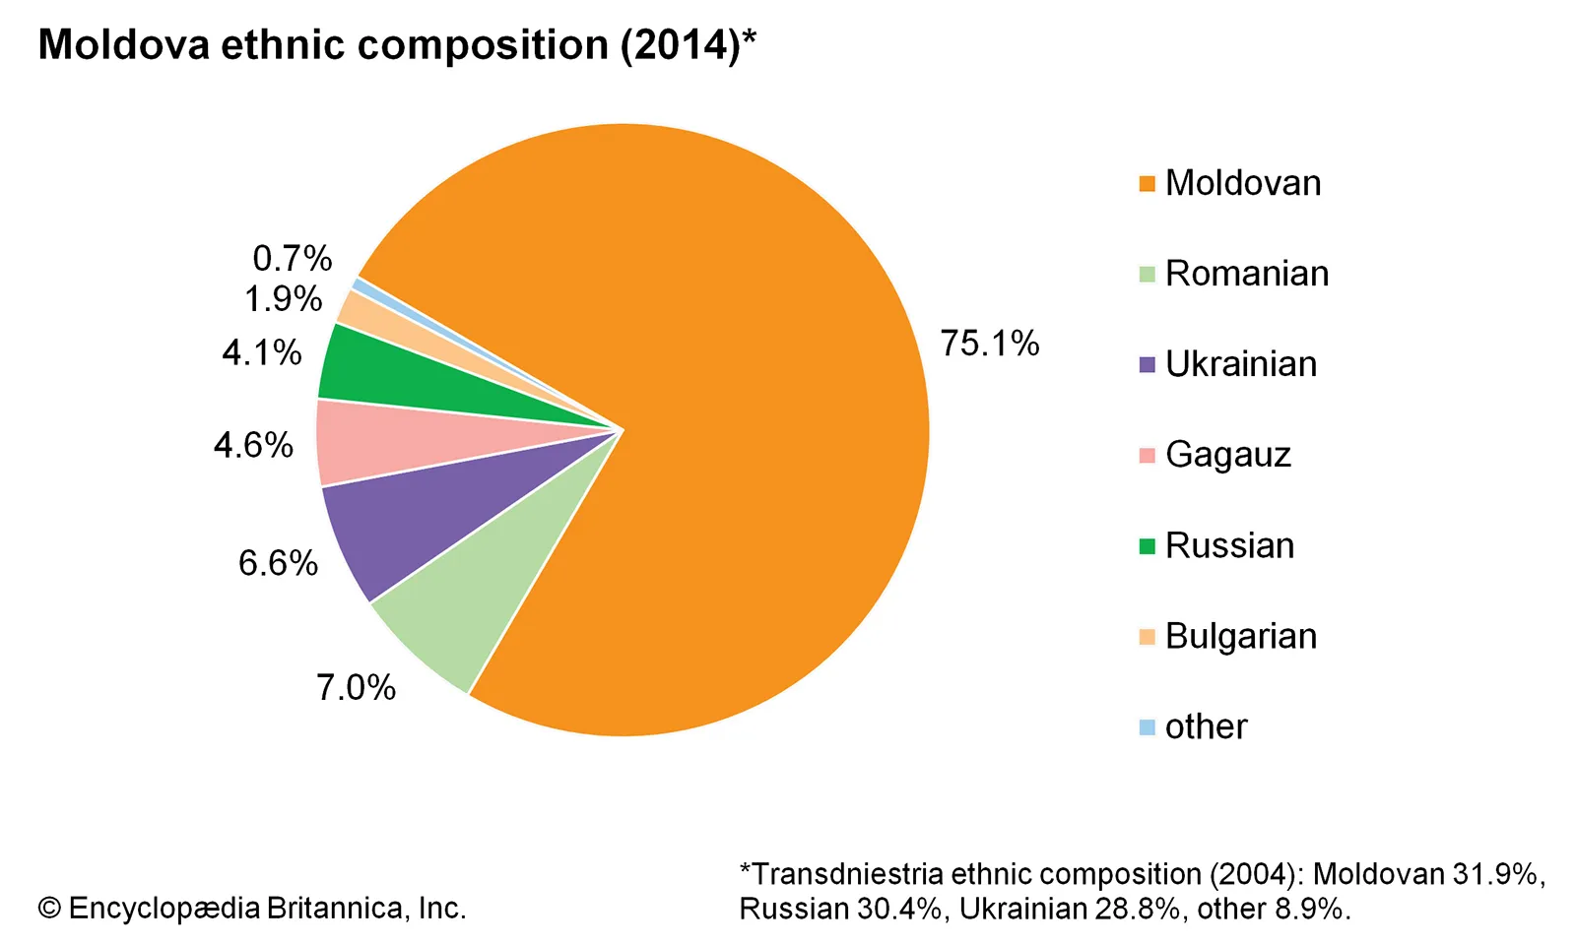
Figure 1. Etnicity (Encyclopaedia Britannica)
2.4 Religions
The main religion is Orthodox Christianity that has church roots from antic Rome(Dima, 1994) and mixed with post-Soviet Russian Orthodox Church. The meeting of two cultures with the same religion showed ‘’para ecclesiastical movements’’ of Moldovan Metropolitinate (Mitrofanova, 2020). It brought to the attention of scholars that the Moldovan Orthodox Church is an meaningful actor for the political schemes(Mitrofanova, 2019) The largest non-Orthodox religion groups are Baptists, Jehovah’s Witnesses, Pentecostals, and Jews counting approximately 20,000 to 30,000 followers each. A small percentage of population include Seventh-day Adventists, Roman Catholics, Lutherans, Muslims, and atheists (state.gov, 2022)
2.5 Main manufacturing and production profile
Moldova’s economy is relying on agriculture sector, vegetables, featuring fruits, wine, and tobacco. The most crucial is the wine production, that accounts the most 50% of the exports in US, Russia, Poland, and Romania, Germany, Italy, and Turkey(Global edge, 2021). Moldova has the number 138 economy in the world and the number 69 of the most complex economy based on Economic Complexity Index (OEC, 2020)
We can see 11% of a growth rate in 2018. The minimum growth rate was 31.9% registered in 2020 and the maximum of 51.6 % was registered on 2021. The main manufacture production in RM decreased in January 2023 by 5.50 % from the Jan 2022. We can observe that from 2021 to 2022 the situation seemed to get better outcome, but perhaps the consequences of Russian special operation in February 2022 destroyed the hopes of the future possibility of prosperity.

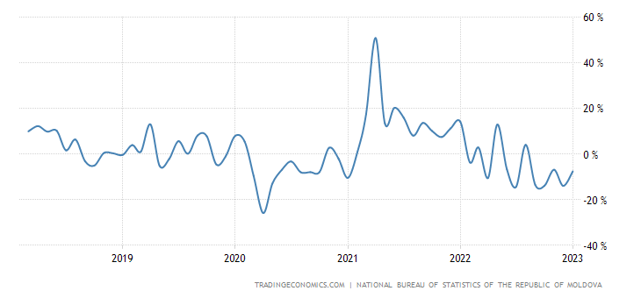
Figure 2. Manufacturing and production profile(Tradingeconomics.com)

https://tradingeconomics.com/moldova/manufacturing-production
2.6 Exports and major trading partners
In 2017 the value was $2,425 billion. 2,210 HS6 products were exported to 131 countries. Top major partner were Romania($600k), Russia ($254k), Italy($236k), Germany($166k), and United Kingdom($136k). Most exported products were Sunflower seeds, electrical machinery, wheat, co-axil cables (WITS, 2023)
In 2018 Moldova’s exports consisted of $2.707 billion, increased with a 14.83% from 2017. The exports were sunflower seeds, Co-axial cable, wiring sets, parts of seats, and Maize. The EU members states totalled US$1.8 million that’s representing 65.9% of total exports. The main trading countries on export has registered Romania($792k), Italy($309k), Germany($219k), Russian Federation($218k),Turkey($107).
In 2019 the exports was $2,779 billion with an increase of a 5.96% from 2018. The EU members states totalled US$1.8 million that’s representing 65.9% of total exports. The CIS countries accounted for 15.6%. The list of the top products is not far from the last year having Sunflower oil again in lead (IPN, 2019). Major trading Partners were Romania($756k), Italy($267k), Russia ($249), Germany($245), Turkey($175).
In 2020 the export worth was $2,467 billion top countries for exports were Romania($707k) with a share of 28.64, Germany ($226k) with a partner share of 9.14, Russia ($217k), Italy($214k), Turkey ($172k). In total exports Moldova has a number 129 of 226 (OEC, 2020) Top products were Insulted wire, Sunflower seeds, cables, parts of seats.
In 2021 was $3.1B, 30.13% increase from 2020. The top 3 exported goods in 2021 was Electrical Machinery, Cereals, and Oil seeds (Globaledge, 2021) 82.7% of Moldova’s exports changed the market from European countries and 15.3 were sold to CIS countries. The Cereals value went up by 327% since 2020 (Workman, 2022) The top trading partners were Romania ($833 Milion), Turkey($313 milion), Russia($276 milion), Germany ($245) Italy($240k). In 2022 the exports of goods increased by 32.3 percent towards the EU, reaching $2.5 billion, and fell towards Russia by 31%.
Table. 1 Export goods(wits.wordbank.org)
Most Extensive Export goods | Year
Sunflower oil seeds | 2017
Sunflower oil seeds | 2018
Sunflower oil seeds | 2019
Insulated Wire | 2020
Electrical machinery, equipment | 2021

By January 2023 Moldova grew buy 0.4 percent from the previous year to $331.7 million, being driven mostly by CIS countries (110.9 percent) and EU (2.9 percent), but with other countries sales were declined by -53.8 percent (Tranding economics, 2023)
2.7 Imports and major trading partners 2017-2021
In 2017 imported 3821 products for $4.8 billion. The top products were petroleum oils ($463k), pharmaceutical mixed and unmixed products ($165k), Electric conductors($64k), Cigarettes ($62k), Transmission apparatus($57k). The top partners were Romania worth $695k with a partner ship of 14.38%, Russia worth $527k with a partner share of 11.83%, Ukraine $511k partner share 10.58%, Chine $505k with partner share of 10.46%, and Germany $391 million with 8.08% parent share.
In 2018 imported 3853 products for $5.7 billion. The top products were petroleum oils($598k), mixed and unmixed pharmacy products($186k), electric conductors >80V($91k), Transmission apparatus($72k), Automobiles with reciprocating piston engine di ($60k).The major trading partners were Romania($838k), Russian Federation($720k), China($606k), Ukraine($577k) and Germany($484k)
In 2019 imported 3879 products worth $5,84 billion petroleum oils($561k), mixed and unmixed pharmacy products($212k), transmission apparatus($80k), electric conductors($72k), Automobiles with reciprocating piston engine di ($60k).The major trading partners were Romania($838k), Russian Federation($720k), China($606k), Ukraine($577k) and Germany($484k)
In 2020 the worth were $5,41 billion. The top products are the same like previous years, but the value of petroleum oil increased by 60% ($349k). Were imported as well rail locomotives worth $46k. Top countries were China($645k), Romania($631k), Russia($603k), Ukraine($527k), Germany($452k)
In 2021 imported $7,17 billion (countryeconomic.com, 2023). In this year was register the hugest value of Petroleum oils and fuel ($1.07B). Electronic equipment consisted $674.99 million Russia ($1.05Bilion), China($836.54M), Romania($829.94m), Ukraine($667.2m), Germany($546.65M)

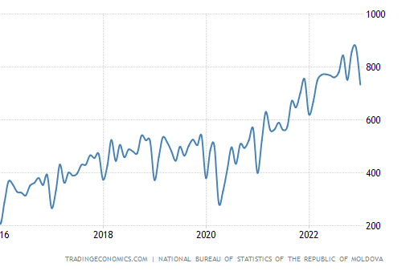
Figure 3. Imports (trading economics)
The imports of RM have significantly opposite figures from exports. They have been surged by 18 % every year to $733.4 million in January of 2023, as purchases increased from the Europe (57.1 percent) and dropped from CIS countries (-29).
The imported resources were petroleum oils, mineral oils, petroleum gases, medicaments, motor cars, and other motor vehicles, insulated cables, electrical apparats for telephony, line telegraphy, tractors.
Table 2. Most imported (wits.worldbank.org)
Most Extensive Import goods | Year
Petrolium Oils | 2017
Petroleum oils | 2018
Petroleum oils | 2019
Petroleum oils | 2020
Petroleum oils | 2021

- Macroeconomic indicators of economic growth
3.1 The Gross domestic product(GDP)
Moldavian GDP measure the national income and the result for country’s economy. In a foreseen period of time GDP is equal to the total expenditures for all produced final goods and services. In 2022 the economy shrank by -5.9% from 13.9% In 2021 with the highest GDP value registered in the history of RM – $13.68 billion, that has and increase from 2020 $11.86 billion. In 2020 COVID has it’s impact on the economy by the steepest shrank of - 7.4% The value in 2020, 2019, and 2018 stays with little change of $4 million GDP, being an increase from $9.7 in 2017. According to the world bank GDP value of Moldova represents 0.01 % of the world economy.
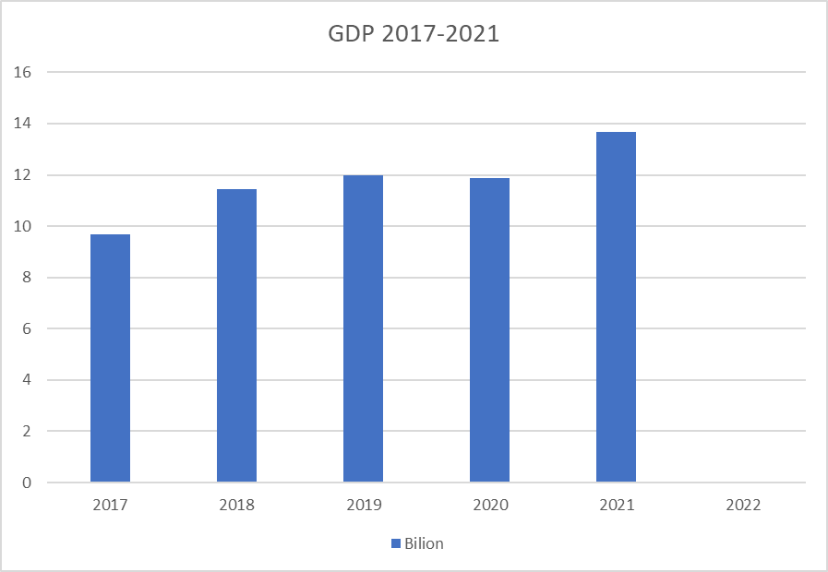
Figure 4. GDP (wits.worldbank.org) (made by author)
3.2 Unemployment 2017-2022
Unemployment is generated by economic activity of population with ability to work but with no chance to find vacancies (Colesnicova and Doga, 2022). Moldova’s unemployment is chaotically risen and dropping twice from 2016-2017, and in 2018 is the registered 2.2%, the lowest figure for the century. It lasts just for couple of months in 2019 is registered the highest rate of 7.7% for first quarter of the year, and closer to 2020 stays at around 4% until the second half of 2021. In 2022 during the Russian invasion on the Ukraine 89,185 refuged on the territory of RM and defines the
drop at 3%.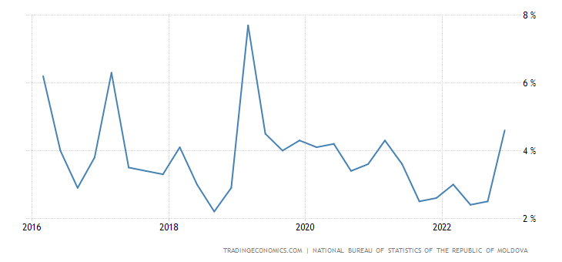
Figure 5. Unemployment (trading economics.com)
3.3 Inflation
Inflation is an crucial indicator for protentional economic growth of every nation (Musarat et al., 2021). The inflation rate for consumer prices in Moldova changed widely in 30 years between -0.1% and 1,613.6% (Worlddata.info, 2022) According to the National Bank of Moldova in figure. In 2017 the highest rate was 7.9% and it dropped to 0.9% in 2018M11. In on year it raised back to 7.5% until 2021M01. At the end of 2021 was registered 13.94% with even higher rate of 33.9% in 2022 influenced by the Russian invasion.
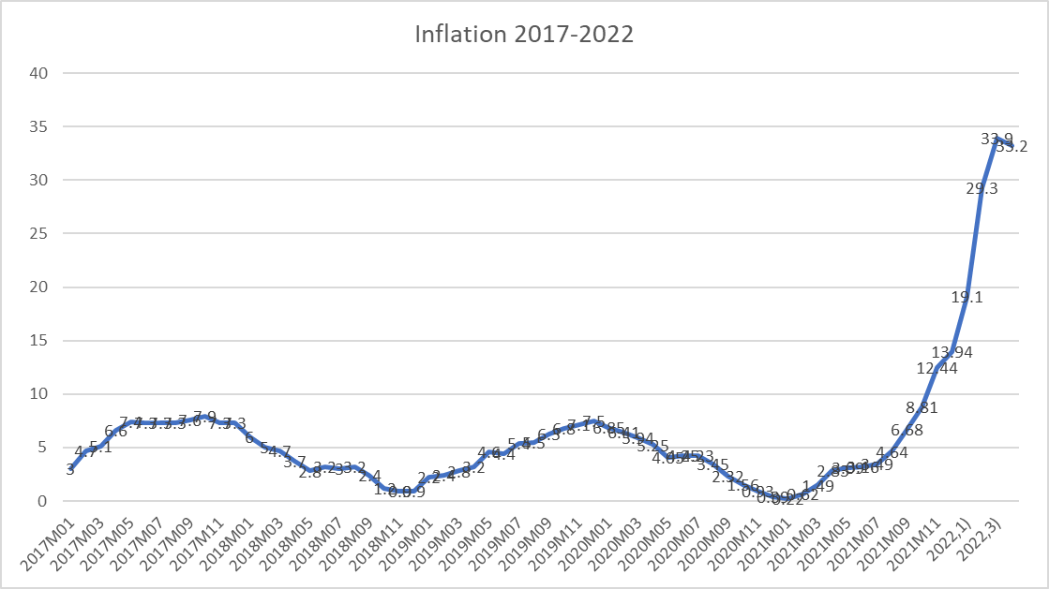
Figure 6. Inflation (made by author)
there are also structural factors that contribute to inflation in Moldova, such as high energy prices and the reliance on imported goods (IMF, 2018). To address these challenges, the government has implemented policies such as fuel price liberalization and import tariff reductions, which have helped to mitigate inflationary pressures (IMF, 2019).

3.4 Balance of payments
In 2017 Moldova has a deficit of $616.94 million, and compared to 2016 is 2.2 times declined. The capital account registered in negative $30.41 million and the financial account declined by $569.77 million. (bnm.md, 2018). In 2018 the current account balance of payments recorded a deficit of $ 1 186,71 million, doubled from previous year and closed to the 2019 negative current account of $1 111,56. The capital account was declined by $54.99 million, and the financial account $1 148,16 million. This figures are changing jus by 0.9% in 2020, but in 2021 was recorded a decline of $1 641 million ($502 million in Quarter II, 2021) on current and capital account and $1 602 million decrease on financial account. According to the data from National bank of Moldova this country has a big decline on goods. The imports has much expenditure then exports, and unfortunately the exports are low-value-added goods(IMF, 2018).
3.5 Budget balance
Turning to the country's budget balance, Moldova has struggled with a high level of public debt in recent years. According to the IMF, the country's debt-to-GDP ratio reached 49.6% in 2019, which is higher than the average for other countries in the region (IMF, 2019). This high level of debt can be attributed to a range of factors, including the country's dependence on external financing, the cost of servicing existing debt, and the need to invest in infrastructure and social programs (IMF, 2019). To address these challenges, the government has implemented policies to improve revenue collection and reduce expenditures, such as the implementation of a new tax code and the reform of social assistance programs (IMF, 2019).
3.6 Interest rates
According to the National Bank of Moldova, the country's average interest rate on loans was 11.1% in 2020, which is relatively high compared to other countries in the region (National Bank of Moldova, 2021). This can be attributed to a number of factors, including the country's high level of risk, the relatively low level of financial intermediation, and the high cost of borrowing on international markets (IMF, 2018). To address these challenges, the government has implemented policies to promote financial sector development and reduce risk, such as the implementation of new banking regulations and the strengthening of the National Bank of Moldova's supervision and oversight functions (IMF, 2019).
- Conclusion
Republic of Moldova is a territory with a historical scar that’s stops the economic developing of the country. Since independency the economic indicators have been just in decline. The most trading partners are Russia and Romania. Republic of Moldova is importing 50% more than exporting figures. The most negative number in balance of accounts is registered on goods. The country needs to develop new products or services, as the Soviet pattern is degrading the performance of the country. The Imports in 2017 consisted $4.8 billion and in 5 years the value became $7.1 billion while the exports in 2017 were $2.4 billion and until 2021 increased to $3.1 billion.
From 2020 Moldova’s GDP shrank by 6%, but in 2021 was registered the higher GDP value of $13.68.

References
2021 report on International Religious Freedom - United States ... (2022). OFFICE OF INTERNATIONAL RELIGIOUS FREEDOM. Available at: https://www.state.gov/reports/2021-report-on-international-religious-freedom/ (Accessed: March 22, 2023).
Mitrofanova, A. (2020) ‘Questioning the European path: Orthodox political radicalism in contemporary Moldova’, Religion, state & society, 48(2-3), pp. 107–124. Available at: https://doi.org/10.1080/09637494.2020.1756708.
Mitrofanova, A.V. (2019) ‘Orthodox actors and equal opportunities policies in the Republic of Moldova in the context of the transformation of post-Soviet societies’, Approaching religion, 9(1–2). Available at: https://doi.org/10.30664/ar.82787.
Coface (2022) Moldova, republic of. Available at: https://www.coface.com/Economic-Studies-and-Country-Risks/Moldova-Republic-of
GlobalEdge (2021) Moldova: Economy., globalEDGE: Your source for Global Business Knowledge. globalEDGE. Available at: https://globaledge.msu.edu/countries/moldova/economy#:~:text=Moldova's%20economy%20relies%20heavily%20on,vegetables%2C%20wine%2C%20and%20tobacco. (Accessed: March 22, 2023).
Calchei, M., Barrett, K.C., Amukune, S. and Józsa, K., 2022. Comparative study of Russian-and Romanian-speaking students’ mastery motivation in the Republic of Moldova. Cogent Education, 9(1), p.2143039.
Ceban, C., 2020. Ethnic and linguistic identification in Moldova: regarding geographic, political, and cultural aspects (Doctoral dissertation, University of Warsaw).
Crowther, W. and Josanu, Y., 2004. Moldova (pp. 549-593). na.
Colesnicova, T. and Doga, V., 2022. The unemployed as a vulnerable group in the Republic of Moldova: data analysis and new social protection measures.
Dima, N., 1994. Politics and religion in Moldova: a case study. Mankind quarterly, 34(3), p.175.
Worldbank
CUPCEA, R., 2020. Cu sau fară coronavirus, Republica Moldova este un stat eșuat. Revista de Științe Politice și Relații Internaționale, 17(2), pp.98-106.
OEC (2020) Moldova (MDA) exports, imports, and trade partners, OEC. Available at: https://oec.world/en/profile/country/mda#economic-complexity (Accessed: March 22, 2023).
IMF. (2018). Republic of Moldova: Selected Issues. IMF Country Report No. 18/255. https://www.imf.org/en/Publications/CR/Issues/2018/11/07/Republic-of-Moldova-Selected-Issues-46289
IMF. (2019). Republic of Moldova: Request for Extended Arrangement Under the Extended Fund Facility—Press Release; Staff Report; and Statement by the Executive Director for Republic of Moldova. IMF Country Report No. 19/166. https://www.imf.org/en/Publications/CR/Issues/2019/06/24/Republic-of-Moldova-Request-for-Extended-Arrangement-Under-the-Extended-Fund-Facility-47002
Moldova - merchandise imports 2021 (2023) countryeconomy.com. Follow us. Available at: https://countryeconomy.com/trade/imports/moldova (Accessed: March 27, 2023).
National Bank of Moldova. (2020). Annual Report 2019. https://www.bnm.md/sites/default/files/rapoarte_annuale/BNM_Annual_Report_2019_1.pdf
National Bank of Moldova. (2021). Interest Rates. https://www.bnm.md/en/content/interest-rates
World Bank. (2021). Inflation, consumer prices (annual %). https://data.worldbank.org/indicator/FP.CPI.TOTL.ZG?locations=MD
Worlddata.info (2022) Inflation rates in Moldova, Worlddata.info. Available at: https://www.worlddata.info/europe/moldova/inflation-rates.php (Accessed: March 24, 2023).
Workman, D. (2022) Countries, Moldova's Top Exports 2021. Available at: https://www.worldstopexports.com/moldovas-top-10-exports/#:~:text=The%205%20biggest%20export%20products,for%20Moldovan%20exports%20during%202021. (Accessed: March 24, 2023).

