Itroduction To Public Health
Module: LCHS4008
Name: Sabirah Gardiner 2318899
LECTURER: Gillian Weaver
Assessment 2: Report On a Health Issue

Introuction
For my written report I have the choice of four non-infectious conditions to choose from, Heart disease, Obesity, Dementia, and Type 2 diabetes. I chose Obesity. My reason for this choice, is that I believe it to be diverse, complex, and I am also interested to find its prevalence, my research will provide the epidemiology of Obesity,
One of the common and simple reasons for obesity is “ If you consume high amounts of energy, particularly found in high fat and high sugar foods, and do not use all of the energy through physical activity, much of the extra energy will be stored in the body as fat”. (NHS). According to the World Health Organisation (WHO) “overweight and obesity are defined as abnormal or excessive fat accumulation that presents a risk to health. In adults a body mass index (BMI) over 25 is considered overweight, and over 30 is obese”.
As stated on GOV.UK official statistical commentary main findings, “In 2023 to 2024, the prevalence of overweight (including obesity) in adults was higher among men (69.7%) than women (59.2%), while the prevalence of obesity in adults was higher among women (26.9%) than men (26.2%)”. (GOV.UK 2025)
Prevalence of overweight (including obesity) and obesity increases with age up to age 64, reaching the peak in the 55 to 64 years group (73.5% and 32.5% respectively) then decreasing in the 65 to 74 years and older groups. (GOV.UK 2025)
According to the World Health Organisation (WHO) “Worldwide adult obesity has more than doubled since 1990, and adolescent obesity has quadrupled. In 2022, 2.5 billion adults (18 years and older) were overweight. Of these, 890 million were living with obesity.
There are many implications of obesity within communities, particularly in low-income areas where prevalence rates are consistently higher than in wealthier regions. Several factors contribute to this imbalance. Families and individuals in deprived communities often struggle to access affordable, healthy food. Even when supermarkets or fresh produce markets are available locally, the cost may may cause restriction, forcing households to rely on cheaper, high in fat and sugar foods.
In addition, those areas often have a higher quantity of fast-food outlets, which makes unhealthy options more convenient and tempting. This food environment reinforces unhealthy habits of eating, which then leads to a poor diet. This will contribute to the rise of obesity and become prevalent to families and individuals in those areas.
As time goes on this will lead to less activity in the homes of families, stress, depression and eventually lead to illness, the NHS show that obesity can cause other serious illnesses such as Type 2 diabetes, high blood pressure, high cholesterol, coronary heart disease, kidney disease, liver disease and much more. Then the strain will way on the medical professionals like GP’s, hospital, nurses, mental health nurse's occupational therapist, and the list goes on.
The impact caused by becoming obese can affect friendships, loved ones, family members as the person who is obese maybe struggling with coming to terms with what this weight gain is doing to them, or they may not have confidence to go out with friends and family, this can cause them to become isolated and of course this will affect their mental health as they struggle to perform everyday chores.
Living with obesity requires affective collaboration between health care and social care professionals. Because obesity is influenced by medical, psychological, and social factors, no single service can address it in isolation. A multidisciplinary approach is therefore essential.
Healthcare professionals such as GP's, nurses, dieticians, and psychologists provide medical assessments, Treatment, and lifestyle guidance. Social care professionals, includes social workers, community support staff, and housing officers, address the wider determinants of health such as poverty, housing, and access to community resources. When these groups work together, they can deliver holistic care that meets both the clinical and social needs of individuals.
Collaboration can take many forms. Shared care plans and integrated Structured framework ensure patient receive consistent support across services. Community based programmes, such as weight management groups or exercise initiatives, activities can be jointly delivered by health and social care teams to encourage participation and reduce stress. Isolation, depression and anxiety. Policy advocacy is another area where professionals can unite, driving forward for healthier food environments, improved further planning, and greater investments to provide a better service.
Strong communication is vital to this collaboration. Regular case conferences, shared electronic health records, and patient centred planning help professionals coordinate effectively. By involving individuals and families in decision-making, professionals empower them to take ownership of their health journey. Ultimately, collaborations between health care and social care professionals create a supportive environment that addresses obesity from multiple angles, improving outcomes for individuals and families, reducing the burden on communities. By involving individuals and families.
All of this would not be possible without the very important role of an Epidemiologist monitoring and bringing to the surface real live facts of the measured and monitoring of incidence by collecting data on body mass index (BMI), Lifestyle factors, and community health surveys. Their work identifies patterns across age, gender, and socioeconomic. groups, highlighting where ability is most prevalent. This evidence guys public health strategies, such as school-based nutrition programmes, NHS weight management service, and community exercise initiatives. By evaluating the success of these interventions, epidemiologists ensure that resources are targeted effectively, helping to reduce. Obesity rates and improve overall well-being.
Obesity is also affecting children as reports by NHS shows “Around one in eight children aged between two and 10 in England are obese, an NHS survey published today found
new statistics show around one in seven children (15%) aged between two and 15 were obese in 2022 – similar to 2019 (16%). Obesity rates in 2022 were 12% among those aged between two and 10, and 19% in those aged between 11 and 15. (NHS 2024)
We have children that have diabetes. “In 2024, 35 million children under the age of 5 were overweight”. (WHO 2025).
This leads to a question, what is our government doing about obesity in young children. The government now say they want to challenge and help with this growing issue by introducing new foods to nursery and schools, banding This will mean they will make better choices of the food in schools by reducing foods that are high fats and saturates, less sugar drinks and low or no salty foods. They plan on banning adverts that show unhealthy foods
I think this could be improved by parents getting involved on what foods to provide and routine of activities, so children get enough exercise. The government will also reduce advertisement for fatty foods, sugar, sweets and reduce the temptation of children wanting to eat anything like that.
I do think that food and nutrients should be taught in schools to provide the younger generation to embrace healthy eating, so they are aware of the danger of such foods, this will help then to make conscious decisions as they develop and grow, it creates awareness for their health going forward.
NICE develops Its recommendations by reviewing. The strongest available evidence and weighing up cost. Effectiveness. Which research evidence is limited? The guidance is instead based on the committee's professional judgement and their view of what represents good practise. Each recommendation is accompanied by a note on the strength of the evidence, shown in. Square brackets using the grading system development by the Great Working Group. (TheJBL 2025)
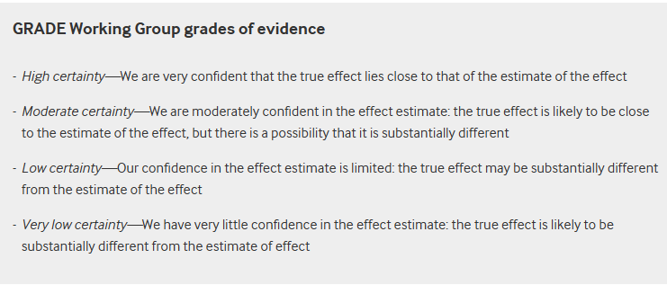
It is imperative that all professionals take time before Engaging in discussion. With individuals. Struggling with the Bay City to approach the conversation with sensitivity and empathy. There are many contributing factors that may explain why a person is living with obesity, including biological, psychological, social, and environmental influences. Recognising this complexity ensures that carries person-centred., respectful, and tailored to the individual circumstances. have included a table below (BMJ 2025)
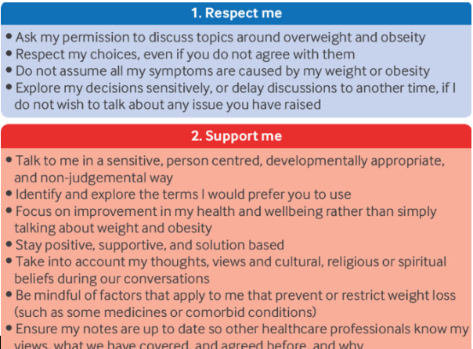
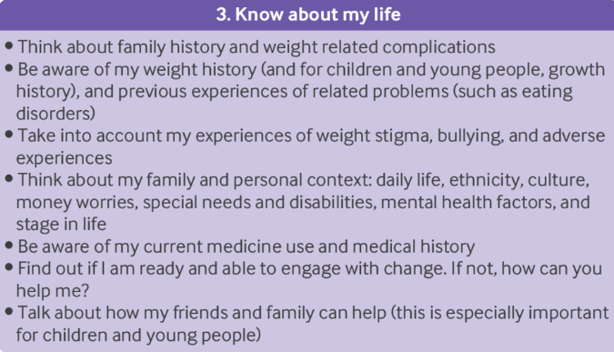

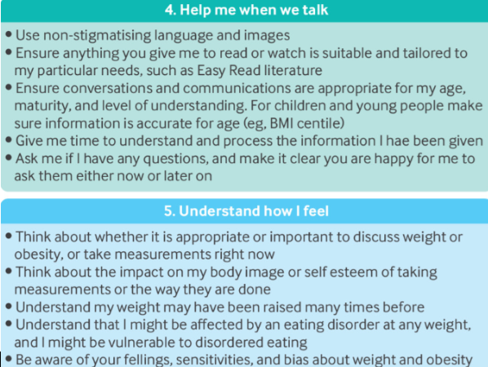

.

Conclusion
Obesity is a complex condition with wide. Ranging consequences for individuals., families, and communities. It disproportionately affects low-income areas., where access to healthy food is limited and fast-food outlets are abundant, creating environments that encourage unhealthy choices. The impact expands beyond physical health, contributing to mental health challenges., social isolation, and significant strain on healthcare and social care services. Collaboration between professionals is essential, as multidisciplinary approaches allow medical treatment to be combined with social support, ensuring interventions are holistic and accessible. Epidemiology. He plays a vital role in measuring and monitoring AB City, providing the evidence base. For effective public health strategies. By integrating prevention., treatment, and community support, SoC can begin to reduce the Bay City rates and improve well-being. tracking is not only a matter of individual responsibility, but a collective effort to build healthier, more resilient communities. I can relate to having put on weight so understand the struggles of losing weight, along with challenges people face.

REFERENCES

National Health Organisation (2025) obesity and overweight Available at: Obesity and overweight (Accessed 03 2025)

NHS NEWS (2024) one in eight toddlers and primary school children obese Available at: NHS England » One in eight toddlers and primary school aged children obese (Accessed 03 November 2025)

NHS (2023) Overview obesity. Available at: Obesity - Causes - NHS (Accessed: 30 November 2025)

TheJBL (2025) Overweight and obesity management: summary of update NICE guidance Available at: Overweight and obesity management: summary of updated NICE guidance | The BMJ (Accessed 30 November 2025)

World Health Organisation (2025) Obesity profile short statistical commentary, May 2025 Main findings: Available at: Obesity profile: short statistical commentary, May 2025 - GOV.UK (Accessed 30 November 2025)

World Health Organisation (2025) westernpacific/health-topics/obesity/ Available at: Obesity (Accessed: 30 November 2025)

