

NAME: | RASHID AHMED
MODULE: | CHANGEMAKERS
MODULE CODE: | BMHP5014
LECTURER: | Diola BIJLHOUT
ASSIGNMENT TITLE: | E-PORTFOLIO. ASSESSMENT 1
DEADLINE: | 21-APRIL-22

CONTENTS

- Introduction Page 1
- Artefact 4 page 2
- Artefact 5 page 3
- Conclusion page 4
- Referencing page 5

1. Introduction

This new project, or rather campaign came naturally to me. We have all experienced and endured perhaps, the most significant impact on our lives as a result of the covid-19 pandemic. Many have lost loved ones, and many more have suffered as a result of the restrictions/lockdowns. This has impacted everyone’s physical and mental health and general wellbeing. The restrictions have all gone and the people, communities need to get back into shape physically and mentally. This was a healthy message pre-Covid, that people paid little or no attention to, but now it is a message post-Covid that everyone will or should pay attention to.
I have chosen artefacts 4 and 5, the leaflet/flyer and seminar poster respectively to promote my campaign for better health and wellbeing on a local and national level, with the support of the Government, NHS, and businesses. There have been many campaigns pre Covid-19 promoting better heath lifestyles to the nation, but with the need being so great post covid-19 regarding the nation’s health in terms of physical, mental, health and social care, and the major issues of loneliness, anxiety, and depression according to Gov.UK (2022) resulting from self-isolations, restriction’s in visiting loved ones primarily the elders. These studies into the populations mental health and well-being revealed deteriorations in mental health, during the covid-19 pandemic from May 2020 through to the Christmas period of 2021.

2. Artefact 4 (Leaflet)

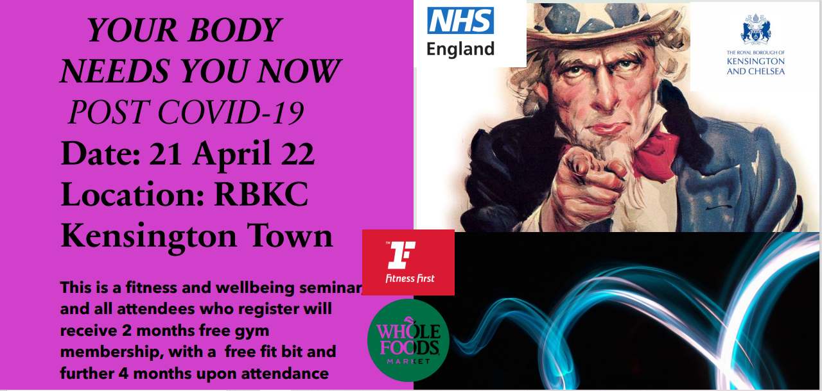

The idea for the artefact 4 (leaflet) and in general, the campaign came naturally as mentioned in the introduction. The image of Uncle Sam, Society (2022) which originated from a merchant in New York called Sam Wilson, but to his friends as “Uncle Sam.” He supplied the American troops in the 1812 war with beef in barrels marked U.S. However, the initials were associated with “Uncle Sam” Wilson. The most famous image of Uncle Same was created by Montgomery Flagg for a U.S. Army recruitment campaign poster during World War 1 and 2.
I knew of the poster and came across it during my e-learning in either unit 1 or unit 2. This inspired me to, not only use the image in my campaign but in the light of the covid-19 pandemic. To encourage and convey to the local and national population, that their body needs them post covid-19. According to Drewniany (2007). The connections that can be made by creative Ads, and the audience targeted are very creative in that, they sell the idea in an unexpected way. I combined colours that would work together to draw in one’s attention. The use of black text upon a purple background to the left, and with Uncle Sam to the right. The NHS in blue above and likewise RBKC council emblem in blue also to match the blue top hat uncle Sam is wearing. The blue streak symbolic of the time passed since the war on the Covid-19 pandemic. All this to colour co-ordinate the message, text, and image, in an attractively striking way, with contact channels in order to participate in this unique campaign. My idea and campaign is being Sponsored by the NHS and RBKC council primarily, my secondary sponsors are Fitness first, Whole foods, Tesco, Twitter, and Facebook.

3. Artefact 5 (Seminar Poster)

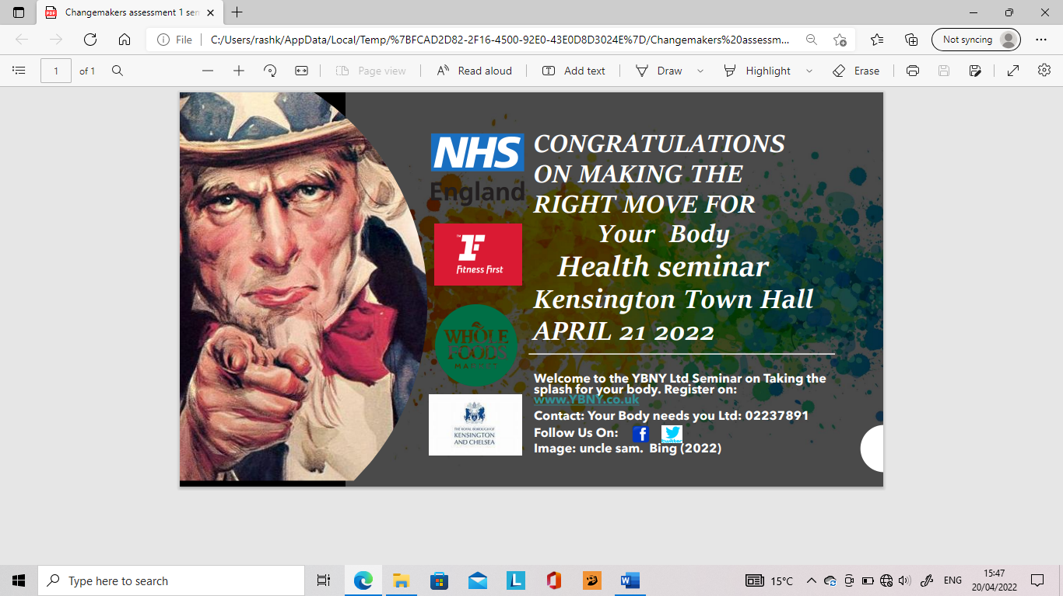

The seminar poster (Artefact 5) is a continuation of my initial idea with artefact 4. An ongoing development of a campaign to create awareness within the local as well as the national communities, of the impact of covid-19 on mental health in England as the BMA (2022) says. To encourage many to attend the seminar. You will note that the poster is more personal in that the image is closer, with the wording being more direct. The decision has been made for you. That you have made the right move for your body. Those who register before the seminar will receive 2 months Fitness first membership for free, with a further 4 months upon attending the seminar, a total of 6 months free membership. Fitbits will be given away courtesy of The Royal Borough of Kensington and Chelsea. There will be free advice on all matters relating to physical, mental health and general wellbeing issues, through the NHS (2022). The importance of this free advice is to also be mindful of the stress and burnout rate of doctors during the covid-19 pandemic according to BJGP Jefferson (2022) and to appreciate the Doctors and Health care professionals.

4.Conclusion
Barton, et al (2015). Suggested many years ago that unhealthy lifestyles and health issues like obesity, mental illness, cannot be solved solely by medication. To which I concur and would say that the pandemic has highlighted the urgent need for people to eat healthy, exercise the body and mind and maintain as a guidance to living well according to the National Institute for Health and Care Excellence (2022). This campaign which will be supported by local government and the National Health Service (NHS), and tailored towards local and national communities, but additionally supported by businesses local to these communities. This can only lead to a positive impact on the communities locally and nationally and inspire generations to come to take care of their bodies, in order for their bodies to take care of them.

5.Referencing
Drewniany. L. B and Jewler. Jerome. A.(2007) Creative strategy in Advertising. 9th edition. Boston, USA. Wadsworth Publishing.
GOV (2022) Important Findings. Available at: 2. Important findings - GOV.UK (www.gov.uk)(Accessed: 4 April 2022).
Society (2022) Uncle Sam. Available at: Uncle Sam | National Geographic Society (Accessed 7 April 2022).
BMA (2022) The impact of covid-19 on mental health England. Available at: bma-the-impact-of-covid-19-on-mental-health-in-england.pdf (Accessed 8 April 2022).
NHS (2022) Exercise: Available at: Exercise - NHS (www.nhs.uk) (Accessed 9 April 2022).
Barton, H. et al. (2015) The Routledge handbook of planning for health and well-being: Shaping a sustainable and healthy future. Abingdon, UK. Routledge.
NICE (2022)Mental health and wellbeing .Available at: Mental health and wellbeing | Topic | NICE (Accesses 10 April 2022).
British Journal of General Practice (2022) GP wellbeing during covid-19 pandemic. Available at: GP wellbeing during the COVID-19 pandemic: a systematic review | British Journal of General Practice (bjgp.org) (Accessed 11 April 2022)

