
Priyankka Sivaperumal (2244738)

Changemakers: Creativity and Value Creation
Content Page
Task 1 – Research Question………………………………………………………………………Pg.2
Task 2 – Research Techniques……………………………………………………………………Pg.5
Task 3 – Presentation of Idea…………………………………………………………………….Pg. 7
Task 4 – Data Analysis……………………………………………………………………………Pg.8
References
Appendix: Script of Pitching

Task 1 – Research Question
Background of the problem
"Accountants and the accountancy profession exist as a means of public service; the distinction which separates a profession from a mere means of livelihood is that the profession is accountable to standards of the public interest, and beyond the compensation paid by clients."
– Robert H. Montgomery, 2009
Unfortunately, ethics and integrity which are fundamental to the accounting profession, are as rare as intangible assets in today's financial world.
Kiradoo (2020) emphasizes ethics in accounting as applied ethics, focusing on human and business ethics, judgments, and moral values within the field. Nambukara-Gamage and Rahman (2020) define ethics as a discipline that addresses issues of good and evil, right and wrong, and virtue and vice. Meanwhile, Huberts (2018) links integrity to moral standards such as truthfulness, honesty, and fairness, as well as to personal ideals that can sometimes conflict with these standards. A person with integrity will consistently choose universally acceptable behaviour when faced with alternative choices (Bakar, Saat and Majid, 2003).
In the realm of accounting, accountants and auditors must maintain high levels of ethics and integrity because external stakeholders heavily rely on their financial statements and audits (Bakar, Saat, and Majid, 2003). KaoDui, Nyamoto, and Mandella Bonsu (2019) argue that adhering to ethics and integrity enables accountants to identify resource wastage, investigate issues, and contribute to policy formation, thereby enhancing the credibility and reliability of financial reporting while fostering trust among stakeholders. Unethical behaviors not only damage individual reputations but also tarnish corporate images, potentially leading to criminal activities and reduced profitability (Enobong, 2017). The Parmalat scandal, along with Enron, WorldCom, HealthSouth, and Tyco, serves as a stark reminder of the widespread epidemic of unethical behaviour in financial markets.
Numerous studies have examined the factors e.g. gender, loopholes in ethical standards and audit firm size influencing the ethics and integrity of accountants. However, there is limited research on how accounting students perceive these factors. This research aims to fill this gap by exploring the perspectives of future accountants.

Research Question
Do accounting students believe that factors such as gender, loopholes in ethical standards, and firm size influence the integrity and ethics of professional accountants?
Objectives
1. To study accounting students’ beliefs about how accounting loopholes affect the ethics and integrity of professional accountants.
2. To examine accounting students' views on the ethical decision-making between male and female accountants.
3. To investigate how accounting students perceive the influence of audit firm size on the ethical behaviour of accountants.
Hypothesis
Hypothesis 1: Accounting students believe that loopholes in ethical standards justify accounting professionals’ unethical behaviour
Hypothesis 2: Accounting students believe that female accountants show a stronger commitment to ethical principles than male accountants.
Hypothesis 3: Accounting students perceive that Big 4 audit firms uphold higher ethical standards and independence than non-Big 4 firms because they have a larger client base and better manage conflicts of interest.
Value of research
First and foremost, the research will inform accounting watchdogs such as the Financial Reporting Council (FRC) about the existing loopholes in accounting practices. This will help them revise these practices to further enhance and clarify principles of integrity, objectivity and independence the profession commits to. Secondly, the findings can help develop ethics in accounting education at universities. Given the perceptions of students regarding ethical challenges within the industry, educators can design curricula that better prepare these future accountants for the ethical issues they might face in their careers. Finally, the research will also encourage audit firms to conduct effective quality reviews of audits and reassess their staff structure to ensure they are adequately equipped to handle client pressures ethically.

Research approach
The research uses a deductive approach to examine the factors affecting ethical behaviour and integrity among accountants. By using established theories and frameworks from ethics and accounting literature, the research conducted a structured investigation into main factors such as gender, audit firm size and external pressures. Besides that, the research also utilized the mixed-methods approach which involves the quantitative and qualitative data. Quantitative data is collected through surveys and qualitative data were obtained through reviewing previous literature on integrity and ethics in the accounting profession.
Data collection method
Primary data was collected using Google Form questionnaires, presented to the accounting students of University-Malaya Wales. They were requested to respond to the questionnaires with answers that depicted their views on the factors affecting the ethical behaviour and integrity of accountants in the accounting profession.
Sampling method & sample size
Quota sampling is used to ensure that specified numbers are obtained from each specified demographic group, the male and female. A sample of 30 students were chosen. Given that the target population are the accounting students of University-Malaya Wales, the sample’s gender quota will assign 15 males (50% of 30) and 15 females (50% of 30). No randomization of unit selection within these groups is carried out.

Task 2 – Research Techniques
Primary Research
A survey was conducted among the 1st, 2nd, and 3rd-year accounting students at University-Malaya Wales using the link provided (https://docs.google.com/forms/d/e/1FAIpQLSc9Ljq5FPdptOGQkmVtuPXgQKsgg_JMu_6E0SRoxYI0GhQgVQ/viewform?usp=sf_link).
Initially, 33 students participated, but only 30 responses were included in the analysis. The survey featured both closed-ended and open-ended questions as follows:
Closed-ended questions:
1. Do you agree that female students are more ethical and scared about cheating compared to male students?
2. Do you think that large audit firms (Big 4s) deliver higher quality audits because they face higher reputational risks, than smaller audit firms (non-Big 4s).
Open-ended questions:
1. The same way, do you think that gender influences ethical decision-making in accounting profession? Provide an example or explanation to justify (open-ended question)
2. Do you think that if professional codes of ethics are unclear, it makes it easier for people to act unethically? Please explain your answer.
3. ‘Creative accounting’ involves manipulating a company's financial performance within legal limits (e.g., accelerating revenue) to present a better picture.
Do this practice compromise integrity and ethical behavior? Explain your view.

Secondary Research
Author | Title of Journal | Key Findings
Boateng, E.A. and Agyapong, D. | Gender and Ethical Behaviour of accounting Students: An Empirical Evidence of University of Cape Coast | Women are more inclined to consider the impact of their actions on others and prioritize ethical behaviour than men.
Adekoya, A.C., Oboh, C.S. and Oyewumi, O.R. | Accountants perception of the factors influencing auditors’ ethical behaviour in Nigeria | Societal expectations and norms shape individuals’ behaviours based on their gender roles
Radtke, R.R. | The Effects of Gender and Setting on Accountants’ Ethically Sensitive Decisions | Men often emphasize competitive success and higher earnings, leading to a greater willingness to bend rules or act unethically in pursuit of these goals.
Bhasin, M.L. | Accounting Manipulation Practices in Financial Statements: An Experience of an Asian Economy | Accountants exploit flexible ethical guidelines to manipulate financial statements, favouring their clients or themselves
Pfeifer, S. and O’Dwyer, M. | King & King’s audits of Sanjeev Gupta companies probed by UK regulator | King & King audited 60 entities of the Gupta Family Group (GFC) individually, despite all being controlled by the same owner, Sanjeev Gupta. This was possible due to a loophole in the Financial Reporting Council (FRC) Ethical Standard. Paragraph 4.24 of the standard states that accounting firms should not generate more than 15% of their revenue from a single client, or 10% for a "public interest entity." However, the standard does not specify whether companies under the same ownership should be considered one client, enabling auditors to audit multiple entities separately, even if they share the same owner.
Ettredge, M. et al. (2017) | Client pressure and auditor independence: Evidence from the “Great Recession” of 2007–2009 | Clients pressure auditors not to issue first-time going concern (GC) modified opinions, which doubt a company's ability to continue operations.
Salman, K.R. and Setyaningrum, B. | The effects of audit firm size, audit tenure, and audit rotation on audit quality | Smaller audit firms (non-Big 4) are more susceptible to pressures related to issuing GC opinions than larger firms (Big 4)
Chen, J.Z., Elemes, A. and Lobo, G.J. | David versus Goliath: The Relation between Auditor Size and Audit Quality for U.K. Private Firms | Big 4 firms have a diverse client base and are less concerned about losing one client. So, Big 4s can maintain higher levels of independence and objectivity in their audit opinions
Task 3 – Presentation on Ideas
Based on the feedback I received for my pitch, the following are the positive comments.
Firstly, my classmates said that the research question was focused and clearly explained. They found it relevant since it addresses the accounting students, the future accountants. Some of them mentioned that "because of this the study has the potential to have a significant impact on the accounting field". They also felt that the quota sampling method is appropriate since the gender influences in ethical decision-making are one of the main aims the research intended to explore.
Friends interning at audit firms said that the pitch and research were relevant to what they are experiencing in their work. They have said that I presented confidently, giving a clear overview of my research topic, its purpose, and how I am conducting it.
However, there were a few drawbacks. Some suggested that interviews would have provided more genuine responses as surveys might result in superficial answers. The participants could just copy the answers from Google or ChatGPT instead of giving their real opinions. Besides that, one of my accounting lecturers said I should touch on current trends like ESG, which would have made my research more significant today.

Task 4 – Data Analysis
For clearer version of the poster, please refer the link below:
https://drive.google.com/file/d/1YG-P5evhtbfAe0OXyvqBiCOYx86AIKM2/view?usp=sharing
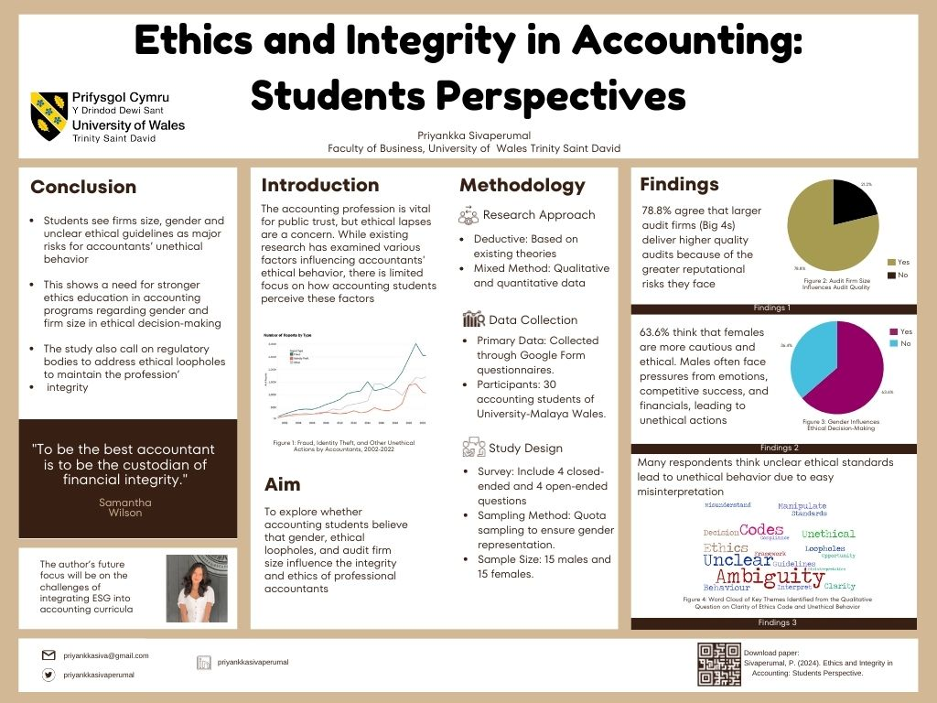
References
Adekoya, A.C., Oboh, C.S. and Oyewumi, O.R. (2020) 'Accountants perception of the factors influencing auditors’ ethical behaviour in Nigeria,' Heliyon, 6(6), p. e04271. https://doi.org/10.1016/j.heliyon.2020.e04271.
Bakar, M.A., Saat, M.M. and Majid, A.Hj.Abd. (2003) 'Ethics and the accounting profession in Malaysia,' Journal of Financial Reporting & Accounting, 1(1), pp. 105–122. https://doi.org/10.1108/19852510380000502.
Bhasin, M.L. (2016) 'Accounting Manipulation Practices in Financial Statements: An Experience of an Asian Economy,' International Journal of Economics and Financial Research, 2(11), pp. 199–214. https://econpapers.repec.org/RePEc:arp:ijefrr:2016:p:199-214.
Boateng, E.A. and Agyapong, D. (2017) 'Gender and Ethical Behaviour of accounting Students: An Empirical Evidence of University of Cape Coast,' Research Journal of Finance and Accounting, 8(4), pp. 49–56. https://www.iiste.org/Journals/index.php/RJFA/article/view/35703.
Chen, J.Z., Elemes, A. and Lobo, G.J. (2021) 'David versus Goliath: The Relation between Auditor Size and Audit Quality for U.K. Private Firms,' European Accounting Review, 32(2), pp. 447–480. https://doi.org/10.1080/09638180.2021.1986090.
Enobong, E.U. (2017) 'Implications of accountants unethical behavior and corporate failures,' International Journal of Business, Economics and Management, 4(4), pp. 82–94. https://doi.org/10.18488/journal.62.2017.44.82.94.
Ettredge, M. et al. (2017) 'Client pressure and auditor independence: Evidence from the “Great Recession” of 2007–2009,' Journal of Accounting and Public Policy, 36(4), pp. 262–283. https://doi.org/10.1016/j.jaccpubpol.2017.05.004.
Financial Reporting Council (2019) Revised Ethical Standard 2019. https://media.frc.org.uk/documents/Revised_Ethical_Standard_2019.pdf.
Huberts, L.W.J.C. (2018) 'Integrity: What it is and Why it is Important,' Public Integrity, 20(sup1), pp. S18–S32. https://doi.org/10.1080/10999922.2018.1477404.
KaoDui, L., Nyamoto, K.K. and Mandella Bonsu, O.-A. (2019) 'The need for Ethics in Professional Accounting,' European Journal of Accounting, Auditing and Finance Research, 7, pp. 27–38. https://eajournals.org/wp-content/uploads/The-Need-for-Ethics-in-Professional-Accounting.pdf.
Kiradoo, G. (2020) 'Ethics in Accounting: Analysis of current financial failures and role of accountants,' Social Science Research Network [Preprint]. https://papers.ssrn.com/sol3/papers.cfm?abstract_id=3553336.

Nambukara-Gamage, B. and Rahman, S. (2020) 'Ethics in Accounting Practices and its Influence on Business Performance,' People: International Journal of Social Sciences, 6(1), pp. 331–348. https://doi.org/10.20319/pijss.2020.61.331348.
Pfeifer, S. and O’Dwyer, M. (2022) King & King’s audits of Sanjeev Gupta companies probed by UK regulator. https://www.ft.com/content/089d2d9d-81d9-4d06-8f70-6ab64797f08f.
Radtke, R.R. (2000) 'The Effects of Gender and Setting on Accountants’ Ethically Sensitive Decisions,' Journal of Business Ethics, 24(4), pp. 299–312. https://doi.org/10.1023/a:1006277331803.
Salman, K.R. and Setyaningrum, B. (2023) 'The effects of audit firm size, audit tenure, and audit rotation on audit quality,' Ilomata International Journal of Tax and Accounting, 4(1), pp. 92–103. https://doi.org/10.52728/ijtc.v4i1.636.

Appendix
Pitching Script
0:00
Hello, I'm Priyanka.
0:01
Today I'll be presenting my speech on my research which explores how accounting students perceive the impact of gender, ethical loopholes and audit firm size on the integrity and ethics of professional accounting.
0:14
So what is ethics?
0:15
Ethics is a discipline that addresses the issues of good and evil, right and wrong, and virtual and voice.
0:21
Integrity Involve moral standards such as the truthfulness, honesty and fairness.
0:27
It's about doing the right thing even when no one is watching.
0:31
Both ethics and integrity are very crucial in the accounting profession, but are often compromised by the accountants, leading to scandals like the Enron and Parmalat.
0:42
While previous studies have examined how gender audit, firm size and ethical loopholes influence accountants, there's limited research on how the future accountants, the students, view these influences.
0:55
Hence, my research aimed to fulfill this gap by examining the students perception.
1:01
In terms of research method and approach.
1:04
I used the deductive approach with a mixed method strategy.
1:07
Quantitative data was gathered via surveys, while qualitative data were gotten from reviewing the existing literatures.
1:15
Primary data were collected through surveys distributed to 30 according students of the University of Malaya, W.
1:22
The survey included both the close ended and open-ended question involving five key questions altogether.
1:29
For sampling, I used the quota sampling to ensure the gender balance with 30 students, 15 male and 15 female participating in the survey.
1:39
This approach was chosen because to accurately reflect the potential gender based differences in ethical perspective among the future accountants.
1:48
The value of the research is firstly, the findings will inform regulatory bodies like the Financial Reporting Council about the existing loophole within their ethical standards in the hope that they will revise those loopholes to enhance integrity, objectivity and independence in the accounting profession.
2:07
The second value of the research is that the research will assist universities in developing ethics focused module within the accounting courses to better prepare the accounting students for future ethical challenge.
2:19
Lastly, the research will encourage audit firms to conduct effective quality reviews and reassess their staff structure to ensure ethical conduct under client pressures.
2:30
In conclusion, this research contributes to improving ethical standards in the accounting profession by addressing the perception of future accountants.
2:39
Understanding this perception is very important for shaping a more ethical and reliable profession in the future.
2:46
Thank you.

