
7

Student name: Luz Perpetua Diaz Alarcon
Student ID: 2439120
Module name: Principles of Health and Social Care Practice
Component 1 : Written Assigment
Module code: BMHP5016
Lecturer name: Sam Parker

Task 1: Reflection on the Importance of Principles of Health and Social Care
Importance of Principles of Health and Social Care
The principles of Health and Social Care are statutory guidance, Ethical frameworks and professionals’ standards and these principles are embedded in the UK law. There are some organizations like: NHS (National Health Service) NICE (National Institute for Health and Care Excellent) CQC (Care Quality Comision) HCPC (Health and Care Professional Consul) the Uk stator of 15 professions. All of these organizations playing different roles. According to (NHS, 2010) the principles “Equity and Excellence “involve a balance between maintains high standards and adapting to individual’s needs. Hence the important of these principles according to (Price Bob, 2020) they provide foundational Ethical frameworks that guides professionals to delivery the care that respects right, dignity and individuals’ needs. Therefore, the important of apply principles in Health and Social care are to protect people, improve dignity and respect, fairness and equality, high quality care, clear guidance for the staff. Furthermore, the principles in the UK Health and Social Care serve the Ethical guides and support person centre to helping professionals dealing with complex demands hence maintains the quality and integrity of care relationship.

Definition of Person Centred Care:
Health Care Systems and Organizations in UK, are looking to improve Health Care System performance. According to (Santana, 2018) the Health Care System going through the implementation of a specific Person-Centred Care (PCC) Model. Hence a numerous frameworks PCC exist, but still a gap to follow the practical guidance on PCC implementation. Hence to specified what is Person-Centred Care in Health and Social Care refers an approach that prioritizes that all individuals have access to Care in the meantime recognizing then as unique person with specifics needs, preferences and values. Therefore, the approach (PCC) involves patients in decision about they Care, hence ensure that patients particularities and wishes are taking in they care process. The important of Person-centred care is to support their Physical, Phycological, social, patients’ needs. (Morgan, Stephanie et al, 2012), In the meantime the benefit of person-centred care is the contribution to make changings in people lives by adapting and improving in their care and independents. (Sanderson, 2011). According to (Maclean associates, 2015) there are 4 principles of person-centred care.
- Treating people with dignity, compassion and respect.
- Offering coordinate care, support and treatments.
- Offering personalized, support and treatments.
- Supporting individuals to be independents and enjoy life.

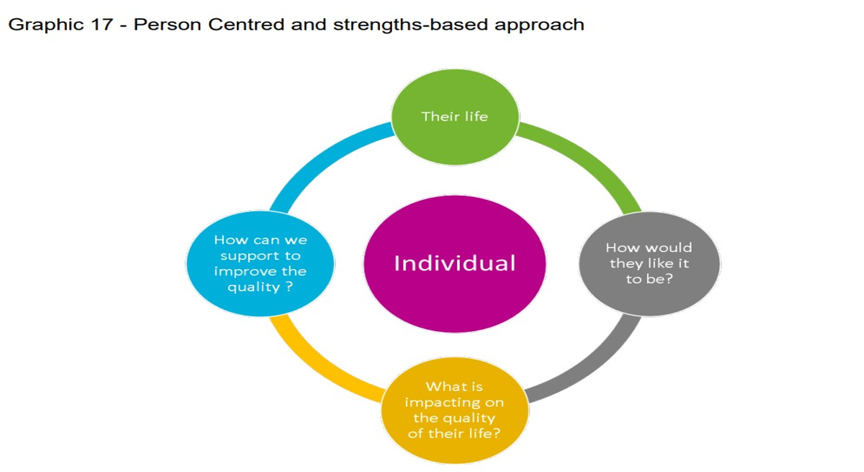
Figure 1 - Person Centred Care and Strength Based Approach to Care Deliver

Importantly to mention Maslow Hierarchy of needs is a Phycology theory that focus on individual needs and where the individual achieves the high level of capacity. According to (McLeod, 2007) Explain the Maslow theory that every person born with special needs, Maslow theory works when the high-level needs appear when the lower levels are met. Hence Maslow theory helps professionals to understand service users’ specific needs.

Definition of partnership working
According to (Douglas, 2008) to understand of partnership working together means improving Social Care Service and bring together different organizations to help meet the needs of services users. Therefore, partnership working together is to helps with experiences. Skills, expertise and exchange information. The goal of partnership is to bring efficiency and quality of service to offer the best service, all the partners working in common aim, decision together, clarity of information acting together. In addition, Partnerships will be co- worker and managers, service users and families, Health and Care professionals.

Defection of Ethics in Health and Social Care
Ethic refers to the Heart of Health Care, as search shows the information founded in a book (Seedhouse. 2008) define Ethics as a moral principle that guide professionals to conduct, complex decision making and the quality of care provide to the patients, Ethics mean as well care with fair, respect, dignity, safe and wellbeing of individuals to avoid harm. In addition, relate to ethic there are challenges that can create dilemmas for healthcare professionals and can lead in stress and conflict. (Markmann. 2022)

Task 2: Practical Examples of Concepts in Practice

Case: A patient who experience a severe Depression and Anxiety.
Description: A patient of 32 years old living and working in London UK, experience a severe Depression and Anxiety due to a busy and continues stressful Routines (work study, family)
According to (Pinho, Lara Guedes de at al., 2021) how these principles in Health and Social Care can improve care and Health outcomes to provide to individuals lifestyle and every individual have rights the principles are to protect people, improve dignity and respect, fairness and equality, high quality care, guidance for the staffs. Therefore, to help patients with these mental illnesses and severely disrupt on daily life and Physical health will need support from different Health Care Settings not only offer medication also it is crucial support from professionals, service users and families to come all together to provide the best care and Health outcomes in individuals, asse in what patient’s priorities treat then with respect and dignity,
‘

Person centred Care crucial support in this case:
Accordance to (Lewis, 2011) The Person Centre care responsibility is to assess the patients’ needs and safe, reassurance the best possible care supporting like offering a care planning, personalized treatments, support in their needs with respect, compassion and involving the patient in their recover process and wellbeing. Overall, Person Centred Care for patients with depression and anxiety involves a combination of specialized assessments, collaborative planning, family involve and supportive environment to improve patients recover and offer then a different lifestyle.
In the meantime, patients need required support from professionals in different care settings to support then.

Partnership working together in this case:
Evident shows according to (Menear, 2022) that other professionals are involved to support the patient like: treatments and therapies from Phycologist, Psychiatrist, GP, with regular appointments, Counselling, collaboration of social workers and the support and love from family. Working in partnership got beneficial results that working with single organization, working in partnership help then with clear solution. evaluate the patient situation, creating strategies like exchange information, tailored plans, specific discussion in patients needs to delivery the clear and the best service possible. Consequently, partnership working together involves Professionals, services user, families to support patients care and health outcomes.

Professionals Ethics to help in this case:
Ethics meaning the Moral principles that guide professional’s conduct. Furthermore, this article (Marsili, 2023) refers Ethics to the rules or principles that governing wrong and right behaviour from professionals what consider appropriate and inappropriate actions. In addition to help patients with depression and anxiety is to show compassion, respect, making appropriate decision & treatments for patient’s wellbeing beyond traditional and professional bandaris. (Liija. 2002)

Task 3: Critical Reflection on these Principles and how will shape your Professional growth

Definition what is Reflection?
According to (University of Edinburgh ,2024) Reflection means thinking carefully about our past experiences in life, our thoughts and actions. Hence Reflect in you past experiences will guide you to take actions on what we do now? And what we do in the future? Reflection creates Questions our thinking in what we can do better to do not do the same mistake again. Therefore, why Reflection is important? is important for professional development and professional growth based in reflecting about their experiences. (Fouler, 2020)

How these Principles of person- centred Care, partnership working and Ethics will shape your personal growth
According to (Koskinen, 2020) The principles of Health and Social Care will influence by knowledge, experience and continuous development in you work as Health and Social Care Professional. Hence Effective Professional growth requires curiosity, compassion, self- awareness and Motivation so important to continue and integrate CPD ( continuing professional development ) these programs will help professionals to development complex skills, such a team work, time management, well communication, interprofessional collaboration leadership and reflect practice, all enhance ability, professional competence and behaviour in the practice. Also, the principles in health and social care highlight the importance of knowledge, awareness and understand standards support by tools and to engage effectively if experiencing any barriers or challenges at work. Conclusion principles in Health and Social Care influence in Professional growth by follow the standards and promoting with continuous learning, demonstrating their ethical behaviour with compassion in different situations that professionals can face, these standards contribute for quality care delivery to the user’s service (Romani.2019). These frameworks will shape your professional growth for example as a Nurse will achieve knowledge from when start as a professional Nurse from novice to and expert clinician and these frameworks will help to make clear decision through you experiences and knowledge that will impact you patients’ wellbeing. (Royal college of Nursing, 2025)
Critical thinking : to follow the principles of Health and social care setting is crucial to prevent harm and protect vulnerable people with dignity and respect, support fairness and inclusion ( religion or culture ) as a professionals working day to day in the practice, According to ( Clements , 2014 ) the Act 2014 introduce a significant reforms in England , stablish a new legal responsibilities to authorities , these reforms focus in individuals wellbeing, prevention or delays in care needs, it is the first legislation who focus in legal right of individuals. Therefore, the Act 2014 address safeguarding, managing care and promoting cooperation & integration between local authorities and Health agencies
Personal experiences: Working in a home care, I notice one of resident were acting strange for couple a days ,no talking, spend all day alone in the room so instead to assuming the resident is in bad mood , I took action reflecting something wrong going on and the resident had actually withdrawn, the health professionals been checking that resident had stress and fear, feeling sad and anxious. As a professionals critical thinking and reflect, taking actions can save lives.
Identify your current skills, strengths, Areas where you can improve your practice, and outline
To identify current skills and strengths according to (Liegh. 2009) using SWOT analysis (strengths, weaknesses, opportunities, threats) SWOT analysis is a powerful personal development tool, not only discover your strengths and weaknesses also help to discover the direction for great personal and professional development. Exploring this article by (Helms. 2012) SWOT is applying in different fields to support strategic plannings to identify strengths and weaknesses by evaluating internal and external factors.

Currents Skills & Strengths.
To mention some skills & Strengths will be Emphasis, communication, teamwork, compassion, listen, adaptability and experiences in the field. Therefore, Strengths is a powerful tool, positive and remember to apply for personal and professional development at work (Belleville, 2020)
Areas where you can improve your practice
According to (Button, 2023) to improve practice involve identifying specifics areas that need to improve (weaknesses) and implement different strategies to address then , assessing professional practice with areas where need to improve, can guide system -wide, with initiatives to strengths professionals’ practices framework.
improving practice involve quality improvement methods, feedback from professionals, evidence base, contextual understanding of the practice environment and innovate educational interventions, as combining and integrate various methods the results in a greatest impact in clinical practice and patient’s outcome. (Makic, 2025).
Outline specific actions for personal and professional development as a health and social care professional.
Using Models of Reflection can evaluate the stage of the situation and reflect in past experiences can be important and outline specific actions about personal and professional life.
Common Models of Reflection: Gibbs Reflecting cycle (1988). Klobs Experiential learning cycle (1984). Driscoll Model of Reflection (1994)
Most Models follow this cycle
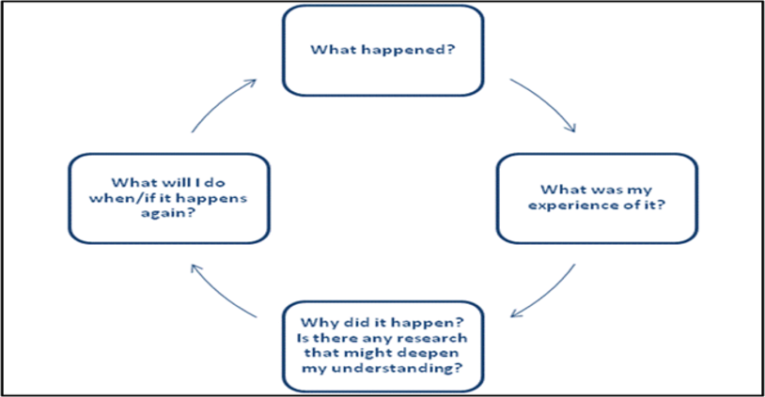
Gibbs Reflecting Cycle
According to (Gibbs, 1988) Reflecting cycle is the ability to reflect in workplace that involve situations where allows to improve in decisions making, In fact reflection is the key component that everyone can reflect and using in personal and professional development. Reflect can help professionals to avoid mistakes and learning to offer a better service.

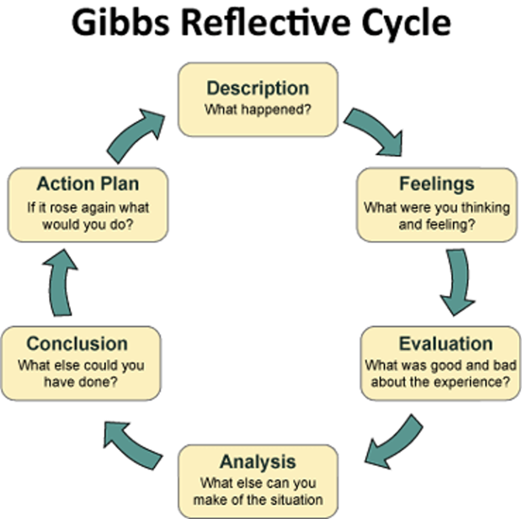

Focus on the practical application of these principles within real UK healthcare settings
According to recent search in an article (Horton, 2025) the application of these principles in UK health care settings involve complex interaction between policy, framework and professional practice, clinician actually support this principle but face barriers like limits awareness, challenge in share information, shortages and dealing with patients’ expectations. Therefore, these principles are applied and tailored to the UK context by addressing Ethical dilemmas, uncertainties, limited support and isolated implementation remain evident.

How you would apply them in your future career.
These principles are the key and important if thinking to work for Health and Social care in Uk, knowledge information, using reflection in my decision making and how to apply in my future carrier as a professional in this area. According to (Merry, 2023) applying CPD for professionals in health care settings is the best option as will help with professional growth, keep update with last technology in your profession. Example on how I can do that assist to event related to my carrier, Seminario’s, workshops and keep education myself.

Conclusion.
NHS (National Health Service) that provide Care for every individual, NHS principles remain crucial and is applying across Uk. In the meantime, these principles still shape decision-making, quality standards, accountability, and protect patients’ rights (everyone has access in their needs)
NHS now continues provide care based in person centred care, partnership working together to improve outcomes, Hence NHS remain free of charge when using hospitals, GP, Emergencies to help with individual’s needs.

.

References

- Carnwell, R. and Carson, A., 2005. Understanding partnerships and collaboration. Effective practice in health and social care, pp.4-20.
- Clements, L., 2014. The care Act 2014 overview [online]
- Chinn, T., 2025. NOTES ON REFLECTIVE MODELS IN NURSING. Nursing Models for Nursing Students-E-Book: Nursing Models for Nursing Students-E-Book, p.293.

- Douglas, A., 2008. Partnership working. Routledge.

- Deckx, Laura; Chow, Ka Hei; Askew, Deborah. et al. Psycho oncology (Chichester,
  - England). 2021
- Grosios, K., Gahan, P.B. and Burbidge, J., 2010. Overview of healthcare in the UK. EPMA journal, 1(4), pp.529-534.

- Ionescu, Dawn F.; Niciu, Mark J.; Henter, Ioline D.. et al. CNS spectrums. 2013.
- Koskinen, Camilla; Koskinen, Monika; Koivula, Meeri. et al. 2020. Nursing ethics.
- Lilja, J., Larsson, S., Hamilton, D. and Bauer, M., 2002. Ethical Values in the Treatment of Depression and Anxiety. Pharmaceutical Ethics, pp.137-160.
- Leigh, D., 2009. SWOT analysis. Handbook of Improving Performance in the Workplace: Volumes 1‐3, pp.115-140.

- Lewis, J. and Sanderson, H., 2011. A practical guide to delivering personalisation: person-centred practice in health and social care. Jessica Kingsley Publishers.
- Morgan, Stephanie; Yoder, Linda H., 2012. Journal of holistic nursing.
- Menear, M., Girard, A., Dugas, M., Gervais, M., Gilbert, M. and Gagnon, M.P., 2022. Personalized care planning and shared decision making in collaborative care programs for depression and anxiety disorders: A systematic review. PLoS One, 17(6), p.e0268649.
- Marsili, Marco. Conatus - journal of philosophy. 2023.

- McLeod, S., 2007. Maslow's hierarchy of needs. Simply psychology, 1(1-18), pp.3-4.
- Peckham, Stephen; Zhang, Wenjing; Eida, Tamsyn. et al., 2023. Journal of health organization and management.

- Pinho, L.G.D., Lopes, M.J., Correia, T., Sampaio, F., Arco, H.R.D., Mendes, A., Marques, M.D.C. and Fonseca, C., 2021. Patient-centred care for patients with depression or anxiety disorder: an integrative review. Journal of personalized medicine, 11(8), p.776.

- Santana, M.J., Manalili, K., Jolley, R.J., Zelinsky, S., Quan, H. and Lu, M., 2018. How to practice person‐centred care: A conceptual framework. Health Expectations, 21(2), pp.429-440

- Seedhouse, D., 2008. Ethics: the heart of health care. John Wiley & Sons.

