

Analytical Assessment of Engine Internal Components

Oliver Moss
2204624

Module Code: ACHA6006
Lecturer: Andrew Harrison
Submission Deadline: 16th March 2025
Work Count: 2173
1. Contents
1. Contents…………………………………………………………………..1
2. Introduction………………………………………………………………3
3. Ford Sigma Cylinder Forces & Motion…………………………………..4
3.1. Piston Motion……………………………………………………...4
3.2. Piston Forces………………………………………………………4
3.3. Torques for Different Engine Configurations……………………..5
3.4. Engine Power……………………………………………………...8
4. Connecting Rod Stresses…………………………………………………9
5. Gudgeon Pin Stresses…………………………………………………...12
5.1. Bending & Shear Stress…………………………………………..12
5.2. Resultant Stress…………………………………………………..13
5.3. Surface Finish…………………………………………………….14
6. Con Rod Bolt Stresses…………………………………………………..15
6.1. Frictional Torque…………………………………………………15
6.2. Bolt Stiffness……………………………………………………..16
6.3. Bot Forces………………………………………………………..16
6.4. Bolt Stresses Without Stress Concentrations…………………….16
6.5. Bolt Stresses With Stress Concentrations………………………..17
7. Bolt Optimisation……………………………………………………….19
7.1. Length of Exposed Thread……………………………………….19
7.2. Bolt Material……………………………………………………..20
7.3. Bolt Cross Sectional Area………………………………………..22
8. Conclusion………………………………………………………………23
9. References………………………………………………………………24

Figure 1 - Piston Position & Velocity 4
Figure 2 - Piston Acceleration 4
Figure 3 - Gas Force on Piston 4
Figure 4 - Inertia Force of Piston Assembly 4
Figure 5 - Piston Net Force (Isometric View) 5
Figure 6 - Piston Net Force (Front View) 5
Figure 7 - Standard Vs Cross-Plane Configurations (Rupp.S, 2022) 5
Figure 8 - Inertia Torque for Standard Configuration 6
Figure 9 - Inertia Torque for Cross Plane Configuration 6
Figure 10 - Comparison of Inertia Torque for Standard & Cross Plane Configurations 6
Figure 11 - Gas Torque for Standard Configuration 6
Figure 12 - Gas Torque for Cross Plane Configuration 6
Figure 13 - Comparison of Gas Torque for Standard & Cross Plane Configurations 7
Figure 14 - Comparison of Crank Torque for Standard & Cross Plane Configurations 7
Figure 15 - Output Torque with a 98% Engine Efficiency 7
Figure 16 - Brake Torque & Power at Different RPMs 8
Figure 17 - Resolved Forces from Net Piston Force 9
Figure 18 - Resolved Forces at Every Angle of Crank 9
Figure 19 - Con Rod Goodman Diagram 10
Figure 20 - How Shot Peening Affects the Con Rod's Goodman Diagram 11
Figure 21 - How Shot Peening Affects Fatigue Safety Factor of Con Rod 11
Figure 22 - Forces on Gudgeon Pin 12
Figure 23 - Second Moment of Inertia Tube 12
Figure 24 - Resultant Stress on Gudgeon Pin 13
Figure 25 - All Stresses Experienced on the Gudgeon Pin 13
Figure 26 - Goodman Diagram for The Gudgeon Pin 13
Figure 27 - Stress-Strain Graphs of Different Nitriding Methods on Steel (Terent.V, Kolmakov.A et al, 2007) 14
Figure 28 - How Nitriding Affects the Gudgeon Pin's Goodman Diagram 14
Figure 29 - Axial Force of a Bolt (NBK, 2019) 15
Figure 30 - Sections of a Bolt 16
Figure 31 - Goodman Diagram of The Bolt with No Stress Concentrations 17
Figure 32 - Stress Concentration Scenario for Under-Head Section 17
Figure 33 - Stress Concentration Scenario for Thread Section 18
Figure 34 - Goodman Diagram of Bolt With & Without Stress Concentrations 18
Figure 35 - How Length of Exposed Thread Affects FSF 19
Figure 36 - How Length of Exposed Thread Affects Bolt Stiffness 19
Figure 37 - How Different Materials Affect FSF 20
Figure 38 - How Different Materials Affect Bolt Stiffness 21
Figure 39 - How Changing CSA of Whole Bolt Affects FSF 22
Figure 40 - How Changing CSA Affects Bolt Stiffness 22

Table 1 - Calculated Bolt Stresses Without Stress Concentrations 17
Table 2 - Calculated Bolt Stresses with Stress Concentrations 18
Table 3 - Maraging Steel 300 Properties (Ansys Granta,2022) 21
2. Introduction
Engine manufacturers constantly strive to improve engine performance, with increasing engine speed (RPM) being the most effective solution for increasing power. However, this can also increase the probability of component failure especially in high-stress areas such as the connecting rod bolts. Therefore, this assignment investigates redesigning the con rod bolts, for a Ford 1.6L Sigma engine, to decrease the likelihood of failure at increased RPM. Usually, the Ford Sigma engine will reach speeds of around 6000rpm, but for this assignment the RPM has been increased to 9000 as seen in figure 3.

3. Ford Sigma Cylinder Forces & Motion
3.1. Piston Motion
$$Piston Position (s) = (R+L)-(Rcosθ+Lcosϕ)$$ |  | [1]
$$Piston Velocity \left(\frac{ds}{dt}\right) = Rωsinθ+\left(\frac{R^{2}ω}{2L}sin2θ\right)$$ |  | [2]
$$Piston Acceleration \left(\frac{d^{2}s}{{dt}^{2}}\right) = Rω^{2}cosθ+\left(\frac{R^{2}ω^{2}}{2L}cos2θ\right)$$ |  | [3]
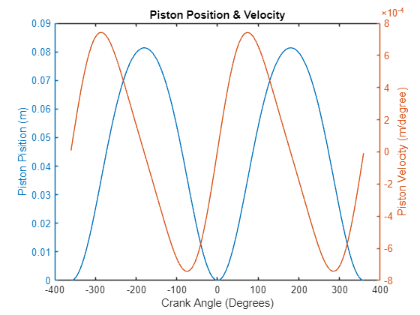  Figure 1 - Piston Position & Velocity | 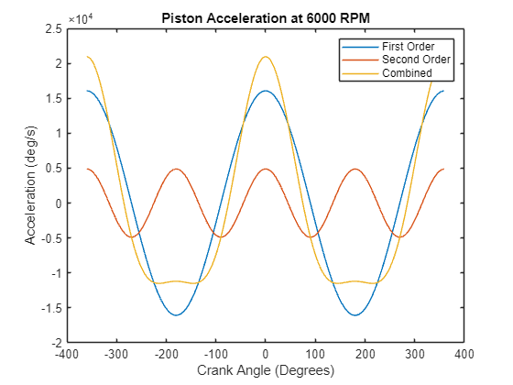  Figure 2 - Piston Acceleration
3.2. Piston Forces
$$F_{net}=F_{gas}-F_{inertia}=(Pressure×\frac{π×{Bore}^{2}}{4})-(m_{recip}×{Accel}_{Pitson})$$ |  | [4]
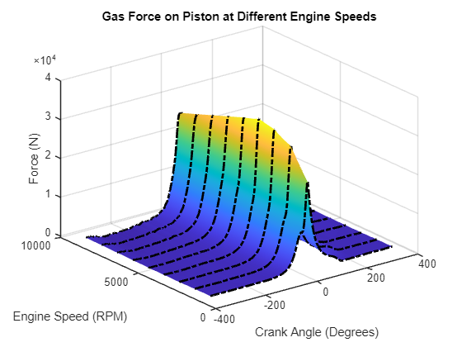  Figure 3 - Gas Force on Piston | 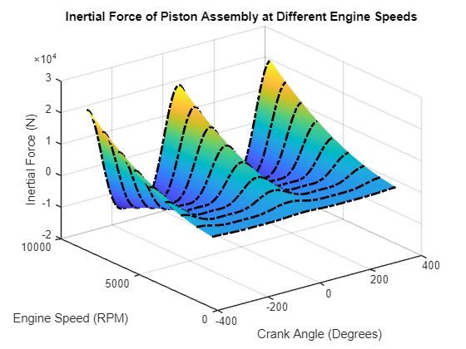  Figure 4 - Inertia Force of Piston Assembly
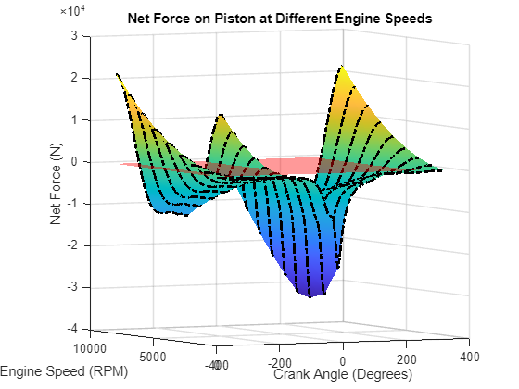  Figure 5 - Piston Net Force (Isometric View) | 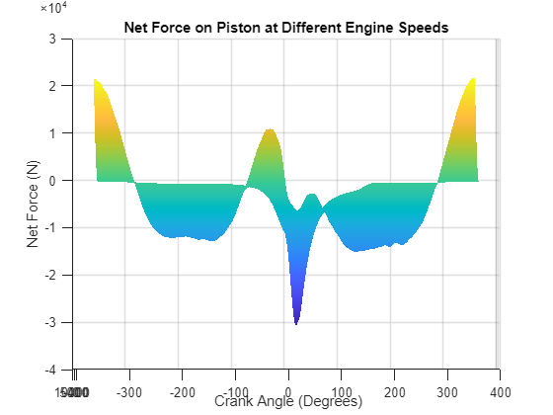  Figure 6 - Piston Net Force (Front View)
3.3. Torques for Different Engine Configurations
Crankshaft design can affect the behaviour of an engine, with the 2 most common being a standard, flat-plane design or a cross-plane design. For an inline-4 engine, like the Ford Sigma, a standard configuration has crank pins offset by 180˚, like figure 9, meaning, cylinders 1 & 3 have the same piston movement however while one is in the compression stage, the other is in the exhaust stage. On the other hand, a cross-plane has crank pins at 90˚ offsets to each other, resembling a cross as seen in figure 9.
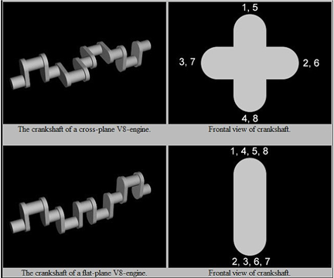
Figure 7 - Standard Vs Cross-Plane Configurations (Rupp.S, 2022)
$$T_{Inertia 1Cyl}=F_{Inertia}×tanϕ×Rcosθ-F_{Inertia}×Rsinθ$$ |  | [5]
$$T_{Inertia}=\sum{T_{Inertia Each Cylinder}}$$ |  | [6]
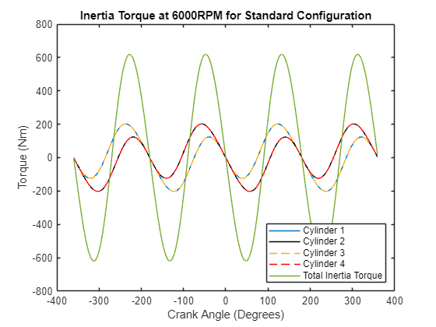  Figure 8 - Inertia Torque for Standard Configuration | 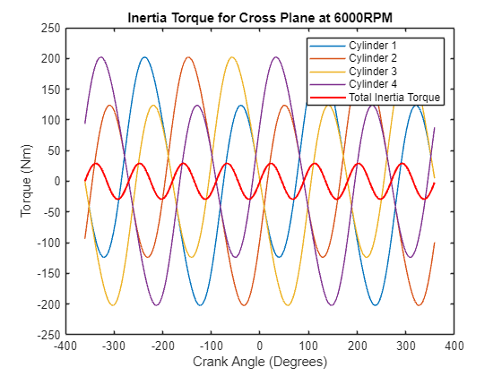  Figure 9 - Inertia Torque for Cross Plane Configuration
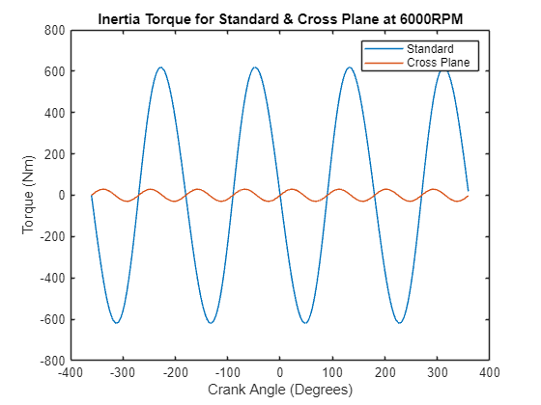
Figure 10 - Comparison of Inertia Torque for Standard & Cross Plane Configurations
$$T_{Gas 1Cyl}=F_{Gas}×tanϕ×Rcosθ+F_{Gas}×Rsinθ$$ |  | [7]
$$T_{Gas}=\sum{T_{Gas Each Cylinder}}$$ |  | [8]
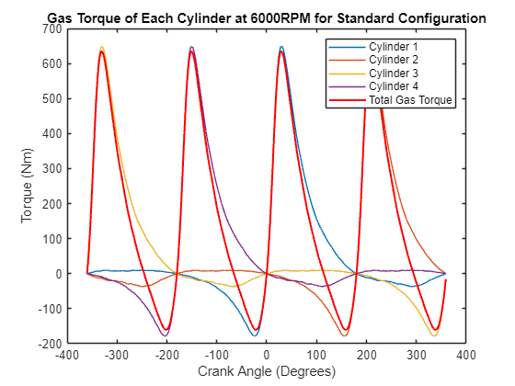  Figure 11 - Gas Torque for Standard Configuration | 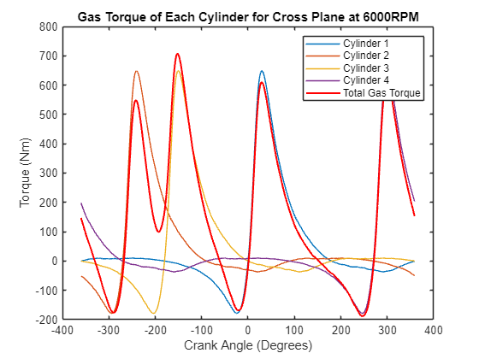  Figure 12 - Gas Torque for Cross Plane Configuration

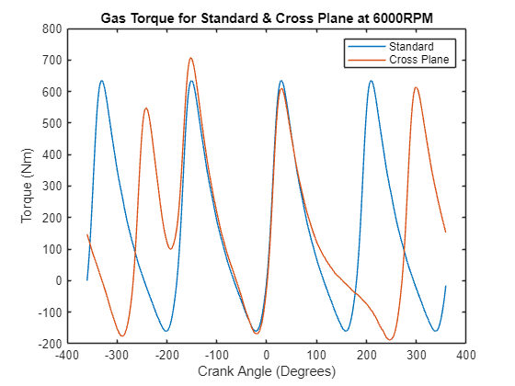
Figure 13 - Comparison of Gas Torque for Standard & Cross Plane Configurations
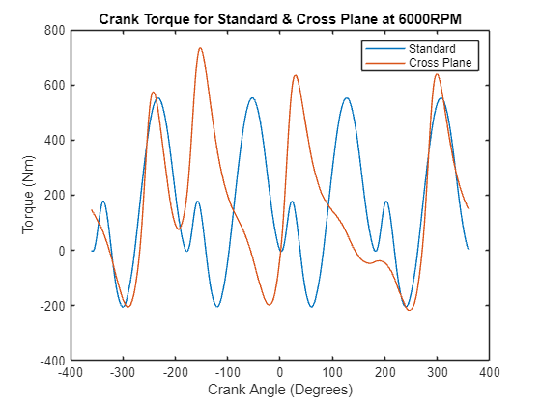  Figure 14 - Comparison of Crank Torque for Standard & Cross Plane Configurations | $$T_{Crank}=T_{Gas}+T_{Inertia}$$ | [9]
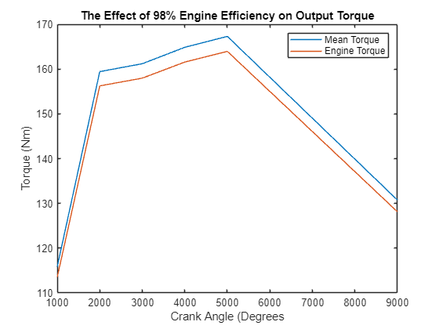  Figure 15 - Output Torque with a 98% Engine Efficiency | $$T_{Mean}=\frac{\sum{T_{Crank}}}{720}$$ | [10]
 | $$T_{Engine}=T_{Mean}×n_{Cyl}$$ | [11]
 | $$T_{Standard}=T_{CrossPlane}$$ | [12]
The best engine configuration is dependent on the environment the car will operate in. A cross-plane configuration produces higher torques at lower RPMs, so the peaks would be larger in figure 16 at lower RPMs. On the other hand, figure 16 shows a flat plane configuration has a more constant toque behaviour providing a flatter torque curve and higher peak power (Jackson.J, AutoHouse, 2023). This, along with its higher RPMs being achievable, due to it being lighter, a flat plane crankshaft suits motorsport vehicles, making it the better option for the Ford Sigma.
3.4. Engine Power
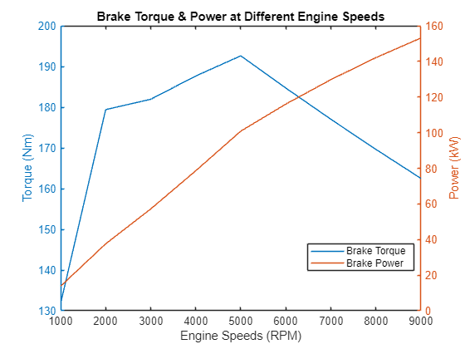  Figure 16 - Brake Torque & Power at Different RPMs | $$W_{Loss}=W_{Ring Frict}+\sum{W_{Side Frict}}$$ | [13]
 | $$W_{Torque}=\sum{T_{Crank}}$$ | [14]
 | $${Brake}_{Torque}=W_{Torque}-W_{Loss}$$ | [15]
 | $$P_{Indicated}=W_{Torque}×ω$$ | [16]
 | $$P_{Friction}=W_{Loss}×ω$$ | [17]
 | $${Brake}_{Power}=P_{Indictaed}-P_{Friction}$$ | [18]

4. Connecting Rod Stresses
To understand the stresses on the bolts, first the forces and stresses experienced on the connecting rod (con rod) can be calculated. To start, the net force can be calculated using eq 4, which, in this case, a compressive force is experienced when the net force is negative.
From this, the net force can be split up into side force and force through the con rod using trigonometry as shown in figure 19.
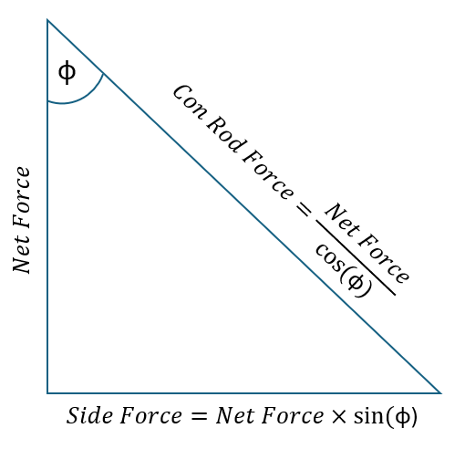  Figure 17 - Resolved Forces from Net Piston Force | 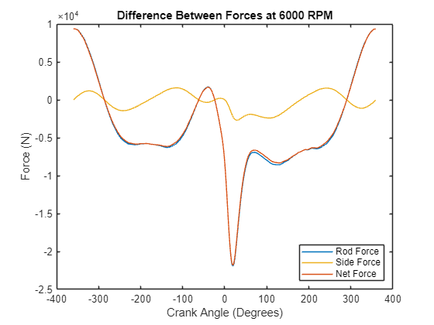  Figure 18 - Resolved Forces at Every Angle of Crank
Knowing the force through the con rod means the stresses can be calculated using eqs 19-23. Therefore, a Goodman diagram can be produced for the con rod as shown in figure 21.
$Stress(σ)=\frac{Force(F)}{Area(A)}$ | [19]
$σ_{mean}=\frac{σ_{max}+σ_{min}}{2}$ | [20]
$σ_{range}=σ_{max}-σ_{min}$ | [21]
$σ_{allowable}=2σ_{Endurance Limit}×\left(1-\frac{σ_{mean}}{UTS}\right)$ | [22]
$Fatigue Safety Factor (FSF)=\frac{σ_{allowable}}{σ_{range}}$ | [23]
A Goodman diagram is a useful tool to analyse a material's ability to withstand cyclical loading by comparing mean stress to the range of stresses experienced. If the stresses experienced are inside the upper and lower endurance limits, then the component is assumed to have an infinite lifecycle.
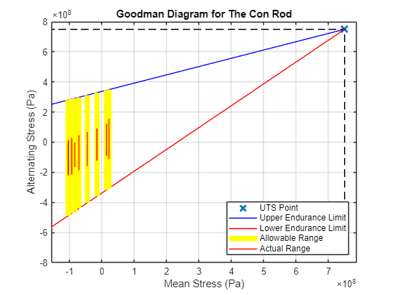
Figure 19 - Con Rod Goodman Diagram
Looking at figure 21, the con rod experiences stresses far from its maximum and minimum allowable stresses as well as being far from the Ultimate Tensile Strength (UTS) point, meaning it theoretically has an infinite lifecycle. Therefore, the conrod could be overengineered and a lighter material or smaller con rod could be used to increase performance and still be within the allowable stress range. However, as the stress range gets closer to the allowable range, the component becomes less likely to have an infinite lifecycle. Also, for most of the RPMs, the con rod experiences more tensile than compressive stresses due to the mean stress being negative, but for the higher RPMs more compressive forces are experienced on the con rod than tensile.
If the stress range was close to the allowable range, then different surface finishing methods can be used to help reduce this range. Shot Peening is a common method for con rods as it is a cold work process that can enhance fatigue strength of a material by hitting the surface with multiple small pellets at high speed, causing the material to have residual compressive stresses and therefore can experience more tensile loading.
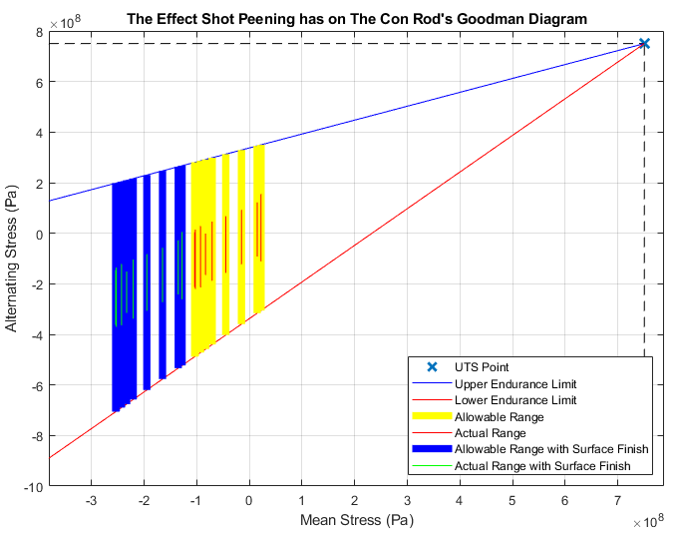  Figure 20 - How Shot Peening Affects the Con Rod's Goodman Diagram | 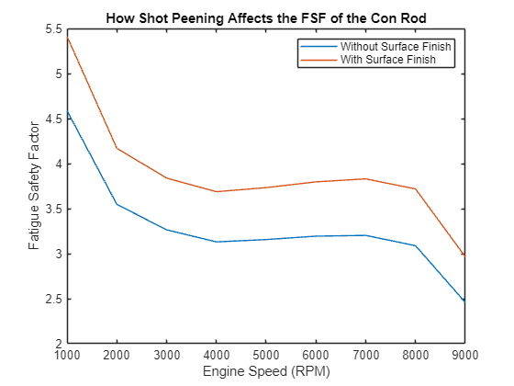  Figure 21 - How Shot Peening Affects Fatigue Safety Factor of Con Rod
If a fatigue factor of safety (FSF) is greater than 1, then theoretically the component should not fail due to fatigue and figure 23 shows that shot peening can increase the FSF at every RPM to values significantly greater than 1, further proving the con rod could be overengineered.

5. Gudgeon Pin Stresses
The Gudgeon Pin is another common piston component that experiences both bending and shear stresses through it.
5.1. Bending & Shear Stress
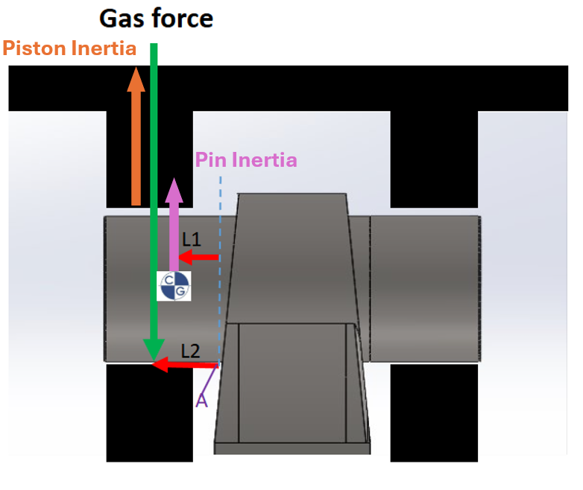  Figure 22 - Forces on Gudgeon Pin | 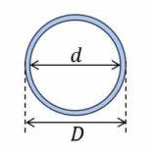  Figure 23 - Second Moment of Inertia Tube  $$I=\frac{π}{64}(D^{4}-d^{4})$$
$$M_{Pin Inertia}=(m_{Exposed Pin}×(Rω^{2}cosθ+\frac{R^{2}}{L}ω^{2}cos2θ))×L_{1}$$ |  | [24]
$$F_{Piston Inertia}=m_{Piston Parts}×(Rω^{2}cosθ+\frac{R^{2}}{L}ω^{2}cos2θ)$$ |  | [25]
$$F_{Net Piston}=F_{Piston Inertia}-F_{Gas}$$ |  | [26]
$$M_{Net Piston}=\left(\frac{F_{Net Piston}}{2}×L_{2}\right)$$ |  | [27]
$$M = M_{Pin Inertia}+M_{Net Piston}$$ |  | [28]
$$σ_{Bending}=\frac{M×y}{I}$$ |  | [29]
$$Shear Stress (τ) = \frac{F_{Net}}{Cross Sectional Area}=\frac{\frac{F_{Net Piston}}{2}+F_{Pin Inertia}}{\frac{π}{4}(D^{2}-d^{2})}$$ |  | [30]

5.2. Resultant Stress
$$σ_{Resultant}=\sqrt{{σ_{Max Bending}}^{2}+4τ^{2}}$$ |  | [31]
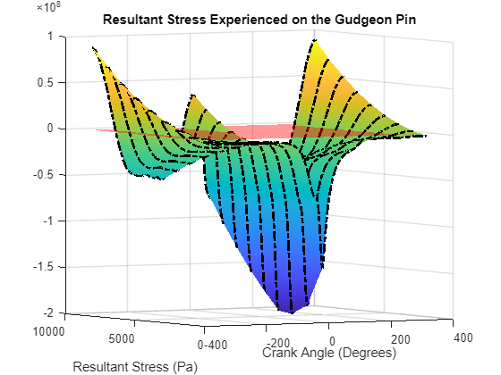  Figure 24 - Resultant Stress on Gudgeon Pin | 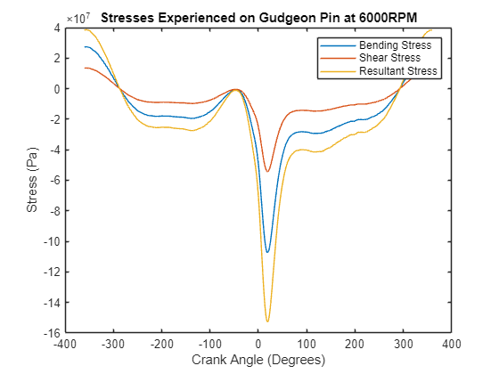  Figure 25 - All Stresses Experienced on the Gudgeon Pin
As the engine speeds increase, the piston and pin have more inertia, which could contribute to the resultant tensile stress on the pin at combustion to decrease, as seen in figure 26. Start of Combustion (SoC) can be identified in figure 27, where the stresses resolve to 0 just before a sudden spike due to the SoC occurring. Figure 27 also shows that most of the stress experienced is a bending force as the gudgeon pin is in a similar environment to a simple cantilever beam. The shear stress is then induced due to the bending moment and the center of the gudgeon pin being constrained.
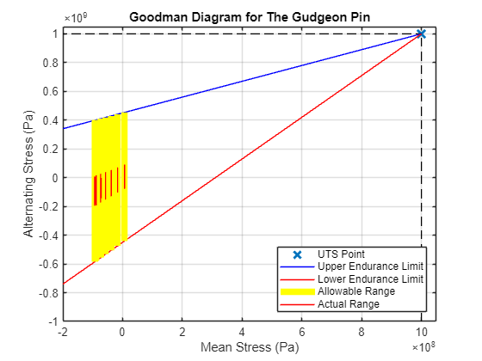
Figure 26 - Goodman Diagram for The Gudgeon Pin

5.3. Surface Finish
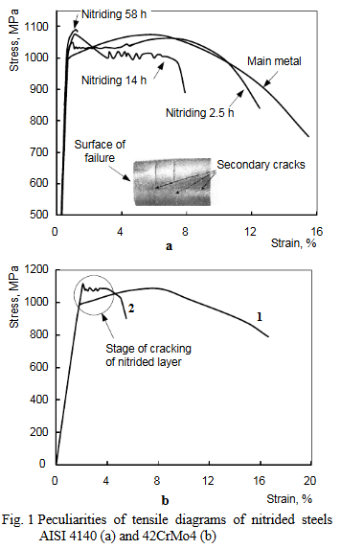  Figure 27 - Stress-Strain Graphs of Different Nitriding Methods on Steel (Terent.V, Kolmakov.A et al, 2007) | While it's uncommon to apply a surface finish to a gudgeon pin, it is possible, with nitriding being a popular method for more high-performance engines. Sild,S from Fractory (2023) states that nitriding involves hardening the surface of a material by exposing it to specific atoms, like nitrogen, to harden the surface and increase fatigue strength. As seen in figure 29 from Terent.V, Kolmakov.A et al (2007) it can increase fatigue strength by around 10%.
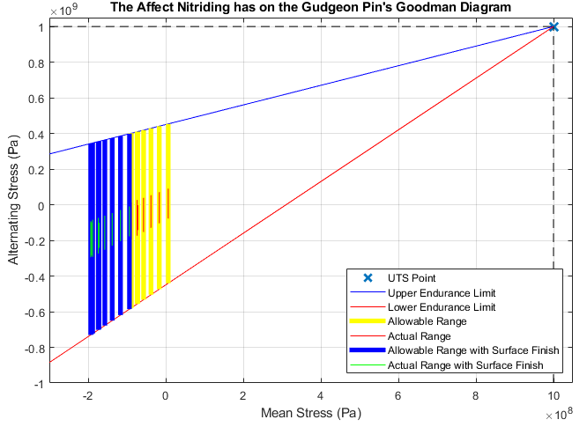
Figure 28 - How Nitriding Affects the Gudgeon Pin's Goodman Diagram
Figure 30 shows a similar trend to figure 22 as both surface finishes increase fatigue safety factor, meaning the gudgeon pin can experience a larger stress range before it fails.

6. Con Rod Bolt Stresses
The bolts that connect the connecting rod to the cap are usually the first engine component to fail, so they are the most important to redesign to suit the stresses it experiences. When applying a tightening torque to a bolt, the threads of both components interact, creating a clamping/compressive force on the 2 surfaces being connected and a tensile stress down the bolt, inducing an axial force.
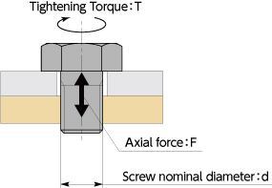
Figure 29 - Axial Force of a Bolt (NBK, 2019)
Commonly, this axial stress is around 60% of the yield stress, which is usually 90% of the UTS of the bolt.
6.1. Frictional Torque
This axial force derives from the applied tightening torque and the frictional force needed to overcome to tighten the bolt. However, to reduce this frictional force, lubricant or smaller surface areas can be used.
$$σ_{Axial}=60\%×90\%{×UTS}_{Bolt}$$ | [32]
$$F_{Axial}=σ_{Axial}×{CSA}_{Bolt}$$ | [33]
$$r_{Effective}=\frac{D_{1}+D_{2}}{2}÷2$$ | [34]
$$T_{Friction Head}=μ_{Head}×F_{Axial}×r_{Effective Head}$$ | [35]
$$T_{Friction Thread}=μ_{Thread}×F_{Axial}×r_{Effective Thread}$$ | [36]
$$T_{Total}=T_{Friction Head}+T_{Friction Thread}=8.47x{10}^{5}Nm$$ | [37]

6.2. Bolt Stiffness
The bolt’s stiffness can be split into sections, as shown in figure(), with each section having a stiffness with no stress concentrations included.
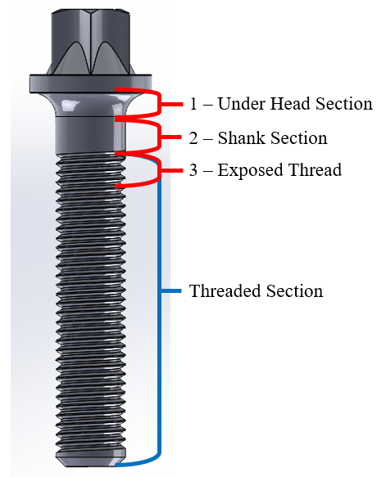
Figure 30 - Sections of a Bolt
 | $$K=E\frac{A}{L}$$ | [38]
 | $$\frac{1}{K_{Bolt}}=\frac{1}{K_{1}}+\frac{1}{K_{2}}+\frac{1}{K_{3}}$$ | [39]
6.3. Bolt Forces
$$F_{Bolt Inertia}=\frac{F_{Cap Inertia}}{No. Bolts}$$ |  |  | [40]
$$F_{Extra}=\frac{(F_{Bolt Inertia}×K_{Bolt})}{(K_{Bolt}+K_{Cap})}$$ |  |  | [41]
$$F_{Total}=F_{Bolt Inertia}+F_{Extra}$$ |  |  | [42]
$$F_{max}=max(F_{Total})$$ | [43] | $$F_{min}=F_{Axial}$$ | [44]

The minimum force on the bolt will always be the axial force as, independent of loads on the bolt, it will always experience tensile stress due to the tightening torque.
6.4. Bolt Stresses Without Stress Concentrations
Using eqs 19-23, the stresses through the bolt can be calculated to produce the Goodman diagram in figure 31.
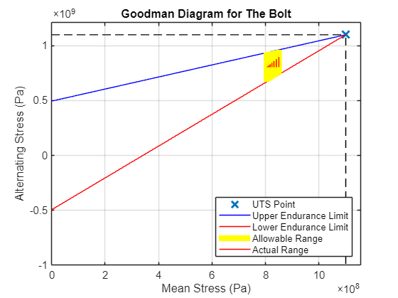
Figure 31 - Goodman Diagram of The Bolt with No Stress Concentrations

Engine Speeds |  | 1000 | 2000 | 3000 | 4000 | 5000 | 6000 | 7000 | 8000 | 9000
Actual  $$[x{10}^{8} Pa]$$ | $$σ_{Mean}$$ | 8.04 | 8.06 | 8.09 | 8.13 | 8.18 | 8.24 | 8.31 | 8.40 | 8.50
Actual  $$[x{10}^{8} Pa]$$ | $$σ_{Min}$$ | 8.05 | 8.08 | 8.14 | 8.22 | 8.32 | 8.45 | 8.60 | 8.77 | 8.96
Actual  $$[x{10}^{8} Pa]$$ | $$σ_{Max}$$ | 8.03 | 8.03 | 8.03 | 8.03 | 8.03 | 8.03 | 8.03 | 8.03 | 8.03
Allow  $$[x{10}^{8} Pa]$$ | $$σ_{Min}$$ | 6.71 | 6.73 | 6.77 | 6.83 | 6.91 | 7.00 | 7.11 | 7.23 | 7.37
Allow  $$[x{10}^{8} Pa]$$ | $$σ_{Max}$$ | 9.37 | 9.38 | 9.40 | 9.42 | 9.45 | 9.48 | 9.52 | 9.57 | 9.62
$$FSF$$ |  | 51.21 | 12.73 | 5.60 | 3.11 | 1.95 | 1.33 | 0.95 | 0.70 | 0.53
Table 1 - Calculated Bolt Stresses Without Stress Concentrations
6.5. Bolt Stresses with Stress Concentrations
Looking at figure 30 the bolt has 2 stress concentrations, the main one being the thread and the other being the fillet in the under-head section.
The under-head section resembles a similar stress concentration to figure 32 from Roarks Formulas for Stress and Strain, 2012.
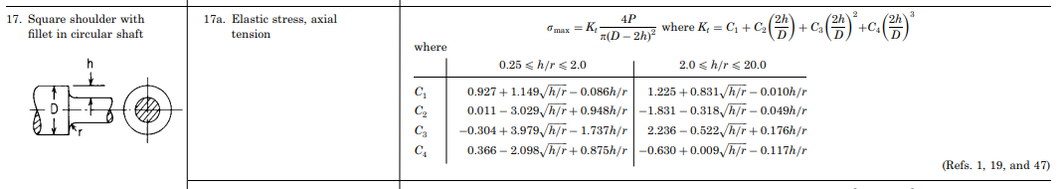
Figure 32 - Stress Concentration Scenario for Under-Head Section
Similarly, from Roarks Formulas for Stress and Strain, 2012, the thread of the bolt has a similar stress concentration to figure 33.
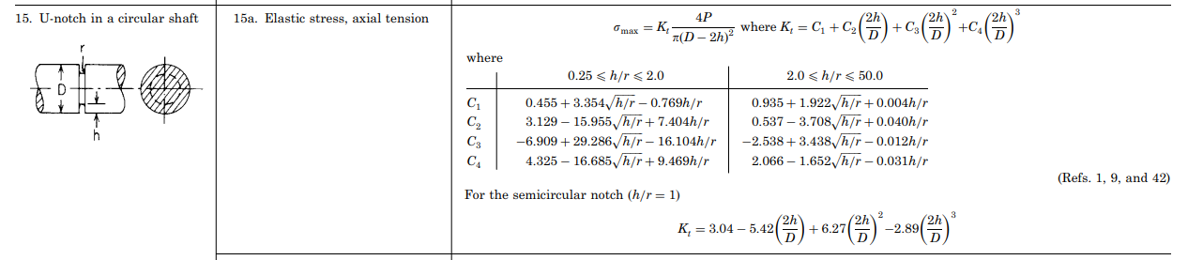
Figure 33 - Stress Concentration Scenario for Thread Section
The largest stress concentration factor is chosen as it will be the first place the bolt fails. This stress concentration factor will only affect the allowable stress and FSF as the applied stress will still be the same.
$$σ_{Allowable Kt}=2\frac{σ_{Endurance Limit}}{K_{t}}×\left(1-\frac{σ_{mean}}{UTS}\right)$$ | [45]
$${FSF}_{Kt}=\frac{σ_{Allowable Kt} }{σ_{Range}}$$ | [46]

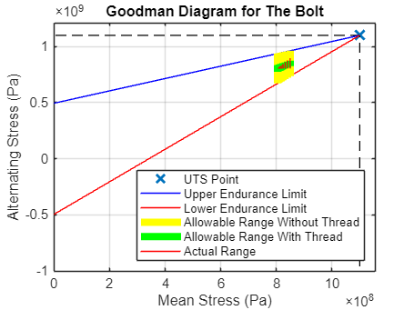
Figure 34 - Goodman Diagram of Bolt With & Without Stress Concentrations

Engine Speeds |  | 1000 | 2000 | 3000 | 4000 | 5000 | 6000 | 7000 | 8000 | 9000
Allow  $$[x{10}^{8} Pa]$$ | $$σ_{Min}$$ | 8.05 | 8.08 | 8.14 | 8.22 | 8.32 | 8.45 | 8.60 | 8.77 | 8.96
Allow  $$[x{10}^{8} Pa]$$ | $$σ_{Max}$$ | 8.03 | 8.03 | 8.03 | 8.03 | 8.03 | 8.03 | 8.03 | 8.03 | 8.03
Allow  $$[x{10}^{8} Pa]$$ | $$σ_{Mean}$$ | 8.04 | 8.06 | 8.09 | 8.13 | 8.18 | 8.24 | 8.31 | 8.40 | 8.50
$$FSF$$ |  | 51.21 | 12.73 | 5.60 | 3.11 | 1.95 | 1.33 | 0.95 | 0.70 | 0.53
Table 2 - Calculated Bolt Stresses with Stress Concentrations

7. Bolt Optimisation

With the con rod bolts being the primary failure component, optimising them for their intended purpose is crucial. The main factor to a bolt’s performance is its stiffness, which can be affected by the variables in eqs 38&39.
7.1. Length of Exposed Thread
The length of exposed thread, section 3 in figure 30, is the main contributor to bolt failure as it is where the max stress concentration factor is found in most cases. Therefore, changing this length will affect the stiffness of that area, and the overall FSF of the bolt.
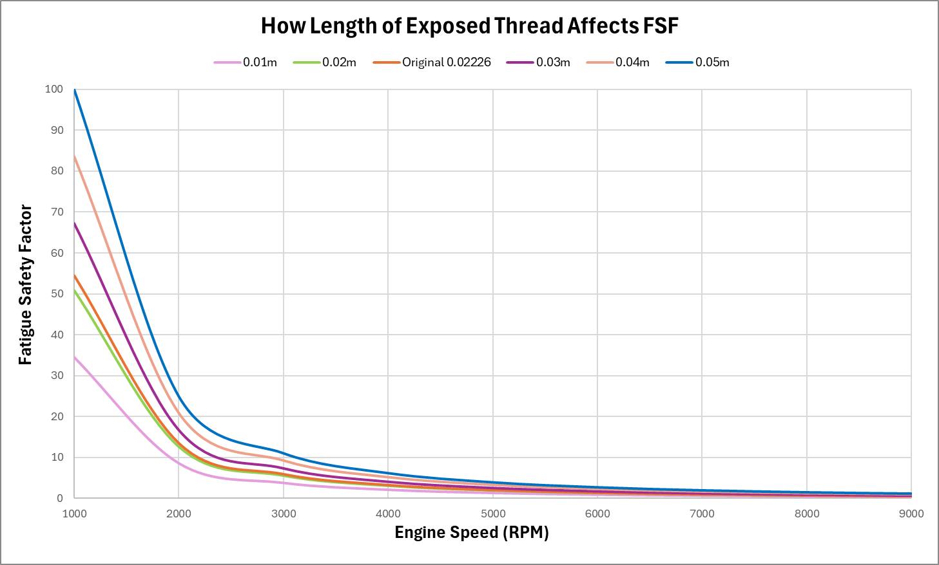
Figure 35 - How Length of Exposed Thread Affects FSF
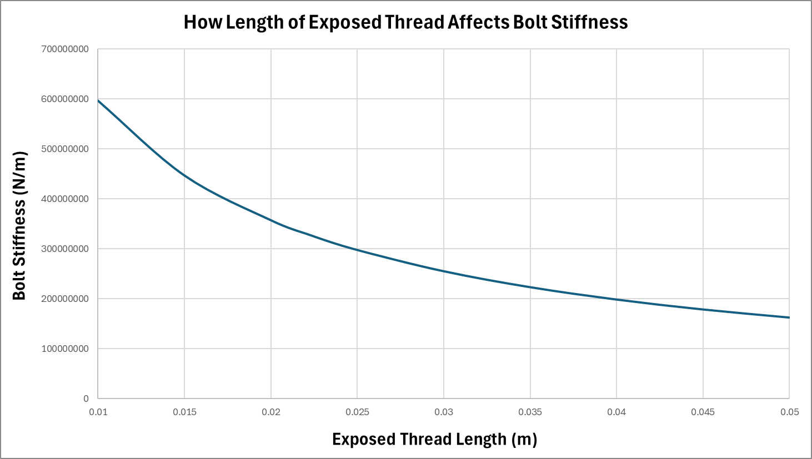
Figure 36 - How Length of Exposed Thread Affects Bolt Stiffness
Interestingly, as the bolt gets longer and more thread is exposed, the FSF increases. This is because the bolt’s stiffness decreases, making it more flexible and less brittle, meaning the bolt can absorb more load, reducing max stress. Therefore, this increases FSF as the allowable stress range doesn’t change because Kt stays constant due to the thread not changing but just more places where the thread could fail. However, as the bolt gets bigger, implementation and packaging become a concern as well as the length having a reduced effect at higher, more operable engine speeds. But, for this context, a length of 0.05m exposed thread is best as it’s the minimum length at which FSF is above 1, resulting in it theoretically having an infinite life at all engine speeds.
7.2. Bolt Material
A bolt’s material is also a crucial factor in a bolt's performance as it can affect the Young’s modulus and UTS of the component. While Steel is the most used material, Titanium Lasting (2024) state businesses like Baoji Sino-Swiss Titanium have been expanding into using Titanium bolts.
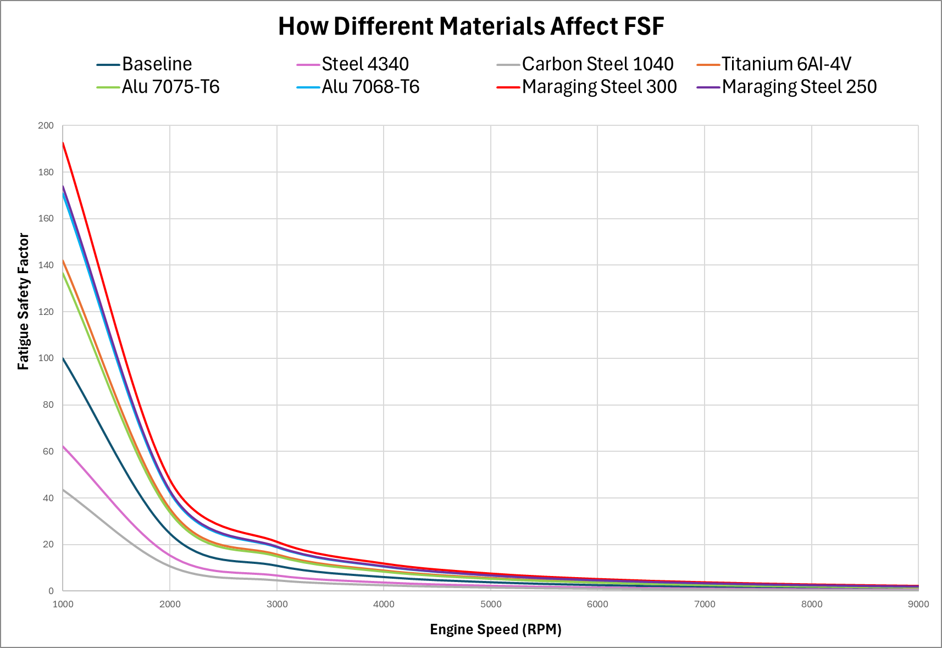
Figure 37 - How Different Materials Affect FSF
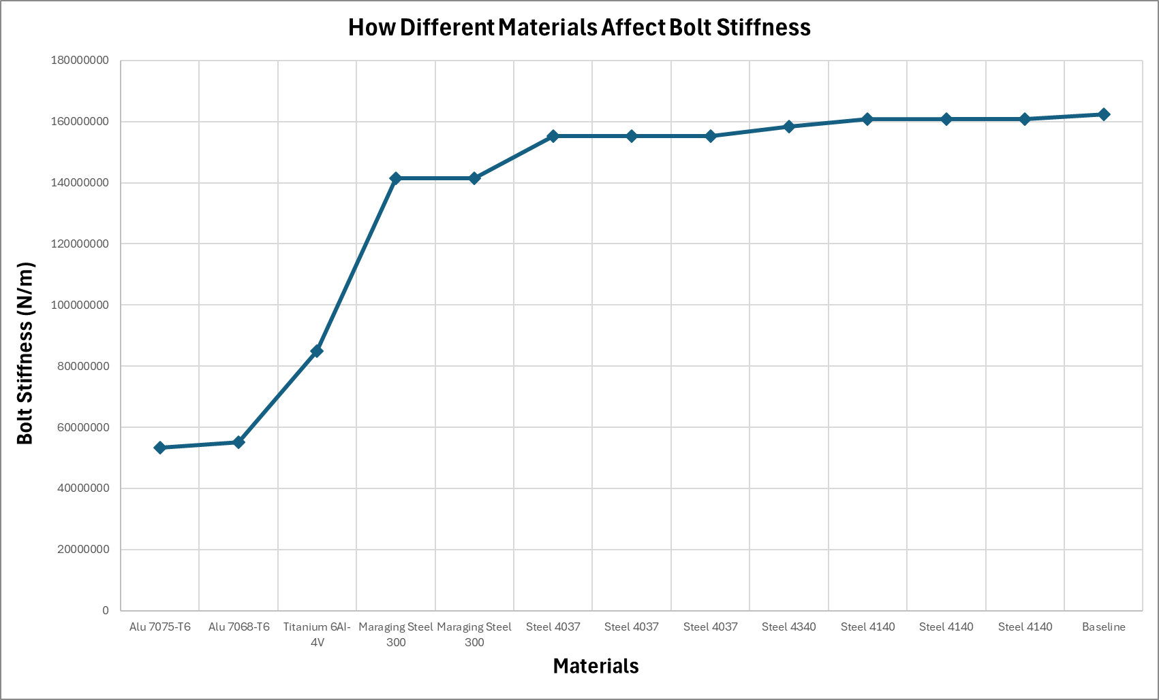
Figure 38 - How Different Materials Affect Bolt Stiffness
At first, figures 37&38 suggest Aluminium is a useful material due to its high FSF and large strength to weight ratio, suiting the aim to reduce the engine's weight and increase RPM. However, Ansys Granta (2022) state that both Aluminiums have a maximum operational temperature of 100˚C, making it unusable for a con rod bolt as temperatures exceed this. As well as that, the figures show Aluminium has a good fatigue strength however it doesn’t consider its strength, as it cannot withstand as much load compared to steel so while it can endure stress for longer periods, it cannot handle higher loads, which is one limitation so this study that needs to be considered.
Overall, the best material would be Maraging Steel 300 which is validated by MachineMFG (2024). It has the highest FSF but also has a high stiffness, meaning it can withstand large loads as well as MarchineMFG (2024) stating it is easily machinable when annealed and has high resistance to crack propagation. These are some of the reasons it is commonly used in engine components and transmission shafts.
Maraging Steel 300
Density | 7.88 – 7.96g/cm³
Melting Point | 1430 – 1450˚C
Modulus of Elasticity | ≈ 183 – 192GPa
Ultimate Tensile Strength | ≈ 1870 – 2070MPa
Fatigue Strength | ≈ 816 – 897MPa
Elongation | 4 – 5% Strain
Fracture Toughness | 75 – 85MPa∙m^{0.5}
Table 3 - Maraging Steel 300 Properties (Ansys Granta,2022)

7.3. Bolt Cross Sectional Area
The final variable that can affect FSF is the area of the bolt, which figure 39 below shows an equal increase and decrease in the cross-sectional area (CSA) of each section of the bolt.
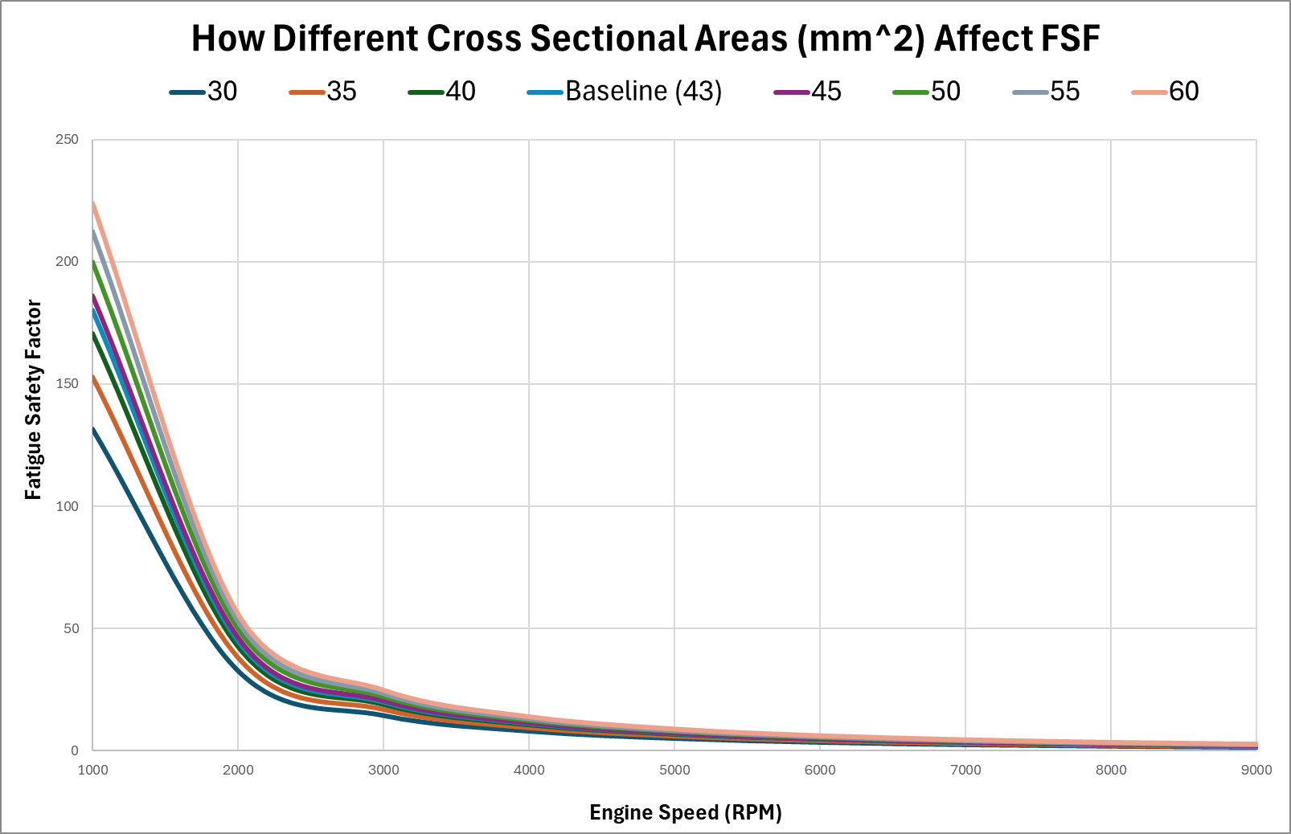
Figure 39 - How Changing CSA of Whole Bolt Affects FSF
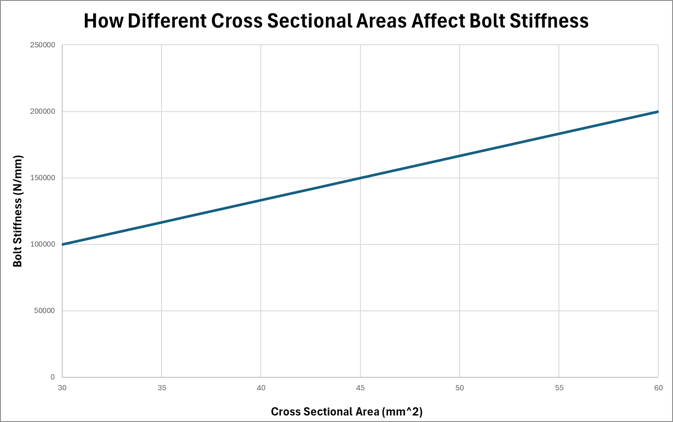
Figure 40 - How Changing CSA Affects Bolt Stiffness
Figures 39&40 show that as CSA of the whole bolt increases, its stiffness increases resulting in FSF to increase. This is because a bigger area results in compressive and tensile loads to be dissipated over a larger area resulting in the FSF increasing as the operating stress range decreases. However, the area of the bolt is restricted by the bolt holes. This is because, as the diameter of the holes increases, more material is removed, weakening the cap and con rod and introducing a new area of failure.
8. Conclusion
Overall, if the Ford Sigma engine was increased to 9000rpm, changes to the con rod bolts would be required, otherwise they would fail as well as a flat-plane crankshaft being preferable if the Sigma was used in a motorsport environment. For the bolt to withstand the increased RPM, it should be as long and thick as possible and preferably made from maraging steel 300. However, this report has focused on optimising the bolt for fatigue life and hasn’t considered other factors like maximum load as an increased length does increase FSF but could decrease the maximum load on the bolt because the stiffness has decreased. This means that while a length and area can be specified, it isn’t reliable until more research into other factors are conducted.

9. References

Jackson.J, Auto House Motoring, (2023), Cross-plane and flat-plane engines explained. Available at: https://autohousemotoring.co.uk/2023/04/15/cross-plane-and-flat-plane-engines-explained/, (Accessed 12 March 2025).

MachineMFG, (2024), Maraging Steel 300 (UNS K93120) Composition, Properties, and Uses. Available at: https://shop.machinemfg.com/maraging-steel-300-uns-k93120-composition-properties-and-uses/, (Accessed 10 March 2025).

Lasting Titanium, (2024), The World of Titanium Bolt Manufacturers. Available at: https://www.lastingtitanium.com/the-world-of-titanium-bolt-manufacturers.html, (Accessed: 14 March 2025).

Terent'ev, V.F., Michugina, M.S., Kolmakov, A.G., Kvedaras, V., Čiuplys, V., Čiuplys, A. and Vilys, J. (2007), The effect of nitriding on fatigue strength of structural alloys, Mechanika.

ASM Handbook Committee, (1990), Volume 1: Properties and Selection: Irons, Steels, and High-Performance Alloys. ASM International.
Ansys Granta, 2022, Granta EduPack 2022 R2, [Software], Ansys.

MAHLE, (2016), Cylinder components : Properties, applications, materials. Springer Fachmedien Wiesbaden.

Curtiss-Wright Surface Technologies, (n.d.), Shot Peening. Available at: https://cwst.com/our-services/shot-peening (Accessed 12 March 2025).

TWI, (n.d.), What is Shot Peening and How Does it Work? Available at: https://www.twi-global.com/technical-knowledge/faqs/what-is-shot-peening (Accessed 12 March 2025).

Sild.S, (2023), Nitriding Explained – How It Works, Benefits & Types. Fractory, Available at: https://fractory.com/nitriding-explained/, (Accessed 12 March 2025).

Young.W.C, Budynas.R.G, (2012), Roark’s Formulas for Stress and Strain, McGraw Hill.

Guagkiano.M, Vergani.L, (1996), Effect of Nitriding on Low-Cycle Fatigue Properties. Elsevier.

Rupp.S, (2022), Difference Between Cross-Plane and Flat-Plane Cranks, HotRod, Available at: https://www.hotrod.com/how-to/difference-between-cross-plane-and-flat-plane-cranks/, (Accessed 15 March 2025).

NBK, (2019), Vol.2 - Explaining the Vocabulary of Screws. Available at: https://www.nbk1560.com/en-US/resources/specialscrew/article/nedzicom-topics-02-term/, (Accessed 14 March 2024).

SDC Verifier, (n.d.), Bolt Fatigue Calculations: A Practical Approach to Structural Integrity, Available at: https://sdcverifier.com/structural-engineering-101/bolt-fatigue-calculations/#:~:text=The%20Fatigue%20Safety%20Factor%20(FSF,both%20cyclic%20and%20mean%20stresses. (Accessed 10 March 2025).

