The Novel Coronavirus Pneumonia’s damage to tourism industry and countermeasures
Student Name：WANNING JIN

Student ID : 2001426

TABLE OF CONTENTS
CHAPTER 2: LITERATURE REVIEW 3
2.1: Impact of Novel Corona virus on Tourism sector 3
2.2: Impact on geography due to Novel corona virus 5
2.4: Impact of Corona virus on Accommodation sector 6
2.5: Impact of Corona virus on Event set up 8
2.6: Impact of Corona virus on sightseeing in tourism 8
2.7: Countermeasures to be taken in tourism sector in Corona virus 8
2.8: Research Gap 9
CHAPTER 3: RESEARCH METHODOLOGY 10
3.1: Research Methodology 10
3.2: Research Paradigm and Philosophy: 10
3.3: Research Approch: 11
3.4: Research Method: 11
3.5: Research Strategy: 11
3.6: Research Design: 12
3.7: Research Technique and Procedure: 12
3.8: Research Ethics: 13
CHAPTER 4: ANALYSIS 14
4.1: Analysis 14
4.2: Method of Analysis 14
4.3: Impact of Coronavirus on tourism sector 15
4.4: Impact of Coronavirus on transportation sector 15
4.5: Impact of Coronavirus on Accommodation sector 17
4.6: Impact of Coronavirus on Event organisers 18
4.7: Impact of Coronavirus on Sightseeing service providers 19
4.8: Countermeasures for tourism industry 20
4.9: Inference 21
5.0: REFERENCES 23

CHAPTER 2: LITERATURE REVIEW

2.1: Impact of Novel Corona virus on Tourism sector
The industry of tourism was among the greatest markets of the world; before being driven down by a universal epidemic in the 21st century, the COVID-19 (Uğur and Akbıyık 2020). Travelling is a very favourable way to explore new places; but it is also the most affected sector by any global crises. The plans and reservations change or get cancelled on the very same day when any such news related to pandemic is heard. This research aims to study the influence of corona virus on travel and related sectors.
The United Nation World Tourism Organization has estimated that only 25M tourist arrival was noted in the year 1950. Later, after 68 years this number has reached up to 1.4 billion per year arrivals internationally, which is a 56-fold increase (Roser 2017). Along with this, the direct contribution to GDP of the tourism and travel industry was approximately $ 2.9 trillion globally in the year 2019 (Lock 2018). Among this, the United States secured the first position in generating revenue from tourism amounting to $580.7 billion, before China with $403.5 billion and Germany with $143.4 billion (Lock 2020). Though the trend of revenue generation was showing an increase, it was estimated that in 2020 International tourism would go down by 22% in the first quarter and could further go down by 60-80% over the whole year due to the spread of corona virus as compared with 2019 (UNWTO 2020). According to the United Nation World Trade Organization the travel and tourism industry will be facing a loss of $ 910 Billon to US$ 1.2T in export from tourism – the spending done by international visitors. The following chart shows the revenue change in percentage from 2019 to 2020 in tourism sector per passenger and kilometer (KIM-DANNIBALE 2020).
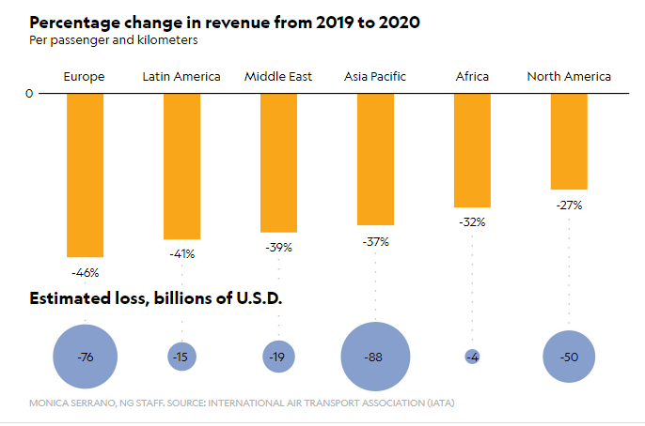The European Region facing the highest percentage of loss, 46% will around 76 billion U.S.D loss in revenue, followed by Latin America and Middle East. Not only was the willingness to travel effected by this severe pandemic but many other decisions related to travel were also modified by it. A willingness to use public transport was declining as well as the intention to travel by private car was increasing. This resulted in an increase in force on existing infrastructure of road transport. Similarly, the industry of tourism was expecting a few more negative impacts with around half of the answerer of the survey were intending to take their next holiday later than six months or more delayed after it is managed to ring the crises under control (Li et al. 2020). Thus making it harder and taking longer for the sector of tourism to again gain its position in world ranking and providing huge revenue to the world.

2.2: Impact on geography due to Novel corona virus
Novel Corona Virus was first found in human in the Wuhan City, China in December 2019 (World Health Organization 2020). The outbreak of corona virus was declared a Public Health Emergency of International Concern in January 2020 and a pandemic in March 2020 by the World Health Organization. As of 27 January 2021, more than 100 million cases were confirmed as corona positive, with more than 2.15M deaths due to COVID-19 (WHO 2020a). Till date, more than 100 million cases of corona virus were found with over 2.16 million deaths and 55.4 million recovered (The Visual and Data Journalism Team 2020, WHO 2020b, WHO 2021). As the number of deaths starting increasing, many countries initially cut off all kind of travel and transport for local as well as international means. Even now when the transportation has restarted and people have started travelling locally and internationally, host country people look at them at the sight of doubt of spreading the virus. To bring this spread of virus under control many measures were taken into consideration and lock down was among these measures. China was the first to announce the lockdown and after two months of China being locked down the number of increasing cases was getting under control (Langton 2020).

2.3: Impact of Corona virus on transportation sector
The sector of transportation is also highly affected by this severe pandemic. The unwillingness of people to use public transport and providing social distancing measures by different transport sectors by reducing passenger capacity is making a burden on profit earnings capacity of these service providers. According to the International Air Transport Association, the airlines globally are estimated to lose passenger revenues of up to 113 billion U.S.D. due to the pandemic. As there has been 30% decline in bookings to the virus-affected places, the airfares have also come under influence. Due to this, the airfares have declined by 20-30% (IATA 2020; Riley 2020).
Many other measures like disinfecting customer touch point and sanitizing the seats and other parts of the plane, providing overall half of the sitting capacity for maintaining social distancing, are also being done making the travellers satisfied for their health. Proper usage of masks and regular health checkups of the crew team also helps in maintaining a good environment. Cancellation of flights, lower passenger rate, extra maintenance cost is leading airlines to face a loss of U.S.D 157 billion in 2020, making it the worse year in the history of airlines. It is also estimated that the loss occurred due to this pandemic will count five times as compared to the loss suffered during the 2008-2009 recession according to IATA (Jasper and Bloomberg 2020).
Railways are not the one who was untouched by this pandemic. The lockdown period provided the railways with no function causing loss not only to the government but also to the workers. According to AllRail(the Alliance of Passenger Rail New Entrants in Europe), the pandemic has resulted in an unparallel predicament for independent passenger rail companies which together face over 1.21 billion U.S.D income loss by the end of this year (IRJ 2020). Proper sanitization and reducing passenger capacity are included in the measures taken to stave off the risk of COVID 19. Roadways transport also faced the pandemic alike rail and airways. It was estimated that road freight transport will lose more than 66.8 billion U.S.D. due to this pandemic, which is about 18% of last year’s income and Europe alone will face a loss of around 57% as compared to pre corona period’s income. The goods transport companies expected an average 18% decline in turnover in 2020 (IRU 2020). While talking about the means of transport, the cruise industry cannot be left behind. The cruise industry was initially considered as a safer means of transport, statistics show that in 2018 about 28.5 million people chose to use cruise transportation and it was estimated that in 2020 this figure would go up till 32 million (Giese 2020).
A case of ship named Diamond Princess and Grand Princess got viral where total 800 passengers and 10 deaths were counted at their different stops (Moriarty 2020). This situation continued and cruise industry also suffered a great loss. The earnings when calculated of few largest cruise organizations, they were found 70%-80% lower than the pre corona period (Giese 2020). After this many different efforts to stop the transmission of the virus were worked out. These jobs include travel limitations applied to number of passengers, movement limitations applied to ships, infection stoppage and control measurement like equipment for personal protection for medical staff and for cleaning staff, sanitization of cabins with persons who were suspected with symptoms of Corona Virus (Moriarty 2020). With all such efforts, it is being tried at its best to stop the spread of virus but the adverse effect of these measures is declining the earning capacity of these transport modes.

2.4: Impact of Corona virus on Accommodation sector
The sector of hospitality and accommodation was also among those who were greatly affected by this pandemic. With the order of government of closing the transport and bringing travel to a standstill, the industry of international hospitality and leisure was experiencing an enormous economic and financial problem, as accommodation providing companies in most countries were forced to close their businesses. Due to this, 70 % of hotel employees have been left jobless, leading to 2.4 billion U.S.D. loss in the wages and 3.9 million U.S.D. hospitality-supported jobs getting lost (Farmaki et al. 2020). When, after the lock-down, the hotels resumed working, they needed staff to work extra for COVID 19 safety guidelines, sanitizing the rooms regularly, taking care of proper usage of masks and sanitizers by themselves and the visitors, making it an extra burden on income; and against this, the revenue realization was not enough as there were not many visitors making it harder to cover the cost incurred. Not only the luxury hotels; but also, the local hotels were facing this problem. 2020 was named the worst year for hospitality in terms of occupancy rates as there was 50% loss in revenue recorded in this year (Farmaki et al. 2020). This graph will define properly the loss faced by different hotels in generating revenue per available room (KIM-DANNIBALE 2020).
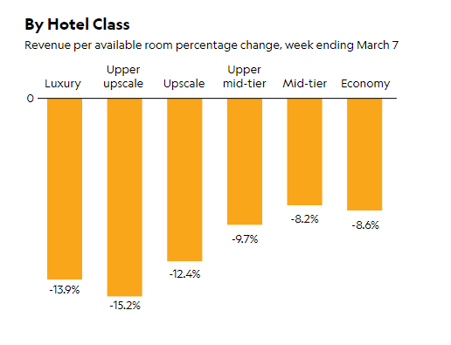
The upper upscale class hotels are facing the most serious conditions due to the pandemic as of -15.2% of loss in revenue per available room, followed by upscale and luxury facility providing hotels. This is showing the loss in occupancy rate. Less occupancy and higher costs lead to loss in this sector. As for businesses, lower revenue ruined the sector’s profitability and as for employees, loss in wages or jobs leads to a severe unemployment and job dissatisfaction.

2.5: Impact of Corona virus on Event set up
Hosting meetings and events in the world was also affected by the COVID 19. Hosting and managing events mainly depend of the venue and transportation and during the time of corona virus spread, both the venue and travel were nearly unavailable. The impact of corona on transportation and accommodation was severe. When we talk about event we talk about public gathering, conferencing, seminars, and corporate events, proposals and fund raising etc. The global event industry had a value of more than $1.1 B. in 2018, and it was estimated to increase by 10% till 2026. But now after the corona pandemic it is being estimated that this event industry will face a loss of 325 billion U.S.D. A survey conducted by PCMA on business events brought up that 87 percent of answerers cancelled their pre planned events, with 66% among those being postponed due this severe pandemic. The same report also showed up that events have been switched to virtual platform by 7 out of 10 businesses. This shows that the event industry is also not free from corona crises and is fighting to cover up the losses that are incurred during this time.

2.6: Impact of Corona virus on sightseeing in tourism
The quick spread of COVID 19 has led to a significant fall in almost all global tourism. As per the views of the United Nations World Tourism Organization, the tourism industry was of the value of 7% of world goods and services (Folinas and Metaxas 2020). But after the spread of this virus the sightseeing tourism industry has borne a great loss. Talking about the mainland China because it was the first place to face corona, China will lead to 25 million fewer outbound trips, wiping out $73 billion in spending. Italy is highly famous among the places to visit, but there almost 90% of hotel bookings were cancelled in March 2020 (ibid). As of now when the world is again opening itself the sightseeing tourism industry is yet trying to cope up with the deficits. On the other hand, the curative measures to be taken for safety, as social distancing is making it harder. Almost all the modes of transport are offering on an average 50% of the customer capacity, for maintaining social distancing, which means not all who are willing to visit will get their tickets on time.

2.7: Countermeasures to be taken in tourism sector in Corona virus
The sector of tourism has been affected to a great extent due to corona virus. A drastic effect can be seen all over the world and in different sectors whether it is transport, tourism or event organization. A drastic fall in revenue is also seen in almost all the sectors in world, it is estimated that countries all over the globe will be facing a loss in GDP of around 0.42% (Folinas and Metaxas 2020). The world needs to take some countermeasures to stop this loss to occur and reverse it into profits and growing GDP. These countermeasures are needed in every field that is affected due to this pandemic. SARS-CoV-2 (COVID 19) is highly infectious, especially in the environment of high public gatherings such as transportation areas. Therefore, to stop the spreading of this disease, many effective countermeasures ought to be taken, such as environmental hygiene, personal protection management measures, disinfections, and health promotion. Management measures include proper management of travellers, providing them seats with social distancing, making sanitizers and disinfectants available to them. Environmental and personal cleanliness is also of utmost importance. The travelling service provider team such as the crew member in ships, the railway or train maintenance workers, the workers and pilots in planes, etc, should be trained during the epidemic. This training must be conducted on training the members for prevention and control measures for Corona Virus (Shen et al., 2020). Same about hotels and accommodation should be done. The staff of hotel management should be trained for any emergency situation related to COVID 19. In case of any person found with symptoms must be treated with utmost care and as per the4 guidelines provided by the WHO and the local regulatory. In event industry, it should always be taken into consideration that the venue used must properly get disinfected each time the event is over. Many more such countermeasures can be adopted suiting to the situation to prevent the virus from spreading.

2.8: Research Gap
This research mainly focuses on the facts and figures on tourism industry in China and other countries worldwide. The tourism industry and related aspects such as travel, accommodation and event industry are facing problems due to the spread of Novel Corona Virus. The facts and figures presently available through different papers and researches are truly knowledgeable and are having proper data but it still needs to be more deeply researched and presented as there are no sufficient actual data of how and till what extent the tourism industry in China and worldwide will overcome its deficit and other practicing problems such as countermeasures to be taken to overcome the spread of disease. This research will showcase the actual level of work done and deficit covered in the industry.

CHAPTER 3: RESEARCH METHODOLOGY

3.1: Research Methodology
Research methodology refers to a specific procedure used to identify the problem in a scientific way, to collect data for it and to process that data to find a scientific conclusion. A research methodology therefore, includes a scientific pathway and techniques used to search for a particular knowledge. A research onion describes this pathway in a simpler way (Saunders, Lewis and Thornhill 2016). The following steps are included in the research methodology

3.2: Research Paradigm and Philosophy:
There are two research paradigms such as: Ontology and epistemology. Ontology refers to the state of being and epistemology would describe the reason behind the existence of the fact. In this research the ontology would be to analyse the decline in tourism sector and epistemology is the reason behind it which is COVID-19 and to analyse the probable countermeasures through which it can be improved (Rehman and Alharthi 2016).
These paradigms are then connected with appropriate research philosophy in order to create a relevant research. Research philosophy describes idea and base of the research. The research philosophy has four types: positivism, realism, interpretivism, and pragmatism. The positivism philosophy claims that the social world can be understood in an objective way, the researcher, on the basis of this objectivity works independently. The realism philosophy is based on the theory that a human mind is independent of reality and this philosophy identifies the reality and examines under which approach it works. The Interpretivism philosophy argues that the knowledge is subjective and culturally and historically positioned as per the mass’ experience. The pragmatic philosophy refers to the combination of two or more philosophy and it is used when the nature of the data is a mixture of both, the qualitative and quantitative. This study is based on interpretivism philosophy as this philosophy is widely used to examine the qualitative data which is the base of this study. The data for this research will be collected from a secondary source of data collection and analysed to get the knowledge and conclusion of this research (Avenier and Thomas 2015). The information would be interpreted and such interpretation would be used to recommend counter measures which can boost the tourism sector.

3.3: Research Approch:
A research approach can either be inductive, deductive or abductive. Inductive approach starts with the observations where theories are proposed towards the end of the research process as a result of observations. While in deductive approach a hypothesis is proposed in the beginning and after this the data collection and observations are made to find out the conclusion. The abductive approach is a mixture of both these techniques. The abductive approach best suits the pragmatic philosophy where the data can be of dual nature (qualitative and quantitative). This research will use inductive approach as the analysis would be performed on already existing facts about decline in tourism due to novel coronavirus and its resultant variables. The collected data which is of qualitative nature will be analyzed and observed in order to conclude this research. This result presented would provide generic conclusion for entire tourism industry (Thomas 2006).

3.4: Research Method:
The methods used to collect the data that describes the nature of that data forms research methods. The data can either be qualitative or quantitative (Queirós, Faria and Almeida 2017). The qualitative data can be explained as the data that can be categorised as per the quality of the topic. This type of data is non-numerical in nature. While quantitative data is numerical in nature. Quantitative data are those which express the details of the research topic in numbers. This research will be done on the qualitative data collected as per the requirement of the research. There are two sources for data collection i.e., primary and secondary. In primary source of data collection, the first-hand data is collected by contacting the respondents of the research. It can be collected through tools like observation, interview and survey. Whereas, the secondary data is collected through credible sources like government issues data, research agencies, newspapers, articles, journals, books and such other sources. In this research secondary source of data collection is to be used as primary analysis would have covered limited responses and narrow data.

3.5: Research Strategy:
This layer of research onion describes about the strategy used in the research to collect the data. There are many different research strategies like experiment, survey, grounded theory, case study, action research, thematic analysis and content analysis (Denzin and Lincoln 2013). Experiments are done to find out any new knowledge which is yet unknown. Case study refers to any specific situation of any organization to identify the problem and work for its solution. Action research is applied when the researcher takes actions according to the research and this process continues over time. Survey is carried out through questionnaire which is based on ‘Likert-scale’ response or numeric options. This research will be done using the strategy of thematic analysis and the data will be collected from secondary source. As this research is based on qualitative data, the strategy of thematic analysis will be considered appropriate.

3.6: Research Design:
A time horizon needs to be decided for any research. Research has two-time horizons namely cross-sectional and longitudinal (Teti, Robinson and Schmidt 2005). The cross-sectional time horizon refers to the situations those are bounded into a particular time period. In this type of study, the outcome is measured or exposed at the same time. While the longitudinal time horizon refers to a longer time period. Researchers here study about a particular topic over a long period of time. In this research cross-sectional time horizons will be considered. This research is based on the current scenario of epidemic hence it is supporting only the cross-sectional time horizon. Also, it is significant to note that the methodologies undertaken in this research would subjectively refer the conclusions which would be relevant only for this research. If the similar study is undertaken with different aim and objective then the present methodology structure would not generate relevant results. Hence, cross-sectional design is justified for the current research.

3.7: Research Technique and Procedure:
Research technique refers to the method of working for the collection of data and evidences to bring to light any new knowledge or to create better understanding of the topic, and procedure includes the pathway to process the data. As this research is based on thematic analysis, the qualitative secondary data (raw data) will be collected from different sources such as newspapers, magazines, and websites of different travel agencies and published sources. This collected data will be then classified or categorise into different categories according to the relevancy of different sectors, then coding of this data will be done. This coded data will be then interpretated to find the conclusion of the research. The procedure is as follows (Walker 2010):
Step1: Familiarisation of the data is to be done. To certain extent, this part is completed while doing research for introduction and literature review of this research.
Step 2: Coding the data is next step. From the information overview some of the relevant information which can be used for analysis is separated from the context used above. Some phrases or sentences are highlighted and coded. For example, phrases like ‘there was reduction in bookings’, ‘the tourism industry was all time low’, etc. These can be coded as decline.
Step 3: Themes are prepared. Now based on the phrases and the codes generated from the respective information, the similar kinds of codes are clubbed together in one theme. For example, decline in transport, tourism, event, etc can be clubbed together as Decline in tourism industry.
Step 4: The themes prepared would be reviewed and if any corrections are required, it would be promptly done.
Step 5: This would be naming the themes appropriately i.e., to provide meaningful and academic names to the theme so that it exactly can be identified from the name of the theme itself that what is going to be discussed in this theme and at which level will it be implemented.
Step 6: The final step would be Writing up the analysis on the basis of themes and codes generated.

3.8: Research Ethics:
The University ethical norms and researcher’s code of conduct would be taken into consideration and completely followed. The data is in this research is collected from the secondary source and therefore its credibility is to be maintained. The data would not be fabricated as per the aim of this research but true and factual information would be presented. There is no hidden benefit of the researcher from this research and also it would not be used for nay personal benefit or for wrongful purpose ahead. The information presented would not be damaging the political, social or economic aspect of any place, company or country. The data collected from any sources will not be changed or modified as per the interest of the researcher. The sources from where this data is collected will be mentioned and cited properly, and this data will not be used for any other purpose different from this research (Brakewood and Poldrack 2013).

CHAPTER 4: ANALYSIS

4.1: Analysis
In this section the detailed analysis about the impact of Coronavirus in the tourism industry is presented and for combating those impact, what all measures have been taken by the tourism industry is also presented herewith. There is a sheer decrease in tourism sector and a thematic analysis is performed on the basis of the data in each determinant of tourism and the countermeasures in those sectors be it transportation sector, accommodation, event and sightseeing. Since, in the duration of the analysis the statistics of Novel virus has been affected more due to the second drive of virus, efforts have been made to include the impact of both on this industry and how far will the industry be able to take this pressure and combat the same i.e., the recovery period of world tourism is depicted below:
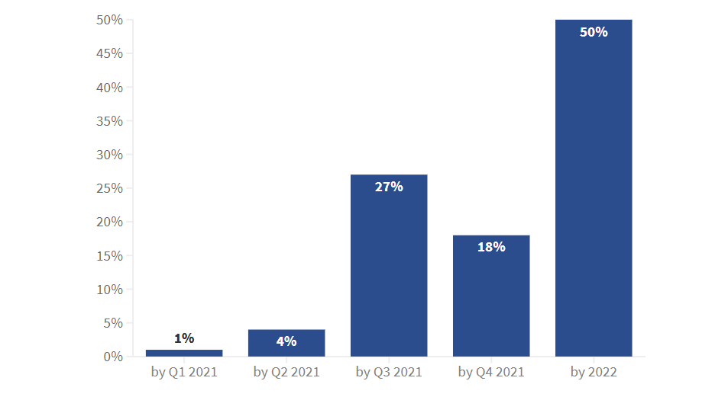
Figure : Recovery period in tourism over the world (UNWTO, 2020)

4.2: Method of Analysis
Thematic analysis would be used as mentioned above and the details of its how it is conducted has been mentioned in the research methodology section. The following significant information has been obtained from the secondary analysis:

4.3: Impact of Coronavirus on tourism sector
It is observed that on every day basis in the year 2020, there was a loss of job for one million jobs in the tourism industry due to this pandemic. The industry has suffered a loss of $21 trillion and is yet facing such conditions (WTTC, 2020). This pandemic has been very sabotaging for the tourism sector as over the period of time there were different pandemics but the tourism rate has been almost nil due to Coronavirus for few months in 2020 which can be observed from the World Bank Database below (Škare, Soriano and Porada-Rochoń, 2020):
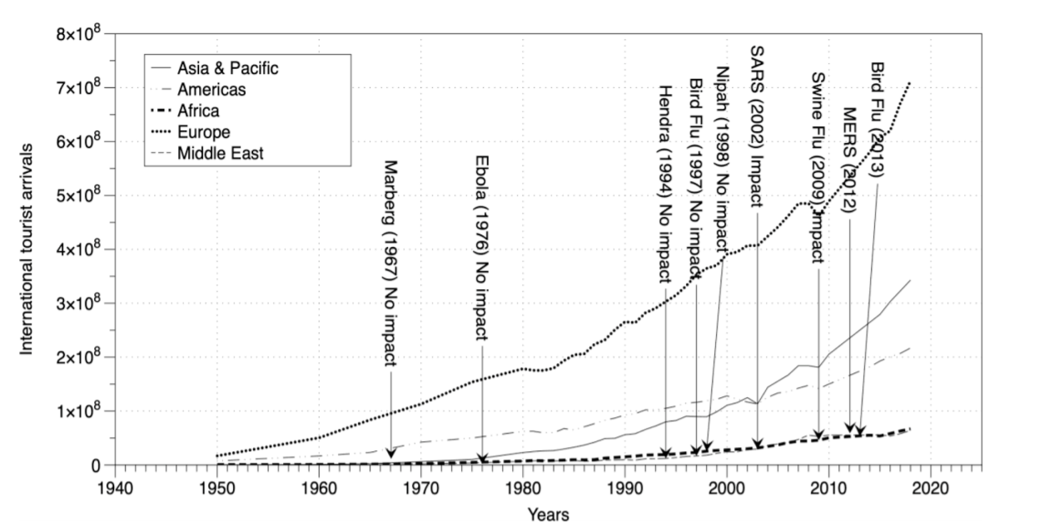
Figure : International tourist arrivals in different countries
It is observed from the graph that the tourism in Europe has been highest of all in every virus drive. Corona virus is more vital compared to other epidemics such as SARS (2002), H1N1 (2009) and MERS (2012). The GDP of the countries are observing a critical impact and there is a plummeting observed from -2.09% to -7.82% in Central Asia and Caribbean respectively. It would be difficult for economies to revive back the shock. Tourism industry would be in complete shock and it would face two types of shocks one is idiosyncratic shock which is associated with the shocks observed by specific countries and also there was a common shock i.e., all the countries of the world had been affected by COVID-19 impact (Bakar and Rosbi, 2020).

4.4: Impact of Coronavirus on transportation sector
Air: The air transport sector has also been significantly affected by the Coronavirus impact. IN the research based on Malaysia, it was identified that almost all the major airlines had registered increasing losses due to pandemic. The top three air lines of Malaysia did a salary cut (Foo et al., 2020). Also due to the restrictions of transport from China and allowing only one flight per week that too with 75% capacity as strict norms to combat the spreading of the infection, it was observed that the airlines faced much of the losses and there was high threat of bankruptcy in this industry (Republic of China Ministry of Foreign Affairs, 2020).
It was observed that even at the world level almost 13 airline companies filed for bankruptcy and this would create a great issue in the future travellers as they would be having a smaller number of options. offers and discounts. Because of COVID-19, there has been a lot of sufferings even on the side of consumers as those who would have booked airline tickets from such bankrupt companies might not be availed any refund. their vouchers might be of no value and along with airline companies, the consumers would also be at the loss (Bloom, 2020).
Rail: The decline in railway is also a matter of concern. In cities around the world people commute through rail lines for everyday work and this is a major source of domestic travel. In a research by Coppola and De Fabiis, (2021) which was based on Milan rail network, it was identified that the local every commute declined due to COVID and this resulted to 79% decline in everyday passengers travelling through railways. In the research by Tardivo, Martín and Zanuy, (2020) it was also depicted that some of the railway networks are left untouched and this might lead to collapse in the transport industry and many of the trains might be discontinued owing to the high maintenance expenses of the staff and the rail.
Water: In the year before pandemic, the cruise industry had almost more than 30 million passengers all over the world and it provided jobs to more than 1 million people. This shows the outreach of industry and due to pandemic, it has declined due to Coronavirus. Many of the listed shipping and cruise companies stock observed a crash of nearly about 80% which threatened the existence of such companies. The ships were not allowed with passengers and for those ships who were allowed to come along passengers, the travellers were kept quarantined for days which increased their cost, threat of infection and stress of the passengers. This led to loss of passengers in future and the reputation of the cruise was also affected which sabotaged the company and plummeted tourism (Nhamo, Dube and Chikodzi, 2020).

4.5: Impact of Coronavirus on Accommodation sector
There was a decline in the accommodation sector and hotel industry. There were so many cancellations around the world in the sector of hotel industry. The occupancy rate in the hotels have been declined in top spot tourist places in the world.
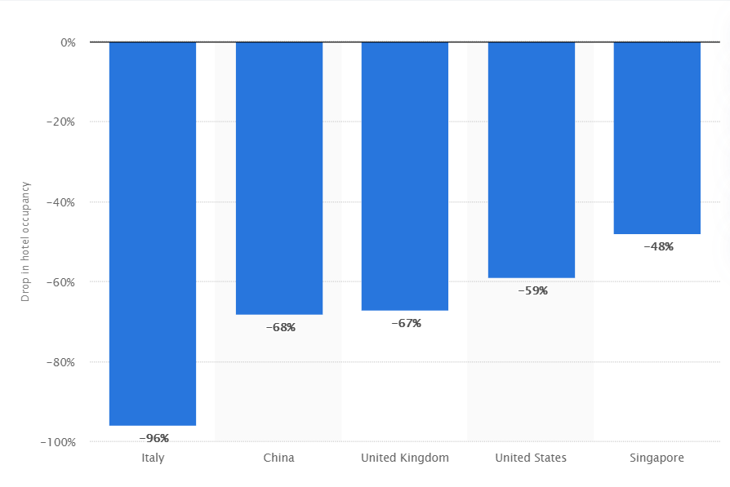
Figure: Hotel occupancy changes year-over-year due to the coronavirus (COVID-19) pandemic in selected countries worldwide for the week ending March 21, 2020 (Statista, 2020)
It is observed from the above graph that there has been a surging decline in the occupancy rate in these countries. The occupancy rate is the customer accommodation in context to hotel capacity. Italy observed the highest decline i.e., 96% and the death toll was also highest in Italy during pandemic. This affected the accommodation sector as tourists refrain to go to Italy because of increase in number of deaths. The decline in China and UK was also significant followed by US and Singapore. Singapore still had less than 50% decline.
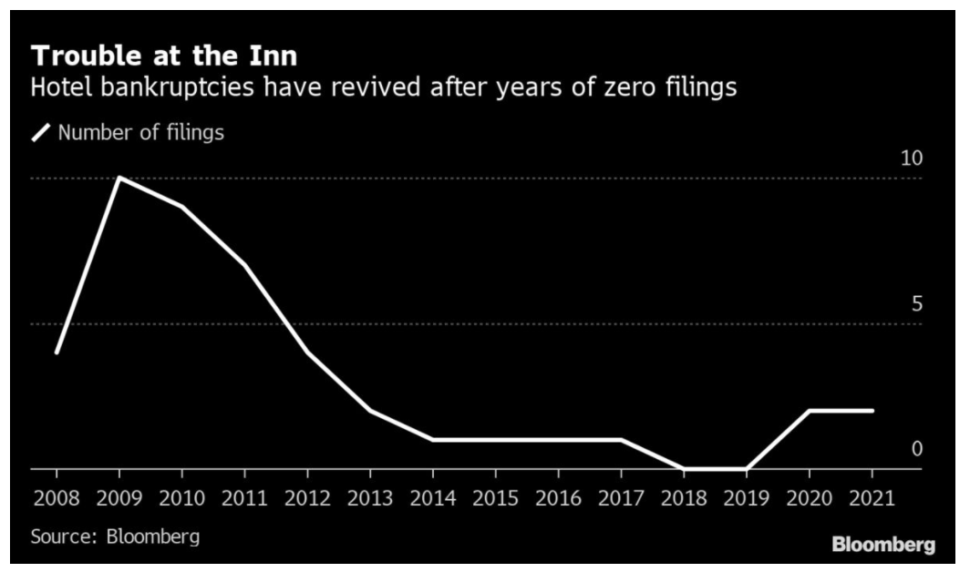
Figure: Bankruptcies in US in Hotel segment
There are many US hotel sector companies which filed for bankruptcy in this COVID-19. Due to heaps of cancellations in this pandemic, the maintenance cost of the hotels outscored their capitals which forced them to file for liquidation and close down the hotels or ask for restructuring (Hill and Doherty, 2021). The hotels faced too many restrictions like limited walk-ins in the restaurants, the lay-offs of the staff and the added cost of sanitisation facilities (Restaurant Hospitality, 2021; Tucker, 2020). It was observed that there was a leading increase in the filing of bankruptcies in the accommodation sector and due to pandemic, it was leading the race of observing the significant decline and loss. In Japan, it was observed that more than 200 companies filed for bankruptcy due to pandemic and of which 34 were hotel businesses, 34 restaurants were shut down due to restrictions and lockdown (HAKOTANI, 2020).

4.6: Impact of Coronavirus on Event organisers
Top 15 events around the world got cancelled due to Corona virus. The events like Geneva Auto Show, IBM Think 2020, Milan furniture fair in field of business (Everything Experimental, 2020). In the field of sports events like ‘Euro 2020’, ‘All Champion League’, ‘Europa matches’, ‘Wimbledon’, ‘NBA season’, ‘Under -21 European Championship’ and ‘Women’s Euro 2021’ is also cancelled and postponed, yet no certain future date has been fixed. It is identified that due to Coronavirus, there would be a loss of 4.6 million jobs in US (Research and Markets, 2020). Many technological events have been cancelled in US and UK. The events like South by Southwest in Austin, Texas, Mobile World Conference in Barcelona Spain. It was observed that the loss due to such cancellation of events outscored $1.1billion (Evans and Brigham, 2020).
The impact of Coronavirus was also observed on Haj pilgrimage, Olympic 2020, Indian premier League, IIFA awards, and many more. It is observed that events can be the greatest source of transmission of such infectious viruses and so cancellation and postponement were the only life saving options for this situation of pandemic (Mohanty, Dhoundiyal and Choudhury, 2020).
The Hollywood star celebrity musical performances events have been cancelled due to COVID-19. The events of Taylor Swift – Lover’s Fest, Harry Styles – Love on Tour, and Billie Eilish – All. Justin Bieber also launched his new dates for 2021 and cancelled the shows in 2020. The world’s largest DJ festival of Tomorrowland also cancelled the entire event without rescheduling the future date due to pandemic. There was trillion-dollar loss in the economy due to all these events. These were just some prominent ones but the list is quite long around the world (Vulture Editors, 2021).

4.7: Impact of Coronavirus on Sightseeing service providers
The tourism industry has observed an all time low during this pandemic therefore, it is certain that there would be plummeting effect of the same in the sight seeing tourism industry even. Sightseeing is visiting the famous places in specific tourism place and know about the history and infrastructure of that place. Sight seeing can be of historic monuments or of natural places, museums. art and literature famous libraries, it can be anything special and authentic about any place. Certainly, when number of tourist visitors are less, there would be decline in sightseeing tourists even. Since, the foreign travellers did not visit the sight, there was a possibility that domestic visitors increases but due to lockdown for few months in almost all the countries infected by this virus, there was even less number of domestic travellers visiting the sights.
Sightseeing is an insignificant part of the tourism whereby it is a luxury for tourist visiting Tunisia from Italy and France but sightseeing of the same place was observed as a necessity for the UK and US based tourists. Therefore, tourist origin also played a vital role in the impact of sightseeing as people visiting from UK and Germany would have definitely undertaken sightseeing and from France and Italy, it would have been dependent on whether the tourists are able to afford that or not. This way when multinational tourism was blocked, so it has majorly affected the sightseeing sector of tourism. Also, there are many picnics of the students in order to make them aware about the place and the history behind it but that too was not observed in pandemic (Inspiration taken from: Wang, 2009).

4.8: Countermeasures for tourism industry
The tourism sector should open up with new guidelines. The World Health Organisation guidelines on tourism should be followed. Some basic protocols like social distancing, sanitisation and wearing masks should be followed in all the industries associated with the tourism sector. A bit of a microscopic view on how the measures should be taken in order to motivate people to travel.
The tourism companies should promote tourism packages stating all the risk mitigating guidelines and give tourist some exclusive discounts. The assurance should be given to the tourists that their safety is what matters the most to the tour operators.
The researcher’s recommendation to this would be that government of countries should make it transparent that for visiting country, there would be specific guidelines and if the tourist fulfils all of them then only, they would be allowed to enter the country or else they would be quarantined.
The transportation sector already has some specific rules like for the passengers boarding flights, the COVID-19 report before 24hrs to 48hrs depending on the norms in different countries. After visiting the specific country also when the customers land, they are tested for virus. This report should be mandatorily given at the accommodation hotels even where the tourist would stay. This way not only tourist but the entire industry would be functioning without nay casualties.
The accommodation hotels should always follow proper sanitation of the property. After every tourist leave the room, it should be very well sanitised so as to protect the interest of the tourist and the hotel itself. There should be kiosks replacing the reception and the check-in staff, in order to avoid the one-to-one contact while delivering the keys to the tourists. There should be sanitizing showers through which the luggage has to be screened and the tourist should be given censored sanitisation facilities along with mask. The tourist’s temperature should be measured with the help of contactless thermometer and if suspected, prompt actions should be taken. The hotel staff should always wear masks and hand glows for protection. Proper hygiene and disinfectants should be used.
The events and sightseeing should be totally based on pre-booking of appointments. The issue here would be that many of the tourist might not turn up for the event or sight seeing even though they must have booked in advance due to COVID-19. The tourists who give their COVID-19 positive report to the event organisers then they should refund the entire amount of ticket. This way the consumer would be attracted in terms of safety also and the consumer would also be at ease that he/she would not be in a complete loss but will get the refund back if they get infected by this virus. The capacity of the events and sight seeing should not be reduced but proper safety guidelines should be followed.

4.9: Inference
Table : Thematic Analysis table with issues and countermeasures in Tourism industry due to Coronavirus (Created by Author)
Theme | Issues | Countermeasures
Tourism industry | The decrease in the tourism sector is observed in entire world due to which millions of job cuts have been observed and the GDP of the countries have been falling.  Inference: People travel for leisure as well as for business, many of the students travel to foreign countries for education, but due to pandemic there was a sheer decline in all this which has affected the growth of the world economy even. | Promoting the tourism packages for business travellers, leisure travellers and students with all safety guidelines and assurance of security while travelling and up to coming back home or settling there for their future prospects.
Transportation | There were issues in the field of air, rail, road and water transport. The virus is contagious and due to this the transportation around the world was stopped by lockdown in various countries. This affected even domestic transportation along with the international tourism transportation. | Test report mandatory before availing any public transport medium of service. Tools like face shield, mask, sanitiser, hand gloves and masks should be mandatory for travelling through any medium.
Accommodation | Due to lockdown, there was a decrease in the registration of the hotels. This resulted in decrease in the occupancy rate. | The kiosks facilities should be installed. Proper sanitisation facilities should be provided. COVID-19 tests reports should be mandatory and that too of the recent one i.e., 24 hours.
Events | Cancellation of events leads to trillion-dollar loss around the world and due to which many event organisers had faced losses. The events were rescheduled but due to the second drive of the virus, many of the rescheduled events also got cancelled. | Pre-bookings, sanitisation, refund should be provided if the tourist is found COVID-19 positive and could not attend the event. Social distancing and limited crowd entry should be allowed. Online concerts can also be arranged.
Sight Seeing | Sight seeing if overpopulated, can be a cause for increase in numerous positive cases of COVID-19 infected tourists. Cancellation led to job cuts of guides and local tour operators. | Pre-bookings. limited entry and transparency should be maintained in order to know how many people are daily visiting the sight and is proper sanitisation facility available there or not? Such information should be made available to the potential tourists on the inquiry which would generate a sense of visiting the place if safe and sound.

5.0: REFERENCES
Farmaki, A. et al. 2020. Impacts of Covid-19 on peer-to-peer accommodation platforms: Host perceptions and responses. International Journal of Hospitality Management 91, p. 102663. doi: 10.1016/j.ijhm.2020.102663.
Folinas, S. and Metaxas, T. 2020. TOURISM: THE GREAT PATIENT OF CORONAVIRUS COVID-2019. International Journal of Advanced Research 08(04), pp. 365–375. doi: 10.21474/ijar01/10788.
Giese, M. 2020. COVID-19 impacts on global cruise industry. Available at: https://home.kpmg/xx/en/blogs/home/posts/2020/07/covid-19-impacts-on-global-cruise-industry.html [Accessed: 25 January 2021].
IATA 2020. IATA Updates COVID-19 Financial Impacts -Relief Measures Needed-. Available at: https://www.iata.org/en/pressroom/pr/2020-03-05-01/ [Accessed: 23 January 2021].
IRJ 2020. AllRail calls for action to prevent private operators from going out of business. Available at: https://www.railjournal.com/financial/allrail-coronavirus-private-operators-future/ [Accessed: 27 January 2021].
IRU 2020. Global recovery on the line as road transport losses escalate. Available at: https://www.iru.org/resources/newsroom/global-recovery-line-road-transport-losses-escalate [Accessed: 28 January 2021].
Jasper, C. and Bloomberg 2020. Airlines face $157 billion in losses as COVID is expected to wipe out even more flights in the year ahead. Available at: https://fortune.com/2020/11/24/airlines-157-billion-loss-covid-iata/ [Accessed: 24 January 2021].
KIM-DANNIBALE, A. 2020. 3 charts show how coronavirus is affecting the travel industry. Available at: https://www.nationalgeographic.com/travel/2020/04/charts-show-coronavirus-impact-on-travel-industries/ [Accessed: 24 January 2021].
Langton, K. 2020. China lockdown: How long was China on lockdown? Available at: https://www.express.co.uk/travel/articles/1257717/china-lockdown-how-long-was-china-lockdown-timeframe-wuhan [Accessed: 24 January 2021].
Li, J. et al. 2020. Coronavirus impacts on post-pandemic planned travel behaviours. Annals of Tourism Research , p. 102964. doi: 10.1016/j.annals.2020.102964.
Lock, S. 2018. Topic: Global Travel and Tourism Industry. Available at: https://www.statista.com/topics/962/global-tourism/ [Accessed: 25 January 2021].
Lock, S. 2020. Travel and tourism: direct economic impact in leading countries 2019. Available at: https://www.statista.com/statistics/292461/contribution-of-travel-and-tourism-to-gdp-in-select-countries/ [Accessed: 24 January 2021].
Moriarty, L.F. 2020. Public Health Responses to COVID-19 Outbreaks on Cruise Ships — Worldwide, February–March 2020. MMWR. Morbidity and Mortality Weekly Report 69. Available at: https://www.cdc.gov/mmwr/volumes/69/wr/mm6912e3.htm.
Riley, C. 2020. “This is a crisis.” Airlines face $113 billion hit from the coronavirus. Available at: https://edition.cnn.com/2020/03/05/business/airlines-coronavirus-iata-travel/index.html [Accessed: 27 January 2021].
Roser, M. 2017. Tourism. Our World in Data . Available at: https://ourworldindata.org/tourism#:~:text=The%20United%20Nations%20World%20Tourism.
Shen, J. et al. 2020. Prevention and control of COVID-19 in public transportation: Experience from China. Environmental Pollution, 266, p.115291.
The Visual and Data Journalism Team 2020. China coronavirus: A visual guide to the outbreak. BBC News 29 January. Available at: https://www.bbc.com/news/world-51235105 [Accessed: 24 January 2021].
Uğur, N.G. and Akbıyık, A. 2020. Impacts of COVID-19 on global tourism industry: A cross-regional comparison. Tourism Management Perspectives 36, p. 100744. doi: 10.1016/j.tmp.2020.100744.
UNWTO 2020. International Tourist Numbers Could Fall 60-80% in 2020, UNWTO Reports | UNWTO. Available at: https://www.unwto.org/news/covid-19-international-tourist-numbers-could-fall-60-80-in-2020 [Accessed: 23 January 2021].
WHO 2020a. A Joint Statement on Tourism and COVID-19 - UNWTO and WHO Call for Responsibility and Coordination. Available at: https://www.who.int/news/item/27-02-2020-a-joint-statement-on-tourism-and-covid-19---unwto-and-who-call-for-responsibility-and-coordination#:~:text=On%2030%20January%202020%2C [Accessed: 26 January 2021].
WHO 2020b. Coronavirus disease (COVID-19) Global epidemiological situation. Available at: https://www.who.int/docs/default-source/coronaviruse/situation-reports/20201012-weekly-epi-update-9.pdf [Accessed: 24 January 2021].
WHO 2021. WHO Coronavirus Disease (COVID-19) Dashboard. Available at: https://covid19.who.int/?gclid=CjwKCAiAgc-ABhA7EiwAjev-jxEy7sT8QRXRii5MXEflmdGvWmXnoIHngoLABcnnlYdRxPssMyQashoCugkQAvD_BwE [Accessed: 23 January 2021].
World Health Organization 2020. Coronavirus disease 2019 (COVID-19) Situation Report -94 HIGHLIGHTS. Available at: https://www.who.int/docs/default-source/coronaviruse/situation-reports/20200423-sitrep-94-covid-19.pdf [Accessed: 24 January 2021].
Avenier, M.J. and Thomas, C. (2015) “Finding one’s way around various methodological guidelines for doing rigorous case studies: A comparison of four epistemological frameworks”. Systemes d'information management 20(1), 61-98
Brakewood, B. and Poldrack, R.A. (2013) “The ethics of secondary data analysis: Considering the application of Belmont principles to the sharing of neuroimaging data”. Neuroimage 82, 671-676
Denzin, N.K. and Lincoln, Y.S. (2013) Strategies of Qualitative Inquiry. Thousand Oaks, Ca ; London: Sage
Queirós, A., Faria, D. and Almeida, F. (2017) “Strengths and limitations of qualitative and quantitative research methods”. European Journal of Education Studies 3(9)
Rehman, A. and Alharthi, K. (2016) “An Introduction to Research Paradigms”. International Journal of Educational Investigations 3(8), 51-59
Saunders, M., Lewis, P. and Thornhill, A. (2016) Research Methods for Business Students. 7th ed. Pearson.
Teti, D.M., Robinson, K. and Schmidt, T. eds., (2005). Issues in the use of longitudinal and cross-sectional designs. In: Handbook of Research Methods in Developmental Science. USA: Blackwell Publishing Ltd.
Thomas, D. (2006) “A General Inductive Approach for Analyzing Qualitative Evaluation Data. American Journal Of Evaluation” 27(2), 237-246
Walker, I. (2010). Research methods and statistics. Basingstoke, Hampshire: Palgrave Macmillan.
Bakar, N.A. and Rosbi, S. (2020). Effect of Coronavirus disease (COVID-19) to tourism industry. International Journal of Advanced Engineering Research and Science, [online] 7(4), pp.189–193. Available at: https://ijaers.com/uploads/issue_files/23IJAERS-0420201-Effectof.pdf [Accessed 30 Apr. 2021].
Bloom, L.B. (2020). You Won’t Believe How Many Airlines Haven’t Survived Coronavirus. How Does It Affect You? [online] Forbes. Available at: https://www.forbes.com/sites/laurabegleybloom/2020/06/27/airlines-coronavirus-travel-bankruptcy/?sh=5cd59af15f69 [Accessed 30 Apr. 2021].
Coppola, P. and De Fabiis, F. (2021). Impacts of interpersonal distancing on-board trains during the COVID-19 emergency. European Transport Research Review, 13(1).
Evans, D. and Brigham, K. (2020). The economic impact of coronavirus event cancellations. [online] CNBC. Available at: https://www.cnbc.com/2020/03/18/the-economic-impact-of-coronavirus-event-cancellations.html [Accessed 30 Apr. 2021].
Everything Experimental (2020). Top 15 events that got cancelled/postponed due to COVID-19 scare. [online] Everything Experiential. Available at: http://everythingexperiential.businessworld.in/article/Top-15-events-that-got-cancelled-postponed-due-to-COVID-19-scare/09-03-2020-185803/ [Accessed 30 Apr. 2021].
Foo, L.-P., Chin, M.-Y., Tan, K.-L. and Phuah, K.-T. (2020). The impact of COVID-19 on tourism industry in Malaysia. Current Issues in Tourism, [online] pp.1–5. Available at: https://www.tandfonline.com/doi/full/10.1080/13683500.2020.1777951.
HAKOTANI, S. (2020). COVID-19 crisis sends more than 200 companies into bankruptcy. [online] The Asahi Shimbun. Available at: http://www.asahi.com/ajw/articles/13429744 [Accessed 30 Apr. 2021].
Hill, J. and Doherty, K. (2021). U.S. Bankruptcy Tracker: Hotel Filings Rise Amid Virus Spike. [online] BloombergQuint. Available at: https://www.bloombergquint.com/business/u-s-bankruptcy-tracker-hotel-filings-rise-amid-virus-spike [Accessed 30 Apr. 2021].
Mohanty, P., Dhoundiyal, H. and Choudhury, R. (2020). Events Tourism in the Eye of the COVID-19 Storm: Impacts and Implications. SSRN Electronic Journal.
Nhamo, G., Dube, K. and Chikodzi, D. (2020). Counting the Cost of COVID-19 on Global Cruise Ship Industry. pp.135–158.
Republic of China Ministry of Foreign Affairs (2020). Ministry of Foreign Affairs of the People’s Republic of China National Immigration Administration Announcement on the Temporary Suspension of Entry by Foreign Nationals Holding Valid Chinese Visas or Residence Permits. [online] Fmprc.gov.cn. Available at: https://www.fmprc.gov.cn/mfa_eng/wjbxw/t1761867.shtml [Accessed 30 Apr. 2021].
Research and Markets (2020). Global Travel and Sports Markets 2020: Widespread Cancellation of Sporting Events Due to COVID-19 and the Economic Impact on the Industry. [online] GlobeNewswire News Room. Available at: https://www.globenewswire.com/news-release/2020/05/07/2029149/0/en/Global-Travel-and-Sports-Markets-2020-Widespread-Cancellation-of-Sporting-Events-Due-to-COVID-19-and-the-Economic-Impact-on-the-Industry.html [Accessed 30 Apr. 2021].
Restaurant Hospitality (2021). Restaurants and restaurant groups that filed for bankruptcy during the COVID-19 pandemic. [online] Restaurant Hospitality. Available at: https://www.restaurant-hospitality.com/coronavirus/restaurants-and-restaurant-groups-filed-bankruptcy-during-covid-19-pandemic [Accessed 30 Apr. 2021].
Škare, M., Soriano, D.R. and Porada-Rochoń, M. (2020). Impact of COVID-19 on the travel and tourism industry. Technological Forecasting and Social Change, 163, p.120469.
Statista (2020). Drop in global hotel occupancy due to COVID-19 by country 2020. [online] Statista. Available at: https://www.statista.com/statistics/1109521/hotel-occupancy-coronavirus/ [Accessed 28 Apr. 2021].
Tardivo, A., Martín, C.S. and Zanuy, A.C. (2020). COVID-19 IMPACT IN TRANSPORT, AN ESSAY FROM THE RAILWAYS’ SYSTEMS RESEARCH PERSPECTIVE. [online] European Rail Research Network of Excellence, pp.1–17. Available at: http://www.eurnex.org/wp-content/uploads/2020/05/Covid-19_Rail_Final_EURNEX.pdf [Accessed 30 Apr. 2021].
Tucker, H. (2020). Coronavirus Bankruptcy Tracker: These Major Companies Are Failing Amid The Shutdown. [online] Forbes. Available at: https://www.forbes.com/sites/hanktucker/2020/05/03/coronavirus-bankruptcy-tracker-these-major-companies-are-failing-amid-the-shutdown/?sh=7d6464033425 [Accessed 30 Apr. 2021].
UNWTO (2020). Impact assessment of the COVID-19 outbreak on international tourism | UNWTO. [online] www.unwto.org. Available at: https://www.unwto.org/impact-assessment-of-the-covid-19-outbreak-on-international-tourism [Accessed 28 Apr. 2021].
Vulture Editors (2021). All the Live Events, Movie Releases, and Productions Affected by the Coronavirus. [online] Vulture. Available at: https://www.vulture.com/2021/01/events-cancelled-coronavirus.html [Accessed 30 Apr. 2021].
Wang, Y.-S. (2009). The impact of crisis events and macroeconomic activity on Taiwan’s international inbound tourism demand. Tourism Management, 30(1), pp.75–82.
WTTC (2020). Crisis Readiness Are You Prepared and Resilient to Safeguard Your People & destinations? Global+rescue report. [online] www.wttc.org. Available at: https://www.wttc.org/-/media/files/reports/2019/generating-jobs [Accessed 28 Apr. 2021].

