Problem Solving and Decision Making – WE Insure
BMSK4014

Callum Mason

Table of Contents
- Nature, Scope and Impact 1
- Brainstorming 1-2
- Root cause ……………………………………………………………………………………………………………………….3
  - Mind Map …………………………………………………………………………………………………………………………….3
  - 5 Whys 3
- Grid Analysis 4
- Cost Benefit Analysis …………………………………………………………………………………………………………….5
- Gantt Chart …………………………………………………………………………………………………………..………………6
- Stakeholder Mapping …………………………………………………………………………………………………………..7
- Communication Plan …………………………………………………………………………………………………………8
- Monitoring ……………………………………………………………………………………………………………………….8
References

1. Nature, Scope and Impact
According to Anderson (2005), ‘‘any goal directed sequence of cognitive operations’’ is classified as
an instance of problem solving”, and this assignment will cover a range of cognitive operations
including Gantt Chart, Grid Analysis, Cost Benefit Analysis, 5 Whys, Brainstorming and mind mapping
to find a solution to the problem the organisation is currently facing.
The problem under consideration is a complex problem, defined as ‘those that include the ability to
approach them from multiple, sometimes competing, perspectives and which may have multiple
possible solutions’ (Penn State Agricultural College, 2023).

Nature – The problem my company is facing is members of staff who regularly turn up late for work.
These members of staff are high performing and generate massive revenue, however their
behaviour is now affecting other staff members.
Scope- This issue has become more urgent as it does affect other members of staff affecting their
morale and commitment therefor this does require immediate attention. In a sales environment all
staff need to be happy and positive to perform to their full capacity and the atmosphere is now
being affected by this situation. Other members of staff will feel treated unfairly if the high-end
earners turn up late repeatedly and no action is taken. The impact and effect this has on the company goes as high as the FCA to tuto money limited the company that authorises the this company to sell financial products. It also has effect on customers waiting for callbacks to get there protection sorted .
Impact – The impact this has on my company is spreading. It effects staff in all departments and
ripples out as far as effecting family and loved ones. If a member of staff finds it unfair that someone
who turns up late don’t face disciplinary?
2. Brainstorming
- Attendance bonus -yes
- Reduce hours-no
- Loss of commission - yes
- Sent home. -yes
- Work from home- no
- Leave changed to hours not days.- no
- Disciplinary -yes
- Payback on all hours via comms – no
Brainstorming (BS) is one of the techniques for fostering group creativity by which ideas and
thoughts are shared among members spontaneously in order to reach solutions to practical
problems (Gogus, 2012).
In order to come up with some solutions to the problem we undertook a brainstorming session
which promotes ‘individuals’ ability to generate quality and novel ideas in order to solve complex
problems are considered a valuable asset in any organization’ (Al-Samarraie &amp; Hurmuzan, 2017). The results of my brainstorming are shown below

Once all the ideas had been captured on the brainstorming chart we then had to go back over the
ideas to see which ones could be considered to help solve our problem. This means we need to
categorise each idea into yes or no and those that are deemed yes will be looked into later.
Then put a list of those that are yes ones into a list
The solutions we are going to follow up are:
- Attendance Bonus
- Send employee home
- Loss of commission
- Disciplinary with a view to sacking the employee

- Root Cause
The root cause to the company’s problem would be attitude as high earning members of staff continue to come in late don’t get effected by losing the going rate for the time they have not been in work. When you earn 100s of pounds in commission why would the loss of £30/£40 each be week effective? Its known to see people attitude change as they earn more.
Once we have identified all the possible solutions we can adopt to prevent this problem from
continuing, we then need to find the root cause to our problem in order to find the most cost-
effective way of solving the problem. To help me find the solutions I will use a range of tools that
will help me gather information to find the root cause.

3.1 Mind Map –
Mind Maps are successfully used when a company is trying to identify a problem. Once the overall
problem is identified, Root Cause analysis is used to help further recognize not only what the issue
is, what happened, why it happened, and what to do to prevent it from happening again. (PUI, 2023)
3.2 5 Why’s
Five whys was devised by Toyota as they developed their manufacturing methodologies. By
repeatedly asking the question ‘why?’ (use five as a rule of thumb), you can conduct a very
superficial review of a simple problem (NHS England, 2022)
3.3 Fishbone diagram – from the Saturday
A cause and effect diagram, often called a “fishbone” diagram, can help in brainstorming to identify
possible causes of a problem and in sorting ideas into useful categories. A fishbone diagram is a
visual way to look at cause and effect (CMS.GOV, n.d.)
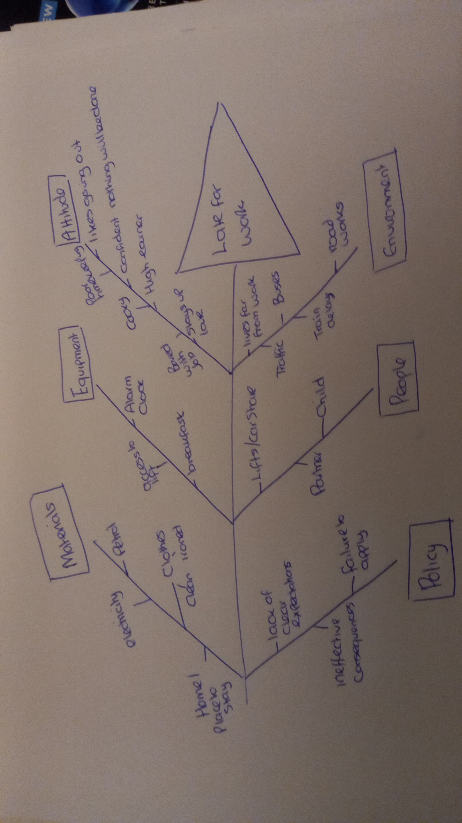

- Grid Analysis
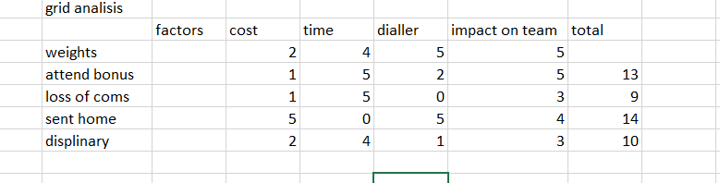

This grid analysis demonstrates the factors of impact this problem has on the company and
members of staff at work. This analysis will also show ways of options to tackle the problem. The
analysis does statistically give you the best course of action to tackle the problem my company has.
Some of the options we must overcome high earning staff turning up to work late regularly. For
example, loss of commission. Disciplinary, sent home or loss of attendance bonus. This grid shows
me that sending the late member of staff home comes out as my best as the impact this problem
has on the rest of the team outweighs the earnings the late member of staff brings to the company.
Being sent home is a better option than disciplinary or loss of attendance bonus as the late member
of staff earns enough money during the week so loss of attendance bonus doesn’t counter act the
problem enough to require it as policy. Loss of commission came close to final option but doing that
would put the late member of staff in a position to quit the job as loss of commission can be classed
as to harsh. Sent home for the day seams to be the best option as it helps keep the team motivated
and on board to the idea that lateness won’t be tolerated. This grid analysis also shows the factors
and impact on the company as lateness leads to a slow dialler which slows the team down from
contacting customers every 30 seconds. If the team don’t make regular contact with customers, it’s
hard to build momentum to generate solid leads to be closed. With out this flow it costs the
company money and eats away at the time during the day. The final factor is the impact on the team
seeing a high earning member of staff turning up late but still earning lots of money each week.
What does that do to a less experienced agent? what does this teach them?
- cost benefit analysis
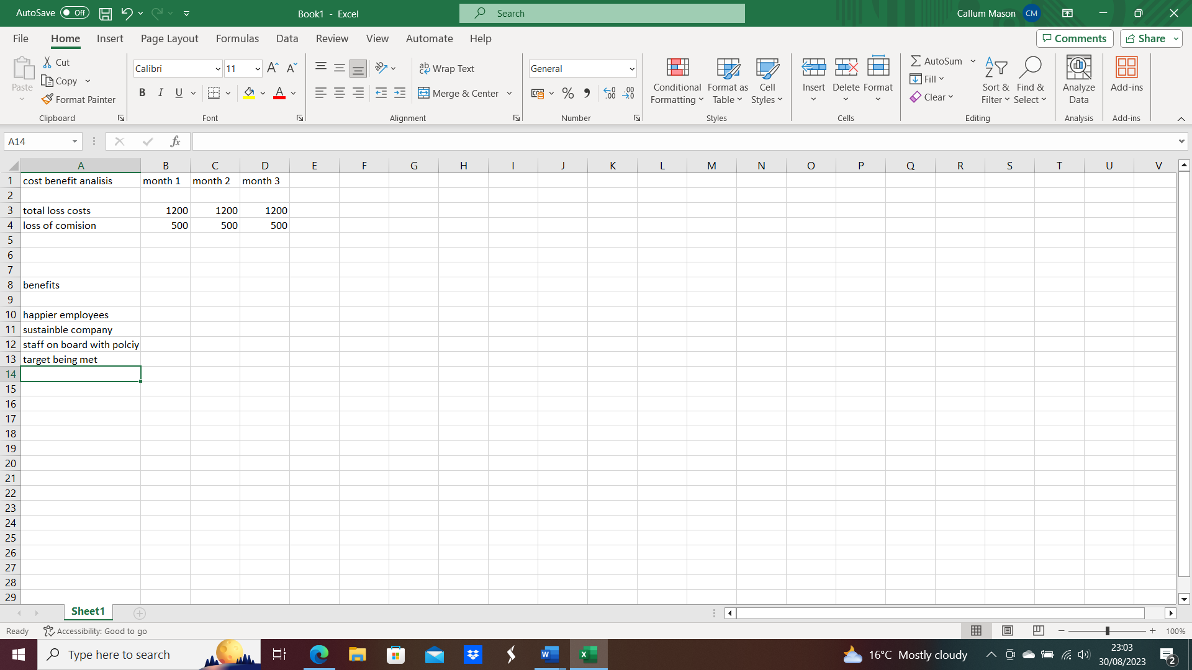

The purpose of cost-benefit analysis is to provide a consistent procedure for evaluating decisions in
terms of their consequences (Dreze &amp; Stern, 1987)

- Gantt Chart
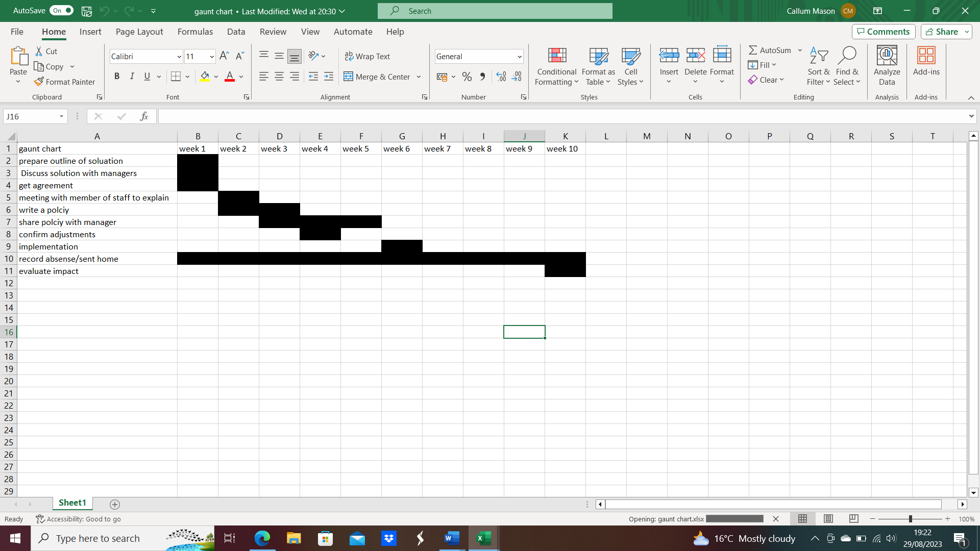

This Gantt chart shows the timeline when I’m going to implement my activities and how their going
to help me over coming the problem. Week 1 would require a discussion between managers and
coming to an agreement by the end of the week. Also prepare an outlined solution while recording
the absence. I will continue to monitor absence but in a more formal manner that will allow me to
evaluate the process in week 10 and robust evidence of whether there is any change in behaviour.
Going into week 2 I will write a policy ready for it to be put into motion. In the same week I do tend
to have the circular perform a meeting to staff to explain. Week 3 will also include writing a policy as
I will have to do research and follow regulations and legislation. By the end of week 3 I do intend to
share the policy with all managers to everyone is on board with the future. It can take up to 3 weeks
for all managers to take the policy om aboard as they do have to read the policy, check it and give
feedback. There must be time to get it right. They may not even read it straight away. I will confirm.

adjustment after week 4 with implementation not arriving until week 6 but will monitor any
behaviour across a 10-week period. Also behaviour will be monitored after the policy is
implemented to see if there is any change or improvement otherwise action will be taken.

- Stakeholder Mapping
The next stage is to identify who the stakeholders are who might be involved in, or affected by, the
solution to the problem, together with any shareholders in the business.
A stakeholder is defined as “any group or individual who can affect or is affected by the achievement
of an organization’s purpose” (Freeman 2010). Whereas a shareholder is defined as
The people who will be involved in the solution are:

Varvasovszky and Brugha (2000) define stakeholder analysis as an approach, a tool or a set of tools.
for generating knowledge about the actors – individuals and organization – to understand them.
behaviour, intentions, interrelations and interests; and for assessing the influence and resources.
they bring to bear on decision-making or implementation processes.
Once the stakeholder has been identified and prioritised there is a need to map them, stakeholder.
mapping ‘is a support tool for the analysis of the stakeholder community and a tool for supporting.
the decision-making processes of managers’ (Slaba, 2016) 7. Stakeholder Mapping
The next stage is to identify who the stakeholders are who might be involved in, or affected by, the
solution to the problem, together with any shareholders in the business.
A stakeholder is defined as “any group or individual who can affect or is affected by the achievement.
of an organization’s purpose” (Freeman 2010). Whereas a shareholder is defined as
The people who will be involved in the solution are:
- financial conduct authority – The FCA would be classed as low power and low influences as my company acts as an independent broker.
- insurance companies –the insurance companies we broker for would be high influence but low power as they can be affected by the problem but would have the power to offer disciplinary.
- tuto money LTD- as previously mentioned tuto money limited is the company that authorises us and have high influence and high power as they would pay our statement weekly.
- customers –with customers they would have low power as there not actively a part of the working operation and don’t have any influence on the staff.
- managers – managers would defiantly have the highest power and the highest influence as they would be apart of dealing with the situation and of loading the solution to solve it.
- employees- some employees are the problem so they have influence but have low power as a majority of the staff will have to engage in the solution of new policy so they would have low power.

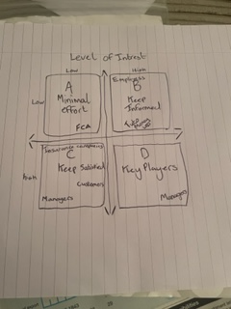

- Communication Plan

A well-organised, comprehensive communications program with stakeholders is essential (Khan & Gerrard, 2005)
What Information | When | How will you send it?  (Letter, email, phone call) | Which stakeholder (s) | Who is responsible
Draft Policy | Month before implementation | E-mail with request for feedback | Manager | Callum Mason
Confirmation of Policy | Week before implementation | e-mail | Owner | Manager
Awareness of new policy | Week before implementation | Meeting & follow-up e-mail | All employees | Callum Mason
Implementation of New Policy |  | E-mail with request for signature | All employees | Callum Mason
Implementation of New Policy | Date of Implementation | E-mail to confirm start date of new Policy | All employees | Callum Mason

9. Monitoring
My main source for monitoring is my Gantt chart as it provides us evidence on a weekly basis as it maps out our process of using our solution to tackle the problem my company has with members of high earning staff turning up late for work regularly.
References
Al-Samarraie H, and Hurmuzan S, 2017, A review of brainstorming techniques in higher education,
Thinking Skills and Creativity, 27, pp78-91
Anderson JR (2005) Cognitive psychology and its implications, 6th edn. Worth, New York
CMS GOV, n.d., How to use the fishbone tool for root cause analysis,
https://www.cms.gov/medicare/provider-enrollment-and-
certification/qapi/downloads/fishbonerevised.pdf, accessed 28/8/2023
Dreze J &amp; Stern N, 1987, The Theory of Cost Benefit Analysis, Handbook of Public Economics
Freeman, R. E., 2010: Strategic Management: A Stakeholder Approach. Cambridge: Cambridge
University Press.
Gogus A, 2012, Brainstorming and learning Encyclopedia of the sciences of learning
Khan S J, &amp; Gerrard L E, 2005, Stakeholder Communications for Successful Water Reuse Operations,
Integrated Concepts in Water Recycling, pp 355-367
NHS England, 2022, Using five whys to review a simple problem, https://www.england.nhs.uk/wp-
content/uploads/2022/02/qsir-using-five-whys-to-review-a-simple-problem.pdf, accessed
28/8/2023
Penn State Agricultural College, 2023, Complex or ‘Wicked Issues’,
https://aese.psu.edu/research/centers/cecd/engagement-toolbox/problems/complex-or-wicked-
issues#:~:text=Complex%20problems%20are%20typically%20defined,may%20have%20multiple%20
possible%20solutions. Accessed 28/8/2023
PUI, 2023, Mind Mapping and Root Cause, https://www.probesunlimited.com/mind-mapping-and-
root-
cause/#:~:text=Occasionally%2C%20Mind%20Maps%20are%20successfully,prevent%20it%20from%
20happening%20again, accessed 28/8/2023
Slaba M, 2016, Stakeholder profile and stakeholder mapping of SMEs, Littera Scripta, 9(1), pp 124-
139
Varvasovszky, Z. &amp; Brugha, R, 2000. How to do (or not to do) … A stakeholder analysis. Health Policy
and Planning. 15(3), pp 338–345.

