University of Wales Trinity Saint David

Title: Greenpower Project

BSC/HND Motorsport Engineering Year 2

Module: Group Project & CAE
(M5X02204)

Student(s):
Dion Billing (1701657)
Toby Marshall (1702695)
Harrison Liddell (1700953)
Ben Coney (1703189)
Ashleigh Jones (1707088)

Contents Page – Ben Coney 1703189
Abstract Page 3
Ashleigh Jones 1707088 Pages 4 - 12
Benjamin Coney 1703189 Pages 13 - 19
Toby Marshall 1702695 Pages 20 - 26
Dion Billing 1701657 Pages 27 - 34
Harrison Liddell 1700953 Pages 35 – 43
Bibliography Pages 44 - 47

Abstract – Ben Coney 1703189
Within this group project, the members of the group will be taking part in investigating various aspects of a Greenpower car. Each member of the group has been set a research topic in which to investigate, for instance the first investigation that will be discussed within this report is the Battery selection, this investigation will be completed by Ashleigh Jones (1707088). The battery selection investigation will be done to decide on which type of battery is best for the application. The next investigation in which will be discussed within this report is the Energy Recovery System and Heat Management investigation, this investigation will be completed by Benjamin Coney (1703189), the need for such systems will be discussed within this report and the regulations around the subject area will be outlined. From here the report will go on to investigate the controlling of the motor on the Greenpower car, this investigation will be completed by Toby Marshall (1702695), this investigation will discuss the regulations around motor controlling and the methods of which can be used to do so. From here, the gearing of the Greenpower car will be investigated, Dion Billing (1701657) will be the one investigating this subject are, a comparison between the standard gearing and other forms of gearing mechanism will be discussed. Finally, Harrison Liddell (1700953) will go on to investigate the rolling resistance on the Greenpower car, looking into the regulations around the tyres and what bearings can be used on the car.

Introduction – Ashleigh Jones (1707088)

Greenpower formula 24+ is an endurance race that last 1 hour which gets teams from ages between the ages of 16 and 24 to design and build and make an electric vehicle more efficient. This is done to engage student into thinking about eclectic vehicles allowing the students go develop and innovate ways to make an electric last longer. In this project we focused on ensuring that the vehicle drive train is at its most efficient point by developing every aspect of it. The section of the drive train that will be developed is the battery, gearing, motor control, rolling resistance, heat management and energy recovery. All of these aspects are investigated and developed by me and my colleagues in the team to ensure that all aspects of the vehicle are efficient as possible.
The first section of the report will be dedicated to the battery selection and investigating the different battery types and its advantages and disadvantages in gaining a full understanding of the option and how it can benefit the development of the green power vehicle. This section highlights the regulation in the limitation of choice of the battery due to the regulation set upon this race.
The next section is investigating into the battery choice on the specific traits the battery has by proposing a test using the green power vehicle. This section especially highlights the issues with the vehicle and how to combat the problems that dose arise with different techniques by developing different efficiency devices to ensure that the vehicle is at its most inefficient point.
The last section is concluding the experiments that is conducted and how to improve the vehicle to be at its most efficient point. The last section also highlights the groups participation and by using a planning Gantt chart to regulate the time it takes for each take which is vital to ensure that a project stays on time.

Battery Selection – Ashleigh Jones (1707088)
There are many different options on batteries which hold different advantages and disadvantages. Batteries deferrer by the chemical composition of each battery. There are many different batteries that can be selected for the purpose of the green power buggy but there is only a select few with capacity to comply with the requirements.
In selecting a battery, the requirements need to be identified to enable a correct battery sedition. In the application of the green power formula 24+ vehicle, the requirement is to have a battery that can withstand the 60-minute race. This means that the desired battery needs to withhold a certain amount of charge to last the whole race. A battery with a large capacity is recommended for this type of race. There are three batteries that have the capability for a large storage capacity. These batteries are: Lithium-iron, Nickel Metal Hydride or Lead-acid.
A Lithium-ion battery is one of the widely used batteries for many electric components and is composed of lithium cobalt oxide and graphite. This battery can store a vast amount of energy with a charge and discharge efficiency of 80%. Although this battery can store an impressive amount of charge, the battery has a short lifecycle and has a limited temper range limiting its output at certain temperature, but the main drawback is that lithium can become very volatile when punctured and could cause a serious explosion or fire. For this reason, the lithium-ion battery is not viable for the green power vehicle due to the location and vulnerability of the driver. (Yoshio, Brodd and Kozawa, 2010)
Nickel metal hydride battery is a dated battery type compared to the lithium –ion battery. This battery has a high capacity but has the limitation of having a low efficiency. This efficiency is also affected by temperature meaning that the output is affected the lower the temperature is. This has a similar trait to the lithium battery. Another disadvantage of this battery is the high discharge rate over time which isn’t ideal for a endurance race. This battery also has a difficult charge cycle to ensure a full capacity. (Ovshinsky, Fetcenko and Ross, 1993)
The Lead-acid battery is one of the heaviest types of battery due to the flooded lead cells. For our application, deep cycle batteries are ideal due to the relatively high amount energy retention and output. This means that the battery has an efficiency of 70-75% which isn’t high compared to the lithium-ion and the nickel mete hydride. This battery also has the disadvantage of reduced energy retention at lower capacities which is the same as the competing batteries. But setting this battery apart from the others is the release of gasses like hydrogen, oxygen and sulphur which isn’t toxic but is a factor to consider when selecting the correct battery. (Bode, 1977)
Taking all of the betters in consideration, the Lithium-ion battery is the most desirable when comparing its traits to the requirements. This type of battery has a high efficiency and high energy retention. The only problem is that fact that the green power formula 24+ endurance race requires that the battery is kept a to a certain standard and type. This is in the Green power regulations under section T2.1 which state: “Two unmodified 12v batteries supplied by Greenpower, referred to as main batteries, will be used on each vehicle. Only one set of two main batteries will be used in a race. No external energy source may be used. Energy recovery systems are permitted.” (Greenpower.co.uk, 2019) The supplied battery is the Yuasa REC35-12I which is a lead-acid battery which is a deep cycle battery for increased energy retention.
The Yuasa Battery Is a designated battery to be used for this endurance race and there are many features that define the limitation of the usage of the battery. The specification comes from the official Yuasa website and the specification is as follows:
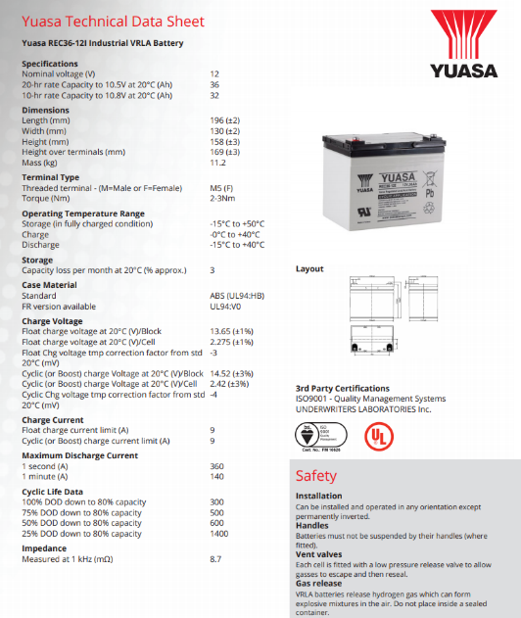

Figure 1: Yuasa REC36-12I Battery specification. (Yuasa.co.uk, 2019)
Using the Specification (Fig 1) of the battery, voltage of the battery and capacity is clear. For this particular battery the voltage is 12volts which can be paired and hooked in series to create a 24volt battery system. The specification also has the battery capacity in amp hours. In a 20-hour period and at 20°c, the battery exerts 36-amp hours. This means in a hour period, the battery can output 36 amps.

Battery Testing Methodology – Ashleigh Jones (1707088)

To define the batteries maximum capacity, a live test with the vehicle is conducted with simulated load. The two batteries is connected in series to combine to create 24volts. This is the desired voltage used to run the motor. At this moment of time the motor isn’t controlled using motor controller that varies the voltage or a PWM (Pulse with Modulation) controller to vary the motor on time with alternating voltage. The vehicle used a relay that is directly connected with the motor and a localised switch by the steering wheel. The vehicle is loaded on a roller type dyno to investigate voltage loss out of the battery under certain loads. A voltmeter in connected to the battery to record these results and the temperature is recorded to ensure that the battery temperature stays within a specific temperature of 20°C temperature to ensure a repeatable experiment.
Once ready the vehicle accelerates to maximum speed which is the desired race speed and load. Under certain time periods, the voltages are recorded for every 1 minute until 15 minutes of time has elapsed. Ideally the vehicle is to be tested under real world circumstances to further add load on the system from rolling resistance, air resistance etc. But the main aim of these tests is to identify the longevity of these particular batteries and to identify the voltage drop to also identify the battery usage these tests also highlight the need to implement battery saving strategies to enable maximum range of the green power vehicle.

Battery Testing Analysis – Ashleigh Jones (1707088)
By using the method specified above three tables are created to validate the results and gain a clear understanding of the voltage drop when the vehicle is a maximum speed.
Figure 2: Battery Usage Test at Full motor Speed
Time interval (Minute)) | voltage (v) | Motor Temp (°C)
0 | 26.1 | 9.3
1 | 24.4 | 8.2
2 | 24.3 | 15.8
3 | 24.2 | 24.4
4 | 24.2 | 36
5 | 24.2 | 40.9
6 | 24.2 | 42.1
7 | 24.1 | 43.4
8 | 23.8 | 44.7
9 | 23.6 | 46.3
10 | 23.6 | 47.6
11 | 23.6 | 48.2
12 | 23.5 | 49.1
13 | 22.8 | 50
14 | 22.6 | 50.8
15 | 22.6 | 51.5
By looking at the results from the battery usage at full motor speed, shows the voltages at certain time intervals and the temperature of the motor. The motor temperature was initially recorded for steady reasons to protect the equipment but is vital for the analysis of the battery usage. From the initial start-up the motor shows a slight decrease in battery resting voltage of 26.1 volts. As the motor generates heat, the load of the motor increases which intern increases the draw on the system which decreases the voltage supplied by the battery. As the system then increases towards the 50°C mark, the voltage has more draw causing a further battery draw. By converting this table into a line graph can further illustrate the battery draw at a certain motor temperature.

Figure 3: Line graph of the battery usage results.

Using the line graph can clearly show a correlation in the motor temperature and the voltage draw. This means that the motor has an ideal temperature efficiency range between 10°C and 42°C. To ensure battery longevity of the battery, the motor temperature needs to be controlled between this efficiency range.
Ultimately decreasing the battery voltage from 26.1 volts to 22.6 volts. This is a decrease of 13.4% of the of the battery voltage in a 15-minute timeframe. Looking at the specification of the battery (Fig1), shows that the lowest voltage the battery can become is 10.5volts per battery. For two batteries in a series configuration, the lowest voltage for the battery to be classes as discharged is 21 volts. This means that in the 15 minuets cycle the battery was depleted 70% of charge. If a prediction based on the results from this experiment based on the current voltage drop in a race environment would mean that the battery would be depleted in 21 minutes. Certain steps need to be made to ensure the longevity of the battery charge. Modifications by my colleagues can be used to combat the severe draw on the battery to ensure that the race is completed in its 60-minute time requirement.

Battery Efficiency techniques – Ashleigh Jones (1707088)
Due to the Greenpower race regulations for the formula24+, there is allot of factors that affect the choice of battery as well as what can be done to said battery to gain some efficiency. In the effort to ensure that the battery is as efficient as possible is mandatory to look at the regulations and identify the traits that can be exploited to ensure maximum energy retention. Looking at the regulation concerning the batteries, there is only one main factor that can be exploited. The first is concerning section T2.9 which states “The mains batteries in the vehicle at the start of the practice sections or the races will not exceed 25°C or ambient temperature plus five Celsius when ambient is above 20°C as measured by Greenpower.” (Greenpower.co.uk, 2019) Temperature management is being investigates by one of my colleagues but the battery temperature can be regulated at 25°C which is at its maximum permitted temperature. This is due to the fact that the battery efficiency the point at which the battery is at its most efficient point. Looking at the graph (fig 4) shows at 80°F (26°C) the efficiency of a lead-acid battery is 100%. This is evidence that proves that the battery is at its most efficient point at 25°C so the battery should be kept at this very temperature.
Figure 4: table shows the battery efficiency at certain temperatures
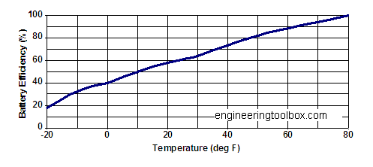
(Engineeringtoolbox.com, 2019)

Ensuring that the batteries are matched together is also vital. This is due to the fact that the if both cells are not balanced and one of the cells has a higher resting voltage than the other cell. The batteries in series would try to balance the voltage out and settle at a lower voltage. This is devastating is the goal is to have the maximum amount of capacity possible

Project Progression – Ashleigh Jones (1707088)
The group has been working on the project for some time and each member has a designate task to complete. Below is a Gantt chart showing the timeframe of each task to complete fully. This table composes of four tasks over a 30-week period. The majority of the time was devoted to the build of the vehicle and the testing of the vehicle. In the build everyone contributed their fair share of work assembling each component. Once the vehicle was complete, testing was done individually due to the verity of features that need to be investigated.
Figure 5: Gantt Chart of the project time plan


Conclusion – Ashleigh Jones (1707088)
If the regulation allowed for a battery to be selected, the lithium-ion battery would have been the first selection due to the high efficiency and high capacity but the regulation limit what battery can be used. By using the data revealed by the test revealed that the battery can be affected by the motor temperature drastically increasing its demand on the battery. This intern leaves the battery to have increased voltage draw which limits the batteries capacity drastically. Just in a 15-minute time period, 70% of the battery was used which would not have been ideal for the green power 60-minute race. By using the disguised battery longevity techniques like keeping the battery at a certain temperature not exceeding 25°C as per the green power regulations and ensuring that the battery cells are matched to ensure that both cells don’t draw off on another.

Battery efficiency is a small part in a much bigger machine, and it takes small modification to different aspect of the vehicle to make it more efficient. This is where my colleagues and their research come into play in making the green power vehicle more efficient combining efficiency in gearing, motor control, roll resistance, energy recovery and heat management. With all of the main factors investigated the vehicle can be developed and refined to ensure that the vehicle is as efficient as possible.

Introduction – Ben Coney 1703189
The aims and objectives of this section of the project are to investigate methods of which can be used as a form of energy recovery and heat management, whilst complying to the Greenpower rules. The aim of the investigation is to find the most suitable energy recovery system and the most suitable heat management system. Firstly, the timing plan for the project will be discussed, within this discussion the processes of which have been undertaken to complete the project will be shown using a Gannt chart. The investigation on the heat management and energy recovery systems will then begin and the and testing will be conducted in order to give an idea of what the temperature of the motor would be when running and the voltage usage that would be seen when under load. An evaluation on the project and the research should then be made, this should be done to outline how well the project went and how each member of the group took responsibility to the tasks in which they were given to complete. The advantages and disadvantages of how the group worked together will be discussed in this, along with what would have been done differently if the project was to be completed again in the future. The aims of the project evaluation are to discuss what went well and what didn’t go so well, along with how everyone in the group did their tasks and how they work as a team. The final section within this report would be to make a conclusion on the energy recovery systems and heat management systems that will be used. The aims for the conclusion are to produce a justification as to the choices of heat management system and the energy recovery systems that will be made within the investigation.
Timing Plan – Ben Coney 1703189





Figure 1 - Gantt Chart for Timing Plan

The above Gannt Chart (Fig. 1) was used to produce a timing plan for the project. The Gantt chart underlines the time allocated for each task, the tasks that were undertaken include, measuring the Greenpower car and reverse engineering the components on Solidworks, to create a CAD model of the car. The Building of the model also had an allocated time scale as each member of the group had to produce components for the model. The Research was the next task to have been allocated time along with the proposed testing for the Greenpower car. Each member of the group stuck to their allocated time frames and completed their tasks within the time allocated for each task. As an example, the time allocated for the measuring of the Greenpower car was between the 11/10/18 and the 01/05/19, this was a long period of time to complete the measurements of the car, however each member of the group completed this task within the first 3 weeks of the task being set, thus meaning that there was more time to complete the next task, which in this case was to reverse engineer the Greenpower car using the measurements that had previously been taken. The next task that was to be completed was to build a model of the Greenpower car on CAD, this was completed well within the allotted time frame. The Research was the final task for each member to complete, this was the largest of the tasks as there was a lot to investigate, within this report, the various methods of energy recovery and heat management for the Greenpower car will be discussed.

Work Carried Out and Research – Ben Coney 1703189
The work carried out within this project was to investigate the possible forms of energy recovery and heat management systems that can be used for the Greenpower car whilst complying with the 2018 regulations. The following testing was done to investigate the voltage usage and motor temperature of the Greenpower car under full load, the testing was conducted using a dynamometer, the results of the testing can be seen below (Fig.2)

Figure 2 – Illustrates the test results.

From the above table it is evident that as the time increases, the voltage decreases, thus showing that there is a large amount of voltage usage when the motor is under full load, to reduce the voltage usage overtime, energy recovery systems can be used. The table also shows that as the time increase so does the motor temperature. The temperature of the motor gets rather warm within the test period, due to this, it is evident that there is a need for a heat management system. The test results were then put into a graph to make a comparison between the voltage usage over time compared to the motor temperature (Fig. 3)

Figure 3 – Illustrates the comparison between motor temperature and voltage against time

From the above graph, it is evident that as time increases, the motor temperature increases rapidly, and the battery voltage decreases at a decent rate. From the graph is evident that within a short period of time, the motor temperature reached ambient temperature and increases further until its operational temperature. Due to the temperature increase it is evident that heat management is needed in order to keep the motor temperatures down and to reduce the chances of failure due to thermal fatigue. The methods for the heat management for this application will discussed further within this report. The voltage usage also shows the need for some form of energy recovery, this will also be discussed further within this report.

Energy Recovery
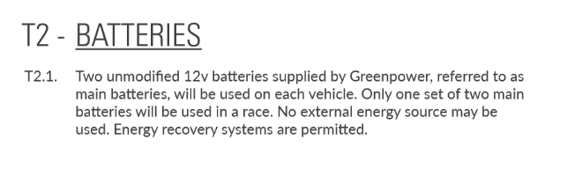
Figure 4 – Illustrates the battery regulations on the Greenpower car. (Greenpower Regulations 2018, n.d.)

Energy recovery systems are permitted for use within the 2018 Greenpower regulation (Fig.4) For this application, the options for energy recovery would be to either use a form of KERS (Kinetic Energy Recovery System) or to use a Thermal Energy Recovery system (TERS) (TERS: Thermal Energy Recovery Systems, n.d.), this form of energy recovery system coverts the waste thermal energy produced by the motor into kinetic energy. The heat being produced by the motor is wasted, if the wasted heat was utilised as a form of energy recovery, then the length of time of which the battery can remain at peak voltage. From the testing that had been conducted it is very clear that there is a need for a form of energy recovery system, with an energy recovery system, the rate of which the battery voltage decreases would not be as fast, with an energy recovery system, the voltage being used by the motor would be minimal as the heat energy being lost by the motor will be reused by the motor and thus prolonging battery life. The two options for energy recovery systems that could be used are KERS and TERS, from these methods the most suitable for the application would be Thermal Energy Recovery, this is due to the fact that the motor produces a substantial amount of heat whilst under load, this heat can thus be utilised as a form of energy recovery. The reasoning for using this form of energy recovery over the Kinetic Energy Recovery system is because KERS would utilise the energy that is wasted when the car is braking, however unlike in applications such as an F1 car, where they brake a lot whilst going around a circuit, the Greenpower cars do not really brake as they do not reach the speeds where they would need to brake. Due to this, it would not be suitable to utilise a Kinetic Energy Recovery system in this application.
Heat Management
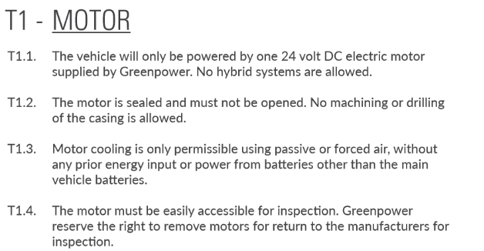
Figure 5 – Illustrates the motor regulations for the Greenpower car. (Greenpower Regulations 2018, n.d.)

Due to the Greenpower regulations (Fig.5) the methods for heat management that can be used within this application would be to produce heat transfer fins that can be bolted onto the motor, these fins create a larger surface area to allow for greater convection of heat. Within the regulations, it is permitted that the use of passive or forced air is allowed as a form of cooling, the cooling system must not use any prior energy input or power from batteries other than the main 12V batteries that are used to power the motor. Due to these regulations the use of cooling fans would not be permitted unless they were being powered by the main batteries, due to the nature of the Greenpower car, it would not be the best of decisions to use the main batteries as a power source for the cooling as it will drain the voltage of the batteries quicker than if they were only powering the motor. However, if a thermal energy recovery system was to be utilised as a form of power source for a cooling system then the power being used would not affect the voltage usage of the batteries, thus meaning that electronic cooling fans could be used for this application. However, due to the complexity of this system, the best form of heat management for the motor would be to use heat convection like stated previously. From the testing that had been conducted previously it is evident that the heat management system is needed, this is made evident by the Figure 3, from the graph it is evident that the temperature of the motor increases rapidly when under load, due to the increase in temperature the voltage draw also increases drastically, the operating temperature for the motor should be between 10 and 42°C, however, when testing, the motor reached a temperature of 52°C before the testing was stopped, if the motor was subjected to these temperatures for a long period of time, it could cause damage to the motor. The heat that is produced by the motor can be utilised as a from of energy recovery as stated above. The most suitable form of heat management would be to utilise heat transfer fins, these fins can be used alongside the energy recovery system to both keep the heat of the motor down and to recover the wasted thermal energy.

Evaluation – Ben Coney 1703189
The project went well on a whole, and each member worked well together as everyone was equal, however, due to this, no one was appointed as a group leader, this as would be expected caused for a few disadvantages. The main disadvantages were that no one took control of the group, however, the group all communicated well, and everyone did the research and testing that they had planned to do. The testing that was conducted could have been done better if the test was repeated as this would provide results with a higher accuracy. The testing of the motor and voltage usage should also be done from when the battery has full charge until it is flat as this would give an understanding on how long the charge can last when under a steady state, this would also allow for the peak temperature to be recorded, thus allowing for the size of the heat transfer fins that are needed for the application to be theoretically calculated, to ensure maximum efficiency when cooling the motor. Other than the testing, the investigation went well and there is not really a need to change what has been investigated or how the investigation was conducted. The group would however benefit from having a leader if the project was to be completed again, having someone as a leader would push each member to complete their tasks on time and to a good standard, as the team leader can take control of the situation.
Conclusion – Ben Coney 1703189
To conclude, the most suitable form of energy recovery system to use on the Greenpower car is to use a Thermal Energy Recovery System, this is because it complies with the Greenpower regulations and can be used alongside the Heat Management system, the most suitable heat management system for this application are the heat transfer fins, once again, this is due to them complying with the Greenpower regulations. When using both the heat management and the energy recovery systems alongside each other, the motor will run at a better operating temperature and the voltage usage will not be as high, thus meaning that the car will be able to travel over a longer distance with a singular charge. Due to the nature of the Greenpower championship being an endurance race, this would allow for the car to be more successful within the series of races. Due to the methods used for the energy recovery and heat management, the weight can be kept down as they would not need to be large systems to work effectively. The research has shown that the motor temperature has a direct effect on the voltage draw that the motor needs to work efficiently, however, in order to keep the motor temperatures down and at a good operating temperature, then the heat management system has a great importance, as it keeps the temperature down whilst not effecting the weight of the car or the voltage usage as this method of cooling system does not require any form of power source.
Introduction - Toby Marshall (1702692)
In this section the theories and practices around motor controlling, efficiency, current draw and power output. Different methods of motor controllers will be analyzed and evaluated against their performance when fitted to the system used on the Greenpower car. Improvement of efficiency of battery usage is the main objective of this report and the report aims to evaluate different solution to improve this. Drivability of the car is a key aspect due to the car being controlled by a driver and receiving a manual input from them, different methods to improve the input from the driver to the output of the motor will be covered. Motor temperature can be shown to coincide with the control of the motor output, therefore the effects of motor controlling, and motor temperature have been investigated to see were development can be introduced. The motor controlling investigation will also look in to the avoidance of motor snatch and current draw surge which at the moment present a large disadvantage to the performance of the Greenpower car.
The final section of this report will be split into to two sections; an evaluation of what went well and what didn’t go well throughout the project, then an evaluation of aspects of the report which could be improved if it was completed again differently.

Motor Controlling - Toby Marshall (1702692)
The Greenpower car uses a dc motor which draws 24v from two 12v batteries, this motor produces 240 watts of power and has a maximum speed of 2000rpm. The motor is current controlled currently by a 24v 100amp replay which switches the power to the motor from the batteries via a push to make button on the steering wheel. I have evaluated the current replay design so the control of the car could be evaluated in a whole allowing to proposals of steps forward to be made. The rely has a limit advantages; the replay is a cheap part which is easily replaced if one needs replacing, the part is simple therefore less susceptible to failure, the replay is also easily installed in the system due the simplicity of its design. The replay design carries many disadvantages which heavily affect the efficiency of the car. Due to the replay only supply the full current available from the battery when it is switch on has disadvantages on the system. This leads to a snatch engage of the motor which is harsh on the motor’s components and will eventually lead to lasting damage to the motor, this would be a problem especially during the race start. Also engaging the motor with full current hard takes a large surge current from the batteries, this can damage the batteries over time whilst also reducing the efficiency of the available power from the batteries during race. The large relay has a rather low efficiency when compared to other system of controlling the motor needing high current to operate again lowing the efficiency of the system. A switching replay which only provides maximum current voltage available can make driving the car slow difficult and inefficient due the motor being switched on and off to regulate speed. (Chipping Sodbury Greenpower, 2018) Another issue found during a rolling test of the Greenpower was that when the motor was ran with full current with load the motor overheated very quickly which decreases the power output of the motor and will damage the motor over time the results can be seen in the table below, being able to control the power output of the motor will help reduce the possibility of a overheat as the motor will not be constantly run at its maximum operating condition.
Time Interval (minuets) | Voltage | Motor Temperature (°c)
0 | 26 | 9.3
2 | 24.4 | 8.2
4 | 24.3 | 34.4
6 | 24.3 | 36
8 | 24.2 | 40.9
10 | 24.2 | 42.1
12 | 24.2 | 43.4
14 | 24.1 | 44.7
16 | 23.8 | 46.3
17 | 23.6 | 47.6
18 | 23.6 | 48.2
19 | 23.6 | 49.1
20 | 23.5 | 50
21 | 22.8 | 51.5
22 | 22.4 | 52.2
Figure 1- Table of results obtained from rolling test monitoring battery voltage and motor temperature
As mentioned above the use of a motor controller can be very beneficially to the efficacy of the green power car.’ Control of basic D.C machine is achieved by the controlling the current in the conductor, which is result done by variation of the voltage. A controllable voltage source is therefore a key element of motor drive’ (Austin Hughes, 2013) Controlling can be achieved by a variety of methods, each with their own advantages and disadvantages.
Controlling the motor can be done through the use of a variable resistor to limit current. This allows for the speed of the motor to be controlled for speed and gradual motor wind up avoiding snatch. Unless a variable resistor is operating at no resistance which is when the motor is receiving total battery voltage and current, the variable resister will create a resistance in the system to limit voltage to control the speed of the motor. For example, if the variable was to restrict the motor 50%(12v) then the loses from the resistor would be 50% of the current, the more resistance the bigger the loses. The low efficiency would dramatically affect the performance of the Greenpower car during a race, to make the Greenpower car as competitive as possible these loses to need to be reduced as much as possible. (Austin Hughes, 2013)
The Majority of Greenpower teams use a switching controller to control the power and speed of their motor. (4QD Electric Motor Control, 2019) A switching controller will not limit current instead a controller will deliver full current at variable time intervals which creates a mean power output. The motor can be operated without drawing high battery current when the motor speed demand is low, avoiding an initial high surge in battery current found with the original replay switch. (4QD Electric Motor Control, 2019) A switching controller works by switching the current on and off in milliseconds to achieve a mean power output by altering the dwell time between each off and on switch, this method of switching is known as pulse-width modulation (PWM). The advantage of PWM is no power is wasted meaning near 100% efficiency. (Austin Hughes, 2013)Efficiency is not 100% due to the motor controller placing a very small resistance in the circuit, however this resistance is negligible. (4QD Electric Motor Control, 2019) Pulsing voltage at high speeds allows for a smooth control of the motor. A controller specified for the vehicle where low voltage and current is be controlled tend to use a metal oxide semi-conductor field effect transistor (MOSFET), however bipolar junction transistor or an insulated gat bipolar transistor can also be used to pulse current to control a motor. A MOSFET is more suited to control the current of the Greenpower car, this is due to a MOSFET only needing a very low power to hold it in its on state. This is suited to the 24v system fitted on the Greenpower car where current will need to be limited to a low value when the car is being driven at low speed. (Austin Hughes, 2013)From the graphs provided by green power for the specification of the motor, the motor motors operating conditions can be evaluated (the graph can be seen below).
The graph shows the peek torque is achieved at 1800rpm, however the motor will run at its maximum rpm of 2000 if regulated by the replay and supplied with maximum battery power. The results from figure 1 shows that the motor overheated after only being run for 20 minutes, this means the motor would not last a whole race without overheating if constantly be provided with high battery current. If the stator current is over its rated value and the motor is allowed to run continuously it will overheat, small or medium motors don’t an overload protection normally a larger motor for the current is fitted however, the motor is specified and sealed by Greenpower, so this isn’t possible. (Austin Hughes, 2013) A motor controller will help protect the motor from overheating by being able to hold the motor at a rpm where it is at its peak torque (1800 rpm), thus not running the motor above its rated output therefore avoiding possibility of overheating the motor. A future test would allow for an analysis of motor temperature using a motor controller against its rpm to evaluate its likely hood to overheat whilst being run at high rpms. This will allow the motor to be regulated during a race as the output can be restricted to allow for cooling.
A motor controller needs accurate method of adjusting and operating motor speed, the key to effectually utilizing a motor controlling is to have an efficient method of switching the controller. The trend to control the motor is to use a hall effect which the controller processes the signal and limit the current accordingly. Another switch which can be used in tandem with a controller is a potentiometer similar to the hall effect sends a range of resistance to the controller for it to process, these switches can then be housed in a casing similar to a motorbike throttle or a pedal throttle, some hall effect motorbike style throttle are already available to buy from various manufactures. Motor controller are available to be purchased from two supply who have specialized them for use on Greenpower cars; the 4QD Porter 5/ Porter 10xxx which has proven success being fitted to previous winners (Chipping Sodbury Greenpower, 2018), the other controller is the GP speed which is a self-build controller however, this controller has additional capabilities if required including telemetry, battery testing and data logging. (4QD Electric Motor Control, 2019) Both controller use hall effect throttle to precisely control motor output. The GP speed capability to display telemetry to the driver could prove to be key in preserving battery voltage during a race to make sure the batteries are not flattered before the end of the race. The battery testing capability is of great gain as the batteries need to discharge and recharge to understand there dis-charge rate to increase the capacity of them, this controller will allow monitoring and availability to eb part of a test rig to drain the batteries in the same condition as a race. (Chipping Sodbury Greenpower, 2018) In conclusion a motor controller using a hall effect throttle will allow for finite control of power output and usage, the throttle allows easy operation for the driver and a smooth acceleration of the car from a race start or exit of a corner.

Discussion of Project Achievements - Toby Marshall (1702692)
The project can be split in two sections of how it was completed; Good aspects of the projects and aspects of the project which could have been completed better. The following sections were the main achievement of the group demonstrating how they were able to work together towards a common goal of improving the performance of a Greenpower car. The initial research was very productive with each member evaluating areas of car which could be developed this can be seen in figure 2. Each member then chose an area which showed particular interest to them and them completed secondary research to gain an understanding of car, Greenpower, regulation and chosen development. Each member worked really to achieve this, this was demonstrated in the initial research viva where each member showed confidence and knowledge in their area which was positively reviewed.
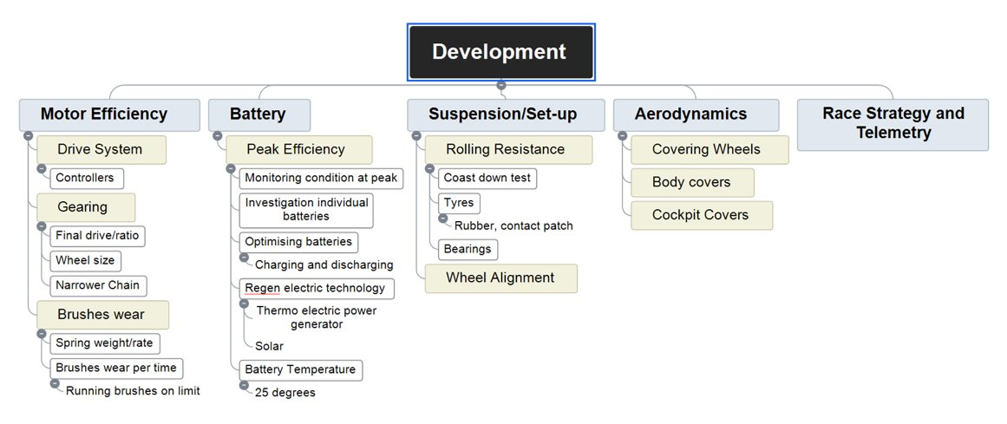
Figure 2-Map of Development Ideas
The assembly of the car was completed by each member of the group and other groups who were developing the Greenpower car as well. The group assembled the car to a high standard taking care to make sure parts were fitted correctly. Some members also spent additional time going through the car to check assembly was correct, tidying and improving the visual aspect of the car. Creating a CAD model of the car in Soildworks was a job taken on by the whole group, the group spent a large amount of time measuring parts them producing them in Soildworks. The group allocated times to each member to spread the job fairly them assemble ng all the part in on whole CAD model of the car. The group showed good communication and planning when completing this task. The group successfully created a Gantt charge to map the millstones in the project and set goals for items of work to be completed to help keep the group on track. Regular communication and team meeting occurred between members to make sure each member was okay with their aspects of the project and members were able to raise any issues or post progress. Testing was aspect of the project each member completed individually based on their secondary research. Each member was able create a testing plan and then use their results to evaluate the improve their area would have on the performance of the Greenpower.
The project did however have areas which could be been completed better to improve the overall achievement of the group. The group worked together as equals which meant everyone took on the same responsibility towards achieving goals and deadlines. However, no group leader was appointed, and this meant the group suffered disadvantages which of appointing a leader could have avoided. A leader would of benefited the group as it would of meant one person was in control of keep each member on track to reach deadlines and promote depth of work as these items were left tight on the timescale when completed by the members, a leader could of pushed the group to achieve goals above they had set by controlling completed work and organizing the group to meet and discuss advancements to the original proposal ideas. A leader would have also pushed regular team meeting were progress could be recorded as this was an issue through the second half of the project. Implicating ideas from secondary research was a particular week aspect from the group, in particular from Toby Marshall. It was not possible for all the ideas from the group to implicate there developments on to the car however certain developments researched could have been erected on the car if the secondary research was completed earlier. Toby research was completed very late in the project this meant that Toby was not able to use the theoretical information gathered to develop the car. If Toby’s research was completed earlier, Toby’s researched theory could have been applied to the car to gain extra primary research of the improvements. This would have allowed an evaluation of the improvements against the original car to show it would improve the car in a racing scenario. The time management was well prepared during the first of the project, during the second phase of the project the time management was not of the same quality. The time management was completely individual during the project. A common plan between members could have been structured better to improve everyone’s work, a more detailed Gantt chart was needed for the second phase of the project. This can be linked back the group working has a whole taking on an equal position without a team leader.
If the project was to be completed aspects could be completed differently which could be of improvement to the group project. A teamer leader should be appointed to control the group and make sure everyone is keeping deadline, completing work, communicating together and making sure the best quality of work the group is capable of is achieved. Time management should be changed; a thorough plan should be made with more smaller deadlines spread across the whole project. This would allow for tasks to not seem as large and means tasks are completed in plenty of time and not rushed. This also gives the opportunity for time to be allocated for further research, testing or study if the project required it. However, I feel the idea of the project and how there were investigated and researched was completed well by the group and this would not need to be changed if the project was to be completed again.
Conclusion- Toby Marshall (1702692)
The report has shown the importance of motor controlling of the Greenpower car and how accurate control of the motor can allow for key improvements of efficiency. A switching controller has proved to be the best option for improving the performance of the Greenpower car. A switching controller has shown to give the best increase of battery usage efficiency with it reaching near 100% efficiency. (Austin Hughes, 2013) A switching controller has the best parameters for allowing accurate control and input from a driver during a race and has important improvements of motor temperature control. The use of MOSFET has shown to be the best suited switching transistor due the relatively small voltage and current of the battery and motor system. (Austin Hughes, 2013) Future testing would allow validation of a motor controller to gain results to confirm the improvement of efficiency of the buttery usage and motor current draw.

Introduction - Dion Billing (1701657)
This section of the report will be dedicated to the drivetrain of the Greenpower car given. More specifically the gearing system of the vehicle. The report will aim to find the best possible gearing system that will work for the group within the budget decided that is fair under the circumstances. The current gearing system of the car will be spoken about along with how this system can be improved by staying relatively the same. It will also have the advantages and disadvantages of this gearing system.
The next section will be about the first suggestion and the most likely suggestion, which is the mechanical derailleur. The operation of the derailleur will be included along with how adjusting some components of the derailleur can favour the setup of the Greenpower car. Also included in this section will be the cost of implementing this system onto the car and if it works within budget or not, along with any tweaking of the chassis or components to allow this system to work and adhere to regulations. The advantages and disadvantages of the system will also be included.
The last suggestion will be an electronic derailleur. This section will be mainly comparing it to the mechanical derailleur in terms of complexity and the advantages and disadvantages of choosing this system over the first suggestion. The pricing of the system will also be included along with if it will work within the budget allocated.
The final section before the conclusion is about the project progression. This is about how the group kept track of their work, how the group kept in touch while working, spoke with their supervisor in meetings, and keeping minutes. It will also include suggestions on how and what the group would have done better if given a chance to start again.

Current Gearing System – Dion Billing (1701657)
On the Greenpower chassis currently, there is a single gear system or also known as fixed gear system implemented as given straight from the Greenpower Company in the box. This system is a relatively simple gear system and is used a lot on children’s bikes or bikes like BMX’s. The fixed gear system is a very simplistic system, the motor drives uses its electrical energy to rotate the motor sprocket which in turn rotates while a chain is sat on the teeth. From here the chain is linked to the second sprocket which is bolted onto the rear axle which drives one wheel while the other is sat on a bearing making the car one-wheel drive. The fixed gear system although it may either be lighter than other systems, it is very simplistic and allows the driver two modes of operation, nothing at all or full speed which isn’t ideal for the type of race the Greenpower Company hold. This system According to (Greenpower, 2019) the rear sprocket which attaches to the axle is a 72 sprocket and the motor sprocket has 12 teeth. This gives the gear ratio of 6:1. This ratio is a fixed ratio and isn’t very efficient in terms of the objective of the team trying to get the car as far as they can within the hour allocated by Greenpower.
Although this system is very simplistic and only offers one drive mode, you could change the gearing to suit the circuit in which the car will be racing. Some circuits will be tight cornering and small straights whereas some will be very basic where straight line speed is essential. Changing the gearing to suit the track will give you better race pace however it will not allow you to use the energy efficiently as it is all or nothing. Another disadvantage to this system is that if the circuit isn’t flat and has dips and hills in it the single gear system will struggle to tackle these issues unless it is geared correctly which is often the case. The single gear system is very easy to maintain according to (Evanscycles, 2016) the maintenance of the single speed is easy as you do not have a derailleur or cage to worry about all there is that could go wrong really is the chain which is very simple to fix. You also don’t lose efficiency due to the chain scrub when the gears are slightly offset like with a derailleur system as well as you do not get the added weight of the cassettes etc.

Mechanical Derailleur – Dion Billing (1701657)
What the group has discussed is to get the most out of the cars battery and motor, one of the ways of doing this was discussed and it was changing the gearing system on the car. One of the ways to do this is change from a single gearing system to a rear derailleur system. A rear derailleur system is most commonly seen on geared bicycles; however, it is believed that the system could be implemented into the Greenpower car.
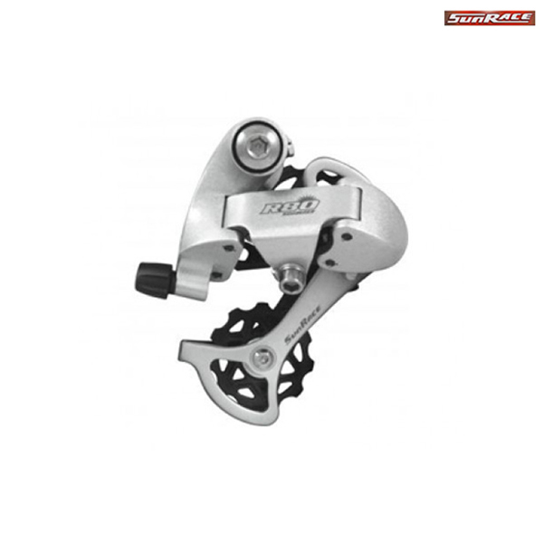
According to (Park Tool, 2017) the rear derailleur shifts the chain across the sprockets to the drivers’ gear of choice. On a bicycle it is mounted to the bike by bolting it to the derailleur hangar, however a design will have to made for the derailleur to fit onto the Greenpower vehicle. On the mechanical derailleur most have a cable running to a pinch bolt, this cable is there to move the cage inwards. The cage is a part of the derailleur where it tensions the belt from the gear cassette. If and when the cable is released there is a return spring pushing the derailleur in the opposite direction. When shifting through the gears on a bicycle usually there is a cable leading from the derailleur either by the side of the bike frame or even through the bike frame to the handle bars. There will be a shifter near the drivers’ fingers so they can change gear if and when required. Each gear change is predetermined by the manufactures to move the cable a set amount each gear change. However, this can be adjusted by slacking or tightening the barrel adjusters, this brings the G-clamp further inward or outward depending on which way you go. All this does is adjust the time it takes for the gear change to occur. Another adjustment that is available on the derailleur is the H and L screws. The ‘L’ Screw adjusts the innermost cage travel and the ‘H’ screw the opposite.
Figure 1 Gear Cage (SJS Cycles)
The derailleur system would be a rather complex system to fit, some changes would have to be done, and certain components would have to be redesigned to allow it to fit properly. Firstly, the gear cassette would have to be able to slide onto the 25.4mm that the car currently has fitted however, there are no regulations in the rulebook stipulating the axle diameter has a limit (Regulations, 2019). If it would be easier to change the axle to allow for the cassette to be fitted this would be done if the axle diameter is deemed safe enough to be used. From here a piece would have to be designed to allow the derailleur to sit safely near the axle to allow the gear changes to actually happen. From here the cable would have to be plumbed through the car in a manner that it doesn’t interfere with anything and so it doesn’t become too close to being worn down too quickly when used. The gear shifters would then have to be mounted somewhere where the driver can change quickly when required, which could be fitted onto the steering wheel. The only issue with this is the cable would be too long as the steering input could over stretch the cable and snap it. A better alternative is to mount it onto the chassis in the cockpit, which the regulations aren’t opposed to. The same would have to be done if the front derailleur were to be fitted. After a little bit of research, it was found that a team has already added a rear derailleur at Wolstanton High School in America. However, they have made adjustments to the chassis of the car to fit it, which is against the regulations apart from the formula 24+ category. Another team from the UK used a similar design however, there was one good idea picked up from their design, which was making their own gear shifter. Similar to a ride on lawn mower system they used a ratchet type system where they applied more and more tension on the cable changing up and down the gears by adding a return spring to the system for going back down the gears. The derailleur itself was found on a tubular piece of metal and it was sliding across when the gears were changing allowing the chain to be straight at all times. The small axle that the derailleur sits on is driven which rotates a much smaller gear at the end which is linked to the original 72 tooth sprocket which drives the single wheel. The video shows the speed getting up to 36 however this could be kph or mph as the picture was unclear (Burkett, 2016). The regulations do stipulate T11.7. The drive train must be guarded to prevent fingers, hair and clothing becoming trapped at any time (Regulations, 2019). This means that a new chain guard must be designed also to allow the gearing system to be legal when racing.
Looking at different systems for the gearing section of the vehicle and working within the budget set of £500, the gear cassette that was decided to be one of the best options was the Shimano XTR M9001 11 Speed MTB Cassette. This cassette costs £200. The teeth range from 11 to 40 teeth on this particular cassette, which is believed to be enough of a range to allow for peak performance at most stages of the race. At a weight of 331 grams, this cassette doesn’t add a lot of weight to the overall vehicle mass. (Chain reaction Cycles, 2019) recommend the 11-speed SIL-TEC chains to go with the cassette, which is priced at £35. This chain weighs only 243 grams, which is added to the weight saving of the cassette being a lightweight chain. The chain is at a width of 5.62 mm, which is believed to be strong enough for this application. The derailleur that works best with both these components is the Shimano SLX M7000 11 Speed Rear Derailleur. This derailleur can handle a maximum of 41 teeth, which works for the gearing of the cassette which max’s out at 40 teeth. The derailleur only weighs 323 grams, which once again minimises the weight added on by fitting it. According to (Chain reaction Cycles, 2019) the derailleur has all these added features; Shadow design with optimised, shallow slant angle, low profile design; 20% reduced shift effort, Chain stability improved, Improved driving and shifting stability, Adjustable clutch tension, High efficiency pulleys which are added bonuses and more of a reason to select this derailleur, priced at £70 it is also a relatively cheap option to help work within budget. With the remaining £200 in budget would go for materials for the new designs of the chain guard, the derailleur holder, the ratchet gear changing mechanism and the new axle if required.
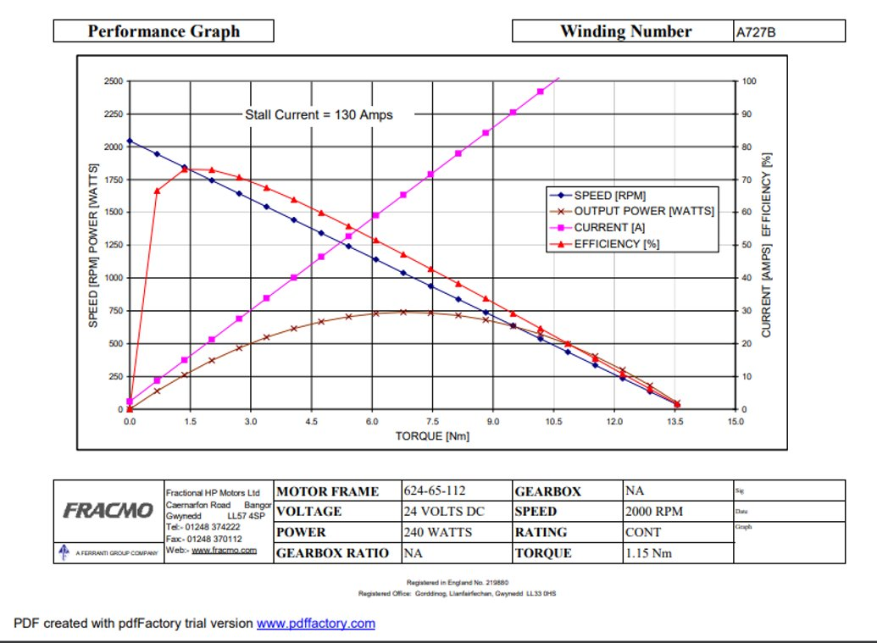
The group believe that the advantages of changing the mechanical derailleur system to the Greenpower car outweigh the disadvantages. The talking points of the meeting concurred that the derailleur does add variability in terms of speed and it allows the motor of the car to sit very close to where it works at its best. As you can see to the right, the dyno graph shows the motor working at its peak at 73% at 1800 rpm while reading 18 amps. The derailleur system will allow the motor to sit near this range allowing the team to maximise the potential of the motor. The ability to change gears also allows the driver to attack undulations on the course easier than the original systems due to the different gearing ratios available this also true for pick up after a tight corner or indeed the beginning of the race.
Figure 2 Motor Dyno Graph (GreenPower, n.d.)

Although the derailleur is beneficial for the vehicle, there are some downsides that are taken into consideration. One of them being the extra-added weight in total this system will add on 823 grams of weight which may not be a lot but could make all the difference. This is without adding the cables, the new gear shifter along with the new chain guard and the derailleur holder designs which will take the total added extra weight to over a kilogram easily. The amount of R&D required to make sure this system works well and efficiently will also cost money to the team as well as time that may not be had if any adjustments are required to be made. The gear changing time is also a disadvantage as it takes a small amount of time for the chain to move from one sprocket to another which doesn’t seem like a big issue however it does take time and eventually it will be had up into the seconds. You could also look at the serviceability of the system if an error occurs with this system it will take a lot longer to fix it compared to the original fixed gear system as there are more components which means more could go wrong.

Electronic Derailleur – Dion Billing (1701657)
For the further research on the gearing in the first presentation, it was noted that electric derailleurs would be researched and to see if, it would be worthwhile to fit one onto the Greenpower car. With an electrical derailleur, it is the same basic principle as the mechanical derailleur minus al the loose cable that comes with the mechanical side. According to (Evanscycles, 2018) the main improvement using the electronic derailleur is the shifting aspect of it. What is meant by this is that the gear changes occur quicker than the mechanical derailleur and you can also skip gears while using the electronic system. The fact that the derailleur is electronic allows you to use an app that allows you to see what gear you are in and also the battery life remaining in the derailleur.
According to (Regulations, 2019) Greenpower allow one PP3 battery or six AA coin batteries T2.2. After doing some research the PP3 battery hold 9v whereas the electronic derailleur battery is a Li-ion battery carrying 7.4v (Ribblecycles, 2019). This is believed to be acceptable as it produces less than the voltage of a pp3 battery. If this system were to be fitted, the battery only weighs 50 grams, which is not a lot of weight. The complete system will be lighter overall than the mechanical derailleur but not by much. However, there is a downside to the electronic derailleur if the group were to fit it onto the vehicle which is the cost of the system. The battery and the charger alone cost £185. The complete set which is called Shimano Ultegra 6870 Di2 Group set according to (Chain reaction Cycles, 2019) costs £2000 originally but is down to £850 due to clearance. The budget would have to be larger to allow the team top fit this system to the vehicle. Of course, the electronic derailleur brings with it several issues like how versatile is it in terms of different weather as the electrics could damage when raining also the maintenance of the electrics will cost more than the mechanical. The reliance of technology is also massive if they were to change to the electronic side because you can never predict when a component will go wrong where as in a mechanical derailleur you can visually inspect the cables etc.

Project Progression – Dion Billing (1701657)



The group has worked on the project for several months now. As you can see from the timing plan below. The project was split into 4 phases with one member of the group doing different things in each phase apart from measuring and building. For example in reverse engineering, Dion Billing (1701657) was working on solely the front-end suspension system, whereas Harrison Liddell (1700953) was working on miscellaneous items such as steering column etc. the build was done as a whole team and so was the measuring as they were measuring the whole car together. This timing plan allowed the group to stay on track with their work and see when the deadline was for each aspect of the job. To help keep track of the work carries out there were weekly meetings help with the supervisor and minutes were kept to keep track of the whole project.
Figure 3 Timing Plan

The research side of the project went very well as the whole group has found what they wanted to talk about and spoken about these things in a way that it is clear in which direction the group wants the build to go. The building of the vehicle also went well with the measuring tied into the building section the car was built within a week allowing more time for the reverse engineering section. The reverse engineering section the group could have performed better in terms of efficiency of work and also dedication towards the reverse engineering of the vehicle.
To improve the project in general the group should have been more dedicated to the cause. However, due to the lack of funding and support from the institution to allow testing and new parts coming in then it is believed the group would have more motivation and would have worked a lot harder to get the vehicle to the best it could have been within that budget. This could have maybe allowed the group to enter the competition to see how well their design would have done against other competition.

Conclusion – Dion Billing (1701657)
In conclusion, to this report it is found that the mechanical derailleur is the best suitable option for the Greenpower car given the budget allocated. It is also because the pros and cons of this system outweigh the original system along with the electronic derailleur. The group discussed the situation and all came to the same agreement. The original system was found to be too simple and would waste the motors energy too inefficiently. The electronic derailleur was simply out of budget as well as the weather aspect being in Britain would be too much of a risk. The mechanical derailleur seems to be a happy medium where the driver can change gear to suit the circuit while maximising the motors efficiency while running.
The project progression was discussed and evaluated by the group and the findings are that the group would have worked better if the budget was there and the institution allowed for work to be commenced on the vehicle. It is also believed the group would have worked a lot harder on the project if there was an end goal for a race or an event in which the car could enter and the team would have some sense of pride in the hard work they have done at the end of it all.

Introduction; - Harrison Liddell 1700953
In this section of the report, the Investigation of rolling resistance of the Greenpower vehicle will be discussed. Rolling resistance is a major factor when considering energy loss in a vehicle. Once a tire begins rolling, a portion of the mechanical energy produced to turn the when is converted to heat, therefore leaving less energy to tur the wheels. (Transport, 2009) during this report the discussion of how to reduce the effect of rolling resistance will also cover other forms of energy loss linked with rolling resistance. Factors such as Tyre compound, wheel materials, bearings and suspension geometry. Aspects such as tyre compound and wheel material will be theoretically investigated to decide if a suitable upgrade is possible to enhance the performance of the vehicle and reduce weight. Bearings shall be researched as they can provide a high frictional loss of energy if conventional, less effective bearings are used, an investigation to whether they can be improved shall be conducted. In regards to suspension geometry, a test was conducted to determine how different tyre pressures, camber and toe setups would affect the resistance. A simple pull test, which will be discussed in this report, was used to determine which setup would improve the vehicle. The results of this test will be displayed in the report. The aims of this project are to improve the base vehicle provided by Greenpower in order to make it more competitive. By making alterations to the vehicle where possible, the aim is to see successful performance gains.

Project Timing Plan; - Harrison Liddell 1700953




The Gantt chart shown above was used to plot out the entire process of the project into concise sections so they could be monitored closely to ensure that all tasks would be completed on time. The first stage of the project was to measure all relevant components of the vehicle. There was no immediate rush to complete the task as some components could be measured whilst attached to the vehicle, only certain components had to be measured prior to assembly. Although the end date for the task is 1/5/19, the task was completed sooner. With the measuring complete the next phase of the project was to reverse engineer the vehicle and design the components. The target for this was also set to the 11/10/19 as there was no immediate rush to complete the drawings. This allowed for modification to any of the drawings if necessary whilst the research and development was taking place. The task was completed on time and the necessary drawings and designs were brought together to create a full model. The next stage of the project was to assemble the vehicle. The deadline for this task was 12/11/18, The build process had to be completed quickly as the vehicle was required for testing in order to develop the vehicle further. The build process was completed over two days with the most of it going smoothly, however, one of the brake callipers had not been packaged therefore delayed the process and the testing of the vehicle. The chain guard that was supplied was the incorrect shape and fouled the driveshaft, meaning it had to be re-shaped and mounted differently to intended. The final stage was testing. The proposed test for rolling resistance was a pull test, this had to be completed by 31/03/19. This task was completed on time with the relevant data being collected successfully. To keep to the schedule set, weekly team meetings were held to discuss any progress made or future plans to complete tasks.

Work carried out and research - Harrison Liddell 1700953
For this section of the project, the areas that will be researched relate to decreasing the effect caused by rolling resistance. Tyre compound, wheel material, wheel bearings and suspension setup shall be investigated. The first area of research will focus on tyres.
The current tyres implemented on the Greenpower vehicle are conventional wire bead tyres. These tyres are cheap and cost effective, although do not provide the best performance. The tyre consist of a thin steel wire between the tyre and the rim of the wheel, which keeps the tyre in place. Because of this steel wire, there is extra weight and also less flexibility in the tyre. To upgrade the tyres of the vehicle, a Kevlar based tyre, folding bead, can be used in its place. These tyres are designed to be more flexible and lighter as the bead between the tyre and the rim of the wheel consists of a stiff fabric covered cord. (Tubbs, n.d.) By reducing the weight of the tyre, if only marginal, the benefit would be improved performance due to the wheel taking less energy to be rotated, creating less rolling resistance, this would also improve corner exit acceleration. The only disadvantage to folding bead tyres is cost, the typical cost, per tyre, is at least £20 more than standard wire bead tyres. This could potentially see the cost of tyres rising to between £80-£100 per set depending on quality and tread. Although the cost of the tyres is high, the benefit provided given the reduction of resistance is justified
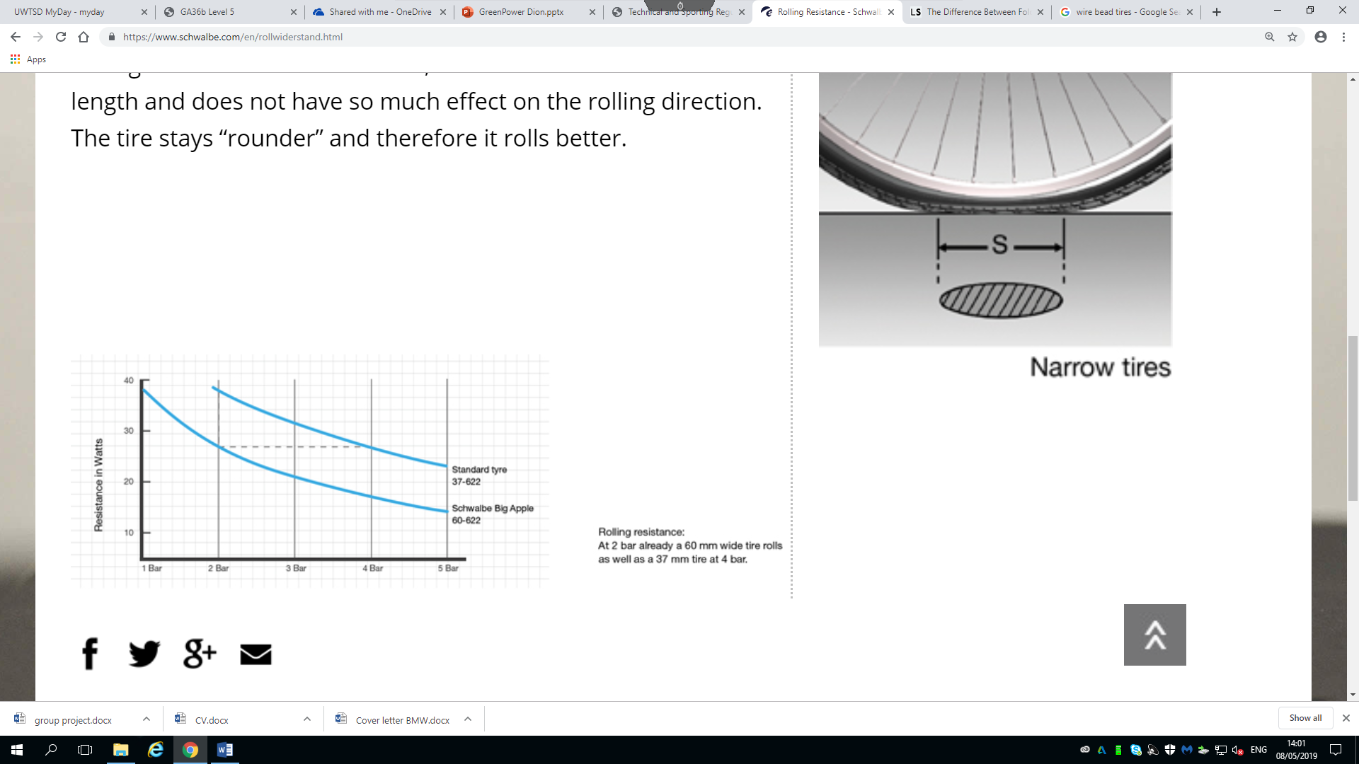
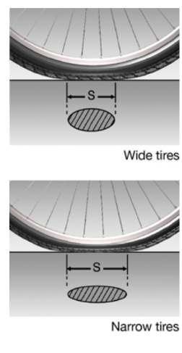
Along with improved tyre compound, the tyre size itself can also have an impact on the rolling resistance. By running a slightly wider tyre at the same pressure, the contact patch is essentially the same between a slim tyre and a wide tyre. The only difference is a wide tyres contact patch will appear wider and a slim tyre contact patch will appear longer, both however have the same contact patch. A wider tyre will benefit as it does not deform as much as a slim tyre during rotation, and will hold the original shape, whereas, a slim tyre will deform and take an oval shape. Due to this a wider tyre will retain its original shape and essentially roll better. As can be seen on the graph above, as the tyre pressure is raised the wider tyre produces far less resistance, with an 8-watt difference in resistance. By upgrading the tyre size, and reducing resistance, the performance of the vehicle will be enhanced.

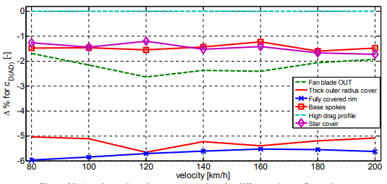
The next area of improvement that was investigated was the wheel material. The standard wheels provided by green power are 20-inch aluminium wheels, with stainless steel spokes, another factory option would be 16 inches, but for the purpose of this project, the 20 inch wheel was investigated. It was found that larger wheels increase air resistance but decrease rolling resistance, to combat this, covering the wheel completely produces the lowest amount of air resistance as it deflects oncoming air around the wheel, to improve and develop the wheel covers to reduce ventilation resistance, a wind tunnel simulation would be generated to determine if flat covers or patterned cover would benefit further. This would greatly improve the air resistance of the wheel and ultimately improve the vehicle.
(Vdovin, 2013)

The approximate weight per wheel is 1,880g (approximate as there can be imperfections in each wheel so will slightly differ) which totals as 7,502g for the entire set (Greenpower, 2017). This adds up to be an incredible amount of extra weight across the vehicle that potentially can be heavily reduced. An alternate choice of wheel design would be to switch to carbon fibre wheels. With an estimated weight of 1,360g per wheel, totalling at 5,440g, the reduction in weight accumulates to 2,062g (Zuus, n.d.). With such a drastic reduction in weight it would be an essential upgrade as it would improve acceleration performance and decrease resistance. Along with the benefit of weight saving the carbon fibre wheels also reduce air resistance as they are more aerodynamic that aluminium wheels, although to see these benefits the correct tyres would have to be selected. The carbon fibre wheels also have a higher stiffness rating than aluminium therefore will be stronger and more durable to fatigue ware as well as provide a more responsive nature. However, due to carbon fibre wheels being stiffer than aluminium, they do not bend and are more susceptible to damage from high impact crashes, meaning if one of the wheels is involved in a crash, the likelihood of repair is incredibly low. (Arthur, 2019) Another disadvantage to carbon fibre wheels is the high cost of them, typically a carbon fibre wheel is priced at £450 each, therefore costing £1,800 for a full set. The cost is extortionately high if the wheels were to be bought in from a supplier, however the university institution does possess the materials and equipment necessary to produce a set of these wheels, which would greatly reduce the cost of production given that the average cost of carbon fibre is £21.5 per Kg. (Roa & Kumar, 2018)



Another area of study into reducing rolling resistance was how to improve the bearings. The current bearings used on the vehicle are standard lubricated caged ball bearings. As the name suggests these bearings must be lubricated to function or else the rotational friction caused by the balls would cause the bearing to collapse and fail. These bearings work by housing a set of small balls in a cage around the rotational shaft, as the shaft rotates the balls rotate in the cage allowing free movement. These types of bearing are cost effective but less efficient as they can prematurely fail if not lubricated correctly as stated above. They also have a limited life span as they are usually a sealed unit therefore the lubrication cannot be re-applied once the part has been installed (Bearing, n.d.). There are two potential upgrades possible that were discovered during the investigation, the initial upgrade being polymer- based materials being used as cages rather than steel. These polymer-based cages have the ability to be self-lubricating. When tested the polymer based bearings tend to show almost zero wear when the lubricant transfer film is complete, therefore meaning the only ware imposed on the bearing is internal and caused by clearance issues between the balls. If the lubricant transfer film is partial then there is very small amounts of wear on the external cage. These types of bearings can also withstand high operation temperatures, up to 360 degrees, and provided higher load capacity at lower speeds (K & M, 2003). These types of bearing would greatly improve the vehicle as they have been proved to operate better at higher temperatures and also be more durable, meaning as a cost-effective solution, will need to be replaced less.
The second form of bearing research is a greaseless ball bearing. Using a similar design to the standard bearing, a set of balls are sat in a steel cage. The main difference is the need for lubrication. This is made possible by implementing small dimples on the inside of the cage, as can be seen in the example photo (Right). The effect caused by these small dimples means that as the balls pass the dimples, they marginally slow down and then speed up again. Because of this phenomenon, it makes the ball cage redundant therefore is no longer need, reducing friction commonly caused between the cage and balls. The dimples also aid with keeping the balls separated equally. As they rotate, some cycles will become unbalanced as the balls catch up to the one in front, if this occurs the deceleration of the first ball caused by the dimple will act as a break for the ball following and will return to normal, meaning the unbalancing is negligible and not noticeable. These type of bearings report up to 90% less friction than a standard caged bearing, meaning they can spin freely for a far more extended amount of time (Bearing, n.d.). Out of the two types investigated, the later would definitely benefit the vehicle grater as it offers a lightweight option, as it eliminates the cage, and also reduces frictional losses significantly. With also eliminating the need to apply grease to these bearings, their life expectancy is longer as there is less frictional ware imposed. Given their design is incredibly basic, the cost of these bearings is also expected to be lower. By implementing these bearings, a great decrease in resistance would be expected from wheel and motor bearings, all of which contribute to enhanced performance.

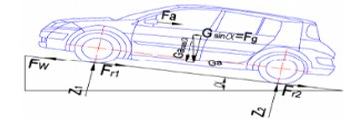
The final area of research was suspension setup and how it could be altered to decrease rolling resistance. To do this, camber, toe and tyre pressures will be analysed. The test originally proposed was a coast down test. The basis of a coast down test is simple, a vehicle is launched, with the engine ungeared, down a slope and the speed and travelled distance is recorded. By changing the tyre pressures in increments of 5psi, until the safe limit is reached, it is possible to determine what pressure is optimal (Preda, 2010). Unfortunately this test could not be completed as there were no viable areas local to conduct it, therefore a replacement test was conducted, a pull test. This was executed by using a newton measurement tool, in this case it was a lb/ft measurement tool, but the basis is the same. The test was conducted in an enclosed indoor space on even ground to ensure reputable results. The results from the test are listed below, note that the results recorded are with no driver;
Tyre pressure (PSI) | Force (lb/ft)
5 | 8
10 | 4.75
15 | 3
20 | 2.75
25 | 2.5
30 | 2
35 | 2
40 | 1.75
40 PSI with driver - 3lb/ft
Driver = 70.5KG

Given the Greenpower vehicle has a very basic suspension format, toe and camber adjustments are very minimal, and when measured proved to have unnoticeable effects on the rolling resistance, therefore, for the test conducted, was not necessary. However, when tyre pressures were altered, a noticeable change was found. Initially, with low tyre pressures, the vehicle was hard to pull and took a high amount of force to move. In comparison, when the tyre pressure is raised, the vehicle becomes easier to pull, 40Psi being the safe limit for the tyres tested, showed the lowest level of rolling resistance. If upgraded tyres were also available that can handle higher tyre pressure, then resistance would have been reduced further, although not considerably as the graph trails off and the rate of reduction is far less as the pressure is increased.

Project Evaluation; - Harrison Liddell 1700953
The project as a whole was successful flowed well in the group. The process of building and testing the vehicle were all carried out with professionally and with ease. By working together as a group and dividing roles accordingly on skills the dynamic meant tasks were completed promptly. How the CAD section of the project was handled could have been improved on as, although components were shared and a plan was devised for completion, the section was less focused by the group with other tasks taking more attention. The research and testing were thoroughly accomplished successfully and completed by all members and all areas that were initially mentioned had been covered. By holding weekly team meetings, the group ensured that all tasks were up to date and new research ideas were discussed to decide if they would be developed further and how other avenues of research could branch and connect with other members work. If more funding were available to the team and support from the institution to do more live testing, such as track / road testing, then group motivation and engagement would have been improved. By doing live testing it would have been an ideal opportunity to bring the group together to prepare the vehicle for race conditions, such as when the build process was in place, the group came together enthusiastically to complete the car and get involved. Given this has been an extensive project that has been continuously worked on over a number of months, the overall success has been very good with only minor setbacks during the entirety of the project.

Conclusion – Harrison Liddell 1700953
To conclude, in this section of the report it has been discovered that there are many pathways of improvement for the Greenpower vehicle in regard to reducing rolling resistance. All of the options discussed will provide a considerable upgrade to the vehicle with minimal work needed to make the upgrades work. The most cost effective and easy upgrade would be the bearings as they are incredibly simple in design and cheap to implement on the vehicle. Given the benefits that they would provide and frictional loss, it would be an ideal upgrade to allow the wheels to use less rotational energy and reduce rolling resistance. Although the carbon fibre wheels that were reviewed would provide an incredible weight saving, it would appear that at the current time, with the limited budget, to not be a viable and cost-effective option. Although this does not mean that wheel covers to improve air flow would be ruled out as these can be bought / produced cheaply and would still provide a benefit in reducing air resistance. Upgrading tyre compound to the folding bead would also be a viable option as they are not excessively expensive and do prove to increase performance by reducing rolling resistance.

Bibliography – Ashleigh Jones (1707088)

Greenpower.co.uk. (2019). GreenPower Technical and Supporting Regulations 2019. [online] Available at: https://www.greenpower.co.uk/sites/default/files/uploads/Technical%20and%20Sporting%20Regulations%202019%20V1.2.pdf [Accessed 3 May 2019].

Yoshio, M., Brodd, R. and Kozawa, A. (2010). Lithium-ion batteries. 1st ed. New York: Springer, p.143.

Ovshinsky, S., Fetcenko, M. and Ross, J. (1993). A Nickel Metal Hydride Battery for Electric Vehicles. Science, 260(5105), pp.176-181.

Engineeringtoolbox.com. (2019). Lead Acid Batteries. [online] Available at: https://www.engineeringtoolbox.com/lead-acid-battery-d_1544.html [Accessed 2 May 2019].

Yuasa.co.uk. (2019). REC36-12I - REC - VRLA - Cyclic Use - Industrial - Batteries. [online] Available at: https://www.yuasa.co.uk/batteries/industrial/rec-vrla-cyclic-use/rec36-12.html [Accessed 3 May 2019].

Engineeringtoolbox.com. (2019). Lead Acid Batteries. [online] Available at: https://www.engineeringtoolbox.com/lead-acid-battery-d_1544.html [Accessed 2 May 2019].

References – Ben Coney 1703189
Greenpower Regulations 2018. (n.d.). Retrieved from https://www.greenpower.co.uk/sites/default/files/uploads/Technical%20and%20Sporting%20Regulations%202019%20V1.pdf
TERS: Thermal Energy Recovery Systems. (n.d.). Retrieved from https://www.f1technical.net/forum/viewtopic.php?t=5751

References- Toby Marshall (1702695)
4QD Electric Motor Control, 2019. Greenpower. [Online]
Available at: https://www.4qd.co.uk/docs/greenpower/
[Accessed 28 03 2019].
Austin Hughes, B. D., 2013. Influence of Supply Voltage on Torque-Speed Curve. In: Electric Motor and Drives. Oxford: Newnons, p. 186.
Austin Hughes, B. D., 2013. Switching Control. In: Electric Motors and Drives. Oxford: Newnes, pp. 42-43.
Austin Hughes, B. D., 2013. Voltage Control - D.C. Output from D.C. Supply. In: Electric Motors and Drives . Oxford: Newnes, p. 41.
Chipping Sodbury Greenpower, 2018. Chipping Sodbury Greenpower. [Online]
Available at: http://www.greenpower.beamweb.co.uk/files/groups/electronics/GreenpowerElectronics/SpeedController.html
[Accessed 28 03 2019].

Bibliography – Dion Billing (1701657)
Burkett, C. (Director). (2016). Finished Gearing [Motion Picture].
Chain reaction Cycles. (2019). Chain reaction Cycles. Retrieved from Chain reaction Cycles: https://www.chainreactioncycles.com/shimano-xtr-m9001-11-speed-cassette/rp-prod171221
Evanscycles. (2016, Aprill 7). Why a singlespeed or fixie bike? Retrieved from Evanscycles: https://www.evanscycles.com/coffeestop/events/why-a-singlespeed-or-fixie-bike
Evanscycles. (2018, January 24). Mechanical vs Electronic Derailleur. Retrieved from Evanscycles: https://www.evanscycles.com/coffeestop/advice/electronic-vs-mechanical-groupsets
Greenpower. (2019, May 1). Greenpower Shop. Retrieved from Greenpower: https://www.greenpower.co.uk/product/252
GreenPower. (n.d.). GreenPower. Retrieved from Greenpower: https://www.greenpower.co.uk/
Park Tool. (2017, July 29). Park Tool. Retrieved from Park Tool: https://www.parktool.com/blog/repair-help/how-a-rear-derailleur-works
Regulations, G. (2019). Greenpower Technical Regulations. Retrieved from Greenpower Regulations: https://www.greenpower.co.uk/sites/default/files/uploads/Technical%20and%20Sporting%20Regulations%202019%20V1.2.pdf
Ribblecycles. (2019). Shimano Di2 internal fit battery. Retrieved from ribblecycles: https://www.ribblecycles.co.uk/shimano-di2-internal-fit-battery-7-4v/
SJS Cycles. (n.d.). SJS Cycles. Retrieved from SJS Cycles: https://www.sjscycles.co.uk/derailleurs-rear/sunrace-r86-8-speed-rear-derailleur-short-cage/

Bibliography – Harrison Liddell 1700953
Arthur, D. (2019, 04 03). road.cc. Retrieved from road.cc: https://road.cc/content/feature/171115-pros-and-cons-carbon-fibre-wheels
Bearing, I. (n.d.). INF Bearing. Retrieved from INF Bearing: http://www.infbearing.com/2018/01/18/greaseless-ball-bearings/​
Greenpower. (2017, 18 01). Greenpower inspiring engineers. Retrieved from Greenpower: https://www.greenpower.co.uk/node/401
K, S. T., & M, T. J. (2003). Parametric study of solid-lubricant composites as ball bearing cages. Risley : National centre of tribology.
Preda, I. (2010). Coast down test - theoretical and experimental approach . Brasov: University of Transilvania.
Roa, S., & Kumar, R. (2018). Carbon composites are becoming competitive and cost effective. Infosys Limited. Retrieved from https://www.infosys.com/engineering-services/white-papers/Documents/carbon-composites-cost-effective.pdf
Shwalbe. (n.d.). Shwalbe. Retrieved from Shwalbe : https://www.schwalbe.com/en/rollwiderstand.html
Transport, U. D. (2009). NHTSA. Virginia: NHTSA.
Tubbs, R. (n.d.). livestrong. Retrieved from livestrong: https://www.livestrong.com/article/118592-difference-between-folding-regular-bicycle-tires/
Vdovin, A. (2013). Investigation of aerodynamic resistance of rotating wheels on passenger cars. Gothenburg: Chalmers University of Technology.
Zuus. (n.d.). Zuus. Retrieved from Zuus: https://www.zuus.co.uk/zuus-pro-elite-sl-38mm-carbon-wide-disc-brake-ceramic-bearings-sapim-cx-ray-bladed-spokes/

