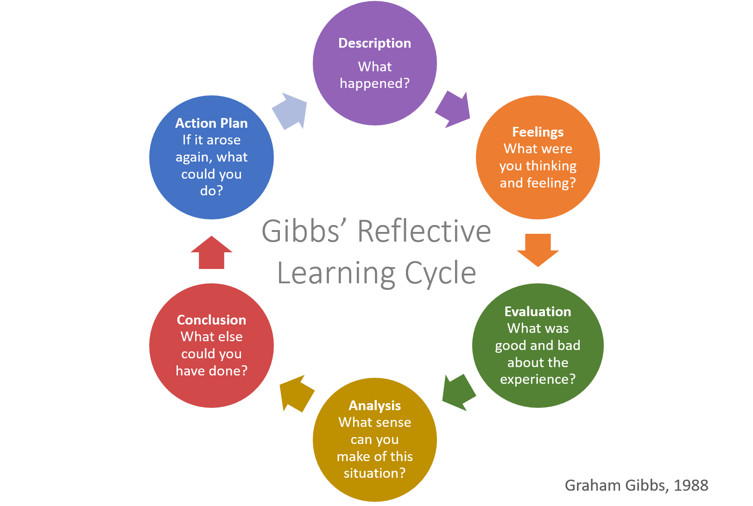

INTERNSHIP AND VOLUNTEERISM
BMSP5022

NATALIE GRIFFITHS
2316480

My Reflective Journal
My reflective journal on my internship and volunteerism, the university provided a supervised internship to develop experience of working in an orangisation. my placement was in Canolfan Carwyn which is a third sector organisation, this is a non-profit organisation that reinvest profits back into the community, it is associated with volunteering and community work it plays a crucial role in societal needs. It is not about making a profit but rather providing a service for the community. for my reflective journal I will be using Gibbs Reflective cycle, (Gibbs).
Before beginning my internship, I had to create a CV as I have not updated mine since my teenager years, I found this quite challenging at first but once I found my old CV I worked of that and done the alterations and made it more professional. My internship involved helping out with the warm space in the community hall, finding information on potential people that might want to use the warm space free of charge. On the days of the warm space, I would get the tea and coffees ready and interact with people that attended.
The community hall has also started a vinted paged with donations of clothes people have given them to help raise money to put back into the community hall. I was also asked to help another volunteer Zoe to go through the donations and upload the items on the vinted paged, this involved looking at the item of clothing making sure it was suitable to sell and taking photos of the items including the labels and any other imperfections and noted them in the description on vinted. When I was in Canolfan Carwyn for my daughters training I would also help out cleaning and sorting out the equipment cupboard and the essential’s cupboard, getting out any costumes that was needed. The only resources I was going to use at the community hall was their iPad for serving people that came into the community hall for the gym or for any groups of people that have booked to use their facilities.
Canolfan Carwyn had a community based easter funday, with a variety of food stalls and craft stalls, entertainment that everyone got involved with including demonstrations, animal handling to bouncy castles. like many volunteers I participated in helping out with this funday, my role was hiding the golden eggs throughout the day and putting out letters that spelt out a word the children had to find. I was manning a stall with another volunteer Zoe the money this stall made was going towards the Celtique Twirlers. The event was so successful the community really came together to support the event, the local police and fire brigade came allowing the children to sit in their vehicles and try on their equipment. On my break I walked around the stall holders and asked how it was going, all the feedback was positive. Looking back at this community based even there were a few issues that arise throughout the day, stickers on the tombola didn’t match up with the winning tickets, the lesson we learnt is to supervise the children when ticketing up prizes, we had also run out of £1 as people came with notes rather than change, we needed to have more £1 as a back-up. In an event based on children fun day maybe the stalls should be more children based, so when selecting stalls for an event suggest they bring children-based items rather than more mature items.
Leading up to the internship I started to feel really worried that I was unable to fit in my 90 hours alongside university twice a week and also my home life. I have my granddaughter twice a week to help out, my daughter has commitments three times a week with twirlers training as she is a Welsh athlete. I put my concerns to my lecture and was reassured that I could work around my commitments, as I was in the Canolfan Carwyn with my daughter I could also help out on them days.
When going through the donations for the vinted page was very time consuming but extremely rewarding, I felt like I have achieved something good in helping and giving back to the community. I was excited to be asked to help out in the easter funday, it was a long but fantastic day, I came away feeling happy.
Reflecting on my internship at Canolfan Carwyn, I can identify several key successes and challenges I aver come. I successfully updated my CV , this was a significant achievement. I initially found it challenging, but once I located my old CV, I was able to make the necessary alterations and present a more professional document. This prepared me for future job applications. My involvement in the warm space and the easter fun day were particularly rewarding, helping out, interacting with attendees. Managing the vinted page with Zoe allowed me to directly contribute to the community hall. Working along side Zoe was a valuable experience, collaborating on tasks like sorting donations, taught me the importance of teamwork and effective communication. My internship was a learning experience, it allowed me to develop my skills and overcome challenges.
Throughout my internship, the significance of thorough preparation and the ability to adapt to unforeseen circumstances became evident. For instance, the issue with mismatched tombola tickets during the Easter funday underscored the need for meticulous planning and supervision. Similarly, running out of £1 coins highlighted the importance of anticipating potential issues and having contingency plans. These experiences taught me that being well-prepared and adaptable is crucial in community work, where unexpected challenges can arise. The positive feedback from the community during the Easter funday and the success of the warm space initiative demonstrated the tangible impact of our efforts. Seeing the community come together and benefit from the services provided by Canolfan Carwyn was incredibly rewarding. It reinforced the importance of non-profit organizations in addressing societal needs and the value of volunteerism in making a difference.
Moving forward, I will ensure better preparation for events, anticipate potential issues, and continue to seek feedback to make improvements based on past experiences. These steps will help me contribute more effectively to community projects and enhance my professional skills.
For future events I will ensure detailed planning, including a check list and plans to anticipate potential issues. I will continue to seek feedback and identify areas for improvement. I will manage my time effectively to balance my commitments to university, home life, and volunteer work. This includes setting realistic goals and prioritising tasks.

References

Canolfan Carwyn Sports Facility, (2025). Welcome To Y Gampfa, Drefach.
Sports hall | Canolfan Carwyn Sports Centre | Drefach

Simply Psychology. (2025,). Gibbs Reflective Cycle. https://www.simplypsychology.org/gibbs-reflective-cycle.html

