April 19, 2023
Rhys Higgins (2110763)
UNIVERISTY OF WALES TRINITY ST DAVID (UWTSD)
WORD COUNT: 2500
Designing a Density Based
Traffic Light Controller using
Ultrasonic and PIR Sensor.
ACDA5002: ELECTRONICS I
Table of Contents

Introduction 2
Background Research 2
Similar Products 4
System Overview 4
Circuit Schematic 5
Flowchart 6
Code Listing 7
Main.c 7
Main.h 9
Required Components and Cost 11
Outcome 11
Further Development 11
References 12

Table of Figures

Figure 1. 5
Figure 2. 6
Figure 3. 9
Figure 4. 10
Figure 5. 11

Introduction

The proposal is to develop a density and timeslot-based traffic light system using wireless sensors to manage the flow of both pedestrian and road traffic at a 4-way crossroads. The proposal will consist of two components, a circuit schematic and software, which will be used in the Proteus Professional 8 application to simulate the operation of the circuit.
Traffic lights are signalling devices, which are used to control traffic flow at road junctions, pedestrian crossings, and intersections. Traffic lights are a universally recognised medium for controlling traffic, consisting of three colours: red; prohibiting traffic, amber; warning traffic to prepare to stop/go, and green; allowing the flow of traffic – all executed within fixed time slots [1] [2].
Whilst traffic lights are an effective means to control traffic flow, the use of fixed timeslots, as is common, to control traffic can lead to unnecessary delay through an inability to respond to ‘rush-hour’ traffic, alongside other external factors such as: RTAs (Road Traffic Accidents), pedestrians in distress, broken-down vehicles, and priority traffic (i.e., Emergency Services, VIPs) – leading to congestion in the proximity of the traffic light [3] [2].
The intent is to improve upon existing fixed and hard-coded traffic light systems [3] and develop a dynamic sensor-controlled timeslot for the operation of the traffic lights and crossings, rather than a fixed timeslot, which offers greater flexibility for the control of traffic in the vicinity of the junction. The use of dynamic timeslots for traffic management would ensure that the time spent waiting for both pedestrians and road traffic is reduced, preventing unnecessary congestion caused by the traffic lights and pedestrian crossings [2]. If all sensors are LOW, such as from dusk until dawn, the proposal will also implement a legacy ‘fallback’ mode, where fixed timeslots are used when no sensors are triggered, iterating through each of the traffic lights in a loop fashion.
The proposed circuit will use a combination of wireless sensors, both PIR (Proximity Infrared) and Ultrasonic, to control the pedestrian crossings and traffic lights - dependant on the density of the pedestrian traffic measured at each crossing and the detected vehicles waiting at each junction.

Background Research

The code for the proposal was developed in C. The decision to use C language, rather than using C++ or Python, was influenced by the deep level of hardware interaction available in C; having direct hardware control of the peripherals within the PIC MCU helps to remove abstraction present in higher-level languages, reducing the time requirement to develop working and efficient code [4].
Significant research was conducted into finding a suitable PIC16F/18F MCU (Microcontroller) which had enough I/O (Input and Output) Pins to be able to interface with the sensors, LEDs, and 7-segment LED displays. The PIC used would act as the workhorse of the circuit and handle all I/O, utilising the internal peripherals, enabling the circuit to respond to all inputs in a manner defined in the PICs programming. To successfully meet the target of the assignment, 26 Pins of digital I/O would be required, alongside 4 Pins of analogue inputs. All analogue inputs would come from the PIR sensors; 14 Pins of digital I/O would serve as individual outputs for the traffic light and pedestrian crossing LEDs; 8 Pins of digital outputs on their own 8-bit PORT for the 7-segment displays; The remaining 4 Pins of I/O would be used as inputs from the Ultrasonic sensors. Due to the volume of I/O Pins required, less complex/feature-rich PIC MCUs with only a few analogue and digital outputs, such as the PIC16F84A, could be ruled out.
As shown in Figure 1., the choice of MCU was narrowed down to the PIC16F877. This PIC is part of the PIC16F family and is an 8-bit RISC (Reduced Instruction Set Computer) Harvard-Architecture MCU with electronically erasable Flash Memory (denoted by the F following PIC16) [5]; electronically erasable flash memory is desirable for this application as it allows for easy-programming and subsequent modification of the program on the PIC using a suitable toolchain.
To ensure the C code was straightforward, the 8-bit PORTD of the PIC would be used for the 7-segment displays. Here a count down from decimal 10-0 (10, 9, 8, 7, etc.) could be implemented, triggered when a pedestrian crossing sensor value was over a given threshold. Typically, a single 7-segment display requires 7 digital I/O lines; a Hexadecimal, Binary, or Denary value is passed to the PORT to output a given number on the display (i.e., 0x40h would be ‘0’). Given the requirement for two 7-segment displays, a decision was made to use a 4-input BCD (Binary Coded Decimal) driver, allowing two displays to be driven from PORTD of the PIC. For this application, the CD4511BE latching Common-cathode driver was used. Essentially, this converts a 4-bit binary number into a decimal value to display on a 7-segment display, via an internal decoder [6]. Two of these could then be used on PORTD Pins RD0 – RD7 to display a 2-digit decimal number via two 7-segment displays, each driven by a separate CD4511 driver (see Figure 1). Alongside this, a separate digital input from the PIC is connected to the ‘BL’ input on both CD4511 ICs, to blank the displays when the pedestrian crossings are not triggered [6] [7].
As there would be 4 separate traffic lights, a total of 12 LEDs (Light Emitting Diodes), 4 for each 3 colours, would be required. To allow the circuit to be made on breadboard, TH (Through-Hole) LEDs and resistors would be used. As these would be driven by 5V TTL from the PIC, a 330Ω resistor is needed between the LED cathode and ground for current limiting [8].
Regarding the sensors for the traffic light system, the HC-SR-04 Ultrasonic sensor and AM312 PIR were selected. Both are inexpensive and commonly used in the Hobbyist space [9] [10]. The HC-SR04 sensor requires an analogue (Trigger) input and an analogue (Echo) output, along with a reference to +5VDC and Ground [11]. Here, the Trigger Pin could be supplied a 10uS TTL Pulse from an Output on the PIC, the Echo Pin used to return an analogue value to the PIC – where the distance of the object from the sensor could be calculated using the equation in Equation 1. As the HC-SR04 ultrasonic sensor provides a single analogue output on the Echo Pin, 4 channels of analogue inputs would be needed on the PIC for the required 4 sensors. For the PIC16F877, there are up-to 8 analogue inputs available between 6-bit PORTA (AN0 – AN4) and 3-bit PORTE (AN5 – AN7) [12]; PORTA Pins AN0 to AN4 mapped as analogue inputs on the PIC, during the Project Wizard setup in CCS PIC C Compiler.
The AM312 sensor is a 2-input sensor (+3-12VDC, GND) with a single 3.3V digital output [13]. Akin to the HC-SR04, it is low cost and well documented, therefore suitable for a proof-of-concept implementation – where a more robust (and more capable) sensor could be used in a real-world application.
$$Distance=\frac{Speed*Time}{2}$$
Equation 1.
HC-SR04 Distance Equation

Similar Products

Due to the proliferation of traffic light systems, numerous other solutions have been developed regarding the automation of traffic lights via a density-based or dynamic time slot system – others have also identified and attempted to address the issue of traffic congestion related to fixed time slot traffic light signals. The solutions having been developed both by industry/commercial and hobbyists, shared via internet blog posts.
Commonly, hobbyist solutions are developed around open-source hardware such as the Arduino Platform. One solution found uses four IR sensors to monitor the density of vehicles passing each traffic light, adjusting the time slot of the lights (ratio of time green to red), in respect to the other traffic lights at the junction, based on the density of traffic [14]. Limitations of this system are that it is designed for road traffic only and does not account for pedestrian traffic.
Commercial enterprises, like Wireless, have also developed density-based traffic light and pedestrian crossing solutions. These implementations use technology and tools including AI and wide-angle cameras to monitor traffic crossings and tailor the duration of each traffic light – based on the density of pedestrians and road traffic waiting at each crossing [15]. Essentially, this is a completely variable density-based traffic control system. Whilst this will undoubtedly be an effective solution, the use of AI and multiple wide-angle cameras far exceeds the capabilities of a MCU like a PIC. Other commercial enterprise has experimented with LiDAR technology, combined with AI, and have taken a pedestrian-centric approach to managing traffic crossings, focusing on lowering CO2 emissions, and enabling longer pedestrian crossing times – helpful to those who require longer to safely cross [16]. Unfortunately, this is beyond the typical capabilities of PIC16F/18F MCU.

System Overview

As shown by the code listing in in Figure 3., the system functions in an automated manner when there is no signal received from both the PIR and Ultrasonic sensors, running through an idle fixed-time slot-based routine where the traffic lights cycle between each crossing and the pedestrian crossing light remain red.
When the analogue pin connected to the Ultrasonic sensor exceeded the pre-defined threshold value of 127 (0-255), the system switches the respective traffic signal to green; achieved through the digital output of the PIR set to a logic HIGH (TTL +5V), pulling the connected digital input to HIGH on the PIC. When the received signal on the respective analogue pin is below the threshold value of 127, the light then will turn to red. This is implemented for all four crossings and is an example of a density-based system, the value returned by the ultrasonic sensor indicating the number of vehicles waiting.
Similarly, with the pedestrian crossing, if any of the Ultrasonic sensors are triggered, all lights changed from red to green to allow pedestrians to cross. A countdown timer from decimal ‘10’ to decimal ‘0’ is displayed on the 7-segment displays during the crossing sequence. As a safety-feature, if the PIR sensors detect pedestrians remaining on the crossing post-countdown, all lights are maintained as red until the digital pin connected to the PIR is a logic LOW, meaning no pedestrians are using the crossing.

Circuit Schematic

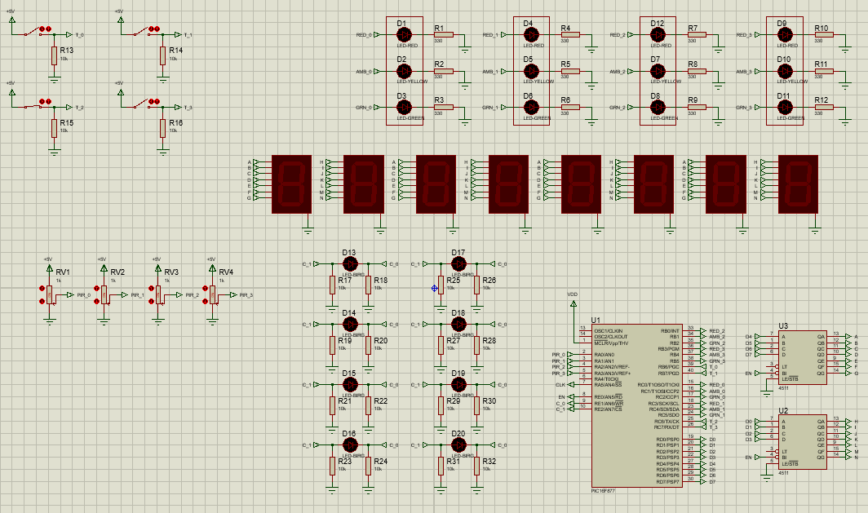
Figure 1.
Circuit Schematic in Proteus

Flowchart

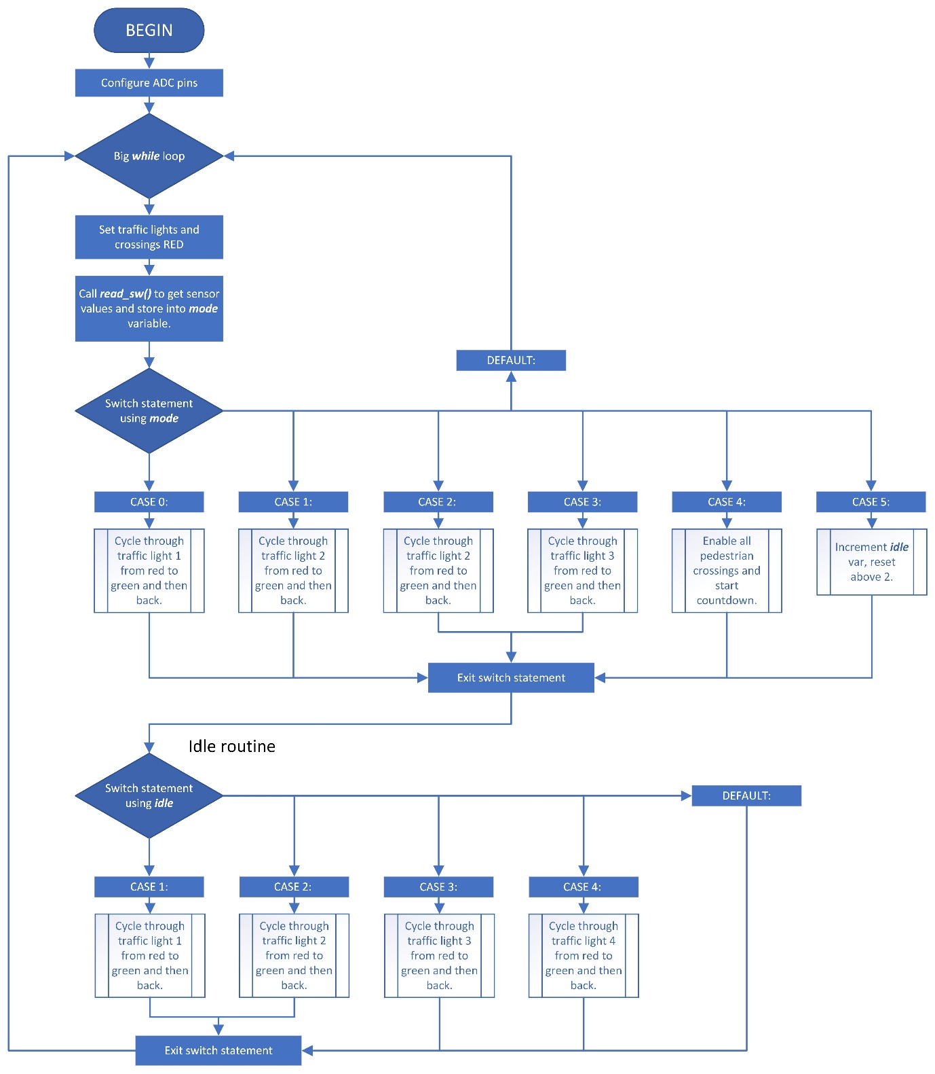
Figure 2.
Program Flow Chart

Code Listing

Main.c

#include <main.h>
void main(){
setup_adc_ports(AN0_AN1_AN2_AN3_AN4); //config ADC for pins A0,A1,A2,A3,A4 (run once)
setup_adc(ADC_CLOCK_INTERNAL);
while(TRUE){ //stay in here.
set_red(); //set all lights red.
walk_leds(0); //set all crossings to red.
mode = read_sw(); //store sensor state into mode.
switch(mode){ //sensor-controlled traffic lights and crossings.
case 0: traffic_lights(0,1,2); //run through L1.
break;
case 1: traffic_lights(3,4,5); //run through L2.
break;
case 2: traffic_lights(6,7,8); //run through L3.
break;
case 3: traffic_lights(9,10,11); //run through L4.
break;
case 4: lcd_count(); //run through traffic lights.
break;
case 5: idle++; //increment idle.
if(idle > 4){idle = 0;} //if idle is larger than 2 reset idle var to 0.
default: break;
}
switch(idle){ //idle routine for traffic lights.
case 1: traffic_lights(0,1,2); //run through L1.
break;
case 2: traffic_lights(3,4,5); //run through L2.
break;
case 3: traffic_lights(6,7,8); //run through L3.
break;
case 4: traffic_lights(9,10,11); //run through L4.
default: break;
}
}
}
void lcd_count(){
walk_leds(1); //set crossing lights green.
output_HIGH(EN); //turn on 7 segment display.
output_d(16); //display 10 on 7 segments
for(int i = 0; i < 10; i++){delay_ms(100); output_d(lcd[i]);} //count down from 9 - 0
check_for_walkers(); //check button pressed.
output_LOW(EN); //turn off 7 segment display.
}
void walk_leds(int set){
if(set == 1){ //turn pedestrian lights green
output_HIGH(GRN); output_LOW(RED);
}
else{ //turn pedestrian lights red
output_LOW(GRN); output_HIGH(RED);
}
}
void traffic_lights(int a,int b,int c){ //cycle from RED to GREEN and then back to RED
output_HIGH(pins[b]); //turn on amber.
delay_ms(100);
output_LOW(pins[a]); //turn off red.
output_LOW(pins[b]); //turn off amber.
output_HIGH(pins[c]); //turn on green.
delay_ms(700);
output_LOW(pins[c]); //turn off green.
output_HIGH(pins[b]); //turn on amber.
delay_ms(300);
output_LOW(pins[b]); //turn off amber.
output_HIGH(pins[a]); //turn on red.
delay_ms(100);
}
int get_adc(int num){ //read adc value of selected channel.
int adc; //local variable to store adc value.
set_adc_channel(num); //select adc channel to read.
delay_us(10);
adc = read_adc(); //read adc value and store into temp var.
return adc; //return read value from adc channel.
}

int read_sw(){ //read all sensor values and return active sensor.
pot0 = get_adc(0); //read Ultrasonic0
pot1 = get_adc(1); //read Ultrasonic1
pot2 = get_adc(2); //read Ultrasonic2
pot3 = get_adc(3); //read Ultrasonic3
if(pot0 > 127){return 0;}
if(pot1 > 127){return 1;}
if(pot2 > 127){return 2;}
if(pot3 > 127){return 3;}
if(input(T_0) || input(T_1) || input(T_2) || input(T_2)){return 4;} //if any button high, return 4.
else{return 5;}
}
Figure 3.
Code listing for Main.c

Main.h

#include <16F877.h>
#device ADC=8

#FUSES BROWNOUT //Reset when brownout detected
#FUSES LVP //Low Voltage Programming on B3(PIC16) or B5(PIC18)
#FUSES NOPROTECT //Code not protected from reading

//definitions
#define T_0 PIN_B6 //PIR SENSORs
#define T_1 PIN_B7
#define T_2 PIN_C6
#define T_3 PIN_C7
#define EN PIN_E0 //7-segment enable/disable pin.
#define RED PIN_E1 //LEDs
#define GRN PIN_E2

//globals
int pins[] = {56,57,58,59,60,61,48,49,50,51,52,53}; //array for traffic pins.
int lcd[] = {9,8,7,6,5,4,3,2,1,0}; //array for 7seg BCD count.
int pot0,pot1,pot2,pot3; //variables to store pot values.
unsigned int mode = 0, idle = 0;

//function prototypes
int get_adc(int); //pass in int to select adc channel and return.
int read_sw(); //read sensor state.
void traffic_lights(int,int,int); //traffic light output.
void check_for_walkers(); //check pot values.
void lcd_count(); //count down from 10 to 0.
void walk_leds(int); //turn pedestrian lights red/green.

//inline functions
void set_red(){output_c(9); output_b(9);} //set traffic lights red.
void check_for_walkers(){while(input(T_0) || input(T_1) || input(T_1) || input(T_3));} /*while any button pressed, stay in while loop*/

#use delay(crystal=8MHz)
Figure 4.
Code listing for Main.h

Required Components and Cost

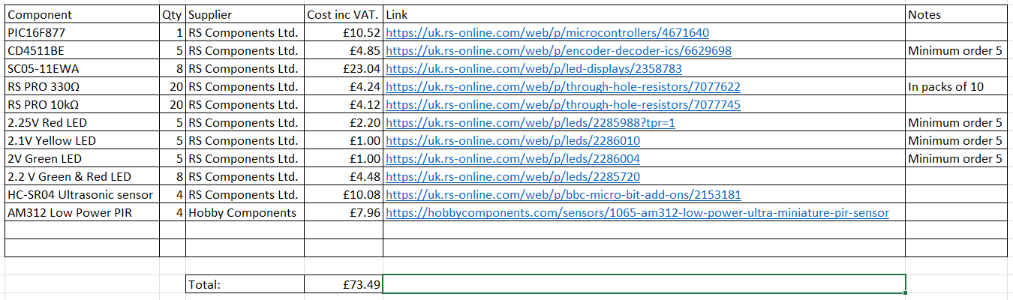
Figure 5.
Component type, qty, supplier and cost

Outcome

Through testing using Proteus VSM (Virtual System Modelling), the C-language code and circuit schematic inter-operated properly – with the core functionality working fully and as desired.
However, due a software issue with the 8.14 SP3 version of Proteus 8, external libraries for the PIR sensor (AM312) and Ultrasonic Sensor (HC-SR04) could not be used due to numerous bugs in their implementation.
As a workaround, an ADC was used in place of the ultrasonic sensors, with the ADC value simulating that which would be returned by the HC-SR04 sensor on the Echo Pin [4]. Also, as the PIR sensor returns a Logic HIGH when triggered [13], these could be simulated using a simple push-button switch referenced to 5V when closed, a pull-down resistor used when the switch is open – shown in the schematic in Figure 1.
When testing, all the ultrasonic sensors where triggered, raising each above the threshold value would turn the respective light to green, falling below this (i.e., as traffic is no longer waiting) turns the light back to red. Triggering the PIR sensor would also enable the pedestrian crossing and begin a countdown from “10” to “0” on the 8 BCD (Binary Coded Decimal) 7 segment displays. Leaving one (or more) of the PIR sensors high, keeps all the traffic lights red and the pedestrian crossings green. Once the PIRs are no longer high, road traffic flows normally; when no sensors were triggered, the traffic lights followed an automated fixed time slot routine – as intended.
Finally shown in Figure 5., the total cost of the system components would be £73.49, the solution could be easily implemented on a breadboard and then developed into a PCB.

Further Development

To develop the concept further, and improve the effectiveness and responsiveness of the system, both PIR and Ultrasonic sensors could be replaced with items with greater range – as the respective 3000mm and 4000mm ranges of the AM312 and HC-SR04 sensors [9] [13] do limit their effectiveness in this application for gauging speed and distance. Especially true as the length of even a small car (2012 Volkswagen Up!) is 3600mm [17] – close to the entire range of the HC-SR04 sensor. Developing on this, utilising ultrasonic sensors with a greater range would allow the system to accurately determine the speed of incoming traffic from all directions. A threshold value could be stored in a variable to determine whether a car is likely to stop or run a red light. From this, the system could react by setting the pedestrian crossing and traffic lights red and then emitting a clearly audible alert (from a loudspeaker or buzzer) alerting pedestrians and other road users of the impending danger. As a matter of fact, vehicles failing to stop is a common and dangerous occurrence; in the year 2003, incidents involved red-light-running (vehicles failing to stop at a red light) exceeded 260,000 in the USA, with over 700 fatalities as a result [18]. Including this feature like this in the traffic light system could have a net positive impact on read safety.
Additionally, another factor to consider is the addition of another form of wireless communication to the proposal to aid emergency traffic. Currently, in most fixed time slot traffic light systems, emergency traffic is unrecognised and not given priority by the traffic light system. Instead, priority to emergency traffic given at the discretion of other road users, leading to longer response times for emergency traffic and putting lives at risk – where in Ireland 700 fatalities are averaged annually due to late ambulance responses [19]. Therefore, a system which could recognise emergency traffic via an integrated sensor [20], such a GPS module, or RFID module could ensure that emergency traffic is prioritised by the traffic light system in advance – so that emergency traffic does not have to stop at the traffic lights, enabling a quicker response time.
Regarding pedestrian safety, using ultrasonic sensors alongside PIR sensors for the pedestrian crossings would allow for measurement of the pedestrians’ position and speed on the crossings, with the intent to avoid car-to-pedestrian contact. Car to pedestrian contact is a major issue, accounting for 1714 (or 35%) of all fatalities (in Japan 2010) involved in road accidents [21]. This system could also be tied into the system for vehicles failing to stop or red light running [18], creating a safety-net for pedestrians where every step is taken to avoid car-to-pedestrian contact – even in the event of the traffic light system being misused.
Finally, another avenue to explore would be the translation of the circuit to physical hardware. Here, the previously discussed limitations of the Proteus Software could be avoided, and the AM312 and HC-SR04 sensors used in the circuit and testing could be carried out at a reduced scale (i.e., using toy cars for scale) – allowing the system to be tested in a manner which reflects real world usage. The costs of this would be those shown in Figure 5., as well as the cost of a PCB.

References

[1] DfT., “The Highway Code, Light signals controlling traffic”, Department for Transport, 2015. Accessed: 28th March 2023. [Online] Available: https://assets.publishing.service.gov.uk/media/560aa3f9e5274a036900001c/the-highway-code-light-signals-controlling-traffic.pdf
[2] B. Ghazal, K. ElKhatib, K. Chahine, and M. Kherfan, “Smart traffic light control system”, IEEE, 2016, pp. 140–145, doi: 10.1109/EECEA.2016.7470780. Accessed: 30th March 2023 [Online] Available: https://ieeexplore.ieee.org/abstract/document/7470780

[3] A. Goel, S. Ray, and N. Chandra, “Intelligent Traffic Light System to Prioritized Emergency Purpose Vehicles Based on Wireless Sensor Network” in International Journal of Computer Applications, vol. 40, no. 12, pp. 36–39, Jan. 2012, doi: 10.5120/5019-7352. Accessed: 30th March 2023 [Online] Available: https://www.researchgate.net/profile/Sukanya-Ray/publication/258650947_Intelligent_Traffic_Light_System_to_Prioritized_Emergency_Purpose_Vehicles_Based_on_Wireless_Sensor_Network/links/573eae2b08aea45ee842f177/Intelligent-Traffic-Light-System-to-Prioritized-Emergency-Purpose-Vehicles-Based-on-Wireless-Sensor-Network.pdf
[4] Barr M., “The Least Common Denominator” in Programming Embedded Systems in C and C++, O’Reilly Media Inc, 1999. pp 9-10. Accessed: 30th March 2023 [Online] Available: https://books.google.co.uk/books?id=a2Q6U0b36rMC&lpg=PR11&ots=YjsQioIhRh&dq=c%20programming%20embedded%20systems&lr&pg=PA18#v=onepage&q=c%20programming%20embedded%20systems&f=false
[5] N. Agnihotri., “PIC Microcontroller: All You Need To Know”, Engineers Garage. https://www.engineersgarage.com/pic-microcontroller-all-you-need-to-know/ [Accessed 27th March 2023]
[6] https://www.ti.com/lit/ds/symlink/cd4511b.pdf [Accessed 28th March 2023]
[7] Unknown., “CD4511be: Pinout, Application, Features, Operation of the Decoder Driver”, OurPCB. https://www.ourpcb.com/cd4511be.html [Accessed 28th March 2023]
[8] Unknown., “Current Limiting Resistor: Protective Resistor for Regulating Current”, OurPCB. https://www.ourpcb.com/current-limitings-resistor.html [Accessed 28th March 2023]
[9] Unknown., “How HC-SR04 Ultrasonic Sensor Works & Interface It With Arduino”, Last Night Engineers. https://lastminuteengineers.com/arduino-sr04-ultrasonic-sensor-tutorial/#google_vignette [Accessed 28th March 2023]
[10] Unknown., “AS312 (AM312) Mini PIR module review”, Unusual Electronics. https://unusualelectronics.co.uk/as312-am312-mini-pir-module-review/ [Accessed 28th March 2023]
[11] Unknown., “Complete Guide for Ultrasonic Sensor HC-SR04 with Arduino”, Random Nerd Tutorials. https://randomnerdtutorials.com/complete-guide-for-ultrasonic-sensor-hc-sr04/ [Accessed 28th March 2023]
[12] Microchip., “PIC16F87X Data Sheet”, Microchip Technology Incorporated, 2001. Accessed: 29th March 2023 [Online] Available: https://ww1.microchip.com/downloads/en/DeviceDoc/30292c.pdf
[13] Unknown., “AM312 Low Power Ultra-Miniature PIR Sensor”, Hobby Electronics. https://hobbycomponents.com/sensors/1065-am312-low-power-ultra-miniature-pir-sensor [Accessed 28th March 2023]
[14] S. Mehta, “Motion Based Traffic Control System Using Arduino”¸ Medium.com. https://stutimehta9.medium.com/motion-based-traffic-control-system-using-arduino-e3d8f6ac0663 [Accessed: 4th April 2023]
[15] K. Ahuja, “SMART TRAFFIC LIGHTS SIGNAL FEWER STOPS FOR MOTORISTS”, Sunday Times Driving, 2021. https://www.driving.co.uk/news/roads/smart-traffic-lights-fewer-stops-motorists/ [Accessed: 5th April 2023]
[16] Unknown., “Smart traffic light technology controlled using Artificial Intelligence”, Innovation News Network, 2022. https://www.innovationnewsnetwork.com/smart-traffic-light-technology-controlled-using-artificial-intelligence/17869/ [Accessed: 5th April 2023]
[17] Unknown., “Volkswagen Up (2012 onwards) Specs & Dimensions”, Parkers.co.uk https://www.parkers.co.uk/volkswagen/up/hatchback-2012/specs/ [Accessed March 28th, 2023]
[18] Bonneson, James; Zimmerman, Karl and Quiroga, Cesar., “Review and Evaluation of Enforcement Issues and Safety Statistics Related to Red-Light-Running”, Texas Transportation Institute, Texas A & M University, 2003. Accessed: 29th March 2023. [Online] Available: https://static.tti.tamu.edu/tti.tamu.edu/documents/4196-1.pdf.
[19] S. Djahel, N. Smith, S. Wang and J. Murphy, "Reducing emergency services response time in smart cities: An advanced adaptive and fuzzy approach", IEEE ISC2, pp. 1-8, 2015. Accessed: 6th April 2023. [Online] Available: https://ieeexplore.ieee.org/abstract/document/7366151?casa_token=T9Ew67esAf8AAAAA:FAe5EFnR8OH7W8SHWH_OJmLpUiemKdl4nhJxWLuxpoJKNAWgldQJf7TL57SSxnZvfin5YHhEj3t_
[20] A. Khan, F. Ullah, Z. Kaleem, S. Ur Rahman, H. Anwar and Y. -Z. Cho, "EVP-STC: Emergency Vehicle Priority and Self-Organising Traffic Control at Intersections Using Internet-of-Things Platform”, in IEEE Access, vol. 6, pp. 68242-68254, 2018, doi: 10.1109/ACCESS.2018.2879644 Accessed: 6th April 2023 [Online] Available: https://ieeexplore.ieee.org/abstract/document/7366151?casa_token=T9Ew67esAf8AAAAA:FAe5EFnR8OH7W8SHWH_OJmLpUiemKdl4nhJxWLuxpoJKNAWgldQJf7TL57SSxnZvfin5YHhEj3t_
[21] Y. Matsui, et. al., “Situations of Car-to-Pedestrian Contact”, vol. 14, no. 1, pp. 73–77, Jan. 2013, doi: 10.1080/15389588.2012.678511. Accessed: 6th April 2023 [Online] Available: https://www.tandfonline.com/doi/full/10.1080/15389588.2012.678511?casa_token=O8KGLeLOdMUAAAAA%3ARbYx8fv_7zxBp19YeOVN7gZOCINaBXazAAZ4ziy1HodCyFdZSl0FMg98gSI0TO3hQqEz4J1FYUjF

