Flor Yasmin Perez Paula
Student ID: 2226712
Hotel Placement Research Project BMIH6008
The Role of Emotional Intelligence in Delivering Quality Guest Service: A Case Study of DoubleTree by Hilton London – Chelsea
Supervisor: Kathryn Flynn
Word count: 7,811

Declaration
I confirm that I have not used any AI tools in the research and creation of this assignment. I confirm that I have not presented any AI generated materials as my own work. I confirm I have copies of my drafts, notes, and other resources I used, which I may be asked to provide in evidence.
Signed: Flor Yasmin Perez Paula
Date: 06.11.2025

Abstract

This research project investigated the role of emotional intelligence (EI) in delivering quality guest service, using the DoubleTree by Hilton London – Chelsea as a case study. Conducted during a ten-week professional placement, the study examined how emotional awareness, empathy, teamwork, and leadership influence service quality and guest satisfaction. Adopting an interpretivist philosophy and a qualitative case study design, data were collected through direct observation of daily operations in the Front Office, Housekeeping, and Food & Beverage departments. Thematic analysis and reflective interpretation, guided by Gibbs’ Reflective Cycle (1988), revealed that emotionally intelligent behaviours were central to maintaining effective communication, resolving service failures, and sustaining team morale under operational pressure. Leaders who demonstrated empathy and composure created a positive service culture that enhanced both employee wellbeing and guest experiences. The findings confirm that emotional intelligence functions as both a personal competency and an organisational capability within hospitality. The study recommends that Hilton further integrate EI into staff training, leadership development, and performance evaluation frameworks to strengthen its “Hospitality from the Heart” ethos. Overall, this research highlights that empathy, self-awareness, and emotional regulation remain essential for authentic, human-centred service delivery in the modern hotel industry.

Table of Contents
Declaration 1
Abstract 2
Acknowledgements 6
Chapter One: Introduction 7
1.1 Aim and Objectives 9
1.2 Rationale and Significance 9
1.3 Structure of the Project 9
Chapter Two: Literature Review 11
2.1 Introduction 11
2.2 Concept and Dimensions of Emotional Intelligence 11
2.3 Emotional Intelligence and Service Quality 12
2.4 Emotional Intelligence and Teamwork in Hospitality 13
2.5 Emotional Intelligence and Guest Satisfaction 13
2.6 Training and Development of Emotional Intelligence in Hotels 14
2.7 Research Gaps and Conceptual Summary 15
2.8 Summary of the Literature Review 15
Chapter Three: Methodology 16
3.1 Research Philosophy and Design 16
3.2 Research Approach and Data Collection 17
3.3 Data Analysis 18
3.4 Ethical Considerations 18
3.5 Limitations 19
Chapter Four: Findings and Discussion 20
4.1 Findings 20
4.1.1 Theme 1: Emotional Awareness and Empathy in Guest Interaction (Front Office) 20
4.1.2 Theme 2: Emotional Intelligence and Teamwork During Operational Pressure (Housekeeping) 21
4.1.3. Theme 3: Emotional Control and Service Recovery in Food & Beverage 21
4.1.4 Theme 4: Leadership Support and Organisational Culture 22
4.1.5 Summary of Findings 23
4.2 Discussion 24
4.2.1 Theme 1: Emotional Awareness and Empathy in Guest Interaction (Front Office) 24
4.2.2 Theme 2: Emotional Intelligence and Teamwork Under Operational Pressure (Housekeeping) 25
4.2.3 Theme 3: Emotional Control and Service Recovery (Food & Beverage) 26
4.2.4 Theme 4: Leadership Support and Organisational Culture 27
4.2.5 Integrated Reflection Across All Themes 28
4.2.6 Reflection on the Research Process 29
4.2.7 Summary of Discussion 29
Chapter Five: Conclusion and Recommendations 30
5.1 Conclusion 30
5.1.2 Key Findings Summary 30
5.1.3 Theoretical Contributions 31
5.1.4 Practical Insights 31
5.1.5 Limitations and Future Research 32
5.1.6 Final Reflection 32
5.2 Recommendations 32
5.2.1 Integrate Emotional Intelligence into Staff Training 32
5.2.2. Implement Structured Reflective Practice 33
5.2.3. Establish Peer Support and Mentoring Systems 33
5.2.4. Develop Emotionally Intelligent Leadership 33
5.2.5. Promote Emotional Wellness and Burnout Prevention 33
5.2.6. Incorporate EI Metrics into Performance Reviews 34
5.2.7. Encourage Cross-Departmental Communication 34
5.2.8. Share Findings within the Hilton Network 34
5.2.9. Summary of Recommendations 34
References 36

Figure 1. DoubleTree by Hilton London – Chelsea 7
Figure 2. Make it right service culture by Hilton 8
Figure 3. The SERVQUAL Model 12
Figure 4. Saunders' Research Onion 16
Figure 5. Braun and Clarke’s (2006) six-phase framework 18
Figure 6. Gibbs’ Reflective Cycle 24

Acknowledgements

I would like to express my deepest appreciation to my supervisor, Ms. Kathryn Flynn, for her constant support, patience, and advice throughout this research project. Her encouragement, insightful feedback, and calm direction have been invaluable in helping me develop both my critical thinking and reflective understanding. I am sincerely grateful for her kindness and for the confidence she inspired in me during every stage of this work.
My special thanks also go to all the academic and administrative staff at the University of Wales Trinity Saint David, whose dedication, professionalism, and genuine care have shaped a meaningful and inspiring learning experience. Their commitment to supporting students with empathy and respect has made this journey both challenging and rewarding.
I would also like to thank the team at DoubleTree by Hilton London – Chelsea for giving me the opportunity to complete my placement in such a supportive and professional environment. Their teamwork, positive energy, and passion for hospitality have greatly influenced my personal and professional growth, providing the real-life foundation for this study.
Most importantly, I would like to convey my heartfelt gratitude to my family for their unconditional love, patience, and encouragement. Their belief in me gave me strength during difficult moments and motivated me to keep going when things felt overwhelming. This achievement belongs as much to them as it does to me.
To everyone who has supported me in ways big or small — thank you. Your kindness, understanding, and inspiration have made this journey truly meaningful.

Chapter One: Introduction
The hospitality industry is built on human connection. Every guest interaction depends not only on technical efficiency but also on the skill of employees to manage emotions, show empathy, and respond sensitively to the needs of others (Umasuthan, Park and Ryu, 2017; Solnet et al., 2019). Recently, emotional intelligence (EI) has surfaced as a central competency in achieving high standards of service and guest satisfaction (Kim et al., 2012; Stoyanova-Bozhkova, Paskova and Buhalis, 2022). Emotional intelligence implies the capability to understand and regulate one’s own emotions while recognising and influencing the emotions of others (Goleman, 1995; Salovey and Mayer, 1990). Within hotels, this ability enables staff to maintain composure under pressure, handle guest complaints tactfully, and create memorable experiences that foster loyalty (Kernbach and Schutte, 2005; Prentice, Chen and King, 2020).
DoubleTree by Hilton London – Chelsea is a modern four-star property located in Imperial Wharf, London, operating under the Hilton Worldwide brand (Hilton, 2025).
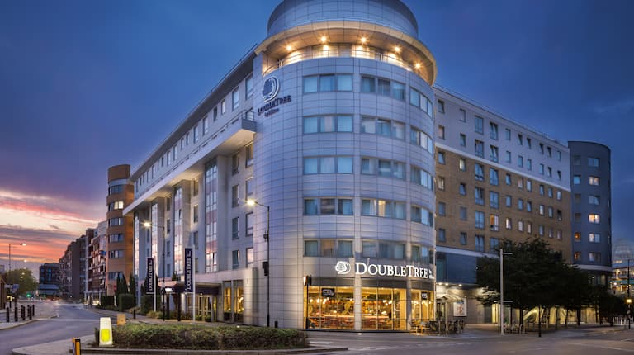
Figure 1. DoubleTree by Hilton London – Chelsea
Source: Hilton, 2025
The hotel features 172 guest rooms, an on-site restaurant and bar, and several meeting facilities, serving both business travellers and leisure guests seeking convenient access to central London and Heathrow Airport (Hilton, 2024). The property follows Hilton’s global service culture to offer heartfelt experiences for guests, which promotes warmth, empathy, and professionalism in every guest encounter (Stories Hilton, 2025). The hotel’s location near major transport links and corporate offices makes it an ideal environment to observe how emotional intelligence influences daily operations and guest interactions in a busy, mid-scale urban setting (Li, Tse and Huang, 2021; Prentice, Chen and King, 2020). This context provided a balanced view of how emotional awareness, communication, and teamwork are embedded in hospitality practice.
The research presented in this project investigates the role of EI in delivering quality guest service, focusing on the DoubleTree by Hilton London – Chelsea case study. The hotel is part of the Hilton Worldwide brand, which is known for its “Make It Right” service culture and commitment to guest satisfaction (Stories Hilton, 2024).
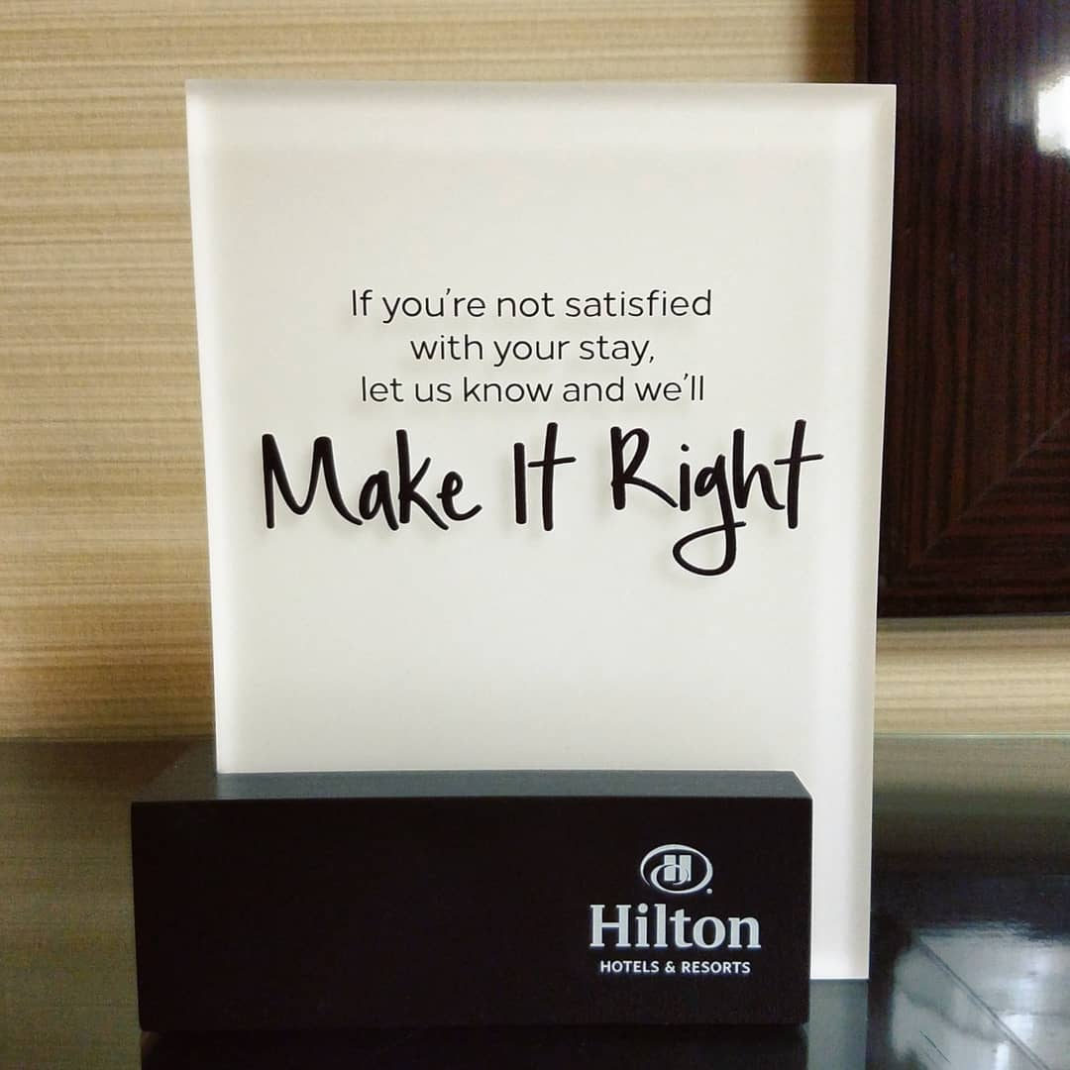
Figure 2. Make it right service culture by Hilton
Source: DoubleTree by Hilton Spokane City Center, 2018

During the placement period, the researcher worked across several operational departments (i.e., Front Office, Housekeeping, and Food & Beverage) observing how emotionally intelligent behaviours contributed to teamwork and service recovery. This context provides an authentic environment to explore how EI shapes guest experiences in a real hospitality setting.
The global hospitality sector has undergone major transformation due to rising customer expectations, staff shortages, and the post-pandemic emphasis on wellbeing and personalisation (Baum et al., 2020; Kim, Choi and Li, 2023). As hotels rebuild staff morale and adapt to new service models, emotional intelligence has become a differentiating factor in how service quality is perceived and delivered. Studies indicate that guests increasingly value empathy and authenticity alongside efficiency (Li, Tse and Huang, 2021). In such an environment, emotionally intelligent staff is better equipped to control stress, resolve conflicts, and build rapport with guests, resulting in higher satisfaction and stronger brand reputation (Prentice et al., 2020; Lee and Ok, 2022).
The placement at DoubleTree by Hilton London – Chelsea offered opportunities to witness these dynamics first-hand. Whether managing late check-ins, resolving room complaints, or assisting guests with special requests, employees demonstrated varying levels of emotional awareness and adaptability. Observing these behaviours raised important questions about how EI influences not only the immediate guest experience but also teamwork, motivation, and overall service quality.

1.1 Aim and Objectives
The aim of this research is to evaluate how emotional intelligence among hotel employees influences service quality, teamwork, and guest satisfaction within DoubleTree by Hilton London – Chelsea.
To achieve this aim, the project pursues the following objectives:
- To identify key emotional intelligence competencies exhibited by hotel employees in guest-facing roles.
- To examine how emotional intelligence contributes to teamwork and communication within operational departments.
- To analyse how emotionally intelligent behaviours affect guest satisfaction and perceptions of service quality.
- To provide recommendations for enhancing staff emotional intelligence through training and leadership support.

1.2 Rationale and Significance
This study is significant because it connects human behaviour and operational excellence within a hotel environment (Amah and Ogah, 2023). While many hospitality studies focus on technology and efficiency (Law et al., 2018; Khatri, 2019; Park et al., 2023) , fewer explore the emotional aspects of service delivery (Escobar Rivera et al., 2019; Akinyemi and Onukwulu, 2024). By analysing EI in the context of a live placement, this research bridges theory and practice, contributing to both academic understanding and managerial development. The findings are expected to help hotels such as DoubleTree by Hilton enhance service culture by integrating emotional competence into recruitment, training, and performance evaluation.

1.3 Structure of the Project
The remainder of the research is structured as follows: chapter 2 reviews existing literature on emotional intelligence, service quality, and guest satisfaction, identifying theoretical foundations and research gaps; chapter 3 outlines the methodological framework, explaining the case study approach, data sources, and thematic analysis used; the subsequent chapters present findings, discussion, and practical recommendations aligned with the research objectives.
In sum, this project seeks to demonstrate that emotionally intelligent behaviour is not a soft skill but a strategic asset in hospitality management. Through the case study of DoubleTree by Hilton London – Chelsea, it aims to highlight how cultivating emotional intelligence among employees can transform service encounters, strengthen teamwork, and elevate overall guest experience.

Chapter Two: Literature Review

2.1 Introduction
This literature review explores how EI contributes to service quality and guest satisfaction within the hospitality trade. It critically examines academic and industry perspectives related to EI, teamwork, and guest experience, connecting these to the real-world operations of the DoubleTree by Hilton London – Chelsea. The review is structured around the project’s objectives and includes key themes such as the definition and dimensions of EI, its role in hotel operations, its relationship with teamwork, and its impact on guest satisfaction. It concludes by identifying existing research gaps relevant to the study.

2.2 Concept and Dimensions of Emotional Intelligence
The notion of EI was first presented by Salovey and Mayer (1990), who outlined it as the capability to observe, recognise, and control emotions in oneself and others. Goleman (1995) afterwards extended the model into five dimensions (self-awareness, self-regulation, motivation, empathy, and social skills) making it widely applicable in workplace contexts. In hospitality, these traits are essential for employees who interact with guests in emotionally charged environments (Kernbach and Schutte, 2005; Wong and Law, 2002).
According to Mayer, Caruso and Salovey (2016), EI enhances interpersonal communication, allowing staff to interpret guest moods and respond appropriately. This skill is especially vital in front office, housekeeping, and food and beverage departments (Jung and Yoon, 2016; Park and Kim, 2021; Kuri, Biswas and Shabbir, 2025), where service delivery relies on both efficiency and emotional engagement (Chathoth et al., 2016; Akinyemi and Onukwulu, 2024. Petrides and Furnham (2001) distinguish between “ability EI,” which focuses on emotional problem-solving, and “trait EI,” which relates to personality-driven emotion management. Both dimensions are relevant in hospitality, as service encounters require both cognitive and affective understanding (Prentice, Chen and King, 2020).
Scholars such as Huy (2012) argue that EI provides resilience against stress and burnout in service industries. Employees who recognise their emotions can manage frustration during high-pressure situations, such as guest complaints or system failures (Yang, Wang and Yang, 2020; Konstantinidis et al., 2025). Moreover, emotionally intelligent leaders can model empathy and composure, influencing organisational culture and team morale (Boyatzis, 2018). Thus, EI functions not only as an individual skill but also as a collective resource within service organisations.

2.3 Emotional Intelligence and Service Quality
Service quality is one of the most researched concepts in hospitality management, often measured using the SERVQUAL model (Parasuraman, Zeithaml and Berry, 1988).
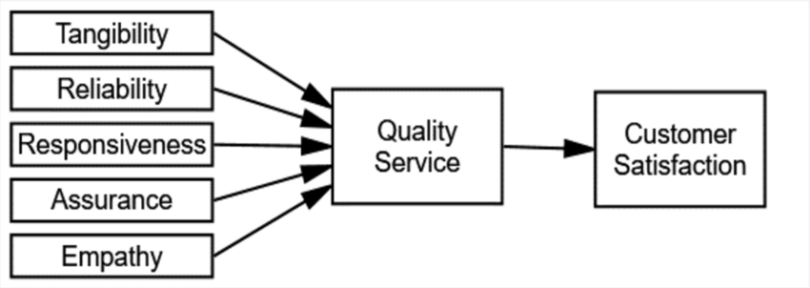
Figure 3. The SERVQUAL Model
Adapted from Parasuraman, Zeithaml and Berry, 1988
While traditional measures focus on tangibles, reliability, and responsiveness, modern researchers increasingly consider the emotional dimension of service encounters (Nasution and Mavondo, 2008; Lee and Ok, 2022). Employees’ EI directly influences how these dimensions are perceived by guests.
Kernbach and Schutte (2005) observed a strong correlation between the EI of service providers and customer satisfaction in hotels and restaurants. Staff with higher EI were more likely to manage guest expectations effectively and maintain positive emotional climates (Lam, Cheung and Lugosi, 2021; Nguyen, Ladkin and Osman, 2022; Zhu et al., 2022). Similarly, Karatepe, Yavas and Babakus (2005) argue that emotionally intelligent employees demonstrate better service recovery skills, as they can remain calm and empathetic when handling complaints.
In budget and mid-scale hotels such as DoubleTree by Hilton, emotional intelligence compensates for limited material luxuries by enhancing personalised interaction (Li, Tse and Huang, 2021). Guests remember warmth and empathy more than décor or technology when evaluating their experience (Solnet, Ford and Robinson, 2020). Consequently, Hilton’s service philosophy regarding the relationship with guests aligns closely with EI principles, emphasising genuine care and responsiveness to individual needs (Hilton, 2024).
However, some studies caution against overemphasising emotional labour (Xu, Cao and Huo, 2020; Chehab, Ilkhanizadeh and Bouzari, 2021; Amissah, Blankson-Stiles-Ocran and Mensah, 2022; Annor, Ayertey and Agyemang, 2023). Hochschild (2012) suggests that constant emotional regulation can lead to exhaustion, detachment, and reduced authenticity. Therefore, organisations must provide training and psychological support to help staff sustain genuine empathy without emotional depletion (Kim, Choi and Li, 2023; Lajante et al., 2023).

2.4 Emotional Intelligence and Teamwork in Hospitality
Effective teamwork is critical to hotel operations, where departments such as housekeeping, reception, and food service must coordinate to deliver seamless experiences. Emotional intelligence fosters this coordination by promoting mutual understanding and communication (Jordan and Troth, 2011). Team members with high EI are better at resolving conflicts, supporting colleagues, and adapting to changing workloads (Clarke, 2010; Jordan and Troth, 2021; Woime and Shato, 2025). According to Bell and Kozlowski (2012), EI influences team effectiveness through two mechanisms: improved communication and stronger relational bonds. In hotel environments where tasks are interdependent, these factors translate into smoother handovers and reduced errors. Moreover, emotionally intelligent leaders act as “emotional anchors,” (Choeni, Babalola and Nwanzu, 2023; Drigas, Papoutsi and Skianis, 2023; helping to stabilise team morale during stressful shifts (Humphrey, 2013).
Research by Lee and Ok (2022) highlights that team empathy, an extension of individual EI, enhances collective performance. In practice, this can be observed when front-desk staff collaborate with housekeeping to address guest complaints promptly. At DoubleTree by Hilton London – Chelsea, such collaboration often determines whether guests perceive the service as efficient or disorganised.
Nonetheless, team EI can be undermined by cultural diversity and communication barriers (Waseem, Rasheed and Izhar, 2025). As global hospitality workforces are multicultural, differences in emotional expression can create misunderstandings (Baum, 2015; Skordoulis et al., 2024). To address this, training programmes must include cross-cultural emotional awareness to strengthen inclusivity and cohesion (Chan and Mak, 2019).
Overall, the literature confirms that emotionally intelligent teams are more adaptive, communicative, and resilient, which are qualities essential for maintaining service consistency in busy hotel environments.

2.5 Emotional Intelligence and Guest Satisfaction
Guest satisfaction is the ultimate indicator of service success. It reflects the degree to which guest expectations are met or exceeded through interactions with hotel staff (Oliver, 1997; Sofi et al., 2025). Research increasingly recognises that emotional connection is central to this satisfaction (Ladhari, 2012; Han and Hyun, 2017). Emotional intelligence enhances these connections by enabling staff to recognise non-verbal cues, respond to guest moods, and personalise service encounters (Wong and Law, 2002).
Prentice, Chen and King (2020) demonstrate that employees who display empathy and emotional control foster trust and comfort, leading to higher guest loyalty. This “emotional contagion” effect (Hatfield, Cacioppo and Rapson, 1994) suggests that guests often mirror the emotional tone set by service staff. When employees remain calm and positive under pressure, guests perceive the overall experience as more pleasant and professional.
Moreover, EI strengthens service recovery. When service failures occur (such as delays, errors, or complaints) emotionally intelligent responses can transform dissatisfaction into loyalty (Hart, Heskett and Sasser, 1990). According to De Matos et al. (2020), this is known as the service recovery paradox, where guests may leave more satisfied after a well-managed complaint than if no problem had occurred. Empathetic listening and quick corrective action are key components of this process (Kandampully, Zhang and Jaakkola, 2018).
Annual reports from Hilton (2024) also highlight emotional engagement as a driver of repeat bookings. Their internal training initiatives, such as “Hilton University” and “Make It Right,” encourage staff to use emotional awareness to enhance guest experiences. This organisational investment reinforces research findings that EI-based service cultures yield long-term benefits for both staff wellbeing and guest loyalty (Boyatzis, 2018; Kim et al., 2023).

2.6 Training and Development of Emotional Intelligence in Hotels
Developing EI is increasingly viewed as a strategic investment rather than a personal trait. Scholars such as O’Boyle et al. (2011) argue that EI can be enhanced through targeted training that integrates reflection, feedback, and role-play. In hospitality, these programmes often focus on conflict management, empathy-building, and stress control (Hassi, 2019).
Studies by Cherniss and Goleman (2001) show that EI training leads to measurable improvements in communication, motivation, and performance. Hotels like Hilton, Marriott, and Accor have incorporated emotional competence into their leadership frameworks (Hilton, 2024). At the operational level, regular feedback sessions and peer coaching help employees translate theoretical concepts into daily practice (Walker, 2021).
However, training effectiveness depends on organisational culture. If management fails to recognise the emotional demands of service work, employees may perceive EI initiatives as superficial (Hochschild, 2012). Sustainable outcomes require supportive environments where staff are encouraged to express emotions appropriately and seek assistance when overwhelmed (Kim et al., 2023).
In summary, literature underscores that EI can be cultivated through continuous learning and leadership support. This perspective aligns with the research’s aim to provide recommendations for strengthening emotional intelligence among staff at DoubleTree by Hilton London – Chelsea.

2.7 Research Gaps and Conceptual Summary
Although EI has been widely studied in hospitality, several gaps remain. First, most studies focus on luxury or resort hotels, with limited research in mid-scale urban properties such as DoubleTree by Hilton. Second, few empirical investigations combine real workplace observation with academic analysis, as this project does. Third, existing research often treats EI as an individual trait rather than a collective organisational capability. This study aims to address these gaps by applying a qualitative case study approach grounded in lived placement experience.
The conceptual framework emerging from this review suggests that emotional intelligence influences guest service quality through three interconnected pathways: (1) personal emotion regulation, (2) teamwork and communication, and (3) empathetic guest interaction. Each of these pathways will be explored thematically in later chapters.

2.8 Summary of the Literature Review
This chapter has critically reviewed the main theories and empirical findings related to emotional intelligence in hospitality. The evidence indicates that EI enhances service quality, strengthens teamwork, and improves guest satisfaction through empathy, emotional control, and effective communication. However, sustaining these benefits requires supportive organisational culture and continuous staff development.
By situating the study within these theoretical foundations, the literature provides a framework for examining how emotional intelligence operates in practice at DoubleTree by Hilton London – Chelsea. The next chapter explains the research design and methodology used to explore these relationships.

Chapter Three: Methodology
This chapter explains the research design and methods used to explore the role of emotional intelligence (EI) in delivering quality guest service at DoubleTree by Hilton London – Chelsea.
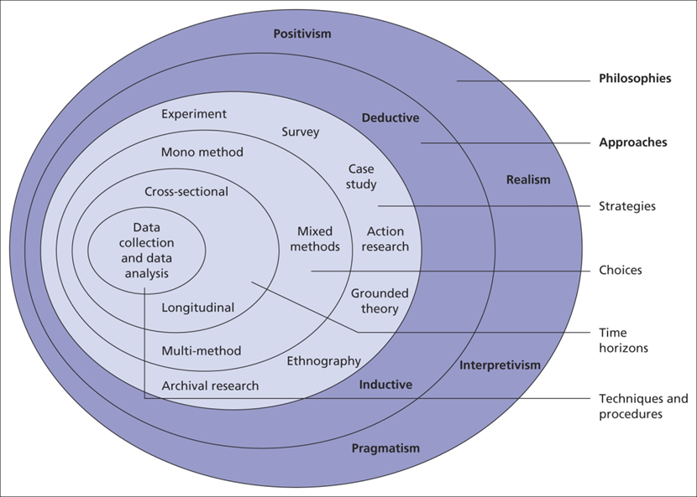
Figure 4. Saunders' Research Onion
Source: adapted from Saunders, Lewis and Thornhill, 2019
It outlines the research philosophy, approach, data collection, analysis techniques, and limitations, ensuring that the chosen design aligns with the study’s objectives and ethical requirements of the University of Wales Trinity Saint David (UWTSD, 2023).

3.1 Research Philosophy and Design
The study adopts an interpretivist philosophy, which focuses on understanding social behaviour through individual experiences and meanings (Saunders, Lewis and Thornhill, 2019). Emotional intelligence is an inherently human and context-dependent concept, making an interpretivist stance appropriate. This philosophy allows the researcher to examine how emotions influence service quality and guest satisfaction within a real hospitality environment (Bryman, 2016).
A qualitative case study design was selected to enable an in-depth investigation of a single organisation, namely DoubleTree by Hilton London – Chelsea. Yin (2018) describes the case study as suitable for exploring complex, real-world phenomena where the boundaries between context and behaviour are blurred. This method captures the nuances of workplace emotions, teamwork, and guest interaction that quantitative approaches may overlook.

3.2 Research Approach and Data Collection
This research combines both secondary and primary methods to ensure theoretical depth and contextual accuracy. Secondary research involved an extensive review of academic literature, hospitality textbooks, and industry reports related to emotional intelligence, teamwork, leadership, and guest satisfaction. According to Saunders, Lewis and Thornhill (2019), secondary data provide a theoretical framework and conceptual grounding for understanding complex organisational phenomena. These sources, critically analysed in Chapter Two, helped the researcher identify relevant models and concepts such as Goleman’s (1995) five dimensions of emotional intelligence and the SERVQUAL model of service quality (Parasuraman, Zeithaml and Berry, 1988). This theoretical foundation supported the primary research, which explored emotional intelligence in practice at DoubleTree by Hilton London – Chelsea through qualitative observation. Combining both methods enhanced the credibility of the study and reflected the interpretivist approach that values meaning derived from real experiences (Bryman, 2016; Denscombe, 2014).
The research uses a mono-method qualitative approach, relying on non-intrusive observations made during the researcher’s placement in the Front Office, Housekeeping, and Food & Beverage departments. Observation is one of the most effective methods for understanding service delivery in hospitality, as it records natural behaviours without interference (Veal, 2017).
Primary data consisted of reflective field notes documenting staff–guest interactions, teamwork dynamics, and emotionally charged service encounters. These notes were recorded daily over a ten-week period following a consistent structure, focusing on instances of empathy, communication, and service recovery. No personal or identifiable data were collected to protect privacy.
Secondary data included peer-reviewed academic sources, hospitality industry reports, and Hilton’s annual and sustainability reports (Hilton, 2024). Combining these sources provided triangulation and helped validate the observational findings (Denscombe, 2014).
The choice of observational methods was influenced by their suitability for capturing natural workplace behaviour without intervention. Veal (2017) highlights that observation allows researchers to record actions and interactions in real time, offering authenticity and ecological validity. Within this study, observations enabled the identification of emotionally intelligent behaviours as they occurred in operational settings—such as empathy in guest handling, teamwork under pressure, and service recovery processes. This approach aligns with the interpretivist philosophy, which seeks to understand how individuals attach meaning to their actions in social contexts (Saunders, Lewis and Thornhill, 2019; Bryman, 2016). The researcher’s direct experience within the hotel provided rich, context-sensitive data that numerical surveys or external interviews might have overlooked, reflecting the value of immersion in qualitative hospitality research (Creswell and Creswell, 2018).

3.3 Data Analysis
Data were investigated using thematic analysis, as per Braun and Clarke’s (2006) six-phase framework: familiarisation, coding, theme generation, review, naming, and reporting.
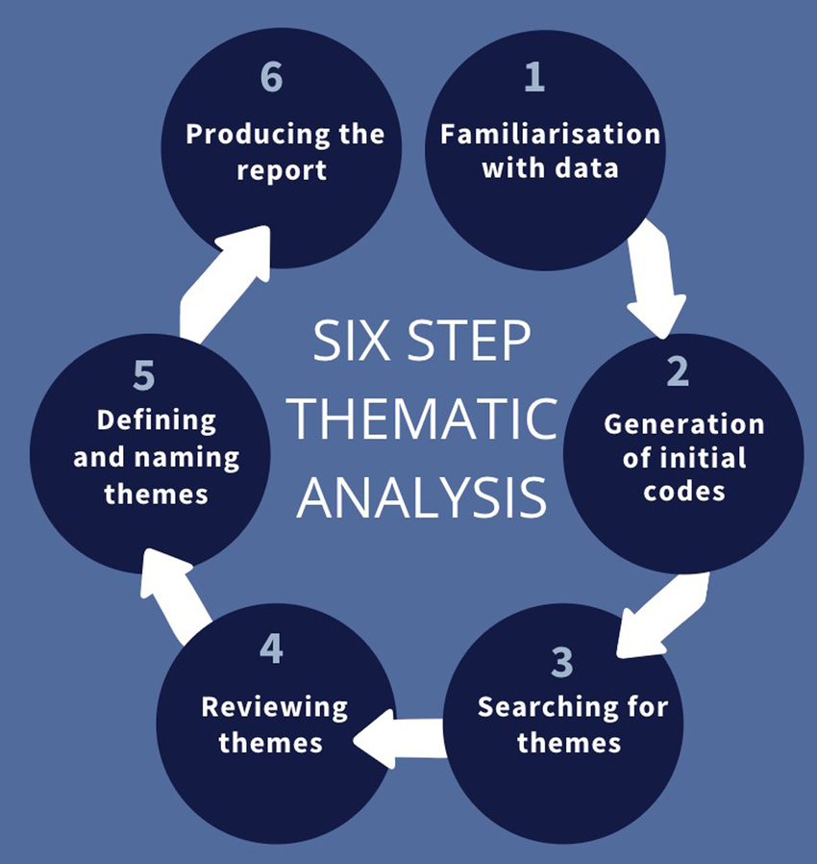
Figure 5. Braun and Clarke’s (2006) six-phase framework
Source: adapted from: Braun and Clarke, 2006

Themes were detected both deductively, founded on the research objectives, and inductively, occurring from observed behaviours. The main categories included emotional awareness, teamwork communication, and guest interaction. This method is suitable for hospitality research as it allows flexible interpretation of qualitative data while maintaining transparency (Nowell et al., 2017).

3.4 Ethical Considerations
The project received prior ethical approval from UWTSD (2025). No interviews or recordings were conducted, and all data were anonymised. Observations were limited to public or staff-authorised spaces within the hotel. The researcher adhered to principles of informed consent, confidentiality, and non-maleficence (Bell and Waters, 2018). All documents and field notes were stored securely and deleted after assessment.

3.5 Limitations
As a single-case qualitative study, findings cannot be generalised to all hotels. The research also relies on subjective interpretation, as data were drawn from personal observation rather than guest or staff interviews. However, triangulation with secondary sources and a transparent analytical process enhance the study’s credibility and dependability (Creswell and Creswell, 2018).

Chapter Four: Findings and Discussion

4.1 Findings

This chapter presents the findings of the research gathered through qualitative observations conducted during a ten-week placement at DoubleTree by Hilton London – Chelsea. The study investigated how emotional intelligence (EI) manifests in everyday guest service delivery, teamwork, and service recovery across three core departments: Front Office, Housekeeping, and Food & Beverage. The findings are organised thematically according to the research objectives, revealing patterns of emotional awareness, empathy, collaboration, and leadership behaviour observed in the hotel.

4.1.1 Theme 1: Emotional Awareness and Empathy in Guest Interaction (Front Office)

Observations at the Front Office revealed that empathy and emotional awareness were central to maintaining guest satisfaction. Reception staff frequently demonstrated attentiveness to verbal and non-verbal cues from guests, adjusting their tone and body language accordingly. For example, when dealing with delayed check-ins or room allocation issues, receptionists often began with apologies, maintaining calm and polite demeanours even when guests were visibly frustrated. One receptionist was seen lowering her voice and maintaining eye contact with a family arriving late after a flight delay, acknowledging their tiredness and offering complimentary water while resolving the issue.
Such gestures created an atmosphere of understanding and reassurance, consistent with Hilton’s brand culture of “Hospitality from the Heart” (Hilton, 2024). Staff seemed aware that the emotional tone set at the front desk shaped the guest’s first impression of the entire stay. In several cases, guests’ initial irritation shifted to appreciation after empathetic handling, suggesting that emotional intelligence played a key role in diffusing tension and reinforcing trust.
The placement also revealed varying levels of emotional control among staff. While senior receptionists displayed composure during high-pressure check-in periods, newer employees occasionally showed visible stress, such as speaking hurriedly or avoiding eye contact when queues formed. Supervisors often intervened discretely to offer guidance or take over complex situations. This dynamic highlighted the role of experience and emotional regulation in delivering consistent service quality.
Communication between receptionists and guests during check-out provided further insight into EI practice. Staff who engaged guests with friendly, personalised comments, such as asking about their journey or offering genuine farewell remarks, tended to receive more positive feedback. These micro-moments illustrated how emotionally intelligent communication supports guest satisfaction beyond functional service tasks.

4.1.2 Theme 2: Emotional Intelligence and Teamwork During Operational Pressure (Housekeeping)

In the Housekeeping department, emotional intelligence was most evident in how team members managed stress and cooperated during high-occupancy periods. Observations indicated that the department operated under significant time pressure, particularly during weekends and flight-change turnover days when multiple check-outs coincided.
Teamwork and mutual understanding were crucial to maintaining efficiency. Supervisors allocated tasks each morning, often with motivational comments that acknowledged the team’s workload. During busy shifts, attendants helped one another complete rooms when colleagues fell behind, demonstrating empathy and solidarity. This cooperation appeared to ease tension and sustain morale, even when operational targets were demanding.
One instance involved a senior room attendant assisting a new staff member who was struggling to complete a suite cleaning within the expected time. Instead of reprimanding her, the senior calmly offered step-by-step guidance, explaining shortcuts while ensuring standards were met. This behaviour reflected emotional awareness and constructive support, fostering a sense of teamwork rather than competition.
However, there were also moments of emotional strain. A few attendants expressed frustration when communication with maintenance or the front desk was delayed, leading to repeated room status changes. These incidents occasionally caused irritation but were resolved quickly once supervisors intervened. Notably, supervisors who approached such problems calmly and empathetically seemed to restore order faster than those who relied solely on instruction.
Daily interactions suggested that positive emotions were contagious. Smiles, humour, and simple words of encouragement circulated during room inspections and shift endings. These acts of emotional connection strengthened group cohesion and reduced the perceived pressure of routine tasks. Overall, the findings suggest that emotional intelligence—especially empathy and interpersonal awareness—underpinned effective teamwork and resilience in the Housekeeping department.

4.1.3. Theme 3: Emotional Control and Service Recovery in Food & Beverage
The Food & Beverage (F&B) department offered multiple examples of emotional control and service recovery in action. Breakfast and dinner periods were the most dynamic times, requiring fast service, clear communication, and composure under pressure. Staff interactions with guests varied depending on the situation, revealing how emotional intelligence shaped both immediate responses and recovery outcomes.
One notable observation involved a guest complaint about a missing allergen label on a breakfast tray. The server immediately apologised, informed the chef, and returned with properly labelled dishes while reassuring the guest that the issue was being corrected. The guest’s tone softened, and the situation ended with appreciation rather than anger. This response demonstrated the effectiveness of calm acknowledgement and timely action—key indicators of emotional intelligence in service recovery.
Another example occurred during a particularly busy morning when a coffee shortage caused delays at the buffet station. A supervisor calmly redirected staff, instructed one attendant to serve guests fresh alternatives, and personally communicated with waiting guests. Her composed demeanour appeared to diffuse potential frustration. Staff later reflected that her calmness “kept the team grounded.”
Interactions between F&B staff also illustrated empathy and awareness. When one waiter appeared anxious after spilling a drink near a guest table, a colleague quietly stepped in to help clean and offered reassurance. Rather than escalating embarrassment, this supportive behaviour maintained professionalism and team morale.
At the same time, some inconsistencies were noted. A few staff members struggled to maintain patience during repeated guest requests, especially near closing time. Minor signs of fatigue—such as curt replies or lack of eye contact—suggested emotional exhaustion during longer shifts. Supervisors often mitigated this by rotating responsibilities or offering short breaks. These findings reinforce how emotional regulation is tested most in fast-paced service environments and requires continuous reinforcement through supportive leadership.

4.1.4 Theme 4: Leadership Support and Organisational Culture
Leadership behaviour at DoubleTree by Hilton London – Chelsea significantly influenced emotional climate and team performance. Across all departments, supervisors who modelled empathy and calmness created a positive tone for their teams. They frequently used inclusive language, such as “we’ll manage together” or “thank you for your effort today”, that encouraged collaboration and trust.
During the placement, morning briefings served as key emotional alignment sessions. Supervisors began by acknowledging challenges such as high occupancy or equipment issues, followed by motivational remarks that framed the day as a shared goal. This approach helped staff start shifts with optimism, reflecting emotionally intelligent leadership.

Conversely, when leaders were less communicative, small issues escalated faster. For instance, on one occasion when a housekeeping supervisor was absent, confusion arose regarding room priorities. Staff expressed mild frustration until another team leader stepped in to reorganise tasks. This contrast suggested that emotionally present leadership reduced uncertainty and improved emotional stability within the team.
Front Office management also demonstrated empathy through mentoring. Supervisors regularly provided constructive feedback in private rather than in front of guests or colleagues. This maintained staff confidence while encouraging learning from mistakes. One memorable moment involved a manager reassuring a receptionist after a booking system failure, reminding her that the guest’s attitude was not a reflection of her performance. Such interactions exemplified emotionally intelligent leadership, balancing accountability with compassion.
The placement also revealed that the Hilton culture actively promotes recognition and positivity. Staff were encouraged to celebrate small successes through internal “Catch Me at My Best” cards, where colleagues could acknowledge each other’s supportive actions. These rituals nurtured gratitude and emotional connection across teams, reinforcing a service culture rooted in empathy and appreciation.
Overall, the leadership style observed at DoubleTree by Hilton London – Chelsea reflected a balance between operational efficiency and emotional understanding. Managers who demonstrated emotional intelligence fostered confidence, reduced workplace stress, and contributed directly to consistent guest service quality.

4.1.5 Summary of Findings

The findings indicate that emotional intelligence permeates multiple aspects of guest service at DoubleTree by Hilton London – Chelsea. Across all departments, staff who demonstrated empathy, composure, and emotional awareness positively influenced both guest satisfaction and team morale.
At the Front Office, emotionally intelligent communication improved guest trust and diffused potential conflicts.
Within Housekeeping, empathy and mutual support enhanced teamwork and efficiency during high-pressure operations.
In Food & Beverage, emotional regulation and prompt service recovery maintained guest satisfaction even when errors occurred.
Leadership behaviours that modelled emotional understanding created a supportive culture, reinforcing Hilton’s service values and staff motivation.

These patterns collectively highlight how emotional intelligence operates as both an individual and organisational competency, enabling staff to deliver consistent, human-centred service. The next section interprets these findings through Gibbs’ Reflective Cycle and the theoretical perspectives presented in Chapter 2.

4.2 Discussion
This chapter interprets the findings from the ten-week placement at DoubleTree by Hilton London – Chelsea, examining how emotional intelligence (EI) shapes guest service, teamwork, and leadership within the hotel. The discussion applies the stages of Gibbs’ Reflective Cycle (1988), namely description, feelings, evaluation, analysis, conclusion, and action plan, as a reflective framework to connect lived experience with theoretical understanding.
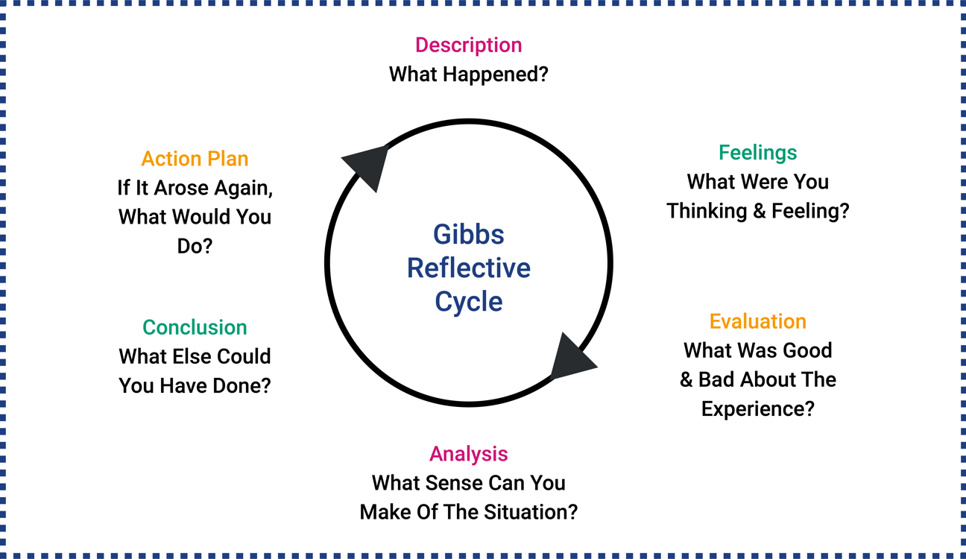
Figure 6. Gibbs’ Reflective Cycle
Source: adapted from Gibbs, 1988
Each theme is discussed in relation to existing literature and the practical implications for hospitality management.

4.2.1 Theme 1: Emotional Awareness and Empathy in Guest Interaction (Front Office)
Description
During front-desk operations, staff often handled emotionally sensitive situations such as delayed check-ins and complaints about room allocation. Senior receptionists displayed patience and empathy, while newer employees sometimes struggled under pressure.

Feelings
At first, these interactions created tension and sympathy from the researcher’s perspective, especially when witnessing guests’ frustration. However, it soon became clear that empathy and calmness helped to diffuse conflicts, evoking admiration for staff who maintained composure.
Evaluation
These experiences reflected Hatfield, Cacioppo and Rapson’s (1994) concept of emotional contagion: staff emotions influenced guests’ reactions. When employees remained calm and polite, guests reciprocated with understanding. Conversely, visible stress from staff heightened dissatisfaction.
Analysis
The theme confirms Goleman’s (1995) and Mayer, Caruso and Salovey’s (2016) argument that emotional awareness and regulation underpin service excellence. Staff who recognised emotional cues could tailor communication to guests’ moods, consistent with Kernbach and Schutte (2005). Hilton’s “Hospitality from the Heart” culture visibly encouraged empathy as a brand standard (Hilton, 2024).
Conclusion
Empathy is both a skill and a mindset essential for guest satisfaction. Emotional intelligence enabled staff to turn potential service failures into positive experiences by acknowledging guest emotions.
Action Plan
To reinforce empathy, the hotel could include role-play sessions on emotion recognition and stress control in front-desk training. Supervisors might also conduct post-shift reflections to share examples of positive emotional engagement.

4.2.2 Theme 2: Emotional Intelligence and Teamwork Under Operational Pressure (Housekeeping)
Description
Housekeeping teams at DoubleTree worked under intense time pressure, particularly on weekends. Despite demanding conditions, team members often supported one another by sharing tasks or offering encouragement.
Feelings
The researcher initially felt concerned for attendants facing heavy workloads but also inspired by their mutual support and optimism. Observing moments of laughter and encouragement created a sense of collective pride.

Evaluation
These behaviours exemplify emotionally intelligent teamwork. Jordan and Troth (2011) found that team-level EI improves coordination and morale, which matched the observed cooperation. When communication with other departments failed, stress briefly increased—showing how emotional awareness stabilises workflow.
Analysis
The data aligns with Clarke (2010) and Bell and Kozlowski (2012), who argue that emotional intelligence enhances team adaptability and trust. The mentoring moment between a senior and a new attendant reflected transformational leadership (Hassi, 2019), where empathy builds competence and motivation. From a cultural view, diverse backgrounds required emotional sensitivity to bridge language barriers (Baum, 2015; Chan and Mak, 2019).
Conclusion
Emotional intelligence sustains teamwork by fostering belonging and shared responsibility. Empathy reduces the strain of repetitive tasks and builds collective resilience in high-pressure contexts.
Action Plan
Management could introduce a buddy system pairing new and experienced attendants during the first weeks of training, promoting peer mentoring and emotional learning. Short “gratitude rounds” at shift ends could reinforce teamwork and recognition.

4.2.3 Theme 3: Emotional Control and Service Recovery (Food & Beverage)
Description
In the Food & Beverage department, staff frequently encountered emotionally charged scenarios such as guest complaints or shortages during busy meal times. Successful outcomes often depended on emotional control and calm communication.
Feelings
Initially, the researcher felt anxious observing stressful breakfast rushes but gradually recognised admiration for employees who managed these moments with poise and politeness. It became evident that emotional regulation defined professionalism in service recovery.
Evaluation
The allergen-label incident illustrated that timely apologies and empathetic reassurance restored guest confidence. This aligns with the service recovery paradox (De Matos, Henrique and Rossi, 2020). Staff who panicked tended to worsen tension, confirming Hochschild (2012) that emotional exhaustion leads to inconsistent performance.

Analysis
The findings support Boyatzis (2018) and Kim, Choi and Li (2023), who associate emotionally intelligent leadership with stable service performance. Supervisors’ calm intervention during shortages demonstrated emotional maturity and modelled behaviour for others. According to Prentice, Chen and King (2020), emotional intelligence boosts both staff confidence and guest satisfaction, as empathy and calmness humanise service encounters.
Conclusion
Emotional control is essential to effective service recovery. Staff who combine empathy with composure can transform service errors into loyalty-building opportunities.
Action Plan
The F&B team should implement short post-service debriefs to reflect on challenging interactions, supporting emotional release and learning. Incorporating brief stress-management workshops could help prevent burnout during peak hours.

4.2.4 Theme 4: Leadership Support and Organisational Culture
Description
Leaders at DoubleTree influenced team morale through their emotional tone. Supervisors who communicated clearly and expressed gratitude nurtured positivity, while absence of leadership presence sometimes caused confusion.
Feelings
The researcher initially underestimated the impact of leadership style but later recognised that emotionally supportive managers created calmer, more motivated teams. Seeing supervisors encourage staff generated feelings of respect and reassurance.
Evaluation
This corresponds with Humphrey (2013) and Huy (2012), who describe emotionally intelligent leaders as “emotional anchors.” Morning briefings that balanced honesty and encouragement reflected Boyatzis’ (2018) view that compassion fosters engagement. Recognition cards such as “Catch Me at My Best” visibly strengthened emotional connection.
Analysis
The pattern supports Hilton (2024) corporate principles and the fact that transparent communication enhances trust. By offering private feedback and acknowledging effort, managers reinforced self-esteem and consistency. From Gibbs’ lens, leadership emerged as both a stabilising and transformative force, directly influencing emotional climate and performance.

Conclusion
Leadership emotional intelligence determines the emotional culture of the workplace. When managers demonstrate empathy and gratitude, teams mirror those behaviours, improving morale and service quality.
Action Plan
To sustain emotionally intelligent leadership, DoubleTree should provide regular EI refresher sessions for supervisors focusing on empathy, listening, and constructive feedback. Periodic one-to-one conversations could also be formalised to maintain open communication.

4.2.5 Integrated Reflection Across All Themes
Description
Across all departments, emotional intelligence was observed as a consistent factor linking employee behaviour, teamwork, and guest satisfaction.
Feelings
The researcher initially perceived service performance as largely technical but grew to appreciate its emotional dimension. Feelings of admiration and empathy toward staff replaced early assumptions about hospitality as purely procedural.
Evaluation
Using Gibbs’ framework revealed that positive emotional management consistently led to smoother operations and happier guests, while emotional neglect produced stress and inconsistency.
Analysis
This synthesis confirms Goleman’s (1995) and Mayer et al.’s (2016) models of EI, showing how emotional awareness underpins motivation and relationship-building. It also supports Kandampully, Zhang and Jaakkola (2018), who argue that emotional engagement is the foundation of guest experience management. The placement demonstrated Li, Tse and Huang’s (2021) claim that emotional intelligence compensates for limited tangible luxury in mid-scale hotels.
Conclusion
Emotional intelligence functions as a strategic resource that integrates the human and operational sides of hospitality. Staff who embody empathy, teamwork, and composure collectively create a culture of service excellence.
Action Plan
Hilton and similar properties should embed emotional intelligence metrics into staff appraisals and leadership training. Reflection sessions and emotional awareness workshops could become part of ongoing professional development to sustain positive service culture.

4.2.6 Reflection on the Research Process
Description
The researcher’s method relied on observation and reflection rather than surveys, focusing on authentic workplace behaviour.
Feelings
At first, it felt challenging to avoid subjective judgment, but systematic note-taking and thematic analysis provided structure and confidence.
Evaluation
The process offered personal insight into the power of empathy and composure in professional settings. Limitations included the single-case scope and the absence of direct interviews, but immersion in the workplace created deep contextual understanding.
Analysis
Following Braun and Clarke (2006), thematic analysis allowed patterns to emerge organically. Integrating Gibbs’ Cycle enhanced self-awareness and reflexivity, fulfilling Veal (2017)’s criteria for reflective hospitality research.
Conclusion
Despite its qualitative scope, the research achieved validity through triangulation with academic literature and critical self-reflection. It demonstrated that emotional intelligence can be meaningfully analysed through lived experience.
Action Plan
Future research could combine observation with short interviews or reflective diaries from staff to capture multiple emotional perspectives within the same setting.

4.2.7 Summary of Discussion
Using Gibbs’ Reflective Cycle provided a structured, human-centred approach to interpret findings from the placement. Each stage—description, feelings, evaluation, analysis, conclusion, and action—highlighted how emotional intelligence operates across guest interaction, teamwork, service recovery, and leadership.
Collectively, the discussion demonstrates that emotionally intelligent behaviour is not incidental but integral to achieving guest satisfaction and maintaining a cohesive, motivated workforce. By embedding reflection and empathy into daily routines, DoubleTree by Hilton London – Chelsea reinforces its reputation for authentic, people-centred hospitality.

Chapter Five: Conclusion and Recommendations

5.1 Conclusion

This research project set out to explore the role of emotional intelligence (EI) in delivering quality guest service, using the DoubleTree by Hilton London – Chelsea as a case study. Drawing on qualitative observations during a ten-week placement across the Front Office, Housekeeping, and Food & Beverage departments, the study examined how emotional awareness, empathy, teamwork, and leadership contribute to guest satisfaction and operational effectiveness.
The research adopted an interpretivist philosophy and a qualitative case study design, focusing on natural interactions within the hotel. Using thematic analysis (Braun and Clarke, 2006) supported by Gibbs’ Reflective Cycle (1988), findings were organised around four key themes:
- Emotional awareness and empathy in guest interaction.
- Emotional intelligence and teamwork under operational pressure.
- Emotional control and service recovery.
- Leadership support and organisational culture.
These themes collectively confirmed that emotional intelligence is a critical factor underpinning service performance and employee wellbeing.

5.1.2 Key Findings Summary

The Front Office observations revealed that empathy and self-regulation are pivotal in shaping the guest experience. Receptionists who remained calm and compassionate during stressful situations, such as delayed check-ins or booking errors, not only resolved problems efficiently but also built trust and rapport. This aligns with Goleman’s (1995) model of EI, emphasising self-awareness, social skills, and empathy as essential components of professional success.
In Housekeeping, emotionally intelligent teamwork emerged as vital for managing stress and workload. Attendants who showed empathy toward one another improved efficiency and morale, supporting Jordan and Troth’s (2011) and Clarke’s (2010) claims that emotionally aware teams outperform those with purely task-based coordination. The willingness to help colleagues created an emotionally cohesive environment that balanced pressure with humour and mutual respect.
Within Food & Beverage, emotional control determined the effectiveness of service recovery. Staff who addressed complaints with composure and courtesy transformed negative experiences into positive impressions, illustrating De Matos, Henrique and Rossi’s (2020) concept of the service recovery paradox. Emotionally intelligent supervisors acted as stabilisers, guiding staff through peak demand with reassurance rather than reprimand.
Finally, leadership observations confirmed that emotionally intelligent management directly affects service culture. Leaders who communicated transparently, expressed gratitude, and modelled empathy cultivated loyalty and psychological safety. This finding mirrors Boyatzis (2018) and Huy (2012), who identify compassion as a defining feature of effective leadership.

5.1.3 Theoretical Contributions

The project reinforces the literature that positions EI as both an individual and organisational asset (Mayer, Caruso and Salovey, 2016; Prentice, Chen and King, 2020). However, it contributes uniquely by showing how these dynamics operate within a mid-scale, airport-adjacent property, a context often underrepresented in hospitality research that typically focuses on luxury brands.
The research also highlights team-level emotional intelligence as a collective capability. Emotional awareness within groups not only supports task completion but strengthens resilience in multicultural environments. This observation extends Chan and Mak’s (2019) argument that emotional understanding bridges cultural differences in global hospitality.
Furthermore, the study validates the applicability of Gibbs’ Reflective Cycle as an interpretive tool for hospitality research. By analysing experiences through its six stages—description, feelings, evaluation, analysis, conclusion, and action—the model bridged theory and practice, allowing richer insight into emotional behaviour at work.

5.1.4 Practical Insights

From an operational perspective, the findings underline that emotionally intelligent service is not merely about politeness but about recognising emotions as part of the workflow. Employees who understand and regulate emotions contribute to smoother coordination, faster service recovery, and stronger guest relationships. Emotional intelligence thus acts as a “soft system” supporting the “hard system” of operational efficiency.
The placement at DoubleTree by Hilton London – Chelsea demonstrated that Hilton’s corporate culture already embeds emotional awareness through practices such as recognition cards and reflective briefings. However, the research suggests that these practices could be further systematised to ensure that EI becomes an explicit part of staff training, leadership evaluation, and performance metrics.

5.1.5 Limitations and Future Research

The study’s limitations stem from its qualitative, single-case nature. Findings are context-bound and cannot be generalised across the entire Hilton network. Observations relied on the researcher’s interpretation without direct guest or staff interviews. Despite this, triangulation with literature and corporate materials enhanced reliability.
Future research could adopt a mixed-methods approach, combining observation with staff interviews and guest satisfaction surveys to capture multiple emotional perspectives. Comparative studies across different hotel categories—budget, mid-scale, and luxury—could also reveal how EI manifests under varying resource and guest expectation levels.

5.1.6 Final Reflection

Through reflective analysis, the project deepened understanding of how emotions shape service delivery. The placement experience demonstrated that genuine empathy and composure have tangible effects on guest satisfaction, teamwork, and brand reputation. As Goleman (1995) suggested, emotional intelligence is not an optional trait but a professional necessity in customer-facing industries.
In summary, this study affirms that emotional intelligence is both a personal competency and an organisational capability. Within the DoubleTree by Hilton London – Chelsea, it functions as the invisible framework binding operational systems with human connection — the true essence of hospitality.

5.2 Recommendations
Building on these conclusions, the following recommendations aim to strengthen emotional intelligence and service quality at DoubleTree by Hilton London – Chelsea and within the wider Hilton network. They are grounded in academic research and practical observation.

5.2.1 Integrate Emotional Intelligence into Staff Training
Hilton already provides extensive operational training, yet emotional intelligence should be formally embedded into induction and ongoing development programmes. According to O’Boyle et al. (2011) and Cherniss and Goleman (2001), EI can be enhanced through targeted coaching, reflection, and feedback. Training should include recognising emotional cues in guest interactions, managing stress through mindfulness and breathing techniques, and practising empathy in role-play scenarios reflecting real service challenges. Moreover, regular refresher workshops would sustain awareness and build a consistent emotional vocabulary across departments.

5.2.2. Implement Structured Reflective Practice
Adopting Gibbs’ Reflective Cycle (1988) at the departmental level can transform daily experiences into learning opportunities. Short debriefs at the end of each shift could allow staff to describe incidents, express feelings, evaluate responses, and identify lessons learned. Such sessions, guided by supervisors, would embed continuous learning and emotional self-regulation in everyday operations (Veal, 2017).
Reflection could also be encouraged through digital logs or “reflection corners” in back-of-house areas where employees can note challenges and positive interactions. Over time, these reflections could inform internal service improvement plans.

5.2.3. Establish Peer Support and Mentoring Systems
The findings show that teamwork and peer empathy sustain morale during high-pressure periods. A formal buddy system pairing new recruits with experienced staff would help newcomers adapt emotionally and technically. Peer mentors could share coping strategies and provide emotional reassurance, echoing Clarke (2010) on the importance of social learning in developing workplace EI.
Supervisors should monitor these partnerships and celebrate successful mentoring relationships during team briefings to reinforce a culture of shared support.

5.2.4. Develop Emotionally Intelligent Leadership
Leaders set the emotional tone for the entire team. Hilton should expand managerial training to include emotional leadership modules focusing on empathy, listening, and recognition. Research by Hassi (2019) and Boyatzis (2018) shows that emotionally aware leaders drive engagement and reduce turnover.
Supervisors could be encouraged to hold regular one-to-one meetings that combine performance feedback with wellbeing check-ins. Recognising emotional effort, such as handling a difficult guest, should be valued equally to technical achievement in evaluations.

5.2.5. Promote Emotional Wellness and Burnout Prevention
Observations revealed occasional fatigue and irritability during extended shifts. Hilton could introduce brief “emotional reset” breaks during long service periods to prevent burnout, supported by short relaxation techniques or stretching exercises. Access to wellbeing resources, such as counselling or stress workshops, would reflect ethical care and align with Kim, Choi and Li’s (2023) call for psychological wellbeing initiatives in hospitality.
Encouraging open discussion about emotional challenges would normalise self-care and strengthen resilience across departments.

5.2.6. Incorporate EI Metrics into Performance Reviews
To institutionalise emotional intelligence, Hilton could integrate EI-related competencies—such as empathy, teamwork, and composure—into performance appraisal systems. Managers could use behavioural indicators derived from Goleman’s (1995) five EI components to assess and develop staff.
Recognition programmes should also highlight emotionally intelligent behaviours, such as resolving conflicts peacefully or supporting stressed colleagues, linking emotional excellence to career progression.

5.2.7. Encourage Cross-Departmental Communication
Service quality depends on coordination between departments. Cross-training sessions, where staff temporarily experience other departments’ routines, can deepen empathy and reduce interdepartmental friction. Such exposure builds systemic understanding and reinforces collective EI, echoing Jordan and Troth’s (2011) argument that team emotional intelligence enhances overall performance.
Shared briefings before high-occupancy periods could ensure consistent emotional alignment and communication of priorities.

5.2.8. Share Findings within the Hilton Network
The insights from this study could inform Hilton’s broader training programmes. Internal dissemination, through workshops or intranet features, would encourage best practice sharing among sister properties. By recognising emotional intelligence as a measurable element of service quality, Hilton could further strengthen its reputation for “hospitality from the heart.”

5.2.9. Summary of Recommendations
Collectively, these recommendations advocate for emotional intelligence to be recognised not just as an interpersonal skill but as a strategic organisational asset. Embedding EI into training, leadership, and performance management will enhance both employee wellbeing and guest satisfaction.
As the hospitality industry continues to face global challenges such as staff shortages and heightened guest expectations, emotionally intelligent operations provide a sustainable competitive advantage. Through reflection, empathy, and compassion, hotels like DoubleTree by Hilton London – Chelsea can continue to deliver authentic, human-centred hospitality; thus, ensuring that service excellence comes not only from systems, but from the hearts of those who serve.

References
Akinyemi, M. and Onukwulu, E.C. (2024) ‘Conceptual Framework for Advances in Client Care: Emotional and Social Support in Hospitality and Logistics Environments’. Comprehensive Research and Reviews Journal, 2(2), pp. 23-29.
Amah, O.E. and Ogah, M. (2023) Post-COVID Operational Excellence: Behavioural Operations Management. In Leadership and Organisational Effectiveness Post-COVID-19: Exploring the New Normal (pp. 171-191). Cham: Springer International Publishing.
Amissah, E.F., Blankson-Stiles-Ocran, S. and Mensah, I. (2022) ‘Emotional labour, emotional exhaustion and job satisfaction in the hospitality industry’. Journal of Hospitality and Tourism insights, 5(5), pp. 805-821.
Annor, F., Ayertey, G.N. and Agyemang, C.B. (2023) ‘Emotional labour and contextual performance amongst Ghanaian preschool teachers: the mediating role of emotional exhaustion’. International Journal of Educational Management, 37(6/7), pp. 1271-1287.
Baum, T. (2015) ‘Human resources in tourism: still waiting for change?’, Tourism Management, 50, pp. 204–212.
Baum, T., Mooney, S.K.K., Robinson, R.N.S. and Solnet, D. (2020) ‘COVID-19’s impact on hospitality workforce: new crises, old challenges’, International Journal of Contemporary Hospitality Management, 32(9), pp. 2813–2831.
Bell, J. and Waters, S. (2018) Doing your research project. 7th edn. Maidenhead: Open University Press.
Bell, S.T. and Kozlowski, S.W.J. (2012) ‘Active learning: effects of core training design elements on self-regulatory processes, learning, and adaptability’, Journal of Applied Psychology, 97(2), pp. 296–316.
Boyatzis, R.E. (2018) The competent manager: emotional intelligence and performance. New York: Jossey-Bass.
Braun, V. and Clarke, V. (2006) ‘Using thematic analysis in psychology’, Qualitative Research in Psychology, 3(2), pp. 77–101.
Bryman, A. (2016) Social research methods. 5th edn. Oxford: Oxford University Press.
Chan, S. and Mak, W. (2019) ‘Cultural intelligence and service excellence: bridging communication gaps in hospitality’, Service Industries Journal, 39(9-10), pp. 761–780.
Chathoth, P.K., Ungson, G.R., Harrington, R.J. and Chan, E.S. (2016) ‘Co-creation and higher order customer engagement in hospitality and tourism services: A critical review’. International Journal of Contemporary Hospitality Management, 28(2), pp. 222-245.
Chehab, O., Ilkhanizadeh, S. and Bouzari, M. (2021) ‘Impacts of job standardisation on restaurant frontline employees: Mediating effect of emotional labour’. Sustainability, 13(3), p. 1525.
Choeni, P., Babalola, S.S. and Nwanzu, C.L. (2023) ‘The Effect of Leader's Emotional Intelligence and Role-Breadth Self-Efficacy on Proactive Behaviour at Work’. International Journal of Business Science and Applied Management, 18(1), pp. 63-75.
Clarke, N. (2010) ‘Developing emotional intelligence through workplace learning: findings from a case study’, Human Resource Development International, 13(5), pp. 511–526.
Creswell, J.W. and Creswell, J.D. (2018) Research design: qualitative, quantitative, and mixed methods approaches. 5th edn. Thousand Oaks: Sage.
De Matos, C.A., Henrique, J.L. and Rossi, C.A.V. (2020) ‘Service recovery paradox: a meta-analysis’, Journal of Service Theory and Practice, 30(1), pp. 1–21.
Denscombe, M. (2014) The good research guide: for small-scale social research projects. 5th edn. Maidenhead: Open University Press.
DoubleTree by Hilton Spokane City Center (2018) It's our commitment to #MakeItRight! #DoubleTreebyHilton. Available at: https://www.facebook.com/photo.php?fbid=10157868586404056&id=212456574055&set=a.218842719055 (Accessed 29 October 2025)
Drigas, A., Papoutsi, C. and Skianis, C. (2023) ‘Being an emotionally intelligent leader through the nine-layer model of emotional intelligence—The supporting role of new technologies’. Sustainability, 15(10), p.8103.
Escobar Rivera, D., Casadesús Fa, M., Alexandre Costa Araújo Sampaio, P. and Simon Villar, A. (2019) ‘Exploring the role of service delivery in remarkable tourism experiences’. Sustainability, 11(5), p. 1382.
Goleman, D. (1995) Emotional intelligence: why it can matter more than IQ. New York: Bantam Books.
Hassi, A. (2019) ‘Emotional intelligence and leadership in hospitality: training implications’, International Journal of Hospitality Management, 77, pp. 145–152.
Hatfield, E., Cacioppo, J.T. and Rapson, R.L. (1994) Emotional contagion. Cambridge: Cambridge University Press.
Hilton (2024) Annual report and sustainability update 2024. McLean, VA: Hilton Worldwide Holdings.
Hilton (2025) DoubleTree by Hilton London – Chelsea. Available at: https://www.hilton.com/en/hotels/lonlcdi-doubletree-london-chelsea/ (Accessed 29 October 2025)
Hochschild, A.R. (2012) The managed heart: commercialization of human feeling. 3rd edn. Berkeley: University of California Press.
Humphrey, R.H. (2013) ‘The bright side of emotional labour’, Journal of Organizational Behavior, 34(6), pp. 740–763.
Huy, Q.N. (2012) ‘Emotional balancing of organizational continuity and radical change: the contribution of middle managers’, Administrative Science Quarterly, 47(1), pp. 31–69.
Jordan, P.J. and Troth, A.C. (2011) ‘Emotional intelligence and leader-member exchange: the relationship with employee turnover intentions and job satisfaction’, Leadership & Organization Development Journal, 32(3), pp. 260–280.
Jordan, P.J. and Troth, A.C. (2021) ‘Managing emotions during team problem solving: Emotional intelligence and conflict resolution’. In Emotion and performance (pp. 195-218). CRC Press.
Jung, H.S. and Yoon, H.H. (2016) ‘Why is employees’ emotional intelligence important? The effects of EI on stress-coping styles and job satisfaction in the hospitality industry’. International Journal of Contemporary Hospitality Management, 28(8), pp. 1649-1675.
Kandampully, J., Zhang, T. and Jaakkola, E. (2018) ‘Customer experience management in hospitality: towards a research agenda’, International Journal of Hospitality Management, 75, pp. 174–187.
Karatepe, O.M., Yavas, U. and Babakus, E. (2005) ‘Measuring service quality of banks: scale development and validation’, Journal of Retailing and Consumer Services, 12(5), pp. 373–383.
Kernbach, S. and Schutte, N.S. (2005) ‘The impact of service provider emotional intelligence on customer satisfaction’, Journal of Services Marketing, 19(7), pp. 438–444.
Khatri, I. (2019) ‘Information technology in tourism & hospitality industry: A review of ten years’ publications’. Journal of Tourism and Hospitality Education, 9, pp. 74-87.
Kim, T., Jung‐Eun Yoo, J., Lee, G. and Kim, J. (2012) ‘Emotional intelligence and emotional labor acting strategies among frontline hotel employees’. International Journal of Contemporary Hospitality Management, 24(7), pp. 1029-1046.
Kim, W.G., Choi, H.M. and Li, J.J. (2023) ‘Emotional labour, burnout and psychological wellbeing among hotel employees’, International Journal of Hospitality Management, 109, p. 103485.
Konstantinidis, I., Avdimiotis, S., Stamovlasis, D. and Tsekouropoulos, G. (2025) ‘Do hotel managers deal with employees' emotions? A proposed methodology using EEG devices’. Worldwide Hospitality and Tourism Themes, pp. 1-14.
Kuri, B.C., Biswas, C. and Shabbir, R. (2025) ‘The Role of Emotional Intelligence in the Hospitality Industry’. In Emotional Intelligence and Networking Competencies: Implications for Effective Leadership (pp. 91-111). Cham: Springer Nature Switzerland.
Ladhari, R. (2012) ‘The influence of the quality of the service experience on customer satisfaction: a multidimensional approach’, Managing Service Quality, 22(1), pp. 100–115.
Lajante, M., Del Prete, M., Sasseville, B., Rouleau, G., Gagnon, M.P. and Pelletier, N. (2023) ‘Empathy training for service employees: A mixed-methods systematic review’. Plos one, 18(8), p.e0289793.
Lam, R., Cheung, C. and Lugosi, P. (2021) ‘The impacts of cultural and emotional intelligence on hotel guest satisfaction: Asian and non-Asian perceptions of staff capabilities’. Journal of China Tourism Research, 17(3), pp. 455-477.
Law, R., Chan, I.C.C. and Wang, L. (2018) ‘A comprehensive review of mobile technology use in hospitality and tourism.’ Journal of Hospitality Marketing & Management, 27(6), pp. 626-648.
Lee, J.J. and Ok, C. (2022) ‘Emotional intelligence and customer-oriented behaviour: evidence from hotel front-line employees’, Tourism Management Perspectives, 41, p. 100949.
Li, M., Tse, E.C.Y. and Huang, Y. (2021) ‘Hospitality employees’ emotional labour and guest satisfaction: the mediating role of emotional intelligence’, Tourism Management, 87, p. 104377.
Mayer, J.D., Caruso, D.R. and Salovey, P. (2016) ‘The ability model of emotional intelligence: principles and updates’, Emotion Review, 8(4), pp. 290–300.
Nguyen, Q., Ladkin, A. and Osman, H. (2022) ‘What helps or hinders the emotional intelligence practice? A study of Vietnamese hotel workers’. International Journal of Contemporary Hospitality Management, 34(2), pp. 534-554.
Nowell, L.S., Norris, J.M., White, D.E. and Moules, N.J. (2017) ‘Thematic analysis: striving to meet the trustworthiness criteria’, International Journal of Qualitative Methods, 16(1), pp. 1–13.
O’Boyle, E.H., Humphrey, R.H., Pollack, J.M., Hawver, T.H. and Story, P.A. (2011) ‘The relation between emotional intelligence and job performance: a meta-analysis’, Journal of Organizational Behavior, 32(5), pp. 788–818.
Oliver, R.L. (1997) Satisfaction: a behavioral perspective on the consumer. New York: McGraw-Hill.
Parasuraman, A., Zeithaml, V.A. and Berry, L.L. (1988) ‘SERVQUAL: a multiple-item scale for measuring consumer perceptions of service quality’, Journal of Retailing, 64(1), pp. 12–40.
Park, H., Lee, M. and Back, K.J. (2023) ‘A critical review of technology-driven service innovation in hospitality and tourism: current discussions and future research agendas’. International Journal of Contemporary Hospitality Management, 35(12), pp. 4502-4534.
Park, K.H. and Kim, D.K. (2021) ‘Understanding the relationships among emotional exhaustion, job satisfaction, and emotional intelligence of hotel front desk employees’. Asia Pacific Journal of Tourism Research, 26(5), pp. 504-515.
Petrides, K.V. and Furnham, A. (2001) ‘Trait emotional intelligence: psychometric investigation with reference to established trait taxonomies’, European Journal of Personality, 15(6), pp. 425–448.
Prentice, C., Chen, P.J. and King, B. (2020) ‘Emotional intelligence and service performance: a study of frontline employees in hospitality’, International Journal of Hospitality Management, 90, p. 102605.
Salovey, P. and Mayer, J.D. (1990) ‘Emotional intelligence’, Imagination, Cognition and Personality, 9(3), pp. 185–211.
Saunders, M., Lewis, P. and Thornhill, A. (2019) Research methods for business students. 9th edn. Harlow: Pearson Education.
Skordoulis, M., Patsatzi, O., Kalogiannidis, S., Patitsa, C. and Papagrigoriou, A. (2024) ‘Strategic management of multiculturalism for social sustainability in hospitality services: The case of hotels in Athens’. Tourism and Hospitality, 5(4), pp. 977-995.
Sofi, M.R., Bashir, I., Alshiha, A., Alnasser, E. and Alkhozaim, S. (2025) ‘Creating exceptional guest experiences: the role of engagement and relationship building in hospitality’. Journal of Hospitality and Tourism Insights, 8(3), pp. 891-914.
Solnet, D., Ford, R.C. and Robinson, R.N.S. (2020) ‘Maintaining service quality during workforce disruptions’, Service Industries Journal, 40(13-14), pp. 991–1010.
Solnet, D., Subramony, M., Ford, R.C., Golubovskaya, M., Kang, H.J. and Hancer, M. (2019) ‘Leveraging human touch in service interactions: Lessons from hospitality’. Journal of Service Management, 30(3), pp. 392-409.
Stories Hilton (2024) A Beacon of Hospitality: Global Powerhouse Hampton by Hilton Reaches 3,000th Hotel Milestone. Available at: https://stories.hilton.com/growth-development/a-beacon-of-hospitality-global-powerhouse-hampton-by-hilton-reaches-3000th-hotel-milestone (Accessed 3 November 2025)
Stories Hilton (2025) The Smile Effect: Why Great Service is the Ultimate Travel Upgrade. Available at: https://stories.hilton.com/emea/releases/the-smile-effect-why-great-service-is-the-ultimate-travel-upgrade (Accessed 3 November 2025)
Stoyanova-Bozhkova, S., Paskova, T. and Buhalis, D. (2022) ‘Emotional intelligence: a competitive advantage for tourism and hospitality managers’. Tourism Recreation Research, 47(4), pp. 359-371.
Umasuthan, H., Park, O.J. and Ryu, J.H. (2017) ‘Influence of empathy on hotel guests’ emotional service experience’. Journal of Services Marketing, 31(6), pp. 618-635.
UWTSD (2023) Research Ethics and Integrity Code of Practice. Available at: https://www.uwtsd.ac.uk (Accessed: 10 October 2025).
Veal, A.J. (2017) Research methods for leisure and tourism. 5th edn. Harlow: Pearson Education.
Waseem, S.N., Rasheed, S. and Izhar, M. (2025) ‘Breaking Barriers: How Emotional and Cultural Intelligence Shape Conflict Management and Workplace Success–A Higher Order SEM Comparison’. International Journal of Management Research and Emerging Sciences, 15(1).
Woime, A.W. and Shato, G.A. (2025) ‘The Role of Emotional Intelligence and Conflict Management in Job Satisfaction and Teamwork: A Systematic Review’. Public Health Challenges, 4(2), p.e70054.
Wong, C.S. and Law, K.S. (2002) ‘The effects of leader and follower emotional intelligence on performance and attitude: an exploratory study’, Leadership Quarterly, 13(3), pp. 243–274.
Xu, S.T., Cao, Z.C. and Huo, Y. (2020) ‘Antecedents and outcomes of emotional labour in hospitality and tourism: A meta-analysis’. Tourism Management, 79, p. 104099.
Yang, C.E., Wang, Y.C. and Yang, J. (2020) ‘Hotel restaurant service employees’ sources of positive and negative emotions’. Journal of Quality Assurance in Hospitality & Tourism, 21(5), pp. 542-563.
Yin, R.K. (2018) Case study research and applications: design and methods. 6th edn. Los Angeles: Sage.
Zhu, D., Doan, T., Kanjanakan, P. and Kim, P.B. (2022) ‘The impact of emotional intelligence on hospitality employees’ work outcomes: a systematic and meta-analytical review’. Journal of Hospitality Marketing & Management, 31(3), pp. 326-347.

