

Name surname. Hafsa Latif Rajan
Student ID 2110298
NAME OF THE MODULE Problem Solving and Decision Making
Lecturer NAME Akinseye Aluko
Assignment 1

TABLE CONTENT
Introduction…………………………………………………….2
The complex problem…………………………………………..2
Cause and effect and Brainstorming …………………………2
Swot analysis…………………………………………………….3
Pestle analysis……………………………………………………4
Development Plan and Adkar Model…………………………..5
Review / stakeholders……………………………………………5
Conclusion………………………………………………………..6
References………………………………………………………..7

Introduction,
The subsequent report comprises problem-solving tools and approaches to pinpoint and offer answers to a work-related issue, as well as an assessment of potential solutions. Fishbone, cause-and-effect, brainstorming, swot analysis, and pestle analysis are a few of the problem-solving tools and approaches used to find and suggest solutions.
A work-related issue that has previously occurred to me is the difficult problem. Client pressure, a lack of training, internal politics, a lack of support, a poor income, a lack of technology and training programmes, a lack of resources, a lack of products and resources, a lack of social life within the business, and a lack of technology all contributed to my overwhelming situation. Dissatisfaction and unhappiness at work were the main effects of the work issue.
In conclusion, it is suggested a variety of possible solutions to the work-based problem, utilising a decision-making approach to assess a variety of alternatives and identify the most suitable option. It will include a strategy for putting the solution into practise, communicating with stakeholders, and making the necessary assessments. In order to guarantee that the solution is implemented successfully, it will contain monitoring and review procedures.
While searching for solutions to actual problems that are based on facts rather than opinion, problem-solving develops critical thinking abilities. Finding an appropriate and reasonable solution to an issue sometimes calls for extensive research.

2. The complex problem.
The following problem from the one of the employee is below.
I was employed by a laser clinic in London's Victoria district. I had certain issues there that had an impact on my sleep and mental health. I was working too many hours in production and felt overburdened. With no salary increases for several years, the management insisted on working more hours on the weekends and in the evenings. I consequently felt like I had no time for myself or a social life, in addition to having little value to the business as a decent employee. Since a while ago, I've been under strain and under a lot of work. Since I am the only senior laser therapist and there is a staffing deficit, I am the only senior laser therapist dealing with all types of treatments.
There is a strong chance that the clinic's business environment will be negatively impacted by the politics that are going on there and the disregard for the law. This situation is having an impact on both my work and mental health. Client demands are increasing daily, and junior therapists are not doing much to help since they lack the necessary training. Unsatisfied customers are brought on by a lack of goods and cutting-edge technology, as well as the fact that we lack contemporary electric facial and laser equipment. This is impacting our sales badly. Additionally, a new clinic with the newest laser equipment will open in the coming months. The facility in the laser clinic are very limited.

3. Cause, effect and Brainstoming,
A useful method for doing this is through cause and effect analysis. This diagram-based approach encourages you to think about all potential causes of a problem rather than just the ones that are most obvious. It combines Brainstorming with a type of Mind Map.One method for encouraging creative thinking, teamwork, and individual empowerment in team members is brainstorming.
In this scenario, the fundamental issue is dissatisfaction and unhappiness brought on by numerous other factors that need to be taken into account, which impacts the majority of the team members. The strategy and analysis present a few remedies that will ameliorate and address the issue. Additionally, it will create a fresh framework of concepts to support the diverse solutions.
In the 1960s, Professor Kaoru Ishikawa, a forerunner in quality management, developed cause and effect analysis. He introduced the method in his book "Introduction to Quality Control" in 1990.
Ishikawa Diagrams or Fishbone Diagrams Diagrams are the types of diagrams that you create (because a completed diagram can look like the skeleton of a fish).
Although it was designed as a quality control tool, the approach can also be used in other contexts. You can use it, for example, to

Determine the source of the problem.

Analyze procedures to identify bottlenecks.
Analyses procedures to find any bottlenecks.
Determine the location and cause of a process' failure.

The elements addressed regarding the workplace environment suggest that there is a lack of communication among team members as well as between managers and employees.
Also, poor communication among employees affects the workplace atmosphere.
Lack of growth opportunities lowers self-confidence, engagement, and drive. The productivity and compliance of businesses may also be impacted by the lack of development and training opportunities.
The lack of technological advancements that affect business performance and efficient processes may be seen in the equipment and machine sector.
Additionally, as the business expands, new technology must be introduced and training must be current.
Additionally, a production with outdated or damaged equipment and bad design characteristics is highly capable of producing subpar processing outcomes.
By making an effort to advance existing employees into senior positions, career development can be strengthened.
Both more staff members need to be trained and more courses need to be offered.
The under-trained workers might also benefit greatly from apprenticeship programmes because they will be paid while receiving training.
Regarding the career path, it may be determined that underpaying employees or not being seen as valuable by management enough to receive a promotion results in dissatisfied and unmotivated workers.
All of the internal elements mentioned above combine to form the sub causes of a lack of work-life balance, as well as poor mental and physical health.
Both parties should have a legal contract in place, and no one should be allowed to labour over their capacity.

Working long shifts without a break can lead to stress and fatigue, which can negatively impact an employee's personal and social life.

Furthermore, if an employee is unhappy at work, it could affect their physical and emotional well-being at home by increasing stress. Should also make use of counselling, and should be entitled to paid sick leave.
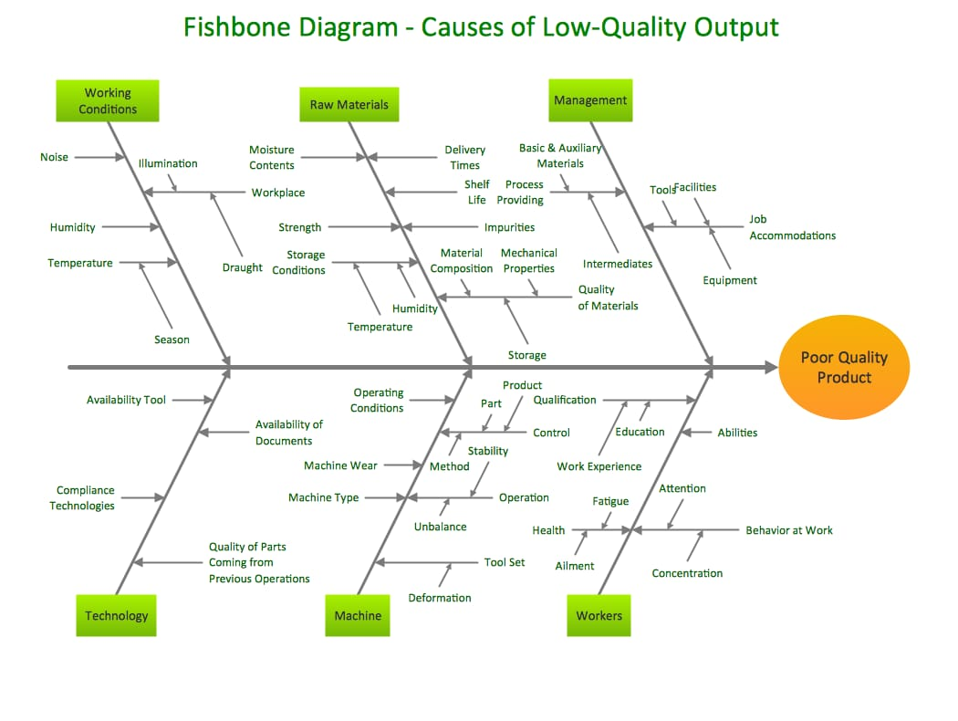
We can now look at the most likely reasons more thoroughly depending on how complicated and significant the issue is. This could entail planning investigations, conducting surveys, etc. These will be made to see which of these potential factors is really causing the issue.

SWOT analysis,
Beauty salons and clinics operate in a highly competitive industry with numerous clients. As a result of the variety and constant changes in the industry, salons and clinics need to adopt an aggressive and strategic strategy. The SWOT analysis is a tool that can be used to develop these plans. Businesses, especially beauty salons, can use this tool to identify their strengths and categorise their weaknesses. It is important to note that a salon or clinic with a large clientele list will demonstrate effective marketing, efficient operations, and good client management. However, a thorough examination will reveal the reasons for such strengths. Salons may have things such as skilled staff and a busy location as their main strengths.
Salon and clinic register receipts can sometimes reveal weaknesses. For example, inadequate beauty and laser training, and poor customer service can impede but not eliminate revenue. Identifying your salon's or clinic's deficiencies is the first step to creating strategic adjustments. While completing this part, it is important to remain objective. The lack of merchandise is one weakness, while locating the right site with ample parking and room is another.
As a part of the SWOT analysis, opportunities and threats are analyzed for the salon's external components, whereas strengths and weaknesses are analyzed for the salon and clinic. Salons may have a number of opportunities due to the constantly changing hair trends and styles. It is possible to attract new clients and expand the salon's inventory by adding more sophisticated therapies, product lines, and brands. Salons and clinics are susceptible to threats that threaten their existence. These include new competitors and changes to the rules and legislation governing the industry. It is important for salons to recognize threats in order to develop tactical adjustments to address upcoming challenges even though many of these risks are unavoidable. New salons opening in the area, for example, can negatively affect a salon's clientele. Despite the fact that you can't physically relocate your new salon, you can come up with creative ways to keep your clientele, attract new ones, and fend off your competitors. By offering new procedures and technology, as well as new deals and promotions, the salon may be able to showcase its clients' benefits.
Pestle analysis,

Because skin and personal care products are frequently regarded as luxury items and are thus not the top priority of customers, economic and political problems in the UK and other EU nations will have a huge impact on this industry.
The withdrawal terms are currently being negotiated in the UK in light of the UK's decision to leave the EU (Brexit). These terms will undoubtedly affect the British political, economic, and legal system as well as the cosmetics industry in the UK and the communication rules.

economic variables
According to a study by Grand View Research, Inc., consumers in the UK have a propensity to spend slightly more on cosmetics and use them up completely. Customers might spend less on beauty items given that the global economic growth rate was predicted to be 2.7% in 2017 and the UK's economic growth rate stayed at 2% (World Bank, 2017).
Online retailing has thrived since the advent of the digital revolution and technological advancement (Margherio, D., Cooke, & Montes), necessitating P&G's investment in online retailing and advertising.
In the skin care and cosmetics market, young and middle-aged people make up the majority of clients. Millennials and Generation X will take the place of Baby Boomers as the primary target market for P&G's skincare and cosmetics products. Communication preferences, product tastes, and product preferences differ between these generations.
Customers are searching for goods that best match their skin types in terms of colours, tones, and substances as they grow more concerned with the traits and qualities of their skin. Additionally, products with little to no preservatives or chemicals, such as those produced with aloe vera and coconut, have become very popular. P&G should cover these in its lines of communication to its customers.
technical aspects
New shopping locations emerge as a result of technological advancement. There are many new internet retailers that swiftly capture a market share. For instance, Amazon became the most valued retail location in the US in 2015 thanks to its extensive section selling beauty and health products (Cheng, 2016). Customers now have more resources to find information and evaluations about a product and a company thanks to the growth of the Internet. These changes result in new communication options and platforms.
The ethical concerns over a company's socio-environmental consequences as well as awareness of green consumerism are expanding. Particularly, businesses that are seen as eco-friendly and ecologically conscious are more likely to get positive client feedback and uphold a positive public image (OECD, 2012).
social influences
Millennials and Generation X will replace Baby Boomers as the primary target market for P&G's skincare and cosmetics as they retire. Young and middle-aged people make up the majority of consumers in skin care and cosmetics. These generations have different tastes and preferences, as well as different ways of communicating.
Customers are searching for goods that best match their skin types in terms of colours, tones, and substances as they become more concerned about the traits and qualities of their skin. Additionally, goods manufactured with minimal to no preservatives or chemicals from natural ingredients like aloe vera and coconut have become very popular. P&G should be clear and concise in its customer communications.

legal aspects

For cosmetic products to be safe for customers, the UK Cosmetic Product Regulation specifies safety requirements. Branding and labeling guidelines require businesses to accurately label products with information such as ingredients, expiration dates, warnings, and safety instructions. Development plan and adkar model,
Personal development plans for salon employees.
The Salon Employee Personal Development Plan (PDP) is intended to document the important areas of learning and professional development on which you and your salon employees have agreed, as well as how these learning needs will be met.
The Salon Employee Systematic Approach is your way to increasing employee profitability and productivity -via- a method of Training Needs which follows a simple to apply staff appraisal system.
ADKAR
Awareness: Leading people to see the need for change.
Desire: Instilling the desire for change.
Knowledge: Providing employees with the information or skills they need to achieve change.
Ability: Applying knowledge and skills to bring about change.
Reinforcement: Making sure that people continue to use the new methods.

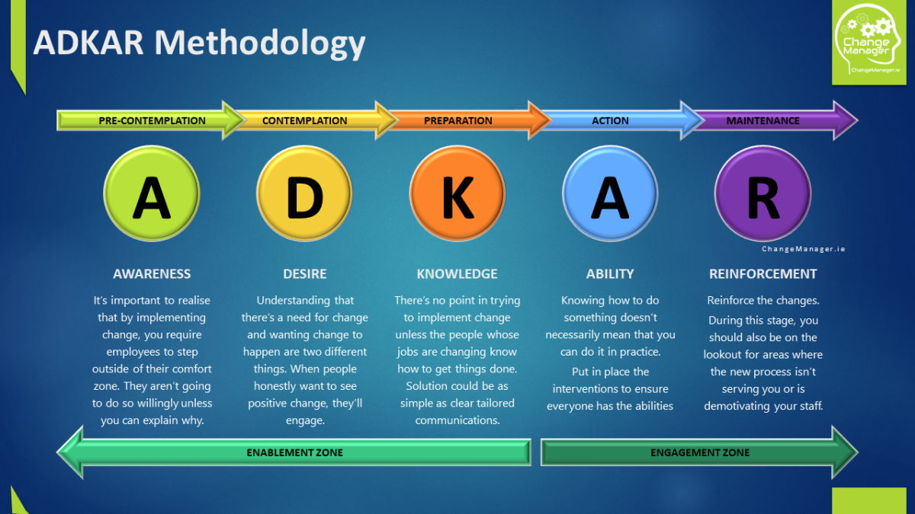
Conclusion,
This report accurately described the various methods for locating, analysing, and assessing complex issues in order to develop solutions and plans for resolving them. It also gave readers access to review and keep track of the solutions as they were being implemented.
The complicated issue that was examined was employee unhappiness at work, and the remedies put into place were based on cause and effect, pestle and swot analysis, methodologies tools that support decision-making and problem-solving.
The formulated plan encompasses all levels of internal and external stakeholders and gives voice to feedback from external stakeholders to guarantee successful implementation of the plan.
Your salon's goals and purpose statement should be included in your executive summary. Use it to draw a broad picture. Your company's secrets to success should be included in the summary. You'll need a skilled workforce, for instance, that can offer excellent customer service.

References,
https://www.thehumancapitalhub.com/articles/The-Adkar-Model-Of-Change-The-Ultimate-Guide-To-Leading-Organisational-Change
https://www.mindtools.com/pages/article/newTMC_03.htm#:~:text=Cause%20and%20Effect%20Analysis%20gives,ones%20that%20are%20most%20obvious
http://www.fullcolumn.co.uk/salon/hairdresser-personal-development-plan.html
https://sites.ualberta.ca/~yreshef/orga432/fishbone.html
https://www.mindtools.com/pages/article/newTMC_03.htm

