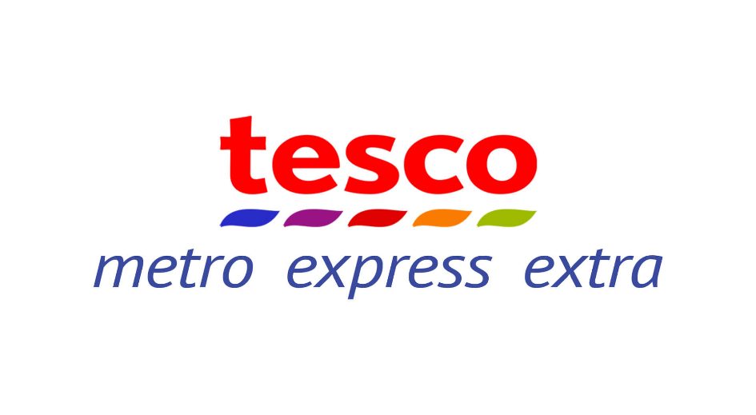
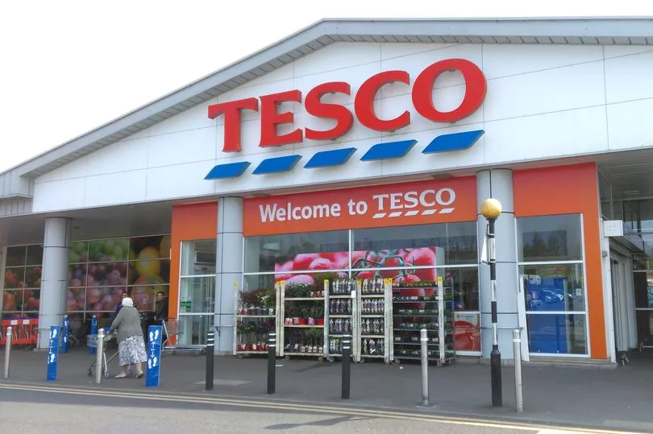
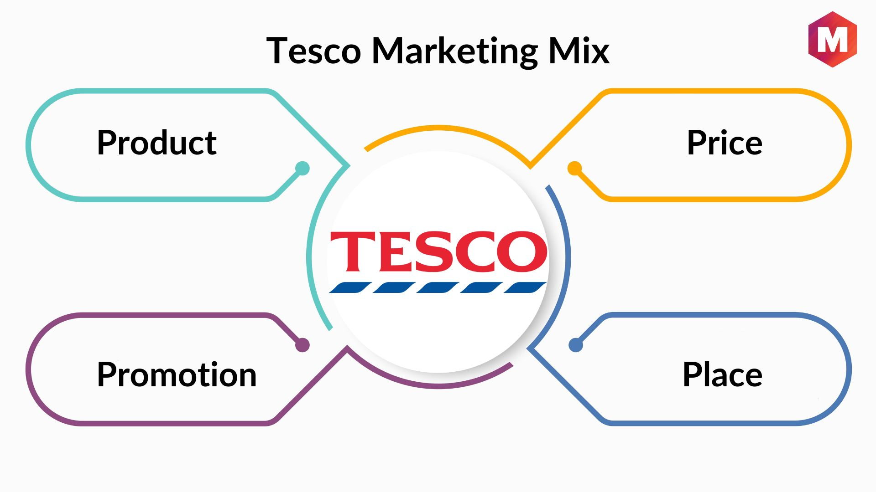


Abstract
This report analyzes Tesco's current and future marketing plans to address the growing demand for plant-based foods through a comprehensive marketing plan. And leveraging its strengths in brand awareness, distribution network and customer loyalty programmes, Tesco aims to increase market share in the plant-based food sector through the implementation of targeted marketing strategies, product innovation and sustainability initiatives. And gave some suggestions for Tesco in the future.

Tesco’s marketing plan

ZhanWen Zhang 2300488
BMBM6016
Strategic Marketing

Directory
Executive Summary 3
1.0 Introduction 4
2.0 Main Findings 5
2.1 Situation Analysis 5
2.2 Objectives 6
2.3 Strategy 8
2.4 Tactics 9
2.5 Actions 10
2.6 Control 11
3.0 Recommendations 13
4.0 Conclusions 14
Reference List 15

Executive Summary
Tesco is embarking on a strategic marketing plan to capitalize on growing consumer demand for plant-based foods. Tesco is focused on increasing market share in this emerging segment, aiming to leverage its brand recognition, distribution network and customer loyalty programs to drive growth and profitability.

The marketing plan covers a multi-faceted approach, including expanding the range of plant-based products, enhancing digital marketing and e-commerce capabilities, and strengthening Tesco’s commitment to sustainability and corporate social responsibility. Through targeted marketing strategies, product innovation and sustainability initiatives, Tesco is committed to meeting changing customer needs while driving positive social and environmental impact.

By implementing these strategies and closely monitoring performance indicators such as sales, market share and customer satisfaction, Tesco aims to achieve its goal of increasing market share in the plant-based food sector while delivering long-term value to its stakeholders.

1.0 Introduction
The purpose of a marketing plan is to outline the strategies and tactics a business will use to market its products or services to its target audience. A complete marketing plan has several important functions such as Setting Goals, Allocating Resources, Creating a Roadmap, Coordinating Efforts, Measuring Success, Adapting to Changes, and Understanding the Market. Overall, a marketing plan provides a structured approach to achieving marketing goals, guides decision-making, and maximizes the effectiveness of marketing efforts.

SOSTAC is a strategic planning framework that stands for Situation Analysis, Objectives, Strategy, Tactics, Action, and Control. SOSTAC is often used in marketing to guide the development of marketing plans and activities. (Kotler，2016)

SMART are part of every aspect of business and provide a sense of direction, motivation, a clear focus, and clarify importance. SMART goals are used to help businesses guide goal setting. SMART is an acronym that stands for Specific, Measurable, Achievable, Realistic, and Timely. (Porter，2008）

2.0 Main Findings

2.1 Situation Analysis
Internal Factors (Strengths and Weaknesses):

1. Strengths:

1.1 Tesco's strong brand recognition and reputation.
1.2 Tesco has an extensive store network and distribution channels.
1.3 Tesco's diverse products include groceries, clothing, electronics and financial services.
1.4 Investment in technology for online shopping and delivery services has deepened customers' dependence on Tesco.

2. Weaknesses:

2.1 Tesco is considered to be more expensive than discount supermarkets.
2.2 Tesco has limited presence in certain areas, especially international areas.
2.3 Potential issues with supply chain management and product quality control.
2.4 Tesco relies too much on traditional retail models and is slow to adapt to e-commerce trends.

External Factors (Opportunities and Threats):

1. Opportunities:
1.1 Growing demand for online shopping and home delivery services.
1.2 Expansion into new markets, both domestically and internationally.
1.3 Potential for partnerships with local suppliers to promote sustainability and local sourcing.
1.4 Introduction of innovative products and services to meet evolving consumer preferences.
1.5 Emphasis on sustainability and corporate social responsibility initiatives to appeal to environmentally conscious consumers.

2. Threats:
2.1 Intense competition from online retailers such as Amazon and discount supermarkets like Aldi and Lidl.
2.2 Economic uncertainty and fluctuations in consumer spending habits.
2.3 Regulatory changes affecting the retail industry, such as food safety regulations or labor laws.
2.4 Revenue declines due to global events such as epidemics or natural disasters..
2.5 Potential negative publicity or brand damage due to issues related to product quality, ethical sourcing, or corporate governance.

Discussion of TESCO's Current Stage:

Based on the TOWS analysis, TESCO is currently in a challenging but opportune position. It has strong brand recognition and an established customer base, but it faces stiff competition from both traditional and online retailers. TESCO's strengths in its brand, distribution network, and loyalty programs provide a solid foundation for growth, but it needs to address weaknesses such as price perception and adaptability to e-commerce trends. (Setiawan，2016)

There are significant opportunities for TESCO to capitalize on, including the growing demand for online shopping, expansion into new markets, and the emphasis on sustainability. However, it must also be mindful of threats such as intense competition, economic uncertainty, and regulatory challenges. (Wind, 2018)

Overall, TESCO is at a stage where it needs to leverage its strengths, address weaknesses, seize opportunities, and mitigate threats to maintain and enhance its market position in an increasingly competitive retail landscape. This may involve strategic investments in e-commerce capabilities, product innovation, customer experience enhancements, and sustainability initiatives. (Wilson，2011)

2.2 Objectives
SMART Analysis for Tesco's Marketing Goal:

1.Objective
Increase online grocery sales by 25% within the next year in order to capture a larger share of the growing e-commerce market and enhance customer convenience.

2.Specific
The objective is clearly defined as increasing online grocery sales specifically, rather than overall sales or market share. It focuses on a specific aspect of Tesco's business strategy.

3.Measurable
The goal of a 25% increase in online grocery sales is measurable using sales data from Tesco's online platforms. This allows for tracking progress and assessing the effectiveness of marketing initiatives and operational improvements.

4.Achievable
With the growing trend of online shopping, coupled with Tesco's existing infrastructure and investments in e-commerce technology, a 25% increase in online grocery sales within a year is achievable.

5.Relevant
The goal aligns with Tesco's strategic focus on adapting to changing consumer preferences and leveraging technology to enhance customer experience. It addresses the shift towards online shopping and positions Tesco as a leader in the e-commerce space.

6.Time-bound
The timeframe of one year provides a clear deadline for achieving the goal, creating a sense of urgency and accountability. It allows for regular monitoring and adjustment of strategies to ensure progress towards the target.

If Tesco's strategic marketing objectives are successfully implemented, the successful achievement of this marketing objective will not only benefit Tesco, but also the wider supermarket industry, driving market growth, improving customer convenience, enhancing competitive advantage and improving operational efficiency. (Westwood，2013)

1. Market Growth
By increasing online grocery sales, Tesco and other supermarket chains contribute to the overall growth of the e-commerce market. This creates new opportunities for revenue generation and expansion within the industry.

2. Customer Convenience
The convenience of online shopping for groceries attracts more consumers, including those who may not have previously considered supermarket chains for their grocery needs. This leads to increased customer satisfaction and loyalty.

3. Competitive Advantage
By capturing a larger share of the e-commerce market, Tesco and other supermarket chains strengthen their competitive position against online retailers and other grocery delivery services. This helps them retain existing customers and attract new ones.

4. Operational Efficiency
Increased online sales can lead to greater operational efficiency for Tesco and other supermarket chains, as they optimize their supply chain, logistics, and inventory management processes to meet the demands of online customers. This efficiency improvement can translate into cost savings and higher profitability. (Wind, 2002)

2.3 Strategy
1. Ansoff's Growth Matrix:

Product Development
Tesco can innovate and introduce new plant-based products to cater to evolving consumer tastes and preferences. This could include collaborating with suppliers to develop unique plant-based alternatives to meat, dairy, and other animal products, as well as investing in research and development to create innovative formulations and packaging. (Mintzberg，2008)

2. Porter's Generic Strategies:

2.1 Differentiation
Tesco can differentiate its plant-based offerings from competitors by emphasizing factors such as quality, taste, variety, and sustainability. This involves partnering with reputable suppliers known for their high-quality plant-based ingredients, offering a diverse range of options to cater to different dietary preferences and restrictions, and promoting the environmental benefits of choosing plant-based foods.

2.2 Cost Leadership
Tesco can leverage its scale and purchasing power to offer competitive pricing on plant-based products, making them accessible to a wider range of consumers. This involves negotiating favorable deals with suppliers to lower production costs, optimizing supply chain and distribution processes to reduce overhead expenses, and passing on the savings to customers through affordable pricing strategies.

3. Segmentation, Positioning, and Positioning Strategies:

3.1 Segmentation
Tesco can segment the market for plant-based foods based on demographic factors such as age, gender, income, and lifestyle preferences. This allows Tesco to tailor its product offerings, marketing messages, and promotions to appeal to specific customer segments, such as millennials, vegetarians, vegans, health-conscious individuals, and environmentally conscious consumers.

3.2 Positioning
Tesco can position itself as a one-stop destination for plant-based foods, offering a wide variety of options to meet the diverse needs and preferences of its target audience. This involves creating a dedicated section within stores for plant-based products, prominently displaying signage and marketing materials to educate and inform customers about the benefits of choosing plant-based foods, and providing personalized recommendations and guidance to help customers make informed purchasing decisions.

3.3 Positioning Strategies
Tesco can employ various positioning strategies to differentiate its plant-based offerings from competitors and create a unique value proposition. This includes emphasizing factors such as freshness, convenience, affordability, taste, health benefits, and sustainability. Tesco can also leverage its reputation as a trusted retailer with a commitment to quality and customer satisfaction to build trust and loyalty among plant-based consumers. (Aaker，2017)

2.4 Tactics
1. Product:
Tesco conducts market research to identify popular plant-based food categories and emerging trends. Work with suppliers to develop a variety of high-quality plant-based products, including meat alternatives, dairy alternatives, plant-based snacks and ready-to-eat meals. Ensure product labels clearly highlight key attributes such as vegan, organic, non-GMO and sustainably sourced ingredients to appeal to environmentally conscious consumers. (Knox, 2003)

2. Price:
Tesco analyzes the pricing strategies of competitors in the plant-based food sector to ensure Tesco's pricing is competitive. Offer competitive prices for plant-based products to appeal to price-sensitive consumers while maintaining profits. Implement promotional pricing strategies such as discounts, BOGO offers, and loyalty rewards to incentivize trial and repeat purchases.

3. Place:
Tesco optimizes distribution channels for plant-based products, ensuring availability in both physical stores and online platforms.
Strategically allocate shelf space within the store, place plant-based products in high-traffic areas, and create dedicated areas to increase visibility and accessibility. Expand online delivery options for plant-based products with convenient delivery or click-and-collect service to meet the needs of busy consumers.

4. Promotion:
Tesco launches targeted marketing campaign to raise awareness and drive demand for Tesco’s plant-based products. Leverage various marketing channels such as social media, email marketing, influencer partnerships, and digital advertising to reach your target audience. Highlight the health, environmental and ethical benefits of choosing plant-based foods through educational content, testimonials and user-generated content.

5. People:
Tesco trains staff to understand plant-based products and dietary preferences, enabling them to provide customers with personalized advice and assistance. Create a positive shopping experience for consumers by hiring employees who are passionate about sustainability and plant-based living.

6. Process:
Tesco streamlines the ordering and delivery process for plant-based products, ensuring timely and accurate fulfillment of online orders. Implement quality control measures to maintain product freshness and consistency across all stores and distribution channels. Continuously monitor and optimize processes for plant-based products to increase efficiency and customer satisfaction.

7. Physical Evidence:
Tesco creates visually appealing displays and signage for plant-based products to increase their visibility and appeal in-store. (Jain,2017) Use packaging design to communicate Tesco’s commitment to sustainability and environmental responsibility. Collect and display customer ratings and reviews to provide social proof of the quality and satisfaction of Tesco's plant-based products. (Day，2011)

2.5 Actions
1. Training and Education:
Tesco offers a comprehensive training program to educate staff about plant-based foods, including product knowledge, nutritional information and cooking techniques. And customer service skills training courses are provided, including effective communication, active listening and problem solving, to ensure employees can assist customer inquiries and provide personalized advice. Incorporate sustainability training to educate staff on Tesco’s commitment to environmental responsibility and the importance of promoting plant-based options.

2. Clear Communication and Expectations:
Tesco clearly communicates to all employees the company’s goals, objectives and expectations related to increasing market share in the plant-based food sector. And provide regular updates and feedback to keep employees informed of progress against goals and any changes in strategy or tactics.

3. Recognition and Rewards:
Tesco recognizes and rewards employees who excel in promoting and selling plant-based products through incentives, bonuses or employee recognition schemes. and celebrate the team’s successes and milestones in growing market share in plant-based foods, fostering camaraderie and motivation among employees.

4. Feedback Mechanisms:
Tesco implements feedback mechanisms such as suggestion boxes, employee surveys or regular team meetings to gather employees’ opinions and insights about their experiences, challenges and ideas for improvement. Actively listen to employee feedback and incorporate their suggestions into the decision-making process to increase employee engagement and satisfaction.

5. Continuous Learning and Development:
Tesco encourages employees to seek ongoing learning and development opportunities related to plant-based foods, sustainability and customer service through workshops, seminars, online courses and certifications. Provide ongoing coaching and mentoring to support employees' professional growth and career development within Tesco. (Chaffey, 2013)

By implementing these actions, Tesco can ensure that its employees are well-equipped to deliver effectively and contribute to the achievement of its goal of increasing market share in the plant-based food segment. Empowered and knowledgeable employees play a vital role in providing exceptional customer service, driving sales, and building long-term relationships with customers. (Cravens，2008)

2.6 Control
1. Monitoring and Evaluation:
1.1Regularly monitor sales volumes of plant-based products across all stores and online platforms to track progress towards the goal of increasing market share.
1.2 Evaluate the effectiveness of marketing initiatives, promotions, and product offerings in driving sales and market penetration in the plant-based food segment.
1.3 Conduct regular reviews of customer feedback, satisfaction scores, and reviews related to plant-based products to identify areas for improvement and address any concerns or issues promptly. (Lilien, 2013)

2. Measurement Metrics:
2.1 Sales Volumes: Track the volume of sales for plant-based products on a weekly, monthly, and quarterly basis to assess performance trends over time.
2.2 Market Share: Measure Tesco's market share in the plant-based food segment relative to competitors using market research data and industry reports.
2.3 Customer Acquisition: Monitor the number of new customers purchasing plant-based products at Tesco stores or online platforms to gauge the effectiveness of marketing efforts in attracting new consumers.
2.4 Customer Retention: Track the frequency of repeat purchases and customer loyalty among plant-based shoppers to assess the success of retention strategies and customer satisfaction levels.
2.5 Basket Analysis: Analyze shopping basket data to understand purchase patterns, cross-selling opportunities, and the impact of plant-based products on overall sales and customer behavior.

3. Key Performance Indicators (KPIs):
3.1 Percentage Increase in Market Share: Set a target percentage increase in Tesco's market share in the plant-based food segment over the specified timeframe (e.g., 12 months).
3.2 Growth Rate of Plant-Based Product Sales: Establish a target growth rate for sales volumes of plant-based products, measured as a percentage increase over the previous period.
3.3 Customer Conversion Rate: Measure the percentage of customers who purchase plant-based products after interacting with marketing campaigns or promotions.
3.4 Customer Satisfaction Score: Implement customer satisfaction surveys to measure satisfaction levels among customers purchasing plant-based products and track improvements over time.
3.5 Return on Investment (ROI): Calculate the ROI of marketing initiatives and promotional campaigns related to plant-based products to assess their effectiveness in driving sales and achieving business objectives. (Westwood, 2013)

4. Frequency of Measurements:
Sales volumes and market share should be monitored on a regular basis, such as weekly or monthly, to track performance trends and make timely adjustments to strategies and tactics.Customer satisfaction scores and other customer-related metrics can be measured periodically, such as quarterly or semi-annually, to capture feedback and assess improvements in customer experience.KPIs should be reviewed and evaluated regularly in conjunction with strategic goals and objectives to ensure alignment and progress towards achieving desired outcomes. (Grant，2019)

3.0 Recommendations
1. Tesco could expand further into plant-based foods

1.1 Given the growing consumer demand for plant-based products, Tesco can continue to expand its offerings in this category by introducing new and innovative plant-based alternatives across various food segments, including meat, dairy, snacks, and ready-to-eat meals.
1.2Tesco can collaborate with suppliers to develop exclusive plant-based product lines and brands, offering unique and differentiated options to attract customers and build brand loyalty.

2. Tesco could enhance digital marketing and e-commerce capabilities

2.1Tesco can invest in enhancing its digital marketing strategies and e-commerce capabilities to capitalize on the increasing trend of online grocery shopping.
2.2Implement targeted digital marketing campaigns to promote plant-based products to online consumers, leveraging data analytics and personalized recommendations to drive sales and customer engagement.
2.3Continuously improve the online shopping experience through website optimization, mobile app enhancements, and streamlined checkout processes to make it easier and more convenient for customers to purchase plant-based products online. (Dave, 2011)

3. Tesco’s sustainability initiatives and corporate social responsibility (CSR)

3.1Tesco can strengthen its commitment to sustainability and CSR by further promoting plant-based options as part of its efforts to reduce environmental impact and promote ethical sourcing practices.
3.2Communicate Tesco's sustainability initiatives and ethical sourcing practices to consumers through marketing campaigns, packaging labels, and in-store signage to raise awareness and reinforce Tesco's brand values. (Hooley, 2016)

By implementing these strategic marketing initiatives, Tesco can further strengthen its position as a leader in the plant-based food segment, drive growth and profitability, and contribute to the overall sustainability and well-being of its customers and the planet. (McDonald, 2011)

4.0 Conclusions
In conclusion, Tesco's strategic marketing efforts are poised to capitalize on the growing demand for plant-based foods, positioning the company for continued growth and success in the ever-evolving retail landscape. By leveraging its strengths in brand recognition, extensive distribution network, and customer loyalty programs, Tesco aims to increase market share in the plant-based food segment through targeted marketing strategies, product innovation, and sustainability initiatives.

Moving forward, Tesco will continue to monitor performance metrics, such as sales volumes, market share, customer satisfaction, and sustainability initiatives, to track progress towards its goals and make data-driven decisions to optimize marketing strategies and achieve desired outcomes. By staying agile, responsive, and customer-centric, Tesco remains well-positioned to maintain its leadership in the retail industry and drive long-term value for its stakeholders, while contributing to a healthier, more sustainable future for all.

Reference List
- Kotler, P., & Keller, K. L. (2016). Marketing Management (15th ed.). Pearson Education Limited.

- McDonald, M., & Wilson, H. (2011). Marketing Plans: How to Prepare Them, How to Use Them. John Wiley & Sons.

- 10. Grant, R. M. (2019). Contemporary Strategy Analysis: Text and Cases Edition. Hagen Verlag

- 10. Greenley, G. E., & Hooley, G. J. (2002). Market segmentation and customer focus. Routledge.

- Porter, M. E. (2008). Competitive Strategy: Techniques for Analyzing Industries and Competitors. Free Press.

- Westwood, J. (2013). How to Write a Marketing Plan. Kogan Page Publishers.

- Chaffey, D., & Smith, P. R. (2013). Emarketing Excellence: Planning and Optimizing your Digital Marketing. Routledge.

- Setiawan, P., Kartajaya, H., & Kotler. (2016). Marketing 4.0: Moving from Traditional to Digital. John Wiley & Sons.

- Jain, S. C. (2017). Marketing Planning and Strategy. South-Western Cengage Learning.

- Wilson, H. (2011). Marketing Plans: How to Prepare Them, How to Use Them. John Wiley & Sons.

- Hooley, G., Piercy, N. F., & Nicoulaud, B. (2016). Marketing Strategy and Competitive Positioning. Pearson.

- Westwood, J. (2013). How to Write a Marketing Plan. Kogan Page Publishers.

- Dave, C. (2011). Marketing Management: Text and Cases. Pearson Education India.

- Mintzberg, H., Ahlstrand, B., & Lampel, J. (2008). Strategy Safari: A Guided Tour Through the Wilds of Strategic Management. FT Press.

- Aaker, D. A., & Moorman, C. (2017). Strategic Marketing Management (11th ed.). John Wiley & Sons.

- Lilien, G. L., Rangaswamy, A., & De Bruyn, A. (2013). Principles of Marketing Engineering and Analytics. DecisionPro.

- Day. (2011). Market-Driven Strategy: Processes for Creating Value. Harvard Business Press.

- Knox, S., & Bickerton, D. (2003). The six conventions of strategic marketing planning: A framework. European Journal of Marketing, 37(1/2), 52-86.

- Cravens, D. W., & Piercy, N. (2008). Strategic Marketing (9th ed.). McGraw-Hill Education.

- Wind, Y. (2018). Beyond advertising: Creating value through all customer touchpoints. Journal of Advertising Research, 58(2), 113-116.

