
Applied Leadership and Management in the Workplace
Module Assignment Submission

Student Name: | Whitney Davies
Student Number: | 2329046
Module No: | BMSK5014
Module Title: | Project Management
Statement of Confirmation of Authenticity
By the act of making this submission, the student declares that this is the work of the student named above. The work has not, in whole or in part, been knowingly presented elsewhere for assessment, or where assessment has been built on a previous assessment, this has been identified. Where materials have been used from other sources it has been properly acknowledged. If this statement is untrue, the student acknowledges that an assessment offence has been committed.
Attention is drawn to the plagiarism and unfair practice policies of UWTSD.

Table of Contents
Introduction 5
Purpose of the Report 5
Overview of the Project Selected 5
Defining the Project Concept 6
Description and Objectives of the Project 6
Business Case and Strategic Fit 6
Alternative Option – Do Nothing 7
Stakeholder Identification and Prioritisation 7
Stakeholder Engagement Strategy 8
Ethical and Legal Considerations 9
Applying Project Management Methodologies 9
Overview of Methodologies 9
Comparison of Methodologies 9
Justification for Methodology Chosen 10
Project Governance and Role Allocation 10
Organisational Readiness and Project Maturity 10
Critical Success Factors for Projects 10
Project Planning 11
Defining Scope, Deliverables and Constraints 11
Scope 11
Key Deliverables 11
Constraints 11
Work Breakdown Structure 11
Gantt Chart 11
Communication Planning and Information Flow 13
Risk and Change Management 14
Risk Identification and Categorisation 14
Risk Assessment Tools 14
PESTLE Analysis 14
SWOT Analysis 15
Risk Mitigation and Response Planning 15
Change Control and Scope Creep 16
Managing Change Resistance and Stakeholder Impact 16
Project Execution and Monitoring 16
Execution Plan and Delivery Strategy 16
Progress Monitoring 16
Quality Assurance and Control 17
Project Performance Monitoring 17
Project Closure and Evaluation 17
Final Deliverables and Handover 17
Benefits Realisation and Success Evaluation 17
Lessons Learned and Organisational Learning 17
Post-Implementation Review 17
Critical Reflection 18
Personal Reflection on PM Capabilities 18
Use of Reflection Models 18
Challenges Faced and Lessons Learned 18
Professional Development Plan 18
Conclusion 18
References 20
Appendix 1 21
Appendix 2 22
Appendix 3 23

Introduction

Purpose of the Report
This report examines project management tools, processes, and techniques, and how they support successful project delivery. It compares widely used approaches, including PRINCE2 and Agile, and applies them to a workplace project introducing artificial intelligence (AI) in an auditing context. The report considers how these methods manage change, stakeholders, risk, and resources across the full project lifecycle, from concept and planning through to execution, monitoring, and closure. It concludes with a critical reflection on my development as a project manager, demonstrating how structured approaches can enhance delivery in professional practice.

Overview of the Project Selected
The project selected involves introducing artificial intelligence (AI) into an auditing firm to automate repetitive tasks, enhance data analysis, and improve decision-making. This aims to reduce manual workload and maintain competitiveness in a rapidly changing industry. Challenges include data privacy, staff training, and potential resistance from employees, making it a strong case for applying structured project management methods. Its complexity provides scope to evaluate planning, stakeholder engagement, risk management, and my own project management capability.

Defining the Project Concept

Description and Objectives of the Project
The aim of this project is to deliver and integrate an artificial intelligence (AI) solution that automates specific aspects of the auditing process, particularly those that are highly repetitive and data intensive. These include transaction testing, exception identification, and basic compliance checks.
The project’s objectives are to:
- Select and implement a suitable AI platform tailored to the firm’s audit environment
- Reduce manual audit processing time by at least 30% within the first year
- Improve accuracy in audit data analysis and anomaly detection
- Ensure full compliance with data protection laws (e.g., UK GDPR) during implementation
- Support staff through appropriate training and change communication
These objectives are designed to meet the organisation’s broader goal of becoming a more data-driven, efficient, and competitive audit provider. The project is time-limited, cost-sensitive, and will be structured around a defined lifecycle using formal project management tools.

Business Case and Strategic Fit
The business case centres on improving efficiency, accuracy, and client value in auditing. Manual processes create delays and risks of error, while AI offers opportunities for automation and more reliable data analysis. According to Jobin, Ienca, and Vayena (2019), AI adoption is becoming critical in sectors where compliance and transparency are essential, while Brynjolfsson and McAfee (2017) highlight its potential to deliver efficiency gains but also caution against workforce disruption.
Alignment with organisational strategy is also essential. The Project Management Institute (2017) notes that projects succeed when they clearly support strategic goals. In this case, the initiative underpins wider digital transformation objectives, positioning the firm to remain competitive in a rapidly evolving industry.
Financially, the project requires upfront investment in software licences, training, and integration. However, Cadle and Yeates (2008) argue that robust business cases consider both direct and indirect benefits. A five-year cost–benefit analysis shows that although initial costs are significant, efficiency gains, reduced manual workload, and improved client retention outweigh them. The benefit–cost ratio of 8.7 demonstrates strong financial justification.
Non-financial benefits also strengthen the case. Staff engagement improves when repetitive work is reduced, while clients benefit from faster and more insightful audits. Kerzner (2017) emphasises that projects with strong alignment between leadership and operational teams are more likely to succeed, and this alignment is already in place. However, the “do nothing” option, while avoiding disruption, would risk missed opportunities for efficiency, compliance, and client satisfaction, leaving the organisation strategically vulnerable.
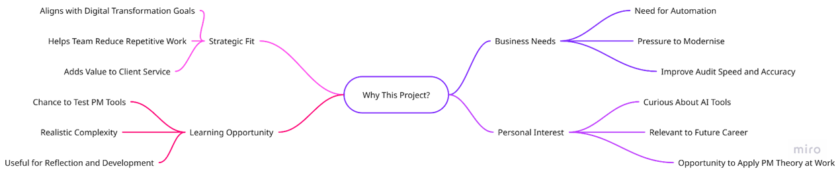
Figure 1: Rationale for Selecting the AI Audit Project (Source: Author’s own analysis)
Figure 1 shows the rationale for adopting AI, highlighting its role in improving efficiency, enhancing client service, and supporting long-term digital transformation.
To strengthen the financial justification, a five-year cost–benefit analysis was prepared. This analysis compares the estimated investment in software licensing, staff training, and internal resource time with the expected financial returns from reduced labour costs, fewer errors, and improved client retention.
Figure 2: Cost–Benefit Summary for AI Implementation (Source: Author’s own analysis)
The cost–benefit analysis illustrates that while AI adoption requires significant upfront investment, the long-term benefits in efficiency, client value, and staff development outweigh the costs over time.
In addition to the net benefit, the benefit–cost ratio (BCR) over the five-year period is estimated at 8.7, meaning that for every £1 invested the firm gains approximately £8.70 in value. This further strengthens the financial justification and confirms the project’s sustainability at enterprise scale.
Finally, Kerzner (2017) explains that strong alignment between leadership, operational teams, and project goals is a critical success factor. This alignment is already in place within the firm, which increases the likelihood that the AI implementation will deliver lasting value and strengthen the firm’s competitive position in the audit market.

Alternative Option – Do Nothing
An alternative option is to take no action and continue operating with the current audit processes and service offerings. This would avoid upfront investment and disruption, but it would also mean the organisation misses opportunities to improve efficiency, strengthen compliance, and enhance client value.

Stakeholder Identification and Prioritisation
Effective stakeholder management is one of the critical success factors for any project. According to Bourne (2015), stakeholders hold varying degrees of influence and interest, and their expectations can shape project outcomes. Therefore, identifying and analysing stakeholders is a necessary step in ensuring that communication, engagement, and resource allocation are aligned with project goals.
For this project, stakeholders have been identified both internally and externally, reflecting the wide scope of an AI adoption initiative in an auditing firm:
- Internal stakeholders include senior leadership, IT specialists, audit managers, frontline auditors, compliance teams, HR and training departments, and wider employee groups.
- External stakeholders include technology vendors, regulators, clients, and other suppliers with indirect links to the business.
To assess the importance of these groups, Mendelow’s (1991) power–interest grid has been applied. This framework helps categorise stakeholders based on their level of influence over project decisions (power) and their level of interest in the project’s outcomes.
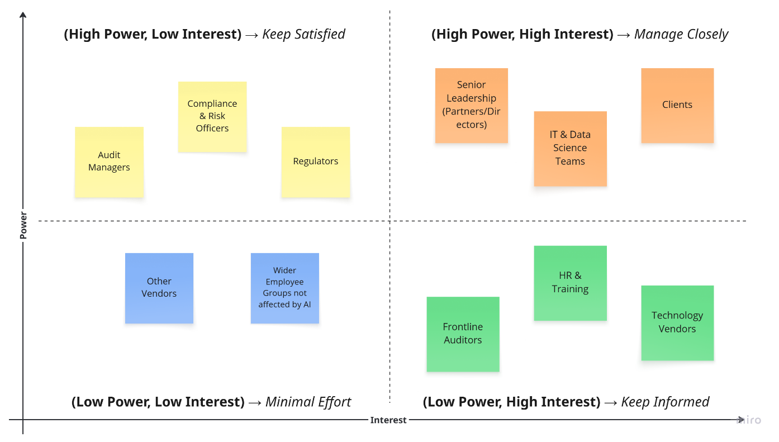
Figure 3: Stakeholder Analysis (Source: Author’s own analysis)
The grid shows that senior leadership, IT, and clients must be managed closely due to their high power and interest, while other groups require proportionate engagement to support project success.

Stakeholder Engagement Strategy
Having identified key stakeholders, it is essential to establish a proportionate engagement strategy. Freeman (1984) defines stakeholders as those who can affect or be affected by a project, while Bourne (2015) stresses that engagement must evolve as expectations change. Mendelow’s (1991) power–interest grid offers a useful framework to prioritise groups, but it can oversimplify dynamic relationships since stakeholder influence may shift over the lifecycle.
- Manage Closely – Senior Leadership and Clients
These stakeholders hold both high power and high interest. Regular reporting, steering committees, and pilot demonstrations will ensure their confidence. However, Kerzner (2017) cautions that over-involvement of leadership can slow decision-making, so engagement will focus on strategic rather than operational issues.
- Keep Satisfied – Audit Managers, Compliance Officers, Regulators
These groups possess high influence but narrower interest. Updates will provide assurance of compliance and alignment with professional standards. While Mendelow’s model categorises them as passive, in practice regulators can quickly escalate their influence, requiring proactive consultation.
- Keep Informed – Frontline Auditors, HR, Technology Vendors
These stakeholders have strong interest but less strategic power. Training and feedback opportunities will reduce resistance and improve adoption, consistent with Kotter’s (1996) emphasis on participation in change. Nonetheless, as Brynjolfsson and McAfee (2017) note, staff may view automation as threatening, so engagement must highlight AI’s supportive rather than replacement role.
- Minimal Effort – Other Vendors, Wider Employees
These groups have low power and interest. General updates ensure transparency without overuse of resources. Yet Bourne (2015) observes that neglecting even low-priority groups can create “hidden resistance,” so periodic communication will still be maintained.
This strategy balances governance with adaptability by combining Mendelow’s framework for prioritisation, Kotter’s change principles for reducing resistance, and Bourne’s adaptive view of engagement. Such synthesis strengthens stakeholder buy-in while ensuring project resources remain focused on the most influential groups.

Ethical and Legal Considerations
Introducing AI into auditing raises both legal and ethical challenges that extend beyond technical implementation. Compliance with data protection regulations such as GDPR is fundamental to maintaining client trust, but legal compliance alone does not guarantee responsible practice. Jobin, Ienca, and Vayena (2019) emphasise that ethical frameworks are necessary for the responsible adoption of AI, particularly in professions that rely on public confidence. However, their analysis also shows fragmentation across existing guidelines, which can create uncertainty when applying principles consistently in practice.
AI also brings the risk of bias. Models trained on incomplete or skewed data may undermine audit reliability, raising questions about fairness and accountability. Brynjolfsson and McAfee (2017) highlight that while AI can enhance productivity, it simultaneously disrupts labour markets and may generate perceptions of workforce displacement. This tension underscores the importance of presenting AI not as a replacement but as a complement to professional judgement, a point reinforced by Kotter’s (1996) argument that visible leadership and clear communication are essential to reducing resistance during change.
From a project management perspective, Kerzner (2017) notes that ethical and legal risks must be integrated into project controls, not treated as afterthoughts. This means embedding compliance checks into governance reviews and maintaining transparency with stakeholders about how AI decisions are reached. Unlike purely operational risks, these issues are directly linked to the firm’s reputation and long-term sustainability, so proactive monitoring is essential.
In summary, ethical and legal considerations are not peripheral but central to project success. They require balancing efficiency with fairness, compliance with trust, and innovation with professional accountability.

Applying Project Management Methodologies

Overview of Methodologies
Project management methodologies provide structured approaches to delivering projects effectively. According to Highsmith (2009), Agile emphasises adaptability, iterative development, and client collaboration, which makes it suitable for projects with uncertainty or changing requirements. PRINCE2, as outlined by the Office of Government Commerce (2009), is a process-driven framework that prioritises governance, accountability, and control, making it particularly effective in large-scale or compliance-heavy environments. The Project Management Institute (2017) presents PMBOK as a comprehensive body of knowledge that covers process groups and knowledge areas, offering flexibility and a common language for diverse project teams.

Comparison of Methodologies
When selecting a methodology, it is important to weigh their relative strengths and limitations. Table X compares Agile, PRINCE2, and PMBOK, showing how each framework contributes to project success and its relevance to implementing AI in auditing.
When selecting a methodology, it is important to weigh their relative strengths and limitations. Table X compares Agile, PRINCE2, and PMBOK, showing how each framework contributes to project success and its relevance to implementing AI in auditing.
Table 1: Comparison of Project Management Methodologies
This comparison shows that no single methodology fully meets the project’s needs. Agile enables flexibility, PRINCE2 ensures control, and PMBOK provides a consistent framework.

Justification for Methodology Chosen
Based on the comparison, a hybrid approach is most appropriate. Agile, as described by Highsmith (2009), supports iterative development and client engagement, which will be critical during pilot testing and refining AI tools. However, it cannot provide the governance required in an audit environment. PRINCE2, according to the OGC (2009), offers the structured oversight, accountability, and compliance mechanisms necessary for this project. PMBOK, as set out by the Project Management Institute (2017), provides a comprehensive reference that ensures processes are aligned and terminology is consistent across stakeholders.
The hybrid model will therefore combine PRINCE2’s governance structure with Agile delivery practices, supported by PMBOK as a knowledge base. This approach balances rigour with flexibility, ensuring that the project meets compliance requirements while remaining adaptable to emerging needs.

Project Governance and Role Allocation
Kerzner (2017) stresses that governance and clear roles are critical to success. In this project, the sponsor will provide strategic direction and resources, while the project manager will oversee planning, delivery, and risk management. Audit managers and IT specialists will act as subject matter experts, and HR will coordinate training and staff engagement. A RACI matrix will be applied to clarify responsibilities and reduce ambiguity.

Organisational Readiness and Project Maturity
As Grant and Pennypacker (2006) explain, maturity models assess whether processes, culture, and resources are ready for change. Previous digital transformation efforts suggest a moderate level of maturity, but further preparation in training and change management is required. Assessing readiness reduces risks of resistance and ensures the organisation is capable of absorbing the change.

Critical Success Factors for Projects
According to Rockart (1979), critical success factors (CSFs) represent the limited number of areas where performance is essential. For this project, the CSFs are strong leadership sponsorship, effective stakeholder engagement, compliance with regulation, reliable technical integration, and high-quality staff training. Maintaining visibility on these factors will enable proactive monitoring and increase the likelihood of successful delivery.

Project Planning

Defining Scope, Deliverables and Constraints
Defining scope at the outset is essential to avoid ambiguity and scope creep. PMI (2017) highlights that scope definition ensures objectives are clear, measurable, and aligned with organisational priorities.

Scope
- Introduction of AI-enabled tools into core audit processes.
- Initial focus on routine testing, anomaly detection, and data analysis.
- Extensions to wider functions considered after evaluation.

Key Deliverables
- Procurement and configuration of AI software licences.
- Integration with Omnia (working papers, review notes, Kanban workflows).
- Development of AI models to support risk assessment and testing.
- Training programmes for auditors, managers, and support staff.
- Updated governance and compliance documentation.
- Pilot rollout with evaluation metrics (accuracy, efficiency, staff adoption).

Constraints
- Budgetary: upfront licensing, integration, and training costs.
- Regulatory: compliance with professional standards and data protection.
- Time: implementation and training before the next audit cycle.
- Change resistance: concerns over role displacement.
As Kerzner (2017) observes, monitoring such constraints is vital as they shape trade-offs between scope, cost, and schedule. Overall, the scope is ambitious but realistic, designed to improve efficiency and quality while supporting strategic priorities.
Work Breakdown Structure
The Work Breakdown Structure (WBS) provides a hierarchical view of the project, breaking down the overall objective into deliverables and work packages. This structure, as recommended by PMI (2017), ensures that each component of the project is clearly defined, measurable, and manageable. The WBS for this project, illustrated in Appendix 1, organises the work into six key deliverables: initiation, procurement, AI model development, training, pilot rollout, and closure. Each deliverable is further decomposed into specific tasks, which provide the basis for scheduling, resource allocation, and accountability. As Kerzner (2017) highlights, a well-structured WBS reduces ambiguity and supports effective project monitoring, ensuring alignment with both business needs and strategic objectives.

Gantt Chart
A Gantt chart provides a timeline view of tasks and dependencies, enabling project managers to monitor progress against planned milestones. As Wilson (2003) notes, Henry Gantt’s original design remains one of the most widely used tools for scheduling, as it allows for clear communication of sequencing, duration, and overlaps. For this project, the Gantt chart maps the six major deliverables identified in the WBS across the implementation period, showing dependencies between procurement, training, and pilot rollout.
The Gantt Chart below shows the stages, the predicted month and those responsible for each stage.
Figure 4: Gantt Chart (Source: Author’s own analysis)

Communication Planning and Information Flow
Effective communication is consistently highlighted as a critical success factor in project management. According to PMI (2017), clear and structured communication ensures that stakeholders receive the right information at the right time, reducing misunderstandings and resistance.
As Project Manager, I am responsible for ensuring that communication is proportionate to stakeholder needs. Senior leadership and clients require close engagement and frequent updates, while wider employee groups and external vendors only require periodic, high-level communication. This targeted approach helps to manage expectations while using resources efficiently.
The communication plan defines objectives, channels, frequency, and responsible roles for each stakeholder group. Appendix 2 illustrates the plan for this project, demonstrating how information will flow across leadership, project teams, and external stakeholders.
Kanban boards in Omnia will track communication deliverables and ensure updates are delivered on time. Bourne (2015) emphasises that engagement is not static; therefore, this plan will be reviewed regularly and adapted in response to stakeholder feedback and project progress.
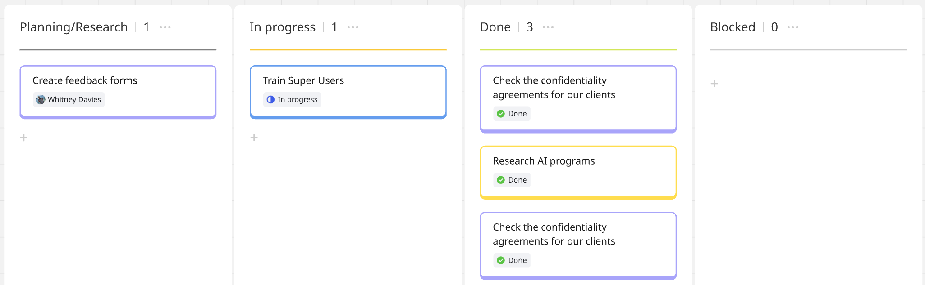
Figure 5: Kanban Board (Source: Author’s own analysis)

Risk and Change Management

Risk Identification and Categorisation
Risk management is central to project success, particularly in technology-driven initiatives. According to Hillson and Murray-Webster (2017), effective risk identification must consider both internal and external sources to ensure a balanced understanding of potential threats.
For this project, the following risks have been identified:
- Internal risks include data quality issues, resistance from staff, limited resource availability, and technical failures during integration.
- External risks include regulatory compliance requirements such as GDPR, dependency on vendors, shifting client expectations, and rapid technological change. These risks demonstrate the need for a proactive management approach. By categorising risks into internal and external domains, the project team can allocate ownership appropriately and prioritise mitigation efforts where they are most critical.

Risk Assessment Tools
Effective risk management requires structured tools to identify and evaluate potential threats and opportunities. According to Hillson (2009), risk identification should combine both internal and external perspectives to ensure that all possible sources of uncertainty are captured. For this project, two established tools have been used: PESTLE analysis to scan the external environment, and SWOT analysis to highlight internal strengths and weaknesses alongside external opportunities and threats.

PESTLE Analysis
Political - Government policies encourage digital innovation but also increase compliance demands around data security.
Economic - While upfront investment in systems and training is significant, long-term savings and efficiency gains strengthen competitiveness.
Social - Staff may fear job losses, making communication and training essential. Clients increasingly expect fast, reliable, and technology-driven services.
Technological - AI offers automation and improved accuracy but requires careful vendor management and adaptation to evolving standards.
Legal - Strict data protection regulations such as GDPR require that AI use remains transparent and auditable.
Environmental - Energy use from AI systems is a minor concern, but sustainability expectations mean efficiency should consider environmental impact.

SWOT Analysis
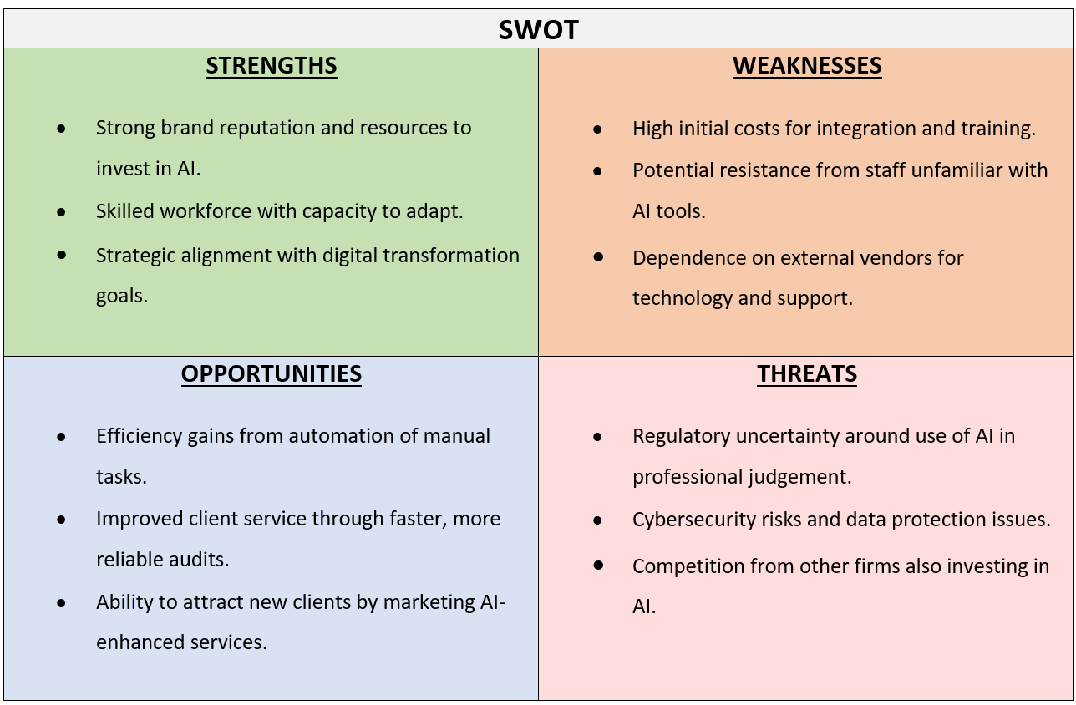
The combined analysis demonstrates that AI adoption addresses external pressures and internal opportunities, while highlighting regulatory, data, and staff-related risks that must be managed carefully.

Risk Mitigation and Response Planning
According to PMI (2017), risk responses generally fall into avoid, transfer, mitigate, or accept. For this project, the emphasis is on mitigation supported by clear governance.
Key risks and responses include:
- Data quality and integration: addressed through early data cleansing and IT oversight.
- Change resistance: reduced through training, communication of benefits, and staff involvement, consistent with Kotter’s (1996) view that participation strengthens adoption.
- Resource constraints: managed by securing commitment of key staff and clarifying roles using a RACI structure.
- Technical reliability: mitigated by phased testing and vendor SLAs, transferring part of the risk externally.
- Regulatory compliance: ensured through consultation with compliance officers and regular GDPR reviews.
- Vendor dependency: reduced by multi-year contracts with exit clauses and retaining some internal capability.
- Market expectations: controlled through cautious client messaging, presenting AI as a support tool.
- Technological evolution: managed by selecting scalable systems and adopting a continuous improvement plan.
These actions reduce the likelihood and impact of risks while keeping the project aligned with strategic objectives. As Kerzner (2017) argues, proactive planning builds resilience and increases the chances of success.

Change Control and Scope Creep
Uncontrolled changes can undermine project delivery. As PMI (2017) notes, scope creep often occurs when additional requirements are introduced without proper assessment, leading to delays and cost overruns.
For this project, change control will be managed through a formal request and approval process. Proposed changes will be logged, assessed for impact on cost, time, and compliance, and reviewed at governance stage-gates. Minor adjustments may be approved by the project manager, while significant changes will require sponsor approval.
Kerzner (2017) stresses that clear baselines for scope, cost, and schedule are essential to control change. Maintaining these baselines, combined with transparent reporting, ensures that only justified and beneficial changes are adopted.

Managing Change Resistance and Stakeholder Impact
Change resistance is a significant risk in technology projects. According to Kotter (1996), involving employees in the change process reduces opposition and strengthens adoption. For this project, resistance will be managed through early engagement, clear communication of AI’s role as a support tool, and tailored training sessions.
Bourne (2015) emphasises that ongoing stakeholder management is essential. Senior leaders and clients will require regular updates, while frontline auditors will need opportunities to raise concerns. HR and training teams will play a key role in supporting adoption, ensuring that staff feel prepared rather than displaced.
By combining communication, participation, and visible leadership support, the project reduces the risk of resistance and strengthens long-term sustainability.

Project Execution and Monitoring

Execution Plan and Delivery Strategy
The project will be delivered through a hybrid methodology, combining PRINCE2 governance with Agile delivery. As OGC (2009) highlights, PRINCE2 ensures structured oversight through defined stages, while Agile methods allow for iterative testing and rapid feedback (Highsmith, 2009). Key stages include initiation, procurement, integration, model development, training, pilot rollout, and closure. Agile practices will be used during development and pilot testing to validate outputs with managers and adapt to feedback. Governance reviews will take place at stage-gates to confirm progress and authorise continuation.

Progress Monitoring
Progress will be tracked through milestones, reports, and dashboards. As Kerzner (2017) notes, milestone reviews provide objective measures of progress and enable timely corrective action. Dashboards in Omnia will present real-time updates on tasks, while formal steering committee meetings will ensure alignment with leadership expectations. This dual approach supports both transparency and control.

Quality Assurance and Control
According to PMI (2017), quality management requires both assurance (process-focused) and control (output-focused). Assurance will be built into governance reviews, ensuring compliance with standards and regulatory requirements. Control will focus on AI outputs, using accuracy metrics and pilot testing results to confirm performance. Peer reviews and sign-offs from audit managers will further validate outcomes before deployment.

Project Performance Monitoring
Project performance will be monitored using Earned Value Management (EVM), which combines cost, schedule, and scope into a single performance measure (Fleming & Koppelman, 2016). This will enable early detection of variance and provide evidence for management decisions. Combined with risk reviews and stakeholder feedback, EVM ensures that the project remains aligned with objectives and delivers measurable value.

Project Closure and Evaluation

Final Deliverables and Handover
Project closure will confirm that all deliverables are complete and formally transferred to business-as-usual teams. According to PMI (2017), this stage ensures accountability and prevents ongoing resource drain. Handover will include AI software, integration with Omnia, training materials, compliance documentation, and pilot evaluation results.

Benefits Realisation and Success Evaluation
Measuring success requires comparing outcomes against the business case. As Cadle and Yeates (2008) note, a strong business case must account for both financial and non-financial benefits. Benefits realisation will focus on efficiency gains, improved audit accuracy, enhanced client satisfaction, and reduced manual workload. A benefits register will track these outcomes against original projections.

Lessons Learned and Organisational Learning
Documenting lessons learned is essential for continuous improvement. Kerzner (2017) stresses that post-project reviews support organisational maturity by capturing best practices and avoiding repeated mistakes. This project will produce a lessons learned report, including successes in stakeholder engagement and areas for improvement such as training timing and technical integration.

Post-Implementation Review
A post-implementation review will be carried out six months after closure, assessing whether AI adoption has delivered long-term value. As Lock (2020) suggests, reviewing actual performance against planned objectives ensures that projects remain strategically relevant beyond delivery.

Critical Reflection

Personal Reflection on PM Capabilities
Looking back on this project, I recognise areas where I demonstrated strength as well as areas for growth. I was able to apply structured methods, combining PRINCE2’s governance with Agile flexibility, which gave me confidence in balancing control and adaptability. At the same time, I found critical path analysis and advanced scheduling more challenging, suggesting a need to build deeper technical skills in these areas. As Gibbs (1988) notes, reflection allows practitioners to learn by evaluating both successes and weaknesses.

Use of Reflection Models
I used Gibbs’ reflective cycle (1988) to evaluate decisions, particularly around stakeholder engagement. This helped me to think critically about how my communication style supported engagement but also where I could improve in managing conflicting expectations. A personal SWOT analysis also showed that I am strong in stakeholder communication and collaboration but weaker in resource estimation. I see opportunities in developing stronger financial management knowledge, while a potential threat is relying too heavily on familiar tools rather than stretching myself.

Challenges Faced and Lessons Learned
One challenge I faced was balancing academic theory with practical application. For example, while PMBOK provides a comprehensive framework PMI (2017), I realised that I could not apply every element and had to adapt it to what was relevant. This confirmed Schön’s (1983) idea of being a “reflective practitioner,” adapting theory to practice. A key lesson I have taken away is that choosing and tailoring methods is often more effective than rigidly following a single framework.

Professional Development Plan
A detailed Professional Development Plan (PDP) is provided in Appendix 3. As Kolb (1984) explains, experiential learning is most effective when practice is combined with reflection, and the plan applies this principle by outlining specific development areas, actions, and measures of success to support my growth as a project manager.

Conclusion
This report has demonstrated how structured project management approaches can support the successful delivery of complex initiatives. While the context was the adoption of artificial intelligence in auditing, the central focus has been on how methodologies and tools contribute to effective planning, control, and delivery.
The analysis showed that no single methodology is sufficient on its own. PRINCE2 offers the governance, accountability, and structured reviews necessary for organisational oversight, while Agile practices provide adaptability and responsiveness during uncertain stages such as development and pilot testing. PMBOK, as a supporting framework, supplied a comprehensive set of processes and terminology that ensured consistency across the project. Together, this hybrid approach illustrated the importance of adapting methods to context rather than applying them rigidly.
Practical tools reinforced these methodologies. The Work Breakdown Structure clarified deliverables, while Gantt charts and network diagrams supported scheduling and dependency management. Stakeholder mapping and communication planning ensured that engagement strategies were proportionate to influence and interest, reducing resistance and aligning expectations. Risk and change management processes demonstrated the value of proactive planning and flexibility in addressing uncertainty.
Ultimately, the project confirmed that project management success depends less on the technology being implemented and more on disciplined application of methodologies, tools, and reflection. By integrating governance with adaptability, and planning with continuous evaluation, project managers can deliver sustainable outcomes in complex and evolving environments.

References
Bourne, L. (2015). Stakeholder relationship management: A maturity model for organisational implementation (2nd ed.). Gower.
Brynjolfsson, E., & McAfee, A. (2017). Machine, platform, crowd: Harnessing our digital future. W. W. Norton & Company. https://ide.mit.edu/publication/machine-platform-crowd-harnessing-our-digital-future/
Cadle, J., & Yeates, D. (2008). Project management for information systems (5th ed.). Pearson Education.
Fleming, Q. W., & Koppelman, J. M. (2016). Earned value project management (4th ed.). Project Management Institute.
Freeman, R. E. (1984). Strategic management: A stakeholder approach. Pitman.
Highsmith, J. (2009). Agile project management: Creating innovative products (2nd ed.). Addison-Wesley.
Hillson, D., & Murray-Webster, R. (2017). Understanding and Managing Risk Attitude. Routledge. https://doi.org/10.4324/9781315235448
Jobin, A., Ienca, M., & Vayena, E. (2019). The global landscape of AI ethics guidelines. Nature Machine Intelligence, 1(9), 389–399. Jobin, A. (2019). The Global Landscape of AI Ethics Guidelines. Nature Machine Intelligence, 1(9), 389–399. https://doi.org/10.1038/s42256-019-0088-2
Kerzner, H. (2017). Project management: A systems approach to planning, scheduling, and controlling (12th ed.). Wiley.
Kolb, D. A. (1984). Experiential learning: Experience as the source of learning and development. Prentice Hall.
Kotter, J. P. (1996). Leading change. Harvard Business School Press.
Lock, D. (2020). Project management (10th ed.). Routledge.
Mendelow, A. L. (1991). Environmental scanning: The impact of the stakeholder concept. Proceedings of the International Conference on Information Systems, Cambridge, MA.
OGC. (2009). Managing successful projects with PRINCE2 (5th ed.). The Stationery Office.
Project Management Institute. (2017). A guide to the project management body of knowledge (PMBOK® Guide) (6th ed.). Project Management Institute.
Schön, D. A. (1983). The reflective practitioner: How professionals think in action. Basic Books.

Appendix 1
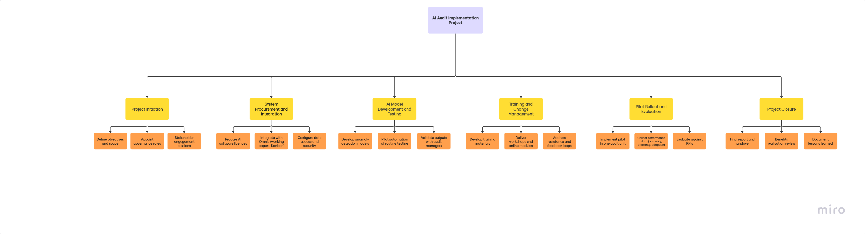
Work Breakdown Structure (Source: Author’s own analysis)

Appendix 2
Communication Plan
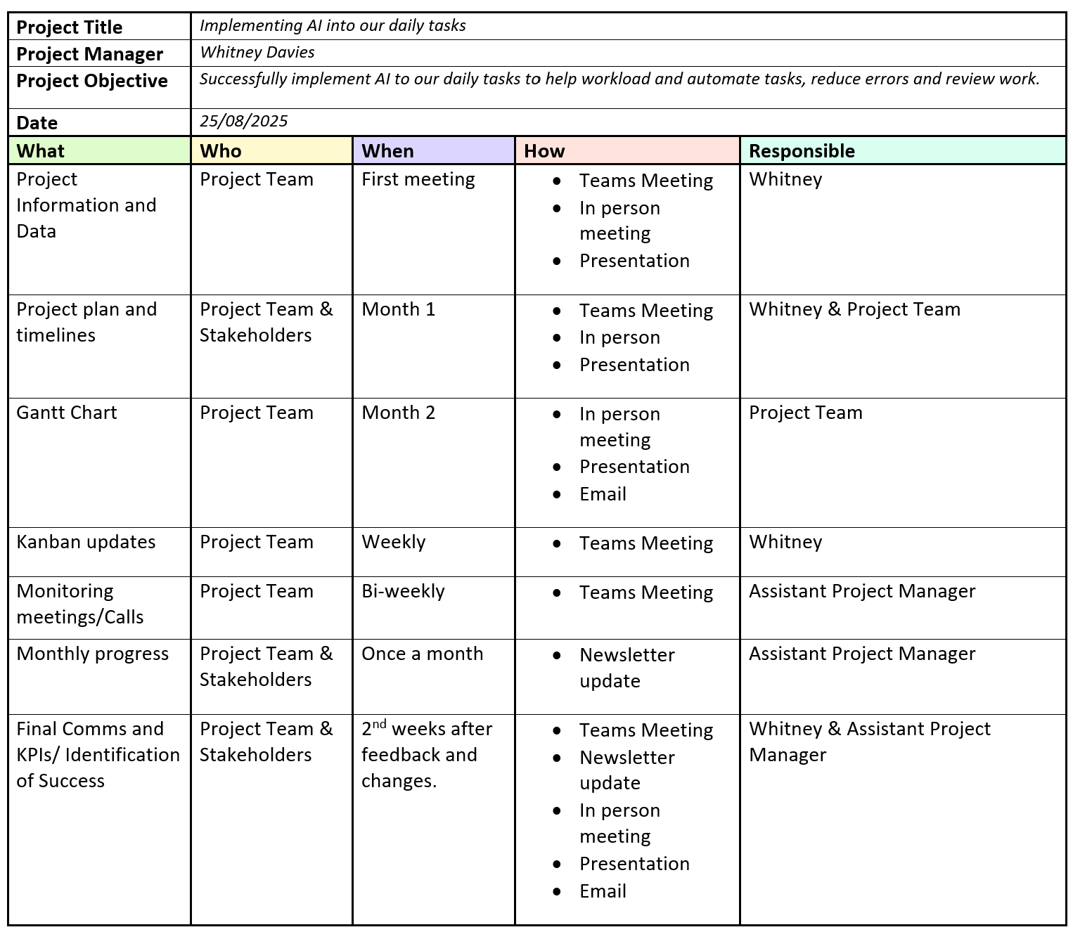

Appendix 3
PDP

