BA (Hons) Leadership and Management Skills for the Workplace
Leading and Implementing Workplace Change
BMSW6103
A Change Management Plan

Name of the Student: Nicusor Ionut Aliu
Student’s ID: 2131114

Table of Contents
1. Introduction 3
1.1 Report Purpose 3
1.2 Change Management 3
1.3 Report Coverage 4
2. Company Background 5
2.1 Company Overview 5
2.2 Current Challenges 5
2.3 Structure and Culture 6
3. Recent History of the Company in the External Environmental Context 6
3.1 Historical Background 6
3.2 Impact of Digital Disruption 7
3.3 Economic Uncertainty 8
4. Critical Appraisal of Change Management Models and Their Application to Sainsbury's 10
4.1 Model Selection and Justification 10
4.2 Strategic Change Issues 12
4.3 Leadership Styles in Change Management 13
5. Evaluation of Organizational Culture Impact on Change Management Program 14
5.1 Organizational Culture 14
5.2 Change Management Plan of Sainsbury's 15
6. Conclusion 18
References 20

1. Introduction

1.1 Report Purpose
This report will seek to analyse the change management process in a UK-based retail company, focusing on the critical role of change management in navigating the dynamic, highly competitive, and technology-driven business landscape (Dockery and Knudsen, 2017). As market environments evolve rapidly due to technological advancements, economic uncertainties, and shifting consumer expectations, businesses must embrace effective change management strategies to ensure resilience and long-term sustainability (Okolie and Memeh, 2022). This report discusses how one of these retail companies has coped with change by studying the techniques employed in coping with sector-specific and overall market threats.

1.2 Change Management
Change management is the systematic process to move individuals, teams, and the whole organization from a present state to the desired future state. The process deals with planning and implementing the transitions that alter the objectives, performance, and productivity of the organizations (Cambalikova, 2021). Internal and external triggers for change are commonplace in today's business environment. Organizations would face inefficiencies in processes or have a need for improving the engagement of staff. There is rapid improvement in technology, market rivalry, pressures from regulations and economic shifts, all pushing for rapid response (Dzwigol et al., 2019). Changes can be embraced effectively by organizational change management in order that changes made will be accomplished with a smooth transition.
An effective change management process will have a good understanding of the nature of change, the involvement of the stakeholders, and the effects of change on organizational culture (Nichols, 2024). Some of the established frameworks of change management include Lewin's Change Model, and the ADKAR Model. All these models will have specific areas of interest like communication, employee motivation, and performance measurement, thus aiding in the facilitation of change. It has always been in the retail industry that the most important factors are customer satisfaction, operational efficiency, and flexibility (Okolie and Memeh, 2022). So, when the sector is demanding change day in and day out, a well-thought-out change management strategy becomes very important.

1.3 Report Coverage
This report provides a change management overview of the chosen retail company. The paper starts with the overview of the company, including its current state regarding market position, operational structure, and the specific challenges it faces in today's retail landscape (Buntak, Martinčević and Mutavdžija, 2017). The report next looks into the recent history of the company, paying attention to how digital disruption and economic uncertainties have affected its operations and strategic direction. This section requires critical evaluation of different models of change management to identify the most suitable approach for the organization (Ngang Tang, 2019). In this section, I talk about the type of leadership style that was applied to implement change and whether it is effective for managing resistance or if it has the ability to provide the leadership for effective transition.
Lastly, the impact of organizational culture on hindering or promoting change effort is also covered, using the effects of values, norms, and attitudes at the workplace level in adapting change (Kotter, Akhtar and Gupta, 2021). A customized change management plan that could be taken would involve specific initiatives, a financial plan, communication strategies, and an evaluation plan measuring the effectiveness of proposed changes. This report is an attempt to present actionable insights to allow the company's change management strategies to align with its overall goals, making it resilient and competitive in this changing retail landscape.

2. Company Background

2.1 Company Overview
Sainsbury's is the UK's leading supermarket store chain with over 1,400 branches, ranging from large supermarkets to local convenience stores. It is very well known for its wide line of products, such as groceries, clothing, and household goods. Sainsbury's has built an excellent brand name based on quality and customer satisfaction (Aluko and Knight, 2017). The company has a large share in the UK market and targets a wide demographic of customers, focusing on offering affordable products of good quality and convenience. However, in an extremely competitive retail market, particularly against giants such as Tesco and new disruptors like Aldi and Lidl, Sainsbury's must constantly change to maintain its market share (Xiao, Chen and Yu, 2021).


2.2 Current Challenges
Sainsbury's is currently experiencing both internal and external challenges. Externally, the pressures affecting the retail sector are attributed to economic uncertainties, inflation, and swings in consumer spending as Sainsbury's attempts to meet customer expectations on affordability while managing costs. The next step of upgrade in the digital abilities has to be taken, looking forward (Witzel, 2022). This shall ensure that it keeps the momentum of the current marketplace on track since growth with online shopping, e-commerce and digital disruption is raising new trends and changing customer purchasing behaviour (Feller, 2024). The immediate concern is that budget retailers, as well as dedicated grocery chains, are pulling Sainsbury's out of its comfort zone while capturing market share, necessitating the company to calibrate its offering even further (Ahmed and Akaak, 2024).
Internally, Sainsbury's must improve operational effectiveness and ensure that the integration between the online and in-store operation is flawless (Cavallo, 2024). Since the investment by the company into technology will be huge, the capacity of its workforce to accept new digital tools is crucial. Still, the biggest internal barriers remain the reluctance of the workers to embrace change and achieve a balance between technology adaptation and upholding standards of service to the customers (Dovganeva, Katrashova and Kirillova, 2024).

2.3 Structure and Culture
Sainsbury's is a vertical organization that at times is clumsy and less agile and responsive. Traditionally customer-centric in orientation, the culture at Sainsbury's values quality and sustainability but is challenged by a rapid pace of change. Recent leadership efforts to develop adaptability have only had mixed results for employee morale due to restructuring efforts and job security concerns (Čavlin, Bulović and Šmitran, 2024). Leadership style is transactional in orientation, focusing on achieving efficiency and performance targets. Such an organizational structure maintains operational control, but is often a limiting factor to the flexible decisions that might have to be made for immediate adaptation to a changing market (Shields, 2024). The relative lack of adaptability from this organization is a pointer to more transformational leadership in innovation and employee empowerment toward fully embracing digital transition.

3. Recent History of the Company in the External Environmental Context

3.1 Historical Background
Sainsbury's has undertaken many changes due to a number of economic, social, and industry conditions. The company responded to the economic recession of 2008 by redefining value in their products: competitive pricing with unfaltering quality. Thus, Sainsbury's is able to maintain customer loyalty even when consumer spending is low. Another expansion was on private-label products: for budget-conscious consumers. But Sainsbury's managed to lose some market share to the budget retailers such as Aldi and Lidl who are continuously expanding in the UK market focusing on cutting prices (Banks, 2024).
For the changes in consumer behaviour over the last decade in terms of healthier and ethically sourced products, Sainsbury's has adopted a sustainability-oriented approach (Wolniak, Stecuła and Aydın, 2024). It has positioned itself as the responsible retailer by promising reduced plastic waste, carbon footprints, and sourcing their products sustainably. A strategy that has helped Sainsbury's differentiate itself with environmentally conscious customers. To some extent, this created an operational cost and capital expenditure for supply chain readjustment and vendor readiness (Collin-Lachaud et al., 2024). Other changes, such as sugar taxes and more stringent labeling regulations, have also compelled Sainsbury's to reformulate certain products and adjust the marketing mix to be compliant. This is yet another source of complexity for the business (Gil‐Saura et al., 2024).

3.2 Impact of Digital Disruption
The digital disruption has been one of the most transformative forces to have hit Sainsbury's in recent years. The rapid shift in preference towards online shopping, both during and after the COVID-19 pandemic, further hastened Sainsbury's digital transformation (Watson, Wilson and Macdonald, 2024). In an effort to evolve, the company increased its online capacity through partnerships with delivery services such as Deliveroo and Uber Eats and invested heavily in further enhancing its own e-commerce capabilities. Sainsbury's has invested heavily in the capability to fulfil e-commerce demand, optimizing supply chains for increased home deliveries (Isharyani et al., 2024). To satisfy demand for faster deliveries, the company also created the "Chop Chop" rapid delivery service, making its digital positioning even more robust.

Despite all this, Sainsbury's migration to digital did not come without its share of tribulations. Where the foundation of an e-commerce model appeared to be well established and strong, the rapid ascent put considerable pressure on logistics, inventory management, and customer service support (Isharyani et al., 2024). Complaints from customers skyrocketed with increased complaints of delay and order inconsistency, an indicator of rising operational strain while scaling up on digital services. It further enhances the focus on digital marketing and tailored offers because customer retention requires more investment in data analysis and CRM systems (Munson, 2019). This requires sustained investments to retain, refresh, and maintain Sainsbury's electronic architecture and risks associated with cyber-security breaches by an increasingly online business model.
On top of that, Sainsbury's, as far as digital transformation is concerned, also brought into its physical stores advanced technology such as self-checkouts, digital shelf labels, and customer loyalty apps (Jones and Comfort, 2019). Among the benefits these innovations have come to create are the enhanced convenience for the customers, though some have also had to face some resistance, especially those not so conversant with the digital technologies. Although the digital push has helped increase operational efficiency, it also has led to job cuts mainly on jobs that are perceived to be manual, impacting the morale of employees and calling for re-skilling initiatives (Jones and Comfort, 2019). Sainsbury's needs to continuously walk this tightrope of balancing automation with human contact so that the customer experience does not go down.

3.3 Economic Uncertainty
As of September 2024, core inflation in the UK was at 3.2 percent. In contrast, the value compared to the month before was a little lower, having been 3.6 percent (Clark, 2024). In contrast, a regular rate of inflation may be taken to account for the fluctuations in prices of food and energy which are regarded as the most volatile prices among goods and services (Papanagnou et al., 2022). The core inflation rates for this country measured for September 2024 are provided by an overall CPI of 1.7 percent. However, consumer confidence is a very sensitive matter to Sainsbury's because the company is directly affected by the overall performance of the economy (Ramadan and Morshed, 2024). Today, with inflation, a supply chain that has just started experiencing disruptions, and consumers who are now constantly uncertain about how much they might spend on their purchases at any given time, these are issues that will affect the company for some time to come.
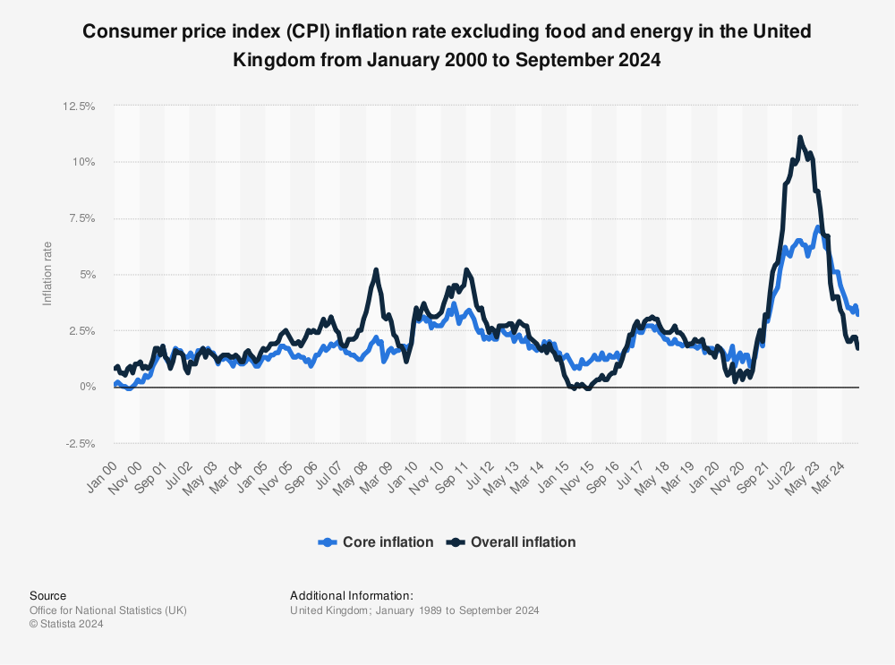
(Source: Clark, 2024)
Almost everywhere in the operations of Sainsbury's, it has faced increased costs following an increase in inflation rates (Pantano et al., 2020). This leaves Sainsbury's with the difficult choice of either passing on the costs to customers, who may be lost to discount retailers due to price sensitivity, or absorbing these costs, which may cut into its profit margins.
Supply chain disruptions, which have been ongoing since Brexit and were amplified by the COVID-19 pandemic, have impacted Sainsbury's ability to maintain product availability and consistency in pricing. For instance, the lack of fresh fruits and meat has prevented Sainsbury's from stocking full product lines, annoying the customers and hurting the sales in the categories (Naveed, n.d). Labor shortages in its supply chain and in-store have further added to Sainsbury's reliance on automation in some areas, which complicates the balance between efficiency and the customer experience.
In addition, changing consumer purchasing power is affecting Sainsbury's ability to win and retain customers across all its segments . Economic stress is forcing more consumers to shop at budget retailers, thus affecting Sainsbury's customer base, which traditionally consists of value-oriented and mid-market consumers. In reaction, Sainsbury's has undertaken several initiatives in the form of value-based options, such as the "Aldi Price Match" campaign, which attempts to compete with discounters on selected staple products. This limits the flexibility in pricing and adds more pressure on profit margins for Sainsbury's (Naveed, n.d).
Energy price volatility also affects Sainsbury's because it increases the price of running a large store network and its distribution centre with the increase in the energy price (Ramadan and Morshed, 2024). The company has vowed to become operationally net zero by 2040. However, the cost involved in the process can be significant when energy inflation is high. This would involve investments in renewable energy sources and energy-efficient technology, which are capital-intensive and lead to decreases in short-term profitability.

4. Critical Appraisal of Change Management Models and Their Application to Sainsbury's

4.1 Model Selection and Justification
The Lewin's Change Model and the ADKAR model best fit Sainsbury's because of the nature of challenges facing the company in terms of disruption, economic uncertainty, and ensuring consistency in the customer experience. Each model gives a structured yet flexible approach to address both strategic and operational change.
1. Lewin's Change Model
Lewin's model will best suit the requirement of Sainsbury's to manage high degrees of digital integration and transform its operating practices in highly volatile markets (Burnes, 2020). The three-phase model can be adapted to support Sainsbury's gradual but impactful changes regarding employee adaptation, operational changes, and cultural changes needed for digital innovation.
Unfreezing In the case of Sainsbury's, it will involve readied the staff for substantial digital and process changes. Communicating the requirement for change, particularly regarding the reason for change resulting from the digital disruption as well as the budget retailer's competitive advantage, can be seen as an enabler for awareness and minimization of resistance (Memon, 2021). Thus, communicating the difficulties as well as the benefits allows the company to tackle morale and preparedness in employees, given past history with adjustments involving the workforce (Memon, 2021).
Changing: As Sainsbury's introduces more complex technology into its business activities (such as self-checkouts and online fulfilment upgrades), the changing phase would involve introducing these systems and training employees to use them effectively (Harrison et al., 2021). Sainsbury's investment in technology can be supported by initiatives that ensure employees feel supported when adapting to new tools, especially in customer service and logistics roles. This stage should be about skill development and digital literacy.
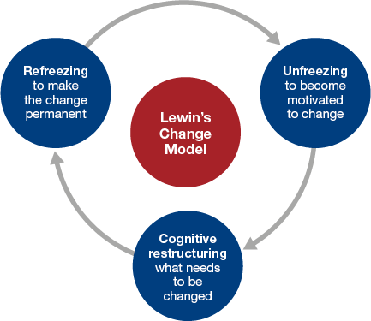
(Source: Harrison et al., 2021)
Refreezing: This is the last step, which anchors new processes and behaviour such as ensuring employees will start to use digital tools constantly (Paramitha, Tobing and Suroso, 2020). For Sainsbury's, this might involve ensuring that digital practices are practiced daily and creating a new norm for engaging customers inside the store and through their online presence. It also means refreezing on further training, mechanisms of giving feedback, and channelling customer feedback into service adjustments (Memon, 2021).
2. ADKAR Model
The ADKAR model is very relevant to individual transition and, therefore, will be highly appropriate for Sainsbury's since change affects frontline employees most of the time.
Awareness: Creating awareness would include letting the employees know why the changes are necessary (Dergletckaia, 2023). In the case of Sainsbury's, what could be highlighted is that technology is going to be what sustains competitiveness and satisfies customers in a digital economy. This will increase the understanding among employees affected by automation.
Desire: The desire can be built around the fact of how the digital tools may assist customers, such as easing the daily operations or increasing the satisfaction of customers (Dergletckaia, 2023). Because there was so much opposition to the use of self-checkout at first, Sainsbury's must engage its staff in the story of change to get them motivated for it.
Knowledge: It will be necessary to give knowledge to the employees in bridging the gap in the digital skills. Sainsbury's will have to invest in the hands-on training for the new systems, and the employees would be in possession of the competencies required for the increasingly digital workflow (Nasamu, 2022).
Ability: Ability is practical application; Sainsbury's will ensure that employees are able to effectively execute their roles in this new digital landscape. Real-time support and troubleshooting options will assist in building confidence and ability in employees.
Reinforcement: In the final stage, reinforcement will ensure that changes are consolidated (Fernandez and Rainey, 2017). It shall reward adaptability and then maintain a feedback loop. Regular performance reviews, recognition, and also digital proficiency will keep the employees engaged with the changes for Sainsbury's.
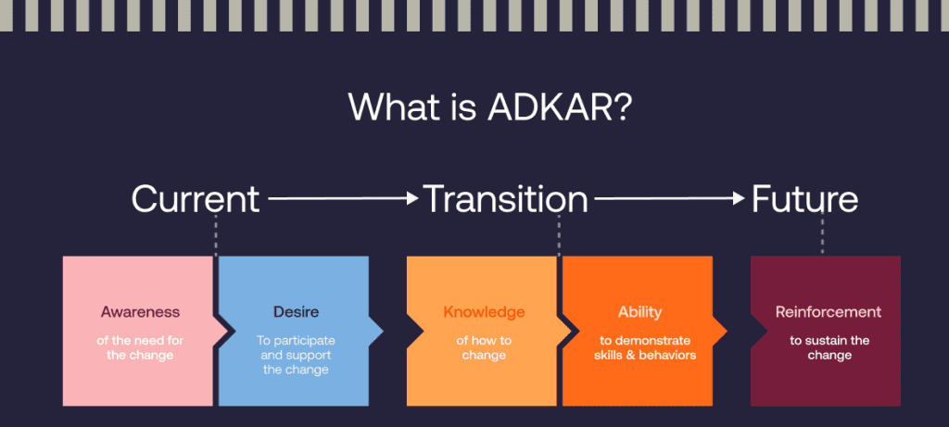
(Source: Fernandez and Rainey, 2017)

4.2 Strategic Change Issues
Employee resistance, strategic alignment, and leadership dynamics are the other key issues that Sainsbury's needs to contend with in relation to strategic change:
Employee Resistance: The main problem is the resistance, especially since this process of digital transformation changes the traditional roles of the people (Al-Surmi, Cao and Duan, 2020). In such a case, resistance can be based on concerns over job security, gaps in skills, or unfamiliarity with new technologies.
Alignment with Strategic Goals: All digital initiatives must be in line with long-term strategic goals, such as building customer loyalty and enhancing efficiency in operations (Cameron and Green, 2019). But such consistent strategic alignment is a challenge in the face of frequent economic disruptions. Here, clear but flexible change objectives are needed.
Leadership Dynamics: Effective leadership will be one of the reasons for that kind of adaptive culture. Thus, with such dynamics, cost efficiencies need to be balanced against empathy and support toward employees under uncertainty (Mansaray, 2019). Strategic goals henceforward should focus on sustainability-be it in growth achieved within the digital world or loyalty sustained from customers.

4.3 Leadership Styles in Change Management
Sainsbury's typically tends to use a transactional form of leadership, which encompasses strong performance targets and practical procedures. This has provided it with short-term deliverance of its immediate operating aims but does not bring inspiration to long-term change adaptation (Akinbode and Al Shuhumi, 2018). A transformational type of leadership would work for Sainsbury's in change, especially about adapting digitally and buying-in employee changes.
- Transactional Leadership: Transactional techniques that are performance outcome focused and efficiency driven have supported Sainsbury's fast digital growth and responsive competitiveness strategies, such as the "Aldi Price Match." However, a strong emphasis on measurable near-term results may miss the motivational appeal required to drive the change (Megheirkouni, Amaugo and Jallo, 2018).
- Transformational leadership: Digital shift inspires people. If transformational, the aim of motivating staff would be achieved through this approach; hence it is very effective in their engagement through learning and shift towards digital operations (Griffith, Baur and Buckley, 2019). Thus, it fosters and maintains ongoing learning; the one required for sustaining morale by making structural change less painful for Sainsbury's employees. More focus should be on visions regarding more growth opportunities so it has a connectivity among goals that are linked with development at various stages.
- Blended Approach: With these pressures from digital transformation and the volatile economy, a blended approach to leadership will do wonders for Sainsbury's (Lapshun and Fusch, 2023). Leaders could make use of transactional methods for short-term digital adoption goals while using transformational methods to inspire employees to share a common vision on customer-centric innovation.

5. Evaluation of Organizational Culture Impact on Change Management Program

5.1 Organizational Culture
The organizational culture of Sainsbury's has the highest impact on the change management programme, mainly because the business model is shifting towards digital-intensive policy (Tasoulis et al., 2024). Traditionally, Sainsbury's customer-oriented culture emphasizes reliability, service excellence, and accessibility. However, for the adoption of the new technologies and economic pressures, it requires a flexible culture with innovation drive.
1. Customer-Centric Tradition
Customer satisfaction is the promise Sainsbury's commits to in terms of attitudes and operational priorities on its employees (Sancak, 2023). This culture always, since its conception, emphasized meeting customer needs on service and affordability. Still, with digital transformation, the company needs to adapt its culture from service-centred culture to an agile, data-driven decisions-based, and technology-centric one.
2. Opposition to Change
While several programs have been implemented to make individuals flexible, the shift towards automation and digitization is resisted by employees who fear insecurity or are not ready to handle new tools (Akbar, 2024). Change can culturally be inspired through the breaking of old ways or traditions. Cultural change in embracing changes, development skills, and a growth mindset should be incorporated to make people feel appreciated.
3. Leadership and Communication Gaps
Leaders must effectively communicate a change management strategy with a compelling vision for the future. In this regard, Sainsbury's leadership has always relied on transactional and efficiency-driven approaches (Yasin et al., 2023). The gaps that transformational leadership within the organization will fill in will promote a more participatory culture where employees are included in the journey of change.
4. Innovation and Continuous Improvement
Thus, Sainsbury's culture would require the inclusion of continuous learning and innovation principles. Because digital integration develops incessantly, workers need to treat the technological change as an on-going helpful process (Robertsone and Lapiņa, 2023). The more workers are fond of the culture of continuous improvement, the more they would be ready and willing to adapt and learn for the entire life cycle in which general strategic objectives are attained.

5.2 Change Management Plan of Sainsbury's
To integrate these cultural changes and ensure a successful implementation of the proposed transformation digitally, Sainsbury's change management plan covers a structured approach in the following key areas:
Proposed Change
Sainsbury's proposed change revolves around developing digital capabilities in their retailing; efficiency, better customer experience, and competitiveness (Robertsone and Lapiņa, 2023). The core areas of focus point at the following:
Digital Integration: Developing self-checkouts, improving online shopping systems, and transforming digital in-store features.
Employee Development: Employee skills development in the use of new technologies; this could include upskilling programs as well as digital literacy workshops (Robertsone and Lapiņa, 2023).
Customer Experience: Data analysis will add to personalized offers, while improvements in the in-store experience are aligned with online convenience (Muhamad et al., 2023). The proposed change ensures that Sainsbury's core value-perceived customer satisfaction-is maintained in pursuing its shift to a digitally-enabled agile operation.
Finance Plan
A digital transformation requires significant investment in capital, yet the economic environment requires it to be financially viable (Sancak, 2023).
The financial plan comprises one-time expenditures in technology and periodic costs on maintenance and training:
Technology Investment: It involves expenditure for acquiring and installing sophisticated self-checkout equipment, redesigning the web platform, and establishing the infrastructure of data analytics (Phillips and Klein, 2023). Estimated figures are going to differ from supplier to supplier but the estimated figure works out at £20 million over a period of three years.
Employee Training: Appointing training personnel that would emphasize digital literacy as well as customer service as they will be interacting with the new system. Annual training programmes will cost around £3 million.
Operational costs: These include maintenance charges of the software, support of IT and also developing the security measures for online use. The annual operating cost is around £2 million.
Return on Investment: Due to increased operational efficiency and reduced transaction time, the online sales of Sainsbury's would increase by 15% in the initial two years, and wait times in-store would fall by 10%. At that point, the cost of implementation would be recouped by increased customer retention and sales.
Communication Plan
It is required for effective communication during the process of digital transformation at Sainsbury's, therefore aligning all the different roles. This means the communications strategy will have a multilevel approach as per stakeholders' specific requirements:
Vision and Objectives: All this change will be introduced by top management. Everything reflects on the focus Sainsbury will give toward the quality customer satisfaction (Hubbart, 2023). Informs, motivates toward their end goal with help of regular presentations, town halls, intranet posting by management.
Tailored Updates for Each Team Based on the role: this implies communication to IT, customers' service, and to management about the different people's roles during the implementation of the change (Turyadi et al., 2023). One should use newsletters, scheduled meetings with teams, or updating people directly on what and how their day-to-day role will be affected: thereby providing a clear, understandable path toward embracing a new change.
Feedback Mechanism: Handling job security-related concerns from employees requires effective two-way communication (Popoola et al., 2024). Different kinds of feedback channels, including surveys and Q&A sessions, allow the staff members to voice their views and add their wisdom, which will help in refining the change management approach and fine-tuning the support if necessary.
Customer Facing Communication: The introduction of new digital features will be informed to the customers, ensuring them of a hassle-free experience. Sainsbury's will use social media, in-store signs, and email newsletters to teach customers how easily digital features will allow convenience and improve the quality of services (Henderson-Carter, 2014). This would make it easier for the customer to maintain trust and satisfaction about the new technologies that have been introduced.
This multi-level communication plan helps smoothen the transition as it engages employees, listens to concerns, and gets staff and customers on board to achieve Sainsbury's vision of digital transformation.
Evaluation Plan
The change management program implemented by Sainsbury's requires a combination of qualitative and quantitative metrics tracked in order to measure the effectiveness. This plan on comprehensive evaluation focuses on KPIs across several dimensions:
Performance Measures: This includes the monitoring of return on digital investment in financial performance. Examples of such measures include growth in online sales, in-store transaction times, and customer retention rates (Lyke-Ho-Gland, 2019). This will enable Sainsbury's to detect trends, measure the impact of digital initiatives, and readjust strategies for the improvement of revenue and efficiency in operations.
Employee Adaptation: A very important measure for the impacts of this digital transformation on work culture is an understanding of how employees adapt and are engaged (Lewis, 2019). This will be known from regular feedback surveys, skill assessments, and performance reviews. These kinds of results will pinpoint areas where further training or support might be useful in preparation for supporting new technologies and processes.
Customer Satisfaction: This is one of the most important success measures. Sainsbury's will track NPS, online reviews, and direct customer surveys to find out what the public feels about the new digital features that are being launched (Lewis, 2019). Positive responses will mean that the integration is successful and Sainsbury's will be in a good position in terms of its commitment to quality service. Negative responses will highlight the imperfections.
Process Audits: Digital process and infrastructure will be subjected to regular audits to search for inefficiencies and opportunity for improvement. A focused team will be conducting regular quarterly assessments to ensure technology is aligned with business objectives and is on top of changes in customer needs (Li et al., 2019). Audits will also give a clue about areas where the change management strategy may need improvement.
Continuous Improvement Cycle: The establishment of a continuous cycle of improvement based on results from evaluation would make Sainsbury's approach change management proactively more refined (Voordt and Jensen, 2023). Performance data and feedback from employees will now provide information for changes in the nature of training programs, changes in communication strategy, and digital systems (Voordt and Jensen, 2023). All this will keep the employee engrossed while keeping customers satisfied so that Sainsbury's would be responsive to the problems and opportunities arising from the digital transformation.

6. Conclusion
For the path of Sainsbury's digital transformation, one needs to make sure the approach is both culturally sensitive and strategically structured. Thus, the suggested change management plan, focusing on integration with digital services, employee training, and upgrading of customer experience, goes along with Sainsbury's long-term culture of meeting customers' expectations as well as adhering to demands from the technology-driven nature of retail. These are some of the key components to the plan. This includes having a financial roadmap, having a communication strategy, and an evaluation plan that reduces the resistance, facilitates adaptability, and ensures maximum leverage from digital tools. Therefore, by putting in a culture of innovation and learning supported by an adaptable change management framework, Sainsbury's will be adequately positioned for the complex demands of this modern retail environment while retaining its core values. By following all these with careful implementation and constant review, Sainsbury's is in good position to provide sustained business growth, operation excellence, and improving customer involvement amidst growing digitization in competition.

References
Ahmed, M.N. and Akaak, A.S., 2024. Integrated Role of Human Resource Management in Mitigating the Post-Covid-19 Challenges in Retail. Business Ethics and Leadership, 8(1), pp.1-14.
Akbar, M.A., 2024. Customer-Centric Strategies: Navigating the Dynamics of Marketing Management for Competitive Advantage. Advances in Business & Industrial Marketing Research, 2(2), pp.96-109.
Akinbode, A.I. and Al Shuhumi, S.R.A., 2018. Change management process and leadership styles. PEOPLE: International Journal of Social Sciences, 4(2), pp.609-618.
Al-Surmi, A., Cao, G. and Duan, Y., 2020. The impact of aligning business, IT, and marketing strategies on firm performance. Industrial marketing management, 84, pp.39-49.
Aluko, O. and Knight, H., 2017. From corner store to superstore: a historical analysis of Sainsbury’s co-evolution. Journal of Management History, 23(4), pp.423-435.
Banks, O., 2024. Driving Retail Transformation: How to navigate disruption and change. Practical Inspiration Publishing.
Buntak, K., Martinčević, I. and Mutavdžija, M., 2017. The Influence of Modern Business Environment on Management Changes. ENTRENOVA-ENTerprise REsearch InNOVAtion, 3(1), pp.292-301.
Burnes, B., 2020. The origins of Lewin’s three-step model of change. The Journal of Applied Behavioral Science, 56(1), pp.32-59.
Cambalikova, A., 2021. Modern trends in business management in the light of globalization. In SHS Web of Conferences (Vol. 92, p. 02009). EDP Sciences.
Cameron, E. and Green, M., 2019. Making sense of change management: A complete guide to the models, tools and techniques of organizational change. Kogan Page Publishers.
Clark, D., 2024. Consumer price index (CPI) inflation rate excluding food and energy in the United Kingdom from January 2000 to September 2024. [Online]. Available at: https://www.statista.com/statistics/1317058/uk-core-inflation-rate/ [Accessed on: 1st November 2024].
Cavallo, A., 2024. Inflation with Covid consumption baskets. IMF Economic Review, 72(2), pp.902-917.
Čavlin, M., Bulović, V. and Šmitran, B., 2024. Strategic Benefits of a Customer-Centric Approach in Customer Relationship Management System. Journal of Agronomy, Technology and Engineering Management, 7(3), pp.1114-1123.
Collin-Lachaud, I., Do Vale, G., Reynolds, J. and Cuthbertson, R., 2024. A retailing dilemma: sell only in-person or go multiple channel and digital?. Journal of Business Strategy, 45(5), pp.348-355.
Dergletckaia, V., 2023. Change Management in a Context of Digital Transformation.
Dockery, D. and Knudsen, L., 2017. Modern Business Management: Creating a Built-to-Change Organization. Apress.
Dovganeva, Y.A., Katrashova, Y.V. and Kirillova, T.V., 2024. The ecosystem of vertical farms: A conceptual framework. Food systems, 6(4), pp.504-511.
Dzwigol, H., Shcherbak, S., Semikina, M., Vinichenko, O. and Vasiuta, V., 2019. Formation of strategic change management system at an enterprise.
Feller, G., 2024. Retail Challenges in the Post-Pandemic Era. Tea & Coffee Trade Journal, 196(1), pp.14-19.
Fernandez, S. and Rainey, H.G., 2017. Managing successful organizational change in the public sector. In Debating public administration (pp. 7-26). Routledge.
Gil‐Saura, I., Ruiz‐Molina, M.E., Berenguer‐Contrí, G. and Marín‐García, A., 2024. Sustainability‐oriented innovation in retailing. Psychology & Marketing, 41(2), pp.240-253.
Griffith, J.A., Baur, J.E. and Buckley, M.R., 2019. Creating comprehensive leadership pipelines: Applying the real options approach to organizational leadership development. Human Resource Management Review, 29(3), pp.305-315.
Harrison, R., Fischer, S., Walpola, R.L., Chauhan, A., Babalola, T., Mears, S. and Le-Dao, H., 2021. Where do models for change management, improvement and implementation meet? A systematic review of the applications of change management models in healthcare. Journal of healthcare leadership, pp.85-108.
Henderson-Carter, R.S., 2014. A Business Case for Return on Investment: Understanding Organizational Change. Walden University.
Hubbart, J.A., 2023. Organizational change: The challenge of change aversion. Administrative Sciences, 13(7), p.162.
Isharyani, M.E., Sopha, B.M., Wibisono, M.A. and Tjahjono, B., 2024. Retail technology adaptation in traditional retailers: A technology-to-performance chain perspective. Journal of Open Innovation: Technology, Market, and Complexity, 10(1), p.100204.
Jones, P. and Comfort, D., 2019. An exploratory case study of resilience and the leading retailers in the UK. International Journal of Management Cases, 21(4), pp.5-18.
Kotter, J.P., Akhtar, V. and Gupta, G., 2021. Change: How organizations achieve hard-to-imagine results in uncertain and volatile times. John Wiley & Sons.
Lapshun, A. and Fusch, G.E., 2023. Times of uncertainties require embracing leadership and feedback. The Qualitative Report, 28(3), pp.828-847.
Lewis, L., 2019. Organizational change. In Origins and traditions of organizational communication (pp. 406-423). Routledge.
Li, J.Y., Sun, R., Tao, W. and Lee, Y., 2021. Employee coping with organizational change in the face of a pandemic: The role of transparent internal communication. Public relations review, 47(1), p.101984.
Lyke-Ho-Gland, H., 2019. Closing the change management gap. Strategic HR Review, 18(4), pp.168-175.
Mansaray, H.E., 2019. The role of leadership style in organisational change management: a literature review. Journal of Human Resource Management, 7(1), pp.18-31.
Megheirkouni, M., Amaugo, A. and Jallo, S., 2018. Transformational and transactional leadership and skills approach: Insights on stadium management. International Journal of Public Leadership, 14(4), pp.245-259.
Memon, F.A., 2021. Improving employee’s engagement in change: Reassessing Kurt Lewin’s model. City University Research Journal, 11(1).
Muhamad, L.F., Bakti, R., Febriyantoro, M.T., Kraugusteeliana, K. and Ausat, A.M.A., 2023. Do innovative work behavior and organizational commitment create business performance: A literature review. Community Development Journal: Jurnal Pengabdian Masyarakat, 4(1), pp.713-717.
Munson, J.E., 2019. The Digital Transformation of the UK’s Grocery Market (Doctoral dissertation, University of Southampton).
Nasamu, I., 2022. Strategies for employees to effect change to improve performance of public organizations. Walden University.
Naveed, S., The Global Economic Impact of the COVID-19 Pandemic.
Ngang Tang, K., 2019. Leadership and Change management. Springer.
Nichols, T., 2024. Ownership, control and ideology: An enquiry into certain aspects of modern business ideology. Taylor & Francis.
Okolie, U.C. and Memeh, N.J., 2022. Influence of change management on modern organizational efficiency. Jurnal Riset Ekonomi dan Bisnis, 15(3), pp.171-195.
Okolie, U.C. and Memeh, N.J., 2022. Influence of change management on modern organizational efficiency. Jurnal Riset Ekonomi dan Bisnis, 15(3), pp.171-195.
Pantano, E., Pizzi, G., Scarpi, D. and Dennis, C., 2020. Competing during a pandemic? Retailers’ ups and downs during the COVID-19 outbreak. Journal of Business research, 116, pp.209-213.
Papanagnou, C., Seiler, A., Spanaki, K., Papadopoulos, T. and Bourlakis, M., 2022. Data-driven digital transformation for emergency situations: The case of the UK retail sector. International Journal of Production Economics, 250, p.108628.
Paramitha, T.A., Tobing, D.K. and Suroso, I., 2020. ADKAR Model to Manage Organizational Change. International Journal of Research Science and Management, 7(1), pp.141-149.
Phillips, J. and Klein, J.D., 2023. Change management: from theory to practice. TechTrends, 67(1), pp.189-197.
Popoola, O.A., Adama, H.E., Okeke, C.D. and Akinoso, A.E., 2024. The strategic value of business analysts in enhancing organizational efficiency and operations. International Journal of Management & Entrepreneurship Research, 6(4), pp.1288-1303.
Ramadan, A. and Morshed, A., 2024. Optimizing retail prosperity: Strategic working capital management and its impact on the global economy. Journal of Infrastructure, Policy and Development, 8(5), p.3827.
Robertsone, G. and Lapiņa, I., 2023. Digital transformation as a catalyst for sustainability and open innovation. Journal of Open Innovation: Technology, Market, and Complexity, 9(1), p.100017.
Sancak, I.E., 2023. Change management in sustainability transformation: A model for business organizations. Journal of Environmental Management, 330, p.117165.
Shields, K., 2024. Customer Centric Strategy.
Tasoulis, K., Pappas, I.O., Vlachos, P. and Oruh, E.S., 2024. Employee reactions to planned organizational culture change: A configurational perspective. human relations, 77(9), pp.1272-1305.
Turyadi, I., Zulkifli, Z., Tawil, M.R., Ali, H. and Sadikin, A., 2023. The role of digital leadership in organizations to improve employee performance and business success. Jurnal Ekonomi, 12(02), pp.1671-1677.
Voordt, T.V.D. and Jensen, P.A., 2023. The impact of healthy workplaces on employee satisfaction, productivity and costs. Journal of Corporate Real Estate, 25(1), pp.29-49.
Watson, R., Wilson, H.N. and Macdonald, E.K., 2024. Engagement logics: How partners for sustainability‐oriented innovation manage differences between organizational logics. Journal of Product Innovation Management.
Witzel, M. ed., 2022. Post-pandemic leadership: Exploring solutions to a crisis. Routledge.
Wolniak, R., Stecuła, K. and Aydın, B., 2024. Digital Transformation of Grocery In-Store Shopping-Scanners, Artificial Intelligence, Augmented Reality and Beyond: A Review. Foods, 13(18), p.2948.
Xiao, B., Chen, Q. and Yu, Z., 2021, April. Research on the Investment Value of Sainsbury’s. In 2021 6th International Conference on Social Sciences and Economic Development (ICSSED 2021) (pp. 108-115). Atlantis Press.
Yasin, R., Jan, G., Huseynova, A. and Atif, M., 2023. Inclusive leadership and turnover intention: the role of follower–leader goal congruence and organizational commitment. Management Decision, 61(3), pp.589-609.

