

Report for Global Marketing Strategy Assignment 1 2020 - Country and Market Entry

March 2020

MODULE NAME: GLOBAL MARKETING STRATEGY
NAME: JIAAI CAO
STUDENT NUMBER: 1904715

TABLE OF CONTENTS

1. EXECUTIVE SUMMARY 1
2. INTRODUCTION 2
2.1 BACKGROUND OF THE ORGANISATION 2
2.2 BACKGROUND OF THE INDUSTRY 3
3. NEW MARKETS ABROAD 5
3.1 MARKET SEGMENTATION 5
3.2 SWOT ANALYSIS 5
4. MARKET ENTRY OPTIONS 9
4.1 ANALYSIS OF MARKET ENTRY OPTIONS 9
4.2 SELECTION OF MARKET ENTRY OPTIONS 10
5. RECOMMENDATION 11
6. CONCLUSION 12
7. REFERENCES 13

LIST OF FIGURES

FIGURE 2-1 Cheese Tea……………………………………………………………………2
FIGURE 2-2 The ‘Nine Strategic Windows’ Model……………………………………….4
FIGURE 3-1 First year non-UK domiciled students by domicile………………………….7
FIGURE 3-2 Supreme Cheese Strawberry…………………………………………………8

1. EXECUTIVE SUMMARY
This report aims at identifying potential overseas markets for HeyTea and select suitable market entry options for the company.

HeyTea is one of the leading new-style tea drink brands in China with over 400 stores in mainland China. In 2018, it opened its first overseas store in Singapore and now owns three. The report identifies the UK as a potential overseas market and the target customers are young urban citizens especially Chinese overseas students. The competition of new-style tea drink is fierce in the UK, with brands such as Coco, T4 and Happy Lemon already taking part in the British markets. After weighing and comparing, franchising has been recommended to HeyTea as the market entry option.

Two localisation suggestions are provided to the company. One is to develop plant milks as an alternative for growing vegan movement in the UK. The other is to develop bread and cakes that suit local people's tastes.

2. INTRODUCTION

2.1 BACKGROUND OF THE ORGANISATION
HeyTea is a new-style tea drink brand founded in 2012 in Guangdong Province, China. At present, it is headquartered in Shenzhen, with 456 shops in mainland China, while the number was only 163 back in 2018 (HeyTea, 2020). Most HeyTea stores are situated in prosperous business districts like retail parks and shopping malls. In 2018, HeyTea set up its first overseas store in Singapore where it is currently the only market abroad. Recently, HeyTea has received $75 million (RMB500 million) in second-round funding from investors (Bolton, 2020).

HeyTea is the originator of cheese tea, which is the shop’s specialty. As the picture shows (heyteahk, 2019), cheese tea features a combination of a salty layer of imported cheese foam from New Zealand on top of the freshly brewed tea, so the customers can enjoy both the fluffy cheese and the scent of tea in one cup. Besides, HeyTea also develops light cheese tea (with light cheese and milk), fresh fruit tea, seasonal fruit tea, boba tea, pure tea, and even cheese coffee.
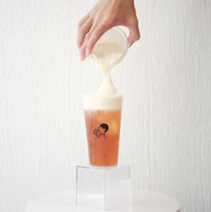
FIGURE 2-1 Cheese Tea (heyteahk, 2019)

The brand positions itself as “Inspiration of Tea”. It integrates elements of Zen spirit, minimalist, and aesthetics into the design of products and stores (HeyTea, 2020). The logo, using simple black lines to form an image of a person drinking tea, is an example. The price of a cup of HeyTea is between ¥19 and ¥33 in China, and in Singapore, it is between S$4.5 and S$8.5 (GDS Editorial Team, 2018). Currently, it can be ordered both offline and online. For online method, except takeaway by delivery, HeyTea also develops an app called "HEYTEA Go" to allow customers to order on the app and take the goods in the store without queueing.

2.2 BACKGROUND OF THE INDUSTRY
The new-style tea drink refers to the beverage that chooses high-quality tea leaves or extracted liquids from raw materials, often mixed with fresh milk, whipped cheese or seasonal fruits, and sold instantly in a retail shop (Wang, 2019). New-style tea drink has been popular in mainland China and Taiwan in recent years, gaining share from sweetened and artificially coloured bubble tea, reshaping the Asian tea market (Bolton, 2020). The difference between new-style tea and traditional bubble tea is that the former uses high-quality ingredients and tend to be more exquisite in the appearance of packaging, while the latter uses tea powder, milk powder, saccharin, coffee powder for instant production (Wang, 2019). Li (2019) wrote in the 36Kr Research that the Chinese tea drink industry has gone through three stages where new-style tea drink was in the third stage starting from 2015. Compared with the former two stages (Powder Stage and Street Stage), the New-style Tea Drink Stage has natural, high-quality and innovative ingredients with new production technology and multiple sale channels. In the future, sinking market and overseas market will be the new directions of the new-style tea drink market (Li, 2019).

Globally, there are already some new-style tea brands sweeping across the world, such as Coco, Chatime and Happy Lemon, which has its stores not only in Asia but in Europe and North America. They are almost all from Taiwan and mainland China. For native European and American brands, Starbucks and Costa are two similar ones, but their main product is coffee rather than tea.

Based on the ‘nine strategic windows’ model, the new-style tea drink industry is at ‘Potentially global’ stage, while HeyTea’s preparedness for internationalisation is around ‘Adolescent’ stage since it has already set up overseas stores in Singapore. Therefore, HeyTea should consider expansion in international markets.
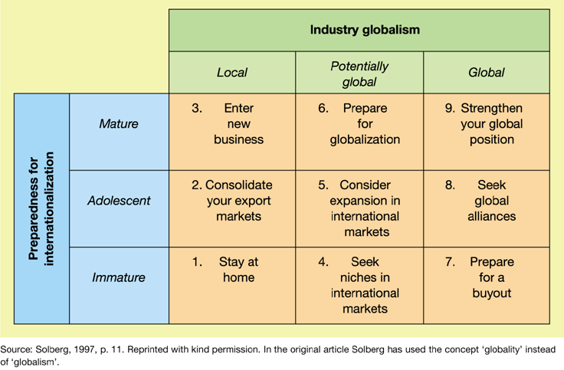
FIGURE 2-2 The ‘Nine Strategic Windows’ Model (Stavrou, 2015)

3. NEW MARKETS ABROAD

3.1 MARKET SEGMENTATION
Chen (2019) pointed out that the trend of new-style tea drink was due to the consumption upgrade in China. With the Chinese middle class getting richer, they have a higher demand for food and drinks. In this case, the target consumers of HeyTea are young urban citizens who have higher income, pursue fashion trends and enjoy a healthier lifestyle.

The report identifies new markets in the UK, and HeyTea can still target young urban citizens. Therefore, HeyTea stores should be set up in big cities like London, Manchester, and Birmingham.

3.2 SWOT ANALYSIS
The report uses SWOT analysis to evaluate HeyTea’s new markets in the UK.

- Strengths
(1) HeyTea is the originator of cheese tea. It has accumulated a customer base over the years. According to 36Kr Research, HeyTea ranked first among 1500 respondents’ favourite new-style tea drink brands (Li, 2019). “The average waiting time can be anywhere from 30 minutes to over an hour”, but this does not decline the enthusiasm of consumers (Wang, 2019).
(2) HeyTea has received a large sum of investment recently. In 2018, the investment arm of Hong Kong-listed Meituan Dianping, pouring $60 million into the company (Wang, 2019). And in 2019, HeyTea completed second-round funding, which totalled $75 million (RMB500 million) (Feng, 2019).
(3) HeyTea has gained overseas experience in Singapore. In 2018, HeyTea founded the first overseas store at ION Orchard in Singapore. Now it has opened another two stores at Clarke Quay and Jurong Westgate in Singapore (Boon, 2019).

- Weaknesses
(1) Products are easy to be imitated in the new-style tea drink industry. “Whenever there is a hit recipe, everyone else starts to make similar stuff,” said Loris Li, associate director of research at consultancy Mintel (Wang, 2019). For example, cheese tea is an original product of HeyTea, but it has been copied by various milk tea shops, like Nayuki and Happy Lemon.
(2) HeyTea was once in a dispute of trademark. The original name for HeyTea was RoyalTea, but its trademark was registered by its imitators in advance and the brand has to change the name into HeyTea (Yi, 2019). Although the acquisition of trademarks and updating of official websites have been done instantly, HeyTea is still bothered by imitative brands like HiTea, which can grab a part of HeyTea’s customers.

- Opportunities
(1) The growing number of Chinese HE students in the UK provides a large target market. According to HESA data, since 2012/13 the number of entrants from China each year has surpassed the number from all EU countries combined; In 2018/19, 32% of first-year non-UK domiciled students come from China.
(2) The UK has a history of drinking milk tea, which acts as an advantage to extend British markets. The milk tea was originated by Tibetan people and was spread through the Silk Road into India, where Indians developed its own Masala tea (nikandreyevas, 2018). Later in the 17th and 18th century, the British brought the milk tea recipe form India, but instead of ‘spiciness’, the ingredients were replaced by sugar and honey, which make British milk tea sweeter (nikandreyevas, 2018).
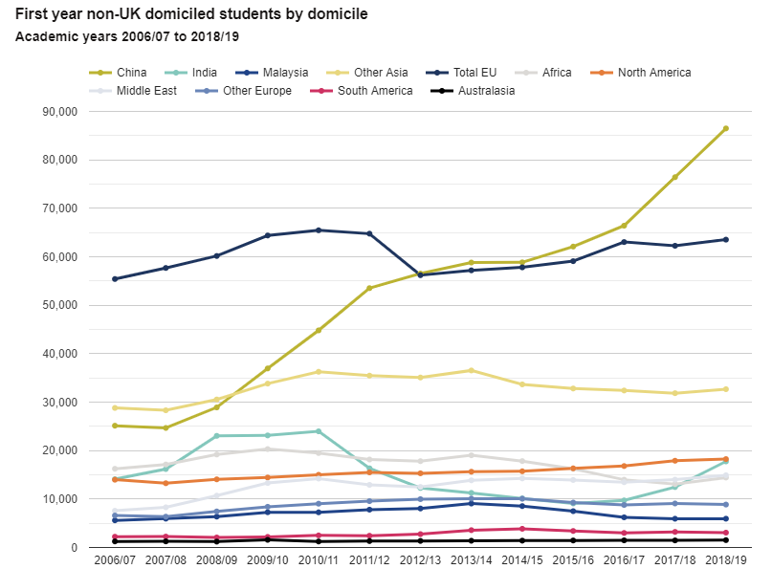
FIGURE 3-1 First year non-UK domiciled students by domicile (HESA, 2020)

- Threats
(1) Wages are increasing in the UK. The minimum wage rates among all age groups are on the rise. For example, for people aged 25 and above, the minimum wage rates were increased from GBP7.83 in April 2018 to GBP8.21 in April 2019 on an hourly basis (MarketLine, 2019). This can influence the cost structure of HeyTea in the UK.
(2) The competition of new-style tea drink is fierce.
Red Scarf (2019) has listed the most popular milk tea shops in the UK in 2019 based on voting results. The top 3 are Coco, T4 and Happy Lemon, who have already taken a part in the British market. The products of Coco and Happy Lemon are very similar, ranging from milk tea, cheese tea, lemon tea, fruit tea to chocolate and coffee (Coco, 2020; Happy Lemon, 2020), while T4 specialises in fruit tea with natural cane sugar (T4, 2020).
Another direct competitor is Nayuki, one of the leading new-style tea drink brands in China, which has also set up overseas stores in Singapore in 2018 (Nayuki, 2020).
(3) As a part of the beverage industry, the raw materials may be affected by unforeseen health issues. For instance, the recent outbreak of coronavirus has an impact on China’s tea harvest since the government adopted lockdown measures to control the virus(Bolton, 2020).
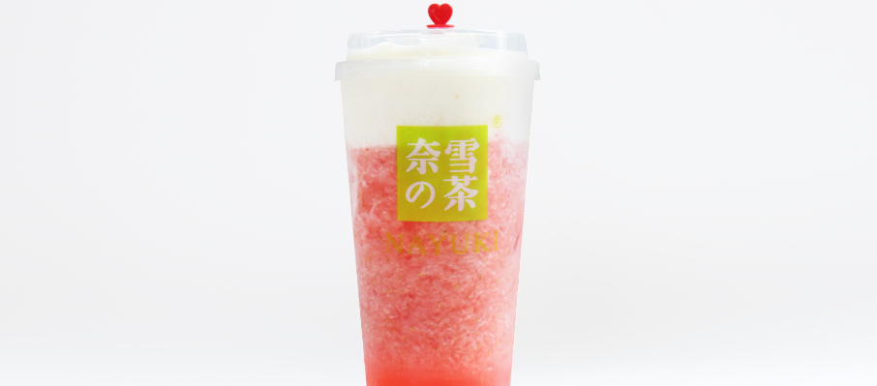
FIGURE 3-2 Supreme Cheese Strawberry (Nayuki, 2020)

4. MARKET ENTRY OPTIONS

4.1 ANALYSIS OF MARKET ENTRY OPTIONS
There are three main market entry modes and internalisation is increasing from export, intermediate to hierarchical modes (Hollensen, 2014, p.334). Export entry modes mean that the company manufactures its products in the home country or a third country and then transferred either directly or indirectly to the host market, which include indirect export, direct export and cooperative export (Hollensen, 2014, p.347). Intermediate entry modes aim to share knowledge and skills with local partners through contractual arrangements such as licensing, franchising and joint ventures, but there is no full ownership by the parent firm involved (Hollensen, 2014, p.369). Finally, hierarchical modes are “where the firm completely owns and controls the foreign entry mode” (Hollensen, 2014, p.399).

Factors to increase internalisation in HeyTea are various. First of all, the products of HeyTea are made instantly, and there is a range of HeyTea with new products launched twice a month (Wang, 2019). Besides, HeyTea has a large firm size with 456 stores in mainland China, and it has more than one year of international experience in Singapore. Last but not least, to maintain consistency, all HeyTea stores are regular chains, which reflects HeyTea desire for strong control over the markets.

Factors to decline internalisation in HeyTea also exist. First, the intensity of competition is rather high in the UK. With a number of competitors like Coco already in the UK markets and some strong competitors like Nayuki following, it is not easy for HeyTea to grab a market share in the UK. Also, the sociocultural distance between China and the UK is great. With totally different languages, legislations, culture and politics, it would be risky to do direct investment.

4.2 SELECTION OF MARKET ENTRY OPTIONS
Based on the analysis above, this report suggests franchising as the best market entry options for HeyTea to enter UK markets. Franchising belongs to intermediate entry modes, and it is a business method where “the franchisor gives a right to the franchisee against payment” (Hollensen, 2014, p.374).

If HeyTea adopts a franchising method, then it will have lots of things to do with franchisees. First of all, HeyTea needs to find franchisees who tend to be a start-up situation. Next, a business plan should be developed for the franchisees and contracts are ready to be made. Then, HeyTea needs to provide training to franchisees, passing on the whole business concept to franchisees including business know-how, trademarks, copyright, designs, location selection, market research for the area, etc. In return, franchisees need to pay "an initial fee upfront and/or continuing franchise fees" (Hollensen, 2014, p.376).

There is a range of benefits for HeyTea to use the franchising method. First of all, it is low-risk and low-cost since "the franchisees are the ones investing in the necessary equipment and know-how" (Hollensen, 2014, p.390). Besides, franchising can help HeyTea to establish the brand image and reputation of HeyTea in the UK because it has more control and sharing with franchisees. Last, it is a mode that is easy to expand quickly in international markets.

The disadvantages of franchising are also worth noticing. For example, searching for competent franchisees can be expensive and time-consuming. And since franchising is a sort of cooperation concept, communication and quality control are key issues. If not partnering well, it will harm the parent company.

5. RECOMMENDATION
To adopt franchising, one good thing is that HeyTea can not only maintain its own characteristics but also localise to meet local consumers' needs. Here are some localisation recommendations:
1) Develop plant milks as an alternative for growing vegan movement in the UK. According to an IPSOS Mori poll commissioned by The Vegan Society in 2016, at least 542,000 people in Britain are now following a vegan diet and plant milks have seen strong double-digit growth in recent years (MarketLine, 2018).
2) Develop bread and cakes that suit local people's tastes. Britain has a tradition of afternoon tea, during which tea is served with sandwiches, scones with clotted cream, cakes and pastries (Johnson, 2020). HeyTea may provide a set of special afternoon tea that will be popular among British people.

6. CONCLUSION
This report talks about HeyTea’s entry to the British markets. HeyTea, as one of the leading new-style tea drink brands in China, has over 400 stores in mainland China and opened the first overseas store in Singapore in 2018. The new-style tea drink industry is expanding, with some brands already going global. Using the 'nine strategic windows' model, HeyTea is expected to consider expansion in international markets. The target market is focused on young urban citizens, typically Chinese overseas students in the UK. A SWOT analysis is developed to evaluate the position of HeyTea in the UK markets. After some exploration about market entry options, the report chooses franchising for HeyTea to go to UK markets. Finally, some localisation suggestions are proposed.

7. REFERENCES
Bolton, D. (2020) New Style Tea Beverages Reshape Asian Tea Market. Available at: https://worldteanews.com/market-trends-data-and-insights/new-style-tea-beverages-reshape-asian-tea-market (Accessed: 12 March 2020).

Bolton, D. (2020) The Coronavirus Impact on China’s Tea Harvest. Available at: https://worldteanews.com/market-trends-data-and-insights/coronavirus-impact-on-chinas-tea-harvest (Accessed: 12 March 2020).

Boon, K. (2019) HEYTEA Is Opening Their Third Outlet at Jurong Westgate. Available at: https://eatbook.sg/heytea-westgate/ (Accessed: 13 March 2020).

Chen, A. (2019) A Blessing and a Curse for China's New Tea Industry. Available at: https://equalocean.com/retail/20190321-a-blessing-and-a-curse-for-chinas-new-tea-industry (Accessed: 12 March 2020).

Coco (2020) Fresh Drinks. Available at: http://www.coco-tea.com.cn/fresh-drinks (Accessed: 12 March 2020).

Feng, L. (2019) Exclusive: HeyTea's New Funding Round Values it at USD 1 billion, Source Says. Available at: https://equalocean.com/retail/20190513-heytea-closes-new-round-funding-valued-it-at-usd-1-billion-source-says (Accessed: 13 March 2020).

GDS Editorial Team (2018) China’s original Cheese Tea inventor HeyTea finally opens in ION Orchard on November 10. Available at: https://www.greatdeals.com.sg/2018/11/08/heytea-singapore-ion-orchard-opening-promotion-november-2018 (Accessed: 12 March 2020).

Happy Lemon (2020) Drinks. Available at: http://www.happy-lemon.com/drink/drink.php (Accessed: 12 March 2020).

HESA (2020) Where do HE students come from? Available at: https://www.hesa.ac.uk/data-and-analysis/students/where-from (Accessed: 10 March 2020).

HeyTea (2020) About Us. Available at: https://www.heytea.com/aboutUs.html (Accessed: 10 March 2020).

heyteahk (2019) Cheese Tea. Available at: https://www.instagram.com/p/Buydiu6g5nF/ (Accessed: 12 March 2020).

Hollensen, S. (2014) Global Marketing. 6th edn. Harlow: Pearson.

Johnson, B. (2020) Afternoon Tea. Available at: https://www.historic-uk.com/CultureUK/Afternoon-Tea/ (Accessed: 11 March 2020).

Li, X. (2019) 36Kr Research | 2019 White Paper About the Consumption of New Style Tea. Available at: https://36kr.com/p/5272286 (Accessed: 12 March 2020).

MarketLine (2018) Key Trends in Non-alcoholic Beverages. Available at: https://advantage-marketline-com.ezproxy.uwtsd.ac.uk/Analysis/ViewasPDF/key-trends-in-non-alcoholic-beverages-powerful-changes-shaping-the-soft-drinks-hot-drinks-enhanced-water-and-packaging-segment (Accessed: 11 March 2020).

MarketLine (2019) Costa Ltd – SWOT Analysis. Available at: https://advantage-marketline-com.ezproxy.uwtsd.ac.uk/Company/Profile/costa-limited?swot (Accessed: 12 March 2020).

Nayuki (2020) About Nayuki. Available at: http://www.naixuecha.com/ (Accessed: 13 March 2020).

nikandreyevas (2018) History of Milk Tea. Available at: https://www.blog.thatsmandarin.com/history-of-milk-tea/ (Accessed: 11 March 2020).

Red Scarf (2019) The Most Popular Milk Tea Shops in the UK in 2019. Available at: https://www.honglingjin.co.uk/360972.html (Accessed: 11 March 2020).

Stavrou, R. (2015) The Nine Strategic Windows Model. Available at: https://globalorientation.blogspot.com/2015/07/the-nine-strategic-windows-model.html (Accessed: 12 March 2020).

T4 (2020) About Us. Available at: http://www.t4.com.tw/cn/about.php (Accessed: 12 March 2020).

Wang, B. (2019) A Brief on Chinese Tea Drink Ramification - The New Style Tea Drink. Available at: https://equalocean.com/retail/20190413-a-brief-on-chinese-tea-drink-ramification-the-new-style-tea-drink (Accessed: 12 March 2020).

Wang, Y. (2019) 30 Under 30 Asia 2019: This 27-Year-Old Is Reshaping China's Tea-Drinking Culture. Available at: https://www.forbes.com/sites/ywang/2019/04/01/30-under-30-asia-2019-this-27-year-old-is-reshaping-chinas-tea-drinking-culture/#7c0884c468d9 (Accessed: 13 March 2020).

Yi, C. (2019) ‘Can the Dispute of HEYTEA Be Settled? – An Analysis of Crowds’ Imitation of HEYTEA’s Innovation and Its Legal Issues’, China Strategic Emerging Industry, 2019(40), pp.83.

