How are designers transforming industry systems for sustainable ends?

Jessica Thomas

Submitted in partial fulfilment of the requirements for the degree of MDes Surface Pattern Design, University of Wales Trinity Saint David, Swansea.

words
Supervisor: Ainsley Hillard
11th December 2019
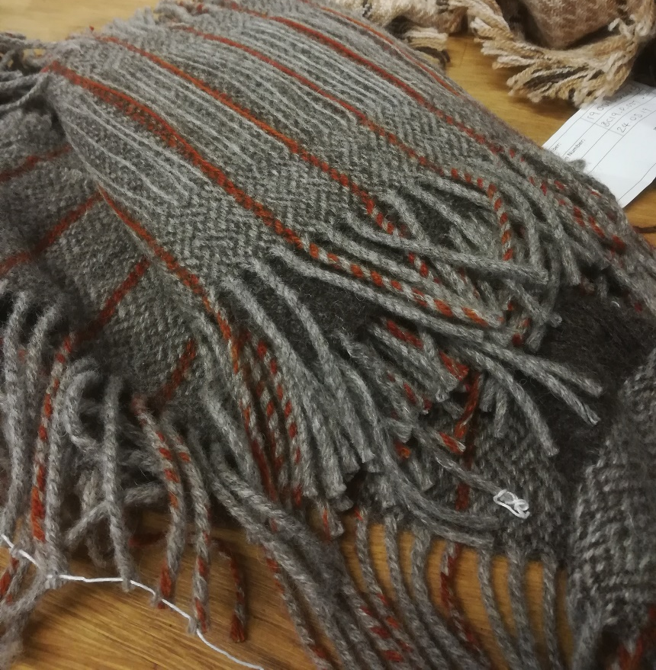
Cover image- Early scarf design, Bristol Cloth, 2019.


Contents

List of Illustrations Page 3
Summary Page 4
Introduction Page 4
Industry Waste Page 5
Finding Solutions Page 7
Sustainability in Bristol Page 8
Changing Systems Page 14
The Bristol Cloth Project Page 15
Shoddy, Authenticity and Aura Page 21
From Small Scale to Worldwide Page 24
Conclusion Page 25
Bibliography Page 27

List of Illustrations
Cover image – Bristol Cloth Project. (2019). Early scarf design. [Bristol Cloth] Bristol Weaving Mill, Bristol.
Figure 1 - Sainsbury’s. (2017). All change! Spring clean. [online] Available at: https://www.about.sainsburys.co.uk/news/latest-news/2017/06-04-2017 [Accessed 31 Jul. 2019].
Figure 2 – Antiform. (2019). The Antiform folk dress. [image]. Available at: http://www.antiformonline.co.uk/product/folk-dress-in-patchwork-navy/ [Accessed: 13 Oct 19.]
Figure 3 - Pym, C. (2010). Norwegian Sweater. [image] Available at: http://celiapym.com/work/norwegian-sweater/ [Accessed 24 Nov. 2019].
Figure 4 – Tamay and Me. (2019). Embroidered indigo jacket with yellow embroidery. [image]. Available at: https://tamayandme.com/collections/embroidered-jackets/products/embroidered-jacket-with-black-white-embroidery-with-people-on-the-mountains[Accessed:13 Oct 19.]
Figure 5 - Tamay and Me. (2019). Embroidered indigo jacket with black and white embroidery detail. [image]. Available at: https://tamayandme.com/collections/embroidered-jackets/products/embroidered-jacket-with-black-white-embroidery-with-people-on-the-mountains[Accessed:13 Oct 19.]
Figure 6 – Wolley, T. (2018). Bristol Fashion. Selvedge, (84), p.77.
Figure 7 – Bristol Cloth. (2019). Swatch card. [woven wool, card] Bristol.
Figure 8 – Behan, B. (2018). Botanical inks. 1st ed. London: Quadrille, p.15
Figure 9 – FinalStraw. (2019). Economy structure comparison. [image] Available at: https://thercollective.com/blogs/r-stories/circular-economy-vs-linear-economy [Accessed 21 Nov. 2019].
Figure 10 – Ciokajilo, L. (2013). 3D printed shoes from wool fibre. [image] Available at: https://3dprintingindustry.com/news/sustainable-footwear-from-3d-printed-moulds-16433/ [Accessed 16 Nov. 2019].
Figure 11– Skunkfunk. (2019). Iradi Sweater. [image] Available at: https://www.skfk-ethical-fashion.com/en/products/2337 [Accessed 5 Nov. 2019].

Summery
This inquiry examines how designing ethically has the potential to transform industry systems and the creative practitioners who work within them through both primary and secondary research. Firstly, discussing independent British designers and small-scale businesses. Furthermore, to how retailers and larger brands are finding solutions for the abundance of waste the fashion and textile industry produce.

Introduction
Sustainability is arguably the defining issue of the twenty-first century. The problems it presents for the fashion industry are broad. “The whole fashion cycle […] has to undergo improvement and not just a few isolated parts” (Fletcher and Grose, 2012, p.11). Labour abuses, toxic chemicals and obvious over consumption provided by fast fashion are the more prominent issues. For example, many companies like Etsy, in recent years have stated that they offset their carbon emissions to lessen their impact on climate change. Despite changes like these textile waste in the UK exceeding from 2.35 millions tonnes a year (Fletcher, 2008, p.98). A more considered approach is required about fibre choices and finishes need to be made for the industry to keep going at the speed it is. Better yet, reducing the speed of manufacture would be a more positive change. Another step would be to transform textile products, transitioning towards something less polluting, more efficient and respectful.
Thinking sustainably shows “understanding of the patterns, networks, balances and cycles at play in the fashion system” (Fletcher and Grose, 2012, p.11). This inquiry examines how designing ethically has the potential to transform industry systems and the creative practitioners who work within them. Firstly, discussing independent British designers and small-scale businesses. In seeing these brands persist with their ideologies as well as they have has encouraged me to think more responsibly about my future choices in terms of my studies and career. However, the issues that they have both faced with sizing means that it is likely that every independent brand suffers from the same dilemma. Furthermore, to how retailers and larger brands are finding solutions. The aim is to solve the negative impact of textiles by transforming fashion, fashion systems and the textile design practise.
Industry waste
In a survey commissioned in April 2016 by Sainsbury’s supermarket in collaboration with Oxfam (figure 1), a predicted 235million items of unwanted clothing would be discarded in the spring clear out that year. Of the 2000 people questioned, 49% do not recycle because the clothes are worn out or dirty, 16% said they have no time to get to a charity shop and 6% didn’t know that clothes could be recycled.
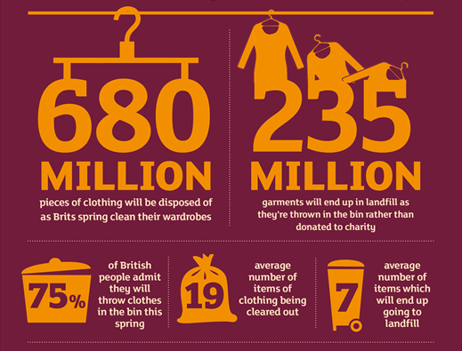
Figure 1 Figures chart detail, Sainsbury's, 2016
In 2016, more than 5,000 tonnes of unwanted clothing were donated through the partnership to Oxfam in the hope of extending the lifecycle of each item (Sainsbury’s, 2017). The campaign highlights to customers clearly the role of the consumer in the industry. Both practitioners and consumers need to be environmentally conscious for the products to be supported economically.
Recycling is an important step to reducing waste and landfill, additionally material composition of clothing also has a detrimental effect on the environment. Bristol textile recyclers are just one of the companies collecting and recycling unwanted textiles, receiving 20 tons of discarded items per day (Bristol Textile Recyclers, 2019). Half of the discarded textiles are synthetics, such as acrylics, polyester or mixed. These products take approximately 500 years to degrade and while they are doing so realise toxic chemicals into the ecosystem. Every time we wash synthetics, micro fibres are realised into the water. The material that was manufactured at the birth of synthetic fabrics will be with us for generations. At least 50% of the textiles we throw away are reusable, however the proportion of textile wastes reused or recycled annually in the UK is only around 25% (LBHF, 2019).
It is crucial that we find a solution to breakdown, in the hope of reversing, the harm that is being done to us and our planet by the manufacture of synthetic materials. It is unlikely that we will stop production of new synthetic textiles until we find an alternative, it is too popular.
“Circularity is being promoted as the latest solution […]. However, it is mostly being tackled from the downstream up, pushing short term waste management approaches […] from other industries as the main solution and betting against the odds that a technological fix will provide an easy solution” (Cobbing & Vicaire, 2017, p. 6).

It is a difficult situation, as re-manufacturing synthetic fibre as it is impossible to remove the oxygen that gets introduced throughout the process. It results are seen as a much weaker, less resilient product. All material has ecological and social impacts, each impacting at a differing rate and type from one another (Fletcher and Grose, 2012, P.13). Due to the rapid expansion of synthetic fibres there is an increased demand for wool due to its “aesthetic and comfort characteristics sought by consumers” (Ribeiro et al., 2015,p.254). Recyclability and biodegradability amongst its other natural properties like softness gives it the advantage over other materials.
“No one fibre, regardless of whether it is organic, fairly treated or recycled can single-handedly transform the practises of a polluting and resource- intensive industry into a more sustainable one” (Fletcher, 2008, P.5).
We need to develop products that use renewable resources with a moral approach, to decrease the demand for unethical methods by the customer. Only 1% of global cotton production is grown using organic methods (Behan, 2018, P.25). However, this ideology for supporting what we see as ‘eco-friendly’ materials is paradoxical to say the least. The industry faces contradictory views on what fibre production is truly ethical. The processing of bamboo, rayon, viscose and Tencel require rigorous chemical treatment despite being made from plant fibres.

Finding solutions
Upcycling and material re-use is a model that is often explored on a small scale. In a large system for the high-street reclaimed materials are never used to the scale of fast fashion. There is much pre-consumer waste that can be used as a resource, more favourable to the customer over pre-loved post-consumer waste. As companies now have to pay to dispose of their waste making it a valuable resource would be economic viable. It is an issue that companies should be addressing regularly. The blame of industry waste is not solely on the consumer for habit buying regularly. Lack of good quality design is a huge factor. Offering good design approaches and a better range of products the consumer will follow. “If more designers were to embrace pre-consumer and show that out of rubbish can come a profit” other companies will follow suit (Hemmings, 2012, p.379). Improving communication between companies is the next step in progressing.
Sustainable design needs to be accessible to a wider market to have the impact. “Small companies perform so much better and they make a conscious decision to stay small” (Hemmings, 2012, p.379). Collaboration between companies of different sizes would allow for those decisions to happen. Profit margins are not the primary concern for smaller brands when it comes to sustainability. They are not as limited but quality control restrictions, more of what they produce can be sold. Waste can be sold to smaller brands as they can vary product outcomes. They can scale production down “to make tote bags, […] little accessories, [badges]” where high-street brands do not have the labour (Hemmings, 2012, p.379). The composition of the market and their audience has changed. Consumer habits have changed so much the customer wants variety. Instead of saving to buy one product, consumers buy multiple of the same design but in different colours or the same print on multiple garments.

Sustainability in Bristol
Focusing on local brands to Bristol and the South West, The Bristol Textile Quarter was established 5 years ago (The Bristol Textile Quarter, 2015). The permanent members of the self-managed community get the benefits of working as part of a collaboration. The facilities are ever expanding due to the demand for the ethical textiles that the collective produce. The studio has been the birthplace to several independent ethical brands who design with sustainability as their focus.
The site shares its space with companies like Fernhill Fleece is another that explores the expanding development of Bristol and the South West’s textile economy, growing and harvesting British wool, maximizing wool production. Similarly, Botanical Inks who produce British plant-based textile dyes without using artificial chemicals or metals. Next door to the studio is the Bristol Weaving Mill, who work alongside Dash and Miller to create high-quality woven fashion and interiors.
Whilst studying in Bristol, I have had the opportunity to speak to a few of the women over the past two years to gain insight on what it is like setting up and managing a sustainable business. The first brand, Antiform, owned by Lizzy Harrison, design sustainable clothing by using reclaimed materials that would otherwise be thrown away as waste.
After moving to Bristol five years ago she came across some issues with her business. Although she uses bulk waste from her suppliers, not all of the material was being used fully each season and therefore falling into the trap of generating waste herself. To solve this issue Antiform scrapped the idea of seasonal collections and started to number their collections instead. This ensures that all the material is used until it has completely run out (Harrison (pers.comm.) 08/11/2017). A decision that actively changes the conventional model of working.
Having permanent collections can cause issues with clients as consumers tend to want the latest designs but improves the ethical standards that the brand wants to encourage. Antiform uses a model centred on pre-consumer waste but, it can cause the finish on the garments is not always to the best standard and the price of the garment to the consumer does not always reflect the final quality of the piece. Having six sizes that range from UK size 8- 18 means that consumers are generally small boutiques or independent buyers.
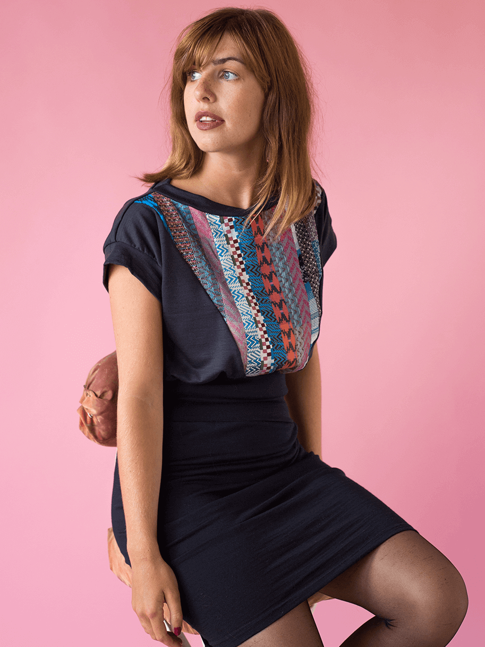
Figure 2 The folk dress, Antiform, 2019
Without the use of outsourcing the focus of the brand is online to meet profit margins. Upcycling material means that the company gets very good quality for low cost in terms of the materials, but the manufacturing costs are more as the products are all constructed in the UK. If the brand were to outsource to a store the brand would receive £36 for a £97.50 dress, cutting profit for the business. The Antiform Folk Dress, in figure 2, is popular with its classic style of creating a flattering shape while still being easy to wear and move around in. It incorporates silk weave swatches in a panel down the front of the dress to give a patchwork effect to a clever stretch design on the waistband and the skirt of the garment. The material is always “becoming something else […] overtaking the formal destinations that […] have been assigned to them”, showing that the resource is never finished (Ingold, 2012, p.435). The other products that the brand produces have similar features like patchwork cuffs to jumpers, pockets on skirts and yokes on variations of T-shirts. Each item has its own aura. The brand also sells loose fitting trousers, knitwear, leggings and accessories all unique and made from surplus textiles.
Skills involved in repairing garments are shared. Antiform offers workshops, open to the public that teaches basic sewing skills like repairing clothing and basic garment care, dying, knitting and weaving workshops to engage their customers in practises like visible mending, similar to Celia Pym’s work (figure 3), to their garments in the hope of extending the life of the garment (Fletcher and Tham, 2015, P.265). Alongside the brand's website, Antiform online, Harrison also co-manages Leeds Community Clothes Exchange where the public can engage with sustainable fashion even when they don’t have the disposable income spend on the Antiform site. Each event is four hours each month and around 2000 items of clothing are exchanged, now having over 2500 members and regularly getting over 150 people attending each Exchange (Leeds Community Clothes Exchange, 2019). The community project has encouraged the local community to recycle and exchange clothing in order to develop community spirit, reduce industry consumption, reduce landfill waste and raise awareness of unethical consumer habits.
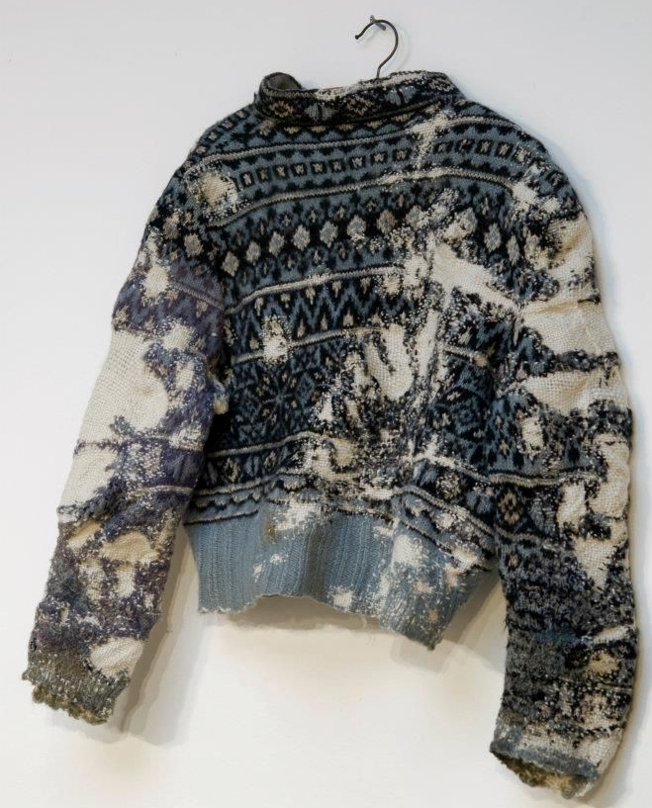
Figure 3 Norwegian Sweater, Celia Pym, 2010
The second of the two companies, Tamay and me, was established by Hannah Cowie in 2008 after visiting Vietnam as part of her anthropology degree. She spent three months in a self-sufficient community where she was taught embroidery by Ly Ta May. This drove Cowie to build a sustainable business built on excellent ethical standards. The delicateness of the embroidery (figure 4) means that each A4 size piece takes over 100 hours to produce and could span over a year’s work (Cowie (pers.comm.)08/11/2017). This community functions on tradition, every year for the Chinese New Year each family makes their own clothing from fibre to a complete garment. They wear them for the full year and sell the previous years at the market as they make new items for the next year (Tamay and Me, 2010). Inspired by this process, after her degree Cowie returned to Vietnam, having built trust with the locals to find that in that time the community has changed in that short amount of time. Having modernised very quickly Cowie wanted to persevere something from their old lifestyle and bring it over to the UK. The traditional clothing was fading from their society, they stopped making their own clothing and selling what they had online for barely anything. Seeing this fade, Cowie replicated how the locals made the jackets traditionally, around 50 years ago, but selling them in Bristol after joining The Bristol textile quarter in 2015.
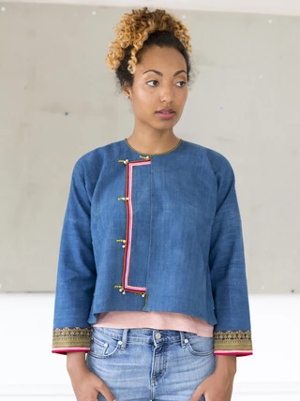
Figure 4 Embroidered indigo jacket, Tamay and Me, 2019

Having only a small community of around 20 people producing these jackets in Vietnam means that the production is as small as possible. The cotton is grown and spun just three hours away from the village, all on a freelance basis, like the machinists also. A substantial amount of trust is needed for every part to be successfully finished in time for the next stage of the process. Just to dye the jackets the traditional blue they need to dip the fabric in Indigo dye between six to ten times for an even tone throughout the piece (see figure 3). To get a deeper black, the jacket would need to be dyed 21 times to get the desired effects (Tamay & Me, 2019 a). Many hours are spent on this process, the community really need to be committed to keep producing these items on a regular basis.
The selling point of the brand is that they produce slow fashion, sustainable and unique. “A handcrafted object evokes the aura of human tradition […] cultural boundaries” (Rovine, 2012, p.272). One of the problems that Cowie found was that although the locals had the skills and the resources to create these pieces, but they did not have the creative mindset to use the skills they had to its full potential and to use them for financial advantage. The Tay ethnic minority spend most of their time coordinating the planting, nurturing, harvesting of rice, cotton, and indigo for the jackets, it seemed a waste to Cowie that the people were not getting anything back from their hard work.

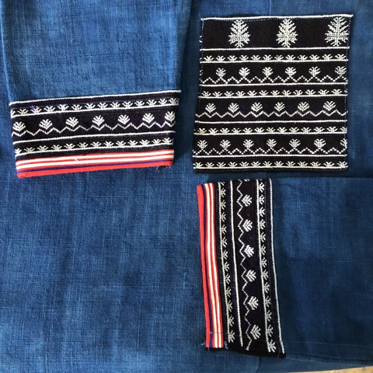
Figure 5 Black and white embroidery detail, Tamay and Me, 2019
The cotton and indigo for the pieces are grown, without pesticides, in the village in North Vietnam, Taphin, by the local Tay ethnic minority. Once the cotton is harvested it is then spun and woven into the material (Tamay and Me, 2019 b). The indigo is then fermented using the alchemic process, this mostly happens during the winter. The material is dipped 3 times a day for a period of one week if the desired colour is black, giving the cloth a dark and rich colour, if not, then it takes only three to four days to dye the garment blue (Tamay & Me, 2019 a). This is then dried and handed over to the machinists to start constructing the garments and embroider the jackets by hand.
But this signifies the brand’s customers have enough disposable income to spend and appreciate the time and work that has gone into its production. (Cowie(per.comm.)07/10/2018). Online, customers can purchase the brand’s jackets in three different styles, embroidered, Indigo and knotted. The plain indigo jackets are made from zero waste pattern to limit the waste that they produce. These are also available in children’s sizes, costing £75, whereas adults can go up to £148 (Tamay and Me, 2019 b). The jackets are made to be unisex and five sizes are available which means that there is more flexibility in the range of consumers the brand can attract.
The brand offers the same workshops and host similar events throughout the year that are open to the public as Antiform. These brands are short-term businesses that would need to expand further to get a consistent workflow to start getting a reliable income for their workers instead of just being supported by independent commissions by the public.
Changing systems
It is more likely that small brands like Antiform and Tamay and Me, are designing sustainability into their products more effectively. They are committed to their ethos. In larger businesses, management are divided into groups making it harder to solve potential problems across departments. Smaller brands do not have this issue as often as generally one person is investigating everything (Hemmings, 2012, 378-9). The research and design route are considered and focused, development ideas are not suppressed by other members of the design team. The simple decisions are made quicker as they do not have to go through multiple people to be approved. Working in a smaller system provides the brand with one-to-one consultations with their clients. Having direct feedback with customers leads to immediate issues with the product that can be re-evaluated (Portas, English, 2019). Any flaws in the product can be reviewed and developed faster, they have more flexibility.
Smaller scale production offers easier access to material and pattern improvements. The limitations to a smaller scale production are restricted to personal experience in the industry, strict time management and the dependency to be financially stable. In order to practice sustainably companies must be able to take risks, every decision has a consequence. They would be viable for any losses. Unconstrained by someone else’s brief they are more willing to allow themselves the time to experiment. Curiosity can be explored with less pressure to get things right first time. Both materials and labour need to be accommodated in the price one charges but clients are satisfied with paying more when the product is ethically made, by hand or not. It is seen as an investment in the client’s wardrobe.
A sustainable ethos is valued by the client. The garment is more likely to be repaired as it is loved. Care would be taken in its manufacture and throughout its lifespan. It is also more likely it will be cared for as it cost more than what is available on the high-street. The client would want to it last longer than the average product. An advantage to this is that the client would buy less each year, slowly reducing demand. It would take a vast amount of the population to decrease the demand for high-street brands. There are many small companies, as previously mentioned, that offer ethical alternatives that will ultimately reduce fashion waste. They have another advantage of being specialist.

The Bristol Cloth project
To reduce the industry dependency on oil, biodegradable fibres like wool would decrease the emphasis on polyester products. The market for wool is small but growing due to brand initiatives to source more sustainable outcomes.The Bristol Cloth Project celebrates the heritage of the South West of England. The project is one of a collaboration between several brands based in, and around Bristol. A collaboration between Fernhill Farm, Botanical Inks and The Bristol Weaving Mill with the addition of Brown In Town, Jokoto Tailoring and OB Wear to aid with commissioned orders (Crowdfunder UK, 2019). The aim of the project was to produce a sustainable material using traditional methods.
Fernhill farm are the fibre providers for the Bristol cloth project. Babs Behan from botanical inks provides the natural dyeing process for the Bristol Cloth project. The Bristol weaving mill are the manufacturers and technical advisors involved in the Bristol cloth project, considering themselves wholesome in their approach, linking social and environmental impacts to regenerate soils. The site of the weaving mill stands where the Great Western cotton factory was situated in 1838 (Baker, 2018, p.9). Showing how the historical sources has influenced the project.
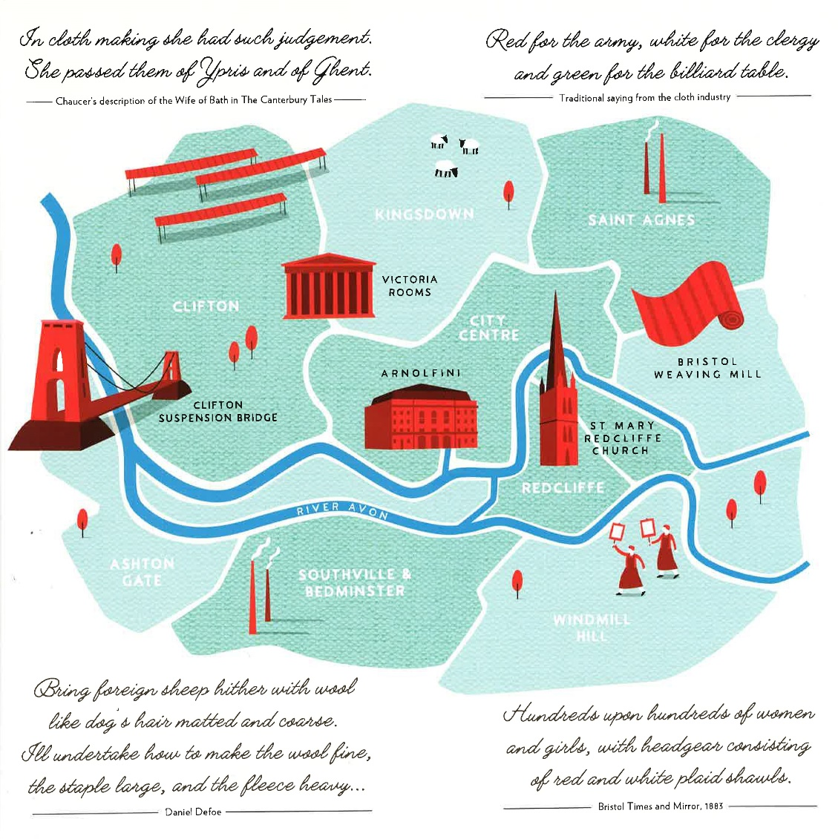
Figure 6 Bristol's landscape, Tom Wolley, 2018
In the past, the British landscape and economy was shaped by the textiles industry, local textile production was vital to our agricultural systems and our livelihoods. Figure 6 shows how the industry formed the landscape in Bristol. Modernisation of traditional British textiles are being threatened to near extinction. Fabric manufacture is part of a damaging global production system. What is missing from the UK is a locally sourced and manufactured cloth for designers to work with.
The Bristol Cloth Project aims to change this by creating a sustainable regional material that regenerates, rather than degrading our land and natural resources (Baker, 2018). Production of cloth, using this method like these shows that small scale production can be commercially viable. The project was first bought to my attention via Crowdfunder. The project was funded by the community for the community. Supporters had the option to purchase products from the value of £5 up to £1401 equal to the amount they contributed. With around 20 products to choose from the £15,000 target was exceeded by over £3000 in only 83 days (Bristol Cloth, 2019). The prizes consisted of textiles, fashion and accessories.
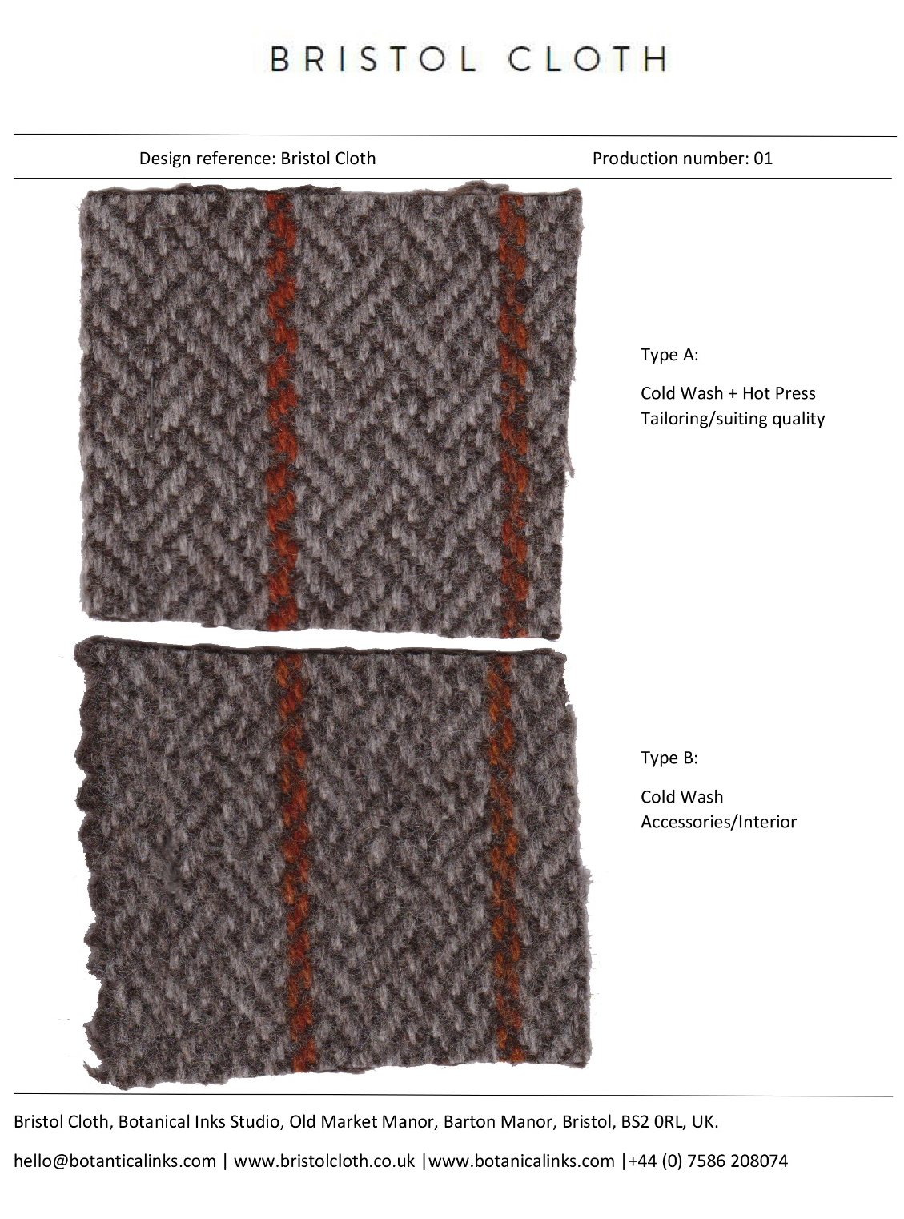
Figure 7 Swatch card, Bristol Cloth, 2019
The project is evidence that there is a demand for slow fashion. The media coverage on the project has bought awareness to the way in which things are made and how they reach us as a physical product (see figure 6). The popularity of the project shows when one does something for the love of it, people respond to it because they are not doing it to make a profit, they are doing it because they want to. The attraction preys on the human quality to want to feel good about oneself, the act of sharing with others that can be even more rewarding. It can often create a loop of positivity.
Often in the fashion and textile industry, the focus is on the negatives or problems with the systems. “ The likely consequences: non-linear, abrupt environmental change with continental – to planetary scale systems” (Fletcher, 2014, p.xvi) To springboard a project on a social media platform like Crowdfunder, it broadcasts the positive message as almost a rebellious act against the said system. It has pushed contributors to have the confidence to believe in what the Bristol Cloth is putting out there. It has bought hope to the industry for change. The hope for the betterment of the planet. Customers are made to think about what they are supporting before they purchase.
The Bristol Cloth Project has provided their customers with solutions, better alternatives to invest in. More independent designers and makers using local, organic responsibly sourced materials and low-impact production will lead to a system not dis-similar to a circular economy.
Changes in consumer interest is the most effective solution for ending the damaging effect of the fashion industry. It is only then we can move away from using synthetic dyes, textiles, paints and inks. It is encouraging to see a resurgence in this interest through this project. Natural materials impact the earth far less. They may also be far cheaper to use than the chemically based options used for mass-market production. Most popular plants used in dyeing can be grown very easily. The feeling of wearing such a material invites you to feel more connected to the environment that surrounds us (BBC Points West, 2018). Life depends on soil. It is estimated that over ten thousand dyes and pigments that are used by commercial industry have eight-thousand chemicals in them (Chequer et al., 2019, p.151). The Fibreshed model or the ‘soil-to-soil’ structure works on the concept of connection.
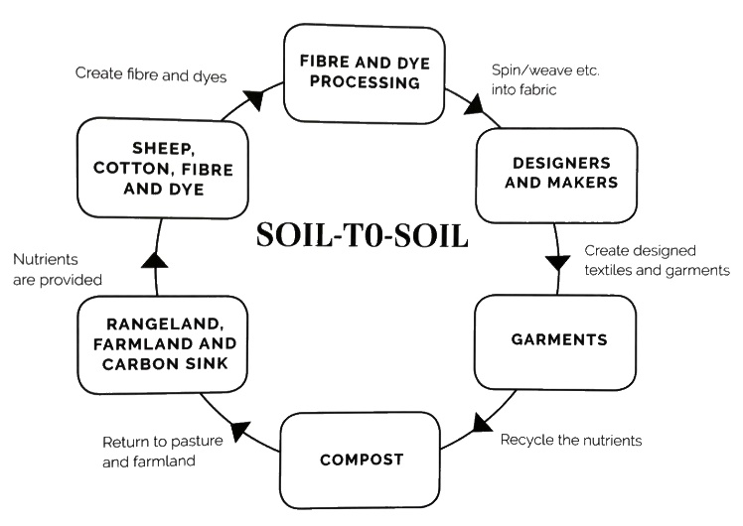
Figure 8 soil-to-soil diagram, Babs Behan, 2018
Structures that are built on these systems are built to be sustainable. Some are adapted to use renewable energy powered mills close to farming or processing areas to reduce transportation and reliance on fossil fuels. Carbon neutral and carbon fixing processes are used to farm, rejuvenating the quality of the soil. By making a cloth that is compositable, this project is giving carbon back to the earth as biological nutrients as opposed to pollutants in landfill waste (Bristol Live, 2018). The cloth nourishes the soil at the end of its useful lifespan as textiles, figure 8 shows the soil-to-soil cycle.
“Unlike the textiles produced in Barton Hill during the Victorian period, the Bristol Cloth will be made without any harmful chemicals and is therefore safe to go back into the ground at the end of its life cycle (Baker, 2018, p.9).”
The collaborative chose wool as their resource to create the cloth. The idea is that the process mimics natural grazing herd systems which mean they are always moving onto fresh grassland. The soil is rested, which leads to better quality grass for the sheep to ingest (Sky News, 2019). There is a lot of nutrients going back into the soil and plants that are growing in regenerative soils. With blade sheering you can leave an inch of wool fibre all over the sheep's body so that they are insulated from the sun and from the rain. Around 2kg of fleece can be utilised from each sheep to spin into yarn (Sky News, 2019). Overall, their system seems to be a high welfare system that is chemical free, is completely transparent and there is a very low footprint (BBC Points West, 2018). They use local organic plant-based materials and natural fibres.
The chosen material for the project was wool. Wool is a yarn that is created from the fleece of animals. This could be made from sheep, goats or llamas, but as the project is situated in the UK the most common animal is sheep. Individual wool fibres attach together when spun to create yarn, which is then used to create garments (Love Your Clothes, 2019 a). Wool retains warmth well and is naturally stain and wrinkle resistant and absorbent. This makes it easier to dye. It also means that like denim, animal hairs should only be washed when it is absolutely needed. Washing on a gentle cycle or by hand, using less water (Love Your Clothes, 2019 b). The material would need to be dried flat to retain its shape. If time was taken to care for the product customers can store their clothing in sealed cotton bags to deter moths (Love Your Clothes, 2017). Disposing of the garment impacts the environment less than the more common cotton and polyester. Pure, un-dyed or naturally dyed wool can be composted as long as it does not contain any synthetic fibres or dyes. To extend its life, clothes swaps or charity shops will take them as wool can last in decent condition for a long time.
As part of a non-toxic creative practice they have chosen madder and weld to dye the Bristol Cloth yarn. Madder is a root, weld is a yellow flowering plant which gives a beautiful burnt rusty orange colour to the yarn (see figure 7). The fleece is prepared in a hot wash without the use of chemicals. It is not only not polluting; it is bio positive as it is creating things which are then becoming food and nourishment for other life forms.
We are seeing a small resurgence with artisan fabrics and people really valuing those traditional methods. The involvement of all the practitioners throughout has created a unique development. By recreating the local production of textiles and to create a regenerative core supporting the project gives one the chance to help build an alternative to the mass-produce global textile industry (Bristol Live, 2018). Supporting carbon sequestering agriculture, non-toxic natural dye processes and small-scale weaving will bring bioregional artisans and cloth production back to the UK (Sky News, 2019). The Bristol cloth Project is a beautiful and uplifting example of what can be possible when communities collaborate, sharing their passions to create something that's bigger than themselves.
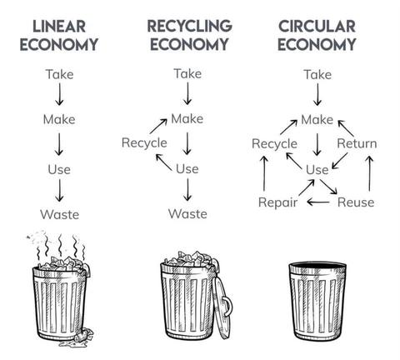
Figure 9 Economy structure comparison, FinalStraw, 2019
The production of the project is also an example of circular technologies. It is built upon an ecological system, a network of cycles and open loops. Circular design is a strategy with the aim to use the earth’s resources in a more sustainable outlook. In circular design material is considered to be part of a loop, a loop where salvage or future use is predicted (see figure 9). The aim is to keep materials in circulation continuously. Circular resources are designed with salvage in mind, or they can be extracted from a linear system to retain their value. Circular materials are anything that escapes an industry cycle. It should aim to do no harm but an active nutrient in the system. This system removes waste altogether. By applying this to textiles, a circular system achieves a sustainable future.
Shoddy, authenticity and aura
The reuse and use of waste wool in the textiles industry have been used before. The concept was practiced in the 19th century in wool production. Shoddy, or wool selvedge, was advertised as new product and was later coined ‘inauthentic’ by the industry. Shoddy was seen as an unreliable and dirty material, “liable to tear or grow threadbare in a fortnight” (Vettese, 2017, p4). Brands like Harris Tweed were very successful as they avoided the use of shoddy and promoted virgin wool as authentic, being valued as a luxury material. Though the custom of branding materials did not develop until much later, the ‘aura’ surrounding shoddy, at this time, did not aid its status and popularity (Vettese, 2017, p9). What is described as luxury or authentic is a matter of perception.
Authenticity has different definitions to different industries. It can be an expression of taste, focused on the craft behind a product. A luxury material would have this value as well as the possibility of heritage and rarity. Long standing companies have prospered on these values to build a reputation of quality. Brands portray this narrative to build customer loyalty. Today, shoddy is often sold as long strips wound up into a ball and sold as knitting material. Long standing companies do not want to risk the image they built on what is seen as a lower quality product. “Touch is a sense most deeply used in questions of authenticity” (Rovine, 2012, p.271). If is not feel genuine or ‘clean’ the customer is less likely to make a purchase.
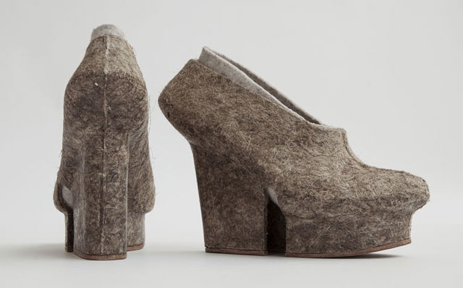
Figure 9 - Early experiment with 3D printed wool and resin , Liz Ciokajilo

In terms of new technology, 3D printing can offer a new perspective on shoddy. The ‘devil’s dust’ can be laminated with a bioplastic such as PLA to be printed with. The experimental nature of 3D printing means that what is produced will show a wabi-sabi aesthetic to the texture, combining both hand and machine (Vettese, 2017, p.8). This can then be laser cut into shapes to lessen waste material further. It can be both bespoke and mass produced, revaluating the material’s authenticity. “There is no such as inauthentic experience because experiences happen inside us” (Gilmore and Pine, 2007, p. 81). The pair of shoes, shown in figure 9, were made similarly to the process mentioned above, with the aid of resin fusing wool, flax and coconut fibre.
Authenticity is a social construct, a human element given to an object, which overtime will change, the ‘aura’ of materials will change as society will progress into becoming more sustainable. We value items because we can see how our life would be affected by parting with them (Hyde, 2019, p.102). The transparency of a brand will become as valued as its narrative. “This will provide positive associations, meaning that consumers will have a positive mindset about the company and its products” (The Swedish School of Textiles, 2014, p.37). When a consumer buys an ethical product, they gain an emotional reward. The Bristol Cloth project benefited from social constructs such as authenticity, associating with traditional and historical methods surrounding heritage. Emotionally connected consumers are more valuable to a brand in the current climate. Cultural acceptance is the most important challenge.
Brands are uncertain in communicating sustainable changes, either to state that their products will now be sustainable or quietly improve closed loop production to escape the loss of customers due to ‘inauthenticity’ (Norris, 2019, p.888). Sustainable can translate as inferior, likewise shoddy did to virgin wool. For example, recycling post-consumer waste back into desirable clothing would be a challenge as it would be seen as ‘dirty’. However, clothing brand Skunkfunk have produced a jumper that does just that with success last year.
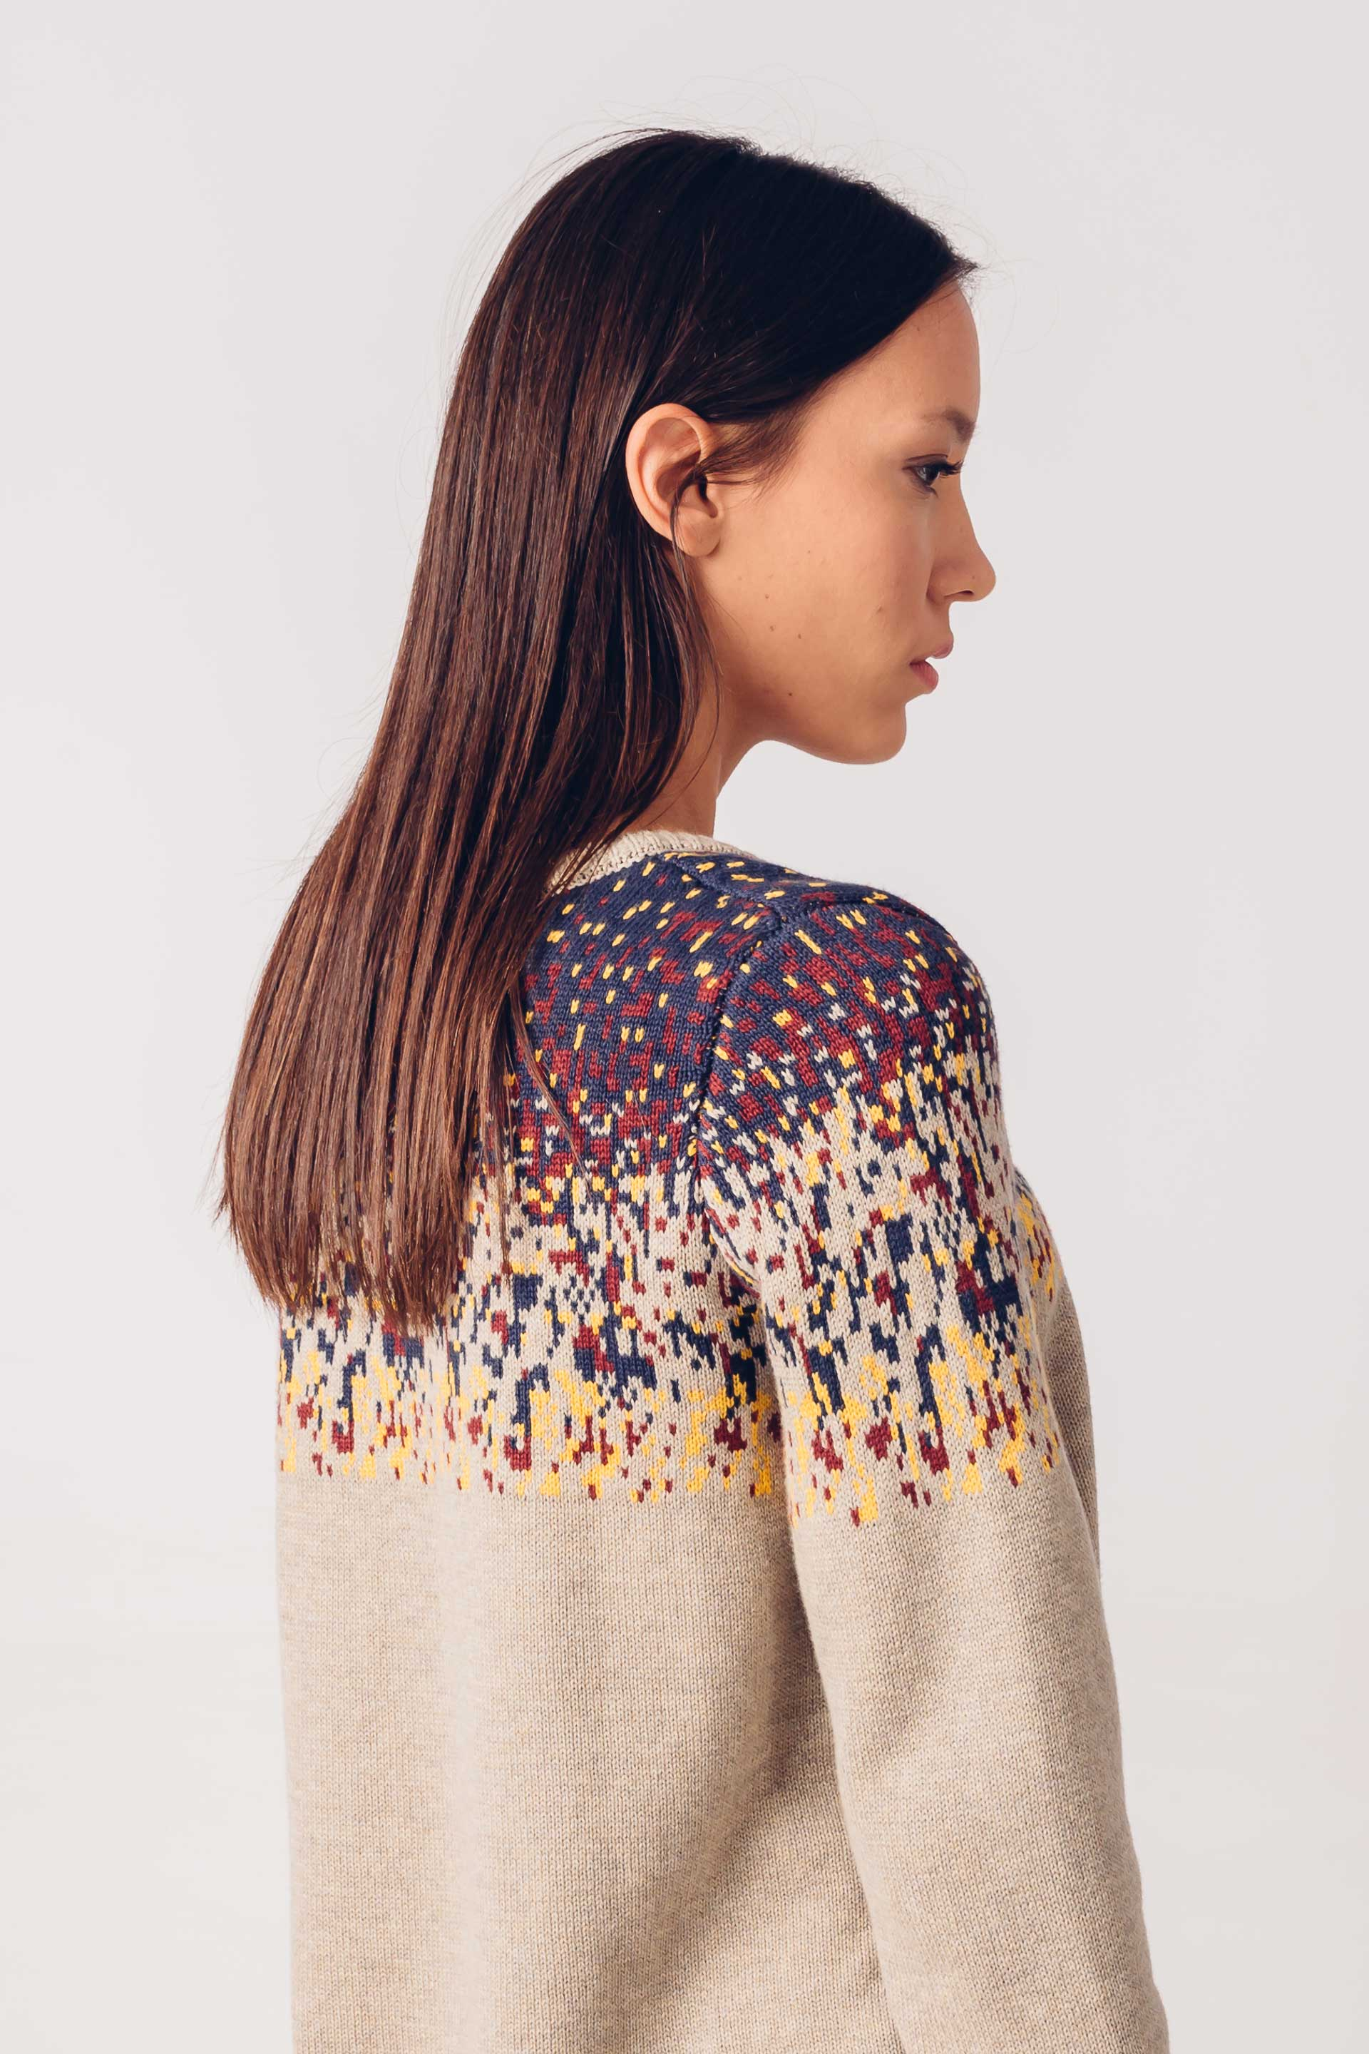
Figure 10- Iradi sweater, Skunkfunk, recycled cotton, 2019

From small scale to worldwide
The Fashion Revolution manifesto states “fashion respects culture and heritage. It fosters, celebrates and rewards skills and craftsmanship. It recognises creativity as its strongest asset. Fashion never appropriates without giving due credit or steals without permission. Fashion honours the artisan” (Fashion Revolution, 2019, p.1).
Concepts like slow fashion, having emotional connections with the garments and mindful production using organic materials have been around for centuries. We need to change our consumption patterns and start re-introducing more culture into fashion. The Cultural Intellectual Property Rights Initiative (CIPRI) designs ethical solutions by appreciating the artisans and designers as equal partners in the creative process. CIPRI provides legal support for traditional and contemporary designers. The association acts as a mediator, helping to build culturally sustainable relationships between communities and the fashion industry (Fashion Revolution, 2019, p.41). The support helps to build business structures in which both parties receive recognition. The members are dedicated in creating a network that connects cultural knowledge and technology to develop sustainable and ethical developments in the industry. Another asset to this expanding globally is that traditional methods are preserved. Mass produced and standardised clothing has replaced garments that have meaning. “Skill would bind them to their ancestors as to their fellows” as a communal bond (Sennett, 2009, p.6). There is far less skill represented in what the average person wears.
National legislation against the use of virgin materials would encourage material re-use. For example, raising taxes on the use of virgin materials, issuing penalties for creating waste and for not putting suitable waste materials to use. Companies would benefit from tax cuts for using recycled resources and recycling their waste clothing and textiles. Investments need to be made in those brands who are actively researching system changes and infrastructures in reducing waste of the fashion and textile industry.

Conclusion
In order to redesign industry systems action needs to be taken within society. One way this is done is by refusing to buy new. There are increasing numbers of vintage, second-hand, swapping and hire clothing events to provide consumers with cheaper or more considered approaches to shopping. Refusing to buy new will cut down on demand for raw virgin materials, consumers will have less items to dispose of when they get tired of the ‘off trend’ garments. Whether consumers still buy new or choose not to, they can still get inspiration from movements such as visible mending. Some will question if regression to previous methods of making the most of resources is the how we should sustain materials for the future. But clothing was valued then, why should we not go back to adopting past systems if they worked? “When we really valued and treasured a very beautiful coat and we repaired it we looked after it and we cleaned it properly and it came back, you know winter after winter” (Portas and English, 2019). Items were cared for, repaired to extend its life and re-worn. They were passed to others if unwanted. Women used their knowledge of craft to make their own clothes for themselves and family members.
Another pathway would be to get the government to pass legislation for extended producer responsibility laws stating that businesses are accountable and responsible for the textile waste they create. Its these changes that will help the innovators to succeed in building a circular economy. Brands needs to accommodate for easier access for consumers to repair and recycle textiles. The garments themselves will be an investment for the customer. To transform industry systems, we must first change the culture it thrives on. To stop feeding the monster. As a society we need to stop promoting the broken narrative that everything is easily disposable. Fast fashion allows for too much planned obsolescence because of increased consumption and micro-trends.
The unwanted waste generated is a design flaw, by taking the time to design a product, that waste can be a resource for another product. A consideration that Antiform exploits as much as possible in their products. In short, the soil-to-soil principles need to be adopted by all companies within every industry in order to improve waste and consumption figures. Further projects like The Bristol Cloth Project will gradually indoctrinate these sustainable ideologies into society that will encourage consumers to look for alternatives to uniformed high-street labels. Social media, client connection and artisan collaboration with inter-connected brands should be exploited as much as possible for their transformational effects they can have for the industry. With this, the economy would transition to one that can withstand the gravity of this change. We need to demand better from ourselves, those in the position to introduce, and design better. Good design should not be wasted. It should be encouraged, especially by the labels with the financial stability to develop such a system.

Bibliography
Baker, H. (2018). Dyeing Art Fabric Pioneers Create First Non-toxic Cloth Using Plant Materials. Bristol Post, Wednesday 7th November, p.9.
BBC Points West (2019). Bristol Cloth On BBC News! 21/11/18. [video] Available at: https://www.youtube.com/watch?v=HLgQH9PYcHc [Accessed 5 Sep. 2019].
Behan, B. (2018). Botanical inks. 1st ed. London: Quadrille, p.25.
Bristol Cloth. (2019). Bristol Cloth. [online] Available at: http://www.bristolcloth.co.uk/ [Accessed 25 Aug. 2019].
Bristol Textile Quarter. (2015). Who we are - Bristol Textile Quarter. [online] Available at: http://bristoltextilequarter.co.uk/about/who-we-are/ [Accessed 1 Aug. 2019].
Bristol Textile Recyclers. (2019). Bristol Textile Recyclers - Diverting 20 tonnes of textiles from landfill daily. [online] Available at: http://btr-ltd.co.uk/ [Accessed 31 Jul. 2019].
Chequer, F., Rodrigues de Oliveira, G., Ferraz, E., Cardoso, J., Zanoni, M. and Palma de Oliveira, D. (2019). Textile Dyes: Dyeing Process and Environmental Impact. [ebook] Intech, p.151. Available at: http://cdn.intechopen.com/pdfs/41411/InTech-Textile_dyes_dyeing_process_and_environmental_impact.pdf [Accessed 5 Sep. 2019].
Cobbing, M., & Vicaire, Y. (2017). Fashion-at-the-crossroads: A review of initiatives to slow and close the loop in the fashion industry. Hamburg, Germany: Greenpeace e.V. Germany.
Available at:http://www.greenpeace.org/international/Global/international/publications/ detox/2017/Fashion-at-the-Crossroads.pdf?utm_campaign=Press%20Release&utm_ source=Link&utm_medium=HK [Accessed 29 Oct. 2019].

Cowie, H (08/11/2017) personal communication.
Cowie, H (07/10/2018) personal communication.
Crowdfunder UK. (2019). Bristol Cloth. [online] Available at: https://www.crowdfunder.co.uk/bristol-cloth-1 [Accessed 25 Aug. 2019].
Harrison, L (08/11/2017) personal communication.
Hemmings, J. (2012). The Textile Reader. 1st ed. London: Bloomsbury Publishing Plc, pp.377-386.
Ingold, T., 2012. Toward an Ecology of Materials. Annual Review of Anthropology, 41(41), pp.427–442.
Fashion Revolution, (2019). Fashion Craft Revolution, (4), p.1.
Fletcher, K. (2008). Sustainable fashion & textiles. 1st ed. London: Earthscan, p.5.
Fletcher, K. and Grose, L. (2012). Fashion and Sustainability. 1st ed. London: Laurence King Publishers, p.13.
Fletcher, K. (2014). Sustainable Fashion and Textiles: Design Journeys. 2nd ed. London: Routledge Taylor & Francis Group, p.xvi.
Fletcher, K. and Tham, M. (2019). Routledge Handbook of Sustainability and Fashion. 1st ed. [ebook] London: Routledge, p.265. Available at: https://www.routledgehandbooks.com/doi/10.4324/9780203519943.ch2 [Accessed 1 Aug. 2019].
Gilmore, J. and Pine, II J. (2007) Authenticity; What Consumers Really Want. Harvard
Business School Press. Boston, Massachusetts, P.81.
LBHF. (2019). Textiles recycling and reuse. [online] Available at: https://www.lbhf.gov.uk/recycling-and-rubbish/recycling/clothes-shoes-and-textiles-recycling-and-reuse [Accessed 31 Jul. 2019].
Leeds Community Clothes Exchange. (2019). About. [online] Available at: https://leedscommunityclothesexchange.com/about/ [Accessed 23 Aug. 2019].
Norris, L. (2019). Waste, dirt and desire: Fashioning narratives of material regeneration. The Sociological Review, [online] 67(4), pp.886-907. Available at: https://journals.sagepub.com/doi/10.1177/0038026119854273 [Accessed 3 Nov. 2019].
Portas, M. (2019). Phoebe English, Miss Jason in Glasgow, Contemporary Chinese furniture design. [podcast] Mary Portas: On style. Available at: https://www.bbc.co.uk/sounds/play/m0008y4b [Accessed 1 Nov. 2019].
Ribeiro, L., Miguel, R., Pereira, M., Lucas, J. and Trindade, I. (2015). Human body as fashion space: fashion accessories, design and woven fabrics. Journal of Fashion Marketing and Management: An International Journal, [online] 19(3), pp.249-257. Available at: http://www.emeraldinsight.com/1361-2026.htm [Accessed 5 Nov. 2019].
Rovine, V. (2012). Handmade Textiles. Museum Objects : Experiencing The Properties of Things, 1, pp.271-272.
Sainsbury’s. (2017). All change! Spring clean. [online] Available at: https://www.about.sainsburys.co.uk/news/latest-news/2017/06-04-2017 [Accessed 31 Jul. 2019].
Sennett, R. (2009). The craftsman. 2nd ed. London: Penguin, pp.5-23.
Sky News (2019). Bristol Cloth - Sky News. [video] Available at: https://www.youtube.com/watch?v=nt_x5yCAOL0 [Accessed 5 Sep. 2019].
Tamay and Me. (2010). [video] Directed by H. Cowie. Taphin, Vietnam: Hannah Cowie. Available at: https://www.youtube.com/watch?time_continue=547&v=cr2LhXkfAFo
Tamay & Me. (2019 a). Our Process. [online] Available at: https://tamayandme.com/pages/our-process [Accessed 9 Aug. 2019].
Tamay & Me. (2019 b). Collections. [online] Available at: https://tamayandme.com/products/ [Accessed 9 Aug. 2019].
The Swedish School of Textiles (2014). The Influence of Authenticity and Transparency. [online] Borås: University of Borås, pp.27-37. Available at: http://hb.diva-portal.org/smash/get/diva2:1310053/FULLTEXT01.pdf [Accessed 10 Nov. 2019].

