University of Wales Trinity Saint David
School of Engineering

Manufacturing methods’ optimization of bushes and sleeves
Materials and Introduction to Manufacturing
M4X01163

Yalan Mo
1805245
20/01/2019

Table of Contents
1 Introduction 1
1.1 Aims 1
1.2 Objectives 1
2 The analysis of the current manufacturing process 2
2.1 The process 2
2.2 Process Schematic 3
2.3 Characteristics 3
2.4 Discuss 4
3 Some possible manufacturing methods 5
3.1 Gravity Die Casting 5
3.1.1 Advantages 5
3.1.2 Disadvantages 5
3.2 Pressure Die Casting 6
3.2.1 Advantages 6
3.2.2 Disadvantages 6
3.3 Investment Casting 7
3.3.1 Advantages 7
3.3.2 Disadvantages 7
3.4 Injection moulding 7
3.4.1 Advantages 8
3.4.2 Disadvantages 8
4 Two most possible options of manufacturing methods 9
4.1 Selection 9
4.2 Detailed introduction 10
4.2.1 Gravity Die casting 10
4.2.2 Injection moulding 11
4.3 Suggestions 13
5 Conclusions 14
6 References 15

Introduction

Aims
A company manufactures bushes and sleeves, which currently uses sand-casting and secondary machining processes. The company aims to improve their products’ surface quality and reduce waste and cost, hence looking for a better manufacturing process to optimize the company’s production. This report is to meet the company’s demand.

Objectives
- Analyse the existing manufacturing process;
- Compare and analyse some possible manufacturing methods;
- Give two most possible options for the management team of the company.

The analysis of the current manufacturing process
So far, the company has used sand-casting as the primary manufacturing process of bushes and sleeves. The general descriptions of sand-casting are as follows.

The process
The specific operation steps in sand-casting are as follows:
- Make a pattern according to the shape of the desired casting;
- Position the pattern on a bottom board and surround it with the drag of the moulding flask;
- Sprinkle a parting compound over the pattern in order to separate the pattern from the mould easily before pouring the liquid metal;
- Pack the sand tightly and remove excess sand;
- Invert the drag and prepare the cope of the mould;
- Form the feeding system to deliver the molten metal in the cope, including a pouring basin, a sprue, runners and ingates connecting the runners to the mould cavity.
- Design riser cavities into strategic positions;
- Separate the cope and drag and remove the pattern;
- Reassemble and clamp the cope and drag together;
- Pour the metal from a small ladle into the sprue;
- Break the mould and remove the cast after solidification;
- Clean off the sand and cut away the riser and the feeding system.

Process Schematic
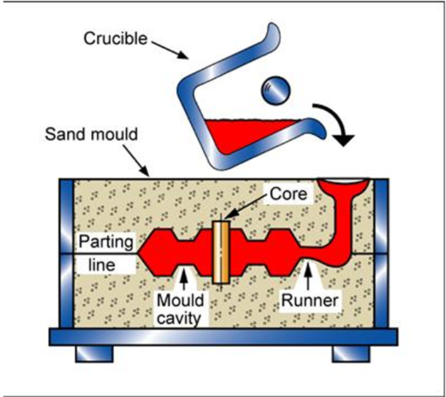
Figure 2-1-Sand casting process

Characteristics
Table 2-1- Characteristics of sand casting
Materials compatibilities | Shape | Economic compatibilities |  |  | Process  characteristics
1.metals-ferrous  2.metals-non-ferrous | 1.Circular prismatic  2.Non-circular prismatic  3.Solid 3-D  4.Hollow 3-D | Relative  Tooling  cost | Relative  Equipment  cost | Labor  intensity | 1.Primary shaping process  2.Discrete  3.Prototyping
1.metals-ferrous  2.metals-non-ferrous |  | low | low | high | 1.Primary shaping process  2.Discrete  3.Prototyping

Discuss
As the table above shows, sand-casting has various advantages, such as design flexibility, high complexity shapes, wider material choice, short lead time, etc.
But meanwhile sand-casting also has many disadvantages, which are as follows.
- Have a high unit cost, as the process is labor intensive and time consuming;
- Leave bad surface finish;
- Require further machining process;
- Cannot make thin sections;
- Not suitable for mass production.
- Remain much scrap metal;
- Poor material strength.
As a result, the company wants to find a better manufacturing process to get over these drawbacks and optimize its products.

Some possible manufacturing methods
Besides sand-casting, there are many other methods to manufacture bushes and sleeves including gravity die casting, pressure die casting, investment casting, etc. If the bushes and sleeves are made of polymers like plastics, they can also be manufactured by injection moulding. The report will introduce them briefly and analyse their pros and cons.

Gravity Die Casting
Gravity Die Casting is a permanent mould casting process, which pours the molten metal from a casting vessel or ladle into the mould. Filling mould cavity is only pushed by the force of gravity. The manufacturing process can control the filling by tilting the die (Invastacast, 2018).

Advantages
1) Good dimensional accuracy;
2) Smoother cast surfaces than sand casting;
3) Thinner walls can be cast compared to sand casting;
4) Inserts can be cast-in (such as threaded inserts, heating elements, and high strength bearing surfaces);
5) Less or no secondary machining operations;
6) Rapid production rates;
7) Casting tensile strength is higher than sand casting;
8) Very repeatable product quality once the tooling is proven;
9) Lower outsourced Tooling setup costs than UK sand casting;
10) Reverse draft internal pockets and forms can be cast in using preformed sand core inserts

Disadvantages
1) High initial cost;
2) Need a large production volume to make this an economical alternative to others;
3) A bit more complex than sand-casting.

Pressure Die Casting
As a fast, dependable and cost-effective manufacturing process, pressure die casting is suitable for mass production of metal components that are net-shaped and have tight tolerances. Basically, the pressure die casting process consists of injecting a molten metal alloy into a steel mould or tool under high pressure, which gets solidified rapidly (from milliseconds to a few seconds) to form a net shaped component. It is then automatically extracted.
According to the varied pressure used, there are two types of pressure die casting namely High Pressure Die Casting and Low Pressure Die Casting. Currently, high pressure die casting has wider application, which occupies some 50% of all light alloy casting production. Low pressure die casting only encompasses about 20% of the total production but its use is increasing. High pressure castings are essential to these castings requiring tight tolerance and detailed geometry because the metal needs to be pushed into more detailed features in the mould by more pressure. Therefore, low pressure die casting is usually used for larger and non-critical parts (TheMetalCasting.Com, 2018; Mustahsan, 2008).

Advantages
- Able to achieve high speed production due to the whole completely automated process;
- Possible to acquire fairly complicated castings than that feasible by gravity die casting as the movable cores are used;
- Can easily fill very small thicknesses because of the high pressure;
- Pretty good surface finish and most of pressure die castings don’t need any further processing;
- Closer dimensional tolerances and better mechanical properties compared to sand casting
- Very cost-effective for large scale production

Disadvantages
- Need large capital investment in order to set up a pressure die casting process;
- A bit expensive die casting machines and tooling costs;
- Not suitable for large castings as a result of the limited casting machine capacity;
- Cannot be used for all materials due to the limitations of the die materials and the alloys used must have a low melting point;
- Common high porosity and difficult heat treatment;

Investment Casting
Investment casting, also known as the lost-wax casting, is a manufacturing technique in which a wax pattern is covered with a refractory ceramic material. Once hardening the ceramic material, its internal geometry takes the shape of the casting. The wax is melted out and molten metal is poured into the cavity where the wax pattern was. The metal casting is broken out (Mustahsan, 2008).

Advantages
- Able to obtain complex shapes which are difficult by any other method in terms of cost and time;
- Very close tolerances and excellent surface finish;
- Ready for use with little or no machining required
- Almost suitable for any metal materials;
- No flash or parting lines;

Disadvantages
- Time consuming as shell moulds cannot be reused;
- Expensive due to many labours included for the preparation of the wax patterns and shell moulds；
- Often limited size of the casting;
- Occasional minute defects.

Injection moulding
Injection moulding is a manufacturing process which produces parts by injecting molten material into a closed mould. A lot of materials can be performed by injection moulding, mainly including metals (namely die-casting), glasses, elastomers, confections, and polymers. Material for the parts is poured into a heated vessel, mixed with a helical shaped screw, and injected forcedly into a mould cavity, where it cools and hardens to the configuration of the cavity. In order to facilitate the moulding process, parts to be injection moulded must be very carefully designed. Meanwhile, many factors need to be taken into consideration, mainly including the material used for the part, the desired shape and features of the part, the material of the mould, and the properties of the moulding machine (Clarke, 2016).

Advantages
- Able to produce more complex products in different shapes and designs that otherwise would be difficult or impossible;
- Suitable for mass parts production because of the high production output with a low labour cost that is easy to repeat;
- Can cut down workload as once the initial mould is designed, the product is almost done;
- Save resources for plastic moulding by recycling material or any unused moulding plastic or scraps;
- Increase productivity because of less money and time during mass production.

Disadvantages
- High initial tooling and machinery cost;
- Part design restrictions;
- Costly small runs of parts.

Two most possible options of manufacturing methods

Selection
By comparing and analysing various methods to manufacture bushes and sleeves above, from my point of view, gravity die casting or injection moulding is most likely to be the manufacturing method in accord with the requirements of the management team of the company, which wishes to improve surface quality of their products and reduce waste and cost.
According to the analysis in part 3.1, the manufacturing process of gravity die casting can obtain smoother cast surfaces than sand casting. The product quality is very repeatable once the tooling is proven. And there is no need for secondary machining operations. Compared with UK sand casting, the outsourced tooling setup expense is lower. Last but not least, when the company produces a large volume of bushes and sleeves, this type of manufacturing method can be a more economical alternative compared. Therefore, it can save more waste, time and cost. Besides, gravity die casting has a host of advantages which sand casting lacks and can help the company optimize its manufacturing process.
In the part 3.4, we can see injection moulding is also a very suitable manufacturing methods for the company to opt to. Firstly, the choices of raw materials to produce bushes and sleeves (including not only metals, but also plastics, glasses, elastomers and so on) will be broader for the company. As injection moulding is a high-precision manufacturing process, it is easy to achieve good surface quality. It also helps to save resources for plastic moulding companies because the company will be able to recycle material or any unused moulding plastic or scraps. Those items can be melted down and reground for possible future use; therefore, the company has very little wasted material. Moreover, it can achieve high production output under a low labour cost which is easy to repeat. The productivity of the company can be greatly improved because this kind of manufacturing method saves more money and time.

Detailed introduction

Gravity Die casting

The process
Apart from the material and the method by which the molten metal is poured into the die cavity, gravity die casting process is essentially the same as sand casting (Harrison Castings Ltd, 2018). It involves four steps:
- Heat the die and then spray it with a refractory coating, and close it;
- Pour molten metal manually or using a machine into the die and;
- Open the die is and remove the cast parts either by hand or in some cases using ejector pins on the mechanised machines after solidification;
- Finally remove the scrap including the gate, runners, sprues and flash from casting(s) and process the castings to remove sharp edges and excess material.

Process schematic
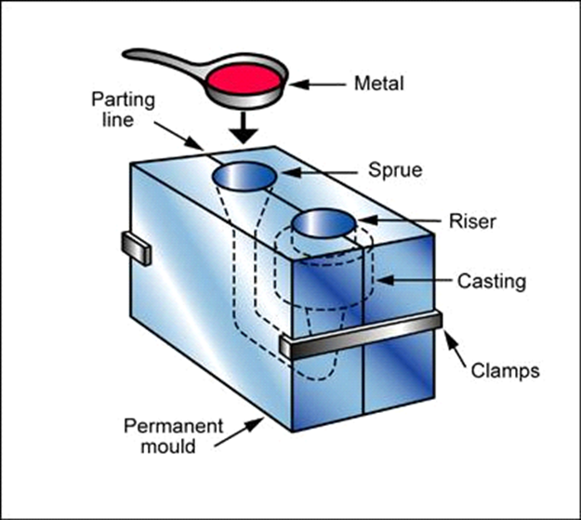
Figure 4-1-Gravity Die Casting process

Characteristics
Table 4-1-Characteristics of Gravity Die Casting
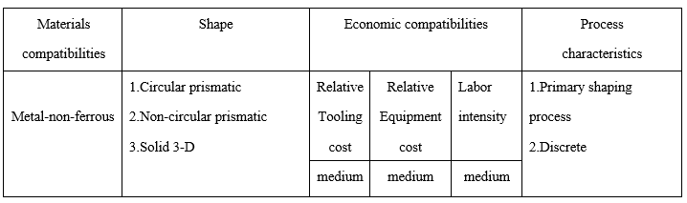

Injection moulding
A number of materials can be performed by injection moulding and the injection moulding processes of different materials can be a bit different. Here, just take the injection moulding of thermoplastic for example.

The process
There are four major stages in the injection moulding process (The Design Technology Department, 2018).
- Stage one:
Granulated or powdered thermoplastic plastic is poured from a hopper into the injection moulding machine.
- Stage two:
The machine consists of a hollow steel barrel with a rotating screw which carries the plastic along the barrel to the mould. Heaters which surround the barrel melt the plastic when it travels along the barrel.
- Stage three:
The screw is forced back after the melted plastic is collected at the end of the barrel.
Once enough plastic has been collected, a hydraulic ram pushes the screw forward injecting the plastic through a sprue into a mould cavity.
The mould is warmed before injecting and the plastic is injected quickly to prevent it from hardening before the mould is full.
- Stage four：
Maintain pressure for a short time to prevent the material creeping back during setting (hardening) and thus prevents shrinkage and hollows, obtaining a better-quality product.
The moulding is left to cool before removing (ejected) from the mould. The moulding takes on the shape of the mould cavity.

Process schematic
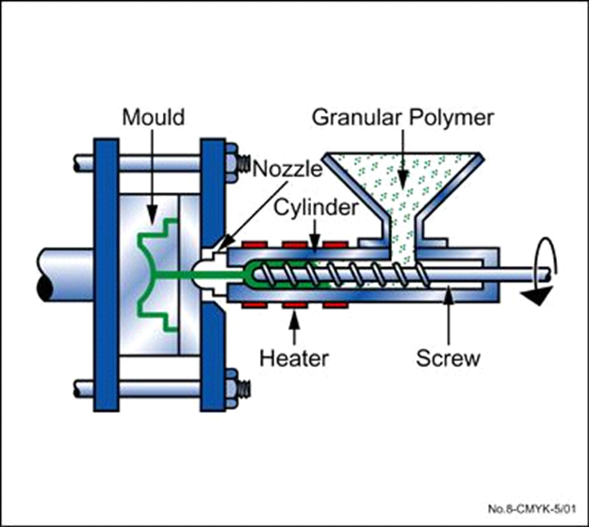
Figure 4-2-Injection moulding process

Characteristics
Table 4-2-Characteristics of injection moulding
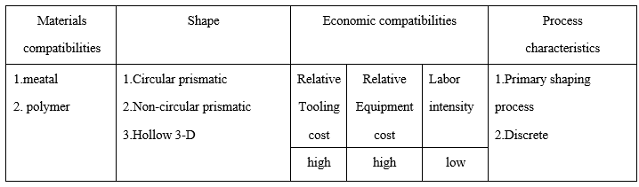

Suggestions
It is also shown in the report that gravity die casting and injection moulding have their own limitations. It improves the defects of sand casting but meanwhile brings certain problems in the manufacturing process. So, some suggestions are given below in order to obtain better production efficiency when the company uses gravity die casting or injection moulding to manufacture bushes and sleeves.
Firstly, both gravity die casting and injection moulding are suitable for a large production volume in order to cut costs and maximise the profits. So, the company had better achieve mass production of bushes and sleeves.
Secondly, as for gravity die casting, it is not recommended for hydrostatic pressure application, which hence the company needs to avoid in its production process.
Thirdly, even though a few materials can be performed by the injection moulding, it is more common to produce parts made from polymers currently because the technology is more mature. If the company wants to manufacture plastic bushes and sleeves, injection moulding is a pretty good option.

Conclusions
Few processes are as cheap and versatile as sand casting for shaping metals, which makes it become the top choice for many companies to manufacture their products. But with the expansion of production scale and the improvement of quality requirements, sand casting will be replaced due to its various defects. According to the company’s demands for their future products, two possible options of manufacturing bushes and sleeves are selected for the management team after analysing many types of manufacturing methods. But every coin has two sides. The two methods also have their own disadvantages. Thus, some suggestions are put forward which may help the company avoid some possible problems in the manufacturing process.

References
Clarke, C. (2016). Injection moulding. Retrieved from Martins Rubber: https://www.martins rubber.co.uk/blog/advantages-and-disadvantages-of-injection-moulding/
Harrison Castings Ltd. (2018). Retrieved from Harrison Castings: http://www.themetalcasting.com/gravity-die-casting.html
Invastacast. (2018). Retrieved from INVASTACAST: https://www.investacast.com/outsourcing/gravity-die-casting
Mustahsan, T. (2008). Retrieved from SCRIBD: https://www.scribd.com/doc/112847186/Advantages-and-Disadvantages-of-Different-Casting-Processes
The Design Technology Department. (2018). Retrieved from The Design Technology Department: http://design-technology.org/injectionmoulding2.htm
TheMetalCasting.Com. (2018). Retrieved from TheMetalCasting.Com: http://www.themetalcasting.com/pressure-die-casting.html

