Level 5 Associate Diploma
in People Management

5CO01
Organisational Performance and Culture in Practice (BMPD5016)

Evaluate the advantages and disadvantages of both a divisional structure and a matrix structure. Within the evaluation, you should include the reasons underpinning each structure. (AC 1.1)

According to Taylor, S. and Woodhams, C. (2022) a workplace structure is a ‘framework of position of job roles, teams and functions within an organisation, and the relationship(s) between these’. There are four main types of organisational structures, and each suit different types of businesses.

Divisional Structures (Figure 1) are used in large organisations with various products and business units and tend to operate in different geographical areas. Organisations with this type of structures include: Boots the Chemist, McDonalds, Barclays Bank.

McDonald's chain, has 1,270 restaurants in the UK and employs more than 120,000 people with a structure of CEO, chief operating officer, a chief people officer, a chief financial officer Departments are under this include corporate affairs, marketing, human resources, national operations, regional managers, finance, information, and strategic planning.

Other departments include legal, customer services, franchising, safety, security and licensing, property and construction, supply chain and restaurant services. Each has their own autonomy, but all work towards the same goal and standards McDonalds advertise

Advantages of this structure is each ‘division’ has a clear and defined role and responsibility; they can concentrate on its performance and accountability which in turn works towards the organisations strategic ‘branded ‘goal.

However, disadvantages include a significant impact if communication breaks down, can be costly to operate, there may be ‘rivalry’ between each entity and each division has to ‘compete’ for resources and can be slow to adapt to change. Taylor, S. and Woodhams, C. (2022)

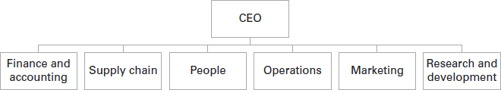
Figure 1: Divisional Structure

A matrix structure, includes vertical and horizontal lines (grid) of dual reporting, which means
Individuals have more than one manager or a ‘two bosses’ structure (Davis & Lawrence, 1977) One would tend to be responsible for general project / day-to-day management, and the other would have other responsibilities.

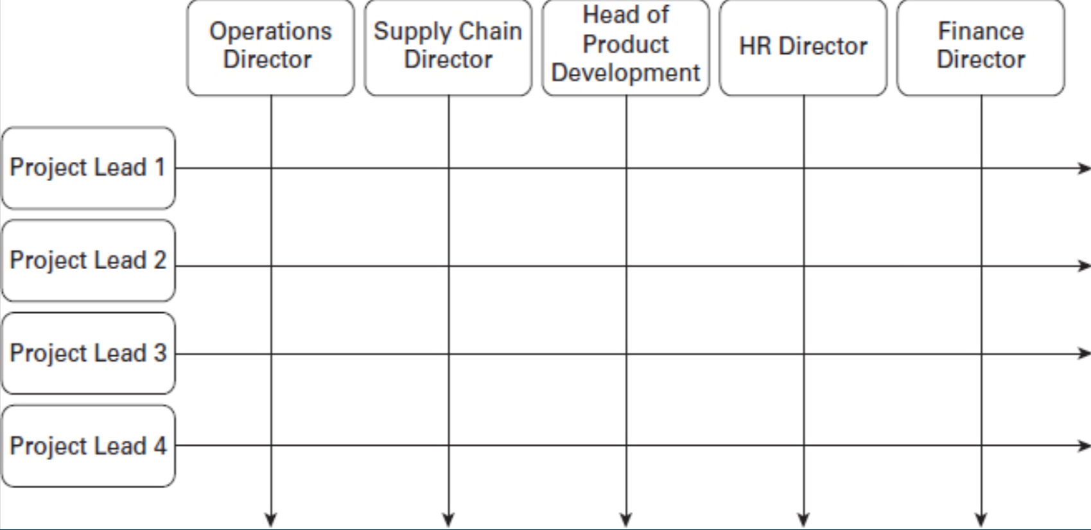
Figure 1.2: Example of Matrix Management Taylor, S. and Woodhams, C. (2022)

BAE Systems, Aerospace and security solution organisations, employees c100k and operates in more than 40 countries.

Advantages of this structure include employees carry out a functional and divisional role, employees feeling engaged and part of a team, shared resources and pooling skills and experience from different teams as well as cross-training, bringing fresh perspectives. However, there needs to be clearly defined roles and what to expect from management, this in turn can lead to delayed decision making, and can cause work overload for staff, which can then have an impact on their quality of work. Taylor, S. and Woodhams, C. (2022) However, disadvantages include leaving the employee having conflicting priorities between two managers

Analyse the extent to which the organisational strategy in your organisation (or an organisation with which you are familiar) helps to ensure products or services meet customers’ needs. (AC 1.2)

An organisational strategy can be defined in lots of different ways, Lynch identifies three core areas of a strategy: strategic analysis, strategy development and strategy implementation (Lynch, 2003). A local authority such as Torfaen Council is a political organisation providing local services to a community ensuring public monies are well spent and to meet the organisation's vision of the corporate strategy needs to reflect both of these elements.
while ensuring this is underpinned by the values of being Supportive, Fair, Effective and Innovative

The constitution of the Council governs the way in which the council (elected members and employees) work together to firstly set the organisation's mission and objectives in order to deliver the council’s functions and priorities to local residents and stakeholders.

The strategic development then operates under a leader and cabinet of the council, each cabinet member has a specific responsibility and works with relevant Chief Officers and relevant Officers to ensure they are working towards meeting the Council’s Strategic aims which is often referred to as a Golden thread while looking at possible a PESTLE analysis to consider the wider external factors of the council and how it impacts the services it delivers.

In order for Torfaen Council Strategy to be effective, the priorities and strategic objectives need to be embedded in the day to day activities within the council.
The hierarchical plans and delivery of services is often referred to as the ‘golden thread’. involves the council ensuring planning of services meet the organisations priorities all stakeholders including residents, officers of the council and elected members have a say in this then sets out the long term objectives laid out in the Council's Corporate Plan identifies four key themes of wellbeing, connectivity, sustainability and culture and heritage and is underpinned by 9 objectives which then breaks down to specific plans produced by individual departments to drive improvement in line with the strategies. These are then signed off by Senior Leadership Team and monitored and challenged at appropriate Scrutiny committees, services and priories must be met within budget and the budget planning process for the council and departments are integral. Individual officers then have appraisals to continually review the performance feeding into the organisation’s objectives
The Council Strategy is then implemented and communicated with all stakeholders, ensuring resources are appropriately allocated and cascaded out to all services.
The monitoring of a range of performance measures are then monitored by the Council Cabinet committee or a regular basis, and scrutiny committees have a role in this performance reporting and monitoring.
For the organisation to deliver services successfully to residents of Torfaen, the Golden thread and its vertical and horizontal integration is monitored and scrutinised effectively while giving Residents the opportunity to give feedback on services at certain times of the year.

Analyse the current impact of interest rates, inflation and one other external factor on your organisation (or one with which you are familiar)
Identify organisational priorities arising from your analysis. (AC 1.3)

Local Governments continue to face significant financial challenges and have not been able to keep up with an increased service demand and inflation impact on the services it can deliver.

According to the Local Government Association (LGA), there's a 27% real term cut in core spending. Despite an increase in funding of 4.3% from the Welsh Government, councils in Wales continue to make difficult decisions. While a local council is receiving the highest increase, they are having to increase resident’s council tax by 6.7% and still having to propose cuts to services including libraries and community centres (BBC, 2025)

Inflation:
Inflation is the measure of the speed of those increases within a local government setting, inflationary factors have an impact on the services delivered and increase the demand on areas such as Housing, Social Care, Children’s additional learning needs, and Transport. The drivers have an impact on pay, supplies and services and there continues to be shortages of staffing resources which then requires using more costly temporary solutions.
MCC's new King Henry 3-18 school, has experienced an additional £26 million because of the increase in supplies and services

Interest rates
Councils are funded from the Welsh Government and then set other chargeable fees such as Council Tax. When Interest rates increase, this illustrates how high the cost of borrowing is. The current interest rate set by the Bank of England is 4.5%, this is the first time in three years it fell below the BoE inflation target of 2%. (Bank of England, 2025).
Following the pandemic, the cost of living crisis has a significant impact on communities. Interest rates have increased which makes it difficult for councils such as MCC to allocate capital funds while it focuses on its revenue spending, rising interest rates make it more difficult for Councils to borrow monies for capital projects (Hayes, 2024)

Teacher Pay Award
Unions are continually campaigning for an increase in pay awards to support their members through the current cost of living crisis. England has led the way, with the Welsh Government then following, so teachers in Wales aren't at detriment to their colleagues in England. The teacher’s pay award has continued to be a pressure for local government and schools. In previous years, it has been assumed these would be fully funded, however, this has not always been the case, there continues to be a potential risk and further budget pressures if the Welsh Government don't provide a fully funded pay award. For example, At the start of the financial year 2024, the budget modelling assumptions allowed for 4.3% pay award for teachers, the final agreed pay award of 5.5% could add an additional 1.2% pressure to schools’ budget. The impact of interest rates, inflation and teachers pay award can have a significant impact on the organisation’s priorities leading to an increase in the demands on its services.

In February 2024, Peter Cheese, current CEO of CIPD stated, “AI is transforming jobs, careers and workplaces. People professionals have a key role to play in encouraging safe experimentation and rapid learning, so we can reap the benefits and mitigate the risks.” Assess the extent AI is, or could be, used in your organisation (or an organisation with which you are familiar) and assess how AI impacts work. (AC 1.4)

In a world where digital technologies are evolving, the range of Artificial Intelligence (AI) tools can vary between Generative (Gen AI), Artificial Intelligence (AI), Automation and Technology (CIPD, 2024).

AI is developing at a considerable rate and has the potential to transform how services are delivered within a local authority setting, but also poses risk and challenge in terms of compliance with legal and ethical standards.

Local Authorities, e.g. MCC uses an AI application such as ‘virtual assistants’ on their website where residents can ask ‘Monty’ to ask general queries or to book appointments by using automated rules.

CIPD, AI in the workplace quiz proves to be a useful tool to find out how people professionals can support the use of AI in the workplace and how AI improves efficiency and assists with decision making, it can’t replace all human making decisions.

AI has the potential to reduce bias in the recruitment process, to assist in shortlisting candidates who have the desired qualifications for the role. It can also be used to enhance learning experiences. It's often assumed AI may lead to job losses, however this isn't always true and varies between industries (CIPD, 2024)

While AI shouldn't be used to make decisions, it has the potential to support work by using Co-pilot (GenAI) to assist with minute taking at meetings, but should always be reviewed by staff. Key principles local authorities must ensure the reliability and accuracy of the data, and any AI systems/applications used are compliant with relevant laws and standards allowing appropriate governance and auditing mechanisms, while also ensuring they are ethical and align with the public interest.

Co-pilot is the only approved AI tool within MCC, however It's still in its trial phase and is used to record meetings to generate Minutes of meetings, with approval of those present.

Ultimately how AI tools are used in local authority and within an education setting, is ongoing. It has the ability to reduce workload, but needs further understanding on the impact and how it can be used most effectively.

Explain Charles Hendy’s model of organisational culture and explain David Rock’s SCARF theory. (AC 2.1)

Molander and Winterton, 1994 says an organisations culture comprises traditions, habits, ways of organising and patterns of relationships.

At the heart of organisations are its values, beliefs, and common expectations and changes over time. Edgar Schein (1992) defines culture as: A pattern of shared basic assumptions the group learned has worked well enough to be considered valid and therefore, to be taught to new members as the correct way to perceive, think, and feel.

Charles Handy, a management consultant at the London Business School, and describes four cultures organisations embrace. While there's likely to be a mix of the elements in every organisation, there will be some pillars (Figure 2.1) more dominant. (Waite et Al, 2021)

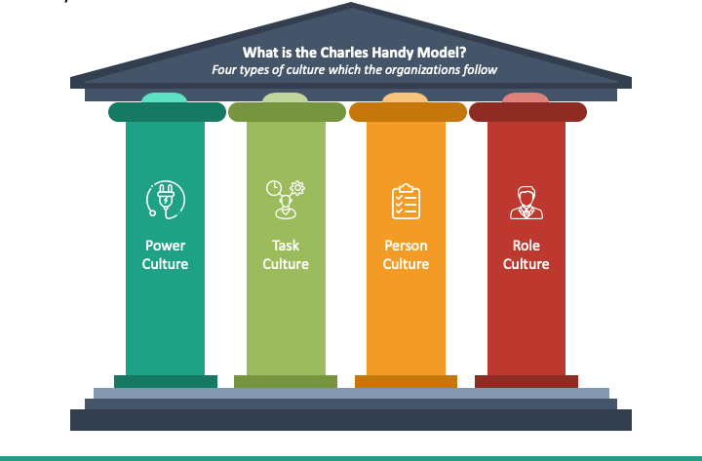
Figure 2.1: Charles Handy Model
Power - this is likened to a spider's web, managers are strong at the centre of the web, and if they move, the web also moves.
An example of this includes centralised power, decision makers are few, and there can be limited employee input.

Task - teamwork is often used to resolve problems and achieve certain goals. Very often a task and finish group are brought together to work together as a team to have shared responsibility to solving a problem. A task culture is usually disbanded upon completion of a certain task.

Person - an orgasnaitions is overridden by a person's individual needs, an example of this is a doctor or lawyer where there’s no “boss”.

Role - an organisation has key departments, where people work to their job descriptions and follow set policies and procedures,
An example is Public Sector/ Local Authority employees have well defined roles and there's a clear hierarchy.

Developed in 2008 David Rock SCARF (figure 2.2) model is used within social situations to where individual seek out five ‘Domains’ listed below and can also be likened to Frederickson’s Broaden and Build theory says people perform better when they feel safer and happier (Mindtools. 2024)

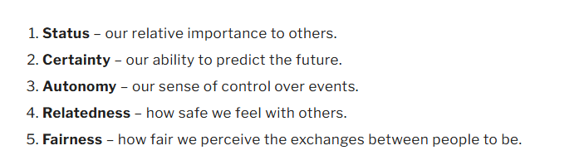
Figure 2.2 SCARF Model, Source Mindtools

The psychological theory motivates individuals based on responding to a situation with a threat and reward response.

New Managers can often create a threat response which in turn results impacts others individuals, where managers should be generating a ‘reward culture’ which in turn can increases motivation and productivity and minimizes feelings of threat or danger
The key with the SCARF model is to ensure positive emotions/ reactions is to show appreciation, have clear expectations, policies or procedures are transparent and applied fairly. Ensure there's trust and respect among peers and allow individuals to have autonomy in their decisions to get a job done.

Assess how employee selection or employee development impacts organisational culture and behaviour in your organisation (or one with which you are familiar). (AC2.2)

According to Balogun and Johnson’s Culture can be defined as ‘the way we do things around here’. (CIPD, 2024)

A PwC survey in 2018, found 80% of employees said workplace culture needs to change and says for organisations to succeed, grow and retain people, A notable difference is employees and employers disagree on how they see culture with leaders who think culture in their workplace is strong.

Organisations can support positive human relationships and interaction by using People Professionals to develop strategies to support and influence culture in line with the organisation’s strategic direction.

CIPD writes how culture can influence people's experiences and behaviours but measuring success has its challenges.

Monmouthshire Council attracts employees because of the culture and ethos it publicly advertises. The Chief Executive openly communications they employ adults and are committed to staff development. They are open in their level of openness and trust its employees to do the job they are employed to do. The organisations values are at the heart of what they do for both employees and residents

The recent employee survey has resulted in the OD team developing a Leadership and Manager Developmental Pathway – to ensure we have consistency across how manager carry out their practices

This will equip managers and leaders with the skills, knowledge, behaviours, attitudes and expectations to excel within a challenging public sector environment. Monmouthshire values their people and believe Investing in them today for the challenges tomorrow.

Objective: of the programme

- to provide an organisational wide managers/leaders developmental pathway (based on what leaders have said they need to be effective).
- To ensure understanding of a clear set of expectations (foundations) as well as cultural
expectations.
- To communicate the consequences (when developed) of not meeting the expected standards.
- To improve the quality of leadership across the organisation.
- To improve the conditions leader’s, create for their colleagues to achieve success.
- To ensure all colleagues understand expectations know how to address it if we don’t meet those standards.
- To create a leader’s checklist
In summary, the Monmouthshire Leadership and Manager Developmental Pathway will help better equip and support managers and leaders to face the challenges ahead (achieve greatness), by providing a suite of tools, knowledge and resources to excel underpinned by the organisation's values of Openness, Fairness, Flexibility, Teamwork, and Kindness.

An organisation is planning a change relating to hybrid working. Many employees moved to home working during the Covid-19 pandemic. Whilst this approach worked well at the time, the organisation now wants all employees to work at least two days a week on site. Explain how Kotter’s approach to managing change could be used to successfully implement this change. (AC 2.3)

Kotter, was a professor at Harvard Business School and was well known for being a ‘change expert’. In his book ‘Leading Change’ (1995) Kotter introduced an eight - step change model. (Figure 3.1)

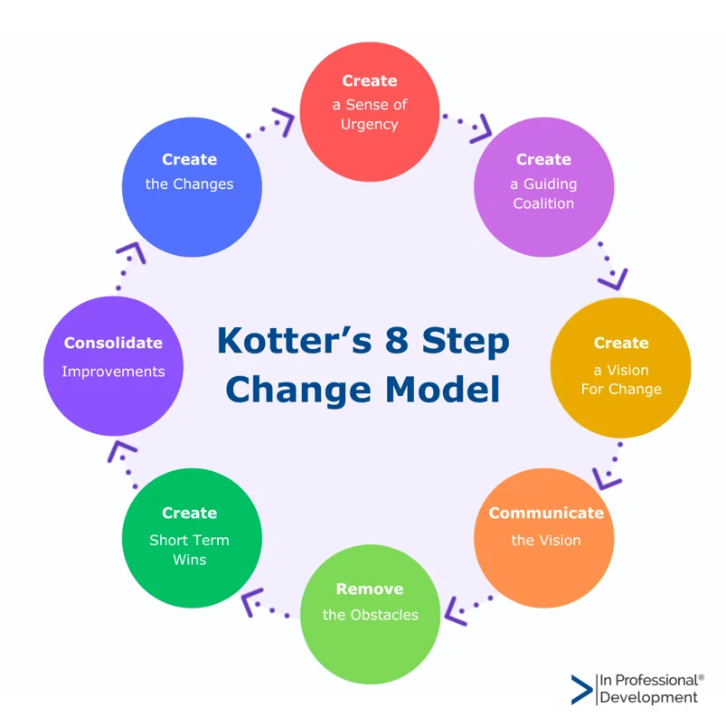
Figure 3.1: Kotter Change Model

If the organisation was to use Kotter's model to introduce the change they would firstly speak to the staff, with an open and honest dialogue ensuring they are made aware of the potential threats, opportunities, and work with other stakeholders to strengthen the argument for the change, while develop a ‘sense of urgency’.

Second of all they would need to convince people the change is necessary, (forming a Powerful Coalition). Ensuring a strong leadership is leading the change, bringing people together, who work together and continue the sense of urgency.

Thirdly, there would be a need to create the vision for change, using those employees who form the coalition in step 2, and ensure the vision is easy to remember and helps people to understand what is trying to be achieved. It can be achieved by ensuring the organisation's values are key to the change, a clear strategy is communicated.

Communicating the vision is step four of Kotter's change model. Comms relating to the changes need to be frequent, relevant and for leaders and representatives to be seen demonstrating the change they wish to embed and ‘leading the way’ thus, will also be available to address people's concerns and talk openly and honestly to staff.
Step five of Kotter's change model is about removing obstacles, however, if followed the steps 1-4 successfully, the organisation should already have in place the structure for change, This can be achieved by identifying leaders who deliver the change in individual departments, ensure the structure and processes are in line with the vision, recognising those make the change happen, but also take action to remove any physical barriers for why people are resisting the change of returning to the office.

As time moves towards the move of returning to the office, continuing to motivate staff with short term wins (step six), employees could come up with these which can help bring on those still resistant to the change.

Kotter says to achieve long term change, change needs to run deep and be embedded and continually look for improvements and build upon the change to ensure It's fully embedded into the organisation's processes, by identifying (Step 7).

Finally, for the change to stick, it needs to become part of the everyday for the organisation. Ensure progress is shared and be sure to include the change ideals and values as part of the employee lifecycle when hiring and training new staff, so they can become leaders and advocates for potential change in the future.

Using the Kubler-Ross change curve, discuss how change is experienced. (AC 2.4)

Change is constant, and this is particularly true for Local Authorities, the sector I am familiar with. During these challenging times schools are facing unprecedented pressures in service delivery due to ever reducing budgets, and we are therefore having to look for different ways to ‘do more for less’. While ensuring teachers are in front of the classroom.

Whilst any change programme can be unsettling for staff, change isn't always a bad thing, and can often bring with it new and exciting opportunities. Original Kubler Ross (Figure 4) change was devised from her work when going through personal grief.

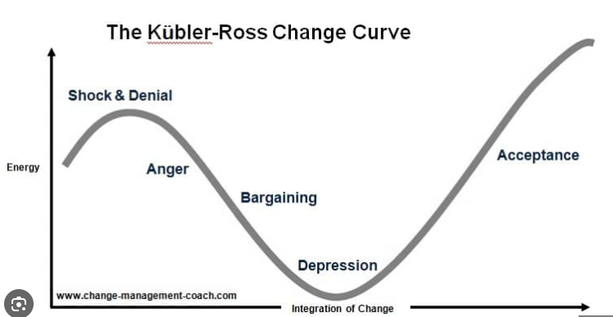
Figure4: Kubler Ross Change Curve

When organisations initiate change, staff can feel unsettled as they react to what is the current status quo. People professionals and management should ensure communications are clear, providing individuals with information on what and when to expect changes, and to support with the shock, ensure EAP are signposted.

When individuals begin to realise change is happening, it disrupts their routines and may protest against the changes, even though change is a constant, when the status quo is disrupted, individuals can feel angry and take it personally. Managers and key staff should be on hand to listen and observe, so people can express their anger ‘professionally’ ensuring they are fully supported, as if badly managed, could be disastrous for the organisation.
When communication and visions are shared, individuals start to accept the decision and look to adapt, while then next committing to the change and embracing the decisions. This could involve ensuring organisational change is successful, people are open to ideas of training and exciting opportunities could arise from their change
When organisations initiate change, it usually involves HR professionals. By being aware of how to manage change and considering the change curve experiences, we can look to make the curve shallower and narrower to help people adapt quickly. By celebrating and sharing the success of changes, people have confidence in the management and people embrace the changes to the way they work.
Whether staffing restructures, introduction of new software, moving offices or adapting to working from home, when organisations use the change curve and plan change effectively can help manage and predict how people are going to react to change and this is how we manage it.

The CIPD’s Health and wellbeing at work survey 2023 found the percentage of organisations that have a standalone wellbeing strategy has risen from 40% in 2018 to 53% in 2023. Although the percentage has increased, this means 47% of organisations don't have a standalone wellbeing strategy. Assess the importance of wellbeing at work and assess how good work could impact wellbeing. (AC 2.5)

CIPD says organisations should foster and promote wellbeing to support a positive working environment for both employees and an organisation. (CIPD, 2024). Ensuring a positive wellbeing environment should be embedded in the culture of the organisations and not be a standalone initiative.

CIPD's previous survey recognised how organisations now respond to the pandemic of 2019 and how the impact of Covd has on our physical and mental health and organisations have priotised a health and wellbeing strategy.

Managers often analyse the data from employee surveys and sickness data to ensure staff are appropriately supported through different policies and procedures and people professionals can support by developing policies.

A holistic approach to Employee wellbeing provides support in a variety of ways through appropriate policies, such as Carers Policy, Parental Policies, Flexible hours and signpost staff to support services

The benefits of an organisation focussing on a standalone wellbeing strategy can improve morale, better work life balance and a healthier and inclusive culture. (CIPD, 2024) CIPD also identified a seven ‘domains can support an organisations wellbeing strategy including

- Health
- Good Work -includes
  - Working environment - Ergonomically designed working areas, open and inclusive culture.
  - Good line management - Effective people management policies, training for line managers, sickness absence management.
  - Work demands - Job design, job roles, job quality, workload, working hours, job satisfaction, work-life balance.
  - Autonomy - Control, innovation, whistleblowing.
  - Change management - Communication, involvement, leadership.
  - Pay and reward - Fair and transparent remuneration practices, non-financial recognition.
- Values/Principles
- Collective/Social
- Personal Growth
- Good Lifestyle choices
- Financial Wellbeing

Wellbeing agenda is on organisations priority, MCC’s Chief Executive promotes openly how the organisation employs adult and the importance of it values to support ‘Good Work’ however, schools have delegated powers and very often don't see themselves as part of the bigger organisation and try and develop their own Wellbeing initiatives aren't always consistent, relevant to the different types of employees i.e. (Support and Teaching).

As a School Business Leader, there's a particular interest in the Education Mutual, a not for profit staff absence protection organisation, annual School Business Leaders survey and have recently published their key findings (Figure 5) for those in a specific School Business Management role. The role of SBM is carried out and requires individuals to wear many hats. The demand can have an impact on leaders' wellbeing while supporting other employees.

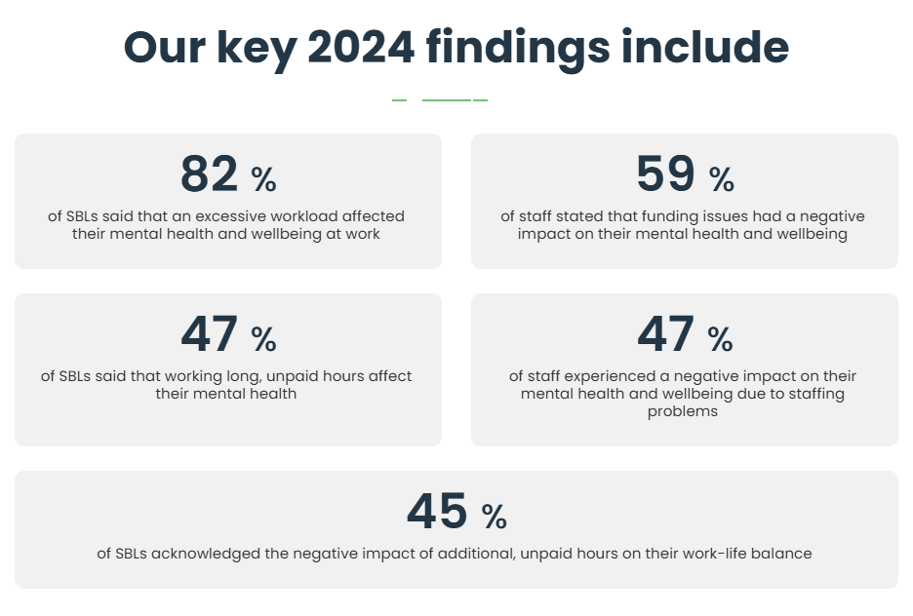
Figure 5. Education Mutual Wellbeing index 2024
The survey results highlight the importance of organisational Wellbeing strategy, and by adopting ‘Good work’ practices such as Pay and reward, working hours, work-life balance for School Business Leaders could improve wellbeing. (Education Mutual, 2024)

Provide a brief overview of the employee lifecycle and discuss people practice roles at the recruitment, development and separation stages of the life cycle. (AC 3.1)

The six stages of the employee lifecycle are Attraction, Recruitment and Selection, Onboarding, Development, Retention, Separation (Waite et al, 2021) Fig 6

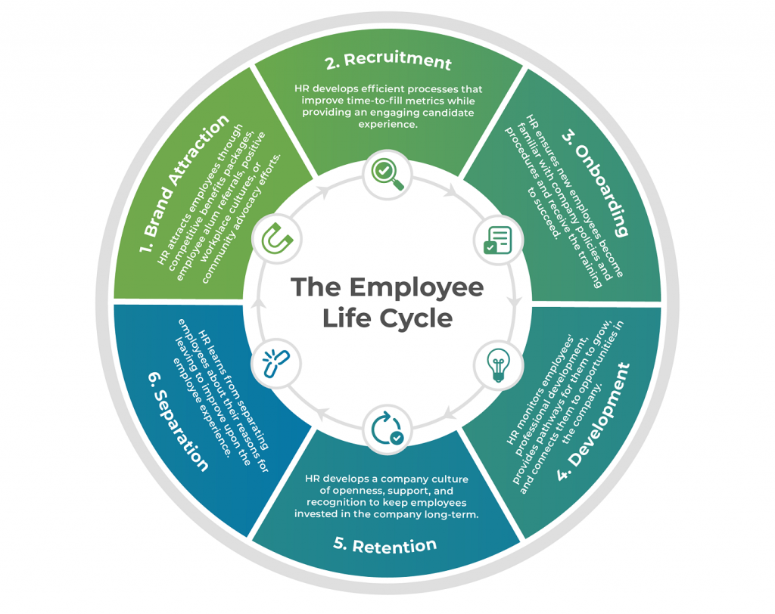
Figure 6: Employee Lifecycle (Source: Technology advice)

- Attracting the right candidate for the organisation begins before the recruitment stage and enables employers to attract the right candidates

- The recruitment process, (application, interview and assessment) draw out the best of the right candidate to ensure they are a ‘good fit’ for the organisation.

People's professional will be involved ensuring the Job Description is clear as well as ensuring the personal specification / competency framework details the attributes needed for the role. This could also involve following a job evaluation process. Other people professional, along with the line manager may be involved at the interview and following up with references. They may also be involved with potentially answering queries from the recruiting manager and challenging ‘like for like’ recruitment, to ensure the skills needed for the role and the organisation (CIPD, 2024f)
- The onboarding experience is also key. Demonstrating the company's values and culture, introducing them to the key policies and processes as well as having a well-planned out induction.

- Employee engagement, is important for not just the employee to be engaged in the business, regular feedback, checking on their wellbeing and work life balance, but also for the business to be able to support employee development, ensure job satisfaction and productivity.

- Developing employees enhance the employee experience, keeping them interested and inspired while also helping to ensure they are a successful.

A professional role within OD or L&D, at this stage can have significant impact on the organisation's culture, by conducting a skills audit and identifying gaps, developing, promoting policies and procedures promoting a positive and effective workplace culture and values upholding ethical practices.

According to Waite, 2021, if an organisation is effective in recruiting an employee but development is limited, retention may be negatively impacted and result in a higher turnover of staff.

- It's important to retain employees and to support, and provide opportunities to ensure they remain engaged and are listened to, by ensuring regular one-to-ones are held, ensuring they have the opportunity to share feedback.

- There are different ways in which an employee may exit an organisation, this could include voluntary resignation, retirement, dismissal, or redundancy.

A people professional roles such as Business Partner, at this stage may be involved to support a line manager with a redundancy or dismissal process, or for those who resign, An exit interview can assist the employer to learn from any possible mistakes or how can improve the employee lifecycle is important as they can continue being an advocate for the organisation, which then takes us back to the attraction stage as well as potentially leaving the door open for the employee should an appropriate opportunity arise.

Analyse how people practice supports organisational strategy through vertical integration and how people practice supports wider people strategies through horizontal integration. (AC 3.2)

Richardson and Thompson (1999) writes the success of an organisation strategy involves combining vertical (external) and Horizontal (Internal) Integration as such, people practices should ensure they are involved in the strategic analysis, development and implementation to support the organisational strategy.

Figure 7 illustrates how strategic HR Management integrates. (Source: Armstrong)

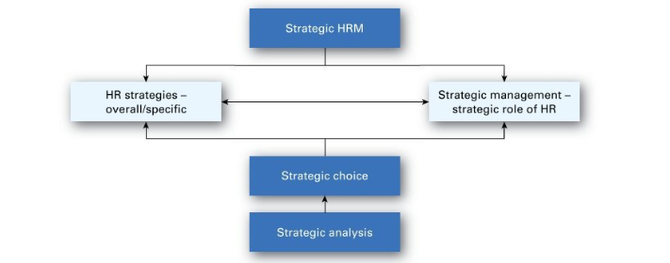
Figure 7: Strategic Human Resources Management

Horizontal integration requires various HR functions (e.g. Organisational Development, Recruitment, Learning and Development) align and develop the organisations policies and practices together, according to Armstrong, p25, this is otherwise known as ‘Bundling’ (Armstrong, p25) ensuring HR practices complement and reinforce each other.

The other is often referred to as vertical integration, this is where HR strategies integrate with the organisation strategies. The strategic HR Manager is part of the Senior Leadership Team and ensures they and the organisation's policies are fully integrated with the strategy and strategic objectives. (Schuler, 1992) and link to the organisation's culture

People practice is a key function in supporting organisation’s as they have a wide overview of the business and provide a wide range of functions including workforce planning, recruitment, onboarding, performance management, training, payroll and employee relations. (strategic analysis, development, and implementation) as such developing and implementing HR policies and procedures need to align with the organisational strategy using the data available.

An organisation is planning to introduce a four-day working week. Discuss the processes the people function could use to consult and engage with managers and employees to understand their needs when moving from a five-day to four-day working week. (AC 3.3)

When an employer and employee have a legally binding agreement (contract), any changes must be agreed by both parties. (ACAS, 2024).

If an organisation is planning to introduce a four-day working week, it’s expected the employer would have considered the reasons for the change. Is it to make savings? Is it to support employee wellbeing? Is it to improve the way of working? Managers working with People Professionals and trade unions must demonstrate what options have been considered and a clear justification for the change.

ACAS states even if the organisation has its own dismissal and re-engagement policy, the Code Practice on dismissal and re-engagement must be followed. (ACAS, 2024).

Changes such as this may bring benefits to both, but are also a risk and as such, how the process is consulted on and communicated to employees must be handled sensitively. If the process isn't handled well, then it could end up the employer being in breach of contract or been seen as constructive dismissal which can be costly for the business.

In order to ensure people, feel valued and listened to for proposing such a big change, it should be reviewed, e.g. current practices, carefully planned and consultation with staff regarding preferences, this would also give management an idea of the challenge they could expect.

Harvard Business Review provides clear step by step guidance and considerations for organisations to work towards a 4 Day working week, while not sacrificing productivity. (Whilans and Locket, 2021)

- Shift Mindset - Do Leaders need to change their mindset to value productivity (HBR, 2021) Will employees be working less hours and pay be affected, or will managers still expect the same productivity when working less hours for the same pay?
- Define the goals (ensuring both employees and leaders are involved) This could involve conducting surveys, establishing focus and task and finish groups involving a range of employees to ensure each department has a voice and is also important to consider how the success will be measured
- Communication (develop a communication plan for both internal and external stakeholder) Internal stakeholders will be concerned about factors such as pay and how it affects leave, giving people the opportunity to have meetings/ interviews and be supported by Trade union representatives.
- Trial Run - Ensuring this time gives opportunity to adjust and redefine issues may arise, what support do staff need, how can staff ask questions and feel safe to do so, how will they be replied to
- Assess/Evaluate the Trial Run - using both qualitative and quantitative measures provide an insight on how the trial run has been received by staff and has it met the intentions set at the start
- Make steps to schedule the permanent change - overcome challenges, but managers should continue to evaluate and adjust if required to ensure buy-in from staff. This would also be issuing a variation to employee’s contracts.

Bibliography - Organisational Performance and Culture in Practice (BMPD5016)

Books / eBooks
Armstrong, M. (2014), Armstrong’s Handbook of Human Resource management, Kogan Page ISBN 9780749469658
Taylor, S. and Woodhams, C. (Eds) (2022) Studying Human Resource Management, A Guide to the Study, Context and Practice of HR, 3rd Ed, CIPD: Kogan Page
Taylor, S. and Woodhams, C. (Eds) (2022) Human Resource Management, People and Organisations, 3rd Ed, CIPD: Kogan Page
Waite, K., Beevers, K., Small, N., Tomlinson, K. and Hussain, S. (2021) People Practice. Kogan Page

Podcasts

CIPD Podcast : Available at Evidence-based L&D – The gift of artificial intelligence | CIPD (accessed 5 January 2025)

Websites

ACAS: Available at Working from home and hybrid working | Acas Accessed 2 January 2025

ASCL Available at ASCL-Response-IWPRB-5th-remit-and-recommendations-fv.pdf (Accessed 9 February 2025)

BAE Systems: Available at About Us | BAE Systems Accessed 28 January 2025

Bank of England Available at Interest rates and Bank Rate | Bank of England Accessed 9 February 2025

BBC, available at Council tax could go up by 15%, warns local authority leader - BBC News Accessed 2 February 2025

CIPD Quiz, AI in the Workplace Available at https://www.cipd.org/uk/knowledge/tools/ai-workplace-quiz/ Accessed 9 February 2025

CPD Online, Available at Organisational Structures | Types, Divisional, Flat, Tall, Functional Accessed 28 December 2024
CIPD (2025) AI in focus: Role of people professionals, regulation and the CIPD
Available at: Briefing | AI in focus: Role of people professionals, regulation and the CIPD | CIPD (Accessed 24 January 2025)
CIPD: Impact of AI; Available at Focus on: impact of AI and the world of work | Accessed 20 January 2025
CIPD: Change Management. Available at Change Management | CIPD Accessed 29 December 2025
CIPD Wellbeing at Work Available at Wellbeing at Work | Factsheets | CIPD, Accessed 10 January 2025

CIPD Organisation Development Available at Organisation development | Factsheets | CIPD Accessed 2 January 2025

CIPD Good Work Index Available at CIPD Good Work Index 2024: Survey report Accessed
9 January 2025

CIPD Organisational climate and culture Available at Organisational climate and culture | Factsheets | CIPD Accessed 28 December 2024)

CIPD Wellbeing at Work. Available at Wellbeing at Work | Factsheets | CIPD. Accessed 9 February 2025

Education Mutual SBL Wellbeing index. Available at SBL 2024 Final Draft Accessed 10 February 2025

Forbes, Managing For Success In A Matrix Organisation Available at: https://www.forbes.com/councils/forbesbusinesscouncil/2023/09/15/managing-for-success-in-a-matrix-organisation/ (Accessed 17 December 2024)

LGA, Available at Save local services: Council pressures explained | Local Government Association Accessed 2 February 2025

McDonalds, Available at Meet the Leadership Team | McDonald's UK Accessed: 28 December 2024
Monmouthshire County Council: Monty the Monmouthshire Chatbot
Available at Monty the Monmouthshire Chatbot - Monmouthshire Accessed: 6 February 2025
Mindtools, David Rock SCARF Available at https://www.mindtools.com/akswgc0/david-rocks-scarf-model, Accessed 28 December 2024

Torfaen County Borough Council. Available at Our 9 Well-being Objectives for 2022/27 | Torfaen County Borough Council Accessed 9 February 2025
Welsh Government Available at Written Statement: Provisional Local Government Settlement 2025-26 (11 December 2024) | GOV.WALES Accessed 2 February 2025

WLGA Funding and Money Management, Available at Funding & Money Management | WLGA Councillors Website Guide Accessed 9 February 2025

