EFFECT OF HUMAN CAPITAL INVESTMENT PRACTICES ON EMPLOYEE RETENTION AND JOB SATISFACTION: CASE OF RENTOKIL INITIAL, BIRMINGHAM

RAMONA-LULIANA STOICAN

A dissertation project submitted in partial fulfilment of the requirements for the award of
The Degree’s in BA (Hons) Business Management at the University of Wales Trinity Saint
David, Quay Place Campus

June 2026

DECLARATION
“This dissertation is entirely my own original work and has not been submitted to any other university for assessment or review”

Name: Ramona-Iuliana Stoican
Student ID: 2246688
Signature: Ramona-Iuliana Stoican
Date: 28/06/2026

Declaration by the Supervisor
“I hereby confirm that this dissertation has been submitted for examination with my approval in my capacity as the university supervisor”.

Signature: …………….

Date: ………………
Dr. Aso Abdullah

ACKNOWLEDGEMENTS
“The completion of a large project such as this depends on efforts of many people. First, I would like to appreciate the assistance I received from my supervisor Dr. Aso Abdullah. He went out of his way to ensure that I select the right topic of study. He also guided me throughout the writing process. Second, I would also like to thank the faculty members and specifically those that taught me research and methodology. I found such knowledge more invaluable in how it helped me develop the research design as a blueprint for most of my research process. Third, my sincere gratitude goes to all the participants and management of Rentokil Initial Company in Birmingham. They helped generate insights for this study. Their responses formed the foundation of insights generated from primary data.
Last but not least, I would also like to thank my family members for their reliance and motivation throughout my learning journey”.

ABSTRACT
This study sought to examine the effect of human capital investment practices on employee retention and job satisfaction at Rentokil Initial Contact Centre in Birmingham. In order to do this, the study set out to test the following hypotheses: employees with career progression, skill development, and better financial incentives find reason to work at Rentokil Initial Company and eventually attain higher job satisfaction. Deductive research was adopted. Moreover, quantitative survey approach was used to collect primary data from a sample of 52 participants working across different departments. Multiple linear regression developed two models – the effect of human capital investment practices on retention and effect of retention on job satisfaction. Results revealed even though none of the three practices had statistically significant effect on retention, they worked together to create moderate positive statistically significant effect on retention among employees. Besides, out of three practices, financial incentives had higher effect followed by career progression and by skill development. Consequently, the study found moderate positive effect between retention and satisfaction. However, the study experienced three core limitations. The study relied on self-reported measures, cross sectional data, and single case study. Self-reported measures introduced both response bias, common method bias. Cross sectional data relied on data collected at one point in time limiting analysis of cause-and-effect relationship between variables. Moreover, by using a single case study, such findings cannot be generalised to similar companies that operate in same industry as Rentokil Initial. Therefore, the study recommends future studies to expand their constructs of human capital practices beyond career progression, skill development, and financial incentives to also integrate culture, leadership, and work life balance. Moreover, studies should consider using longitudinal data to assess the cause-and-effect relationship between variables.

Key Words: Human capital investment practices, career progression, skill development, financial incentives, employee retention, and job satisfaction

TABLE OF CONTENTS
DECLARATION ii
ACKNOWLEDGEMENTS iii
ABSTRACT iv
LIST OF TABLES vii
LIST OF FIGURES vii
CHAPTER ONE: INTRODUCTION 1
1.1 Significance of the topic 1
1.2 Purpose of the research 1
1.2.1 Background of the Study 1
1.2.2 Statement of the Problem 2
1.3 Proposed aim, objectives and research hypothesis 2
1.3.1 Proposed Aim 2
1.3.2 Research Objectives 3
1.3.3 Research Hypotheses 3
CHAPTER TWO: LITERATURE REVIEW 4
2.1 Human capital investment practices theory 4
2.2 Herzberg’s Motivator-Hygiene Theory 4
2.3 Conceptual Framework 5
CHAPTER THREE: RESEARCH METHODS AND METHODOLOGY 6
3.1 Research approach 6
3.2 Research methodology 6
3.3 Research strategy 6
3.4 Sampling methods 6
3.5 Data collection methods/tools 7
3.6 Data Interpretation 7
3.7 Ethical consideration of the research 7
3.8 Conclusion 7
CHAPTER FOUR: RESULTS AND DISCUSSION 9
4.1 Introduction 9
4.2 Results 9
4.3 Regression Analysis 17
4.4 Discussion 23
4.5 Chapter Summary 25
CHAPTER FIVE: CONCLUSION AND SUGGESTIONS FOR FUTURE RESEARCH 27
5.1 Conclusion 27
5.2 Limitations 27
5.3 Recommendations for Future Research 29
REFERENCES AND BIBLIOGRAPHY 30
Appendices 33
5.4 Appendix A: Questionnaire 33
5.5 Ethical Approval Form 38

LIST OF TABLES
Table 1: Age categories 17
Table 2: Proportion of gender 17
Table 3: Department of work 18
Table 4: Current Position 21
Table 5: Regression model 28
Table 6: Regression analysis between retention and satisfaction 30

LIST OF FIGURES
Figure 1: Conceptual Framework 12
Figure 2: Length of service at Rentokil Initial 19
Figure 3: Skills gained from training 20
Figure 4: Frequency of training 23
Figure 5: Frequency of promotion 24
Figure 6: Type of financial incentives 25

CHAPTER ONE: INTRODUCTION
Human capital investment practice: refers to a deliberate strategy, activities, or programs firms use to enhance capabilities of employees. Sachau (2007) outline that businesses use varying practices categorised under training and development, comprehensive health and wellness, recruitment and orientation, and knowledge management.
Employee retention: refers to the ability of employers to sustain employees over a long period. Companies with high retention implies the company has better solutions to maintain a large pool of customers.
Job satisfaction: explains about the status of being contented with the job. Employees develop satisfaction whether they like the people they work with, the work environment, and the kind of work they do (Wanous, and Lawler, 1972).

Significance of the topic
The study seeks to use the results to generate new knowledge in support of the existing literature about effect of human capital investment practices and retention. In addition, the study also seeks to use the results to guide management and owners of Rentokil Initial Contact Centre company. The study shows the factors of human capital investment practice with the highest effect and one without or with less effect. This helped management develop proper mechanisms to improve poorly performing practices. Additionally, the results seek to support policy advocacy among experts.

Purpose of the research

Background of the Study
Contact Centre companies such as the Rentokil Initial in Birmingham relies heavily on people where service quality is determined by the skills, commitment, and motivation of employees. In Birmingham. Companies compete against labour markets where employees are likely to quit because of much pressure, limited opportunities for career growth, failure of recognitions, and repetitive activities (Tooksoon, 2011). Firms that use human capital practices like career development, financial rewards, skill development, supportive leadership among others, improves satisfaction and returns in the rate of turnover.
The study examines how investing in human capital practices influence retention and eventually leads to job satisfaction. Mehreza, and Bakria (2019) argues that when organization values employees, develops them, and treats them in a fair manner, they would have a higher chance of remaining with an organization for a long time and perform effectively. Gaining better understanding helps management develop better human resource strategies, reduce total costs of recruiting employees, improve services, and generate satisfied and loyal employees.

Statement of the Problem
Rentokil Initial contact centre invests in employees at different capacities. A majority of employees gave also worked in the company for a long period. However, reports report conflicting findings on job satisfaction. In reality, little to no research has been conducted on the firm. Lack of specific findings on the firm would mean management adopt generic results.

Proposed aim, objectives and research hypothesis

Proposed Aim
The aim of this project is to examine the effect of human capital investment practices on employee retention and job satisfaction at Rentokil Initial Contact Centre in Birmingham

Research Objectives
1. To Examine relationship between career progressions on employee retention at Rentokil Initial, Birmingham
2. To investigate relationship between skill developments on employee retention at Rentokil Initial, Birmingham
3. To inform effect of financial incentives on employee retention at Rentokil Initial, Birmingham
4. To determine relationship between employee retention on job satisfaction at Rentokil Initial, Birmingham

Research Hypotheses
H1: Employees who undergo career progression find more reason for maintaining their employment with Rentokil Initial
H2: Employees who undergo skill development programs find reason to remain at Rentokil Initial, Birmingham
H3: Employees who receive financial incentives found reason to remain at Rentokil Initial, Birmingham
H4: Employees who report higher cases of retention report higher job satisfaction at Rentokil Initial, Birmingham.

CHAPTER TWO: LITERATURE REVIEW

Human capital investment practices theory
The human capital theory was developed by Gary Becker and Theodore Schultz in 1960s. It explains that people can investment in themselves just like businesses do in machinery in order to increase their capability and future productivity as well as earnings (Aburumman et al., 2020). The theory is anchored on the idea that organizations invest in employees because of their future. Individuals incur the cost of investing in tuition, training fees, and buying of resources at the expectation that they will eventually earn higher returns in terms of monetary and non-monetary benefits. In organizations, human capital investment occurs through skill development (the cost of training employees), paying them well (financial incentives), and ensuring that they get promoted (career progression) (Quader, 2024). Organizations that do this expect returns through higher productivity and retention of employees for a long period. While on employees, this expects to increase job satisfaction.
The theory anchored this study by measuring the human capital investment practices. The study used the theory to guide the measurement of career progression, financial incentives, and skill development. The study developed five Likert scales from 1 = strongly disagree to 5 = strongly disagree.

Herzberg’s Motivator-Hygiene Theory
The Herzberg’s motivation-hygiene theory was developed by Fredrick Herzberg to explain hygiene and motivation factors (Sachau, 2007). The hygiene which forms the basis for retention, covers different extrinsic factors ranging from financial incentives, better physical working conditions, job security. According to Herzberg, is that improvement of extrinsic factors does not make employees to become satisfied, however, their presence helps employees not to become dissatisfied. Presence of poor hygienic factors contribute to a majority of people to quit their places of work leading to low retention. While on the other hand the motivational factors have been considered the core drivers of satisfaction (Malik and Naeem, 2013). They work like intrinsic factors such as career progression, career growth, recognition, achievement, and awarding of meaningful work. Presence of these factors at the place of work increases job satisfaction and internal motivation among employees.
The Herzberg’s two factor theory helped anchor the current study. It measured both retention and job satisfaction. The theory help map the two variables. For example, the hygiene factors help shield employees against turnover hence, achieving high level of retention. While on the other hand, the motivator factors supported the measurement of job satisfaction.

Conceptual Framework
The conceptual framework below shows the link between three constructs of human capital investment practices – career progression, skill develop, and financial incentives to employee retention. The study also shows the connection between employee retention and job satisfaction.
Figure 1: Conceptual Framework
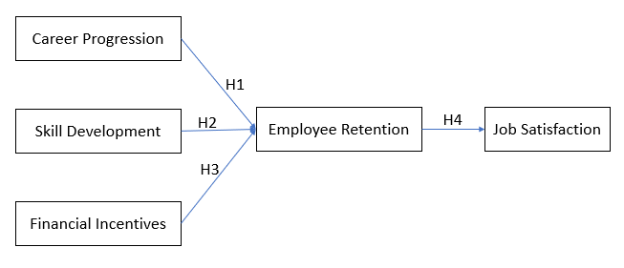

CHAPTER THREE: RESEARCH METHODS AND METHODOLOGY

Research approach
The study used deductive research approach to test the theory and hypotheses (Crowther & Lancaster, 2008). Specifically, the study used the hypotheses to test whether three constructs of human capital investment practices, career progression, skill development, and financial incentives affect employee retention and finally on job satisfaction. By testing the theories, the findings strengthened the benefits to management and academic.

Research methodology
The study adopted mono methodology to examine the effect that human capital investment practices have on retention and job satisfaction. Specifically, the study used quantitative method to collect numerical data through survey.

Research strategy
The study used a case study and survey strategy to collect data. A case study was used to bridge the gap between abstract theory and real application of human capital investment theory. For example, the case study helped explore complex phenomena in depth as well as generate actionable insights for management to act on to increase job satisfaction.

Sampling methods
The study use simple random sampling to pick employees working in different departments at the Contact Centre. The study assumes that everyone at the Contact Centre has equal chance and bears similar characteristics of benefiting from skill development, career progression, and financial incentives. Besides, the study seeks to screen out employees who have undergone career progression, skill development, received different financial incentives, and maintained their position in the company for at least 12 months.

Data collection methods/tools
Structured questionnaires were sent out to participants working in different departments at the company. Online questionnaires were developed with the help of Google Forms. URL was posted on the company social media pages. Employees were asked to clink on the link and be redirected to the Google Form pages they will then fill up the forms. Employees were given a period of two weeks to fill and submit completed questionnaires.

Data Interpretation
Data was interpreted using two approaches. The first approach involves generation of descriptive statics; frequencies and percentages of demographic information such as the department, years of work, gender, financial incentives, training frequency, levels of promotion (McGivern, 2013). Second, the study also seeks to conduct structural equation modelling to understand the effect of human capital investment practices on employee retention and then retention on employee satisfaction.

Ethical consideration of the research
Three ethical codes were used in this study. Ethical approval form was obtained from the university. The study also sought informed consent from both management and employees (Saunders, Lewis, and Thornhill, 2015). During data collect anonymity was maintained. Data analysis was done anonymously without revealing participant identity.

Conclusion
This study examine the effect of human capital investment practices on employee retention and job satisfaction at the case of Rentokil Initial, Birmingham. The study also established three specific objectives as follows – examining the relationship that career progression, skill development, and financial incentives have on retention. Consequently, the study tests the effect that retention has on job satisfaction. Moreover, the study used survey approach to collect quantitative data from the participants working in different departments at Rentokil Initial company.

CHAPTER FOUR: RESULTS AND DISCUSSION

Introduction
The study uses this section in order to present results from primary data to test the relationship between investment in human capital practices on employee retention and job satisfaction among employees working at Rentokil Initial in the UK. Specifically, the study has documented the demographic information to gain insights concerning their gender, age categories, income categories, their current positions, and department of work. In addition, the data analysis also captured the items measuring career training, skill development, financial incentives, retention, and job satisfaction. For example, the study measured participant opinions to understand the extent of agreement or disagreement. The last part of this section focuses on understanding the correlation and relationship through a structural equation modeling relationship.

Results
This section reports all the study results from primary data. The results presented begin with demographic information to describe the characteristics of participants before understanding the inferential statistics. In terms of age categories for example, the results shown in the Figure below revealed that a majority of employees in the sample were aged between 45 to 54 years. They accounted for 3%. The second majority of participants were aged between 35 to 44 years which accounted for 25% of the participants in the sample. Additionalaly, while the older participants aged above 55 years were approximately 27%, at least 24% were aged between 18 and 34 years.

Table 1: Age categories
Age category
 |  | Frequency | Percent | Valid Percent | Cumulative Percent
Valid | 18 - 24 | 6 | 11.5 | 11.5 | 11.5
Valid | 25 - 34 | 7 | 13.5 | 13.5 | 25.0
Valid | 35 - 44 | 13 | 25.0 | 25.0 | 50.0
Valid | 45 - 54 | 17 | 32.7 | 32.7 | 82.7
Valid | 55+ | 9 | 17.3 | 17.3 | 100.0
Valid | Total | 52 | 100.0 | 100.0

The figure below shows the proportion of participants in the sample based on their gender categories. Female participants in the sample (54%) were more than male participants (44%). However, only, 2% preferred to self-describe.

Table 2: Proportion of gender
Gender
 |  | Frequency | Percent | Valid Percent | Cumulative Percent
Valid | Male | 23 | 44.2 | 44.2 | 44.2
Valid | Female | 28 | 53.8 | 53.8 | 98.1
Valid | Prefer to self describe | 1 | 1.9 | 1.9 | 100.0
Valid | Total | 52 | 100.0 | 100.0

The department of work remained critical to gain insights into areas where most of the participants worked. The results were essential in this study since the insights helped gauge the level of career progressions attained by participants. At this point, it can be confirmed that participants were spread across eight different departments. An equal share of participants indicated working sales and marketing and administration (17.3%) respectively, moreover, the customer service department also showed to attract a high number of respondents (13.5%). Additionally, pest control operations and accounts or finance departments had equal number of participants at 11.5%. However, the lowest number of participants in the sample. The t

Table 3: Department of work
Department of work
 |  | Frequency | Percent | Valid Percent | Cumulative Percent
Valid | Pest control operations | 6 | 11.5 | 11.5 | 11.5
Valid | Customer service | 7 | 13.5 | 13.5 | 25.0
Valid | Sales and marketing | 9 | 17.3 | 17.3 | 42.3
Valid | Administration | 9 | 17.3 | 17.3 | 59.6
Valid | Accounts/ Finance | 6 | 11.5 | 11.5 | 71.2
Valid | HR | 5 | 9.6 | 9.6 | 80.8
Valid | Supervision | 5 | 9.6 | 9.6 | 90.4
Valid | Logistics/Supplies/ Stores | 5 | 9.6 | 9.6 | 100.0
Valid | Total | 52 | 100.0 | 100.0

The length at which employees had worked at the company was also important in understanding the number of years such employees had been in their departments. The Figure below presents a clear picture concerning specific period of years employees worked. A majority of participants accounting to more than half (57%) reiterated to have worked for a period of 4 to 10 years. Participants were split into equal shares among those who had spent 4-6 years and 7 to 10 years at 28.85%. Another large group of participants accounted for 23% having worked for a period of 1 to 3 years. While only 10% have been at the company for less than one year, an equal number of participants indicated to have worked for more than ten years.
Figure 2: Length of service at Rentokil Initial
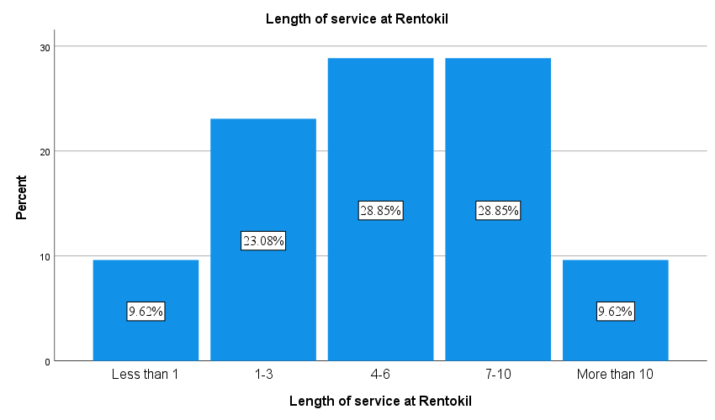
Employees have also gained varying skills after training from the company. For example, as indicated in the figure below, it is evident that five skill areas received the highest training of employees than the rest of skills. The chemical, pesticide, and biocide skill areas have attracted the highest number of employees. Specifically, a third of the employees have undergone training to understand chemical, pesticide, and biocide. In addition, the second majority of participants also indicated to have undergone technical (15.4%) followed by those in client or sales relationships which accounted for 11.5%. Moreover, those who completed the customer service skills accounted for 10%. However, it is surprising that some of the skills such as communication, supervision, and record keeping have attracted the lowest number of employees for training initiatives. Nonetheless, the results show Rentokil Initial conducts training of employees across different skill areas to equip everyone to understand what they do. The company do this to avoid a scenario where employees develop one skill only.
Figure 3: Skills gained from training
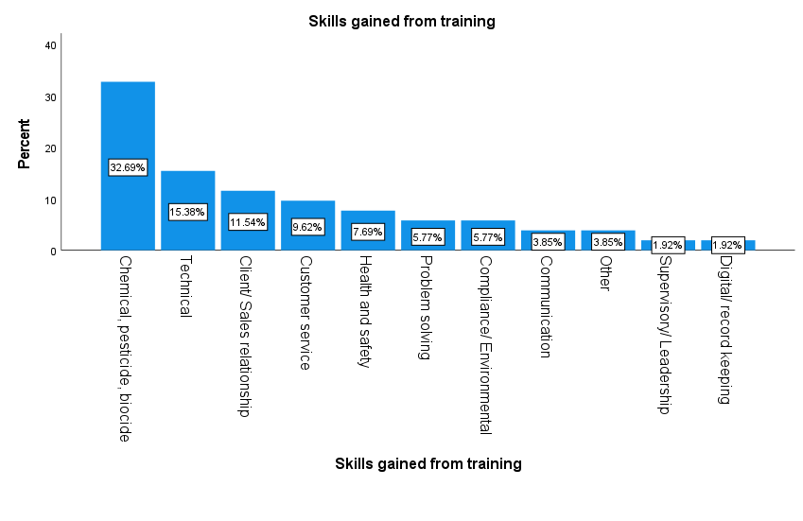

The Figure below is essential to this study because it shows the current positions served by the participants in the sample. Participants who occupy such positions can relate to different levels of career progressions that they have had over the years in the course of working at the company. A majority of participants in the sample served as customer service officers (32.7%). The second majority of customers worked as administrative officers (17.3%). The third majority in the sample comprised of supervisors (15.4%) and sales representatives (15.4%). Those working as operations managers were three participants accounting for 5.8% while those in the finance/ accountants, senior control technicians, as well as pest control technicians.

Table 4: Current Position
Current position
 |  | Frequency | Percent | Valid Percent | Cumulative Percent
Valid | HR Officer | 1 | 1.9 | 1.9 | 1.9
Valid | Supervisor/ Team leader | 8 | 15.4 | 15.4 | 17.3
Valid | Administrative officer | 9 | 17.3 | 17.3 | 34.6
Valid | Sales representative/ Sales consultant | 8 | 15.4 | 15.4 | 50.0
Valid | Customer service officer | 17 | 32.7 | 32.7 | 82.7
Valid | Operations Manager | 3 | 5.8 | 5.8 | 88.5
Valid | Finance/ Accountants | 2 | 3.8 | 3.8 | 92.3
Valid | Senior control technician | 2 | 3.8 | 3.8 | 96.2
Valid | Pest control technician | 2 | 3.8 | 3.8 | 100.0
Valid | Total | 52 | 100.0 | 100.0

The study also collected data to gain insights into frequency of trainings among the participants. This form part of the study to gauge how Rentokil Initial invests in human capital resource practices to achieve higher retentions and further job satisfaction. Therefore, at this points, the study can confirm that a majority of the participants in the sample represented 40.38% who indicated to undergo more than three times of training in a year. The second category comprised of 38.46% of participants who indicated to have undergone two times of training in a year. However, only 13.465 of the participants indicated they only went through training process when there is an operational need of changes in policy within the company. Only 7.69% of the sample reiterated they went through training once in a year.

Figure 4: Frequency of training
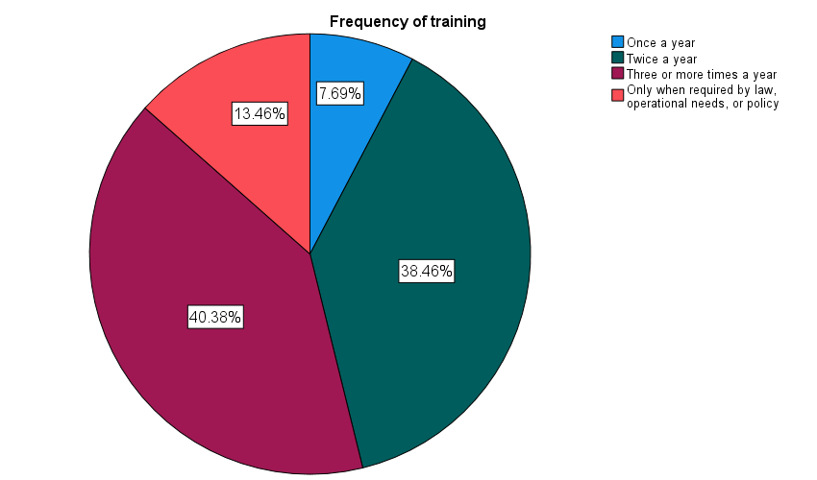

Apart from training development, the study also investigated the frequency at which they benefited from promotions. The study asked participants to indicate the frequency of promotions. The company promoted a majority of participants once in a year (46.15%) while 25% of the sample have never gone through promotion in a year. Only 7.69% of the sample indicated to have undergone two times in a year. While those who had benefited from more than three times in a year were 13.46%. However, the recently employed participants had been employed recently.

Figure 5: Frequency of promotion
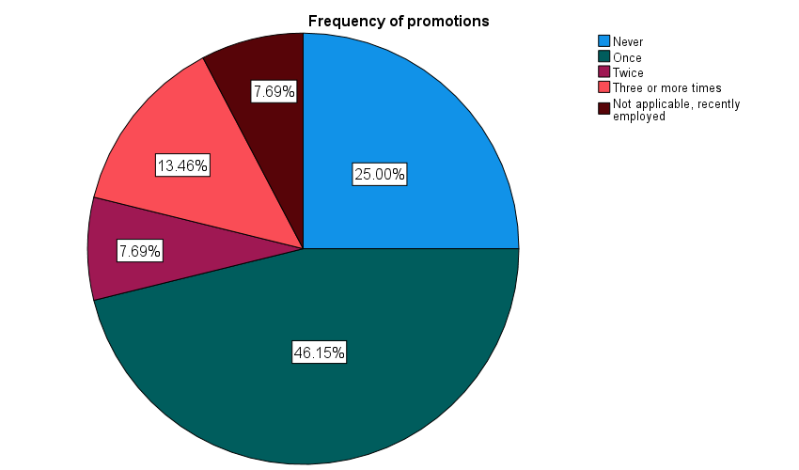

As such, the types of financial incentives given to participants was also important as part of the company financial incentives earned by the company. Notably, a majority of the participants noted that they received performance bonus. Specifically, 44% of the participants received cash rewards after achieving or exceeding targets. The second majority comprised of 27% who indicated that the company offered them pay and allowances as part of additional money to handle travel, transportation, or to support expenses related to the company. The third category of participants comprises of 13% who said the company paid them commissions when they succeed in selling specific pest control products to customers. However, a smaller number of participants benefited from referral bonuses, shared in the company profits, or stock option.

Figure 6: Type of financial incentives
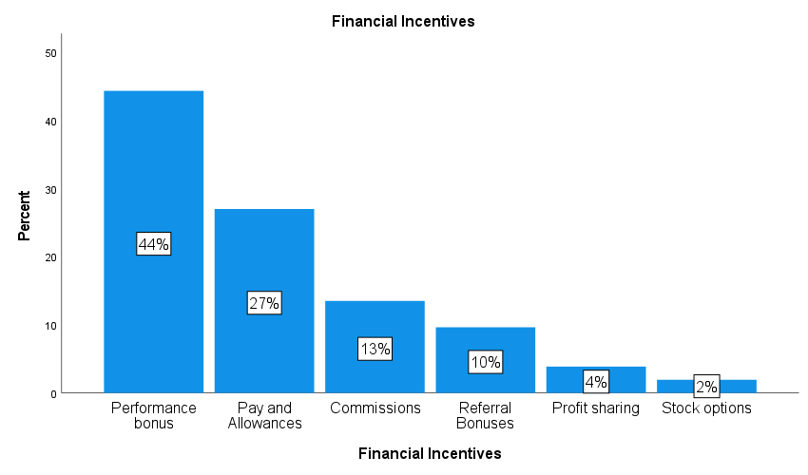

Regression Analysis
The study conducted a regression analysis to gain insights concerning the effect of career progression, development of skills and financial incentives on employee retention. The findings shown in the Figure below expresses the overall effect of all the three variables forming human capital investment practices towards employee retention. The model achieved a correlation coefficient of 0.417. This was a clear expression of a moderate positive relationship between investment practices conducted by the company management and employee retention. For example, with an R-squared of 0.174, all the three practices causes 17.4% variation in retention among employees who participated in the study. Moreover., after making adjustments within the sample size and number of constructs, the explanatory effect of practices dropped to 12.2%. This was a clear view that other unobserved factors created a strong influence on retention of employees. Additionalaly, the results also shows that our standard errors show moderate level of prediction.
The study also generated analysis of variance as an indication of where an overall regression model had any statistically significant effect on retention of employees. In deed, the results confirmed this hypothesis showing $F\left(3, 48\right)=3.37, p<0.05.$The results shows that an integrated effect from the three practices conducted in the case of Rentokil Initial company have statistically significant effect in achieving employee retention. In overall therefore, the study analysis reveals that the model was statistically value in predicting the joint effect of human capital investment practices on employee retention.
Analysis of individual constructs of human capital investment practices showed that the effect of career development on retention was not supported $B=0.20, Beta= 0.196, p>0.05$. Specifically, the results showed that career progression among the participants in the sample had positive effect but lacked statistical significance effect in maintaining employee retention on employees within the sample. Therefore, such results explain that even though we see a clear association between development of career among employees in causing many of them to find the reason to continue working in the company, the effect remain weak to have independent effect on the model. Second, the findings on the skill development also reveals that $B=0.080, Beta= 0.137, p>0.05$. Similarly, the results depict same effect for the lack of independent statistically significant effect towards employee retention. The results explain that both training and development among the sample of employees who participated in the study lacked statistical effect on predicting retention among employees. Additionally, the results from the financial incentives reveal that $B=0.165, Beta= 0.22, p>0.05$. Out of all the three constructs, it is evident that the financial incentive generated the largest influence on retention. However, the results were surprising because the financial incentives also lacked statistical significance effect. Such results depict that even though financial rewards seem to matter, they lack independent effect on driving employee retention at Rentokil Initial Company in London, shows that the model achieved a model fit of 17.4% variation in employee retention. In essence, this was an indication of a weak moderate explanatory power. When we focus on individual constructs of human capital investment practices, it is evident that none of the constructs seem to be working separate or independently. This is because none of the variables were found to have statistically significant effect. They worked together to create a statistically significant effect on employee retention. Besides, each of the factors seemed to have varying unique contribution. For example, the financial incentive made the largest contribution then followed by career progression and finally by the skill development.

Table 5: Regression model
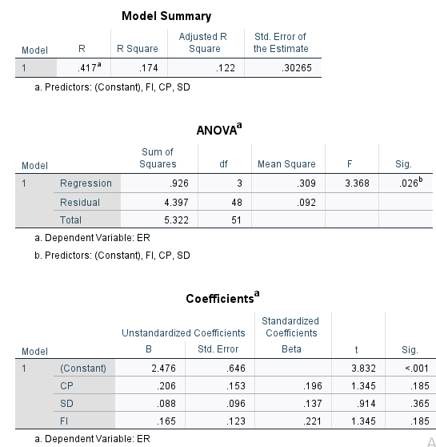

The study also conducted a linear regression to understand the statistical effect of having employee retention on job satisfaction. The results shown in Figure below depicts clearly that we have a moderate positive relationship between employee’s essence of retaining their employee level with Rentokil kill company and job satisfaction. Specifically, the model summary provides a value of 0.109 on R-squared. This is a clear depiction that retention is responsible for causing approximately 10.9% variation in how employees become satisfied by their jobs. Besides, a smaller adjusted R-squared shows that after adjusting for the sample size, the overall explanatory power declines slightly to nine percent. This is a clear indication that the company also have other significant factors that play important function of shaping job satisfaction among employees.
A further analysis of variance showed the final model had statistically significant effect in determining job satisfaction $F\left(1, 50\right)=6.14, p<0.05.$In support of above explanation, the results show that employee retention depicts job satisfaction at Rentokil Initial Company. The overall model remains valid with an explanation that employee retention strategies developed by the company helps increase job satisfaction among employees. Moreover, the results from coefficient interpretation offers the following results shown in the table below. $B=0.333, Beta=0.331, t\left(2.478\right), <0.05.$ There is a positive as well as statistically significant effect between employee retention and job satisfaction. This implies that an increase in retention level makes a majority of employees see the reason to stay for long period in the company without seeing the need to quit. Consequently, this helps increase job satisfaction among employees. Employee retention at the company has a moderate influence on the level of job satisfaction.

Table 6: Regression analysis between retention and satisfaction
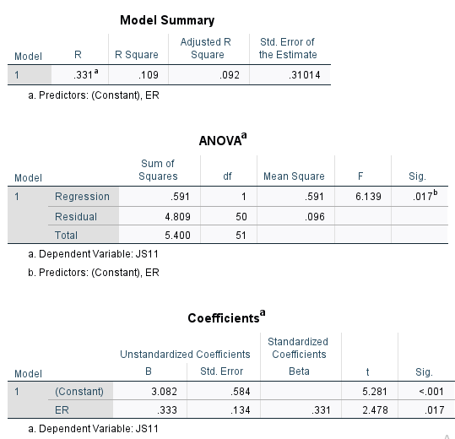

Discussion
This study sought to examine the effect of human capital investment practices on employee retention and job satisfaction among a sample of 52 participants working at Rentolkil Initial Company in the UK. Primary data was collected through a survey approach. In order to understand this topic, the study applied two theories – the human capital investment theory and the Herzberg’s motivator hygiene theory to understand how employee retention links to job satisfaction. Despite the findings showing moderate influence of practices on retention and eventually on job satisfaction, the study also experienced some limitations. Importantly, the results presented in this study shows limitations within the explanatory power of the two theories when used in isolation.
The findings from regression showed that none of the hypotheses were supported at the 5% level. Specifically, none of the target predictors such financial incentives, career progression among employees, as well as development of skills worked independently to cause significant effect on retention. However, all the three predictors worked jointly together to have a positive significant effect on retention $\left(F\left(3,48\right)=3.37, P<0.05\right).$Despite such a relational influence, the results also showed relatively lower explanatory power of the model. This was a clear indication that a small proportion of retentional behaviours among employees were explained by the three predictors. In applying the human capital investment theory, it is evident that even though spending more to invest in these practices remain critical, the company should not invest in isolation with the hope that doing so would increase retention. These findings are in support of Ibrahim (2024) who indicates that investing in individual predictor in isolation weakens the entire practice. Additionally, this also aligns well with past research among service-based companies in pest control, facility management, and those that operate within hospitality industries. Results have gone ahead to posit that broader combination of practices like work life balance, offering job security, and leadership styles strengthen retention. For example, Chew and Chan (2008) argues that organizations must embed heavy investment in human capital in order to achieve significant retention effects.
The results presented in this paper were also supported by the Herzberg’s theory. Specifically, the theory provides two perspectives. First, retention among employees shows foundational hygiene factors like financial stability and job security. Presence of all these factors help prevent cases of dissatisfaction. The second perspective from the theory comes from the fact that retention tend to reflect motivational conditions like perception to leverage on growth opportunities, achieve higher commitment towards the organization, and career continuity. However, despite perspectives on these constructs, the study achieved lower levels of explanatory power. This is a clear indication that most of intrinsic motivators at Rentokil Initial company serve important role of shaping job satisfaction. Such findings support Herzberg’s argument that lack of dissatisfaction such as hygiene factors fail to have an automatic effect on increasing satisfaction. However, satisfaction demands active motivators like creating meaningful job and recognition.
Combination of both theories show significant conceptual gap. For example, the human capital investment practices provide input into what companies need. They help companies develop proper plans to skill employees, promote them, and pay them according to their efforts. While on the other hand, the Herzberg’s theory offers psychological results. The regression analyses have shown that while organizations are likely to invest heavily in human capital by putting in place training programs to give employees opportunities to gain different skills, promote them upward on their career journey, and receive rewards, such efforts should not be expected to have automatic effect on satisfaction. It is important that employees develop meaning perceptions on why organizations are investing in different program. According to Hassan (2016), both employee perceptions and company culture play significant role of ensuring that organizations achieve positive effects from multiple HR practices.
Additionally, the weak effect of human capital practices show that potential issues exist how the company implement such practices. For instance, the company need to offer training most often instead of allowing employees to go through such training few times in a year. Besides, if employees fail to develop positive perception concerning how it makes them develop their careers, then it is likely to have limited effect on retention. Similarly, organizations have different types of financial incentives. However, when employees fail to perceive the importance such incentives as being fairly distributes or linked to their performance efforts, then they are likely to have limited effect on motivation. The results from this study support numerous past studies which emphasises the role of perceived fairness and achievement of psychological contract remain significant predictors of employee retention instead of human capital practices only.

Chapter Summary
In overall, the modest effect of human capital investment practices on employee retention as well the moderate effect of retention towards job satisfaction is a clear indicator that employee behaviours remain multidimensional. For example, having effectiveness in leadership, culture, conditions in the labour markets, and workload play important role in determining both retention and satisfaction. The study also seems to reinforce arguments provided by the two theories. For example, Herzberg argues that satisfaction is not the opposite of dissatisfaction. They do not work within a single continuum. However, they are determined by complex and different sources. In overall, results presented in the current research show that even though human capital investment theory offer important structural explanation for companies to continue investing in employees, there is need to link employee perception and effect on retention. Second, the study also show that Herzberg’s theory generates motivational outcomes, the theory fails to capture employee behaviour among employees working at Rentokil Initial Company in the UK.

CHAPTER FIVE: CONCLUSION AND SUGGESTIONS FOR FUTURE RESEARCH

Conclusion
The focus of this study was to determine the effect of investing in human capital practices on employee retention and job satisfaction among employees working at Rentokil Initial. The study adopted the use of deductive research to test the hypotheses that there is relationship between career progression and retention, skill development and employee retention, and financial incentives on retention. Moreover, the study also sought to establish the relationship between employee retention a job satisfaction at Rentokil Initial company in Birmingham.
The study used survey approach to collect primary data from a sample of 52 employees working across different departments at the company. The results showed there is moderate positive effect between human capital investment practices on employee retention. Specifically, the results showed individually, the human capital practices had no statistically significant effect on retention but they worked together to have integrated effect on employee retention. While individual investment in might not have significant effect on retention, the practices worked together to have significant effect. Second, the results expressed in this study also revealed that employee retention had moderate positive statistically significant effect on employee satisfaction.

Limitations
Despite above findings, it is now clear that this study did not lack numerous limitations. The first limitation involves the lower explanatory power of regression across the two models. As noted above, is that while regression models generated 17.5% variation in model 1 and 10.9% variation in model 2, the study focused mainly on three human resource practices. This implies that several other factors that determine both employee retention and satisfaction were not included in the model. Several other determinants like workload intensity, culture, engagement, and leadership styles were not incorporated in the model. The results show that anyone who seeks to use the results as a reference point, should do so with caution. The findings presented in this study failed to capture all other factors included within the human capital investment practices.
The second limitation presented in this study involves the use of cross-sectional research design only. The study used survey questionnaires to collect primary data at one point in time only. The primary data restricts the ability of research to test the causal-and-effect relationship between different human resource practices, retention, and satisfaction. Even though multiple linear regression shows there is significant relation between the variables, the results failed to confirm whether there was a causality relationship. For example, even though retention was found to influence satisfaction among employees, there is a high possibility that most satisfied employees have a high possibility of maintaining the work status with the company.
The third limitation presented in this study is about the use of questionnaires to collect self-reported data. This approach introduces aspects of response bias, common method bias. First, response bias occurs when participants generate socially desirable responses whenever they evaluate sensitive topics concerning financial incentives, satisfaction, management practices. Second, common method bias in this study occurs because the study collected data on human resource practices, retention, and satisfaction from the same participants. The study used similar tools to collect primary data. This approach has been found to cause inflated relationships among variables. Moreover, the study also collected data from employees working in different departments within the same company that operates in Birmingham. However, these limits generalising the findings to employees working in other companies. Companies that operate either in the same industry or different industry tend to experience varying dynamics around issues of human capital practices, job satisfaction, and even retention when working across different functional or departmental areas. This calls for caution when applying the results to other organizations in different settings.

Recommendations for Future Research
This study recommends that future researchers integrate extra constructs of human capital practices not included in this study. For example, some of the factors found in other studies include engagement, culture, and work life balance. Many contemporary studies continue to highlight these factors as core determinants of behaviours and attitude. This implies that incorporating them would help enhance the influence of the model. Moreover, they would ensure that future researchers have wider perspective concerning what drives retention among employees and satisfaction.
Second, the study also recommends that future researchers consider using longitudinal research designs instead of relying on cross-sectional designs. By adopting this approach, such studies would ensure they collect quantitative data over a period of time. Consequently, this would allow tracking numerous changes that have occurred over time. Future researchers would use the findings to then test cause-and-effect relationship and lower cases of ambiguity concerning directionality in variables. Some of the areas of interest might include showing whether improvements in career progression retains a majority of employees or they seek better positions in other organizations. By using such designs, researchers would deepen HRM studies.
Future studies can also improve methodological rigor through mixed approaches. Studies can integrate survey, interviews, and secondary data. Moreover, studies should consider collecting data from different participants. For example, researchers can consider using the same survey instrument to collect data from different categories of employees such as those working at lower levels and management levels.

REFERENCES AND BIBLIOGRAPHY

Aburumman, O., Salleh, A., Omar, K. and Abadi, M., 2020. The impact of human resource management practices and career satisfaction on employee’s turnover intention. Management Science Letters, 10(3), pp.641-652. Available at: https://www.researchgate.net/profile/Omar-Aburumman/publication/337474159_The_impact_of_human_resource_management_practices_and_career_satisfaction_on_employee's_turnover_intention/links/5dda2704299bf10c5a2e2f19/The-impact-of-human-resource-management-practices-and-career-satisfaction-on-employees-turnover-intention.pdf [Accessed: 18 June 2026]
Adams, K. and Brace, I. (2006) An introduction to market & social research: planning & using research techniques. London: Kogan Page.
Bell, E., Bryman, A. and Harley, B. (2019) Business research methods. 5th edn. Oxford: Oxford University Press.
Burns, P. (2016) Entrepreneurship and small business: start-up, growth and maturity. 4th edn. London: Palgrave Macmillan.
Chew, J. and Chan, C.C., 2008. Human resource practices, organizational commitment and intention to stay. International journal of manpower, 29(6), pp.503-522. Available at: https://www.emerald.com/ijm/article/29/6/503/137798
Crowther, D., & Lancaster, G. (2008) Research methods: A concise introduction to research in management and business consultancy (2nd Ed.). Routledge
Hassan, R., 2016. The role of human capital management in enhancing engagement and retention among top talent in organization: A critical literature review. Journal of Emerging Economies and Islamic Research, 4(4), pp.1-14. Available at: https://ir.uitm.edu.my/id/eprint/32809/
Ibrahim, Y., 2024. Best practices and strategies for talent acquisition, retention and development in Egypt. Leadership, 9(1), pp.35-49. Available at: https://pdfs.semanticscholar.org/62db/585e5bf811fadcc14448dae9408679644819.pdf
Malik, M.E. and Naeem, B., 2013. Towards understanding controversy on Herzberg theory of motivation. World Applied Sciences Journal, 24(8), pp.1031-1036. Available at: https://www.academia.edu/download/120666914/9.pdf [Accessed: 18 June 2026]
McGivern, Y. (2013) the practice of market research: An introduction (4th Ed.). Pearson.
Mehreza, A. and Bakria, A., 2019. The impact of human resource practices on job satisfaction and intention to stay in emerging economies: Model development and empirical investigation among high calibre governmental employees in Qatar. Available at: https://www.academia.edu/download/73944058/j.msl.2018.12.pdf [Accessed: 18 June 2026]
Nabi, M.N., Ahmed, A.A.T. and Rahman, M.S., 2017. The empirical study on human resource management practices with special reference to job satisfaction and employee turnover at Investment Corporation of Bangladesh. Human Resource Management Research, 7(1), pp.54-64. Available at: https://www.researchgate.net/profile/Md-Rahman-1078/publication/320243816_The_Empirical_Study_on_Human_Resource_Management_Practices_with_Special_Reference_to_Job_Satisfaction_and_Employee_Turnover_at_Investment_Corporation_of_Bangladesh/links/655e4388b86a1d521b00cd25/The-Empirical-Study-on-Human-Resource-Management-Practices-with-Special-Reference-to-Job-Satisfaction-and-Employee-Turnover-at-Investment-Corporation-of-Bangladesh.pdf [Accessed: 19 June 2026]
Quader, M., 2024. Exploring human resource management practices and employee satisfaction in Bangladesh's private banking sector. Journal of Policy Options, 7(1), pp.36-45. Available at: http://resdojournals.com/index.php/jpo/article/view/352 [Accessed: 19 June 2026]
Sachau, D.A., 2007. Resurrecting the motivation-hygiene theory: Herzberg and the positive psychology movement. Human resource development review, 6(4), pp.377-393. Available at: https://journals.sagepub.com/doi/abs/10.1177/1534484307307546 [Accessed: 18 June 2026]
Saunders, M., Lewis, P. and Thornhill, A. (2015) Research methods for business students. 7th edn. Harlow: Pearson.
Tooksoon, H.M.P., 2011. Conceptual framework on the relationship between human resource management practices, job satisfaction, and turnover. Journal of economics and behavioral studies, 2(2), pp.41-49. Available at: https://www.academia.edu/download/36956894/Conceptual_framework_on_the_relationship_between_human_resource_management_practices__job_satisfaction.pdf [Accessed: 18 June 2026]
Wanous, J.P. and Lawler, E. E., 1972. Measurement and meaning of job satisfaction. Journal of applied psychology, 56(2), p.95.

Appendices

Appendix A: Questionnaire
Introduction
My name is Ramona-Iuliana Stoican. I am currently studying at Quay Place Campus. As have a project that seeks to study EFFECT OF HUMAN CAPITAL INVESTMENT PRACTICES ON EMPLOYEE RETENTION AND JOB SATISFACTION: CASE OF RENTOKIL INITIAL, BIRMINGHAM. Specifically, my study seeks your responses to help gain insights concerning career progression, skill development, and financial incentives at your company. Please, note than your participation in this study remains voluntary and you can withdraw at any point of filling questions. All the information you provide in this study will only be used for purposes of academic research only.
Section A: Basic Information
- Age category
      - 18 – 24
      - 25 – 34
      - 35 – 44
      - 45 – 54
      - 55+

- Gender
      - Male
      - Female
      - Prefer not to say

- Department of work
      - Pest control
      - Customer services
      - Sales and marketing
      - Administration
      - Accounts/ finance
      - HRM
      - Operations
      - Logic suppliers
- Length of service at Rentokil (s)
      - Less than 1
      - 1 – 3
      - 4 – 6
      - 7 – 10
      - More than 10

- Skills gained from training
      - Technical
      - Health and safety
      - Communication
      - Customer service
      - Chemical, pesticides, biocide
      - Problem solving
      - Leadership / supervisory
      - Sales representants

- Current position
      - HR officer
      - Finance
      - Administrative
      - Sales representative
      - Customer service officer
      - Operations manager
      - Supervisor/ team leader
      - Pest control technician
- Frequency of training
      - Never
      - Once a year
      - Twice a year
      - Three or more times a year
      - Only when required by law, or policy
- Frequency of promotions
      - Never
      - Once
      - Twice
      - Three or more times
      - Not applicable recently employed
- Financial Incentives
      - Performance bonus
      - Commissions
      - Profit sharing
      - Stock options
      - Referral bonuses
      - Pay and allowances
      - Wage incentives
Section B: Career Progression
What is your level of agreement or disagreement with the following items on career progression. 1 = strongly disagree to 5 = strongly agree.
Items | 1 | 2 | 3 | 4 | 5
I receive support from my managers and supervisors to develop my career
I receive encouragements to take up higher responsibilities
Rentokil Initial provides me with clear opportunities to grow my career
I have better understanding of all requirements I need to receive promotions at the company
I receive better opportunities to help me advance in my career depending on my performance level

Section C: Skill development
What is your level of agreement or disagreement with the following items on skill development. 1 = strongly disagree to 5 = strongly agree.
Items | 1 | 2 | 3 | 4 | 5
Rentokil Initial offers training that gives me the ability to perform my job
I receive training that is relevant to my current job responsibilities
Training programs allow me to develop new skills that I need within the industry
The company gives me enough opportunities to attend training and development programmes
I gain skills that increases my confidence at work

Section D: Financial Incentives
What is your level of agreement or disagreement with the following items on financial incentives. 1 = strongly disagree to 5 = strongly agree.
Items | 1 | 2 | 3 | 4 | 5
I receive a fair salary that relates to my duties and responsibilities
Rentokil Initial offers financial rewards that motivates me to perform well
The organization provides fair financial benefits, allowances, and bonuses
The organisation provides financial incentives that makes me feel valued
Rentokil Initial provides financial rewards that encourages me to retain in the company

Section E: Employee retention
What is your level of agreement or disagreement with the following items on employee retention. 1 = strongly disagree to 5 = strongly agree.
Items | 1 | 2 | 3 | 4 | 5
I have plans to continue working at the Rentokil Initial in the future
I would recommend Rentokil Initial at a great place to work
I rarely give my thoughts about leaving Rentokil Initial
Rentokil Initial offers me with enough reasons to continue working here
My decision to work at the Rentokil Initial relies on my career growth. training, and rewards

Section E: Job satisfaction
What is your level of agreement or disagreement with the following items on job satisfaction. 1 = strongly disagree to 5 = strongly agree.
Items | 1 | 2 | 3 | 4 | 5
I am satisfied with my current job at Rentokil Initial
I have motivation when I perform my duties effectively
I am satisfied with support I receive from my manager or supervisors
I feel that Rentokil Initial recognises my work
The workplace at Rentokil Initial makes positive contribution to my job satisfaction

Ethical Approval Form


