Ychwanegu cyswllt at ased/tystiolaeth
Adding a link to an asset/evidence

Cam 1 – dechreuwch deipio yn y bocs priodol.
Step 1 - begin typing in the relevant box.
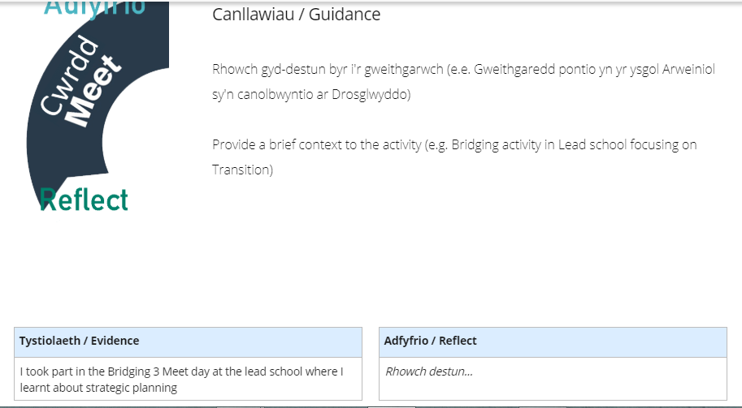

Cam 2 – Uwcholeuwch y darn o ysgrifen rydych am gysylltu at dystiolaeth.
Step 2 – highlight the piece of writing you wish to link to evidence.

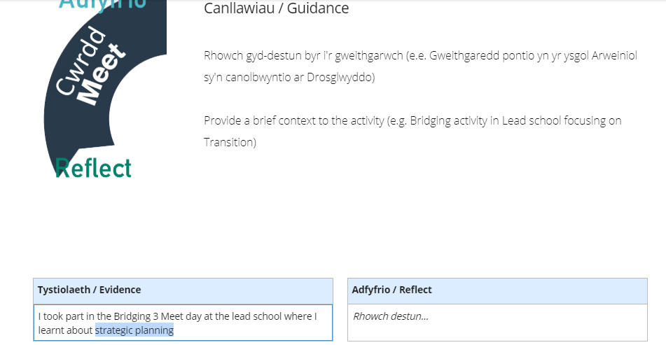

Cam 3 – o’r ‘toolbar’ ar dop y dudalen, dewiswch ‘cysylltu’.
Step 3 – from the toolbar at the top of the page, select ‘link’.

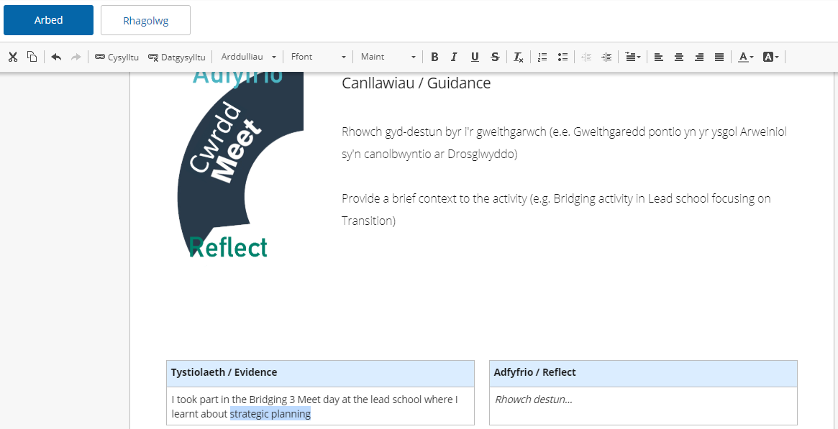

Cam 4 – dewiswch yr opsiwn briodol o’r ddewislen.
Step 4 – select the relevant option from the dropdown (asset, resource, URL, email)
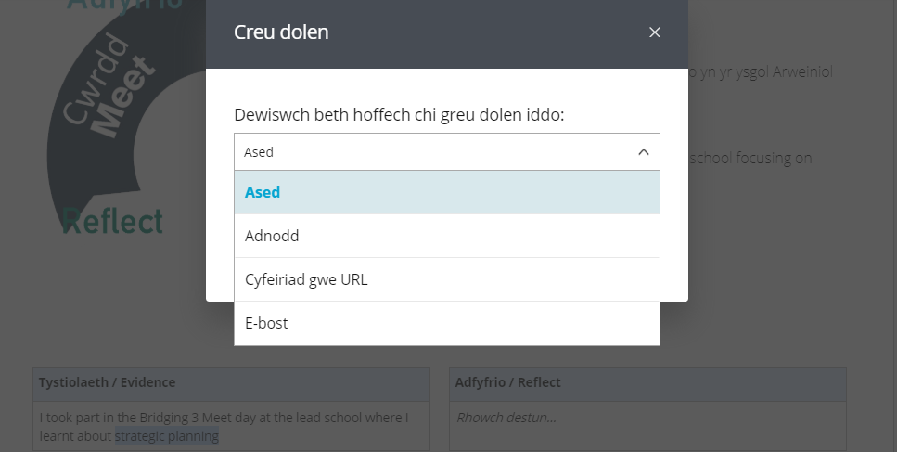

Cam 5 – dewiswch yr opsiwn briodol (fe allwch lanlywtho ffeil, neu ddewis un o’ch storfa asedau).
Step 5 – select the relevant option (you can upload a file or select one you already have in your assets store).


