Lecture 4 Activity: Control Structures – Loops

Activity: Print a Multiplication Table of 5.
Write a program to print the multiplication table of 5.
Sample Solutions:
Example 1:
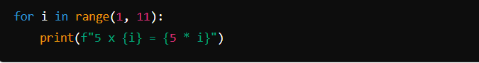
Example 2:
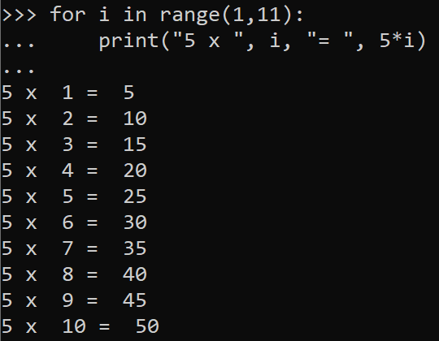

Activity: Ask User to Choose Multiplication Table to Print.
Make your program interactive by prompting the user to indicate the multiplication table to print.

Output (example):

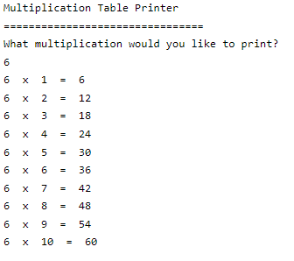

Example Code:
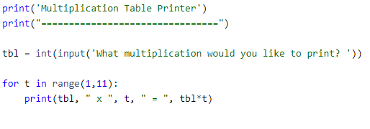

Activity: Print Multiplication Table for Tables 1 –12
Write a program to print the multiplication tables 1 – 12; see an example of an output below.
Hint: use nested loop.
Output (example):
Multiplication Table for 1
1 x 1 = 1
1 x 2 = 2
1 x 3 = 3
1 x 4 = 4
1 x 5 = 5
1 x 6 = 6
1 x 7 = 7
1 x 8 = 8
1 x 9 = 9
1 x 10 = 10
1 x 11 = 11
1 x 12 = 12

Multiplication Table for 2
2 x 1 = 2
2 x 2 = 4
2 x 3 = 6
2 x 4 = 8
2 x 5 = 10
2 x 6 = 12
2 x 7 = 14
2 x 8 = 16
2 x 9 = 18
2 x 10 = 20
2 x 11 = 22
2 x 12 = 24

...

Multiplication Table for 12
12 x 1 = 12
12 x 2 = 24
12 x 3 = 36
12 x 4 = 48
12 x 5 = 60
12 x 6 = 72
12 x 7 = 84
12 x 8 = 96
12 x 9 = 108
12 x 10 = 120
12 x 11 = 132
12 x 12 = 144

Example solution:
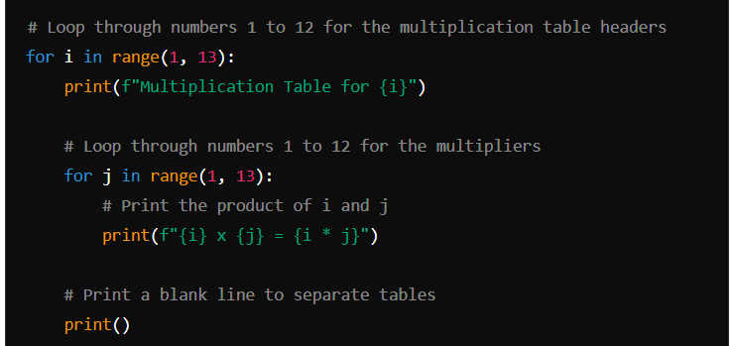

Activity: Sum of Numbers
Use While loop to calculate the sum of numbers from 1 to 10.

Example Solution:
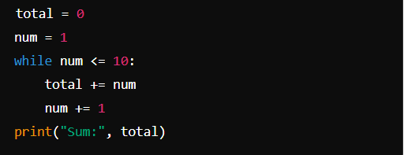

Activity: Custom Loop Control
Participants create a simple program that uses break and continue statements.
Example task: Print numbers 1 to 10 but skip 5 and stop if 8 is reached.

Example Solution:
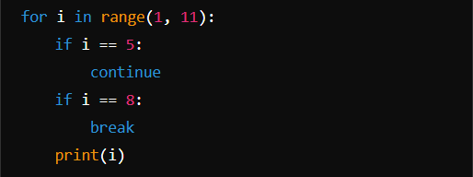

Activity: Summary of Key Points
Summary the key points learnt today. This may include the following:
- the different types of loops and their use cases.
- importance of nested loops
- control statements (break, continue)

Advanced Examples and Practice

Example: Number Guessing Game with Attempts (15 minutes)
- Write a simple guessing game using a while loop and control statements.

Hint: Random Number Generator
You can use a random number generator to make the number to guess to randomly change every time the program is run. This is done as follows:
- At the beginning of the code, load a tool for generating random values, as follows command:
Import random
- Use the library to generate a number with a range. In the following example, between 1 and 100.
GeneratedNo = random.randint(1, 100)

Example Solution:


