Student Name: Michael Thomas

Student Number:1908080

Module Title: Developing Critical workplace thinking (BMSW5101_BIRM)

Lecturer Name: Dr. Obinna Nkwocha

Part B: Academic report

Title of Assignment: A critical evaluation of a management theory and its modern-day workplace usefulness using appropriate critical thinking models.

Hand in date: 30-03-2021

Table of Contents
- Introduction
- Brief background of the theory
- Discuss the main assumptions of the management theory
- Explore other views and critiques about the theory.
- Critically discuss how useful and relevant the theory is in today’s workplace.
- Give a practical example of how the theory is applicable or not in different workplace today (positive or negative views of the theory application)
- Conclusion: key findings of the article
- Recommendation future usefulness or applicability of the theory.
- Appendices
- Part 2
- Introduction
- Critically reflect of how your critical thinking skill has developed based on your learning on the module.
- Week 3, beliefs, and values
- Week 4, developing arguments
- Week 6 Validating evidence
- Week 8, Theories of Management
- References

  - INTRODUCTION

The report will cover the Herzberg two factor theory and analyse the theory's purpose; these contain both hygiene and motivator factors. They are in place to help increase job satisfaction. The factors also have been found to contain some underlying assumptions that have considerable flaws in the theory. Consider what some authors have criticised the theory, which they are perfectly entitled to do; managers need to be aware of how to use these factors in the right way to engage and motivate staff. Also, explore the theory's purpose and how it can be encompassed in an organisation to increase employee motivation within the workplace. From the various types of research undertaken, the two-factor theory is extremely relevant in today's modern work environment. The conclusion will provide clarity and intent while reminding the reader about the importance of Herzberg two factor theory and its relevance in today's 21st century workplace. Finally, the recommendations for any further developments, implications with strong justifications.

2.1 BRIEF BACKGROUND OF THE THEORY (WHO IS THE THEORISTS, HOW IT CAME ABOUT, WHY AND FOR WHAT PURPOSE IS THE THEORY DESIGNED)

Around the late '50s, Frederick Herzberg, considered by many people to be the leading pioneer in the motivation theory. His main drive was to interview a group of employees to determine what made them satisfied and dissatisfied with their employment. (Syptak ,1999) Fredrick Herzberg motivation theory is widely used to study motivation theories. His theory has two factors and is separated into hygiene and motivators. (Elnaga & Imran, 2013)

Herzberg theory model argues that the factors can influence an organisation. Uses these factors in the workplace. They work by Motivators encourage employees to place more effort into their work. The Hygiene factors will only unmotivate staff is not used correctly. (EPM Management, 2018)
These factors are shown below: EPM Management, 2018 ‘Herzberg two factor theories’
(Fig. 1) (Fig. 2)
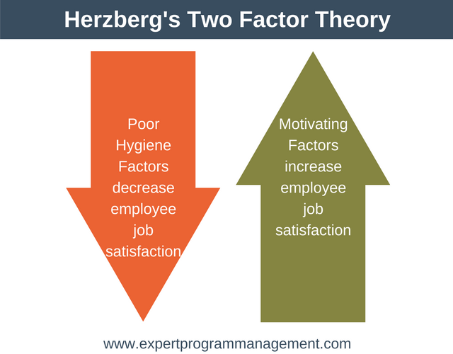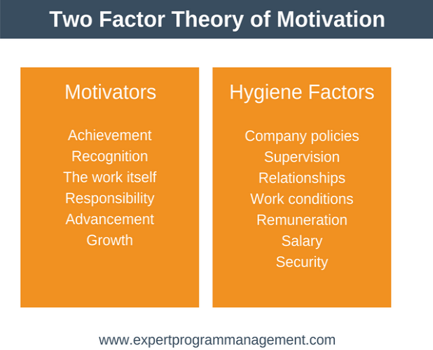
Source: retrieved from ttps://expertprogrammanagement.com/2018/04/herzbergs-two-factor-theory/
Accessed on 12-03-2021

3.1 DISCUSS THE MAIN ASSUMPTIONS OF THE MANAGEMENT THEORY

Certain assumptions of motivation practices that managers need to understand and practice (Stoke, cited in Tella et al, 2007). Motivation is frequently assumed to be a good thing. Staff in the workplace cannot feel good about themselves if there is nothing to become motivated. Secondly, workplace motivation plays different roles in a person's performance. I would agree with both the authors above, as Tella suggests that managers need to be aware of how motivation plays a part in motivating employees. (Mullins, 2010)

Mullins also states that motivation is generally assumed to be the case; however, it can be argued that motivation means different factors to each individual. E.g. these would include resources, conditions, and the employee's ability to perform under is also important. He states thirdly, managers in the workplace assume that motivation is in real short supply and needs to be looked at differently. Fourthly, motivation can be really exploited as a tool that managers can use in their organisations. The point here is if managers recognise what drives the staff working for them. They can adapt to the job and reward staff according to what drives them. (Mullins, 2010)

I would tend to argue with Mullins to a point, as motivation can be assumed as carrot and the donkey syndrome, managers could use this and do whatever it takes to engage workers to perform but satisfying or by appealing to their needs and wants (Mullins, 2010)

4.1 EXPLORE OTHER VIEW CRITIQUES ABOUT THE THEORY

The theory has been criticised on several grounds:

The main criticisms of Herzberg two factor theory as his use of grave technique because the date he was using really depends on the respondent’s recollection and personal evidence (Sachau, 2007) Both Believe The presence of Herzberg two factor does not necessarily mean it will cause satisfaction on its own. Nonetheless, without it will lead to dissatisfaction at some point. (Alshmemri, Maude, & Phillip, 2017).

The author argues that an individual employee’s perception of hygiene and motivators is different for each staff member in the workplace (Rogers, 2005). Believes Herzberg theory is commonly accepted, and there are some criticisms for e, g. staff who work largely in unskilled jobs or those who work in uninteresting, tedious, monotonous this offers a minimal scope. (Gibson,2000)
Employees' expectations may not achieve or focus on their goals are not favourable in organisational culture (Kipps,1976).

The criticism here is that employees tend to work like robots and follow the rules and regulations without taking ownership. This robotic environment encourages, this type of working atmosphere leads to workers being alienated from both their jobs and the organisation. (Kanungo,1990)

There is a flaw in the theory most members of staff are more likely to feature the causes of their accomplishments on the job. On the other hand, an employee may find dissatisfaction through their own personal circumstances or deficiencies and factors in the work environment, e.g. barriers, obstacles presented by company policies, procedures, or vision. (Vroom,1966)

Another criticism of the theory is the lack of reliable data. This was solely based on experience without any connection to a future work world. However, my opinion of the above criticisms is that the theory is still being used by many organisations today. Both supported as well as criticized Herzberg’s approach to measure his two-factor theory. (Herzberg, Mausner, & Snyderman,1959).

Both suggests there are countless areas that are untapped due to modernization, continuously changing busines practices, gender diversity and evolving business and organisational cultures. E.g. from my own personal experience, I used to work for the Hilton Hotel group as part of the kitchen staff. Herzberg theory states that employees can only fulfil their needs and achieving job satisfaction level (Azeem, 2010).

5.1 CRITICALLY DISCUSS HOW AND RELEVANT THE THEORY IS IN TODAY'S WORKPLACE

The two-factor theory is extremely relevant in today's modern work environment. He does mention as a part of human wellness, an emotional process that helps to stimulate and preserves an employee's activity concerning the work they do? (Hitka et al. 2019) affirmed that managers and line managers need to be aware of hygiene and motivators that help change employees from being static, enabling them to move towards these factors. (Schulze and Steyn, 2003)

On the other hand, he argues that even if these factors are present, it does not necessarily mean that employee will be happy at work. He agrees that staff need some stimuli to be guided towards doing their best at work. (Michon,1981)

Herzberg's two factors; they found that most employee's want some achievement to be motivated. Having a decent financial reward for keeping them motivated. (Winer and Schiff,1980) observed that the hygiene factors, especially in today’s modern workplace, dominate the motivators in job satisfaction amongst sales and service staff in the global world of work. (Ismail ,2008) In contrast, Lucas discovered that staff and management's relationship is an important factor, especially in the service sectors. (Lucas,1985)

Two of the hygiene factors that came out significant were, namely, "company policy and relationships formed with their work colleagues. they strongly contend that there is no need to revive Herzberg two factor. In their opinion, it lacks a significant influence in terms of employee motivation in today’s modern working environment. (Deci & Ryan, 2001; Steers, Mowday & Shapiro, 2004)

The nature of work, recognition, advancement, growth, and sense of achievement that one originates from work. In the modern workplace, there are opportunities for an organization to make an impact using the factors to motivate employees. For e.g., work comprises a variety of features of the job in hand, from how an employee participates in the work they are doing. To develop control over assigned tasks. This will eventually lead to a sense of achievement and motivator factor from Herzberg two factor theory. They were leading towards employees being motivated to doing a good job at work. (Raziq & Maulabakhsh, 2015)
In light of the above criticisms, it is possibly predictable that employees’ views of Herzberg two factor theory have tended to be unfavourable due to the changes in organizational work patterns over time, In its pursuit of efficiency and productivity in the modern world of work. All the comments have validity in today's workplace. My argument or critique, even when I was in employment at the Hilton, e.g. included most of Herzberg's two-factor theory achievement, recognition, the work itself and responsibility.
Hygiene factors included company policies, supervision, working conditions, remuneration and salary. For me, frustration took hold when I was actually overlooked for a promotion while working for the Hotel group Hilton. To be overlooked like that dented my confidence. In that respect, both the hygiene and motivators did nothing in terms of my will to work for that particular organisation. (Ralston, 2014)
6.1 HOW THE THEORY IS APLICABLE OR NOT IN DIFFERENT TODAY (POSITIVE OR NEGATIVE VIEWS OF THE THEORY)

6.2 J. D WETHERSPOON HERZBERG TWO FACTOR THEORY

Herzberg argued that to motivate involves identifying and using a range of ‘satisfiers. From the theory, to motivate an employee to complete their job successfully, e.g. in Wetherspoons meeting the need for more responsibility, higher status, and greater job satisfaction or enhanced greater self-esteem. (Winer and Schiff,1980) One of Wetherspoons initiatives comes from employees being allowed to contribute, e.g. the kitchen staff are routinely encouraged to suggest ways of improving menus or food preparation. (BCS,2019)
Herzberg two factor found that “achievement was the highest-rated motivator followed by the chances of promotion. This exactly fits in with Wetherspoons ethos. Winer and Schiff (1980) The company sees its personnel as a major organisational asset that is motivated through a positive organisational culture, pay and benefits, and training and development. (BCS,2019)
Wetherspoons culture across all branches, friendly, motivated staff, who pride themselves on providing first-class customer service, can make a significant difference between a business going under or success within today’s competitive marketplace. (BSC, 2019) He argues that for any company to survive in today’s global workplace, it believes in creating a highly committed and motivated workforce made up of people who achieve personal fulfilment through the freedom to act given to them in their daily work.
The organisation sees its workforce as a prime organisational asset that is motivated through a positive organisational culture. (Raziq,2015). Herzberg two factor theory. Tends to agree with the above comment. The motivators seem to be in line with Wetherspoons ethos; all these factors will promote job satisfaction and encourage productivity and portability within the organisation. They also enabled these working practices to fall in line with today’s modern working practices. (Syptak,1999)
My personal opinion in today's modern working society, employee's want to be valued by their organisation's knowing that their work will be rewarded fairly and acceptably. I believe Wetherspoon's open-minded approach towards its workforce is soundly based and demonstrably successful through Herzberg two factor fits nicely and resonates with today's modern workplace environment (Syptak M,1999)
6.3 NEGATIVE VIEWS OF TWO FACTOR THEORY
Both authors states, Herzberg two factor theory claims both satisfaction and dissatisfaction factors that occur in today’s workplace. When these factors are in play? they cause satisfaction, and they are referred to as motivators, while the other factors that cause dissatisfaction when they are not present are called hygiene factors. (Powell and Kokkranikal, 2015)
In external cases in the NHS, especially, Herzberg theory ran into problems. E.g. inappropriate government and company policies, the organisation’s long-term objectives are just not in line with NHS staff needs and want. These are constantly changing and can cause friction with frontline staff. (Herzberg et al.1959). Factors that affect job satisfaction are divided into supervision, interpersonal relations, physical working conditions, and salary. (Kozioł 2018, Stelmach 2005) The frontline NHS staff have got the unions to involve and not surprisingly have reacted with anger and dismay at the government’s decisions, suggesting a 1% pay rise for the NHS staff. (Ford, 2021)
The author also argues that the powers to be are dangerously out of touch with the NHS frontline staff and the general public. According to the senior managers are paid considerably more than our front staff. In reality, how does that make them feel? (Kinnair, 2021) In this instant, the hygiene needs are a dissatisfaction; I believe this case will only increase fatigue and poor performance from NHS frontline staff. (Herzberg et al., 1965)
Although written in the 1950s, the two factors seem relevant back then; I am not saying they are not relevant now however, in today’s modern workplace, the satisfaction and motivating factors of productivity improvement sought by the organisation. This will continue as the frontline staff are dedicated, loyal and extremely professional in today’s focus in the modern day’s workplace. (Ford,2021)
“This extremely disgraceful, severely unsatisfactory and very disrespectful to our frontline staff who are incredibly under pressure due to the difficult times we are currently facing at present (Kinnair, 2021). My own personal opinion I can disagree with the method of the NHS was taking is definitely the wrong approach; to create harmony, both hygiene and motivators must be improved, especially in today’s modern workplace. (Herzberg et al.1959)
My own personal experience low pay rise, during my time in employment. I feel it does nothing for moral, in terms of the commitment, dedication, loyalty and the value you feel for the organisation that you are working for? It just disconnects the workforce from the management and creates a them and us culture-one of mistrust, lack of loyalty, honesty and most importantly division. If a company want’s more productivity, profitability into day’s modern workplace. They need to look or even implement Herzberg’s two factor theory both hygiene and motivators to have a competitive edge into today’s global marketplace. (Ford, 2021)
7.1 CONCLUSION: KEY FINDINGS OF THE ARTICLE
To conclude, the Herzberg two-factor theory review enhances their understanding of the theory and how it has had to adapt to the modern-day workplace. Herzberg theory model argues that the factors can influence an organisation and still plays a role in the current 21st-century workplace. The two-factor theory is frequently assumed to be a good thing for staff. In some circumstance's employees cannot feel good about themselves if there is no incentive for them to become motivated in the first place.
Senior managers and supervisors need to be careful about how they encourage both hygiene and motivator factors as this may turn from a satisfier into a dissatisfaction. Some authors believe Herzberg's presence of two factors does not always do what it says on the tin; at some point, it will cause employees some dissatisfaction in their working lives. The two-factor theory is still extremely relevant in today's modern organisations and the world of work.
The theory still has a place in both the workplace and the academic learning environment. (Sachau, 2007). He argues that for any organisation to survive and remain competitive in today's modern workplace. He ultimately suggests that a workforce should create a highly committed and motivated workforce made up of people who achieve personal fulfilment through the freedom to act given to them in their daily work. (Raziq, 2015).
Finally, I would agree that staff who feel fulfilled and happy were putting more effort into their work and stretching themselves to the highest of their abilities and limits. This specifies that more staff will feel involved in their working environment, which can only lead to greater performance, productivity, and probability that all organisations are striving for in the modern world of work. This will enable the longevity of Herzberg’s two-factor theory (Curry, 2015)
8.1 RECOMMENDATION FUTURE USEFULNESS OR APPLICABILITY OF THE THEORY
My recommendations would be for continued future studies instead of thinking about what Herzberg’s theory accomplished in the past. Switch the focus towards the 21st working environment and connect both the staff and managers, so they are working in tandem, especially towards the company’s mission. However, it is being noted that the two factors don’t always satisfy the needs of anyone individual employee. What’s need is a two-pronged approach where managers need to look at how the two factors motivate staff in the short and long term. I believe further research is needed, especially around small businesses, to see and maintain how the factors affect businesses and entrepreneurship in this sector.
9.1 JUSTIFICATION
- Future studies in the form of further research or even a report would clarify and help, support more managers in organisations. They would be more appreciative of implementing the factors within today’s workplace properly.
- Align both factors hygiene and motivator factors to increase individual motivation levels as each employee has their own agenda in terms of what they want to achieve from the organisation they are employed by.
- A pathway for all staff who are show commitment, dedication for advancement may be encouraged through better rewards, incentives and promotion in their performance; as we all know, motivation does not last forever; it constantly on the move, just like employees behaviour and mindset. Management needs to pay particular attention to the fulfilment of Herzberg two-factors theory model to help to create an open culture within the 21st-century working environment.

REFERENCES
Alshmemri, M., Maude, L. S.-A., & Phillip. (2017). Herzberg’s Two-Factor Theory. Life Science Journal, 14(5), 12-16.
Azeem, S.M., 2010. Job satisfaction and organizational commitment among employees in the Sultanate of Oman. Psychology, 1(4), p.295.
Curry GD (2015) Supervising across generations. In: Security supervision and management, 4th edn. Oxford, pp 244–255
Deci, E. L., Koestner, R., & Ryan, R. M. (2001). Extrinsic rewards and intrinsic motivation in education: Reconsidered once again. Review of Educational Research, 71(1), 1-27.
Kunnair, D 2021 Nursing Times Work Force https://www.nursingtimes.net/news/workforce/government-suggestion-of-1-pay-rise-for-nurses-branded-an-insult-05-03-2021/ accessed on 12-03-2021
Elnaga, A., & Imran, A. (2013). The effect of training on employee performance. European Journal of Business and Management, 5(4), 137147.
EPM Management, 2018
Mitchell, G, 2021 Nursing Times Workforce https://www.nursingtimes.net/news/workforce/government-suggestion-of-1-pay-rise-for-nurses-branded-an-insult-05-03-2021/ accessed on 14-03-2021
Ford, S (2021), Nursing Times Workforce https://www.nursingtimes.net/news/workforce/government-suggestion-of-1-pay-rise-for-nurses-branded-an-insult-05-03-2021/ accessed on 16-03-2021
Gibson, J., Ivanevich, L., John, M. & Donnelly, J. H. (2000), “Organisations-Behaviour- Structure- Processes”’ 10th Edition. Boston. McGraw-Hill.
Herzberg, F. (1965). The motivation to work among Finnish supervisors. Personnel Psychology, 18(4), 393-402.
Hitka M, Rozsa Z, Potkany M, Lizbetinova L (2019) Factors forming employee motivation influenced by regional and age-related differences. J Bus Econ Manag 20(4):674–693
Kippis, A. (1976), “Association/Royal Historical Society”, Clarendon Press, Oxford, London.
Kanungo, R. N. & Jaeger, A. M. (1990), “Introduction: The need for indigenous management in developing
Islam, R., & Ismail, A. (2008). Employee motivation: a Malaysian perspective. International Journal of Commerce and Management, 18, 344–362.
J.D Wetherspoon | The importance of employee motivation By Business Case Studies: 25 September 2019
Lucas, G. H. (1985). The relationship between job attitudes, personal characteristics, and job outcomes: a study of retail store managers. Journal of Retailing, 61(1), 35–62.
Michon F (1981) Organizacja i kierowanie w przedsiębiorstwie w świetle socjologii i psychologii pracy. KiW, Warszawa
Mullins, L.J. (2010). Management and organisational behaviour. (9th ed.). London: Prentice Hall.
Schulze, S. & Steyn, T. (2003). Educators' motivation: Differences related to gender, age and experience. Acta Academica, 35(3), 138–160.
Tella, A., Ayeni, C. O., & Popoola, S. O. (2007). Work motivation, job satisfaction, and organisational commitment of library personnel in academic and research libraries in Oyo State, Nigeria. Library Philosophy and Practice (e-journal), 118.
J. Michael Syptak, MD, David W. Marsland, MD, and Deborah Ulmer, PhD 1999 Oct;6(9):26-30.Job Satisfaction: Putting Theory Into Practice https://www.aafp.org/fpm/1999/1000/p26.html
Powell P, Kokkranikal J (2015) Motivations and experiences of museum visitors: the case of the Imperial war Museum, United Kingdom. In: Katsoni V (ed) Cultural tourism in a digital era. Springer, Athens, p 170
Raziq, A., & Maulabakhsh, R. (2015). Impact of Working Environment on Job Satisfaction. Procedia Economics and Finance, 23, 712-725.
Rogers, J. (2005). Aspiring to leadership – identifying teacher-leaders. Medical Teacher, 27(7), 629-633.
Sachau, D. (2007). Resurrecting the motivation-hygiene theory: Herzberg and the positive psychology movement. Human Resource Development Review, 6(4), 377-393.
Vroom, V. H. Work and Motivation. New York: John Wiley and Sons, 1964.
Vroom, V. H. “Some Observations Regarding Herzberg’s Two-Factor Theory.” Paper presented at the American Psychological Association Convention, New York, September 1966.
Winer, L. & Schiff, J. S. (1980). Industrial salespeople's views on motivation, Industrial Marketing Management. 9(4), 319–323.

Part 2

10.1 INRODUCTION
As a part of the module, reflection is an influential tool in our university's learning development. Within this, I will use Kolb's model to cement my understanding of the cycle and how the process is used in context? (Shamim et al. 2016). Kolb’s experiential model learning style model Is classically represented by a four-stage learning cycle in which the learner connections with each base at some point during the learning process. (Kolb, 1984).
(Fig 3). Kolb’s Experiential learning Cycle Model
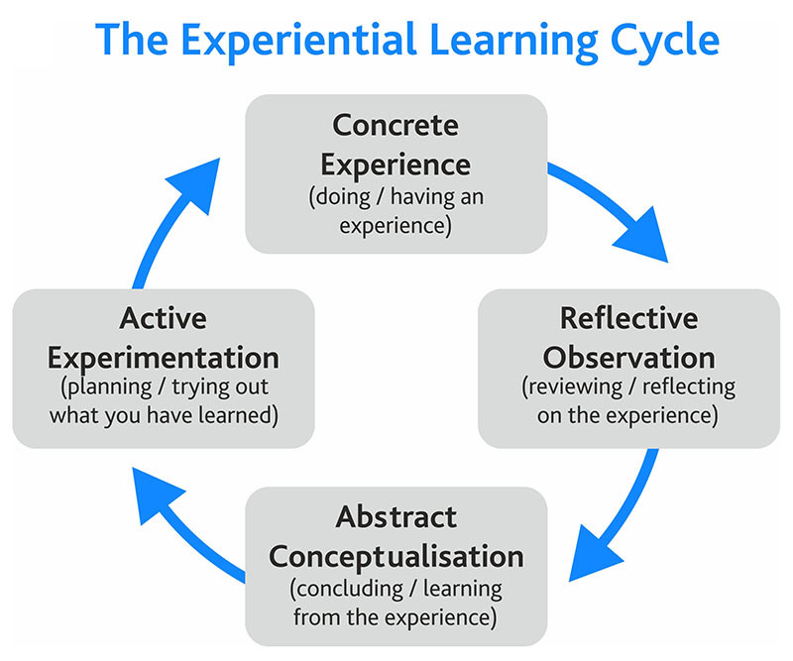
Source: retrieved from https://www.skillshub.com/what-are-kolbs-learning-styles/ accessed on 17-03-2021
CRITICALY REFLECT OF HOW YOUR CRITICAL THINKING SKILL HAS DEVELPOED ON YOUR LEARNING MODULE

10.2 CONCRETE EXPERIENCE
Week 3: beliefs, and values
This lesson introduces beliefs, values, and ideas that a person holds as being true. Many of the student’s beliefs in the group come from many different sources, such as family, cultural, traditions and life experiences. Before entering the lesson, I had some previous knowledge of this topic. On reflection, the lecturer opened up a discussion, which allowed all students to participate in an activity “Do you agree or disagree with these statements?
The activity fully engaged students to participate and reinterpret an existing experience and feedback their answers and thoughts to the class. E.g. a student in the group said we should have the power or right to act or speak or think without barriers or constraints. My personal feeling is that not everyone speaks up, especially in a work culture where communication is closed. (Kolb, 1981) On reflection, what I learned When it comes to core values, everyone is an individual; there is simply no “one size fits all; being tolerant and understanding another person’s belief is vital, especially in the modern cultural workplace.
10.2.1 REFLECTIVE OBSERVATION
Week 4, developing arguments
At this stage, as the learner, we reflect on our learning through experience. In this lesson, we learned how to develop arguments through a series of steps. from the claim the conclusion, to enhance and check our understanding, we were allowed to reflect and put our learning into practice through two activities.
Group Activity1 (Identifying a claim)-this is where we had to read some text and identify the passage's claim.
Class activity 2 From another passage, we had to identify the claim and evaluate the evidence.
I must stress at this point from completing the first task. This gave us the confidence to take on this activity. Evidence was shown by the quality of the answers from each individual student. This is where the true transformation from seeing turns into the doing, and reflecting can be embedded in the learning as it takes place and I can finally observe and absorb the learning that I have finally accomplished.
10.2.2 ABSTRACT CONCEPTUALISATION
Week 6 Validating evidence
The author stressed at the core of learning lies the way we all process knowledge; in particular, our critical reflections will depend on our personal experiences and the meanings we draw from them. We moved our learning onto validating evidence; on reflection, we took our learning to another level as we had to skills to identify various sources through activities designed to stretch our learning. The C.R.R.A.P test involved students testing for currency, relevance, authority, accuracy, and purpose. (Lewin, 1951)
The next learning activity involved us learning about critical thinking models, Pearson’s RED critical thinking model and Socratic questioning. We now have the chance to see how the ideas learned previously can be applied in their real world. For e.g. Pearson’s model is used to sieve through information without letting our emotions cloud our judgement. The Socratic model is about the underlying probing concepts. On reflection, it is about getting us to think more clearly about what exactly they are asking or thinking about, it’s about learning how to be clear, concise, and detailed about questioning techniques.

10.2.3 ACTIVE EXPERIMENTATION
Week 8, Theories of Management
At this final stage, this where the student applies what he/she has learned and captured ideas from the environment to see if there are any modifications to their personal learning experience. We now engage fully with the theoretical practice and connecting our learning through practical application.
This lesson was well structured to give an insight into the theories of management. The learning is associated with three principles as motivation, leadership, and change how these are applied in the modern-day workplace and also used as a functional way to practical solutions and problems
On reflection, as this learning was new to us, the purpose of the learning was to understand what is relevant in today's modern working environment. Also, develop a focus on efficient communication and deal with complex relationships with staff and management. Most importantly, I learnt that theories challenge our individual perceptions about an ever-changing world.
How we as a group demonstrated of our learning founders of the classical management theory Webber, Taylor, Fayol all three develop their theories, but all had one thing in common, and that was to improve the working environment for the workers and to help management to structure better and improved working practices incorporating rewards for the hard work and effort that employees were giving to the organisation. To apply our learning in context, we watched individual videos. Then the lecturer opens up a discussion for student feedback and applies what they have learnt through constructed answers from their notes taken.
11.1HOW WILL THESE NEWFOUND SKILLS BE USED IN THE FUTURE?
To address these issues of new skills, both writers mention that learning comes from experience and requires a focused approach, and this is will be due to practice for behavioral reinforcement through reflection, which at times can be overlooked (DeRue & Wellman, 2009) I agree with the comment to a point, but my question is, “why are new skills overlooked in the first place?” I feel this could be many factors, not creating an environment to provide the necessary skills to flourish, is it also could be the culture of the organization. If you think about Hertzberg two factor theory, you need to balance factors to engage employees and, most importantly, have a culture of investing in your people. As an organization, performance, productivity and most importantly, the company's profitability is what they are in the market to achieve.
As a future leader, my acquired new skills will not be overlooked; however, they will be used to enhance and used in essence with an organizational context. I will need to be aware of the various values, beliefs, and attitudes. Also, I can make staff aware that I can notify them of what the organization expects in terms of good behavior and what is unhealthy. this is now important than ever, especially in a very diverse global workplace. As a manager being able to develop arguments will benefit not just me will also be useful to my staff that I am leading in several ways, e.g., quickly addressing problems, understanding reluctant employees, and formalizing agreements with certain staff members. Active listening plays a huge part as well as leading from the front.
As a leader, I need to be able to use validating evidence to help or enhance our own personal value and be able to appreciate ourselves, which is stable. I need to be able to inspire, motivate and bring others to see the organizational mission and vision. In the modern 21st century workplace, developing and understanding management theories is vital and will need to respond to a changing world of work. Theories will help me as a potential leader to challenge me against its modern-day relevance and practicality, most importantly, to keep learning about the world of work and be able to compete with our competitors in an ever changing world of work, especially with the current situation all organizations are facing at the moment.

REFRERENCES

DeRue, D. S., & Wellman, N. (2009). Developing leaders via experience: The role of developmental challenge, learning orientation, and feedback availability. Journal of Applied Psychology, 94(4), 859–875. https://doi.org/10.1037/a0015317

Lewin, K. (1951). Field theory in social science; selected theoretical papers. New York: Harper & Row.

Kolb, D.A. (1981). Learning styles and disciplinary differences, in: A.W. Chickering (Ed.) The Modern American College (pp. 232–255). San Francisco, LA: Jossey-Bass.

Kolb, D. A. (1984). Experiential learning: Experience as the source of learning and development (Vol. 1). Englewood Cliffs, NJ: Prentice-Hall.

Shamim MS, Zubairi NA, Sayed MH, Gazzaz ZJ. Innovation in ethics and professionalism course: Early experience with portfolio workbook. J Pak Med Assoc 2016; 66: 1149-53.

